

National Evaluation of the Greater Choice for At Home Palliative Care Program

Midpoint Evaluation Report  
Department of Health, Disability and Ageing

June 2025

scyne.com.au

Disclaimer

We prepared this document solely for the Department of Health, Disability and Ageing’s use and benefit in accordance with and for the purpose set out in our purchase order with the Department of Health, Disability and Ageing dated 21 September 2022. In doing so, we acted exclusively for the Department of Health, Disability and Ageing and considered no-one else’s interests.

We accept no responsibility, duty or liability:

* to anyone other than the Department of Health, Disability and Ageing in connection with this document
* to the Department of Health, Disability and Ageing for the consequences of using or relying on it for a purpose other than that referred to above.

We make no representation concerning the appropriateness of this document for anyone other than the Department of Health, Disability and Ageing. If anyone other than the Department of Health, Disability and Ageing chooses to use or rely on it they do so at their own risk.

This disclaimer applies:

* to the maximum extent permitted by law and, without limitation, to liability arising in negligence or under statute; and
* even if we consent to anyone other than the Department of Health, Disability and Ageing receiving or using this report.



scyne.com.au

Executive Summary

Palliative care and the Greater Choice for At Home Palliative Care Program

The Greater Choice for At Home Palliative Care (GCfAHPC) Program (the Program) has been established “to improve awareness of local palliative care options and to coordinate and facilitate access to palliative care services at home” and in the community.[1]

Launched as a pilot in May 2017 by the Department of Health, Disability and Ageing (DHDA), the Program was introduced to drive coordination through the Primary Health Networks (PHNs) with respect to how palliative care is provided at home and in the community. The Program aims to enable people’s preference for palliative and end of life care (EOLC) at home and in the community by enabling PHNs to undertake activities to meet the following four objectives:[2]

* Improve access to safe, quality palliative care at home and support EOLC systems and services in primary health care and community care.
* Enable the right care, at the right time and in the right place, and reduce preventable hospitalisations.
* Generate and use data to support continuous improvement of services across sectors.
* Use available technologies to provide flexible and responsive care, including care after usual business hours.

In 2021-22, the Australian Government committed further funds to expand the Program to all PHNs, nationally, for four years to 2024-25. As part of the expanded Program, PHNs are funded to employ up to two full time equivalent (FTE) staff members to implement activities that are targeted towards “increasing awareness, facilitating and coordinating access to safe, quality palliative and EOLC at home.”[3] Funding may also be used to implement activities that follow the Grant Opportunity Guidance, and in consultation with DHDA.

The Program is intended to lead to the following key outcomes:[4]

* Improved capacity and responsiveness of services to meet local needs and priorities.
* Improved patient access to quality palliative care services at home.
* Improved coordination of care for patients, across health care providers and integration of palliative care services in their region.

Evaluation of the GCfAHPC Program

With the expansion of the Program to all 31 PHNs,[5] a national evaluation was commissioned (the Evaluation) to assess the impact of the Program on access to palliative care at home and in the community, and to inform the future direction of the Program and palliative care policies.

The scope of the Evaluation includes three tranches of data collection, analysis and reporting:

1. Baseline (2023) – to identify PHN activities as part of the Program, and to establish a baseline of key indicators that will be used as a comparator at Midpoint, and Endpoint, to determine the impact of the Program in achieving outcomes.
2. Midpoint (2024) – to understand and analyse the progress of PHN activities since Baseline; and provide up to ten detailed case studies that demonstrate early indicators of value and/or outcomes.
3. Endpoint (2025) – to assess the impact of the Program in achieving intended outcomes, and key insights to inform the future direction of the Program, and other palliative care policies and initiatives.

Figure 1: Progress of the GCfAHPC Evaluation

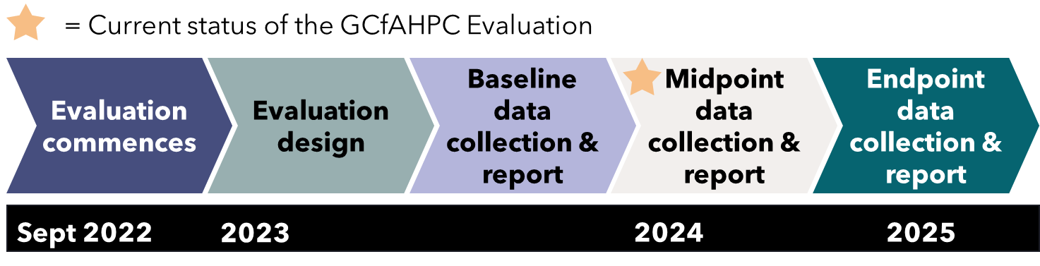

The purpose of this report is to:

* Assess the progress of PHN activities, key challenges within these activities, and any early outcomes achieved.
* Outline next steps for the GCfAHPC Evaluation.

Midpoint evaluation methodology

The methodology for the Midpoint Evaluation is aligned with the GCfAHPC Evaluation Framework and focused on key findings from the following five activity streams (Figure 2).

Figure 2: Categories of PHN activities

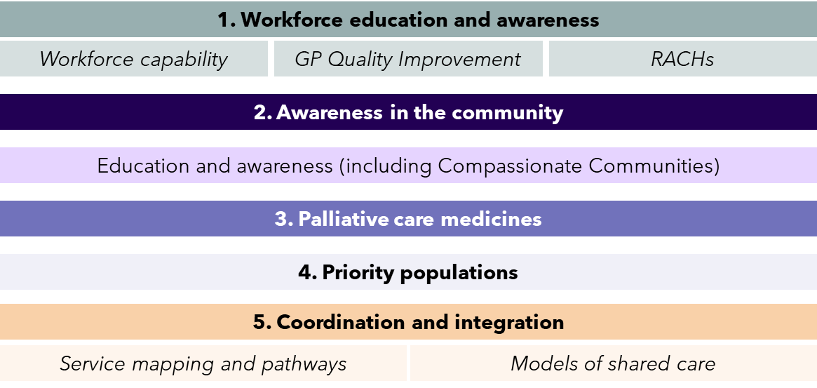

Data has been collected from the following sources:

* Documentation and information provided by DHDA.
* Core datasets and tools such as the Death Literacy Index (DLI) and PHN consultations that apply and will be collected across all or a large proportion of PHNs.
* Supplementary datasets and tools that may apply or be collected by some PHNs, depending on activities and local context.
* Five thematic focus groups and five workshops with PHNs,which investigated the outcomes and progress of PHNactivities across identified themes, as well as any issues regarding implementation. Workshops were organised by activities of a similar nature that were being undertaken by multiple PHNs.

Limitations and considerations

Midpoint Evaluation findings should be considered in the context of the following limitations:

* **Limited consultations with PHNs**: Timelines and scope limited the number of consultations undertaken with PHNs, which were conducted via focus groups and workshops.
* **Sensitivity and specificity of datasets and tools**: The duration of this evaluation compared with the time it may take for PHN activities to demonstrate impact, and the aggregated nature of datasets and tools, means that this Evaluation may not be able to detect significant changes in data between the Baseline and Midpoint tranche of data collection.
* **Causality**: There are several programs and policies nationally and within each jurisdiction that may contribute to changes in palliative care outcomes and data across PHNs, meaning any findings derived will be associative rather than causal in nature.
* **Limited data availability**: There is limited nationally consistent data examining palliative care in Australia. Similarly, there is limited data available at the local system level (i.e. Primary Health Area) or from local service providers.

Summary of midpoint findings

Most PHN activities identified at Midpoint meet the needs of the PHN region, as identified in key documents such as Health Needs Assessment and Healthy Ageing Strategies.

### Workforce Education and Awareness

All 31 PHNs are implementing, or have already implemented, activities aimed at increasing workforce education and awareness, through a total of 97 activities. The objectives of these activities can be further broken down into three sub-categories (Figure 3):

Figure 3: Status of Workforce Education and Awareness activities at Midpoint

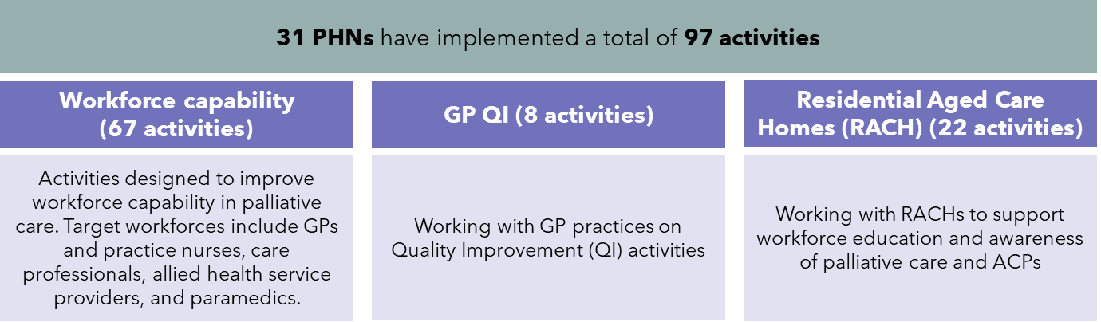

The approaches used by PHNs as part of these activities include:

* Education and awareness events.
* Development of resources and toolkits.
* Communities of Practice, creating connections with experts, and community champions.

Workforce Education and Awareness activities are demonstrating early indicators of impact with participants in workforce education and awareness events reporting increased knowledge, and intention to improve and change practice.

### Awareness in the Community

Activities to promote awareness in the community are being, or have been undertaken, by 26 PHNs, through a total of 60 activities.

PHN activities in this category include:

* Community awareness events such as Death Cafes or film screenings with panel discussions (25 activities).
* Development of palliative care resources (19 activities).
* Face-to-face and virtual workshops for the community (10 activities).
* Hosting Compassionate Community events (6 activities).

The data available shows participants at community events report increased knowledge and awareness of palliative care.

### Palliative Care Medicines

Seven PHNs have undertaken a total of eight activities to improve access to palliative care medicines, including:

* Increasing the availability of palliative care medicines for community members.
* Enhancing the capacity and capability of community pharmacists to support palliative care and building awareness and expanding access for health professionals and community members via the development of interactive maps of pharmacies stocking core palliative care medicines (four PHNs).
* Increasing the practice of anticipatory prescribing in pharmacies (one PHN).
* Encouraging community pharmacists to undertake palliative care training programs (one PHN).
* Developing action plans to increase the capacity and capability of community pharmacists in supporting safe, quality palliative care at home (one PHN).

Five PHNs implementing these activities have partnered with the Pharmaceutical Society of Australia (PSA) to facilitate contact with local pharmacies, and to support development of resources and implementation.

PHN activities are having a positive impact on access to palliative care medications (Figure 4).

Figure 4: Example palliative care medicine activities

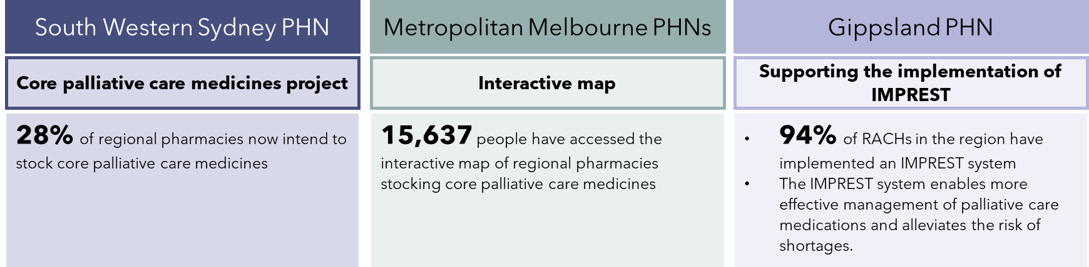

### Priority Populations

Sixteen PHNs have implemented or are implementing activities targeting identified priority populations in their regions, through a total of 23 activities. Activities to better support palliative care among priority populations include:

* The development of action plans to improve access to palliative care at home for people living with disability.
* Exploring how Advance Care Planning design could be improved for different population groups.
* Upskilling local service providers to build their cultural competence with Aboriginal and Torres Strait Islander communities.
* Directly engaging with priority populations and representative organisations to raise awareness and provide resources.

All PHNs implementing activities in this category are working with partner organisations such as NGOs, local health organisations and service providers, interpreters, technology and IT partners. PHNs acknowledge that partner organisations are crucial to the success of activities targeting priority populations due to their knowledge of local conditions and trusted relationships within communities.

Little data is available on the impact of these activities (only three PHNs were able to provide data). Data that is available has been positive, indicating there is increased understanding of palliative care among the workforces.

### Coordination and Integration

Twenty-one PHNs have implemented, or are implementing, activities related to coordination and integration, through 40 activities. The objectives of these activities can be further broken down into two sub-categories (Figure 5):

* Service mapping and pathway activities that improve palliative care service navigation, referrals and pathways in PHN regions.
* Models of shared care activities that support integration and coordination between different service providers.

Figure 5: Status of Coordination and Integration activities at Midpoint

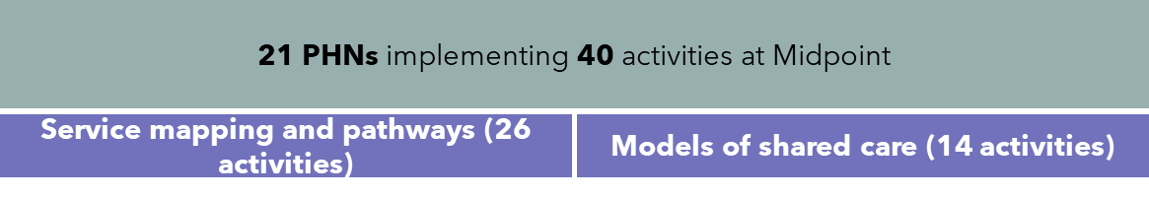

PHN activities for the service mapping and pathways sub-category included:

* Updating HealthPathways so GPs can better identify services that would benefit palliative patients.
* Developing a local directory for the community of key service providers.

Developing new models of care to improve and better coordinate palliative care services.

* Developing decision support tools to help health professionals appropriately refer patients.

Models of shared care activities included:

* Networking initiatives that bring together service providers to build partnerships and raise awareness of available resources.

Programs to bring service providers together to better care for palliative and end-of-life patients.

* The establishment of multidisciplinary teams to help GPs and patients coordinate and navigate supports and access resources.

There is limited data available to understand the impact of these activities on improving coordination and integration. The main information source available is HealthPathways data specific to palliative care, which has been provided by six PHNs. HealthPathways data indicates there is varying impact from these activities.

### Conclusions and next steps

PHNs have made progress implementing activities across most categories. There are early indications of impact from PHN activities across workforce education and awareness; awareness in the community; and palliative care medicines categories.

Based on the data received at the Midpoint Evaluation:

* Most PHN activities identified at Midpoint are meeting the needs of their PHN region, as identified in key guiding documents such as Health or Palliative Care Needs Assessments and Healthy Ageing Strategies.
* There is significant uptake nationally in PHN-driven palliative care education and awareness workshops by a wide range of health professionals.
* The importance of partnerships and collaboration to deliver successful program activities continues to be highlighted.
* Projects with the potential for greater impact often include longer-term planning, sustained efforts, pilot and trials, or PHNs working together towards shared goals. Examples of this include projects in Regional Victoria and Metro Brisbane, where PHNs have collaborated to engage with stakeholders over long periods of time and combined resources to provide financial incentives.
* This includes projects in Regional Victoria and Metro Brisbane where PHNs have been able to collaborate stakeholder engagement efforts, financial incentives and resources.
* Targeting General Practice quality improvement continues to remain a gap for PHNs with only 8 activities occurring overall in this space. This is likely due to the challenging nature of engaging time-poor GPs who have competing priorities.

Between delivery of this Midpoint Evaluation report, and the Endpoint Evaluation, PHNs will collect further data on their activities and impact.

Combined with the observations noted in this Mid-point report, the new data will support the following questions to be explored at Endpoint:

* What is the impact of activities that are completed by one or more PHNs involved?
* What are the enduring strengths and enablers of the Program that have continued from Baseline through to Endpoint?
* What are the key palliative care reforms and system changes that have occurred over the duration of the Program in Australia, and do activities continue to align to contemporary system needs and gaps?
* How should the program be modified to enable a greater impact in the future?

Table of Contents

Disclaimer i

Executive Summary ii

Palliative care and the Greater Choice for At Home Palliative Care Program ii

Evaluation of the GCfAHPC Program iii

Midpoint evaluation methodology iii

Limitations and considerations iv

Summary of midpoint findings v

1 Background and Objectives 12

1.1 Context 12

1.2 The Greater Choice for At Home Palliative Care program 12

1.3 Evaluation of the GCfAHPC Program 13

1.4 Findings of the Baseline Evaluation 14

1.5 Purpose of this document 15

2 Approach to the Midpoint Evaluation 17

2.1 Program Logic 17

2.2 Lines of enquiry for the Midpoint Evaluation 19

2.3 Midpoint Methodology 20

2.4 Limitations and considerations 24

3 Key findings: Workforce Education and Awareness 26

3.1 Summary of findings 26

3.2 Workforce Education and Awareness activities at Midpoint 27

3.3 Analysis of Workforce Education and Awareness activities at Midpoint 31

4 Key findings: Awareness in the Community 34

4.1 Summary of findings 34

4.2 Awareness in the Community activities at Midpoint 35

4.3 Analysis of Awareness in the Community activities 39

5 Key findings: Palliative Care Medicines 44

5.1 Summary of findings 44

5.2 Palliative Care Medicine activities at Midpoint 44

5.3 Progress of Palliative Care Medicine activities at Midpoint 46

6 Key findings: Priority Populations 51

6.1 Summary of findings 51

6.2 Priority Population activities at Midpoint 52

6.3 Impact of Priority Population activities at Midpoint 55

7 Key findings: Coordination and Integration 58

7.1 Summary of findings 58

7.2 Coordination and Integration activities at Midpoint 59

7.3 Analysis of Coordination and Integration activities at Midpoint 64

8 Conclusion and next steps 68

8.1 Summary 68

8.2 The Endpoint Evaluation 69

8.3 Next steps 70

Appendices 71

Appendix A: Glossary 72

Appendix B: PHN activity alignment to Health Needs Assessments and Healthy Ageing Strategies 76

Scope 76

Assumptions and Limitations 76

Appendix C: PHN activity case studies 78

1

Midpoint Evaluation Report

Background and Objectives

# Background and Objectives

## Context

Palliative care is ‘person and family-centred care provided for a person with an active, progressive, advanced disease who has little or no prospect of cure and who is expected to die’.[6] The aim of palliative care is to optimise quality of life.[7] End-of-life care (EOLC) is care and services for people and their families who are facing the end of their life. EOLC is an important part of palliative care and is provided for people of any age. The focus of EOLC is to help a person live out their life as comfortably as possible.[8]

While 70 per cent of Australians prefer to die at home, only 15 per cent do so, with half of all deaths occurring in hospitals, and more than one third in residential aged care homes (RACHs).[9]

The Greater Choice for At Home Palliative Care (GCfAHPC) program (the Program) has been developed and funded “to improve awareness of local palliative care options and to coordinate and facilitate access to palliative care services at home” and in the community.[10]

## The Greater Choice for At Home Palliative Care program

Launched in May 2017 by the Department of Health, Disability and Ageing (DHDA), the GCfAHPC program was introduced to drive coordination through the Primary Health Networks (PHNs) with respect to how palliative care is provided at home and in the community. The Program aims to enable people’s preference for palliative and EOLC at home and in the community by empowering PHNs to undertake activities to meet the following four objectives:

* Improve access to safe, quality palliative care at home and support EOLC systems and services in primary health care and community care.
* Enable the right care, at the right time and in the right place, to reduce preventable hospitalisations.
* Generate and use data to support continuous improvement of services across sectors.
* Use available technologies to provide flexible and responsive care, including care after usual business hours.

The Program was introduced in 2017-18 as a pilot across 11 PHN trial sites and evaluated from July 2018 to December 2020. The evaluation of the pilot program found that there was merit to expand the Program beyond the 11 PHN pilot sites, with recommendations to improve clarity and guidance on the flexible use of funding, greater flexibility on what funding can be used for, and shared learnings from existing activities to facilitate knowledge exchange.[11] In 2021-22, the Australian Government committed further funds to expand the Program to all 31 PHNs, nationally, for four years to 2024-25.

As part of the expanded Program, PHNs are funded to employ up to two full-time equivalent (FTE) staff members to implement activities with the objective of “increasing awareness, facilitating and coordinating access to safe, quality palliative and EOLC at home.”[12] Funding may also be used to cover costs associated with implementing activities.

The Program is intended to lead to the following key outcomes:[13]

* Improved capacity and responsiveness of services to meet local needs and priorities.
* Improved patient access to quality palliative care services at home.
* Improved coordination of care for patients, across health care providers and integration of palliative care services in their region.

## Evaluation of the GCfAHPC Program

With the expansion of the GCfAHPC Program to all 31 PHNs, a national evaluation of the measure has been commissioned (the Evaluation).[14] The aim of the Evaluation is to assess the impact of the Program on access to palliative care at home and in the community, and to inform the future direction of the Program and palliative care policies.

The scope of the Evaluation includes three tranches of data collection, analysis and reporting:

1. Baseline (2023) – to identify progress of PHN activities as part of the Program, opportunities to better support implementation, and to establish a baseline of key indicators that will be used as a comparator at Midpoint, and Endpoint, to determine the impact of the Program in achieving outcomes.
2. Midpoint (2024) – to understand the progress of PHN activities; analyse PHN activity progress since Baseline; and provide up to ten detailed case studies demonstrating earlier indicators of value and/or outcomes.
3. Endpoint (2025) – to focus on impacts of the Program in achieving intended outcomes, and key insights to inform the future direction of the Program, and other palliative care policies and initiatives.

Figure 6: Progress of the GCfAHPC Evaluation



## Findings of the Baseline Evaluation

The Baseline report established data indicators for comparison in future evaluation tranches to monitor and track progress and impact. These included core datasets to be accessed via data custodians such as the AIHW or collected by PHNs (e.g. DLI data), as well as supplementary sources of data provided by, but not used for standardised comparison, between PHNs. The Baseline report was also intended to provide an initial checkpoint for PHN activity design and progress. Key findings of PHN activity progress are listed below.

### PHN activities

The Baseline report found that a range of different activities were being implemented by PHNs to meet the needs of their communities. These included five broad categories of PHN activities (workforce education and awareness; awareness in the community; palliative care medicines, priority populations; and coordination and integration of services). At Baseline, PHN activities were grouped into four areas of action. Palliative care medicines and priority populations were grouped together under the larger ‘needs and preferences’ category. During the Midpoint drafting phase it was decided to separate these two areas of action into two categories as the activities sitting underneath them were thought to be sufficiently distinct.

Figure 7: Categories of PHN activities

PHN progress against Activity Work Plans (AWP) was broadly on track. As expected PHNs that participated in the pilot were generally more progressed in implementing activities. PHNs formed a broad range of partnerships with third-party organisations (including non-government organisations, local service providers, health professionals, peak industry bodies and community groups amongst others) to deliver activities. Activities focused on improving workforce capability in their region were the most common activities undertaken by PHNs under the Program (26 PHNs). Palliative Care Medicines and Priority Populations were the least likely types of activities to be undertaken.

## Purpose of this document

The purpose of the Midpoint Evaluation is to determine the progress of PHNs’ activities highlighting issues experienced and any early identifiable impacts.

This document:

* Describes the context and approach to the Midpoint Evaluation.
* Assesses PHN progress against Activity Work Plans.
* Highlights key challenges and barriers to the delivery of PHN activities.
* Assesses early indicators of outcomes or impact of PHN activities.
* Outlines next steps for the GCfAHPC Evaluation.

2

Midpoint Evaluation Report

Approach to the Midpoint Evaluation

# Approach to the Midpoint Evaluation

## Program Logic

A Program Logic has been developed to capture the objectives, inputs, activities, outputs, and outcomes of the GCfAHPC Program (Figure 8). The Program Logic was developed at the outset of the GCfAHPC Evaluation in partnership with DHDA and has been refined over the course of a series of workshops and consultations with all 31 PHNs. The Program Logic comprises four key elements:

* **Objectives** – what the program is intended to deliver and the outcomes it aims to achieve.
* **Inputs and activities** – the range of resources, investments, actions and processes needed to deliver the Program.
* **Outputs** – the tangible products and processes generated as a result of the Program.
* **Outcomes** – the changes to knowledge, beliefs, behaviours, and to the system because of the Program. Outcomes are grouped into short, medium and long term. Subject to data quality and scope, outcomes can potentially also be assessed by population groups (e.g., individuals from culturally and linguistically diverse background).

Figure 8: GCfAHPC Program Logic

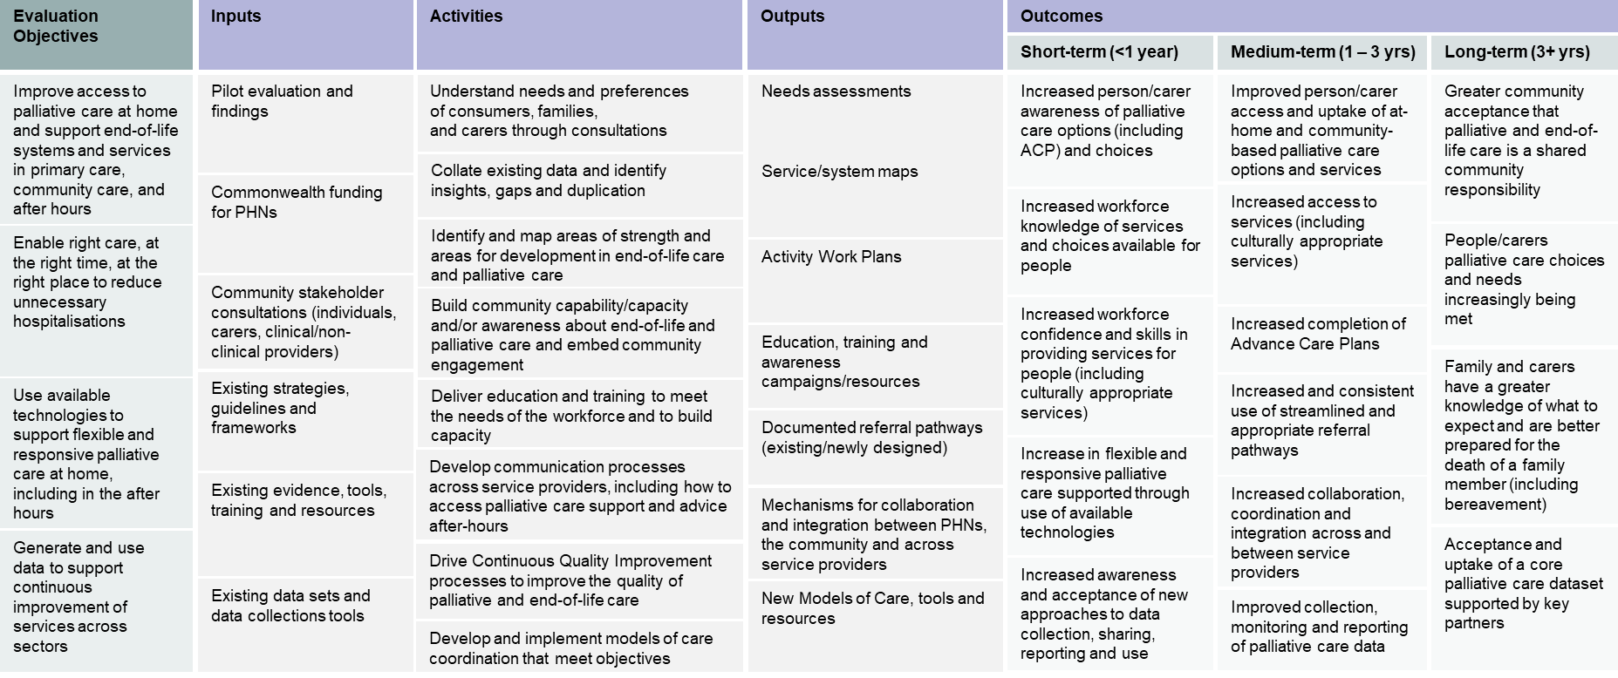

## Lines of enquiry for the Midpoint Evaluation

The Midpoint tranche of the evaluation is focused on:

* Understanding the progress of PHN activities.
* Analysis of PHN activity progress since Baseline.
* Demonstrating early indicators of value and/or outcomes through up to ten detailed case studies.

The Midpoint Evaluation was informed by ten Lines of Enquiry (LoE), as highlighted in Table 1 below.

Table 1: Lines of Enquiry most relevant to Midpoint Evaluation

| Legend | Key Line of Enquiry for Midpoint Evaluation report |
| --- | --- |
| Other Line of Enquiry |
| LoE | Description |
| 1 | To what extent has the Program enabled appropriate palliative care in the home and community, and reduced preventable hospitalisations? |
| 2 | Is the design of the Program appropriate and effective in achieving the Program objectives? |
| 3 | How appropriate is the current funding and resourcing model to enable PHNs to meet the Program objectives? Is this consistent across PHNs? |
| 4 | How effective have governance arrangements been for implementing and achieving the objectives of the GCFAHPC Program? |
| 5 | To what extent do activities/initiatives implemented by PHNs align with Program objectives? |
| 6 | How appropriate are PHN activities and initiatives in meeting the preferences and needs of individuals/carers/workforce? |
| 7 | Has the program been implemented as planned (within PHNs, and nationally)? |
| 8 | To what extent are services coordinated, integrated, and provide continuity of palliative care? |
| 9 | To what extent has the Program generated and used data to support continuous improvement of services across sectors? |
| 10 | To what extent has the Program improved access to palliative care at home and in the community? |
| 11 | How appropriate is the Program at meeting the needs and preferences of families, individuals and carers? |
| 12 | To what extent has awareness of palliative care in the community (including family and carers) increased? |
| 13 | To what extent has the Program increased individual awareness of palliative care options and choices (including ACP) |
| 14 | How cost-effective is the Program? |
| 15 | To what extent has Program increased workforce knowledge and awareness of palliative care options and services available for individuals? |
| 16 | To what extent has Program increased workforce confidence and skills in providing palliative care services available for individuals? |

Table 1 captures both process and outcome-based LoE. Process LoE assess type, quantity and quality of Program activities and assesses the implementation of the Program against proposed strategic intentions. This supports identification of potential efficiencies and improvements in delivery of the GCfAHPC expanded program. It will also allow for understanding where local variation has been needed by PHNs. Outcome-based LoE’s assess how successfully GCfAHPC is delivering intended objectives and outcomes.

## Midpoint Methodology

Midpoint data collection for the Evaluation was conducted between June and September 2024. As part of this tranche the following data was collected and analysed:

* Materials submitted from PHNs including, but not limited to, program documentation, progress reports, post-event survey results, event attendance / participation data, etc, relating to activities.
* Data provided by the Statewide Office of Advance Care Planning (Queensland).
* Five focus groups, each with 8-10 PHNs to discuss broad categories of PHN activities, including progress and outcomes.
* Five workshops, to which all 31 PHNs were invited, to discuss implementation of activities, identify issues or challenges and workshop ways these could be improved.

Data collected from PHNs can be categorised into two types (

Table 2):

**Core datasets and tools**, i.e. those that apply and will be collected across all or a large proportion of PHNs.

**Supplementary datasets and tools**, i.e. those that may apply or be collected by some PHNs, depending on activities and local context.

Table 2: Evaluation data collection approach overview

|  | Data source | Description |
| --- | --- | --- |
| Core | AIHW National Integrated Dataset | AIHW provides nationally aggregated data on palliative care that is of sufficient quality and is relatively easy to access in order to address certain Evaluation LoEs. |
| Palliative Care Outcomes Collaboration (PCOC) | PCOC is a data source that is already in use or is of interest to many service providers. |
| Death Literacy Index (DLI) | The DLI is an existing, validated tool on palliative care confidence and capability that is currently used. |
| Scyne-proposed After Death Audit form | Scyne have developed a proposed After Death Audit Form using the most appropriate/relevant questions from existing Brisbane South (BSPHN) and Murrumbidgee PHN After Death Audit tools. It can be tailored to suit the needs of the Evaluation. |
| PHN consultations | Consultations with PHNs will provide a point of comparison at all stages of the Evaluation. |
| Scyne provided surveys to PHNs | PHN surveys will supplement consultation insights on Program design, governance, and activities. |
| Scyne provided surveys to service providers | Service provider surveys will provide a clinician perspective on PHN led activities. |
| Supplementary | Post-event surveys | Post-event surveys collect feedback from participants on events conducted by PHNs. |
| The Program of Experience in the Palliative Approach (PEPA) surveys | PEPA collects pre and post survey data from education and training sessions to the healthcare workforce. |
| HealthPathways | HealthPathways is a web-based portal for health professions to access clinical management pathways, referral advice from specialist services, educational resources for patients, and treatment options. |
| Office of Advanced Care Planning (QLD only) | Advanced Care Planning data including values and preferences for persons with, and without decision-making capacity. |
| Use of webpages or resources (clicks, views, flyers etc.) | PHNs are tracking webpage or resource uptake through clicks, views of resources. |
| Other materials | May include collateral that captures further data inputs. |

### Desktop review

PHNs were asked to upload relevant core and supplementary data to a secure, access-restricted Microsoft SharePoint site. Together with stakeholder consultations, this data forms the basis for much of the analysis contained within this report. PHNs have been collecting this data since the outset of the Baseline tranche of the Evaluation.

In addition, DHDA have provided updated program documentation as inputs, including:

* Notes and administrative documentation relating to regular one-on-one meetings and communications between PHN leads and DHDA representatives.
* Regular reporting requirements in line with the Program Guidelines, such as updated Activity Work Plans, Progress Reports, and Audited Financial Statements.

### Stakeholder consultation

As part of the refined Midpoint Evaluation approach, qualitative data was collected via a series of group consultations with PHNs in the form of focus groups and workshops.

#### Focus groups

Five targeted focus groups were held with all 31 PHNs to investigate progress and outcomes (where possible) of PHN activities across identified themes and discuss any issues regarding barriers and challenges to activity implementation. These consultations focused on progress of activities undertaken by PHNs since Baseline data collection (i.e. roughly a 12-month period). Focus groups were comprised of a representative mixture of PHNs, accounting for pilot vs non-pilot PHNs, metro vs regional PHNs, and different jurisdictions.

The five focus group themes were:

* Workforce Education and Awareness
* Awareness in the Community.
* Palliative Care Medicines.
* Priority Populations.
* Coordination and Integration.

#### Workshops

All 31 PHNs were invited to five workshops to discuss how to better support PHNs to achieve consistency and scale where similar activities are undertaken by PHNs. The five workshops followed the same five themed areas as described above.

### Case studies

Case studies were developed to showcase early indicators of value and/or outcomes of PHN activities. These were chosen based on the quality of PHN data available at Midpoint. Where required one-on-one consultations were held with PHNs to gather additional information.

Eight case studies have been developed and included as part of this report, to showcase how PHN activities align to the needs of their community and how activity impact is helping meet those needs. Four case studies have been provided for the Workforce Education and Awareness chapter, and one for each of the other four chapters.

## Limitations and considerations

Midpoint tranche findings should be considered in the context of the following caveats:

* **Limited consultation with PHNs** – Time constraints and scope meant that only a small number of focus groups and workshops were conducted. Individual consultations with PHNs did not occur. While these focus groups and workshops enable a high-level understanding of barriers and challenges with implementation of PHN activities, and how to better support PHNs to achieve consistency and scale where similar activities are undertaken by PHNs, more granular details specific to certain PHNs and/or activities were unable to be captured.
* **Sensitivity and specificity of datasets and tools** – While datasets and tools are designed to monitor potential changes over the duration of the evaluation, due to the timeframes, sensitivity/specificity of findings, and other factors, the Evaluation will not be able to detect all the changes and impacts of PHN activities.
* **Causality –** There are several programs and policies nationally and within each jurisdiction that may contribute to changes in palliative care outcomes and data across PHNs. While it may be possible to identify overall trends across PHNs, any findings derived will be associative rather than causal in nature. Causality and the impact of programs and policies across jurisdictions should be kept in mind when considering analysis detailed in Chapters 3-7.
* **Limited data availability –** This Evaluation has been challenged by a paucity of data. There is limited nationally relevant data examining palliative care in Australia and PHNs have described gathering data from local service providers as challenging. This report should be read in the context of this limited data availability.

Methodological limitations that are specific to certain data points or sources analysed within this report are provided in line with the associated analysis.

3

Midpoint Evaluation Report

Key Findings: Workforce Education and Awareness

# Key findings: Workforce Education and Awareness

## Summary of findings

This chapter examines workforce education and awareness activities conducted by PHNs, their status at Midpoint, and any early evidence of the outcomes and impact of these activities. The objectives of these activities can be further broken down into three sub-categories:

* Workforce Capability – Activities designed to improve Workforce capability in palliative care. Target workforces includes the primary care workforce of GPs and practice nurses, care professionals, allied health, and paramedics.
* GP Quality Improvement – Working with GP practices on Quality Improvement (QI) activities.
* Residential Aged Care Homes - Working with RACHs to support workforce education and awareness of palliative care and ACPs.

Figure 9: Status of Workforce Education and Awareness Activities at Midpoint

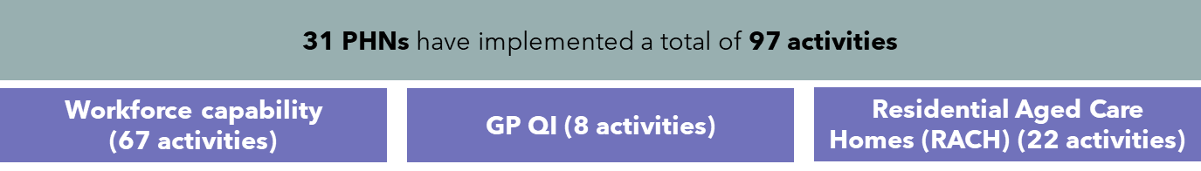

When examining activities in this category, activities conducted by PHNs tend to rely on the following approaches, regardless of sub-category.

* **Education and awareness events:** A large majority of activities conducted by PHNs involve the delivery in person and/or virtual education and training events or sessions. These activities are often delivered in partnership with other organisations.
* **Development of resources and toolkits:** Many activities focused on creating educational resources such as toolkits, frameworks, and modules for GPs, practice nurses, and the RACH workforce to support their daily practice.
* **Communities of Practice, connecting with experts, and QI champions:** Other activities focus on establishing groups for ongoing sharing of ideas, resources, and knowledge to foster continuous improvement, and to link non-specialist healthcare professionals with experts to empower them in delivering best practice care and facilitating collaboration across sectors.

Activities in this category are showing early signs of impacts and outcomes for communities. Workforce response to these activities when surveyed was strongly positive (89%). Findings also indicate that these activities not only enhance individual confidence but also equip workforce members with essential skills and knowledge. This makes them better prepared to address the needs of palliative patients, an outcome which aligns to the overarching goals of the Program.

When implementing their activities, most PHNs partner with third party organisations, suggesting PHNs seek to leverage the expertise of third parties and their networks to achieve the goals of their activities and enhance impact and reach, this also leads to better coordination and integration.

## Workforce Education and Awareness activities at Midpoint

Table 3 below provides a breakdown of activities within each sub-category by rurality, pilot vs. non pilot and jurisdiction. Within this category, Workforce Capability is the most likely sub-category to be implemented, making up more than two-thirds of all PHN activities. GP Quality Improvement activities are the least likely to be implemented, in this case by only 8 PHNs.

Table 3: Workforce Education and Awareness activities, by sub-category and PHN characteristics

|  | 31 PHNs | | | | | | | |
| --- | --- | --- | --- | --- | --- | --- | --- | --- |
|  | Workforce Capability  (67 activities) | | RACH  (22 Activities) | | | GP QI  (8 activities) | | |
| Rurality | # PHNs | # Activities | | # PHNs | # Activities | | # PHNs | # Activities |
| Metro PHNs (14 total) | 14 | 33 | | 9 | 11 | | 4 | 4 |
| Rural PHNs (17 total) | 17 | 34 | | 7 | 11 | | 4 | 4 |
| Pilot status |  |  | |  |  | |  |  |
| Pilot PHNs (13 total) | 14 | 23 | | 7 | 9 | | 3 | 3 |
| Non-pilot PHNs (18 total) | 17 | 44 | | 9 | 13 | | 5 | 5 |
| Jurisdiction |  |  | |  |  | |  |  |
| ACT (1 total) | 1 | 5 | | 1 | 1 | | 1 | 1 |
| NSW (10 total) | 10 | 26 | | 6 | 11 | | 1 | 1 |
| NT (1 total) | 1 | 2 | | 1 | 1 | | 0 | 0 |
| QLD (7 total) | 7 | 17 | | 4 | 4 | | 0 | 0 |
| SA (2 total) | 2 | 3 | | 1 | 2 | | 1 | 1 |
| TAS (1 total) | 1 | 1 | | 1 | 1 | | 1 | 1 |
| VIC (6 total) | 6 | 12 | | 2 | 2 | | 4 | 4 |
| WA (3 total) | 3 | 1 | | 0 | 0 | | 0 | 0 |

The following data sources have been used to monitor and track impact and outcomes for PHN activities in this category.

* PHN consultations.
* Post-event survey data.
* Death Literacy Index (DLI) data.
* Other PHN documentation.

PHN activities under the GCfAHPC Program are funded to meet the needs of their regions, which should be documented in artefacts produced by each PHN, including Health Needs Assessments and Healthy Ageing Strategies. Broadly speaking, PHN activities in this category align with priorities identified in their respective Health Needs Assessments and Healthy Ageing Strategies (where these have been published). Appendix B provides further insight on the alignment of PHN activities and their requirement to meet the needs of their communities, as identified by the PHNs.

### Workforce Capability activities

All 31 PHNs have implemented activities designed to boost workforce capability. Central Queensland, Wide Bay Sunshine Coast PHN is the only PHN to not be actively implementing an activity at Midpoint, having completed their education and awareness activities at Baseline.

Examples of Workforce Capability activities include:

* Healthy North Coast PHN (NSW) developed five pre-recorded webinars specifically for primary care providers with regional Subject Matter Experts highlighting localised information and referral pathways. These webinars form part of a suite of educational resources available on the PHN’s website that aims to build service provider capability. Topics include Advance Care Planning; supporting an expected death at home; care, grief and bereavement; chronic conditions and palliative care; and Carers NSW’s Supporting Carers program.
* Northern Sydney PHN ran multiple education and training events for the palliative care workforce including a Palliative Care Week Community and Health Forum for palliative and end of life care providers to come together, network, share knowledge and learn from speakers. Key topics included Compassionate Communities, Advance Care Planning, Allied Health in Palliative Care, HELP App, and Digital Storytelling. Webinars were also hosted on the HELP App for the workforce and volunteers. All the attendees (n=28) at the volunteer webinar strongly agreed or agreed that the training events helped them learn more about practical and social support for people and feel more confident offering the HELP app to families and loved ones.
* Adelaide PHN worked on implementing Project ECHO (Extension for Community Healthcare Outcomes), an evidence-based model which places healthcare providers from diverse settings in direct contact with subject matter experts, through a series of virtual mentoring sessions or webinars, supporting them to provide best practice care for their local communities. The project is delivered in partnership with SA Postgraduate Medical Education Association. There has been positive stakeholder feedback about the program with 164 people enrolled, including 31 GP’s, 18 junior doctors, 78 nurses and 37 allied health workers. Of those enrolled, 86 are from metropolitan areas and 78 from rural or remote areas.
* Country South Australia PHN facilitated interactive 60-minute online Continuing Professional Development modules on syringe drivers, and prescribing opioids, to increase confidence among GPs and the health workforce. Course outcomes were very positive, with over 90% of respondents indicating the course had ‘entirely met’ outcomes such as understanding how to use syringe drivers, recognise signs that indicate when a patient is approaching the terminal phase of life, and plan, prepare and organise of end-of-life-care in the home setting’.

### Residential Aged Care Home activities

Examples of activities being carried out in this sub-category include:

* Adelaide PHN provided palliative care training and education to health care providers in the aged care community sector, with a particular focus on identifying early indicators of deteriorating health. Sessions have been well received with three face-to-face training days for Home Care Workers (16 attendees) and two face-to-face training days for Enrolled Nurses (33 attendees). Attendees recorded DLI scores averaging 7.9 compared to the national average of 4.7.
* Healthy North Coast PHN (NSW) hosted RACH cross-sector meetings to promote awareness and connect RACH staff with palliative care resources, information and education opportunities. Partners include Local Health Districts, NSW Ambulance Service, participating RACHs, palliative care specialists and national palliative care projects such as PEPA, PACOP, ELDAC etc.
* Primary Health Tasmania employed a project officer to deliver education and training on palliative care and EOLC including ACP and end of life decision making for workforces in RACHs. Partnering with Palliative Care Tasmania, the activity has seen positive outcomes as the target number of statewide facilitated learning sessions (80) was exceeded by 68% (134 sessions total). So far there have been 791 participants across all events with PHT receiving positive anecdotal feedback from event participants.

### GP Quality Improvement activities

Eight PHNs are engaged in quality improvement (QI) activities, for example:

* Western Victoria, Murray and Gippsland PHNs have collaborated on a pilot Palliative Care Quality Improvement Toolkit in general practices to assess and improve care via timely identification and management of people eligible for palliative care. Eighteen general practices from the three PHN regions participated in the pilot.

Phase 1, the development of the QI toolkit, was completed and rolled out to participating general practices in late 2023. Phase 2 was a 12-month Toolkit pilot scheduled to end in November 2024. Lunch and learn sessions were offered monthly to participating practices. Practices have started submitting results with focus areas being Advance Care Planning (ACP), improving palliative care knowledge for both clinical and non-clinical staff, and reviewing palliative care processes within the practice. Many practices have also completed foundational PEPA education and training as part of the pilot. Phase 3 commenced in September 2024 and will see the three PHNs evaluate data collected from participating practices. Workforce shortages from participating practices has been reported as a barrier to implementation and data collection. Other identified barrier is the lack of a specific MBS item number for palliative care provision.

* Capital Health Network PHN (ACT) ran a pilot ACT Breathlessness Intervention Service (ABIS) for physiotherapist and nurse-delivered home visits to patients suffering persistent breathlessness due to chronic disease. Interventions are non-pharmacological and aimed at both patients and carers. The pilot concluded in December 2024. Up to July 2024, a total of 134 patients were referred to ABIS. Of the 115 patients who received at least one home visit, 27 reported thinking about calling an ambulance, on a total of 44 occasions, but self-managed instead. 100% of patients recorded improvement on at least one outcome measure.

## Analysis of Workforce Education and Awareness activities at Midpoint

During workforce education and awareness activities, PHNs collected feedback from service providers to assess their impact. Where data is available, early indications suggest the outcomes and impacts are positive. Out of 2,691 responses 89% were positive, 8% neutral, and 3% negative.

Figure 10: Workforce response to PHN activities (n=2,691)

Two key potential outcomes and impacts have been identified from the available data:

1. A positive impact on workforce knowledge, skills, confidence and intention to change practice.
2. A positive impact on how workforce understands and interacts with ACP.

### Impact of GP Quality Improvement activities on workforce knowledge, skills, confidence and intention to change practice

In all three sub-categories activities are reported to have led to positive outcomes. Regardless of the content or format of these activities, available data suggests that the workforce benefits from these activities, leading to enhanced knowledge, skills, and confidence.

A key measure of this outcome, particularly in terms of increased knowledge, is DLI data which shows notably higher death literacy scores compared to the national average. For instance, after a Palliative and End-of-Life Care Workforce Symposium, Hunter New England Central Coast PHN recorded an average DLI score of 7.5 (from 39 responses), significantly above the national average of 4.7. Similarly, Adelaide PHN, which is providing palliative care training for healthcare providers in the aged care sector, reported an average score of 7.9.

It is important to note that death literacy is influenced by a variety of factors. This makes it difficult to attribute higher or increased scores solely to specific events or activities run by PHNs.

Enhanced knowledge, skills and confidence will empower healthcare providers to better support patients and their families in managing symptoms and maintaining dignity throughout the end-of-life process. With greater expertise, the workforce is better equipped to provide care at home and in the community, improving the quality of life for patients and family members, and with the potential to reduce unnecessary hospitalisations and healthcare costs.

### Impact of GP Quality Improvement activities on ACP

Data from PHNs implementing activities relating to Advance Care Planning indicates potential positive outcomes. GPs report:

* A deeper understanding of ACP.
* Improved skills in identifying opportunities and triggers for ACP discussions.
* Increased confidence in assisting individuals to access ACP information.

As more health professionals gain confidence in discussing and applying ACP in their practices, there is potential to reduce unnecessary medical interventions and hospital admissions.[15] This can relieve pressure on the healthcare system and allows for resources to be allocated more effectively. For instance, Western Victoria PHN is offering education and training sessions for GPs, practice nurses, registered nurses, community nurses, and specialist palliative care nurses focused on "Introduction to ACP for Health Professionals." This activity is ongoing, with several sessions scheduled for late 2024 due to encouraging results from the initial sessions. All 15 survey respondents reported an enhanced ability to recognise opportunities or triggers during routine care (with learning outcomes either fully or partially met) and a boost in confidence when assisting individuals in accessing ACP information.

In addition, 87% of workforce respondents indicated they would change their behaviours in their practice because of the course (Figure 11). This changed behaviour has the potential to empower patients and their families by fostering a more patient-centred approach, better supporting individuals to receive care aligned with their values and preferences, even when they can no longer actively make decisions. PHNs equipping practitioners with skills, knowledge and confidence around ACP may lead to increased death literacy over time and a shift toward proactive decision-making in palliative care settings.

Figure 11: Post-event survey responses following WVPHN CPD activity (n=15)

4

Midpoint Evaluation Report

Key findings: Awareness in the Community

# Key findings: Awareness in the Community

## Summary of findings

This chapter examines Awareness in the Community activities conducted by PHNs, their status at Midpoint and overall outcomes and impact. Activities to promote awareness in the community are, or have, been undertaken by 26 PHNs across a total of 60 activities. These activities include:

* Carer education events.
* Community awareness events such as Death Cafes or film screenings, with discussion panels.
* Development of palliative care resources.
* Face-to-face and virtual workshops for the community.
* Establishment of death literacy working groups.
* Hosting Compassionate Community events.

To deliver these activities PHNs have collaborated with partners, such as peak bodies, local NGOs, and health services. Rural and metropolitan PHNs are equally represented in implementing these activities.

Analysis suggests PHNs have contributed to increased community awareness and engagement with palliative care, as evident by increased death literacy scores, Advanced Care Planning (and Statement of Choices in Queensland) and the positive feedback received on events hosted by PHNs (Figure 12).

Figure 12: Potential insights arising from awareness in the community activities

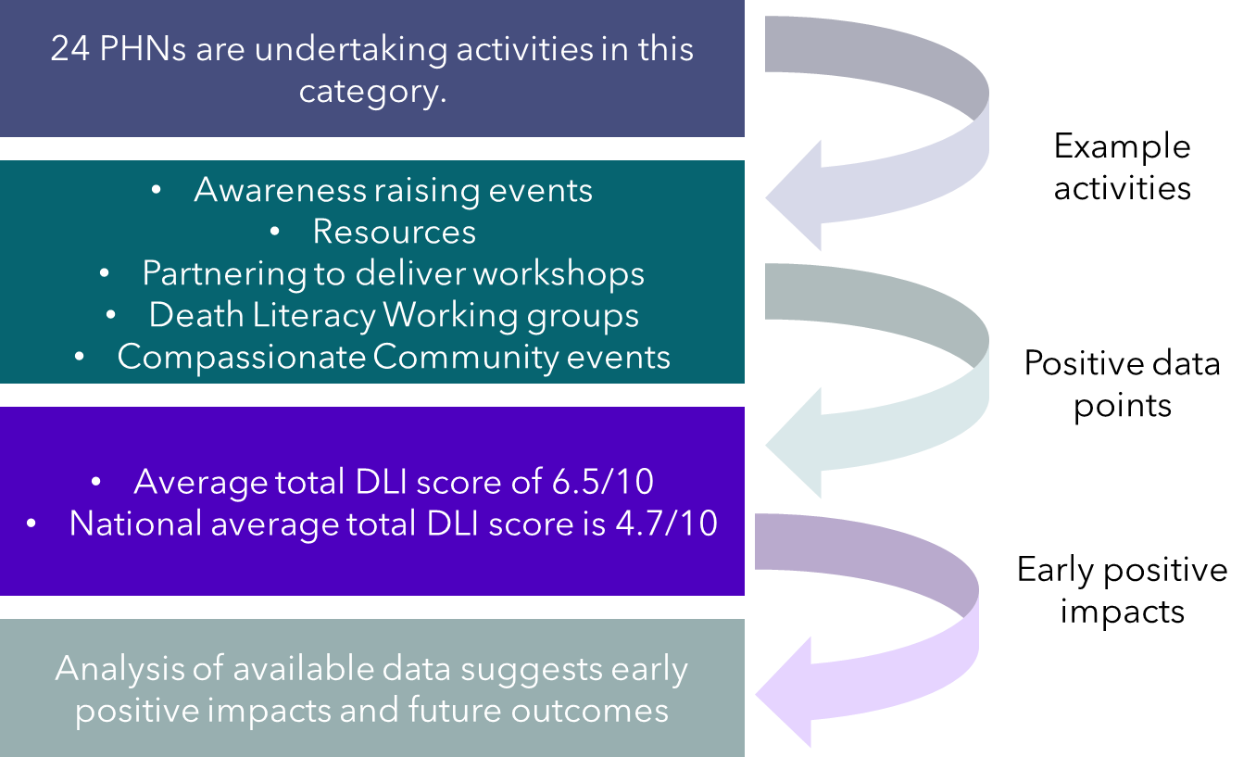

## Awareness in the Community activities at Midpoint

Sixteen activities were completed by Midpoint with 42 continuing. Most PHNs have engaged partner organisations to support these activities.[16] This suggests PHNs look to the experience and networks of partner organisations to help extend their reach. Qualitative feedback from PHNs reinforces this narrative. Several PHNs delivering focus groups and workshops indicated that they viewed their role as being the “glue” between service providers and industry bodies, building capacity to effectively provide services to patients.

Partners for community awareness activities include:

* Peak bodies.
* Non-Government Organisations.
* Local government and local public health catchments.
* Community service providers (e.g. bereavement councillors).
* Local Health Districts/Local Health Networks (including RACHs).

Table 4 below provides an overview of activities by rurality, pilot vs. non pilot and jurisdiction.

Table 4: Awareness in the Community activities

|  | Awareness in the Community | |
| --- | --- | --- |
| Rurality | # PHNs (31 total) | # Activities (60 total) |
| Metro PHNs (14 total) | 10 | 23 |
| Rural PHNs (17 total) | 16 | 37 |
| Pilot status |  |  |
| Pilot PHNs (13 total) | 11 | 21 |
| Non-pilot PHNs (18 total) | 15 | 39 |
| Jurisdiction |  |  |
| NSW (10 total) | 10 | 37 |
| QLD (7 total) | 6 | 9 |
| SA (2 total) | 2 | 4 |
| TAS (1 total) | 1 | 1 |
| VIC (6 total) | 4 | 7 |
| WA (3 total) | 3 | 2 |

There are no discernible differences across jurisdictions, or between rural and metro PHNs or pilot and non-pilot PHNs, which suggests the need for community education is universally recognised as important, regardless of PHN characteristics. Based on the number of PHNs reporting activities in this category, more data was anticipated of PHNs than was provided. However, it is important to note that the nature of awareness in the community activities, including large-scale events with many attendees makes the administrative burden of collecting meaningful data difficult.

Activities in this category broadly align with the priorities identified in key documents such as the Health Needs Assessments and Healthy Ageing Strategies (Appendix B: PHN activity alignment to Health Needs Assessments and Healthy Ageing Strategies). Several PHNs have identified expanded awareness and access to palliative care services and supports as key priorities for their communities The following section describes some of the activities PHNs have undertaken to meet these priorities.

### Examples of Awareness in the Community activities

Examples of PHN activities to build community awareness of palliative care, and the services, supports and activities available to them include:

* Community Awareness events: designed to increase death literacy and improve linkages between the community, local services and resources. Examples of events include screening of the film ‘Live the Life you Please’ with guest speaker panel discussions, facilitating Death Café events and Dying to Know events.
* At Baseline, Healthy North Coast PHN (NSW) developed a consumer Dementia Booklet which includes information on local services and clinics that focus on dementia. The booklet was updated at Midpoint to include palliative and end-of-life care considerations and Advance Care Planning (ACP) embedded in the comprehensive, localised resource. More than 5,500 copies have been distributed and the PHN receives regular requests for additional stock.
* Development of community palliative care resources: providing information on what palliative care is, how it can be accessed, where it is provided, and different services available to the community. These resources commonly include information on ACP and take the form of webpages or printed booklets and YouTube videos.
* WA Primary Health Alliance consulted with its CALD and LGBTQIA+ references groups to develop a hard copy and online booklet targeting community members at the end of life and to help their carers support them. The booklets were launched in February 2024 and since then 5,000 copies have been distributed to households and health services.
* Partnering with organisations to deliver face-to-face and virtual workshops: such as Last Aid Days carer’s workshops or the Dignified Decisions project that builds capacity in the community to support people at the end of life. Some workshops target populations, such as those caring for people living with dementia, to support them to live well for longer in their own communities. For example:
  + Since Baseline Murray PHN have worked with Dementia Australia to deliver four sessions in a series of free community events on dementia (as a life limiting illness), and grief and loss.
  + Primary Health Tasmania worked with Family Planning Tasmania and Carers Tasmania to fund community centres to raise awareness of palliative care and improve death literacy. At Midpoint a second round of grants had been issued targeting education providers offering courses on sexual relations, intimacy, and relationships within a palliative care environment/phase. The course aims to build confidence and capability for people at the end of life.
  + Coordinare (South Eastern NSW PHN) commissioned HammondCare to deliver the Last Days Foundation Workshop on palliative care to consumers and the community. Six workshops have been hosted, with more than 80 attendees. Despite being run as a community awareness activity, some events had more health professionals attend than community (Figure 13).

Figure 13: Outcomes of Coordinare Last Days Foundation workshop

NB: Despite being run as a community awareness activity, some events were attended mostly by health professionals.

* Death Literacy Working groups, for example Adelaide PHN established a Death Literacy Working group to improve the community’s death literacy and identify barriers to decision making regarding end-of-life care. As of September 2024, the Working Group had 15 stakeholders, had met 4 times and developed Terms of Reference. Three subgroups were established to address issues relating to ACP, death literacy, and RACHs.
* Hosting Compassionate Communities events that aim to build community capacity to provide wraparound informal support to a person at the end of life wishing to palliate at home.
* Country South Australia (PHN) continued the ‘Nurturing Compassionate Communities in Country SA’ project utilising the DLI to monitor change in community knowledge. The project will deliver over 60 face-to-face and/or virtual sessions and include: PalliLEARN, Last Aid, Health Professional Hot Topic webinars, Palliative Care Round Table sessions with key stakeholders, a palliative care survey, and publication of Palliative Care Plans for each Local (public) Health Network. Nine workshops were held from November 2023 to January 2024, with 141 participants. 100% of respondents (47 total) said the course had improved their understanding of palliative care. 100% of respondents also said they were confident they could find information and services relating to the end stage of life.
* North Queensland (PHN) ran ‘Train the Trainer’ workshops in 14 communities to build capacity and capability in establishing a wraparound informal support to a person at end of life who wishes to palliate at home. Since February 2024, over 380 “community connectors” have been trained, and the PHN ‘Compassionate Community Connectors’ networks meet monthly. This forms part of a broader plan to build a compassionate community movement in Northern Queensland[17].

The Compassionate Communities framework was viewed inconsistently among PHNs. Some PHNs reported they were undertaking activities to nurture Compassionate Communities. In the Awareness in the Community focus group, one PHN said the lack of service providers available to deliver Compassionate Communities was the key reason behind their pursuit of these activities. In turn, this led to a reliance on engaged community members to progress activities, or engaging with third party organisations such as Proveda to increase community engagement. However, other PHNs expressed the view that other bodies such as peak organisations and local councils are better suited to implement Compassionate Communities, and that PHNs should focus on being the “glue” between the local community and service providers.

In terms of challenges to implementing these activities, several PHNs said that some community members struggled to engage with what was seen by some as distressing content because of stigma and societal views around death and dying and differing needs for bereavement support. When this occurred, PHNs said they gave the community member the option of sitting out, withdrawing from, or taking a break from the activity.

## Analysis of Awareness in the Community activities

Data captured in this category includes responses to PHN-issued post-event surveys, responses to Death Literacy Index (DLI) surveys held after PHN events and activities, and data from the Office of Advance Care Planning (OACP), which applies only to PHNs in Queensland. Data collection was not always appropriate at community activities due to the emotional nature of real-life events being experienced by attendees.

Feedback on PHN activities looking to raise awareness in the community was overwhelmingly positive (95%), as per Figure 14 below.

Figure 14: Responses to awareness in the community activities

### Death Literacy Index Data

Of the 24 PHNs implementing community awareness activities, 10 provided DLI data that could be clearly ascribed to the Program’s activities as evidence of impact (390 responses total). Brisbane North PHN provided data measuring death literacy both before and after an event. Some key insights include:

* Rural PHNs returned an average DLI score of 6.53 out of 10, versus 6.35 out of 10 for metro PHNs
* Pilot PHNs averaged 6.47 out of 10, while non-pilot PHNs returned an average score of 6.52 out of 10.

Given the national average DLI score is 4.7 out of 10, these scores suggest a positive impact on event participants.

Figure 15: National average total DLI score vs responses to PHN activities

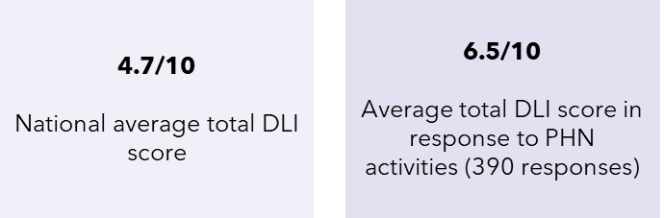

The DLI provides a useful quantitative measure of a population’s death literacy and is the only validated tool used nationally for this purpose. DLI data provided by PHNs indicates greater levels of death literacy compared with the national average (Figure 16Figure 16). However, this finding should be considered carefully given the lack of pre and post-event DLI data (with the exception of Brisbane North PHN). In addition, the low response rate could mean the data provided is not representative of the broader groups of community members attending these events.

Figure 16: Average total DLI scores submitted by PHNs versus national average total DLI score

### Office of Advance Care Planning data

Data collected by the Queensland OACP tracks the number of Advance Care Plans submitted annually across Queensland, including by PHN region. This data provides a count of preferred place of death, and the number of complete and incomplete ACPs submitted annually.

The following three graphs show changes that align with some of the intended outcomes of the GCfAHPC Program. These include higher levels of ACP completion and ultimately, more people dying at home. While these figures should be considered in the context of their limitation to Queensland, small population and sample sizes, and difficulty attributing causality to PHN activities, they suggest some early indicators of impact from PHN activities.

Figure 17 shows the percentage change in completed ACPs in Queensland from 2021/22 to 2023/24. Except for Darling Downs and West Moreton PHN (DDWMPHN), each PHN region has seen an increase in the percentage of completed ACPs.

Figure 17: Percentage of completed ACPs (2021/22-2023/24)

Note: Brisbane North PHN, BNPHN; Brisbane South PHN, BSPHN; Central QLD, Wide Bay, Sunshine Coast PHN, CCQPHN, Darling Downs, West Moreton PHN, DDWMPHN, Gold Coast PHN, GCPHN, Northern QLD PHN, NQPHN, Western QLD PHN, WQPHN

5

Midpoint Evaluation Report

Key findings: Palliative Care Medicines

# Key findings: Palliative Care Medicines

## Summary of findings

This chapter examines Palliative Care Medicines activities conducted by PHNs, their status at Midpoint and overall outcomes and impact of these activities. At Baseline this category was grouped with priority populations under the larger ‘Needs and Preferences’ category. Given the distinct nature of their activities, the palliative care medicines and priority populations have been separated into two categories at Midpoint. Activities in this category focus on:

* Improving the availability of palliative care core medicines.
* Enhancing the capacity and capability of community pharmacists to support safe, quality palliative care at home.
* Working with RACHs to implement the IMPREST system.

Seven PHNs were progressing palliative care medicine activities, often working together or working with partner organisations such as the Pharmaceutical Society of Australia (PSA). Indicators suggest that PHN activities have enhanced access to palliative care medicines. Positive impacts are evidenced by increased engagement with interactive maps of pharmacies stocking core medicines and increases in commitments from more pharmacies to stock the medicines, as well as positive community feedback (Figure 18).

Figure 18: Insights arising from palliative care medicine activities

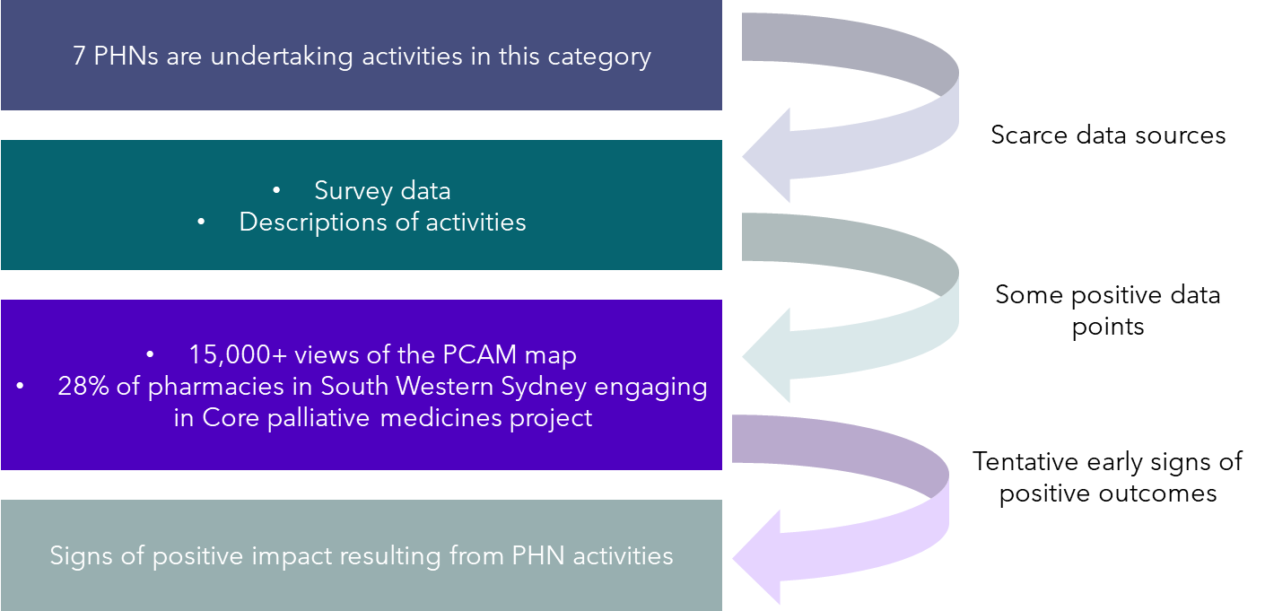

## Palliative Care Medicine activities at Midpoint

Five of the PHNs working in this category are partnering with the PSA. Due to influence, resources, and importantly, its contacts with community pharmacies across each PHN region, PSA is a critical stakeholder for PHNs to work with.

It is worth noting that work designed to enhance community access to palliative care medicines aligns with a broader national movement to establish a National Core Community Palliative Care Medicines List. Since PHNs began activities in this category, the new National List has been agreed, identifying four medicines for use by home-based palliative patients in the terminal phase who require urgent symptom relief.

Table 6: Palliative Care Medicine activities, by PHN characteristics

|  | Palliative Care Medicine | |
| --- | --- | --- |
| Rurality | # PHNs (31 total) | # Activities (8 total) |
| Metro PHNs (14 total) | 4 | 4 |
| Rural PHNs (17 total) | 3 | 4 |
| Pilot status |  |  |
| Pilot PHNs (13 total) | 3 | 3 |
| Non-pilot PHNs (18 total) | 4 | 5 |
| Jurisdiction |  |  |
| NSW (10 total) | 2 | 2 |
| QLD (7 total) | 1 | 1 |
| VIC (6 total) | 4 | 5 |

The majority of PHNs in this category provided data to support analysis of their activities. Beyond individual consultations, focus groups and workshops, the main source of data was from reports on each of the specific initiatives. These reports were either developed by PHNs, or by the PSA on behalf of PHNs. They describe the process by which the Palliative Care Access to core Medicines (PCAM) Project in Melbourne or the Core palliative care medicines project in South Western Sydney evolved, and how pharmacies engaged with the projects over time.

Focus groups and workshop feedback suggested that activities in this category were viewed favourably by other PHNs and that, had there been greater visibility of these activities, then other PHNs would be interested in leveraging the knowledge and experience of PHNs currently working in this space for similar activities in their own communities.

PHNs reported that jurisdictions often have different arrangements, processes and systems in place which can impact their ability to improve access to palliative care medication, indicating a high degree of regional variability. PHNs also reported that efforts to implement or improve anticipatory prescribing are challenging for remote community pharmacies and RACHs.

With some exceptions, these activities broadly do not reflect priorities identified in Health Needs Assessments or Healthy Ageing Strategies (Appendix B: PHN activity alignment to Health Needs Assessments and Healthy Ageing Strategies). The reasons for this are unclear. However, these activities do align with the core goal of the Program to increase access to palliative care at home and in the community.

## Progress of Palliative Care Medicine activities at Midpoint

Compared to other categories, there is not much variation in the type of activities being undertaken in this category at Midpoint, or their status. Activities are primarily focused on increasing access to palliative care medicines by partnering with community pharmacies to stock medication on the Core Medicines List (CML) or to build capabilities of pharmacists to support safe palliative care in their communities. It is worth noting that some PHN activities, for example Country South Australia PHN’s facilitation of CPD modules on syringe drivers and prescribing opioids, could be grouped under more than one activity category. However, for ease of readability, activities have been placed into the ‘best fit’ category. This chapter focuses only on activities that best fit in the palliative care medicines category.

Palliative Care Access to core Medicines (PCAM) Project

North Western, Eastern, and South Eastern Melbourne PHNs have worked in partnership with the PSA on the PCAM Project which aims to:

* Increase awareness and use of the Core Medicines List (CML) with prescribers, community palliative care providers and community pharmacists.
* Increase the number of community pharmacies stocking all medicines in the CML.
* Increase awareness of anticipatory prescribing.
* Increase collaboration between general practitioners and community pharmacists for end-of-life care.
* Improve timely access to palliative care medicines for patients.

The CML was initially funded by North Western Melbourne PHN in 2021. To promote the PCAM project, the three PHNs and the PSA undertook significant engagement with community pharmacies. This included direct engagement with pharmacies across the three regions; collaboration with the PSA’s partnerships group to work with representatives from “banner groups” (i.e. organisations operating multiple retail pharmacies) to discuss the initiative with them; and education sessions on the goals of the program. Eastern Melbourne PHN provided post-event survey data from one of their education sessions, with the results indicating a good understanding of the goals and purpose of the PCAM project on the part of participating pharmacists (Figure 19).

Figure 19: To what degree were the learning outcomes of the program met (n=15)

As part of the PCAM project, an interactive map was developed to build community awareness and display pharmacies stocking core medicines. The intention is that community members and health care professionals will be able to see quickly and easily which pharmacies are stocking core palliative care medicines close to their location. As of 16 October 2024, it has been accessed more than 15,637 times by members of the community, a 241% increase in views from June 2023. Data from Eastern Melbourne PHN suggests the average engagement time per user of the map was 1 minute and 12 seconds.

As of November 2024, 305 pharmacies across Melbourne have signed up to participate in the PCAM project. This represents a more than 100% increase in participating pharmacies from December 2023. The PSA concluded in a report on the project that the PHN activities had directly contributed to increased awareness about anticipatory medicines and the importance of removing barriers to the timely treatment of palliative symptoms in a community setting. In May 2024, the PSA emailed all participating pharmacies to inform them that ongoing maintenance of the PCAM would be handed back to the three PHNs. Going forward, updates will be made to the interactive map based on any new pharmacies participating or withdrawing from the project.

### Core palliative care medicines project in South Western Sydney

Between July 2023 and June 2024, South Western Sydney PHN and the PSA worked to deliver the Core palliative care medicines: Building collaborative Relationships with Community Pharmacists project. This aimed to improve access to essential palliative care medicines for people receiving palliative care at home. A map of pharmacies stocking palliative care core medicines was developed to raise awareness of, and participation in the project, helping community and health professionals to locate pharmacies stocking palliative care medicines.

Three webinars were developed and delivered to pharmacists, GPs and community nurses from South-Western Sydney with 148 attendees across the three sessions. Attendees were surveyed after each webinar and the results recorded. In addition to clinical upskilling, 100% of pharmacists surveyed (24 total) after one session either agreed or strongly agreed that they felt confident ‘to support patients who have been diagnosed with a life-limiting illness and their family/carers’. Of GPs surveyed 100% (n = 20) said they would change something in their practice as a result of this CPD activity.

Figure 20: Pharmacist, GP and community nurse responses to question before and after SWSPHN activity

Across the project, 55 community pharmacies in South Western Sydney, representing 28% of all pharmacies in the region, signed the non-legally binding Letter of Intent to stock at least one full box of each of the medicines listed on the Core palliative care medicines list for NSW Community Pharmacy. As of 24 June 2024, the online map of pharmacies stocking palliative care medicines throughout South-Western Sydney had been viewed more than 10,066 times.

Despite these achievements, the need to update palliative care education and supporting resources to ensure they remain useful and relevant for local pharmacists is an ongoing challenge with this activity given the frequent effort and focus this requires.

### Other palliative care medicine activities being undertaken by PHNs

* Gippsland (PHN) have worked to increase the practice of anticipatory prescribing across pharmacies in their region. Anticipatory medicines are injectable or sublingual medications prescribed to a person with a life limiting illness. These medications are prescribed and dispensed in preparation for a time when a person needs them. Gippsland has been working with RACHs to implement the IMPREST system in their facilities by subsidising the cost of registration. This leads to more effective management of palliative care medications and helps to alleviate the risk of shortages by ensuring a ‘ward stock’ of palliative care medicines on site.[18]
* As of October 2024, 51 of 54 RACHs in the region have completed implementation of the IMPREST system. A further two RACHs are in the process of completing implementation. In comparison, in November 2023, only 8 RACHs had implemented IMPREST, meaning an additional 43 have completed implementation of an IMPREST system in the 11 months to October 2024.
* Healthy North Coast (NSW PHN) have worked with the PSA to encourage community pharmacists to undertake the PSA’s National Palliative Care Foundational training program. Following completion of the course, Healthy North Coast facilitates a series of activities for pharmacists to consolidate their knowledge. These activities include Program of Experience in the Palliative Approach (PEPA) workshops, currently scheduled for October 2025.
* Brisbane North (PHN) worked in close collaboration with local pharmacists to develop a Palliative Care in Community Pharmacy Action Plan. The Plan aims to increase the capacity and capability of community pharmacists in supporting safe, quality palliative care at home. As part of this, Brisbane North created a list of palliative friendly pharmacies stocking core medications. Further research identified a need; for pharmacies to stock the right medicines at the right time (i.e. anticipatory prescribing); to coordinate more closely with other local pharmacies; and for education and resources to enhance their capability.[19] As of August 2024, 42 pharmacies had committed to working as “palliative friendly pharmacies” as defined by the Community Pharmacy Action Plan, a 91% increase in the number of pharmacies since the outset of the initiative in 2022.

6

Midpoint Evaluation Report

Key findings: Priority Populations

# Key findings: Priority Populations

## Summary of findings

This chapter examines PHN activities benefiting specific priority populations and their status at Midpoint. Fourteen PHNs are, or have, implemented, a total of 23 activities at Midpoint. These include:

* Efforts directly targeted at better supporting priority populations (e.g. developing Action Plans).
* Upskilling specialist palliative care services, and primary and community care providers to enable them to provide better palliative care support to priority populations.
* Developing resources to assist priority populations with access to palliative care.
* Engaging directly with priority populations and representative organisations to raise awareness of palliative care resources and supports available to them.

Partner organisations for these activities include technology partners, local health organisations and service providers, NGOs, and interpreters. Barriers impacting PHN implementation of these activities include language and cultural differences between PHN staff and the identified priority populations, and the inaccessibility of resources for some populations (e.g. those living with visual impairments).

Assessing the outcomes and impact of PHN activities in this work category is limited by a lack of data to support the evaluation; only three PHNs provided data for analysis of outcomes and impact (Figure 21).

Figure 21: Insights arising from priority population activities

An info graphic of activates arising from priority population activities. 


## Priority Population activities at Midpoint

14 PHNs have implemented or are continuing to implement activities that target identified priority populations in their regions across a total of 23 activities (Table ).

Table shows the characteristics of PHNs that have implemented activities in this category. Rural PHNs are less likely to implement priority population activities. All PHNs implementing activities in this category are working with partner organisations. Partners range from technology organisations such as GoShare, Aboriginal Controlled Community Health Organisations (ACCHOs), NGOs working at the local, state and national levels, service providers working in the region, and language translators.

During focus groups and workshops, PHNs stressed the importance of activities being tailored to meet local needs, and particularly the needs of priority populations. PHNs emphasised that partner organisations were crucial to the successful implementation and continuation of PHN activities targeting priority populations due to their knowledge of local conditions and trusted relationships with these communities.

Table 7: Priority Population activities, by PHN characteristics

|  | | Priority Populations | |
| --- | --- | --- | --- |
| Rurality | # PHNs (31 total) | | # Activities (23 total) |
| Metro PHNs (14 total) | 9 | | 15 |
| Rural PHNs (17 total) | 7 | | 8 |
| Pilot status |  | |  |
| Pilot PHNs (13 total) | 8 | | 10 |
| Non-pilot PHNs (18 total) | 8 | | 13 |
| Jurisdiction |  | |  |
| NSW (10 total) | 5 | | 12 |
| NT (1 total) | 1 | | 1 |
| QLD (7 total) | 2 | | 2 |
| SA (2 total) | 2 | | 2 |
| VIC (6 total) | 3 | | 4 |
| WA (3 total) | 3 | | 2 |

Challenges specific to priority populations include:

* Not all palliative/end of life care concepts directly translate into other languages (e.g. there is no AUSLAN word for palliative care).
* Cultural barriers can get in the way of planned activities. For example, Northern Territory PHN said language barriers and periods of mourning following a death in the community made it difficult to coordinate events.
* Many resources specific to palliative care are inaccessible to some priority populations (e.g. people with visual impairments).

In focus groups and workshops PHNs noted the difficulty they have experienced collecting data on priority population activities. Several PHNs noted difficulties collecting data from service providers following activities targeting priority populations. Despite this observed gap, many PHNs highlighted a commitment to priority populations in their Health Needs Assessments and Healthy Ageing Strategies (Appendix B).

### Examples of priority population activities at Midpoint

PHN activities targeting identified priority populations include:

Efforts to identify opportunities to better support priority populations:

* Adelaide (PHN) recently completed a Needs Assessment, working with local service providers, to explore how to improve ACP completion for homeless and LGBTIQA+ populations. The aim is to identify needs, improve awareness and uptake of ACP within these organisations, identify obstacles, barriers and challenges relevant to these populations, and provide recommendations to address these barriers. At the time of writing, Adelaide have approached 21 service providers to progress preliminary consultations on how the recommendations of the Needs Assessment can be advanced. Ten have agreed to participate.
* Brisbane North (PHN) developed a Disability Action Plan to improve access to at home palliative care for people living with disability. This work follows the identification of major gaps in disability and palliative care understanding across the continuum of health service providers. Recent progress includes the development of a knowledge framework to help health and disability workers identify available sources of information to build their knowledge and key contacts. This component of the Action Plan was developed through a ten-month consultation process. Brisbane North have reported that the initial response from local stakeholder groups has been positive, describing the document as useful, and a step in the right direction. Most of the resources contained within this framework are available nationally, and the document does not speak to specific State legislation, meaning that it could be scaled nationally for use across all PHN regions. Furthermore, while the Brisbane North PHN resource speaks to the intersection of palliative care and people living with disabilities, additional frameworks for other priority populations could also be developed using a similar approach.

Upskilling service providers to enable them to better support priority populations:

* Coordinare (South Eastern NSW PHN) engaged facilitators to conduct cultural knowledge workshops for healthcare professionals, designed to build their cultural competence when engaging with Aboriginal and Torres Strait Islander communities. They also undertook a review of the regional health care system to identify and design solutions to make the system more safe, welcoming and appropriate for Aboriginal and Torres Strait Islander patients and their families.
* Central Eastern Sydney (PHN) are planning a series of education sessions to boost death literacy amongst CALD communities by engaging Dr Kerrie Noonan, creator of the Death Literacy Index. Dr Noonan will facilitate a series of workshops with CALD community organisations to provide death literacy education for their own communities.

Developing resources to assist priority populations:

* Country South Australia PHN (CSAPHN) are tailoring the previously developed culturally appropriate educational Aboriginal Peoples ACP, Palliative Care, and End of Life information bundles to be freely available on the digital GoShare Plus platform.

Four local South Australian Aboriginal and Torres Strait Islander community leaders have provided messaging on these subjects by way of pre-recorded video. CSAPHN funds access to the GoShare Tool for all General Practices and Aboriginal Community Controlled Health Organisations (ACHHOs). CSAPHN has been able to draw on the support of general practices and ACCHOs, but securing their commitment to install the digital GoShare plus platform has been difficult.

* South Western Sydney and Murray (PHNs) have each developed a series of resources to assist priority populations. These include ‘Journey into Sorry Business’ booklets for local Aboriginal and Torres Strait Islander communities; the translation of existing palliative care community resources into AUSLAN to improve accessibility for deaf and hard of hearing communities; ‘easy read’ documents for people with English as a second language; and the development of a dementia and palliative care directory. Murray (PHN) leveraged work undertaken by South Western Sydney (PHN) to develop a copy of the ‘Journey into Sorry Business’ that was appropriate for their own region.

Engaging directly with priority populations and representative organisations to raise awareness of resources and supports available to them:

* WA Primary Health Alliance (PHN) provided education and training to health professionals with ACHHOs on how to recognise deterioration, understand trajectories of chronic disease, what palliative care is, services and supports that are available, and the communication skills required to have conversations on ACP, in the specific context of Aboriginal and Torres Strait Islander populations.
* NTPHN (Northern Territory PHN) worked with Aboriginal and Torres Strait Islander and CALD community members to normalise the conversation around end-of-life planning and empower people to take control of their future care. NTPHN have engaged the support of priority population representative organisations to support these conversations.

## Impact of Priority Population activities at Midpoint

Of the 23 activities undertaken by PHNs relating to priority populations nine are complete at the time of writing. Of these, four were implemented by South Western Sydney (SWSPHN), which has a very diverse population (40% born outside of Australia compared to the national average of 29.5%).[20] Adelaide PHN and Coordinare also completed priority population activities at Midpoint, while Murrumbidgee, Northern Sydney and Brisbane South PHNs all completed activities targeting priority populations in their regions at Baseline.

SWSPHN developed several resources targeted at priority populations. One of these was a ‘Journey into Sorry Business’ booklet for Aboriginal and Torres Strait Islander peoples to understand preferences for death, cultural practices and protocols associated with death. The booklet was updated and released to the community in 2024. [In](https://auspwc-my.sharepoint.com/personal/jack_patfield_scyne_com_au/Documents/Desktop/Pal%20Care%20Evaluation/Midpoint/Pal%20care%20Midpoint%20data%20analysis.xlsx?web=1) the period May-September 2024 it was downloaded 81 times and viewed more than 360 times. Murray PHN reached out for permission to adapt this resource for their own region and have recently published this version.

Murrumbidgee PHN worked with HammondCare to improve carer capacity in caring for people living with dementia via a series of workshops and the development of resources such as a carer handbook and Carer Gateway Emergency Plan. In February 2024, HammondCare published a final evaluation report on the dementia capacity building program for people living with dementia. The evaluation relied on post-workshop assessments and participant interviews to make a series of conclusions, including that there were no observable changes to carer stress levels, but an increase in carer confidence accessing support services, as well as increased confidence recognising signs of acute change or deterioration.

Finally, Brisbane South provided a report outlining their activities to upskill the interpreter workforce in palliative care settings. After face-to-face training and facilitated discussions, and onsite visits to palliative care settings, participants were surveyed (some virtual training was provided for participants who could not travel to attend). Their feedback indicated very positive outcomes, including a significant improvement in the understanding of palliative care and its aims (92% increase), and improved confidence interpreting palliative care settings and a willingness to take this new knowledge and apply it to palliative care assignments (87% increase).

7

Midpoint Evaluation Report

Key findings: Coordination and Integration

# Key findings: Coordination and Integration

## Summary of findings

The focus of this chapter is on PHN activities that look to improve palliative care access, coordination and integration of services and sectors. Coordination and Integration activities can be divided into the service mapping and pathways and models of shared care sub-categories.

Within this category, 40 activities are being undertaken by a total of 21 PHNs (16 are implementing service mapping and pathway activities, and 8 are implementing models of shared care activities). PHN activities for the service mapping and pathways sub-category included:

* Updating HealthPathways so GPs can better identify services that would benefit palliative patients.
* Developing a local directory for the community of key service providers.
* Developing new models of care to improve and better coordinate palliative care services.
* Developing decision support tools to help health professionals appropriately refer patients.
* Multidisciplinary approaches to help health professionals develop partnerships to optimise systems, processes and outcomes for palliative care patients.

For models of shared care, activities included:

* Networking and programs to bring service providers together to better care for palliative and end-of-life patients and enabling a multidisciplinary approach.
* Reviewing models of care.
* Technological initiatives to support integration and coordination between service providers.

Figure 22: Status of Coordination and Integration activities at Midpoint

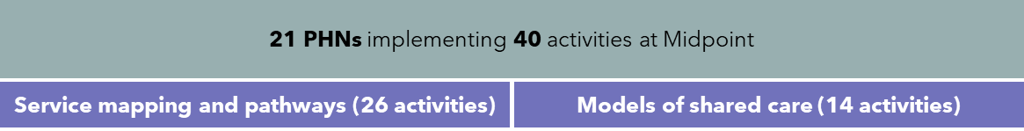

* HealthPathways data is a key source PHNs can provide to help assess the impact of their activities in the Coordination and Integration category (Figure 23). At Midpoint, six PHNs provided HealthPathways data in a format conducive to assessment of changing workforce behaviours. Even so, this data only serves as a proxy for the intention of health service providers to change their behaviour.

Figure 23: Insights arising from coordination and integration activities

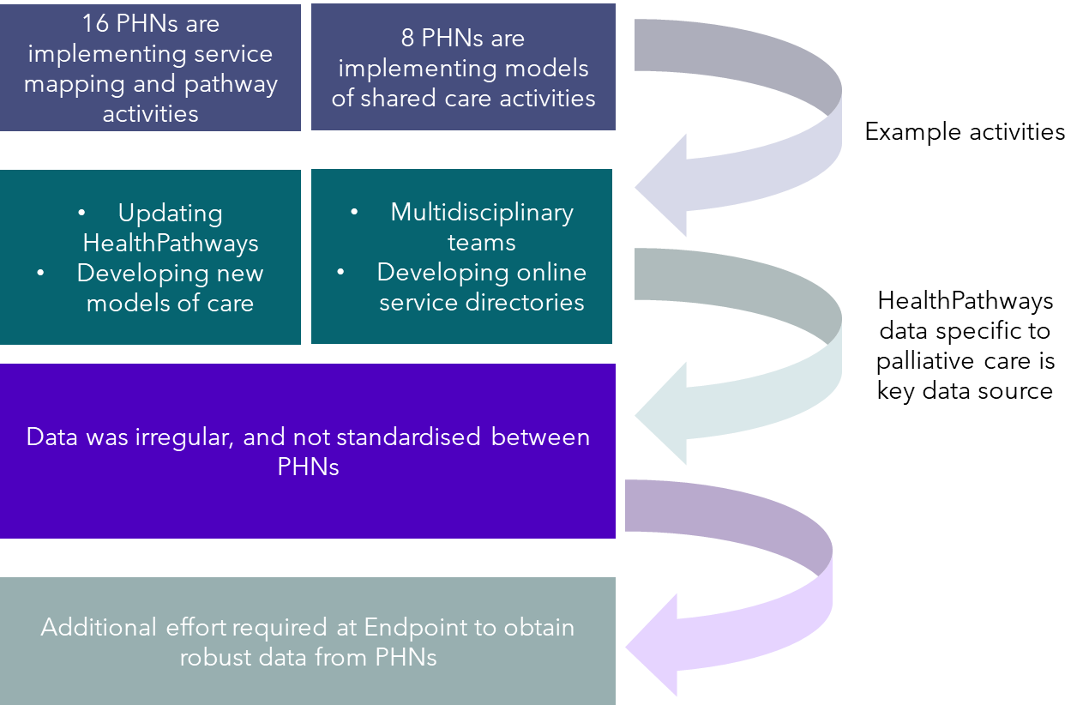

## Coordination and Integration activities at Midpoint

Activities in the Coordination and Integration category look to improve palliative care access, coordination and navigation in their regions. Two sub-categories sit beneath this:

* Service mapping and pathways: Supports service navigation and updated pathways of referral in their regions. This has been noted by PHNs as a key issue, due to the complexity and difficulty navigating the palliative care service system.
* Models of shared care: Supports integration and coordination between different service providers.

Sixteen PHNs are implementing activities in the service mapping and pathways sub-category and 8 in the models of shared care sub-category (Table 8).

Based on analysis of PHNs implementing coordination and integration activities, non-pilot PHNs are much more likely to be implementing service mapping and pathway activities.

Table 8: Coordination and Integration activities, by PHN characteristic, by sub-category

|  |  |  |
| --- | --- | --- |
|  | Service mapping and pathways | Models of shared care |

| Rurality | # PHNs (31 total) | # Activities (26 total) | # PHNs (31 total) | # Activities (14 total) |
| --- | --- | --- | --- | --- |
| Metro PHNs (14 total) | 5 | 7 | 3 | 3 |
| Rural PHNs (17 total) | 11 | 19 | 5 | 11 |
| Pilot status |  |  |  |  |
| Pilot PHNs (13 total) | 4 | 6 | 3 | 6 |
| Non-pilot PHNs (18 total) | 12 | 20 | 5 | 8 |
| Jurisdiction |  |  |  |  |
| ACT (1 total) | 1 | 1 | 1 | 1 |
| NSW (10 total) | 8 | 13 | 3 | 4 |
| NT (1 total) | 1 | 1 | 0 | 0 |
| QLD (7 total) | 3 | 7 | 2 | 4 |
| SA (2 total) | 0 | 0 | 1 | 4 |
| VIC (6 total) | 3 | 4 | 1 | 1 |

Almost all PHNs worked with a partner organisation to implement coordination and integration activities. Partners varied by activity, but tended to be:

* Health service providers, including GPs, nurses and allied health, as well as hospitals and LHDs.
* Peak bodies and consumer groups.
* RACHs.
* Local NGOs.
* Aboriginal and Torres Strait Islander and CALD community groups or organisations.
* Other service providers, such as web designers.

Broadly speaking, these activities align with priorities identified by PHNs in their respective Health Needs Assessments and Healthy Ageing Strategies (Appendix B).

### Service mapping and pathways activities at Midpoint

PHN activities for this sub-category fall into one of the following themed areas:

#### Updating HealthPathways

11 PHNs have updated HealthPathways data so GPs are better able to identify services that would benefit palliative patients.[21] Often these updates are informed by meetings of different reference groups to ensure any updates include the most accurate and up to date information.[22] The nature of updates varies by PHN. Among other changes, examples include updates to dementia and cognitive impairment pathways, tailored pathways specific to CALD or Aboriginal and Torres Strait Islander communities, and Advance Personal Planning in the Northern Territory.

#### Service mapping

* Darling Downs West Moreton (PHN) have developed a local directory for the community of key service providers, after hours contacts and other contacts for palliative care professionals to access to help improve care coordination. A website is currently being developed to improve access to this resource.

#### Development of new models of care

* Hunter New England Central Coast (PHN) led the development, commissioning and implementation of a new end-of-life-care coordination model for primary care. The service is designed to assist people aged over 55 years with limited financial or family support to effectively coordinate their EOLC and documentation, improve their death literacy, and manage referrals to the relevant palliative care professionals. Baptist Care is currently trialling use of the new model to enable people to undertake EOLC planning. The pilot will operate from April 2024 to June 2025, with the University of Newcastle having been commissioned to conduct a program evaluation.
* Healthy North Coast (NSW) were developing new models of care to improve palliative care services in RACHs. The intention is to join care services so that residents receive the right care, at the right time, in the right place. Key enablers of the model will include Advance Care Planning, anticipatory planning, recognising deterioration and the provision of high-quality, person-centred palliative and end-of-life care by RACHs. Co-design workshops will be used to develop the model of care. An education solution provider and change consultant have been engaged to implement a change framework. Healthy North Coast cited ‘huge appetite’ among local service providers for this activity.

#### Developing decision support tools

* Gippsland (PHN) were developing a decision support tool to provide clear criterion to health professionals to appropriately refer patients to community and/or specialist palliative care. This will include scoping existing issues surrounding the development of triage tools and meeting education needs in RACHs for the criterion to work effectively. Since Baseline progress has been made to develop an embedded template in practice software.

#### Multi-Disciplinary Approaches:

* Murrumbidgee (PHN) were funding a general practice to host monthly palliative care multi-disciplinary team meetings. The meetings aim to ensure that all health professionals who care for patients can discuss aspects of a patient’s physical and supportive care needs, divide roles and responsibilities, and collaboratively plan appropriate care.
* Darling Downs West Moreton (PHN) established a Care at the End of Life Collaborative (CAEOLC) to develop partnerships across government and non-government services to optimise systems, processes and outcomes for people living with life limiting illnesses. CAEOLC has set a series of targets in pursuit of this overarching goal, including the co-design of shared care pathways for people approaching the end of life. CAEOLC began meeting in mid-2022, meeting bi-monthly since then. At Midpoint they have developed four journey maps for patients.

### Models of shared care activities at Midpoint

PHN activities in this sub-category generally fell into one of the following themed areas:

#### Programs to improve care between settings

Three PHNs are undertaking pilot programs to bring health service providers together to better care for palliative and EOLC patients.

* Country South Australia PHN (CSAPHN) were working with SA Health to develop and implement the SA Health Palliative Care Navigation Pilot, to better connect terminally ill patients with local palliative care services, supports and information. The pilot for this service launched in February 2024.
* Western NSW (PHN) continued with a “Yellow Envelopes” pilot, which looks to ensure a warm transfer process for patients, including all relevant case information, between RACHs and hospital via Ambulance or Patient Transfer services. (“Yellow Envelopes” refers to the envelope that contains relevant patient information). At Midpoint the initiative continues to be challenged by workforce capacity issues.
* Central Queensland, Wide Bay, Sunshine Coast PHN (CCQPHN) were running a hospice capacity building project to integrate 5 hospices with specialist palliative care services, align capability building domains, develop community linkages and improve relationships.

#### Shared care

* Brisbane South PHN (BSPHN) were implementing a shared care model for home-based palliative care between GPs and specialist palliative care services and patients. This includes coordination and navigation support, access to resources, mentoring for GPs and patients, and capability building sessions and workshops for GPs. BSPHN are currently assessing outcomes of the shared care model. At Midpoint, 13 patients have been enrolled into the program. Eight new ACP conversations have been initiated with patients who did not previously have an ACP in place.

#### Models of shared care technological initiatives

Two PHNs have investigated implementing technological solutions to support integration and coordination between different service providers.

* South Eastern Melbourne PHN looked to build an interoperability function to enable GPs to use Palliative Care Software to e-refer patients requiring palliative care from GP medical record systems to palliative care services. This activity was paused due to limited capacity from the service provider (an IT vendor).
* Country SA (PHN) investigated implementing an Integrated Shared Care Planning Platform (INCA) web portal in aged care services which would put the patient at the centre of care, connecting healthcare teams to better manage chronic disease and help keep people well and out of hospital. The portal allows GPs to create patient-centred, Medicare-compliant General Practitioner Management Plans (GPMP), Team Care Arrangements (TCAs) and conveniently shares these with other healthcare providers using a secure referral system. This activity has been ceased due to difficulty engaging GPs in the initiative.

#### Model of care reviews

* South Eastern NSW PHN (Coordinare) were reviewing their palliative and end of life stepped care model. This model features key levels of patient care needs relating to a spectrum of services and interventions, using a multidisciplinary care composition. Coordinare report that project activities often attract only those with an interest in palliative care, aged care and the end of life. The new model of care is expected to be launched in October 2024.

#### Networking initiatives

All PHNs have been working to bring health professionals together to raise awareness of different services and initiatives. For example:

* Country to Coast (Qld PHN) were running clinical society events to bring different service providers together as a networking initiative and raise awareness of resources at the local and state level.
* Western Victoria PHN have established a Project Advisory Group (PAG) to meet bi-monthly to oversee the planning and delivery of quality and system improvement initiatives, sharing information and integration opportunities. The PAG acts as a coordinating body, bringing together service providers to deliver on activities such as Dying to Know Day and workforce education and awareness events.

#### Developing an online palliative care service directory

* Central Eastern Sydney (PHN) have partnered with Bright, a web developer, to produce an online palliative care service directory (by local government area and across sectors) and navigation 1-pager for the community (“HealthPathways for patients”). The service directory contains subcategories for priority populations. From May to September 2024, there have been over 3,000 page views, and 100 on the palliative care page.

## Analysis of Coordination and Integration activities at Midpoint

Analysis of activities in this category is based on the following data sources:

* **PHN documentation**, the majority of documents are comprised of Terms of Reference, high-level activity descriptions, annual reports and information stemming from individual and group consultations. Data on the outcomes of PHN activities, in the form of changed behaviours, new skills learnt, improved community palliative care outcomes was not evident in the Midpoint documentation provided by PHNs.
* **HealthPathways data,** is a web-based portal designed to support primary care professionals in patient consultations. It provides access to clinical management pathways, referral advice from specialist services, educational resources for patients, and treatment options. This includes information on the number of website clicks, page views, unique users, time spent on page etc.[23] The quality of this data varies across PHN regions. HealthPathways are co-delivered by PHNs and local health districts/networks. HealthPathways are targeted to GPs and other clinicians and each pathway is peer reviewed.

HealthPathways data can help understand what information is being accessed, and how frequently, through analysis of ‘views’. An increase in the number of ‘views’ may indicate PHN activities to enhance the coordination and integration of services in their region are leading to changed behaviours by health professionals. However, for this data to be useful, comparison needs to be made over time.

11 PHNs had undertaken activities to update HealthPathways pages at Midpoint. Analysis of HealthPathways data in time series shows significant variation between PHNs. 6 of 17 PHNs provided HealthPathways data in time series.[24] The other 11 PHNs were not able to provide sufficient detail to track how ‘views’ changed over time, or to provide timestamps to discern when HealthPathways was being used by primary care professionals.

Even where HealthPathways data was provided in a format that tracks changing views over time, it was not possible to compare HealthPathways datasets to one another. The ‘pathways’ provided varied between PHNs. Some PHNs provided a limited selection of pathways relating specifically to palliative care. Others provided a broader array of ‘pathways’ to analyse. Furthermore, some PHNs provided information on page views, while others described the amount of time spent on a particular page, in seconds. Finally, the timescale provided often differed between PHN regions. Some data was provided on a month-by-month basis, others quarterly, and others annually.

Figure 24 highlights some of the key data observed from PHN HealthPathways extracts.

Figure 24: HealthPathways data provided by PHNs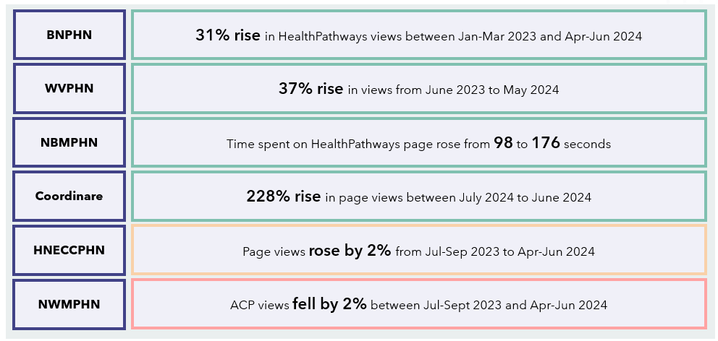

Note: Brisbane North PHN = BNPHN; Western Victoria PHN = WVPHN, Nepean, Blue Mountains PHN = NBMPHN, Hunter New England, Central Coast PHN = HNECCPH, South Eastern NSW PHN = Coordinare, North Western Melbourne PHN = NWMPHN

Figure 25 provides a closer look at the HealthPathways data provided by Brisbane North PHN. This data has been chosen for display here as it shows the change in total HealthPathways page views (across 19 unique pages) over regular intervals of time. The trendline displays a positive change in the number of views over time.

Figure 25: HealthPathways ‘views’ data provided by BNPHN

8

Midpoint Evaluation Report

Conclusion and next steps

# Conclusion and next steps

## Summary

This chapter summarises key findings of this Midpoint Evaluation Report, which will help shape key questions to be addressed at the Endpoint stage of this evaluation. Lastly, a brief discussion of next steps for the GCfAHPC Evaluation is provided.

Overall, PHNs have made good progress implementing activities across most categories under the GCfAHPC Program. The proportion of complete activities has increased since delivery of the Baseline report, suggesting PHNs are progressing and implementing activities in their communities. The exception to this is Palliative Care Medicines, where all activities underway at Baseline are still continuing.

Figure 26 summarises the number of PHNs undertaking activities under each category, and the number of activities taking place.

Figure 26: Summary of PHN activities at Midpoint

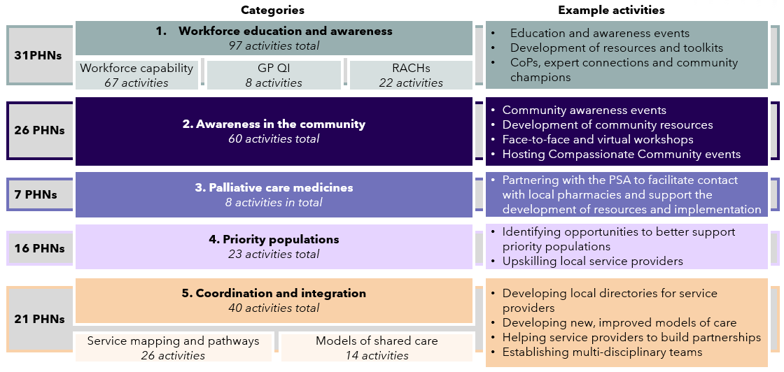

For the categories of Workforce Education and Awareness, Awareness in the Community and Palliative Care Medicines, sufficient data was available at Midpoint to draw a tentative conclusion that positive impacts are being made. Examples of this impact include:

* Higher average total Death Literacy Index scores when compared to the national average of 4.7 out of 10. This may indicate improvement in death literacy after participating in PHN activities. For example:
  + For Workforce Education and Awareness, the average score returned from PHN activities was 7.06 out of 10 (104 responses).
  + For Awareness in the Community activities, the average total DLI score was 6.48 out of 10 (390 responses).
* Positive responses to post-event surveys following PHN activities. For example:
  + Out of 2,691 responses to Workforce Education and Awareness post-event surveys, 89% were positive, 8% neutral, and 3% negative.
  + More than 95% of feedback on Awareness in the Community activities was positive (1,959 responses).
* Significant community and workforce use of an interactive map displaying pharmacies stocking core palliative care medicines in metropolitan Melbourne. For example, the map has been accessed almost 16,000 times, a 241% increase since June 2023.

In each of these three categories, PHNs delivered activities in partnership with other organisations. Partner organisations included peak bodies, local NGOs, local government, community service providers, or hospitals and health services.

However, for Priority Populations and Coordination and Integration, insufficient data was available to make an assessment of the impact of PHN activities. What data was available pointed to generally positive observed impacts. For instance, 92% of participants (90 total) in a Brisbane South PHN activity to upskill the interpreter workforce in palliative care settings demonstrated increased understanding of palliative care. However, more data is required to enable an assessment of the impact of activities for these two categories at Endpoint.

## The Endpoint Evaluation

Based on the data received at the Midpoint Evaluation:

* Most PHN activities identified at Midpoint are meeting the needs of their PHN region, as identified in key guiding documents such as Health or Palliative Care Needs Assessments and Healthy Ageing Strategies.
* There is significant uptake nationally in PHN-driven palliative care education and awareness workshops by a wide range of health professionals.
* The importance of partnerships and collaboration to deliver successful program activities continues to be highlighted.
* Projects with the potential for greater impact often include longer-term planning, sustained efforts, pilot and trials, or PHNs working together towards shared goals. Examples of this include projects in Regional Victoria and Metro Brisbane, where PHNs have collaborated to engage with stakeholders over long periods of time and combined resources to provide financial incentives.
* Targeting General Practice quality improvement continues to remain a gap for PHNs with only 8 activities occurring overall in this space. This is likely due to the challenging nature of engaging time-poor GPs who have competing priorities.

The GCfAHPC Endpoint report will continue the discussion of the outcomes, impact, design and implementation of PHN activities under the Program. A greater depth and breadth of data will allow for additional and more nuanced analysis on the impact of PHN activities.

The questions we will seek to explore further at Endpoint may include:

* What is the impact of activities that are completed by one or more PHNs involved?
* What are the enduring strengths and enablers of the Program that have continued from Baseline through to Endpoint?
* What are the key palliative care reforms and system changes that have occurred over the duration of the Program in Australia, and do activities continue to align to contemporary system needs and gaps?
* How should the program be modified to enable a greater impact in the future?

## Next steps

The purpose of the Midpoint report is to determine the progress of PHN activities as part of the GCfAHPC Program. This report highlights progress made since delivery of the Baseline report, challenges and barriers faced and overcome by the PHNs, and, using available data, a tentative assessment of the impact of these activities.

Next steps for the GCfAHPC Evaluation include:

* Updating data collection tools, such as PHN and service provider surveys, for use in the Endpoint Evaluation.
* Engaging data custodians including the OACP, AIHW and the University of Wollongong’s Palliative Care Outcomes Collaboration to ensure data sets are ready for use at Endpoint.
* Communicating key dates, requirements and opportunities for engagement to PHNs ahead of the Endpoint tranche of the GCfAHPC Evaluation.

Appendices

| Appendix | Page number |
| --- | --- |
| Appendix A: Glossary | 66 |
| Appendix B: PHN activity alignment to Health Needs Assessments and Healthy Ageing Strategies | 69 |
| Appendix C: PHN activity case studies | 71 |



# Appendix A: Glossary

Table 9: Glossary of terms

|  |  |
| --- | --- |
| Abbreviation | Description |
| ACCHO | Aboriginal Controlled Community Health Organisation |
| ACP | Advance Care Plan |
| ACPA | Australian Community Pharmacy Authority |
| AIHW | Australian Institute of Health and Welfare |
| APHN | Adelaide PHN |
| AUSLAN | Australian Sign Language |
| AWP | Activity Work Plans |
| BNPHN | Brisbane North PHN |
| BSPHN | Brisbane South PHN |
| CAEOLC | Care at the End of Life Collaborative |
| CALD | Culturally and Linguistically Diverse |
| CALD | Culturally and Linguistically Diverse |
| CCQPHN | Country to Coast, Queensland PHN |
| CESPHN | Central and Eastern Sydney PHN |
| CHNPHN | Capital Health Network PHN |
| CML | Core Medicines List |
| CoP | Community of Practice |
| CPD | Continuing Professional Development |
| CSAPHN | Country South Australia PHN |
| DDWMPHN | Darling Downs and West Moreton PHN |
| DLI | Death Literacy Index |
| DHDA | Department of Health, Disability and Ageing |
| ECHO | Extension for Community Healthcare Outcomes |
| ELDAC | End of Life Direction for Aged Care |
| EMPHN | Eastern Melbourne PHN |
| EOLC | End of Life Care |
| FTE | Full Time Equivalent |
| GCfAHPC | Greater Choice for At Home Palliative Care |
| GCPHN | Gold Coast PHN |
| GP | General Practitioner |
| GPHN | Gippsland PHN |
| GPMP | General Practitioner Management Plans |
| HELP | Healthy End of Life |
| HNCPHN | Health North Coast PHN |
| HNECCPHN | Hunter New England and Centre Coast PHN |
| INCA | Integrated Share Care Planning Platform |
| LGBTIQA+ | Lesbian, Gay, Bisexual, Transgender, Intersex, Queer/questioning, Asexual |
| LHD | Local Health District |
| LHN | Local Health Network |
| MBS | Medicare Benefits Schedule |
| NBMPHN | Nepean Blue Mountains PHN |
| NGO | Non Government Organisation |
| NQPHN | North Queensland PHN |
| NSPHN | Northern Sydney PHN |
| NTPHN | Northern Territory PHN |
| NWMPHN | North Western Melbourne PHN |
| OACP | Office of Advance Care Planning |
| PAG | Project Advisory Group |
| PCAM | Palliative Care Access to core Medicines |
| PCOC | Palliative Care Outcomes Collaboration |
| PEPA | Program of Experience in the Palliative Approach |
| PHN | Primary Health Network |
| PHT | Primary Health Tasmania |
| PSA | Pharmaceutical Society of Australia |
| QI | Quality Improvement |
| RACH | Residential Aged Care Home |
| RACH | Residential Aged Care Home |
| SAPMEA | SA Postgraduate Medical Education Association |
| SDA | Specialist Disability Accommodation |
| SEMPHN | South Eastern Melbourne PHN |
| SESLHD | South Eastern Sydney Local Health District |
| SIL | Supported Independent Living |
| SWSPHN | South Western Sydney PHN |
| TCA | Team Care Arrangements |
| WAPHA | Western Australia Primary Health Alliance |
| WNSWPHN | Western New South Wales PHN |
| WQPHN | Western Queensland PHN |
| WVPHN | Western Victoria PHN |

# Appendix B: PHN activity alignment to Health Needs Assessments and Healthy Ageing Strategies

## Scope

Scyne analysed Health Needs Assessments and Health Ageing Strategies published by PHNs as part of Midpoint analysis, to assess whether PHN activities under the GCfAHPC Program were appropriately targeting the needs of the community (i.e. priority areas).

## Assumptions and Limitations

* Not all activities being undertaken by PHNs were assessed. Only those activities aligning to identified priorities were examined.
* Health Needs Assessments, Palliative Care Needs Assessments and Healthy Ageing Strategies were accessed through publicly available information online through PHN websites.
* Alignment of activities to priority areas is contingent on the information provided by PHNs during the Midpoint data collection and evaluation process.
* Where activities aligned to a specific Needs Assessment or Healthy Ageing Strategy priority area was not identifiable, this was noted.
* Needs Assessments and Healthy Ageing Strategies do not always have a sufficient level of granularity however, where identified priorities appear to encompass palliative care, these were included in the alignment analysis.
* Not all PHNs published a Healthy Ageing Strategy and the publication dates of available strategies also vary.

Analysis of the alignment between Health Needs Assessments, and Healthy Ageing Strategies to community needs

* Overall, there is a reasonable level of alignment between PHN activities and priority areas identified in Health Needs Assessments.
  + A high level of alignment was identified for 61% of identified priority areas (72/118). Often there are multiple PHN activities responding to priority areas.
  + Low/no alignment was recorded for 31% of identified priority areas (36/118).
  + A medium level of alignment was recorded 9 times. No relevant priorities were identified in Western Victoria PHN’s Health Needs Assessment, however, a short-term Primary Care Palliative Care Working Group was established to inform future priorities and activities of the Program.
  + It is important to note 14 of 29 PHNs conducted a stand-alone Palliative Care Needs Assessment, which will be further analysed as part of Endpoint evaluation.
* This suggests that PHNs are prioritising particular priority areas based on available resources and funding.
* No Health Ageing Strategy was identified for most PHNs (23/29).
  + Where a Strategy was identified a high level of alignment between PHN activities and identified priority areas was detected in 10/16 cases. Low/no alignment was recorded in 5/18 cases. There was one instance of a medium level of alignment.
* As with Health Needs Assessments, this suggests PHNs are prioritising where to focus their efforts based on available resources and funding.

# Appendix C: PHN activity case studies

Appendix C showcases a selection of PHN activities designed and implemented as part of the Program. These were selected to showcase with the aim of highlighting the diversity of activity across regions, locations, rurality and demographics.

A summary of the case studies is summarised on Table 10 below

Table 10: PHN activity case studies summary table

|  |  |  |
| --- | --- | --- |
| # | PHN | Activity |
| 1 | Country South Australia PHN | Palliative Medication Proficiency Education |
| 2 | Western Australia Primary Health Alliance (Perth North PHN, Perth South PHN and Country Western Australia PHN) | Palliative Care Champion project in General Practice |
| 3 | Australian Capital Territory PHN (Capital Health Network) | ACT Breathlessness Intervention Service (ABIS) |
| 4 | Regional Victorian Collaborative (Murray PHN, Gippsland PHN and Western Victoria PHN) | Palliative Care Quality Improvement Project |
| 5 | Central Queensland, Wide Bay and Sunshine Coast PHN (Country 2 Coast PHN) | Advance Care Planning (ACP) in Community |
| 6 | Metropolitan Melbourne PHNs (Eastern Melbourne PHN, North Western Melbourne PHN and South Eastern Melbourne PHN) | Palliative Care Access to core Medicines (PCAM) |
| 7 | Brisbane South PHN | Upskilling the interpreter workforce in palliative care settings |
| 8 | Brisbane North PHN | Living and dying well for people with disability: palliative and end of life case knowledge framework |

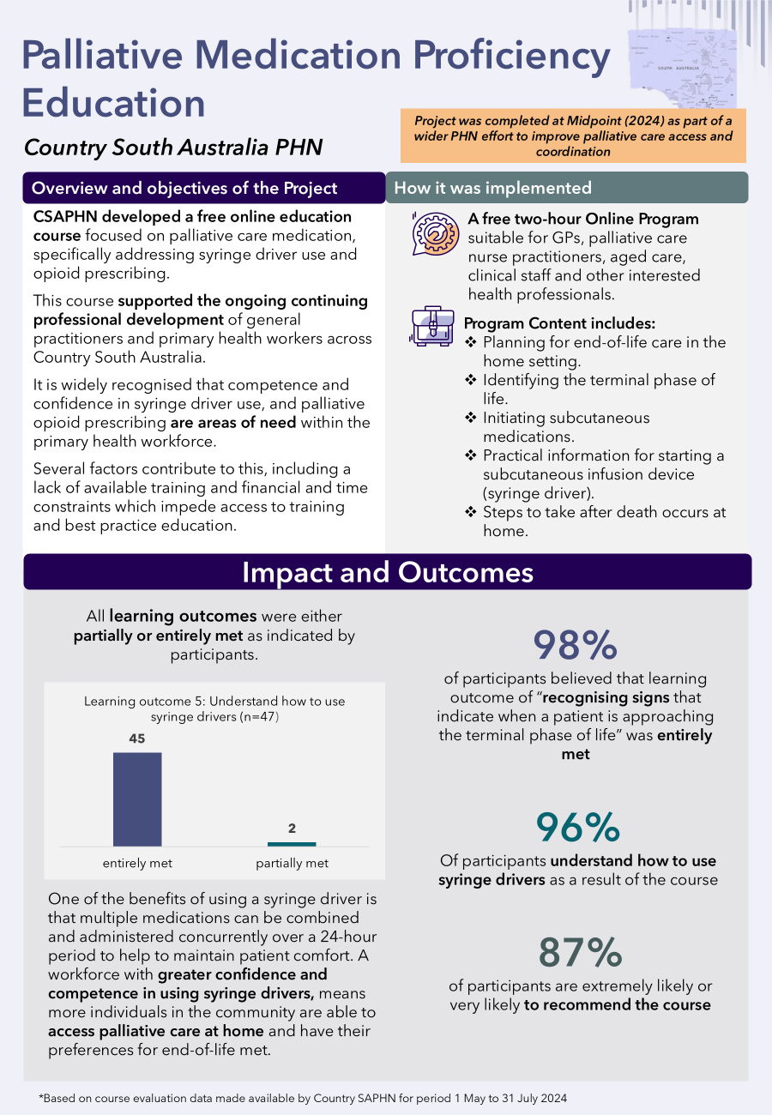

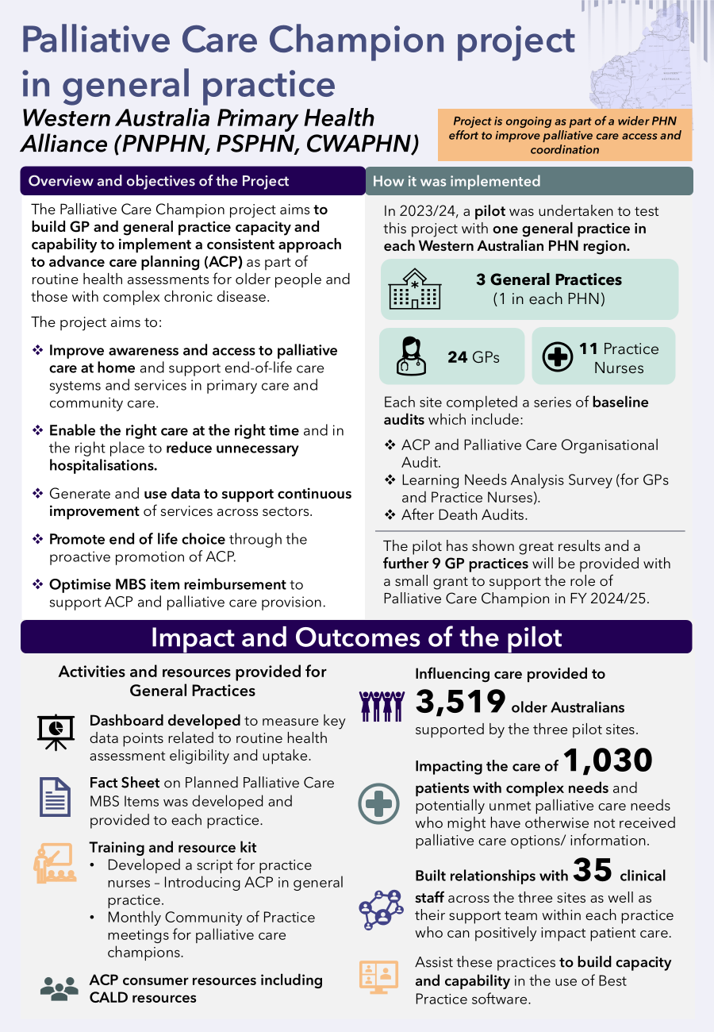

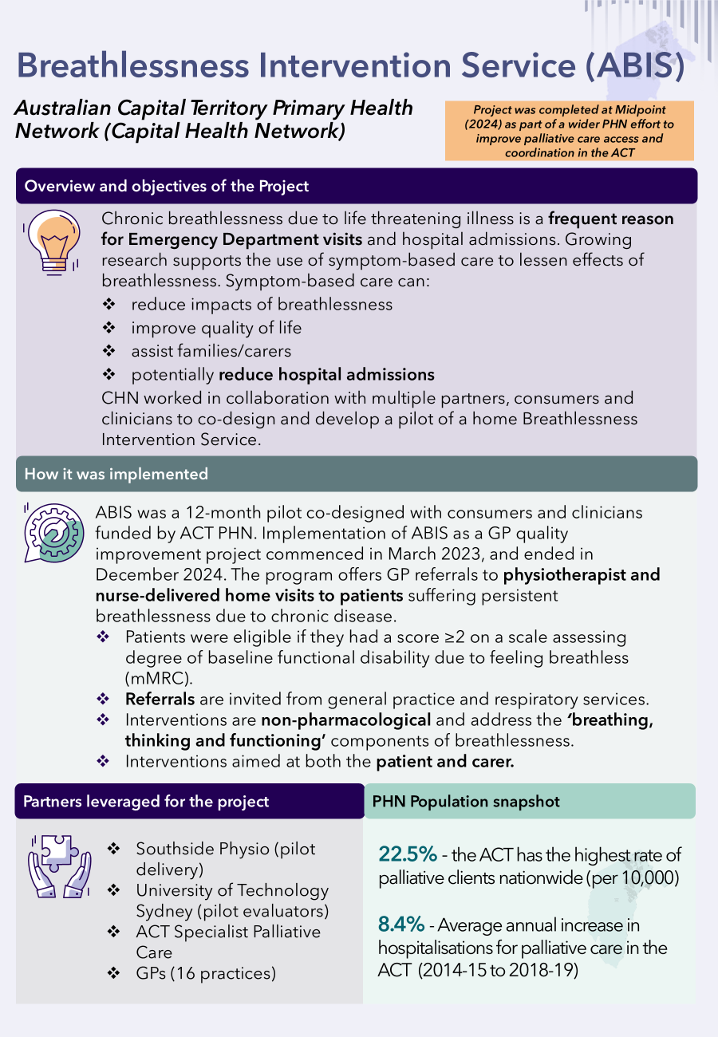

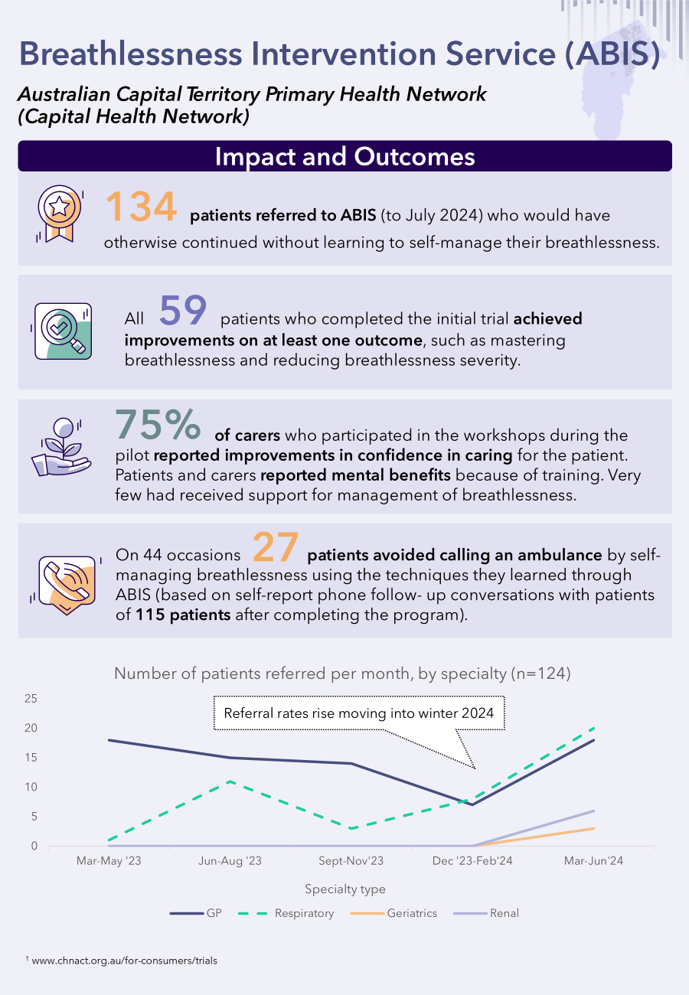

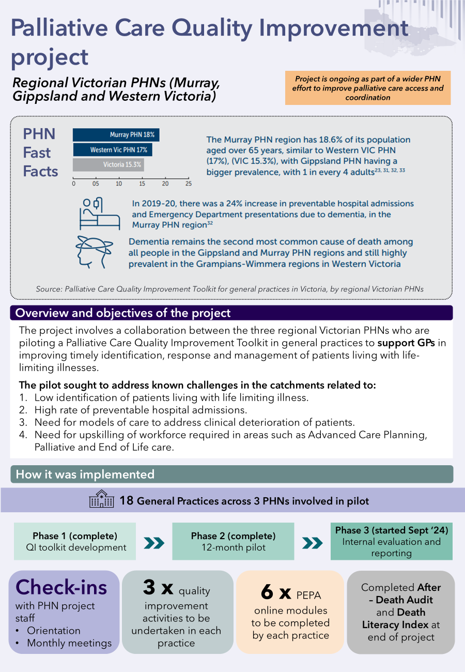

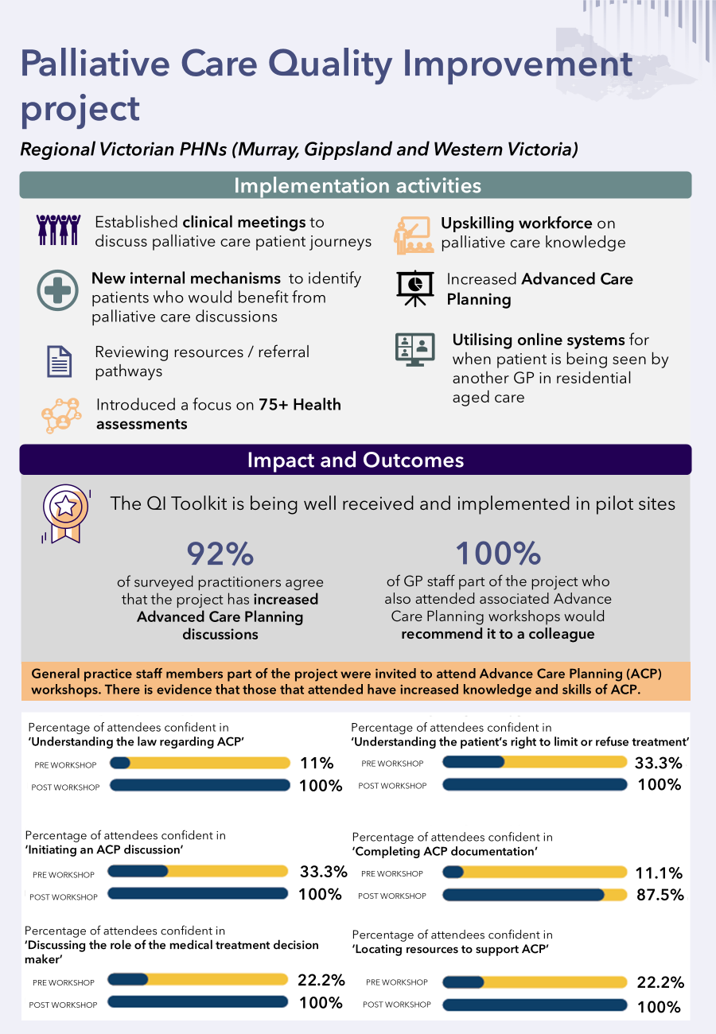

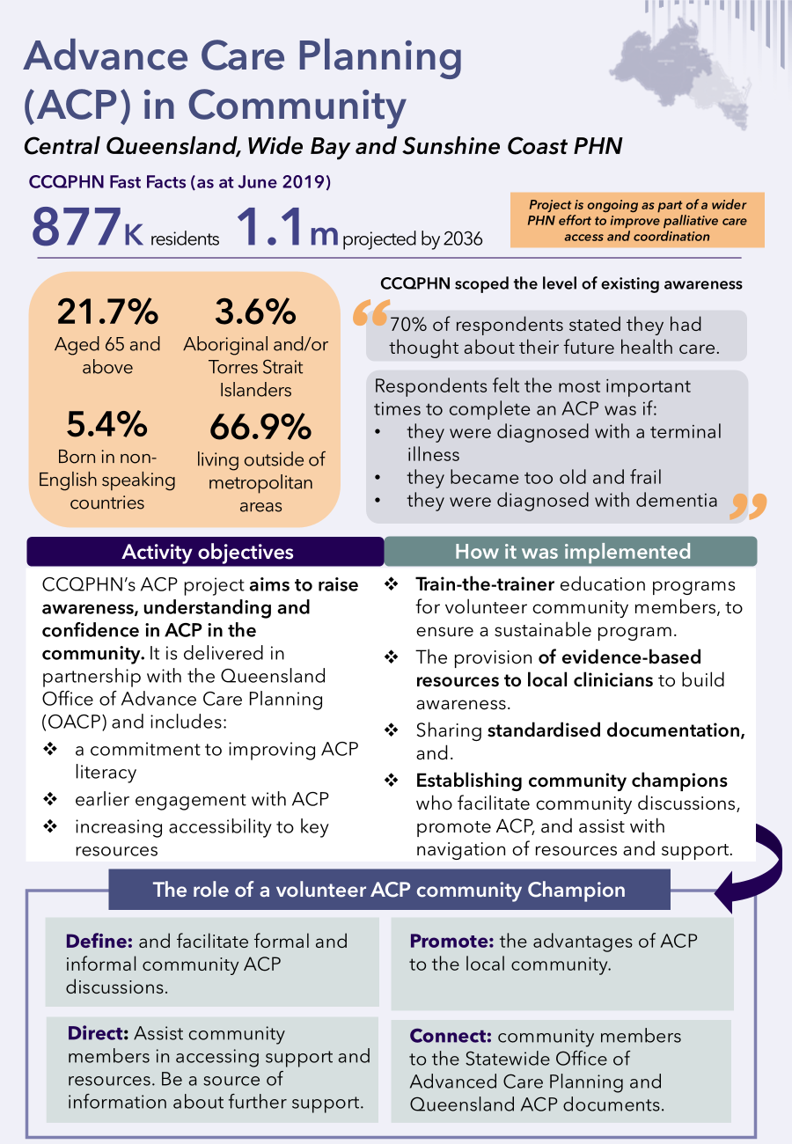

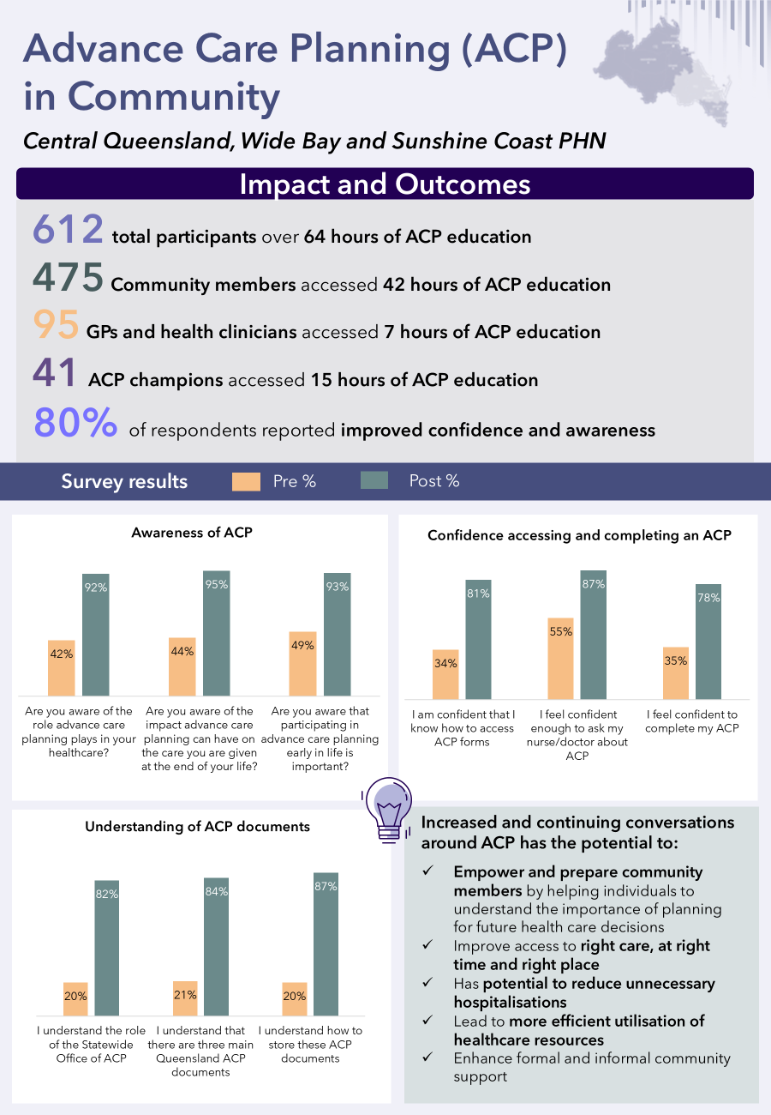

A case study from metropolitan VIC PHNs on access to core palliative medicines


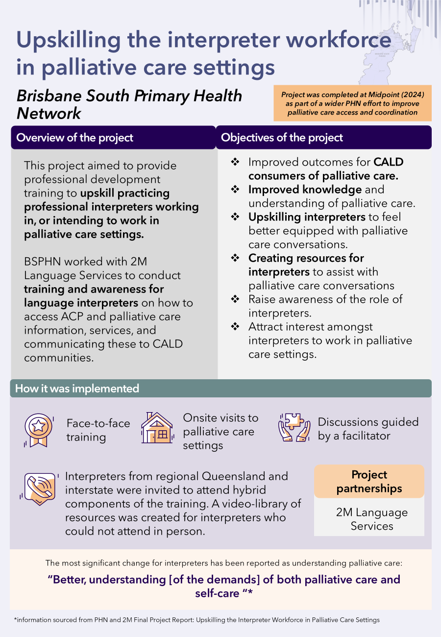

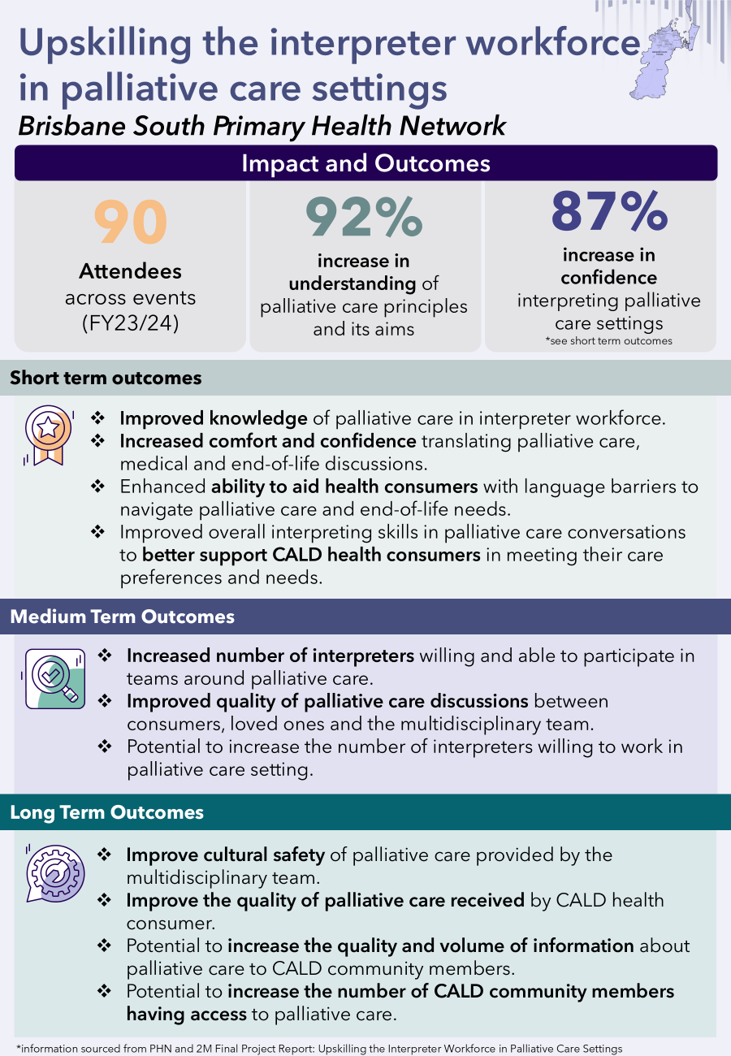

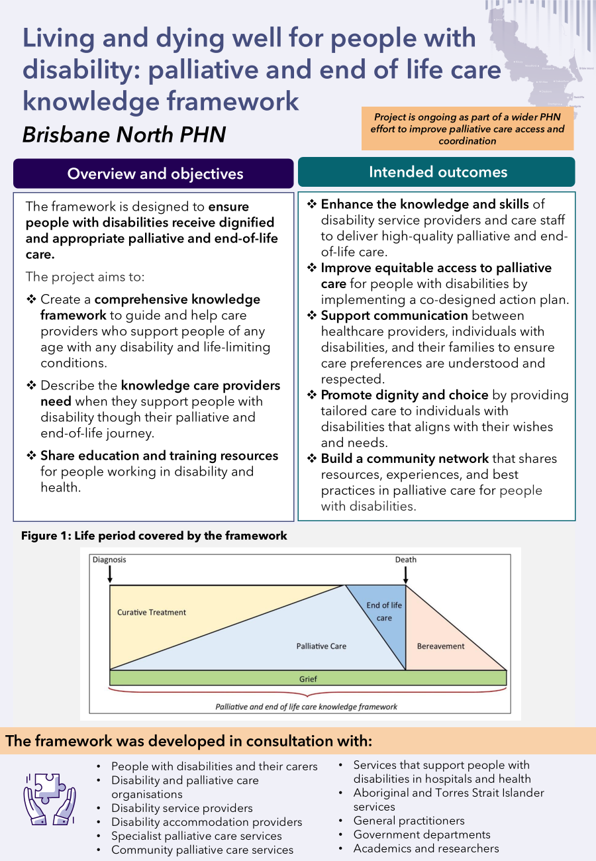

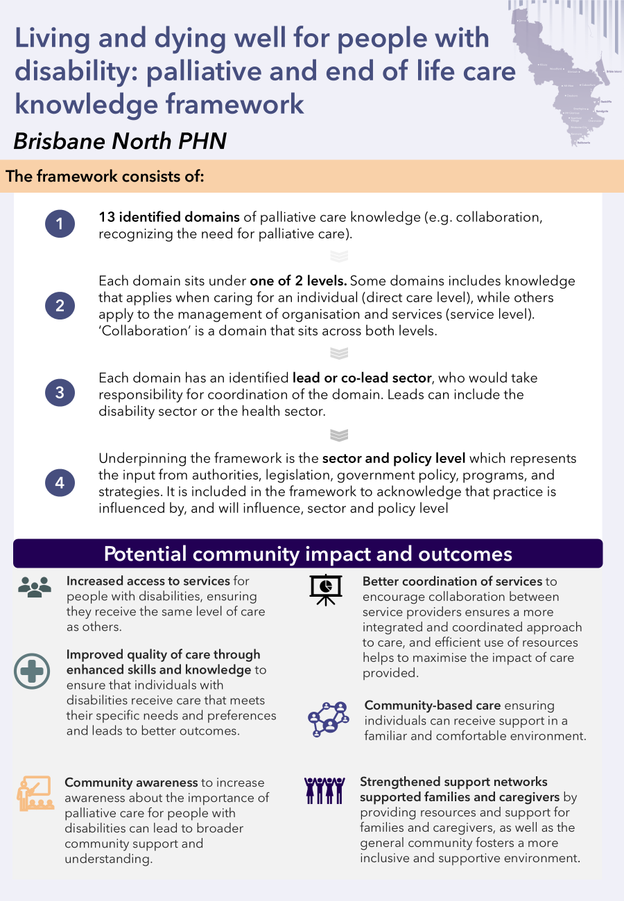



scyne.com.au  
© 2025 Scyne Advisory. All rights reserved.  
Scyne Advisory refers to Scyne Advisory Pty Ltd. Please see [www.scyne.com.au](http://www.scyne.com.au/) for further details.

1. DHDA (2021). Primary Health Networks (PHN) Program Expansion of the Greater Choice for At Home Palliative Care (GCfAHPC) Measure Grant Opportunity Guidelines.
2. DHDA (2025). Greater Choice for At Home Palliative Care Program
3. DHDA (2021). PHN Program Expansion of the GCfAHPC Measure Grant Opportunity Guidelines.
4. DHDA (2021). PHN Program Expansion of the GCfAHPC Measure Grant Opportunity Guidelines.
5. For the purposes of the GCfAHPC Evaluation Perth North, Perth South and Country Western Australia are co-operating as the Western Australia Primary Health Alliance (WAPHA). As a result, when counting the number of PHNs undertaking an activity, these three PHNs count as one entity (i.e. WAPHA). Otherwise, this report refers to 31 PHNs nationally.
6. Palliative Care Australia (2018). Background Report to the Palliative Care Service Development Guidelines. Available at: https://palliativecare.org.au/wp-content/uploads/dlm_uploads/2018/02/PalliativeCare-Background-to-Service-Delivery-2018_v3.pdf
7. DHDA. (2019). What is Palliative Care? Available at: www.health.gov.au/topics/palliative-care/about-palliative-care/what-is-palliative-care#what-is-endoflife-care
8. DHDA. (2019). What is Palliative Care? Available at: www.health.gov.au/topics/palliative-care/about-palliative-care/what-is-palliative-care#what-is-endoflife-care
9. Palliative Care Australia. (2017). The Economic Value of Palliative Care and End-of-Life Care. Available at: www.pallcare.asn.au/getattachment/News/Palliative-Care-the-value-proposition-for-health/PCA019_Economic-ResearchSheet_1a_General.pdf.aspx?lang=en-US
10. DHDA (2021). Primary Health Networks (PHN) Program Expansion of the Greater Choice for At Home Palliative Care (GCfAHPC) Measure Grant Opportunity Guidelines.
11. Deloitte (2021). Greater Choice for at Home Palliative Care Final Report.
12. DHDA (2021). PHN Program Expansion of the GCfAHPC Measure Grant Opportunity Guidelines.
13. DHDA (2021). PHN Program Expansion of the GCfAHPC Measure Grant Opportunity Guidelines.
14. For the purposes of the GCfAHPC Evaluation Perth North, Perth South and Country Western Australia are co-operating as the Western Australia Primary Health Alliance (WAPHA). As a result, when counting the number of PHNs undertaking an activity, these three PHNs count as one entity (i.e. WAPHA). Otherwise, this report refers to 31 PHNs nationally.
15. Advance Care Planning Australia (2024). Advance care planning explained. https://www.advancecareplanning.org.au/understand-advance-care-planning/advance-care-planning-explained
16. PHN data uploads (n=3 PHNs)
17. NQPHN (2023), <https://www.nqphn.com.au/news/plan-create-compassionate-communities-north>
18. SMRPCC (2020). Imprest Medication system for RACFs. https://smrpcc.org.au/wp-content/uploads/2020/04/Imprest-RACF-Medications-FAQs-April-2020_c.pdf
19. BNPHN. Community Pharmacy in Palliative Care Action Plan Co-Design Report
20. SWSPHN. About our community. https://swsphn.com.au/about/health-of-our-region/#:~:text=We%20have%20a%20greater%20proportion,per%20cent%20of%20the%20population.
21. PHN data uploads (n=11 PHNs)
22. PHN data uploads (n=1 PHN)
23. PHN data uploads (n=17 PHNs)
24. PHN data uploads (n=6 PHNs),