What are Disability Representative Organisations

# Part 1

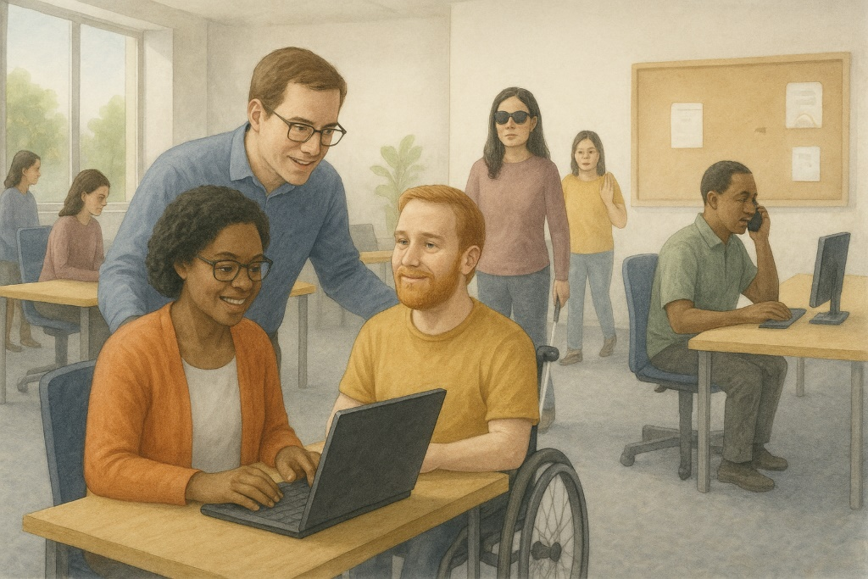

|  |  |
| --- | --- |
| department of health disability and ageing logo | The Australian Government Department of Health Disability and Ageing wrote this.  We say **DHDA** for short.  When you see the word **we** it means the DHDA. |
| A person holding a white book with easy read on the cover | We wrote this in an easy to read way.  We use pictures to explain some ideas. |
| The word bold is in bold and the words not bold are in plain text | We have some words in **bold**.  This means the letters are thicker and darker.  These are important words. |
| An easy read document with pictures and lines for text. | This is an Easy Read summary of another document.  This means it has the most important ideas. |
| teal envelope | We can answer any questions by email.  Email us [SystemicDisabilityAdvocacy@Health.gov.au](mailto:SystemicDisabilityAdvocacy@Health.gov.au) |
| Two people with their arms around each other with thumbs up. | You can ask for help to read this document.  You can ask   * A friend * Family members * A support person. |
| Illustration of First Nations people with flags in the background | We recognise Aboriginal and Torres Strait Islander people as the **Traditional Owners** of the land we live on. |
| map of Australia | They were the **first people** to live on and use the   * Land * Waters. |

**Contents**

|  |  |
| --- | --- |
| Who is this document for | 5 |
| What is a DRO | 7 |
| What DROs do | 11 |
| DRO Program funding | 18 |
| Review | 21 |
| Contact us | 24 |

Who is this document for

|  |  |
| --- | --- |
| Three people giving thumbs-up, wearing professional attire and ID badges. | This is a **guide** for Australian Government staff.  It has 2 parts.  You can read part 2 on our website.  [www.health.gov.au/resources/publications/engagement-protocols-for-working-with-disability-representative-organisations](https://www.health.gov.au/resources/publications/engagement-protocols-for-working-with-disability-representative-organisations) |
| book with Guide and lines representing words | A guide says   * How things should be done * Step by step what to do * Can give **recommendations**.   Recommendations are ideas to do things better. |
| illustration of DROs with people with disability and symbols to represent different disabilities | Both parts talk about **Disability Representative Organisations**.  We call them **DROs** for short. |
| Three people giving thumbs-up, one holding a whiteboard, one in a wheelchair. | Part 1 says what DROs   * Are * Do. |
| A group of six people discussing around a table with an empty speech bubble . | Part 2 says how the government should work with DROs. |
| Young woman smiling and reading an open book or document against a white background with part 1 on the cover. | It is best to read **part 1** first.  [www.health.gov.au/resources/publications/engagement-protocols-for-working-with-disability-representative-organisations](https://www.health.gov.au/resources/publications/engagement-protocols-for-working-with-disability-representative-organisations) |

What is a DRO

|  |  |
| --- | --- |
| A diverse group of people with empty purple speech bubbles around them. | DROs are organisations that speak up for people with disability.  They help governments understand what people with disability   * Need * Want. |
| a vertical shot of Australian dollar banknotes in a black wallet on the white background | The government has a program that gives money to DROs so they can   * Speak up for the **rights** of people with disability |
| A group of people in white t-shirts giving thumbs up | Rights are **rules** about treating everyone   * Fair * Equal. |
| people posing for a photo | * Help make things * Fair * More **inclusive**   Inclusive is when everyone   * Can **take part** * Feels like they **belong**. |
| Elderly woman and man with Down syndrome talking with speech bubbles above their heads. | * Share the experiences of people with disability |
| illustration of people with disability in the park | * Support people with disability to take part in the community |
| teal parliament house with a red cross | DROs are **independent**.  Independent means separate to the government.  This means they   * Make their own decisions * Choose what work to do. |
| A man with a white cane standing against a plain background. | Some DROs work with people who have a certain type of disability like   * People who are blind or have low vision |
| Illustration of people with disability and a person holding a sign with a rainbow infinity on it | * Autism. |
| Group of five diverse individuals with disabilities smiling and standing together. | DROs might work with different groups of people with disability. |
| teal and blue computer | Our website has   * A list of DROs * The groups they work with   [www.health.gov.au/our-work/disability-representative-organisations-program](https://www.health.gov.au/our-work/disability-representative-organisations-program)  It is **not** in Easy Read. |

What DROs do

|  |  |
| --- | --- |
| A group of six people discussing around a table with an empty speech bubble.  a book with rules on the front and a green tick and red cross | DROs do lots of things.  Like  Talk to government about things that affect people with disability like   * **Laws** * Services * Plans   Laws are **rules** for how we live. |
| Person holding a microphone and smiling, wearing a striped shirt with a white background. | * Help government hear real stories from people with disability |
| A group of people standing around a table with a piece of paper saying policy and a whiteboard with a gold coin on it in the background | * Work on changes to * **Policies** * Systems   Policies are plans for how to do things. |
| A diverse group of six people pointing at something on a table. | * Be a part of * **Reviews** * **Research** |
| Man looking through a magnifying glass while wearing a blue checkered shirt. | A review is when you check what   * Works * Needs to change. |
| 2 people standing either side of a board with a graph | Research means   * Finding out what people think about things * Using the information to **help others**. |
| Elderly person in an orange jacket holding a clipboard and giving a thumbs-up. | * Share important information with their communities |
| Man in a suit holding a clipboard with a checklist and a green marker. | Run   * **Events** * **Workshops** * **Campaigns** |
| A cheerful woman inviting people to an event. | Events are activities that bring people together in a community. |
| Two people standing next to a blank flip chart, one writing and the other gesturing. | A workshop is when a group of people meet to talk about something. |
| a person pointing with the word goals at the bottom | A campaign is working in way to do a **goal**.  Goals are things you want to do. |
| A colorful political world map with countries labeled. | * Speak up for the **rights** of people with disability * **In Australia** * **Overseas**. |
| a vertical shot of Australian dollar banknotes in a black wallet on the white background | **Funding** for the DRO Program   * Helps organisations **advocate** for people with disability.   Funding is **money from the government** to take part. |
| Four diverse individuals, three standing and one in a wheelchair, raising their hands in front of speech bubbles. | An advocate is someone who supports you to speak up for your **rights**.  It can also be called **advocacy**. |
| Man with striped sweater and speech bubble | DROs speak to government to uphold the **rights** of people with disability. |
| illustration of people with disability in the park | Advocacy helps to make good changes in the community. |
| Four individuals standing in a row with various expressions and clothing styles. | Advocacy can help with issues people with disability deal with like **barriers** |
| a stop sign with a white hand | A barrier is something that stops you from doing what you   * Want * Need. |
| Three people, including an elderly woman with a cane and two younger individuals in hooded jackets, smiling and interacting. | * **Discrimination** |
| Woman holding scales labelled 'Right' and 'Wrong'. | Discrimination means treating someone unfairly because of something about them they can **not** change.  Like that they have a disability. |

DRO Program Funding

|  |  |
| --- | --- |
| A smiling man with a tattooed arm holding a megaphone. | The DRO Program funding helps organisations to speak up about |
| Three women, one in a wheelchair, chatting on a park bench with trees and buildings in the background. | * What it feels like to have a disability   This can be called **lived experience**. |
| A group of people in white t-shirts giving thumbs up | * The rights of people with disability |
| illustration of people with disability in the park | * Supporting people with disability to take part in the community. |
| Four people having a conversation with speech bubbles overhead. | It is important for people with disability to have a say about things that affect them. |
| Two women standing beside a flip chart with the word ideas, both pointing at it with markers. | We can do this by supporting DROs to take part in **engagements**.  Engagements are activities to share ideas. |
| Woman in professional attire holding a notepad with a large green checkmark symbol beside her. | This will help the government make good policies about people with disability. |
| Person in a red shirt holding a clipboard with red X marks. | The DRO Program funding has rules about how it can be used.  It can **not** be used for |
| A diverse group of people within a magnifying glass. | * Big **co design** work   Co design means working with people who are affected by the project.  Like people with disability working on projects about disability. |
| Person in a blue patterned jacket looking at their wristwatch. | * Engagements that last a long time. |

Review

|  |  |
| --- | --- |
| A group of five people having a discussion around a table, with one person standing and holding a document. | We will work with DROs to review the documents regularly. |
| A diverse group of people interacting with speech bubbles overhead. | This will make sure DROs and the government know how to work well together. |
| teal and blue computer | In the reviews we will look at the **Guidelines**.  You can look at them on this website.  [www.disabilitygateway.gov.au/good-practice-guidelines](https://www.disabilitygateway.gov.au/good-practice-guidelines)  It is in Easy Read. |
| Australia's Disability Strategy 2021-2031, Creating an inclusive community together logo. | The Guidelines have been made as part of **Australia’s Disability Strategy**.  We call it **ADS** for short |
| Woman in green shirt giving thumbs-up next to a checklist with green check marks. | This will make sure people with disability are included in   * Helping the government make decisions |
| A diverse group of five people sitting and talking together, with one person in a wheelchair. | * Sharing their ideas |
| Four people having a conversation with speech bubbles overhead. | * Being part of changes that affect them |
| A group of people standing around a table with a piece of paper saying policy and a whiteboard with a gold coin on it in the background | * Making policies. |
| feedback icon with speech bubble with happy face and sad face | It is important for DROs to give feedback about these documents.  You can talk to DHDA about your feedback. |
| Person in a wheelchair holding a clipboard with a green check mark, smiling and giving a thumbs-up. | It will help us to make sure they are working well. |

Contact us

|  |  |
| --- | --- |
| white circle with teal i in the middle | You can contact us if you need more information. |
| teal envelope | You can send us an email.  [SystemicDisabilityAdvocacy@Health.gov.au](mailto:SystemicDisabilityAdvocacy@Health.gov.au) |
| teal and blue computer | You can read **part 2** on our website.  [www.health.gov.au/resources/publications/engagement-protocols-for-working-with-disability-representative-organisations](https://www.health.gov.au/resources/publications/engagement-protocols-for-working-with-disability-representative-organisations) |

Images in this Easy Read must **not** be used or copied without permission