Impact Case Studies



from SAHMRI Registry Centre Member Registries



**Acknowledgment of country**

SAHMRI acknowledges Aboriginal and Torres Strait Islander people as the first peoples of Australia and the longest continuous living culture in the world. We recognise the injustices of the past and that Aboriginal and Torres Strait Islander people do not experience the same equality of rights and life expectancy as other Australians. We respect the resilience of Aboriginal and Torres Strait Islander people in the face of adversity.

##### **Elsie Nunu, Tamara Hooper, Cindy Turner**

**June 2025**

This report has been developed by the South Australian Health and Medical Research Institute Registry Centre with funding provided by the Australian Department of Health, Disability and Ageing through the National Clinical Quality Registry Program.

**Publication Details**

Publication Title: SAHMRI_Registry_Centre_Collated_Impact_Case_Studies Published: 2025

Publisher: South Australian Health and Medical Research Institute <https://doi.org/10.58138/sjq6-4v20>

**Suggested Citation**

SAHMRI_Registry_Centre_Collated_Case_Studies. South Australian Health and Medical Research Institute. June 2025. Version 1. [https://www.health.gov.au/resources/publications/clinical-quality-registries-cqrs-collated-impact-case-studies](https://aus01.safelinks.protection.outlook.com/?url=https%3A%2F%2Fwww.health.gov.au%2Fresources%2Fpublications%2Fclinical-quality-registries-cqrs-collated-impact-case-studies&data=05%7C02%7CTamara.Hooper%40sahmri.com%7Cca761fcddce64820153908ddfa6a2b9f%7Ca264755d215f486fb5bb00cd4b3a5058%7C0%7C0%7C638942056334866715%7CUnknown%7CTWFpbGZsb3d8eyJFbXB0eU1hcGkiOnRydWUsIlYiOiIwLjAuMDAwMCIsIlAiOiJXaW4zMiIsIkFOIjoiTWFpbCIsIldUIjoyfQ%3D%3D%7C0%7C%7C%7C&sdata=qOiMFPtqVBKpbKAonJihestmlAJfJqTbtQKQA7NCXDg%3D&reserved=0)

**Copyright**

Except as otherwise stated, all material is © South Australian Health and Medical Research Institute Limited.

All material presented in this publication is provided under a Creative Commons Attribution NonCommercial-NoDerivatives 4.0 International Licence [(www.](http://www/) creativecommons.org.au), with the exception of all images (including background images, logos and illustrations) and any content identified as being owned by third parties. The details of the relevant licence conditions are available on the Creative Commons website [(www.creativecommons.org.au),](http://www.creativecommons.org.au/) as is the full legal code for the CC BY-NC-ND 4.0 International Licence <https://creativecommons.org/licenses/by-nc-nd/4.0/deed.en>

**Attribution**

Creative Commons Attribution NonCommercial-NoDerivatives 4.0 International Licence is a standard licence agreement that allows you to copy and distribute this publication provided that you attribute the work, do not use the material for commercial purposes and do not distribute modified work.

SAHMRI requests that you attribute this publication (and any material sourced from it) by using the following wording: Source: South Australian Health and Medical Research Institute.

**Use of Images**

Unless otherwise stated, all images (including background images, logos, icons and illustrations) are copyrighted by their original owners.

**Contact Us**

For further details or feedback contact [registrycentre@sahmri.com,](mailto:registrycentre@sahmri.com) [SAHMRI | SAHMRI Registry Centre](https://sahmri.org.au/research/programs/registry-centre)

Contents

Background 5

The SAHMRI Registry Centre 6

Case Studies from SAHMRI Registry Centre Members 6

The role of **ARENA** in enhancing sports cardiology guidelines 7

The BEST-Fluids Trial: An **ANZDATA** registry-based trial to optimise transplant fluid selection 9

Improving utility and equity of kidney allocation by harnessing **ANZOD** and **ANZDATA** 11

Improving Access and Waitlisting for Kidney Transplantation through the **National Indigenous Kidney Transplantation Taskforce (NIKTT)** 13

Harnessing Long-Term **ACGR** Data to Secure Medicare Support for Corneal Collagen Cross-Linking for Keratoconus 15

**ASPIRE**'s Role in Building Capacity and Fostering Effective Partnerships with Nursing Staff 17

Integrating **CADOSA** activity into routine clinical practice 19

**CADOSA** supports future workforce capacity through student development 21

Streamlining dental implant procedures with the **DIR** 23

**Oz-POTS** registry advocates for an ICD code in Australia 26

Leveraging Existing Data to Generate Evidence and Inform National Aged Care Policy and Reforms: **The Registry of Senior Australians (ROSA)** 28

A linkage study using **SABDR** data and its application in shaping South Australian clinical practice 32

Driving practice change to improve preoperative risk assessment compliance in emergency laparotomy: The **ANZELA–QI** impact at Midland and Bunbury Hospitals 34

Developing a tool to identify non-technical errors in surgical care using **ANZASM** 40

Appendix: Data Tables 41

References 48

# Background

Clinical Quality Registries (CQRs) are generally classified into: Health Services Registries, Condition or Disease Registries, and Product Registries. While registries across Australia vary in their focus, purpose and operational models, they all aim to support a high-quality, safe and sustainable health system and improve patient outcomes. Registries contribute to this goal by generating insights that can lead to meaningful impact across the healthcare landscape.

Definitions for impact vary. For example, the National Health and Medical Research Council (NHMRC) defines impact as ‘the verifiable outcomes that research makes to knowledge, health, the economy and/or society. Impact is the effect of the research after it has been adopted, adapted for use, or used to inform further research’[1] Meanwhile, the OECD describes impact as ‘The extent to which the intervention has generated or is expected to generate significant positive or negative, intended or unintended, higher-level effects’.[2]

Communicating the impact of registries is essential to demonstrate their continued relevance, effectiveness, and value to the healthcare system. The work of registries can have an impact across many domains (See Figure 1) including influencing clinical practice, supporting evidence-based policy, and improving patient outcomes.

*Figure 1* Examples of type of impact 1,[3], [4]

|  |  |
| --- | --- |
| Cultural | Knowledge |
| Changes in prevailing values, attitudes, beliefs, discourse and patterns of behaviours | Adoption, adaption or use of new knowledge – further research -change in practice / quality improvement measures– basic and fundamental impacts |
| Health | Environment |
| Includes improvements in health status and outcomes, health system change, health policy, new therapeutics and diagnostics, disease prevention, changes in health access and behaviour. | Improvements in environmental outcomes |
| Social | **Economic** |
| Improvements in the health of society, improved access to services, improved social equity, inclusion or cohesion | Reducing healthcare costs and socio-economic benefits, creation of new jobs, new products, commercial outcomes. |
| Capacity Building | **Legislation and policy** |
| This type of impact relates to enhancements in skills and expertise and infrastructure. It reflects the development of capabilities, whether through training, education, or experience, that enable individuals or organisations to perform better or address challenges more effectively | Refers to the contribution that the registry has made to new or amended laws, regulations or other policy. |

## The SAHMRI Registry Centre

The South Australian Health and Medical Research Institute (SAHMRI) Registry Centre a centre of excellence for registries and registry science was established in 2018. Its mission is to bring together the registry science and operational expertise available among our community, to strengthen the Institute’s existing role in the registry space and expand our research capacity and training in this area.

The SAHMRI Registry Centre is a rapidly growing collaboration, consisting of 27 member registries as of 2025. Commencing with mostly South Australian based CQRs, it has expanded to include several major national/bi-national registries, from across the country. Twelve of these are based within SAHMRI.

The purpose of the SAHMRI Registry Centre is to provide a platform to enhance the enormous value of registry data, supporting the utilisation of other important data sources such trials, surveys, biobank data, administrative data sets, and information systems, through data linkage and research collaborations. For further information about the SAHMRI Registry Centre, see SAHMRI | SAHMRI Registry Centre.

The SAHMRI Registry Centre, funded by the Australian Government Department of Health, Disability and Ageing National Clinical Quality Registry Program (the Department), led a project on measuring CQR value and impact. A Guide to Demonstrating CQR Impact was developed to support registries in the creation of these case studies.

### Case Studies from SAHMRI Registry Centre Members

This document presents a collection of case studies and impact statements that showcase the diverse impact delivered by SAHMRI Registry Centre member registries. Together, these

examples highlight how clinical registries inform policy and guidelines, and support high-quality, evidence-based care across a range of health areas. The contributing registries include the:

* Australasian Registry of Electrocardiograms in National Athletes (ARENA)
* Australia and New Zealand Dialysis and Transplant Registry (ANZDATA)
* Australian and New Zealand Organ Donation Registry (ANZOD)
* Australian Corneal Graft Registry (ACGR)
* Australian Particle Therapy Clinical Quality Registry (ASPIRE)
* Coronary Angiogram Database of South Australia (CADOSA) Registry
* Dental Implant Registry (DIR)
* Registry of Senior Australians (ROSA)
* South Australian Birth Defects Register (SABDR)
* The Australian Postural Orthostatic Tachycardia Syndrome (POTS) Registry (Oz-POTS)
* Australia and New Zealand Emergency Laparotomy Audit–Quality Improvement (ANZELA–QI)
* Australian and New Zealand Audit of Surgical Mortality (ANZASM)



The role of **ARENA** in enhancing sports cardiology guidelines

**Corresponding Author**

A/Prof Jessica Orchard, PhD, MPH (with Merit), BEc/LLB (Hons I), Grad Dip Leg Prac, AMusA, FESC FCSANZ

**Contact**

[Jessica.orchard@sydney.edu.au](mailto:Jessica.orchard@sydney.edu.au)

**Website**

[The ARENA project - Faculty of Medicine and Health](https://www.sydney.edu.au/medicine-health/our-research/research-centres/the-arena-project.html) https://[www.sydney.edu.au/medicine-health/our-research/research-](http://www.sydney.edu.au/medicine-health/our-research/research-) centres/the-arena-project.html

### IMPACT STATEMENT

The Orchard Sports Injury and Illness Classification System (OSIICS) is a sports medicine and injury surveillance coding system that requires regular updates to reflect current evidence and athlete diversity, a need that the International Classification of Diseases (ICD) cannot address due to its hospital-based context. The Australasian Registry of Electrocardiograms in National Athletes (ARENA) collects and publishes cardiac screening data across Australasia, contributing 31 new cardiac codes and additional diagnoses to OSIICS Version 15. Endorsed by the Australasian College of Sport and Exercise Physicians (ACSEP), ARENA’s efforts have fostered a culture of pre-participation cardiac evaluation among young athletes. This work is expected to improve the capture of cardiac conditions in sports injury surveillance, enhancing diagnostic practices and health outcomes for athletes.

### Case study

Sports medicine and sports injury surveillance require distinct coding systems as the International Classification of Diseases (ICD) is a hospital-based coding system. The Orchard Sports Injury and Illness Classification System (OSIICS) is one of two sports medicine coding systems recommended by the International Olympic Committee and has been used for injury surveillance for 30 years. However, it is important that regular updates to the coding systems are carried out to reflect current understanding. It is also imperative that such updates are informed by evidence that is representative of the diversity of athletes.

Established in 2023, the Australasian Registry of Electrocardiograms in National Athletes (ARENA)[5] collects and centralises cardiac screening data from sporting organisations across Australasia to improve the quality of the cardiac screening programs and provide better cardiac care for young athletes. ARENA’s current outputs are publishing registry data and continued collection of data on relevant outcomes, including outcomes listed in the new OSIICS sports cardiology codes.

In its first years of operation, ARENA’s work has been utilised to contribute to the latest revision of OSIICS- version 15 to include new sports cardiology codes. The publication of OSIICS version 15, cites ARENA’s outputs, noting these have allowed for the identification of further diagnoses to be adopted into the latest version of OSIICS,[6] creating a more comprehensive list of the cardiac codes that are most relevant for athletes. In total 31 cardiac codes were added to the latest version of OSIICS, which will better capture relevant sports cardiology conditions in athletes.

Through its establishment, ARENA has also influenced the culture around pre-participation cardiac evaluation for athletes. The registry is endorsed in the Australasian College of Sport and Exercise Physicians (ACSEP) Position Statement of Pre-Participation Cardiac Evaluation in Young Athletes.[7] This endorsement will encourage organisations with cardiac evaluation programs to contribute to the registry and address the gap in cardiac evaluation data in Australia and New Zealand. Looking to the future, it is hoped that the clinical implementation of these guidelines in sports medicine will likely also have a health impact through improved diagnostic practice and health outcomes for athletes. It is also hoped that there will be better capture of cardiac conditions in athletes in sports injury surveillance systems, which will contribute to more accurate data capture. It is also anticipated that these greater diagnostic options provided by OSIICS Version 15 will be utilised by ARENA in the future for surveillance of these cardiac conditions in athletes.



The BEST-Fluids Trial: An **ANZDATA** registry-based trial to optimise transplant fluid selection

**Corresponding Author**

Prof. Stephen McDonald

**Contact**

[stephen@anzdata.org.au](mailto:stephen@anzdata.org.au)

**Website**

[Home - ANZDATA](https://www.anzdata.org.au/)

<https://www.anzdata.org.au/>

### IMPACT STATEMENT

The BEST-Fluids trial investigated whether using a balanced, low chloride solution instead of saline could reduce delayed graft function (DGF) in deceased donor kidney transplantation. Trial activities including enrolment and data collection were embedded in the Australia and New Zealand Dialysis and Transplant (ANZDATA) Registry. Results showed that the use of balanced crystalloid solution reduced the incidence of DGF compared with saline. For patients, this better recovery means fewer dialysis treatments post operatively, and potentially less time in hospital. For the health system, this translates to reduced costs and decreased demand on stretched haemodialysis capacity. The Caring for Australians and New Zealanders with Kidney Impairment (CARI) Guidelines are under now under review, with a strong recommendation for the use of balanced electrolyte solutions in this setting. Additionally, the trial’s registry-based design offers a cost-effective model for long-term follow-up and provides a model for future Nephrology trials.

### Case study

Kidney transplantation improves survival, quality of life, and is cheaper in the long term than dialysis treatment for kidney failure. However, delayed graft function (DGF) is a major adverse complication of deceased donor kidney transplantation. In this case, kidney transplants from a deceased donor function poorly after surgery, and a period of continued dialysis is needed. In addition to complicating recovery, DGF can adversely affect long-term kidney function and the health of the recipient. Patients undergoing kidney transplantation often require substantial amounts of intravenous fluid during and after surgery. The intravenous “normal saline” (a 0.9% sodium chloride solution), has been used in patients for this purpose for many years. While normal saline is widely used, evidence from other domains suggested it may slow the recovery from kidney injury, and concerns were raised that its use might increase the risk of DGF due to its high chloride content.

The Better Evidence for Selecting Transplant Fluids (BEST-Fluids) trial was a registry-embedded, multicentre, double-blind, randomised, controlled trial at 16 hospitals in Australia and New Zealand.[8] The primary objective of the study was to find out whether using a balanced low-chloride crystalloid solution, Plasma-Lyte, instead of saline would improve kidney transplant function and reduce the impact of DGF. Following informed consent, participants were randomly assigned to intravenous Plasma-Lyte or saline during surgery and up until 48 hours after transplantation. The BEST-Fluids trial commenced in January 2018.

Data on all kidney transplant recipients in Australia and New Zealand are routinely reported to the Australian and New Zealand Dialysis and Transplant (ANZDATA) Registry. In BEST-Fluids, trial enrolment, randomisation, and most data collection were embedded within the ANZDATA Registry. A key advantage of using the registry-based design is that all participants will continue to have data submitted to ANZDATA for outcomes such as graft failure, which will facilitate long-term follow-up of trial participants at minimal cost.[9]

The results of the study show that using a balanced crystalloid solution in deceased donor kidney transplantation reduced the incidence of DGF compared with saline. DGF occurred in 30% of participants in the balanced crystalloid group compared to 40% in the saline group. The research team recommended that balanced crystalloid solution should be the standard-of-care intravenous fluid used in deceased donor kidney transplantation. For patients, this better recovery means fewer dialysis treatments post operatively, and potentially less time in hospital. For the health system, this translates to lower costs and less strain on stretched haemodialysis capacity.

Following the trial, updates to the Caring for Australians and New Zealanders with Kidney Impairment (CARI) Guidelines: Australian and New Zealand living guideline for chronic kidney disease are currently under review, with a strong recommendation for the use of balanced electrolyte solutions in patients receiving a deceased donor kidney transplant.[10]

It is expected that the innovative registry-based design of the BEST-Fluids trial utilising ANZDATA will enhance integration of balanced crystalloid solutions into routine care, enable low-cost, long-term follow-up, and provide a model for future Nephrology trials aiming to reduce research costs while maintaining high-quality evidence generation.



Improving utility and equity of kidney allocation by harnessing **ANZOD** and **ANZDATA**

**Corresponding Author**

A/Prof Philip Clayton, PhD

**Contact**

[phil@anzdata.org.au](mailto:phil@anzdata.org.au)

**Website**

[ANZOD - Australia and New Zealand Organ Donation Registry - ANZDATA](https://www.anzdata.org.au/anzod/)

(<https://www.anzdata.org.au/anzod/>)

### IMPACT STATEMENT

Organ allocation decisions are complex due to the many factors involved in matching a donor kidney with potential recipients. There is a national algorithm that allocates kidneys, aiming to balance utility and equity, but it is based on a tiered priority system which does not allow for much nuance. Data from the Australia and New Zealand Organ Donation Registry (ANZOD) and Australia and New Zealand Dialysis and Transplant Registry (ANZDATA), as well as OrganMatch, have been leveraged to conduct simulations of potential new allocation algorithms. The proposed new algorithm is based on registry data and uses a continuous scoring system to allow for greater flexibility in immune matching, along with other efficiencies and nuances that aren’t possible with the tiered system. The new system is expected to be implemented in Australia in 2026 and, according to simulations, will lead to benefits including improved immune matching for people of all ages, blood groups and ethnicities, shorter waiting times for young adults and improved utility and equity.

### Case study

In Australia, approximately 1,500 people are on the waiting list for a kidney transplant. [11] When a donor passes away and donates a kidney, a critical decision must be made regarding who on the list should receive the organ. Decisions about organ allocation can be very difficult due to the number of factors that must be considered. There is a national algorithm that allocates kidneys, aiming to balance utility and equity. However, the current algorithm is based on a tiered priority system which does not allow for meaningful nuance.

The Australian kidney transplant community recently undertook a major project to re-design the algorithm from the ground up. This effort has involved cross-registry collaboration and stakeholder engagement with renal transplant experts and consumers, through a process developed by the Transplantation Society of Australia and New Zealand (TSANZ) and partly funded by the federal Organ and Tissue Authority.

The Australia and New Zealand Organ Donation Registry (ANZOD) collects information on all organ, eye and tissue donation, including on kidney donors. Meanwhile, the Australia and New Zealand Dialysis and Transplant Registry (ANZDATA) is a clinical quality registry that collects information relating to the outcomes of treatment of those with kidney failure. To support the design of the new algorithm, data from ANZOD and ANZDATA as well as OrganMatch, the national system that facilitates compatibility matching of recipients and donors, were leveraged to conduct detailed simulations of potential allocation algorithms.

The new algorithm is based on registry data, including data on all donors during the simulation period, waiting list patients, and factors including the likelihood of transplant candidates becoming sick, being removed from or added to the waiting list, and their likelihood of accepting an allocated kidney. The simulations also included data on transplant outcomes, influenced by donor, recipient, and match factors. Donor and recipient prognosis scores, validated with registry data, are used for prognosis matching for optimal donor-recipient matches. Unlike the existing allocation algorithm, the new system uses a continuous score whereby all the different elements are added up for a total score. This allows for greater flexibility in immune matching, and many efficiencies and nuances that aren’t possible with the current tiered system.

The new system is currently undergoing an approval process and is expected to be implemented in Australia in 2026. According to simulations, implementation of the new algorithm will lead to benefits including improved immune matching for people of all ages, blood groups and ethnicities, shorter waiting times for young adults, and improved utility and equity (See Figure 2).

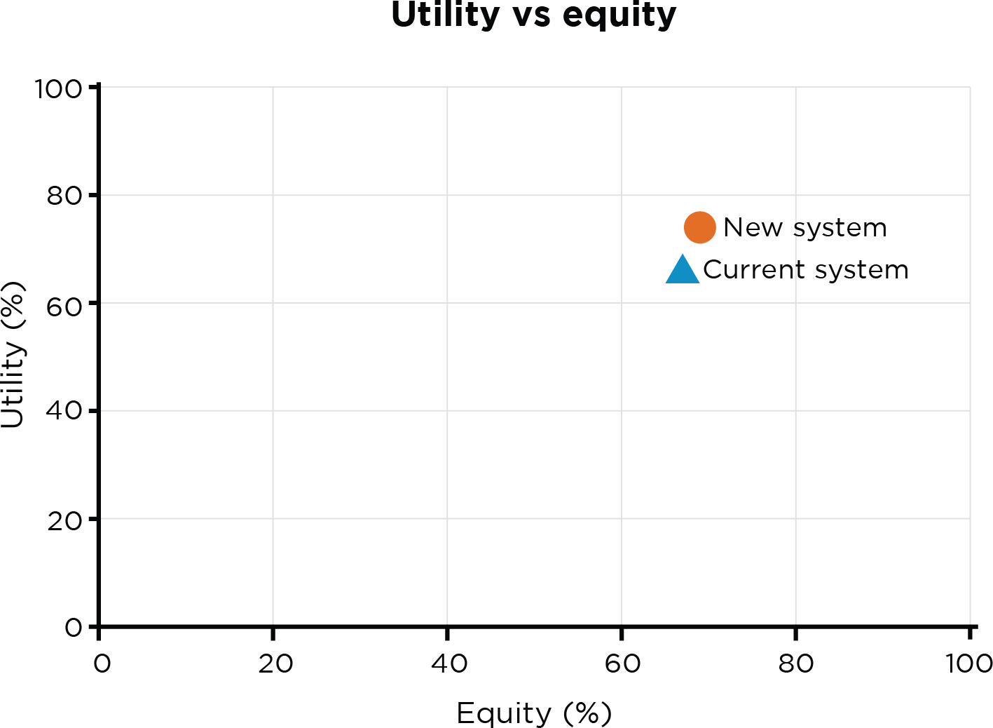Figure 2 The utility and equity of the current national allocation algorithm compared to the proposed new system

**View the data table for Figure 2 at Appendix - Table 1 ANZOD Utility and Equity**



Improving Access and Waitlisting for Kidney Transplantation through the **National Indigenous Kidney Transplantation Taskforce (NIKTT)**

**Corresponding Author**

Prof. Stephen McDonald

**Contact**

[stephen@anzdata.org.au](mailto:stephen@anzdata.org.au)

**Website**

[Home | National Indigenous Kidney Transplantation Taskforce](https://www.niktt.com.au/)

(<https://www.niktt.com.au/>)

### IMPACT STATEMENT

Aboriginal and Torres Strait Islander people face kidney failure at rates up to eight to nine times higher than non-Indigenous Australians and are less likely to receive the preferred treatment of kidney transplantation due to systemic barriers. In 2019, the Australian Government established the National Indigenous Kidney Transplantation Taskforce (NIKTT), investing $2.3 million (AUD) to improve access through Indigenous led, culturally safe care. The NIKTT ran pilot programs around Indigenous Reference Groups, Patient Navigators, and Outreach Clinics. These initiatives have reduced travel burden, improved patient-provider communication, and increased trust in the system, with early results showing more Aboriginal and Torres Strait Islander patients being assessed and waitlisted for a kidney transplant. The outcomes from these pilots directly informed and are cited in the National Transplant Strategy released in August 2024. The implementation of these is now with the Federal Department of Health. NIKTT’s community-driven model now informs broader healthcare reforms and contributes to long-term change.

### Case study

Kidney failure affects Aboriginal and Torres Strait Islander people at rates eight to nine times higher than non-indigenous Australians, and at substantially younger ages[12]. Although transplantation is the preferred treatment,[13] systemic barriers, including delayed referrals, complex procedures, culturally unresponsive care and institutional racism,[14] have led to significantly lower transplant waitlisting rates for Indigenous patients,12 resulting in prolonged dialysis, disconnection from Country, and poorer outcomes.

To address this, the Australian Government established the National Indigenous Kidney Transplantation Taskforce (NIKTT) in 2019, investing $2.3 million (AUD) to improve transplant access. Led by Indigenous leaders, health professionals, and researchers, NIKTT focusses on embedding self-determination and cultural safety into kidney care.[15] , [16] Key initiatives include Indigenous Reference Groups, a series of pilot programs examining the impact of various strategies and enhanced data collection through the Australia and New Zealand Dialysis and Transplant Registry (ANZDATA).[17]

Strategies such as Outreach Assessment Clinics and Indigenous Patient Navigators have reduced travel burdens and improved patient understanding, improving waitlisting rates. Community-led education delivered in local languages, along with Indigenous Reference Groups in transplant units,[18] has fostered trust, cultural safety, and improved patient-provider communication. Workforce development, including respectful practices such as Smoking Ceremonies and employing Indigenous health professionals has further enhanced responsiveness to care.15

Early evidence indicates an increase in transplant assessments and waitlisting among Aboriginal and Torres Strait Islander patients. Over time, these efforts are expected to reduce reliance on dialysis and help close the gap in kidney health outcomes. NIKTT’s scalable, community-led models are informing broader healthcare reforms and driving systemic change, grounded in Indigenous leadership and culturally safe care.[19]



Harnessing Long-Term **ACGR** Data to Secure Medicare Support for Corneal Collagen Cross-Linking for Keratoconus

**Corresponding Author**

Dr Miriam Keane, PhD, BPsych (Hons)

**Contact**

[miriam.keane@flinders.edu.au](mailto:miriam.keane@flinders.edu.au)

**Website**

[Corneal graft survival research and registry - Flinders University](https://www.flinders.edu.au/fhmri/research/fhmri-eye-vision/corneal-graft-registry) (<https://www.flinders.edu.au/fhmri/research/fhmri-eye-vision/corneal-graft-registry>)

### IMPACT STATEMENT

Keratoconus is the leading indication for primary corneal transplantation registered with the Australian Corneal Graft Registry (ACGR) and usually develops in adolescence and young adulthood. Corneal collagen cross-linking (CCXL) was introduced in Australia to halt or delay the progression of keratoconus in the early 2000s. In 2018, CCXL was added to the Medicare Benefits Schedule (MBS). Lacking long-term Australian data, the Medical Services Advisory Committee (MSAC) contacted the ACGR in 2021 to inform its decision on whether CCXL should stay on the MBS. The evidence showed a significant decline in grafts for keratoconus over the preceding 10 years, particularly in recipients under 40. There was also no significant difference in survival of first grafts performed for keratoconus, irrespective of a history of CCXL. The evidence provided by the ACGR supported the utility of CCXL in reducing the need for corneal transplantation for keratoconus and the treatment has remained on the MBS. Access to the rebate makes this treatment available for people who might previously have been unable to access it due to cost and availability.

### Case study

Keratoconus is a progressive condition of the eye where the cornea thins and bulges outward into a cone shape, impairing vision. Keratoconus usually develops in adolescence and young adulthood. The condition is the leading indication for primary corneal transplantation registered with the Australian Corneal Graft Registry (ACGR). The ACGR operates an Australia-wide register of corneal transplants, collecting and analysing information to inform clinical practice and identify risk factors for poor patient outcomes.

Corneal collagen cross-linking (CCXL) was introduced in Australia as a procedure to halt or delay the progression of keratoconus in the early 2000s. The CCXL procedure involves the eye being treated with riboflavin and ultra-violet light to stiffen the cornea and prevent it from becoming more misshapen.

In May 2018, following an application from the Royal Australian and New Zealand College of Ophthalmologists (RANZCO), CCXL as an intervention for keratoconus was added to the Medicare Benefits Schedule (MBS).

Due to the lack of long-term evidence on the efficacy of CCXL in Australia, the Medical Services Advisory Committee (MSAC) contacted the ACGR in 2021, requesting a review of its data to help inform their decision on whether CCXL should remain listed on the MBS. Specifically, MSAC wanted to determine whether the ACGR had observed a decline in the number of corneal grafts performed for keratoconus since the introduction of CCXL.

The evidence showed that the number of grafts performed each year for keratoconus over the preceding 10 years had decreased to a significant extent. The reduced numbers were most apparent in recipients under 40 years at the time of corneal transplantation. Registry data also showed that there was no significant difference in survival of first grafts performed for keratoconus, irrespective of a history of CCXL.[20]

The evidence provided by the ACGR supported the utility of CCXL in reducing the need for corneal transplantation for keratoconus. As a result, CCXL has remained on the MBS, improving access for patients who may have previously faced cost or availability barriers and potentially helping to delay or prevent the need for surgery.[21] Timely CCXL may help to slow the progression of keratoconus and delay or even prevent the need for corneal transplantation.

## ASPIRE registry logo

**ASPIRE**'s Role in Building Capacity and Fostering Effective Partnerships with Nursing Staff

**Corresponding Author**

Ms Kelly Skelton, PhD Candidate, McncrSc, AdvDipEN, GCertAdolHlthWelb

**Contact**

[Kelly.skelton@sahmri.com](mailto:Kelly.skelton@sahmri.com)

**Website**

[SAHMRI | Australian Particle Therapy Clinical Quality Registry…](https://sahmri.org.au/research/programs/registry-centre/groups/australian-particle-therapy-clinical-quality-registry-aspire) <https://sahmri.org.au/research/programs/registry-centre/groups/australian-particle-therapy-clinical-quality-registry-aspire>

### IMPACT STATEMENT

The Australian Particle Therapy Clinical Quality Registry (ASPIRE) was established to validate the clinical outcomes and cost-effectiveness of Proton Beam Therapy (PBT), which offers precise tumour targeting with minimal damage to surrounding tissues. To ensure patient engagement in the registry, ASPIRE collaborated with nursing staff at the Royal Adelaide Hospital (RAH) to enhance patient recruitment for data collection. Nurses were trained on efficient and ethical recruitment, REDCap software for patient registration and automated reporting to identify eligible patients. This collaboration resulted in a streamlined, time-efficient recruitment process that contributed to the recruitment of 300 participants from April 2022 to May 2025. Nurses now educate new staff on REDCap, fostering shared responsibility between the ASPIRE team and clinical staff, as well as increasing the potential of nurses involved in future research.

### Case study

Proton beam therapy (PBT) is an advanced form of radiation treatment that offers precise targeting of tumours while minimising damage to surrounding healthy tissues and organs. Following an application by the South Australian Health and Medical Research Institute (SAHMRI) and the Australian Bragg Centre for Proton Therapy and Research (ABCPTR) in 2020, the Australian Medical Services Advisory Committee (MSAC) approved new item numbers for specific cancer tumour types treated with PBT be added to the Medicare Benefits Schedule (MBS). However, given the uncertainties surrounding the cost-utility of PBT, MSAC proposed the establishment of a national registry to gather evidence to validate the clinical outcomes and cost-effectiveness of PBT compared to conventional photon radiation therapy.[22] In response to these calls, the Australian Particle Therapy Clinical Quality Registry (ASPIRE) was established.

A key consideration of the enrolment strategy was to focus on enhancing patient recruitment through collaboration with nursing staff and automated screening reports using patient treatment management systems. The ASPIRE research team established a strong partnership with nursing staff in the Radiation Oncology Department at the Royal Adelaide Hospital (RAH). Nurses were provided the necessary training to ensure efficient and ethical recruitment practices. This included education on how to register participants using REDCap software[23], [24] which was delivered to staff via group sessions or one to one training. Step-by-step guides on the participant registration process were also produced by the registry to support the enrolment of patients by the nurses. The rationale of this approach was supported by evidence which shows involvement of nurses in recruitment processes enhances trust and communication, leading to increased participation and retention [25], [26]

The capacity building outcomes of this collaboration with nursing staff are reflected in the development of staff skill sets and enhanced expertise in study recruitment practices, which have been built through the training they received. An experience survey conducted by the ASPIRE team highlighted that over half of the nurses reported REDCap was ‘easy to use’. The nursing team now also provide education to new nursing staff members on how to use REDCap.

The ASPIRE team observed significant improvements in recruitment efficiency. This has been attributed to factors such as successful nurse training and the integration of automated reporting which identifies those patients eligible for recruitment. This efficiency was demonstrated in nurses’ responses to the survey, where seven of the nine nurses reported that recruitment was not time consuming, rather it was ‘quick’ or ‘very quick’. Furthermore, it was noted that the recruitment process used nursing resources efficiently and did not require additional staff allocation. The ASPIRE team reflected on the success of the collaboration with nursing staff:

“Prior to being involved with ASPIRE the radiation oncology nursing team hadn’t had much involvement in research. This collaboration has demonstrated the value of integrating nurses into recruitment strategies and what roles nursing can have in future research studies.”

Nurses' support and participation in the registry, particularly through recruiting patients, has fostered a sense of shared responsibility between the ASPIRE team and clinical staff. ASPIRE began active participant recruitment in April of 2022 and as of May 2025, has recruited 300 participants.



Integrating **CADOSA** activity into routine clinical practice

**Corresponding Authors**

A/Prof Rosanna Tavella, PhD (Medicine), BSc (Hons) and Dr Clementine Labrosciano, PhD (Medicine), BHlthMedSci (Hons)

**Contact**

[Rosanna.Tavella@sa.gov.au](mailto:Rosanna.Tavella@sa.gov.au); [Clementine.labrosciano@sa.gov.au](mailto:Clementine.labrosciano@sa.gov.au)

### IMPACT STATEMENT

In 2021, the introduction of Cardiac Quality Assessment Officers (CQAOs) into The Queen Elizabeth Hospital’s Cardiology Cath Lab improved communication between medical teams, nursing staff, and patients, addressing fragmented information sharing that previously led to missed follow-up appointments and disrupted continuity of care. The CQAOs implemented templates for clinical admission notes and discharge summaries, incorporating Coronary Angiogram Database of South Australia (CADOSA) registry data, which enhanced workflow and ensured 100% of patients undergoing elective cardiac procedures received discharge summaries. By collaborating with referring cardiologists and attending morning huddles to address workflow issues, the CQAOs contributed to a shift in staff culture, improving documentation, communication, and data capture. These efforts fostered better patient follow-up and interdisciplinary collaboration, ultimately leading to a more efficient, patient-centred healthcare system.

### Case study

The Coronary Angiogram Database of South Australia (CADOSA) Registry was established in 2012 to provide a comprehensive data infrastructure of invasive coronary procedures to facilitate clinical improvement and support clinical coronary research. Between 2012-2024, over 70,000 participants have been enrolled in the CADOSA registry. CADOSA sites include all public tertiary hospitals with a cardiac catheterisation laboratory in South Australia.

Communication between the medical team, nursing staff, referring cardiologists and patients would often be fragmented, leading to issues such as missed follow-up appointments or incomplete information sharing between healthcare providers. Both of which are important for continuity of care.

In 2021, Cardiac Quality Assessment Officers (CQAO) were introduced into The Queen Elizabeth Hospital Cardiology catheterization laboratory (cath lab) team. As part of this integration, a template for elective clinical admission notes and discharge summaries was developed incorporating data elements of the CADOSA Registry. The CQAO interview the patient using the CADOSA Registry case report form and then transfers the answers onto the templates on the electronic medical records system to create an admission note. This provides clinicians and the patient with a detailed, up to date, patient centred summary reporting the patients’ symptoms, medications and medical history. Once the cardiac procedure is completed the CQAO collaborates with the cardiac registrar to incorporate the findings/results of the procedure to create a discharge summary which is provided to the patient upon discharge and sent to their GP and referring cardiologist.

The new role integrated the activities of the CADOSA clinical quality registry into routine clinical practice by embedding researchers into the unit leading to improvements in workflow and further enhancing the quality of care cardiac patients receive. Following implementation of this process 100% of patients undergoing elective cardiac procedures receive a discharge summary.

This creation of the CQAO role has improved communication with patients and the medical team, as the CQAOs call the referring cardiologists’ rooms to ensure that all patients have a follow up appointment with their referring cardiologist.

The introduction of these roles has also shifted the staff culture within the interdisciplinary team, with CQAOs collaborating with the medical and nursing team to ensure high-quality, timely and relevant documentation is available to care teams, such as the referral letters for all elective patients. Simultaneously this optimises the CADOSA Registry data capture. Moreover, the CQAO attend the morning huddles with the rest of the cath lab staff, this forms an integral part of the day’s planning and provides an opportunity for open communication among staff of any potential issues that may arise to allow for planning to improve workflow.

Head of the Cardiology Unit at the Queen Elizabeth Hospital, Professor Chris Zeitz reflected on the value of the integration of Cardiac Quality Assessment Officers (CQAO):

**“The support of the CADOSA Cardiac Quality Assessment Officers has been an invaluable addition to our team. Their work has improved the day to day workflow in the cath lab and ensures that all patients are going home with a discharge summary and follow-up plan.”**



**CADOSA** supports future workforce capacity through student development

**Corresponding Authors**

Dr Rosanna Tavella, PhD (Medicine), BSc (Hons) and Dr Sarena La, PhD (Medicine), BHlthMedSci (Hons)

**Contact**

[Rosanna.Tavella@sa.gov.au](mailto:Rosanna.Tavella@sa.gov.au); [sarena.la@adelaide.edu.au](mailto:sarena.la@adelaide.edu.au)

### IMPACT STATEMENT

Supporting the development of a health and medical workforce in South Australia requires resources including high-quality data for research projects for undergraduate and postgraduate researchers. Also, increasingly professional colleges require medical trainees to undertake research projects, as part of their training requirements. The Coronary Angiogram Database of South Australia (CADOSA) Registry has demonstrated a commitment to supporting the development of students. The registry facilitates governed access to large, high-quality datasets for students which are compatible with international standards including National Cardiovascular Data Registry (NCDR) of the American College of Cardiology. To date, it has provided data for research studies undertaken by nine Doctor of Philosophy students and over 60 undergraduate health science and medical students. The CADOSA registry has fostered research training and built capacity among student cardiac researchers and data scientists, demonstrating its potential to support the future health and medical research workforce by promoting the development of research skills through hands-on experience with registry data.

### Case study

The Coronary Angiogram Database of South Australia (CADOSA) registry captures public hospital patients undergoing diagnostic coronary angiography and or percutaneous coronary intervention (PCI) in South Australia and is managed by a Steering Committee with clinical representatives from all participating sites. Since its establishment in 2012, over 70,000 participants have been enrolled in the CADOSA registry.

Supporting the development of a health and medical workforce in South Australia requires resources including high-quality data for research projects for undergraduate and postgraduate researchers. Also, increasingly professional colleges require medical trainees to undertake research projects, as part of their training requirements.

The CADOSA registry has demonstrated a commitment to supporting the development of students. The registry facilitates governed access to large, high-quality datasets for students which are compatible with international standards including National Cardiovascular Data Registry (NCDR) of the American College of Cardiology. To date, it has provided data for research studies undertaken by nine Doctor of Philosophy students and over 60 undergraduate health science and medical students. An exemplar of CADOSA data use, the PhD studies of Sarena La from the University of Adelaide, for which she was awarded a Dean’s Commendation for Thesis Excellence. Underscoring the unique attributes of CADOSA with its inclusion of diagnostic coronary angiography procedures, Sarena’s doctoral work focused on an overlooked group of patients who experience chest pain but have non-obstructive coronary arteries (ANOCA, angina with non-obstructive coronary arteries), a heart condition which commonly afflicts women.

The CADOSA registry has played an important role in fostering research training and building capacity among student cardiac researchers and data scientists, demonstrating its potential to support the future health and medical research workforce. It has promoted the development of research skills through hands-on experience with registry data. A notable example of this is Sarena, who was able to showcase her work and present her findings at over 20 conferences at local, national, and international levels throughout her candidature. She is now a postdoctoral cardiovascular researcher, continuing to apply and expand the skills she developed she has built using CADOSA data.



Streamlining dental implant procedures with the **DIR**

**Corresponding Author**

Dr Steve Soukoulis, MDS (Periodontics), CertClinDent

**Contact**

[steve@dentalimplantregistries.com](mailto:steve@dentalimplantregistries.com)

**Website**

Dental Imnplant Registry (https://www.dentalimplantregistry.org.au/)

### IMPACT STATEMENT

Identifying implant components can be a complex and time-consuming process in dental implant procedures. With approximately 420,000 dental implants placed annually across Australia and New Zealand, clinicians frequently encounter situations where patients present with incomplete or undocumented implant information. This lack of readily accessible data can lead to significant delays and increased risk of complications. Launched in 2018, the Dental Implant Registry (DIR) records key information such as patient details, implant types, graft materials, and abutment specifications, and makes this data accessible to clinicians when needed. Over 5000 patients and 9000 implants and abutments have been registered since 2018 in the DIR. This facilitates the prompt and accurate identification of implant components, thereby mitigating the risk of complications and significantly reducing the time required by clinical staff to verify information relating to both the implant components and the patient's dental history. By providing a secure data platform, the DIR also enables communication and information sharing between treating dental clinicians, dental implant manufacturers, and patients. The Therapeutic Goods Administration has since recognised the importance of DIR, recommending dental implant registration with DIR or My Health Record as best practice. Broader adoption of the DIR is expected to improve tracking of dental implants components, enhancing service efficiency and improving patient outcomes across Australia and New Zealand.

### Case study

Dental implants are widely used to replace missing teeth due to injury, tooth decay, or other causes, helping patients restore both oral function and self-confidence. A dental implant comprises three main components: the implant post (or screw) that is anchored into the jawbone, the abutment that connects the post to the crown, and the crown that mimics the natural tooth. It is currently estimated that around 420,000 dental implant procedures are performed annually across Australia and New Zealand. Yet, dental practitioners frequently encounter situations where patients present with unknown or undocumented implant components. This often leads to significant time burden during the identification process, an increased risk of complications such as the use of incompatible instruments that may damage the implant, and ultimately, implant failure.

To address these challenges, the Dental Implant Registry (DIR), an online data collection platform, was officially launched in March 2018. The DIR records key information such as patient details, implant types, graft materials, and abutment specifications, and makes this data accessible to clinicians when needed. These details are all entered through a user-friendly, online platform. The DIR has expanded rapidly, registering over 5000 patients and more than 9000 implants and abutments across Australia and New Zealand since 2018. Through the registry, clinicians and patients receive detailed, up-to-date information on the components and materials used in dental implant procedure. In addition, the registry enables communication and information sharing between treating dental clinicians, dental implant manufacturers, and patients. This facilitates the prompt and accurate identification of implant components, thereby mitigating the risk of complications and significantly reducing the time required by clinical staff to verify procedural information relating to both the implant components and the patient's dental history. The value of procedural and implant identification is reflected in the shared experiences of a Maxillofacial Surgeon and Periodontist:

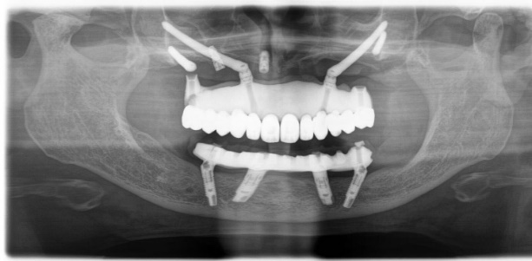**“As a Maxillofacial Surgeon, I’m typically referred the most complex implant cases - medically, psychologically, and surgically. These patients often have multiple implants placed over years by different dentists, using different systems. Components may have failed, and bone loss is common, requiring reconstruction. They’re often older, unwell, on multiple medications, and understandably disheartened after failed treatments. While I can manage the medical and surgical aspects, identifying the implant systems is a major challenge for both me and my prosthodontist. If implant components were consistently recorded in a Registry, we could quickly identify what’s in place and plan replacements more efficiently. It would make surgery safer, faster, and more predictable." Anonymous Surgeon, MBBS, BDS, FRACDS(OMS)**

**“A patient presented to my practice requiring the removal of a tooth and insertion of a new implant. Adjacent to the proposed implant is an existing, healed implant. To reduce the risk that the new implant will not integrate and be lost (post-surgical complications), I required details about the existing implant.**

**Unfortunately, the patient couldn’t recall when or where it was placed, he believed it may have been done somewhere interstate. Despite our efforts, we were unable to retrieve the implant information in a timely manner.**

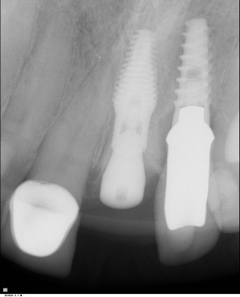**If the information was recorded in a registry with the information easily accessible, then I would have been able perform the procedure with the lowest (nearly negligible) complication rate for my patient. Without this information I wouldn’t know what tools are needed to remove the crown and if I used inappropriate tools, I risk damaging the components which may result in the loss of the implant crown (present on the old implant). This can mean that the clinician must cover costs of damage to the implant and hence many clinicians are hesitant to select this treatment option, which can mean the patient does not receive the treatment of best practice with the lowest complication rate.**

**This case highlights how the lack of accessible information regarding a previously placed implant can directly compromise the outcome of a new implant procedure or the maintenance and repair of existing implants.”** **Anonymous Periodontist**

The Therapeutic Goods Administration has formally recognised the importance of DIR, recommending that dental implants be registered with the DIR or My Health Record as the best practice.[27] As the DIR gains wider recognition and becomes more integrated into clinical practice, more dental implant procedures are expected to be registered and tracked, ultimately enhancing service efficiency and improving patient outcomes.

## **APF registry logo**

**Oz-POTS** registry advocates for an ICD code in Australia

**Corresponding Author**

Dr Marie-Claire Seeley, PhD, MNurse, RN

**Contact**

[marie-claire.seeley@adelaide.edu.au](mailto:marie-claire.seeley@adelaide.edu.au)

**Website**

Australian POTS Foundation – Postural Orthostatic Tachycardia Syndrome

(<https://potsfoundation.org.au/>)

### IMPACT STATEMENT

Until recently, Australia had not recognised postural orthostatic tachycardia syndrome (POTS) with its own unique International Classification of Diseases (ICD) code. Without a unique code, POTS is frequently misclassified, leading to poor understanding of the burden of the condition, misdiagnoses, and treatment delays. In conjunction with the University of Adelaide, the Australian POTS Foundation (APF) used data from the Australian POTS Registry (Oz-POTS) to support advocacy efforts aimed at addressing these issues, highlighting diagnostic delays and the reduced quality of life experienced by those with the condition. The APF successfully lobbied the Independent Health and Aged Care Pricing Authority (IHACPA) for the recognition of POTS. As a result, the unique ICD code is now part of nationally mandated practice, having been adopted into the ICD-10- AM/ACHI/ACS Thirteenth Edition, 2025. This is expected to improve diagnostic accuracy, enable more appropriate treatment for individuals living with POTS, and assist in tracking healthcare costs and resource use.

### Case study

Postural orthostatic tachycardia syndrome (POTS) is a condition that results from dysfunction of the autonomic nervous system. POTS has a major impact on the health-related quality of life for those affected.[28] The World Health Organisation (WHO) has allocated a unique code for POTS in the International Classification of Diseases (ICD) Eleventh Edition. Until recently, Australia had not recognised POTS with its own ICD classification. Instead, it has been classified under a residual code for other disorders of the autonomic nervous system. Without a unique code, POTS is frequently misclassified, leading to limited understanding of the burden of the condition, misdiagnoses, treatment delays and gaps in reimbursement.

In collaboration with the University of Adelaide, the Australian POTS Foundation established the first Australian patient registry for POTS. The Australian POTS Registry (Oz-POTS) aims to better understand the clinical presentation, management, healthcare utilisation and prognosis of POTS in Australia. Oz-POTS registry data has been used by the Australian POTS Foundation to support advocacy efforts aimed at addressing these issues. This includes drawing upon research evidence produced using registry data, highlighting diagnostic delays of 7 years for women and 3.8 years for men[29] as well as the reduced quality of life experienced by those with the condition.25

The Australian POTS Foundation successfully lobbied the Independent Health and Aged Care Pricing Authority (IHACPA) for the recognition of POTS.[30] The unique ICD code will now be part of nationally mandated practice, having been adopted into the ICD-10-AM/ACHI/ACS Thirteenth Edition, the classification system used in hospitals across Australia. The code is scheduled for implementation in July 2025 and will be supported by resources for clinicians and consumers to enhance awareness and improve documentation. This includes resources such as electronic code lists and hard copy manuals, which will become available in Australia from May 2025. In addition, guidelines released prior to July will enable clinicians and healthcare providers to start using the new code in clinical practice.

Adding this code to the Australian healthcare system is expected to improve diagnostic accuracy, enable more appropriate treatment for individuals living with the POTS, and assist in tracking healthcare costs and resource use. These changes are essential for informed decision-making, better resource allocation and advancing future research efforts for POTS.



Leveraging Existing Data to Generate Evidence and Inform National Aged Care Policy and Reforms: **The Registry of Senior Australians (ROSA)**

**Corresponding Author**

ROSA Research Centre Manager

**Contact**

[ROSA@sahmri.com](mailto:ROSA@sahmri.com) , (08) 8128 4622

**Website**

[SAHMRI | Registry of Senior Australians (ROSA) Research Centre](https://sahmri.org.au/research/programs/registry-centre/groups/rosa) (https://sahmri.org.au/research/programs/registry-centre/groups/rosa)

### IMPACT STATEMENT

**Expansion of the Quality Indicator Program and ROSA’s role in aged care reform**

Previously there has been a lack of reliable, accessible and comprehensive data on safety and quality in the aged care sector, and existing data has not been adequately integrated nor analysed to inform improvements in care. The Registry of Senior Australians (ROSA) team contributed significantly to the Royal Commission into Aged Care Quality and Safety (2018-21), providing two reports on international quality and safety monitoring and four using ROSA’s monitoring system. In response to ROSA's recommendations, the Australian Senate passed a motion calling for routine monitoring and public reporting of aged care quality indicators at the service provider level.34 The Commission’s final report in March 2021 recommended expanding the National Quality Indicator (QI) Program, influenced by ROSA’s work.35 ROSA continues to provide evidence and technical advisory input for aged care reforms, including the expansion of the QI Program by informing the recent development of additional staffing36 and home care quality indicators.37

### IMPACT STATEMENT

**Leveraging the ROSA to address overuse of antipsychotics in aged care**

People living with dementia can experience behaviour changes like aggression and agitation, often leading to antipsychotic prescriptions in aged care.38 Inappropriate use of these drugs was a major concern but the extent of this was unknown. The Registry of Senior Australians (ROSA) team produced two commissioned reports on psychotropic medicine use in aged care.40,41 Evidence compiled by the ROSA team using data from the ROSA Historical National cohort showed the transition to residential care was associated with a rise in initiation of antipsychotics.35 This work influenced the Royal Commission’s Interim recommendation in 2019 for a response to the significant over-reliance on chemical restraint by antipsychotics,42 adoption of changes to the Pharmaceutical Benefits Scheme in 2020 which restricted antipsychotic dispensing for individuals with dementia39 and the expansion of the Quality Indicator Program in 2021 to include a medication management indicator.

### IMPACT STATEMENT

**Identifying the risks associated with long wait times through the ROSA to promote timely access to home care**

Timely access to appropriate Home Care Packages for older Australians has been part of the reform agenda over the past two decades. In 2019, the estimated wait time was between three to six months for someone with basic care needs and more than 12 months for someone with high-level care needs.42 It was unclear what the impact of waiting time was on those waiting for care. A 2019 study by the ROSA team showed prolonged wait times for Home Care Packages were associated with a higher risk of longer-term mortality as well as transition to permanent residential aged care.43 The evidence provided by ROSA informed the Royal Commission’s Interim recommendations to provide more Home Care Packages to reduce wait-time and thus, stimulated the subsequent release of 180,000 packages nationally for older Australians (2019-22) to improve access to care.

### Case study

In Australia, more than 16% (4.2 million) of the population is aged 65 years and over[31] and approximately 1.5 million people receive aged care services.[32] The Registry of Senior Australians (ROSA) was established in 2017 by a multi-institute collaborative of researchers, clinicians, aged care providers and consumer advocacy groups with the purposes of generating evidence to improve the quality of ageing and aged care services delivered to older people. The ROSA data platform contains two cohorts: Prospective cohort [South Australia only] (N=66,382 participants, 2018-2023; updated annually) and the ROSA Historical National cohort (N~3.85 million participants, 2002-2022; updated every 2 years). The ROSA data platform is built from the integration of existing aged care, health care, and social welfare datasets.[33]

The ROSA team had a significant role in the Royal Commission into Aged Care Quality and Safety (2018-21) investigations and subsequent Aged Care Reforms (2021-current), when it delivered several commission reports that informed recommendations made by the Commission and now the implementation of programs as part of the Reforms.

***ROSA produced evidence for the Australian Government Department of Health and Aged Care to expand the National Aged Care Mandatory Quality Indicator Program***

Previously there has been a lack of reliable, accessible and comprehensive data on safety and quality in the aged care sector, and existing data has not been adequately integrated nor analysed to inform improvements in care. The ROSA team made significant contributions to the Royal Commission into Aged Care Quality and Safety (2018-21) including two commissioned reports on international quality and safety monitoring and four reports using ROSA’s monitoring system. Here, ROSA provided evidence on how to measure and monitor quality of care both in residential and home care settings using Australia’s rich data landscape. In response to the recommendations made by ROSA, the Australian Senate passed a motion based on ROSA’s recommendations calling on the Australian Government to implement routine monitoring and public reporting of aged care quality indicators at the service provider level to enhance transparency and accountability.[34] In March 2021, the Royal Commission released its final report[35] in which the Commission recommended the expansion of the National Quality Indicator Program, a call informed by ROSA’s work.

Following the Royal Commission, ROSA contributed evidence and technical advisory input through commissioned work for the Australian Government Aged Care Reforms. ROSA has provided evidence and expert consultation for the National Quality Indicator Program expansion, including the latest development of staffing Quality Indicators for enrolled nurses, allied health professionals, and lifestyle officers, to be implemented in 2025.[36] In 2024, ROSA also provided evidence to support the development of home care quality indicators which are yet to be implemented.[37]

***ROSA influenced how antipsychotics are utilised and monitored in aged care settings***

People living with dementia may experience changed behaviours, such as aggression, agitation and delusions.  Prescription of antipsychotics for people with these behaviours and symptoms occurs most commonly in residential aged care facilities.[38] Inappropriate prescribing of antipsychotic medicines is a major concern for older people.[39]

ROSA produced two commissioned reports on psychotropic medicine use before and after entering residential aged care.[40], [41] Evidence compiled by the ROSA team using data from the ROSA Historical National cohort showed the transition to residential care was associated with a rise in initiation of antipsychotics.38

The work produced by ROSA influenced the Royal Commission’s Interim recommendation in 2019 for a response to the significant over-reliance on chemical restraint by antipsychotics,[42] informed changes to the Pharmaceutical Benefits Scheme in 2020 which restricted antipsychotic dispensing for individuals with dementia9 and informed the expansion of the Quality Indicator Program in 2021 to improve antipsychotic monitoring through the addition of the medication management indicator.

The study conducted by the ROSA team38 was also chosen as one of the top 10 2020 studies published in the Australia’s leading general medical journal, the Medical Journal of Australia, highlighting the academic impact and quality of the evidence.

***ROSA provided evidence and increased the urgency for the release of extra Home Care Packages for older Australians waiting* *for care***

Timely access to appropriate Home Care Packages for older Australians has been part of the reform agenda over the past two decades. In 2019, the estimated wait time was between three to six months for someone with basic care needs and more than 12 months for someone with high-level care needs.42 It was unclear what the impact of waiting time was on those waiting for care.43

A 2019 study by the ROSA team showed prolonged wait times for home care packaged were associated with a higher risk of longer-term mortality as well as transition to permanent residential aged care.[43]

The evidence provided by ROSA informed the Commission’s Interim recommendations to provide more home care packaged to reduce wait-time42 and thus, stimulated the subsequent release of 180,000 home care packages nationally for older Australians (2019-22) to improve access to care.

**Conclusion**

In 2024, the ROSA Research Centre was nationally recognised by the Australian Government’s Office of the Inspector-General of Aged Care in its inaugural statutory report on the **‘Implementation of the Recommendations of the Royal Commission into Aged Care Quality and Safety’**.[44] The Inspector-General recommended ‘**that the government examine the potential of [ROSA] SAHMRI’s work in a national context, and how it can be best supported to achieve its full potential.’** This national recognition of ROSA is reflective of how the ROSA team have pioneered the use of big data and high-quality analytics in the aged care sector.

By leveraging ROSA’s infrastructure and expertise in population health surveillance, epidemiology, medical informatics, statistics, data science and combining it with significant clinical and aged care expertise, the ROSA team has provided new insights into how to evaluate cross-setting care, the current quality of care provided nationally, and tools that can be used to improve care.



A linkage study using **SABDR** data and its application in shaping South Australian clinical practice

**Corresponding Authors**

Dr Catherine Gibson, PhD and Heather Scott, BMgmt

**Contact**

[sabdr@sa.gov.au](mailto:sabdr@sa.gov.au)

**Website**

[Women’s and Children’s Hospital • Birth Defects Register](https://www.wch.sa.gov.au/professionals/registers/birth-defects-register) (<https://www.wch.sa.gov.au/professionals/registers/birth-defects-register>)

### IMPACT STATEMENT

In 2016, the South Australian Birth Defects Register (SABDR) partnered with the University of Adelaide and the Pregnancy Outcomes Statistics Unit to identify perinatal risk factors for late-diagnosed Developmental Dysplasia of the Hip (DDH), an abnormal development of the hip joint, and assess the current state of DDH diagnoses in Australia. This linkage study resulted in updates to the South Australian Perinatal Practice Guidelines for DDH screening and management. A direct referral pathway to the Women’s and Children’s Hospital Hip Clinic was also introduced, along with a ‘Train the Trainer’ program for Child and Family Health Service (CaFHS) nurses to implement the new guidelines. Between August 2020 and May 2023, 325 patients were referred to the Women’s and Children’s Hospital Hip Clinic from the new CaFHS referral pathway, with 13 of them requiring treatment for DDH. These efforts demonstrate how registry data is being translated into evidence-based clinical practice, promoting earlier diagnosis and treatment of DDH.

### Case study

The South Australian Birth Defects Register (SABDR) is a population-based register in South Australia (SA) administered by the Women’s and Children’s Health Network. The SABDR collects information on children born in SA on or after 1st January 1986 who have a significant congenital anomaly detected in the first five years of life.

Developmental dysplasia of the hip (DDH) describes an abnormal development of the hip joint. Early detection and treatment of DDH in newborns is important, as late diagnosis is associated with a significant risk of poorer treatment outcomes and increased complications.[45] In SA, DDH is a notifiable condition and SABDR receives notifications of all cases of DDH diagnosed during the first five years of life.

A 2016 linkage study of data collected by the SABDR and the Pregnancy Outcomes Statistics Unit of the SA Department of Health aimed to determine whether there are identifiable perinatal risk factors associated with late diagnosed DDH in babies born in SA between 2003 and 2009.[46] Additionally, they reviewed the treatment required for patients with late diagnosed DDH, screening practices at the time, and strategies to address the increased incidence of late diagnosed DDH in Australia. The authoring team of the study represents a collaboration between SABDR, the Women’s and Children’s Hospital, the University of Adelaide and the Pregnancy Outcomes Statistics Unit.

The findings of the collaborative study contributed evidence to the South Australian Perinatal Practice Guidelines for Neonatal Hip Screening and Management of Developmental Dysplasia of the Hip (2017), specifically the sections of the guidelines pertaining to Risk Factors and Screening.[47] The guidelines highlight risk factors for late diagnosed DDH identified in the SABDR linkage study including birth in a rural hospital as well as protective factors such as breech presentation. Regarding screening, the guidelines emphasise that ultrasound is not recommended for screening in DDH because of insufficient evidence of benefit in preventing late diagnosis of DDH - a finding supported by the study’s results. As state-wide practice recommendations, the guidelines reach clinicians across the SA Health landscape, enabling them to make evidence-based decisions in their practice.

The establishment of a direct referral pathway and a new learning package for Child and Family Health Services (CaFHS) nurses occurred alongside the introduction of the new guidelines. The direct referral pathway enables CaFHS nurses to refer babies directly to the Women’s and Children’s Hospital Hip Clinic, replacing the previous, more complex referral pathway. This simplified and direct pathway reduces the time to diagnosis. A capacity-building opportunity for CaFHS nurses was provided through a 'Train the Trainer' approach, supporting the implementation of the referral pathway and clinical guidelines. Between August 2020 and May 2023, 325 patients were referred to the Women’s and Children’s Hospital Hip Clinic from the new CaFHS referral pathway, with 13 of them requiring treatment for DDH.



## Driving practice change to improve preoperative risk assessment compliance in emergency laparotomy: The **ANZELA–QI** impact at Midland and Bunbury Hospitals

**Corresponding Authors**

Dr Lettie Pule, PhD and Dr Helena Kopunic, PhD

**Contact**

[Anzela-qi@surgeons.org](mailto:Anzela-qi@surgeons.org)

**Website**

ANZ Emergency Laparotomy Audit – Quality Improvement | RACS

(<https://www.surgeons.org/research-audit/morbidity-audits/morbidity-audits-managed-by-racs/anz-emergency-laparotomy-audit-quality-improvement>)

### IMPACT STATEMENT

Preoperative risk assessment (PRA) using the National Emergency Laparotomy Audit (NELA) risk of mortality tool is a key performance indicator (KPI) that guides surgical decision-making, escalates care when required and supports avoidance of futile procedures. Benchmarking through the Australia and New Zealand Emergency Laparotomy Audit–Quality Improvement (ANZELA–QI) program revealed suboptimal compliance at several Western Australian hospitals, including Midland and Bunbury. Both hospitals introduced a change in departmental practice, requiring that PRA be documented prior to emergency laparotomy. This shift, modelled on the local high-performing Sir Charles Gairdner Hospital (SCGH), was supported by strong clinical leadership and embedded into routine workflows. This change was supported and monitored through the ANZELA–QI program, which provided ongoing feedback using statistical process control (SPC) charts and KPI reporting. Following the change in practice, Midland Hospital improved from 66.7% in February 2023 to 100% compliance in February 2025, while Bunbury Hospital improved from 28.5% in February 2023 to 58.3% compliance in February 2025, both showing measurable improvements supported by SPC chart trends. Both hospitals have near complete data so the observation will have high reliability. These improvements exceeded the national average of 44.6%, positioning both hospitals as local exemplars of audit-driven improvement.

### Case study

Emergency laparotomy (EL) is a high-risk surgical procedure often performed in acutely unwell patients. Key performance indicators (KPIs) continue to evolve to reflect best practice in EL care. Preoperative risk assessment (PRA) using the National Emergency Laparotomy Audit (NELA) risk of mortality score is a key performance indicator (KPI PRE 3) guiding surgical decision-making and escalating care in high-risk patients and supporting avoidance of futile procedures. National benchmarking through the Australia and New Zealand Emergency Laparotomy Audit–Quality Improvement (ANZELA–QI) program revealed suboptimal compliance at several hospitals in Western Australia (WA). Notably, the recording of PRA at St John of God Midland (Midland) and Bunbury hospitals in the start of the audit was poor. In contrast, Sir Charles Gairdner (SCGH) had a high compliance rate as it has always had a policy of requiring a PRA when an EL was booked.

As both Midland and Bunbury hospitals came to appreciate the better performance at SCGH they actively updated their departmental protocols to require that a PRA be documented before proceeding to theatre.

Figure 3 Proportion of patients for whom a risk assessment was preoperative was performed and documented preoperatively by audit period (2022-23 vs 2023-25)

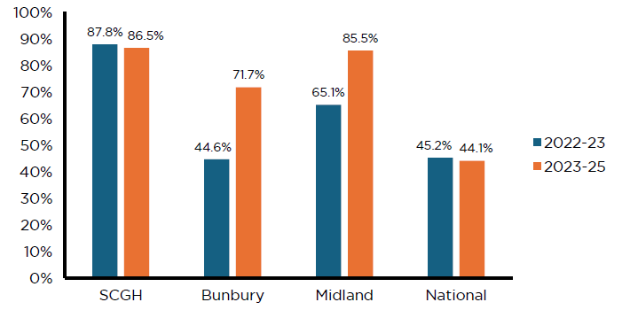

**View the data table for Figure 3 at Appendix Table 2 Risk Assessment**

Both hospitals reported approximately 0% missing data for EL cases, suggesting that data quality improved alongside clinical compliance (Figure 3).

This change in practice was operationalised with support from the heads of department, who demonstrated strong local clinical leadership. The goal of the policy was to embed PRA completion into routine preoperative workflows and foster a culture of accountability and patient-centred care.

The latest analysis shows Midland and Bunbury hospitals have an unadjusted postoperative mortality rate that is significantly lower than expected (below 3 standard deviations from the mean) (data not shown). This is likely to reflect their comprehensive engagement in ANZELA–QI. As local and national exemplars of audit-driven improvements, it is important to outer metropolitan and rural hospitals that excellent delivery at these hospitals is recognised.

This change in practice was supported and monitored through the ANZELA–QI program, which provided ongoing feedback using statistical process control (SPC) charts and KPI reporting (Figure 4). The intervention leveraged the audit’s capacity to benchmark performance and identify areas requiring targeted quality improvement.

Following the change in practice, Midland Hospital improved from 66.7% in February 2023 to 100% compliance in February 2025, while Bunbury Hospital improved from 28.5% in February 2023 to 58.3% compliance in February 2025, both showing measurable improvements supported by SPC chart trends (Figure 4). These improvements exceeded the national average of 44.6% over the full reporting period (2022-2025), positioning both hospitals as local exemplars of audit-driven improvement.

This case highlights how targeted practice changes, supported by local clinical leadership and real-time audit data, can drive measurable improvements in surgical practice. The ANZELA–QI program provided the benchmarking and feedback infrastructure to identify deficiencies and monitor intervention impacts. The change in practice and communication between teams at Midland and Bunbury demonstrates how audit data can be translated into clinical governance strategies that enhance quality of care, reduce the risk of futile surgery, and promote evidence-based, shared surgical decision-making.

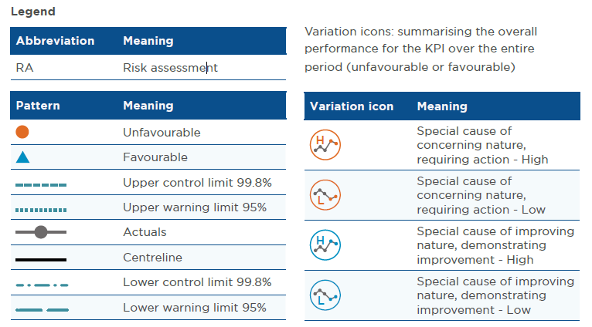

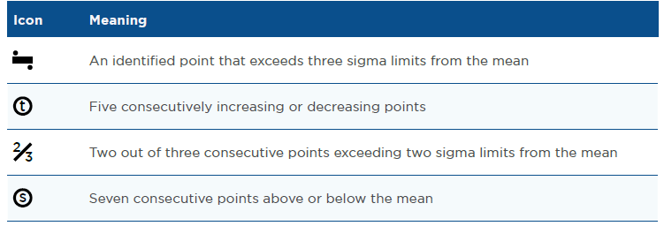

### ****ANZELA-QI Hospital results****

Figure 4 Proportion of cases meeting KPI PRE 3 (proportion of patients for whom a risk assessment was performed and documented preoperatively) for each hospital within the state

**Albany Hospital Results**

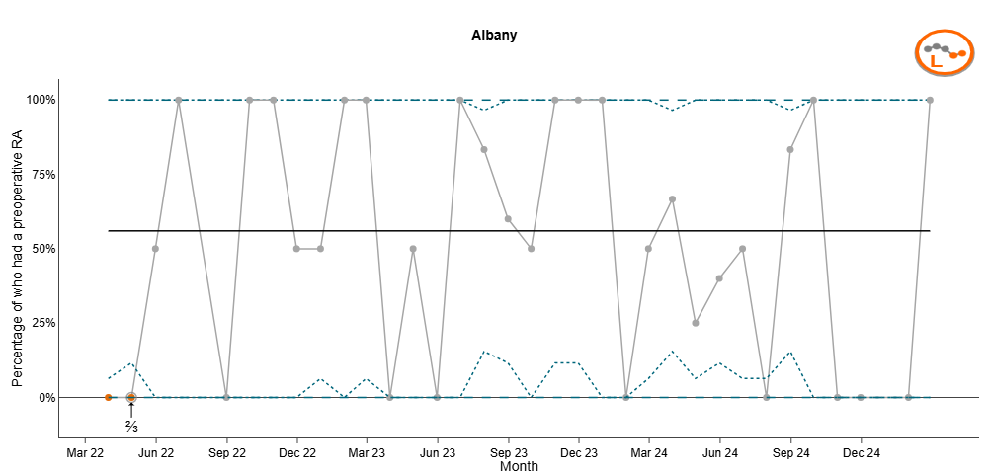

**View the data table for Albany hospital at Appendix Table 3**

**Bunbury Hospital Results**

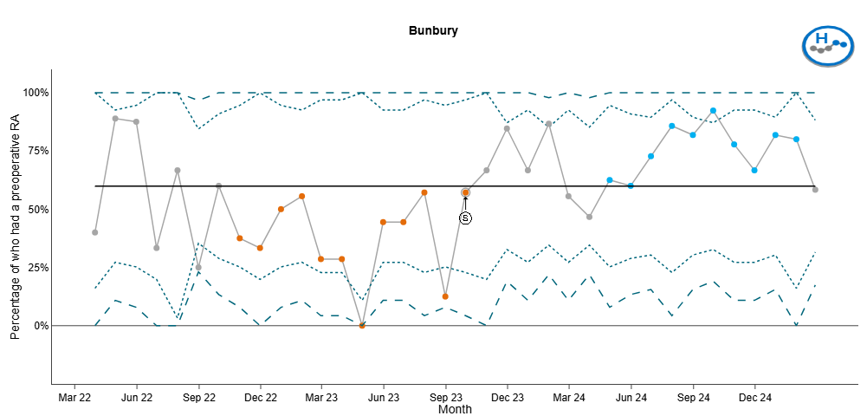

**View the data table for Bunbury hospital at Appendix Table 4**

**Fiona Stanley Hospital Results**

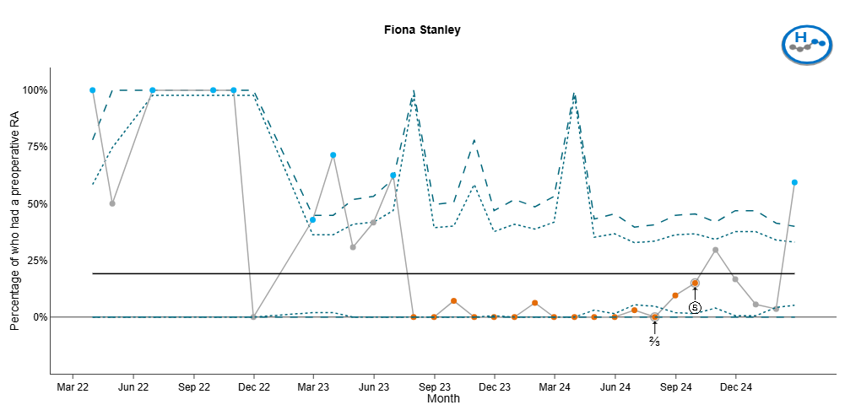

**View the data table for Fiona Stanley at Appendix Table 5**

**Midland Hospital Results**

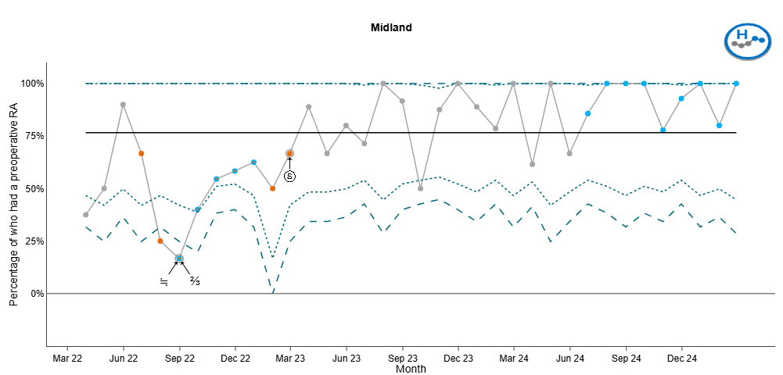

**View the data table for Midland hospital at Appendix Table 6**

**Royal Perth Hospital Results**

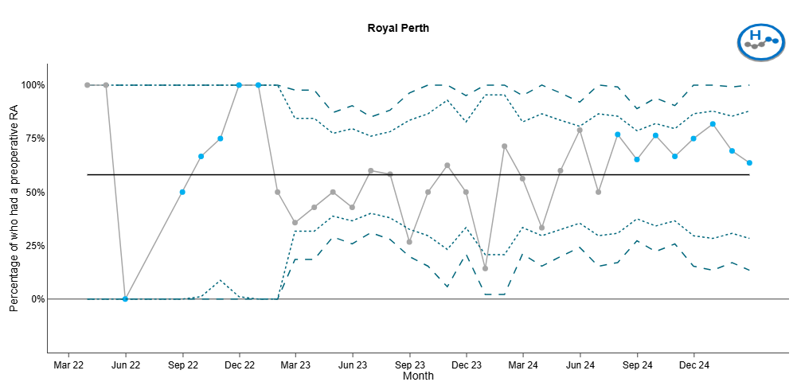

**View the data table for Royal Perth hospital at Appendix Table 7**

**Sir Charles Gairdner Hospital Results**

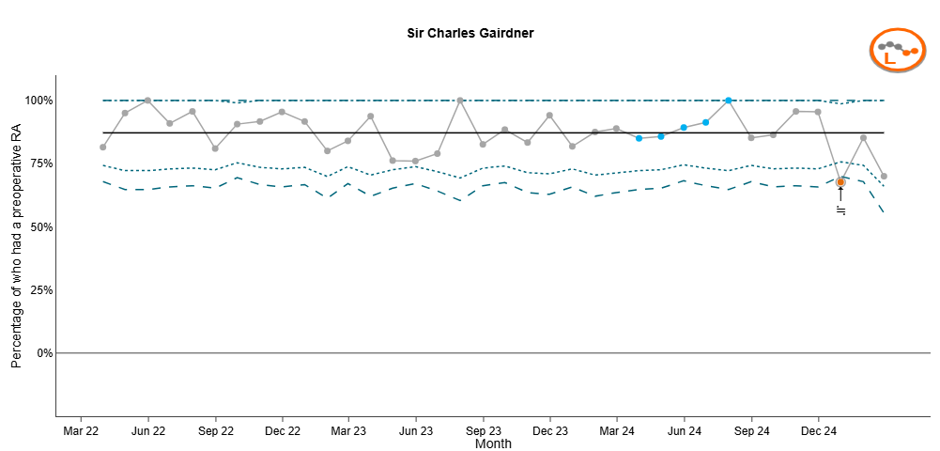

**View the data table for Sir Charles Gairdner hospital at Appendix Table 8**



Developing a tool to identify non-technical errors in surgical care using **ANZASM**

**Corresponding Author**

Dr Helena Kopunic, PhD

**Contact**

[Anzasm.RACS@surgeons.org](mailto:Anzasm.RACS@surgeons.org)

**Website**

Surgical mortality audits | RACS

(<https://www.surgeons.org/research-audit/surgical-mortality-audits>)

### IMPACT STATEMENT

Up to half of all surgical adverse events are due to non-technical errors, making non-technical skill assessment and improvement a priority. However, evidence to guide non-technical skill improvement is lacking and no specific tools have been available to retrospectively identify non-technical errors that have occurred in surgical patient care. The development of a new tool, the System for Identification and Categorisation of Non-technical Error in Surgical Settings (SICNESS), utilised surgical mortality data from the Australian and New Zealand Audit of Surgical Mortality (ANZASM) alongside expert opinion and literature review. The SICNESS enables retrospective identification and categorisation of non-technical errors. The tool has since been applied in academic studies, including an 8-year retrospective audit of ANZASM data which identified national priorities for non-technical skill improvement. In addition, local South Australian clinicians plan to implement the tool to assess improvements in response to their efforts in promoting education around non-technical skills for surgeons, to ultimately reduce the number of future non-technical errors.

Appendix: Data Tables

## ANZOD

Table 1 ANZOD Utility and Equity

|  |  |  |
| --- | --- | --- |
| **Model** | **Utility** | **Equity** |
| Current system | 66% | 67% |
| New system | 74% | 69% |

# ANZELA-QI proportion of patients with risk assessment

Table 2 Risk Assessment

|  |  |  |
| --- | --- | --- |
| **Hospital** | **2022-23** | **2023-25** |
| SCGH | 87.8% | 86.5% |
| Bunbury | 44.6% | 71.7% |
| Midland | 65.1% | 85.5% |
| National | 45.2% | 44.1% |

# ANZELA-QI data tables with individual hospital results

Table 3 Albany hospital results

|  |  |  |  |  |  |  |  |  |  |  |
| --- | --- | --- | --- | --- | --- | --- | --- | --- | --- | --- |
| **Month** | **Numer- ator** | **Denom- inator** | **Propor- tion** | **Standard of error** | **Actuals** | **Lower warning limit 95%** | **Upper warning limit 95%** | **Lower control limit 99%** | **Upper control limit 99%** | **Centre- line** |
| Mar 22 | 0 | 4 | 0.0 | 0.0 | 0.0 | 0.0 | 0.0 | 0.0 | 0.0 | 56 |
| Apr 22 | 0 | 5 | 0.0 | 0.0 | 0.0 | 0.0 | 0.0 | 0.0 | 0.0 | 56 |
| May 22 | 1 | 2 | 0.5 | 0.4 | 50.0 | 0.0 | 100.0 | 0.0 | 100.0 | 56 |
| Jun 22 | 1 | 1 | 1.0 | 0.0 | 100.0 | 100.0 | 100.0 | 100.0 | 100.0 | 56 |
| Aug 22 | 0 | 1 | 0.0 | 0.0 | 0.0 | 0.0 | 0.0 | 0.0 | 0.0 | 56 |
| Sep 22 | 1 | 1 | 1.0 | 0.0 | 100.0 | 100.0 | 100.0 | 100.0 | 100.0 | 56 |
| Oct 22 | 2 | 2 | 1.0 | 0.0 | 100.0 | 100.0 | 100.0 | 100.0 | 100.0 | 56 |
| Nov 22 | 1 | 2 | 0.5 | 0.4 | 50.0 | 0.0 | 100.0 | 0.0 | 100.0 | 56 |
| Dec 22 | 2 | 4 | 0.5 | 0.3 | 50.0 | 1.0 | 99.0 | 0.0 | 100.0 | 56 |
| Jan 23 | 3 | 3 | 1.0 | 0.0 | 100.0 | 100.0 | 100.0 | 100.0 | 100.0 | 56 |
| Feb 23 | 4 | 4 | 1.0 | 0.0 | 100.0 | 100.0 | 100.0 | 100.0 | 100.0 | 56 |
| Mar 23 | 0 | 2 | 0.0 | 0.0 | 0.0 | 0.0 | 0.0 | 0.0 | 0.0 | 56 |
| Apr 23 | 1 | 2 | 0.5 | 0.4 | 50.0 | 0.0 | 100.0 | 0.0 | 100.0 | 56 |
| May 23 | 0 | 1 | 0.0 | 0.0 | 0.0 | 0.0 | 0.0 | 0.0 | 0.0 | 56 |
| Jun 23 | 1 | 1 | 1.0 | 0.0 | 100.0 | 100.0 | 100.0 | 100.0 | 100.0 | 56 |
| Jul 23 | 5 | 6 | 0.8 | 0.2 | 83.3 | 53.5 | 100.0 | 44.1 | 100.0 | 56 |
| Aug 23 | 3 | 5 | 0.6 | 0.2 | 60.0 | 17.1 | 100.0 | 3.6 | 100.0 | 56 |
| Sep 23 | 1 | 2 | 0.5 | 0.4 | 50.0 | 0.0 | 100.0 | 0.0 | 100.0 | 56 |
| Oct 23 | 5 | 5 | 1.0 | 0.0 | 100.0 | 100.0 | 100.0 | 100.0 | 100.0 | 56 |
| Nov 23 | 5 | 5 | 1.0 | 0.0 | 100.0 | 100.0 | 100.0 | 100.0 | 100.0 | 56 |
| Dec 23 | 1 | 1 | 1.0 | 0.0 | 100.0 | 100.0 | 100.0 | 100.0 | 100.0 | 56 |
| Jan 24 | 0 | 1 | 0.0 | 0.0 | 0.0 | 0.0 | 0.0 | 0.0 | 0.0 | 56 |
| Feb 24 | 2 | 4 | 0.5 | 0.3 | 50.0 | 1.0 | 99.0 | 0.0 | 100.0 | 56 |
| Mar 24 | 4 | 6 | 0.7 | 0.2 | 66.7 | 29.0 | 100.0 | 17.1 | 100.0 | 56 |
| Apr 24 | 1 | 4 | 0.3 | 0.2 | 25.0 | 0.0 | 67.4 | 0.0 | 80.8 | 56 |
| May 24 | 2 | 5 | 0.4 | 0.2 | 40.0 | 0.0 | 82.9 | 0.0 | 96.4 | 56 |
| Jun 24 | 2 | 4 | 0.5 | 0.3 | 50.0 | 1.0 | 99.0 | 0.0 | 100.0 | 56 |
| Jul 24 | 0 | 4 | 0.0 | 0.0 | 0.0 | 0.0 | 0.0 | 0.0 | 0.0 | 56 |
| Aug 24 | 5 | 6 | 0.8 | 0.2 | 83.3 | 53.5 | 100.0 | 44.1 | 100.0 | 56 |
| Sep 24 | 2 | 2 | 1.0 | 0.0 | 100.0 | 100.0 | 100.0 | 100.0 | 100.0 | 56 |
| Oct 24 | 0 | 1 | 0.0 | 0.0 | 0.0 | 0.0 | 0.0 | 0.0 | 0.0 | 56 |
| Nov 24 | 0 | 2 | 0.0 | 0.0 | 0.0 | 0.0 | 0.0 | 0.0 | 0.0 | 56 |
| Jan 25 | 0 | 1 | 0.0 | 0.0 | 0.0 | 0.0 | 0.0 | 0.0 | 0.0 | 56 |
| Feb 25 | 1 | 1 | 1.0 | 0.0 | 100.0 | 100.0 | 100.0 | 100.0 | 100.0 | 56 |

Table 4 Bunbury hospital results

|  |  |  |  |  |  |  |  |  |  |  |
| --- | --- | --- | --- | --- | --- | --- | --- | --- | --- | --- |
| **Month** | **Numer- ator** | **Denom- inator** | **Propor- tion** | **Standard of error** | **Actuals** | **Lower warning limit 95%** | **Upper warning limit 95%** | **Lower control limit 99%** | **Upper control limit 99%** | **Centre- line** |
| Mar 22 | 2 | 5 | 0.4 | 0.2 | 40.0 | 0.0 | 82.9 | 0.0 | 96.4 | 60 |
| Apr 22 | 8 | 9 | 0.9 | 0.1 | 88.9 | 68.4 | 100.0 | 61.9 | 100.0 | 60 |
| May 22 | 7 | 8 | 0.9 | 0.1 | 87.5 | 64.6 | 100.0 | 57.4 | 100.0 | 60 |
| Jun 22 | 2 | 6 | 0.3 | 0.2 | 33.3 | 0.0 | 71.1 | 0.0 | 82.9 | 60 |
| Jul 22 | 2 | 3 | 0.7 | 0.3 | 66.7 | 13.3 | 100.0 | 0.0 | 100.0 | 60 |
| Aug 22 | 4 | 16 | 0.3 | 0.1 | 25.0 | 3.8 | 46.2 | 0.0 | 52.9 | 60 |
| Sep 22 | 6 | 10 | 0.6 | 0.2 | 60.0 | 29.6 | 90.4 | 20.1 | 99.9 | 60 |
| Oct 22 | 3 | 8 | 0.4 | 0.2 | 37.5 | 4.0 | 71.1 | 0.0 | 81.6 | 60 |
| Nov 22 | 2 | 6 | 0.3 | 0.2 | 33.3 | 0.0 | 71.1 | 0.0 | 82.9 | 60 |
| Dec 22 | 4 | 8 | 0.5 | 0.2 | 50.0 | 15.4 | 84.7 | 4.5 | 95.5 | 60 |
| Jan 23 | 5 | 9 | 0.6 | 0.2 | 55.6 | 23.1 | 88.0 | 12.9 | 98.2 | 60 |
| Feb 23 | 2 | 7 | 0.3 | 0.2 | 28.6 | 0.0 | 62.0 | 0.0 | 72.6 | 60 |
| Mar 23 | 2 | 7 | 0.3 | 0.2 | 28.6 | 0.0 | 62.0 | 0.0 | 72.6 | 60 |
| Apr 23 | 0 | 4 | 0.0 | 0.0 | 0.0 | 0.0 | 0.0 | 0.0 | 0.0 | 60 |
| May 23 | 4 | 9 | 0.4 | 0.2 | 44.4 | 12.0 | 76.9 | 1.8 | 87.1 | 60 |
| Jun 23 | 4 | 9 | 0.4 | 0.2 | 44.4 | 12.0 | 76.9 | 1.8 | 87.1 | 60 |
| Jul 23 | 4 | 7 | 0.6 | 0.2 | 57.1 | 20.5 | 93.8 | 9.0 | 100.0 | 60 |
| Aug 23 | 1 | 8 | 0.1 | 0.1 | 12.5 | 0.0 | 35.4 | 0.0 | 42.6 | 60 |
| Sep 23 | 4 | 7 | 0.6 | 0.2 | 57.1 | 20.5 | 93.8 | 9.0 | 100.0 | 60 |
| Oct 23 | 4 | 6 | 0.7 | 0.2 | 66.7 | 29.0 | 100.0 | 17.1 | 100.0 | 60 |
| Nov 23 | 11 | 13 | 0.8 | 0.1 | 84.6 | 65.0 | 100.0 | 58.8 | 100.0 | 60 |
| Dec 23 | 6 | 9 | 0.7 | 0.2 | 66.7 | 35.9 | 97.5 | 26.2 | 100.0 | 60 |
| Jan 24 | 13 | 15 | 0.9 | 0.1 | 86.7 | 69.5 | 100.0 | 64.1 | 100.0 | 60 |
| Feb 24 | 5 | 9 | 0.6 | 0.2 | 55.6 | 23.1 | 88.0 | 12.9 | 98.2 | 60 |
| Mar 24 | 7 | 15 | 0.5 | 0.1 | 46.7 | 21.4 | 71.9 | 13.5 | 79.9 | 60 |
| Apr 24 | 5 | 8 | 0.6 | 0.2 | 62.5 | 29.0 | 96.1 | 18.4 | 100.0 | 60 |
| May 24 | 6 | 10 | 0.6 | 0.2 | 60.0 | 29.6 | 90.4 | 20.1 | 99.9 | 60 |
| Jun 24 | 8 | 11 | 0.7 | 0.1 | 72.7 | 46.4 | 99.1 | 38.1 | 100.0 | 60 |
| Jul 24 | 6 | 7 | 0.9 | 0.1 | 85.7 | 59.8 | 100.0 | 51.6 | 100.0 | 60 |
| Aug 24 | 9 | 11 | 0.8 | 0.1 | 81.8 | 59.0 | 100.0 | 51.9 | 100.0 | 60 |
| Sep 24 | 12 | 13 | 0.9 | 0.1 | 92.3 | 77.8 | 100.0 | 73.3 | 100.0 | 60 |
| Oct 24 | 7 | 9 | 0.8 | 0.1 | 77.8 | 50.6 | 100.0 | 42.1 | 100.0 | 60 |
| Nov 24 | 6 | 9 | 0.7 | 0.2 | 66.7 | 35.9 | 97.5 | 26.2 | 100.0 | 60 |
| Dec 24 | 9 | 11 | 0.8 | 0.1 | 81.8 | 59.0 | 100.0 | 51.9 | 100.0 | 60 |
| Jan 25 | 4 | 5 | 0.8 | 0.2 | 80.0 | 44.9 | 100.0 | 33.9 | 100.0 | 60 |
| Feb 25 | 7 | 12 | 0.6 | 0.1 | 58.3 | 30.4 | 86.2 | 21.7 | 95.0 | 60 |

Table 5 Fiona Stanley hospital results

|  |  |  |  |  |  |  |  |  |  |  |
| --- | --- | --- | --- | --- | --- | --- | --- | --- | --- | --- |
| **Month** | **Numer- ator** | **Denom- inator** | **Propor- tion** | **Standard of error** | **Actuals** | **Lower warning limit 95%** | **Upper warning limit 95%** | **Lower control limit 99%** | **Upper control limit 99%** | **Centre- line** |
| Mar 22 | 4 | 4 | 1.0 | 0.0 | 100.0 | 100.0 | 100.0 | 100.0 | 100.0 | 19 |
| Apr 22 | 1 | 2 | 0.5 | 0.4 | 50.0 | 0.0 | 100.0 | 0.0 | 100.0 | 19 |
| Jun 22 | 1 | 1 | 1.0 | 0.0 | 100.0 | 100.0 | 100.0 | 100.0 | 100.0 | 19 |
| Sep 22 | 1 | 1 | 1.0 | 0.0 | 100.0 | 100.0 | 100.0 | 100.0 | 100.0 | 19 |
| Oct 22 | 1 | 1 | 1.0 | 0.0 | 100.0 | 100.0 | 100.0 | 100.0 | 100.0 | 19 |
| Nov 22 | 0 | 1 | 0.0 | 0.0 | 0.0 | 0.0 | 0.0 | 0.0 | 0.0 | 19 |
| Feb 23 | 9 | 21 | 0.4 | 0.1 | 42.9 | 21.7 | 64.0 | 15.0 | 70.7 | 19 |
| Mar 23 | 15 | 21 | 0.7 | 0.1 | 71.4 | 52.1 | 90.8 | 46.0 | 96.8 | 19 |
| Apr 23 | 4 | 13 | 0.3 | 0.1 | 30.8 | 5.7 | 55.9 | 0.0 | 63.7 | 19 |
| May 23 | 5 | 12 | 0.4 | 0.1 | 41.7 | 13.8 | 69.6 | 5.0 | 78.3 | 19 |
| Jun 23 | 5 | 8 | 0.6 | 0.2 | 62.5 | 29.0 | 96.1 | 18.4 | 100.0 | 19 |
| Jul 23 | 0 | 1 | 0.0 | 0.0 | 0.0 | 0.0 | 0.0 | 0.0 | 0.0 | 19 |
| Aug 23 | 0 | 15 | 0.0 | 0.0 | 0.0 | 0.0 | 0.0 | 0.0 | 0.0 | 19 |
| Sep 23 | 1 | 14 | 0.1 | 0.1 | 7.1 | 0.0 | 20.6 | 0.0 | 24.9 | 19 |
| Oct 23 | 0 | 4 | 0.0 | 0.0 | 0.0 | 0.0 | 0.0 | 0.0 | 0.0 | 19 |
| Nov 23 | 0 | 18 | 0.0 | 0.0 | 0.0 | 0.0 | 0.0 | 0.0 | 0.0 | 19 |
| Dec 23 | 0 | 13 | 0.0 | 0.0 | 0.0 | 0.0 | 0.0 | 0.0 | 0.0 | 19 |
| Jan 24 | 1 | 16 | 0.1 | 0.1 | 6.3 | 0.0 | 18.1 | 0.0 | 21.8 | 19 |
| Feb 24 | 0 | 12 | 0.0 | 0.0 | 0.0 | 0.0 | 0.0 | 0.0 | 0.0 | 19 |
| Mar 24 | 0 | 1 | 0.0 | 0.0 | 0.0 | 0.0 | 0.0 | 0.0 | 0.0 | 19 |
| Apr 24 | 0 | 24 | 0.0 | 0.0 | 0.0 | 0.0 | 0.0 | 0.0 | 0.0 | 19 |
| May 24 | 0 | 20 | 0.0 | 0.0 | 0.0 | 0.0 | 0.0 | 0.0 | 0.0 | 19 |
| Jun 24 | 1 | 33 | 0.0 | 0.0 | 3.0 | 0.0 | 8.9 | 0.0 | 10.7 | 19 |
| Jul 24 | 0 | 30 | 0.0 | 0.0 | 0.0 | 0.0 | 0.0 | 0.0 | 0.0 | 19 |
| Aug 24 | 2 | 21 | 0.1 | 0.1 | 9.5 | 0.0 | 22.1 | 0.0 | 26.0 | 19 |
| Sep 24 | 3 | 20 | 0.2 | 0.1 | 15.0 | 0.0 | 30.7 | 0.0 | 35.6 | 19 |
| Oct 24 | 8 | 27 | 0.3 | 0.1 | 29.6 | 12.4 | 46.9 | 7.0 | 52.3 | 19 |
| Nov 24 | 3 | 18 | 0.2 | 0.1 | 16.7 | 0.0 | 33.9 | 0.0 | 39.3 | 19 |
| Dec 24 | 1 | 18 | 0.1 | 0.1 | 5.6 | 0.0 | 16.1 | 0.0 | 19.5 | 19 |
| Jan 25 | 1 | 28 | 0.0 | 0.0 | 3.6 | 0.0 | 10.5 | 0.0 | 12.6 | 19 |
| Feb 25 | 19 | 32 | 0.6 | 0.1 | 59.4 | 42.4 | 76.4 | 37.0 | 81.7 | 19 |

Table 6 Midland hospital results

|  |  |  |  |  |  |  |  |  |  |  |
| --- | --- | --- | --- | --- | --- | --- | --- | --- | --- | --- |
| **Month** | **Numer- ator** | **Denom- inator** | **Propor- tion** | **Standard of error** | **Actuals** | **Lower warning limit 95%** | **Upper warning limit 95%** | **Lower control limit 99%** | **Upper control limit 99%** | **Centre- line** |
| Mar 22 | 3 | 8 | 0.4 | 0.2 | 37.5 | 4.0 | 71.1 | 0.0 | 81.6 | 77 |
| Apr 22 | 3 | 6 | 0.5 | 0.2 | 50.0 | 10.0 | 90.0 | 0.0 | 100.0 | 77 |
| May 22 | 9 | 10 | 0.9 | 0.1 | 90.0 | 71.4 | 100.0 | 65.6 | 100.0 | 77 |
| Jun 22 | 4 | 6 | 0.7 | 0.2 | 66.7 | 29.0 | 100.0 | 17.1 | 100.0 | 77 |
| Jul 22 | 2 | 8 | 0.3 | 0.2 | 25.0 | 0.0 | 55.0 | 0.0 | 64.4 | 77 |
| Aug 22 | 1 | 6 | 0.2 | 0.2 | 16.7 | 0.0 | 46.5 | 0.0 | 55.9 | 77 |
| Sep 22 | 2 | 5 | 0.4 | 0.2 | 40.0 | 0.0 | 82.9 | 0.0 | 96.4 | 77 |
| Oct 22 | 6 | 11 | 0.5 | 0.2 | 54.6 | 25.1 | 84.0 | 15.9 | 93.2 | 77 |
| Nov 22 | 7 | 12 | 0.6 | 0.1 | 58.3 | 30.4 | 86.2 | 21.7 | 95.0 | 77 |
| Dec 22 | 5 | 8 | 0.6 | 0.2 | 62.5 | 29.0 | 96.1 | 18.4 | 100.0 | 77 |
| Jan 23 | 1 | 2 | 0.5 | 0.4 | 50.0 | 0.0 | 100.0 | 0.0 | 100.0 | 77 |
| Feb 23 | 4 | 6 | 0.7 | 0.2 | 66.7 | 29.0 | 100.0 | 17.1 | 100.0 | 77 |
| Mar 23 | 8 | 9 | 0.9 | 0.1 | 88.9 | 68.4 | 100.0 | 61.9 | 100.0 | 77 |
| Apr 23 | 6 | 9 | 0.7 | 0.2 | 66.7 | 35.9 | 97.5 | 26.2 | 100.0 | 77 |
| May 23 | 8 | 10 | 0.8 | 0.1 | 80.0 | 55.2 | 100.0 | 47.4 | 100.0 | 77 |
| Jun 23 | 10 | 14 | 0.7 | 0.1 | 71.4 | 47.8 | 95.1 | 40.3 | 100.0 | 77 |
| Jul 23 | 7 | 7 | 1.0 | 0.0 | 100.0 | 100.0 | 100.0 | 100.0 | 100.0 | 77 |
| Aug 23 | 11 | 12 | 0.9 | 0.1 | 91.7 | 76.0 | 100.0 | 71.1 | 100.0 | 77 |
| Sep 23 | 7 | 14 | 0.5 | 0.1 | 50.0 | 23.8 | 76.2 | 15.6 | 84.4 | 77 |
| Oct 23 | 14 | 16 | 0.9 | 0.1 | 87.5 | 71.3 | 100.0 | 66.2 | 100.0 | 77 |
| Nov 23 | 12 | 12 | 1.0 | 0.0 | 100.0 | 100.0 | 100.0 | 100.0 | 100.0 | 77 |
| Dec 23 | 8 | 9 | 0.9 | 0.1 | 88.9 | 68.4 | 100.0 | 61.9 | 100.0 | 77 |
| Jan 24 | 11 | 14 | 0.8 | 0.1 | 78.6 | 57.1 | 100.0 | 50.3 | 100.0 | 77 |
| Feb 24 | 8 | 8 | 1.0 | 0.0 | 100.0 | 100.0 | 100.0 | 100.0 | 100.0 | 77 |
| Mar 24 | 8 | 13 | 0.6 | 0.1 | 61.5 | 35.1 | 88.0 | 26.8 | 96.3 | 77 |
| Apr 24 | 6 | 6 | 1.0 | 0.0 | 100.0 | 100.0 | 100.0 | 100.0 | 100.0 | 77 |
| May 24 | 6 | 9 | 0.7 | 0.2 | 66.7 | 35.9 | 97.5 | 26.2 | 100.0 | 77 |
| Jun 24 | 12 | 14 | 0.9 | 0.1 | 85.7 | 67.4 | 100.0 | 61.6 | 100.0 | 77 |
| Jul 24 | 11 | 11 | 1.0 | 0.0 | 100.0 | 100.0 | 100.0 | 100.0 | 100.0 | 77 |
| Aug 24 | 8 | 8 | 1.0 | 0.0 | 100.0 | 100.0 | 100.0 | 100.0 | 100.0 | 77 |
| Sep 24 | 11 | 11 | 1.0 | 0.0 | 100.0 | 100.0 | 100.0 | 100.0 | 100.0 | 77 |
| Oct 24 | 7 | 9 | 0.8 | 0.1 | 77.8 | 50.6 | 100.0 | 42.1 | 100.0 | 77 |
| Nov 24 | 13 | 14 | 0.9 | 0.1 | 92.9 | 79.4 | 100.0 | 75.1 | 100.0 | 77 |
| Dec 24 | 8 | 8 | 1.0 | 0.0 | 100.0 | 100.0 | 100.0 | 100.0 | 100.0 | 77 |
| Jan 25 | 8 | 10 | 0.8 | 0.1 | 80.0 | 55.2 | 100.0 | 47.4 | 100.0 | 77 |
| Feb 25 | 7 | 7 | 1.0 | 0.0 | 100.0 | 100.0 | 100.0 | 100.0 | 100.0 | 77 |

Table 7 Royal Perth hospital results

|  |  |  |  |  |  |  |  |  |  |  |
| --- | --- | --- | --- | --- | --- | --- | --- | --- | --- | --- |
| **Month** | **Numer- ator** | **Denom- inator** | **Propor- tion** | **Standard of error** | **Actuals** | **Lower warning limit 95%** | **Upper warning limit 95%** | **Lower control limit 99%** | **Upper control limit 99%** | **Centre- line** |
| Mar 22 | 2 | 2 | 1.0 | 0.0 | 100.0 | 100.0 | 100.0 | 100.0 | 100.0 | 58 |
| Apr 22 | 1 | 1 | 1.0 | 0.0 | 100.0 | 100.0 | 100.0 | 100.0 | 100.0 | 58 |
| May 22 | 0 | 1 | 0.0 | 0.0 | 0.0 | 0.0 | 0.0 | 0.0 | 0.0 | 58 |
| Aug 22 | 1 | 2 | 0.5 | 0.4 | 50.0 | 0.0 | 100.0 | 0.0 | 100.0 | 58 |
| Sep 22 | 2 | 3 | 0.7 | 0.3 | 66.7 | 13.3 | 100.0 | 0.0 | 100.0 | 58 |
| Oct 22 | 3 | 4 | 0.8 | 0.2 | 75.0 | 32.6 | 100.0 | 19.2 | 100.0 | 58 |
| Nov 22 | 3 | 3 | 1.0 | 0.0 | 100.0 | 100.0 | 100.0 | 100.0 | 100.0 | 58 |
| Dec 22 | 1 | 1 | 1.0 | 0.0 | 100.0 | 100.0 | 100.0 | 100.0 | 100.0 | 58 |
| Jan 23 | 1 | 2 | 0.5 | 0.4 | 50.0 | 0.0 | 100.0 | 0.0 | 100.0 | 58 |
| Feb 23 | 5 | 14 | 0.4 | 0.1 | 35.7 | 10.6 | 60.8 | 2.7 | 68.7 | 58 |
| Mar 23 | 6 | 14 | 0.4 | 0.1 | 42.9 | 16.9 | 68.8 | 8.8 | 76.9 | 58 |
| Apr 23 | 13 | 26 | 0.5 | 0.1 | 50.0 | 30.8 | 69.2 | 24.7 | 75.3 | 58 |
| May 23 | 9 | 21 | 0.4 | 0.1 | 42.9 | 21.7 | 64.0 | 15.0 | 70.7 | 58 |
| Jun 23 | 18 | 30 | 0.6 | 0.1 | 60.0 | 42.5 | 77.5 | 37.0 | 83.0 | 58 |
| Jul 23 | 14 | 24 | 0.6 | 0.1 | 58.3 | 38.6 | 78.1 | 32.4 | 84.3 | 58 |
| Aug 23 | 4 | 15 | 0.3 | 0.1 | 26.7 | 4.3 | 49.1 | 0.0 | 56.1 | 58 |
| Sep 23 | 6 | 12 | 0.5 | 0.1 | 50.0 | 21.7 | 78.3 | 12.8 | 87.2 | 58 |
| Oct 23 | 5 | 8 | 0.6 | 0.2 | 62.5 | 29.0 | 96.1 | 18.4 | 100.0 | 58 |
| Nov 23 | 8 | 16 | 0.5 | 0.1 | 50.0 | 25.5 | 74.5 | 17.8 | 82.2 | 58 |
| Dec 23 | 1 | 7 | 0.1 | 0.1 | 14.3 | 0.0 | 40.2 | 0.0 | 48.4 | 58 |
| Jan 24 | 5 | 7 | 0.7 | 0.2 | 71.4 | 38.0 | 100.0 | 27.4 | 100.0 | 58 |
| Feb 24 | 9 | 16 | 0.6 | 0.1 | 56.3 | 31.9 | 80.6 | 24.3 | 88.2 | 58 |
| Mar 24 | 4 | 12 | 0.3 | 0.1 | 33.3 | 6.7 | 60.0 | 0.0 | 68.4 | 58 |
| Apr 24 | 9 | 15 | 0.6 | 0.1 | 60.0 | 35.2 | 84.8 | 27.4 | 92.6 | 58 |
| May 24 | 15 | 19 | 0.8 | 0.1 | 79.0 | 60.6 | 97.3 | 54.9 | 100.0 | 58 |
| Jun 24 | 6 | 12 | 0.5 | 0.1 | 50.0 | 21.7 | 78.3 | 12.8 | 87.2 | 58 |
| Jul 24 | 10 | 13 | 0.8 | 0.1 | 76.9 | 54.0 | 99.8 | 46.8 | 100.0 | 58 |
| Aug 24 | 15 | 23 | 0.7 | 0.1 | 65.2 | 45.8 | 84.7 | 39.6 | 90.8 | 58 |
| Sep 24 | 13 | 17 | 0.8 | 0.1 | 76.5 | 56.3 | 96.6 | 50.0 | 100.0 | 58 |
| Oct 24 | 14 | 21 | 0.7 | 0.1 | 66.7 | 46.5 | 86.8 | 40.2 | 93.2 | 58 |
| Nov 24 | 9 | 12 | 0.8 | 0.1 | 75.0 | 50.5 | 99.5 | 42.8 | 100.0 | 58 |
| Dec 24 | 9 | 11 | 0.8 | 0.1 | 81.8 | 59.0 | 100.0 | 51.9 | 100.0 | 58 |
| Jan 25 | 9 | 13 | 0.7 | 0.1 | 69.2 | 44.1 | 94.3 | 36.3 | 100.0 | 58 |
| Feb 25 | 7 | 11 | 0.6 | 0.1 | 63.6 | 35.2 | 92.1 | 26.3 | 100.0 | 58 |

Table 8 Sir Charles Gairdner hospital results

|  |  |  |  |  |  |  |  |  |  |  |
| --- | --- | --- | --- | --- | --- | --- | --- | --- | --- | --- |
| **Month** | **Numer- ator** | **Denom- inator** | **Propor- tion** | **Standard of error** | **Actuals** | **Lower warning limit 95%** | **Upper warning limit 95%** | **Lower control limit 99%** | **Upper control limit 99%** | **Centre- line** |
| Mar 22 | 22 | 27 | 0.8 | 0.1 | 81.5 | 66.8 | 96.1 | 62.2 | 100.0 | 87 |
| Apr 22 | 19 | 20 | 1.0 | 0.0 | 95.0 | 85.5 | 100.0 | 82.5 | 100.0 | 87 |
| May 22 | 20 | 20 | 1.0 | 0.0 | 100.0 | 100.0 | 100.0 | 100.0 | 100.0 | 87 |
| Jun 22 | 20 | 22 | 0.9 | 0.1 | 90.9 | 78.9 | 100.0 | 75.1 | 100.0 | 87 |
| Jul 22 | 22 | 23 | 1.0 | 0.0 | 95.7 | 87.3 | 100.0 | 84.7 | 100.0 | 87 |
| Aug 22 | 17 | 21 | 0.8 | 0.1 | 81.0 | 64.2 | 97.8 | 58.9 | 100.0 | 87 |
| Sep 22 | 29 | 32 | 0.9 | 0.1 | 90.6 | 80.5 | 100.0 | 77.4 | 100.0 | 87 |
| Oct 22 | 22 | 24 | 0.9 | 0.1 | 91.7 | 80.6 | 100.0 | 77.1 | 100.0 | 87 |
| Nov 22 | 21 | 22 | 1.0 | 0.0 | 95.5 | 86.8 | 100.0 | 84.0 | 100.0 | 87 |
| Dec 22 | 22 | 24 | 0.9 | 0.1 | 91.7 | 80.6 | 100.0 | 77.1 | 100.0 | 87 |
| Jan 23 | 12 | 15 | 0.8 | 0.1 | 80.0 | 59.8 | 100.0 | 53.4 | 100.0 | 87 |
| Feb 23 | 21 | 25 | 0.8 | 0.1 | 84.0 | 69.6 | 98.4 | 65.1 | 100.0 | 87 |
| Mar 23 | 15 | 16 | 0.9 | 0.1 | 93.8 | 81.9 | 100.0 | 78.2 | 100.0 | 87 |
| Apr 23 | 16 | 21 | 0.8 | 0.1 | 76.2 | 58.0 | 94.4 | 52.3 | 100.0 | 87 |
| May 23 | 19 | 25 | 0.8 | 0.1 | 76.0 | 59.3 | 92.7 | 54.0 | 98.0 | 87 |
| Jun 23 | 15 | 19 | 0.8 | 0.1 | 79.0 | 60.6 | 97.3 | 54.9 | 100.0 | 87 |
| Jul 23 | 14 | 14 | 1.0 | 0.0 | 100.0 | 100.0 | 100.0 | 100.0 | 100.0 | 87 |
| Aug 23 | 19 | 23 | 0.8 | 0.1 | 82.6 | 67.1 | 98.1 | 62.3 | 100.0 | 87 |
| Sep 23 | 23 | 26 | 0.9 | 0.1 | 88.5 | 76.2 | 100.0 | 72.3 | 100.0 | 87 |
| Oct 23 | 15 | 18 | 0.8 | 0.1 | 83.3 | 66.1 | 100.0 | 60.7 | 100.0 | 87 |
| Nov 23 | 16 | 17 | 0.9 | 0.1 | 94.1 | 82.9 | 100.0 | 79.4 | 100.0 | 87 |
| Dec 23 | 18 | 22 | 0.8 | 0.1 | 81.8 | 65.7 | 97.9 | 60.6 | 100.0 | 87 |
| Jan 24 | 14 | 16 | 0.9 | 0.1 | 87.5 | 71.3 | 100.0 | 66.2 | 100.0 | 87 |
| Feb 24 | 16 | 18 | 0.9 | 0.1 | 88.9 | 74.4 | 100.0 | 69.8 | 100.0 | 87 |
| Mar 24 | 17 | 20 | 0.9 | 0.1 | 85.0 | 69.4 | 100.0 | 64.4 | 100.0 | 87 |
| Apr 24 | 18 | 21 | 0.9 | 0.1 | 85.7 | 70.8 | 100.0 | 66.0 | 100.0 | 87 |
| May 24 | 25 | 28 | 0.9 | 0.1 | 89.3 | 77.8 | 100.0 | 74.2 | 100.0 | 87 |
| Jun 24 | 21 | 23 | 0.9 | 0.1 | 91.3 | 79.8 | 100.0 | 76.2 | 100.0 | 87 |
| Jul 24 | 20 | 20 | 1.0 | 0.0 | 100.0 | 100.0 | 100.0 | 100.0 | 100.0 | 87 |
| Aug 24 | 23 | 27 | 0.9 | 0.1 | 85.2 | 71.8 | 98.6 | 67.6 | 100.0 | 87 |
| Sep 24 | 19 | 22 | 0.9 | 0.1 | 86.4 | 72.0 | 100.0 | 67.5 | 100.0 | 87 |
| Oct 24 | 22 | 23 | 1.0 | 0.0 | 95.7 | 87.3 | 100.0 | 84.7 | 100.0 | 87 |
| Nov 24 | 21 | 22 | 1.0 | 0.0 | 95.5 | 86.8 | 100.0 | 84.0 | 100.0 | 87 |
| Dec 24 | 23 | 34 | 0.7 | 0.1 | 67.7 | 51.9 | 83.4 | 47.0 | 88.3 | 87 |
| Jan 25 | 23 | 27 | 0.9 | 0.1 | 85.2 | 71.8 | 98.6 | 67.6 | 100.0 | 87 |
| Feb 25 | 7 | 10 | 0.7 | 0.1 | 70.0 | 41.6 | 98.4 | 32.7 | 100.0 | 87 |

References

1. National Health and Medical Research Council. Research impact position statement. 2022. Accessed May 22, 2025. <https://www.nhmrc.gov.au/research-policy/research-translation-and-impact/research-impact>
2. OECD. Applying evaluation criteria thoughtfully. 2021. Accessed May 22, 2025. <https://www.oecd.org/en/publications/applying-evaluation-criteria-thoughtfully_543e84ed-en/full-report/understanding-the-six-criteria-definitions-elements-for-analysis-and-key-challenges_2843ff7d.html#section-d1e4269>
3. Searles A, Doran C, Attia J, et al. An approach to measuring and encouraging research translation and research impact. *Health Res Policy Sys*. 2025;14(1):60. doi:10.1186/s12961-016-0131-2
4. Fast Track Impact. What types of impact are there? Access May 2022, 2025. <https://www.fasttrackimpact.com/what-types-of-impact-are-there-subp>
5. Orchard JJ, La Gerche A, Puranik R*, et al.* Rationale and Design of the Australasian Registry of Screening ECGs in National Athletes Project. *J Am Heart Assoc* 2024;13:e035898. doi: 10.1161/JAHA.124.035898
6. Orchard JW, Rio E, Crossley KM, Orchard JJ, Mountjoy M. Orchard Sports Injury and Illness Classification System (OSIICS) Version 15. *J Sport Health Sci.* 2024. doi: 10.1016/j.jshs.2024.03.004
7. Australasian College of Sport and Exercise Physicians. Position statement on pre-participation cardiac evaluation in young athletes. 2024. Accessed March 11, 2025. <https://www.acsep.org.au/content/Document/Vacancies/Position%20Statement%20on%20Pre-Participation%20Cardiac%20Evaluation%20in%20Young%20Athletes%20-%202024%20UPDATED%2019_8_24.PDF>
8. Collins MG, Fahim MA, Pascoe EM et al. Balanced crystalloid solution versus saline in deceased donor kidney transplantation (BEST-Fluids): a pragmatic, double-blind, randomised, controlled trial. *Lancet*. 2023; 402(10396):105-117. doi:10.1016/S0140-6736(23)00642-6 <https://www.anzdata.org.au/>
9. Collins MG, Fahim MA, Pascoe EM et al. Baseline characteristics and representativeness of participants in the BEST-Fluids Trial: a randomised trial of balanced crystalloid solution versus saline in deceased donor kidney transplantation. *Transplantation Direct*. 2022; 8(12):e1399. doi*:*10.1097/TXD.000000000000139
10. Tunnicliffe D. CARI Guidelines: Australian and New Zealand living guideline for chronic kidney disease. 2024. Accessed May 15, 2025. <https://files.magicapp.org/guideline/e878d64e-8da7-4a5a-b709-f5490e71ee23/published_guideline_8894-3_0.pdf>
11. Patients awaiting organ transplant in Australia. Australia & New Zealand Organ Donation Registry. 2025. Accessed April 10, 2025. <https://www.anzdata.org.au/anzod/publications-2/organ-waiting-list/>.
12. Hughes JT, Cundale K, Owen KJ, McDonald SP. Advancing accessible kidney transplantation for Aboriginal and Torres Strait Islander people: the National Indigenous Kidney Transplantation Taskforce. *Med J Aust*. 2023;219 Suppl 8:S3-S6. doi:10.5694/mja2.52112
13. Tonelli M, Wiebe N, Knoll G, et al. Systematic review: kidney transplantation compared with dialysis in clinically relevant outcomes. *Am J Transplant*. 2011;11(10):2093-2109. doi:10.1111/j.1600-6143.2011.03686.
14. Hughes JT, Owen KJ, Kelly J, et al. Cultural bias in kidney care and transplantation: review and recommendations to improve kidney care for Aboriginal and Torres Strait Islander people. *Med J Aust*. 2023;219 Suppl 8:S11-S14. doi:10.5694/mja2.52110
15. **National Indigenous Kidney Transplantation Taskforce.** Final Report. 2022. Accessed May 1, 2025. ://www.niktt.com.au/_files/ugd/1f23c8_8713a934be2b471ead0aff45a1531bc9.pdf
16. National Indigenous Kidney Transplantation Taskforce (NIKTT). Home. 2025. Accessed May 1, 2025. <https://www.niktt.com.au/>
17. National Indigenous Kidney Transplantation Taskforce (NIKTT). ANZDATA. 2025. Accessed May 1, 2025. <https://www.anzdata.org.au/anzdata/research/collaboration/national-indigenous-kidney-transplantation-taskforce-niktt/>
18. Owen K, Cundale K, Hughes JT, McDonald SP, D'Antoine M, Jesudason S. From talk to action: Indigenous Reference Groups drive practice change in kidney transplantation care. Med J Aust. 2023 Oct 16;219(8 Suppl):S15–S18. doi: 10.5694/mja2.52102
19. Hughes JT, Cundale K, Webster AC, Owen KJ, McDonald SP. Towards equity in kidney transplantation: the next steps. Med J Aust. 2023 Oct 16;219(8 Suppl):S19–S22. doi: 10.5694/mja2.52111
20. Keane MC, Coffrey NE, Jones VJ, Lawson C, Mills RAD, Williams KA. Australian Corneal Graft Registry 2021/22 Report. Australian Corneal Graft Registry. 2022. Accessed March 19, 2024.

    <https://www.flinders.edu.au/content/dam/documents/research/fhmri-eye-and-vision/acgr-2021-2022-report.pdf>
21. Keratoconus treatment Corneal Collagen Cross Linking to be supported by Medicare. Royal Australian and New Zealand College of Ophthalmologists. 2018. Accessed March 19, 2024. <https://ranzco.edu/news/keratoconus-treatment-corneal-collagen-cross-linking-to-be-supported-by-medicare/>
22. Skelton K, Gorayski P, Penfold S, Murray A, Hamilton D, Yeo A, et al. Australian Particle Therapy Clinical Quality Registry (ASPIRE) protocol (TROG 21.12): a multicentre prospective study on patients with rare tumours, treated with radiation therapy. *BMJ Open*. 2024;14(11):e083044. doi: 10.1136/bmjopen-2023-083044.
23. Harris PA, Taylor R, Thielke R, Pyne J, Gonzalez N, Conde JG. Research electronic capture (REDCap)- a metadata-driven methodology and workflow process for providing translation research informatics support. *J Biomed Inform*. 2009;42(2):377-381. doi:10.1016/j.jbi.2008.08.010
24. Harris PA, Taylor R, Minor BL, Elliot V, Fernandez M, O’Neal L, et al. The REDCap consortium: Building an international community of software platform partners. *J Biomed Infrom*. 2019;95:103208. doi:10.1016/j.jbi.2019.103208
25. Luck L, Ng Chok H, Wilkes L. Nurses as participants in research: an evaluation of recruitment techniques. *Nurse Res.* 2017;25(2):44-48. doi:10.7748/nr.2017.e1546
26. Ewens B, Kemp V, Middlewick Y, Towell-Barnard A, Whitehead L. Recruitment and retention of intensive care unit survivors in follow-up studies: A systematic review. *Aust Crit Care*. 2025;38(4). doi:10.1016/j.aucc.2025.101232
27. Therapeutic Goods Administration. Regulatory changes to custom-made medical devices- information for oral and dental health industry. 2021
28. Seeley MC, Wilson Gemma, Ong E, et al. Poor health-related quality of life in postural orthostatic tachycardia syndrome in comparison with a sex- and age-matched normative population. Clin Auton Res. 2023;33(4):469-477. doi:10.1007/s10286-023-00955-9
29. Seeley MC, Wilson G, Ong E, et al. Biological sex-dependent differences in postural orthostatic tachycardia syndrome (POTS). Eur J Cardiovasc Nurs. Published online March 26, 2025. doi:10.1093/eurjcn/zvaf048
30. Seeley MC, Gallagher C, Lau D. Request for adoption of a unique International Classification of Disease Code for Postural Orthostatic Tachycardia Syndrome: request for modification to ICD-10-AM/CHI/ACS Classification 10: 13th Edition. The Australian POTS Foundation and The Australian Dysautonomia and Arrhythmia Research Collaborative. 2023. Accessed April 16, 2025. <https://potsfoundation.org.au/wp-content/uploads/2024/12/ICD-request-Modification-POTS_Submitted.pdf>
31. Australian Institute of Health and Welfare. Older Australians. July 2, 2024. Accessed April 3, 2025. <https://www.aihw.gov.au/reports/older-people/older-australians/contents/demographic-profile>
32. Department of Health and Aged Care. 2023-24 Report on the operation of the *Aged Care Act 1997*. November 29, 2024. Accessed April 3, 2025. <https://www.gen-agedcaredata.gov.au/resources/publications/2024/november/2023%E2%80%9324-report-on-the-operation-of-the-aged-care-act-1997>
33. Inacio M, Caughey GE, Wesselingh S,et al. Registry of Senior Australians (ROSA): integrating cross-sectoral information to evaluate quality and safety of care provided to older people. *BMJ Open*. 2022 Nov 17;12(11):e066390. doi: 10.1136/bmjopen-2022-066390.
34. Commonwealth of Australia. Senate. Hansard, page 3951. 25 August 2020, (Stirling Griff, South Australian Senator).
35. Royal Commission into Aged Care Quality and Safety final report - volume 1: summary and recommendations. Commonwealth of Australia. March 1, 2021. Accessed April 3, 2025. https://www.royalcommission.gov.au/system/files/2024-03/aged-care-rc-final-report-volume-1.pdf.
36. Department of Health and Aged Care. Expanding the national aged care mandatory quality indicator program: staffing QIs final report. January 30, 2025. Accessed April 3, 2025. <https://www.health.gov.au/resources/publications/expanding-the-national-aged-care-mandatory-quality-indicator-program-staffing-qis-final-report?language=en>
37. Department of Health and Aged Care. Establishment of a national aged care mandatory quality indicator program for in-home aged care services consultation paper. May 28, 2024. Accessed April 3, 2025. <https://www.health.gov.au/resources/publications/QI-program-in-home-care-consultation-paper>
38. Harrison SL, Sluggett JK, Lang C, et al. The dispensing of psychotropic medicines to older people before and after they enter residential aged care. *Med J Aust*. 2020 Apr;212(7):309-13. doi:10.5694/mja2.50501.
39. Australian Institute of Health and Welfare. Dementia in Australia. September 13, 2024. Accessed April 3, 2025. <https://www.aihw.gov.au/reports/dementia/dementia-in-aus/contents/health-services-used-by-people-with-dementia/antipsychotics-and-other-medications>
40. Inacio MC, Harrison SL, Lang C, Sluggett JK, Wesselingh S. Antipsychotic medicines dispensed before and after entering residential aged care: preliminary report and findings from the national historical cohort of the Registry of Older South Australians. Registry of Older South Australians. 2019. Accessed April 3, 2025. <https://webarchive.nla.gov.au/awa/20210122083647/https://agedcare.royalcommission.gov.au/system/files/2020-06/RCD.9999.0103.0001.pdf>
41. Inacio MC, Harrison SL, Lang C, Sluggett JK, Wesselingh S. Antidepressants and benzodiazepines medicines dispensed before and after entering residential aged care: preliminary report and findings from the national historical cohort of the Registry of Older South Australians. Registry of Older South Australians. 2019. Accessed April 3, 2025. <https://trove.nla.gov.au/work/239409986>
42. Royal Commission into Aged Care Quality and Safety interim report: neglect - volume 1. Commonwealth of Australia. October 31, 2019. Accessed April 3, 2025. <https://www.royalcommission.gov.au/system/files/2021-03/interim-report-volume-1.pdf>
43. Visvanathan R, Amare AT, Wesselingh S, et al. Prolonged Wait Time Prior to Entry to Home Care Packages Increases the Risk of Mortality and Transition to Permanent Residential Aged Care Services: Findings from the Registry of Older South Australians (ROSA). *J Nutr Health Aging*. 2019;23(3):271-280. doi:10.1007/s12603-018-1145
44. Office of the Inspector General of Aged Care. 2024 progress report on the implementation of the recommendations of the Royal Commission into Aged Care Quality and Safety. August 1, 2024. Accessed April 3, 2025. <https://www.igac.gov.au/resources/2024-progress-report-implementation-recommendations-royal-commission-aged-care-quality-and-safety>
45. Williams N. Improving early detection of developmental dysplasia of the hip through general practitioner assessment and surveillance. Aust J Gen Pract. 2018 Sep;47(9):619-623.
46. Studer K, Williams N, Antoniou G, Gibson C, Scott H, Scheil WK, et al. Increase in late diagnosed developmental dysplasia of the hip in South Australia: risk factors, proposed solutions. Med J Aust. 2016 April 14;204(6):240.
47. Morris S. Neonatal Hip Screening and Management of Developmental Dysplasia of the Hip. 2017. Accessed March 3, 2025. <http://www.sahealth.sa.gov.au/perinatal>