Changes coming to care minutes funding
The Australian Government is introducing changes to the way it funds the delivery of care minutes for residential aged care providers of non-specialised services in metropolitan areas. This fact sheet explains how it will work and when the changes will commence.

Key information
- Care funding will be linked to the delivery of care minutes in all non-specialised aged care homes in metropolitan areas.
- Specialised Homeless services and services in regional, rural and remote areas will not be impacted by this change.
- To make sure providers are meeting care minute targets and to ensure funding is used for its intended purpose, impacted services not meeting their targets will see their care funding reduce from April 2026. The amount will depend on the services’ care minutes performance from the October – December quarter of 2025 onwards.
- The deferral of the commencement of the Aged Care Act 2024 to November 2025 will not change the timing of this policy change.

What is the funding change, and how will it work?
Care funding will be linked to the delivery of care minutes through a new care minutes supplement.
The AN-ACC funding model is how Government funds providers to deliver care, including delivering their care minutes.
Under this funding change, the amount of Base Care Tariff (BCT) funding for MM1 non-specialised services will be reduced by 0.113 of the National Weighted Activity Unit (NWAU) from 1 April 2026.
This amounts to $33.41 per bed day based on the AN-ACC price from 1 October 2025 of $295.64.
The equivalent of this BCT funding will be redirected into a new care minutes supplement. You will receive some or all of the care minutes supplement depending on your care minutes performance.
From 1 April 2026, the maximum amount of supplement payable will be equivalent to the reduction in the BCT funding (0.113 NWAU).
If you meet your care minute targets, you will not see any change in the funding you receive.

Who will the funding change apply to?
This funding change will apply to non-specialised services in metropolitan areas only. There will not be any funding changes to services with Specialised Homeless status and those operating in regional, rural and remote areas.
Metropolitan areas are defined by services operating in Monash Model (MM) 1 areas. Over 60% of aged care services are located in MM1.

Why is this change being introduced?
Although overall average care funding for each day of care has increased by around 59% since September 2022 care time reporting shows a significant proportion of providers are not meeting their care minutes targets. In the July – September quarter of 2024, only 45% of all services met both their care minute targets. Compliance rates are even lower for services in metropolitan areas (43%). This is despite consistent feedback from the sector that workforce shortages are most acute in regional, rural and remote areas.
This change aims to lift compliance with care minutes requirements by metropolitan services to ensure Government’s substantial investment in residential aged care leads to more care for residents as intended. It will also ensure Government is not providing funding for care minutes not being delivered.

When will the funding change start?
You will begin to see funding changes from April 2026. These will be based on your care minutes reported for the October - December quarter 2025 in the Quarterly Financial Report.
You do not need to apply for the care minutes supplement. Services Australia will automatically pay the relevant supplement amount each month over the following 3 months.
For example, care time data for the October – December 2025 quarter will determine the supplement payable for April, May and June 2026 (see Illustration 1).

Illustration 1 – Timeline of changes to care minutes funding

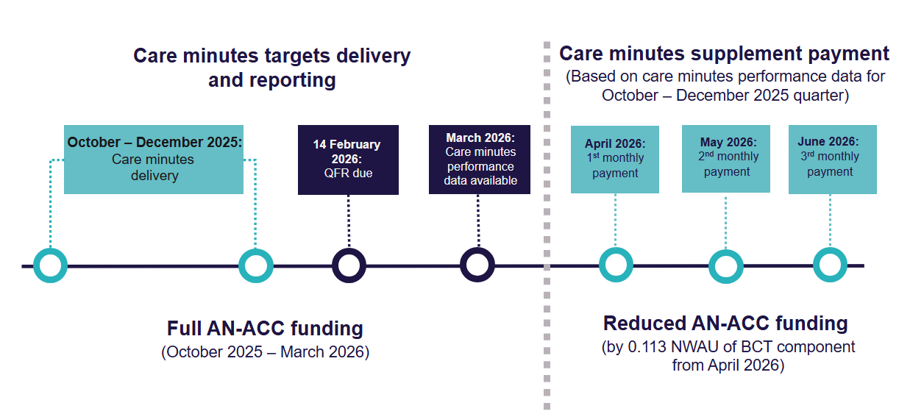

How will the supplement rate be calculated?
The new care minutes supplement works on a sliding scale. You will receive more funding the closer you were to delivering your care minutes targets in the previous quarter.
For example, if you meet 100% or more of both your total care minute and registered nurse (RN) care minutes targets you will receive the maximum supplement of $33.41 per bed day. This is the full value of your reduced BCT funding.
If you do not meet one or both of your targets, you will see a reduction in your care minutes supplement, and therefore your overall funding.
You can use the online care minutes supplement estimator to check the funding you may receive from April 2026. This is an estimator only. The actual amount of supplement will vary based on various factors, including the AN-ACC price at the time and your care minutes performance data.
Table 1 outlines the matrix for the supplement rates payable using current AN-ACC pricing, based on the percentage of care minutes delivered in the relevant period.
Your percentage of registered nurse care minutes delivered will include care time from enrolled nurses of up to 10% of your target. This is in addition to actual care time delivered by registered nurses only.
Table 1: Care minutes supplement
 | % of RN Care Minutes Delivered
% of Total Care Minutes Delivered | <85% | ≥85% - <87.5% | ≥87.5% - <90% | ≥90% - <92.5% | ≥92.5% - <95% | ≥95% - <97.5% | ≥97.5% - <100% | ≥100%
<85% | $0 | $0.59 | $1.18 | $1.77 | $2.37 | $2.66 | $2.96 | $2.96
≥85% - <87.5% | $5.62 | $6.21 | $6.80 | $7.10 | $7.69 | $8.28 | $8.28 | $8.57
≥87.5% - <90% | $10.94 | $11.53 | $12.12 | $12.71 | $13.30 | $13.90 | $13.90 | $14.19
≥90% - <92.5% | $16.56 | $17.15 | $17.74 | $18.33 | $18.92 | $19.51 | $19.51 | $19.81
≥92.5% - <95% | $22.17 | $22.76 | $23.36 | $23.95 | $24.24 | $24.83 | $24.83 | $25.13
≥95% - <97.5% | $27.79 | $28.09 | $28.68 | $29.27 | $29.86 | $30.45 | $30.45 | $30.75
≥97.5% - <100% | $28.38 | $28.97 | $29.56 | $29.86 | $30.45 | $30.75 | $31.04 | $31.34
≥100% | $30.45 | $31.04 | $31.63 | $32.22 | $32.52 | $32.82 | $33.11 | $33.41
New and transferred services* | $ 33.41
+ The rates in the table are based on the $295.64 AN-ACC price (from 1 October 2025)
*Rate applicable for up to 4 quarters (inclusive)

Will there be any impact on funding of other services such as allied health and lifestyle/recreational services?
No. The Government will continue to fund the delivery of required allied health and lifestyle/recreational services in full through the AN-ACC and this change will not impact funding for the provision of these services. Providers must ensure they continue provide allied health and lifestyle/recreational services consistent with their obligations under the relevant legislation.

Additional assurance processes
Starting as part of their 2025-26 ACFR, all residential aged care providers will be required to prepare and submit a new Care Minutes Performance Statement.
Providers must also engage a registered company auditor to complete an audit of their Care Minutes Performance Statement, which includes information about:
- direct care minutes delivered
- associated labour hours and costs
- RN coverage
- occupied bed days
To better understand new reporting requirements, refer to Care Minutes Performance Statement guidance.

