Bulk Billing Incentives Calculator

User guide for practice managers and GPs

September 2025

# The Bulk Billing Incentives Calculator overview

The Bulk Billing Incentives Calculator (the calculator) has been developed by the Department of Health, Disability and Ageing to estimate payments from expanded eligibility for MBS bulk billing incentives (BBIs) and the Bulk Billing Practice Incentive Program (BBPIP) introduced 1 November 2025.

This guide is supported with detailed step-by-step instructions at Appendix 1: Calculator steps.

Please note when using the calculator:

* The calculator will be pre-filled with data based on averages on BBPIP MBS eligible services for similar practices, when you select your Modified Monash Model location
* Ensure all data is entered as accurately as possible. Using estimates may result in misleading outputs
* After viewing results, you can adjust and update your data for further estimates or reset everything to start again
* The results are indicative only. It is recommended you seek independent financial and/or business advice with respect to your decisions to participate in BBPIP
* Additional notes are provided throughout the calculator for clarification on definitions and requirements
* Frequently Asked Questions (FAQs) are available at the end of the calculator.

## 1. Accessing the calculator

Go to the [health.gov.au/BBPIP](https://www.health.gov.au/our-work/upcoming-changes-to-bulk-billing-incentives-in-general-practice) page on the Department of Health, Disability and Ageing website. Click the **Bulk Billing Incentives Calculator** tile to start or read more by selecting the **Bulk Billing Incentives Calculator** link.

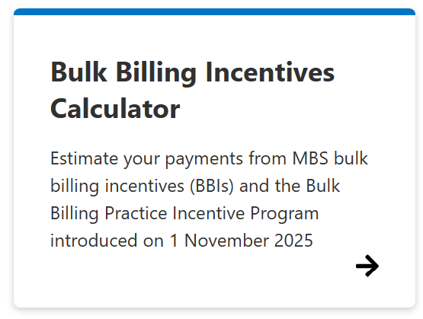

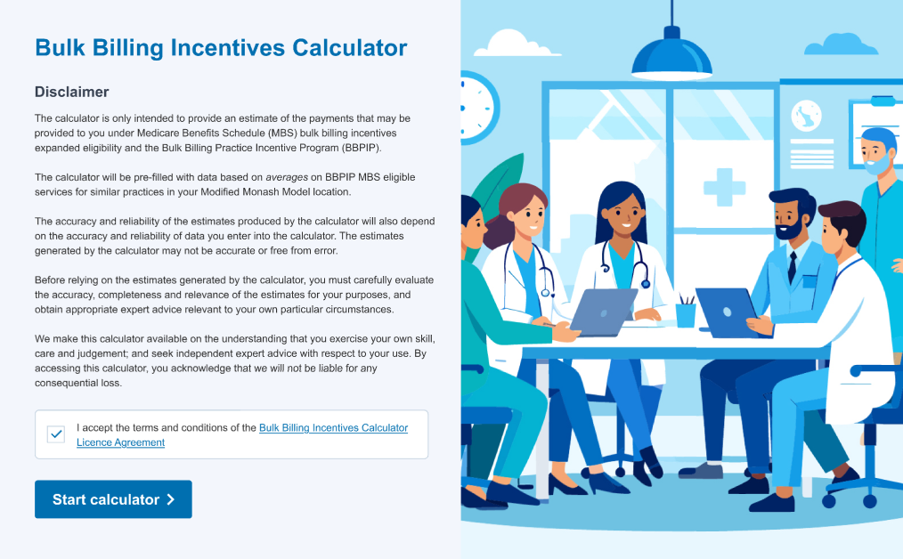

You will be asked to accept the terms and conditions of the Bulk Billing Incentives Calculator Licence Agreement before progressing to the calculator.

## 2. How to use the calculator

Thecalculator uses information about your billing arrangements over the last 12 months, to estimate practice and/or GP payments from 1 November 2025, under the new bulk billing incentives. This section outlines the data you will need to use the calculator:

* Your [Modified Monash Model (MMM)](https://www.health.gov.au/topics/rural-health-workforce/classifications/mmm) classification, which affects many bulk billing incentives
* Your practice’s income split arrangements between the practice and the GP (e.g., the percentage of income returned to the practice to cover overheads and administrative costs)
* Your current billing model: bulk billing, mixed billing, or private billing. This will impact incentive calculations
* The number of BBPIP MBS [eligible services](https://www.health.gov.au/resources/publications/bulk-billing-practice-incentive-program-eligible-services) provided over the previous twelve months. For more information, please see below How to read the Bulk Billing Practice Incentive Program Eligible services table
* The proportion of services provided to concession card holders or children under 16 years as this affects eligibility for certain incentives
* Your bulk billing rates, privately billed fees and annual proportion of MBS service types by:
* Short (level A)
* Standard (level B)
* Long (level C)
* Extended/Prolonged (level D/E)
* Management plans and reviews
* Other BBPIP MBS eligible services.

These details can be found in your practice management system.

### 2.1 How to read the Bulk Billing Practice Incentive Program Eligible Services table

The [Bulk Billing Practice Incentive Program: Eligible Services](https://www.health.gov.au/themes/custom/hga/apps/bbpip/dist/bulk-billing-incentives-calculator-eligible-services-calculator-only.pdf) – for use with the Bulk Billing Incentive Calculator table provides a list of MBS items that will be eligible for BBPIP, this includes eligible Department of Veterans Affairs (DVA) patients.

Flag fall items are not included in the calculator as they are not counted as distinct services. For this reason, flag fall items are not listed and should not be included in your calculations. However, flag fall items will contribute to BBPIP incentive payments.

The MBS items listed in red ceased on 30 June 2025 and can no longer be claimed. These have been included for reference to assist you when using the calculator as you may have claimed these MBS items in the period 1 July 2024 to 30 June 2025.

## 3. Inputting your data

The calculator has sections where you can choose an option, such as ‘What is your role?’

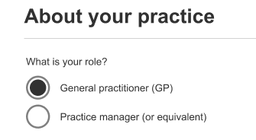

And other sections, where you can enter your own data or leave the pre-filled averages. These fields are blue and have a pencil icon – simply click on the pencil to edit the field:

Throughout the calculator, tool tips (blue circled question marks) will provide additional information and guidance, such as key definitions:



## 4. BBPIP MBS eligible service types

This section requires you to input the proportion of BBPIP MBS eligible services you provide by service type.

Please note, BBPIP MBS eligible services only include GP NRA services and **do not include** procedural services such as skin incisions and biopsies or IUD insertions. GP NRA services also **do not include** ECGs, spirometry services, or any other services outside of GP NRA.

|  |  |
| --- | --- |
| BB PIP MBS Eligible Service Type Category | Description |
| Short (level A) | A GP consult lasting less than 6 minutes, MBS Item 3 and equivalents, including telehealth and after hours consults |
| Standard (level B) | A GP consult lasting at least 6 and less than 20 minutes, MBS Item 23 and equivalents, including telehealth and after hours consults |
| Long (level C) | A GP consult lasting at least 20 minutes and less than 40 minutes, MBS Item 36 and equivalents, including telehealth and after hours consults |
| Extended/Prolonged (level D/E) | A GP consult lasting more than 40 minutes, MBS Item 44, 123 and equivalents, including telehealth and after hours consults |
| Management Plans and Reviews (Complex Care Plans, Mental Health Plans, and Review Items) | This includes GP Management Plans, Team Care Arrangements, GP Chronic Condition Management Plans (from 1 July 2025), Mental Health Plans and Review and Health Assessments  Reminder that MBS Chronic Disease Management Arrangements changed on 1 July 2025. Please include GP Management Plans and Team Care Arrangements delivered prior to 1 July, and GP Chronic Condition Management Plans delivered after 1 July in your calculations, to ensure you get the most accurate outcome |
| Other BBPIP MBS eligible services | This category only includes acupuncture, blood-borne virus, sexual or reproductive health services, emergency services provided in a private hospital, services to patients in imminent danger of death and COVID-19 vaccine items  This category **does not** include:   * Procedural services such as:   + skin incisions   + biopsies   + IUD insertions * ECGs * Spirometry services * Any other services outside of GP NRA   Please note, COVID-19 vaccine items that ceased on 1 July 2025 should still be included for the purpose of calculating the payment in the calculator, noting these MBS items are no longer available to claim |

You can use your own data from your claims over the previous twelve months or choose the pre-filled average data on BBPIP MBS eligible services for similar practices in your MMM region in 2024–25.

For the most useful estimates, input your own claiming data. The information needed to complete this table in can be found in your practice management system.

Bulk Billing Incentives – Payment Comparison Summary
This table compares estimated practice income and patient out-of-pocket costs before and after 1 November 2025, based on changes to bulk billing incentives.
Row 1. Before 1 November 2025
Estimated Practice Income: $435,317
Patient Out-of-Pocket Costs: $80,543
Payment Difference: Baseline (no change)
Row 2. After 1 November 2025 – With Expanded Eligibility for MBS Bulk Billing Incentives
Estimated Practice Income: $461,543
Patient Out-of-Pocket Costs: $80,543
Payment Difference: + $26,226
Row 3. After 1 November 2025 – With Expanded Eligibility + Participation in Bulk Billing Practice Incentive Program (BBPIP)
Estimated Practice Income: $469,742
Patient Out-of-Pocket Costs: $0
Payment Difference: + $34,425

Key Takeaway
If your practice participates in both the expanded MBS bulk billing incentives and the BBPIP:
Your patients save: $80,543
Your practice earns: $34,425 more than before 1 November 2025

When entering your own data, if your column 1 *proportion of services* percentages do not add up to 100%, the calculator will show a red warning, prompting you to correct the data.

A red warning box will appears when the proportions entered for services do not add up to 100%. To proceed, users must adjust the values so that the total equals exactly 100%.

## 5. Payment comparison

The results are calculated from:

* the services you provided
* your bulk billing rates
* your patient fees
* the proportion of services provided to bulk billing incentive eligible patients
* the average MBS benefit and bulk billing incentives received by GPs in your selected MMM and billing type in FY24-25.

Three payment comparisons will be displayed:

|  |  |  |
| --- | --- | --- |
| Current payments | Payments with MBS BBIs expanded eligibility | Payments with MBS BBIs expanded eligibility + BBPIP |
| Screenshot example of current payments calculator data | Screenshot example of payments with MBS BBIs expanded eligibility data | Screenshot example of payments with MBS BBIs expanded eligibility and BBPIP data |



A full breakdown of payment definitions is available in the calculator FAQs.

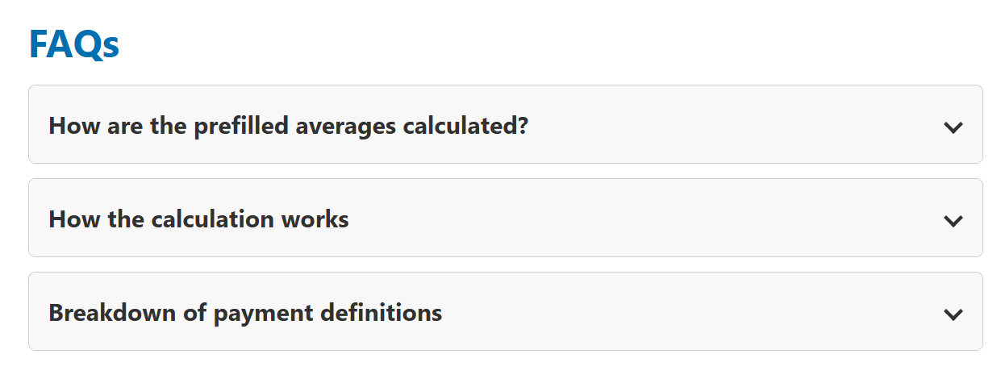

# 6. Interpreting Your Results

Each payment comparison is based on the number of services you provided and includes a breakdown of estimated payments from Medicare benefits, MBS BBI expanded eligibility, patient fees and the total revenue you or your practice will earn.

|  |  |
| --- | --- |
| Screenshot of example MBS BBIs expanded eligibility data with 'Total (gross revenue earned)' circled | Screenshot of example MBS BBIs expanded eligibility and BBPIP data with 'Total (gross revenue earned)' circled |

The summary table highlights the change in payments and savings for practices and patients when participating in BBPIP.

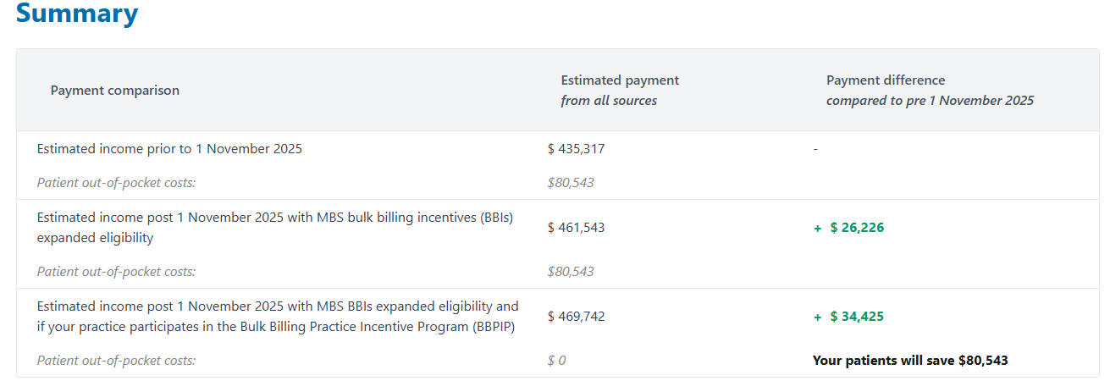

In this example, the annual total changes include MBS BBIs expanded eligibility of **$26,226** plus the additional BBPIP payment of **$8,199** for a total of **$34,425**.

The **$80,543** is the annual out-of-pocket savings for patients visiting your practice.

This table provides a summary of the potential financial benefits for both healthcare providers and patients if a practice participates in BBPIP.

Box 1: Total Change to Payments: shows an increase of $34,425. This is calculated as $26,226 plus $8,199. This figure represents the total change to payments from bulk billing all eligible patients for all eligible services and participating in BBPIP.
Box 2: Savings in Out-of-Pocket Costs: The second box shows savings of $80,543 for patients.

A highlighted message below these boxes states: "We estimate your payments will increase if your practice joins BBPIP."


After viewing the results, you can change your data to see how different choices affect your income and patient savings.

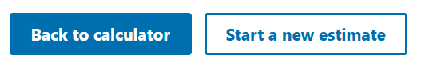

## 7. Participate in BBPIP

Practice managers wanting to participate in BBPIP?

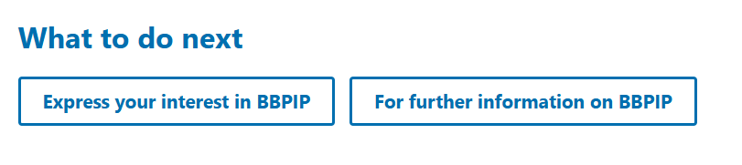

* Express your interest in BBPIP [here](https://www.health.gov.au/our-work/upcoming-changes-to-bulk-billing-incentives-in-general-practice/bulk-billing-practice-incentive-program-expression-of-interest-form). Practice managers (or equivalent) can express your practice’s interest in joining BBPIP and receive early access to Medicare Bulk Billing Practice signage and email updates in the lead up to the launch of BBPIP
* National General Practice Accreditation Scheme (NGPA) accredited practices can prepare for BBPIP registration in advance, by registering for MyMedicare via [Health Professional Online Services (HPOS)](https://www.servicesaustralia.gov.au/hpos?context=20) now. Please note that you will not be able to register for the BBPIP until 1 November 2025
* If you are not NGPA accredited, you should wait to register for MyMedicare and participate in BBPIP from 1 November 2025, when you will be exempt from MyMedicare accreditation requirements
* More information is available at [health.gov.au/BBPIP](http://www.health.gov.au/BBPIP)
* Any questions email [BulkBillingPractice@health.gov.au](mailto:BulkBillingPractice@health.gov.au).

|  |  |  |
| --- | --- | --- |
| **Appendix 1: Calculator steps** | |  |
|  | **Step 1: Launch the calculator**  Read and accept the terms and conditions of the Bulk Billing Incentive Calculator Licence Agreement and click start calculator. Remember, no inputs are stored after you exit the calculator, and your privacy is protected. |  |
|  | **Step 2: Select practice details**  Select your role, practice location (MMM classification), percentage of billings paid to the practice, and current patient billing method. |  |
|  | **Step 3: Enter consultation information**  Enter the estimated number of BBPIP MBS eligible services per year (first free text field) and the percentage of services provided to concession card holders or children under 16 years old (second free text field). |  |
|  | **Step 4: Enter BBPIP MBS Eligible Service types**  Enter the data for your billing types here.  The 4 columns allow you to enter free text (or keep pre-filled averages) on the:   * Percentage proportions of service types (must equal 100%) * Percentage proportions of concession card holders and children under 16 who are bulk billed * Percentage proportions of bulk billed patients * Annual average privately billed fees for your practice   Click on Calculate payment estimate. |  |
|  | **Step 5: Review payment comparison**  Review the estimated current payment (pre-1 November) and projected annual payments (post-1 November). There are two projected payments: MBS BBIs expanded eligibility, and MBS BBIs expanded eligibility **with** participation in BBPIP.  The best option for you or your practice will be highlighted in the green box.  Refer to the FAQs for detailed payment definitions, if required. |  |
|  | **Step 6: View summary**  Review the change in payments and patient out-of-pocket saving. |  |
|  | **Step 7: Final actions**  You can update your results and/or start a new estimate, exploring different outcomes based on your choices and how these affect your income and patient savings.  You may wish to express your interest in BBPIP and/or visit the **registration toolkit** for more information. After completing use of the calculator, close the browser to ensure that your data is deleted. |  |

Print this page to assist

Table summaries each of the calculator steps as detailed throughout the user guideInc