

Alternative care skills mix use in specialised homeless residential aged care services

Final report

Australian Government Department of Health and Aged Care

20 June 2025



© Commonwealth of Australia as represented by the Australian Government Department of Health, Disability and Ageing, 2025

Apart from uses permitted by the Copyright Act 1968 and this copyright notice, all other rights (including all commercial rights) are expressly reserved.

**Permitted uses**

You may download, display, print, and reproduce the whole or part of this publication in unaltered form for:

* your own personal use;
* use within your organisation; or
* distribution and sharing with third parties,

but only if:

* you or your organisation do not use or reproduce the publication for any commercial purpose; and
* if reproduced, this copyright notice and all disclaimer notices are included as part of any reproduction.

This licence does not cover, and there is no permission given for, use of the Commonwealth Coat of Arms or any logos and trademarks (including the logo of the Australian Government Department of Health and Aged Care).

**Disclaimer**

This publication has been produced independently by Australian Healthcare Associates at the request of the Australian Government Department of Health, Disability and Ageing.

The Australian Government accepts no responsibility for material contained in the publication. The views or recommendations expressed in this publication may include the views or recommendations of third parties and do not necessarily reflect those of the Australian Government or indicate a commitment to a particular course of action.

Providing access to the publication does not constitute an endorsement, approval or recommendation by the Australian Government of any organisation, association, entity, service, program, products or research offered by virtue of any information, material or content within the publication.

The information in this publication is provided on the basis that all persons accessing it undertake responsibility for assessing the relevance and accuracy of its content.

**Suggested citation:** Australian Healthcare Associates, 2025, Alternative care skills mix use in specialised homeless residential aged care services: Final report, Australian Government Department of Health, Disability and Ageing, Canberra.

Australian Healthcare Associates: Australia's largest health and human services consulting firm

Level 6, 140 Bourke St, Melbourne VIC 3000

Locked Bag 32005, Collins Street East, VIC 8006

1300 242 111

aha@ahaconsulting.com.au

www.ahaconsulting.com.au

Acknowledgement of Country

In the spirit of respect and reconciliation, Australian Healthcare Associates acknowledges the traditional custodians of Country, the Aboriginal and Torres Strait Islander peoples, and their continuing connection to land, waters, sea and community.

Australian Healthcare Associates is located on the lands of the Kulin Nation. We pay respect to Elders past and present.

Thank you

We extend a heartfelt thank you to all of the stakeholders who took the time to contribute to this evaluation by participating in an interview or completing our online survey. In particular, we would like to thank the managers, staff and residents who welcomed us into their homes.

It has been a privilege to see the incredible work that specialised homeless services are doing and the passion and skill of the managers and staff that are delivering this care, and to hear from residents themselves about what it is like to live in these services.

Abbreviations

|  |  |
| --- | --- |
| Term | Definition |
| ABS | Australian Bureau of Statistics |
| ACAT | Aged Care Assessment Team |
| ACFR | Aged Care Financial Report |
| ACPR | Aged Care Planning Region |
| ACQSC | Aged Care Quality and Safety Commission |
| AFM | Australian Functional Measure |
| AHA | Australian Healthcare Associates |
| AIHW | Australian Institute of Health and Welfare |
| AIN | assistant in nursing |
| AKPS | Australian-modified Karnofsky Performance Scale |
| AN-ACC | Australian National Aged Care Classification |
| ANCOVA | analysis of covariance |
| BCT | base care tariff |
| BRUA | Behaviour Resource Utilisation Assessment |
| CALD | culturally and linguistically diverse |
| DEMMI | De Morton Mobility Index |
| EN | enrolled nurse |
| HAAG | Housing for the Aged Action Group |
| IHACPA | Independent Health and Aged Care Pricing Authority |
| IQR | interquartile range |
| KEQ | key evaluation questions |
| LGBTQIA | lesbian, gay, bisexual, transgender, queer, intersex and asexual |
| MMM | Modified Monash Model |
| NDIS | National Disability Insurance Scheme |
| PCW | personal care worker |
| PTSD | post-traumatic stress disorder |
| QI | quality indicator |
| RN | registered nurse |

Contents

Summary 1

1 Introduction 5

1.1 Specialised homeless residential aged care services 5

1.2 About this evaluation 6

1.3 About this report 11

2 Services and residents 12

2.1 Service characteristics 12

2.2 Resident demographics 18

2.3 Care needs 24

3 Models of care 30

3.1 Characteristics of specialised care 30

3.2 Challenges and enablers to implementing specialised care 44

4 Workforce and care time 48

4.1 Staff skills and characteristics 48

4.2 Care time 51

4.3 Legislative requirements 57

5 Funding and expenditure 64

5.1 Service income 64

5.2 Service expenditure 65

5.3 Reported expenditure and real costs 70

6 Effectiveness 73

6.1 Quality of care 73

6.2 Satisfaction 76

6.3 Outcomes 81

7 Considerations for the future 84

7.1 Models of care 85

7.2 Skills mix and care minutes 86

7.3 Monitoring and reporting 87

Appendix A Base care tariff funding 88

Appendix B Literature review strategy 89

Appendix C Service and resident characteristics 90

Appendix D Additional care time data 97

Appendix E Statistical analysis of care costs 104

Appendix F Additional quality ratings data 105

Appendix G Data tables for figures 106

References 113

Tables

Table 1: Aged care datasets 8

Table 2: Survey responses by role 10

Table 3: Distribution of residential aged care services and homeless population, by jurisdiction 14

Table 4: Distribution of specialised services and homeless population, by remoteness 14

Table 5: Distribution of specialised service beds and older homeless population, by jurisdiction and as a proportion of total beds and population 15

Table 6: Previous accommodation setting for residents of specialised services, by history of homelessness 19

Table 7: Proportion of residents by mobility level, by service type 25

Table 8: Average care time (minutes) in specialised and non-specialised services 52

Table 9: Average income for specialised and non-specialised services, by funding source 65

Table 10: Expenditure patterns by service type 67

Table 11: Average workforce expenditure by service type, per resident per day 69

Table 12: Average expenditure on direct care staff by service type 69

Table 13: Average quality rating for specialised and non-specialised services 73

Table 14: Quality indicators by service type 74

Table 15: Average quality ratings for specialised services that are and are not meeting legislative requirements 75

Table 16: Quality indicator data for specialised services that are and are not meeting legislative requirements 76

Table 17: Base care tariff funding for residential aged care services 88

Table 18: Number of specialised services, by jurisdiction and MM category 90

Table 19: Proportion of specialised services, by jurisdiction and MM category 90

Table 20: Proportion of beds in specialised services, by jurisdiction and MM category 91

Table 21: Occupancy rates in specialised services, by jurisdiction and MM category 91

Table 22: Proportion of residents in specialised services with a history of homelessness, by jurisdiction and MM category 92

Table 23: Average resident age by jurisdiction 92

Table 24: Average resident age by MM category 92

Table 25: Proportion of men in specialised services, by jurisdiction and MM category 93

Table 26: Proportion of First Nations residents in specialised services, by jurisdiction and MM category 93

Table 27: Mean (standard deviation) scores on AN-ACC assessment tools 94

Table 28: Estimated means controlling for age – AFM Physical items 94

Table 29: Pairwise comparison of resident groups on the AFM – Physical items 95

Table 30: Estimated means controlling for age – BRUA 95

Table 31: Pairwise comparison of resident groups on the BRUA 95

Table 32: Proportion of male residents by mobility class – specialised and non-specialised services 96

Table 33: Proportion of female residents by mobility class – specialised and non-specialised services 96

Table 33: Proportion of residents by AN-ACC class – specialised and non-specialised services 96

Table 34: RN care time (mins) per resident per day by service type 97

Table 35: PCW and AIN care time (mins) per resident per day by service type 98

Table 36: EN care time (mins) per resident per day by service type 99

Table 37: Diversional and lifestyle care time (mins) per resident per day by service type 100

Table 38: Care management care time (mins) per resident per day by service type 101

Table 39: Allied health care time (mins) per resident per day by service type 102

Table 40: Average allied health care time (mins) per resident per day by service type and profession 103

Table 41: Results of ANCOVA, care expenditure controlling for resident complexity and service rurality 104

Table 42: Results of post-hoc tests, care expenditure controlling for case mix and MM by service type 104

Table 43: Average quality rating by service type 105

Table 44: Data for Figure 1: Map of specialised residential aged care services 106

Table 45: Data for Figure 2: Occupancy rate in specialised services 106

Table 46: Data for Figure 3: Proportion of residents with a history of homelessness in specialised services 106

Table 47: Data for Figure 4: Age distribution by service type and homelessness status 107

Table 48: Data for Figure 5: Proportion of men, by service type and history of homelessness 107

Table 49: Data for Figure 6: Proportion of First Nations residents, by service type and history of homelessness 107

Table 50: Data for Figure 9: Average care time (mins) by staff and service type 108

Table 51: Data for Figure 10: Proportion of staff by employment, service and staff type 108

Table 52: Data for Figure 11: Average total care minutes and targets – specialised and non-specialised services 109

Table 53: Data for Figure 12: Average RN care minutes and targets – specialised and non-specialised services 109

Table 54: Data for Figure 13: 24/7 RN coverage by service type 109

Table 55: Data for Figure 14: Care, hotel and accommodation income by service type 110

Table 56: Data for Figure 16: Expenditure by service type and cost category 110

Table 57: Data for Figure 17: Resident Experience Survey data – staff and management Question 1 of 8: Are staff kind and caring? 110

Table 58: Data for Figure 17: Resident Experience Survey data – staff and management Question 2 of 8: Are you encouraged to do as much as possible for yourself? 110

Table 59: Data for Figure 17: Resident Experience Survey data – staff and management Question 3 of 8: Do staff explain things to you? 110

Table 60: Data for Figure 17: Resident Experience Survey data – staff and management Question 4 of 8: Do staff follow up when you raise things with them? 111

Table 61: Data for Figure 17: Resident Experience Survey data – staff and management Question 5 of 8: Do staff know what they are doing? 111

Table 62: Data for Figure 17: Resident Experience Survey data – staff and management Question 6 of 8: Do staff treat you with respect? 111

Table 63: Data for Figure 17: Resident Experience Survey data – staff and management Question 7 of 8: How likely are you to recommend this aged care home to someone? 111

Table 64: Data for Figure 17: Resident Experience Survey data – staff and management Question 8 of 8: Is this place well run? 111

Table 65: Data for Figure 18: Resident Experience Survey data – wellbeing Question 1 of 4: Do you feel safe here? 112

Table 66: Data for Figure 18: Resident Experience Survey data – wellbeing Question 2 of 4: Do you get the care you need? 112

Table 67: Data for Figure 18: Resident Experience Survey data – wellbeing Question 3 of 4: Do you have a say in your daily activities? 112

Table 68: Data for Figure 18: Resident Experience Survey data – wellbeing Question 4 of 4: Do you like the food here? 112

Figures

Figure 1: Map of specialised residential aged care services 13

Figure 2: Occupancy rate in specialised services 16

Figure 3: Proportion of residents with a history of homelessness in specialised services 17

Figure 4: Age distribution by service type and homelessness status 20

Figure 5: Proportion of men, by service type and history of homelessness 22

Figure 6: Proportion of First Nations residents, by service type and history of homelessness 23

Figure 7: Core components of specialised services’ philosophy of care 30

Figure 8: Dimensions of wellbeing 37

Figure 9: Average care time (mins) by staff and service type 53

Figure 10: Proportion of staff by employment, service and staff type 56

Figure 11: Average total care minutes and targets – specialised and non-specialised services 58

Figure 12: Average RN care minutes and targets – specialised and non-specialised services 59

Figure 13: 24/7 RN coverage by service type 61

Figure 14: Care, hotel and accommodation income by service type 65

Figure 15: Difference between income and expenditure in specialised services, by proportion of residents with a history of homelessness 66

Figure 16: Expenditure by service type and cost category 68

Figure 17: Residents’ Experience Survey data, specialised and non-specialised services – staff and management 79

Figure 18: Residents’ Experience Survey data, specialised and non-specialised services – wellbeing 80

Figure 19: RN care time (mins) per resident per day by service type 97

Figure 20: PCW and AIN care time (mins) per resident per day by service type 98

Figure 21: EN care time (mins) per resident per day by service type 99

Figure 22: Diversional and lifestyle care time (mins) per resident per day by service type 100

Figure 23: Care management care time (mins) per resident per day by service type 101

Figure 24: Allied health care time (mins) per resident per day by service type 102

Summary

The Australian Government Department of Health and Aged Care (the department) engaged Australian Healthcare Associates (AHA) to identify and evaluate the staffing skills mix and models of care in specialised homeless residential aged care services.

The evaluation took place from October 2024 to June 2025. This final report presents findings from our desktop analysis of literature, documents and existing datasets and consultations with specialised service providers, staff and residents and other key stakeholders. Our high-level findings are summarised below.

Service characteristics

There are 47 specialised homeless residential aged care services across Australia. They:

* are generally distributed in line with the distribution of the homeless population
* are predominantly located in metropolitan areas (68%)
* have 2,586 beds in total, averaging 55 per service.

Resident characteristics

As of November 2024, there were 1,410 residents with a history of homelessness in specialised homeless residential aged care services, accounting for 61% of residents in these services. Residents come from diverse backgrounds and accommodation settings. There are some demographic differences between this cohort and residents in non-specialised services, which may influence the staffing mix and models of care required. We found that:

* residents in specialised services are, on average, 10 years younger than residents in non-specialised services
* residents tend to spend longer in specialised services, with an average stay of 5.2 years compared to 3.7 years in non-specialised services
* men make up two-thirds (67%) of residents in specialised services and nearly three-quarters (72%) of residents with a history of homelessness
* there is a higher proportion of First Nations residents in specialised services (16%) than in non-specialised services (3%), especially in the Northern Territory (52%) and Queensland (46%).

Care needs

Residents with a history of homelessness have diverse care needs. We found that residents in specialised services tend to be more physically independent than residents in other services. However, despite their younger age, residents in specialised services have similar cognitive challenges to residents in other services, and poor mental health, substance use and behavioural challenges are common. We heard that residents of specialised services frequently have unmet psychosocial needs when they enter a specialised service, including a lack of social support, and financial and legal difficulties.

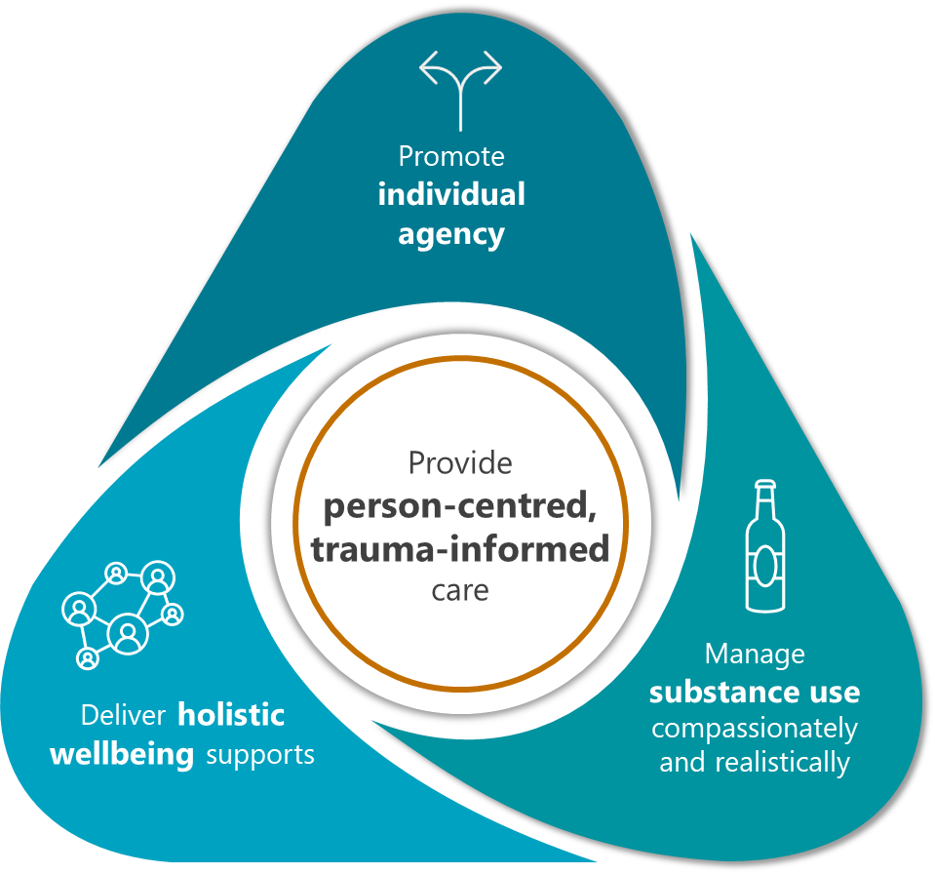Models of care

Specialised services share a **person-centred and trauma-informed philosophy of care. Their approach involves** promoting individual agency, managing substance use sensitively and realistically, and delivering holistic supports that span physical, mental and emotional, social, spiritual and cultural, and legal and financial wellbeing.

The implementation of this approach is made possible by **passionate managers and staff, appropriate physical settings** (i.e. small service size and “home-style” environments) and **strong connections with relevant local** services.

Staff skills and training

Overall, the mix of staff employed in specialised services, and their qualifications, are consistent with the residential aged care workforce more broadly. However, **staff roles and responsibilities are broader and more flexible** in specialised services than they might be in non-specialised services, to enable the delivery of person-centred, trauma-informed care.

“Soft skills” (such as patience, compassion, empathy and tolerance) are highly valued and managers tend to recruit based on fit rather than qualifications.

There is very little training available that is specific to caring for older people with a history of homelessness. However, services often fill this gap with training on relevant topics, such as trauma‑informed care and mental health first aid. Staff also develop their knowledge and skills through on-the-ground experience, mentoring arrangements and ad hoc training opportunities.

Legislated care requirements

Specialised services are, on average, exceeding both their total care minute and RN care minute targets. Between October and December 2024, specialised services exceeded care minute targets by 22 minutes, compared to 7 minutes for non-specialised services. They exceeded RN targets by 8 minutes compared to 9 minutes for non-specialised services.

While current care minute targets are reasonable according to currently included staffing types and care activities, we also heard there is a strong case for a broader definition for specialised services and commensurate increase in targets. This is because residents with a history of homelessness benefit from a holistic approach to care delivered by a wide range of staff. Lifestyle and recreation staff and allied health professionals (including social workers and mental health practitioners) were seen as especially important omissions from current care minute targets.

Funding and expenditure

****In 2023-24, total average expenditure in specialised services was $451.99 per resident per day, compared to $398.13 in non-specialised services, equating to 90% and 95% of income respectively. Within specialised services, there is a slight trend toward the difference between income and expenditure decreasing as proportion of residents with a history of homelessness increases.

Direct care costs account for the majority of expenditure in all service types (ranging from 53% to 59%). In real terms, specialised services with a higher proportion of residents with a history of homelessness spend $28 more on care per resident per day than non-specialised services ($260 compared to $232), after controlling for residents’ level of need and service rurality.

However, financial reporting may not reflect the true costs of delivering specialised care to residents with a history of homelessness. We heard that challenges with consistent and accurate reporting, faced by all aged care providers, may be more pronounced for specialised services due to the nature of their expenses and resident population. In addition, services are taking a considered approach to how they spend the BCT, and balancing their expenses against the financial risk that comes with caring for the homeless population.

Effectiveness

The residents we spoke to provided us with overwhelmingly positive feedback about the care they receive and the staff who provide it.

On average, specialised and non-specialised services provide a similar quality of care overall, as defined by **the Australian Government’s** [**star ratings**](https://www.health.gov.au/our-work/star-ratings-for-residential-aged-care/about-star-ratings) for residential aged care. Specialised services also **generally perform well on specific quality** indicators, reporting lower rates of restrictive practices, falls and prescription of antipsychotic medications without a diagnosis of psychosis, compared with non-specialised services. However, they had slightly higher rates of polypharmacy, unplanned weight loss and pressure injuries.

Overall, we found that specialised services provide homes and care for older people experiencing significant vulnerability and limited options for safe and appropriate housing. Residents often experience considerable improvements to all aspects of wellbeing after they move into a specialised service. For example, their physical health improves with access to consistent health care and high‑quality food in a safe environment, and their social wellbeing improves as they form new relationships with other residents and staff.

Recommendations

The following recommendations are designed to support the continued delivery of high quality, effective care in specialised services.

1. Encourage specialised homeless services to continue designing and delivering flexible, person-centred, trauma-informed care.
2. Support specialised homeless services to expand in-house capacity to address mental health and substance use issues, for example by:

* raising awareness of available training and professional development opportunities
* partnering with or commissioning established providers to develop and deliver tailored training for specialised services
* supporting RNs to obtain advanced qualifications (e.g. Graduate Certificate in Mental Health Nursing).

1. Explore options to support connection and knowledge-sharing between specialised homeless services, for example by establishing a voluntary community of practice, toolbox sessions or an advice line.
2. Expand the activities and professions that can be counted towards care minutes for specialised homeless services, to reflect the different care needs of this population and support the delivery of holistic, person-centred care.
   1. Increase care minute targets accordingly.
3. Establish a framework for specialised homeless services to apply to meet a portion of their RN care minute targets with care time provided by other registered health professionals.
   1. Work closely with the Aged Care Quality and Safety Commission to develop the framework so that its application ensures residents receive high-quality clinical care appropriate to their needs.
4. Waive the MM requirement for specialised homeless services wishing to apply for an exemption from 24/7 RN responsibilities. Specialised services should still meet other exemption requirements, such as service size and appropriate alternative care arrangements.
5. Strengthen data collection practices to generate more reliable information on the delivery of specialised homeless models of care and their associated costs.
   1. Establish mechanisms to consistently and accurately collect information on history of homelessness and previous accommodation setting, and develop associated guidance for providers.
   2. Explore opportunities to leverage existing assessment processes (e.g. AN‑ACC) to collect data on mental health conditions and alcohol and substance use.
   3. Provide specialised homeless services with additional guidance on financial reporting, to better understand the true costs of delivering care in these contexts.
   4. Consider introducing a monitoring program, with departmental staff conducting intermittent visits to specialised homeless services to better understand the specialised supports in place and the residents receiving them.
6. Once more reliable data is available, review the eligibility criteria for awarding the specialised base care tariff.

# Introduction

In the most recent Census, 19,378 Australians aged 55 years and over were experiencing homelessness (ABS 2023a).

These individuals often have complex physical and mental health needs and experience “premature ageing” compared to other Australians (HAAG 2019; Keast 2015; Wood et al. 2024; York et al. 2024). In recognition of this, the Australian Government provides additional funding to residential aged care services that specifically cater to this cohort through the specialised base care tariff (BCT; ‎Appendix A).[1] The BCT is one component of the Australian National Aged Care Classification (AN-ACC) funding model, which also includes variable funding based on the individual care needs of residents and an initial entry adjustment payment for new permanent residential aged care residents.

## Specialised homeless residential aged care services

There are currently 47 specialised homeless residential aged care services across Australia that are managed by 26 approved aged care providers. To be granted specialised status and receive additional funding for a 3-year period, services must:

have the experience and capacity to provide specialist homeless programs

currently provide specialised homeless programs or commit to doing so within 3 months of applying for specialised status

* have at least 50% of non-respite care residents with a history of homelessness and associated complex behavioural needs and social disadvantage.

### Mandated care minutes

The Royal Commission into Aged Care Quality and Safety highlighted the critical importance of having appropriate staffing levels and skills mix to deliver high-quality care to older people in residential aged care and recommended the introduction of a minimum staff time standard (Royal Commission into Aged Care Quality and Safety 2021a). As a result, in 2023 the Australian Government introduced mandatory care minutes targets for residential aged care services.

These targets define the amount of care that must be delivered per resident per day (on average) by:

any combination of registered nurses (RNs), enrolled nurses (ENs) and personal care workers (PCWs) or assistants in nursing (AINs) and

* RNs specifically (although up to 10% of RN care time can be provided by ENs).

While all residential aged care services are bound by care minute requirements, it has been suggested that greater flexibility in how targets are met would enable specialised services to meet their residents’ needs (Gordon et al. 2023; Royal Commission into Aged Care Quality and Safety 2021). This may mean that care provided by staff other than RNs, ENs, PCWs or AINs is counted towards a service’s care minutes. It may also mean that the distribution of care minutes (i.e. the proportion required to be delivered by RNs) could differ from that of non‑specialised residential aged care services.

## About this evaluation

In 2023, a report designed to support the implementation of mandated care minutes in residential aged care found that there was insufficient evidence on whether alternative arrangements for care minute targets should be considered for specialised services. The authors recommended that the department “review current models of care and … differences in staffing and other resource requirements” in specialised services to inform further policy development in this area (Gordon et al. 2023:62).

In a separate study, the Independent Health and Aged Care Pricing Authority (IHACPA) identified that specialised services were delivering less care time than other services (Scyne Advisory 2023) and recommended a reduction in the national weighted activity units applied to the specialised homeless BCT (Independent Health and Aged Care Pricing Authority 2024a).

In light of these recommendations, the Australian Government decided to review its policy settings for specialised homeless residential aged care services. As part of this review, the department engaged AHA to evaluate the staffing skills mix and models of care used in specialised services[2] and consider the extent to which these are meeting the care needs of people with a history of homelessness.

The evaluation was conducted between October 2024 and June 2025.

### Key evaluation questions

This evaluation sought to answer 10 key evaluation questions (KEQs) across 3 domains as shown below.

Current implementation

1. What are the characteristics of specialised homeless residential aged care services nationally, for example, in terms of:

* residential care service demographics, such as state/territory and MM location, size (allocated beds) and any other relevant information
* workforce skills mix (including qualifications of care staff) delivering care
* models of care being delivered
* resident demographics
* spending on workforce and program delivery
* funding?

1. Are specialised services implementing their models of care (including specialised programs) as intended? What have been the challenges to and/or enablers of implementation?
2. How does workforce mix and spending differ between specialised homeless services and non-specialised services?
3. How do resident demographics differ between specialised homeless and non-specialised residential aged care services?
4. How do the care needs of residents of specialised homeless residential aged care services differ from the care needs of residents in non-specialised residential aged care services?

* How does the type and amount of personal and clinical care time (from RNs, ENs, PCWs and AINs) required for residents with a background of homelessness differ between specialised services and residents in the same AN-ACC class in non-specialised services?

1. Does the proportion of residents with a background of homelessness in a specialised homeless residential aged care service impact:

* the service’s workforce mix and spending on workforce?
* the type and amount of required personal and clinical care time (from RNs, ENs, PCWs and AINs)?

Effectiveness

1. What are the providers of specialised homeless residential aged care services achieving (whether positive or negative) in terms of quality of care delivered, consumer satisfaction and outcomes for residents with a background of homelessness?

Considerations for future implementation

1. Is there a particular model of care (or models of care) that would be better suited to meeting the care needs of people with a homelessness background?

* Is this model of care (or models of care) currently being implemented? If so, could it be replicated or expanded?
* What additional model(s) of care, or components thereof, should be introduced?

1. Would allowing specialised homeless residential aged care services to utilise alternative care skills mix (i.e. other than RNs, ENs, PCWs and AINs) to meet their care minutes lead to the delivery of better quality of care, consumer satisfaction and outcomes for residents with a background of homelessness? If so:

* What additional staff categories (professions, qualifications and/or skills) would enhance the quality of care? Why?
* Should the care minute targets be increased to accommodate the additional care needs?

1. How could the delivery of specialised homeless models of care and their associated costs be monitored in the future?

### Data sources

Our answers to the evaluation questions have been informed by 5 data sources as discussed below.

#### Literature review

We searched PubMed, Google Scholar and Google for recent peer-reviewed and grey literature on the care needs of older people with a history of homelessness and how these can be addressed as well as the current specialised residential aged care service landscape (‎Appendix B).

Despite an intentionally broad search strategy, we identified fewer than 50 publications relevant to this evaluation. Many of these related to homeless older people living in the community; as Gordon et al. (2023) suggest, there is currently limited evidence on effective models of residential aged care for people with a history of homelessness.

Our formal literature review was supplemented by additional information and documentation identified throughout the evaluation, including documents shared by the department and specialised services.

#### Environmental scan

We collated information on the characteristics of each of Australia’s 47 specialised services from provider websites and applications for specialised BCT funding (provided by the department).

We also sourced publicly available information on relevant population and aged care service statistics through the Australian Bureau of Statistics (ABS) and Australian Institute of Health and Welfare (AIHW). Note that as these larger datasets are broken down in different ways, comparators may not be consistent throughout this report. For example, the ABS provides data on people experiencing homeless by remoteness and people experiencing homelessness by age, but not both.

#### Aged care data

We analysed 7 datasets for this report (Table 1). Most datasets included information for the 47 specialised services and a comparator sample of 46 non-specialised services. Comparator services were selected by the department and matched to specialised services on Modified Monash Model (MMM) category and resident population characteristics. [3] Exceptions are the star ratings data and Residents’ Experience Survey datasets, for which data was available only for 45 comparator services, and resident demographic data, which was not available for any comparator services.

Table 1: Aged care datasets

| Dataset | Timeframe |
| --- | --- |
| Quarterly Financial Reports submitted by aged care providers | 1 July 2023 to 30 June 2024 |
| Aged Care Financial Reports (ACFR) submitted by aged care providers | 1 July 2023 to 30 June 2024 |
| Monthly 24/7 RN data | 1 January 2024 to 31 December 2024 |
| Specialised homeless resident data | September 2024 |
| AN-ACC assessment data | Variable (resident’s most recent assessment, up to September 2024) |
| Star Ratings data and Residents’ Experience Survey | February, May, July and November 2024 releases |

Note: All datasets supplied by the department except for the star ratings data and Residents’ Experience Survey datasets, which were sourced from the [department’s online resources](http://www.health.gov.au/resources/collections/star-ratings-quarterly-data-extracts).

We included data on resident AN-ACC assessments and demographics for current residents only (i.e. those without an exit from service or deceased date).

Two specialised services were excluded from financial analysis due to their receiving specialisation status part-way through the 2023–24 financial year.

What is homelessness?

Under the *Aged Care Act 1997*, for the purposes of the BCT, an aged care service can record an individual as having a history of homelessness if, immediately prior to admission at their current or previous aged care service, if any of the following apply:

* they were living in a public place or temporary shelter; short-term crisis, emergency or transitional accommodation; boarding house; rooming house or private hotel; or supported community accommodation
* they had no recent housing address
* they had a long history of unsuccessful tenancies or unstable housing arrangements.

However, information on residents’ history of homelessness is often missing in data held by the department, and the accuracy of available data is unclear. For this project, where homelessness status was missing, the department imputed this information using data on previous accommodation setting. As such, “residents with a history of homelessness” in this report include those who either had this history recorded by their service or were previously staying in supported community accommodation; short-term crisis, emergency or transient accommodation; a boarding house, rooming house or private hotel; or public place or temporary shelter. This data may underestimate homelessness: it does not capture those with a history of unstable housing, and the previous accommodation setting is unknown for one-quarter of specialised service residents (see section ‎2.2.1).

Further, we note that ”there is no single definition of homelessness” (AIHW 2025a).

For example, in this report we draw on population statistics from the ABS, which defines someone as experiencing homelessness if their current living arrangement either:

* is in a dwelling that is inadequate
* has no tenure, or a short and unextendible tenure
* does not allow control of, and access to, space for social relations (ABS 2023a).

Also relevant to this project, the Aged Care Act 2024 does not distinguish between people with a history of homelessness and those at risk of homelessness when defining groups that must be afforded “accessible, culturally safe, culturally appropriate, trauma‑aware and healing‑informed funded aged care” (subclause 25(4)).

Finally, it is important to recognise that government definitions of homelessness may not correspond to how people understand and define their own living arrangements.

#### Consultation with specialised services

We invited staff and managers in all 47 specialised services to respond to an online survey about their role and experience providing care to residents with a history of homelessness, and their ideas for what works well and how services could be improved.

We received a total of 101 responses: of these, 25 responses were invalid (primarily due to responding to less than 25% of the survey questions) and were therefore excluded from our analysis, leaving a total of 76 responses.

Table 2 shows the number of survey responses by job role. The highest proportion of respondents were PCWs/AINs (30%) or “other” (32%). Some of the “other” roles included: intake coordinator, leisure and lifestyle officer, care manager, cleaner, pastoral carer, nurse educator, administrative officer, CEO and practice quality business partner.

Table 2: Survey responses by role

|  |  |  |
| --- | --- | --- |
| Role | Count | Percentage |
| Personal care worker/assistant in nursing | 23 | 30% |
| Service manager | 14 | 18% |
| Registered nurse | 11 | 14% |
| Allied health professional | 2 | 3% |
| Other | 24 | 32% |
| Total | 76 | 100% |

We also invited all services to express interest in a series of interviews with their manager, staff and residents to provide us with a richer understanding of their approach to care and suggestions for the future.

We achieved our target of having 15 services opt into this component of the evaluation, although ultimately one was not able to participate and one was only able to participate to a limited degree due to external factors. Thus, we interviewed the managers of 14 specialised services and the staff and residents in 13 of these. We also interviewed several senior managers and executives at the provider level, either individually or together with the service manager.

The staff we spoke to included RNs and ENs, PCWs, lifestyle staff, and those working in other roles (e.g. administration staff, cleaning and maintenance). Residents were eligible to participate if they had a history of homelessness and did not have:

* advanced dementia or other cognitive impairment limiting their ability to provide informed consent
* acute health issues or other crises meaning participation was not appropriate
* behavioural concerns that presented a risk to our staff.

Interviews with staff and residents were conducted in accordance with the protocol approved by the Bellberry human research ethics committee.

Both the survey and interviews were voluntary at the service and individual level: services and people that opted in therefore may not be representative of specialised homeless services and the people who live and work within them. In addition, service managers were responsible for recruiting staff and managers and staff recruited residents. As such, we cannot rule out the possibility of selection bias influencing our results. Our eligibility criteria may also have meant that residents with more severe mental health and behavioural issues were not able to participate.

Consulting with managers, staff and residents in non-specialised services was out of scope for this evaluation.

#### Consultation with other stakeholders

We conducted online interviews with representatives of:

* Aged Care Quality and Safety Commission
* Aged & Community Care Providers Association
* Micah Projects
* IHACPA.

Interviews explored one or more of the following based on the expertise of each stakeholder group:

* care needs and appropriate models of care for people who have a history of homelessness
* current approaches to, and opportunities to improve, the way that care is delivered in specialised homeless services
* the appropriateness of care minute requirements for specialised homeless residential aged care services
* whether current reporting mechanisms adequately capture care being delivered in specialised services.

## About this report

This report sets out our evaluation findings as follows:

* **Section ‎2** outlines the characteristics of specialised services and the demographics and care needs of residents.
* **Section ‎3** describes how these care needs are met by specialised services and the challenges and enablers to implementing this model of care.
* **Section ‎4** examines staff skills and characteristics and care time in specialised services, and the extent to which specialised services are meeting their care minutes targets and 24/7 RN requirement.
* **Section ‎5** looks at specialised services’ funding and expenditure and how this is reported.
* **Section ‎6** considers the effectiveness of specialised services, looking at quality, resident satisfaction and outcomes.
* **Section ‎7** provides recommendations to enhance the implementation of specialised residential aged care for people with a history of homelessness.

# Services and residents

As mentioned in section ‎1, there are currently 47 specialised homeless services across Australia. Over 80% of these have been specialised for at least 5 years, and three-quarters have held this status for more than 10 years.

In November 2024 there were 2,319 people living in these specialised services, or just under 50 residents per service. By way of comparison, there were 19,378 people aged 55 or older who were counted as being homeless in the last Australian Census (ABS 2022). In other words, the population of specialised services equates to approximately 12% of the older homeless population. In contrast, the total population of aged care residents aged 55 or older (n = 186,260) equates to just 3% of the Australian population the same age (ABS 2022; AIHW 2025b).

In this section we explore:

* The characteristics of specialised homeless residential aged care services nationally, in terms of the demographics of the services themselves and the residents that live within them (KEQ 1)
* **The ways in which** resident demographics differ between specialised homeless and non‑specialised residential aged care services (KEQ 4)
* The care needs of residents of specialised homeless residential aged care services, and how these differ from the care needs of residents in non-specialised residential aged care services (KEQ 5)

Where possible, we also compare services and residents to population statistics, using ABS and AIHW data.

## Service characteristics

The service mix includes both low- and high‑level care offerings (or a hybrid of both). Low-care settings cater to residents who are relatively independent, while high-care settings offer more intensive clinical support for people with greater medical needs.

Figure 1 provides an overview of the specialised service landscape, showing the number of services and residents, and the proportion of residents with a history of homelessness, in each jurisdiction. The figure also shows each service’s approximate location; picture-in-picture maps are provided for metropolitan areas where service density is higher.

Following the figure, we explore service location, size, and percentage of residents with a history of homelessness in more detail. Additional data on service characteristics by jurisdiction and MM category is provided in Appendix ‎C.1.

Figure 1: Map of specialised residential aged care services

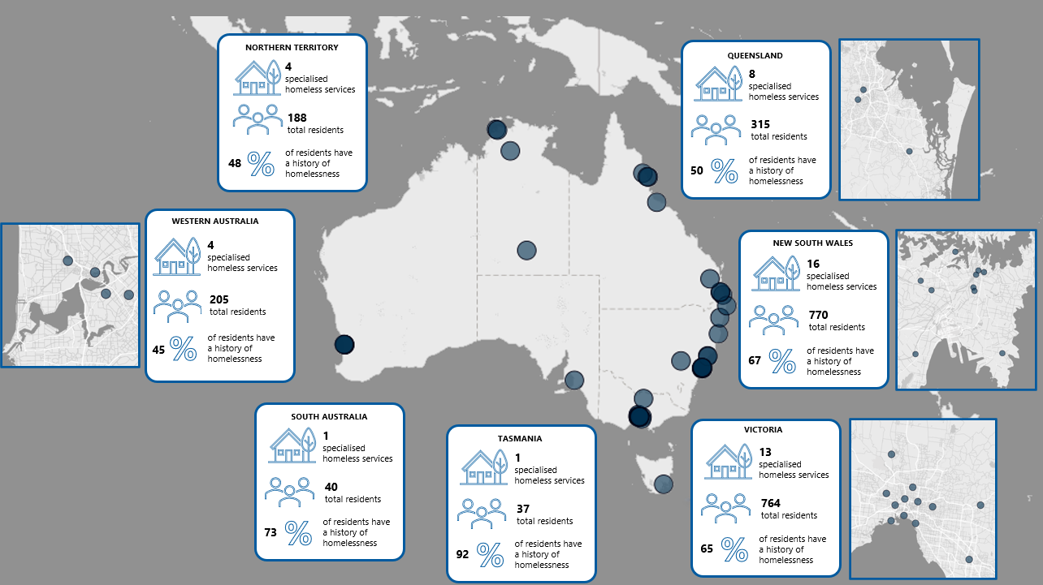

Figure 1 data is provided in Table 45.

### Service distribution generally aligns with the homeless population

Applying for specialised homeless status is voluntary, with service locations determined by aged care providers. Despite a lack of national planning, the distribution of specialised services roughly aligns with the distribution of the homeless population overall (Table 3), perhaps suggesting that providers are seeking specialisation in response to observed local need. For example, in the Northern Territory the proportion of specialised services is appropriately higher than the proportion of residential services overall. However, the reverse is true in South Australia, which is home to just 2% of specialised services but 6% of the homeless population, and 9% of residential aged care services overall. There are currently no specialised services in the Australian Capital Territory.

Table 3: Distribution of residential aged care services and homeless population, by jurisdiction

|  |  |  |  |
| --- | --- | --- | --- |
| Jurisdiction | Homeless population  (n = 122,489) | Specialised services  (n = 47) | All residential aged care services  (n = 2,639) |
| NSW | 28.6% | 34.0% | 31.6% |
| Vic | 25.0% | 28.6% | 28.3% |
| Qld | 18.3% | 17.0% | 17.7% |
| WA | 8.0% | 8.5% | 9.4% |
| NT | 10.7% | 8.5% | 0.5% |
| SA | 6.0% | 2.1% | 8.7% |
| Tas | 1.9% | 2.1% | 2.7% |
| ACT | 1.4% | 0.0% | 1.0% |
| Total | 100.0% | 100.0% | 100.0% |

Sources: Specialised homeless resident data, AIHW (2023a), and ABS (2023b).

Note: Homeless population data includes people of all ages.

Around two-thirds of specialised services are located in metropolitan areas, slightly higher than the proportion of residential services overall and of the general population experiencing homelessness (Table 4). While remote and very remote areas have proportionally more specialised services than residential services overall, they remain underserviced compared to the proportion of the homeless population living in these areas. There are currently just 2 specialised services in remote areas and none in very remote areas of Australia.

Table 4: Distribution of specialised services and homeless population, by remoteness

|  |  |  |  |
| --- | --- | --- | --- |
| Remoteness | Homeless population  (n = 122,489) | Specialised services  (n = 47) | All residential aged care services  (n = 2,639) |
| Metropolitan | 63.8% | 68.1% | 62.6% |
| Regional and rural | 22.7% | 27.7% | 35.9% |
| Remote and very remote | 13.5% | 4.3% | 1.5% |
| Total | 100.0% | 100.0% | 100.0% |

Sources: Specialised homeless resident data, AIHW (2023a), and ABS (2023b).

Note: Homeless population data includes people of all ages.

As of June 2023, there was a total of 2,586 beds in specialised services. The number of beds per service ranged from 20 to 120, with an average of 55 beds per service.

As shown in Table 5, the distribution of specialised service beds does not quite align with the distribution of the older homeless population in some locations. Specifically, Victoria has a higher share of specialised service beds than of the homeless population, while the reverse is true in Queensland and Tasmania.

Across jurisdictions, specialised service beds account for 1% of all residential aged care beds on average, while people experiencing homelessness account for 0.3% of the total Australian population aged 55 or older.

Table 5: Distribution of specialised service beds and older homeless population, by jurisdiction and as a proportion of total beds and population

|  |  |  |  |  |
| --- | --- | --- | --- | --- |
| Jurisdiction | Specialised service beds (n = 2,586) | Homeless population (55+) (n = 19,378) | Specialised service beds as a proportion of all residential beds (n = 225,216) | Homeless population as a proportion of total population (55+) (n = 7,386,315) |
| NSW | 32.9% | 30.9% | 1.0% | 0.3% |
| Vic | 32.9% | 20.3% | 1.3% | 0.2% |
| Qld | 13.5% | 22.7% | 0.7% | 0.3% |
| WA | 9.7% | 9.6% | 1.1% | 0.3% |
| NT | 7.9% | 8.3% | 1.0% | 3.6% |
| SA | 1.6% | 5.1% | 0.7% | 0.2% |
| Tas | 1.6% | 2.0% | 1.2% | 0.2% |
| ACT | 0.0% | 1.1% | 0.0% | 0.2% |
| Total | 100.0% | 100.0% | 1.0% | 0.3% |

Sources: Specialised homeless resident data, ABS (2023c, d), AIHW (2023b)

### Occupancy is similar in specialised and non-specialised services

As of November 2024, the mean occupancy rate (i.e. the proportion of beds in use) in specialised services was 89% (Figure 2), equivalent to the sector overall (88% in June 2024; AIHW 2024a). Occupancy ranged from 81% to 100% across jurisdictions, and, like in non-specialised services, was highest in metropolitan areas and regional centres (Alrewaithi et al 2025).

One specialised service reported an occupancy rate of over 100%, meaning that there were more residents than allocated beds. Anecdotally, we heard that this can occur for a number of reasons, including partners opting to stay together in a single-bed room.

Figure 2: Occupancy rate in specialised services

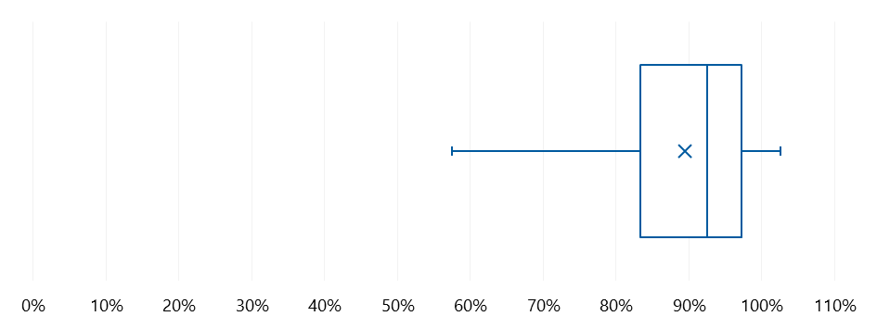

Source: Specialised homeless resident data

Figure 2 data is provided in Table 45.

How to interpret a box and whisker plot

The ends of the boxes correspond to the lower quartile (25th percentile) and upper quartile (75th percentile) of a set of data. The difference between these 2 values is known as the interquartile range (IQR). In essence, 50% of the data sits in the box. The vertical line in the box indicates the median, and the cross indicates the mean. The ends of the whiskers represent the minimum and maximum of the set of data, excluding any outliers (which are not present in the plot above but, if they exist, are represented by a dot). We defined outliers as being more than 1.5 IQRs above the upper quartile or below the lower quartile.

### The proportion of residents with a history of homelessness varies widely across specialised services

As of November 2024, 61% (n = 1,410) of residents across all specialised services had an identified history of homelessness, ranging from 27% to 95% (Figure 3).

Figure 3: Proportion of residents with a history of homelessness in specialised services

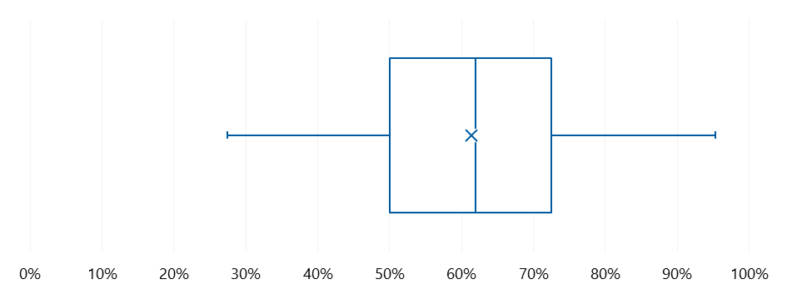

Source: Resident data – demographic

Figure 3 data is provided in Table 47.

As defined in section ‎1.1, at least 50% of residents must have an identified history of homelessness for a service to be eligible for the specialised BCT.[4] In November 2024, 9 services (19%) fell below this threshold. It is important to remember that this data reflects a moment in time, that definitional and data quality issues may impact identification of residents’ homelessness history (see “What is homelessness?”, section ‎1.2.2) and that proportions can fluctuate due to resident turnover. For small services in particular, a change of just one or 2 residents can mean the difference between meeting and not meeting BCT criteria.

Further, we heard from several services (including those above the 50% threshold) that while they would like to care for a higher proportion of residents with a history of homelessness, they face challenges in doing so, due in part to external factors that make it difficult for younger homeless people to connect with the aged care system (section ‎2.2.2).

In addition, service representatives highlighted that they are committed to providing care to those most in need, even if this affects their performance in relation to quantitative metrics. We heard repeatedly that services accommodate individuals who, while they may not meet the BCT criteria for having a history of homelessness, have comparable care needs (e.g. poor mental health or an alcohol acquired brain injury) and are at significant and imminent risk of homelessness.. Services also balance individual needs against their own population-level requirements. For example, one service manager told us that if they received more referrals than they have beds available, a person in unsafe or overcrowded housing with high clinical need might be accepted in preference to someone sleeping rough but with low clinical need, even though the latter would enable the service to maintain a higher proportion of residents with a history of homelessness according to BCT definition.

Residents’ previous accommodation settings are discussed further in section ‎2.2.1.

## Resident demographics

We begin this section by exploring housing arrangements prior to entering residential aged care, and then look at other key demographic characteristics (i.e. age, gender and First Nations status).[5] We compare demographics between specialised and non-specialised services and between residents with and without a history of homelessness where possible, noting that data is sometimes limited (e.g. data available to this evaluation did not include previous accommodation setting for residents in non-specialised services).

### Residents enter specialised services from varied contexts

We looked at residents’ previous accommodation setting to explore where they lived immediately prior to entering specialised residential aged care (Table 6).

It is important to note that there are some issues with data completeness and accuracy (as discussed in section ‎1.2.2). For example, more than one-quarter of residents in specialised services do not have data about where they were living prior to entry into residential aged care. Furthermore, 2% of residents without a history of homelessness were identified as being homeless or in an unstable housing immediately prior to entering their current service.

Unsurprisingly, the most common (known) setting for residents with an identified history of homelessness was “homelessness or unstable housing” (17%). However, almost as many came from a “Private residence – own/purchasing or retirement village” (15%). Indeed, the 3 private residence categories combined account for 28% of residents with a history of homelessness. This underscores the diverse and non-linear journey from homelessness to a specialised service.

Importantly, residents with a history of homelessness are more likely than other residents to come from another residential aged care service (12% compared to 1%). Similar findings have been reported previously (e.g. O’Connor et al. 2023), and may suggest a lack of willingness and/or ability of non‑specialised services to care for individuals with the unique care needs that are common to this population (see section ‎2.3).

Table 6: Previous accommodation setting for residents of specialised services, by history of homelessness

|  |  |  |
| --- | --- | --- |
| Previous accommodation setting | No history of homelessness (n = 910) | History of homelessness (n = 1,409) |
| Not stated or other | 25.1% | 28.4% |
| Homeless or unstable housing arrangement | 2.2% | 16.5% |
| Private residence – own/purchasing or retirement village | 39.2% | 15.3% |
| Residential aged care service | 1.2% | 12.2% |
| Private residence – public rental or community housing | 17.5% | 9.9% |
| Indigenous community or settlement | 2.0% | 5.7% |
| Other institutional care | 1.1% | 3.6% |
| Private rental | 8.1% | 3.5% |
| Private residence – family owns/purchasing | 2.9% | 3.0% |
| Hospital | 0.8% | 1.8% |
| Total | 100.0% | 100.0% |

Source: Specialised homeless resident data

Service managers, staff and residents alike spoke frequently about residents’ backgrounds of insecure housing, public housing which had become unsuitable, rental accommodation falling through or becoming unaffordable or uninhabitable, or following a period of incarceration. Some residents were also frank about their history of sleeping rough.

* Most of the residents come from the streets, the reason they’re on the streets is because they have a mental health diagnosis, and some come from the prison system as well. – Service manager
* I have had a rough run. I have spent 6 months on the streets with no money. – Resident
* When you’re 78 years old, it’s very different sleeping in a car [to when you’re younger and travelling] … it was a bit of a wake-up call. I had a drink of water for breakfast, one banana for lunch, and 2 cheese sticks, a pack of Smith’s crisps and a small tin of baked beans – unheated – for dinner (by the way, they’re still delicious cold). I started to lose weight, my feet were swelling and I ended up in hospital. – Resident

While just 2% of residents with a history of homelessness had “hospital” recorded as their previous accommodation status, both published evidence and stakeholder feedback indicates this is a common referral pathway for residents with a history of homelessness. For example Sussman (2020) noted that older homeless people’s trajectory in to residential care typically includes a series of neglected medical issues culminating in hospitalisation, and O’Connor et al. (2023) found that 63% of specialised service residents had been referred by a hospital or social worker.

* They asked [at the hospital], “Where are you going from here?” and I thought, “I don’t have a clue where I’m going or what I’m doing”. It was a sick feeling. All my family’s overseas. – Resident
* We see residents that … have been able to manage living in overpopulated family situations and then all the wheels have fallen off the bus and they've found themselves in hospital. [While there, it is] recognised that they're not able to care for themselves either living on the streets or living in those communal homes … there's not enough family around to be able to provide the support that they need. – Service manager

### Residents tend to be younger in specialised than non-specialised services

In November 2024, the mean age of all residents in specialised services was 75 years compared to 85 years in non-specialised services. Residents in specialised services with and without a history of homelessness were 74 and 78 years old respectively, or 11 and 7 years younger than residents in non‑specialised services (Figure 4).

This phenomenon was relatively consistent across jurisdictions and MM categories (see Appendix ‎C.2) and was well recognised by stakeholders in our consultations.

* [Residents with a history of homelessness] are nearly always younger – like 15 to 20 years younger [than other aged care residents] – Peak body representative

Figure 4: Age distribution by service type and homelessness status

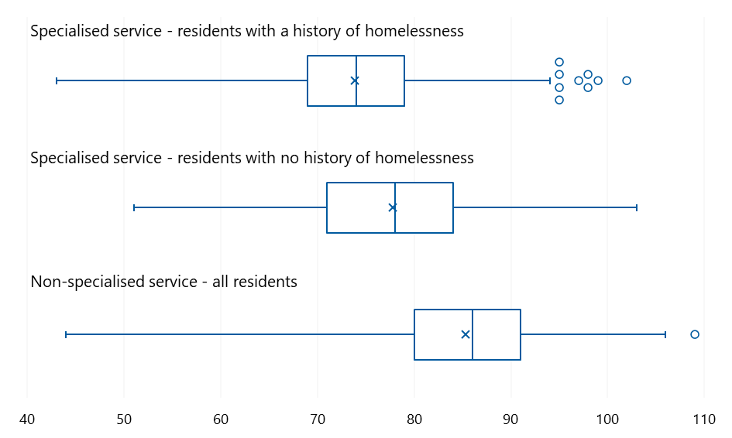

Source: AN-ACC assessment data. See section ‎2.1.2 for “How to interpret a box and whisker plot”.

Figure 4 data is provided in Table 45.

The fact that people with a history of homelessness tend to be younger than people with secure housing when they enter aged care is well documented (Jutkowitz et al. 2019; O’Connor et al. 2023). One reason for this is the premature ageing that people with a history of homelessness can experience (see section ‎2.3.1), meaning they both need and become eligible for aged care services earlier.

While most people can access the Australian Government-funded aged care system from age 65, those who are homeless or at risk of homelessness can do so from age 50 (assuming, in both cases, that the individual is assessed as having aged care needs and approved for government-subsidised services ).

However, service managers highlighted that recent reforms to stop people under 65 going into residential aged care (Department of Health and Aged Care n.d.a) have led to confusion over eligibility for younger people with a history of homelessness. While specialised services are able and willing to care for this population, assessors and referrers are not always aware that residential care is an option. This finding is not unique to this evaluation – we have previously heard that confusion over eligibility and referral pathways for younger homeless people extends to My Aged Care and Services Australia contact centre staff (AHA 2024).

This barrier to entry can make it difficult for services to maintain a population of at least 50% residents with a history of homelessness, and more importantly, results in poor outcomes for individuals and burden on other services (e.g. due to preventable hospital admissions).

* It’s very challenging to get phone calls from different providers, referral agencies and social workers from public hospitals saying “Can you take this person, they have nowhere to go?”, but they are 63 years old and we can’t get them an ACAT assessment, but we know that they are homeless and meet our criteria and they have aged 10 years plus further than their [biological] age. The research shows this, it’s just a no brainer. These people are clogging up the public system. They would be happy [in aged care], we would service their needs. – Service manager

Being younger when they enter residential aged care also means that people tend to live in specialised services for longer. In November 2024, residents had been in their current specialised service for 5.2 years on average, compared to 3.7 in non-specialised services. We spoke with some residents who had lived at their specialised service for up to20 years, or almost one-third of their life. With residents staying in the service for longer, it is especially important that services deliver a model of care that promotes health and wellbeing across all aspects of life, as discussed in section ‎3.

### Men make up two-thirds of residents in specialised services

Men account for 67% of residents in specialised services. This is the reverse of non‑specialised services (Figure 5) and the sector overall, where men make up one-third (n = 34%) of the residential aged care population (AIHW 2024b). The Northern Territory is a notable exception, with men accounting for only 44% of residents in specialised services in that jurisdiction. A service manager suggested that this might be associated with the lower life expectancy of First Nations men.

The proportion of men among residents with a history of homelessness (68%) is also higher than population statistics would suggest, with men accounting for 56% of people who are homeless in the general population (ABS 2023a).

However, as shown in Figure 5, there is substantial variation around the mean, and the high proportion of men in specialised services is largely driven by specialised services in metropolitan (MM1) areas (Appendix ‎C.2). Several services in these areas are for men only. To our knowledge, there are no equivalent services for women (although, in some, certain areas or wings may be dedicated to women’s care).

Figure 5: Proportion of men, by service type and history of homelessness

-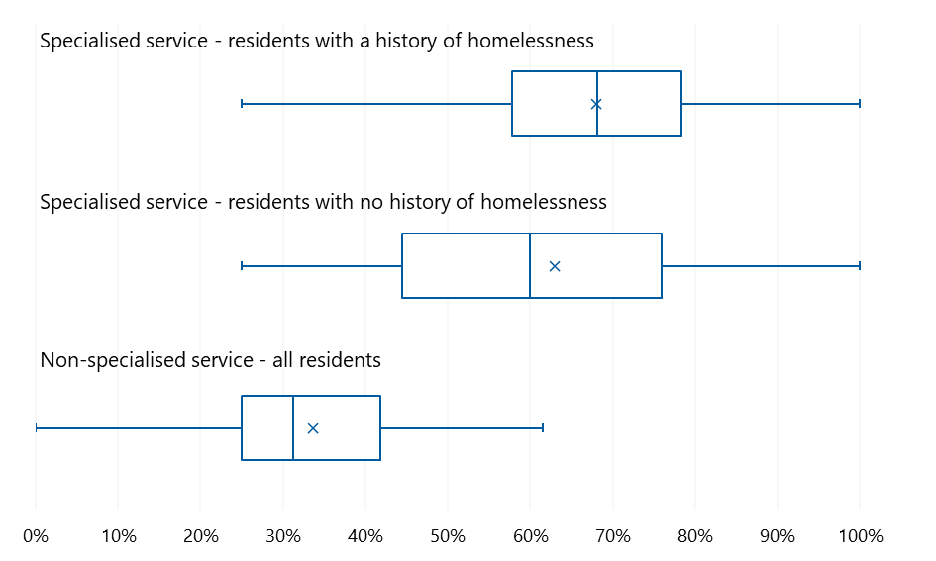

Source: AN-ACC assessment data. See section ‎2.1.2 for “How to interpret a box and whisker plot”.

Figure 5 data is provided in Table 49.

The higher proportion of men in specialised services may be partly explained by gender differences in how mental health conditions and the effects of trauma manifest. At least one staff member speculated that their male residents may have been more likely to enter care because their behaviours were not manageable in other settings. For example, men may display more “externalising symptoms” such as problematic substance use, aggression and risk-taking (Rice et al. 2015). Men diagnosed with schizophrenia may be more likely to experience symptoms such as asociality, attract more severe criticism from relatives and have higher rates of relapse (Falkenburg and Tracy 2014).

Another important reason that men may be overrepresented among residents with an identified history of homelessness is that older homeless women “tend to remain hidden due to their use of informal supports and accommodation … they see themselves as having trouble accessing housing rather than being homeless” (Craig and Hastings 2024:363–364). Older men may be more likely than older women to be ‘sleeping rough’ or living in boarding houses (Petersen 2015), and may therefore be prioritised by services and/or more likely to be considered homeless based on previous accommodation setting (section ‎1.2.2). On the other hand, women entering aged care from a friend or family member’s house may be misclassified as having stable accommodation and undercounted in homelessness statistics.

However, homelessness is an increasing issue among Australian women (Craig and Hastings 2024; Patterson et al. 2019; Pawson et al. 2024), and as such population demographics in specialised services may change in future.

* Older women are a growing group in the homelessness space and are increasingly accessing services. [This cohort brings other challenges, such as] links with things like family and domestic violence. So that’s a growing area that services would need to have the ability to cater for. – Peak body representative

### Some specialised services have a high proportion of First Nations residents

First Nations people are overrepresented among people with a history of homelessness in the general community: they comprise 20% of the homeless population but just 3% of the Australian population overall (ABS 2023a).

These statistics are mirrored in residential aged care, where First Nations people make up 16% of residents in specialised services and 3% of residents in non‑specialised services. However, as Figure 6 shows, these overall figures are skewed by the very high proportion of First Nations residents in a small number of services; the median proportion of First Nations residents in specialised services (regardless of homelessness history) is 5%.

Figure 6: Proportion of First Nations residents, by service type and history of homelessness

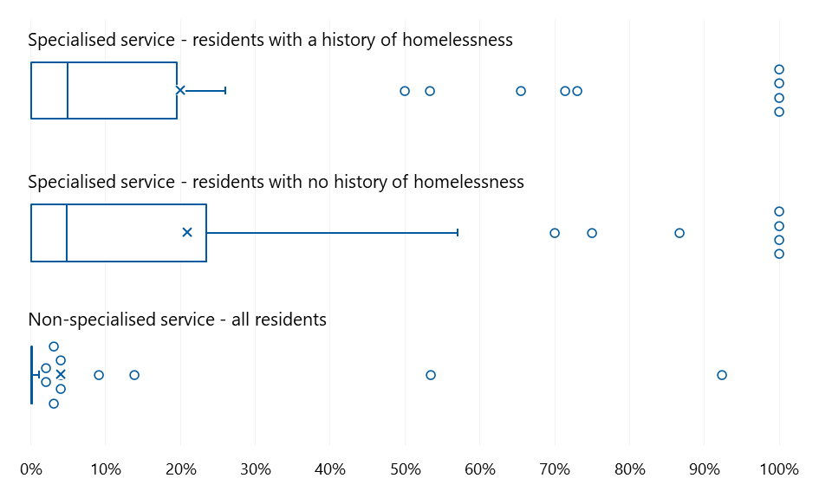

Source: AN-ACC assessment data. See section ‎2.1.2 for “How to interpret a box and whisker plot”.

Figure 6 data is provided in Table 50.

The proportion of First Nations residents is higher in services located in areas with a higher-than-average proportion of First Nations people living in the community. At a jurisdictional level, the proportion of First Nations residents ranges from 3% (n = 19) in specialised services in Victoria to 52% (n = 78) in services located in the Northern Territory.

## Care needs

Older people with a history of homelessness are not a homogenous group. The nature and duration of their homelessness varies; some may have never experienced stable housing while others become homeless later in life (AIHW 2024c). For many, the experience of homelessness is prompted by, or associated with, other difficult and potentially traumatic life events such as:

* abuse and/or trauma, including childhood trauma (Demakakos et al. 2020; HAAG 2019)
* social isolation (including living alone, relationship breakdowns, exhausted social networks, loss of a partner) (Grenier et al. 2016; HAAG 2019)
* estrangement from biological family (Mission Australia 2017)
* incarceration (Grenier et al. 2016)
* military service (Jutkowitz et al. 2019; RPS 2023).

These (and other) experiences, together with the experience of homelessness itself, can have long-term consequences for residents’ health and wellbeing (and must be considered in the design and delivery of appropriate care; see section ‎3).

* The main consideration is the complex nature of the cohort from the time of admission (or even before). There’s often a reluctance to enter an institutional setting or deal with a government-related service, a lot of anxiety and fear related to past trauma (often extreme or repeated). – Peak body representative
* As an example, veterans may experience night terrors, so [services are] going to need to have more staff on night shift which your normal facility wouldn't need to have. – Peak body representative

In this section we explore the diverse care needs of residents with a history of homelessness. Where possible, we present findings from the 2,036 residents in specialised services, and the 2,181 in non‑specialised services who had had an AN-ACC assessment as of September 2024.[6] It is evident from both the literature and stakeholder consultations, however, that residents’ care needs are more complex and nuanced than what is apparent from the AN-ACC data alone. The AN-ACC tool primarily focuses on physical and cognitive functioning (i.e. does not capture data on other needs such as mental health conditions or substance use problems), and is administered for funding purposes rather than care planning. The Resource Utilisation and Classification Study, which informed the development of the AN-ACC model, identified that “care needs of residents in these specialised facilities are different and not well captured through standard measures of physical mobility and related domains” (McNamee et al. 2019:17).

Naturally, the nature and extent of residents’ care needs varies between and within specialised services. For example, in services operating a low-care model designed for people that are relatively independent, residents may have lower physical health needs but require significant support for psychosocial and substance use problems. Other services have a resident cohort with much higher clinical and personal care needs. It is also important to recognise that residents’ care needs will change as they age.

* I used to get out of here once a day, but now I don’t get out much – getting to and from the bus is more difficult [due to a general increase in frailty]. – Resident

### Residents in specialised services tend to be more physically independent

People with a history of homelessness experience poorer health much earlier than other community-dwelling adults their age or even older (HAAG 2019; Keast 2015; Mantell et al. 2023; Wood et al. 2024; York et al. 2024). That is, they age prematurely.

* We find that their health can deteriorate a lot quicker, so for some people supports do need to be wrapped around them at a younger age, [compared with] somebody else that has lived a really nice life. – Service manager

In addition to unmanaged chronic conditions (e.g. hypertension, heart disease, pain, renal disease, diabetes and chronic wounds) we heard that malnutrition can be one of the most pressing physical health needs for residents when they are admitted to specialised services.

While people with a history of homelessness who enter residential aged care are in poorer health than people who are stably housed in the community, they tend to fare better on some measures of physical wellbeing than people who enter aged care because they are no longer able to live in their own home. For example, AN-ACC data shows that residents in specialised services – and especially those with a history of homelessness – are more physically mobile than residents in non-specialised services. This difference is evident even after controlling for age differences between the resident cohorts (Appendix ‎C.3‎0).

* It’s an eye-opener. [In mainstream care, residents are] usually lying in bed, they can’t get up. In this service, they’re more independent, which is totally different to what I’m used to. It’s really good. – Service staff

Further, as residents with a history of homelessness are more likely to be classified as having independent mobility than residents with no history of homelessness, the proportion of residents with a history of homelessness impacts the overall distribution of AN-ACC classes within a specialised service (summarised in Table 7, with a full breakdown by individual AN-ACC classes provided in Appendix ‎C.3.2).

Table 7: Proportion of residents by mobility level, by service type

|  |  |  |  |  |  |  |  |
| --- | --- | --- | --- | --- | --- | --- | --- |
| Mobility level | Less than 50%  (n = 466) | 50–60%  (n = 526) | 60–70%  (n = 412) | 70–80%  (n = 380) | More than 80%  (n = 252) | Specialised – all residents  (n = 2,036) | Non-specialised  (n = 2,181) |
| Independent mobility (classes 2–3) | 5.8% | 14.8% | 11.7% | 17.9% | 20.2% | **13.3%** | 3.6% |
| Assisted mobility (classes 4–8) | 59.0% | 59.1% | 60.7% | 63.9% | 59.1% | **60.3%** | 58.6% |
| Not mobile (classes 9–13) | 35.2% | 26.0% | 27.7% | 18.2% | 20.6% | **26.4%** | 37.8% |

Source: AN-ACC assessment data

There are some differences in physical mobility across different demographic groups; however, these are evident in both specialised and non-specialised services. For example, residents in metropolitan areas are more likely to be independently mobile than those in rural and remote areas, and men are more likely to be independently mobile than women (data on mobility and gender is provided in Table 32).

### Residents’ cognitive functioning is often impacted by substance use

Older people with a history of homelessness are consistently found to have higher rates of cognitive impairment and dementia than other people their own age and older (Brown et al. 2017). However, AN-ACC data suggest that they have similar cognitive abilities to residents in specialised services without a history of homelessness, and those in non-specialised services (Appendix ‎C.3).

Importantly, cognitive function scores captured in AN-ACC assessments represent a moment in time; a resident’s cognitive functioning may fluctuate from day-to-day or even over the course of a day. While this is true in all residential aged care services, we heard that it can be particularly pronounced in specialised services. This is due in part to the substance use issues that are prevalent among older people with a history of homelessness (van Dongen et al. 2020), meaning that cognition is subject to abrupt changes due to both alcohol-related dementia and intoxication.

* Some of these people have been self-medicating for years, and now they’ve reached the point where [their body] can't cope with the amount of alcohol they’ve consumed. They are some of our most challenging [residents]. – Service manager
* We have some residents with...alcohol-related dementia which is very unique. You have to be well trained to manage that kind of person, it’s not like [providing mainstream] memory support. They can be really high functioning but lack insight into their health and safety. – Service manager

In addition to affecting residents’ day-to-day cognition, problematic substance use may impact a resident’s other care needs, causing or exacerbating social or family difficulties and physical and mental health challenges.

In addition to the issues caused by a long history of substance use, we heard that residents’ needs frequently centre around managing, rather than restricting, their use of alcohol (and tobacco, for that matter). Requiring residents to abstain would result in behavioural problems, potentially fatal alcohol withdrawal syndrome and residents being unable or unwilling to enter and remain in residential care.

### Complex mental health challenges are common in specialised services

Mental health challenges are common among people with a history of homelessness, including those in residential aged care. This is a function of both pre-admission factors (e.g. systemic neglect, discrimination, trauma) and admission-related factors (e.g. grief and loss associated with the transition to residential care) (Cameron et al. 2022; Toomey 2018).

Managers and staff in specialised services told us that mental health challenges play a key role in the day-to-day care needs of their residents. They indicated that some conditions are particularly common including anxiety disorders, severe depression, personality disorders, psychoses (including paranoia and delusions), eating disorders, hoarding behaviours, self-harm and suicidal thoughts.

* We have some complex health issues but not so much physical health – more mental health. A lot of people are on medication – antipsychotics and things like that. Way more than I’ve seen anywhere else. – Service staff
* The most commonly looked after health issues would be mental health, we've got a lot of residents with mental health issues, including schizophrenia, which is a challenging disease to experience and also to manage because there will be a lot of fluctuation in the everyday situation. There will be a lot of delirium, hallucinations, and people can be violent. – Service manager

While the published evidence and stakeholder feedback is clear about the prevalence and severity of mental health conditions among people with a history of homelessness, quantitative data on these conditions is not currently uniformly collected or reported in the residential aged care setting..

Some information on mental health is captured using the Integrated Assessment Tool (which determines eligibility for aged care services) and the Specialised Homeless Status Care Recipient Assessment Form (used to determine eligibility for the specialised BCT) (Department of Health and Aged Care n.d.b). However, neither of these provides reliable information on mental health needs and how these may differ between specialised and non-specialised services:

* We heard that pre-admission assessments are not always an accurate representation of a person’s mental health needs when they arrive at the specialised service, whether due to delays in accessing care or the instability of the condition itself.
* The Specialised Homeless Status Care Recipient Assessment Form defines diagnoses according to the Aged Care Assessment Program (AIHW 2002), which predates the current version of both major diagnostic classification systems (i.e. International Classification of Diseases and the Diagnostic and Statistical Manual of Mental Disorders) by over a decade. This may affect the accuracy of information and limit its comparability to published data on mental health diagnoses in other populations.

### AN-ACC data may underestimate the extent and complexity of behavioural challenges

Partly as a result of traumatic life experiences, mental health challenges and problematic substance use, residents of specialised services are more likely to present with challenging and unpredictable behaviours that need to be appropriately and safely managed by staff.

In AN-ACC assessments, residents with a history of homelessness were rated as displaying behaviours requiring significantly more monitoring than residents without a history of homelessness, who in turn were identified as requiring more monitoring than residents in non‑specialised services (Appendix ‎C.3).

Stakeholders highlighted that AN-ACC data tells only part of the story, with the nature of behavioural challenges in specialised services often being quite different to those encountered in non-specialised services and requiring different levels and types of resourcing to manage.

* [Services] will assist with a lot of people that have just left prison. That's just mind blowing, where you are having to transition people that are so scared, so anxious, so heightened – but also quite volatile. They're having to take people [who are] wanting to hide knives in their bed – they’re tunnelling out their mattresses to then hide things in there to give them a sense of security. But imagine trying to staff and manage that! So it is a completely different set of needs. Then this might be overlaid with dementia, drugs, paranoia and psychosis. – Peak body representative

Some of these behavioural challenges may be exacerbated by other resident characteristics, such as increased physical independence coupled with impaired or fluctuating cognitive function (as noted in section ‎2.3.1).

* Our average residents are significantly younger. They’re often male and they’re physically active. The combination of those things means that if a person isn't living a full lifestyle, especially if they've also got [for example] a brain injury from alcohol use, they can become quite frustrated, and their behaviour can start impacting other people. – Service manager

### Residents of specialised services often require intensive psychosocial support

Service managers and direct care staff identified that psychosocial needs are common among their residents. Below we discuss 2 of these, namely a lack of social support and legal and financial difficulties.

* Our residents have low clinical needs but typically they have experienced lots of trauma through their life and don't have much family support or social support, and so they have higher psychosocial needs. – Service manager

We heard that residents in specialised services, particularly those with a history of homelessness, are less likely than other residents to have family and social supports. One service manager suggested this situation applied to “90 to 95% of residents”. Family estrangement has been noted to be an issue for many older Australians (Mission Australia 2017). In some cases, residents’ lack of support systems reflects their own choices and behaviours but, unfortunately, we also heard instances where residents were estranged from family due to physical, emotional or financial abuse.

* He starved me, he starved the dog, locked us in a room, no water, no nothing. – Resident

Negative life experiences can mean that many residents with a history of homelessness are used to being independent and are reluctant to trust or develop relationships with new people, including staff and residents.

* People [with a history of homelessness] are used to having their own space, not talking to people, discussing their personal life/issues. So we’re trying to expand that for them, but it’s hard to get them to open up, because they’ve been closed off for so long. – Service staff
* Some come here the first time and they want to stay inside their room, and they feel very insecure. – Service staff

Related to their lack of family and social supports, we also heard that many people with a history of homelessness enter specialised services with unmet legal and financial needs. For example, they may have become estranged from family because of financial difficulties, or be in financial difficulty due to escaping an unstable or unsafe living situation (e.g. domestic violence). Often, a lack of close relationships means that residents with a history of homelessness do not have anyone to make decisions on their behalf when needed.

* Sometimes an individual will have no Medicare number, no pension number etc. They often have no supporting person in their lives, no doctor. – Peak body representative
* We often see people go under legal guardianship, and have public trustee involvement to manage their finances. – Service manager

# Models of care

In this section, we describe:

* **T**he characteristics of care being delivered in specialised homeless residential aged care services nationally (KEQ1)
* **The extent to which** specialised services are implementing their intended models of care, and the factors that have helped or hindered them to do so (KEQ2)

Despite limited opportunities for collaboration and sharing (see section ‎4.1.2), most specialised services – regardless of location, proportion of residents with a history of homelessness, or other characteristics – describe remarkably similar approaches to caring for their residents.

## Characteristics of specialised care

As part of their application for specialisation, aged care providers have to describe the specialised programs they deliver (or intend to deliver). After reviewing these applications and engaging with specialised services, we found that the *models* of care could more appropriately be characterised as a *philosophy* of care defined by “meeting people where they are”.

Broadly speaking, the care provided in specialised services has 4 core components (Figure 7). At the centre is a person-centred, trauma-informed approach, which enables services to promote individual agency, deliver holistic wellbeing supports, and manage substance use realistically and compassionately. Below, we share common examples of how these components of care are operationalised.

Figure 7: Core components of specialised services’ philosophy of care



Of note, in most cases services do not differentiate between the care provided to residents with a history of homelessness and those without; the activities and supports implemented within the service are available to all residents who need them. This approach is consistent with evidence showing that providing specialised care to some residents but not others can create friction within the resident population (Rota-Bartelink 2016). It also suggests that residents in specialised services have similar care needs (e.g. complex mental health conditions, substance use and behavioural challenges) regardless of their history of homelessness.

### Care is person centred and trauma informed

Person-centred care and trauma-informed care are interrelated concepts that are important for all residential aged care services but particularly for those services catering to older people with a history of homelessness (Demakakos et al. 2020; Grenier et al. 2016; HAAG 2019; Mission Australia 2017).

**Person-centred** care “respects and responds to the preferences, needs and values of patients and consumers”. It recognises and upholds the person’s rights and autonomy, and considers the person’s background (including culture, ethnicity, and life experiences) and needs (including the need for support to make decisions, if applicable), in all aspects of care, from assessment through planning and delivery (ACQSC n.d.a). It “is dependent on understanding the individual as a person with a past, present and future” (ARIIA Knowledge & Implementation Hub 2022:1).

Person-centred care benefits all aged care residents, and will be required of all aged care providers from July 2025, under the strengthened Aged Care Quality Standards. However, this approach may be especially important in addressing inequities in the quality and experience of care experienced by people from disadvantaged backgrounds – such as those with a history of homelessness.

* [What works for these residents is] investing time in making a plan that works best for the person, and having staff that are well aware of their life history and care needs and can provide continuity of care. – Service manager

**Trauma-informed** care recognises that most people will experience a potentially traumatic event in their lifetime, and that these experiences can have profound and ongoing effects on how a person perceives and interacts with the world around them, including how they think, communicate, form relationships, respond to stress, and so on.

Significantly, trauma-informed care helps to reframe “difficult” behaviours as coping strategies that are evidence of an individual’s resilience and resourcefulness, thus reducing stigma and increasing empowerment. More importantly, a trauma-informed approach asks why a person is behaving in a particular way and what they need to behave differently.

* One gentleman went through my bag yesterday as he was sure that I had his cigarette. So, I let him to do that. Then this morning he has greeted me in a totally different frame of mind. I registered that this was important to him. So, it is thinking outside of the box. We have a range of [residents] here who have trauma and life experiences we probably can’t fix. Our job is to create a place where they feel safe to be themselves and supported to be themselves even if their best self is not great. That is hard to do in a typical setting [mainstream aged care service]. – Service manager

Providing effective trauma-informed care requires understanding of trauma and its impacts and building safe relationships between staff and residents; knowledge of each resident’s history and “triggers” can also be extremely helpful (Center for Health Care Strategies 2025; MacRae et al. 2023).

* We have a resident that doesn’t like anyone sneezing – if someone sneezes, we’ll run towards him and distract him. The staff know his trigger, someone sneezed, and we act before it escalates. He’s got a big issue with noise, and we got him some headphones, so that helps a lot. – Care staff

Delivering person-centred and trauma-informed care is more time-consuming than delivering care under older, system- or service-centred models. Staff take the time to build relationships with residents and develop an understanding of their needs, interests and preferences.

* We need to spend more time understanding our residents here than in any mainstream nursing home because we have less information about their past life – they don’t have family members to provide a life history. We start by getting to know the residents really well so we can develop an individual care plan and start providing the right supports for them. – Service manager

To design and deliver this highly individualised care, service managers and staff work collaboratively to develop detailed care plans, identify creative ways to meet residents’ needs, and review and discuss care. One service manager explained that their service holds a monthly multidisciplinary committee meeting with the NDIS team, clinical team, and lifestyle team to talk about the care needs of each individual resident. They told us that “this makes sure residents with a history of homelessness don’t fall through the gaps, as these residents often can’t advocate for themselves”. Services will also hold meetings to discuss residents with complex care needs, and how these can be met.

* We sometimes have … residents that move in, and *then* we become aware of more complex or tricky behaviours. A group of people [e.g. clinical care, RN, case manager] will come up with solutions. It can get to the point where the site says we are out of ideas but are not giving up on this person. So then we will do what is called a case conference which is facilitated at head office, and we will invite people from the site and from throughout [the provider organisation] who all have different expertise. So we get a range of people to come up with solutions. – Service manager

Resident stories

Willow

Willow had tried living in a few non-specialised services but they weren’t a great fit because they didn’t give her the freedom she wanted. She prefers to sleep in communal areas because she feels safer there than in her room, but the non-specialised services wouldn’t allow this. Eventually, she was asked to leave for not following their strict rules. The specialised service she lives at now is different – they’ve made arrangements so that she can sleep in communal areas when she wants to. Willow has a swipe card, so she can come and go as she likes. Now she spends most days out with her friends, and comes back to the facility at night. The staff just ask that she tell them where she’s going so that they know she’s safe.

Aidan

Aidan used to work in a creative job and art is very important to him. The staff at his specialised service have set him up with a painting desk with lots of natural light and an impressive array of art supplies, which they help him restock as needed. He has recently taken up colouring and finds it very soothing. Frustratingly, adult colouring books are too intricate for him, but children’s books are too basic and babyish. Seeing this, staff members have started to create special drawings and shapes for him to colour. He now spends most of his days drawing, painting or colouring and likes to join the weekly art group with other residents. Aidan’s art is on display throughout the corridors – he feels proud to see it on the wall, and it helps the place feel like his home.

Note: Names and revealing details have been altered to protect individual’s privacy.

Justine

Justine was admitted to her specialised service from hospital. The hospital social worker had helped her find the service because she had nowhere to be discharged to. She had nothing – no clothing or personal items – and was worried that she’d be stuck wearing a hospital gown. The hospital gave the specialised service a heads‑up: by the time she was welcomed to her new home, she not only had clothing and shoes but also her own space with new bedding and pictures on the wall. This really helped her feel comfortable in her new environment. When the staff computers were upgraded, the service’s IT person refurbished one of the old computers and set it up for her. One of Justine’s favourite things to do now is to spend time on her computer, looking things up online and watching movies.

Hugh

Hugh had lived under a bridge for a lot of his adult life, and he was pretty happy with that. But as he got older, he wound up in hospital quite a lot. This became a problem and eventually he was appointed a public guardian and admitted to a specialised service. He was pretty apprehensive about living in residential aged care after always being able to choose how he lived his life; he thought there’d be lots of rules and was worried he wouldn’t be able to smoke. But he was pleasantly surprised. The first time he wanted to go out the front door and the staff said “no worries”, he couldn’t believe it! He went outside and had a smoke at a local bus shelter while watching the world go by. It quickly became his favourite spot. Hugh made lots of friends at the service – including the maintenance worker and the music therapist. When his health deteriorated and he needed palliative care, the maintenance worker would organise for a group of staff to wheel his bed outside so that he could have a smoke. Instead of passing away alone or at hospital, he passed away peacefully at his new home with his friends around him.

Sam

Sam used to keep to himself – he didn’t have much to do with the other residents and he wasn’t interested in the art classes, word games, and bingo that the specialised service organised. One day, he heard that a group were going to play golf and he figured he’d go along and play a few holes (it would be an excuse to get out, and he could easily stay away from the residents). The manager found some second-hand clubs for him to use, and he had fun playing a couple of holes. He quickly became hooked, and a few months later Sam had become a regular with the golfing group. He bought himself a beautiful set of golf clubs – they were pretty expensive, so he cut down on alcohol and cigarettes to save up for them. He felt himself get healthier thanks to drinking and smoking less and getting more exercise. After spending time playing golf with the other residents, Sam realised that he had more in common with them than he’d thought. He built some close relationships – so much so that the manager one day found him not just chatting with one of his neighbours but trimming their beard!

Dale

Dale was a Vietnam veteran who’d had a pretty normal life before he was conscripted to the war: a job in a bank, a girlfriend, a loving family. His war experiences left him with PTSD and what people see now is a big, blustery fellow who repeats himself and mutters about the police and the state being the enemy. He’s terrified of not having money in his wallet because of his experiences on the street: if he didn’t have money in his wallet, he’d be charged with vagrancy. His wartime experiences and life on the streets led to the specialised service he lives in now being his last resort. The staff have created a comfortable space for him over the 6 years he’s been with them. They understand how his story has made him who he is and listen to what he needs. He asked for a blue wall one day, and the staff helped him to paint it: this is just one of the many little things the service staff have done that settled him into his new home and have kept him out of long-term mental health care.

### Care prioritises and promotes individual agency

Apprehension about losing independence is common for many older people when moving into aged care (Brownie et al. 2014). However, this apprehension can be even more pronounced for people with a history of homelessness, because their life experiences have taught them to be self-reliant and wary of authority and institutions. Because of this, specialised services tend to have policies that enable freedom of choice and movement and minimise restrictive practices.

* We have zero restrictive practices. They can do whatever they want. They can come in and out. After 6 pm, there is a bell [that they can use to enter the service]. Having said that, they can stay outside for as long as they want as long as they tell us. If they don’t [tell us that they’re staying out], the problem is we have to report it to the police. But they have the freedom – for example, if they want to eat in their rooms they can, if they want to go outside they can. – Service manager

We heard numerous examples of services supporting individual agency by allowing residents to set their own hours, come and go from the service at will, choose from a range of pre‑planned and short-order menu options, decorate their rooms, and bring their pets with them (provided the pet is able to be properly cared for by the residents and does not pose safety concerns).

* I get up early in the morning, have breakfast and then just do what I want to do. If I want to go out, I will tell them, and they will make arrangements for a [staff member] to come with me. That’s good. I don’t get lost anymore. – Resident

We heard that this emphasis on freedom of choice can sometimes create challenges for meeting other aspects of high-quality care. For example, residents may refuse to shower, not allow staff into their room to clean it, or act against medical advice. We heard of several creative ways that services have come up with to address these challenges (see “Physical wellbeing” in section ‎3.1.3); however, the idea of “dignity of risk” is fundamental to person-centred care – it means that “people have the right to live the life they choose… even if their choices involve some risks” (ACQSC n.d.b). In these instances, staff will discuss the situation with the resident to make sure they understand the risks to themselves and others and come up with ways to manage them. In some cases, this may mean asking the resident (and family member or public guardian, if relevant) to sign a dignity of risk form so the service can support the resident’s individual agency without neglecting their duty of care.

* The most challenging part is providing ADLs [Activities of Daily Living] to residents who were homeless. We don’t force them to do things they don’t want to do. If they don’t want a shower, we don’t give them one. We have those talks. – Service staff
* We try to keep their rooms as clean as we can, but there are some people who don’t want to have people go in their rooms, so we don’t go in there if that’s what they want. We just try and manage the risk. We do risk assessments and [support] dignity of choice. – Service manager

Specialised services also support the agency of their residents by asking for their input into how the service runs and the care that they receive. This can involve suggestions for everything from menu items to leisure activities (such as the introduction of a cooking group) to new equipment and facilities – one resident told us: “We asked for a barbecue, we got a barbecue. We asked for a pool table, it’s on the way.”

Some services have formal mechanisms for gathering residents’ input, such as surveys and feedback forums. Others seek resident feedback through informal, day-to-day interactions.

* My main goal is that we listen to the consumers. They have consumers meetings regularly to see what it is that they want, what they like, what they dislike. And consumers can come to anyone at any time to talk about their grievances. – Service manager

We heard of one service that even provided training and support to ensure residents had the skills, knowledge and comfort to participate in the feedback forums.

* For people from middle class and professional backgrounds, sitting on a committee and chairing a meeting may be comfortable for them. For our residents, it’s a challenge and we had to run training sessions – one was a leadership training, how to lead and chair a meeting, how to take minutes, etc. – Service manager

### Care spans different dimensions of wellbeing

Staff provide holistic care across the interconnected dimensions of physical, mental and emotional, social, financial and legal, and spiritual and cultural wellbeing (Figure 8). This care entails a range of activities and considerations to meet individual residents’ needs, as described in the following subsections.

Figure 8: Dimensions of wellbeing

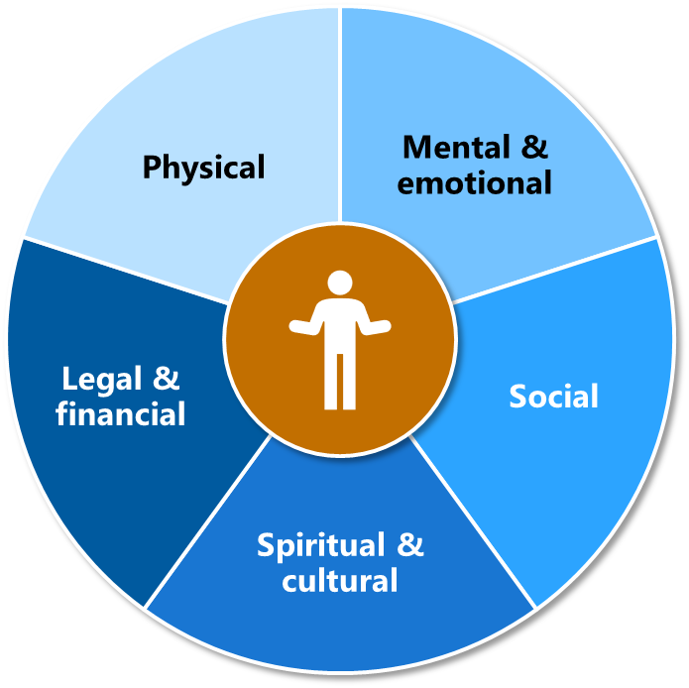

#### Physical wellbeing

Caring for resident’s physical wellbeing involves both clinical care (for health conditions) and personal care (for hygiene and support with daily activities).

We heard that delivering clinical and personal care to residents with a history of homelessness can require considerable patience and take a lot longer than expected – for example, it might take 5 minutes to administer an injection but an hour to mentally prepare the resident for the procedure and gain their consent.

Services employ a range of approaches to ensure the care is delivered in a way that makes residents feel safe and comfortable – for example, one service offers a “day spa” for personal care.

* The home has a day spa which is used to encourage sound hygiene practices in a non‑clinical manner by giving the feeling of a salon but without the cost. For those that are reluctant to undertake regular hygiene practices, staff often encourage them to visit [the spa] where they can have their hair washed and/or a haircut, as well as a manicure. It provides a relaxing, calming environment … making hygiene practices feel more like a pampering session than everyday clinical care. – Care staff

While day-to-day clinical care is provided by clinical staff such as nurses, some services have also developed collaborative relationships with hospitals and external health professionals – such as GPs, podiatrists, geriatricians, physiotherapists, dieticians, dementia services, and optometrists – to ensure residents’ clinical care needs can be met.

This works best when services can be provided on site (as described in section ‎3.2.3). But when residents do need to attend an appointment off-site, it is common for services to either arrange transportation for the resident or have a staff member accompany them, as many residents with a history of homelessness don’t have family members who can take them to appointments.

Some services also make arrangements to help residents feel more comfortable attending off-site appointments – for example, one service notifies hospital reception staff when a resident will be arriving for an appointment so that they can ensure the resident will not need to spend time in the waiting room.

#### Mental and emotional wellbeing

As described in section ‎2.3.3, many residents in specialised services experience mental health challenges. Service managers and staff explained that, as such, person-centred and trauma-informed care is especially important and that they work to meet the mental and emotional wellbeing needs of residents in a range of ways.

For example, some services also deliver on-site group therapeutic activities, such as art therapy, music therapy or pet therapy. These are tailored to the resident cohort; for example, one specialised service is looking to include heavy metal tracks in its music therapy program to match residents’ musical tastes.

We heard that the “settling in period” following a resident’s admission is particularly important for identifying and developing a plan to effectively meet mental and emotional wellbeing needs. This includes ensuring appropriate handover from other services (e.g. social workers or older person mental health units); undertaking mental health assessments; developing a care plan; identifying opportunities to help a resident feel safe, comfortable and engaged; and building trusting relationships between the resident and staff.

* Because of the history of our residents, you can’t rush them. One of our residents here, it will take them up to a year to warm to a new staff member. So there is a lot of working into building up trust. – Service staff
* Since I’ve been here, I’ve received nothing but help and understanding. And – oh! – did I need help and understanding! Did I need a safe place so that I could get myself together! – Resident

Some services employ psychologists or have nursing or other care staff with mental health qualifications and expertise. Others encourage staff to develop their skills through short courses (such as mental health first aid) and, often, experiential learning (see section ‎4.1).

As with other health professions, specialised services usually have agreements with psychiatrists and psychologists who come on site to undertake assessments, develop treatment plans, and provide individual mental health care. A number of services have also established collaborative relationships with older persons’ mental health units to meet the needs of residents with more severe mental health challenges, including residents with a history of inpatient mental health treatment.[7]

* Older people’s mental health really help us out, from the hospital. We now, recently, have a mental health nurse [from the older persons mental health team] who comes once a fortnight. If we are concerned, he builds a rapport with the guys we’ve got at the moment and keeps a check on them for us and then he can report back to the psychiatrist and if there is an urgent need they will come help us out. – Service staff

More broadly, we heard that all components of specialised services’ philosophy of care are important for mental and emotional wellbeing – including providing residents with a safe and comfortable home, allowing them agency and independence (as described in section ‎3.1.2), and providing them opportunities to engage in activities they enjoy (see below).

#### Social wellbeing

Social wellbeing is the “ability to form and maintain positive personal and community relationships” (Strout and Howard 2012).

To support residents’ social wellbeing, all residential aged care services offer a range of lifestyle programs, typically through a formal schedule of group activities (such as art classes, bus trips, bingo, word games, cooking groups and movie nights). However, we heard that specialised services tend to offer more extensive and individualised lifestyle supports than non-specialised services. These supports are typically delivered by a service’s lifestyle team, sometimes with the support of other staff such as PCWs, occupational therapists, and catering staff.

In particular, specialised services tend to support residents’ social wellbeing through individual or one-on-one leisure activities tailored to their specific interests and preferences. This is because many residents with a history of homelessness don’t feel comfortable in a group environment, don’t feel like they have a lot in common with the other residents, or have niche interests.

* What I have heard about mainstream [aged care services] is that all of the recreation is based on site and there will be things running all the time, whereas we do the opposite. My plan is based on the needs and wants of the residents. Always finding out what they are interested in and something that they might like to do. Gently encouraging things if they are a bit stuck [on what to do]. We try and group things where we can, but generally it is one-on-one or one [staff member] to two [residents]. – Service staff

We heard about a wide range of tailored activities and outings that specialised services have delivered to enhance residents’ social wellbeing. For example:

taking residents fishing

taking a resident to an LGBTQIA+ community group

taking a d/Deaf resident to a pottery class for d/Deaf people

taking a resident to the library to learn about local history

* taking residents out for a coffee or meal one-on-one.

Staff find out what residents are interested in and then build lifestyle programs around this to facilitate social connections.

* We ask questions like “what have you done in the past? What do you enjoy doing now? Is there anything you have always wanted to do and never had the opportunity to do?” The purpose is fun, enjoyment, and making the most of a person’s life, but the benefits are huge. – Service manager

The benefits of these individualised activities extend beyond providing social connection. Staff members told us that activities have a marked impact on residents’ quality of life, satisfaction with the service, and overall engagement with the service and broader community.

* We feel tailoring supports to individual needs allows them to regain health and self-esteem to allow a quality of life and to socialise back into the community and our home – each resident has a different story of why they came to our service and their needs vary. We see friendships forming and an increase in participation within the community. – Service manager

Specialised services also organise celebrations for a range of occasions such as birthdays, Christmas, New Years, and sporting events. This regularly involves holding parties, providing special food, and providing residents with gifts. Residents told us that they looked forward to these celebrations and felt cherished by the staff and managers.

* We celebrate birthdays – no different for homeless or other people. One person asked for a watch, and the manager bought it for him. This is the special thing – your family aren’t going to do it for you, so [the manager] does it. One man wants a big sausage sizzle every year for his birthday, he invites his friends. – Service staff

As the quote above suggests, staff and managers build genuine connections with residents, often over the course of many years, meeting social needs that might otherwise be filled by family members. Managers, staff, and residents at almost all of our site visits described the relationships at their service as being that of “family”.

#### Financial and legal wellbeing

Some specialised services help residents to navigate legal services and the justice system. For example, service staff might work with a resident on parole to ensure that they are complying with the requirements of their release.

* We get people from prison. When they come to us, they will come with some sort of requirement for ongoing meetings with the correction office, for example, or some yearly review. That's where we are spending our time supporting them … Some of them can be quite challenging, they become very anxious to go and meet the police officer and they usually want one of us to be with them. – Service manager

Most specialised services also help residents to address unmet financial needs. For example, staff regularly support residents to:

deal with government agencies such as Centrelink, Medicare and the NDIS

set up essential resources such as identification cards and bank accounts

* engage with public guardians.

The staff members providing support with financial and legal matters vary between services, and include lifestyle and administrative staff, service managers and social workers. However, we heard of one service that explicitly excludes financial issues from their support offerings, and instead refers residents to other services for assistance.

* We're here to care for the residents and do not get involved at all with any financial concerns because then it’s a blurry line once they actually start living with dementia. [Then you get accusations like] ”they took all my money” when in fact they spent all their money.– Servicer manager

Managers and staff mentioned that their residents typically have low levels of financial literacy coupled with limited financial means and often need support with budgeting and paying bills. Low financial literacy can also increase the risk of financial abuse; services provide support to help minimise this abuse, for example by cancelling bank cards that have been taken and used by family members.

Significantly, we heard that specialised services regularly step in to support residents when they do not have the financial means to meet their needs. For example, purchasing necessities such as clothing and personal care items (which residents often arrive without); purchasing medication; paying for social activities (e.g. movie tickets or coffee) so that residents can participate, and sourcing items such as laptops so that residents can pursue their interests. This type of direct financial support increases the cost of caring for residents with a history of homelessness but is essential to meet residents’ needs and deliver the other core components of specialist care.

#### Spiritual and cultural wellbeing

Spiritual wellbeing comes from having a “sense of purpose and meaning in life” (Stride n.d.). This may include participating in religious or cultural practices, engaging with a religious or cultural community, or carrying out personal practices associated with an individual’s beliefs or morals.

Many services provide specific support for spiritual and cultural wellbeing, including connecting residents with religious groups and places of worship, providing pastoral care, running meditation sessions and celebrating significant cultural and religious holidays. Caring for residents’ spiritual wellbeing continues to the end of life:

* People should not pass away by themselves (even if it dents the budget). Most residents don’t have a family member or a friend so the staff will stay with a person who is dying. – Service manager
* Our end stage care here, we often get called in to sit with people if they are dying and they don’t have family or someone to sit with them. You don’t see that anywhere else, its commendable really. – Service staff

An emphasis on spiritual and cultural wellbeing is particularly evident in specialised services with a high proportion of First Nations residents. This is reflected in strong commitment ensuring cultural awareness among staff, and to supporting First Nations residents to maintain their cultural identify and traditional knowledge systems. For example, residents might be supported to do traditional artwork, eat traditional foods, stay connected with their community, and receive support from specialised First Nations health and social services.

* Spirituality is high with Aboriginal people, to be on their Country is important. If you can’t get them onto their Country, we try to bring it to them (smells, sounds). – Service manager

For many First Nations people, moving into residential care means leaving their Country. Specialised services make travel and care arrangements to help residents return to Country – either for short visits, to live, or at end of life. Some services also actively support the process of Sorry Business.

* Spiritually, we try and be as culturally safe as we can. When our Elders pass, we have smoking ceremonies to clear our whole facility and we’re mindful not to fill that room straight away. I know in other services and especially in mainstream, as awful as this is to say, any resident that has passed will be taken by the funeral home and we will literally be signing the contract for someone else to be moving in the next morning. We certainly don't see that here – we're very fortunate to be able to be extremely culturally safe. – Service manager

Supporting the spiritual and cultural wellbeing of First Nations residents can present a significant – and invisible – financial cost to services, as discussed in section ‎5.3.1.

### Specialised services manage substance use realistically and compassionately

Unlike most mainstream services, many specialised services allow residents to use tobacco and alcohol on site. This is supported by the literature, which recommends a realistic and compassionate approach to substance use that balances health, safety, and respect for human rights (Beaujoin et al. 2023; Theisen et al. 2017).

* We know that we are providing a safe place for them where they will continue drinking. The resident is not prepared to stop drinking but at least we can provide an environment where they eat and where we can see if they have any clinical needs. You know you’re not going to change people, some of these people have been self-medicating for years. – Service manager

Specialised services support residents to budget for, purchase, and portion out their tobacco and/or alcohol. This is often dispensed alongside medications by nursing, administration, or lifestyle staff.

* We support our residents with cigarettes. Some of our residents have the ability to go and buy cigarettes themselves, but there are a few who are unable to because of their disability. So our staff collect the money from the resident, go and purchase the cigarettes and then provide the receipt. The lifestyle team do cigarette allocation as well. Some of our residents … if we give them a whole pack of cigarettes, they would have the whole pack in one go. So that's part of my staff's job as well, allocating those cigarettes. – Service manager

Allowing alcohol consumption in specialised services isn’t without its challenges. We heard that intoxicated residents can exhibit cognitive changes and challenging behaviours and that excessive consumption can have harmful impacts on an individual’s physical health.

* We also manage alcoholism related issues, like someone will go out and come home intoxicated. They can do that, that’s their personal choice. We make sure we have enough staffing to monitor any risk they could have while they’re intoxicated – risk of fall, or risk of choking from vomit. We don’t want to leave them alone until we know they’re through [that risk]. – Service manager
* One resident [consumes] alcohol in his room. When he gets drunk it’s very hard for us to manage it. Even if he is drunk, he won’t come out of his room, but he refuses everything – eating, drinking, medications – and that makes us worry if he is okay or not, safe or not. – Service staff

Specialised services also support residents who want to reduce or stop their use of tobacco, alcohol or other drugs. For example, they may help residents access cessation programs or medications or change their physical environment (e.g. move them to a room away from smoking areas). One service that we visited is a “dry” service, with no alcohol on site. Importantly, this policy was initiated by the residents because many of them had given up drinking alcohol.

Specialised services take a firm stance on not allowing the possession and use of illicit substances on site, although we heard some examples of residents using these substances off-site. In general, however, use of illicit substances does not appear to be a significant issue for specialised services at present. However, one manager explained that they expect this to change over the next decade as the “next generation” of people with a history of homelessness enters residential care. In addition, we note that services may need to consider their stance on use of marijuana as it is increasingly prescribed and decriminalised.

## Challenges and enablers to implementing specialised care

Overall, it appears that specialised services are delivering care that is consistent with the plans set out in their BCT funding applications.

However, as described in section ‎3.1, specialised services provide person-centred and trauma‑informed care that is highly tailored to the needs of residents. This means that service offerings can change over time. Specific supports and activities listed in funding applications may change or be replaced by new supports that are not reflected in the application. These changes should not be taken as an indication of failure; rather, they show that care is being adjusted to meet the current needs and preferences of residents.

That said, we did hear about some factors that make it easier, or more challenging, for services to deliver care as planned. These fit into 3 broad and interconnected themes as described below.

### Successful implementation requires passionate managers and staff

Passionate managers and staff are the heart of specialised services. They are often driven by a commitment to equity, and a sense of social justice, to provide care that makes a difference to the lives of residents who have experienced disadvantage and trauma.

We consistently heard that senior management – at both the provider and service level – have fostered a positive workplace culture; many staff told us that they “can’t imagine working anywhere else”. Being afforded individual choice, independence, dignity and respect by their manager increases staff commitment to adopting these same values when caring for residents.

* I’ve never worked in an environment where the boss is so open, but she really cares about progressing things and making them better. That’s particularly important given this population, because they come from troubled backgrounds. [We] genuinely make a difference, and seeing the progress gives us enjoyment. – Service staff

Similarly, managers emphasised the need to recruit staff who are the right “fit” for the work and the organisational culture. Compassion, patience and flexibility in approaching and solving problems are key attributes that managers look for when screening candidates. Processes to establish fit may include conducting psychometric testing, providing case studies of resident behaviours, and discussing differences between specialised and “standard” aged care homes in interviews.

* We hand pick our staff – we know who will do well in this environment from the interview. Then giving staff the right environment to grow, enough time to know the residents and provide that respectful care that the resident deserves. – Service manager
* I remember when I was interviewing for the placement, the [service manager] said this is not “normal” aged care. This helped me to prepare so I wouldn’t be shocked. – Service staff

Training and formal qualifications are often a secondary consideration, and services will often support staff to obtain these as needed. This recognition of and investment in staff is returned to services through staff retention and a dedicated workforce. This has a flow on effect to resident care as effective teamwork and high staff morale and commitment are known to enable trauma‑informed care (MacRae et al. 2023).

* We have really good staff retention because people love the work they do. I think we have the same values, we work very closely with our organisation values. We really want to make it a great place for residents to live and a great place for staff to work so they want to stay here. – Service manager

On the flip side, staffing issues can have a significant impact on the delivery of care. We heard that residents with a history of homelessness can be reluctant to engage with people they are not familiar with, and that rotating, new or agency staff may not have the training and experience to deliver highly individualised, person-centred and trauma-informed care. Both staff and residents also noted that these staff simply have not had time to develop the rich understanding of who the residents are, that is essential to supporting their wellbeing.

For example, one resident spoke highly of the nursing and care staff, explaining that they clean her room for her, do her washing and “they know where to put it away, things that go on the hanger, just the way I like it”. In contrast, the agency staff (who she thinks come in about once a week) don’t know how she likes things, and she doesn’t like having to explain herself repeatedly.

When new or temporary staff are required, specialised services employ a number of strategies to minimise the potential negative impact of unfamiliar carers for residents. This includes pairing these carers with an employed staff member for “buddy” shifts, and ensuring there is clear documentation and lines of communication so that new and temporary staff are aware of the specific needs of the resident they are working with.

We also heard that, where possible, services try and get the same agency staff. One service manager noted that often these “regulars” are highly capable and develop the passion and skills needed to work in a specialised setting on an ongoing basis. Similarly, some of the direct care staff we spoke to had previously worked in an agency role, and found their work at the specialised service more rewarding. However, the service manager noted that in practice, transitioning passionate agency staff into a permanent role can be difficult due to the need to pay the agency an “introduction fee”.

### Appropriate settings support appropriate care

Specialised services tend to be relatively small: 70% of specialised services have fewer than 60 beds, compared to 34% of all residential services (AIHW 2023a). Both staff and managers told us that this lets them “get to know the residents really, really well” and emphasised that their highly individualised, person‑centred approach to care would be difficult to implement in larger settings.[8]

* Residents are well cared for in terms of their physical needs and emotional needs. I do not think that would be possible [in a larger service] because there are things that would not be able to be replicated, purely from the point of view of the staffing mix and that intimacy. We can keep that concentrated with those smaller groups of regular staff. It wouldn't work in a larger environment. – Service manager

This perspective is supported by the literature (Cohen et al. 2016) and the royal commission’s finding that “creating ‘familiar households’ facilitates the provision of person-centred care” (Royal Commission into Aged Care Quality and Safety 2021a:105).

Consistent with this household approach, residents valued having the privacy and security of their own room, and access to shared living spaces, including smoking areas. The one drawback of a household model for some staff was that encouraging residents to feel at home meant a lack of private (lockable) spaces for staff to have confidential discussions about resident care. However, this was substantially less of an impediment to care than the alternative; we found that a more “institutional” setting where rooms are shared is not well-received by residents, exacerbating behavioural challenges and having negative knock-on effects for staff in managing these.

Managers and staff across specialised services recognised the degree to which the physical environment can help or hinder their ability to deliver effective care. However, several organisations – particularly smaller, not-for-profits – highlighted a lack of resourcing to upgrade existing facilities or build new ones to ensure the service is fit-for-purpose.

### Connection with external services is especially important – and especially challenging

As described in section ‎3.1.3, specialised services’ ability to implement their planned supports for residents with a history of homelessness hinges in many ways on the availability of, and connection with, other services in their community. Of course, these connections are important in all aged care settings but they are essential to removing barriers to appropriate care for people from disadvantaged backgrounds (Royal Commission into Aged Care Quality and Safety 2021a).

We heard that external services are most successful in supporting residents’ wellbeing when they provide care:

* at no cost to the resident – many residents have very limited funds and may not have the money to pay for unplanned costs
* consistently – it can take time for residents with a history of homelessness to build trust with service providers, so it is important to see the same person each visit
* on site – this ensures that care is provided in an environment that is comfortable for the resident and means they are more likely to attend the appointment.

One of the most common examples that service staff provided was that timely access to on-site mental health care significantly enhances their ability to provide quality care – and conversely, that a lack of appropriate services contributes to poor outcomes and potentially avoidable situations. Staff know the residents well and can identify when they need to escalate care, but they also need access to the right services to do so.

* [We had] a resident that I knew for weeks [was experiencing deteriorating mental health]. I could see [a crisis point] coming, the one thing I didn’t want was for him to be injected, dragged out of here by police and taken away. Six weeks later, exactly that happened. It could have been nipped in the bud if a service came here. – Service manager

Challenges accessing external support extends to other services such as alcohol and other drug programs, GPs and allied health including social workers, dentists, physiotherapists and occupational therapists. We heard that connections with external providers can be difficult for specialised services to build due to a range of factors, such as:

scarce and/or overstretched providers in their region

reluctance from some professionals to deliver care on site, due in part to the lack of financial incentive to do so; this is an issue that is not unique to specialised services but is exacerbated in this setting due to the high likelihood of last-minute cancellations when residents are unwilling to see the health professional on arrival

lack of familiarity and training in the delivery of care to older people with a history of homelessness, and lack of financial incentive to provide this care due to the additional time required to build rapport with this population.

* We’re lucky, we’ve got people like [oral health service] who come in and look after their dental care, but then we have the podiatrist who will say “this is a risky environment; we have to charge you extra”. There’s a surcharge. We signed up for this [work] but they didn’t. It’s a hard gig. – Service manager

# Workforce and care time

In this section we explore:

* the characteristics of specialised homeless residential aged care services nationally in terms of staffing mix and care staff qualifications (KEQ 1)
* how the workforce differs between specialised homeless services and non-specialised services (KEQ 3)
* whether the proportion of residents with a history of homelessness has an impact on the service’s workforce and the type and amount of care time (KEQ 6).

Data from the Australian Census shows that in 2021, there were almost 260,000 people employed in residential aged care across Australia, the majority of these being PCWs/AINs or nurses. Because of the way staffing and care time is captured in aged care reporting, it is not possible to determine the true size (head count or full-time equivalent positions) or characteristics of the specialised service workforce.

## Staff skills and characteristics

As discussed in section ‎3.2.1, managers focus on hiring staff who have “the right attitude and approach” to work in a specialised homeless residential aged care setting and meet the diverse needs of their residents. They often prioritise “soft skills” such as patience, compassion, empathy, tolerance and being a good listener over formal qualifications. The literature also notes the importance of these skills, along with attributes such as resilience and a sense of humour when working with residents with challenging behaviours (Rota-Bartelink 2016).

* The focus should be more on who we employ rather than on what roles we fill. Training and skills can be provided or learned, but compassion, empathy and tolerance are more complex acquisitions. – Service manager

Below we discuss the qualifications, training and skills that supplement these highly valued soft skills.

### Staff bring diverse qualifications and are supported to obtain others

Staff in specialised services have a mix of qualifications ranging from high school certificates to postgraduate degrees. In our consultations we found that:

* most PCWs and AINs have at least a certificate III in aged care and some have certificates in related fields (e.g. disability support, mental health, health service)
* the majority of service managers have a nursing degree and a minority have a management qualification.

This is consistent with the residential aged care workforce more broadly (Department of Health 2021).

Clinical staff have diplomas (ENs) or bachelors or masters degrees (allied health and RNs), while staff in other roles reported a mix of qualifications including certificates in aged care and degrees in nursing, management, commerce and health sciences. Several people commented that their service lacked staff with qualifications in social work, psychology or counselling, and addiction medicine.

Staff also talked about how seemingly unrelated qualifications and experience contribute to their current work. For example, staff with beauty certificates help with pampering days, staff with cooking certificates hold cooking demonstrations, staff with financial experience support residents with their budgeting, and staff with recreation qualifications contribute to leisure and lifestyle programs.

* **Everybody brings their own qualities to the role and if you can make the most of those qualities, you get a lot further. We’ve got some very varied backgrounds. I was at the [government] employment services, then in an admin role, then social work and then was managing a hotel for 18 years. All these things help in lifestyle. – Service staff**

As noted above, specialised services tend to hire for “fit” and then support staff to obtain the qualifications they need to take on new roles. For example, we heard of PCWs undertaking Bachelor of Nursing degrees, and of kitchen and maintenance staff becoming PCWs or nurses before ultimately moving to management roles.

* I have worked as a carer, leisure and lifestyle, enrolled nurse, registered nurse and manager roles. This is my niche, this is where I am going to be until I retire. – Service manager

Internationally, aged care services are acknowledged to have high turnover, with evidence that at least 25% and up to 99% of staff will leave care support roles after one year (Thwaites et al. 2023). However, many of the staff that we consulted with have worked in their specialised service for more than 5 years. We heard that these opportunities for upskilling, professional development and career progression were a key contributor to staff retention.

* I started as a care worker, and I’ve been supported to step up and do further study. The support I received [from the service] during the Bachelor of Nursing was tremendous. With 2 years of working as an RN I had the opportunity to step up and work in the clinical team. I see the same thing with other staff – they’re given the opportunity. – Service manager

Providers recognised the benefit of this investment, noting that supporting staff to grow and develop is “the key to good resident outcomes”.

### Staff develop relevant skills through ad hoc training and experience

Very few of the aged care staff we consulted with had undertaken homelessness-specific training. This was primarily due to lack of availability, although some staff and service managers were interested in accessing such training if it was available.

* Currently I have not had the opportunity to participate in homelessness training. I have not really come across courses that offer training in homelessness. I would really like to undertake courses in homelessness, especially if it was offered online. – Service staff

However, we also heard that training on homelessness may not be useful for specialised service staff because residents in their care are, by definition, no longer homeless. Instead, it may be more helpful for them to access training that addresses the care needs and challenges associated with residents’ history of homelessness.

* Specific on-site training for people to talk about handling situations that we deal with, that’s what we need. There’s stuff online but if we do a course here that’s mandatory, we know they have done it and they have the awareness. That [face-to-face training] has been difficult to source. – Service manager

We heard isolated examples of services having sourced training specifically on working with residents with a history of homelessness – for example, the Council of Homeless Persons (online) and Bolton Clarke’s Homeless Persons Program (on site), both Victorian-based providers. Some services also run their own internal training programs.

Several staff also discussed training on relevant topics such as responding to challenging or aggressive behaviours, delivering trauma-informed care, and managing mental health challenges. However, others indicated that they had not received training on these topics but would value the opportunity to do so. This is consistent with both the latest aged care workforce census (conducted prior to recent reforms) and Australian and international literature, which show that gaps remain in trauma-informed care and mental health training for residential aged care staff (Cameron et al. 2022; Department of Health 2021; MacRae et al. 2023).

* We have great training here, like trauma-informed care and mental health first aid. If you find something they don’t hesitate to do it. That trauma-informed care training changed my life. It changed the way I think. – Service staff
* We get a lot of training here – we’ve got first aid, CPR – we’ve got that covered, but I’ve never been offered mental health training as a PCW in aged care. – Service staff

In lieu of formal training, knowledge and skills in working with residents with a history of homelessness have largely been developed through on‑the‑ground experience, internal training and ad hoc learning opportunities (e.g. “toolbox” sessions to provide brief education on specific issues as they arise).

Some services also have mentoring programs in place, where a new staff member is partnered with a more experienced staff member (on “buddy shifts”) to support them while they are settling in.

* Experiential training takes the place of any formal training on homelessness. – Service staff

Importantly, some managers and staff have been able to reach beyond their own organisations to support and learn from other specialised services. We heard about an online forum and site visits hosted by one provider that has been particularly helpful; some managers had felt isolated and welcomed having somewhere where to turn for support, while others welcomed the opportunity to share learnings and troubleshoot sticking points (which has benefited both residents and staff).

* [The forum] has been really helpful. They invited me to go to some of the [provider] homes, which I did, and it was an enlightening experience to see the support out there, to know that I’m not on my own managing this. It’s not just me [facing these challenges], it’s the same experience for everyone working in specialised homeless [services]. – Service manager

## Care time

To examine how the workforce mix compares across specialised and non-specialised services we used ACFR data to explore the amount of direct care time delivered per resident per day by direct care staff (RNs, ENs, AINs, PCWs, care management staff, lifestyle staff and allied health staff). This is distinct from legislated care minutes, which are discussed in section ‎4.3.1.

It is important to bear in mind that this data reflects reported care time, which may underrepresent actual care time. Neither care delivered to residents prior to their AN-ACC assessment (see section ‎5.3.1) nor delivered by staff in non-care roles “counts” in current reporting requirements. However, staff in specialised services work together to deliver a team‑based approach to care, which can mean that there is flexibility in role definitions and responsibilities. For example, administrative staff may assist with leisure and lifestyle activities, and residents may develop trust with anyone on staff – from the service manager to the cleaner. That person then plays a key role in identifying and responding to resident needs.

* Some residents will never come out of their room – that’s ok, you do what you can. We learned that one resident likes reading the paper with chocolate and chips – so we leave them outside his door. The laundry lady is the only one allowed in his room, and he’ll tell her if something’s wrong. – Service staff
* What we’ve learned over years of operating these types of homes [specialised homeless residential aged care services] is that maintenance, admin and recreation play a far bigger role than they would in mainstream aged care. – Service manager

### Care time is similar in specialised and non-specialised services

Proportionally, the direct care staffing mix is similar in specialised services and non-specialised services, with PCWs and AINs delivering the greatest amount of care time on average (equating to 62% and 64% of total care time per resident per day), followed by RNs, ENs, diversional and lifestyle staff, care management staff and allied health staff (Table 8).

Table 8: Average care time (minutes) in specialised and non-specialised services

| Staff type | Specialised services | Non-specialised services |
| --- | --- | --- |
| PCWs/AINs | 142 | 141 |
| RN | 44 | 47 |
| EN | 22 | 15 |
| Diversional and lifestyle | 11 | 7 |
| Care management | 7 | 5 |
| Allied health | 4 | 5 |

Source: Aged Care Financial Report, 2023–24

The similarity between specialised and non-specialised services is in contrast to IHACPA’s 2023 costing study which found that specialised services delivered less care time than any other service type (Scyne Advisory 2023). There are several potential explanations for this difference in findings:

* **Data source:** The data above is self-reported by specialised services, whereas IHACPA’s study used proximity devices to capture direct care time when residents and staff were near each other.
* **Sample:** The data above comes from all specialised services, whereas only 8 specialised services took part in the IHACPA study and individual residents could opt out.
* **Data cleaning:** Data was excluded from the IHACPA study when staff and residents appeared to have been in proximity of each other for more than 4 hours or where a resident had more than 9 hours of direct care time in a single day, meaning that holistic care activities such as fishing trips (section ‎3.1.3) may be missed.

The proportion of residents with a history of homelessness appears to impact the amount of care time delivered by different staff groups (Figure 9). However, behind these averages lies substantial variation within, and overlap between, care time in individual service types. For example, on average PCWs deliver 53 minutes less care time in services with more than 80% of residents with a history of homelessness than those with less than 50%.

However, PCW care time ranges from 113 to 199 minutes in services where less than 50% of residents have a history of homelessness, and from 82 to 160 minutes in services where more than 80% of residents have this history. In other words, despite a lower average, there are some high-proportion services in which PCWs deliver more care time than PCWs in low-proportion services, and low-proportion services in which PCWs deliver less care time than some high-proportion services.

Detail on variation in the amount of care time by staff and service type is provided in ‎Appendix D.

Figure 9: Average care time (mins) by staff and service type

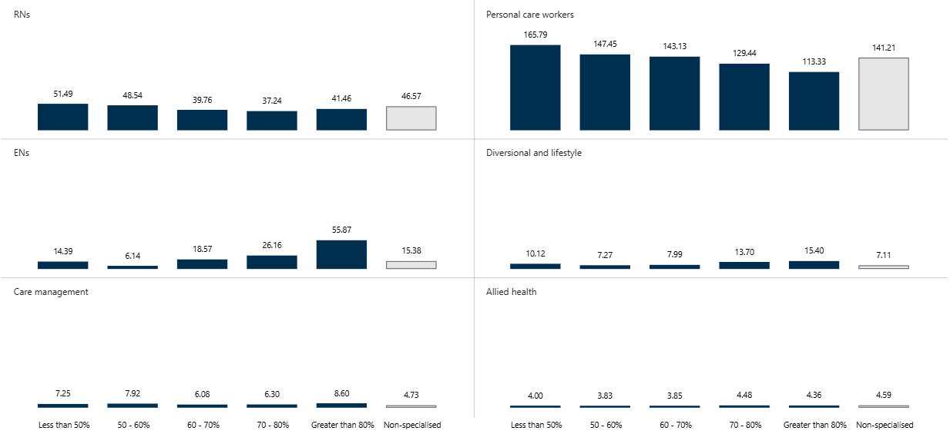

Source: Aged Care Financial Report, 2023–24

Figure 9 data is provided in Table 51. A breakdown of allied health care time by profession is provided in Appendix ‎D.5.

While the data in Figure 9 shows the average care time over the course of a year, it does not capture the fluctuation in the volume of care provided nor the nature of that care. Stakeholders highlighted that a lot of care time in specialised services is dedicated to managing resident behaviours, including negotiating with individual residents or overseeing their interactions with others. We heard that the amount of time required for these activities can vary both on a macro level (e.g. as new residents enter the service and change the population dynamics, resulting in increased staff presence at group activities) and micro level (e.g. as resident needs change over the course of the day).

* They can get verbally and physically aggressive [with each other]. They love to sit outside for a smoke, but often there’s a bit of a verbal outburst that will end up in physical aggression if we don’t get to it in a timely manner. Managing that is something we do a lot of, and that takes a lot of staffing and skilled staff to de-escalate. And to maintain monitoring post-incident – we can’t just say “yes we’ve separated them, they’re not going to do it again”. They might do it again. Our staff are always observing for early signs [of trouble] and managing from there. – Service manager
* We have a new resident from a disadvantaged background, she’s going into everyone’s room. We know she’s not stealing, but the other residents think she is. So one person needs to keep an eye on that lady. – Direct care staff
* Physically residents might be in one state, but mentally they may be in a different state, so we need 2-3 people working together to attend to that resident. We rely on that teamwork. – Service staff

To be able to effectively and safely respond to incidents such as these, services need to have sufficient baseline staffing levels – including overnight and on weekends. Further, we heard that when there are periods of high care needs, additional staff will be rostered on to meet these.

* Our residents’ care [needs] vary. For example, for someone with [challenging] behaviour I might need to increase the number of staff. We change the dynamic of working. It changes all the time, it is a really live roster. – Service manager

### Overall use of agency staff is similar in specialised and non-specialised services

As noted in section ‎3.2.1, the use of agency staff can present challenges to the delivery of effective care in specialised services. As such, it may be expected that use of agency staff would be lower in specialised than non‑specialised services. Indeed, we heard that some specialised services try to avoid using agency staff where possible, instead incentivising their own staff to cover shifts and provide continuity of care.

On the other hand, both managers and staff emphasised that staffing shortages can have significant impacts on the wellbeing of both residents and staff, and that there is no hesitation to use agency staff if the alternative is insufficient staffing. One provider representative suggested that their specialised service uses “a disproportionately high number of agency staff” to ensure appropriate care delivery, while another indicated that use of agency staff varies across services, depending on whether the services offers a high or low level of care.

This variation across specialised services ultimately results in no net difference in the use of agency staff in specialised services (where agency staff account for 9% of total staff) and non-specialised services (8%). However, specialised services report that a higher proportion of their ENs (14% compared to 3%) and allied health professionals (86% compared to 71%) are agency staff (Figure 10). This may reflect the more prominent role of ENs in specialised services overall (see section ‎4.2.1) and the periodic nature of allied health professional involvement. Note that differences in the use of agency staff remained when looking only at services in metropolitan areas and regional centres (MM1 and MM2), so are not accounted for by specialised services having more trouble filling permanent roles in rural areas.

Figure 10: Proportion of staff by employment, service and staff type

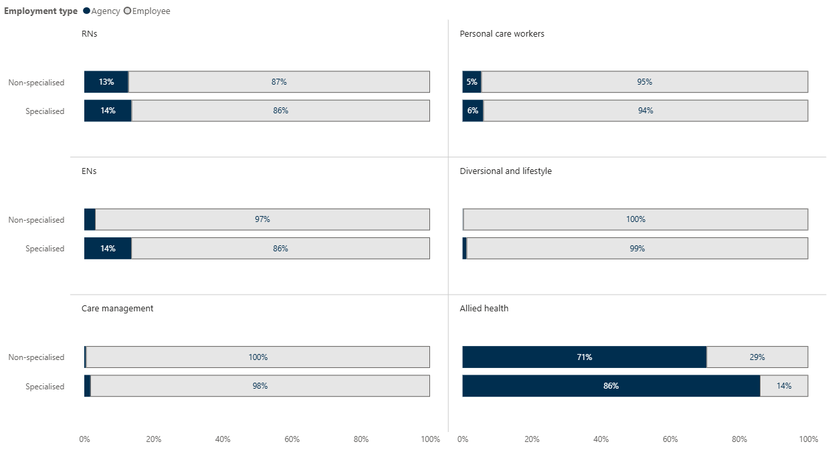

Source: Quarterly Financial Report, 2023–24

Figure 10 data is provided in Table 52

## Legislative requirements

The royal commission found inadequate staffing numbers and skills in residential aged care were contributing to the substandard care provided to many aged care residents that failed to address “the most basic of human needs” (Royal Commission into Aged Care Quality and Safety 2021b:69). As a result, all residential aged care providers are now bound by legislation defining 2 separate but related staffing responsibilities: care minutes, and 24/7 RN coverage.

**Care minutes** (and the funding provided to deliver them) are designed to help providers “maintain an adequate number of appropriately skilled staff to ensure the care needs of care recipients are met and to provide safe, respectful and quality care and services” (Department of Health and Aged Care 2025a).

As discussed in section ‎1.1.1, service-specific targets are calculated based on resident need (according to AN-ACC assessments) and define:

* **Total care minutes:** The amount of care to be delivered per resident per day (on average), by any combination of RNs, ENs and PCWs or AINs.
* **RN care minutes:** The amount of care – within the total care minute target – that must be provided by an RN (although providers have the flexibility to meet up to 10% of RN targets with care time provided by ENs).

To count towards care minute targets, an activity must be delivered by an RN, EN, or PCW/AIN and involve:

* **Personal care:** Daily living assistance, social and emotional support, one-on-one assistance to participate in social activities or recreational therapy, and support for residents with cognitive impairment.
* **Clinical care:** Treatments and procedures, assistance in obtaining health practitioner services, assistance in obtaining access to specialised therapy services, and nursing services (Department of Health and Aged Care 2025a).

The **24/7 RN** responsibility aims to enable early healthcare intervention, reduce harm and prevent unnecessary hospitalisations. All aged care services must have an RN or nurse practitioner on site and on duty at all times, unless a temporary exemption has been granted (Department of Health and Aged Care 2024).[9]

Below we consider the extent to which care minute and 24/7 RN responsibilities are being met, as an indicator of differences in care time between and within service types. For this report we have defined responsibilities as met if a service achieves at least 99% of its target. Section ‎6.1.3 compares the quality of care in services that do and do not meet their legislated staffing requirements.

### Specialised services are exceeding care minute targets

Specialised services exceeded their total care minute targets throughout 2024, and increased the margin by which they did so (from 9 minutes in the first quarter to 22 minutes in the fourth). Specialised services also exceeded their targets by a greater margin than non-specialised services, who on average delivered 7 minutes more than required by the end of 2024 (Figure 11).

Depending on the quarter, between 72% and 81% of specialised services met their care minute targets, compared to between 58% and 75% of non-specialised services.

Figure 11: Average total care minutes and targets – specialised and non-specialised services

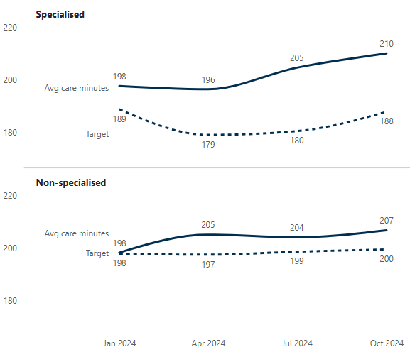

Source: Aged Care Financial Report, 2023–24

Figure 11 data is provided in Table 53.

The majority of both specialised (66% to 75%) and non‑specialised services (58% to 75%) exceeded RN targets, resulting in these targets being met on average throughout 2024 (Figure 12).

Figure 12: Average RN care minutes and targets – specialised and non-specialised services

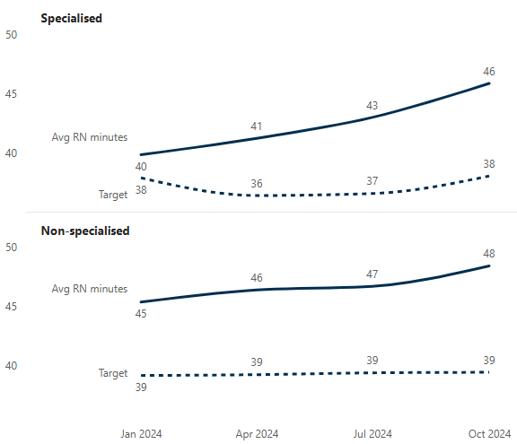

Source: Aged Care Financial Report, 2023–24

Figure 12 data is provided in Table 54.

Care minute targets are determined by the case mix of residents in a service (according to AN-ACC classifications). The fact that specialised services, on average, exceed their care minute targets (and to a greater extent than non-specialised services) may highlight the discrepancy between the care needs assessed by the AN-ACC tool and those that are common in specialised services.

Specifically, the literature and stakeholders are clear that poor mental health and substance use represent big challenges in caring for people with a history of homelessness. However, neither of these needs are assessed in the AN-ACC tool, meaning the time required to address them is not factored into care minute targets. Thus, the volume of care that services are providing in order to meet the needs of their residents is higher than what AN‑ACC-based calculations would suggest is required. We heard that the BCT funding has been invaluable in allowing them to do so.

* Having the right workforce to be able to give that support is really important, and that’s where the additional funds is handy, being able to source the additional workforce that’s qualified and trained to provide this care. – Service manager

There were mixed views on mandated RN care minute targets. Several specialised services with a high proportion of residents with a history of homelessness have a low-care service offering in place (i.e. one catering to residents needing relatively little assistance with personal or clinical care). They indicated that an RN care minute target is not relevant for their resident population, and that they intentionally operate an alternative staffing model that reflects the roles required to most effectively support resident wellbeing.

* If we take a rigid approach we will fall down. Our staffing model tries to reflect that. The biggest thing is, we’ve operated very well for over 30 years, without an RN-led model of care. This has worked quite well for our cohort. We need to have the view that our cleaners influence resident care outcomes as much as our care and nursing staff do. – Service manager

On the other hand, some stakeholders were of the opinion that while residents may need little in the way of medical care, their other complex needs mean that RN targets are “the absolute basic minimum requirement”. We also heard that, while there should always be a mandated clinical care target, it may be appropriate to consider flexibility in the clinician required to meet that target; for example, that a drug and alcohol or mental health clinician may be more appropriate than an RN in a service where substance use or mental health challenges are particularly pronounced. Of course, we note that these clinician types are not mutually exclusive; RNs may also complete advanced training to deliver specialised substance use or mental health care.

* The only thing we have to remember is that’s it’s like any sport – putting more people on the soccer pitch won’t make you score more goals. It’s not putting more people on the roster – that creates more confusion for the residents on who to go to, and who’s accountable and responsible for what. I want to have the *right* players on the pitch. We’ve got a chaplain – I don’t think he’s captured in care minutes, but he provides pastoral care for the residents. We’re hindered by what is eligible to be captured in care minutes, and what isn’t. – Provider manager

### RN coverage depends on service type and resident need

Overall, specialised services had lower RN coverage in 2024, with an RN on site and on duty 92 per cent of the time compared to 99 per cent in non-specialised services. As shown in Figure 13, this difference was largely driven by lower coverage in specialised services with a higher proportion of residents with a history of homelessness. As discussed in section ‎4.3.1, many of these services offer a low-care service model. As such, their lower RN coverage is consistent with feedback about the importance of RN care for residents with lower medical need..

Figure 13: 24/7 RN coverage by service type

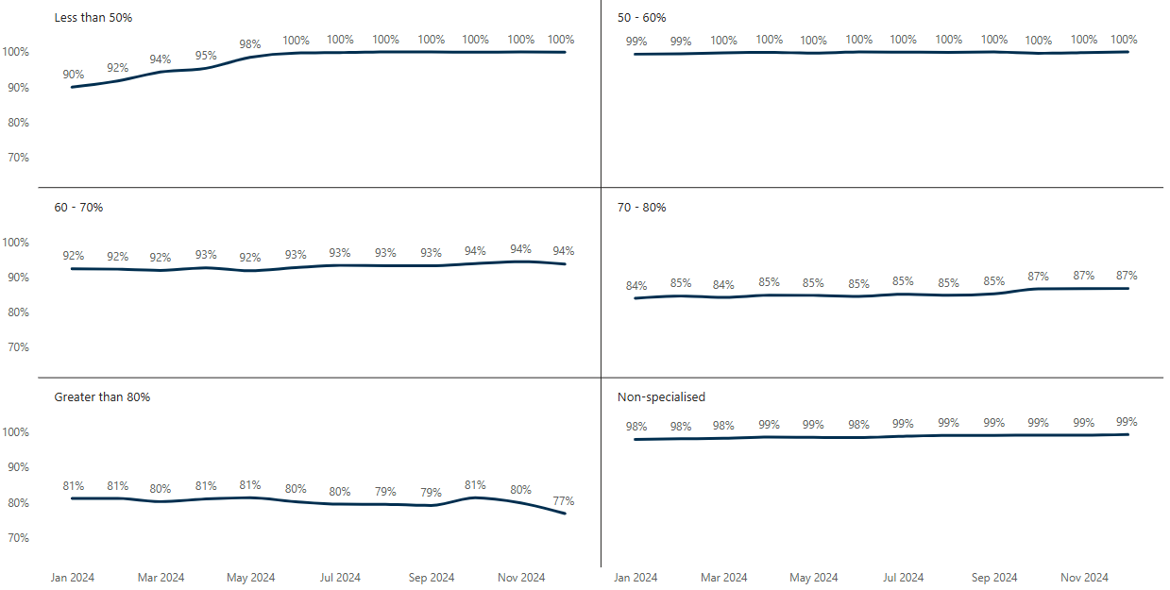

Source: 24/7 RN coverage data, 2024

Figure 13 data is provided in Table 55.

### Care minute definitions do not reflect the care needs of residents with a history of homelessness

We consistently heard from provider and service managers that current care minute targets are reasonable according to currently included staffing types and care activities. However, there was a strong view that these do not reflect the needs of residents with a history of homelessness, or the flexible care provided by specialised services. Managers argued that both definitions should be expanded – and that there should be a corresponding increase in care minute targets.

#### Activities in scope

As discussed in sections ‎2 and ‎3, residents living in specialised services have unique care needs that must be addressed in unique ways. We heard that activities ineligible for care minute reporting are often essential components of a resident’s care. For example:

* time spent decorating a resident’s room can support improved mental, emotional and social wellbeing by providing a sense of safety and belonging that the resident has never experienced
* time spent planning and implementing recreation and lifestyle activities results in a program that meaningfully engages residents with diverse needs and supports improvements in all aspects of a resident’s wellbeing.

Some staff also highlighted that the group activities can require higher staffing levels to deliver (as noted in section ‎4.2.1) to ensure the safety and wellbeing of all participants. These staff are not providing one‑on‑one assistance for individual residents to participate (an activity that is eligible for care minute reporting) but rather, monitoring group dynamics and stepping in to address issues as needed.

The eligibility of other components of the care delivered by specialised services – such as activities to support residents’ legal, financial and spiritual wellbeing – is often unclear. For example, while liaising with specialised therapy services to ensure residents’ needs are met is within scope for care minute reporting, there is no guidance on liaising with police or correctional services.

Overall, service managers felt that the clinical and personal care focus of care minutes is out of step with their holistic approach to resident care.

#### Professions in scope

We heard that greater flexibility in the professions that contribute to care minutes would better support the complex needs of the cohort. Feedback from service staff, managers, and residents alike highlighted that every member of staff in specialised services contributes to resident care.

* It also surprises me that our hospitality staff are not integrated into care minutes because our residents wouldn't live without our hospitality staff. So, while it's not clinical care, it's still care. I guess we would have to see an increase in the amount of care minutes if they were counted. However, it just amazes me that they're not classed as being a care worker for our residents. – Service manager

Within existing “care staff” categories, the most common suggestions for staff that should count towards care minutes are lifestyle and recreation staff, mental health professionals, and allied health professionals (e.g. physiotherapists, dieticians, social workers, occupational therapists, and diversional therapists). Our consultations indicate that not recognising these roles in care minute targets devalues the critical role they play in enabling services to “meet the individual needs of residents and move beyond treatment of issues, to proactive prevention and quality of life initiatives”.

We also heard that some specialised services may make different staffing choices if care minutes captured a wider range of roles and activities. For example, services may need to roster PCWs to meet care minutes, but have a highly mobile population that would be better served by greater lifestyle and recreation coverage.

# Funding and expenditure

Providers report both their income and expenditure in an Aged Care Financial Report (ACFR), submitted to the Australian Government annually. In this section, we use ACFR data for the 2023-24 financial year to examine:

* the characteristics of specialised homeless residential aged care services nationally, in terms of funding and spending on workforce and program delivery (KEQ 1)
* the extent to which workforce spending differs between specialised and non‑specialised services (KEQ 3)
* whether and how the proportion of residents with a background of homelessness influences workforce spending (KEQ 6)

Because reporting data relates to a single financial year, it should not be taken to imply anything about services’ overall financial status or trends in the amount and nature of their income and expenditure.

## Service income

Residential aged care providers rely on 3 primary funding sources to support their operations and deliver quality care to residents: government subsidies and supplements, resident contributions, and additional income.

The **Australian Government subsidy** payment consists of a base care tariff (BCT) for fixed costs, an initial entry adjustment payment for new residents, and a variable component based on each resident’s assessed care needs (i.e. their AN-ACC class). Additional supplements are also available to help cover specific costs such as 24/7 RN requirements, and providing accommodation and care for residents in financial hardship (Department of Health and Aged Care 2025b). Providers may also receive additional subsidies and supplements from their local state or territory government.

**Residents contribute** towards the cost of their care and accommodation through a basic daily fee (set at 85% of the basic age pension), a means-tested care fee (based on the individual’s income and assets), and means-tested accommodation payments (covering the total accommodation price or a proportion thereof).

Finally, aged care providers may receive income from **other sources** such as investments, donations and bequests.

On average, specialised services report a total income of $504.59 per resident per day, compared to $420.96 for non‑specialised services. This difference is largely driven by higher government subsidies (Table 9), including the specialised homeless BCT of $259.84 per occupied bed per day compared to between $141.22 and $160.99 for non‑specialised services, depending on their MM location (Department of Health and Aged Care 2025c).

Table 9: Average income for specialised and non-specialised services, by funding source

|  |  |  |
| --- | --- | --- |
| Income type | Specialised | Non-specialised |
| Government subsidies and supplements | $424.18 | $322.29 |
| Resident contributions | $69.02 | $84.25 |
| Other | $11.39 | $14.42 |
| Total | $504.59 | $420.96 |

Providers report their income against 3 main categories: care, hotel services (e.g. catering, cleaning, laundry), and accommodation (e.g. room, furnishings and bedding).

Within specialised services there is a slight trend towards care income decreasing, and hotel and accommodation income increasing, as the proportion of residents with a history of homelessness increases (Figure 14). This may reflect the fact that several services with a higher proportion of residents with a history of homelessness cater to people with lower clinical need as defined under the AN-ACC funding model.

Figure 14: Care, hotel and accommodation income by service type

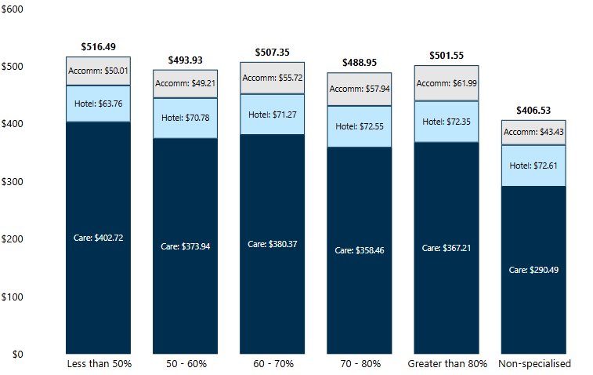

Source: Aged Care Financial Report, 2023–24

Figure 14 data is provided in Table 56.

## Service expenditure

In 2023–24, average expenditure in specialised services was $451.99 per resident per day, compared to $398.13 in non-specialised services. Income exceeded expenditure in both service types, although the average differential was substantially greater in specialised services ($55.23) than non‑specialised services ($4.59). In other words, expenditure equated to 90% of income in specialised and 95% of income in non-specialised services. However, as shown in Figure 15, a higher proportion of a history of homelessness was weakly associated with a smaller difference between income and expenditure.

Figure 15: Difference between income and expenditure in specialised services, by proportion of residents with a history of homelessness

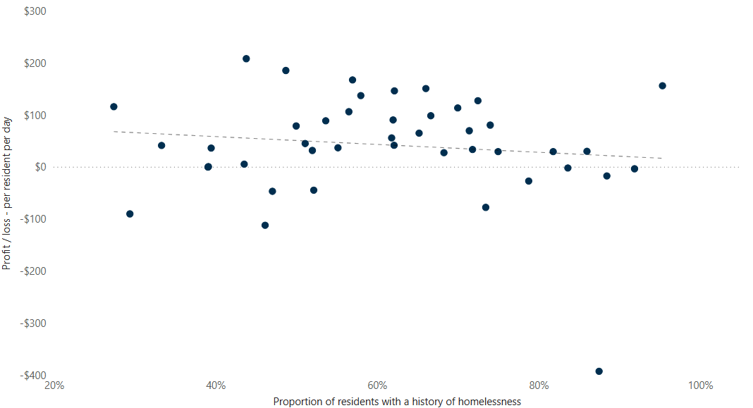

Source: Aged Care Financial Report, 2023–24

### Care costs are higher in specialised than non-specialised services, independent of AN-ACC class

Patterns of expenditure are generally similar across services, regardless of specialisation and proportion of residents with a history of homelessness (Table 10). That is, care-related costs account for the greatest proportion of expenditure in all service types, and accommodation-related costs the smallest. However, as the proportion of residents with a history of homelessness increases, expenditure appears to become more heavily weighted towards administration, and less heavily weighted towards care. We heard that administrative tasks such as incident management and, where appropriate, reporting to the Serious Incident Response Scheme (e.g. for inappropriate sexual conduct, or unexplained absence) may be more frequent and time-consuming in specialised services than might be expected in a non-specialised service. Higher administrative costs may also reflect the training and professional development opportunities provided to staff in these services, and the diverse and unexpected expenses that are encountered when supporting residents with a history of homelessness that providers are unsure how to categorise (see section ‎5.3.1).

Table 10: Expenditure patterns by service type

|  |  |  |  |  |  |  |  |
| --- | --- | --- | --- | --- | --- | --- | --- |
| Cost category | Less than 50% | 50–60% | 60–70% | 70–80% | More than 80% | Specialised total | Non-specialised |
| Direct care | 56% | 59% | 54% | 55% | 53% | 56% | 59% |
| Hotel | 16% | 17% | 18% | 18% | 16% | 17% | 17% |
| Administration | 16% | 14% | 15% | 18% | 20% | 17% | 14% |
| Accommodation | 12% | 10% | 12% | 9% | 10% | 11% | 10% |
| Total | 100% | 100% | 100% | 100% | 100% | 100% | 100% |

While specialised services spend proportionally less on direct care than non-specialised services, they generally spend more in real terms (i.e. dollar value) (Figure 16). Analysis of covariance (ANCOVA) shows that this difference is not accounted for by case mix and MM category; in other words, care costs are higher in specialised than non-specialised services catering to residents in the same AN-ACC class (‎Appendix E).

Specifically, after controlling for case mix and MM category, services with a higher-than-average proportion of residents with a history of homelessness (i.e. more than 60%) spent $28 more on care per resident per day than non-specialised services. This equates to just over half (53%) of the overall difference in expenditure between the 2 service types, and 6% of total expenditure in higher proportion services.

Figure 16: Expenditure by service type and cost category

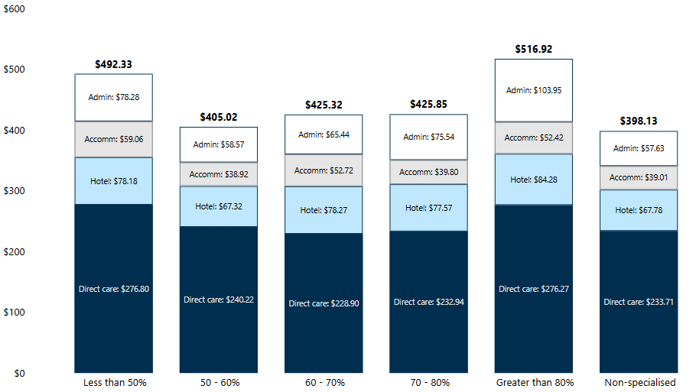

Source: Aged Care Financial Report, 2023–24

Figure 16 data is provided in Table 57.

### Workforce expenses are higher across most staffing categories

Overall, average workforce costs are 8% or $23 higher in specialised than non-specialised services, at $306.69 compared to $283.26 per resident per day. This difference includes greater expenditure on all staff categories:

* $251.05 compared to $233.71 on direct care staff
* $33.38 compared to $32.36 on hotel staff
* $14.47 compared to $12.97 on administration staff
* $7.79 compared to $4.22 on accommodation staff.

The difference in workforce expenditure is largely driven by specialised services with the lowest and highest proportion of residents with a history of homelessness (Table 11). This may be due to services at both ends of the spectrum catering to populations with specific, resource-intensive needs:

* Many services with less than 50% of residents with a history of homelessness cater to First Nations residents with high clinical and personal care needs, or people with psychiatric and cognitive conditions.
* Services with more than 80% of residents with a history of homelessness often cater to residents with prominent psychosocial and substance use problems.

Table 11: Average workforce expenditure by service type, per resident per day

|  |  |  |  |  |  |  |  |
| --- | --- | --- | --- | --- | --- | --- | --- |
| Cost category | Less than 50% | 50–60% | 60–70% | 70–80% | More than 80% | Specialised total | Non-specialised |
| Direct care | $276.80 | $240.22 | $228.90 | $232.94 | $276.27 | $251.05 | $233.71 |
| Hotel | $34.41 | $27.65 | $37.91 | $32.74 | $35.75 | $33.38 | $32.36 |
| Administration | $19.70 | $9.49 | $14.16 | $12.99 | $16.36 | $14.47 | $12.97 |
| Accommodation | $10.28 | $4.60 | $6.62 | $6.86 | $11.62 | $7.79 | $4.22 |
| Total | $341.19 | $281.96 | $287.59 | $285.53 | $340.00 | $306.69 | $283.26 |

Source: Aged Care Financial Report, 2023–24

Breaking care staff costs down by staffing type, PCWs and AINs account for the majority of expenditure across all service types (Table 12). Overall, compared to non-specialised services, specialised services spent:

* 82% more on diversional and lifestyle staff ($10.27 compared to $5.64 per resident per day)
* 43% more on ENs ($25.62 compared to $17.92)
* 38% more on care management staff ($10.99 compared to $7.94).

In both dollar value and as a proportion of care spending, expenditure on diversional and lifestyle staff and ENs generally increases – and expenditure on PCW/AINs decreases – as the proportion of residents with a history of homelessness increases. This likely reflects the importance of care planning and supporting psychosocial wellbeing among this cohort, compared to the higher clinical and personal care needs associated with other aged care residents.

Table 12: Average expenditure on direct care staff by service type

| Staff type | Less than 50% | 50 – 60% | 60 – 70% | 70 – 80% | More than 80% | Specialised total | Non-specialised |
| --- | --- | --- | --- | --- | --- | --- | --- |
| PCWs/AINs | $157.05 | $137.87 | $128.78 | $119.66 | $107.13 | $132.32 | $127.03 |
| RNs | $76.70 | $73.74 | $56.09 | $56.46 | $66.20 | $66.31 | $69.52 |
| ENs | $16.98 | $6.14 | $23.03 | $28.39 | $64.02 | $25.62 | $17.92 |
| Care management | $10.78 | $11.84 | $8.55 | $9.65 | $15.09 | $10.99 | $7.94 |
| Allied health | $6.25 | $4.90 | $4.86 | $5.78 | $5.85 | $5.54 | $5.66 |
| Diversional and lifestyle | $9.05 | $5.75 | $7.59 | $13.00 | $17.97 | $10.27 | $5.64 |
| Total | $276.80 | $240.22 | $228.90 | $232.94 | $276.27 | $251.05 | $233.71 |

Source: Aged Care Financial Report, 2023–24

## Reported expenditure and real costs

ACFR data indicates that, on average, specialised services have lower expenditure as a proportion of income than non-specialised services. Participants in our consultations suggested several reasons why this data may not reflect the true costs of delivering specialised care to residents with a history of homelessness.

### Consistent and accurate reporting may be more challenging for specialised services

Aged care stakeholders have previously raised concerns about financial reporting, noting it is too complex but, at the same time, does not collect the data needed to identify cost variations across provider types (Independent Health and Aged Care Pricing Authority 2024b). Imperfect reporting mechanisms affect all residential aged care providers, but those operating specialised homeless service may find it particularly difficult to accurately and completely report the cost of providing care, for several reasons.

First, care-related labour costs can only be reported for residents that have undergone an AN‑ACC assessment. This is likely to have a disproportionate impact on specialised services, as getting residents with a history of homelessness to the point of assessment can require significant time and effort. This includes preadmission communication and rapport building to help the resident feel safe accessing the service and supporting them to navigate administrative, financial and legal matters (e.g. registering for Medicare), in addition to meeting their day‑to‑day care needs. Importantly, not only are the labour costs associated with these activities not captured, they are incurred in an environment where the service is not benefiting from the income associated with that resident.

Second, providers highlighted that some expenses are allocated to central cost centres or are averaged across multiple sites. For providers operating similar service types, this approach provides a relatively good estimate of service-level expenditure. However, for providers operating both specialised and non‑specialised services, a central cost centre or service average can obscure substantial variation in expenditure across sites. For example, several services with a high proportion of First Nations people noted that they incur high costs associated with returning residents to Country, or leaving a bed unoccupied until Sorry Business is completed. They explained these expenses are beyond what can be achieved at a service level but are manageable at a provider level thanks to being offset by savings elsewhere in the organisation.

Finally, some specialised services are uncertain about how to allocate expenses that are common in their setting but may not be encountered in non-specialised services. For example, while ACFR guidance clearly defines the cost of medication as being in scope for resident care expenses, specialised services lack advice on where to allocate expenses such as residents’ clothing, art supplies, or taxi fares for external appointments. As such, these expenses may be reported under different cost categories by different providers – or not reported at all – making it difficult to interpret apparent differences in expenditure.

### Services are taking a considered approach to spending their BCT funds

Service managers and other stakeholders highlighted that specialised services are operating in a sector experiencing a high volume and pace of major reform. The specialised BCT commenced in 2023, and was quickly followed by the introduction of mandatory care minute and 24/7 responsibilities.

Unsurprisingly, most services have prioritised meeting these legislative responsibilities in the first instance (and, as demonstrated in section ‎4.3, have been successful in doing so). We heard that the BCT funding has been invaluable in allowing services to grow their “care minute” workforce: this enables the service to both meet its targets and allows these staff to spend time on activities that do not count towards care minutes but are critical for understanding and addressing resident needs.

Having complied with legislative requirements, services are now turning their attention to how they can best use their BCT funding in the longer term to meet the needs of their residents and adapt to ongoing sector changes (e.g. the introduction of the new Aged Care Act and strengthened Quality Standards).

* We don’t take for granted our specialist service funding. It’s there, it has a purpose and we really strive to achieve what we can with what we have. We understand we are very fortunate to have that and very fortunate to be given this opportunity to make sure we are doing justice to the extra funding. We would be in the red without it. We are very purposeful with what we spend it on. – Operations manager
* The current level of funding has only been in place for 2 years; we are stabilising the staffing model to reflect a true multidisciplinary mental health model that is titrated towards resident’s needs. This means not just treating their complex medical, mental health and psychosocial needs, but also looking at prevention measures and quality of life initiatives – Service manager

In our consultations in early 2025, we saw and heard how the activities and staffing models in place in specialised services have evolved since the ACFR data informing this report was submitted. For example, several services had newly established roles such as “social and emotional support workers” specifically designed to develop and deliver tailored programs and activities for residents with a history of homelessness. Staffing expenditure for these roles will be invisible to government until the next ACFR is submitted in October 2025.

### Specialised services take on substantial financial risk and uncertainty

It is important to reiterate that the ACFR data reported in this section relates to a single financial year. There is no requirement that expenditure equates to income over this time period, and indeed, it is good business practice to maintain a prudent financial reserve to cover future operating expenses.

We heard that this is particularly important for specialised services, as caring for their resident population comes with a degree of financial risk that non-specialised services may not face. Service and provider managers highlighted that without BCT funding, they would be unable to maintain the “buffer” they need to cover the frequent, varied unexpected expenses that resident care can entail.

* If we see a drop in revenue, we’re not able to continue this for much longer because of all the other things that we cover that aren’t being captured. – Service manager

For example, residents often rely on the generosity of the services to cover expenses such as clothes, outings, and medications (see “Financial and legal wellbeing” in section ‎3.1.3). It can be difficult for services to predict the extent of a person’s financial need, and they must therefore maintain sufficient cash resources to respond to situations as they arise.

* We have a resident from a homeless background who doesn’t have a Medicare card. The doctor isn’t getting any benefit for looking after this person, so we’re paying the doctor. Imagine that cost in the long run. It’s not a gap fee, the doctor has to charge us the full fee because the resident doesn’t have Medicare. – Service manager

In addition, staff and managers told us that specialised services require more regular, and more significant, upkeep than non-specialised services, due to the nature of the population and the individual agency that residents are afforded. For example, we heard stories of residents breaking furniture, windows and other items when under the influence of alcohol. Other residents were less destructive, but their care nonetheless resulted in unplanned maintenance costs.

* We had a lady whose late husband was an artist. She had quite a few paintings that couldn’t fit in her wardrobe or hang on the walls, and she was really distressed when they weren’t with her. So we said to her that you could fit all the paintings on the walls if you hung it like a collage, it would mean every bit of your room would be covered. And she said that’s beautiful, so that’s what we did. Of course when she left there were holes in the walls and repairs we needed to do, but that was really very important to her and made it feel like home to her. So we were prepared to do whatever it took. – Service manager

# Effectiveness

In this section, we draw on interviews, star ratings data, and Residents’ Experience Survey datasets to examine what specialised services are achieving in terms of quality of care delivered, consumer satisfaction and outcomes for residents with a background of homelessness (KEQ7).

## Quality of care

We heard that the person-centred approach taken by specialised services results in high‑quality care for residents. Residents and staff told us that their specialised service compares favourably to non‑specialised services.

* I still work sometimes in the private sector and they’re paying millions, but the residents aren’t getting that care. I look at them and I think “we give better care”. – Service staff
* [When visiting a friend in a non-specialised service] there was no light, no windows and I didn’t like the way they treated my friend. [Returning to the specialised service] was like walking into sunshine, I was so happy to be back. – Resident

While the feedback we received about the quality of care in specialised services was overwhelmingly positive, quantitative data shows that performance on pre-defined measures of quality is similar across specialised and non-specialised settings.

### Star ratings are similar for specialised and non-specialised services

Star ratings are released on a quarterly schedule and provide each service with a score from 1 to 5 for:

* Residents’ experience – based on surveys gathered by an independent team (see section ‎1.2.2)
* Compliance – defined as a service’s conduct against government regulations and standards
* Staffing – the amount of care delivered per resident by nursing and personal care staff
* Quality – across the indicators presented in section ‎6.1.2
* Overall star rating – an overall measure of quality and safety based on these 4 areas of performance.

On average, specialised and non-specialised services received equivalent ratings for sub-categories and overall star ratings in 2024. There was also little variation across specialised services; regardless of the proportion of residents with a history of homelessness, scores were highest for Compliance and lowest for Residents’ Experience and Staffing (‎Appendix F).

Table 13: Average quality rating for specialised and non-specialised services

| Star rating | Specialised | Non-specialised | All services |
| --- | --- | --- | --- |
| Residents’ experience | 3.3 | 3.5 | 3.5 |
| Compliance | 4.5 | 4.6 | 4.6 |
| Staffing | 3.4 | 3.2 | 3.3 |
| Quality | 3.8 | 3.7 | 3.7 |
| Overall star rating | 3.8 | 3.8 | 3.8 |

Source: Star Ratings quarterly data extracts, 2024

### Specialised services generally perform well on quality indicators

The National Aged Care Mandatory Quality Indicator Program (QI Program) monitors the quality and safety of care in residential aged care using 14 quality indicators. Of the 14 quality indicators, 5 inform star ratings: unplanned weight loss, pressure injuries, falls and falls resulting in major injury, restrictive practices, and potentially inappropriate medication management (i.e. polypharmacy and off-label prescribing of antipsychotics).[10] Compared to non‑specialised services, specialised services – especially those with a high proportion of residents with a history of homelessness (Table 14) – generally report lower rates of:

* restrictive practices – as described in section ‎3.1.2, specialised services support residents’ agency and freedom of movement
* falls – which may be associated with the younger age of residents in specialised services
* prescription of antipsychotic medications without a diagnosis of psychosis – note that this does not suggest that there is lower antipsychotic use overall in specialised services.

Table 14: Quality indicators by service type

| Quality indicator | Less than 50% | 50–60% | 60–70% | 70–80% | More than 80% | Specialised total | Non-specialised |
| --- | --- | --- | --- | --- | --- | --- | --- |
| Pressure injuries | 0.5% | 0.8% | 0.7% | 0.8% | 0.8% | **0.7%** | 0.5% |
| Restrictive practices | 24.0% | 13.0% | 12.7% | 17.2% | 12.8% | **16.1%** | 20.9% |
| Unplanned weight loss | 9.7% | 7.6% | 8.1% | 9.2% | 9.1% | **8.7%** | 8.1% |
| Falls | 25.9% | 25.1% | 27.3% | 27.9% | 26.3% | **26.4%** | 29.6% |
| Falls – major injury | 1.4% | 1.7% | 0.7% | 1.0% | 1.4% | **1.3%** | 1.4% |
| Polypharmacy | 35.4% | 30.6% | 29.9% | 39.0% | 45.4% | **35.3%** | 33.2% |
| Antipsychotics | 9.7% | 3.3% | 4.4% | 3.8% | 1.6% | **4.8%** | 9.6% |

Source: Star ratings quarterly data extracts, 2024

On the other hand, specialised services have slightly higher rates of unplanned weight loss and pressure injuries and notably higher rates of polypharmacy. Importantly, these metrics are not necessarily the best measure of the quality of care in specialised services. For example, we heard multiple examples of residents not allowing staff to help with personal care, resulting in suboptimal hygiene practices that may increase their risk of pressure injury. While any pressure injuries that develop would count against the service in quantitative data, the service’s greater concern may be to adhere to their person-centred approach to care, which respects individual rights and autonomy and upholds the dignity of risk.

### Quality of care is similar in specialised services that do and do not meet legislative requirements

As noted in section ‎4.3, we have defined legislative requirements as met if services are delivering at least 99% of their overall and/or RN care minute targets, or have an RN on duty at least 99% of the time. Specialised services that were not meeting their targets in 2024 did not appear to be providing substantially worse quality of care compared to services that met their targets; they performed slightly better on some measures, and slightly worse on others (Table 15). However they do consistently achieve lower staffing quality ratings (as these are calculated based on the amount of care delivered by nursing and personal care staff.

Table 15: Average quality ratings for specialised services that are and are not meeting legislative requirements

|  |  |  |  |  |  |
| --- | --- | --- | --- | --- | --- |
| Service category | Residents’ experience | Compliance | Staffing | Quality | Overall Star Rating |
| Not meeting care minutes  (n = 15) | 3.2 | 4.7 | 2.5 | 3.9 | 3.7 |
| Meeting care minutes  (n = 31) | 3.5 | 4.3 | 3.7 | 3.8 | 3.8 |
| Not meeting RN minutes  (n = 13) | 3.0 | 4.7 | 2.2 | 3.9 | 3.5 |
| Meeting RN minutes  (n = 33) | 3.5 | 4.3 | 3.8 | 3.8 | 3.8 |
| Not meeting 24/7 requirement  (n = 7) | 3.8 | 4.6 | 2.7 | 3.7 | 3.8 |
| Meeting 24/7 requirement  (n = 39) | 3.3 | 4.4 | 3.5 | 3.9 | 3.7 |

Sources: Star Ratings quarterly data extracts, 2024; Aged Care Financial Report, 2023–24

Quality indicator data further shows that care does not uniformly achieve better or worse outcomes depending on whether services do or do not meet legislative requirements. As seen in Table 16:

* services not meeting their overall care minute targets have higher rates of off‑label antipsychotic prescribing and, to a lesser extent, falls and polypharmacy, but lower rates of restrictive practices
* services not meeting their RN care minute targets have higher rates of pressure injuries and a slight increase in falls, but lower rates of falls causing major injury and off‑label antipsychotic prescribing
* services not meeting the 24/7 RN requirement have higher rates of pressure injuries, unplanned weight loss and polypharmacy, but lower rates of falls, falls causing major injury, off‑label antipsychotic prescribing.

Table 16: Quality indicator data for specialised services that are and are not meeting legislative requirements

| Service category | Pressure injuries | Restrictive practices | Unplanned weight loss | Falls | Falls –  major injury | Poly-pharmacy | Anti-psychotic |
| --- | --- | --- | --- | --- | --- | --- | --- |
| Not meeting care minutes  (n = 15) | 0.7% | 12.4% | 8.7% | 27.7% | 1.3% | 36.9% | 5.7% |
| Meeting care minutes  (n = 31) | 0.7% | 18.2% | 8.6% | 25.6% | 1.3% | 34.4% | 4.2% |
| Not meeting RN minutes  (n = 13) | 0.9% | 16.3% | 8.8% | 27.8% | 1.1% | 36.3% | 3.3% |
| Meeting RN minutes  (n = 33) | 0.6% | 16.0% | 8.6% | 25.8% | 1.3% | 34.9% | 5.4% |
| Not meeting 24/7 requirement  (n = 7) | 1.3% | 15.6% | 10.1% | 24.4% | 0.9% | 43.0% | 1.5% |
| Meeting 24/7 requirement  (n = 39) | 0.6% | 16.2% | 8.4% | 26.7% | 1.3% | 33.9% | 5.3% |

Sources: Star Ratings quarterly data extracts, 2024; Aged Care Financial Report, 2023–24

## Satisfaction

As reflected in the Residents’ Experience sub-category of the star ratings, residents in specialised services generally report a similar experience of care to those in non-specialised services.

This could be a considered a slightly surprising – and promising – finding given that many residents with a history of homelessness have often had negative experiences with care providers, government agencies and institutions. On the other hand, we heard that some residents in specialised services are unlikely to complain; the equivalence with non-specialised services may reflect this characteristic rather than true satisfaction with care.

It is worth noting that resident satisfaction data – collected through both the Residents’ Experience Survey and our interviews – reflects a resident’s views at a point in time; service staff and managers emphasised that resident satisfaction can vary significantly depending on their mood.

### Independence and agency are key to residents’ satisfaction

It is common for residents with a history of homelessness to be reluctant to enter residential aged care and, at least initially following their admission, to be wary of staff, other residents, and their new environment. This often stems from nervousness about losing independence and individual agency – indeed, one resident told us he was “forced to live here”.

* People have done it hard on the streets if they’ve been homeless. The man who had previously lived in the tent took 8 months to accept the care. He struggled with the supports as well as the limitations. – Service manager

However, after an initial adjustment period, residents are frequently surprised by how much they enjoy living in their specialised service. For many, the realisation that they can retain control over their daily activities contributes to their satisfaction with their new home. Residents told us that **they have the flexibility to “do what I want when I want” and that “knowing I have the freedom is good”.**

* I thought I liked living independently, but life has turned around. I realised what I was missing out on. – Resident
* I couldn’t fault this place. I came here reluctantly, but my ex-wife made me come. She is also involved in aged care. She got me in here. I have never regretted it. Look at it, it is lovely. I have been here for about 4 to 5 months. I wasn’t well when I came here but I am a brand-new man. I am back to my old ways and going for a walk in the morning. The staff are just great. They look after your medication. They do your washing for you. They clean your room. I have travelled the world and stayed in great motels, but this is better. This is fantastic. – Resident

### Residents are generally satisfied with staff and care

Data from the Residents’ Experience Survey shows that most residents in specialised services, like non‑specialised services, provide positive feedback about staff (Figure 17). In interviews, residents frequently told us about how happy they were with the kindness and competence of staff members in their service. They highlighted that this was true of staff across all levels, from management staff to clinical staff to support staff.

* The staff make it of course. It shows when staff put an effort in. – Resident
* The nurses and the staff are very good. They are just really nice and that means a lot to me. They are always polite, and they don’t go crook at me. At [a previous aged care service] I felt like the staff were talking to a child. Here they give me respect. – Resident
* Overall, the staff are extremely good and always polite and courteous. If you need to have something done for you, then they are there to help. The boss [site manager] is great. – Resident
* Every staff member – from medical to kitchen staff – I’d adopt them all! The staff aren’t just caring, they are like friends. – Resident

**We heard that specialised services provide residents with a safe environment, and that this is important to them as it is often in stark contrast to their previous living situation (e.g. on the street, in unstable housing, or in prison).**

* **I feel safe and protected. They look after me. – Resident**

Residents also told us about being satisfied with the care they receive and in particular how much they enjoy the group and individual leisure activities and excursions on offer (as described in section ‎3.1.3).

* **I go to happy hour with some of the people I get along with. – Resident**
* The highlight of my week is the cooking group on a Sunday. I also spend a lot of time in the lifestyle room. I like word games like hangman but don’t really like crosswords, I’m a terrible speller! Instead, I’ll sit and have a chat with the staff and other residents. – Resident (paraphrased)
* I’m doing more now than when I lived by myself. – Resident

Consistent with feedback received through the Residents’ Experience Survey (Figure 18), the residents we spoke to had mixed views on the food served in specialised services. Food was a common topic of discussion in our interviews, and most residents had strong views on the matter. We heard that some services put a lot of effort into providing high quality and varied food but, as one resident told us, “you can’t please everyone”.

* **I thought food would be difficult, because I’ve been vegetarian for a long time. But apparently there used to be a vegan upstairs. I talk to the chef every other day and they always accommodate my requests. – Resident**
* The food is okay. It can suffer a little from “meat and 3 veg syndrome”, but it is rare for me to get a meal I don’t like. – Resident
* The food is good. I don’t like every single thing as much as others. It is a good standard, nutritious and varied as well. We get a choice of 2 hot meals at lunch time, so we can pick one or the other. Everyday there is something different. They have a menu roster but that changes each week, which is good. – Resident
* I’d like more food options. Everything is chicken or beef. It would be nice to have some Asian food. – Resident

Figure 17: Residents’ Experience Survey data, specialised and non-specialised services – staff and management

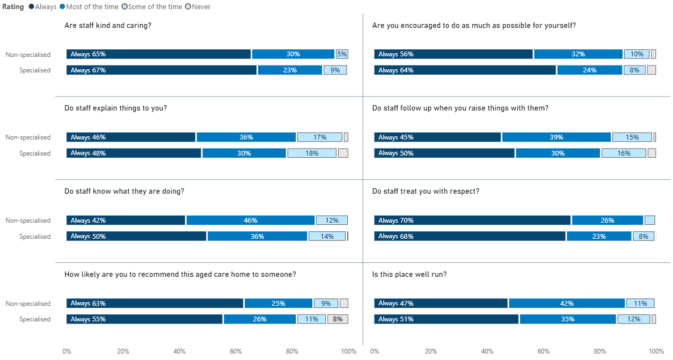

Figure 17 data is provided in Table 58 to Table 65.

Figure 18: Residents’ Experience Survey data, specialised and non-specialised services – wellbeing

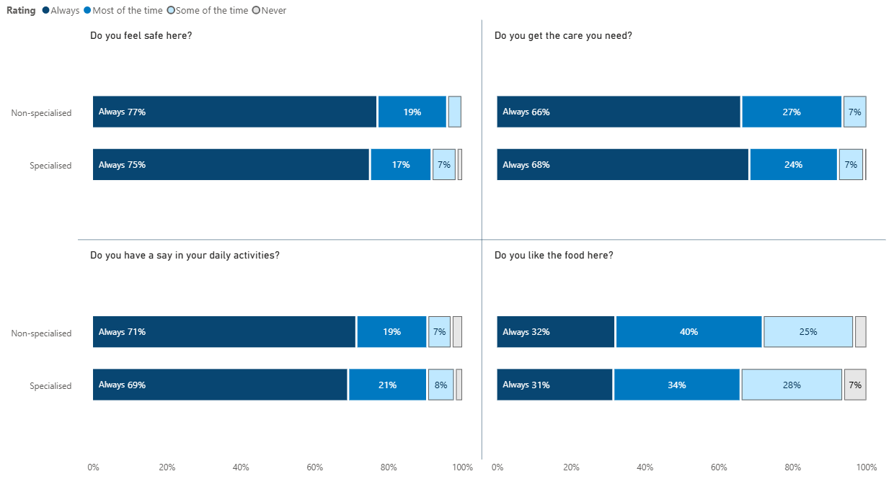

Figure 18 data is provided in Table 66 to Table 69.

### Resident dissatisfaction primarily relates to living in a shared environment

Some residents shared that they were dissatisfied with some aspects of their specialised service. This dissatisfaction typically resulted from sharing an environment with other residents:

Some residents disliked the tobacco policies in their service and didn’t like being exposed to smoke. A resident told us that others would smoke near doorways and that the smoke would come inside and give her a headache.

Some residents found some behaviours of other residents frustrating or uncomfortable – for example, when other residents were rude to staff or walked around partly clothed. Residents acknowledged that in some cases this behaviour was associated with dementia and was not deliberate.

While residents in most specialised services have private bedrooms and bathrooms, it can be challenging for residents when this is not the case and can exacerbate interpersonal conflicts and behavioural challenges.

* A few residents reported feeling bored, with one telling us that they were “marking time”. Most of these residents were reluctant to participate in group activities and engage with other residents. However, some told us that they enjoyed one-on-one activities with staff members.

We note that these issues are not necessarily unique to specialised services.

## Outcomes

We found that specialised services provide homes for older people experiencing significant vulnerability and with limited options for safe housing. Once admitted to a specialised service, the wellbeing of these residents increases – often considerably.

### Specialised services provide a safe home for people with few alternatives

Specialised services provide care and a safe environment for people with limited housing options. Many of these residents would be turned away from non-specialised services, for example, due to a history of incarceration, use of alcohol, tobacco or other drugs, complex mental health needs, or behavioural challenges. We were told by residents and service staff that some residents would be living on the street if not for their specialised service. For others, their alternative might be unstable or inadequate housing, residential mental health services, or a corrections facility.

We heard that decisions to admit residents with complex care needs are not made lightly because it is important for the service to ensure both that their service remains safe for other residents and staff and that the needs of the incoming resident can be met.

* When we have applications from residents or potential residents, who I am pretty confident most other aged care facilities would say no to, we find a way to say yes. This lady who is very financially and socially disadvantaged, very frail, prematurely ageing, not eating well, uses illicit drugs and has spent some time in prison. She also has a cat that she insists on bringing even though it is difficult for her to afford looking after that cat. Basically, she is a tricky person to care for. Before we say yes, we have to be sure that we can meet her needs, keep all other residents safe and safe work environment from our staff. – Service manager

Specialised services, and the providers that operate them, will often go to great lengths to admit a person with a history of homelessness or insecure housing. This advocacy approach is very different to the admissions process for non-specialised services and in some cases is an important driver for successfully providing care for a resident.

* [There was] a resident who took weeks and weeks and weeks of work [to admit] because he was about to be kicked out of his Department of Housing accommodation, as he was living in squalor with rats. They weren’t going to keep him; they were trying to get him out for years. The amount of work it took to get him into hospital and over to us was huge. We spend a lot of time talking to other organisations who help people and try to get good outcomes. – Service staff

By providing a home for people with a history of homelessness, specialised services are saving a potentially significant amount of public money that would otherwise be spent caring for the older person elsewhere, such as hospital or jail. In a study of a specialised service in Sydney, comparing pre- and post-admission data for a small cohort (n = 13) of people with a history of homelessness suggested an average saving of approximately $32,000 per resident per year in health and social service costs (O’Connor et al. 2023).

* The wards are full of people that have profiles like our residents – they’re people that no‑one wants; they have mental health problems; you can’t put them in a generic facility because it upsets the balance. Not getting this [specialised homeless aged care] system right will swamp the health system. Our residents, if they didn’t have this facility, would be frequent fliers in the health system. – Provider manager

### Residents with a history of homelessness experience increased wellbeing following admission to a specialised service

Managers, staff, and residents described the positive outcomes that specialised services are achieving across all the dimensions of wellbeing defined in section ‎3.1.3.

* People come into these services skinny, sick, and abandoned by their families. We feed them, we give them clinical care and we love them and they get fatter. – Service provider

Residents often experience considerable and swift improvements to their physical wellbeing after they move into a specialised service and start receiving consistent health care and high‑quality food in a safe environment.

* Even though I’d had the stroke, I didn’t put myself down as a person “like that” [i.e. needing residential care]. But they sent me there and it was the best thing they could have done. They kept an eye on my medication, checked in on me and made sure I wasn’t going back to my old ways. I’m really grateful for that. – Resident
* We have an impact health-wise. We provide the medication, routine, people to talk to. It makes a difference. Going from living in an environment in which you’re always tense, to one in which you can be relaxed, can be life-changing. You can see the impact in terms of their presentation, how they engage, they put on weight. – Service staff

In addition, some residents shared that their cognitive functioning had improved with the care they received from their specialised service.

* The best part is that my memory has come back! The staff are happy for me and that makes me feel lovely. – Resident

We also heard that the social wellbeing of residents often improves, with residents who were previously socially isolated forming new relationships with other residents and staff. In some instances, residents are also able to rekindle relationships with family members with the support of staff.

* I have found friendship here, with the residents and the staff. – Resident
* I catch up with my neighbour down the hall at least once a day. – Resident
* We’ve also had some experiences where people have talked about their family and expressed that they really miss them, and our lifestyle team invested a lot of time trying to link up with those family members. And we’ve had 2 or 3 successes where we actually finally connected them with their family members, they’d been out of contact for more than 20 years. – Service manager

More generally, mental and emotional wellbeing improves for many residents following a period of care. Staff told us that this is often seen in the “small wins”, such as withdrawn residents venturing into communal spaces, engaging in activities, and being less wary of staff.

* I’ve got a lot more courage and understanding of things since I came here. My life before was unstable. I couldn’t settle anywhere, I couldn’t read a book. The first few years [here] I kept myself to myself, then I thought “I might as well start talking to people”. I started going to sessions, out on shopping trips, out for a coffee. – Resident
* I do believe that they [the residents] have improved quality of life. I do believe that it’s trust building because they start bringing issues and concerns to us. – Service staff

In some cases, people with a history of homelessness experience such an improvement in their wellbeing after spending time in a specialised service that they can transition into lower‑care settings. This is especially the case for younger residents in good physical health.

* There were 3 recent ones who came in who were homeless, they came here, then they got back to where they were when they were out in the community and have moved into independent living. They are just up the road – they come back and visit sometimes. – Service staff

# Considerations for the future

Throughout this evaluation we have heard how immensely proud staff and managers in specialised services are of the work they do. They are extremely grateful for their BCT funding, and intentional in their use of it. As the BCT funding was introduced recently and at a time of significant change in the aged care sector, specialised services turned their attention first to meeting the newly introduced care minute and 24/7 RN requirements. They are now thinking strategically about how they can use their funding to holistically meet the diverse care needs of their residents, for example through the addition of new roles to support social and emotional wellbeing.

In this section, we summarise key findings related to the following KEQs, and provide associated recommendations to support the continued delivery of high quality, effective care in specialised services:

**KEQ 8** Is there a particular model of care (or models of care) that would be better suited to meeting the care needs of people with a homelessness background?

* + Is this model of care (or models of care) currently being implemented? If so, could it be replicated or expanded?
  + What additional model(s) of care, or components thereof, should be introduced?

**KEQ 9** Would allowing specialised homeless residential aged care services to use alternative skills (i.e. other than RNs, ENs, PCWs and AINs) to meet their care minutes lead to the delivery of better quality of care, consumer satisfaction and outcomes for residents with a background of homelessness? If so:

* + What additional staff categories would enhance the quality of care? Why?
  + Should the care minute targets be increased to accommodate the additional care needs?
* **KEQ 10** How could the delivery of specialised homeless models of care and their associated costs be monitored in the future?

Our findings highlight that the successful delivery of care to older people with a history of homelessness is affected by a range of broader systemic challenges that are out of scope for this evaluation. For example, stakeholders identified broader opportunities for improvement such as:

* Increasing exposure to people accessing aged care and homelessness services for students enrolled in clinical degrees, to ensure that health professionals have the confidence and skills to work with these populations.
* Raising awareness among referrers and assessors about eligibility for aged care services for younger people who are experiencing, at risk of, or have a history of homelessness.
* Providing additional incentives for health professionals to attend specialised services, recognising the often difficult and time‑consuming nature of the work and the opportunity cost of taking it on (i.e. travel, administration, and foregone income from full-fee paying patients).

## Models of care

The characteristics and care needs of residents in specialised services are notably different to those of residents in non-specialised services (as described in section ‎2). Residents tend to be younger and more mobile, many have complex mental health needs, there are high rates of alcohol and tobacco use (including problematic use), and challenging behaviour is common.

In section ‎3, we described how, to address these needs, specialised services share a philosophy of care that is *person centred* and *trauma informed*. Underpinned by this philosophy, key components of care are relatively consistent across specialised services in that they tend to:

support individual agency, for example by allowing residents to have freedom of movement, set their own schedule, and provide input into both their own care and how the facility operates

deliver holistic care that supports the physical, mental and emotional, social, spiritual and cultural, and legal and financial wellbeing of residents

* take a sensitive approach to managing substance use, not only allowing residents to use tobacco and alcohol on site but also supporting residents to budget for, purchase and portion out these substances.

The care delivered in specialised services is consistent with, and contributes to, the evidence base for supporting older people with a history of homelessness. Crucially, it is also closely aligned with the intention of the new rights-based Aged Care Act. We heard that by being afforded the flexibility to deliver supports that are tailored to resident need, specialised services can and do deliver high‑quality care that results in meaningful improvements in residents’ wellbeing.

Passionate and skilled management and staff, and connections to external services, are key enablers of services’ approach to care. However, some specialised services reported a lack of expertise in mental health and substance use as a challenge for them – either due to an internal skill gap in their team or difficulty accessing these supports from external providers.

We also heard that there are currently few opportunities for knowledge-sharing within the sector. Greater collaboration could be particularly valuable in the management of residents with complex needs or challenging behaviours, delivery of tailored training to staff, refinement of policies and practices, or even to support new providers looking to establish a specialised service.

Recommendations

1. Encourage specialised homeless services to continue designing and delivering flexible, person-centred, trauma-informed care.
2. Support specialised homeless services to expand in-house capacity to address mental health and substance use issues, for example by:

* raising awareness of available training and professional development opportunities
* partnering with or commissioning established providers to develop and deliver tailored training for specialised services
* supporting RNs to obtain advanced qualifications (e.g. Graduate Certificate in Mental Health Nursing).

1. Explore options to support connection and knowledge-sharing between specialised homeless services, for example by establishing a voluntary community of practice, toolbox sessions, or an advice line.

## Skills mix and care minutes

As described in section ‎4.3.1, specialised services tend to exceed their care minute targets, and do so to a greater extent than non-specialised services. This indicates that the targets reflect the minimum care minutes required to effectively meet the personal and clinical care needs of residents.

However, recommendation 86 of the royal commission states that the “minimum staff time standard [care minutes] should allow approved providers to select the appropriate skills mix for delivering high quality care in accordance with their model of care”. As they stand, the targets for specialised services do not reflect the staffing mix or activities required to effectively deliver high quality care that leads to high satisfaction and positive outcomes for people with a history of homelessness. Specialised services must (and do) provide considerable care time to meet the mental and emotional, social, and legal and financial wellbeing needs of residents. These important components of care are:

* often delivered by lifestyle and recreation staff, social and emotional support workers, and mental health and allied health professionals (including social workers), whose work does not contribute to care minutes
* often ineligible for care minutes reporting, even when delivered by RNs, ENs, PCWs and AINs.

Further, we heard that for some low-care specialised services the RN care minute targets and requirement for 24/7 RN coverage are not suitable for residents who have lower clinical care needs but substantial social and emotional care needs. The royal commission recommended that “approved providers should be able to apply … for an exemption from the quality and safety standard relating to skills mix” and that the grounds for granting an exemption should include “specific purpose residential aged care facilities, such as specialist homeless facilities, where the profile of the residents is such that it may be appropriate to substitute a registered nurse with another qualified health professional”. The Australian Government has established exemptions from the 24/7 RN requirement for residential aged care services; however, these are currently restricted to services in rural and remote areas (MM categories 5 to 7) with up to 30 occupied beds (Department of Health and Aged Care 2024).

Recommendations

1. Expand the activities and professions that can be counted towards care minutes for specialised services, to reflect the different care needs of this population and support the delivery of holistic, person-centred care.
   1. Increase care minute targets accordingly.
2. Establish a framework for specialised homeless services to apply to meet a portion of their RN care minute targets with care time provided by other registered health professionals.
   1. Work closely with the Aged Care Quality and Safety Commission to develop the framework so that its application ensures residents receive high-quality clinical care appropriate to their needs.
3. Waive the MM requirement for specialised homeless services wishing to apply for an exemption from 24/7 RN responsibilities. Specialised services should still meet other exemption requirements, such as service size and appropriate alternative care arrangements.

## Monitoring and reporting

In section ‎1.2.2, we identified challenges in accurately capturing data on resident demographics and care needs. Importantly, there are competing definitions for homelessness, data is often missing or unclear, and there is inconsistency and lack of clarity in data on previous accommodation.

Further, data on mental health and substance use issues is not uniformly collected or reported in the residential aged care setting (section ‎2.3). These issues account for a significant portion of care needs for people with a history of homelessness, and a lack of data poses a barrier to understanding and recognising how these needs are being met by specialised services.

We also identified limitations in reporting on expenditure. As described in section ‎5.2, ACFR data indicates that in 2023-24, specialised services had higher expenditure overall than non-specialised services but spent a lower proportion of the income they received. However, this data may not reflect the true costs of operating specialised services (section ‎5.3) because:

Care-related labour costs are not reportable for residents that have not yet undergone and AN‑ACC assessment – it can take considerable (uncaptured) time and effort to get a resident with a history of homelessness to the point of assessment.

Some expenses are allocated to providers’ corporate cost centres or are averaged across multiple services, potentially masking variation between specialised and non-specialised services.

* There is uncertainty around how to capture certain expenses that are common in specialised services but not in non-specialised services. These expenses might be captured differently by different services or omitted completely.

Further, there is currently no mechanism for the department to specifically assess whether and how services are implementing the staffing arrangements and models of care described in their BCT application. Thus, it is clear that existing reporting captures only a very small part of the picture in relation to the delivery and cost of care in specialised services. Service and provider managers advised that, while they would welcome the opportunity to more accurately represent their activities and expenses, reporting is already burdensome so they would need to be consulted on any adjustments to ensure they align with operational needs.

Recommendations

1. Strengthen data collection practices to generate more reliable information on the delivery of specialised homeless models of care and their associated costs.
   1. Establish mechanisms to consistently and accurately collect information on history of homelessness and previous accommodation setting, and develop associated guidance for providers.
   2. Explore opportunities to leverage existing assessment processes (e.g. AN‑ACC) to collect data on mental health conditions and alcohol and substance use.
   3. Provide specialised homeless services with additional guidance on financial reporting, to better understand the true costs of delivering care in these contexts.
   4. Consider introducing a monitoring program, with departmental staff conducting intermittent visits to specialised homeless services to better understand the specialised supports in place and the residents receiving them.
2. Once more reliable data is available, review the eligibility criteria for awarding the specialised base care tariff.

##### Base care tariff funding

Table 17 shows BCT funding to standard and specialised residential aged care services, and the basis on which this funding is paid.

Table 17: Base care tariff funding for residential aged care services

|  |  |  |  |  |
| --- | --- | --- | --- | --- |
| BCT category | Services Australia Payment Statement code | National Weighted Activity Unit | Funding basis | Funding per occupied/‌operational place |
| Standard MM 1 | Fixed subsidy – class 6 | 0.50 | Occupied places | $141.22 |
| Standard MM 2‑3 | Fixed subsidy – class 4 | 0.55 | Occupied places | $155.35 |
| Standard MM 4‑5 | Fixed subsidy – class 7 | 0.57 | Occupied places | $160.99 |
| Standard MM 6‑7 | Fixed subsidy – class 3H | 0.68  for first 29 places | Operational places | $192.06 |
| Standard MM 6‑7 | Fixed subsidy – class 3L | 0.52  for places 30 and above | Operational places | $146.87 |
| Specialised homeless | Fixed subsidy – class 5 | 0.92 | Occupied places | $259.84 |
| Specialised Aboriginal and Torres Strait Islander MM6 | Fixed subsidy – class 2 | 0.78 | Operational places | $220.30 |
| Specialised Aboriginal and Torres Strait Islander MM7 | Fixed subsidy – class 1 | 1.80 | Operational places | $508.39 |

Source: [Schedule of subsidies and payments for aged care](https://www.health.gov.au/sites/default/files/2025-03/schedule-of-subsidies-and-supplements-for-aged-care_0.pdf) (effective March 2025).

##### Literature review strategy

We conducted our literature review in December 2024. Our search strategy included 2 distinct but related activities, designed to identify relevant peer-reviewed and grey literature. In addition, we reviewed information provided to us by the department and identified through handsearching reference lists of documents retrieved through the searches described below.

Peer-reviewed literature

We searched PubMed and Google Scholar for peer-reviewed articles published since 2014, using the following search terms:

(“Nursing home” OR “long-term care” OR “residential aged care” OR   
“skilled nursing facility” OR “aged care facility” OR “aged care home”)

AND

(Homeless OR “social* disadvantage” OR “financial* disadvantage” OR   
“indigent population” OR “transient population” OR “transiency”)

We screened titles and abstracts of all PubMed results returned, and the first 5 pages (i.e. 50 items) of Google Scholar results for relevance. We included articles examining any outcomes, including those for residents with a history of homelessness and their families, residential aged care staff and management, and funders and policy makers. We then sourced the full text of articles of relevance for review. Articles published in languages other than English, books and book chapters, articles that do not relate to residential aged care and homeless populations were excluded.

Grey literature

We also conducted 8 Google searches to look for publicly available documentation about the current service landscape and other relevant publications not identified through databases searches above, using the following search terms:

* Search 1: "aged care" homelessness
* Search 2: "residential care" older homeless
* Search 3: "nursing home" homeless alternative care
* Search 4: “skills mix” homeless “aged care”
* Search 5: specialist homeless “aged care”
* Search 6: senior homeless "aged care"
* Search 7: older homeless "residential care" model
* Search 8: older homeless residential program

We reviewed the first 2 pages of results for each Google search.

##### Service and resident characteristics

This appendix provides a more detailed breakdown of the data presented in section ‎2. In interpreting data presented by both jurisdiction and MM category, please bear in mind the small number of services within each combined geographic setting (Table 18). Findings reflect the characteristics of a small number of services at a single point in time and should not be extrapolated beyond this.

Table 18: Number of specialised services, by jurisdiction and MM category

| Jurisdiction | MM 1 | MM 2 | MM 3 | MM 4 | MM 5 | MM 6 | Total |
| --- | --- | --- | --- | --- | --- | --- | --- |
| NSW | 12 | 0 | 2 | 2 | 0 | 0 | 16 |
| Vic | 12 | 0 | 1 | 0 | 0 | 0 | 13 |
| Qld | 3 | 2 | 0 | 0 | 3 | 0 | 8 |
| WA | 4 | 0 | 0 | 0 | 0 | 0 | 4 |
| NT | 0 | 2 | 0 | 0 | 0 | 2 | 4 |
| SA | 1 | 0 | 0 | 0 | 0 | 0 | 1 |
| Tas | 0 | 1 | 0 | 0 | 0 | 0 | 1 |
| Total | 32 | 5 | 3 | 2 | 3 | 2 | 47 |

Source: Specialised homeless resident data

###### Service characteristics

Specialised services are predominantly located in metropolitan areas of New South Wales and Victoria (Table 19).

Table 19: Proportion of specialised services, by jurisdiction and MM category

| Jurisdiction | MM 1 | MM 2 | MM 3 | MM 4 | MM 5 | MM 6 | Total |
| --- | --- | --- | --- | --- | --- | --- | --- |
| NSW | 25.5% | 0 | 4.3% | 4.3% | 0 | 0 | 34.0% |
| Vic | 25.5% | 0 | 2.1% | 0 | 0 | 0 | 27.7% |
| Qld | 6.4% | 4.3% | 0 | 0 | 6.4% | 0 | 17.0% |
| WA | 8.5% | 0 | 0 | 0 | 0 | 0 | 8.5% |
| NT | 0 | 4.3% | 0 | 0 | 0 | 4.3% | 8.5% |
| SA | 2.1% | 0 | 0 | 0 | 0 | 0 | 2.1% |
| Tas | 0 | 2.1% | 0 | 0 | 0 | 0 | 2.1% |
| National | ****68.1%**** | ****10.6%**** | ****6.4%**** | ****4.3%**** | ****6.4%**** | ****4.3%**** | ****100.0%**** |

Note: Percentages were calculated as a proportion of the total number of specialised services across Australia (n = 47).

Source: Specialised homeless resident data

The distribution of beds is similar to that of the services themselves, with the majority located in metropolitan New South Wales and Victoria (Table 20).

Table 20: Proportion of beds in specialised services, by jurisdiction and MM category

| Jurisdiction | MM 1 | MM 2 | MM 3 | MM 4 | MM 5 | MM 6 | Total |
| --- | --- | --- | --- | --- | --- | --- | --- |
| NSW | 24.6% | 0 | 4.4% | 3.9% | 0 | 0 | 32.9% |
| Vic | 32.1% | 0 | 0.8% | 0 | 0 | 0 | 32.9% |
| Qld | 7.8% | 2.7% | 0 | 0 | 3.0% | 0 | 13.5% |
| WA | 9.7% | 0 | 0 | 0 | 0 | 0 | 9.7% |
| NT | 0 | 4.4% | 0 | 0 | 0 | 3.5% | 7.9% |
| SA | 1.6% | 0 | 0 | 0 | 0 | 0 | 1.6% |
| Tas | 0 | 1.5% | 0 | 0 | 0 | 0 | 1.6% |
| National | 75.8% | 8.7% | 5.1% | 3.9% | 3.0% | 3.5% | 100.0% |

Note: Percentages were calculated as a proportion of the total number of beds in specialised services across Australia (n = 2,586).

Source: Specialised homeless resident data

Occupancy (i.e. the proportion of total beds currently in use) is just below 90% nationally but generally lower in rural and remote areas (Table 21

Table 21: Occupancy rates in specialised services, by jurisdiction and MM category

|  |  |  |  |  |  |  |  |
| --- | --- | --- | --- | --- | --- | --- | --- |
| Jurisdiction | MM 1 | MM 2 | MM 3 | MM 4 | MM 5 | MM 6 | Total |
| SA | 100 | 0 | 0 | 0 | 0 | 0 | 100.0% |
| Tas | 0 | 92.5% | 0 | 0 | 0 | 0 | 92.5% |
| NT | 0 | 98.2% | 0 | 0 | 0 | 84.4% | 92.2% |
| NSW | 93.6% | 0 | 89.4% | 73.0% | 0 | 0 | 91.1% |
| Qld | 97.5% | 87.1% | 0 | 0 | 73.1% | 0 | 90.0% |
| Vic | 90 | 0 | 80 | 0 | 0 | 0 | 89.8% |
| WA | 81.7% | 0 | 0 | 0 | 0 | 0 | 81.7% |
| National | 91.1% | 93.8% | 88.0% | 73.0% | 73.1% | 84.4% | 89.7% |

Note: Percentages were calculated as the number of occupied beds in specialised services divided by the total number of beds in those services, in each jurisdiction and MM category.

Source: Specialised homeless resident data

In total, there were 2,319 residents in specialised homeless services in November 2024. Of these, 61% had a history of homelessness. Residents in Western Australia, the Northern Territory, and Queensland were less likely to have a history of homelessness (Table 22), perhaps suggesting the role that specialised services play in caring for people experiencing other types of social and financial disadvantage.

Table 22: Proportion of residents in specialised services with a history of homelessness, by jurisdiction and MM category

| Jurisdiction | MM 1 | MM 2 | MM 3 | MM 4 | MM 5 | MM 6 | Total |
| --- | --- | --- | --- | --- | --- | --- | --- |
| NSW | 67.6% | 0 | 70.3% | 52.1% | 0 | 0 | 66.5% |
| Vic | 64.2% | 0 | 87.5% | 0 | 0 | 0 | 64.7% |
| Qld | 52.3% | 44.3% | 0 | 0 | 49.1% | 0 | 50.2% |
| WA | 44.9% | 0 | 0 | 0 | 0 | 0 | 44.9% |
| NT | 0 | 42.0 | 0 | 0 | 0 | 56.6% | 47.9% |
| SA | 72.5% | 0 | 0 | 0 | 0 | 0 | 72.5% |
| Tas | 0 | 91.9% | 0 | 0 | 0 | 0 | 91.9% |
| National | 62.0% | 51.4% | 72.6% | 52.1% | 49.1% | 56.6% | 60.8% |

Note: Percentages were calculated as the percentage of the total number of residents in specialised service in each jurisdiction and MM category.

Source: Resident data – demographic

###### Resident demographics

Resident age is relatively consistent across jurisdictions (Table 23) and MM category (Table 24).

Table 23: Average resident age by jurisdiction

|  |  |  |  |  |  |  |  |  |
| --- | --- | --- | --- | --- | --- | --- | --- | --- |
| Resident type | NSW | NT | Qld | SA | Tas | Vic | WA | National |
| Non-specialised service – all residents | 85.1 | 81.3 | 85.9 | 88.8 | 89.5 | 86.3 | 84.7 | 85.4 |
| Specialised service – no history of homelessness | 78.1 | 79.0 | 76.9 | 77.0 | 74.0 | 78.7 | 75.1 | 77.8 |
| Specialised service – history of homelessness | 74.3 | 76.9 | 74.1 | 71.8 | 74.6 | 73.3 | 72.9 | 73.9 |
| All services | 80.3 | 79.9 | 81.0 | 80.9 | 83.0 | 80.9 | 79.7 | 80.5 |

Table 24: Average resident age by MM category

|  |  |  |  |  |  |  |  |
| --- | --- | --- | --- | --- | --- | --- | --- |
| Resident type | MM1 | MM2 | MM3 | MM4 | MM5 | MM6 | National |
| Non-specialised service – all residents | 85.6 | 85.5 | 85.2 | 85.0 | 86.2 | 78.7 | 85.3 |
| Specialised service – no history of homelessness | 78.1 | 78.1 | 78.8 | 74.7 | 73.9 | 77.1 | 77.8 |
| Specialised service – history of homelessness | 74.1 | 74.9 | 72.2 | 67.6 | 75.9 | 74.7 | 73.9 |
| All services | 80.7 | 81.6 | 79.6 | 78.5 | 80.4 | 77.5 | 80.5 |

The proportion of men in specialised services is generally higher in metropolitan areas (Table 25)

Table 25: Proportion of men in specialised services, by jurisdiction and MM category

| Jurisdiction | MM1 | MM2 | MM3 | MM4 | MM5 | MM6 | Total |
| --- | --- | --- | --- | --- | --- | --- | --- |
| NSW | 71.0% | 0 | 59.4% | 46.6% | 0 | 0 | 67.1% |
| Vic | 72.1% | 0 | 87.5% | 0 | 0 | 0 | 72.4% |
| Qld | 71.6% | 47.5% | 0 | 0 | 54.4% | 0 | 63.8% |
| WA | 67.8% | 0 | 0 | 0 | 0 | 0 | 67.8% |
| NT | 0 | 42.9% | 0 | 0 | 0 | 46.1% | 44.1% |
| SA | 77.5% | 0 | 0 | 0 | 0 | 0 | 77.5% |
| Tas | 0 | 64.9% | 0 | 0 | 0 | 0 | 64.9% |
| National | 71.3% | 48.1% | 63.2% | 46.6% | 54.4% | 46.1% | 66.8% |

Note: Percentages were calculated as the percentage of all residents in each jurisdiction and/or MM category.

Source: Resident data – demographic

The proportion of First Nations residents in specialised services varies markedly between jurisdictions and MM categories; the relatively high proportion of these residents overall is largely driven by a small number of services in Queensland, the Northern Territory and rural New South Wales (Table 26).

Table 26: Proportion of First Nations residents in specialised services, by jurisdiction and MM category

| Jurisdiction | MM1 | MM2 | MM3 | MM4 | MM5 | MM6 | Total |
| --- | --- | --- | --- | --- | --- | --- | --- |
| NSW | 3.0% | 0 | 14.4% | 50.0% | 0 | 0 | 9.0% |
| Vic | 2.8% | 0 | 0 | 0 | 0 | 0 | 2.8% |
| Qld | 28.9% | 87.5% | 0 | 0 | 65.4% | 0 | 46.2% |
| WA | 14.7% | 0 | 0 | 0 | 0 | 0 | 14.7% |
| NT | 0 | 43.4% | 0 | 0 | 0 | 68.6% | 52.0% |
| SA | 5.3% | 0 | 0 | 0 | 0 | 0 | 5.3% |
| Tas | 0 | 17.2% | 0 | 0 | 0 | 0 | 17.2% |
| National | 7.1% | 51.1% | 13.1% | 50.0% | 65.4% | 68.6% | 15.7% |

Note: Percentages were calculated by dividing the number of First Nations residents by the total number of residents in specialised services in each jurisdiction and MM category.

Source: AN-ACC assessment data

###### Resident care needs

AN-ACC assessment data shows that residents in specialised services – especially those with a history of homelessness – have lower physical needs than residents in non-specialised services (assessed by the AKPS, AFM – Physical and DEMMI measures), similar cognitive needs (AFM – Cognitive), and higher behavioural care needs (indicated by slightly lower scores on the BRUA; Table 27).

Table 27: Mean (standard deviation) scores on AN-ACC assessment tools

|  |  |  |  |  |
| --- | --- | --- | --- | --- |
| Measure | Specialised – history of homelessness  (n = 1,266) | Specialised – no history of homelessness  (n = 770) | Specialised – all residents  (n = 2,036) | Non-specialised – all residents  (n = 2,181) |
| AKPS1 | 52.1 (10.5) | 50.5 (10.6) | 51.5 (10.6) | 49.1 (9.9) |
| AFM – Physical2 | 48.3 (21.0) | 43.7 (21.6) | 46.6 (21.4) | 38.0 (20.0) |
| DEMMI3 | 7.6 (4.6) | 6.7 (4.6) | 7.3 (4.6) | 5.5 (4.2) |
| AFM – Cognitive4 | 18.5 (7.7) | 18.8 (8.3) | 18.6 (8.0) | 17.9 (8.5) |
| BRUA5 | 13.4 (4.1) | 14.0 (4.0) | 13.7 (4.1) | 14.8 (4.0) |

Source: AN-ACC assessment data

Notes:

1 The Australian-modified Karnofsky Performance Scale (AKPS) is a measure of a resident’s ability to perform their activities of daily living. Possible scores range from 0 to 100 (in intervals of 10); a higher score indicates better performance.

2 The Australian Functional Measure (AFM) physical scale comprises 12 items related to the physical care required by a resident. Possible scores range from 7 to 87; a higher score indicate that a lower levels of care is required.

3 The De Morton Mobility Index (DEMMI) measures the mobility of older people. Possible scores range from 0 to 16; a higher score indicates better physical ability.

4 The AFM social cognition scale comprises 5 items related to comprehension, expression, social interaction, problem solving and memory. Possible scores range from 5 to 35, with higher scores indicating greater independence.

5 The Behaviour Resource Utilisation Assessment (BRUA) quantifies the implications of a person’s behaviour for carers and service providers, in terms of the level of monitoring required. Possible scores range from 0 to 20; a higher score indicates lower monitoring requirements.

Differences in physical and behavioural needs are statistically significant

We conducted a Quade Nonparametric Analysis of Covariance test to determine whether differences in physical and behavioural care needs were statistically significant. We used this test as several statistical assumptions of the more common parametric test (analysis of covariance or ANCOVA) were violated, necessitating a non‑parametric alternative.

We found that even after controlling for age, specialised residents with a history of homelessness had significantly better physical mobility scores (F(2) = 30.15, *p* < 0.001). Estimated marginal means controlling for age are displayed in Table 28.

Table 28: Estimated means controlling for age – AFM Physical items

| Resident group | Mean | 95% Confidence interval |
| --- | --- | --- |
| Specialised service – history of homelessness | 46.9 | 45.7 – 48.2 |
| Specialised service – no history of homelessness | 43.1 | 41.6 – 44.5 |
| Non-specialised service – all residents | 39.0 | 38.1 – 40.0 |

Source: AN-ACC assessment data

Pairwise comparisons identified significant differences between all groups; in other words, residents in specialised services without a history of homelessness have better mobility than residents in non-specialised services, and residents in specialised witha history of homelessness have better mobility than both other groups (Table 29).

Table 29: Pairwise comparison of resident groups on the AFM – Physical items

| Comparison | t(df) | p |
| --- | --- | --- |
| Non-specialised services and specialised services (residents with no history of homelessness) | -2.8 (4,214) | .006 |
| Non-specialised services and services  (residents with a history of homelessness) | -7.8 (4,214) | <.001 |
| Specialised service residents with and without a history of homelessness | -3.4 (4,214) | .001 |

Source: AN-ACC assessment data

Estimated marginal means on the BRUA tool, controlling for age, are displayed in Table 30.

Table 30: Estimated means controlling for age – BRUA

| Resident group | Mean | 95% Confidence interval |
| --- | --- | --- |
| Specialised service – history of homelessness | 13.7 | 13.5 – 14.0 |
| Specialised service – no history of homelessness | 14.1 | 13.9 – 14.4 |
| Non-specialised service – all residents | 14.6 | 14.4 – 14.8 |

Source: AN-ACC assessment data

After controlling for age, there was a significant effect of resident group on BRUA scores (F(4,214) = 9.7, *p* <.001). Pairwise comparisons (Table 31) show that all means are significantly different from each other, meaning that residents in specialised services with a history of homelessness require more resourcing to monitor than residents without a history of homelessness, who in turn require greater supervision than residents in non-specialised services. Feedback from service staff and managers suggests that this statistical difference is also clinically significant, as discussed in section ‎2.3.4.

Table 31: Pairwise comparison of resident groups on the BRUA

| Comparison | W statistic | p |
| --- | --- | --- |
| Non-specialised services and specialised services (residents with no history of homelessness) | -13.9 | <.01 |
| Non-specialised services and services  (residents with a history of homelessness) | -6.6 | <.01 |
| Specialised service residents with and without a history of homelessness | 4.6 | <.01 |

Source: AN-ACC assessment data

As noted in Section ‎2.3.1, men are more likely to be independently mobile than women – both in specialised and non-specialised services. This is demonstrated in Table 32 and Table 33 below.

Table 32: Proportion of male residents by mobility class – specialised and non-specialised services

|  |  |  |
| --- | --- | --- |
| Mobility class | Specialised services | Non-specialised services |
| Independent mobility | 16.4% | 5.1% |
| Assisted mobility | 60.1% | 59.6% |
| Not mobile | 23.5% | 35.2% |

Source: AN-ACC assessment data

Table 33: Proportion of female residents by mobility class – specialised and non-specialised services

|  |  |  |
| --- | --- | --- |
| Mobility class | Specialised services | Non-specialised services |
| Independent mobility | 7.4% | 2.9% |
| Assisted mobility | 60.7% | 58.0% |
| Not mobile | 31.9% | 39.1% |

Source: AN-ACC assessment data

Resident AN-ACC classifications

There is substantial heterogeneity in AN-ACC classifications between resident groups (Table 34). A higher proportion of residents in specialised services receive a lower classification, reflecting their greater physical mobility.

Table 34: Proportion of residents by AN-ACC class – specialised and non-specialised services

| AN-ACC class | Specialised service – history of homelessness (n = 1,266) | Specialised service – no history of homelessness (n = 770) | Specialised service – all residents  (n = 2,036) | Non-specialised service – all residents (n = 2,181) |
| --- | --- | --- | --- | --- |
| Class 1 | 0.0% | 0.0% | 0.0% | 0.0% |
| Class 2 | 10.4% | 7.8% | 9.4% | 2.9% |
| Class 3 | 5.1% | 1.9% | 3.9% | 0.7% |
| Class 4 | 9.2% | 9.5% | 9.3% | 6.4% |
| Class 5 | 12.5% | 14.8% | 13.4% | 18.4% |
| Class 6 | 12.3% | 11.3% | 11.9% | 8.8% |
| Class 7 | 19.0% | 15.5% | 17.7% | 15.4% |
| Class 8 | 7.8% | 8.3% | 8.0% | 9.6% |
| Class 9 | 4.1% | 4.9% | 4.4% | 4.7% |
| Class 10 | 3.7% | 6.4% | 4.7% | 6.5% |
| Class 11 | 6.6% | 9.2% | 7.6% | 13.6% |
| Class 12 | 1.2% | 1.8% | 1.4% | 2.3% |
| Class 13 | 7.9% | 8.6% | 8.2% | 10.7% |

Source: AN-ACC assessment data

##### Additional care time data

This appendix provides a more detailed breakdown of data presented in section ‎4.2.1

###### Variation in care time by service type

Figure 19 to Figure 24 show the distribution of care time delivered by the 6 categories of care staff, in specialised and non‑specialised services for 2023–24.

Figure 19: RN care time (mins) per resident per day by service type

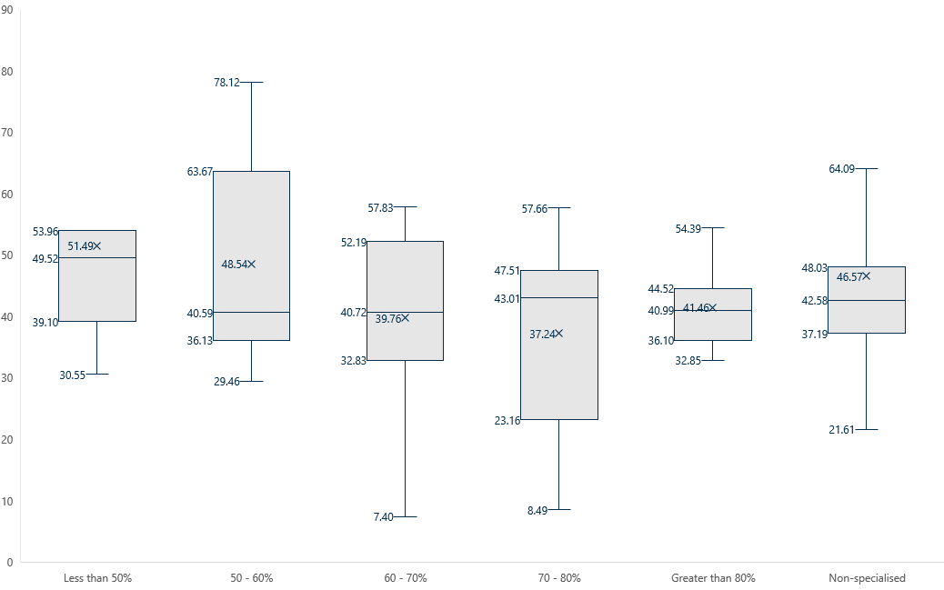

Table 35: RN care time (mins) per resident per day by service type

|  |  |  |  |  |  |  |
| --- | --- | --- | --- | --- | --- | --- |
| Statistic | Less than 50% | 50 – 60% | 60 – 70% | 70 – 80% | Greater than 80% | Non-specialised |
| Max | 53.96 | 70.12 | 57.83 | 57.66 | 54.39 | 64.09 |
| Quartile 3 | 53.96 | 63.67 | 52.19 | 47.51 | 44.52 | 48.03 |
| Mean | 51.49 | 48.54 | 39.76 | 37.24 | 41.46 | 46.57 |
| Median | 49.52 | 40.59 | 40.72 | 43.01 | 40.99 | 42.58 |
| Quartile 1 | 39.10 | 36.13 | 32.83 | 23.10 | 36.10 | 37.19 |
| Min | 30.55 | 29.46 | 7.40 | 8.49 | 32.85 | 21.61 |

Figure 20: PCW and AIN care time (mins) per resident per day by service type

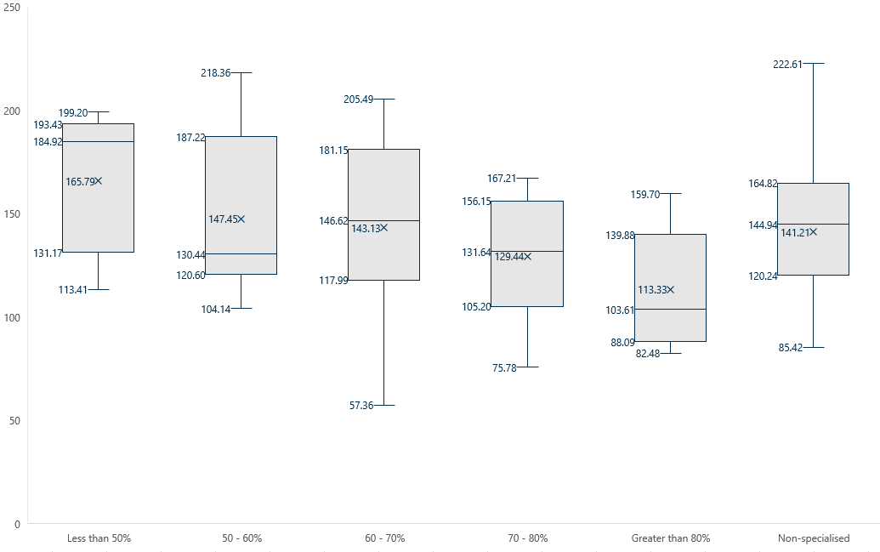

Table 36: PCW and AIN care time (mins) per resident per day by service type

|  |  |  |  |  |  |  |
| --- | --- | --- | --- | --- | --- | --- |
| Statistic | Less than 50% | 50 – 60% | 60 – 70% | 70 – 80% | Greater than 80% | Non-specialised |
| Max | 199.20 | 218.36 | 205.49 | 167.21 | 159.70 | 222.61 |
| Quartile 3 | 193.43 | 187.22 | 181.15 | 156.15 | 139.88 | 164.82 |
| Mean | 165.79 | 147.45 | 143.13 | 129.44 | 113.33 | 141.21 |
| Median | 184.92 | 130.44 | 146.62 | 131.64 | 103.61 | 144.94 |
| Quartile 1 | 131.17 | 120.60 | 117.99 | 105.20 | 88.09 | 120.24 |
| Min | 113.41 | 104.14 | 57.36 | 75.78 | 82.48 | 85.42 |

Figure 21: EN care time (mins) per resident per day by service type

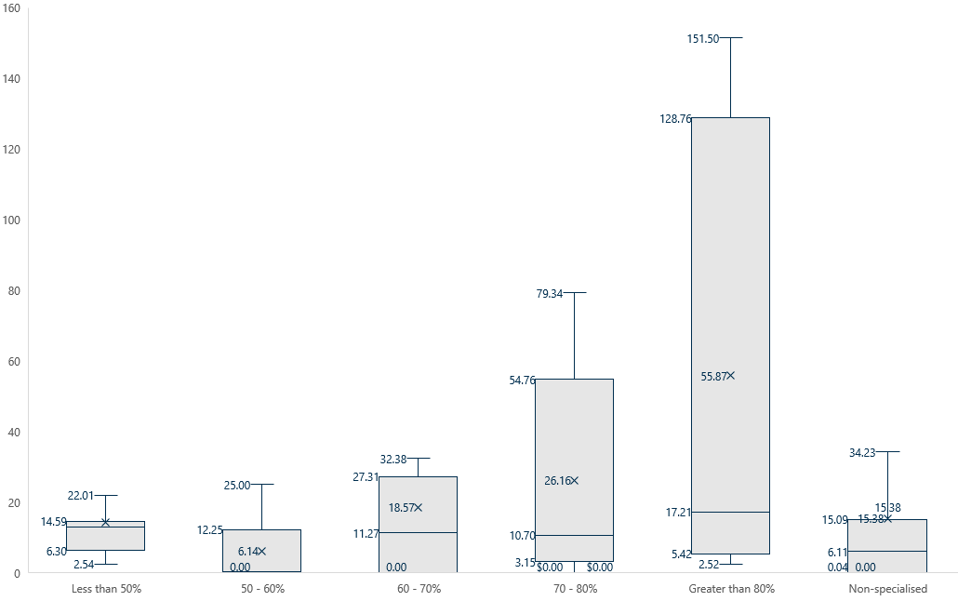

Table 37: EN care time (mins) per resident per day by service type

|  |  |  |  |  |  |  |
| --- | --- | --- | --- | --- | --- | --- |
| Statistic | Less than 50% | 50 – 60% | 60 – 70% | 70 – 80% | Greater than 80% | Non-specialised |
| Max | 22.01 | 25.00 | 32.30 | 79.34 | 151.50 | 34.23 |
| Quartile 3 | 14.59 | 12.25 | 27.31 | 54.76 | 128.76 | 15.09 |
| Mean | 14.39 | 6.14 | 18.57 | 26.16 | 55.87 | 15.38 |
| Median | 12.84 | 0.00 | 11.27 | 10.70 | 17.21 | 6.11 |
| Quartile 1 | 6.30 | 0.00 | 0.00 | 3.15 | 5.42 | 0.04 |
| Min | 2.54 | 0.00 | 0.00 | 0.00 | 2.52 | 0.00 |

Figure 22: Diversional and lifestyle care time (mins) per resident per day by service type

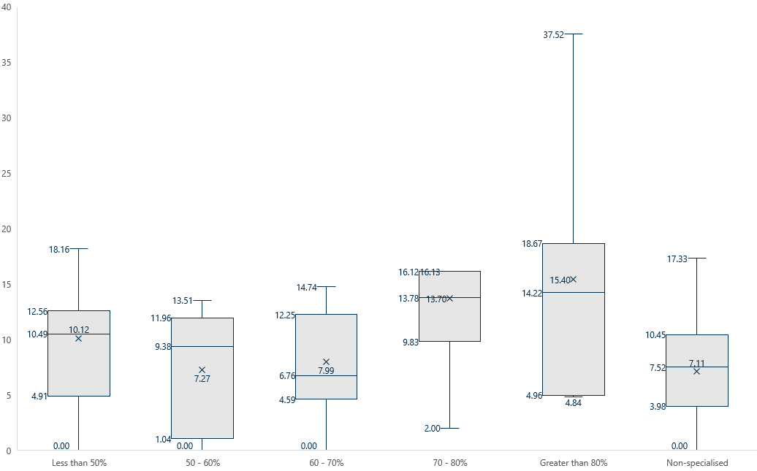

Table 38: Diversional and lifestyle care time (mins) per resident per day by service type

|  |  |  |  |  |  |  |
| --- | --- | --- | --- | --- | --- | --- |
| Statistic | Less than 50% | 50 – 60% | 60 – 70% | 70 – 80% | Greater than 80% | Non-specialised |
| Max | 18.16 | 13.51 | 14.74 | 16.13 | 37.52 | 17.33 |
| Quartile 3 | 12.56 | 11.96 | 12.25 | 16.12 | 18.67 | 10.45 |
| Mean | 10.12 | 7.27 | 7.99 | 13.70 | 15.40 | 7.11 |
| Median | 10.49 | 9.38 | 6.76 | 13.70 | 14.22 | 7.52 |
| Quartile 1 | 4.91 | 1.04 | 4.59 | 9.83 | 4.96 | 3.98 |
| Min | 0.00 | 0.00 | 0.00 | 2.00 | 4.84 | 0.00 |

Figure 23: Care management care time (mins) per resident per day by service type

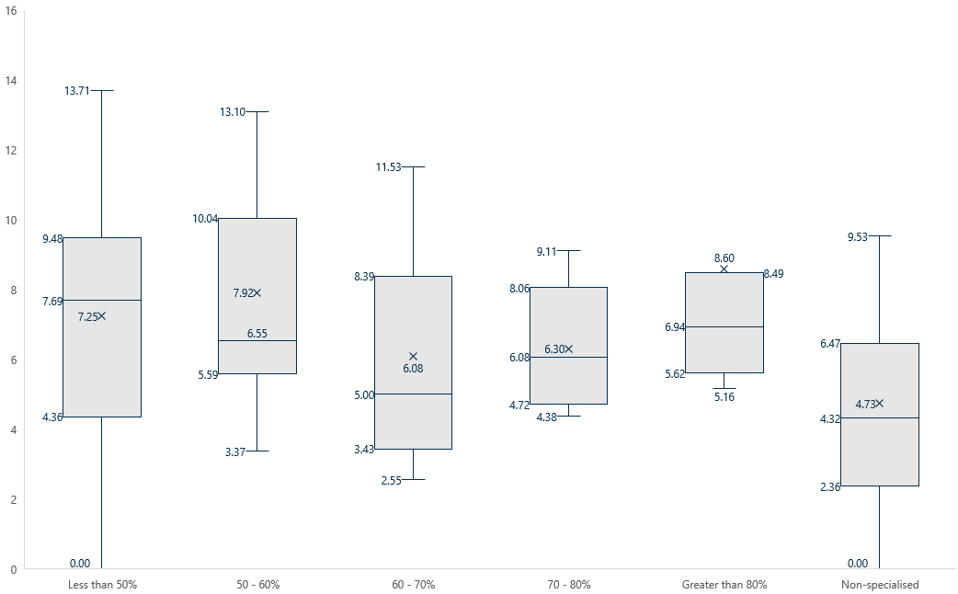

Table 39: Care management care time (mins) per resident per day by service type

|  |  |  |  |  |  |  |
| --- | --- | --- | --- | --- | --- | --- |
| Statistic | Less than 50% | 50 – 60% | 60 – 70% | 70 – 80% | Greater than 80% | Non-specialised |
| Max | 13.71 | 13.10 | 11.53 | 9.11 | 8.49 | 9.53 |
| Quartile 3 | 9.48 | 10.04 | 8.39 | 8.06 | 8.49 | 6.47 |
| Mean | 7.25 | 7.92 | 6.08 | 6.30 | 8.60 | 4.73 |
| Median | 7.69 | 6.55 | 5.00 | 6.08 | 6.94 | 4.32 |
| Quartile 1 | 4.36 | 5.59 | 3.43 | 4.72 | 5.62 | 2.36 |
| Min | 0.00 | 3.37 | 2.55 | 4.38 | 5.16 | 0.00 |

Figure 24: Allied health care time (mins) per resident per day by service type

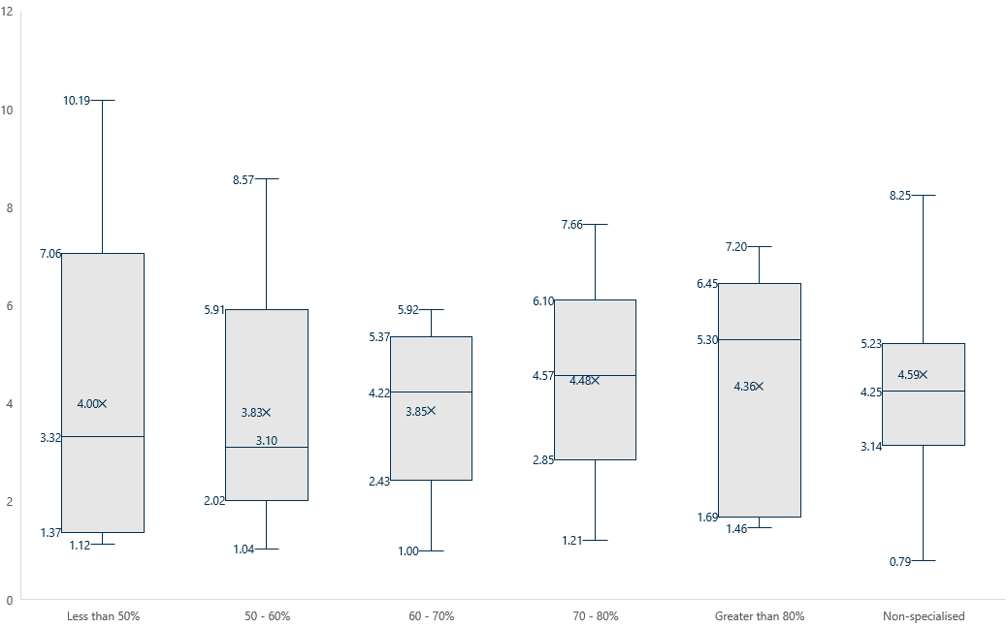

Table 40: Allied health care time (mins) per resident per day by service type

|  |  |  |  |  |  |  |
| --- | --- | --- | --- | --- | --- | --- |
| Statistic | Less than 50% | 50 – 60% | 60 – 70% | 70 – 80% | Greater than 80% | Non-specialised |
| Max | 10.19 | 8.57 | 5.92 | 7.66 | 7.20 | 8.25 |
| Quartile 3 | 7.06 | 5.91 | 5.37 | 6.10 | 6.45 | 5.23 |
| Mean | 4.00 | 3.83 | 3.85 | 4.48 | 4.36 | 4.59 |
| Median | 3.32 | 3.10 | 4.22 | 4.57 | 5.30 | 4.25 |
| Quartile 1 | 1.37 | 2.02 | 2.43 | 2.85 | 1.69 | 3.14 |
| Min | 1.12 | 1.04 | 1.00 | 1.21 | 1.46 | 0.79 |

###### Allied health care time by profession

In section ‎4.2.1 we showed that allied health care time is similar across service types. Figure 24 shows minor variations in the use of different allied health professions, with higher proportion specialised services reporting more dietetic care time and occupational therapists delivering more care time in lower proportion services. Physiotherapists account for the majority of allied health care time in all service types.

Table 41: Average allied health care time (mins) per resident per day by service type and profession

|  |  |  |  |  |  |  |  |
| --- | --- | --- | --- | --- | --- | --- | --- |
| Profession | Less than 50% | 50–60% | 60–70% | 70–80% | More than 80% | Specialised total | Non-specialised |
| Allied health assistant | 0.14 | 0.02 | 0.03 | 0.06 | 0.00 | 0.05 | 0.43 |
| Dietetic care | 0.17 | 0.27 | 0.23 | 0.34 | 0.36 | 0.27 | 0.18 |
| Occupational therapist | 0.55 | 0.55 | 0.03 | 0.11 | 0.02 | 0.29 | 0.26 |
| Physiotherapist | 2.40 | 3.28 | 2.94 | 3.49 | 3.56 | 3.01 | 3.02 |
| Podiatrist | 0.22 | 0.24 | 0.52 | 0.38 | 0.28 | 0.32 | 0.34 |
| Speech pathologist | 0.08 | 0.07 | 0.08 | 0.08 | 0.07 | 0.08 | 0.12 |
| Other allied health | 0.31 | 0.17 | 0.02 | 0.08 | 0.08 | 0.15 | 0.28 |

Source: Quarterly Financial Report, 2023–24

##### Statistical analysis of care costs

As discussed in section ‎5.2, there appear to be some differences in expenditure between specialised and non-specialised services, and across specialised services with different proportions of residents with a history of homelessness. We ran an ANCOVA to determine if these differences were accounted for by:

* residents' level of need, defined as the variable component of the subsidy provided to each service according to residents’ AN-ACC classifications
* service rurality, defined as MM category.

**Note**: Elsewhere in this report we have classified specialised services into 5 groups, ranging from less than 50% to more than 80% having a history of homelessness. To ensure more robust statistical analysis, we have collapsed these into 2 groups. “High-proportion” and “low-proportion” services are defined as those with more, and less, than 61% of residents with a history of homeless, respectively. We selected this cut off of 61% as this represents the overall proportion of residents with a history of homelessness across all specialised services. Thus, in the results that follow we compare expenditure across 3 service types: high-proportion, low-proportion, and non-specialised services.

We found a significant effect of service type on care expenditure F(2,5325) = 4.07, *p* <0.05, with a medium effect size observed η2 = 0.06). In other words, differences in expenditure were not accounted for by resident need or service rurality.

Table 42: Results of ANCOVA, care expenditure controlling for resident complexity and service rurality

| Model | Sum of squares | df | Mean square | F | p | n2 |
| --- | --- | --- | --- | --- | --- | --- |
| Overall | 71,014 | 4 | 17,753 | 14.46 | <.001 | - |
| Case mix | 37,365 | 1 | 37,365 | 28.55 | <.001 | 0.219 |
| Rurality | 22,998 | 1 | 22,998 | 17.57 | <.001 | 0.135 |
| Service type | 10,650 | 2 | 5,325 | 4.07 | 0.021 | 0.062 |
| Residuals | 99,467 | 76 | 1,309 | - | - | - |

Post-hoc tests revealed a significant difference in care expenditure between high-proportion and non‑specialised services, t(76) = 2.85, *p* < 0.05, with a medium effect size (Cohen's d = 0.76; Table 43). Based on the estimated marginal means (mean value for care expenditure controlling for resident need and service rurality), high-proportion services spent $260 on average per resident per day compared to $232 by non-specialised services.

The estimated marginal mean from low-proportion services was $242, which was not significantly different from either high-proportion or non-specialised services.

Table 43: Results of post-hoc tests, care expenditure controlling for case mix and MM by service type

| Comparison | M difference | SE | df | t | p | Cohen’s d | 95% Confidence interval |
| --- | --- | --- | --- | --- | --- | --- | --- |
| High and low-proportion | $17.40 | 11.75 | 76 | 1.48 | 0.43 | 0.48 | -0.17 – 1.13 |
| High and non-specialised | $27.50 | 9.64 | 76 | 2.85 | 0.01 | 0.76 | 0.22 – 1.31 |
| Low and non-specialised | $10.10 | 10.49 | 76 | 0.96 | 1.0 | 0.28 | -0.30 – 0.86 |

Note: p values are Bonferroni-corrected.

##### Additional quality ratings data

In section ‎6.1.1 we presented average quality ratings for specialised and non-specialised services overall. Table 44 expands on this data to show the minor variation in quality ratings across specialised services with different proportions of residents with a history of homelessness.

Table 44: Average quality rating by service type

| Quality rating | Less than 50% | 50–60% | 60–70% | 70–80% | More than 80% | Non-specialised |
| --- | --- | --- | --- | --- | --- | --- |
| Compliance | 4.2 | 4.7 | 4.6 | 4.8 | 4.5 | 4.6 |
| Quality | 3.3 | 3.9 | 4.0 | 3.9 | 4.0 | 3.7 |
| Residents’ experience | 3.3 | 3.5 | 3.3 | 3.5 | 3.5 | 3.5 |
| Staffing | 3.6 | 3.3 | 3.1 | 3.0 | 3.6 | 3.2 |
| Star rating | 3.7 | 3.9 | 3.7 | 3.9 | 3.9 | 3.8 |

Source: Star Ratings quarterly data extracts, 2024

##### Data tables for figures

Table 45: Data for Figure 1: Map of specialised residential aged care services

|  |  |  |  |
| --- | --- | --- | --- |
| Jurisdiction | Number of specialised services | Number of residents in specialised services | Proportion of residents with a history of homelessness |
| NSW | 16 | 770 | 67% |
| Vic | 13 | 764 | 65% |
| Qld | 8 | 315 | 50% |
| WA | 4 | 205 | 45% |
| NT | 4 | 188 | 48% |
| SA | 1 | 40 | 73% |
| Tas | 1 | 37 | 92% |

Go back to Figure 1.

Table 46: Data for Figure 2: Occupancy rate in specialised services

| Summary statistics | Value |
| --- | --- |
| Count | 47 |
| Minimum | 58% |
| Quartile 1 (25th percentile) | 83% |
| Median (50th percentile) | 93% |
| Quartile 3 (75th percentile) | 97% |
| Maximum | 103% |
| Mean | 89% |

Go back to Figure 2.

Table 47: Data for Figure 3: Proportion of residents with a history of homelessness in specialised services

|  |  |
| --- | --- |
| Summary statistics | Value |
| Count | 47 |
| Minimum | 27% |
| Quartile 1 (25th percentile) | 50% |
| Median (50th percentile) | 62% |
| Quartile 3 (75th percentile) | 73% |
| Maximum | 95% |
| Mean | 61% |

Go back to Figure 3.

Table 48: Data for Figure 4: Age distribution by service type and homelessness status

|  |  |  |  |
| --- | --- | --- | --- |
| Summary statistic | Specialised service – residents with a history of homelessness | Specialised service – residents with no history of homelessness | Non-specialised service – all residents |
| Count | 1,266 | 770 | 2,181 |
| Minimum | 43 | 51 | 44 |
| Quartile 1  (25th percentile) | 69 | 71 | 80 |
| Median  (50th percentile) | 74 | 78 | 86 |
| Quartile 3  (75th percentile) | 79 | 84 | 91 |
| Maximum (excluding outliers) | 94 | 103 | 106 |
| Maximum (including outliers) | 102 | 103 | 109 |
| Mean | 74 | 78 | 85 |

Go back to Figure 4.

Table 49: Data for Figure 5: Proportion of men, by service type and history of homelessness

| Summary statistic | Specialised service – residents with a history of homelessness | Specialised service – residents with no history of homelessness | Non-specialised service – all residents |
| --- | --- | --- | --- |
| Count | 47 | 47 | 49 |
| Minimum | 25% | 25% | 0% |
| Quartile 1  (25th percentile) | 58% | 44% | 25% |
| Median  (50th percentile) | 68% | 60% | 31% |
| Quartile 3  (75th percentile) | 78% | 76% | 42% |
| Maximum | 100% | 100% | 62% |
| Mean | 68% | 63% | 34% |

Go back to Figure 5.

Table 50: Data for Figure 6: Proportion of First Nations residents, by service type and history of homelessness

| Summary statistic | Specialised service – residents with a history of homelessness | Specialised service – residents with no history of homelessness | Non-specialised service – all residents |
| --- | --- | --- | --- |
| Count | 47 | 47 | 49 |
| Minimum | 0% | 0% | 0% |
| Quartile 1  (25th percentile) | 0% | 0% | 0% |
| Median  (50th percentile) | 5% | 5% | 0% |
| Quartile 3  (75th percentile) | 20% | 23% | 0% |
| Maximum (excluding outliers) | 26% | 57% | 1% |
| Maximum (including outliers) | 100% | 100% | 92% |
| Mean | 20% | 21% | 4% |

Go back to Figure 6.

Table 51: Data for Figure 9: Average care time (mins) by staff and service type

| Staff type | Less than 50% | 50–60% | 60–70% | 70–80% | More than 80% | Non-specialised |
| --- | --- | --- | --- | --- | --- | --- |
| Allied health | 4.00 | 3.83 | 3.85 | 4.48 | 4.36 | 4.59 |
| Care management | 7.25 | 7.92 | 6.08 | 6.30 | 8.6 | 4.73 |
| Diversional and lifestyle | 10.12 | 7.27 | 7.99 | 13.7 | 15.4 | 7.11 |
| ENs | 14.39 | 6.14 | 18.57 | 26.16 | 55.87 | 15.38 |
| PCWs/AINs | 165.79 | 147.45 | 143.13 | 129.44 | 113.33 | 141.21 |
| RNs | 51.49 | 39.76 | 39.76 | 37.24 | 41.46 | 46.57 |

Go back to Figure 9.

Table 52: Data for Figure 10: Proportion of staff by employment, service and staff type

|  |  |  |  |  |
| --- | --- | --- | --- | --- |
| Staff type | Specialised – agency | Specialised – employee | Non-specialised – agency | Non-specialised – employee |
| Registered nurses | 14% | 86% | 13% | 87% |
| PCW/AINs | 6% | 94% | 5% | 95% |
| Enrolled nurses | 14% | 86% | 3% | 97% |
| Diversional and lifestyle | 1% | 99% | 0% | 100% |
| Care management | 2% | 98% | 0% | 100% |
| Allied health | 86% | 14% | 71% | 29% |

Go back to Figure 10.

Table 53: Data for Figure 11: Average total care minutes and targets – specialised and non-specialised services

|  |  |  |  |  |
| --- | --- | --- | --- | --- |
| Quarter beginning | Specialised – target | Specialised – care minutes | Non-specialised – target | Non-specialised – care minutes |
| January 2024 | 189 | 198 | 198 | 198 |
| April 2024 | 179 | 196 | 197 | 205 |
| July 2024 | 180 | 205 | 199 | 204 |
| October 2024 | 188 | 210 | 200 | 207 |

Go back to Figure 11.

Table 54: Data for Figure 12: Average RN care minutes and targets – specialised and non-specialised services

|  |  |  |  |  |
| --- | --- | --- | --- | --- |
| Quarter beginning | Specialised – target | Specialised – care minutes | Non-specialised – target | Non-specialised – care minutes |
| January 2024 | 38 | 40 | 39 | 45 |
| April 2024 | 36 | 41 | 39 | 46 |
| July 2024 | 37 | 43 | 39 | 47 |
| October 2024 | 38 | 46 | 39 | 48 |

Go back to Figure 12.

Table 55: Data for Figure 13: 24/7 RN coverage by service type

| Month | Less than 50% | 50 – 60% | 60 – 70% | 70 – 80% | More than 80% | Non-specialised |
| --- | --- | --- | --- | --- | --- | --- |
| January | 90% | 99% | 92% | 84% | 81% | 98% |
| February | 92% | 99% | 92% | 85% | 81% | 98% |
| March | 94% | 100% | 92% | 84% | 80% | 98% |
| April | 95% | 100% | 93% | 85% | 81% | 99% |
| May | 98% | 100% | 92% | 85% | 81% | 99% |
| June | 100% | 100% | 93% | 85% | 80% | 99% |
| July | 100% | 100% | 93% | 85% | 80% | 99% |
| August | 100% | 100% | 93% | 85% | 79% | 99% |
| September | 100% | 100% | 93% | 85% | 79% | 99% |
| October | 100% | 100% | 94% | 87% | 81% | 99% |
| November | 100% | 100% | 94% | 87% | 80% | 99% |
| December | 100% | 100% | 94% | 87% | 77% | 99% |

Go back to Figure 13.

Table 56: Data for Figure 14: Care, hotel and accommodation income by service type

| Income category | Less than 50% | 50 – 60% | 60 – 70% | 70 – 80% | More than 80% | Non-specialised |
| --- | --- | --- | --- | --- | --- | --- |
| Care | $402.72 | $373.94 | $380.37 | $358.46 | $367.21 | $290.49 |
| Hotel | $63.76 | $70.78 | $71.27 | $72.55 | $72.35 | $72.61 |
| Accommodation | $50.01 | $49.21 | $55.72 | $57.97 | $61.99 | $43.43 |
| Total | $516.49 | $493.93 | $507.35 | $488.95 | $501.55 | $406.43 |

Go back to Figure 14.

Table 57: Data for Figure 16: Expenditure by service type and cost category

| Cost category | Less than 50% | 50 – 60% | 60 – 70% | 70 – 80% | More than 80% | Non-specialised |
| --- | --- | --- | --- | --- | --- | --- |
| Care | $276.80 | $240.22 | $228.90 | $232.94 | $276.27 | $233.71 |
| Hotel | $78.18 | $67.32 | $78.27 | $77.57 | $84.28 | $67.78 |
| Accommodation | $59.06 | $38.92 | $52.72 | $39.80 | $52.42 | $39.01 |
| Administration | $78.28 | $58.57 | $65.44 | $75.54 | $103.95 | $57.63 |
| Total | $492.33 | $405.02 | $425.32 | $425.85 | $516.92 | $398.13 |

Go back to Figure 16.

Table 58: Data for Figure 17: Resident Experience Survey data – staff and management  
Question 1 of 8: Are staff kind and caring?

|  |  |  |  |  |
| --- | --- | --- | --- | --- |
| Service type | Always | Most of the time | Some of the time | Never |
| Non-specialised | 65% | 30% | 5% | 0% |
| Specialised | 67% | 23% | 9% | 0% |

Table 59: Data for Figure 17: Resident Experience Survey data – staff and management  
Question 2 of 8: Are you encouraged to do as much as possible for yourself?

|  |  |  |  |  |
| --- | --- | --- | --- | --- |
| Service type | Always | Most of the time | Some of the time | Never |
| Non-specialised | 56% | 32% | 10% | 2% |
| Specialised | 64% | 24% | 8% | 4% |

Table 60: Data for Figure 17: Resident Experience Survey data – staff and management  
Question 3 of 8: Do staff explain things to you?

|  |  |  |  |  |
| --- | --- | --- | --- | --- |
| Service type | Always | Most of the time | Some of the time | Never |
| Non-specialised | 46% | 36% | 17% | 1% |
| Specialised | 48% | 30% | 18% | 4% |

Table 61: Data for Figure 17: Resident Experience Survey data – staff and management  
Question 4 of 8: Do staff follow up when you raise things with them?

|  |  |  |  |  |
| --- | --- | --- | --- | --- |
| Service type | Always | Most of the time | Some of the time | Never |
| Non-specialised | 45% | 39% | 15% | 1% |
| Specialised | 50% | 30% | 16% | 4% |

Table 62: Data for Figure 17: Resident Experience Survey data – staff and management  
Question 5 of 8: Do staff know what they are doing?

|  |  |  |  |  |
| --- | --- | --- | --- | --- |
| Service type | Always | Most of the time | Some of the time | Never |
| Non-specialised | 42% | 46% | 12% | 0% |
| Specialised | 50% | 36% | 14% | 0% |

Table 63: Data for Figure 17: Resident Experience Survey data – staff and management  
Question 6 of 8: Do staff treat you with respect?

|  |  |  |  |  |
| --- | --- | --- | --- | --- |
| Service type | Always | Most of the time | Some of the time | Never |
| Non-specialised | 70% | 26% | 4% | 0% |
| Specialised | 68% | 23% | 8% | 1% |

Table 64: Data for Figure 17: Resident Experience Survey data – staff and management  
Question 7 of 8: How likely are you to recommend this aged care home to someone?

|  |  |  |  |  |
| --- | --- | --- | --- | --- |
| Service type | Always | Most of the time | Some of the time | Never |
| Non-specialised | 63% | 25% | 9% | 3% |
| Specialised | 55% | 26% | 11% | 8% |

Table 65: Data for Figure 17: Resident Experience Survey data – staff and management  
Question 8 of 8: Is this place well run?

| Service type | Always | Most of the time | Some of the time | Never |
| --- | --- | --- | --- | --- |
| Non-specialised | 47% | 42% | 11% | 0% |
| Specialised | 51% | 35% | 12% | 1% |

Go back to Figure 17.

Table 66: Data for Figure 18: Resident Experience Survey data – wellbeing  
Question 1 of 4: Do you feel safe here?

| Service type | Always | Most of the time | Some of the time | Never |
| --- | --- | --- | --- | --- |
| Non-specialised | 77% | 19% | 4% | 0% |
| Specialised | 75% | 17% | 7% | 1% |

Table 67: Data for Figure 18: Resident Experience Survey data – wellbeing  
Question 2 of 4: Do you get the care you need?

| Service type | Always | Most of the time | Some of the time | Never |
| --- | --- | --- | --- | --- |
| Non-specialised | 66% | 27% | 7% | 0% |
| Specialised | 68% | 24% | 7% | 1% |

Table 68: Data for Figure 18: Resident Experience Survey data – wellbeing  
Question 3 of 4: Do you have a say in your daily activities?

| Service type | Always | Most of the time | Some of the time | Never |
| --- | --- | --- | --- | --- |
| Non-specialised | 71% | 19% | 7% | 3% |
| Specialised | 69% | 21% | 8% | 2% |

Table 69: Data for Figure 18: Resident Experience Survey data – wellbeing  
Question 4 of 4: Do you like the food here?

| Service type | Always | Most of the time | Some of the time | Never |
| --- | --- | --- | --- | --- |
| Non-specialised | 32% | 40% | 25% | 3% |
| Specialised | 31% | 34% | 28% | 7% |

Go back to Figure 18.

References

Australian Bureau of Statistics (2022) [Population data summary](https://www.abs.gov.au/statistics/people/population/population-census/latest-release#data-downloads) [data set], accessed 5 February 2025.

Australian Bureau of Statistics (2023a) [Estimating homelessness: census](https://www.abs.gov.au/statistics/people/housing/estimating-homelessness-census), ABS website, accessed 15 January 2025.

Australian Bureau of Statistics (2023b) [State and territory by place of enumeration, remoteness areas](https://www.abs.gov.au/statistics/people/housing/estimating-homelessness-census/latest-release#data-downloads)[data set], accessed 5 February 2025.

Australian Bureau of Statistics (2023c) [Census of Population and Housing: estimating homelessness](https://www.abs.gov.au/statistics/people/housing/estimating-homelessness-census/latest-release#data-downloads) [data set], accessed 5 February 2025.

Australian Bureau of Statistics (2023d) [State and territory of usual residence, all persons](https://www.abs.gov.au/statistics/people/housing/estimating-homelessness-census/latest-release#data-downloads) [data set], accessed 5 February 2025.

ACQSC (n.d.a) [*Standard 1: The Individual*](https://www.agedcarequality.gov.au/strengthened-quality-standards/individual), Aged Care Quality and Safety Commission website, accessed 8 May 2025.

ACQSC (n.d.b) [*About the Quality Standards*](https://www.agedcarequality.gov.au/providers/quality-standards/about-quality-standards), Aged Care Quality and Safety Commission website, accessed 11 May 2025.

AHA (2024) [*Evaluation of the care finder program: first evaluation report*](https://www.health.gov.au/resources/publications/first-report-on-the-implementation-of-the-care-finder-program), report to the Australian Government Department of Health and Aged Care, accessed 5 May 2025.

AIHW (2002) [*Aged Care Assessment Program data dictionary*](https://www.aihw.gov.au/reports/aged-care/aged-care-assessment-program-data-dictionary-versi/summary), AIHW cat. no. AGE 26, Australian Institute of Health and Welfare website, accessed 5 February 2025.

AIHW (2023a) [*Services and places in aged care, 30 June 2023*](https://www.gen-agedcaredata.gov.au/resources/access-data/2025/april/gen-data-providers,-services-and-places-in-aged-care)[data set], GEN data: Providers, services and places in aged care, accessed 5 February 2025.

AIHW (2023b) [*Allocated places by state and territory, 30 June 2023*](https://www.gen-agedcaredata.gov.au/resources/access-data/2023/october/stocktake-data-30-june-2023)[data set], Stocktake data: 30 June 2023, accessed 5 February 2025.

AIHW (2024a) [*Providers, services and places in aged care*](https://www.gen-agedcaredata.gov.au/topics/providers,-services-and-places-in-aged-care), AIHW website, accessed 15 January 2025.

AIHW (2024b) [*People using aged care*](https://www.gen-agedcaredata.gov.au/topics/people-using-aged-care), AIHW website, accessed 10 January 2025.

AIHW (2024c) [*Older Australians, housing and living arrangements*](https://www.aihw.gov.au/reports/older-people/older-australians/contents/housing-and-living-arrangements), AIHW website, accessed 16 December 2024.

AIHW (2025a) [*Homelessness and homelessness services*](https://www.aihw.gov.au/reports/australias-welfare/homelessness-and-homelessness-services), AIHW website, accessed 12 May 2025.

AIHW (2025b) [*People using aged care*](https://www.gen-agedcaredata.gov.au/topics/people-using-aged-care#agedcareusebyage), AIHW website, accessed 5 February 2025.

Alrewaithi AM, Kruger E and Tennant M (2025) 'Distribution and accessibility of residential aged care facilities concerning socioeconomic indicators and geographic remoteness in Australia', *Health & Social Care in the Community*, 2025(1):7696896, doi:10.1155/hsc/7696896.

ARIIA Knowledge & Implementation Hub (2022) [*Person-centred approach: meaningful lifestyle activities*](https://www.ariia.org.au/knowledge-implementation-hub/meaningful-lifestyle-activities/meaningful-lifestyle-activities-evidence-themes/meaningful-lifestyle-activities-person-centred-approach), ARIIA website, accessed 5 February 2025.

Beaujoin C, Bergeron-Longpré M, Bleau L-P, Beausoleil J, Pinchinat J-CK, Guerrero M, Aubut V, Blanchette-Martin N, Ferland F, Flores-Aranda J, Huỳnh C, L’Espérance N and Wagner V (2023) 'Substance use among older residents in residential and long-term care facilities: a scoping review on intervention practices', *Sante Mentale au Quebec*, 48(2):257–294.

Brown RT, Hemati K, Riley ED, Lee CT, Ponath C, Tieu L, Guzman D and Kushel MB (2017) 'Geriatric conditions in a population-based sample of older homeless adults', *The Gerontologist*, 57(4):757–766, doi:10.1093/geront/gnw011.

Brownie S, Horstmanshof L and Garbutt R (2014) 'Factors that impact residents’ transition and psychological adjustment to long-term aged care: A systematic literature review', *International Journal of Nursing Studies*, 51(12):1654–1666, doi:10.1016/j.ijnurstu.2014.04.011.

Cameron N, Fetherstonhaugh D, Rayner J-A and McAuliffe L (2022) 'Loss, unresolved trauma and gaps in staff knowledge: a qualitative study on older adults living in residential aged care', *Issues in Mental Health Nursing*, 43(8):748–754, doi:10.1080/01612840.2022.2043496.

Center for Health Care Strategies (2025) [*What is trauma-informed care?*](https://www.traumainformedcare.chcs.org/what-is-trauma-informed-care/), Trauma-Informed Care Implementation Resource Centre, accessed 7 January 2025.

Cohen LW, Zimmerman S, Reed D, Brown P, Bowers BJ, Nolet K, Hudak S, Horn S and Grabowski D (2016) 'The Green House model of nursing home care in design and implementation', *Health Services Research*, 51(Suppl 1):352–377, doi:10.1111/1475-6773.12418.

Craig L and Hastings C (2024) 'Intersectionality of gender and age : a critical realist approach to explaining older women’s increased homelessness', *Journal of Critical Realism*, 23(4):361–383, doi:10.1080/14767430.2024.2389675.

Demakakos P, Lewer D, Jackson SE and Hayward AC (2020) 'Lifetime prevalence of homelessness in housed people aged 55–79 years in England: its childhood correlates and association with mortality over 10 years of follow-up', *Public Health*, 182:131–138, doi:10.1016/j.puhe.2019.12.017.

Department of Health (2021) [*2020 Aged Care Workforce Census report*](https://www.health.gov.au/sites/default/files/documents/2021/10/2020-aged-care-workforce-census.pdf), accessed 6 May 2025.

Department of Health and Aged Care (2024) [*24/7 registered nurse responsibility: guide for residential aged care providers*](https://www.health.gov.au/resources/publications/care-minutes-and-247-registered-nurse-responsibilities-guides-for-residential-aged-care-providers?language=en), Department of Health and Aged Care website, accessed 6 May 2025.

Department of Health and Aged Care (2025a) [*Care minutes responsibility: guide for residential aged care providers*](https://www.health.gov.au/resources/publications/care-minutes-and-247-registered-nurse-responsibilities-guides-for-residential-aged-care-providers?language=en), Department of Health and Aged Care website, accessed 6 May 2025.

Department of Health and Aged Care (2025b) [*Aged care subsidies and supplements*](https://www.health.gov.au/topics/aged-care/providing-aged-care-services/funding-for-aged-care-service-providers/aged-care-subsidies-and-supplements), Department of Health and Aged Care website, accessed 5 August 2025.

Department of Health and Aged Care (2025c) [*The Australian National Aged Care Classification (AN-ACC) funding guide*](https://www.health.gov.au/sites/default/files/2025-02/the-australian-national-aged-care-classification-an-acc-funding-guide_0.pdf), accessed 9 May 2025.

Department of Health and Aged Care (n.d.a) [*Younger people in residential aged care*](https://www.health.gov.au/our-work/ypirac), Department of Health and Aged Care website, accessed 5 May 2025.

Department of Health and Aged Care (n.d.b) [*Specialised homeless status – care recipient assessment form*](https://www.health.gov.au/sites/default/files/2023-03/specialised-homeless-base-care-tariff-care-recipient-assessment-form.pdf), accessed 21 November 2024.

van Dongen SI, Klop HT, Onwuteaka-Philipsen BD, de Veer AJ, Slockers MT, van Laere IR, van der Heide A and Rietjens JA (2020) 'End-of-life care for homeless people in shelter-based nursing care settings: a retrospective record study', *Palliative medicine*, 34(10):1374–1384, doi:10.1177/0269216320940559.

Falkenburg J and Tracy DK (2014) 'Sex and schizophrenia: a review of gender differences', *Psychosis*, 6(1):61–69, doi:10.1080/17522439.2012.733405.

Gordon R, Loggie C, Kobel C, Westera A, Fildes D, Larson-Truong K and Grootemaat P (2023) [*Alternative arrangements for residential aged care staffing responsibilities: final report*](https://www.health.gov.au/sites/default/files/2024-03/alternative-arrangements-for-residential-aged-care-staffing-responsibilities-final-report.pdf), Centre for Health Service Development, Australian Health Services Research Institute, University of Wollongong, accessed 25 November 2024.

Grenier A, Barken R, Sussman T, Rothwell D, Bourgeois-Guérin V and Lavoie J-P (2016) 'A literature review of homelessness and aging: suggestions for a policy and practice-relevant research agenda', *Canadian Journal on Aging / La Revue canadienne du vieillissement*, 35(1):28–41, doi:10.1017/S0714980815000616.

HAAG (2019) [*Aged Care Homelessness Action Plan*](https://www.oldertenants.org.au/i-want-change/projects/aged-care-homelessness-action-plan), HAAG website, accessed 5 December 2024.

Independent Health and Aged Care Pricing Authority (2024a) [*Residential aged care pricing advice 2024-25*](https://www.ihacpa.gov.au/sites/default/files/2024-09/residential_aged_care_pricing_advice_2024-25_0.pdf), accessed 11 May 2025.

Independent Health and Aged Care Pricing Authority (2024b) [*Pricing framework for Australian residential aged care services 204-25: consultation report*](https://www.ihacpa.gov.au/sites/default/files/2024-09/pricing_framework_for_australian_residential_aged_care_services_2024-25_consultation_report.pdf), accessed 9 May 2025.

Jutkowitz E, Halladay C, McGeary J, O’Toole T and Rudolph JL (2019) 'Homeless veterans in nursing homes: care for complex medical, substance use, and social needs', *Journal of the American Geriatrics Society*, 67(8):1707–1712.

Keast J (2015) [*Older homeless being overlooked, tailored residential care needed: provider*](https://www.australianageingagenda.com.au/executive/older-homeless-being-overlooked-tailored-residential-care-needed-provider/), Australian Ageing Agenda website, accessed 16 December 2024.

MacRae A, Berkovic D, Ryan J, Hatzikiriakidis K and Ayton D (2023) 'Trauma‐informed care within residential aged care settings: a systematic scoping review', *International Journal of Geriatric Psychiatry*, 38(12):e6028, doi:10.1002/gps.6028.

Mantell R, Hwang YIJ, Radford K, Perkovic S, Cullen P and Withall A (2023) 'Accelerated aging in people experiencing homelessness: A rapid review of frailty prevalence and determinants', *Frontiers in Public Health*, 16(11):1086215, doi: 10.3389/fpubh.2023.1086215.

McNamee J, Snoek M, Kobel D, Rankin R and Eagar K (2019) [*A funding model for the residential aged care sector The Resource Utilisation and Classification Study: Report 5*](https://ro.uow.edu.au/articles/report/A_funding_model_for_the_residential_aged_care_sector_The_Resource_Utilisation_and_Classification_Study_Report_5/27701694), Australian Health Services Research Institute, University of Wollongong, accessed 6 May 2025.

Mission Australia (2017) [*Ageing and homelessness: solutions to a growing problem*](https://www.missionaustralia.com.au/publications/position-statements/ageing-and-homelessness-solutions-to-a-growing-problem), Mission Australia website, accessed 9 May 2025.

O’Connor CMC, Poulos RG, Sharma A, Preti C, Reynolds NL, Rowlands AC, Flakelar K, Raguz A, Valpiani P, Faux SG, Boyer M, Close JCT, Gupta L and Poulos CJ (2023) 'An Australian aged care home for people subject to homelessness: health, wellbeing and cost–benefit', *BMC Geriatrics*, 23(1):253, doi:10.1186/s12877-023-03920-3.

Patterson K, Proft K and Maxwell J (2019) [*Older women’s risk of homelessness background paper: exploring a growing problem*](https://humanrights.gov.au/sites/default/files/document/publication/ahrc_ow_homelessness2019.pdf), Australian Human Rights Commission, accessed 6 May 2025.

Pawson H, Parsell C, Clarke A, Moore J, Hartley C, Aminpour F and Eagles K (2024) [*Australian Homelessness Monitor 2024*](https://cityfutures.ada.unsw.edu.au/australian-homelessness-monitor-2024/), UNSW City Futures Research Centre website, accessed 6 May 2025.

Petersen M (2015) 'Addressing older women’s homelessness: service and housing models', *Australian Journal of Social Issues*, 50(4):419–438, doi:10.1002/j.1839-4655.2015.tb00358.x.

Rice SM, Fallon BJ, Aucote HM, Möller-Leimkühler A, Treeby MS and Amminger GP (2015) 'Longitudinal sex differences of externalising and internalising depression symptom trajectories: Implications for assessment of depression in men from an online study', *International Journal of Social Psychiatry*, 61(3):236–240, doi:10.1177/0020764014540149.

Rota-Bartelink A (2016) *The provision of skilled specialist consultancy services to people living with highly complex needs and their caregivers*, The Wicking Project II (2015-2016): final report, Wintringham.

Royal Commission into Aged Care Quality and Safety (2021a) [*Final Report - Volume 1: Summary and recommendations*](https://www.royalcommission.gov.au/system/files/2024-03/aged-care-rc-final-report-volume-1.pdf), accessed 6 May 2025.

Royal Commission into Aged Care Quality and Safety (2021b) [*Final Report - Executive summary*](https://www.royalcommission.gov.au/system/files/2021-03/final-report-executive-summary.pdf), accessed 6 May 2025.

RPS (2023) *Leave no veteran behind: the long term economic costs of not housing veterans in need*, [Report to Housing All Australians by RPS](https://www.rpsgroup.com/imported-media/11982/haa_give-me-shelter_veterans_5_june_final.pdf), accessed 12 May 2025.

Scyne Advisory (2023) [*2023 Residential Aged Care Costing Study Final Report*](https://www.ihacpa.gov.au/resources/2023-residential-aged-care-costing-study-final-report), IHACPA website, accessed 18 November 2024.

Stride (n.d.) [*What Is Spiritual Wellbeing?*](https://stride.com.au/dimensions-of-wellness/spiritual-wellness/), Stride website, accessed 24 April 2025.

Strout KA and Howard EP (2012) 'The six dimensions of wellness and cognition in aging adults', *Journal of Holistic Nursing*, 30(3):195–204, doi:10.1177/0898010112440883.

Sussman T (2020) 'Supporting older homeless persons’ positive relocations to long-term care: service provider views', *Gerontologist*, 60(6):1149–1158, doi:10.1093/geront/gnz171.

Theisen H, Tanderup L, Stavad B and Hesse M (2017) 'Healthcare cost reductions after moving into a wet nursing home stay - a case series', *Geriatrics*, doi:10.3390/geriatrics2040031.

Thwaites C, McKercher JP, Fetherstonhaugh D, Blackberry I, Gilmartin-Thomas JF-M, Taylor NF, Bourke SL, Fowler-Davis S, Hammond S and Morris ME (2023) 'Factors impacting retention of aged care workers: a systematic review', *Healthcare*, 11(23):3008, doi:10.3390/healthcare11233008.

Toomey J (2018) 'Older people experiencing homelessness: what models of housing and support work best?', *Parity*, 31(4):6–7.

Wood L, Vallesi S and Turvey J (2024) [*Access to aged care for people experiencing homelessness in WA*](https://waaeh.org.au/resource/access-to-aged-care-for-people-experiencing-homelessness-in-wa/), Western Australian Alliance to End Homelessness website, accessed 9 May 2025.

York F, Maher A, Stapleton C, Feldman P, Engel L, Majumdar I and Brijnath B (2024) [*Older people at risk of homelessness: improving early intervention via aged care assessment services*](https://www.oldertenants.org.au/sites/default/files/older_people_at_risk_of_homelessness_final_report_24.12.20.pdf), HAAG, The National Ageing Research Institute, and Deakin University, accessed 6 May 2025.

1. A specialised BCT is currently available to residential aged care providers that specialise in caring for people with a history of homelessness (anywhere in Australia) or Aboriginal and Torres Strait Islander people (in remote locations only). For the sake of brevity, in this report we use “specialised services” to refer specifically to specialised homeless residential aged care services.
2. “Models of care” include both the supports provided to aged care residents and how they are delivered. Supports include specialised programs, activities and any other arrangements in place to meet residents’ care needs.
3. MMM measures the remoteness or rurality of a location on a scale of 1 to 7, with MM 1 representing a metropolitan area and MM 7 representing a very remote community (Department of Health and Aged Care n.d.).
4. The criteria also require associated complex needs and social disadvantage these issues are discussed in section ‎2.3.
5. We were unable to assess CALD status and other demographic characteristics of the resident population using the data available to this evaluation.
6. The number of residents with an AN-ACC assessment is lower than the number of people living in residential aged care (e.g. there were 2,319 specialised service residents in November 2024); residents that have not had an assessment may differ from those that have.
7. Although we heard that timely access to appropriate mental health expertise can be a challenge for some specialised services (see section **Error! Reference source not found.**).
8. Larger specialised service providers often approximated a smaller service environment by having dedicated floors for residents with similar characteristics.
9. Exemptions can be granted for up to 12 months. Providers can apply for an exemption if they are located in MM 5 to 7, have no more than 30 operational places on the day an exemption decision is made, have alternative clinical care arrangements in place to ensure that the clinical needs of their residents are met, and complete monthly 24/7 RN reporting.
10. To enable fair comparison between homes, quality indicators for pressure injuries, unplanned weight loss, and falls and major injuries are risk adjusted for each home using the residents’ AN-ACC classes and assessment data.