Aged Care Worker Screening Guidance Material

Worker Screening Requirements from 1 November 2025



Contents

| Section | Page Number |
| --- | --- |
| 1 Introduction: key aged care worker screening requirements | 4 |
| 2 Aged care workers and responsible persons | 5 |
| 3 Worker screening requirements | 7 |
| 4 Precluding offences | 10 |
| 5 Record keeping responsibilities | 12 |
| 6 Future screening requirements | 13 |
| Appendix | 15 |

# List of acronyms

| **Acronym** | **Meaning** |
| --- | --- |
| ACIC | Australian Criminal Intelligence Commission |
| AFP | Australian Federal Police |
| Ahpra | Australian Health Practitioner Regulation Agency |
| CEO | Chief Executive Officer |
| CHSP | Commonwealth Home Support Program |
| ICT | Information and Communication Technology |
| NATSIFACP | National Aboriginal and Torres Strait Islander Flexible Aged Care Program |
| NDIS  ACQSC  WSU | National Disability Insurance Scheme  Aged Care Quality and Safety Commission  Worker Screening Unit |

## Introduction: Key aged care worker screening requirements

### Purpose of this document

This guidance material aims to assist registered providers delivering funded aged care services to understand and comply with the worker screening requirements introduced by the [Aged Care Act 2024](https://www.legislation.gov.au/C2024A00104/asmade/text) (the Act) and the Aged Care Rules 2025 (Aged Care Rules) that commence on 1 November 2025.

### Key dates and changes

From 1 November 2025, all aged care workers and responsible persons will continue to need either a police certificate or an NDIS Worker Screening Clearance to work in aged care.

While these worker screening requirements will remain the same, there will be some changes due to new definitions in the Act (such as an aged care worker) and the record keeping requirements in the Aged Care Rules.

There are additional changes that will impact CHSP providers. These changes relate to how criminal offences are treated for aged care workers and responsible persons of a CHSP provider (see table 1, section 4). This will ensure the same precluding offences apply consistently across CHSP and NATSIFACP, while also preparing for the introduction of a more comprehensive screening process in the future.

### Summary of key requirements for all registered providers

Registered providers must ensure:

* each aged care worker and responsible person has one of the following:
  + a police certificate that is less than 3 years old and does not record certain offences (see table 1, section 4), or
  + an NDIS Worker Screening Clearance.
* if an aged care worker or responsible person has been a citizen or permanent resident of another country after turning 16, they also need a statutory declaration (see section 3.4)
* they have a record of each aged care worker and responsible person’s police certificate or NDIS Worker Screening Clearance and (if applicable) statutory declaration, and
* if an aged care worker or responsible person is convicted of a precluding offence, then that worker or responsible person does not continue to work in a role delivering funded aged care services.

It is important to note that the worker screening requirements apply to aged care workers and responsible persons engaged directly by a registered provider, as well as those engaged through associated providers and digital platforms.

### Future of aged care worker screening

The Australian Government is working with state and territory governments to expand NDIS worker screening to aged care. This will enhance screening checks, introduce ongoing monitoring of worker conduct and reduce administrative burden on registered providers and workers. An aged care worker screening check will be recognised in the NDIS sector and vice versa.

Final arrangements are subject to agreement with states and territories and will not start before mid-2026. Further information is set out in section 6 (future screening requirements).

### Other legislative requirements

It is a condition of registration for all registered providers to comply with the worker screening requirements set out in the Aged Care Rules. Worker screening is an important safeguard to reduce the risk of harm to older people accessing funded aged care services. Worker screening supports the right to be free from all forms of violence, degrading or inhumane treatment, exploitation, neglect, coercion, abuse or sexual misconduct (see Principle 4 of the [Statement of Rights](https://www.health.gov.au/resources/publications/a-new-aged-care-act-for-the-rights-of-older-people) for older people).

In addition to the worker screening requirements, there are also other requirements in the Act that registered providers will need to comply with. These include:

* the Aged Care Code of Conduct
* banning orders
* Aged Care Quality Standards
* the Serious Incident Response Scheme
* complaints management and whistleblowers
* suitability matters in relation to a responsible person.

Each of these requirements plays an important role in their own right, however they also operate collectively to provide an overarching framework of checks and balances that supports the delivery of safe and quality funded aged care services and reduce the risk of harm to older persons.

For more information see [Responsibilities of registered aged care providers](https://www.health.gov.au/topics/aged-care/providing-aged-care-services/responsibilities#:~:text=Approved%20providers%20have%20responsibilities%20under%20the%20Aged%20Care,also%20sets%20out%20requirements%20for%3A%20provider%20reporting%20obligations.).

## Aged care workers and responsible persons

### Definition of an aged care worker, including volunteers

An aged care worker is defined in the Act as a person who:

* is employed or otherwise engaged (including as a volunteer) by a registered provider to deliver funded aged care services, or
* a person who:
  + is employed or otherwise engaged (including as a volunteer) by an associated provider of the registered provider, and
  + is engaging in conduct under the associated provider’s arrangement with the registered provider relating to the registered provider’s delivery of funded aged care services, or
* a person who is a registered provider.

Examples of aged care workers include:

* employees and contractors of a registered provider who deliver a funded aged care service to older people. This includes all workers employed, hired, retained or contracted to deliver a funded aged care service whether in the residential aged care setting, a community setting or in the older person’s own home
* health professionals contracted by a registered provider to deliver a funded aged care service to older people
* kitchen, cleaning, laundry, garden and office personnel employed by a registered provider to deliver a funded aged care service
* workers who are employed through third-party agencies (such as a labour hire company) or an associated provider (such as a subcontracting arrangement with the registered provider) to deliver a funded aged care service
* workers who are engaged by the older person through a self-management arrangement and are paid by (or through) the registered provider.

Examples of people who are not aged care workers include:

* visiting medical practitioners, pharmacists and other allied health professionals who have been requested by, or on behalf of an older person, and these practitioners are not contracted by the registered provider
* trades people who perform work otherwise than under the control of the registered provider. For example, plumbers, electricians or delivery people who are utilised on an ‘ad-hoc’ basis
* workers of a registered provider that are not involved in the delivery of a funded aged care service. For example, if the registered provider has business operations that are separate to those operations providing funded aged care services.

Registered providers must meet their responsibilities under the Act and the Aged Care Rules. Registered providers that subcontract funded aged care services to other organisations must be satisfied that the workers delivering the funded aged care service meet the aged care worker screening requirements.

### Responsible persons

A responsible person is defined in the Act as an individual who has authority or responsibility for the executive decisions of the registered aged care provider. This would include a Chief Executive Officer (CEO), board member or executive manager, or a person responsible for the management of nursing services delivered by the registered provider (such as a director of nursing, facility or service manager, or nurse manager).

A responsible person will be subject to the same screening requirements as an aged care worker. This is intended to reduce risk of harm to older people, provide consistency and promote integrity and confidence in the delivery of funded aged care services.

### Students

Under the Act, secondary school students will not be required to obtain a police certificate or an NDIS Worker Screening Clearance if:

* the student is on a formal work experience placement, and
* the student is directly supervised by someone who holds a police certificate or an NDIS Worker Screening Clearance.

## Worker screening requirements

Registered providers must ensure that each aged care worker and responsible persons has:

* a police certificate that is less than 3 years old and does not record certain offences, or
* an NDIS Worker Screening Clearance.

If an aged care worker or responsible person has been a citizen or permanent resident of another country after turning 16, they will also need to provide a statutory declaration setting out certain matters (see section 3.4).

### Police certificates

A police certificate is issued following a nationwide review of a person’s criminal history. The terms ‘police certificate’ and ‘police check’ are often used interchangeably. The police certificate may be prepared by the Australian Federal Police (AFP), a state or territory police service, Australian Criminal Intelligence Commission (ACIC), or an organisation accredited by ACIC.

#### What is included in a police certificate

A police check is a national search of the worker’s name and date of birth against the criminal history records held by Australian police services. The police certificate will contain a list of disclosable court outcomes and pending charges from all Australian police jurisdictions, including traffic and non-police prosecuted matters.

A police certificate will show if a person:

* has been convicted of an offence
* was found guilty but discharged without conviction
* has pending criminal charges.

Information available on a certificate is from all Australian jurisdictions and subject to spent conviction schemes in the relevant state or territory. A spent conviction is a criminal conviction that after a certain period is no longer required by law to be disclosed.

Spent convictions are not disclosed on police certificates unless the purpose for the application (e.g., working with children) is exempt from the spent conviction scheme. Legislation varies by jurisdiction, and some offences cannot be spent, depending on the jurisdiction or offence.

#### How to apply for a police certificate

An application for a police check can be made by the person themselves, or a registered provider can apply for a police certificate with the person’s consent. Certain eligibility criteria apply, and identification documents are required. For more information, visit the [AFP](https://www.afp.gov.au/our-services/national-police-checks) website or the website for your state or territory police service.

#### Duration of validity of a police certificate

For the purpose of the Aged Care Rules, a police check is valid for three years from the date of issue and is recognised in all states and territories.

#### Police certificate format and verification

Police certificates can be printed or electronic and must include the following information:

* full name and date of birth of the worker
* date of issue
* reference number or similar.

A registered provider must be satisfied that a certificate is genuine.

### NDIS Worker Screening Clearances

An [NDIS Worker Screening Clearance](https://www.ndiscommission.gov.au/workforce/worker-screening) provides confirmation that a person has undergone the NDIS Worker Screening Check and is permitted to work in a risk assessed role with NDIS participants. The terms NDIS Worker Screening Clearance and NDIS Worker Screening Check are often used interchangeably.

The NDIS Worker Screening Check is a nationally consistent process that assesses a person’s criminal and misconduct history to determine whether the person poses an unacceptable risk of harm to people with disability. The NDIS Worker Screening Check assessment includes access to spent convictions and offences committed as a juvenile (under 18 years). It is conducted by the NDIS Worker Screening Unit (WSU) in the state or territory where the person lives or works. If the assessment determines that the person does not pose an unacceptable risk, they receive an NDIS Worker Screening Clearance. An NDIS Worker Screening Clearance is valid for 5 years. An NDIS Worker Screening Clearance can be suspended or revoked (excluded) by the WSU if the person’s criminal or misconduct circumstances change. Changes in the person’s circumstances are monitored by WSUs with the help of information sharing across jurisdictions.

There are registered providers and aged care workers that operate in both the aged care and NDIS sectors. Under the Aged Care Rules, if an aged care worker or a responsible person has an NDIS Worker Screening Clearance then they do not need to obtain a police certificate.

If you are a registered provider who is also a registered NDIS provider, please ensure you are also aware of your [responsibilities for NDIS worker screening.](https://www.ndiscommission.gov.au/provider-registration/apply-registration/worker-screening-registered-providers)

It is important to note that a person can only apply for an NDIS Worker Screening Check if they work, or are seeking to work, with NDIS participants.

#### Duration of validity of an NDIS Worker Screening Clearance

A NDIS Worker Screening Clearance is valid for 5 years from the date of issue and is recognised in all states and territories of Australia.

#### Verifying an NDIS Worker Screening Clearance

Registered providers must verify an aged care worker or responsible person’s NDIS Worker Screening Clearance. This includes being satisfied that the person holds a valid clearance and maintaining a record of that clearance.

Registered providers that also provide NDIS services and supports can use the NDIS Quality and Safeguards Commission Portal to check a person’s clearance status by accessing the NDIS Worker Screening Database.

Registered providers that do not provide NDIS services and supports must view evidence of a valid NDIS Worker Screening Clearance, which may be an email, letter, or card, depending on the issuing WSU. The NDIS Worker Screening Clearance will include the following:

* Full name
* NDIS Worker Screening ID
* Issue date and/or expiry date.

For registered providers that do not provide NDIS services and support, you must obtain the worker's consent to contact their most recent NDIS employer.

### Working while a police certificate (or NDIS Worker Screening Clearance) is pending

Registered providers should aim to ensure all new aged care workers and responsible persons have obtained a police certificate or, where applicable, have an NDIS Worker Screening Clearance before they start work. However, there are circumstances which enable the person to commence work while their police certificate (or NDIS Worker Screening Clearance) is pending. In these circumstances:

* the person must have applied for a police certificate (or NDIS Worker Screening Clearance if they intend to work with NDIS participants)
* until the outcome of the police certificate (or NDIS Worker Screening Clearance) is obtained, the person will be subject to appropriate supervision, and
* the person makes a statutory declaration stating that they have never been convicted of the precluding offences that are relevant (see table 1, section 4 for further details).

Appropriate supervision means that there are supervision arrangements in place while that person has access to older people. This is a matter for each registered provider to determine according to its own service delivery model. For example, a supervision arrangement could mean ensuring that the person is accompanied by another aged care worker while visiting an older person’s home. The overarching purpose is to ensure there are safeguards in place to reduce the risk of harm to older people.

If you are a registered provider who is also a registered NDIS provider, please ensure you are also aware of your [responsibilities for NDIS worker screening.](https://www.ndiscommission.gov.au/provider-registration/apply-registration/worker-screening-registered-providers)

### Statutory declarations (where applicable)

In addition to having a police certificate or NDIS Worker Screening Clearance, an aged care worker or a responsible person will need to provide a statutory declaration if:

* the person has been a citizen or permanent resident of another country after turning 16, and/or
* the person will commence in the role while their application for a police certificate (or NDIS Worker Screening Clearance) is still pending.

A statutory declaration serves as a legal affirmation from the aged care worker or responsible person that they have never been convicted of certain offences (see table 1, section 4).

The use of a statutory declaration in place of a police certificate does not apply for existing aged care workers or responsible persons whose police certificate has expired This means that a new police certificate is needed and the person cannot rely on a statutory declaration.

#### What to include in the statutory declaration

Aged care workers or responsible persons must declare in their statutory declaration that they have never been convicted of the precluding offences that apply to the type of registered provider they are engaged by. The offences that must be disclosed in the statutory declaration are set out in the table in section 4.

## Precluding offences

A registered provider is obliged to review police certificates from an aged care worker or responsible person, to check that they do not contain certain convictions, known as ‘precluding offences’.

A precluding offence is a conviction that will stop a person from working as an aged care worker or responsible person.

Table 1: Precluding offences that apply to registered providers

| Registered providers | Registered providers of NATSIFACP and CHSP* services |
| --- | --- |
| * Conviction for murder * Conviction for sexual assault * Conviction and imprisonment sentence for any other form of assault | * Conviction for an offence involving the death of a person * In the past 5 years, a conviction and imprisonment sentence for 1 year or longer for: * a sex related offence or a crime, including sexual assault (whether against an adult or child) * child abuse material offences * an indecent act involving a child, or * a crime or offence involving dishonesty |
| *The precluding offences for CHSP apply to:   * aged care workers and responsible persons engaged from 1 November 2025 * existing aged care workers and responsible persons that renew their police certificate after 1 November 2025 |

Terminology used in legislation across different states and territories to describe criminal offences can vary. The offences listed above have been expressed in broad terms to account for possible variations. Convictions are also different to charges. If a registered provider is unsure about the offences listed on a person’s criminal record they should consider seeking their own legal advice.

There are differences between the precluding offences that apply to registered providers and registered providers of NATSIFACP or CHSP services. This is due to the different worker screening requirements that applied prior to 1 November 2025. Screening requirements were captured under the Accountability Principles 2014 (for approved providers) or through grant funding requirements (for NATSIFACP and CHSP providers).

In the future, there will be consistent worker screening requirements for all registered providers (see section 6, future worker screening requirements). Until then, the precluding offences set out for different providers in the table above apply to aged care workers or responsible persons that have a police certificate.

### Ongoing notification and assessment

A registered provider has an ongoing requirement to:

* take reasonable measures to require each aged care worker or responsible person to notify the registered provider if the person is convicted of a precluding offence, and
* ensure that an aged care worker or responsible person is not allowed to continue as an aged care worker or a responsible person if the person is convicted of a precluding offence.

It is up to the registered provider to consider what steps it will take to satisfy these requirements. Steps could include setting out procedures as part of its human resource management documents or building this step in as part of performance discussions.

This requirement is intended to ensure that an aged care worker or responsible person remains suitable to deliver funded aged care services.

### Assessing other offences

It is up to registered providers to develop their own policy and procedure on assessing non-precluding offences. Decisions made under these policies and procedures must be rigorous, defensible, and transparent.

As a guide, the following factors for assessing a worker’s suitability for employment should be considered:

* Degree of access to individuals receiving aged care and/or their personal information
* Type of offence and its relation to job duties
* Whether exclusion would be proportional to the conviction
* When the conviction occurred
* Post-conviction employment and references
* Any assessment reports and attitude towards offending
* Whether the offence represents an isolated incident or a pattern of criminality
* Probability of future incidents, and impact of potential incidents
* Any previous working with vulnerable persons’ or worker screening application decisions that may have resulted in exclusion.

It is also a registered provider’s responsibility to document the decisions made with a date, reason, and the involved parties (e.g. the registered provider, worker, and legal representatives, if applicable).

#### Refusing or terminating employment based on a criminal record

If a registered provider is unsure about refusing or terminating employment due to a criminal record, they should consider seeking their own legal advice. The Australian Government cannot advise on whether a provider should refuse or terminate a person’s employment.

The Fair Work Act 2009 covers unfair dismissal and unlawful termination, and more details are on the Fair Work Commission website. The Australian Human Rights Commission Act 1986 allows inquiries into employment based on criminal records. Complaints can be made to the Australian Human Rights Commission if a person feels they have been discriminated against based on their criminal record.

## Record keeping responsibilities

Registered providers must keep records of the following for each aged care worker and responsible person:

* the person’s full name, date of birth and address
* the person’s police certificate or NDIS Worker Screening Clearance, and if applicable the person’s statutory declaration, and
* the name of the hiring manager or supervisor who checked the person’s police certificate or NDIS Worker Screening Clearance.

These requirements are intended to ensure that the registered provider has information on who is delivering a funded aged care and the suitability of the person.

A registered provider also has requirements under the [strengthened Aged Care Quality Standards](https://www.health.gov.au/our-work/strengthening-aged-care-quality-standards/about) to maintain standards on information management (Outcome 2.7) and human resource management (Outcome 2.9).

It is recommended that registered providers keep a consolidated register of all aged care workers’ and responsible persons’ police certificates, NDIS Worker Screening Clearances (and exclusion decisions) and (if applicable) statutory declarations. This should include police certificate reference numbers, NDIS Worker Screening IDs and expiry dates.

How long must a record be kept

Records relating to worker screening must be kept for 7 years starting on the day the record is made. This includes retaining records after a person has left a registered provider’s employment, if the 7 year period has not expired at that time.

In what form must a record be kept

Records may be kept in electronic or written form. It is up to a registered provider to consider how it will demonstrate compliance with the record keeping responsibilities. It is important to note that providers must keep records of all workers and responsible persons, i.e. those engaged directly by the registered provider and those who may be engaged by an associated provider or through a self-management arrangement.

If a worker obtains their own police certificate, registered providers should see and record an original or certified copy of the police certificate, and its information must be recorded.

A sample template to assist registered providers is included at *Appendix 2*.

Privacy considerations

A registered provider should consider if the [Australian Privacy Principles](https://www.oaic.gov.au/privacy/australian-privacy-principles) apply to their organisation. These Principles set out standards, rights and obligations concerning the collection, use, storage and disclosure of personal information. State and territory legislation may also govern the handling of personal information, such as a police certificate. For more information on the Australian Privacy Principles and links to state or territory legislation, please visit the [Office of the Australian Commissioner](https://www.oaic.gov.au/) website.

## Future aged care worker screening requirements

There are future changes under development for aged care worker screening. The planned approach is to expand the NDIS worker screening model to the aged care sector. This will be rolled out in stages to avoid disruption to the workforce. The future aged care worker screening process will not start before mid-2026. The future worker screening system will mean that a worker screening check provided to a person will be one decision that applies to both aged care and the NDIS sectors.

To work in aged care in the future, you will need **one** of these:

* an NDIS Worker Screening Clearance or an aged care worker screening clearance
* [Ahpra registration](https://www.ahpra.gov.au/Registration.aspx)
* Police certificate (for aged care workers in non-risk assessed roles).

Below is a diagram of the expected stages for worker screening for risk assessed roles. For workers in a non-risk assessed role they will continue to need a valid police certificate.

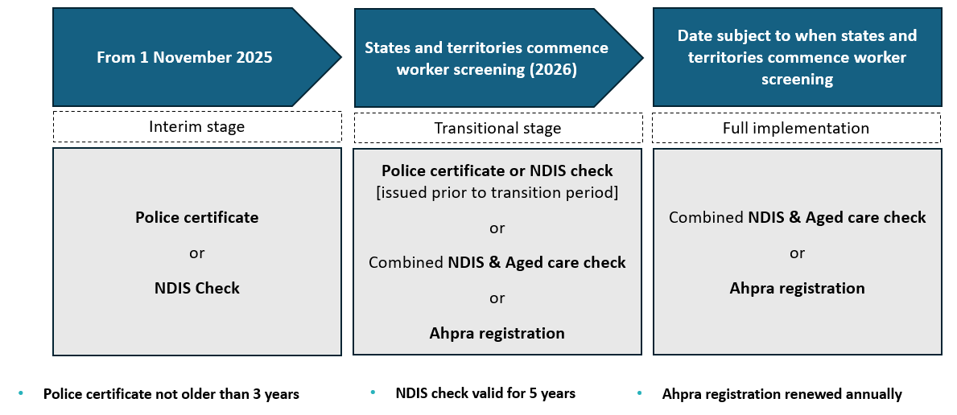

The process for an aged care worker screening check will be the same as [NDIS Worker Screening Checks](https://www.ndiscommission.gov.au/workforce/worker-screening).

Why the Government is making these changes

The new aged care worker screening check will consider more information than a police certificate, and will:

* create a national approach that better protects older people
* deliver consistent screening outcomes with skilled decision-makers doing the checks on disability and aged care workers
* allow the ongoing monitoring of workers
* make it easier for workers to move between employers in the disability and aged care sectors or work in both sectors
* make it easier for workers to work in a different state or territory
* make it easier to employ workers who have already been screened to work in aged care or disability
* make it easier to employ workers who are registered with Ahpra to work in aged care
* prevent unsuitable workers from providing care to older people.

Next steps

Registered providers do not need to prepare for the new aged care worker screening check yet. There will be transitional arrangements in place when the new process starts to manage workforce impacts. This will make sure:

* clear information is given to registered providers, workers and responsible persons on how to prepare for the aged care worker screening check
* new screening applications are processed efficiently.

When the future screening arrangements commence, there will be an ICT solution that will support registered providers to facilitate, record and manage worker screening checks for their aged care workers and responsible persons, and to assist in the regulation of the aged care sector.

We know registered providers need time to get ready. We are working with states and territories to plan for implementation. We will share information with registered providers as soon as we can.

Appendix 1 – Diagram to identify the required check for workers

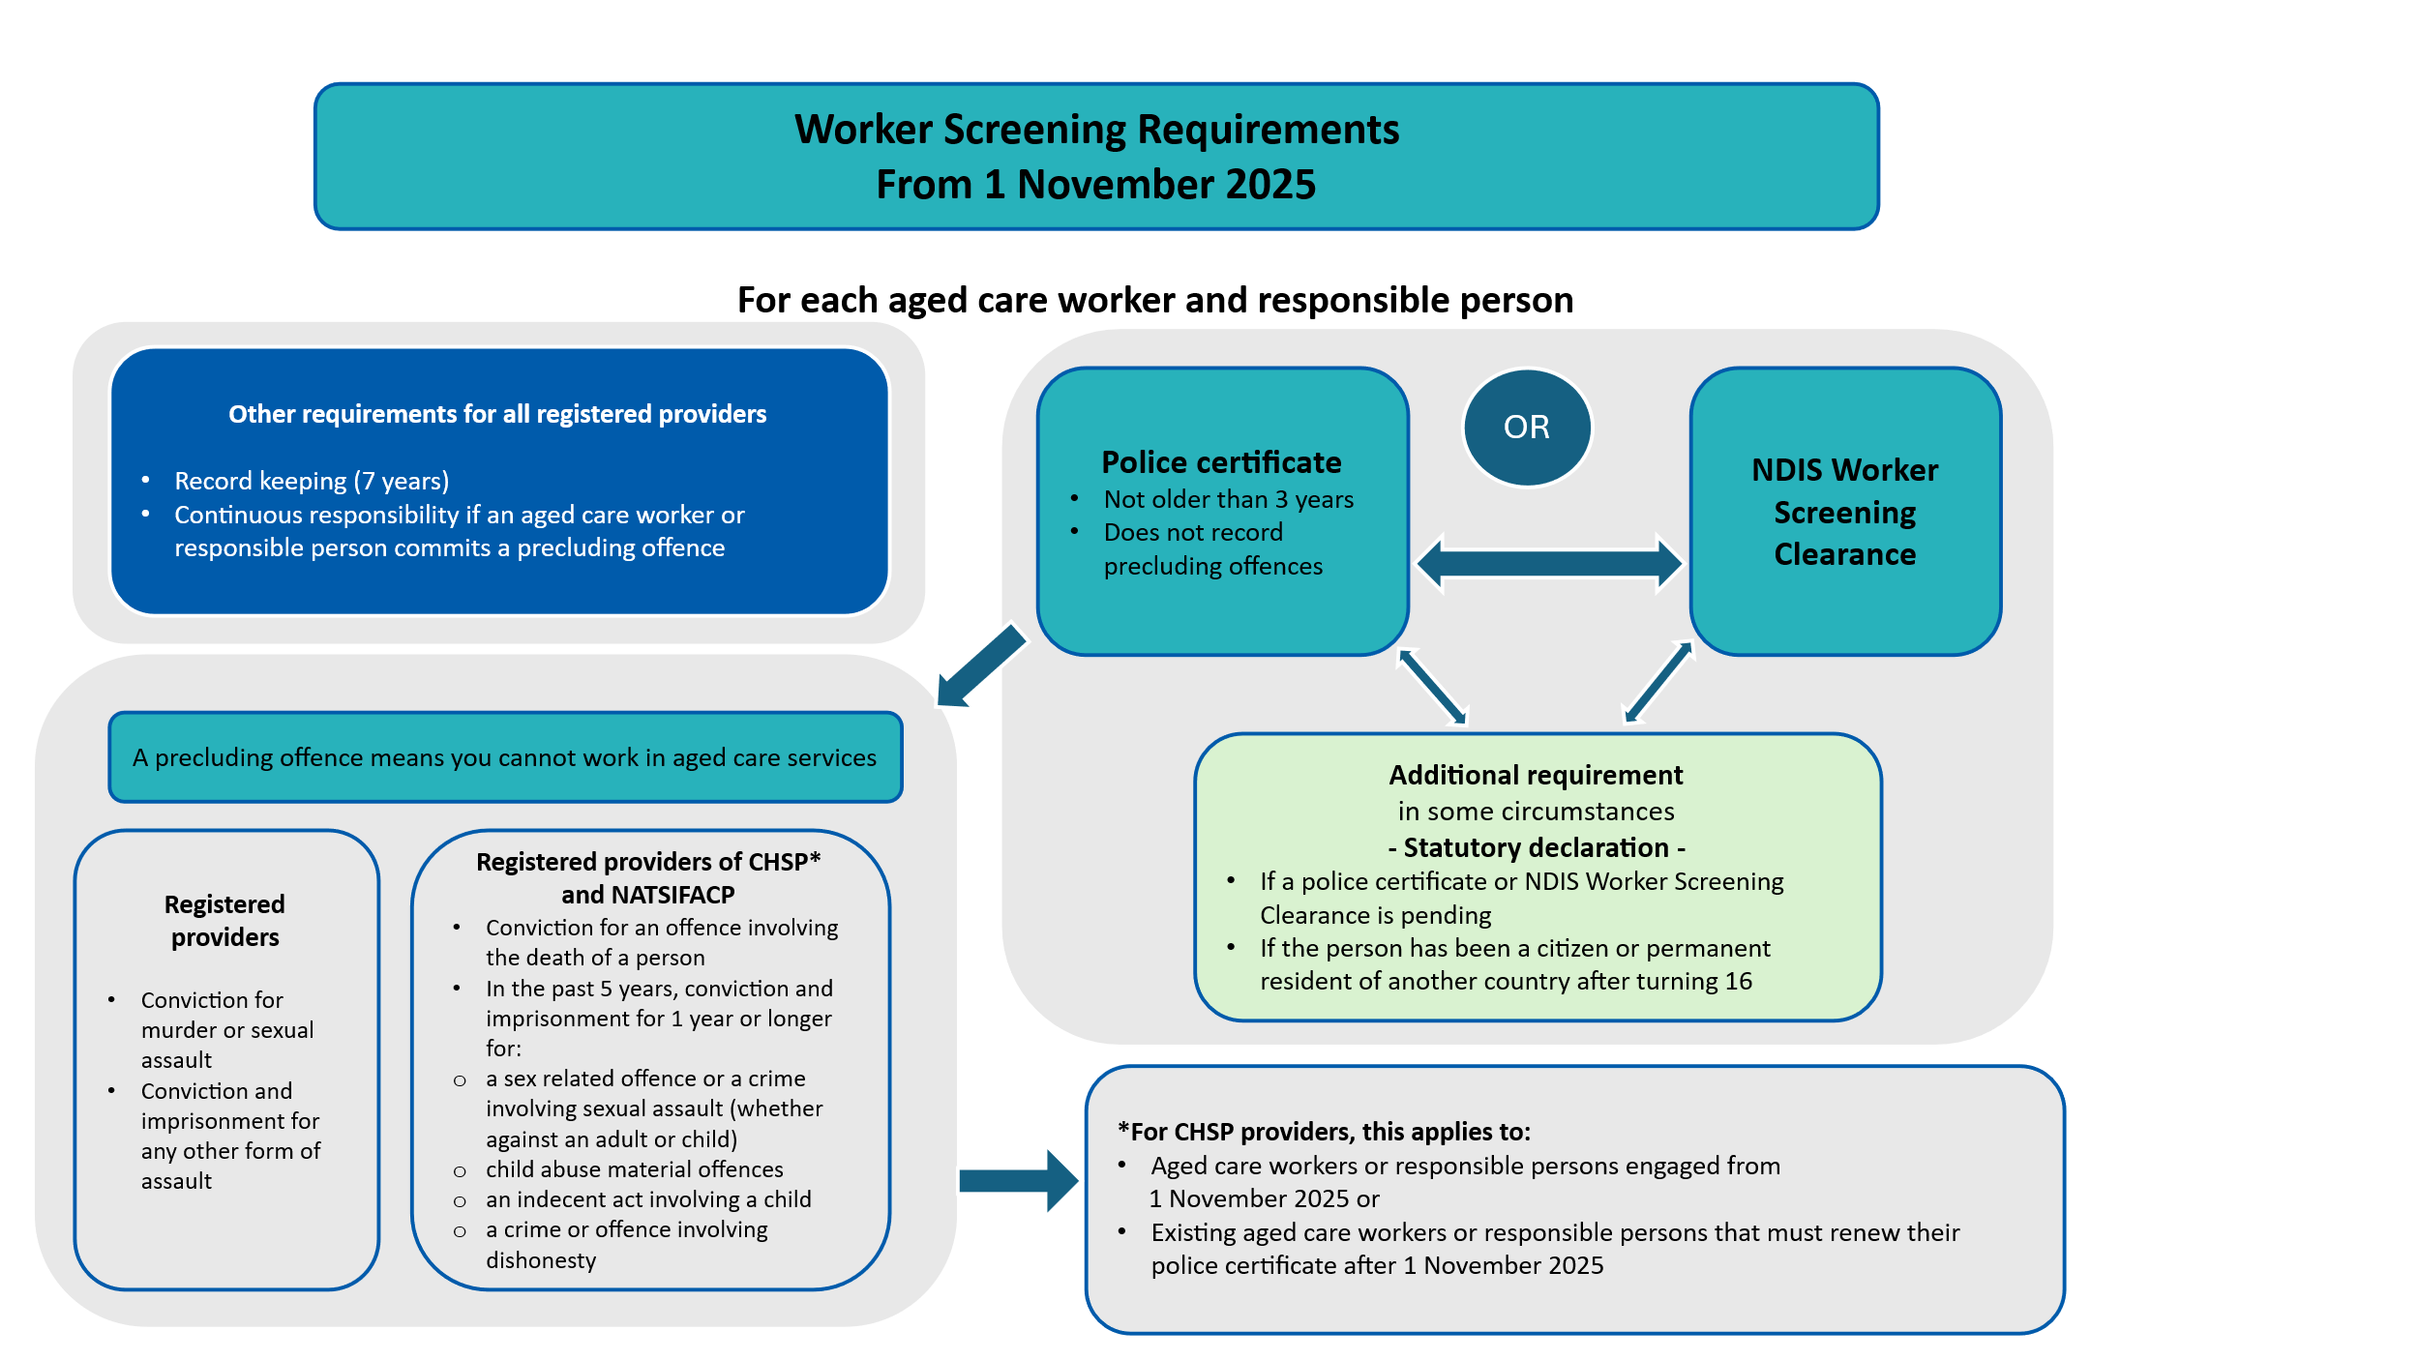

Appendix 2 – Sample police certificate/NDIS Worker Screening Clearance register

|  |  |  |  |  |  |  |  |  |
| --- | --- | --- | --- | --- | --- | --- | --- | --- |
| Name | Date of Birth | Address | Position | Police certificate reference number / NDIS Worker Screening ID | Date of issue | Date of expiry | Record or copy on file | Name of supervisor/manager reviewing Police certificate/NDIS worker screening ID and date of review |
|  |  |  |  |  |  |  |  |  |
|  |  |  |  |  |  |  |  |  |
|  |  |  |  |  |  |  |  |  |
|  |  |  |  |  |  |  |  |  |
|  |  |  |  |  |  |  |  |  |
|  |  |  |  |  |  |  |  |  |
|  |  |  |  |  |  |  |  |  |
|  |  |  |  |  |  |  |  |  |
|  |  |  |  |  |  |  |  |  |