# Building the next National Oral Health Plan

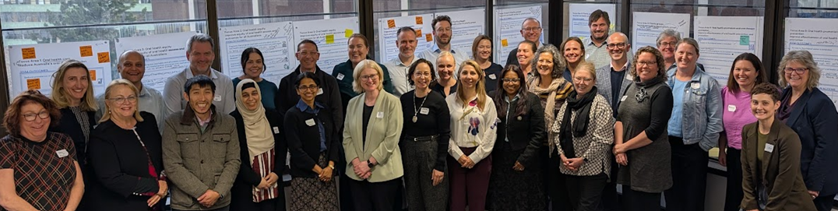

The Department of Health, Disability and Ageing has engaged [HealthConsult](https://www.healthconsult.com.au/) to provide expert analysis, and facilitate stakeholder engagement to build the evidence base for the next National Oral Health Plan 2025 to 2034 (the Plan.

[A two-day national co-design workshop](https://www.health.gov.au/news/developing-the-national-oral-health-plan-2025-2034) held in December 2024 helped shape the draft vision, principles and focus areas. On 30 June 2025, we reconvened 29 participants from 24 organisations including state and territory health departments, peak bodies, consumer groups, universities and specialist providers to help refine the key elements of the draft Plan.

In July 2025, two online workshops were held with 27 stakeholders from rural, remote and very remote communities. Participants included representatives from Aboriginal medical services, local dental providers, state and territory health departments, academic institutions, peak bodies, and advocacy organisations.

Throughout, stakeholders brought energy, practical experience, and a shared commitment to improving Australia’s oral health.

## Broader stakeholders’ insights

|  |
| --- |
| * Participants strongly supported “Better oral health” as the proposed vision. Participants noted that it was easy to remember, inclusive, and covered all aspects of oral health. |
| * Participants discussed and refined the principles underpinning the vision. There was consensus the following would be important: * A population health approach to oral health, emphasising prevention and promotion. * Person-centred, equitable oral health care across the lifespan * A sustainable oral health system * An oral health workforce for contemporary and future needs * Integrating oral health into general health * Optimising technologies and innovation for oral health. |
| * Participants supported **Focus Areas** that concentrated on important goals forthe next Plan and expressed strong support for the following **outcomes**: * Reduce prevalence of oral diseases * Reduce disparity of oral health access due to geographical location * An oral health workforce strategy that supports training, retention and distribution * Improve oral health literacy * Local jurisdictional and national leadership driving oral health reform * Oral health research and data compliance strategy. |
| * Participants emphasised the need for practical and implementable actions. There was a strong call for locally adaptable strategies, infrastructure investment, flexible workforce models, and accountability mechanisms to ensure change occurs on the ground. |
| * Participants recommended that the next Plan should use **Plain English and consistent terminology**, to improve accessibility for all audiences. They also recommended to include a broad range of stakeholders in its implementation such as private providers, health insurers, general health services, consumers, educators and researchers to drive a more coordinated and aligned oral health system. |

## Rural, remote and very remote stakeholders’ insights

|  |
| --- |
| * Participants agreed the current Plan has been successful in highlighting that people in rural and remote communities have different needs and the challenges faced in addressing those needs. Key challenges being funding, workforce and infrastructure. |
| * Participants consistently called for **flexible funding models** that incorporate **rural loadings** to reflect the true cost of service delivery, including activities that occur *before the chair*, such as care coordination, travel, and community engagement. Participants discussed the value of **public–private partnerships**, particularly in **thin markets** where neither sector alone can maintain viable services. |
| * Participants emphasised that access does not necessarily mean having every service available locally. Instead, they highlighted the importance of **well-supported referral pathways** and **regional centres**. Several noted the need for **data-driven planning** to guide the location and resourcing of these hubs. |
| * There was strong support for **embedding oral health within broader health strategies**, including primary care, aged care, maternal and child health, and chronic disease management. Participants highlighted oral health’s role in supporting **functional wellbeing, dignity, and quality of life**. |
| * Participants advocated for a system-wide **shift towards prevention**, rather than reactive treatment. Recommended strategies included: * Strengthening oral health literacy across the community * Investing in early outreach to children and families * Expanding community water fluoridation * Enabling non-dental health professionals to play a role in preventive care. |
| * Examples of **effective practices** shared during the workshops included student placement programs, mobile outreach, and ACCHO-led initiatives. Participants encouraged scaling up of these successful models, supported by: * Flexible commissioning arrangements * Collaborative design and governance * Long-term funding certainty to attract and retain workforce. |

## This is what we’re doing next

If you haven’t had a chance to contribute your insights and expertise, there will be more opportunities this month (August 2025):

* First Peoples Health Consulting will lead targeted consultations with First Nations stakeholders.
* A public survey will be released via the Department’s Consultation Hub to gather broader community feedback.

Share your thoughts or feedback

Send us an email to: [oral.health@health.gov.au](mailto:oral.health@health.gov.au)