First Nations Health Governance Group

# Terms of Reference

## Establishment

Established in 2024, the First Nations Health Governance Group (the Group) is a genuine partnership between the Department of Health and Aged Care and First Nations health experts and leaders. The group will be in place until 2031, aligning with the term of the National Aboriginal and Torres Strait Islander Health Plan 2021-2031 (Health Plan).

## Purpose

The Group seeks to co-design and share decision making to drive improvements including the three health Closing the Gap (CtG) targets, by embedding expert and First Nations perspectives in the department’s policy design, delivery and advice to government.

## Key areas of focus

The Group, supported by the department, will achieve their purpose through:

* + Co-design and shared decision-making on implementing the Health Plan and the National Aboriginal and Torres Strait Islander Health Workforce Strategic Framework and Implementation Plan 2021-2031 (Workforce Plan) in areas within the department’s remit
  + providing expert advice to drive the implementation of the Health Plan and the Workforce Plan in areas beyond the department’s remit
  + shared decision-making on action to embed the CtG Priority Reforms within the department
  + providing expert advice to the department and Australian Government health ministers on health priorities, decisions and progress such as the National Health Reform Agreement.
  + calling out systemic racism and identifying areas for reform to improve health outcomes for Aboriginal and Torres Strait Islander people, and
  + providing expert advice on the representation of regional and local voices in health policies and services.

## Membership

The Group is comprised of leaders of the First Nations health sector and four departmental representatives as follows.

Organisational based members include:

* + National Aboriginal Community Controlled Health Organisation (NACCHO)
  + National Indigenous Health Leadership Alliance (NIHLA)
  + National Aboriginal and Torres Strait Islander Ageing and Aged Care Council (NATSIAACC)
  + the department, represented by:
    - the Secretary,
    - Deputy Secretary of Health Strategy, First Nations and Sport Group,
    - Chief Operating Officer, and
    - First Assistant Secretary (FAS) of the First Nations Health Division (FNHD).

Skills-based members to provide expertise across the breadth of the department’s roles and responsibilities include the areas of:

* + Data
  + Research
  + Workforce
  + Mental health
  + Independent First Nations health expert/professional
  + Comprehensive primary health care
  + Hospitals
  + Ageing and aged care (represented organisationally by NATSIAACC)

Membership (names and membership capacity) of the group will be made available on the department’s website.

### Members’ responsibilities

Members are responsible for providing input, making decisions, supporting issue resolution and facilitating the effective operation of the Group. This includes:

* + representing the views and opinions of the organisations and/or their subject matter(s)
  + contributing evidence that supports the need for change and the solutions to drive action
  + attending and actively participating in meetings
  + ensuring meeting records accurately reflect discussions and decisions
  + advising the Secretariat when they have completed actions assigned by the group
  + raising conflicts of interest, real or perceived prior to each meeting with the co-chairs and Secretariat, and
  + notifying the Secretariat of any change in circumstances relevant to their membership.

### Skills-based membership appointments

Skills-based members will be appointed via an expression of interest. A selection panel consisting of the NACCHO and NIHLA members, and the FAS FNHD will assess and select the skills-based members.

Skills-based members will be appointed for a two-year term and may re-apply for their positions following their term. Expressions of interest for skills‑based member roles will be advertised following the two-year terms.

## Invited subject matter experts

Subject matter experts (SME) may be invited to attend meetings, as agreed by the co-chairs. SME will provide their expertise and participate in discussion. SME will not have full membership rights to vote on decisions.

SME may only attend a meeting when they have signed a Confidentiality, Conflict of Interest, Privacy and Secrecy Deed Poll form.

## Observers

In line with Priority Reform 2 (Building the Community Controlled Sector), to foster capacity and capability building within the Aboriginal and Torres Strait Islander community, a First Nations member may invite an additional Aboriginal and/or Torres Strait Islander leader and/or expert to observe the group’s meetings.

Observers may participate or contribute to discussions at the discretion of the respective member. Observers will not have full membership rights to vote on decisions.

Observers may only attend a meeting when they have signed a Confidentiality, Conflict of Interest, Privacy and Secrecy Deed Poll form.

## Proxies

In the event of a planned absence:

* + organisational members may delegate a proxy to represent their organisation (this proxy would have full membership rights for the meeting they attend as the proxy), and
  + skills-based members, who are selected for their individual expertise, may nominate an appropriately qualified observer-proxy to attend a meeting of the group, in an observer capacity (this proxy may participate or contribute to discussions, they will not have full membership rights to vote on decisions).

Members must notify the Secretariat in writing of their absence and proxy at least three days before a meeting and provide the full name and position of their proxy. Proxies must complete an Appointment of Proxy form and provide to the Secretariat within this timeframe.

Proxies may only attend a meeting when they have signed a Confidentiality, Conflict of Interest, Privacy and Secrecy Deed Poll form.

## Co-chairs of the Group

The Group will be co-chaired by a First Nations member and the department Secretary. The Group will agree to the First Nations co-chair and two deputy co-chairs at its first meeting as per Decision Making. The co-chairs may delegate to the deputy co-chairs as required.

Co-chairs, with support from the deputies, are responsible for:

* + ensuring the discussions and activities of the group are aligned to its purpose and deliver on its priorities
  + consulting with the members to agree the agenda, and
  + ensuring messages, communications and language are aligned to the group’s expectations.

## Quorum

Meetings may only be held when a quorum of members are present. A meeting will be considered quorate when the following minimum representation is achieved:

* + majority of sector members (being organisational representatives or skills-based members), or persons acting on behalf of members, and,
  + majority of departmental members, or persons acting on behalf of members.

Every reasonable effort will be made by the Secretariat, in consultation with the Co-Chairs, to schedule meetings to maximise availability and maintain balanced representation.

## Meetings

The Group will meet up to six times each year with a meeting held at least quarterly. Meetings will be held for up to 2 hours with at least one fully in-person meeting per year.

The Secretary will co-chair quarterly meetings with the Secretary’s deputy co-chairing other meetings. Other senior departmental representatives may attend meetings as required depending on topics determined by the Group when it sets its work plan.

A forward schedule of meetings will be developed, noting that flexibility may be required. The forward schedule may include yearly meetings with:

* + Australian Government Health Ministers (subject to agreement from the government of the day),
  + Secretaries (or their delegates) of other relevant Australian Government departments with responsibilities covering the social determinants of health, and
  + the department’s Closing the Gap Steering Committee.

The co-chairs may agree extraordinary meetings to consider urgent matters, as required.

## Decision Making

Decision-making through the setting of the group’s priorities will be by consensus, whereby all Group members agree on the proposed outcome. If consensus cannot be reached after reasonable effort, decisions will be made by a majority vote. Each Group member, including the co-chairs, will have one vote. In the event of a tied vote, the co-chairs will cast the deciding vote.

Decisions made by the Group will be documented in the meeting minutes. To support transparency, a meeting communique developed by the Secretariat will be published on the department’s website.

## Meeting minutes and public communique

After each meeting, the Secretariat will produce a draft meeting summary and communique and update the action items register. The Secretariat will circulate these items to members for review within two weeks of the meeting. If feedback is not received by the date nominated by the Secretariat, the Secretariat will assume the post-meeting items are endorsed and the communique will be placed on the department’s website.

## Out-of-Session

The co-chairs may authorise certain matters to be considered by the Group out-of-session. In such cases the Secretariat will circulate relevant material for members for review and action, or approval. Should decision making on out-of-session items be required, this will be done through majority vote. Members will provide their approval or vote via email to the Secretariat. The decision will then be ratified at the Groups’ next scheduled meeting.

## Terminating appointments

Termination of a member’s appointment will be a decision of the co-chairs and the member.

## Secretariat

Secretariat services will be provided by the department’s First Nations Health Division. The Secretariat can be contacted via [FirstNationsGovernance@health.gov.au](mailto:FirstNationsGovernance@health.gov.au).

The Secretariat will distribute meeting agendas and papers at least three business days prior to the meeting, or at the discretion of the co-chairs. Changes to the agenda will be accepted up to five days prior to the circulation of the agenda. There is a standing invitation for members to nominate meeting agenda items to the Secretariat at any time.

## Deliverables and timeframes

Deliverables and timeframes for the Group’s actions, and any associated changes, will be agreed by members.

## Reporting and evaluation mechanisms

The group will undertake an internal review of its composition and activities 12 months after its establishment.

The Health Plan’s scheduled independent evaluations in 2026 and 2031 will include an evaluation of the group.

The group will be embedded within existing health governance structures to provide authority and pathways for its decisions and advice to be actioned as shown in Figure 1.

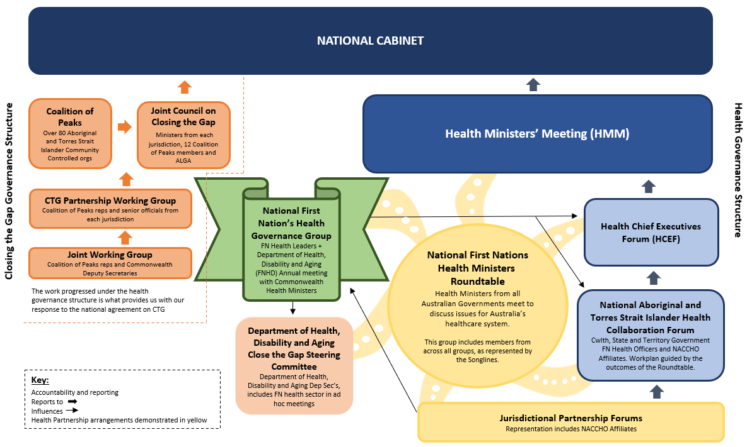

Figure : First Nations health governance structures.

## Remuneration and travel arrangements

Eligibility for remuneration is stipulated under the Departmental Remuneration Framework for Members of Non-Statutory Committees (Remuneration Framework), which is benchmarked off the Remuneration Tribunal Determination.

Individual skills-based members will be eligible for remuneration at rates under the Health Professional tier under the Remuneration Framework. Members are eligible for Sitting fees on official meeting days and Preparation Fees for time spent on business on non-meeting days. Co-chairs will be responsible for certifying and notifying the Secretariat of the total time claimed by an office holder, including any travel time.

Organisational based members acting as representatives of their organisations and provide policy advice as part of agreements with the department, are not eligible for remuneration under the Remuneration Framework.

Proxies, SME, and observers are not classified as members under the Remuneration Framework and will not be eligible for remuneration.

In accordance with the Remuneration Tribunal (Official Travel) Determination for part-time office holders, remunerated members will be eligible for expenses for travelling within Australia through economy class (Tier 3), accommodation and meal and travel allowances. Proxies, subject matter experts, and observers will not be eligible for travel expenses.

Travel and accommodation will be booked by the Secretariat in accordance with the Whole of Government policies.

## Media contact

All contact with the media requires consultation with the co-chairs and Secretariat. Any information to be publicly released from or about the group must be cleared through the department’s Communications Branch.

## Probity

Probity is the evidence of ethical behaviour, and can be defined as complete and confirmed integrity, uprightness and honesty in a particular process. All members, proxies, SME and observers must act ethically when undertaking business of the Group.

## Conflict of interest

All members, proxies, SME, and observers have a responsibility to raise conflicts of interest, real or perceived, prior to each meeting. This must be confirmed via email to the Secretariat prior to the meeting and raised in the meeting’s standing item. Matters will be openly discussed at the respective group meeting. Where a conflict of interest is identified, appropriate handling will be determined jointly by the co-chairs and other members and recorded in the minutes.

## Confidentiality

All members, and where relevant proxies, SME and observers (as determined by the co-chairs, informed by the relevant meeting agenda) will be required to sign a confidentiality agreement before their first Group meeting.

Members may, on occasion, be provided with confidential material. Members are not to disclose this material to anyone outside the group and are to treat this material with the utmost care and discretion and in accordance with terms of their confidentiality agreement.

All deliberations, decisions and activities of the Group are confidential unless expressly stated by the co-chairs.

Members and attendees acknowledge their responsibility to maintain confidentiality of all information that is not in the public domain. Where relevant, additional confidentiality agreements may be required to ensure due diligence and protection of sensitive information.