New Aged Care Act

**Stakeholder toolkit to support communications with older people**

**August 2025**

This toolkit provides information and materials to help peak bodies, advocacy organisations and community groups inform older people, their families and carers about the new Aged Care Act (the new Act). It includes a supporting infographic and animation that illustrates how the different parts of the new Act fit together.

About this toolkit

This toolkit supports your communications on the new Act. It includes a new infographic and animation, which illustrate how the different parts of the new Act fit together.

We encourage you to use both the infographic and the animation in your communications to help explain what the aged care changes will mean for older people, their families and carers.

You can use the infographic and the animation in presentations, websites, printed materials (e.g. booklets, newsletters) and social media.

What’s in this toolkit

* Information about the infographic
* Key messages
* Discussion guide
* Editorial content
* Social media posts

Audiences

* Older people, their families and carers

Call to action

* We recommend using the following calls to action in your communication materials:
  + [Download the infographic](https://www.health.gov.au/resources/publications/the-new-aged-care-act-puts-older-people-at-the-centre-of-aged-care) and [watch the animation](https://www.health.gov.au/resources/videos/new-aged-care-act?language=en) to see how the different parts of the new Act fit together.
  + Learn more about the [new Act](https://www.health.gov.au/our-work/aged-care-act) and [what it means for you](https://www.health.gov.au/our-work/aged-care-act/about/what-it-means) on the Department of Health, Disability and Ageing’s website.
  + Visit the [My Aged Care](https://www.myagedcare.gov.au/improving-australias-aged-care-system) website to understand how Australia’s aged care system is improving.
  + [Explore the resources, training and guidance materials](https://www.health.gov.au/our-work/aged-care-act/resources/older-people) to help you understand what, and how, changes will impact you under the new Act.

Hashtags

* #AgedCare
* #AgedCareAct
* #AgedCareReforms

About the infographic and animation

* The infographic and the animation offer a simple and accessible way to explain the new Act to older people who access aged care services.
* It is designed to help older people, their families, and carers understand how the new Act brings together a range of key improvements to Australia’s aged care system, including:
  + enhanced rights and protections for older people
  + stronger rules and regulations for providers
  + higher quality care
  + easier access and entry to aged care services
  + greater choice and transparency
  + a stronger workforce.
* The animation is available in a number of different languages – Arabic, Auslan, English, Greek, Italian, Simplified Chinese, Traditional Chinese, Vietnamese.
* The infographic and animation depict a house to represent a safe, structured and supportive aged care system.
* Like a home, the new Act provides protection, security and a strong foundation.

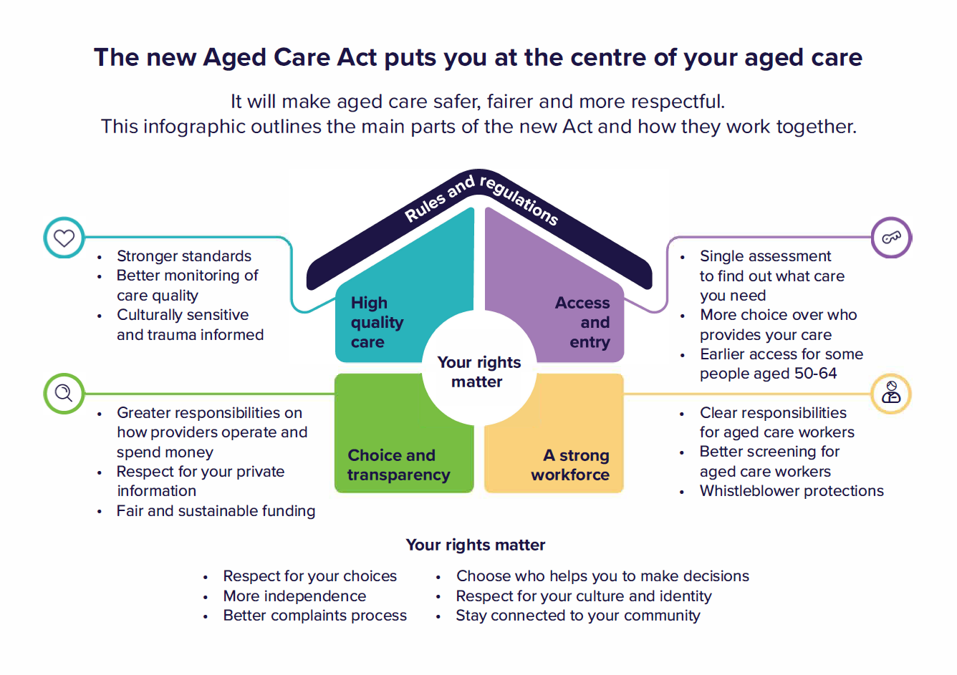

Key messages

* From 1 November 2025, the new Act will ensure you are at the centre of your aged care. It will make the system safer, fairer and more respectful.
* Some of the key changes include:
  + enhanced rights and protections
  + stronger rules and regulations for providers
  + higher quality care and better monitoring of care quality
  + easier access and entry to aged care services
  + greater choice and transparency
  + a stronger workforce.
* You will have the right to make your own decisions about your own life. You will have a greater say and a more independent voice about the care and services you receive. This includes support to speak up when you are not satisfied and better equipping providers to manage complaints effectively.
* All aged care programs will operate under a similar registration model with the same obligations to deliver services that place you at the centre of your aged care.
* Stronger care standards and better monitoring of providers will make aged care safer. This will also ensure services acknowledge and respond to the rights of all older people accessing aged care, including Aboriginal and Torres Strait Islander people and people from culturally and linguistically diverse (CALD) backgrounds.
* A simpler and fairer entry process will allow you to choose what services you want and who provides it.
* Providers will be more accountable, with clearer rules on how they operate, spend money and protect your personal information. This will equip you with the information you need to make an informed choice about your aged care.
* Workers will have clearer job responsibilities under the new Act, including more robust screening requirements to work in aged care. Whistleblowers will also be protected under the new laws so people can raise concerns without fear.

Discussion guide

Guidance

This discussion guide can be used to guide conversations with older people, their families and carers about the changes under the new Act.

Why is there a new Act?

* The new Act directly responds to recommendations 1 to 3 of the Royal Commission into Aged Care Quality and Safety. In total, the new Act addresses or partially addresses 58 recommendations.
* The Royal Commission found the existing *Aged Care Act 1997* is no longer fit for purpose. It does not adequately consider the rights and needs of older people in the delivery of aged care services.
* The new Act will ensure older people are at the centre of aged care. It will make the system safer, fairer and more respectful.

When do the changes start?

* The Australian Government recently announced that the start of the new Act, and the new Support at Home program, would be briefly deferred to 1 November 2025.
* Implementation of the new programs under the Act will take a staggered approach. For example, the new Support at Home program and the new regulatory model will launch from 1 November 2025, while the worker screening model depends on separate laws being passed at the state and territory level before it can be implemented in 2026.
* Existing rights and obligations under current laws and policies will continue to apply until the new Act starts.
* The government established a Transition Taskforce which has been working in partnership with providers, workers and the broader sector in the lead up to 1 November 2025 and beyond. This is to make sure we are all ready to make the necessary changes to how we deliver aged care services for the better.

Why was the start date for the new Act delayed?

* While some providers were ready for the new Act to start on 1 July 2025, others indicated they needed more time to prepare.
* The deferral to 1 November 2025 ensures:
  + older people accessing care are prepared
  + provider operations and systems are ready
  + workers are trained and supported.
* Until the new Act starts, the way you receive care and services will not change.
* A [frequently asked questions (FAQs) document](https://www.health.gov.au/resources/publications/new-aged-care-act-start-update-frequently-asked-questions) is available on the department’s website which further explain what the deferred start date means for you.

What rights do older people have under the new Act?

* The new Act introduces a Statement of Rights to put older people first. It explains what rights older people have when accessing aged care services funded by the Australian Government.
* It gives older people the right to:
  + make their own decisions about their own life
  + have their decisions not just accepted, but respected
  + get information and support to help them make decisions
  + communicate their wishes, needs and preferences
  + feel safe and respected
  + have their culture and identity respected
  + stay connected with their community.
* A summary of the Statement of Rights is available on the department’s website in [plain language](https://www.health.gov.au/resources/publications/a-new-aged-care-act-for-the-rights-of-older-people?language=en) and [Easy Read](https://www.health.gov.au/resources/publications/a-new-aged-care-act-for-the-rights-of-older-people-easy-read-fact-sheet?language=en) format.

How can older people make a complaint about their aged care?

* Under the Act, you will be more empowered to raise concerns or make a complaint without fear of punishment.
* This will apply if you think:
  + your rights have not been met
  + someone has broken the law
  + you are worried about the quality of care you receive.
* Feedback is an important way for providers to understand what is working well and to identify areas that can be improved.
* You can make a complaint to your aged care provider, worker or responsible person of an aged care provider, such as a CEO or Board Member.
* If you do not feel comfortable raising a complaint with your provider or are not satisfied with the outcome, you can make a complaint to:
  + the [Complaints Commissioner](https://www.agedcarequality.gov.au/making-complaint/lodge-complaint) (who is independent from the regulatory functions of the Aged Care Quality and Safety Commission)
    - email [info@agedcarequality.gov.au](mailto:info@agedcarequality.gov.au)
    - call 1800 951 822 for general complaints
    - call 1800 844 044 for food, nutrition and dining related complaints
  + a staff member of the Aged Care Quality and Safety Commission
  + the Department of Health, Disability and Ageing
  + a police officer
  + an advocate.
* The Government funds the [Older Persons Advocacy Network (OPAN)](https://opan.org.au/) to deliver the National Aged Care Advocacy Program (NACAP). The program provides free, confidential, and independent information and support to older people seeking or receiving government-funded aged care as well as their families of choice and other people who support them.
* If you need support to make a complaint or find out more information, you can speak to an aged care advocate by calling the Aged Care Advocacy Line on 1800 700 600.

Who can access aged care services under the new Act?

* From 1 November 2025, to be eligible for an aged care needs assessment you must be:
  + 65 years and over
  + 50 years and over if you are Aboriginal or Torres Strait Islander
  + 50 years and over if homeless or at risk of homelessness.
* If you are a younger person already in the system, you can continue receiving care under the new Act.
* If you are seeking government-funded aged care services, you must have an aged care needs assessment to determine your care needs and the services you are eligible for.
* If you already receiving aged care services on 1 November 2025, you will not need to be reassessed to continue to receive those services.
* If your circumstances change significantly after 1 November 2025, you may need to be reassessed to ensure your aged care needs are being met.

How do eligible people get assessed for services under the new Act?

* Once eligible, the first step to accessing aged care services is registering with [My Aged Care](https://www.myagedcare.gov.au/) and applying for an assessment.
* The [Single Assessment System](https://www.health.gov.au/our-work/single-assessment-system) is making it simpler and fairer for older people to access aged care services. It provides one streamlined process for assessing eligibility for all government-funded aged care services.
* The new system is also:
  + helping to reduce wait times to access an aged care needs assessment
  + ensuring assessments adapt to changing needs
  + improving access in regional, rural, and remote areas.
* As part of this, new [Aboriginal and Torres Strait Islander assessment organisations](https://www.health.gov.au/our-work/single-assessment-system/needs/first-nations-aged-care-assessments) are being rolled out in a phased approach from July 2025 to provide more culturally safe pathways for older Aboriginal and Torres Strait Islander people.

Is cultural safety part of the new Act?

* The new Act recognises that people accessing aged care have the right to culturally safe care, including Aboriginal and Torres Strait Islander people and those from culturally and linguistically diverse backgrounds.
* This means care that is trauma aware, healing informed and respectful of culture, spirituality and identity.
* The new Act also supports the right to stay connected to community, Country and Island Home. This is essential to the wellbeing of many Aboriginal and Torres Strait Islander people.
* The new system will make sure these rights are part of both the delivery of, and assessment for, aged care services, making sure care is delivered in a way that is respectful, safe, and meaningful.
* A fact sheet on culturally safe care for Aboriginal and Torres Strait Islander people under the new Act is available on the [department’s website](https://www.health.gov.au/resources/publications/the-new-aged-care-act-culturally-safe-care-for-older-aboriginal-torres-strait-islander-people-fact-sheet).

Editorial content

Guidance

This suggested content can be used on your website or in an email, printed newsletter or e-newsletter.

Editorial

**New Aged Care Act**

From 1 November this year, the new Aged Care Act will ensure you have greater rights and more choice when accessing aged care services.

The new Act improves key areas of the new aged care system, including:

* putting your rights at the centre of your aged care
* strong rules and regulation to ensure safety, quality and fairness
* quality care through higher standards and cultural safety
* more choice and transparency for you, your family and carers
* simple access and entry into the aged care system
* a strong workforce with clear responsibilities.

What it means for you

The new Act will give you a stronger, more independent voice. This will empower you to make informed decisions about the care and services you receive, and have those decisions not just accepted but respected.

With clearer protections in place, you will have a safer way to speak up if you are not satisfied with your care. Providers will also be better equipped and supported to handle complaints and feedback effectively.

To help you understand these changes and how they come together under the new Act, a supporting [infographic](https://www.health.gov.au/resources/publications/the-new-aged-care-act-puts-older-people-at-the-centre-of-aged-care) is now available. An [animated version](https://www.health.gov.au/resources/videos/new-aged-care-act?language=en) is available in a variety of languages, as well as in [Auslan](https://www.health.gov.au/resources/videos/new-aged-care-act-auslan?language=en).

To stay up to date on the aged care changes, [subscribe to EngAged](https://comms.agedcareupdates.net.au/link/id/zzzz6362ab6557522561P/page.html?prompt=1&parent_id=zzzz636275cf98f68511), the Department of Health, Disability and Ageing’s newsletter for older people.

Visit the [My Aged Care](https://www.myagedcare.gov.au/improving-australias-aged-care-system) website to understand how Australia’s aged care system is improving.

Social media posts

Guidance

Below are suggested posts for your social media channels.

| Channel | Copy | Social media tile |
| --- | --- | --- |

|  |  |  |
| --- | --- | --- |
| Facebook | The new Aged Care Act starts from 1 November this year, putting older people’s rights at the centre of aged care.  Here is what’s changing:  ✅ rules and regulation  ✅ quality care  ✅ easier access and entry to aged care services  ✅ more choice & transparency  ✅ a stronger workforce  ✅ rights and protections to give older people more independence.  The new aged care system will be stronger, safer and fairer for you.  To check out the new resources which explain how the new Act comes together, see the comments below.  **First comment:**  Explore the infographic 👉 [www.health.gov.au/resources/publications/the-new-aged-care-act-puts-older-people-at-the-centre-of-aged-care](http://www.health.gov.au/resources/publications/the-new-aged-care-act-puts-older-people-at-the-centre-of-aged-care)  **Second comment:**  Watch the animation in a variety of languages 👉 <https://www.health.gov.au/resources/videos/new-aged-care-act?language=en>  **Third comment:**  Watch the animation in Auslan 👉 <https://www.health.gov.au/resources/videos/new-aged-care-act-auslan?language=en> | Social media tile which illustrates how the different parts of the new Aged Care Act come together to put the rights of older people at the centre of aged care. It uses the metaphor of a house to explain these concepts. |
| X (Twitter) | From 1 November 2025, the new Aged Care Act will ensure older people’s rights are at the centre of aged care.  A supporting infographic and animation is now available to help you understand the new aged care system.  Download the infographic 👉 [www.health.gov.au/resources/publications/the-new-aged-care-act-puts-older-people-at-the-centre-of-aged-care](http://www.health.gov.au/resources/publications/the-new-aged-care-act-puts-older-people-at-the-centre-of-aged-care)  Watch the animation 👉 <https://www.health.gov.au/resources/videos/new-aged-care-act?language=en> | Social media tile which illustrates how the different parts of the new Aged Care Act come together to put the rights of older people at the centre of aged care. It uses the metaphor of a house to explain these concepts. |
| Instagram | Do you know an older person or care for one?  From 1 November this year, a new Aged Care Act will put older people at the centre of a stronger, safer and fairer aged care system.  To help you understand the changes, there’s a new infographic and animation to show you how the different parts of the Act fit together.  Click New Aged Care Act in our bio to learn more and explore the infographic and animation.  **Links for bio:**  [www.health.gov.au/resources/publications/the-new-aged-care-act-puts-older-people-at-the-centre-of-aged-care](http://www.health.gov.au/resources/publications/the-new-aged-care-act-puts-older-people-at-the-centre-of-aged-care)  <https://www.health.gov.au/resources/videos/new-aged-care-act?language=en>  <https://www.health.gov.au/resources/videos/new-aged-care-act-auslan?language=en> | Social media tile which illustrates how the different parts of the new Aged Care Act come together to put the rights of older people at the centre of aged care. It uses the metaphor of a house to explain these concepts. |
| LinkedIn | The new Aged Care Act starts from 1 November, putting older people’s rights at the centre of aged care.  Here is what’s changing:  ✅ rules and regulation  ✅ high quality care  ✅ easier access and entry to aged care services  ✅ more choice & transparency  ✅ a stronger workforce  ✅ rights and protections to give older people more independence.  The new aged care system will be stronger, safer and fairer.  To check out the new resources which explain how the new Act comes together, see the comments below.  **First comment:**  Explore the infographic 👉 [www.health.gov.au/resources/publications/the-new-aged-care-act-puts-older-people-at-the-centre-of-aged-care](http://www.health.gov.au/resources/publications/the-new-aged-care-act-puts-older-people-at-the-centre-of-aged-care)  **Second comment:**  Watch the animation in a variety of languages 👉 <https://www.health.gov.au/resources/videos/new-aged-care-act?language=en>.  **Third comment:**  Watch the animation in Auslan 👉 <https://www.health.gov.au/resources/videos/new-aged-care-act-auslan?language=en> | Social media tile which illustrates how the different parts of the new Aged Care Act come together to put the rights of older people at the centre of aged care. It uses the metaphor of a house to explain these concepts. |