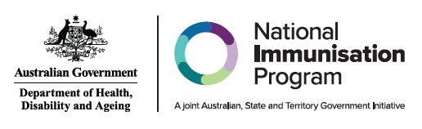

| Administration of RSV vaccines and RSV monoclonal antibodies by age group or cohort | | | | |
| --- | --- | --- | --- | --- |
| **Age group or cohort** | **RSV vaccines for adults** | | **RSV monoclonal antibodies for Infants** | |
| Abrysvo® 0.5ml (Pfizer) | Arexvy® 0.5 mL (GSK) | Beyfortus™ (Nirsevimab) 0.5 mL (Purple) (Sanofi) | Beyfortus™ (Nirsevimab) 1 mL (Blue) (Sanofi) |
| Pregnant women at 28 to 36 weeks | **NIP FUNDED** | **DO NOT USE** | **DO NOT USE** | **DO NOT USE** |
| Infants & children <24 months | **DO NOT USE** | **DO NOT USE** | **STATE & TERRITORY**  **FUNDED** | **STATE & TERRITORY**  **FUNDED** |
| People aged ≥50 years with medical risk factors | **DO NOT USE** | **AVAILABLE PRIVATELY BASED ON CLINICAL DECISION\*** | **DO NOT USE** | **DO NOT USE** |
| All people aged ≥60 years (including Aboriginal and Torres Strait Islander people) | **AVAILABLE PRIVATELY BASED ON CLINICAL DECISION** | AVAILABLE PRIVATELY BASED ON CLINICAL DECISION* | **DO NOT USE** | **DO NOT USE** |

**Note**: **NIP FUNDED** indicates vaccine is NIP funded. DO NOT USE indicates that the vaccine is NOT recommended to be used by that age group. **STATE & TERRITORY FUNDED** indicates that it is funded under a state and territory Immunisation program. *Funded under some state and territory programs. For state and territory eligibility, refer to the state or territory’s immunisation schedule. **AVAILABLE PRIVATELY** indicates this product is only available through private prescription and is not subsidised under the NIP. For further information including dosage and administration, refer to the Australian Immunisation Handbook chapter – [Respiratory syncytial virus (RSV)](https://immunisationhandbook.health.gov.au/contents/vaccine-preventable-diseases/respiratory-syncytial-virus-rsv)

This information is current as of August 2025