Acknowledgements

We gratefully acknowledge the contributions of the many stakeholders who shared their time, insights, and expertise through surveys and interviews as part of this Review. Their input has been invaluable in shaping our findings.

We sincerely thank the members of the Dementia, Ageing and Aged Care Mission Review Panel for their expert advice and considered feedback throughout the Review: Professor Glenda Halliday AC, Ms Imelda Lynch, Ms Bobby Redman, Professor Linda Deravin, Professor Carol Brayne CBE, and Mr Tom Symondson.

We acknowledge with appreciation the guidance and support provided by officials from the Health and Medical Research Office (Performance and Evaluation Section and the Missions Strategy and Implementation Section), whose leadership and collaboration have been central to the delivery of this Review.

We acknowledge the contribution of the Science Unit, Health and Medical Research Office, for providing the desktop scan.

MHC: MH Consulting Group

|  |
| --- |
| The MH Consulting Group (MHC) Review team members are Professor Mary Haines, Dr Antonio Penna, Professor Julie Byles AO, Professor Sanchia Aranda AM, Mr Ryan Romero, Dr Bea Brown, and Ms Cindy Peng.  MHC is a boutique consultancy, established in 2015, specialising in research strategy and program reviews. We bridge research, policy, and practice, working across all areas of public policy. Our clients span sectors including health, research, education, human services, and transport. Learn more at [www.mhcgroup.com.au](http://www.mhcgroup.com.au). |

Disclaimer:

*MH Consulting Group (MHC) has prepared this report for the benefit of the Health and Medical Research Office, Department of Health, Disability and Ageing (the* ***Client****).*

*The report should not be used or relied upon for any purpose other than as an expression of the conclusions and recommendations of MHC to the Client as to the matters within the scope of the report. MHC and associates expressly disclaim any liability to any person other than the Client who relies or purports to rely on the report for any other purpose.*

*MHC has prepared the report with care and diligence. The conclusions and recommendations given by MHC in the report are given in good faith and in the reasonable belief that they are correct and not misleading. The report has been prepared by MHC based on information provided by the Client and by other persons. MHC has relied on that information and has not independently verified or audited that information.*

Table of Contents

Glossary and acronyms 10

1. Executive Summary 16

1.1 Background 16

1.2 Review questions, methods and scope 17

1.3 Summary of Review findings 18

1.4 Opportunities for improvement 19

2. Background 22

2.1 Background to the Medical Research Future Fund (MRFF) 22

2.2 Background to Dementia, Ageing and Aged Care Mission 25

2.3 Background to the Review 28

3. Methodology 33

3.1 Data sources 33

3.2 Data analysis 45

3.3 Structure of Review findings 46

4. Positioning of MRFF-funded DAAC research within the national and international landscape 47

4.1 Summary of findings and improvement opportunities 48

4.2 MRFF funding of DAAC research in the context of the national and international landscape 50

4.3 Positioning of MRFF DAAC priority areas relative to national and international research funders 54

4.4 MRFF positioning in partnerships, workforce and commercialisation pathways for DAAC research 56

4.5 Positioning of MRFF-funded DAAC research on consumer and health service engagement 59

4.6 Australia’s research strengths in DAAC research 62

5. Contribution of MRFF-funded research into DAAC 64

5.1 Summary of findings and improvement opportunities 65

5.2 How the MRFF has funded DAAC: Funding trends 68

5.3 Funding distribution and strategic alignment of MRFF-funded DAAC research 75

5.4 Who contributed to and participated in MRFF DAAC investments 92

6. Progress and impact of MRFF-funded DAAC research 107

6.1 Summary of findings and improvement opportunities 108

6.2 Project completion stage of funded projects 109

6.3 Progress towards Mission benchmarks (evaluation measures) 110

6.4 Progress towards MRFF benchmarks (measures of success) 117

7. Key strategic themes and opportunities for the MRFF and Mission 152

7.1 What research is conducted – strengthening Mission aims and priorities 153

7.2 How research is funded – enhancing funding and granting arrangements 157

7.3 How research is conducted – improving research end-user involvement 164

7.4 How research is used – increasing translation and impact 166

8.2 Summary of strategic improvement opportunities 167

Appendices 171

Appendix 1. Projects in scope for the Review 171

Appendix 2. Profile of the Mission Review Expert Panel 180

Appendix 3. Grantee survey 181

Appendix 4a. Stakeholder survey (national) 195

Appendix 4b. Stakeholder survey (international) 204

Appendix 5. Stakeholder interview sample 210

Appendix 6. Stakeholder interview topics 215

Appendix 7. Overview of grant opportunities and reports in-scope for this Review 218

Appendix 8. Examples of innovative research funding models 226

List of Figures

Figure 1. Data sources informing the Review with participation numbers 16

Figure 2. MRFF monitoring, evaluation and learning conceptual framework, updated 2024 21

Figure 3. Program logic model for monitoring and evaluation of the MRFF, highlighting the MRFF performance indicators 22

Figure 4. Projects in scope: MRFF projects funded from MRFF inception to 20 August 2024 related to dementia ageing and aged care 28

Figure 5. Survey response rates by Mission status, jurisdiction, and organisation type 34

Figure 6. Survey response rates by stakeholder category 36

Figure 7. Summary of stakeholder interviews: Participants, engagement, and representation 38

Figure 8. Investment in DAAC-related research 2018–2024, by national and international funding bodies 50

Figure 9. Amount of investment and number of grants for DAAC research through Mission and non-Mission initiatives, based on data current to 20 August 2024 65

Figure 10. MRFF funding for DAAC research through Mission and non-Mission initiatives, and total MRFF by year, based on data current to 20 August 2024 66

Figure 11. MRFF funding in DAAC research by states and territories, showing breakdown by Mission and non-Mission initiatives, based on data current to 20 August 2024 69

Figure 12. MRFF investment in DAAC research by type of research organisation, based on data current to 20 August 2024 70

Figure 13. Distribution of Mission and non-Mission research funding across MRFF grant models and initiatives, based on data current to 20 August 2024 71

Figure 14. Mission investment across research areas, based on data current to 20 August 2024 73

Figure 15. Research project alignment with research areas as reported by project CIA 73

Figure 16. Percentage of Mission funding mapped to Mission aims and priorities, based on data current to 20 August 2024 75

Figure 17. Self-reported primary focus of MRFF-funded DAAC studies, by Mission and non-Mission 78

Figure 18. Self-reported primary and secondary focus of MRFF-funded DAAC studies, across all grants in scope 79

Figure 19. Placement of MRFF-funded research in DAAC along the research translation pipeline 83

Figure 20. Alignment of MRFF-funded DAAC research with WHO Healthy Ageing Framework action areas 85

Figure 21. What roles Aboriginal and/or Torres Strait Islander researchers have had in MRFF-funded dementia, ageing and aged care research? 86

Figure 22. Which Mission priority populations have been involved in MRFF-funded DAAC research? 90

Figure 23. What research end-users have been involved in MRFF-funded DAAC research? 92

Figure 24. What roles have research end-users had in MRFF-funded DAAC research? 93

Figure 25. Number of consumers involved in MRFF-funded DAAC research projects 94

Figure 26. Stage of completion of MRFF-funded DAAC research projects 101

Figure 27. Number of projects addressing each of the eight Mission benchmarks (B1-B8) 103

Figure 28. Overall (Mission and non-Mission) project progress against Mission benchmarks 105

Figure 29. Mission project progress against Mission benchmarks 105

Figure 30. Non-Mission project progress against Mission benchmarks 106

Figure 31. Progress towards an increased focus of research on areas of unmet need 111

Figure 32. Progress towards more Australian’s accessing clinical trials 117

Figure 33. Progress towards new health technologies and interventions are embedded in health policy and practice 122

Figure 34. Progress towards the research community having greater capacity and capability to undertake translational research 128

Figure 35. Progress towards health professionals adopting best practices faster 130

Figure 36. Progress towards the benchmark: community engages with and adopts new technologies, treatments and interventions 134

Figure 37. Progress towards increased commercialisation of health research outcomes 138

List of Tables

Table 1. Key findings of the Review against the Review questions 17

Table 2. Strategic opportunities for the department to enhance MRFF-funded DAAC research 19

Table 3. Dementia, Ageing, and Aged Care Mission aims, strategic investment priorities and evaluation benchmarks 24

Table 4. Roles and responsibilities for the Mission Review 29

Table 5. Overview of Review data sources, focus areas, collection responsibility and response rates 32

Table 6. Data source contribution to the Review 33

Table 7. National and international investments in DAAC-related research awarded between 2018–2024 47

Table 8. Potential areas of opportunity for Mission priorities 51

Table 9. Missions aims and priority areas for investment 74

Table 10. Grantees self-reported primary focus of MRFF-funded DAAC research projects (Mission and non-Mission) 77

Table 11. Stakeholder feedback on the Mission’s three aims and priorities 82

Table 12. Comparisons of Mission, non-Mission and NHMRC funding across broad DAAC research areas 84

Table 13. Co-funding of Mission and non-Mission MRFF-funded DAAC research 97

Table 14. List of Mission benchmarks 102

Table 15. Summary of stakeholder perspectives aligned to each Mission benchmarks 106

Table 16. Number and proportion of MRFF-funded DAAC research projects reporting progress toward each MRFF benchmark 110

Table 17. Summary of grantee and stakeholder views about Australia’s current unmet research needs and/or emerging research priorities in DAAC care 112

Table 18. Site of clinical trials of MRFF-funded DAAC research projects 116

Table 19. Clinical trial participant enrolments for MRFF-funded DAAC research projects 117

Table 20. Positions of the researchers involved in MRFF-funded DAAC research projects 126

Table 21. Capacity-building activities undertaken through MRFF-funded DAAC research projects 127

Table 22. Key strengths and achievements of the DAAC Mission 154

Table 23. Review key messages – strategic opportunities for the department to enhance the MRFF-funded DAAC research 155

List of Boxes

Box 1. Excerpt of the Mission grant opportunity guidelines around encouraging partnerships 56

Box 2. Overview of the CUREator+ Dementia and Cognitive Decline Program 70

Box 3. Key Royal Commission into Aged Care Quality and Safety (2021) recommendations of relevance to the Mission and future priorities 86

Box 4. Dementia Action Planactions and associated areas that are of relevance to the Mission and future priorities 87

Box 5. Overview of Principles for consumer involvement in research funded by the MRFF 103

Box 6. Case study of a project that has addressed ‘Key components of high-quality care identified and accepted for implementation by the aged care sector’ 115

Box 7. Case study of a project that has addressed ‘New tools and strategies for improving quality of life for people living with dementia and their carers developed and implemented through guidelines, practice or private partnerships’ 116

Box 8. Case study of a project working towards increasing focus of research on areas of unmet need 123

Box 9. Case study of a project working towards increasing focus of research on areas on unmet need 124

Box 10. Overview of The National One Stop Shop 129

Box 11. Case study of a project working towards more Australian’s accessing clinical trials 130

Box 12. Case study of a project working towards new health technologies and interventions being embedded in health policy and practice 134

Box 13. Case study of a project working towards new health technologies and interventions being embedded in health policy and practice 136

Box 14. Case study of a project working towards the research community having greater capacity and capability to undertake translational research 141

Box 15. Case study of a project working towards health professionals adopting best practises faster 144

Box 16. Case study of a project working towards health professionals adopting best practises faster 145

Box 17. Case study of a project working towards the community engaging with and adopting new technologies, treatments and interventions 147

Box 18. Case study of a project working towards the community engaging with and adopting new technologies, treatments and interventions 148

Box 19. Case study of a project working towards increasing the commercialisation of health research outcomes 151

Box 20. Mission priority populations identified in the implementation roadmap, with currently underrepresented groups shown in bold 156

Glossary and acronyms

| **Term or abbreviation** | **Definition** |
| --- | --- |
| Aged care | Refers to services designed to support older individuals in their daily living and health needs.[1] |
| Ageing | Refers to the process of growing older, encompassing physical, psychological, and social changes.[2] |
| Ageing-in-place | A concept promoting strategies and support that enable older adults to live safely, independently, and comfortably in their own home or community as they age, rather than moving to residential care. |
| All grants | Refers collectively to all research grants (Mission and non-Mission) within the scope of this report. |
| ARC | Australian Research Council |
| ARIIA | Aged Care Research and Industry Innovation Australia |
| ARUK | Alzheimer’s Research UK |
| CALD | Culturally and linguistically diverse |
| CIA | Chief Investigator A. The lead investigator of the project. |
| CIHR | Canadian Institutes of Health Research |
| CIHR-IA | Canadian Institutes of Health Research – Institute of Aging |
| Co-design | An approach in which research end-users and other stakeholders actively participate alongside researchers in all phases of the research process, ensuring research relevance, cultural safety, and meaningful outcomes. |
| Commercialisation | The process of developing research discoveries into marketable products, technologies, or services that can be adopted commercially to benefit public health or generate economic value. |
| Comparators | Organisations or funding bodies (both national and international) selected for their relevance to the Review based on criteria such as significant investment in DAAC research, use of priority-driven funding models, focus on research translation and improved health outcomes, and support for collaborative, high-impact research. These comparators are used to gain insights into how MRFF investment and funding strategies sit within the national and international landscape of dementia, ageing and aged care research. |
| Consumer | A person with lived experience as a patient, client, potential patient, user of health services, and/or providing support as a carer, family or community member.[3]  We use the term ‘consumer’ in this document as it is used across the MRFF based on the work of the MRFF Consumer Reference Panel, and used for consistency within the NHMRC-MRFF Consumer Advisory Group. However, we acknowledge that not all individuals resonate with or feel represented by this term. The MRFF may wish to consider exploring alternative language in future to better reflect the diversity of perspectives and preferences among people with lived experience. |
| Consumer involvement | Active involvement of consumers, carers, and community members in the research process to ensure the research outcomes align with the needs, preferences, and priorities of those directly impacted. |
| CRC | Cooperative Research Centres |
| DAAC | Dementia, ageing and/or aged care |
| Dementia | A term used to describe a group of similar conditions characterised by gradual impairment of brain function. Changes due to the condition may affect memory, speech, cognition (thought), behaviour, mobility and an individual’s personality, and their health and functional ability decline as the disease progresses.[4] |
| The department | The Department of Health, Disability and Ageing |
| EMCR | Early- and mid-career researchers |
| ERC | European Research Council |
| GP | General practitioner |
| HMR | Health and medical research |
| HMRO | Health and Medical Research Office, Department of Health, Disability and Ageing |
| MHC | MH Consulting Group |
| Mission | The Dementia, Ageing, and Aged Care Mission |
| MRFF | Medical Research Future Fund |
| Mission benchmarks (Mission evaluation measures) | The eight benchmarks documented in the [MRFF Dementia, Ageing and Aged Care Mission Implementation Plan.](https://www.health.gov.au/sites/default/files/2023-12/medical-research-future-fund-mrff-dementia-ageing-and-aged-care-mission-implementation-plan-mrff-dementia-ageing-and-aged-care-missi_2.pdf) They are:   * New diagnostic or prognostic tools for dementia developed * Utility of neuropsychological testing improved, resulting in increased use by clinicians * New tools and strategies for improving quality of life for people living with dementia and their carers developed and implemented through guidelines, practice or private partnerships * Evidence of improved diagnostic approaches, deferred onset and improved quality of life of people living with dementia and their carers * New tools and strategies for improving uptake of preventive activities developed and implemented through guidelines, practice or private partnerships * Increase in average healthy life expectancy and reduction of variability in healthy life expectancy * Key components of high-quality care identified and accepted for implementation by the aged care sector * New tools and strategies for implementing the key components of high-quality care in short- and long-term residential aged care settings developed and implemented through guidelines, practice or private partnerships. |
| MRFF benchmarks (MRFF measures of success[5]) | These are documented in the [MRFF Monitoring, evaluation and learning strategy – August 2024 update](https://www.health.gov.au/sites/default/files/2025-02/mrff_monitoring_evaluation_and_learning_strategy_-_august_2024.pdf). They are:   * Increased focus of research on areas of unmet need * More Australians access clinical trials * New health technologies are embedded in health policy and practice * New health interventions are embedded in health policy and practice * Research community has greater capacity and capability to undertake translational research * Health professionals adopt best practices faster * The community engages with and adopts new technologies, treatments and interventions * Increased commercialisation of health research outcomes. |
| MRFF impact measures[6] | The five measures documented in the [MRFF Monitoring, evaluation and learning strategy – August 2024 update](https://www.health.gov.au/sites/default/files/2025-02/mrff_monitoring_evaluation_and_learning_strategy_-_august_2024.pdf). They are:   * Better health outcomes * Beneficial change to health policy and practice * Increased health efficiency * Economic growth * Increased job and export potential. |
| MRFF performance indicators (indicators for the MRFF benchmarks) | Nine sets of indicators developed in 2023 to assess the MRFF benchmarks. They are found [here](https://www.health.gov.au/sites/default/files/2023-03/performance-indicators-towards-the-impact-of-the-medical-research-future-fund.pdf) and have been measured through the MRFF performance indicator grantee survey. They are:   * Projects targeting priority populations * Projects targeting emerging issues * Clinical trials * Research workforce indicators * Knowledge gain indicators * Consumer involvement indicators * Healthcare change indicators * Commercialisation pathway indicators * Case studies. |
| MRP | Mission Review Panel |
| Multimorbidity | The presence of two or more chronic medical conditions simultaneously in an individual |
| NGO | Non-government organisation |
| NHMRC | National Health and Medical Research Council |
| NIA | National Institute on Aging - National Institutes of Health (US) |
| NIH | National Institutes of Health (US) |
| NIHR | National Institute for Health and Care Research (UK) |
| Non-mission | Any MRFF initiative that is not the Dementia, Ageing, and Aged Care Mission |
| Priority populations (for the Mission) | Inequity is addressed through a focus on priority populations including those specific to the Dementia, Ageing and Aged Care Mission, as identified in the Mission Roadmap. This refers to:   * People from Aboriginal and Torres Strait Islander communities * People from culturally and linguistically diverse backgrounds * People who live in rural or remote areas * People who are financially or socially disadvantaged * People who are veterans of the Australian Defence Force or an allied defence force, including the spouse, widow or widower of a veteran * People who are homeless, or at risk of becoming homeless * People who are care leavers (which includes Forgotten Australians, Former Child Migrants and Stolen Generations) * Parents separated from their children by forced adoption or removal * People from lesbian, gay, bisexual, trans/transgender and intersex (LGBTI) communities * Prisoners and ex-prisoners. |
| Research end-user | Refers to individuals, organisations or entities that directly benefit from or can apply or use the outcomes of research (e.g., clinicians, industry, healthcare service providers and facilities, aged care service providers facilities, networks, NGOs, policymakers etc.). |
| Research translation pipeline | A continuum outlining stages of research progression from basic research through clinical application to policy implementation and real-world practice. |
| Review | Refers to this independent Review of the MRFF DAAC Mission. The Review assesses the Mission’s positioning, contribution, progress, and opportunities for improvement. |
| UK | United Kingdom |
| US | United States |
| WHO | World Health Organization |

1. Executive Summary

|  |
| --- |
| **Purpose:** The purpose of this independent Review of the Medical Research Future Fund (MRFF) Dementia, Ageing and Aged Care Mission (Mission) conducted by MH Consulting Group (MHC) is to:   1. Assess mid-term progress of the MRFF Dementia, Ageing and Aged Care Mission towards Mission aims and priorities, as well as the MRFF and Mission benchmarks. 2. Identify opportunities to improve the impact of the Mission, including a refresh of Mission priorities if necessary, and guide future investment from 2025-26 onwards.   **Use:** The outcomes from this Review will be used by the Department of Health, Disability and Ageing (the department) to inform future funding and granting arrangements for dementia, ageing, and aged care research through the Mission and the MRFF more broadly.  **Outcome:** At this mid-point in its funding cycle, the Mission is making strategic early progress in addressing national health and aged care priorities. Research investments to 20 August 2024 are well aligned with the Mission aims and priority areas for investment. |

1.1 Background

The Medical Research Future Fund (MRFF) was established through the *Medical Research Future Fund Act 2015*[7] with the objective to ‘improve the health and wellbeing of Australians’. It awards research funds for national priority areas[8] to address unmet medical needs, with a focus on research translation and commercialisation to improve the health and wellbeing of Australians.

The Dementia, Ageing, and Aged Care Mission is one of ten current Research Missions within the Australian Government’s $22 billion Medical Research Future Fund. This Mission represents a significant investment of $185 million to make transformative improvements in dementia, ageing and aged care for all Australians.

|  |
| --- |
| *“The Dementia, Ageing and Aged Care Mission aims to improve outcomes for people living with dementia, and support older Australians to maintain their health and quality of life as they age, live independently for longer and access quality care when they need it.”*  The Mission has three aims   1. Achieve measurable improvements in detection, prevention, assessment, care and support for people living with dementia 2. Achieve measurable improvements in healthy life expectancy among older Australians 3. Achieve measurable improvements in consistency and quality of care for older Australians across all care settings   *The Dementia, Ageing, and Aged Care Mission Implementation Plan (2021)* [9] |

It is timely to review the Mission now, as approximately half of the allocated funds have been invested across all Mission priorities. Moreover, this Review provides an avenue to identify opportunities to enhance the investment of remaining funds.

1.2 Review questions, methods and scope

This independent Review addressed four key Review questions, drawing on six data sources to inform the findings (see Figure 1).

Figure 1. Data sources informing the Review with participation numbers

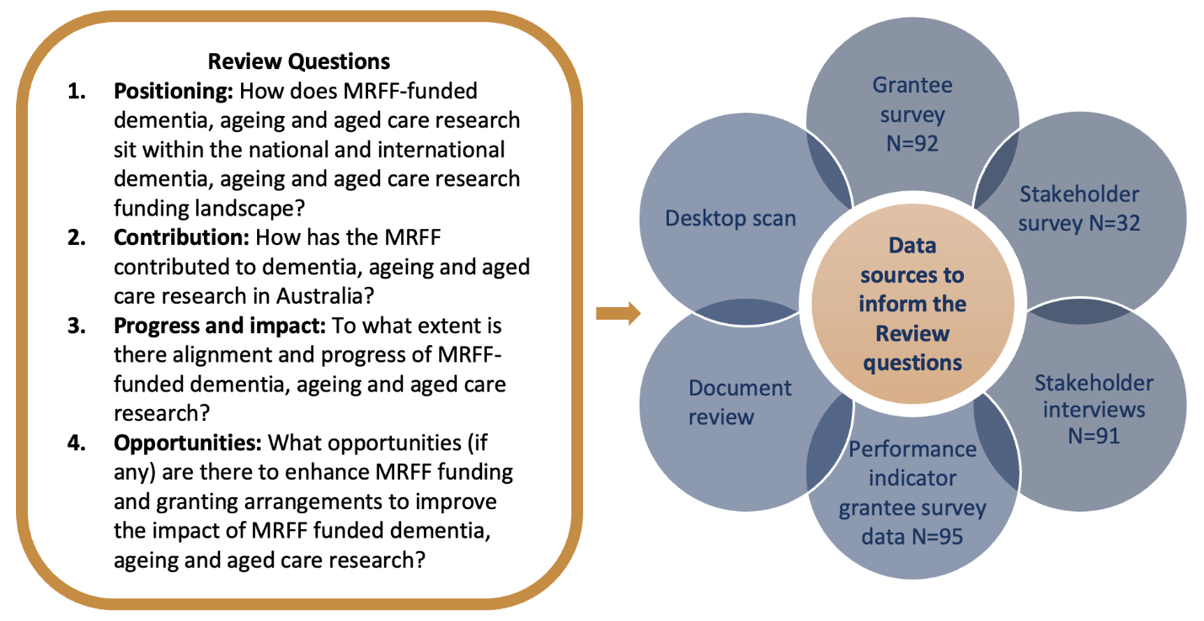

The Review examined the portfolio of 126 MRFF-funded dementia, ageing and/or aged care (DAAC) grants awarded up to 20 August 2024, totalling $295 million. This included 52 grants funded under the Mission (Mission-funded grants, $92M) and 74 grants related to dementia, ageing and/or aged care funded through other MRFF initiatives not part of the DAAC Mission (non-Mission funded grants, $203M).

1.3 Summary of Review findings

Table 1 below summarises key findings of the Review aligned to each of the Review questions.

Table 1. Key findings of the Review against the Review questions

|  |
| --- |
| Key findings of the Review against the Review questions |
| **Review question 1. Positioning** |

|  |
| --- |
| * The MRFF Dementia, Ageing and Aged Care Mission is strongly positioned as Australia's second-largest funder of DAAC research, accounting for 33% of national funding between 2018 and 2024, indicating substantial scale and impact. * Stakeholder interviews and sector feedback reinforced the view that Australia is a global leader in dementia research, particularly in prevention, post-diagnostic care, and inclusive research practices, with MRFF funding playing a key role in enabling high-quality, translational research across these domains. |

|  |
| --- |
| Review question 2. Contribution |

|  |
| --- |
| * The Mission is contributing meaningfully to its aims and priority areas, with funded research broadly aligned to its intended focus. While investment has been balanced across dementia, ageing, and aged care at the project level, gaps remain, where no projects have yet targeted interventions to delay dementia onset or promote multigenerational engagement in aged care. * The Mission is emerging as a critical mechanism to bridge the funding gap between early-stage basic research (typically funded by the NHMRC) and later-stage translational research. MRFF research, prioritising interventions ready for clinical, policy, and community application, strives to have real-world impact. * Consumer involvement was reported in 93% of projects, with many including consumers[10] in advisory, design, and data collection roles. Stakeholder feedback corroborated this, highlighting meaningful engagement, including roles as chief investigators, as a distinct strength of MRFF-funded DAAC research. * Approximately 75% of funded projects engaged one or more identified priority populations, including Aboriginal and Torres Strait Islander communities, CALD groups, people in rural and remote areas, veterans, LGBTI communities, and others. The breadth and inclusivity of this targeting reflect a strong alignment with the Mission’s distinctive emphasis on priority populations, as well as its wider set of priority populations compared with other national and international DAAC research funders. |

|  |
| --- |
| Review question 3. Progress and impact |

|  |
| --- |
| * While the majority of projects are still underway, the MRFF-funded DAAC research portfolio is broadly on track to achieve its intended outcomes. As of March 2025, only 2% of Mission-funded projects and 18% of non-Mission projects had been completed, with most others still progressing through key phases of delivery. * Around 62% of Mission-funded and 49% of non-Mission projects have reached the second half (late-stage) of their funding period, indicating that research outputs and outcomes are expected to emerge over the coming years as projects mature. * Progress against MRFF benchmarks is emerging. The most frequently addressed benchmark was increased focus on unmet needs, reported by 79% of projects. Among these, 24% of Mission and 14% of non-Mission projects reported major progress. * Co-funding from industry has totalled approximately $7 million, reflecting promising early signs of commercial engagement and new partnership models. * Several Mission benchmarks may require additional focus over the next five years to remain on track, particularly those related to dementia diagnostics and neuropsychological testing. * Stronger involvement of clinicians – including general practitioners and medical specialists – could help bridge the gap between research, policy, and practice, and support improved research translation and adoption. |

1.4 Opportunities for improvement

In answering Review question 4, nine strategic opportunities were identified for the department to consider. These are grouped under four domains – what research is conducted, how research is funded, how research is conducted, and how research is used – and reflect both areas within the remit of the MRFF (i.e., the department and/or the Health and Medical Research Office (HMRO)) and those requiring action across the broader health and medical research (HMR) sector. Table 2 provides an overview of these opportunities and where responsibility may lie.

Collectively, these opportunities aim to enhance the practical application and real-world impact of MRFF-funded DAAC research – by strengthening strategic focus, promoting collaboration and equity, embedding translation expectations, and ensuring alignment with system needs, research end-user priorities, and aged care reform.

Table 2. Strategic opportunities for the department to enhance MRFF-funded DAAC research

| **Strategic improvement opportunities** | **Responsibility** | |
| --- | --- | --- |
| **MRFF** | **HMR sector**[11] |
| **What research is conducted** |  |  |
| 1. Recognise the ‘real world’ overlap across dementia, ageing and aged care within the Mission | Tick with solid fill suggesting this is an MRFF responsibility. |  |
| 1. Refocus research priorities to support aged care reform | Tick with solid fill suggesting this is an MRFF responsibility. | Tick with solid fill suggesting this is a HMR sector responsibility. |
| 1. Continue and strengthen research effort across underrepresented Mission priority populations to support equity | Tick with solid fill suggesting this is an MRFF responsibility. |  |
| **How research is funded** |  |  |
| 1. Embed translation expectations in funding and reporting to drive real-world impact | Tick with solid fill suggesting this is an MRFF responsibility. |  |
| 1. Foster collaboration between Australian research institutions, not competition | Tick with solid fill suggesting this is an MRFF responsibility. | Tick with solid fill suggesting this is a HMR sector responsibility. |
| 1. Introduce targeted funding streams for currently underfunded areas and emerging needs | Tick with solid fill suggesting this is an MRFF responsibility. | Tick with solid fill suggesting this is a HMR sector responsibility. |
| 1. Strengthen coordination of national DAAC research funding | Tick with solid fill suggesting this is an MRFF responsibility. | Tick with solid fill suggesting this is a HMR sector responsibility. |
| **How research is conducted** |  |  |
| 1. Strengthen research end-user involvement across all research stages to ensure relevance and impact | Tick with solid fill suggesting this is an MRFF responsibility. | Tick with solid fill suggesting this is a HMR sector responsibility. |
| **How research is used** |  |  |
| 1. Enhance communication about MRFF DAAC research | Tick with solid fill suggesting this is an MRFF responsibility. |  |

2. Background

2.1 Background to the Medical Research Future Fund (MRFF)

The MRFF was established through the *Medical Research Future Fund Act 2015*[12] with the objective to ‘improve the health and wellbeing of Australians’. It is a $22 billion endowment fund that awards research funds for national priority areas[13] to address unmet medical needs, with a focus on research translation and commercialisation to improve the health and wellbeing of Australians. The MRFF complements other research funding mechanisms in the wider ecosystem that also invest in medical research. The MRFF’s ethos is summed up by the phrase “today’s research is tomorrow’s health care”.

MRFF investments are guided by the *Australian Medical Research and Innovation Strategy* and the *Australian Medical Research and Innovation Priorities*[14], which are determined by the Australian Medical Research Advisory Board. These inform the Government’s decisions on where MRFF funds are directed. The *third 10-year Investment Plan*[15]is the key mechanism through which the Strategy and Priorities are implemented, outlining 22 initiatives across four research themes. A central feature of the MRFF is the Research Missions – large, collaborative programs of work that bring together researchers, clinicians, stakeholders, industry, and consumers to tackle major health challenges.

MRFF is a learning system – the importance of evaluation and monitoring

At its inception, the MRFF recognised how important – but also how challenging – it would be to evaluate the impact of research investments. The model for consistent, impartial, and transparent evaluation is outlined in the *MRFF Monitoring, Evaluation and Learning Strategy (August 2024)* [16]*.* This strategy sets out the framework for monitoring progress, assessing outcomes, and supporting continuous improvement across MRFF investments. This includes a focus on the MRFF’s impact measures and measures of success, as illustrated in Figure 2.

Figure 2. MRFF monitoring, evaluation and learning conceptual framework, updated 2024

Infographic showing the intended outcomes and success measures of the Medical Research Future Fund (MRFF).
Vision: A health system fully informed by quality health and medical research.
Aim: To transform health and medical research and innovation to improve lives, build the economy, and support health system sustainability.
Key impact areas: better health outcomes, economic growth, beneficial change to health policy and practice, increased health efficiency, and increased job and export potential.
Measures of success include increased focus on unmet need, greater clinical trial access, embedding of new technologies and interventions in policy and practice, enhanced research capacity, faster adoption by health professionals, public engagement, and increased commercialisation of research.

As part of operationalising the MRFF Monitoring, Evaluation and Learning Strategy (August 2024), the department developed a set of nine performance indicators to provide quantifiable metrics that support the assessment of the MRFF’s measures of success. These indicators, outlined in Performance indicators towards the impact of the Medical Research Future Fund[17], help track how funded research contributes to the MRFF’s intended outcomes (MRFF measures of success / MRFF benchmarks) and, ultimately, its impact (MRFF impact measures). The nine MRFF performance indicators are:

* Projects targeting priority populations
* Projects targeting emerging issues
* Clinical trials
* Research workforce indicators
* Knowledge gain indicators
* Consumer involvement indicators
* Healthcare change indicators
* Commercialisation pathway indicators
* Case studies

These indicators are embedded within a broader program logic for monitoring and evaluation, which links MRFF investments to outputs, outcomes, and long-term impact (Figure 3).

Figure 3. Program logic model for monitoring and evaluation of the MRFF, highlighting the MRFF performance indicators

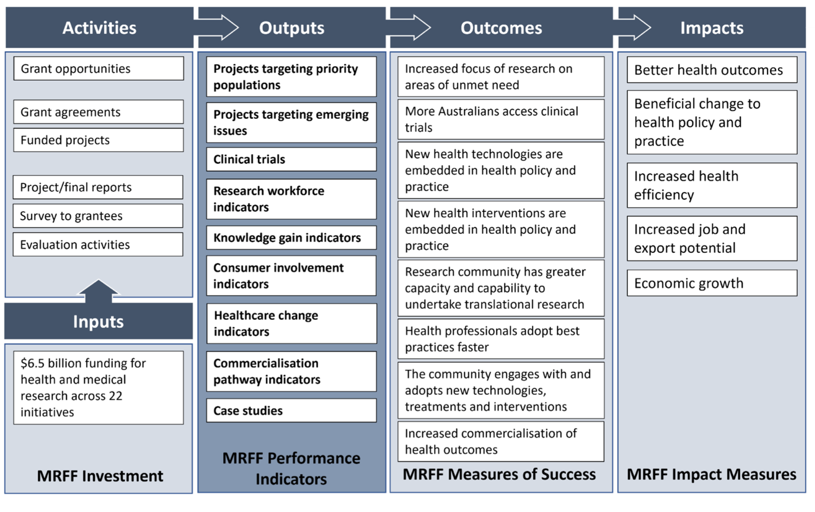

2.2 Background to Dementia, Ageing and Aged Care Mission

The Dementia, Ageing, and Aged Care Mission (the Mission) is one of ten current Research Missions within the Australian Government’s $22 billion Medical Research Future Fund. With a significant investment of $185 million over ten years (2018-19 – 2028-29), the Mission is focused on making transformative improvements in dementia and aged care for all Australians. It aligns with the ‘Priority Populations’ priority outlined in the *Australian Medical Research and Innovation Priorities 2024–2026*[18].

According to the *Dementia, Ageing, and Aged Care Mission Implementation Plan (2021)*[19]:

|  |
| --- |
| *“The Dementia, Ageing and Aged Care Mission aims to improve outcomes for people living with dementia, and support older Australians to maintain their health and quality of life as they age, live independently for longer and access quality care when they need it. The mission will generate measurable improvements for those living with dementia, increasing the healthy lifespan experienced by older Australians and improving care for older Australians across all care settings”.* |

Approximately half of the allocated funds have been invested to date across the Mission’s priority areas, marking a key point in the delivery of its objectives and providing an opportunity to reflect on progress and refine future funding directions.

Development of the Mission

The Dementia, Ageing and Aged Care Mission Expert Advisory Panel[20] appointed by the Australian Government developed a Roadmap and Implementation Plan to advise the Minister for Health on the strategic priorities for research investment through the Mission.

The draft Roadmap and Implementation Plan were reviewed by an international panel of experts in November 2020 who provided expert feedback and advice in the context of relevant activities occurring internationally[21]. The draft Roadmap and Implementation Plan also underwent a national consultation between 14 December 2020 and 23 April 2021 to seek community feedback on these documents[22]. Based on the feedback from the international review panel and the national consultation, changes were made to the final Roadmap and Implementation Plan. The final Roadmap and Implementation Plan for this Mission were published in September 2021 and are used to develop the Mission’s grant opportunities[23].

Mission aims, objectives and evaluation measures

Table 3 below outlines how each of the Mission’s three aims has shaped the priority areas for investment, alongside the corresponding Mission evaluation measures (Mission benchmarks).

Table 3. Dementia, Ageing, and Aged Care Mission aims, strategic investment priorities and evaluation benchmarks

| Mission Goal: To improve quality of life for Australians as they age | | |
| --- | --- | --- |
| Aim | Priority areas for investment[24] | Mission Evaluation Measures[25] (Mission benchmarks) |
| 1. Achieve measurable improvements in detection, prevention, assessment, care and support for people living with dementia[26] | 1.1 Determine and implement interventions that prevent or delay the onset of dementia symptoms — pre- and post-diagnosis  1.2 Implement care approaches for people with dementia and their carers that provide reliable and robust strategies to manage the impact of dementia on wellbeing, quality of life and end of life  1.3 Implement care and diagnostic pathways that improve timeliness of diagnosing dementia | * New diagnostic or prognostic tools for dementia developed * Utility of neuropsychological testing improved, resulting in increased use by clinicians * New tools and strategies for improving quality of life for people living with dementia and their carers developed and implemented through guidelines, practice or private partnerships * New tools and strategies for improving uptake of preventive activities developed and implemented through guidelines, practice or private partnerships * Evidence of improved diagnostic approaches, deferred onset and improved quality of life of people living with dementia and their carers |
| 2. Achieve measurable improvements in healthy life expectancy among older Australians | 2.1 Discover and implement health and medical interventions in mid-life and beyond that will extend healthy, active years of life and compress the period of morbidity  2.2 Conceive and encourage implementation of new ways to embed more proactive health management, including health literacy, for older people  2.3 Develop interventions that address social, economic and cultural barriers to healthy ageing to reduce inequality in healthy life expectancy in Australia | * New tools and strategies for improving uptake of preventive activities developed and implemented through guidelines, practice or private partnerships * Increase in average healthy life expectancy and reduction of variability in healthy life expectancy |
| 3. Achieve measurable improvements in consistency and quality of care for older Australians across all care settings | 3.1 Investigate and support implementation or adoption of models of care that are most effective in:   * delivering high-quality, culturally appropriate[27] care, informed by life experience, in home and residential aged care settings, that support individuals and their informal/family carers * ensure equitable and appropriate access to quality clinical care and minimise avoidable transitions between all care settings * identify and implement ways to maximise medical, nursing and allied health impact * identify and implement ways to maximise social inclusion and multigenerational engagement in long‑term care settings | * Key components of high-quality care identified and accepted for implementation by the aged care sector * New tools and strategies for implementing the key components of high-quality care in short- and long-term residential aged care settings developed and implemented through guidelines, practice or private partnerships |

2.3 Background to the Review

Intent and outcomes

The mid-term Review of the Mission, conducted by MHC, aimed to assess the progress of MRFF-funded dementia, ageing and aged care (DAAC) research – both under the Mission and through other MRFF initiatives – with a view to guiding future investment.

The department’s requirement was that the Review investigated:

**Positioning:** How MRFF-funded dementia, ageing and aged care research sits within the national and international dementia, ageing and aged care research funding landscape, by:

* + assessing key dementia, ageing and aged care health research funding priorities, quanta of funding, and outcomes for national (outside of MRFF) and comparable international funders
  + identification of national strengths and opportunities for improving complementarity and transformative capacity of MRFF funding, to better inform strategic allocation of Mission funding.

**Contribution:** How the MRFF has contributed to dementia, ageing and aged care research in Australia, via:

* + all existing investments under the Mission (i.e., progress made through all funded projects)
  + all other existing investments in dementia, ageing and aged care research made through the MRFF.

**Progress and impact:** Alignment and progress of MRFF-funded dementia, ageing and aged care health research towards:

* + the Mission Roadmap and Implementation Plan
  + the Australian Government’s 10-year MRFF investment plan (updated in 2024) and
  + monitoring and evaluation measures as outlined in the Evaluation Strategy.

**Opportunities:** Opportunities (if any) to enhance MRFF funding and granting arrangements to improve the impact of MRFF funded dementia, ageing and aged care research.

The outcomes from this Review will be used by the department to inform future funding and granting arrangements for DAAC research through the Mission and the MRFF more broadly.

Scope

**Within scope**

The Review examined MRFF grants related to DAAC that were funded both through the Mission and outside the Mission (i.e. non-Mission) up to and including 20 August 2024.

In total, 126 projects related to DAAC were funded through the MRFF, with a combined value of $295,029,360.73. Appendix 1 details the list of projects in scope for this Review.

* **Mission-funded projects:**

52 projects totalling $92,158,920.66 were funded under the Mission.

* **Non-Mission funded projects:**

74 non-Mission projects totalling $202,870,440.07 were funded under other MRFF Initiatives. These included projects delivered through the following initiatives:

* + Cardiovascular Health Mission $4,473,930.28
  + Clinical Trials Activity $22,914,970.57
  + Clinician Researchers $13,587,568.01
  + Early to Mid-Career Researchers $2,253,555.65
  + Emerging Priorities and Consumer Driven Research $40,625,880.05
  + Frontier Health and Medical Research $4,960,353.60
  + Global Health $5,899,999.99
  + Indigenous Health Research Fund $951,004.44
  + Medical Research Commercialisation $50,000,000.00
  + National Critical Research Infrastructure $2,999,924.00
  + Preventative and Public Health Research $20,800,327.12
  + Primary Health Care Research $4,999,745.91
  + Rapid Applied Research Translation $18,212,300.00
  + Research Data Infrastructure $3,915,588.00
  + Stem Cell Therapies Mission $952,873.50
  + Traumatic Brain Injury $5,322,418.95

Figure 4 provides a summary of the number and value of both Mission and non-Mission funded projects included in the scope of the Review.

Figure 4. Projects in scope: MRFF projects funded from MRFF inception to 20 August 2024 related to dementia ageing and aged care

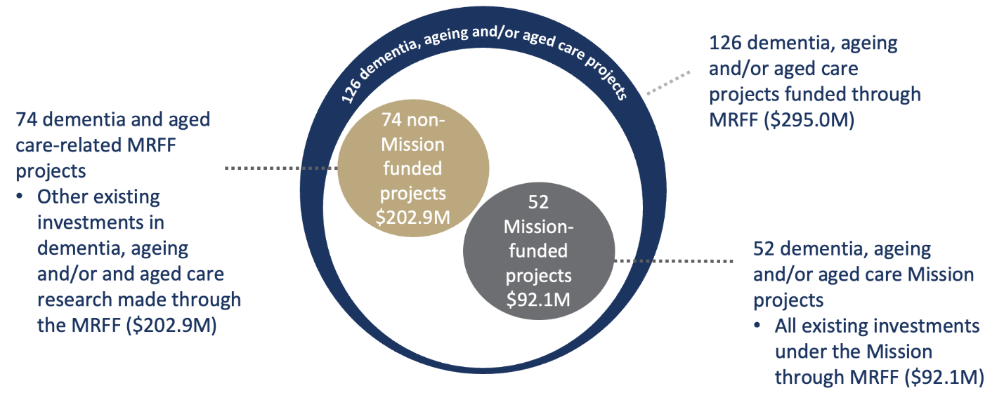

**Assessment benchmarks**

The Review assessed the Mission’s progress in line with *the* Mission Roadmap and Implementation Plan, the Australian Government’s 10-year MRFF investment plan, and the MRFF’s Monitoring, Evaluation and Learning Strategy *(updated in 2024),* and to inform investment from 2025-26 onwards.

Therefore, the two sets of benchmarks to measure progress against were:

* **Mission benchmarks**
  + These are the Mission evaluation measures set out in the [Mission Roadmap and Implementation Plan](https://www.health.gov.au/resources/publications/mrff-dementia-ageing-and-aged-care-mission-strategic-documents?language=en) (see Table 3 and glossary).
  + These were most relevant for the assessment of Mission-funded projects (N=52, see Figure 4). However, where possible, progress and alignment of non-Mission projects (N=74, see Figure 4) against these Mission benchmarks and Mission priorities were described.
* **MRFF benchmarks**
  + These are the MRFF measures of success and associated MRFF performance indicators as set out in the [MRFF's Monitoring, Evaluation and Learning Strategy](https://www.health.gov.au/our-work/mrff/about/monitoring-evaluation-learning) (see Figure 2 and glossary).
  + These were relevant for all grants (N=126, see Figure 4) in scope (i.e., all Mission and non-Mission projects in Figure 4).

**Out of scope**

The Review did not assess or examine the following:

* The department’s administrative processes of the MRFF
* Broader healthcare and aged care system issues, including service delivery, providers, medicines, or wider government policy – though these were noted where relevant to contextualise research contributions
* The scientific quality or rigour of individual research projects
* A detailed evaluation or formal research impact assessment – the Review instead focused on broader progress and high-level insights as part of a mid-term assessment
* The performance of individual grants – assessment was conducted at an aggregated level across all MRFF-funded DAAC research regarding progress
* The original process of establishing the Mission, including its aims, investments, and evaluation measures
* A financial audit of Mission investments
* A performance audit of grant arrangements or compliance with government guidelines
* Assurance or verification of information provided to MHC through MRFF documentation or stakeholder input

Governance

The Health and Medical Research Office (HMRO) within the department commissioned this Review of the Mission, outlining clear roles and responsibilities for all responsible parties, per Table 4 below.

Table 4. Roles and responsibilities for the Mission Review

|  |  |
| --- | --- |
| Party | Responsibilities |
| **Mission Review Panel (MRP)**  MRP membership comprised international and national panel members with qualifications and/or experience in DAAC research, service delivery and leadership, health policy and a consumer representative.  See Appendix 2 for a profile of the MRP members. | * Advised HMRO and MHC on the collection, analysis, and interpretation of information supporting the Review. * Provided feedback on deliverables prepared by MHC and HMRO (desktop scan). |
| **HMRO** | * Led and oversaw the design and delivery of the Review supported by the advice of the Mission Review Panel. * Provided feedback on and approved deliverables prepared by MHC. * Prepared a desktop review of the national and international DAAC research funding landscape. Part of this involved descriptive analysis of administrative MRFF data of investments up to August 2024. |
| **MH Consulting Group (MHC)** | Prepared and conducted the independent Review of the Mission:   * Reviewed program and project documentation provided by HMRO (e.g. progress reports). * Conducted a survey of MRFF grantees. * Consulted with key national and international stakeholders. * Collected and synthesised evidence from Mission grantees and national and international stakeholders in DAAC research, as well as the findings of the desktop scan. * Prepared the Review report. |

3. Methodology

3.1 Data sources

Six data sources (Figure 1) were used to inform the answers to the Review questions, also found in Table 5 below. At a high-level, these were:

1. **A grantee survey** – MHC designed and disseminated a brief online survey to each Chief Investigator A (CIA) for grants within scope of this Review*.* Appendix 1 details the grants within scope of this Review, while Appendix 3 includes the survey CIAs received.
2. **A stakeholder survey** – MHC designed and disseminated a concise online survey to all identified stakeholders. This approach aimed to efficiently gather diverse perspectives from a broad range of stakeholders, complementing the targeted individual and group interviews (as below). Appendix 4 includes the survey stakeholders were able to complete.
3. **Stakeholder interviews** – MHC undertook targeted individual and group interviews with relevant stakeholders drawn from Australian and international organisations. Appendix 5 provides the list of stakeholder organisations represented at the interviews, while Appendix 6 provides a broad overview of the topics for these interviews.
4. **Performance indicator grantee survey data** – HMRO conducted a survey of all MRFF grantees to assess the five impact measures and eight MRFF measures of success, using the MRFF performance indicators. Where data was captured for grants in scope for this Review, an extract of the relevant responses was provided to MHC by HMRO.
5. **A document review** – MHC conducted a targeted analysis of internal MRFF and Mission documents provided by HMRO to gather evidence aligned with the Review questions and key lines of inquiry. The documents included:
   1. Program-level documents: This included Mission implementation materials, MRFF program documentation, and other related departmental documents.
   2. Grant-level documents: This included documentation for all grants within scope, such as progress reports, final reports, and other materials provided by the department. Appendix 7 outlines the progress and final reports, as well as the grant opportunity guidelines, that were in scope for this Review. It also includes the number of grants funded under each grant opportunity for reference.
6. **A desktop scan** – HMRO conducted a desktop review of the Australian and international DAAC research landscape. As part of this, HMRO also conducted an analysis of internal MRFF administrative data for all grants in scope.

Table 5 below provides a high-level summary of these data sources for the Review, including their response rates where applicable.

Table 5. Overview of Review data sources, focus areas, collection responsibility and response rates

| **Data source** | **Focus** | **Responsibility** | **Number invited / in scope (n)** | **Number of responses (n)** | **Response rate (%)** |
| --- | --- | --- | --- | --- | --- |
| Grantee survey | CIA of MRFF-funded DAAC research | MHC | 125 | 92 | 74% |
| Stakeholder survey | Targeted and semi-open consultation | MHC | n/a | 32 | n/a |
| Performance indicator grantee survey data[28] | All MRFF grant recipients | HMRO with MHC analysis | 118 | 95 | 81% |
| Stakeholder interviews | Individuals and organisations with a stake in DAAC research (see Appendix 3 for list of organisations) | MHC | 96 organisations | 65 organisations[29] | 68% |
| Document review | Mission and non-Mission documents | MHC | A total of 271 progress reports and 17 final reports were reviewed. | | |
| Desktop scan | National and international funding landscape | HMRO | n/a | | |

Table 6 provides an overview of how each data source contributed evidence to address each Review question.

Table 6. Data source contribution to the Review

|  | **Grantee survey** | **Stakeholder survey** | **Stakeholder interviews** | **Performance indicator grantee survey** | **Document review** | **Desktop scan** |
| --- | --- | --- | --- | --- | --- | --- |
| 1. Positioning  *How does MRFF-funded dementia, ageing and aged care research sit within the national and international dementia, ageing and aged care research funding landscape?* | Tick with solid fill indicating that the grantee survey was a data source for this Review question. | Tick with solid fill indicating that the stakeholder survey was a data source for this Review question. | Tick with solid fill indicating that the stakeholder interviews were a data source for this Review question. |  |  | Tick with solid fill indicating that the desktop scan was a data source for this Review question. |
| *2.* Contribution  *How has the MRFF contributed to dementia, ageing and aged care research in Australia?* | Tick with solid fill indicating that the grantee survey was a data source for this Review question. | Tick with solid fill indicating that the stakeholder survey was a data source for this Review question. | Tick with solid fill indicating that the stakeholder interviews were a data source for this Review question. | Tick with solid fill indicating that the performance indicator survey data was a data source for this Review question. | Tick with solid fill indicating that the document review was a data source for this Review question. | Tick with solid fill indicating that the desktop scan was a data source for this Review question. |
| 3. Progress and Impact  *To what extent is there alignment and progress of MRFF-funded dementia, ageing and aged care research?* | Tick with solid fill indicating that the grantee survey was a data source for this Review question. | Tick with solid fill indicating that the stakeholder survey was a data source for this Review question. |  | Tick with solid fill indicating that the performance indicator survey data was a data source for this Review question. | Tick with solid fill indicating that the document review was a data source for this Review question. | Tick with solid fill indicating that the desktop scan was a data source for this Review question. |
| 4. Opportunities  *What opportunities (if any) are there to enhance MRFF funding and granting arrangements to improve the impact of MRFF funded dementia, ageing and aged care research?* | Tick with solid fill indicating that the grantee survey was a data source for this Review question. | Tick with solid fill indicating that the stakeholder survey was a data source for this Review question. | Tick with solid fill indicating that the stakeholder interviews were a data source for this Review question. |  |  | Tick with solid fill indicating that the desktop scan was a data source for this Review question. |

Grantee survey

The online grantee survey (Appendix 3) was sent via email to the CIA for both Mission projects (*n*=52) and non-Mission projects (*n*=73[30]) that were identified as having relevance to DAAC. The primary aim of this survey was to collect strategic and impact-oriented information on:

1. Opportunities to focus future MRFF funding to achieve better outcomes in dementia, ageing, and aged care.
2. How grantees’ research is structured to maximise the translation of findings into practical applications and policies.
3. How grantees’ research is contributing to progress towards the Mission benchmarks.

The grantee survey was open for four weeks from 3–28 February 2025. CIAs were notified of the survey’s launch on 3 February, following an earlier advisory email from HMRO. CIAs who had not completed the survey received follow-up reminders two weeks and one week before the survey closed.

The overall survey response rate was 74% (92/125) and the breakdown of response rates by grant type, institution and jurisdiction can be found in Figure 5.

Figure 5. Survey response rates by Mission status, jurisdiction, and organisation type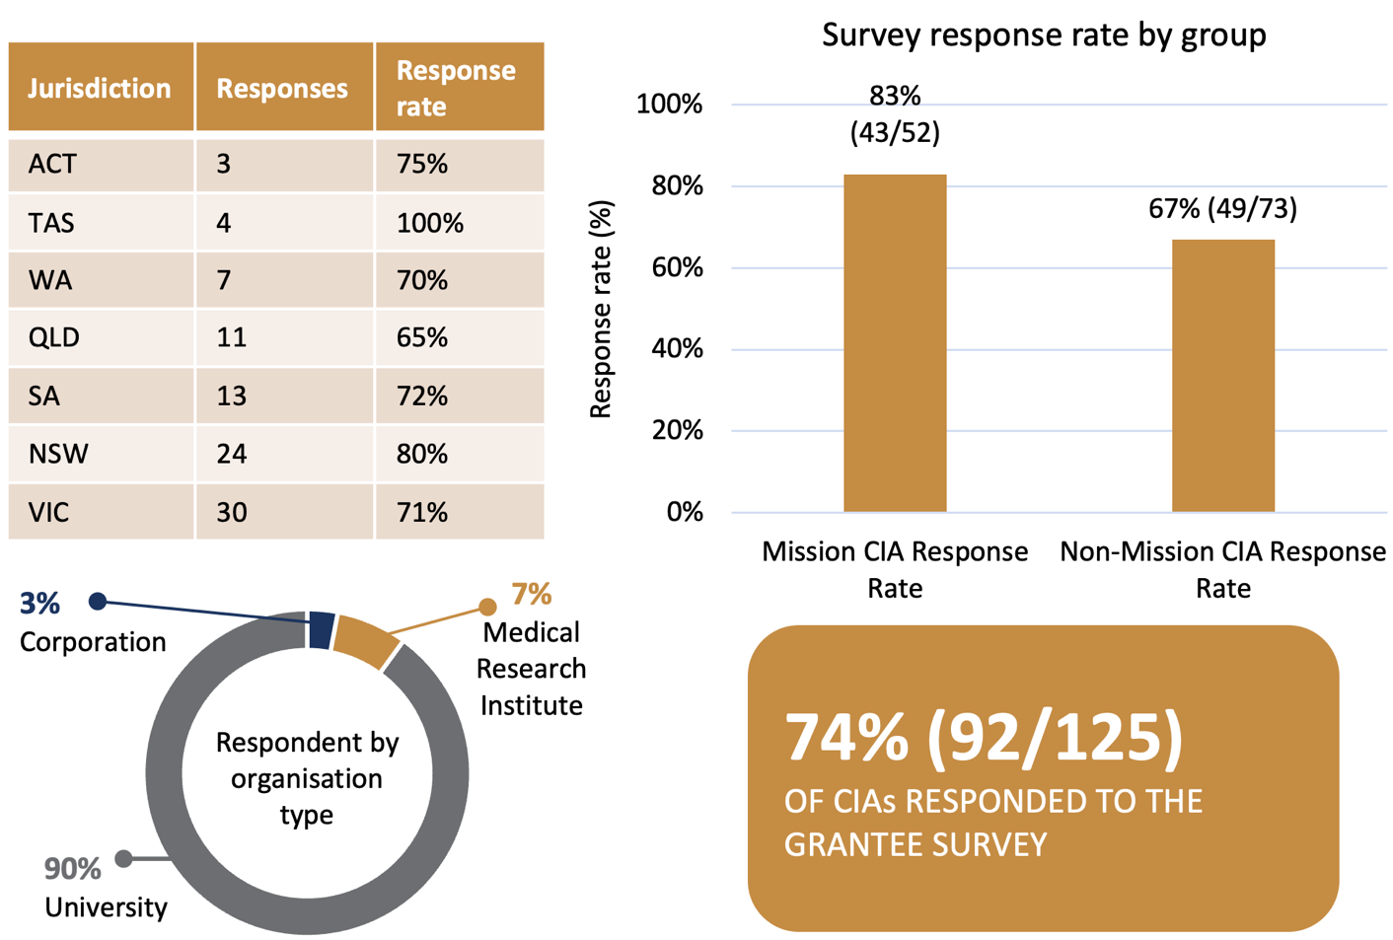

Stakeholder survey

The online stakeholder survey (Appendix 4a and 4b) was an additional targeted consultation mechanism distributed to individuals and organisations with an interest in DAAC (excluding grantees who were surveyed separately). Recipients were identified by the MRP, HMRO, and MHC. The survey was sent to:

* Individuals and organisations identified as relevant stakeholders (excluding grantees)
* Those who had participated in stakeholder interviews
* Those invited to stakeholder interviews but unable to attend
* Identified peak organisations, which were requested to distribute the survey to their members

The primary aim of this survey was to collect strategic and impact-oriented information on:

1. Opportunities to focus future MRFF funding to achieve outcomes in dementia, ageing, and aged care.
2. Practical ways to enhance how future research is structured to maximise the translation of findings into practical applications and policies.

The stakeholder survey was open for approximately five weeks from 3 February to 11 March 2025. Identified stakeholders, including peak organisations which were requested to distribute the survey to their members, were notified of its launch on 3 February, following an earlier advisory email from HMRO. Stakeholders who participated in interviews were informed during their session that they would have the opportunity to provide further insights through the survey. They received a follow-up notification within 1–2 working days after their interview with the survey link.

Since the stakeholder survey was further distributed by identified peak organisations to their members, the total number of recipients could not be determined, and therefore, a proportionate completion rate could not be calculated. However, details on the number of responses (N=32) received and their broad stakeholder categories, as identified by themselves, are provided in Figure 6.

Figure 6. Survey response rates by stakeholder category

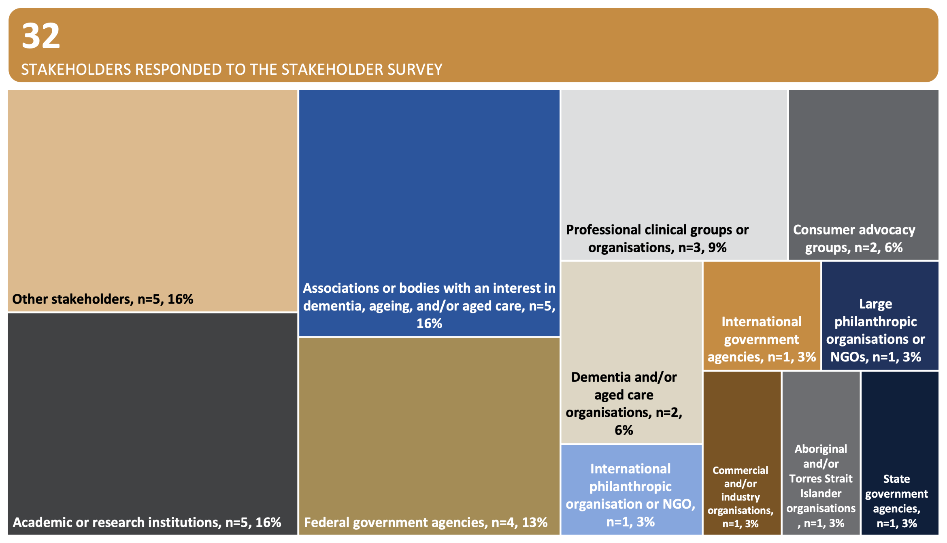

Stakeholder interviews

Individual (*n*=13) and group (*n*=10) interviews involving a total of 91 individuals were conducted across these stakeholder categories:

* Consumers and consumer organisations
* Aboriginal and Torres Strait Islander organisations
* Commercial and industry organisations
* Large philanthropic organisations and NGOs responsible for dementia, ageing, and/or aged care research funding
* Academic and research institutions, including their representative organisation(s)
* Professional clinical groups, including their representative organisation(s)
* Aged care providers, including their representative organisation(s)
* The Dementia, Ageing and Aged Care Mission Expert Advisory Panel (who developed the Mission Roadmap and Implementation Plan)
* International government agencies responsible for dementia, ageing and/or aged care research funding
* State and territory government agencies responsible for dementia, ageing, and/or aged care research funding
* Federal Government agencies responsible for dementia, ageing, and/or aged care policy and programs OR funding

In total, 91 stakeholders participated across both individual and group interviews, with Figure 7 providing further insights.

The department initially identified a list of stakeholders for interviews, which was refined based on advice from the MRP and then categorised into the broad stakeholder categories outlined above. Appendix 5 provides the list of stakeholder organisations represented at the interviews.

The primary aim of these interviews was to collect strategic and impact-oriented information on:

1. Opportunities to focus future MRFF funding to achieve outcomes in dementia, ageing, and aged care.
2. Practical ways to enhance how future research is structured to maximise the translation of findings into practical applications and policies.

The virtual, semi-structured interviews were conducted by MHC over a period of approximately 5 weeks between 28 January and 13 March 2025. In late December 2024 and early January 2025, the department made initial contact with stakeholders via email, providing an invitation to participate and an introduction to MHC. Following this, MHC reached out to schedule interview times and share interview topics to be covered and a participant information sheet. Stakeholders who did not respond received one follow-up contact.

Tailored interview topics were developed for each individual or group stakeholder interview. A broad overview of these topics is found in Appendix 6.

Figure 7. Summary of stakeholder interviews: Participants, engagement, and representation

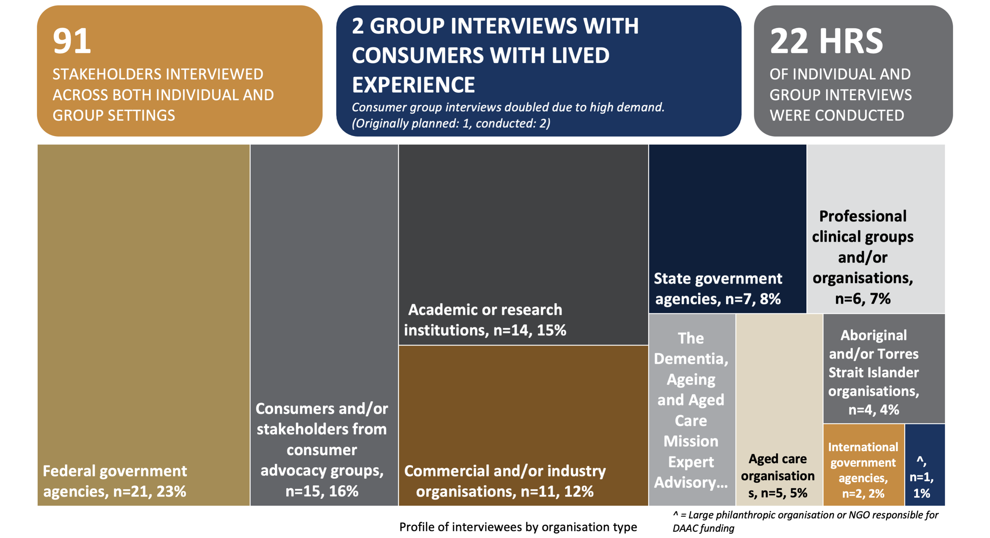

Document review

MHC conducted a targeted review of program and project documentation to support and complement other data sources used in the Review. The document review focused on internal materials provided by HMRO and was used to assess the progress and focus of MRFF-funded DAAC research.

The document review included:

* **Grant guidelines:**  
  HMRO provided guidelines for all five Mission-funded grant rounds (2019–2023), each comprising multiple streams, as well as for 41 DAAC-related non-Mission MRFF grant opportunities across 16 initiatives. These documents were reviewed to understand the intended focus and structure of MRFF grant opportunities.
* **Progress and final reports:**  
  A total of 271 progress reports (114 from Mission-funded grants and 157 from non-Mission-funded grants) and 17 final reports (1 from a Mission-funded grant and 16 from non-Mission-funded grants) were reviewed. The most recent report available for each grant was used to assess delivery status and progress.

Project documentation was analysed to:

* Categorise each grant’s stage of progress based on its maturity (e.g. planning stage, moderate progress, major progress, complete)
* Assess project progress against the MRFF benchmarks – while also using case study examples to illustrate progress where appropriate

This evidence informed assessments of alignment with broader MRFF benchmarks. The review also enabled identification of case examples across the DAAC research landscape.

Appendix 7 provides a summary of the grant opportunities and associated reports included in the Review.

Performance indicator survey data

HMRO conducted a performance indicator survey between March and May 2024. The purpose of the survey was to provide a high-level public overview of the success and impact of MRFF-funded research across all initiatives, in alignment with the *MRFF Monitoring, Evaluation and Learning Strategy 2020–21 to 2023–24* (Figure 2) and the MRFF performance indicators (Figure 3).

The survey was structured around the nine MRFF performance indicators developed in 2023 to assess the MRFF’s eight measures of success. These indicators cover:

* Projects targeting priority populations
* Projects targeting emerging issues
* Clinical trials
* Research workforce indicators
* Knowledge gain indicators
* Consumer involvement indicators
* Healthcare change indicators
* Commercialisation pathway indicators
* Case studies

In addition to indicator-based questions, the survey also included open-text questions inviting researchers to reflect on how the MRFF could more effectively deliver practical health and innovation benefits for Australians.

The survey was sent to all MRFF-funded grant recipients with active or completed grants as of May 2024. For this Review, HMRO provided MHC with a subset of responses relevant to MRFF-funded DAAC grants – both Mission and non-Mission. In total, 95 of the 118 eligible grantees responded, representing an overall response rate of 80.5%. Response rates were 93% for Mission-funded grants (42/45) and 73% for non-Mission grants (53/73).

MHC analysed the relevant survey responses to inform assessment of progress achieved against the MRFF benchmarks. Specifically, data drawn from survey questions included:

* Unmet needs and emerging priorities
* Clinical trial activity, type, location, and scale
* Workforce capacity and FTE contributions
* Consumer involvement and co-design
* Healthcare change efforts and policy engagement
* Commercialisation outcomes and co-/post-funding generation

These data contributed evidence primarily to the Review’s analysis of MRFF benchmarks and were used in conjunction with document review findings and qualitative stakeholder input.

Desktop scan

HMRO conducted a desktop scan to inform a broader understanding of DAAC research funding within Australia and internationally. The desktop scan aimed to contextualise MRFF-funded DAAC research – both Mission and non-Mission – by examining funding patterns, research priorities, and emerging trends across the national and global research landscape.

The scan drew on a combination of MRFF administrative data, publicly available documentation from national and international funding bodies, and bibliometric analyses. It assessed funding distribution, grant characteristics, research focus areas, and the extent of consumer involvement and collaboration across MRFF-funded grants. Where possible, the analysis distinguished between dementia, ageing, and aged care research, and included breakdowns by funding round, year, organisation, and state or territory.

In addition to MRFF-funded activity, the desktop scan reviewed published and grey literature to identify:

* National and international research priorities for dementia, ageing, and aged care
* Funding levels and priority alignment among comparable funders (domestic and global)
* Notable funding programs, co-funding arrangements, and partnerships across the research pipeline
* Support for research translation, commercialisation, and workforce development
* Approaches to consumer engagement, particularly in setting research priorities and shaping program design
* Innovative funding models, including those supporting culturally appropriate and inclusive research

To identify funding levels of comparable funders, grant investment data was obtained from each organisation’s grant databases, published reports and funding announcements between 2018 and 2024.

* Where publicly available, grant databases were filtered using specific keywords relevant to dementia, ageing and aged care research, as identified in the sub-point below. Relevant grants data identified from these keyword searches was then checked for accuracy, consolidated and used for subsequent analyses.
  + “accidental falls”, “aged care”, “Aged Care Nursing”, “aged health”, “Aged Health Care”, “ageing”, “ageing population” , “Alzheimer’s disease” , “amyloid beta-protein” , “brain ageing”, “cognitive decline” , “community geriatrics” , “delirium” , “dementia” ,“dementia care”, “dementia with Lewy bodies” , “dementia-related decline in memory” , “falls prevention” , “fracture risk” , “frontotemporal dementia” , “geriatric assessment” , “geriatrics” , “Geriatrics and Gerontology”, “healthy ageing” , “neurodegeneration” , “neurodegenerative disorders” , “neurofibrillary tangles” , “nursing homes” , “older people” ,“post-stroke dementia” , “psychogeriatrics” , “vascular dementia”
* Some of the comparable funders only funded grants related to dementia or ageing/aged care. For these funders, all grant data was considered in-scope and included for analysis.
* Where possible, data included all funding models related to the keywords such as scholarships, fellowships, research projects, large centres/programs and clinical trials.

The scan also sought to identify research gaps, strengths, and opportunities to enhance the impact of MRFF investments.

Findings from the desktop scan were used to inform the Review’s assessment of how MRFF-funded DAAC research is positioned within the broader national and international research landscape. The scan also supported analysis of the MRFF’s contribution to the DAAC research and helped identify strategic opportunities to strengthen the future impact of MRFF investments and enhance policy alignment.

3.2 Data analysis

Grantee and stakeholder survey data

Two separate frameworks were developed to guide the qualitative analysis of survey responses – one for the grantee survey and one for the stakeholder survey. Each framework was structured around the Review questions and allowed free-text responses to be systematically categorised.

Key qualitative points were mapped to the appropriate framework areas, with an ‘Other’ category used for unaligned insights. A thematic analysis assessed the frequency of themes and their alignment with findings from the interviews. This cross-source review helped determine whether survey data introduced new insights, reinforced existing findings, or revealed divergence.

Quantitative survey data were analysed using descriptive statistics. Frequencies and percentages were calculated and summarised in tables and figures included throughout the findings section of this report.

Stakeholder interview data

A framework was developed to guide the analysis of qualitative interview data, structured around the Review questions. The framework took the form of a matrix, enabling key points from interviews to be systematically aligned and categorised.

All interviews were automatically transcribed with the interviewee’s consent. A senior consultant conducted the initial analysis, preparing a high-level one-page summary for each interview. Key insights from the one-page summary and full transcript were then mapped to the relevant framework categories. Where insights did not align to a pre-defined area, they were recorded under an ‘Other’ category. A second senior consultant reviewed the mapped data, with input from senior advisors who attended or facilitated the discussions, to validate and refine the analysis.

A thematic analysis was then undertaken to assess the frequency and salience of key points raised. The strength of emerging themes was reviewed and confirmed by senior advisors to ensure accuracy and consistency in interpretation.

Document review data

Document analysis focused on grant guidelines and project reports for all MRFF-funded grants within scope. Each grant’s most recent progress report was reviewed to assess stage of project progress and progress towards MRFF benchmarks. Reports were also used to extract examples of projects working towards the Mission benchmarks and MRFF benchmarks.

Document review data were synthesised to complement findings from the surveys and interviews.

Performance indicator survey data

Quantitative data from the performance indicator survey were analysed at the level of individual questions posed in the survey and, where appropriate, groups of related survey questions. While the survey was structured around the MRFF’s nine performance indicators – each linked to the MRFF benchmarks – the analysis focused on how question responses could collectively inform insights against those broader MRFF benchmarks.

Responses were summarised using descriptive statistics and used to provide insights into how MRFF-funded DAAC research is achieving progress against the MRFF benchmarks. While the primary assessment of project-level progress was drawn from the document review, the performance indicator survey data offered a broader perspective on achievements.

Desktop scan data

The desktop scan was conducted by HMRO to contextualise MRFF-funded DAAC research within the broader national and international funding landscape. MHC reviewed the outputs of this scan to extract comparative data on funding levels, research priorities, areas of strength, and identified gaps.

The desktop scan findings informed assessments of the MRFF’s positioning, contribution, and strategic opportunities within the DAAC research ecosystem. These data were used to support high-level comparisons and identify opportunities to enhance the impact of future MRFF DAAC investment.

3.3 Structure of Review findings

The following sections present the key findings of the Review, organised according to the four Review questions. Each Review question is addressed in the following structure:

Orientation

* Defines the scope of the Review question.
* Lists the data sources used to extract evidence to answer the question.

Summary of findings and improvement opportunities

* Lists the key findings, providing a high-level summary of the main insights.
* Identifies opportunities for improvement based on evidence, including stakeholder and grantee views gathered through surveys and interviews.

Detailed findings by focus area

* Introduces a specific topic area relevant to the Review question.
* Provides a structured entry point for exploring detailed insights.
* The focus areas under each Review question:
  + Expand on key aspects of the focus area presenting detailed supporting evidence from the data sources
  + Highlight where the evidence indicates potential opportunities for improvement.

4. Positioning of MRFF-funded DAAC research within the national and international landscape

|  |
| --- |
| Review Question 1 – How does MRFF-funded dementia, ageing and aged care research sit within the national and international dementia, ageing and aged care research funding landscape?  **Scope**  This Review question establishes the broader context for positioning MRFF-funded DAAC research within the national and international funding landscape. In addition, this section also describes the relevant policy environment and identifies Australia’s research strengths. These latter components provide important context for identifying opportunities to strengthen the impact of MRFF investments, that are expanded upon under Opportunities – Review Question 4.  **Focus areas covered in this Review section are:**   * 4.2 MRFF funding of DAAC research in context of the national and international landscape * 4.3 Positioning of MRFF DAAC priority areas relative to national and international research funders * 4.4 MRFF positioning in partnerships, workforce and commercialisation pathways for DAAC research * 4.5 Positioning of MRFF-funded DAAC research on consumer and health service engagement * 4.6 Australia’s strengths in DAAC research   **Data sources used to answer this Review question:**  The desktop scan was the primary data source for this section. Supplementary insights were drawn from the grantee and stakeholder survey and interviews. |

4.1 Summary of findings and improvement opportunities

4.1.1 Key findings

* The investments made by the MRFF in DAAC research are well placed in the context of other national and international research funders.
  + Second only to the National Health and Medical Research Council (NHMRC), the MRFF was one of the largest funders of DAAC research in Australia during the Review period (2018-2024), accounting for 33% of national funding.
  + Despite providing slightly less funding and comparatively fewer grants than the NHMRC annually, on average, the MRFF provides more funding per grant than all other national or international research funders identified for the Review (referred to as ‘comparators’[31]), apart from the European Research Council (ERC).
* All the national and international funding comparators focused on DAAC research have overlaps between their priorities, and those of the Mission. Overall, the MRFF has a strong focus on consumer engagement and priority populations.
* National and international stakeholders consistently described Australia as an international leader in dementia research, particularly in prevention and post-diagnostic care), and in inclusive and community-led research models. MRFF funding was seen as playing a key role in enabling high-quality, translational research across these areas, supporting multidisciplinary approaches, strong consumer involvement, and research aligned with real-world care needs.

4.1.2 Improvement opportunities

* In line with international research funders, there is an opportunity to consider explicitly identifying women and people with disability as priority populations for DAAC research funding. This is particularly important noting the higher risk these populations face in relation to dementia, ageing and aged care.
* In line with approaches adopted by other international and national research funders, there is an opportunity for the Mission to strengthen its impact by:
  + At the grant opportunity level – establishing strategic partnerships to develop joint research grant opportunities that promote innovation, scaling, and research translation.
  + At the research project level – requiring researchers to partner with health services and/or aged care providers, or to demonstrate how implementation will be supported.
* A key learning for the Mission and the MRFF is the value of innovative research funding models that effectively support the translation of practical and scalable DAAC interventions into health and aged care settings. These models align with key recommendations of the Royal Commission into Aged Care Quality and Safety. Examples of such models – both nationally and internationally are provided in Appendix 8.
* While partnerships are encouraged at the project level, unlike some other MRFF initiatives and international comparators, the Mission has not established joint funding arrangements. Formalising strategic partnerships with government agencies, health and aged care providers, philanthropic organisations, and international research bodies would strengthen the Mission’s reach and real-world impact.

4.2 MRFF funding of DAAC research in the context of the national and international landscape

4.2.1 MRFF DAAC research funding is strongly positioned nationally

MRFF funding for DAAC research holds a significant position within the national research landscape. Between 2018 (when the Mission commenced) and 2024, total MRFF investment – including both Mission and non-Mission initiatives – amounted to $295.03 million, averaging approximately $42.15 million annually (Table 7). Overall, MRFF awarded 126 grants, averaging $2.34 million per grant, the highest among Australian funding bodies. This positioned MRFF as the second-largest funder of DAAC research by average annual investment, behind the NHMRC, which primarily operates through investigator-driven funding but also includes priority-based initiatives such as dementia research[32].

Table 7. National and international investments in DAAC-related research awarded between 2018–2024

|  | Total research funding (million; AUD) | Average annual funding  (million; AUD) | Number of grants | Average grant size (million; AUD) |
| --- | --- | --- | --- | --- |
| MRFF Mission | $92.16 | $13.17 | 52 | $1.77 |
| MRFF (non-Mission)[33] | $202.87 | $28.98 | 74 | $2.74 |
| Total MRFF | $295.03 | $42.15 | 126 | $2.34 |
|  |  |  |  |  |
| NHMRC | $495.32 | $61.92 | 391 | $1.27 |
| Australian Research Council (ARC) | $74.40 | $9.30 | 124 | $0.60 |
| Dementia Australia | $17.13 | $2.86 | 112 | $0.15 |
| Aged Care Research and Industry Innovation Australia (ARIIA) | $9.20 | $4.60 | 62 | $0.15 |
|  |  |  |  |  |
| National Institute on Aging (US) | $15,357.20 | $1,919.65 | 15132 | $1.01 |
| National Institute for Health and Care Research (UK) | $101.30 | $14.47 | 196 | $0.52 |
| Canadian Institutes of Health Research (CAN) | $297.20 | $37.15 | 1331 | $0.22 |
| Wellcome Trust (UK) | $153.92 | $21.99 | 163 | $0.94 |
| European Research Council (EU) | $157.21 | $19.65 | 60 | $2.62 |
| Alzheimer’s Association (US) | $634.27 | $105.71 | 1275 | $0.50 |
| Alzheimer's Research UK (UK) | $269.49 | $38.50 | 539 | $0.50 |
| Alzheimer’s Society (UK) | $153.30 | $19.16 | Insufficient data | |

Source: Desktop scan

Specifically, the Mission allocated $92.16 million, averaging around $13.17 million annually, ranking third in total investment for DAAC research among national funders.

Across Australia, no states or territories had dedicated funding schemes specifically for DAAC research during this period. Nevertheless, several jurisdictions funded discrete DAAC projects within their broader health and medical research initiatives. For example, Victoria funded research into improved diagnosis of dementia using biomarkers through the Victorian Medical Research Acceleration Fund. New South Wales (NSW) supported projects on gene therapy for dementia, injury prevention for older adults, and palliative care frameworks under the NSW Early Mid-Career Research Grant. Additionally, South Australia (SA) funded research aimed at empowering informal carers and examining their role in enhancing quality care for older people through its HTSA Medical Research Future Fund Catalyst Grant Program.

4.2.2 MRFF DAAC research is distinguished by high grant value when   
compared internationally

Compared to international research funders, the MRFF’s total investment in DAAC research between 2018 and 2024 was modest in overall scale but notable for its focus on larger grant sizes. The MRFF’s total investment of $295.03 million over this period placed it on par with the Canadian Institutes of Health Research (CIHR) ($297.20 million), and ahead of other public funders such as the UK’s NIHR ($101.30 million) and the EU’s ERC ($157.21 million) (Figure 8).

When looking specifically at the Mission, its total funding ($92.16 million) was smaller than all international comparators, including philanthropic funders such as Alzheimer’s Association (US; $634.27 million) and Alzheimer’s Research UK (ARUK) (UK; $269.49 million) (Figure 8). This lower total funding reflects the Mission’s narrower focus on specific research priority areas for investment within DAAC, and the fact that it forms just one part of Australia’s broader national funding landscape, which also includes non-Mission MRFF initiatives and NHMRC investments.

However, both the Mission and non-Mission MRFF initiatives stood out for their comparatively high average grant sizes (Table 7). The Mission averaged $1.77 million per grant, and non-Mission MRFF grants averaged $2.74 million – the highest across all national and international funders. By contrast, average grant sizes from other major government funders ranged from $0.22 million (CIHR) to $1.01 million (NIA), and philanthropic organisations such as Dementia Australia and Aged Care Research & Industry Innovation Australia (ARIIA) averaged $0.15 million per grant.

The MRFF’s investment profile – fewer but larger grants – reflects a deliberate strategy to enable research teams to pursue ambitious, high-impact projects (see Table 7). However, some stakeholders raised concerns that, in practice, MRFF DAAC funding has still been spread across many smaller projects and institutions. Participants from academia, government, and international funding agencies highlighted that this fragmentation can dilute overall impact, encourage competition rather than collaboration, and risk duplicating effort and reducing efficiency. There was strong support for more coordinated, larger-scale investments that incentivise multi-centre research and foster strategic partnerships between universities, research institutes, and non-academic organisations.

|  |
| --- |
| *“If we want to maximise impact, we need to move away from lots of small grants and towards larger, collaborative funding models. The current system encourages institutions to compete rather than work together. We need to prioritise research that changes healthcare, not just generates papers. Some grants fund projects that show ‘this might be useful if we tested it in more patients’ – we need to move towards funding properly powered trials that test real-world interventions.”*  **Stakeholder from an international research funder** |

Figure 8. Investment in DAAC-related research 2018–2024, by national and international funding bodies

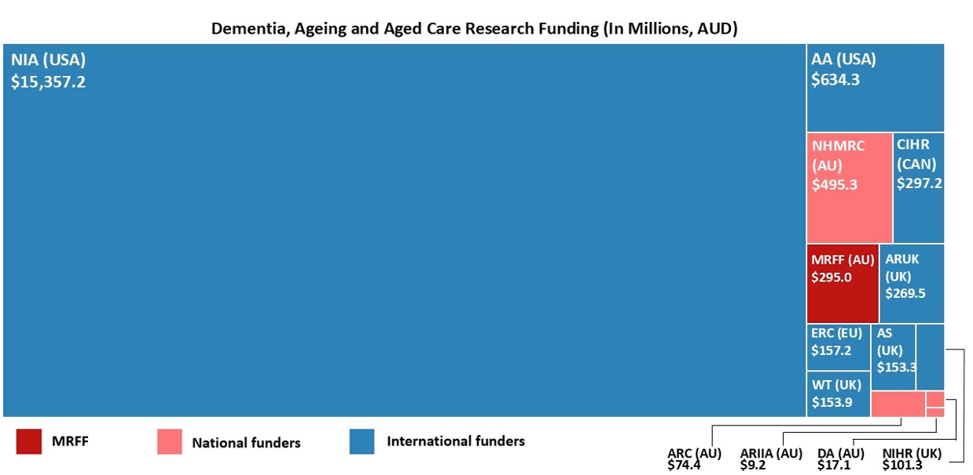

Source: Desktop scan

4.3 Positioning of MRFF DAAC priority areas relative to national and international research funders

4.3.1 Mission priorities are broadly aligned with national and international comparators, with a unique focus on aged care models and implementation

The Mission priority areas for investment are broadly aligned with the priorities of major national and international funders, particularly in areas such as prevention, dementia care, diagnostics, and healthy ageing. However, it stands out for its specific emphasis on improving aged care models – an area less prominent in other funding body priority areas.

Nationally, the Mission shares common ground with the NHMRC and ARIIA but adopts a more targeted approach to aged care service delivery. Unlike the Mission, NHMRC focuses more on building and retaining Australia’s dementia research capacity and dementia research led by and/or that benefits Aboriginal and Torres Strait Islander populations, while ARIIA includes palliative care, social isolation, and workforce as additional priorities.

Internationally, funders such as NIA (US), CIHR-Institute of Aging (CIHR-IA) (Canada), and Alzheimer’s Association (US) prioritise many of the same areas, although the Mission’s system-level focus on aged care is relatively unique. CIHR-IA comes closest with initiatives around integrated care and ageing-in-place. The desktop scan compared the priorities of the Mission with those of other funders to identify other potential priority areas of funding.

Table 8 presents potential opportunities for Mission priorities identified in the desktop scan, based on review of other funders' priorities.

Table 8. Potential areas of opportunity for Mission priorities

|  |  |
| --- | --- |
|  | Areas of opportunity |
| **Dementia** | * Support the dementia workforce and research enterprise. * Disseminate research findings to the public to support policy design and implementation. * Strengthen research focused on dementia in Aboriginal and/or Torres Strait Islander peoples, noting that Aboriginal and/or Torres Strait Islander peoples are identified as a priority population in the DAAC Mission and across the MRFF more broadly. * Explore the use of technology and AI as tools for intervention, service delivery, and health monitoring. * Address the needs of patients with dementia in aged care settings. |
| **Ageing and aged care** | * Investigate mechanisms of ageing in women. * Explore the use of technology to support ageing and aged living. * Identify best practice for mitigating risks associated with COVID-19, in addition to identifying means of supporting the older population in the post-pandemic space. * Strengthening research into palliative care support and best practices in aged care settings. * Address social isolation in aged care and other aged living settings. * Explore alternative/novel arrangements of housing for the older people outside of traditional aged care settings. * Investigate causes of and interventions for staff burnout in aged care and health services settings. |

*Source: Desktop scan*

4.3.2 The Mission identifies a broader range of priority populations than most national and international comparators

The Mission outlines a broader and more specific set of priority populations than any other comparator reviewed. Its focus on Aboriginal and/or Torres Strait Islander peoples, people from culturally and linguistically diverse (CALD) backgrounds, and people who live in rural and remote areas aligns with common comparator funders – but it extends further to include veterans (including spouses and widows/widowers), people from lesbian, gay, bisexual, trans/transgender and intersex (LGBTI) communities, people experiencing or at risk of homelessness, care leavers, prisoners and ex-prisoners, and those affected by forced adoption.

While NHMRC and non-Mission MRFF initiatives highlight some overlapping groups, they do not match the Mission’s breadth. ARIIA’s emphasis on social isolation is unique nationally but otherwise limited. Internationally, CIHR-IA (Canada) and NIA (US) identify several similar populations but do not include groups such as LGBTI communities or care leavers (including Forgotten Australians, former child migrants and Stolen Generations). However, women and people living with disability are consistently identified as priority populations internationally.

This suggests a potential area of improvement for the Mission – to consider whether women and people living with disability should be more explicitly included in its priority population framework.

4.4 MRFF positioning in partnerships, workforce and commercialisation pathways for DAAC research

4.4.1 Co-funding partnerships in DAAC research are common among national and international comparators, but are not established under the Mission

Unlike other MRFF initiatives, the Mission has not established joint funding opportunities with co-investment partners in DAAC research. While some MRFF initiatives have participated in collaborative arrangements, none currently apply to this Mission.

In contrast, national funders such as NHMRC and ARIIA have well-developed partnerships. NHMRC participates in multilateral efforts such as the EU Joint Programme in Neurodegenerative Disease Research (JPND), while ARIIA fosters collaboration through its Aged Care Partnering Program, linking researchers with care providers.

Internationally, co-funding is widespread. CIHR-IA (Canada) holds over 50 global agreements and partnerships on initiatives like the Human Frontier Science Program. NIHR (UK) plays a key role in the NHS Accelerated Access Collaborative, while funders such as NIA (US), ERC, ARUK and the Alzheimer’s Association (US) regularly engage in joint initiatives with governments, philanthropy and industry.

There remains a clear opportunity for the Mission to strengthen its impact by developing strategic partnerships that support innovation, scaling, and research translation – building on the partnership foundations already encouraged at the project level (Box 1).

Box 1. Excerpt of the Mission grant opportunity guidelines around encouraging partnerships

| Mission efforts to encourage partnerships for funded projects |
| --- |
| From MRFF Grant Opportunity Guidelines (section 2.7): Applicants are encouraged to seek strategic partnerships involving organisations whose decisions and actions affect Australians’ health, health policy and health care delivery in ways that improve the health of Australians. Organisations that are capable of implementing policy and service delivery and would normally not be able to access funding through the MRFF are highly valued as partners. Partnerships and co-investment are encouraged in order to maximise impact of investment, provide opportunities for more mature sites/agencies to build the capacity of emerging sites/agencies, reduce duplication of activities, and reduce potential respondent administrative burden on participating communities. Partnerships are also encouraged to ensure the proposed research is of relevance to consumers and delivery of services, and to support translation of research outcomes into practice. |

4.4.2 Support for early- to mid-career and clinician researchers is well developed across national and international comparators, but not embedded within the Mission

While the MRFF supports early- to mid-career researchers (EMCRs) and clinician researchers through broader initiatives, the Mission does not include targeted schemes for these groups. This contrasts with national and international funders that have dedicated grant programs, fellowships, career development grants, and training pathways.

Nationally, the MRFF’s Clinician Researchers and EMCR Initiatives, along with targeted requirements in programs like Million Minds Mental Health Research Mission, build research capacity and promote EMCR and clinician researcher-led innovation. However, these mechanisms have not been extended to the Mission.

Other Australian funders – NHMRC, ARC, and Dementia Australia – offer structured support across career stages. NHMRC’s Investigator and Ideas Grants, ARC’s Discovery Early Career Researcher Award (DECRA) and Future Fellowships, and Dementia Australia’s targeted fellowships for dementia care and prevention are key examples.

Internationally, support is embedded more deeply. NIA (US) funds early-stage clinician-scientists through GEMMSTARR and Katz Grants. CIHR-IA (Canada) offers the Health System Impact Program, embedding EMCRs within health organisations. NIHR (UK) supports dementia-focused career development through its Three Schools Program, and the Alzheimer’s Society (UK) maintains a comprehensive suite of EMCR and clinician-focused grants.

Across funders, there is a growing emphasis on multidisciplinary pathways and career transitions into dementia and ageing research. Incorporating similar supports into the Mission could strengthen its role in workforce development and long-term sector capability.

4.4.3 The MRFF supports research commercialisation through dedicated national initiatives, but international comparators offer more holistic support for individual commercial capability development

The MRFF plays a leading national role in commercialising biomedical and health research, funding translation from proof-of-concept to clinical implementation through initiatives like the Frontier Health and Medical Research initiative, the Medical Research Commercialisation initiative, and the Targeted Translation Research Accelerator. In DAAC research, this includes the $50 million CUREator+ Dementia and Cognitive Decline program, funded through the Medical Research Commercialisation initiative’s 2023 BioMedTech Incubator – Dementia and Cognitive Decline grant opportunity.

While commercialisation is well supported across MRFF programs, the Mission itself does not include specific commercialisation mechanisms. Most commercial pathways for DAAC research are accessed via broader MRFF initiatives. Notably, 13 Mission-funded projects reported industry co-funding (see Section 6.4.7), suggesting that some research teams may already be pursuing commercialisation opportunities independently.

Other national funders offer limited commercialisation support. NHMRC’s Development Grants focus on early-stage commercialisation, while ARC’s Linkage Program supports cross- sector partnerships. Dementia Australia and ARIIA do not offer dedicated commercialisation grants.

International comparators take a more holistic approach. CIHR (Canada) pairs project funding with training through programs like Science to Business, which supports PhDs pursuing MBAs. It also funds commercialisation management and industry fellowships. The NIA (US) supports small business-led translation through its Small Business Innovation Research and Small Business Technology Transfer programs, which encourage academic-industry collaboration. NIHR (UK) and ERC (EU) provide dedicated innovation funding for medical technologies.

While the MRFF provides strong support for commercialisation through other initiatives, and individual Mission project teams may be pursuing commercialisation opportunities independently, the Mission itself does not provide structured commercialisation support. In contrast, some international comparators place additional emphasis on building individual researcher capability and institutional commercial readiness. These complementary approaches may offer insight for enhancing support for research translation and scale-up, whether through the MRFF more broadly, or within the Mission itself.

This highlights a strategic consideration: whether the Mission should embed dedicated commercialisation support to increase translational impact or instead strengthen coordination with existing programs that already offer robust commercialisation pathways, allowing the Mission to maintain its focus on other priority areas.

4.5 Positioning of MRFF-funded DAAC research on consumer and health service engagement

4.5.1 The MRFF takes a leading role in consumer engagement, with the Mission embedding co-design as a core feature of its implementation approach

The MRFF takes a strong, structured approach to consumer engagement, involving patients, carers, clinicians and the public throughout the research process. Consumers contribute to priority setting, roundtables, consultations, and grant assessments. Until mid-2024, this was supported by the MRFF Consumer Reference Panel, now replaced by the NHMRC-MRFF Consumer Advisory Group. The MRFF also funds a consumer-led research stream – rare internationally in that it enables consumers to lead applications.

This commitment is further reflected in the MRFF’s publication *Consumer Involvement in Research Funded through the Medical Research Future Fund*[34], developed with guidance from the operating Consumer Reference Panel at the time, which outlines principles and expectations for meaningful consumer involvement.

The Mission reflects this commitment by embedding co-design in its implementation plan, calling for interdisciplinary collaboration with consumer representatives – particularly people with lived experience of dementia and aged care.

Nationally, NHMRC also engages consumers through the shared NHMRC-MRFF Consumer Advisory Group and has published resources to guide consumer involvement. ARIIA and Dementia Australia also support research co-design, though with less formal infrastructure.

Internationally, models vary. CIHR-IA (Canada) and NIHR (UK) have well-developed advisory councils and co-production strategies, while other funders like the ERC and Alzheimer’s Association involve consumers more informally.

4.5.2 Health services engagement is a priority across national and international comparators, with opportunities for the Mission to expand translational partnerships in health service settings

Engagement with health services is critical to translating research into better care, especially in complex areas like DAAC. The MRFF recognises this, with initiatives such as the National Critical Research Infrastructure, Preventive and Public Health Research, Primary Health Care Research, Rapid Allied Research Translation, and the Clinical Trials Activity initiatives all aimed at improving care delivery and outcomes. These mechanisms help connect research to practice across healthcare settings.

However, within the Mission, health services engagement is encouraged but not a mandated requirement. There is no embedded framework for partnering with health services and/or aged care providers or supporting implementation. This presents a clear opportunity to strengthen the Mission’s translational impact, which was echoed by stakeholders and grantees, and further explored in section 5.4.2 - 5.4.4.

|  |
| --- |
| *“If you don’t have clinicians involved from the start – people who are actually delivering the care – you won’t get research that translates into practice. It’s the same as consumer involvement; we need both."*  **Stakeholder from a professional clinical group** |

Nationally, the NHMRC leads with established translation-focused schemes, including Partnership Centres and Centre of Research Excellence, which formalise collaboration between researchers, clinicians, and policymakers through dedicated funding. The NHMRC also accredits Research Translation Centres, which form part of the national research translation infrastructure but are not directly funded by the NHMRC.

State-based examples – such as the NSW Translational Research Grant Program and Queensland’s Clinical Research Fellowships – demonstrate how embedding partnerships and consumer input into research design can increase implementation success. Programs such as ARIIA’s Aged Care Partnering Program[35] offer additional models for integrating research into aged care settings.

Internationally, funders such as CIHR (Canada) and NIA (US) embed translational intent through health system-focused initiatives and workforce development. The UK’s NIHR supports integration through models like the Queen Square dementia research hub and adaptive clinical trials. These models frequently include staged or milestone-based funding, policy engagement from the outset, and infrastructure that supports system-wide adoption.

While many funders promote translation broadly through project grants, research funders who focus on achieving translational outcomes go further by supporting embedded roles, sector partnerships, and implementation strategies. The Mission could further enhance its influence by allocating late-stage funding to scale successful interventions and by more consistently requiring structured co-design models that embed aged care and health service providers in grant assessment and governance to ensure research remains relevant and implementable. Where appropriate, this could be complemented by consumer involvement to ensure research remains relevant and implementable. This opportunity was also raised by stakeholders consulted as part of this Review.

|  |
| --- |
| *“Our Translational Research Grant Program has really strong rates of implementation compared to other similar schemes. A lot of that comes down to it needing to be led by someone in the health system. We're also seeing that with our cardiovascular grants, very much led academically but with a stronger level of partnership with the health system."*  **Stakeholder from a state or territory government agency responsible for dementia, ageing, and/or aged care research funding** |
| *"Our Clinical Research Fellowships program involves consumers in assessments to make sure there's that level of input. It's about engaging with clinicians around that translation continuum towards implementation [by ensuring consumer perspectives inform the research from the outset]."*  **Stakeholder from a state or territory government agency responsible for dementia, ageing, and/or aged care research funding** |

|  |
| --- |
| *“We're implementing within the state a sector advisory panel to have representatives from across health, medical research, and innovation all broadly connected, with opportunities to talk about particular research themes. It's about increasing connections across the country."*  **Stakeholder from a state or territory government agency responsible for dementia, ageing, and/or aged care research funding** |

4.6 Australia’s research strengths in DAAC   
research

Stakeholders consistently described Australia as an international leader in dementia research, with the MRFF funding playing a key role in advancing work across prevention, diagnostics, and care. Australia’s strength in dementia prevention – particularly through research into lifestyle interventions, cognitive training, and personalised risk reduction – was viewed as internationally significant, with strong potential for broader impact through implementation in primary care. Australia's contributions to biomarker discovery (e.g. the Australian Imaging, Biomarker and Lifestyle (AIBL) study), neuroimaging, and stroke and vascular dementia research also enhance its global reputation.

|  |
| --- |
| *“We have a rapidly emerging reputation in dementia prevention research. The work on lifestyle interventions, for example in sleep and cognitive health, is an area where Australia is contributing significantly on the international stage.”*  **Stakeholder from a research organisation with a focus in DAAC.** |

International stakeholders echoed this view, citing Australia’s world-leading research in dementia prevention, neurodegeneration, and vascular disease, as well as the global recognition of the Australian Imaging, Biomarker and Lifestyle study and Australia’s strength in clinical older adult research.

|  |
| --- |
| *"The quality of clinical research in the field of dementia in Australia is something I’m very aware of. There are internationally recognised leaders in neurodegeneration, vascular disease, and frontotemporal dementia [in Australia]."*  **Stakeholder from an international research funder with a focus in DAAC** |

MRFF funding is widely seen as enabling high-quality, translational research, with grantees and stakeholders highlighting clinical, health services, implementation and public health research as national strengths. Post-diagnostic care is a standout area, with MRFF-supported projects recognised for their multidisciplinary approach, strong consumer involvement, and focus on ageing-in-place, rehabilitation, and quality improvement in aged care.

Australia is also noted for leading in inclusive and community-led research models. Stakeholders pointed to meaningful consumer engagement – where consumers, carers, and people with dementia co-design research and serve as chief investigators – as a distinct strength of MRFF-funded DAAC research. Community-driven approaches are gaining traction, especially in rural and remote settings, where local knowledge is shaping more responsive service models. Strong support was voiced for expanding Aboriginal and Torres Strait Islander-led research, with community-controlled, culturally safe approaches identified as more effective and impactful than externally imposed models.

|  |
| --- |
| *“One of our real strengths is how we involve consumers in research from the beginning. Several MRFF projects have succeeded because consumers were actually chief investigators. That level of engagement makes our research more relevant and impactful.”*  **Stakeholder from research organisation with a focus in DAAC** |

|  |
| --- |
| *"Some MRFF-funded projects are doing this [consumer involvement] well – there are research teams that really engage consumers at every stage, and the impact of that is obvious.”*  **Consumer** |

While basic research and technological innovation were less frequently cited as current strengths – particularly by MRFF grantees – this likely reflects the MRFF’s translational focus, with basic science more commonly funded through NHMRC. Stakeholders suggested future investment in these areas could strengthen the pipeline from discovery to implementation.

5. Contribution of MRFF-funded research into DAAC

|  |
| --- |
| Review Question 2 – How has the MRFF contributed to dementia, ageing and aged care research in Australia?  **Scope**  This Review question examines the contribution of the MRFF through its portfolio of research grants dedicated to DAAC. The scope includes grants funded through the Mission and other MRFF funding mechanisms outside of the Mission. The Review question focuses on the overall grant portfolio and does not assess the contributions of individual grants.  After outlining key characteristics of the funded grants within the portfolio, this section assesses the contributions of the grant portfolio across the translational research pipeline and its alignment with the World Health Organization’s (WHO’s) Healthy Ageing Framework. The Review also considers the reach of the research, with particular attention to engagement with Aboriginal and Torres Strait Islander researchers, consumer involvement, research end-user engagement and relevance to MRFF priority populations**.**  **Focus areas covered in this Review section are:**   * 5.2 How the MRFF has funded DAAC research: funding trends * 5.3 What priorities have been funded: investment flows into DAAC priority areas. * 5.4 Who contributed to and participated in MRFF DAAC investments.   **Data sources used to answer this question**  The primary data sources for this Review question were the grantee survey and desktop scan. Supplementary insights were gathered through stakeholder surveys, stakeholder interviews, and a document review of department data. |

5.1 Summary of findings and improvement opportunities

5.1.1 Key findings

* MRFF investment in DAAC-related research has been significant ($295 million). This investment has attracted approximately $22 million in co-funding, comprising $12 million in cash and $10 million in in-kind contributions.
* The focus of MRFF-funded DAAC research spans the three domains of dementia, ageing, and aged care, as well as the Mission’s priority areas, although the balance of this focus varies depending on the data source. Grantee-reported data, which includes both Mission and non-Mission MRFF grants, suggests an even distribution across the three domains. In contrast, administrative data – reflecting only Mission-funded grants – shows a greater emphasis on dementia research. Notably, no projects have been funded in some priority areas, such as interventions to delay dementia onset and promote multigenerational engagement in aged care.
* The Mission is a critical mechanism to bridge the funding gap between basic research (predominantly funded by NHMRC) and later-stage translation and commercialisation.
  + MRFF-funded DAAC research predominantly target later-stage translational research, prioritising interventions ready for clinical, policy, and community application. Foundational or basic research has received minimal MRFF investment, consistent with MRFF’s strategic focus on translational research and complementing NHMRC’s role in basic discovery.
  + The Mission made no investment into basic research, considering ‘broad research areas’ of grants funded by the MRFF and NHMRC. Rather, the Mission funded a higher proportion of health services research (50%) compared to the NHMRC (16%), consistent with the MRFF’s stronger translational focus.
* Involvement of Aboriginal and Torres Strait Islander researchers and organisations in MRFF-funded DAAC research remains limited and fragmented, although stakeholders highlighted strong examples of community-controlled and co-designed approaches.
* Consumers were involved in 93% of MRFF-funded DAAC research projects, reflecting the MRFF’s focus and Australia's recognised strength in consumer participation. Stakeholders emphasised Australia’s strong consumer involvement in research and stressed that this involvement ensures research outcomes are relevant, impactful, and closely aligned with real-world needs.
* A strength of the research portfolio is that 75% of MRFF-funded DAAC research projects have involved at least one of the Mission’s identified priority populations. However, several priority populations remain significantly under-represented, including carers, veterans, people with lived experience of homelessness, and individuals from LGBTI communities.
* Culturally safe and community-led research is considered by grantees and stakeholders as essential to equitable and accessible involvement in dementia and aged care research.

5.1.2 Improvement opportunities

* Stakeholders called for a greater clarity on the Mission’s strategic focus and scope to delineate more clearly between dementia, ageing and aged care research, given the significant overlap between these areas of research, which could be leveraged more effectively. At the same time, they cautioned against rigid separation given the strong interconnections across these domains. Stakeholders emphasised that clearer boundaries would help applicants navigate funding opportunities, while also highlighting opportunities to better leverage the overlap through integrated research approaches that support both prevention and care, address workforce needs, and reflect the lived experience of people affected across the life course.
* Stakeholders also called for more strategic investments, with a stronger focus on targeted priorities aligned with emerging challenges and policy shifts, including the new Aged Care Act[36], the Royal Commission findings[37], and the Dementia Action Plan[38].
* There was strong stakeholder support for continued investment in Aboriginal and/or Torres Strait Islander-led dementia research to develop culturally safe and responsive dementia care models.
  + Representative organisations for Aboriginal and/or Torres Strait Islander peoples emphasised that DAAC research must be led by Aboriginal and/or Torres Strait Islander researchers and conducted in partnership with communities.
* All stakeholders called for research focused on and involving priority populations and under-represented groups (particularly: Aboriginal and/or Torres Strait Islander peoples, rural and remote communities, CALD communities, and people who are financially and socially disadvantaged).
  + Equitable and culturally safe dementia care, particularly for CALD, Aboriginal and/or Torres Strait Islander peoples, and underserved communities (including regional, rural, remote, financially, and socially disadvantaged populations), was identified by stakeholders as an unmet need and emerging research priority.
* Consumer groups suggested new mechanisms be embedded into MRFF funding to ensure genuine – not ‘tokenistic’ – consumer and community involvement in research. Suggested approaches included clearer expectations for early-stage involvement (e.g. in co-design and priority setting), structured reporting requirements, dedicated funding for lived experience expertise, and mandating the inclusion of consumers in grant assessment and governance structures. It was also noted that consumers involved in research are not always representative of underserved or disadvantaged communities, highlighting the need for more inclusive and culturally safe engagement approaches. In addition, stakeholders emphasised the importance of avoiding over-reliance on the same consumer or community groups, to ensure participation remains safe, sustainable, and not extractive. Conversely, more effort is needed to ensure the inclusion of underserved groups who are often left out of research processes.
* The most consistently mentioned strategies to improve translation were to involve research end-users (e.g., aged care service providers) throughout the research process and to incorporate this and other translational requirements into grant arrangements. Other suggestions made to improve research translation were:
  + Ensure research results are findable, accessible and actionable.
  + Resources and funding processes need to be strengthened to enhance translation.
  + Increase commercialisation of research through greater early engagement and collaboration between industry, researchers, and funders.

5.2 How the MRFF has funded DAAC: Funding  
trends

5.2.1 Total DAAC funding

The MRFF has invested $295 million across a total of 126 grants focused on dementia, ageing and aged care related research (from MRFF inception to 20 August 2024). Of this investment, approximately one-third ($92.2 million across 52 grants), was funded under the Mission, with the remainder ($202.9 million across 74 grants) funded through non-Mission initiatives (Figure 9).

Figure 9. Amount of investment and number of grants for DAAC research through Mission and non-Mission initiatives, based on data current to 20 August 2024

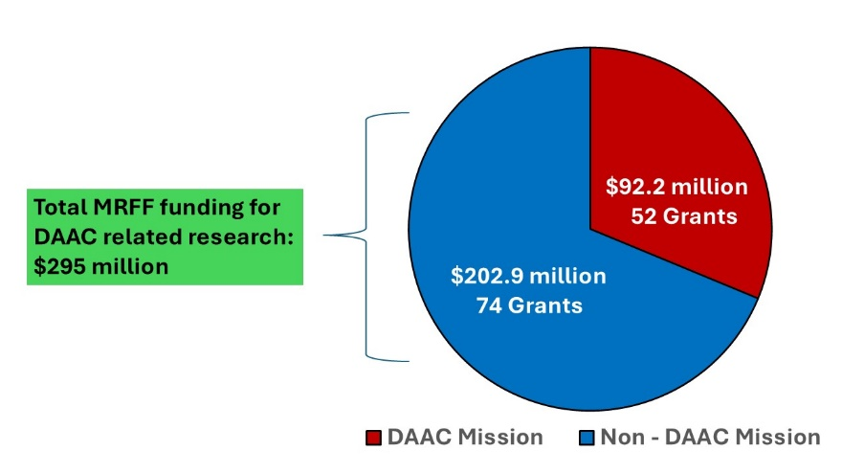

Source: Desktop scan

5.2.2 DAAC investments over time

The yearly breakdown of MRFF funding for DAAC research through the Mission and non-Mission initiatives from 2018–2024 is provided in Figure 10. There is a general increasing trend in investments in DAAC research over time, with the exception of 2020 when funding was redirected from the Mission as part of an MRFF-wide Coronavirus Research Response investment.

Figure 10. MRFF funding for DAAC research through Mission and non-Mission initiatives, and total MRFF by year, based on data current to 20 August 2024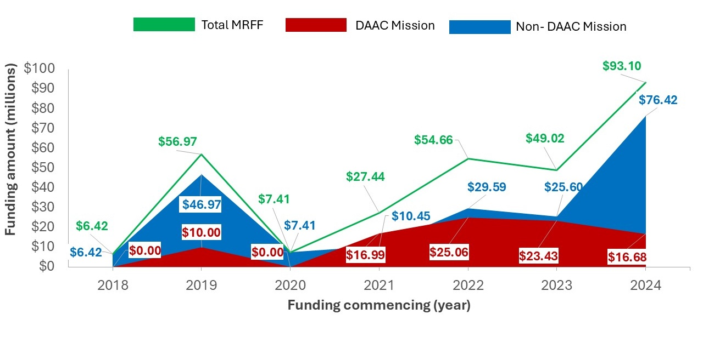

Source: Desktop scan

Of note, the sharp increase in funding for DAAC research in 2024 is due to a $50 million grant from Medical Research Commercialisation initiative (non-Mission initiative) awarded to Brandon Biocatalyst, a collaborative initiative of the venture capital firm Brandon Capital, to develop the CUREator+ Dementia and Cognitive Decline incubator – see Box 2 below for more information on this.

Box 2. Overview of the CUREator+ Dementia and Cognitive Decline Program

|  |
| --- |
| CUREator+ Dementia & Cognitive Decline Program[39]  The CUREator+ Dementia and Cognitive Decline program is one of several programs funded under the MRFF Medical Research Commercialisation initiative (non-Mission initiative). This national incubator program aims to accelerate the translation and commercialisation of promising early-stage Australian innovations that will prolong or improve the lives of Australians currently living with dementia and cognitive decline and the caregivers who support them.   * The $50 million CUREator+ Dementia and Cognitive Decline grant was awarded to Brandon BioCatalyst, in partnership with ANDHealth and Dementia Australia, under the MRFF 2023 BioMedTech Incubator - Dementia and Cognitive Decline Grant Opportunity. * The partnership brings together Brandon BioCatalyst, managed by Australia’s leading biomedtech investment firm Brandon Capital, ANDHealth, Australia’s leading digital health organisation, and Dementia Australia, the national peak body for people impacted by dementia and cognitive decline in Australia, to deliver an impactful program that addresses the funding and expertise gaps of research translation and commercialisation.   About the Program   * Small and medium enterprises (SMEs) developing novel research discoveries and health solutions addressing dementia and cognitive decline can apply to the CUREator+ Dementia and Cognitive Decline program to receive non-dilutive grant funding of up to $5 million.   + Eligible projects include the development of biomarkers, diagnostics, therapeutics (novel or repurposed), assistive and medical devices, and digital health technologies.   + Projects must have commercial potential and may be from early-stage research development to real-world clinical and commercial impact.   + Applications entail a multi-stage process with evaluation from expert investment review and advisory committees with strong, diverse, local and international experiences in dementia and cognitive decline, pharma, IP, business development, venture capital, clinical and R&D across multiple health and technology areas. A community steering committee led by Dementia Australia integrates the lived experience insights and ensures projects address the breadth of patient, carer and workforce needs.   + Opportunities are assessed on their clinical and commercial differentiation, IP position, market opportunity, maturity and development stage with the aim that CUREator+ funding will progress the opportunity to a de-risking and value-adding inflection point. * Under the CUREator+ Dementia and Cognitive Decline program, successful SMEs are provided access to the following benefits[40]:   + Significant non-dilutive grant funding of up to $5 million per project.   + Hands-on support, mentorship and commercial guidance to design milestone-based programs that achieve technically and commercially relevant milestones aligned with stage-gated funding.   + Dedicated project management team and access to the Brandon BioCatalyst, ANDHealth and Dementia Australia teams and networks.   + Several training initiatives providing opportunities for skills development and supporting researchers, founders and entrepreneurs to drive the development of their assets.   + International expert networks.   + Connections to pharmaceutical companies, local and international venture capital firms and institutional investors. * In addition, SMEs will be positioned for partnering or supported to secure follow-on investment capital critical to drive their continued development and commercialisation of their innovation.   Why it stands out   * The CUREator+ Dementia and Cognitive Decline is a national incubator dedicated specifically to supporting targeted medical research commercialisation for innovations with the potential to treat, manage or slow progression of dementia and cognitive decline. * There are other grant sources that provide dementia, ageing and aged care research funding, however, the CUREator+ Dementia and Cognitive Decline program fills an important key gap by providing translationally focussed funding coupled with developmental and commercialisation expertise, which will help build a pipeline of innovative solutions to improve outcomes for people living with dementia and cognitive decline. * The CUREator+ Dementia and Cognitive Decline program design provides several benefits beyond grant funding for research translation, including expertise support for scientific, clinical and commercial development and access to local and international networks. * Using a milestone-driven funding approach, the CUREator+ program is designed to nurture and mature SMEs and ensures accountability and delivery of translational focused outcomes. This unique incubator model increases the likelihood of successful follow-on investment and/or partnerships by de-risking and maturing early-stage innovations. * By aligning funding incentives and progress, the CUREator+ program aims to cultivate a thriving local ecosystem of innovation and entrepreneurship dedicated to tackling the escalating global issue of dementia and cognitive decline. |

5.2.3 Research investment by jurisdiction

Across all grants, the largest proportion of MRFF investment in DAAC research has been awarded to lead organisations based in Victoria (VIC), receiving $123.4 million. This is followed by NSW with $76.4 million and Queensland (QLD) with $42.3 million (Figure 11). To 20 August 2024, no lead organisations in the Northern Territory (NT) have received MRFF funding for DAAC research.

Figure 11. MRFF funding in DAAC research by states and territories, showing breakdown by Mission and non-Mission initiatives, based on data current to 20 August 2024[41] [42] 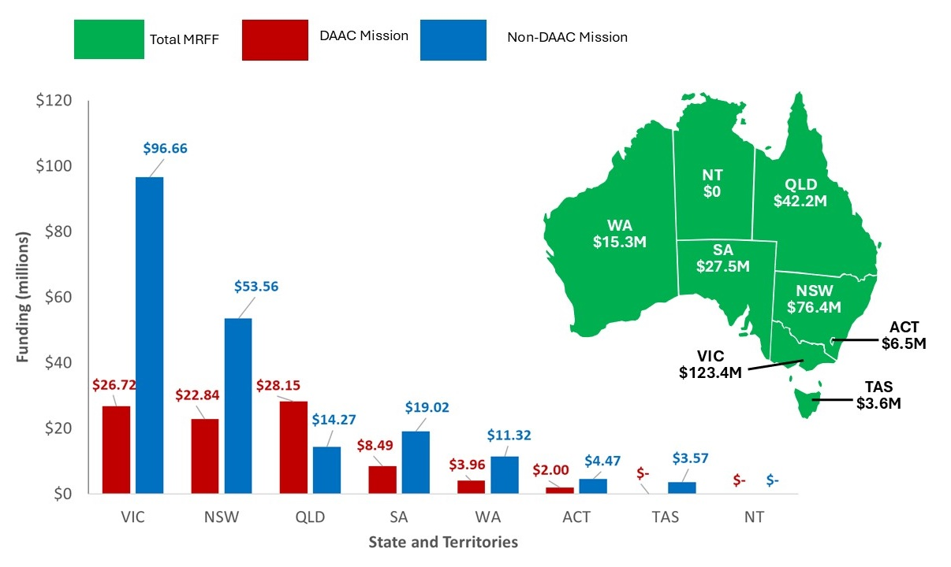

Source: Desktop scan

5.2.4 Research investment by institution type

MRFF funding for DAAC research has been awarded to a range of lead organisations including universities, medical research institutes and various non-academic organisations. Universities have received the greatest proportion of overall (73.1%), Mission (97.5%) and non-Mission MRFF DAAC funding (62%) (Figure 12).

The larger proportion of funding to non-academic organisations through non-Mission initiatives may be attributed to a single grant worth $50 million, awarded to Brandon Capital through the 2023 Biomed Tech Incubator in the Medical Research Commercialisation Initiative (see Box 2).

Figure 12. MRFF investment in DAAC research by type of research organisation, based on data current to 20 August 2024

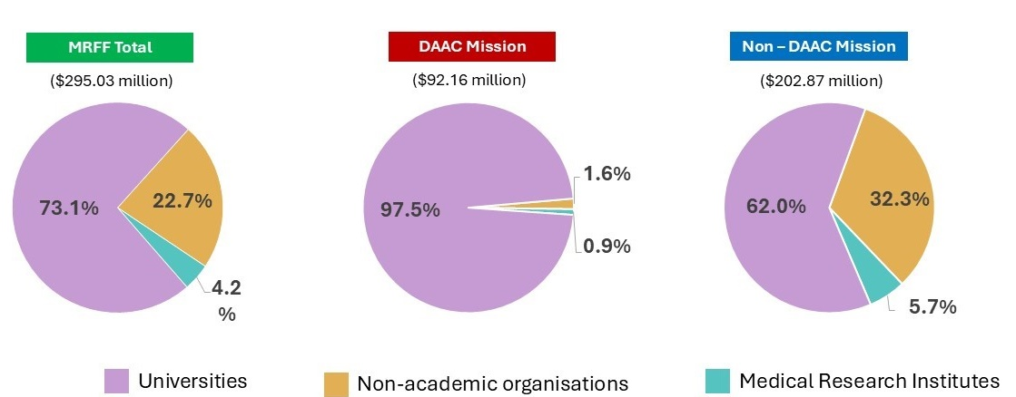

*Source: Desktop scan*

5.2.5 MRFF funding schemes investing in DAAC research

The distribution of MRFF funding for DAAC research spans both the Mission and a range of non-Mission initiatives. As illustrated in Figure 13 the Mission accounts for 31.2% of total MRFF investment in this research area, representing the single largest contributor.

This is followed by the Medical Research Commercialisation initiative, which accounts for 16.9% of the total MRFF investment in DAAC research. This initiative supports projects with commercial potential, including the development of novel or repurposed drugs, medical devices, and digital health technologies, from proof-of-concept through to clinical implementation.

MRFF investment in this field has been delivered through various grant models (Figure 13). The Targeted Call for Research model accounts for most funding, representing 94.7% of all MRFF investment in DAAC research. Smaller proportions were awarded through the Accelerator (4.0%), Incubator (1.1%), and Innovation (0.3%) models.

All MRFF grants in this area have been awarded through competitive processes, with the exception of three non-competitive grants awarded in 2019 – one under the Mission and two under non-Mission initiatives.

Stakeholders strongly supported improved coordination between MRFF and other funders – such as NHMRC, state and territory agencies, and NGOs – to reduce duplication, ensure a strategic balance across research types, and support translation along the full pipeline from discovery through to implementation.

|  |
| --- |
| *“Australia has world-class researchers, but greater coordination is needed to ensure that funding is used strategically and that research efforts are more integrated across the sector.”*  **Stakeholder from an Australian research organisation** |

Figure 13. Distribution of Mission and non-Mission research funding across MRFF grant models and initiatives, based on data current to 20 August 2024[43]

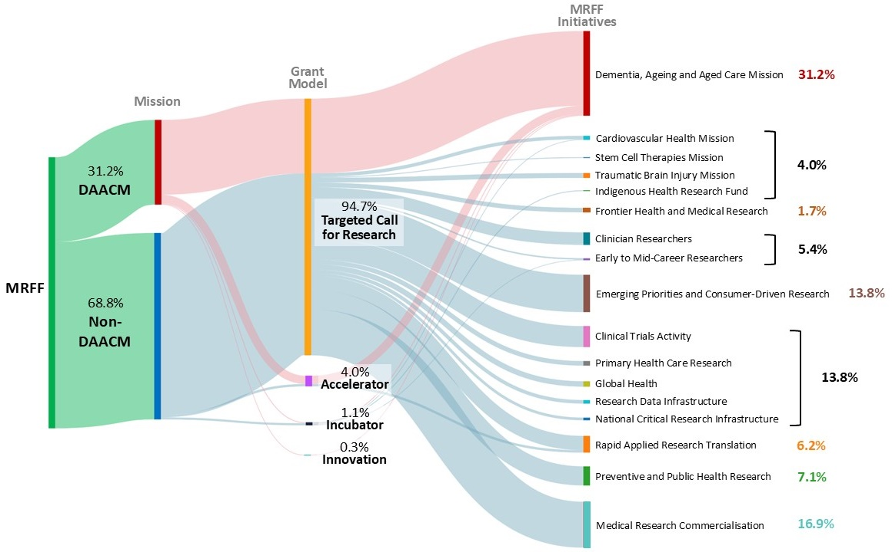

*Source: Desktop scan*

5.3 Funding distribution and strategic alignment of MRFF-funded DAAC research

5.3.1 Funding allocation and research focus across the areas of DAAC

The Mission targets three inter-related research areas: dementia, ageing, and aged care. Analysis of administrative data on Mission funding allocation shows clear prioritisation among these areas, with notable overlaps between them. Of the total $92.2 million in DAAC funding awarded under the Mission (to 20 August 2024) (Figure 14):[44] [45]

* **$55.0 million** (29 grants) supported dementia research
* **$31.4 million** (18 grants) supported ageing research
* **$17.8 million** (14 grants) supported aged care research

Some projects addressed more than one research area. Specifically:

* $6.1 million (5 grants) focused on both dementia and aged care
* $4.3 million (2 grants) covered both dementia and ageing
* $1.7 million (2 grants) spanned ageing and aged care

Because of these overlaps, the proportional breakdown of funding is not mutually exclusive[46]. Calculated against the total investment, approximately:

* **60%** of funding was directed toward dementia research
* **34%** toward ageing research
* **19%** toward aged care research

These proportions closely mirror the distribution of funding across the Mission's priority areas for investment (Table 9). As shown in Figure 16, approximately 61% of invested funds were directed to dementia-related priorities (1.1, 1.2, 1.3), 23% to ageing-related priorities (2.1, 2.2, 2.3), and 16% to aged care (Priority 3.1). While the classification methods differ, with Figure 14 based on a manual review of project titles, public summaries and funding round objectives, and Figure 16 based on alignment to predefined priority areas (Table 9), the similarity in proportional investment suggests a consistent emphasis on dementia research across both thematic focus and strategic funding intent.

Figure 14. Mission investment across research areas, based on data current to 20 August 2024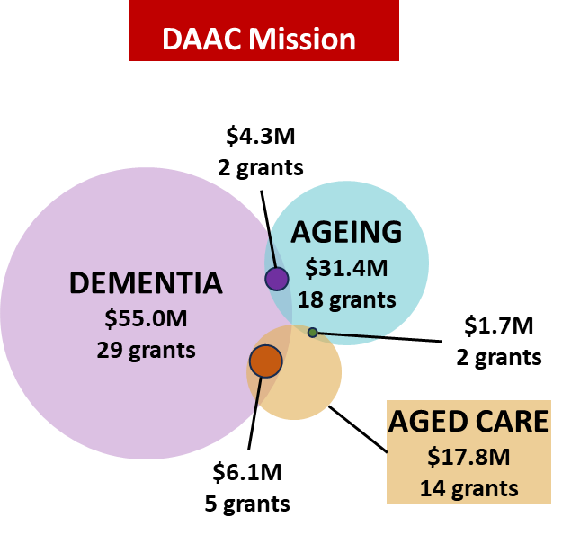

Source: Desktop scan

To complement this funding classification, the Chief Investigator A (CIA) of funded Mission and non-Mission projects within scope of this Review also self-reported the thematic focus of their projects. Overall, the distribution of thematic focus was relatively balanced, with approximately one-third of projects focused on each stream: dementia (34%), ageing (32%), and aged care (35%) (Figure 15).

Figure 15. Research project alignment with research areas as reported by project CIA

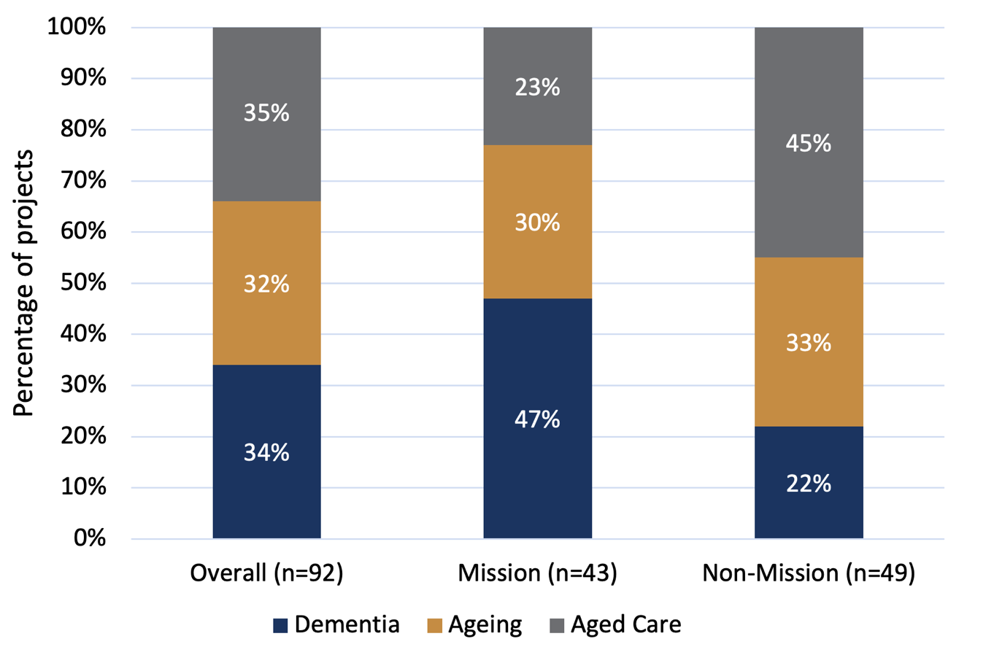

*Source: Grantee survey*

However, the focus varied notably between Mission and non-Mission projects.

* Mission grants were more strongly oriented towards dementia, with 47% of projects reporting this as their primary focus, compared with 22% of non-Mission projects.
* Non-Mission projects had a higher concentration in aged care (45%) compared with Mission projects (23%).
* The proportion of projects focused on ageing was broadly similar across both funding types (30% for Mission and 33% for non-Mission).

These complementary analyses suggest that while the Mission maintains a sharper emphasis on dementia research, non-Mission funding is making a substantial contribution to research in aged care and ageing, supporting the broader MRFF-funded DAAC research ecosystem.

5.3.2 Investment patterns, strategic alignment with Mission priority areas for investment and stakeholder perspectives on future directions

The Mission covers three aims and seven priority areas for investment (Table 9).

Table 9. Missions aims and priority areas for investment

|  |  |
| --- | --- |
| Mission aim | Mission priority areas for investment |
| **Aim 1: Achieve measurable improvements in detection, prevention, assessment, care and support for people living with dementia** | **Priority area 1.1**  Determine and implement interventions that prevent or delay the onset of dementia symptoms pre- and post-diagnosis.  **Priority area 1.2**  Implement care approaches for people with dementia and their carers that provide reliable and robust strategies to manage the impact of dementia on wellbeing, quality of life and end of life.  **Priority area 1.3**  Implement care and diagnostic pathways that improve timeliness and diagnosing dementia. |
| **Aim 2: Achieve measurable improvements in health life expectancy among older Australians** | **Priority area 2.1**  Discover and implement health and medical interventions in mid-life and beyond that will extend healthy, active years of life and compress the period of morbidity  **Priority area 2.2**  Conceive and encourage implementation of new ways to embed more proactive health management, including health literacy, for older people.  **Priority area 2.3**  Develop interventions that address social, economic, and cultural barriers to healthy ageing to reduce inequality in healthy life expectancy in Australia. |
| **Aim 3: Achieve measurable improvements in consistency and quality of care for older Australians across all care settings** | **Priority area 3.1**  Investigate and support implementation or adoption of new or existing models of care that are most effective in:   * delivering high-quality, culturally appropriate care, informed by life experience, in home and residential aged care settings, that support individuals and their informal/ family carers, and promote and protect the human rights of older people * ensure equitable and appropriate access to quality clinical care and minimise avoidable transitions between all care settings * identify and implement ways to maximise medical, nursing and allied health impact, including palliative care and end of life care * identify and implement ways to maximise social inclusion and multigenerational engagement in long-term care settings |

*Source: Mission implementation plan*

Funding data for the Mission (as at 20 August 2024) shows the investment has been distributed across its three research areas of dementia, ageing, and aged care (Figure 14). Reflecting the broader trend of higher Mission investment in dementia research, more than 60% of Mission funding to 20 August 2024 ($56.14 million across 28 grants) has been allocated to priorities 1.1 to 1.3 (Figure 16)[47].

Figure 16. Percentage of Mission funding mapped to Mission aims and priorities, based on data current to 20 August 2024

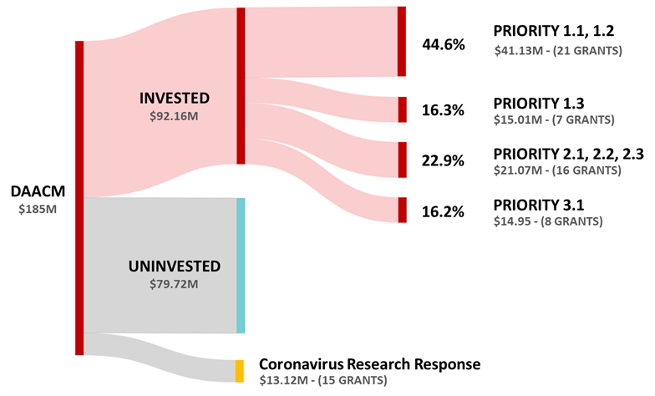

*Source: Desktop scan*

Complementing the administrative data funding classification (Figure 16), CIA-reported data from grantee surveys indicate broader alignment across Mission and non-Mission funded projects[48] (Figures 17 and 18). Overall, grantees report that MRFF-funded DAAC research projects are distributed across all Mission aims and almost all priority areas for investment. As shown in Table 10 and Figure 17, the largest proportion of projects (40%) aligned with Aim 3, which focuses on improving the consistency and quality of care across all settings for older Australians. Within this aim, the most commonly cited priority areas for investment were models of care that deliver culturally safe care (15%) and those that maximise medical, nursing, and allied health impact (15%).

Projects also aligned with Aim 2 (32%), focused on extending healthy life expectancy, and Aim 1 (27%), targeting dementia prevention, diagnosis, and care. No projects identified the development of models that maximise social inclusion and multigenerational engagement (Priority 3.1d) as a primary focus, though two indicated it as a secondary focus (Figure 18).

The distribution of focus areas also varied for Mission and non-Mission projects. Mission projects were more concentrated in priority areas for investment related to dementia care and diagnostic pathways, particularly Priority 1.3, while non-Mission projects were more likely to focus on aged care models, including Priority 3.1a (high-quality, culturally safe care) and Priority 3.1c (maximising medical and allied health impact) (Figure 17).

When both primary and secondary focus areas are considered (Figure 18), nearly half of all projects (49%) align with Priority 3.1, indicating a strong collective emphasis on models of care – particularly those that support integration, quality, and multidisciplinary approaches in aged care.

Although administrative investment data and CIA self-reports differ in scope and classification, both indicate alignment with all three Mission aims, while highlighting variations in the level of emphasis placed on specific priorities. Notably underrepresented areas include:

* Priority 3.1(d): Models that maximise social inclusion and multigenerational engagement in long-term care settings – no projects reported this as a primary focus, and only two as a secondary focus.
* Priority 1.1: Interventions that prevent or delay the onset of dementia symptoms (pre- and post-diagnosis) – received the largest proportion of investment (44.6%) yet was less frequently identified by CIAs as a primary research focus.

Table 10. Grantees self-reported primary focus of MRFF-funded DAAC research projects (Mission and non-Mission)

| **Mission aims and priority areas for investment** | **Projects** |
| --- | --- |
| **Aim 1: Achieve measurable improvements in detection, prevention, assessment, care, and support for people living with dementia** | **25 (27%)** |
| 1.1 Interventions that prevent or delay the onset of dementia symptoms (pre- and post-diagnosis) | 8 (9%) |
| 1.2 Care approaches for people with dementia and their carers to improve wellbeing, quality of life, and end-of-life outcomes | 7 (8%) |
| 1.3 Care and diagnostic pathways to improve the timeliness of dementia diagnosis | 10 (11%) |
| **Aim 2: Achieve measurable improvements in healthy life expectancy among older Australians** | **30 (32%)** |
| 2.1 Health and medical interventions in mid-life and beyond to extend healthy, active years and compress the period of morbidity | 13 (14%) |
| 2.2 Proactive health management approaches, including health literacy, for older people | 10 (11%) |
| 2.3 Interventions that address social, economic, and cultural barriers to reduce inequality in healthy life expectancy | 7 (8%) |
| **Aim 3: Achieve measurable improvements in consistency and quality of care for older Australians across all care settings.**  3.1 Models of care that: | **37 (40%)** |
| Deliver high-quality, culturally safe care^, informed by life experience, in home and residential aged care settings, supporting individuals and their informal/family carers | 14 (15%) |
| Ensure equitable and appropriate access to quality clinical care and minimising avoidable transitions between care settings | 9 (10%) |
| Maximise the impact of medical, nursing, and allied health care | 14 (15%) |
| Maximise social inclusion and multigenerational engagement in long-term care settings | 0 (0%) |

*Source: Grantee survey*

Figure 17. Self-reported primary focus of MRFF-funded DAAC studies, by Mission and non-Mission[49]

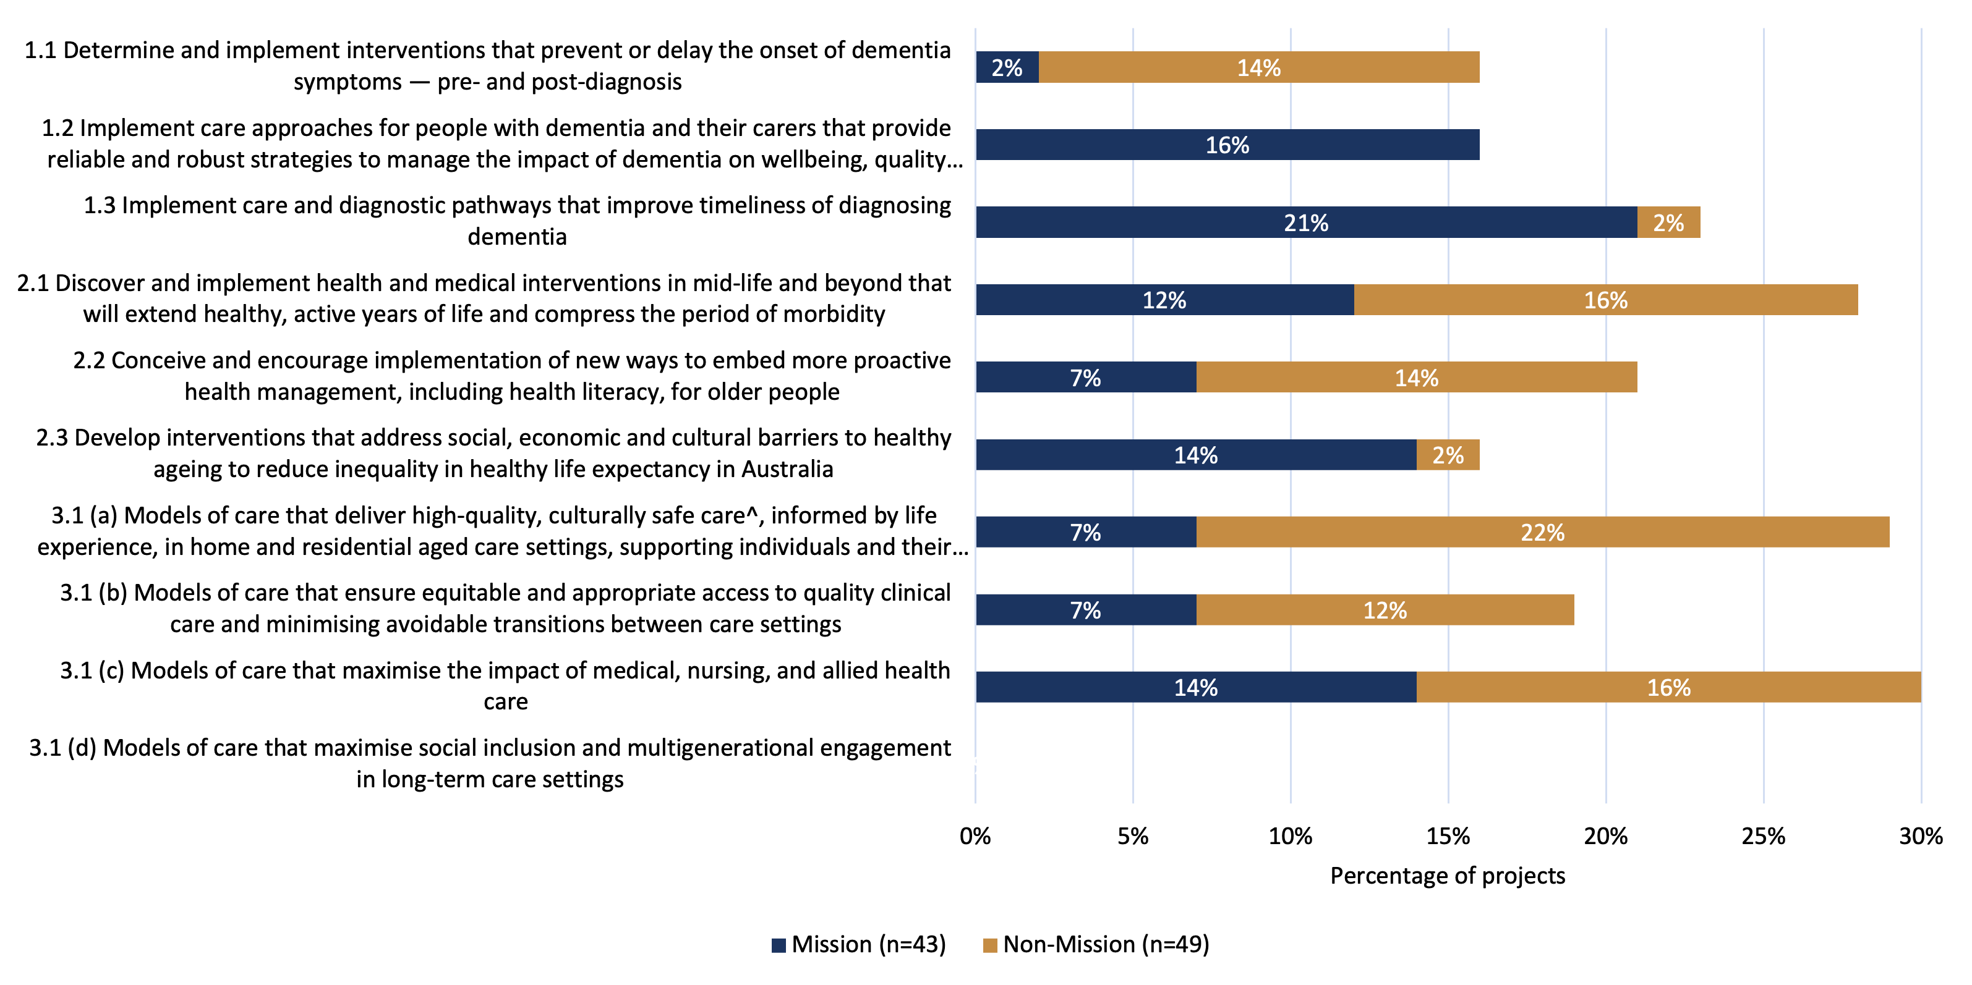Source: Grantee survey

Figure 18. Self-reported primary and secondary focus of MRFF-funded DAAC studies, across all grants in scope[50]

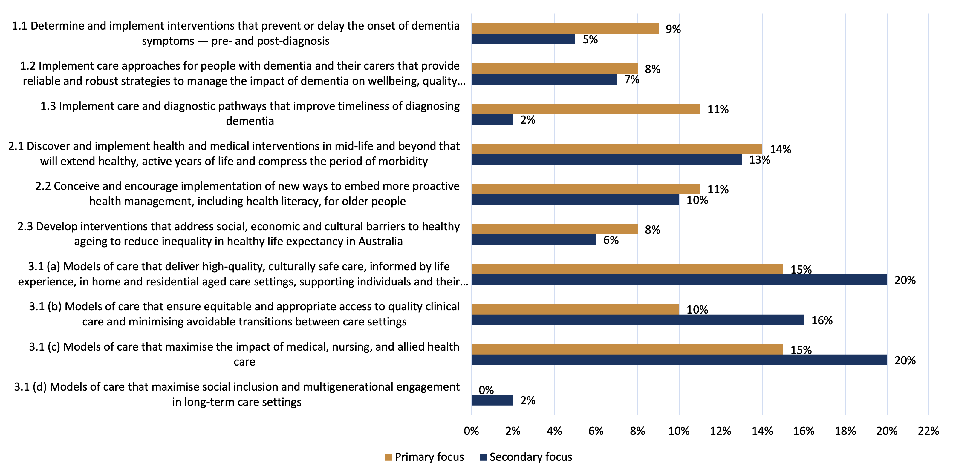

*Source: Grantee survey*

In parallel, stakeholder interviews and survey responses revealed nuanced views about how well current funding reflects contemporary system and population needs. Many participants welcomed the MRFF’s investment in DAAC research but identified several areas where funding could be better targeted to reflect evolving needs, policy settings, and gaps in the evidence base.

A consistent theme across interviews was the need for greater clarity around the Mission’s strategic focus and scope. Many participants questioned whether dementia should be treated as distinct from ageing and aged care, particularly given that dementia risk factors emerge in mid-life and are not exclusively linked to older age. Consumer advocacy groups emphasised a need to reinforce a lifespan approach to dementia risk reduction, with several suggesting changes to the Mission’s aims to reflect this. In contrast, some research institutions and aged care providers advocated for a broader focus on aged care system reforms, workforce development, and service delivery innovation – arguing that the balance of funding has leaned too heavily toward dementia. Across these perspectives, stakeholders cautioned against over-defining boundaries, noting that greater clarity is important for practical purposes, such as funding applications, but that the interconnectedness of DAAC must be preserved to avoid reinforcing silos.

Stakeholders also called for stronger alignment between the Mission’s priorities and current system and policy reforms. There was broad agreement that the research priorities set in 2019 need to be updated in light of recent policy and system developments. While specific research opportunities arising from the new Aged Care Act (to be introduced in July 2025) are yet to be fully identified, the findings of the Royal Commission into Aged Care Quality and Safety and the National Dementia Action Plan have already highlighted a number of priority research areas (see Boxes 3 and 4).

Box 3. Key Royal Commission into Aged Care Quality and Safety (2021)[51] recommendations of relevance to the Mission and future priorities

| Royal Commission into Aged Care Quality and Safety |
| --- |

|  |
| --- |
| In developing future strategic directions for the Mission, decision makers may wish to consider the below areas which were specifically identified in recommendation 107 as those that should be supported through research grants:   * Research into, and innovation in, the delivery of aged care, including through co‐funding arrangements with industry and aged care providers, and through workforce‐related research and technology * Research into the socioeconomics of ageing * Research into, and innovation in, the prevention and treatment of ageing‐related health conditions. |

Box 4. Dementia Action Plan[52] actions and associated areas that are of relevance to the Mission and future priorities

|  |
| --- |
| Dementia Action Plan |
| In shaping future strategic directions, decision-makers may wish to consider the following areas for research investment, as identified in Action 8 (Improve dementia data, maximise the impact of dementia research), as areas that could be supported through the Mission:   * Research to prevent dementia, enable earlier and more accurate diagnosis, develop effective treatments, and improve comprehensive models of care for all types of dementia. * Research initiatives that better coordinate national efforts and embed the voices of people living with dementia and their carers in setting research priorities. * Research to deepen understanding of the experiences of people with dementia from First Nations communities, culturally and linguistically diverse backgrounds, and other underrepresented groups. * Research into innovative approaches for collecting and using dementia data, such as clinical quality registries and other emerging methods. * Research that strengthens the use of linked data across health, aged care, and social care to inform policy, improve service planning, monitor progress, and evaluate outcomes across the dementia care and support system. |

Participants highlighted the risk of investment being spread too thin and called for more targeted funding focused on high-impact areas – such as prevention, treatment development, early diagnosis, and workforce models – rather than small-scale grants dispersed across many topics. A strong focus on prevention was emphasised, including in grantee survey responses.

|  |
| --- |
| *“Prevention is key – as a greater number of people move into the older adult bracket, we simply don't have the health budget to only focus on treatment once people are unwell.”*  ***Stakeholder survey respondent*** |

Table 11 below summarises stakeholder feedback on each of the Mission’s three aims, highlighting specific research priorities and areas where investment could be refined.

Table 11. Stakeholder feedback on the Mission’s three aims and priorities

|  |  |
| --- | --- |
| Mission aim | Feedback on Mission aims and priorities |
| Mission Aim 1: Achieve measurable improvements in detection, prevention, assessment, care and support for people living with dementia | * Strong support for prevention and early detection tools (e.g. AI, biomarkers), with caution raised around privacy and bias. * Call for updated investment to reflect emerging treatment options, including support for large-scale clinical trials. * Emphasis on underfunded areas such as post-diagnostic care, carer support, management of dementia-related behavioural issues in residential and community settings, palliative care, social isolation and stigma reduction. |
| Mission Aim 2: Achieve measurable improvements in healthy life expectancy among older Australians | * Noted overlap with Aim 1 in relation to prevention, particularly for managing multiple long-term conditions. International evidence supports a shift towards interdisciplinary, holistic approaches to healthy ageing. |
| Mission Aim 3: Achieve measurable improvements in consistency and quality of care for older Australians across all care settings | * Strong support for research supporting the new Aged Care Act and implementation of quality frameworks. * Workforce development was highlighted as an urgent need, including new models of care, better support for allied health, and strategies to manage workforce shortages and burnout. * Research into ageing-in-place, home-based supports, and technology-enabled care was also prioritised. |

*Source: Grantee survey, stakeholder survey, stakeholder interviews*

|  |
| --- |
| *“…more attention needs to be placed on helping Australia's population to age well (not just on care for people with dementia) by improving their health and wellbeing. By doing this it would likely decrease the number of people who develop dementia (or at least slow the trajectory of decline) AS WELL AS reducing risks for chronic diseases, loneliness, mental disorders and frailty, and increase social and economic participation by older people in society.”*  **Grantee survey respondent** |

|  |
| --- |
| *“[There is] Failure to fully utilise various allied healthcare professionals (e.g. exercise physiologists) and/or upskill other relevant HCPs to deliver high quality services, care and support for older people, those with chronic conditions and their carers.”*  ***Grantee survey respondent*** |

5.3.3 Contribution of MRFF-funded DAAC research along the research translation pipeline

Consistent with the MRFF’s focus on translational and applied research, the majority of DAAC projects are positioned towards the later stages of the research translation pipeline, as determined by CIA self-report. As shown in Figure 19, nearly two-thirds (62%) of projects are focused on finalising products or applications for imminent use in clinical, policy, community, or commercial contexts. A further 17% are engaged in early applied research, while 11% are at the stage of full clinical or market translational research. Very few projects are situated at the beginning of the pipeline, with just 4% classified as basic science, and 5% not clearly aligned to a specific stage. These self-reported data from CIAs reflect the MRFF’s role in funding research that is closer to implementation and real-world application.

Figure 19. Placement of MRFF-funded research in DAAC along the research translation pipeline

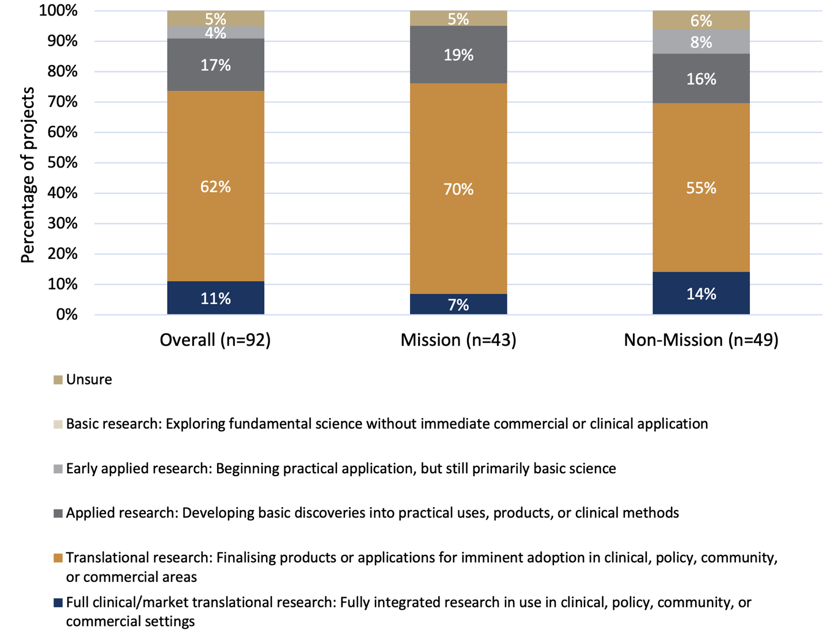

Source: Grantee survey

This pattern is reinforced by administrative data on broad research areas (Table 12). Mission funding was concentrated in health services research (50%) and public health research (21%), with no investment recorded in basic science research. In contrast, NHMRC funding in DAAC was primarily directed to clinical medicine and science (45%) and basic science research (22%). These complementary roles highlight the Mission’s unique position in bridging the gap between discovery and application and ensuring that innovations are translated into real-world outcomes.

Table 12. Comparisons of Mission, non-Mission and NHMRC funding across broad DAAC research areas

| Broad Research Area | % DAAC Mission Funding | % Non-DAAC Mission Funding | % NHMRC Funding |
| --- | --- | --- | --- |
| Basic Science Research | 0% | 1% | 22% |
| Clinical Medicine and Science Research | 18% | 24% | 45% |
| Health Services Research | 50% | 14% | 16% |
| Public Health Research | 21% | 5% | 17% |
| Not Available | 11% | 57% | n/a |

*Source: Desktop scan*

The World Health Organization’s Decade of Healthy Ageing (2021–2030)[53] framework is a global strategy that prioritises four interconnected action areas – combatting ageism, creating age-friendly environments, delivering integrated care, and ensuring access to long-term care – to improve the lives of older people. To assess MRFF alignment with these global goals ​CIAs were also asked how their work aligns with the WHO’s Healthy Ageing Framework. As shown in Figure 20, nearly 70% of respondents (64 out of 92) reported a focus on health system quality improvements, particularly in relation to integrated or long-term care for older Australians. Smaller proportions reported alignment with WHO priority areas such as access to long-term care (15%), age-friendly environments (12%), and combatting ageing (5%). Thirteen per cent of respondents indicated that their work did not align with any of the listed WHO categories. This demonstrates consistency with other findings in the Review: research efforts are largely directed towards strengthening aged care systems and are aligned with the Mission’s aims of improving outcomes for older Australians.

Figure 20. Alignment of MRFF-funded DAAC research with WHO Healthy Ageing Framework action areas[54]

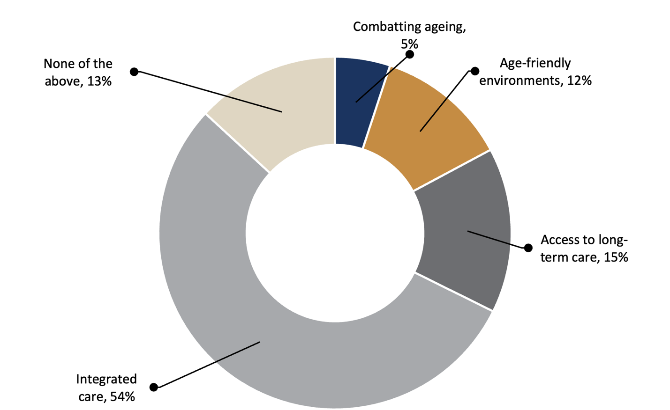

*Source: Grantee survey*

5.4 Who contributed to and participated in MRFF DAAC investments

5.4.1 Aboriginal and Torres Strait Islander researchers’ involvement in MRFF-funded DAAC research

Survey findings indicate that the involvement of Aboriginal and/or Torres Strait Islander researchers in MRFF-funded DAAC research remains limited. Seventeen of the 92 (18%) survey respondents reported participation by Aboriginal and/or Torres Strait Islander researchers or organisations.

Where involvement was reported, it was most commonly through advisory roles, with 14 of the 17 projects including Aboriginal and/or Torres Strait Islander representation on advisory groups. More substantive leadership roles were less common; Aboriginal and/or Torres Strait Islander researchers were named investigators on two-thirds of these projects (11 projects) and served as Chief Investigator A or Lead Investigator in six projects. Ten projects reported Aboriginal and/or Torres Strait Islander peoples participation in setting research priorities and co-design, while 10 involved Aboriginal and/or Torres Strait Islander researchers in the dissemination of findings and 5 in the translation of research into practice (Figure 21).

Figure 21. What roles Aboriginal and/or Torres Strait Islander researchers have had in MRFF-funded dementia, ageing and aged care research?[55]

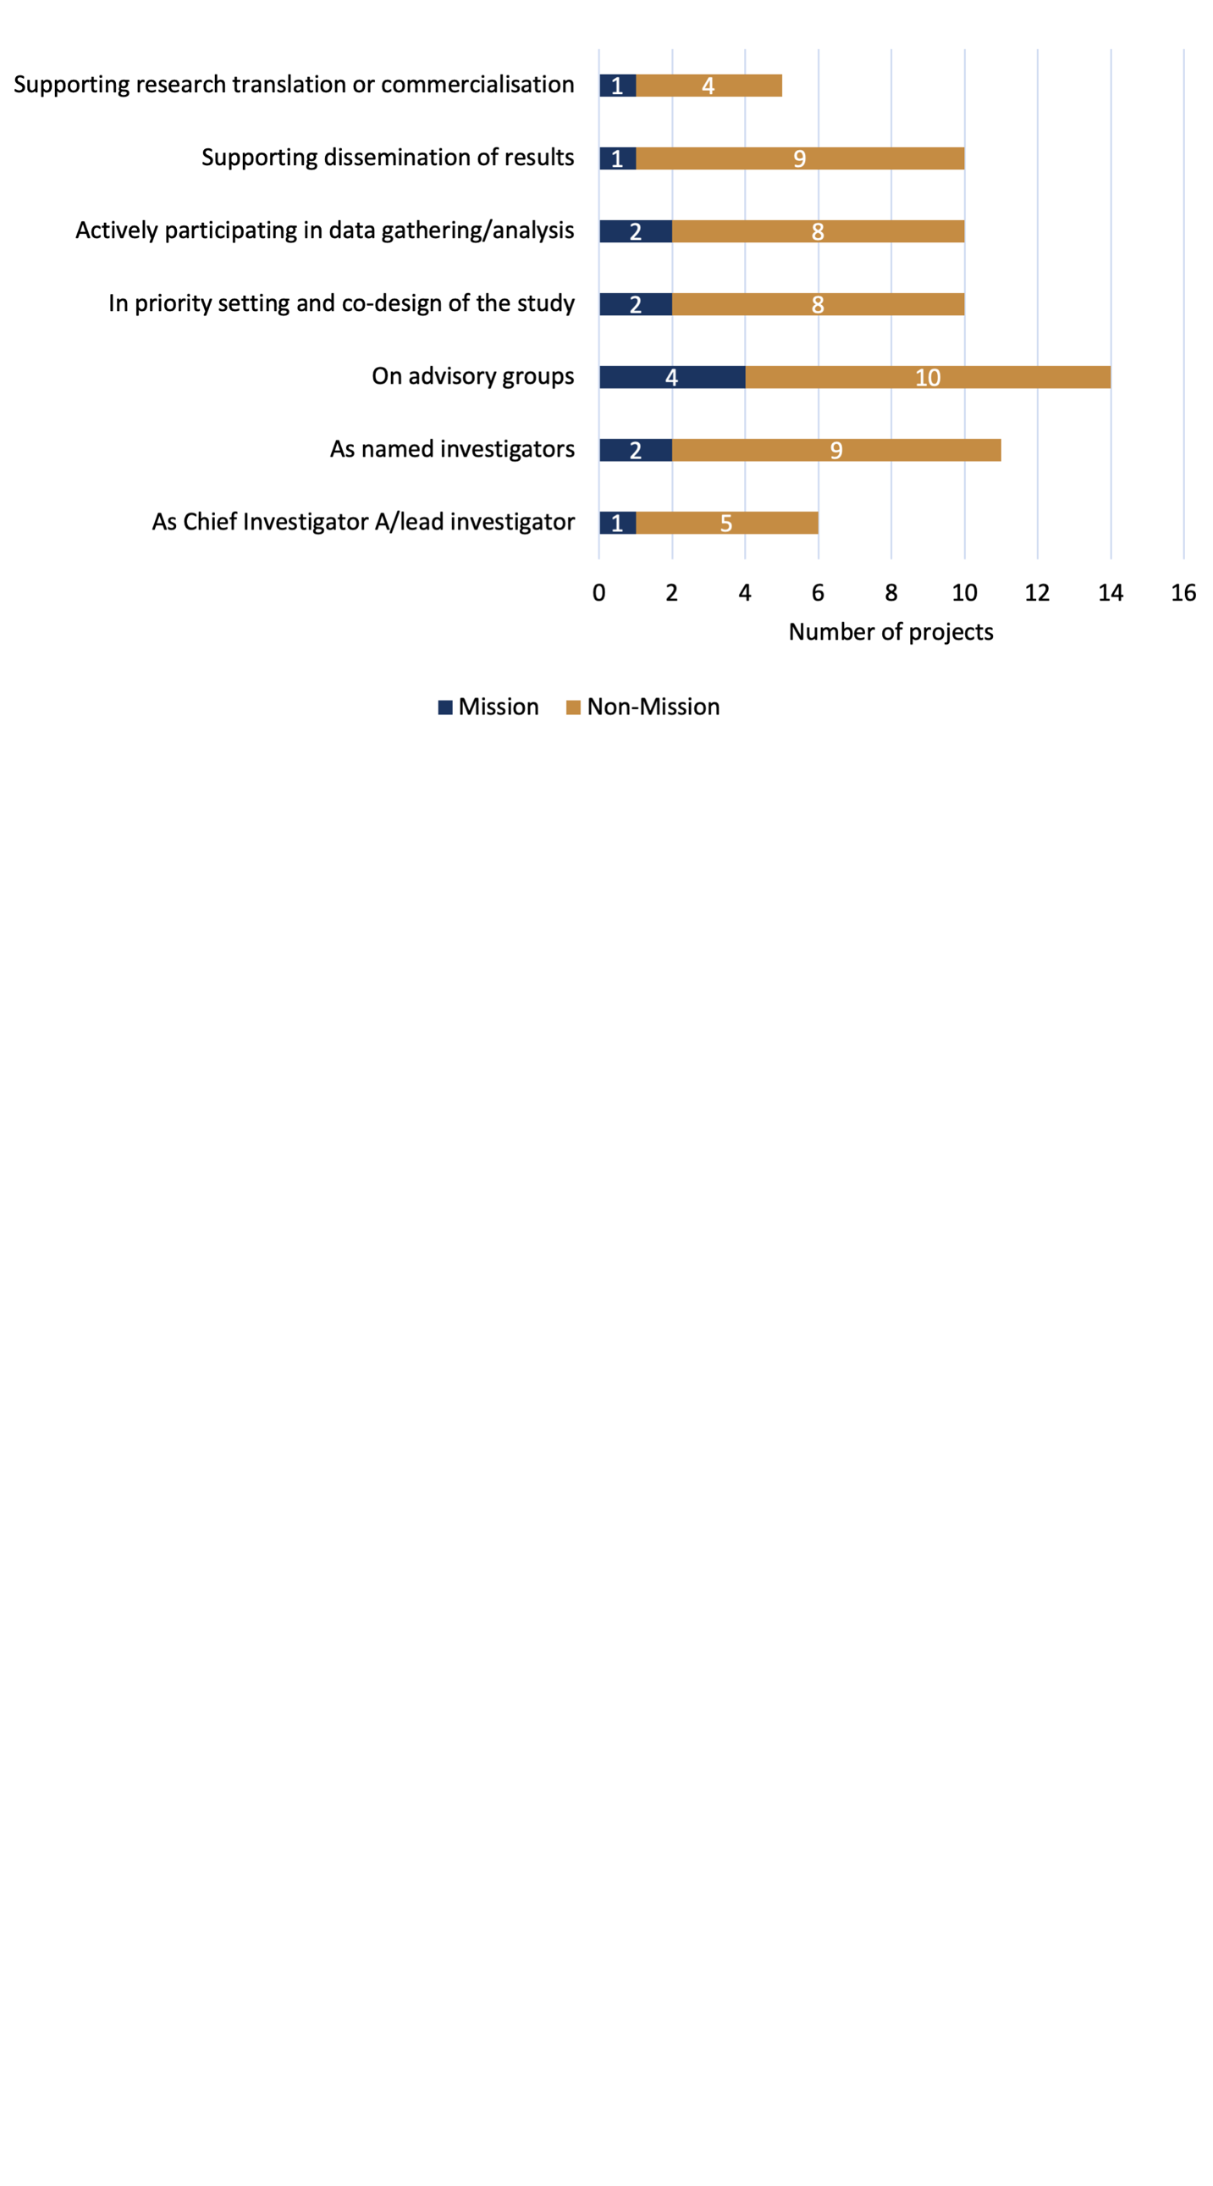

*Source: Grantee survey*

Stakeholders echoed the survey findings, highlighting that Aboriginal and Torres Strait Islander leadership remains limited and fragmented in MRFF-funded DAAC research. While some projects have demonstrated promising practice, including roles in co-design and research translation, there was consensus that that this level of involvement is not yet the norm. Stakeholders from Aboriginal and Torres Strait Islander organisations called for structured funding pathways that require Aboriginal and/or Torres Strait Islander researchers and leadership on relevant projects, alongside mechanisms for cultural supervision and long-term sustainability.

|  |
| --- |
| *“You know, I think we could be much better at actually getting things implemented if we gave greater control, including administering the research funding, to community-controlled organisations. If you give it to an academic institution [...] they're researchers, they come up with their hypothesis and their own model of care, which is totally divorced normally from these innovative models [already in communities]."*  **Stakeholder from an Aboriginal and/or Torres Strait Islander organisation** |

Community-led research was viewed as essential – not only for building trust, but for ensuring culturally safe approaches that reflect the collective, family-based care models central to many communities. Across all groups, Aboriginal and Torres Strait Islander stakeholders emphasised that meaningful involvement must extend beyond consultation to include community control, transparent data governance, and long-term investment.

Stakeholders emphasised that research involving Aboriginal and/or Torres Strait Islander peoples must uphold Indigenous data sovereignty[56] and cultural intellectual property[57]. This includes ensuring communities have control over how data is collected, used and shared, and that cultural knowledge is protected and safeguarded. Co-design and Indigenous governance were seen as essential to conducting ethical, impactful, and culturally safe research.

|  |
| --- |
| *“Culturally safe and community-led aged care models are essential, as Western approaches do not align with the collective, family-based care structures of Aboriginal and Torres Strait Islander communities.”*  ***Stakeholder from Aboriginal and Torres Strait Islander organisation*** |

5.4.2 MRFF priority populations involvement in DAAC research

The Mission identifies 10 priority populations to ensure inclusive and equitable research. Encouragingly, around three-quarters of MRFF-funded DAAC research projects report involvement of at least one priority population (Figure 22), reflecting growing attention to inclusive research practices across both Mission and non-Mission initiatives.

The most frequently involved groups were people living in rural or remote areas, those from CALD backgrounds, and Aboriginal and Torres Strait Islander communities (Figure 22). Notably, much of this inclusion has been driven by non-Mission initiatives, which are playing an important role in supporting the Mission’s intent to address equity and priority populations.

However, some Mission priority populations remain underrepresented. These include carers, veterans, people with lived experience of homelessness, parents separated from their children by forced adoption or removal, prisoners or ex-prisoners, and individuals from LGBTI communities (Figure 22). While a small number of projects have begun to engage with these groups, there is clear scope to broaden and deepen involvement across the full spectrum of priority populations in future research efforts.

Stakeholders strongly supported the involvement of priority populations throughout the research process – not only as participants, but as active contributors and collaborators. While some groups such as Aboriginal and Torres Strait Islander peoples, CALD communities, and those in rural and remote areas have been included in MRFF-funded research projects, the nature of their involvement was often described as fragmented or superficial. Barriers to meaningful engagement included lack of culturally safe approaches, limited visibility of research opportunities in communities, unclear roles for contributors, and under-resourcing of sustained partnerships.

|  |
| --- |
| *“It [research] also needs relationship-building at the community level. Communities need to feel confident and understand what the research is really trying to deliver for them. Researchers sometimes come in without culturally informed strategies, creating barriers that exclude CALD communities from participating."*  **Stakeholder from a consumer advocacy group that focuses on CALD populations** |

Stakeholders highlighted that community organisations are often consulted but not embedded in governance or decision-making, and that opportunities for ongoing involvement remain limited. There were strong calls for more structured and inclusive models that enable communities to contribute to research design, implementation, and translation. This includes clearer expectations in funding guidelines, support for long-term partnerships, and greater recognition of the value of lived experience and community expertise in shaping relevant, equitable research.

This was particularly evident in discussions about Aboriginal and Torres Strait Islander peoples involvement. While 17 projects overall reported engagement with these communities, only five were funded through the Mission– highlighting an opportunity to strengthen the Mission’s role in supporting and embedding culturally safe and community-led research within future Mission investments.

|  |
| --- |
| *“Ensuring that Aboriginal and Torres Strait Islander people lead research on their own communities is critical. We’ve seen the impact of community-controlled models, like the dementia clinic in Perth, which saw 70 Aboriginal and Torres Strait Islander patients in two years, compared to just two at the mainstream memory clinic across the road. Delivering through community control enables better access to care and outcomes.”*  **Stakeholder from an Aboriginal and Torres Strait Islander organisation** |

Figure 22. Which Mission priority populations have been involved in MRFF-funded DAAC research?[58]

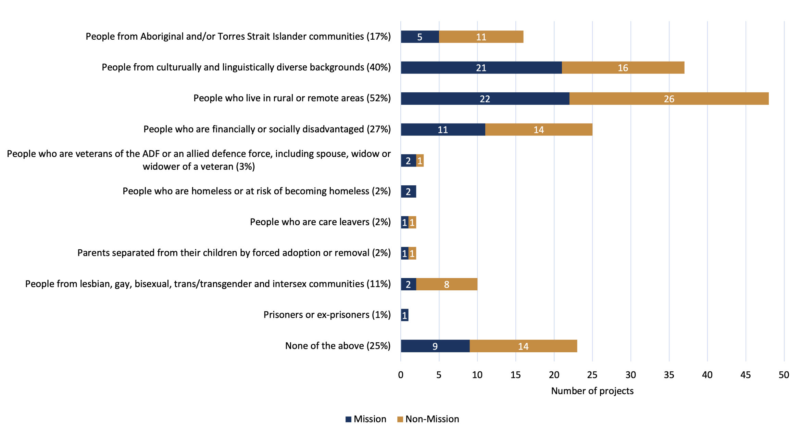 *Source: Grantee surve*

5.4.3 Research end-user involvement in MRFF-funded DAAC research[59]

Research end-user involvement in MRFF-funded DAAC research is widespread, with survey data indicating that most projects actively engaged multiple stakeholder groups. As shown in Figure 23, consumers were the most frequently involved end users, participating in 93% of projects (86 projects) – this is further explored below in section 5.4.4. Clinical providers (79%) and health and aged care organisations (77%) were also highly represented.

Around half of projects involved government agencies or policymakers (52%), consumer organisations (49%), and advocacy, non-government or peak bodies (49%). Fewer projects reported engagement with industry and commercial partners (27%) or Aboriginal and/or Torres Strait Islander organisations (11%).

While involvement was reported across a wide range of research end-users, the nature and depth of engagement varied considerably (Figure 24). Health and aged care organisations and clinical providers were most likely to have embedded, ongoing roles – frequently named as investigators and engaged across the full research lifecycle, from priority setting and co-design through to data collection, dissemination, and translation. Consumers, consumer organisations, and advocacy groups were more commonly involved in advisory roles. However, these groups were also regularly engaged in dissemination activities, supporting broader community reach and impact. This suggests both the value and potential for further strengthening these partnerships in the earlier stages of research design.

Industry and commercial partners were typically involved later in the research process, particularly in supporting translation and commercialisation. While this aligns with their expertise, it also highlights opportunities to foster earlier and more integrated research–industry collaboration to improve the pathway from discovery to impact.

Stakeholders echoed the importance of broad research end-user engagement in MRFF-funded DAAC research but expressed concern about the quality and consistency of this engagement. While high levels of engagement were welcomed, aged care providers, clinicians, and consumer groups reported that they are often included in project planning or grant applications but excluded from meaningful participation throughout the project. This disconnect was particularly evident among aged care providers, who frequently support research activities such as recruitment or intervention delivery but are not adequately resourced or recognised for their role.

|  |
| --- |
| *“We need to ensure that aged care providers are more than just research participants – we need to be part of shaping the research itself."*  **Stakeholder from aged care organisation** |

To address these gaps, stakeholders called for more structured partnerships and funding mechanisms that embed research end-users – including clinicians, service providers, and policy makers – as co-investigators and decision-makers from the outset. Embedding research end-users across all phases of the research process was widely viewed as critical to ensuring relevance, feasibility, and translation. Many proposed models for structured collaboration, including long-term advisory groups, dedicated policy engagement, and partnership criteria in grant assessment.

Figure 23. What research end-users have been involved in MRFF-funded DAAC research?

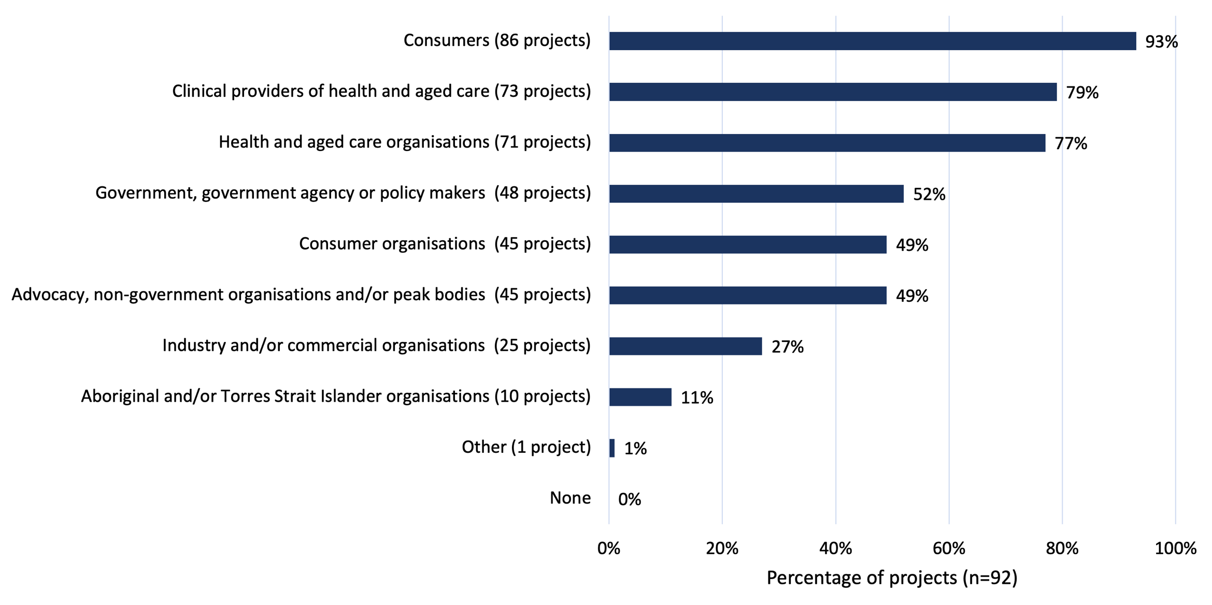

*Source: Grantee survey*

Figure 24. What roles have research end-users had in MRFF-funded DAAC research?

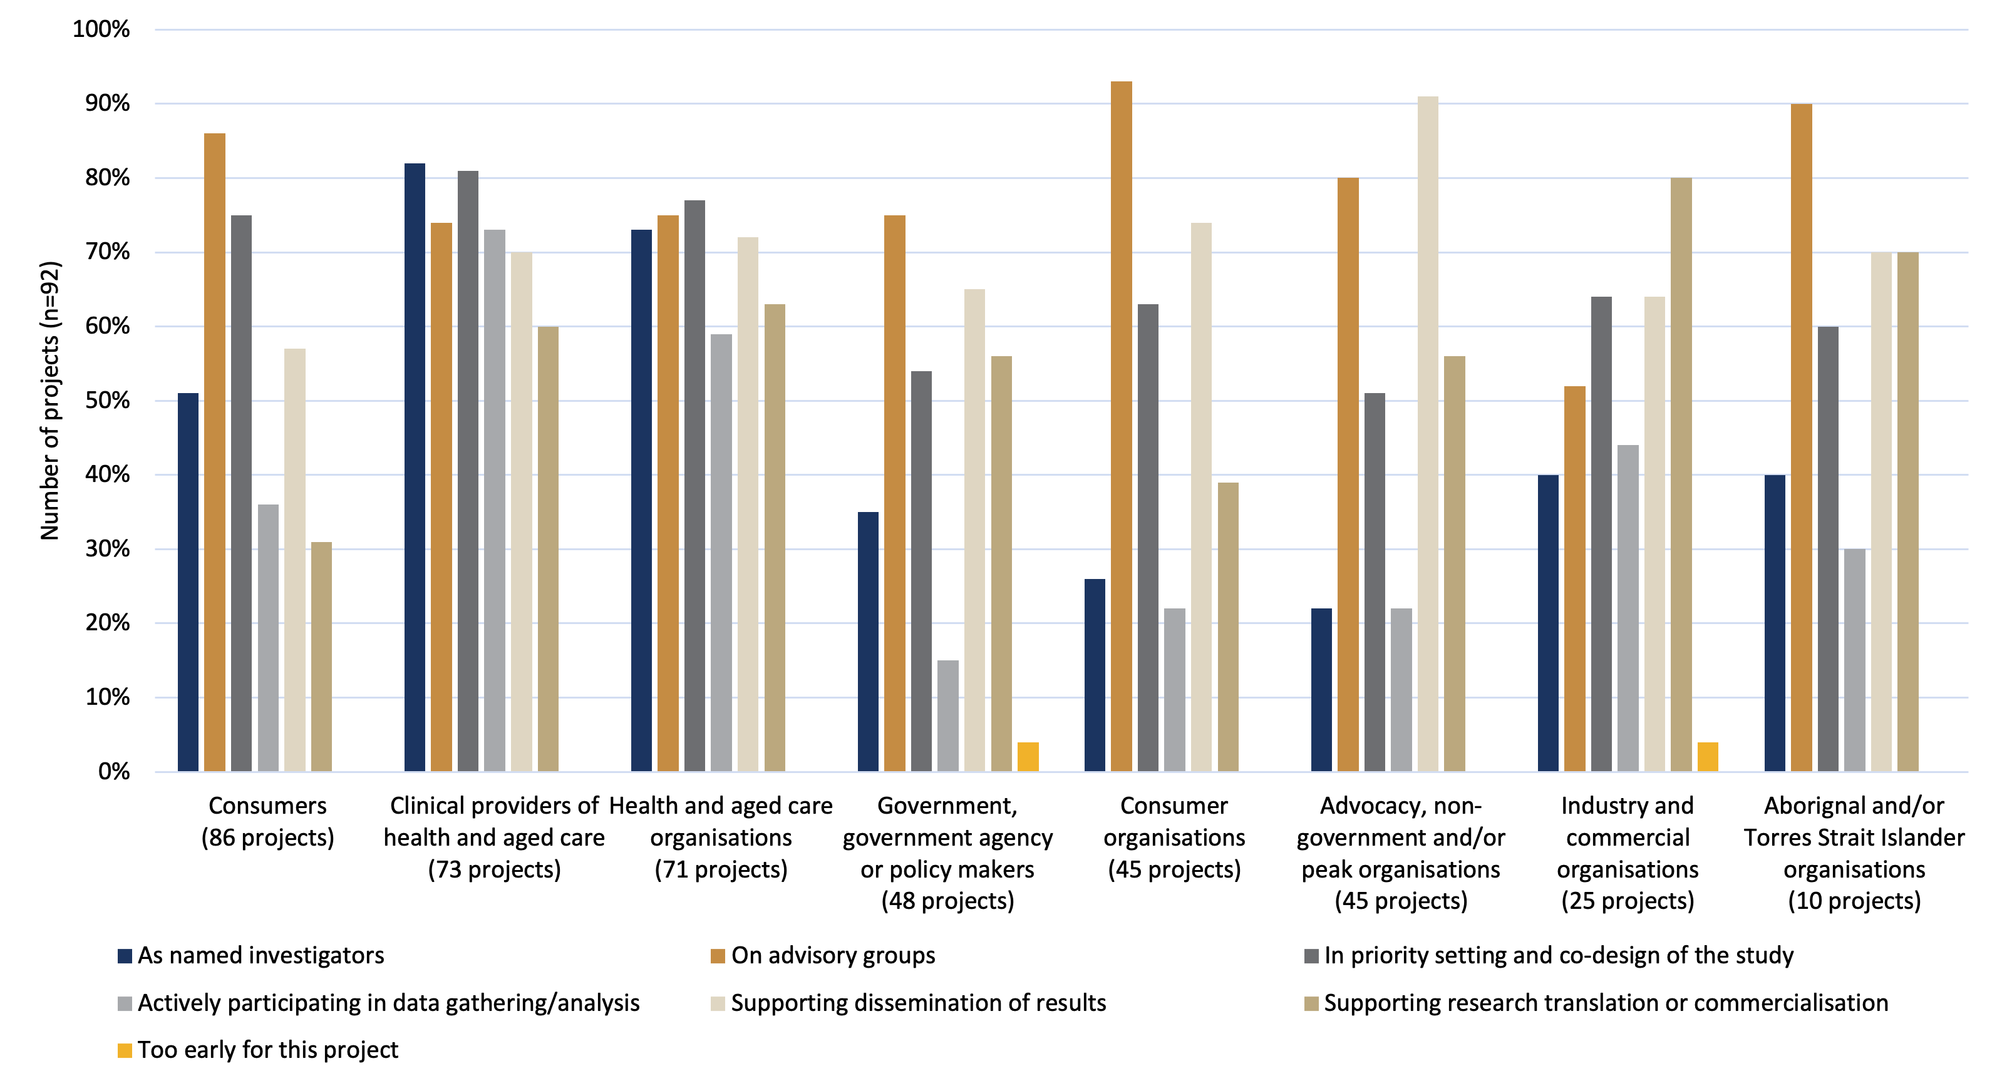

Source: Grantee survey

5.4.4 Consumer involvement in MRFF-funded DAAC research

Consumer involvement is a central feature of MRFF-funded DAAC research. A total of 93% of grantees (86 projects) surveyed reported some form of consumers involvement (Figure 23). However, the extent of consumer involvement varied.

As shown in Figure 25, nearly one-third of projects (30%) involved five or fewer consumers, while a similar proportion (29%) reported the involvement of 21 or more. This suggests that while consumer engagement is widespread, the depth and scale of involvement are highly variable across projects.

Figure 25. Number of consumers involved in MRFF-funded DAAC research projects

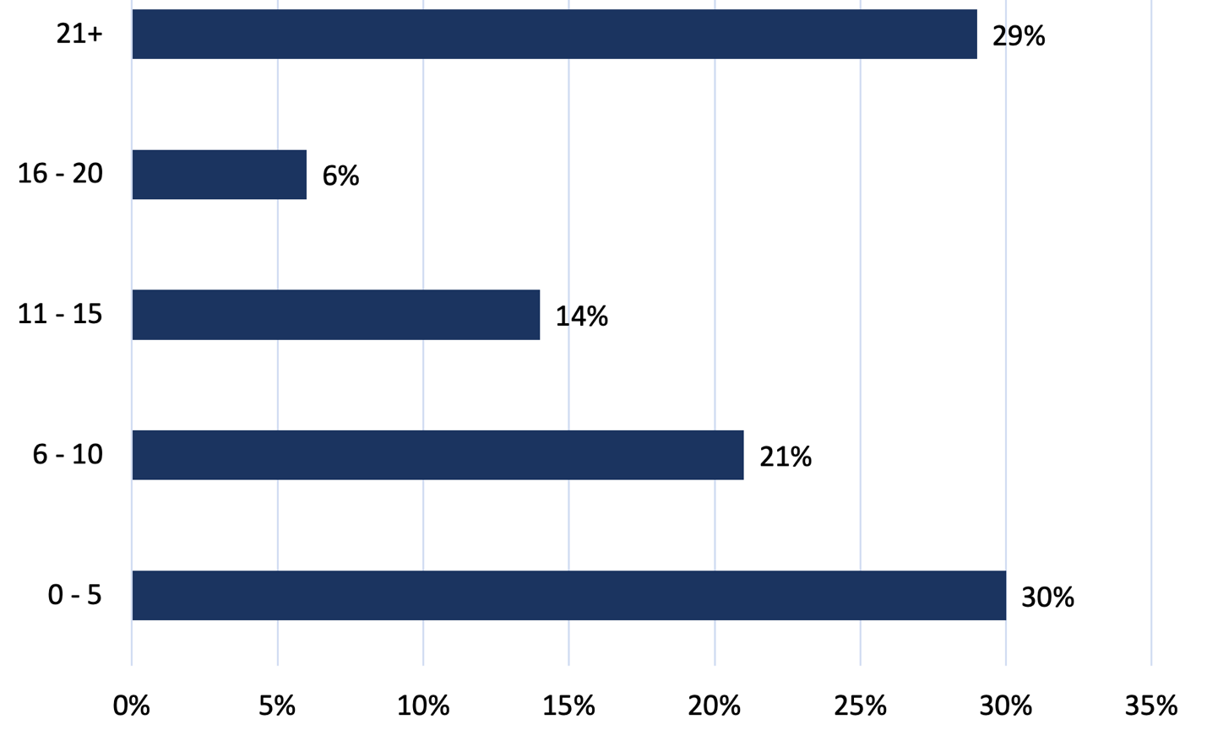

Percentage of projects (*n*=86)

*Source: Grantee survey*

While consumers were involved in the majority of projects, the nature of their participation varied. As shown in Figure 24, consumers were most commonly engaged as members of advisory groups (over 80%) or through active involvement in data collection and analysis (around 75%). However, fewer projects reported consumers being involved as named investigators (just over 50%), or in early-stage activities such as priority setting and co-design (around 35%). This suggests that while consumer engagement is widespread, there may be missed opportunities to embed consumers more deeply into project leadership and early design phases.

Stakeholders strongly endorsed consumer involvement as essential to ethical, relevant, and impactful research. However, stakeholders also emphasised that this involvement must be genuine and continuous – not tokenistic or front-loaded. Many consumers and advocacy groups described current practices as superficial, with limited influence over research priorities, methods, or dissemination.

|  |
| --- |
| *“Current engagement requirements can be vague or minimal. Clearer expectations and stronger accountability measures should be introduced.”*  **Consumer respondent** |

While these concerns highlight genuine issues, it is important to note that the MRFF has developed a formal set of principles for consumer involvement in research, which aim to embed meaningful and inclusive engagement across all stages of MRFF-funded DAAC research, as outlined in Box 5 below.

Box 5. Overview of Principles for consumer involvement in research funded by the MRFF

| Principles for consumer involvement in research funded by the Medical Research Future Fund[60] |
| --- |
| The MRFF has established a set of principles to guide and strengthen consumer involvement in the research it funds. These principles were developed by the MRFF Consumer Reference Panel, a group of individuals with diverse lived experiences, including as patients, carers, and members of underrepresented communities. The aim is to ensure that research funded by the MRFF is shaped by the voices and needs of the people it is intended to benefit.  The principles emphasise that consumer involvement should occur across all types of research – ranging from basic science to public health and clinical studies – and throughout all stages of the research process. This includes identifying priorities, designing studies, conducting research, and sharing results. Consumers are to be treated as equal partners in the research process, with recognition of their unique insights and contributions.  Meaningful involvement is supported through adequate time, resources, and training, both for consumers and researchers. The principles also highlight the importance of inclusive, culturally safe engagement that reaches priority populations, including Aboriginal and Torres Strait Islander peoples, people from rural and remote areas, and those with disabilities or from culturally and linguistically diverse backgrounds.  To support implementation, the MRFF has embedded consumer involvement into its grant assessment processes. Applicants are expected to explain how they will engage consumers, and a dedicated Consumer Involvement Statement is being piloted to enhance the visibility of these efforts.  Overall, these principles reflect a broader commitment by the MRFF to ensure that research is relevant, inclusive, and responsive to the community. |

Stakeholders identified opportunities to strengthen implementation of these principles. These included clearer guidance for researchers, structured reporting requirements, dedicated funding to support lived experience expertise (including appropriate compensation and recognition), and the mandatory inclusion of consumers in grant review panels.

|  |
| --- |
| *“If we want to get consumer engagement right, we need to fund it properly – dedicated funding for involvement, not just expecting it to happen. Paying people for their time, resourcing engagement, and embedding it as an essential part of the process.”*  **Consumer respondent** |

|  |
| --- |
| *“There are great models out there – some universities and institutes have consumer advisory groups that actively shape research before it even begins. Why can’t this be a standard for all MRFF grants?"*  **Consumer respondent** |

While these principles provide a strong foundation, some stakeholders noted that consumers involved in research are not always representative of underserved or marginalised communities. This highlights the importance of inclusive, culturally safe engagement approaches that actively reach priority populations and ensure diverse voices are embedded throughout the research process. As well, although these principles include guidance on best practice, such as appropriate compensation and recognition, these expectations may not be consistently implemented or well-communicated to researchers and consumer participants, suggesting a need for stronger support and clearer operationalisation within MRFF funding processes.

Together, these findings highlight both the strong foundation for consumer engagement across MRFF-funded DAAC research and the opportunity to improve consistency, depth, early-stage involvement and communication. Strengthening the implementation of MRFF’s principles, and ensuring representativeness and inclusivity in consumer partnership, will be important to ensuring research remains relevant, inclusive, and community informed.

5.4.5 Co-funding of MRFF-funded DAAC research

Many MRFF-funded DAAC research projects received supplementary support from other funding sources (Table 13). These co-funding contributions – provided as in-kind, cash, or a combination of both – came from a range of sectors including Commonwealth and state government departments, international funders, industry, philanthropy, and other contributors.

In total, 56 projects (47%) received co-funding from 71 sources. This included 29 Mission projects and 27 non-Mission projects.

The combined value of co-funding for all grants in scope totalled approximately $22.6 million, comprising $9.8 million in in-kind contributions, $11.9 million in cash, and $875,000 in combined in-kind and cash support.

* Mission-funded projects attracted $8.9 million in total, made up of $4.9 million in in-kind support, $3.4 million in cash, and $650,000 in combined contributions.
* Non-Mission projects reported $13.7 million in co-funding, including $4.9 million in-kind, $8.5 million in cash, and $225,000 in combined support.

Key sources of co-investment included:

* Industry, contributing over $5.9 million across both Mission and non-Mission projects.
* Philanthropy and not-for-profit organisations, providing $5.5 million, predominantly in cash.
* State and territory governments, supporting mostly non-Mission projects, with $1.2 million in contributions.
* A single international government funder contributed $3 million to a non-Mission project.
* Other sources collectively contributed more than $5.4 million, including both cash and in-kind support.

Table 13. Co-funding of Mission and non-Mission MRFF-funded DAAC research

| **Source of co-funding**[61] | **Mission / non-Mission** | **In-kind funding** | **Cash funding** | **Both in-kind and cash funding** | **Total** |
| --- | --- | --- | --- | --- | --- |
| **Commonwealth Department other than Health (including NHMRC and ARC) (*N*=3)** | Mission (*n*= 1) | $33,000 | n/a | n/a | $33,000 |
| Non-Mission (*n*= 2) | $52,000 | $350,000 | n/a | $402,000 |
| **State / territory government funding (*N*=13)** | Mission (*n*= 4) | $150,000 | n/a | n/a | $150,000 |
| Non-Mission (*n*= 9) | $1,147,596 | $60,000 | n/a | $1,207,596 |
| **International government funding (*N*=1)** | Mission (*n*=0) | n/a | n/a | n/a | n/a |
| Non-Mission (*n*= 1) | n/a | $3,000,000 | n/a | $3,000,000 |
| **Industry (*N*=21)** | Mission (*n*= 13) | $2,466,398 | n/a | n/a | $2,466,398 |
| Non-Mission (*n*= 8) | $3,498,683 | $1,000,000 | n/a | $4,498,683 |
| **Philanthropy / not-for-profit (*N*=12)** | Mission (*n*= 9) | $160,000 | $3,083,000 | n/a | $3,243,000 |
| Non-Mission (*n*= 3) | n/a | $2,000,000 | $225,000 | $2,225,000 |
| **Other (*N*=21)** | Mission (*n*= 9) | $2,084,227 | $300,000 | $650,000 | $3,034,227 |
| Non-Mission (*n*= 12) | $230,000 | $2,136,325 | n/a | $2,366,325 |
| **Totals** | Mission (*n*= 36) | $4,893,625 in total in-kind funding for Mission projects | $3,383,000 in total cash funding for Mission projects | $650,000 in both in-kind and cash funding for Mission projects | $8,926,625 in total co-funding for non-Mission projects |
| Non-Mission (*n*= 35) | $4,928,279 in total in-kind funding for non-Mission projects | $8,546,325 in total cash funding for non-Mission projects | $225,000 in both in-kind and cash funding for non-Mission projects | $13,699,604 in total co-funding for non-Mission projects |
| Overall | Total in-kind co-funding for MRFF-funded DAAC research: $9,821,904 | Total cash co-funding for MRFF-funded DAAC research: $11,929,325 | Total in both in-kind and cash funding for MRFF-funded DAAC research: $875,000 | **Total co-funding for MRFF-funded DAAC research: $22,626,229** |

*Source: Performance indicator survey data*

Stakeholders offered a mixed assessment on the extent to which MRFF has catalysed additional co-investment in DAAC research. While some examples of leveraged investment – particularly from NGOs and international partners – were cited, others expressed uncertainty about whether MRFF funding had systematically attracted private sector or philanthropic support.

Concerns were also raised that MRFF investment is not always strategically aligned with other potential funders, which may limit opportunities for complementary investment and reduce the likelihood of coordinated, large-scale collaboration. Some participants noted that partnerships formed around MRFF grants could feel compliance-driven rather than genuine, particularly when roles were not clearly defined or sustained throughout the project.

Despite these perceptions, data from the performance indicator survey shows that nearly half of MRFF-funded DAAC research projects reported co-funding, totalling over $22 million (Table 13). This suggests that MRFF investment is successfully attracting co-investment, although this may not always be visible or well understood by stakeholders.

While the Mission’s priorities are broadly aligned with those of national and international funders (Section 4.3.1), this alignment does not appear to be widely recognised by stakeholders and may not always be clearly communicated or visible in practice. To strengthen the perceived and actual impact of MRFF co-investment, stakeholders recommended clearer communication of co-funding outcomes and stronger accountability mechanisms to ensure partnerships are sustained and strategic. Improving the visibility of alignment with other national and community funding priorities may also help address stakeholder perceptions and promote greater coordination.

6. Progress and impact of MRFF-funded DAAC research

|  |
| --- |
| Review Question 3 – To what extent is there alignment[62] and progress of MRFF-funded dementia, ageing and aged care research?  **Scope**  In this chapter we detail the stage of completion of MRFF-funded DAAC research projects, followed by project progress towards the eight Mission evaluation benchmarks (evaluation measures), and the eight MRFF benchmarks (measures of success).  **Focus areas covered in this Review section are:**   * 6.2 Project completion stage of funded projects * 6.3 Progress towards Mission benchmarks (evaluation measures) * 6.4 Progress towards MRFF benchmarks (measures of success)   **Data sources used to answer this question:**   * Project progress was assessed through a document review of department data. * The Mission benchmarks (evaluation measures) were primarily assessed through the grantee survey. Insights about these Mission benchmarks (evaluation measures) were drawn from grantee and stakeholder surveys and interviews. * The MRFF benchmarks (measures of success) were primarily assessed by the performance indicator grantee survey data and through a document review of department data. Insights about these MRFF benchmarks (measures of success) were drawn from grantee and stakeholder surveys and interviews. |

6.1 Summary of findings and improvement   
opportunities

6.1.1 Key findings

* While individual projects are progressing at different stages, overall, it remains early days in demonstrating outcomes against the Mission benchmarks and MRFF benchmarks. As of March 2025, only 2% of Mission-funded projects and 18% of non-Mission projects had been completed, with most still in progress.
* The MRFF-funded DAAC research portfolio is on track to achieve the Mission and MRFF goals. Notable highlights include:
  + Most projects (62% of Mission-funded projects and 49% of non-Mission projects) are in the second half (late-stage) of their funding period. Research findings are expected to emerge over the coming years as these projects mature.
  + Good progress is evident across most areas, with the exception of certain Mission benchmarks, particularly those related to dementia diagnosis.
  + Progress against MRFF benchmarks is emerging, with the strongest reported outcomes relating to increased focus on areas of unmet need. This benchmark was the most frequently addressed, with 79% of projects reporting progress. Among these, 24% of Mission projects and 14% of non-Mission projects reported major progress. There is a clear and increasing focus on addressing areas of unmet need. This includes strong emphasis on dementia prevention, equitable care, ageing-in-place, and workforce development.
  + Approximately $7 million in co-funding from industry has been secured, with some promising early signs of commercialisation and innovative partnership models.

6.1.2 Improvement opportunities

Stakeholders identified several opportunities to improve the Mission’s impact over the next phase:

* The gap between research, policy and practice remains a key barrier to translation and impact.
* Some Mission benchmarks appear to be at risk and will require increased focus over the next five years, particularly:
  + **Benchmark 1:** Development of new diagnostic or prognostic tools for dementia
  + **Benchmark 2:** Improved utility and uptake of neuropsychological testing
  + **Benchmark 5:** Improved diagnostic approaches, deferred onset, and better quality of life for people living with dementia and their carers
* There is scope to strengthen clinician involvement in research, with current participation by general practitioners (2%) and medical specialists (5%) still limited.

6.2 Project completion stage of funded   
projects

6.2.1 Project completion stage across MRFF-funded DAAC research projects

To assess stage of completion across MRFF-funded DAAC research projects, data were drawn from grantee-submitted progress and final reports. As of March 2025, most Mission-funded projects (62%, *n* = 32 out of 52) were categories as late-stage, with only one project (2%) reported as complete. In contrast, among the 74 non-Mission projects, nearly half (49%, *n* = 36) were classified as late-stage, while 13 projects (18%) had reached completion (Figure 26).

Project completion stage was classified into four categories based on project status and available documentation:

* Planning – project within the first 6 months of their funding period, with no progress report available
* Early-stage – projects in the first half of their funding period, based on progress reports and milestone completion
* Late-stage – projects in the second half of the funding period, based on progress reports and milestone completion
* Complete – projects for which a final report had been submitted

For projects approximately midway through their funding period, milestone completion (as reported in the most recent progress report) was used as a proxy to determine whether they were best classified as early-stage or late-stage. While this method may not always perfectly reflect time elapsed, it provided a consistent and practical approach to classifying project stage based on available documentation.

Figure 26. Stage of completion of MRFF-funded DAAC research projects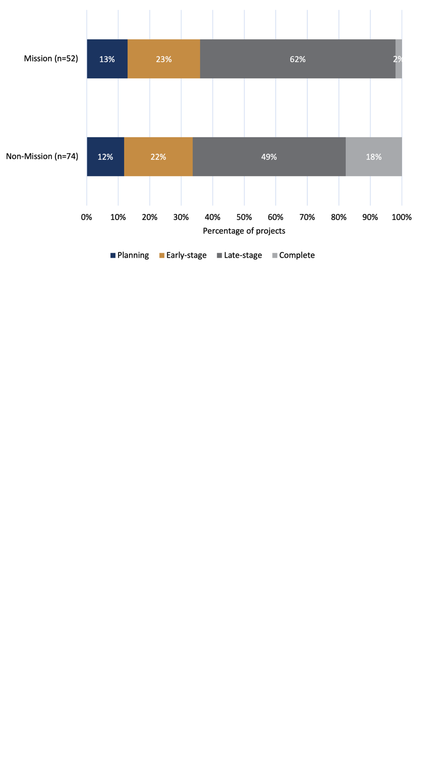

*Source: Document review (grantee progress and final reports)*

6.3 Progress towards Mission benchmarks (evaluation measures)

6.3.1 MRFF-funded DAAC research projects addressing the Mission benchmarks (evaluation measures)

Mission and non-Mission funded projects are addressing the eight Mission benchmarks (Table 14) at varying levels (Figure 27). While there are both Mission and non-Mission funded projects across all benchmark areas, with the exception of B2, which has only been addressed by a relatively small number of Mission funded projects, there are notable differences in both distribution of funding and the number of projects contributing to each benchmark.

Table 14. List of Mission benchmarks

|  |
| --- |
| Mission benchmarks |

|  |
| --- |
| * Benchmark 1 (B1). Development of new diagnostic or prognostic tools for dementia * Benchmark 2 (B2). Utility of neuropsychological testing improved, resulting in increased use by clinicians * Benchmark 3 (B3). New tools and strategies for improving quality of life for people living with dementia and their carers developed and implemented through guidelines, practice, or private partnerships * Benchmark 4 (B4). New tools and strategies for improving uptake of preventive activities developed and implemented through guidelines, practice, or private partnerships * Benchmark 5 (B5). Evidence of improved diagnostic approaches, deferred onset, and improved quality of life of people living with dementia and their carers * Benchmark 6 (B6). Increase in average healthy life expectancy and reduction of variability in healthy life expectancy * Benchmark 7 (B7). Key components of high-quality care identified and accepted for implementation by the aged care sector * Benchmark 8 (B8). New tools and tools and strategies for implementing the key components of high-quality care in short- and long-term residential care settings developed and implemented through guidelines, practice or private partnerships |

Across the benchmark areas, Mission projects tend to have made a stronger contribution in areas such as B3 (15 of 21 projects; 71%), B1 (5 of 7 projects; 71%), and B2 (4 of 4 projects; 100%). However, the absolute number of projects in these categories varies. For instance, while the Mission fully funds all B2 projects, the total number of projects in this category remains small, meaning its overall contribution to this area is currently limited.

Non-Mission funded projects contribute more substantially to B6 (9 of 15 projects; 60%) Meanwhile, benchmarks such as B4, 5, 7 and 8 are addressed more evenly by Mission and non-Mission funded projects.

These variations highlight that while the Mission is the primary contributor in most areas, non-Mission funding is meaningfully supporting progress toward the broader Mission benchmarks across nearly all benchmarks.

Figure 27. Number of projects addressing each of the eight Mission benchmarks (B1-B8) [63] [64]

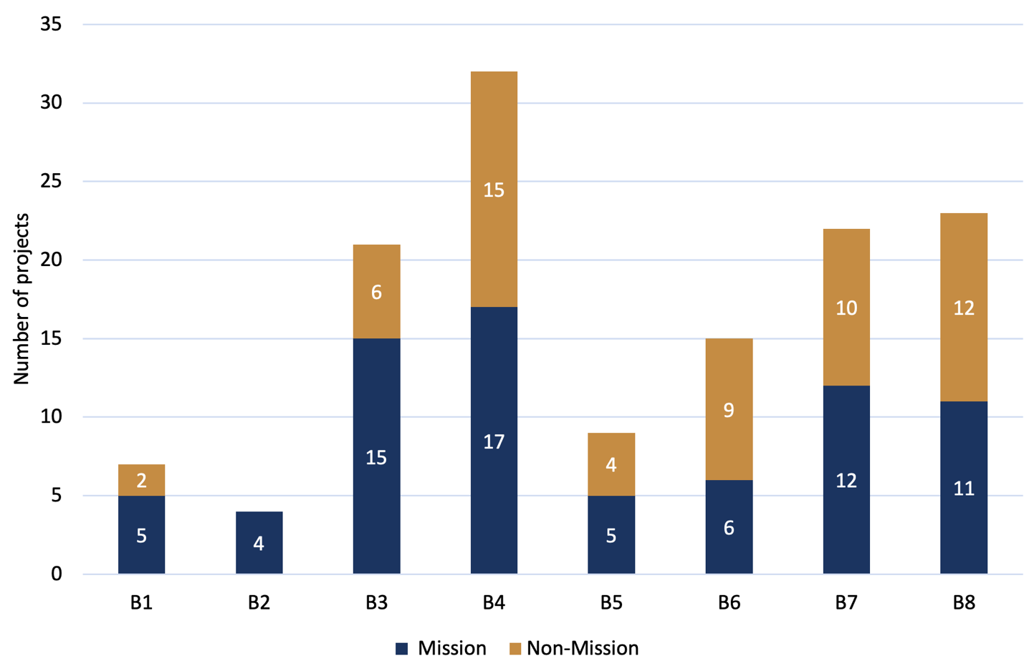

*Source: Grantee survey*

6.3.2 Stage of progress of MRFF-funded DAAC research towards each of the Mission benchmarks (evaluation measures)

Stage of progress towards the eight Mission benchmarks remains at an immature stage, with around 70% of MRFF-funded DAAC research projects either in the early stages or midway through achieving their aligned benchmarks (Figure 28). Only six projects reported having fully completed progress against any Mission benchmark:

* Three projects developed and implemented new tools or strategies to support high-quality care in short- and long-term residential aged care, through guidelines, practice changes, or partnerships with private providers.
* Two projects developed and implemented new tools or strategies to improve quality of life for people living with dementia and their carers.
* One project identified a key component of high-quality care that has been accepted for implementation by the aged care sector.

It is worth noting that nearly one-quarter (23%) of projects reported being close to completing their aligned benchmarks.

Stakeholders conveyed a cautiously optimistic view of the Mission’s progress towards achieving the desired outcomes, noting that while many projects are well into their funding period, few are complete, meaning tangible impacts are still emerging. Only a small proportion of MRFF-funded DAAC projects have reached completion (2% of Mission and 18% of non-Mission projects; see Section 6.2.1), with the remainder still underway.

To provide a more concise view of benchmark progress while retaining the richness of stakeholder feedback, Figures 28–30 summarise overall, Mission, and non-Mission project progress across all eight Mission benchmarks, while Table 15 synthesises stakeholder input on these benchmarks, highlighting key opportunities and concerns raised during interviews and survey responses.

Figure 28. Overall (Mission and non-Mission) project progress against Mission benchmarks63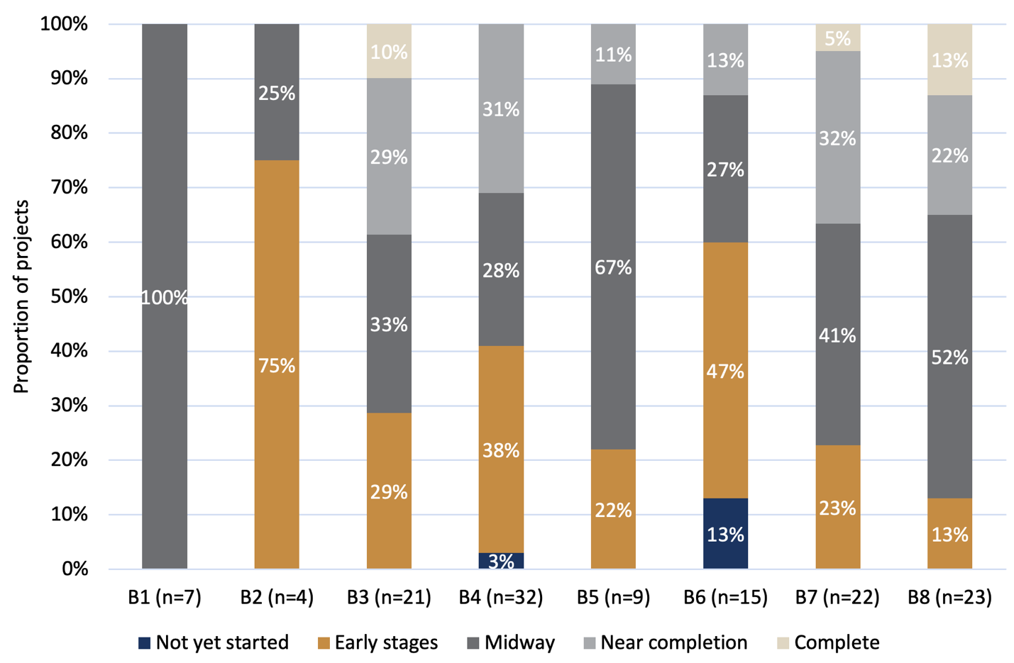

Source: Grantee survey

Figure 29. Mission project progress against Mission benchmarks63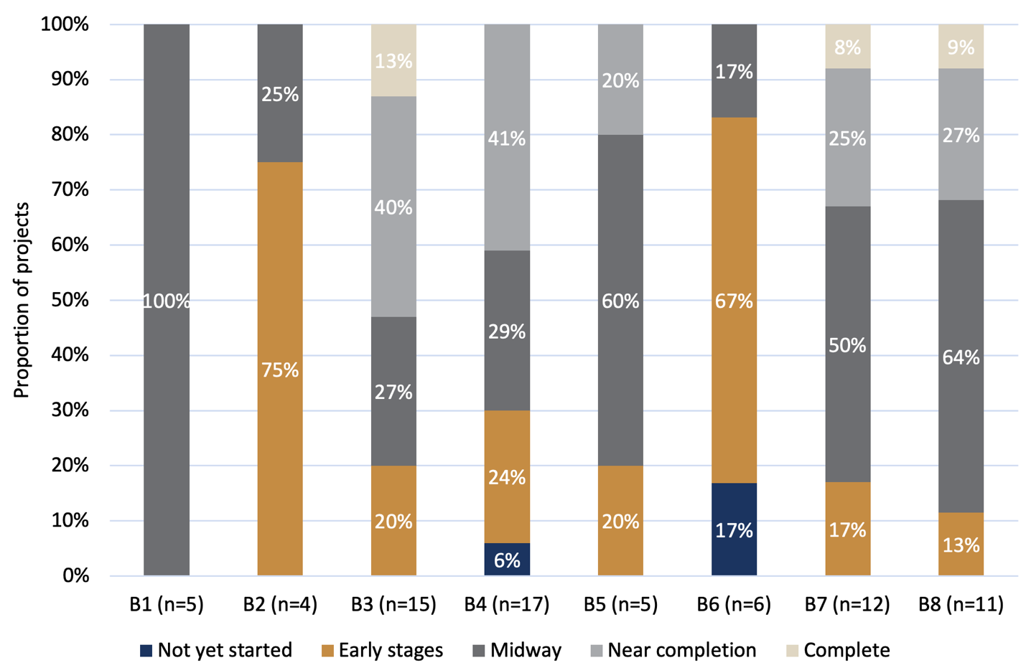

Source: Grantee survey

Figure 30. Non-Mission project progress against Mission benchmarks63

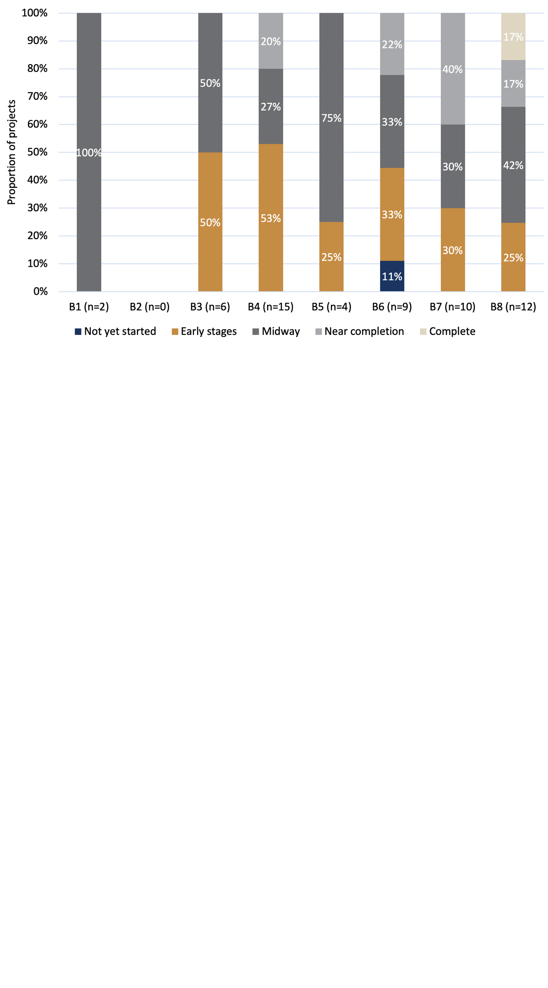

Source: Grantee survey

Table 15. Summary of stakeholder perspectives aligned to each Mission benchmarks

| **Benchmark** | **Key stakeholder themes** |
| --- | --- |
| B1. Development of new diagnostic or prognostic tools for dementia | Strong support for early diagnostic methods (e.g. AI, blood biomarkers); privacy and bias flagged as concerns. |
| B2. Utility of neuropsychological testing improved, resulting in increased use by clinicians | Stakeholder views not prominent. |
| B3. New tools and strategies for improving quality of life for people living with dementia and their carers developed and implemented through guidelines, practice, or private partnerships | Emphasis on post-diagnostic support, practical interventions, and social inclusion. |
| B4. New tools and strategies for improving uptake of preventive activities developed and implemented through guidelines, practice, or private partnerships | “Prevention is key” was a consistent message; call for more investment in delaying dementia onset. |
| B5. Evidence of improved diagnostic approaches, deferred onset, and improved quality of life of people living with dementia and their carers | More research needed; emphasis on early pathways and preventive trials. |
| B6. Increase in average healthy life expectancy and reduction of variability in healthy life expectancy | Stakeholder views not prominent. |
| B7. Key components of high-quality care identified and accepted for implementation by the aged care sector | Focus on care transitions, behaviour management, and community-based models. |
| B8. New tools and tools and strategies for implementing the key components of high-quality care in short- and long-term residential care settings developed and implemented through guidelines, practice or private partnerships | Call for practical improvements and best-practice standards in residential care. |

Box 6. Case study of a project that has addressed ‘Key components of high-quality care identified and accepted for implementation by the aged care sector’

| A Preventative Care Program to optimise mental health during transition into residential aged care, The University of Newcastle (Mission, 2021) |
| --- |
| **Issue**  The transition from living in the community to residential aged care (a nursing home), is a stressful experience for the person and their family that can lead to poor mental health.  **MRFF research**  The study included a program to assist the new resident (PEARL), the family (aSTART), and to provide additional training for staff (Dignity of Choice). It aims to reduce and prevent symptoms of depression in the resident. We will evaluate the impact of the program to guide national rollout.  **How this project has addressed ‘key components of high-quality care identified and accepted for implementation by the aged care sector’**  Following the training of staff and the implementation of a referral pathway to the PEARL (adjustment to aged care) program at Hunter Primary Care, our partner has committed to continuing to offer the program to other facilities not involved in the research. The PEARL program will now continue to run as part of normal services provided by the Aged Care Psychology team at Hunter Primary Care. Not only will it continue to run in the facility where the research was conducted, but all Hunter Primary Care Aged Care Psychology staff have received training on the PEARL program and can offer this program to appropriate referrals at all of the 55 facilities they service. Further, promotion of the program has led to knowledge of its availability by other aged care facilities who now initiate direct referrals to the program. |

Box 7. Case study of a project that has addressed ‘New tools and strategies for improving quality of life for people living with dementia and their carers developed and implemented through guidelines, practice or private partnerships’

| Drawing out care: Using animation and digital technologies to support Culturally and Linguistically Diverse (CALD) family carers and people living with dementia, National Ageing Research Institute (Mission, 2020) |
| --- |
| **Issue**  With approximately 30% of older Australians being from a culturally and linguistically diverse (CALD) background, it is important to meet the needs of non-English speaking Australians with dementia and their carers.  **MRFF research**  This study aims to improve the lives of CALD family carers and people living with dementia using animations, digital fact sheets, and a multilingual chat-bot, collectively titled the Draw-Care Intervention. The animated films and digital fact sheets were based on the World Health Organization’s iSupport Lite programme. The i-Support Lite were culturally adapted by working with CALD family carers, clinicians, service providers, and people living with dementia, as well as Dementia Australia and the Federation of Ethnic Communities Council of Australia. The clinical effectiveness in reducing carer burden and cost effectiveness were evaluated in a randomised controlled trial.  **How this project has addressed ‘new tools and strategies for improving quality of life for people living with dementia and their carers developed and implemented through guidelines, practice or private partnerships’**  The resulting intervention included 60 animated films and 60 tip-sheets in 10 languages, hosted on a multilingual website. These resources aimed to reduce carer stress, improve wellbeing, and ultimately support better quality of life for people with dementia.  Qualitative findings indicated that carers experienced reduced stress, increased help-seeking, improved self-care, and enhanced empathy. These behavioural changes were perceived to have positive effects on those receiving care.  The resources have been widely disseminated across Australia and internationally. They are freely available via the Mind Care website and have been promoted through social media, newsletters, and community workshops. Partnerships with organisations such as Dementia Australia, FECCA, and WHO’s iSupport network have enabled global distribution, with adaptations completed for Chinese-speaking regions and underway for Indonesia.  The project demonstrates how co-designed, guideline-aligned digital tools can be translated into practice and scaled through partnerships to address the needs of under-served populations. |

6.4 Progress towards MRFF benchmarks (measures   
of success)

The *MRFF Monitoring, Evaluation and Learning Strategy*, published in 2020, and updated in 2024[65], outlines eight MRFF benchmarks (measures of success) that assess achievement of MRFF outcomes.

Progress against these benchmarks was assessed using available progress reports from MRFF-funded DAAC research projects where benchmark reporting was applicable (n=75 of 126 projects)[66]. To complement the progress report data and address the gaps in data, additional data sources were used to assess progress towards the MRFF benchmarks. These included performance indicator survey data, grantee survey responses, and stakeholder consultations.

Reported progress against MRFF benchmarks, particularly as captured in progress reports, should be interpreted with caution, as MRFF benchmark-reporting projects were typically at an earlier project completion stage and may not yet have reached measurable outcomes.[67] Additionally, some later completion stage projects, while potentially having achieved more substantial progress, were not required to report against the MRFF benchmarks and are therefore not reflected in this analysis.

Among projects that did report, Mission projects were more likely than non-Mission projects to be required to report progress towards the benchmarks and generally reported more substantial progress overall. For four of the eight benchmarks, more than half of Mission projects reported achieving at least some progress. This pattern may partly reflect reporting requirements: of the 35 projects that did not report against benchmarks, 32 were non-Mission. While these projects may have made progress, their contributions are not captured in this analysis.

Table 16 presents the number and proportion of all projects that reported progress toward each MRFF benchmark. Note that grantees self-nominated in their application which MRFF benchmark(s) their project was working towards; projects are not expected to address all MRFF benchmarks.

Table 16. Number and proportion of MRFF-funded DAAC research projects reporting against each MRFF benchmark

| **MRFF benchmark / measure of success** | **Projects reporting** |
| --- | --- |
| Increased focus of research on areas of unmet need | 59 (79%) |
| More Australians access clinical trials | 25 (33%) |
| New health technologies are embedded in health policy and practice | 29 (39%) |
| New health interventions are embedded in health policy and practice | 35 (47%) |
| Research community has greater capacity and capability to undertake translational research | 38 (51%) |
| Health professionals adopt best practices faster | 46 (61%) |
| The community engages with and adopts new technologies, treatments and interventions | 43 (57%) |
| Increased commercialisation of health research outcomes | 12 (16%) |

*Source: Document review*

Where grantees reported against these measures, they were asked to describe outcomes either qualitatively or quantitatively and to estimate their level of progress. For consistency for subsequent sections, ‘minor progress’ is defined as less than 35% completion; ‘moderate progress’ as 35–70%; and ‘major progress’ as more than 70% completion. These thresholds were used to provide a broad indication of the extent of reported progress. Where a measure was not applicable to the project, grantees could report ‘N/A’.

6.4.1 MRFF Benchmark 1 – Increased focus of research on areas of unmet need

This section explores the extent to which projects report progress towards this benchmark and identifies the areas of unmet need being addressed by MRFF-funded DAAC research projects.

Progress

Increased focus on areas of unmet need was the most frequently reported benchmark across both Mission (*n*=37) and non-Mission (*n*=22) projects (Figure 31). Among Mission projects, progress towards addressing unmet needs was categorised as minor (51%), moderate (24%), and major (24%). Comparatively, non-Mission projects indicated a higher level of minor progress (73%) but lower level of moderate (14%) and major progress (14%).

Figure 31. Progress towards an increased focus of research on areas of unmet need

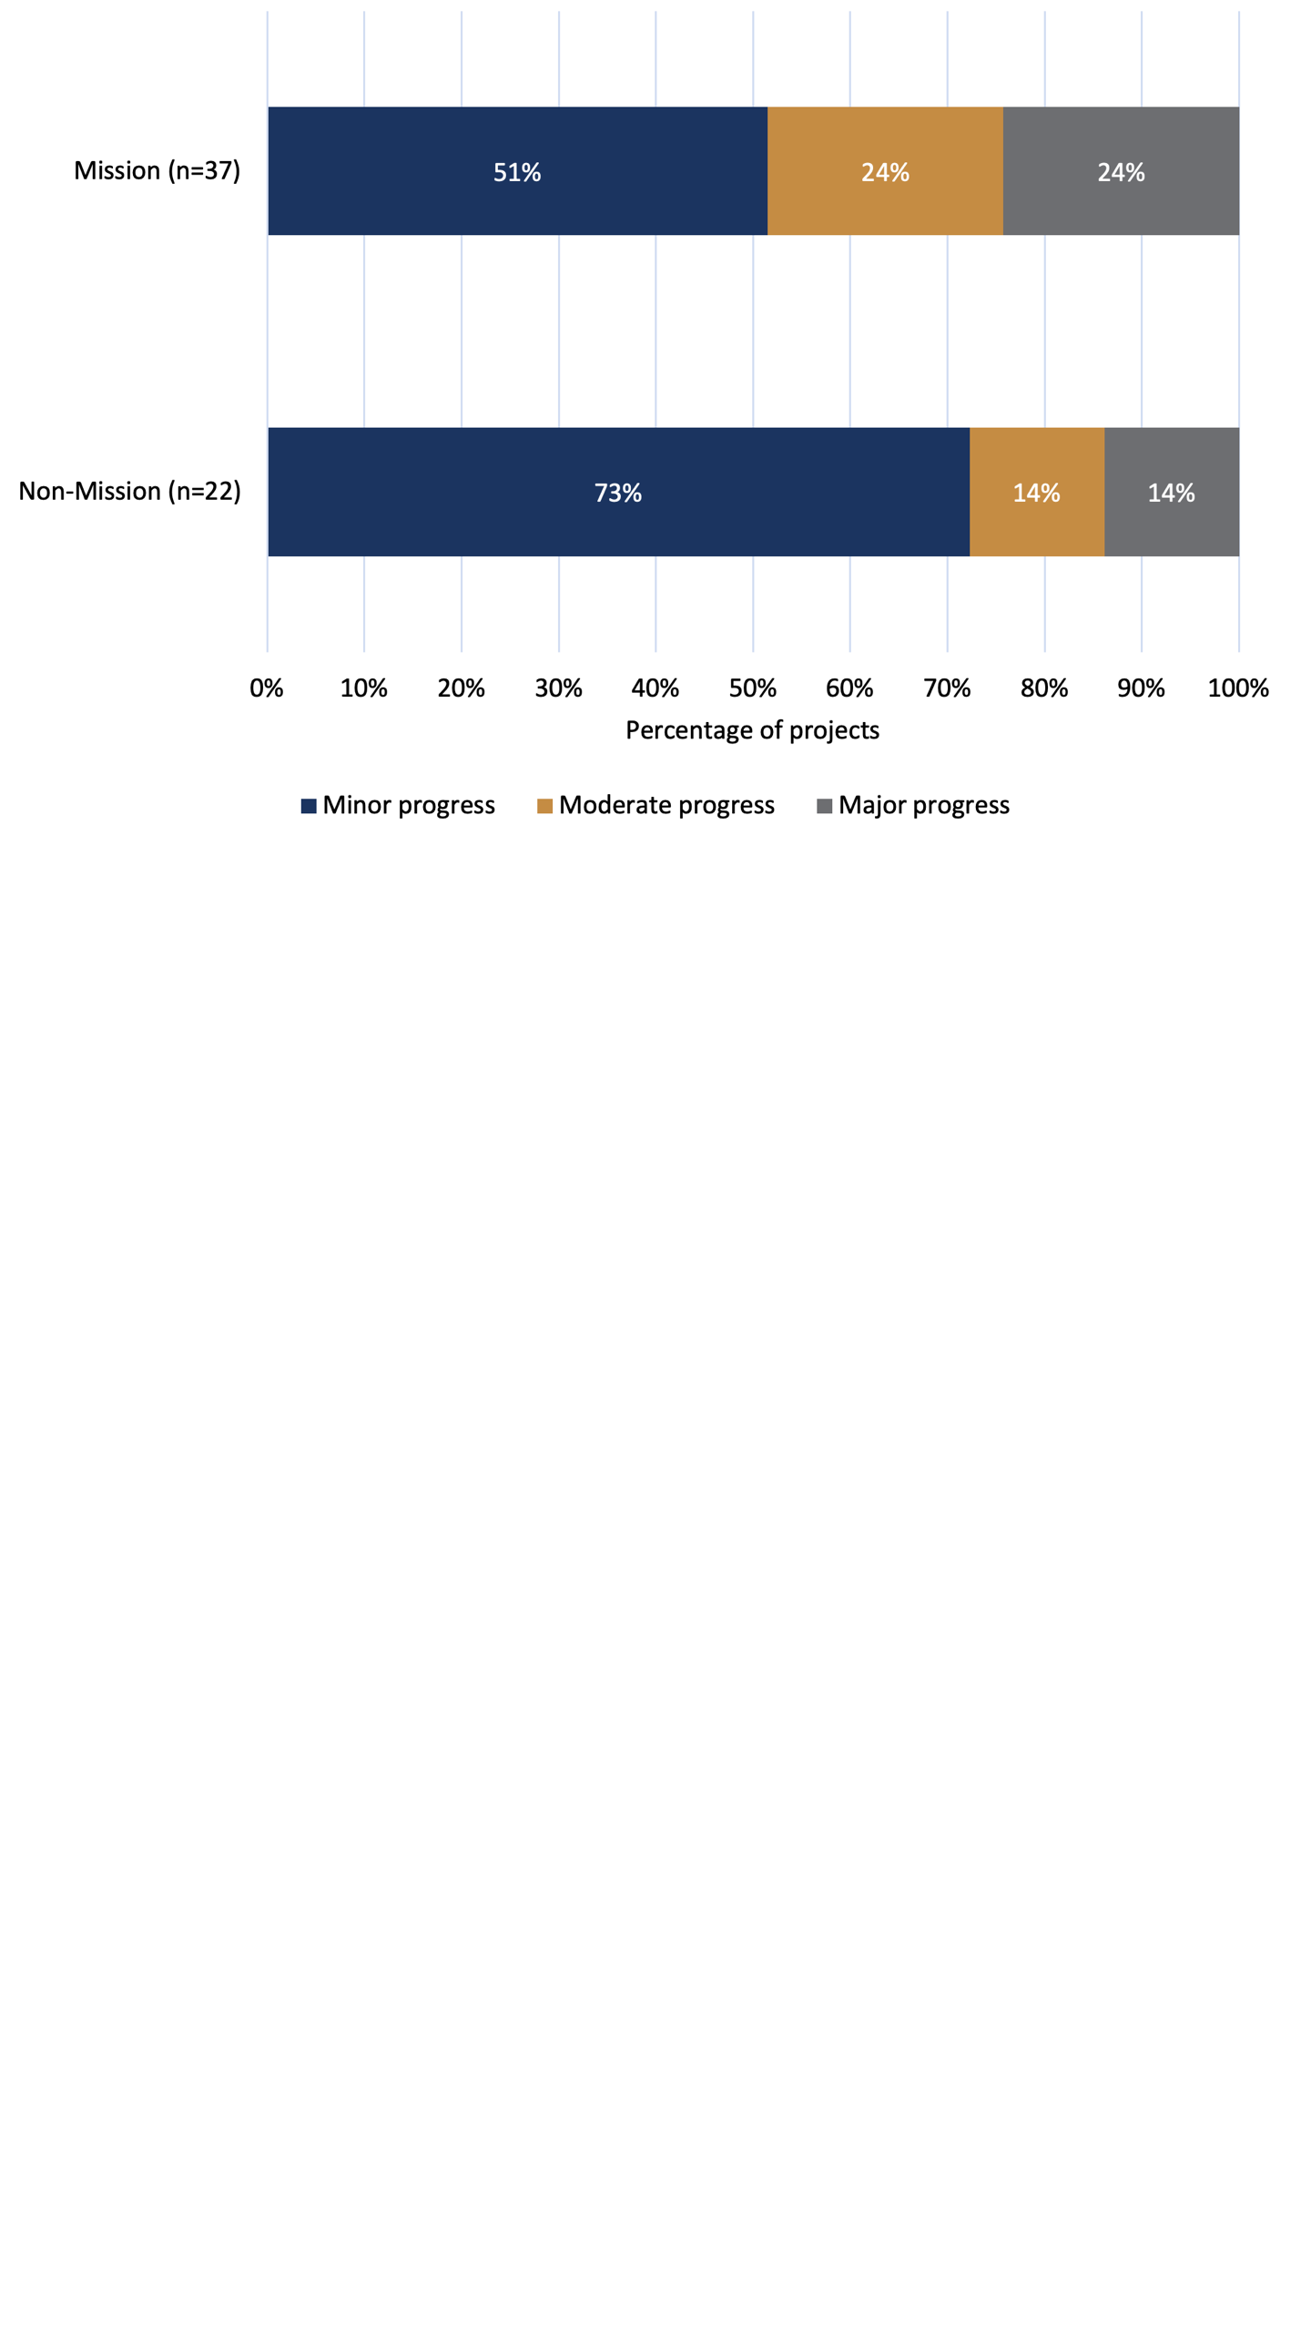

*Source: Document review (grantee progress and final reports)*

Areas of focus identified by funded projects

As anticipated given the scope of this Review, 65 out of 95 projects (68%) reported a focus on aged care –an area consistently identified as an unmet need or emerging challenge, often highlighted through parliamentary inquiries[68]. Other significant areas of unmet need being addressed identified by respondents included:

* Other (*n*=17), with 10 of these respondents suggesting dementia as an area of unmet need
  + Some ‘other’ significant areas of unmet need that are being addressed included frailty, falls, vision loss, medication safety, telehealth, and transitions of care.
* None of the above[69] (*n*=17)
* Mental illness (*n*=8)
* Hearing health (*n*=4)
* Cancers with low survival rates (*n*=2)

These responses suggest a strong alignment with aged care and dementia priorities, while also indicating a diversity of focus areas across the MRFF DAAC research portfolio.

Review participants’ perspectives on: ‘MRFF-funded DAAC research increasing focus of research on areas of unmet need’

While many projects reported activity aligned with this benchmark, review participants identified several areas where future research could more directly respond to current unmet needs. These insights reflect stakeholder and grantee views on the types of research priorities that should underpin further progress against this benchmark.

Table 17 summarises the thematic priorities raised by stakeholders and survey respondents, highlighting areas where greater investment and research focus may be required to fully address this benchmark over time.

Table 17. Summary of grantee and stakeholder views about Australia’s current unmet research needs and/or emerging research priorities in DAAC care

|  |  |
| --- | --- |
| Frequency of perspective[70] | Current unmet research need/emerging research priority (in descending order of number of respondents) |
| **Many** survey respondents thought research should focus on… | * dementia prevention, detection and early intervention * increasing equitable and culturally safe care * supporting older Australians to ‘age-in-place’ * workforce development and capacity building |
| **Some** survey respondents thought research should focus on… | * implementation/translation of evidence into practice * improving care coordination through integrated models of care * technological innovation * medication safety/policy pharmacy |
| **A few** survey respondents thought research should focus on … | * data-driven policy-development * early onset dementia * shared decision-making |

*Source: Grantee and stakeholder survey*

Review participants frequently identified dementia prevention, detection, and early intervention as a leading unmet need. Emphasis was placed on lifestyle, medical, and personalised interventions to prevent or delay dementia onset, with some highlighting the broader benefits of supporting healthy ageing to reduce overall morbidity.

|  |
| --- |
| *“Dementia prevention and early intervention – risk reduction strategies: Investing in research to identify and implement effective lifestyle and medical interventions that can delay or prevent the onset of dementia.”*  **Grantee survey respondent** |
|  |

Strong support was also expressed for culturally safe research approaches, particularly those co-designed with Aboriginal and Torres Strait Islander and CALD communities:

|  |
| --- |
| *“Culturally Inclusive dementia prevention and care research must focus on co-designing culturally and linguistically diverse interventions, ensuring accessibility and community engagement in dementia prevention and care. Equitable access to digital health and dementia services addressing the digital divide is crucial to ensure telehealth and digital interventions reach underserved populations, including rural, Indigenous, and CALD communities.”*  **Grantee survey respondent** |

|  |
| --- |
| *“Dementia research has none to little representation of Indigenous and CALD people. It should be mandatory for researchers to take active steps to include these populations and reach sample characteristics that are representative of the locality they are conducting the research in OR the Country's population.”*  **Stakeholder survey respondent** |

Stakeholders also identified ageing-in-place, mental health in older adults, and allied health workforce development as critical unmet needs.

|  |
| --- |
| *“How to better support older Australians to 'age-in-place' - i.e. Home care, with focus on health outcomes.”*  **Grantee survey respondent** |

|  |
| --- |
| *“[There is] Failure to fully utilise various allied healthcare professionals (e.g. exercise physiologists) and/or upskill other relevant HCPs to deliver high quality services, care and support for older people, those with chronic conditions and their carers.”*  ***Grantee survey respondent*** |

These views suggest that future progress against this benchmark will depend not only on volume of activity, but also on how well funded research aligns with lived experience, service gaps, and priorities identified by research end-users and consumers.

Box 8. Case study of a project working towards increasing focus of research on areas of unmet need

| BEFRIENDING with GENIE: An intervention to reduce loneliness and increase social support and service access for people living with dementia and their caregivers from CaLD backgrounds, Edith Cowan University (Mission, 2022) |
| --- |
| **Issue**  People with dementia and their caregivers from CaLD communities have unequal knowledge about, access to, and uptake of activities that support their social connections.  **MRFF research**  This project combines two evidence-based approaches: ‘BEFRIENDING’ which consists of informal conversations with a trained facilitator, and ‘GENIE’, which is an online tool that maps participant’s social networks and interests, tailoring expanded resources and activities to their needs using an inbuild database, while also measuring changes in supports over time. The BEFRIENDING with GENIE intervention comprises 8 weekly visits that facilitate increased knowledge about services and the expansion of participants’ support networks. It will be delivered to 100 participant dyads (comprising the person living with dementia and their family carer) from four language/culture groups: Italian, Chinese, Vietnamese and South Asian.  **How this project is achieving ‘increased focus of research on areas of unmet need’**  By addressing the social and support needs of a priority and under-served group, the research helps close gaps in dementia care for multicultural communities. |

Box 9. Case study of a project working towards increasing focus of research on areas on unmet need

| Connecting aged care, health care and social services systems to support older Aboriginal and Torres Strait Islander people to live their best lives, The University of Adelaide (Mission, 2022) |
| --- |
| **Issue**  Aboriginal and Torres Strait Islander people have unequal access to aged care assessment and culturally safe services. Additionally, people receiving aged care often have unmet needs that may not be provided for by their aged care service alone. This results in older people and their families having to navigate multiple disconnected systems at the same time.  It is critical for Aboriginal and Torres Strait Islander people to lead community-driven research priorities, co-design initiatives, and benefit from the outcomes of research.  **MRFF research**  This research will co-design integrated pathways that link services and support networks, addressing the multifaceted needs of older Aboriginal and Torres Strait Islander people more effectively. An Aboriginal-informed System Connector workforce will link individuals to services and create, strengthen, and formalisecare pathways between aged care, health and social services. This model builds on eight years of significant foundational work of Wardliparingga that has explored individual and workforce understandings of healthy ageing, social and emotional wellbeing, and ageing well. Key attributes of the System Connector Model for Ageing Well include cultural needs, communication, choice-making, collaboration, and coordination. The Indigenous-led, multidisciplinary team of Aboriginal and Torres Strait Islander and non-Indigenous researchers, health, aged care, and community service providers will prepare, implement and evaluate the Model for sustainability and scalability.  **How this project is achieving ‘increased focus of research on areas of unmet need’**  Improved linkages across health care, aged care and social service sectors are required to help address unmet needs, barriers to access and gaps in services. This research will generate much needed evidence on novel approaches to system integration to support ageing well for older Aboriginal and Torres Strait Islander peoples. It will also demonstrate Aboriginal and/or Torres Strait Islander–led research practice and governance. |

6.4.2 MRFF Benchmark 2 – More Australians access clinical trials

This section examines the extent to which MRFF-funded DAAC research projects are contributing to greater access to clinical trials. It explores the number, location, and scale of trials undertaken, and considers reported progress towards this Measure of Success.

Involvement in clinical trials

Fifty out of 95 projects (53%) involved at least one clinical trial, with similar proportions across both Mission and non-Mission grants. Twenty-two Mission projects (52%) included clinical trials, and 28 non-Mission projects (53%) included clinical trials.

Across all projects, the number of clinical trials per grant ranged from one to four. The 22 Mission-funded projects conducted one trial each. Among the 28 non-Mission projects, a total of 35 clinical trials were conducted: one project undertook four trials, one undertook three, two projects each undertook two, and the remaining 24 each conducted a single trial.

Geographic distribution of trial activity

Clinical trials were conducted across diverse geographic locations, reflecting broad outreach and access across Australia. The majority of trials were conducted in urban/metropolitan areas (*n*= 46), followed by regional (*n*=27), rural (*n*=14), and remote locations (*n*=5) (Table 18). Although only 57 unique trials were conducted, a total of 92 trial locations were reported, as some trials took place across multiple geographical areas.

Table 18. Site of clinical trials of MRFF-funded DAAC research projects

| **Site of clinical trial**[71] | **Mission** | **Non-Mission** | **Total** |
| --- | --- | --- | --- |
| Urban/metropolitan (MM1) | 18 | 28 | 46 |
| Regional (MM2) | 11 | 16 | 27 |
| Rural (MM3, MM4 or MM5) | 7 | 7 | 14 |
| Remote (MM6 or MM7) | 4 | 1 | 5 |

*Source: Performance indicator survey*

Participant enrolment and scale

As of May 2024, trial enrolments indicate substantial differences between Mission and non-Mission funded projects, both in actual and planned participant numbers (see Table 19). Non-Mission projects consistently show higher enrolment figures, highlighting notable variation in scale between the two groups.

Table 19. Clinical trial participant enrolments for MRFF-funded DAAC research projects

| **Participant enrolments** | **Mission** | **Non-Mission** | **Total** |
| --- | --- | --- | --- |
| Number of enrolments (as of May 2024) | 484 | 1,433 | 1,917 |
| Planned enrolments (as of May 2024) | 5,932 | 15,122 | 21,054 |
| Number of planned enrolments per grant (range) | 12 –1,000 | 12 – 3,456 | 12 – 3,456 |
| Median no. of planned enrolments per grant | 192 | 223 | 208 |

*Source: Performance Indicator (PI) survey*

Progress

Although 50 projects reported conducting at least one clinical trial, few identified this activity as having made major progress to this MRFF benchmark. Among Mission projects, 12 reported progress towards this benchmark, the second least commonly reported benchmark, with 6 projects (50%) reporting minor progress. Among the 13 non-Mission projects that reported against this benchmark, 12 (92%) indicated minor progress only (Figure 32).

These findings likely reflect the timing and stage of many projects, rather than the perceived value of clinical trial activity. In some cases, minor progress may have been reported simply because trials had not yet commenced, were still recruiting, or were early in implementation. As such, clinical trial activities may not yet have translated into broader or measurable improvements in access. As projects mature, progress against this benchmark may become more visible over time.

Figure 32. Progress towards more Australian’s accessing clinical trials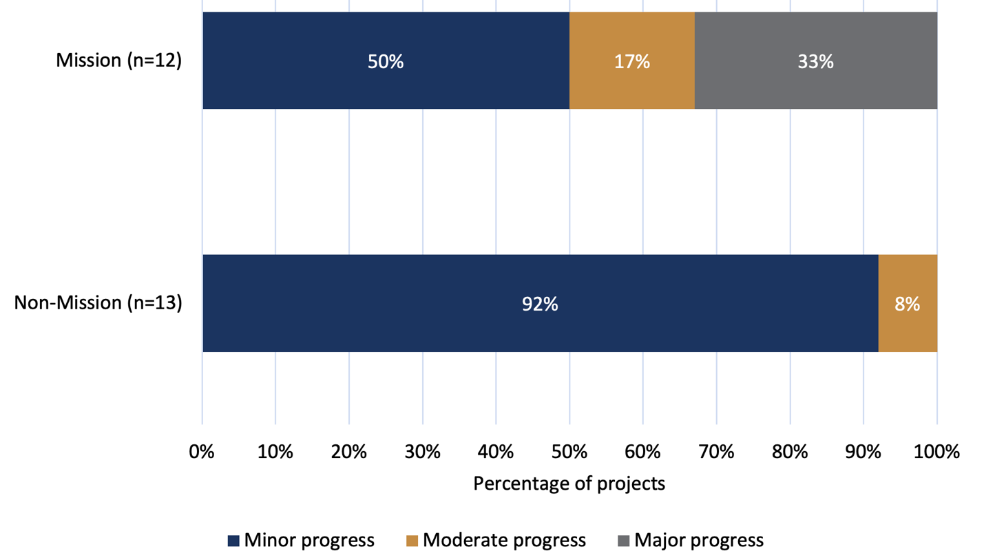

*Source: Document review (grantee progress and final reports)*

Review participants’ perspectives on: ‘More Australian’s accessing clinical trials’

Stakeholders identified several barriers affecting broader participation in DAAC clinical trials, along with recommendations to strengthen Australia's capacity in this area.

A common concern was the absence of a national dementia clinical trials network, seen as limiting recruitment and broader community involvement. Stakeholders suggested establishing a national clinical trials register, leveraging existing platforms such as StepUp and ADNET, to centralise trial information for patients, clinicians, and researchers. Additionally, standardised recruitment pathways and embedding clinical trials into routine clinical care were recommended to improve accessibility.

Stakeholders highlighted the importance of expanding clinical trial access beyond traditional hospital settings, advocating for decentralised trial models integrated within primary care, community health, and aged care settings. 'Light-touch' trial models were proposed as a practical way to enable aged care providers to engage without significantly disrupting existing service delivery.

State and territory research funding bodies further recommended dedicated funding for consumer outreach and education, particularly targeting rural and remote regions to cultivate a stronger culture of trial participation. Improved integration of routinely collected dementia and aged care data across healthcare and community sectors was also seen as essential to support clinical trials and broader research initiatives.

Innovative clinical trial designs, such as adaptive platform trials which have been successfully implemented internationally, were suggested to optimise trial efficiency. Furthermore, stakeholders recommended targeted MRFF funding mechanisms to bolster Australia's clinical trial capacity, including supporting EMCRs and facilitating Australian participation in international clinical trials.

The Australian Government has recognised these barriers and opportunities, including those that extend beyond the remit of the MRFF, through the establishment of the National One Stop Shop – a national cross-government system for health-related human research (Box 10). Many of the recommendations made by stakeholders reflect broader systemic challenges in the clinical trial ecosystem, including workforce development, infrastructure, and data integration. While MRFF funding mechanisms may support progress in some areas, addressing these barriers will require coordinated efforts across health, research, aged care, and policy systems at both national and jurisdictional levels.

Box 10. Overview of The National One Stop Shop

|  |
| --- |
| The National One Stop Shop (NOSS) – a cross-government system for health-related human research[72] |
| NOSS is a transformative initiative that will offer a consistent, national approach for health and medical research, including clinical trials – from start to finish. Led by the department, and developed through extensive national consultations, the system is designed to centralise and simplify access for patients, researchers, industry representatives, and sponsors.  By streamlining approvals and processes into a single national system, the NOSS will:   * help more Australians get early access to potential lifesaving and life-changing treatments * improve health outcomes * make the process more efficient * stimulate Australia's innovation economy and health system improvements * position Australia as a global leader for clinical trials.   By addressing longstanding issues such as duplication, fragmentation, and delays inherent in current jurisdiction-specific systems, the NOSS will create a single, interconnected national approvals infrastructure. This will include a unified ethics approval and site-specific authorisation platform, integrated Therapeutic Goods Administration (TGA) notification systems, and a next-generation clinical trials registry.  Additionally, the NOSS will:   * Automate data and reporting to support the National Clinical Trials Governance Framework accreditation process. * Be accessible to all public, private, not-for-profit, universities and aged care organisations conducting health and medical research. * Ensure the privacy, confidentiality, integrity and availability of information. |

Box 11. Case study of a project working towards more Australian’s accessing clinical trials

|  |
| --- |
| SENSEcog aged care: Hearing and vision support to improve quality of life for people living with dementia in residential aged care, The University of Queensland (Mission, 2020) |
| **Issue**  Over 90% of people living with dementia in residential aged care or home care settings have hearing and vision problems and they are often under-detected. Poor sensory function worsens quality of life and increases dependency, increases likelihood of transition from independent living to residential aged care, and exacerbates the impact of dementia, increasing confusion and challenging behaviour.  **MRFF research**  This project is being delivered as a clinical trial evaluating the impact of a sensory support intervention’(SSI) for people living with dementia in aged care settings. The trial recruits participants with dementia and co-occurring sensory impairment – groups often excluded from research due to lack of decision-making capacity or comorbidities.  The SSI involves training aged care staff to detect sensory problems and communicate better, ensuring access to hearing/vision care, and improving the environment. The research project includes multiple components:   * Co-designing SSI adaptation for Australian residential aged and home care settings with people living with dementia, care staff and hearing/vision professionals * Implementing the SSI and evaluating impact on quality of life, functional ability, behaviour and cognition, and delivery/acceptability to staff and consumers * Estimating the cost-effectiveness of the SSI * Co-producing with consumers, aged care and hearing/vision professionals, a roadmap for national roll-out and a sustainable health system approach to implementing the SSI   **How this project is achieving ‘more Australians access clinical trials’**  The study includes extensive consumer and community involvement to facilitate research participation of people living with dementia in aged care settings. A Consumer and Community Involvement advisory group was formed, comprised of four members of the public with lived experience of sensory impairment, dementia, and aged care. They were consulted on the study protocol and intervention design. |

6.4.3 MRFF Benchmarks 3 and 4 – New health technologies and interventions are embedded in health policy and practice

This section considers how MRFF-funded DAAC research projects are contributing to the integration of new health technologies and interventions into health policy and practice. It examines the type of research being conducted, activities undertaken to influence health policy and practice, and reported outcomes.

Positioning along the translation pipeline

Only a small proportion of projects (11%) were classified as fully clinical or market translational, indicating direct integration into health practice (Figure 19). Most were reported as translational research (62%) or applied research (17%), suggesting that most projects are focused on generating evidence or preparing for future implementation. This overall positioning aligns with the MRFF’s objective of embedding new health technologies and interventions into practice, while also reflecting the longer timelines often required for measurable change.

Activities contributing to embedding new technologies and interventions

Responses to the performance indicator survey from grantees with completed projects (as at May 2024) revealed that 9/10 completed projects reported activities or outcomes aligned with embedding new health technologies or interventions into practice. Among these, one Mission project (2% of all Mission projects) and eight non-Mission projects (15% of all non-Mission projects) reported activity contributing to this benchmark. While this represents only 10% of the total survey respondents, it suggests that 9 out of 10 completed projects were working towards embedding health technologies or interventions – indicating that more progress may become evident as additional projects reach completion.

Across both Mission and non-Mission projects, the most commonly reported activities included:

* Engagement with clinicians (*n*=8)
* Engagement with partners capable of influencing practice change (*n*=6)
* Updating educational materials for health professionals (*n*=4)
* Collaborating with or establishing clinical quality registries (*n*=1)
* Developing an online training course (*n*=1)

Projects also reported a range of early outcomes from these activities. The most frequently cited outcome was contribution to clinical guidelines or healthcare policy (*n*=5). Other outcomes included:

* Repurposing current treatments and technologies (*n*=2)
* Enabling evidence use by NGOs or organisations outside the formal health system (*n*=2)
* Advancing new treatments or interventions into further development (*n*=2)
* Introducing new or modified prevention programs (*n*=1)
* Improvements in clinical quality indicators (*n*=1)
* Improved access to treatments, interventions or technologies (*n*=1)

Progress

These findings above reflect responses only from grantees whose project were completed as at May 2024. As such, they may not represent the full extent of activities or progress toward embedding new technologies or interventions across the broader MRFF DAAC portfolio. Many ongoing projects were not required to report on this MRFF benchmark, and others may not yet have reached a stage where embedding into practice is feasible or measurable.

Where progress was reported through grantee progress report, most Mission and non-Mission projects indicated minor progress (Figure 33). This likely reflects that many projects are still in earlier stages and have not yet reached points where embedding into practice is feasible or measurable. As shown in Figure 27, only 2% of Mission and 18% of non-Mission projects were identified as complete, likely limiting the opportunity to observe or report downstream implementation outcomes.

Figure 33. Progress towards new health technologies and interventions are embedded in health policy and practice

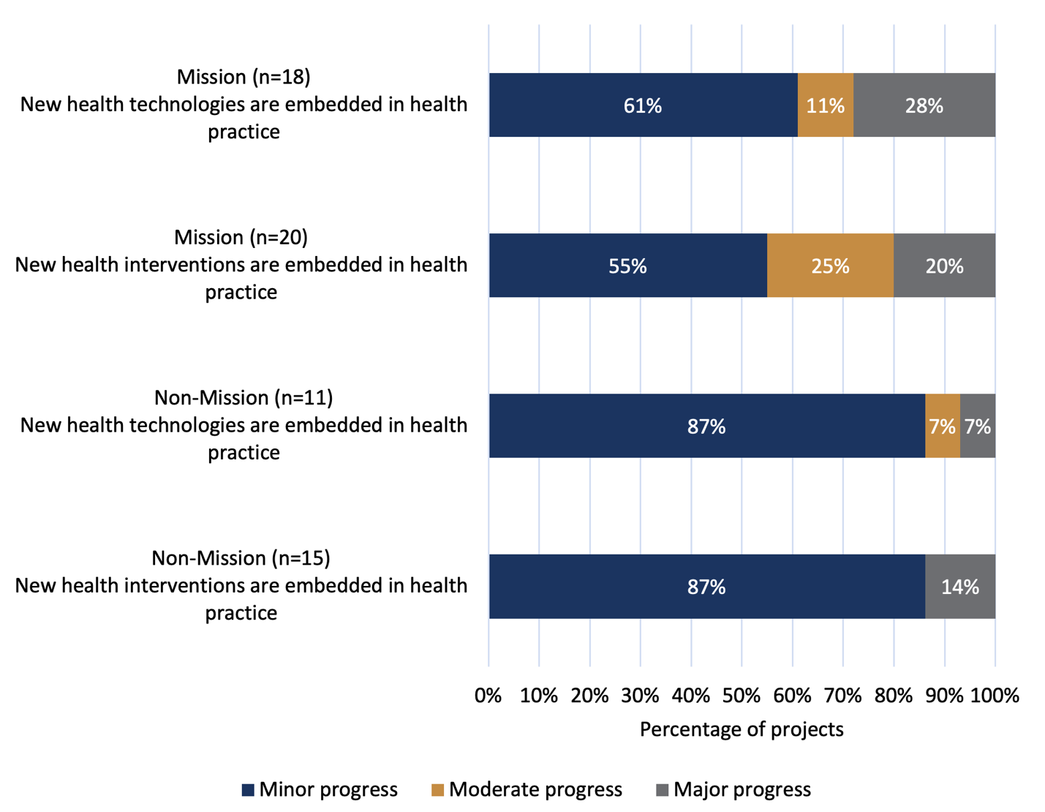

*Source: Document review (grantee progress and final reports)*

Review participants’ perspectives on: ‘Embedding new health technologies and interventions in health policy and practice’

Stakeholders broadly agreed that embedding research into health and aged care practice requires more than generating evidence – it requires active strategies for translation. A recurring theme was the disconnect between research findings and real-world policy or service delivery. Participants described a fragmented system where aged care providers innovate out of necessity, but these models are rarely supported or evaluated through formal research channels.

|  |
| --- |
| *“[There is a need for] initiatives that focus on bridging the evidence-to-practice gap in dementia care, including a focus on translating clinical practice guidelines and other evidence-based resources.”*  **Grantee survey respondent** |

|  |
| --- |
| *“There is a major gap in the implementation of dementia and aged care evidence – there is a plethora of studies that report similar interventions packaged in a different way over and over again – often in a small scale, claiming more research is needed to get stronger evidence. In the absence of the best outcome measures for dementia care and aged care, we need to look at implementation of what is already known that could address the adoption issues years later. For any care research we need to focus on implementation research to see any impact in care.”*  **Stakeholder survey respondent** |

To bridge this gap, stakeholders advocated for research end-user involvement – particularly clinicians, aged care service providers and policymakers – throughout the research process. Genuine co-design was seen as essential to ensuring that research addresses practical challenges and is implementable. Many stakeholders noted that current models often treat these groups as recipients of research, rather than partners in its development.

|  |
| --- |
| *“We want research that asks the right questions – the questions that matter to aged care providers, not just to universities. True co-design will make MRFF-funded research more relevant and impactful.”*  **Stakeholder from an aged care provider organisation** |

|  |
| --- |
| *“There’s a real opportunity to embed research within aged care pilots and policy implementation. That way, we’re not just generating knowledge – we’re applying it in real time.”*  **Stakeholder from a Federal Government agency** |

There was also strong support for incorporating translation mechanisms directly into MRFF grants. Suggested strategies included funding implementation research, requiring policy impact statements, and creating clearer expectations for how findings will be used in practice. Participants proposed that translation outcomes be built into grant reporting and that stronger incentives be given to researchers with experience in service delivery or prior policy impact.

Finally, many participants raised concerns about the accessibility of research outputs. Service providers and government stakeholders called for more practical resources – such as toolkits, training modules, and implementation guides – highlighting that many research findings remain difficult to access or apply in everyday care settings.

|  |
| --- |
| *“The research is valuable, but we need it in a format that aged care providers can actually use. Practical guides, toolkits, and training resources should be a required part of every MRFF-funded project.”*  **Stakeholder from an aged care provider organisation** |

Box 12. Case study of a project working towards new health technologies and interventions being embedded in health policy and practice

| "There must be a better way": partnering with consumers to implement a digitally enabled geriatric urgent care unit to improve hospital flow, Flinders University (Non-Mission, 2022) |
| --- |
| **Issue**  Traditional emergency departments (EDs) are overcrowded and sometimes not suitable for older adults with complex needs. Specialised geriatric urgent care pathways for selected patients can alleviate ED demand and improve patient experience.  **MRFF research**  In 2021, the Southern Adelaide Local Health Network invested in an alternative model of urgent care for older people. In collaboration with the Council of the Ageing, consumer workshops were held to gather data on older Australians’ needs and preferences for urgent care, which were fed back to refine the model of care. This research used mixed methods to assess the outcome of this new model for patients, families and the health service, and inform service improvements.  **How this project is achieving ‘new health interventions and technologies are embedded in health policy and practice’**  The research team is positioned within the Southern Adelaide Local Health Network and Flinders University which has facilitated collaboration between researchers, practitioners, and peak organisations to support implementation and translation. Staff were interviewed regarding care integration as well as the performance of technologies in clinical practice and an increase in care integration efforts was found. |

Box 13. Case study of a project working towards new health technologies and interventions being embedded in health policy and practice

|  |
| --- |
| DELIVERing enhanced healthcare at home for older people in rural Australia, Western Alliance Health Research Ltd (Non-Mission 2020) |
| **Issue**  Older Australians living in rural, regional, and remote communities face distinct challenges related to their geographic location. Despite a growing emphasis on home-based care aimed at reducing preventable hospital admissions, enhancing patient experiences, and containing healthcare costs, current efforts remain fragmented and insufficiently adaptable to the diverse needs of older patients. The dependency on resource-intensive, face-to-face services continues to place substantial strain on healthcare infrastructure, highlighting an urgent need for integrated and sustainable solutions.  **MRFF research**  This project unites rural healthcare providers, consumers, academic health science centres, universities, and national peak bodies to collaboratively design, test, optimise, implement, and scale tailored solutions. DELIVER seeks to establish a robust, sustainable model for rapid clinical and health services research translation across western Victoria. Through comprehensive capacity building and rigorous evaluation methods, the project aims to systematically identify, prioritise, and trial locally adapted solutions that address critical barriers in delivering effective home-based care for older people in rural areas.  **How this project is achieving ‘new health interventions and technologies are embedded in health policy and practice’**  ***Health interventions***  Current DELIVER program initiatives include a trial evaluating the clinical and cost-effectiveness of a co-designed, region-wide home-based care program tailored to the specific needs of western Victoria. The intervention is now being rolled out, with delivery supported by telehealth to ensure access for rural services. An implementation and evaluation plan for a 'hospital without walls' program is in development, informed by a co-designed program logic model, implementation science theory, and health economics considerations. These evidence-informed approaches are embedding new home-based care interventions into usual care practice across health services.  ***Health technologies***  DELIVER has scoped around 15 interventions to optimise home-based healthcare for older people, with half undergoing feasibility assessment and three advancing to detailed design. A scan of 200 remote patient monitoring platforms is supporting technology selection. Five rapid evidence summaries, covering digital readiness, monitoring success factors, geriatrician virtual care setup, and patient cohort identification, are guiding the use of evidence-informed health technologies. A budget impact analysis framework is also in development. By assessing infrastructure and workflows, building rural clinicians’ digital capability, and gathering older persons experience and preferences for home-based healthcare, DELIVER is laying the foundation for successful uptake of health technologies in rural and regional areas. |

6.4.4 MRFF Benchmark 5 – Research community has greater capacity and capability to undertake translational research

This section examines workforce development and collaborative research activity. It provides insights into the composition of the research workforce supported by MRFF-funded DAAC research projects and the types of activities undertaken to advance translational research capacity and capability.

Supporting researchers across disciplines, professions and career stages

A total of 578 researchers were supported through MRFF-funded DAAC research projects, according to the performance indicator survey of grantees (Table 20). This included a broad range of research roles and disciplines, from students to clinicians, allied health professionals and industry-based researchers. More than half (51%) of those supported were early to mid-career researchers, reflecting a strong investment in future research leadership and long-term capability.

Table 20. Positions of the researchers involved in MRFF-funded DAAC research projects

| **Category** | **Mission (*n*=42)** | **Non-Mission (*n*=53)** | **Total (*n*=95)** |
| --- | --- | --- | --- |
| Total number of researchers | 274 | 304 | 578 |
| General practitioners/medical doctors in primary care | 1 | 8 | 9 (2%) |
| Medical doctors - specialists | 2 | 27 | 29 (5%) |
| Nurses | 13 | 38 | 51 (9%) |
| Allied health professionals | 63 | 62 | 125 (22%) |
| Early to mid-career researchers | 137 | 156 | 293 (51%) |
| Higher degree research students | 31 | 38 | 69 (12%) |
| Aboriginal and/or Torres Strait Islander peoples | 8 | 24 | 32 (6%) |
| Located in regional, rural or remote areas | 12 | 38 | 50 (9%) |
| Cultural and linguistically diverse people | 80 | 67 | 147 (25%) |
| Researchers based in industry | 16 | 24 | 40 (7%) |

*Source: Performance indicator survey*

The supported workforce brought together diverse professional expertise. Allied health professionals formed the largest group (22%), followed by higher degree research students (12%) and nurses (9%). While smaller in number, involvement of GPs, specialists and industry-based researchers reflects engagement with professional groups that are critical to the translation of research into clinical and care settings.

There was also strong representation of groups historically underrepresented in the research workforce. One in four (25%) researchers identified as culturally and linguistically diverse, 6% identified as Aboriginal and/or Torres Strait Islander peoples, and 9% were located in regional, rural or remote areas.

Building workforce capability

Performance indicator survey respondents reported a wide range of capacity-building activities undertaken through MRFF-funded DAAC research projects (Table 21). Collaboration emerged as a defining feature. The majority of respondents reported working on projects with researchers outside their institution (85%) and across disciplines (83%), reflecting the highly networked and interdisciplinary nature of translational research. New research collaborations or partnerships were also reported by 79% of projects, indicating that MRFF funding is catalysing fresh connections across the research sector.

Table 21. Capacity-building activities undertaken through MRFF-funded DAAC research projects

| **Category** | **Mission (*n*=42)** | **Non-Mission (*n*=53)** | **Total (*n*=95)** |
| --- | --- | --- | --- |
| Research translation training of research staff | 24 | 40 | 64 (67%) |
| Research staff involvement in exchange programs or placements with industry | 5 | 3 | 8 (8%) |
| Collaboration with Australian researchers outside of your institution | 38 | 43 | 81 (85%) |
| Collaboration with international researchers | 23 | 25 | 48 (51%) |
| Interdisciplinary collaborations | 36 | 43 | 79 (83%) |
| New research collaborations/partnerships | 37 | 38 | 75 (79%) |
| Establishing or expanding relationships and engagement with industry | 26 | 30 | 56 (59%) |
| Contract research or consultancies | 2 | 8 | 10 (11%) |
| Other | 1 | 4 | 5 (5%) |
| None of the above | 1 | 4 | 5 (5%) |

*Source: Performance indicator survey*

Targeted workforce development was also evident. Two-thirds (67%) of projects reported providing research translation training for staff – a clear investment in building the skills required to translate research into real-world contexts. While fewer in number, 8% of projects involved research staff in industry placements or exchange programs, supporting real-world exposure and cross-sector learning.

Importantly, more than half of all projects (59%) reported establishing or expanding engagement with industry, and 51% reported international collaboration. These connections help to position Australian research within global efforts and open pathways to translation through commercial and implementation partnerships.

Progress

A total of 38 projects – 24 Mission-funded and 14 non-Mission – reported progress towards building the research community’s capacity for translational research. As shown in Figure 34, most Mission projects reported moderate or minor progress, while nearly all non-Mission projects reported minor progress. Only a small proportion of projects reported major progress, indicating that for many, activity remains at an early or developing stage.

Figure 34. Progress towards the research community having greater capacity and capability to undertake translational research

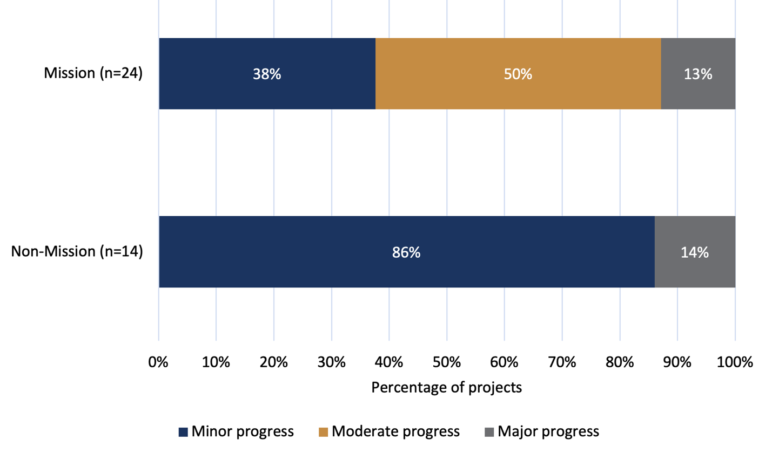

*Source: Document review (grantee progress and final reports)*

Review participants’ perspectives on: ‘The research community has greater capacity and capability to undertake translational research’

Stakeholders broadly supported the MRFF’s role in strengthening translational research capability, particularly through support for early- and mid-career researchers and interdisciplinary collaboration. However, participants also highlighted gaps in engagement with key parts of the health workforce, particularly general practitioners (GPs), allied health professionals and nurses (see quotations in section 6.4.5). While these professionals are essential to successful translation into primary and aged care settings, their participation in MRFF-funded DAAC research remains relatively low. Many stakeholders suggested this reflected broader systemic challenges, including the need for dedicated funding to enable frontline practitioners to contribute meaningfully to research.

Box 14. Case study of a project working towards the research community having greater capacity and capability to undertake translational research

| Co-designing an exercise and fall prevention program for older people from CALD backgrounds, University of Melbourne (Mission, 2021) |
| --- |
| **Issue**  There is strong evidence that exercise reduces falls in older people. Most older people do not meet physical activity guidelines and there are limited resources to support people from culturally and linguistically diverse (CALD) communities.  **MRFF research**  The project has codesigned an exercise and falls prevention program with older people from three culturally and linguistically diverse communities and stakeholders including service providers and health professionals. The program will be evaluated in over 600 older people from CALD communities.  **How this project is achieving ‘research community has greater capacity and capability to undertake translational research’**  The project team is interdisciplinary and includes 11 clinician researchers and 6 early career researchers. Multiple team members have experience in implementation science and implementation outcomes were embedded within the co-design process. Implementation and Dissemination Working Group was established to facilitate implementation. |

6.4.5 MRFF Benchmark 6 – Health professionals adopt best practices faster

This section explores how MRFF-funded DAAC research projects are contributing to the faster adoption of best practices by health professionals. It considers reported impacts on clinical and service delivery, progress toward this outcome, and factors influencing the adoption timeline.

Low levels of reported adoption outcomes

Adoption of best practices is closely linked to how new health technologies and interventions are embedded in health policy and practice (Section 6.4.3). Responses to the performance indicator survey – which was completed only by projects that had reached completion as at May 2024 (10 projects) – indicated minimal immediate impacts in this area. Specifically, no MRFF-funded DAAC research projects, either Mission or non-Mission, reported achieving measurable impacts such as 'New or changed local standard healthcare procedures or service delivery' or 'New treatments or interventions being adopted'.

Progress

Despite the limited reporting of adoption outcomes, faster adoption of best practices was the second most reported MRFF benchmark among Mission (*n*=28) and non-Mission (*n*=18) projects (Figure 35). Most projects reported only minor progress, indicating that while measurable adoption outcomes are limited at this stage, many projects may still be in earlier phases of translation. As implementation activities progress, there is potential for further contributions to this benchmark to emerge over time.

Figure 35. Progress towards health professionals adopting best practices faster

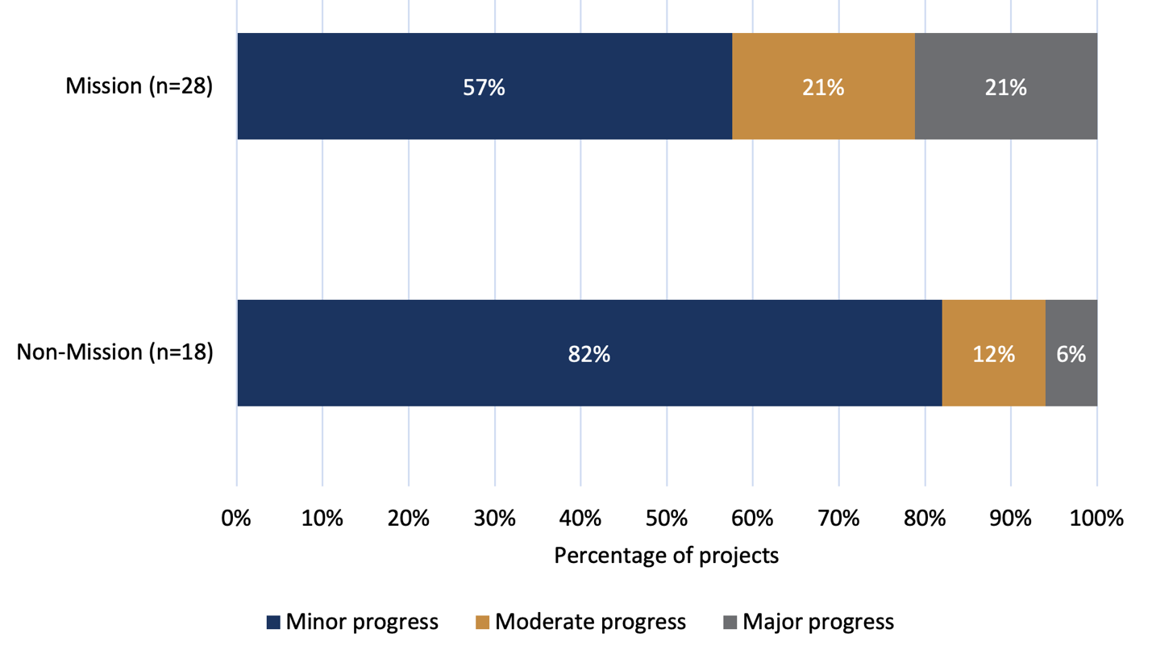*Source: Document review (grantee progress and final reports)*

Contextualising low adoption reporting

Low levels of reported adoption outcomes, such as 'new or changed local standard healthcare procedures or service delivery' or 'new treatments or interventions being adopted', should be interpreted with caution. Only grantees with completed projects (10 projects) were asked to report on these specific outcomes through the performance indicator survey carried out in May 2024, meaning that many current projects have not yet had the opportunity to demonstrate or report adoption-related impacts. This is reflected in the progress report data: most projects reported only minor progress towards this benchmark (57% of Mission projects and 82% of non-Mission projects reporting on this benchmark; Figure 35). The limited adoption reporting at this stage is consistent with the translational maturity of the portfolio, as most projects are at an early or mid translational research stage (Figure 19). While change is yet to be realised, many projects are undertaking preparatory activities – such as clinician engagement, educational resource development, and input into guidelines or policy (see new health technologies and interventions are embedded in health practice) – which may lay the groundwork for future best practice adoption.

Review participants’ perspectives on: ‘Health professionals adopting best practices faster’

Stakeholders noted that while MRFF projects are building an evidence base, this has not yet translated into widespread changes in clinical practice. Most described the adoption of best practices as delayed, largely due to capacity constraints in the health and aged care workforce.

Several participants highlighted the importance of supporting health professionals– particularly GPs, nurses, and allied health staff – to engage with new research. However, time and workforce constraints were frequently cited as barriers. Many frontline professionals struggle to participate in research or training without backfill support, limiting their exposure to emerging best practices. Stakeholders recommended targeted investment to make engagement feasible, including funding to free up staff time, and the development of concise, practical tools tailored to real-world settings.

|  |
| --- |
| *“If MRFF wants more aged care providers to engage in research, we need support – whether that’s funding to free up staff time or simplified ways to participate in clinical trials without disrupting services.”*  **Stakeholder from an aged care provider organisation** |

|  |
| --- |
| *“GPs and allied health professionals want to be involved in research, but they can’t afford to do it for free. If we’re serious about research translation, we need to fund their involvement properly."*  **Stakeholder from a professional clinical group** |

Several participants suggested that current funding models do not recognise the value of practice-based knowledge. To accelerate adoption, they recommended recognising alternative track records in grant applications, valuing the experience of frontline staff alongside traditional academic outputs[73].

Stakeholders also suggested that education and implementation support should be integrated into research from the outset. Training resources and best-practice tools should be treated as core deliverables, not optional extras. Supporting clinicians to adopt new approaches requires both accessible content and dedicated time and funding to engage with it.

Box 15. Case study of a project working towards health professionals adopting best practises faster

| Alignment, Harmonisation, and Results: translating Core Outcome Measures to Improve Care (COM-IC) for People Living with Dementia into Australian practice, The University of Queensland (Mission, 2020) |
| --- |
| **Issue**  The delivery of interventions and care models across different settings and for different populations, combined with the capability and capacity of service organisations, naturally leads to the use of a wide range of instruments and approaches to report outcomes and to measure success, despite their shared focus on dementia. The use of different assessment instruments reduces the comparability of results across care models, leading to the slow translation of evidence into practice and reduced capacity to improve quality of care. It also results in fragmentation and duplication of service provision across providers, creating system-wide inefficiencies. In Australia, there is no recommendation or mandatory reporting of outcomes relating specifically to the provision or quality of care for people living with dementia, despite the increasing burden of disease associated with dementia in older people.  **MRFF research**  This project identified, analysed, implemented and audited suitable core outcome measures. The methods for analysing each stage were codesigned with stakeholders, through the conduit of a Stakeholder Reference Group including people living with dementia, formal and informal carers, aged care industry representatives, researchers, clinicians and policy actors. The codesigned evaluation methods considered two key factors: feasibility and acceptability. Feasibility was explored through consultation with aged care industry partners. These organisations provided feedback on the practicality of implementing the proposed measures within routine care settings, helping to refine the recommendations.  **How this project is achieving ‘health professionals adopt best practises faster’**  Industry representatives have been included as part of the research team and clinician representation are on the stakeholder reference group. The research team has developed a close relationship with champions in industry, who are positioned to support implementation of recommended core outcomes. |

Box 16. Case study of a project working towards health professionals adopting best practises faster

| IMpleMenting Effective infection prevention and control in ReSidential aged carE (IMMERSE), University of Melbourne (Mission, 2020) |
| --- |
| **Issue**  Older people living in residential aged care facilities are at high risk of acquiring infections such as influenza, gastroenteritis, and more recently COVID-19. These infections are a major cause of morbidity and mortality among this cohort. Quality infection prevention and control practice in residential aged care is therefore imperative.  **MRFF research**  Using mixed methods, this four-phase implementation study uses theory-informed approaches to: (1) assess residential aged care facilities’ readiness for infection prevention and control (IPC) practice change, (2) explore current practice using scenario-based assessments, (3) investigate barriers to best practice IPC, and (4) determine and evaluate feasible and locally tailored solutions to overcome the identified barriers. IPC leads will be upskilled and supported to operationalise the selected solutions.  **How this project is achieving ‘health professionals adopt best practises faster’**  Summary reports of barriers and enablers to prioritise infection prevention and control, including recommended strategies to overcome barriers, have been provided to each facility. IPC Leads participated in a training and networking workshop. A Community of Practice for IPC Leads was co-designed with Victorian IPC Leads. A 6-month pilot of the IPC Leads Community of Practice was conducted. Sessions were facilitated by two of the IPC Lead members and topics for discussion were selected by members of the group. This grass roots approach provided a safe forum for IPC Leads to share experiences and learnings, ask questions among peers, and feel supported. It improved access to the evidence and best practice IPC, and reduced feelings of professional isolation. |

6.4.6 MRFF Benchmark 7 – The community engages with and adopts new technologies, treatments and interventions

This section is closely linked to earlier analysis of research end-user and consumer involvement in MRFF-funded DAAC research (Sections 5.4.6 and 5.4.4), which examine how these groups are engaged across projects. While those sections focus on the nature and extent of involvement, they are relevant to this MRFF benchmark. See the following sections:

* Section 5.4.3 – Research end-user involvement in MRFF-funded DAAC research
* Section 5.4.4 – Consumer involvement in MRFF-funded DAAC research

The progress data below provides a complementary view, highlighting where projects currently sit along their delivery timeline in relation to community engagement.

Progress

A total of 43 projects – 25 Mission-funded and 18 non-Mission – reported progress towards this benchmark on community engagement (Figure 36). Mission projects were relatively evenly distributed across the project timeline, with 32% at a moderate stage and 28% nearing completion. In contrast, most non-Mission projects (72%) were in early stages, reporting minor progress. This reflects the relatively more advanced timeline of Mission-funded projects in this area, with a greater proportion having reached later stages of delivery or nearing completion.

Figure 36. Progress towards the benchmark: community engages with and adopts new technologies, treatments and interventions

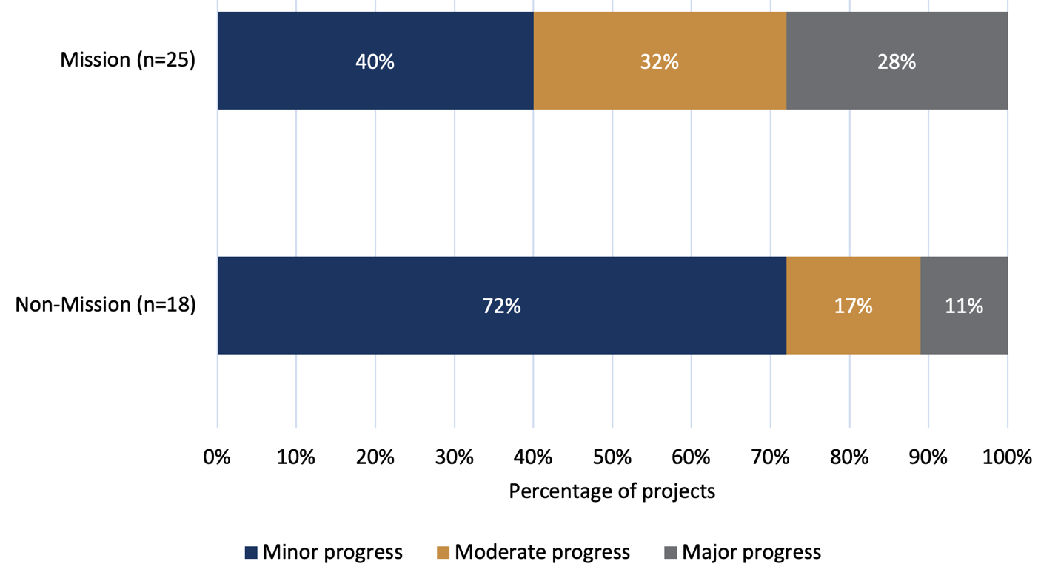

*Source: Document review (grantee progress and final reports)*

Box 17. Case study of a project working towards the community engaging with and adopting new technologies, treatments and interventions

| The ENJOY Seniors Exercise Park IMP-ACT project: IMProving older people's health through physical ACTivity: a hybrid II implementation project design, University of Melbourne (Mission, 2021) |
| --- |
| **Issue**  The health benefits of physical activity are well established; however, most older people are not sufficiently physically active. Despite the availability of various physical activity interventions and programs, implementation of effective prevention strategies to reduce older people’s physical inactivity are lacking.  **MRFF research**  The ENJOY IMP-ACT aims to inform scale up across Australia and increase participation in physical activity to improve health outcomes for older people. The project is an implementation research project, based on a previous evidence-based physical and social activity program utilising specialised outdoor exercise equipment (the Seniors Exercise Park) for older people. Five local governments will undergo a 3-month control period followed by 9-months implementation intervention and a 3-month maintenance phase. Research will include direct observations of park users, intercept surveys with park users, online access monitor platform (using an online app), interviews with stakeholders and exercise program leaders, a process evaluation of physical activity programs, a social return-on-investment analysis, and other related activities.  **How this project is achieving ‘the community engages with and adopts new technologies, treatments and interventions’**  The project actively supports community engagement and adoption of new health interventions through the establishment of a Community of Practice committee and regular site-specific project meetings. These forums enable local government staff and stakeholders to collaborate, share resources, exchange practical solutions, and provide peer support throughout the implementation process. Each participating local government includes representatives from the community, including trained volunteers, who are actively involved in promoting the initiative. Upskilling activities have equipped these community members to lead free “come and try” sessions at the Seniors Exercise Parks, helping older adults engage with the outdoor equipment safely and confidently. These council-led sessions aim to encourage sustained park-based physical activity. In addition, a mobile app has been developed to support users and community members with guided instructions, safety tips, and exercise routines. The study will also generate resources and implementation processes to ensure long-term integration of the Seniors Exercise Park program into local government operations and community health initiatives beyond the life of the study. |

Box 18. Case study of a project working towards the community engaging with and adopting new technologies, treatments and interventions

|  |
| --- |
| The right to rehabilitation for people with dementia: tackling stigma and implementing evidence-based interventions, University of Tasmania (Mission, 2021) |
| **Issue**  People with dementia are often denied treatments to help them maintain their everyday activities. This can be due to stigma and a lack of knowledge by health professionals.  **MRFF research**  The overall aim of the project is to work with people with dementia, their care partners and service providers to develop and test resources and strategies to improve access to treatments that will assist people living with dementia maintain independence and wellbeing in the community for as long as possible.  **How this project is achieving ‘the community engages with and adopts new technologies, treatments and interventions’**  The Chief Investigator team includes a person with dementia and a range of health professionals. People with dementia, carers, health professionals, and organisations (e.g., Primary Health Networks, Dementia Australia, Dementia Alliance International, allied health professional national bodies) participated in co-design and evaluation.  The outputs of the project were:   * a brochure describing how allied health can help optimise function for people with dementia * training for GPs and practice nurses on the role of allied health in dementia care * an interdisciplinary e-course on dementia rehabilitation using a human rights approach (>450 health professionals enrolled from across Australia, resulting in improved knowledge, confidence and attitudes) * a community of practice – participates took action in their workplace to improve knowledge and improve access to rehabilitation for people with dementia   Patient advocacy groups like Dementia Australia, and organisations that provide health professional education such as Dementia Training Australia and national health professional bodies, have been engaged to support dissemination of education and resources. |

6.4.7 MRFF Benchmark 8 – Increased commercialisation of health research outcomes

This section explores the current commercialisation activity of MRFF-funded DAAC research projects. It includes information on reported commercialisation outcomes, industry co-funding as a potential signal of commercial interest, and the extent to which projects identified progress against this MRFF benchmark.

Reported commercialisation outputs

According to performance indicator survey responses from grantees with completed projects (10 projects) as at May 2024, only one Mission-funded project reported a commercialisation outcome. The outcome was a product entering Phase III/IV clinical trials – an advanced stage in the translation and regulatory approval process. Among non-Mission projects, one reported generating income from intellectual property.

These data suggest that while commercialisation is occurring, it remains an uncommon output across both Mission and non-Mission DAAC projects. This may reflect both the early translational stage of many research activities, that only a subset of projects had reached completion (10/95) and were eligible to report on commercialisation outcomes, and that some MRFF-funded DAAC research projects were not captured by the performance indicator survey. For example, initiatives such as the Medical Research Commercialisation Initiative and the Preventive and Public Health Research Initiative provide funding to intermediary organisations, which in turn support ventures led by small-to-medium enterprises. One such example is the CUREator+ Dementia & Cognitive Decline Program (see Box 2, pg. 72), which specifically targets commercialisation of dementia-focused research. However, as these downstream projects do not report directly to the department, they fall outside the scope of the performance indicator survey data used in this analysis. As such, the commercialisation outputs presented here likely underestimate the full extent of activity underway across the MRFF DAAC research portfolio.

Industry co-funding as a signal of commercial interest

A number of projects identified industry co-investment as part of their funding model (Table 13), which may indicate areas of emerging commercial opportunity or application. Among Mission-funded projects, 13 reported industry co-funding, all of which were in-kind contributions, with a combined estimated value of $2,466,398.

Eight non-Mission projects reported industry co-funding. Of these, all eight received in-kind contributions (valued at $3,498,683), and one also reported a cash contribution of $1,000,000. While not a direct commercialisation output, the presence of industry involvement and significant in-kind support suggests a degree of alignment between research aims and industry interest.

Progress

Commercialisation was the least commonly nominated MRFF benchmark among projects, with only 16% across both Mission and non-Mission grants identifying it as a MRFF benchmark their project was addressing. Among these, most reported only minor progress against this benchmark, reflecting limited advancement along project timelines related to commercialisation objectives. This trend was more pronounced in non-Mission projects, where 83% of projects reported only minor progress, compared to 67% of Mission projects (Figure 37).

Figure 37. Progress towards increased commercialisation of health research outcomes

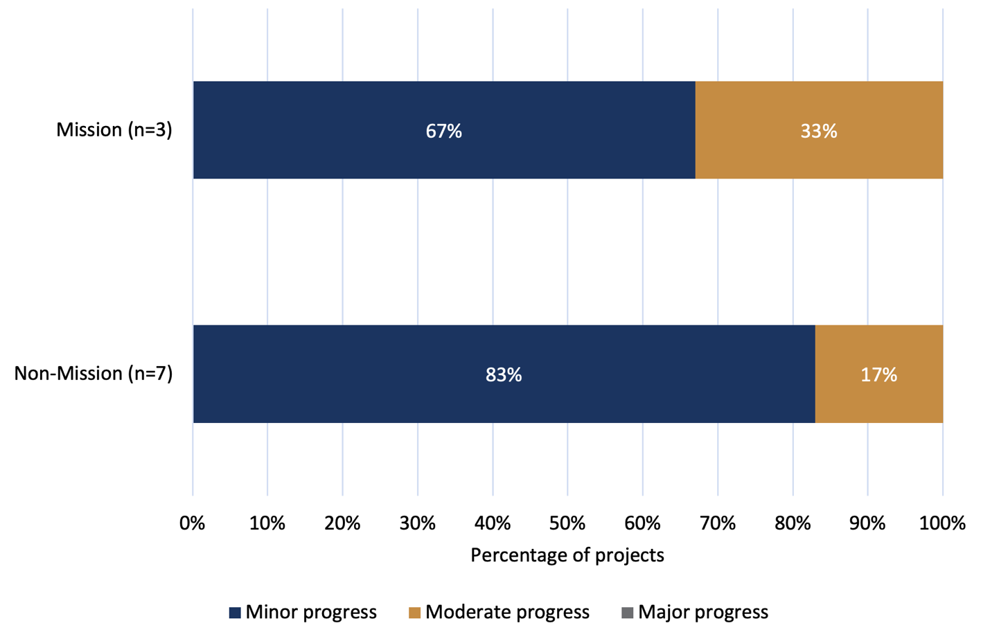

*Source: Document review (grantee progress and final reports)*

Review participants’ perspectives on: ‘Increasing the commercialisation of health research outcomes’

Commercialisation was not a strong focus among Review participants, but participants who were interested in this area – particularly from industry – identified opportunities to strengthen action in this area. Early engagement between researchers, industry and funders was widely viewed as essential to support successful commercialisation. Recommendations included embedding commercial considerations in grant design, encouraging greater support from university technology transfer offices, and sharing case studies of successful partnerships to build mutual understanding.

Industry stakeholders noted that commercialisation pathways in Australia are well developed for pharmaceuticals, but less so for diagnostics and digital products. This lack of clarity makes it more difficult to bring diverse dementia-related innovations to market. Limited access to late-stage capital was also seen as a major barrier, with participants noting that while early-stage funding (e.g. seed or proof-of-concept grants) is available, few funding mechanisms exist to support later-stage development and clinical trials in Australia, often forcing researchers to seek international investment and partnerships.

Data-related challenges were also raised. Fragmentation of dementia and aged care data, lack of integrated systems, and inconsistent benchmarking reduce the commercial attractiveness of new technologies and limited post-market monitoring, stakeholders suggested. Participants across sectors, including industry, highlighted the need for continued investment in national data infrastructure to support commercial readiness and adoption.

Box 19. Case study of a project working towards increasing the commercialisation of health research outcomes

| Music Attuned Technology Care eHealth (MATCH): A music based mobile eHealth solution to support care of people with dementia, University of Melbourne (Mission, 2020) |
| --- |
| **Issue**  People with dementia often display agitation, a challenging symptom that can lead to physical and verbal aggression, distress to families and professional carers, and most importantly, poorer quality of life for the person with dementia. Carers recognise the benefit of music therapy in calming people with dementia if they experience states of agitation.  **MRFF research**  The project aims to develop and test the acceptability of a mobile eHealth technology that draws on the unique power of music to support the care of people with dementia. The technology teaches carers how to use music in a targeted way, to reduce agitation, stimulate autobiographical recall, and shared meaningful experiences. A feature of the eHealth solution will be its ability to monitor the agitational state of the person with dementia using a wearable sensor with our own developed algorithms and select and adjust the music accordingly to meet the moment-by-moment changing needs.  **How this project is achieving ‘increased commercialisation of health research outcomes’**  The project has received additional funding from Google AI for the Global Goals Impact Challenge and seed grant from Australia’s Economic Accelerator. It is currently working to complete a commercially viable product and seeking additional funding to establish a commercial pathway. A commercial arm was established, and the plan is to launch the app in community care in 2025 and in residential care in 2026. |

7. Key strategic themes and opportunities for the MRFF and Mission

|  |
| --- |
| Review Question 4 - What opportunities (if any) are there to enhance MRFF funding and granting arrangements to improve the impact of MRFF-funded dementia, ageing and aged care research?  **Scope**  This section identifies strategic opportunities to enhance the impact of the Mission. It draws on the findings presented in the preceding chapters, particularly the insights and improvement opportunities raised by grantees and stakeholders. Some of the opportunities presented are for the department to consider for the Mission, while others relate to broader aspects of the MRFF or the wider health and medical research ecosystem and would require coordination with other government entities, funding agencies, or sector stakeholders.  While grounded in the evidence gathered during the Review, this section goes beyond a summary of findings. It reflects the Review team’s evaluative judgement, based on critical analysis of the evidence in the context of the MRFF’s purpose and the HMRO’s responsibilities. The themes and considerations presented here are intended to support future planning and continuous improvement of the Mission. They have also been informed by the experience and expertise of the Mission Review Panel.  The section starts with the key achievements and progress of the DAAC Mission identified by the Review, followed by the strategic opportunities for the Mission, presented under four domains:   * **7.1 What research is conducted** – strengthening mission aims and priorities * **7.2 How research is funded** – enhancing funding and granting arrangements * **7.3 How research is conducted** – improving research end-user involvement * **7.4 How research is used** – increasing translation and impact.   **NB:** This section presents suggestions for decision-makers to consider. They are not formal recommendations but are intended to inform planning, priority setting, and continuous improvement. |

7.1 What research is conducted – strengthening Mission aims and priorities

7.1.1 Recognise the ‘real world’ overlap across dementia, ageing and aged care within the Mission

**Opportunity for MRFF to consider**

There is an opportunity to enhance the strategic focus of the Mission by more clearly recognising the ‘real world’ interlinking relationship between dementia, ageing, and aged care. Strengthening the articulation of the Mission’s scope would also support more coherent priority-setting and increase the impact of funding by avoiding unintended dilution and duplication of other MRFF funding schemes.

Specific areas for consideration include:

* The Mission could clarify that dementia is defined broadly by pathology and across adult age groups, and that studies focused on dementia are likely to be interrelated to the aged care system and ageing.
  + While current priorities remain relevant, there may be value in placing greater emphasis on prevention (to slow the growing number of people living with dementia), treatment, and post-diagnostic care.
  + While recognising its importance, childhood dementia is explicitly not within this Mission’s remit, as confirmed by previous departmental guidance. A clear statement to this effect would assist stakeholders in understanding the boundaries of the Mission’s scope.
* The ageing research component of the Mission should be retained but could be more tightly focused to align with dementia and aged care. The current broad focus on ageing potentially duplicates other MRFF Missions (e.g. Cardiovascular Health, Genomics Health Futures, Million Minds, and Reducing Health Inequities) and investment initiatives (e.g., Preventive and Public Health Research Initiative). The Mission could emphasise the aspects of ageing not explicitly covered by other investments such as, preserving intrinsic capacity in later life, frailty and supporting people with multiple long-term health conditions. This would strengthen the Mission’s relevance to dementia and aged care and align with emerging international trends.
* Aged care research is considered a critical priority area that requires sustained and dedicated investment. However, concern was raised about the limited involvement of aged care providers and service delivery organisations in shaping and delivering research.
  + It was suggested that the Mission more clearly articulate how aged care providers, workforce issues, and care models across multiple settings (e.g. ageing-in-place) are integrated within its scope.
  + Considerations also need to be given as to how aged care research be more closely aligned with national reforms (including the new Aged Care Act, Royal Commission findings, and the Dementia Action Plan), and address transitions between care type, such as from community-based to residential care settings (see also 7.1.2).

7.1.2 Refocus research priorities to support aged care reform

**Opportunity for MRFF to consider working with multiple DAAC stakeholders**

Australia is currently undergoing a once-in-a-generation reform of its aged care system, which is significantly reshaping models of care, particularly in residential and community-based settings. There is an opportunity for the Mission to ensure its research investments align more closely with these national reforms[74], supporting practical improvements in service delivery and workforce capability. Clearer alignment between research priorities and aged care reform directions may also assist in enhancing the relevance, implementation and system-level impact of MRFF-funded DAAC research.

Specific areas for consideration include:

* Better collaboration between the department’s aged care policy areas, including the First Nations Aged Care Commissioner, and the research sector could help to shape research questions that are directly relevant to reform priorities. There was a call for structured engagement models where researchers, policymakers, and aged care providers can collaborate without conflicts of interest. Potential solutions included sharing successful experiences and processes of engaging with researchers across the government agencies. It was also suggested that researchers could be invited to an open forum with policymakers to discuss research priorities and findings as a mechanism to manage conflicts of interest
* Specific research priority areas aligned with the Australian Government’s aged care reform agenda, including the recommendations of the Royal Commission into Aged Care Quality and Safety (see Box 3), the Dementia Action Plan (see Box 4), and the forthcoming new Aged Care Act, could form the basis of an initial process to determine additional research priorities. Working with the department, consideration could also be given to:
  + Research evidence that needs to be created to support the design and implementation of the reforms
  + How the new reforms will be evaluated.

7.1.3 Continue and strengthen research effort across underrepresented Mission priority populations to support equity

**Opportunity for MRFF to consider**

Review participants emphasised the importance of distinguishing between research that merely includes members of priority populations as part of a study sample, and research that is specifically designed to address their needs in terms of lived experiences[75]. The latter was considered critical to achieving genuine equity, with research priorities and questions needing to be shaped by the needs of priority populations. For further detail on how this could be achieved, see sections 7.2.3 and 7.3.1.

Greater attention may be needed to embed culturally safe and community-led Aboriginal and/or Torres Strait Islander-led research within future Mission investments.

Participants supported dedicated, targeted funding for Aboriginal and/or Torres Strait Islander-led, community-controlled research that responds to priorities identified by Aboriginal and Torres Strait Islander communities. This includes research informed by the aged care needs identified by the Interim First Nations Aged Care Commissioner through their recent extensive consultation with older Aboriginal and Torres Strait Islander people, their families and communities, service providers and peak bodies[76]. Additionally, any research funded through the MRFF should be aligned with the principles of Indigenous data sovereignty, as stated per the Maiam Nayri Wingara principles[77], which emphasise the rights of Aboriginal and Torres Strait Islander peoples to govern the collection, ownership and application of data about their communities.

A consistent theme across discussions was the importance of delivering care that is culturally safe. In general terms cultural safety is achieved when individuals from diverse backgrounds feel respected and safe to be themselves, with their cultural identity acknowledged and valued in all interactions and services. Cultural safety has specific meaning for Aboriginal and Torres Strait Islander people and has been defined in Appendix 1 of the [Aboriginal and Torres Strait Islander Aged Care Framework 2025 – 2035](https://www.health.gov.au/sites/default/files/2025-02/aboriginal-and-torres-strait-islander-aged-care-framework.pdf). Participants called for investment in research that tests how to embed culturally safe approaches into aged care.

Strengthening focus on underrepresented priority populations within the existing Mission framework

Some of the currently listed Mission priority populations (see Box 20) remain underrepresented in the current research portfolio (Figure 22) and may warrant greater focus for future funded research. These include carers, veterans, people with lived experience of homelessness, parents separated from their children by forced adoption or removal, prisoners or ex-prisoners, and individuals from LGBTI communities. Additional groups that could be considered for inclusion are women and people with disability based on observations of the priorities of compactor funders (see Section 4.3.1).

Box 20. Mission priority populations identified in the implementation roadmap, with currently underrepresented groups shown in bold

|  |
| --- |
| Mission priority populations |

|  |
| --- |
| * People from Aboriginal and Torres Strait Islander communities * People from CALD backgrounds * People who live in rural or remote areas * People who are financially or socially disadvantaged * People who are veterans of the Australian Defence Force or an allied defence force, including the spouse, widow or widower of a veteran * People who are homeless, or at risk of becoming homeless * People who are care leavers (including Forgotten Australians, Former Child Migrants and members of the Stolen Generations) * Parents separated from their children by forced adoption or removal * People from lesbian, gay, bisexual, trans/transgender and intersex (LGBTI) communities * People who are prisoners or ex-prisoners |

7.2 How research is funded – enhancing funding and granting arrangements

7.2.1 Embed translation expectations into research project funding and reporting to drive real-world impact

**Opportunity for MRFF to consider**

Participants emphasised that the most effective way for the MRFF to improve outcomes of Mission-funded research is to embed clear expectations for translating research into practice – distinct from conducting translational research itself. This involves creating the right conditions within funding and reporting processes to support the practical application of research findings.

Survey responses from both grantees and stakeholders highlighted the importance of more active and structured engagement between researchers and government decision-makers, particularly those with responsibility for implementing policy and service delivery change.

Embedding translation requirements across the funding lifecycle – for example, within grant criteria, assessment processes, and progress reporting frameworks – would help ensure MRFF investments deliver measurable, real-world impact.

Specific areas for consideration include:

* **Embedding research end-user partnerships for translation at the grant-level**
  + Currently MRFF grants encourage partnerships and that has been beneficial. A potential next step to strengthen partnerships could be to require research end-user partnerships. This is where arrangements are in place in the grant for research end-users such as service providers, industry partners, or governments to co-design and be involved in MRFF-funded DAAC research projects to ensure sustained implementation and practical application of research outcomes. This could be beneficial for targeted grant schemes, with explicit grant conditions or scoring criteria to reward proposals demonstrating substantial research end-user partnerships aimed at translation. These partnerships must include in-kind support and may include additional funding. The MRFF could consider developing a resource to support researchers in establishing and sustaining research end-user partnerships throughout their research projects.
* **Encouraging the inclusion of translation plans in grant applications**
  + Funded projects could be required to include a clear translation plan at the time of application, outlining how research findings will be applied in practice or policy. Funding bodies from states and territories as well as internationally are increasingly prioritising grants with a clear impact pathway and the MRFF could consider making it a requirement to include a policy impact statement or a translation plan in grant applications. Other funders, such as NHMRC’s Research Translation Centre Initiative and ARIIA’s Aged Care Partnering Program, embed such components within their schemes to support impact and alignment with system needs.
* **Enhancing progress reporting on translation activities**
  + Progress reporting frameworks could be strengthened to explicitly require more detailed updates on translation activities, including engagement with research end-users, development of practical outputs, implementation milestones, and strategies for sustaining outcomes over time. Guidance could be provided to researchers as to what is considered research end-user engagement and translation.

7.2.2 Foster collaboration between Australian research institutions, not competition

**Opportunity for MRFF to consider working with multiple DAAC stakeholders**

While this theme extends beyond the scope of the Mission, and indeed the MRFF more broadly, there are clear opportunities to address it within the Mission. Participants strongly advocated for funding approaches that incentivise collaboration across Australian research institutions. This includes further enabling researchers from multiple institutions to work with clinicians, consumers, service providers and other stakeholders on shared priorities, rather than competing for limited funding. Such approaches were seen as critical to drawing on broader expertise, strengthening national research capability, and enhancing Australia’s international competitiveness in DAAC research. The MRFF already supports collaborative research through mechanisms such as the Rapid Applied Research Translation initiative and targeted funding within the Mission.

Specific ways in which collaboration across research institutions could be strengthened within these existing mechanisms include:

* **Strengthening government facilitation and requirements for multi-institution collaboration**
  + Governments can play a constructive and enabling role in fostering collaboration across research institutions. A successful example was provided by a NSW Health COVID-19 research initiative, where the funding approach required joint proposals from multiple institutions. This model led to more coordinated research efforts, improved knowledge sharing, and greater overall impact.
  + Rather than acting as neutral observers, government funders were seen as well-placed to actively shape collaboration by designing grant processes that encourage partnership, such as collaborative funding calls, facilitated proposal development, or structured co-design workshops. These mechanisms can be implemented without compromising impartiality and are consistent with the government’s role in ensuring that public investment delivers maximum value and real-world outcomes.
* **Leveraging peak bodies and non-government organisations to support cross-institution collaboration**
  + Stakeholders noted the value of engaging bodies such as ARIIA and Dementia Australia in supporting collaboration across the research sector. Mechanisms identified for consideration included co-design workshops or pre-grant forums, based on successful models used by other organisations (e.g. the National Breast Cancer Foundation) that promote multi-research institution collaboration.
* **Embedding multicentre collaborative funding with grants**
  + Mission granting arrangements currently encourage multicentre collaborative grants. However, this could potentially be strengthened to make these mandatory under certain granting arrangements. This approach was seen as conducive to producing research that is generalisable across diverse settings, with potential for wider uptake and implementation. Examples cited included initiatives such as the Dynamic Analyses to Optimise Ageing (DYNOPTA)[78] and national longitudinal studies, which have demonstrated benefits such as improved data harmonisation, enhanced statistical power, and capacity building for early-career researchers.
* **Reducing institutional competition to enable collaboration**
  + Existing funding structures and academic recognition systems were seen as factors that may limit collaboration between and within institutions. Current performance and reward systems were seen as contributing to institutional competition, which can act as a barrier to joint research efforts. Whilst these are systemic issues that are broader than the Mission and MRFF, consideration could be given to funding models that explicitly recognise and incentivise meaningful collaboration, for example, through criteria that value shared research outputs, joint data infrastructure, and cross-institutional research teams.

7.2.3 Introduce targeted funding streams for currently underfunded areas and emerging needs

**Opportunity for MRFF to consider working with multiple DAAC stakeholders**

To maximise the impact of the Mission, new targeted funding streams could be introduced to address currently underfunded areas and respond to emerging research and service delivery priorities. These could be delivered through existing MRFF grant mechanisms, strengthened and adapted to better meet the needs of the sector.

Moreover, some of these funding schemes could be developed through MRFF establishing partnerships with major research end-users, such as the Ageing and Aged Care Group of the department and relevant peak bodies. These partnerships could involve joint calls for funding focused on research end-user priorities articulated in specific grant opportunity guidelines.

In addition to the broad areas outlined in 7.1, several priority areas were identified through the Review for targeted investment:

* **Research led by Aboriginal and Torres Strait Islander people aligned with aged care reform**
  + Targeted research funding could aim to support Aboriginal and Torres Strait Islander-led research initiatives aligned with the new Aged Care Act and the priorities identified by the Interim First Nations Aged Care Commissioner. See 7.1.3.
* **Research conducted within aged care settings**
  + A clear gap was identified in sustained research infrastructure located within aged care environments, such as residential aged care homes and community-based aged care programs. Participants noted the need for dedicated research centres or embedded research programs to support ongoing evidence generation, service improvement, and innovation in care delivery. These centres could provide a platform for collaboration between researchers, clinicians, and aged care providers.
  + Creating opportunities for aged care and community-based providers and their staff to articulate research needs may support a more provider-informed research agenda[79]. This could help ensure research is focused on questions that are implementable in practice, including those related to: models of care to ‘age-in-place’, aged care workforce capacity, preserving intrinsic capacity, addressing early frailty and enhancing functional independence.
  + Research on transitions between care settings – such as from home or community care into residential aged care – and on integration between health and aged care systems could help to address key pressure points identified in current reforms. In addition, the interface between the aged care and disability sectors (e.g. transitions from the NDIS into aged care) was noted as a growing area requiring further attention.
* **Dedicated funding for implementation-focused research**
  + A separate funding stream for implementation research could be considered to support the translation of findings into practice. This could include targeted support for late-stage translation pipeline for ‘translation ready’ interventions. This scheme could be designed involving research partnership with service delivery organisations to help ensure research outcomes are integrated and sustained within aged care programs. It could also involve adopting structured co-design models, including the involvement of consumers and aged care providers in grant assessment and governance. Models for consideration include the NHMRC Partnership Grants and the NSW Translational Research Grants Scheme, which require or support implementation partnerships.
* **Support for clinician-researchers in aged care**
  + A significant gap was identified in support for clinician-researchers in aged care, particularly aged care nurses and GPs. Participants proposed dedicated funding for professionals working in both clinical and research roles, to support research end-user involvement in research projects and thereby help embed research into routine care and strengthen practice-based innovation. The MRFF Clinician Researchers initiative provides a promising avenue to support health professionals, especially those embedded in aged care delivery settings, to undertake research aligned with real-world practice challenges[80]. While the initiative's broad scope is encouraging, it will be important to monitor whether the funding meaningfully reaches aged care settings. Clear mechanisms to prioritise practice-based research in aged care would strengthen its impact and ensure alignment with sector needs. Given these uncertainties, there may be value in the Mission supporting clinician-researchers in aged care through its own dedicated funding mechanisms, rather than relying solely on this broader initiative.
* **Targeted research on dementia diagnosis and treatment**
  + Compared with other dementia research priorities, diagnostic- focused research has received relatively limited investment and may warrant greater attention in the next phase of the Mission (Priority 1.3). Strengthening investment in this area would also address an identified risk that the Mission is not currently on track to meet its diagnostic-related benchmarks. In addition, there may be value in introducing a new priority to capitalise on emerging developments in early intervention and dementia treatment and to build on Australia’s established strengths in clinical trials and post-diagnostic care. Future research should be underpinned by robust quality standards to ensure diagnostic and prognostic tools demonstrate clinical validity, utility and cost-effectiveness. Equally, ethical frameworks[81] must be embedded throughout development and implementation to mitigate risks of overdiagnosis, inequitable access or other unintended harms.
* **Targeted research on dementia prevention**
  + Research focused on dementia prevention has received limited investment relative to other areas and may warrant greater attention in the next phase of the Mission. Investment in prevention-focused research (e.g., dementia-specific predictive modelling, ranging from the biomarker to larger scale population-level) could support a greater understanding of modifiable risk factors across the life course and inform interventions to reduce dementia incidence at a population level. Stakeholders called for coordinated efforts across disciplines, spanning public health, primary care, and aged care, to strengthen the evidence base for effective prevention strategies.

7.2.4 Strengthen coordination of national DAAC research funding

**Opportunity for MRFF to consider working with multiple DAAC stakeholders**

There was strong consensus that coordination of national DAAC research funding requires improvement. Current arrangements were described as fragmented, with duplication across funding bodies and limited alignment with national priorities. Improved coordination was seen as important to reduce redundancy, leverage existing investments, and accelerate translation of research into practice and policy.

While the issue of national research coordination extends beyond this Mission and the MRFF, the Review presents a timely opportunity to inform the National Health and Medical Research Strategy currently under development[82], and to align with emerging mechanisms designed to promote collaboration and harmonisation between the MRFF and the NHMRC.

Specific areas of improvements to national coordination include:

* **Aligning Mission investments with broader national priorities**
  + Align DAAC funding more broadly and Mission investments with broader Australian Government priorities such as aged care reform, disability policy (e.g. NDIS), and health system sustainability, as well as with other MRFF Missions and NHMRC programs to maximise impact and avoid duplication.
* **Strengthening coordination between major research funders**
  + Strengthen collaboration between major funders of DAAC research, including the MRFF, NHMRC, state and territory governments, and non-government organisations. A national steering committee or coordination mechanism could be considered to set shared priorities, align funding programs, oversee a whole portfolio of research along a translation pipeline, facilitate translation pathways, and address research gaps. This committee could initially include the five biggest funders of DAAC research: NHMRC, MRFF, ARC, Dementia Australia and ARIIA.
* **Enhancing visibility through national mapping of research investments**
  + Develop a national system to map and track DAAC-related research funding across sectors. This would provide visibility into funded populations, topics and regions, and help identify opportunities and gaps. A partnership with a national entity such as Dementia Australia or the Australian Institute of Health and Welfare could support delivery.
* **Tapping into international research and funding opportunities**
  + Improve mechanisms to incorporate international research funding opportunities and insights into Australian funding decisions. This would help ensure Australian researchers can contribute to international funding programs that build on global knowledge and avoids unnecessary replication. This could also enhance Australians’ access to clinical trials.

7.3 How research is conducted – improving research end-user involvement

7.3.1 Strengthen research end-user involvement across all research stages to ensure relevance and impact

**Opportunity for MRFF to consider working with multiple DAAC stakeholders**

There was strong support for strengthening research end-user involvement across all stages of research funded through the MRFF. While research end-user engagement is a core focus of the MRFF, participants noted that involvement is often inconsistent and, at times, tokenistic. Review participants emphasised the need for meaningful, embedded engagement throughout the research lifecycle, including priority setting, design, implementation, translation, and dissemination.

Specific challenges in engaging aged care providers and community organisations in research highlighted systemic limitations such as workforce shortages, limited research capacity, and infrastructure. These barriers can constrain meaningful participation and require additional time, resources, and tailored approaches. There is a need to acknowledge these constraints in funding and research design, and to support the development of practical models, protocols, and guidance for conducting research in aged care and community settings.

|  |
| --- |
| *“If we can create structured ways for researchers and policymakers to collaborate early in the funding process, we’d see research findings translated much faster into practice.”*  **Stakeholder from a Federal Government agency** |

Opportunities to strengthen research end-user engagement include:

* **Clarifying and defining appropriate research end-user groups**
  + Generally, in the research ecosystem there is confusion around the definition of ‘research end-users’, which is often used to refer to a broad range of groups, including individual consumers, carers, aged care providers, clinicians, workforce representatives, and peak bodies. Future grant calls could clearly identify and define the relevant research end-user groups for each funding opportunity and provide tailored guidance on appropriate forms of involvement for each category.
* **Strengthening the requirements** **and accountability for consumer engagement**
  + Consumer engagement is a recognised strength of the MRFF, supported by the Principles for Consumer Involvement in Research Funded by the MRFF[83]. Participants proposed strengthening the impact of these principles by making adherence mandatory and introducing progress reporting mechanisms to track how researchers are involving consumers throughout the research process. For example, participants cited the [Walter and Eliza Hall Institute of Medical Research’s](https://www.wehi.edu.au/research/clinical-trials/consumers-and-research/) work in brain cancer as a model of best practice in integrating consumers into research teams, including in question development and results interpretation. Other examples include the [Step Up for Ageing Research](https://www.stepupfordementiaresearch.org.au) initiative, which connects older Australians with researchers to improve involvement in ageing-related studies, and [Dementia Australia’s Dementia Advocates Program](https://www.dementia.org.au/about-us/advocates), which supports people living with dementia and carers to contribute to research, policy, and service design.
* **Developing equivalent guidance for other research end-user groups**
  + In addition to consumers, practical guidance on how to engage other research end-user groups such as federal policymakers, providers, clinicians, and workforce representatives could be developed. MRFF or other coordinating bodies in the sector could play an active role in facilitating these relationships and supporting researchers and research end-users to work collaboratively from project inception.
* **Monitoring research end-user involvement post-awarding of grants**
  + Strengthen post-award monitoring of research end-user involvement by requiring grant recipients to demonstrate ongoing, meaningful involvement in progress reports.
* **Incentivising translation partnerships with research end-users**
  + Research end-user partnerships were seen as essential to effective implementation and translation. Participants recommended that MRFF funding explicitly incentivise partnerships with research end-users – such as aged care providers, workforce representatives, and peak bodies – to co-develop practical outputs including toolkits, training modules, and implementation resources. Projects could also be required to articulate clear implementation pathways that involve research end-users throughout, to support sustained real-world impact beyond project completion.

7.4 How research is used – increasing translation and impact

Collectively, the preceding strategic opportunities aim to improve the practical application and real-world impact of MRFF-funded DAAC research. Clarifying the Mission’s scope (7.1.1), aligning research priorities with aged care reform (7.1.2), and continuing to invest in research focused on priority populations (7.1.3) will sharpen strategic focus and ensure relevance to current system needs. Embedding translation expectations in funding and reporting (7.2.1), fostering collaboration across Australian research institutions (7.2.2), and introducing targeted funding streams (7.2.3) will create the right conditions for MRFF research investment to result in research that can be translated into impact. Improved national coordination (7.2.4) and stronger research end-user involvement at all research stages (7.3.1) will further ensure that research is aligned with practice realities and policy priorities.

7.4.1 Enhance communication about MRFF DAAC research

**Opportunity for MRFF to consider**

Traditional academic outputs (journal articles, reports) alone are insufficient to support the practical translation of research findings. To maximise the practical impact of DAAC research there is a need to complement academic dissemination with tailored user-friendly outputs for research end-users, including policymakers, aged care providers, clinicians, carers, and consumers. These could be considered as a requirement of funding. For example, where the research end-user is the department, researchers could produce structured policy briefs aligned with departmental templates.

In addition, there may be value in establishing an annual or biannual MRFF-facilitated showcase of Mission and MRFF-funded research. This event could highlight progress, promote peer exchange, and foster dialogue between researchers, policy agencies, peak bodies, and community stakeholders. Over time, it could help build a more cohesive and engaged research community focused on reflection, impact, and shared problem-solving.

8. Conclusion

8.1 Key achievements and strengths of the DAAC Mission

At this mid-point in its funding cycle, the Mission is making strategic early progress in addressing national health and aged care priorities. Research investments to 20 August 2024 are well aligned with the Mission aims and priority areas for investment. Key achievements and strengths identified in this Review are found in Table 22.

Table 22. Key strengths and achievements of the DAAC Mission

| **Key strengths and achievements of the DAAC Mission** |
| --- |
| **1. Large-scale investment in a national priority** |
| The Mission is strongly positioned as Australia's second-largest funder of DAAC research, accounting for 33% of national funding between 2018 and 2024, indicating substantial scale and impact. |
| **2. Strong focus on research translation and real-world application** |
| The Mission is emerging as a critical mechanism to bridge the funding gap between early-stage basic research (typically funded by the NHMRC) and later-stage translational research. MRFF research, prioritising interventions ready for clinical, policy, and community application, strives to have real-world impact. However, the Mission is still at its midpoint, so impact cannot yet be fully assessed. |
| **3. High levels of consumer involvement in research** |
| Consumer involvement was reported in 93% of projects, with many including consumers in advisory, design, and data collection roles. |
| **4. Inclusive targeting of priority and under-served populations** |
| Approximately 75% of funded projects engaged one or more identified priority populations, including Aboriginal and Torres Strait Islander communities, CALD groups, people in rural and remote areas, veterans, LGBTI communities, and others. The breadth and inclusivity of this targeting reflect a strong alignment with national equity objectives. |
| **5. Positive contribution to Australia’s international research standing** |
| Stakeholder interviews and sector feedback reinforced the view that Australia is a global leader in dementia research – particularly in prevention, post-diagnostic care, and inclusive research practices. |

8.2 Summary of strategic improvement opportunities

Based on the Review findings, nine strategic improvement opportunities have been identified for the department to consider. These are grouped under four domains – what research is conducted, how research is funded, how research is conducted, and how research is used – and reflect both areas within the remit of the MRFF (i.e., the department and/or HMRO) and those requiring action across the broader HMR sector. Table 23 provides an overview of these opportunities and where responsibility may lie.

Table 23. Review key messages – strategic opportunities for the department to enhance the MRFF-funded DAAC research

| **Strategic improvement opportunities** | **Responsibility** | |
| --- | --- | --- |
| **MRFF** | **HMR sector**[84] |
| **7.1 What research is conducted** |  |  |
| 7.1.1. Recognise the ‘real world’ overlap across dementia, ageing and aged care within the Mission | Tick with solid fill suggesting this is an MRFF responsibility. |  |
| 7.1.2 Refocus research priorities to support aged care reform | Tick with solid fill suggesting this is an MRFF responsibility. | Tick with solid fill suggesting this is an HMR sector responsibility. |
| 7.1.3 Continue and strengthen research effort across underrepresented Mission priority populations to support equity | Tick with solid fill suggesting this is an MRFF responsibility. |  |
| **7.2 How research is funded** |  |  |
| 7.2.1 Embed translation expectations in funding and reporting to drive real-world impact | Tick with solid fill suggesting this is an MRFF responsibility. |  |
| 7.2.2 Foster collaboration between Australian research institutions, not competition | Tick with solid fill suggesting this is an MRFF responsibility. | Tick with solid fill suggesting this is an HMR sector responsibility. |
| 7.2.3 Introduce targeted funding streams for currently underfunded areas and emerging needs | Tick with solid fill suggesting this is an MRFF responsibility. | Tick with solid fill suggesting this is an HMR sector responsibility. |
| 7.2.4 Strengthen coordination of national DAAC research funding | Tick with solid fill | Tick with solid fill suggesting this is an HMR sector responsibility. |
| **7.3 How research is conducted** |  |  |
| 7.3.1 Strengthen research end-user involvement across all research stages to ensure relevance and impact | Tick with solid fill suggesting this is an MRFF responsibility. | Tick with solid fill suggesting this is an HMR sector responsibility. |
| **7.4 How research is used** |  |  |
| 7.4.1 Enhance communication about MRFF DAAC research | Tick with solid fill suggesting this is an MRFF responsibility. |  |

Appendices

Appendix 1. Projects in scope for the Review

| **Chief Investigator A** | **Grant title** |
| --- | --- |
| **Mission-funded grants** |  |
| Not applicable (Jürgen Götz) | Breaking through dementia - the Clem Jones Centre for Ageing Dementia Research |
| Doctor Nadeeka Dissanayaka | Technology Assisted and Remotely Delivered Anxiety Psychotherapy Intervention for People living with Dementia and Their Care Partners (Tech-CBT) |
| Professor Felicity Baker | Music Attuned Technology Care eHealth (MATCH): A music based mobile eHealth solution to support care of people with dementia |
| Associate Professor Piers Dawes | SENSEcog aged care: Hearing and vision support to improve quality of life for people living with dementia in residential aged care |
| Doctor Simone Reppermund | Development, validation and implementation of a computerised tool to assess instrumental activities of daily living |
| Professor Wen Lim | IMpleMenting Effective infection prevention and control in ReSidential aged carE (IMMERSE) |
| Associate Professor Tracy Comans | Alignment, Harmonisation, and Results: translating Core Outcome Measures to Improve Care (COM-IC) for People Living with Dementia into Australian practice |
| Professor Ashley Bush | Blood testing to predict and discriminate dementias |
| Associate Professor Bianca Brijnath | Drawing out care: Using animation and digital technologies to support Culturally and Linguistically Diverse (CALD) family carers and people living with dementia |
| Professor Lily Dongxia Xiao | Creating partnership in iSupport program to optimise carers' impact on dementia care |
| Associate Professor Noleen Bennett | Development and Implementation of the National Infection Surveillance Program for Aged Care (NISPAC) |
| Professor Simon Bell | Knowledge brokers for evidence translation to improve quality use of medicines in residential aged care |
| Doctor Sarah Wallace | Unspoken, Unheard, Unmet: Improving Access to Preventative Health Care through Better Conversations about Care |
| Professor Lee-Fay Low | Evaluation of primary care and help-seeking promotion programs to increase dementia diagnosis and early treatment |
| Doctor Darshini Ayton | Residential Aged Care - Enhanced Dementia Diagnosis |
| Professor Maria Inacio | The Australian Consortium for Aged Care - Quality Measurement Toolbox (ACAC-QMET): Improving Quality of Care through Better Measurement and Evaluation |
| Professor Yuming Guo | Better Environment, Healthier Ageing |
| Professor Pazit Levinger | The ENJOY Seniors Exercise Park IMP-ACT project: IMProving older people's health through physical ACTivity: a hybrid II implementation project design |
| Associate Professor Michele Callisaya | The right to rehabilitation for people with dementia: tackling stigma and implementing evidence-based interventions |
| Professor Alison Hutchinson | Implementing innovative technology promoting self-awareness of brain health and self-determination in obtaining a timely dementia diagnosis |
| Associate Professor Catherine Said | Implementation of a co-designed exercise and fall prevention program for older people from CALD backgrounds |
| Professor Jonathan Golledge | MEtformin for treating peripheral artery disease Related walking Impairment Trial (MERIT) |
| Professor Bianca Brijnath | No more shame: Changing health providers recognition and response to elder abuse to reduce Associated stigma |
| Professor Johanna Westbrook | Transforming residential aged care through evidence-based informatics |
| Doctor Michelle Kelly | A Preventative Care Program to optimise mental health during transition into residential aged care |
| Professor Ruth Hubbard | Frailty KIT: An Australian Frailty Network to Create Knowledge, Implement Findings and Support Training |
| Doctor Rachel Ambagtsheer | IMPAACT: IMproving the PArticipation of older Australians in policy decision-making on Ageing-related CondiTions |
| Associate Professor Tanya Davison | EMBED: A stepped wedge cluster randomised trial of a tailored, integrated model of care to reduce symptoms of depression in home aged care |
| Doctor Catherine Bondonno | Getting to the heart of healthy ageing: a behaviour change program to promote dietary pattern changes |
| Doctor Theresa Scott | Navigating Fitness to Drive with Patients with Dementia in Primary Care: Delivering an innovative Online Driver Safety Assessment and Management Package to Practitioners |
| Professor Mariko Carey | Increasing days living in the community and improving quality of life among people living with dementia and their carers |
| Associate Professor Nadeeka Dissanayaka | Enhancing utility of neuropsychological evaluation for earlier and effective diagnosis of dementia in Parkinson’s disease |
| Associate Professor Catherine Said | Implementation and evaluation of a codesigned exercise program to reduce falls in older people from culturally and linguistically diverse communities |
| Doctor Katrina Anderson | To know me is to understand me: Digital life story packages in dementia care transitions |
| Doctor Stephanie Wong | Spatial navigation assessment: pathway to clinical translation and early diagnosis of dementia |
| Associate Professor Yen Ying Lim | An Integrated Method for the Assessment and Monitoring of Dementia and Cognitive Impairment: The Cognition - Optimised, Digitised, And Harmonised (C-ODH) platform |
| Professor Muireann Irish | A new tool to optimise the early and accurate diagnosis of frontotemporal dementia |
| Doctor Kate Smith | Strengthening and enhancing the utility of a neuropsychological tool for dementia in First Nations peoples |
| Professor Piers Dawes | Home hearing and vision care to improve quality of life for people with dementia and carers |
| Ms Sandra Bailey | Evaluating the implementation and uptake of prevention programs to support healthy ageing amongst Aboriginal people |
| Professor Anne Tiedemann | Active Women over 50 in rural, regional and remote areas: an effectiveness-implementation trial |
| Associate Professor Odette Pearson | Connecting aged care, health care and social services systems to support older Aboriginal and Torres Strait Islander people to live their best lives |
| Associate Professor Stephen Isbel | Enhancing allied health services for people with dementia in residential aged care: an integrated, transdisciplinary model |
| Professor Loretta Baldassar | BEFRIENDING with GENIE: An intervention to reduce loneliness and increase social support and service access for people living with dementia and their caregivers from CaLD backgrounds |
| Professor Loc Do | Oral Health in Aged Care: Addressing Oral Health Inequity and Unmet Dental Care Needs in Vulnerable Populations |
| Professor Kaarin Anstey | Secondary prevention of dementia through lifestyle risk reduction in cognitively at-risk older adults |
| Doctor Elise Mansfield | Living Well after Hospital: A randomised controlled trial testing the effectiveness of a coordinated transitional care program for older adults being discharged from hospital |
| Professor Sarah Hilmer | Strategic Development of Real-Time Frailty Monitoring Technology to Improve Care for Older Australians |
| Professor Kim Delbaere | Digital Home-Based Rehabilitation Program for Enhancing Health and Independence in Older People |
| Professor Bianca Brijnath | Mind Care Digital: Improving access to dementia prevention in CALD communities |
| Professor Peter Gonski | New solutions for the older person |
| Associate Professor Melinda Jackson | Co-designing a novel digital sleep intervention for community-dwelling people living with cognitive impairment and their care partner |
| **Non-Mission funded grants** | |
| Not applicable (Associate Professor Antony Cooper) | The Australian Parkinson’s Mission: Integrating genomics, biomarkers and patient cell phenotyping into disease modifying clinical trials to identify therapeutics to slow or stop disease progression |
| Professor Jacqueline Center | Improving outcomes in osteoporosis and bone health |
| Associate Professor Leonard Crocombe | Sustaining oral and systemic health in Residential Aged Care Facilities |
| Doctor Lauren Ayton | Improving patient management pathways in age-related macular degeneration |
| Professor Geraint Rogers | Using metagenomics and the Registry of Ageing South Australians to understand carriage and transmission of antimicrobial resistance in the elderly |
| Professor Anton Peleg | Stepped-wedge Trial to increase antibiotic Appropriateness in Residential aged care facilities and model Transmission of antimicrobial resistance (The START Research Program) |
| Professor David Paterson | Cluster randomised trial of a multimodal intervention to reduce antimicrobial use in residential aged care facilities |
| Doctor Henrietta Venter | Turning antimicrobial resistance in residential aged care inside-out from the patient to facility level |
| Professor Leon Flicker | Maximising health for older Australians |
| Professor Andrew Spencer | Frailty-stratified randomised controlled bayesian adaptive trial of bortezomib versus lenalidomide in transplant-ineligible myeloma - the FRAIL-M study |
| Doctor Joan Ostaszkiewicz | Translating dignity principles into practice in aged care homes |
| Professor Andrew Wei | Novel Venetoclax Combinations to Improve Outcomes in Unfit Older Patients with Acute Myeloid Leukaemia |
| Professor Terence O'Brien | Evaluating the effectiveness and safety of sodium selenate as a disease modifying treatment for patients with behavioural variant Frontotemporal Dementia (bvFTD) |
| Professor James Vickers | Preventative Health Research in Rural and Regional Communities (Tasmania) |
| Professor Ralph Martins | The Australian-multidomain Approach to Reduce dementia Risk by prOtecting brain health With lifestyle intervention (AU-ARROW) study |
| Professor Lin Perry | Translation of best practice osteoporosis refracture prevention: stopping fragility fractures to keep Australians out of hospital |
| Professor Gillian Harvey | An early detection program to prevent unnecessary hospital admissions of aged care residents |
| Professor Guy Maddern | Mobile X-ray services provided within residential aged care facilities |
| Doctor Monica Cations | Meeting psychological needs to improve the quality and safety of aged care |
| Professor Viviana Wuthrich | Screening and Risk Reduction for Dementia in Primary Care |
| Associate Professor Neil Orford | Bone Loss Prevention with Zoledronic Acid or Denosumab in Critically Ill Women – A Randomised Controlled Trial (Bone Zone) |
| Associate Professor Maria Inacio | Using big data to create evidence-based primary health care service delivery and policy for the Australian aged care sector - a nationwide study |
| Professor Robin Daly | TeleFFIT - A personalized, telehealth exercise and lifestyle risk factor management program to reduce falls and fracture risk in older adults: A 12-month hybrid effectiveness-implementation trial |
| Professor John Mamo | A randomised control trial in subjects with early Alzheimer's disease in exploring if probucol supports cognitive function through improved cerebrovascular function |
| Associate Professor Lachlan Thompson | Next generation stem cell therapy for Parkinson's disease |
| Doctor Nicole Rankin | Ready to screen. Targeting the high-risk population to improve lung cancer diagnosis |
| Doctor Kylie Gwynne | Early Atrial fibrillation Screening for Indigenous people (EASI) |
| Professor Stephen Nicholls | Atheroma Progression in Clonal Haematopoiesis Investigation with Imaging, Biomarkers and Genomic Sequencing (ARCHIMEDES) |
| Associate Professor Jack Chen | Developing a holistic machine learning based rapid response system and end of life care system in preventing cardiac arrests and preventable deaths and improving end of life care in acute hospitals |
| Professor Roland Bammer | Combining Novel Imaging Biomarkers with AI-Accelerated Diagnosis for Equitable Patient Selection To Proactive Treatment With Middle Meningeal Artery Embolisation To Improve Outcomes in cSDH |
| Associate Professor Robyn Clay-Williams | Working together: innovation to improve Emergency Department (ED) performance, and patient outcomes and experience for five complex consumer cohorts |
| Professor Antonio Celenza | OPERATE: Older Persons Early Recognition Access and Treatment in Emergencies |
| Associate Professor Craig Whitehead | “There must be a better way”: partnering with consumers to implement a digitally enabled geriatric urgent care unit to improve hospital flow |
| Doctor Mouna Sawan | Reducing medication-related harm in people living with dementia through community action: Development and testing of novel co-designed medication management resources across care settings |
| Professor Amy Brodtmann | Better biomarkers for dementia diagnosis: NfL and Voice Acoustic analysis In Dementia Diagnosis (NAVAIDD) |
| Doctor Ashleigh Smith | Small Steps towards personalised dementia prevention |
| Professor Mark Polizzotto | Modulating stem cell differentiation in individuals with high risk clonal haematopoiesis: the MOSAIC trial |
| Professor Ramon Shaban | Nurse-Led Improvements to the Quality and Safety of Residential Aged Care - Project HIRAID-AgedCare |
| Doctor Josefine Antoniades | MINDCARE: Co-producing a dementia risk reduction program for CALD communities to improve health self-efficacy |
| Professor Andrew Wei | ADAPT (Achieving Durable remission via Adaptive Pro-survival Targeting in Acute Myeloid Leukaemia) |
| Associate Professor Lynette Goldberg | Privileging the spirit, voices, and culture of Aboriginal people in dementia care: Education for non-Aboriginal healthcare providers |
| Associate Professor Catherine Said | Implementation of a co-designed, community led exercise program to reduce falls in older people from culturally and linguistically diverse communities: a pilot trial |
| Doctor Joan Ostaszkiewicz | IDC-IMPROVE: The co-design, implementation and evaluation of a care bundle to improve indwelling catheter care (IDC) in residential aged care homes |
| Associate Professor Joshua Lewis | Investigating genetic and lifestyle determinants of abdominal aortic calcification, and their relationship with cardiovascular disease |
| Professor Anne Holland | Personalised Exercise Rehabilitation FOR people with Multimorbidity - The PERFORM trial |
| Professor Kaarin Anstey | Chronic disease risk reduction in older adults with high dementia risk: CogCoach trial |
| Professor Meera Agar | Delivering Better Care for Older Australians with Cancer |
| Professor Mark Hughes | Co-creating rainbow-inclusive care for gender & sexually diverse people in residential aged care |
| Doctor Louisa Smith | SAGE Dem: A model of care to improve health of sexuality and/or gender diverse people living with dementia |
| Doctor Jacinta Johnson | Evaluating a Collaborative Approach for Reducing harm and optimising Medication outcomes through partnered charting: The CARe-MED study |
| Professor Anne-Marie Hill | Safe Recovery - Reducing Falls Injuries by Older People in Australian Hospitals |
| Professor Meredith Makeham | The General Practice and Residential Aged Care Study of Virtual Care Models (The Grace-VC Study): Implementing safe, person-centred virtual care for residents |
| Professor Simon Stewart | Optimising the Detection and Multidisciplinary Management of Heart Failure in Primary Care |
| Professor Sarah Dennis | A primary care multi-disciplinary team care approach, including pulmonary rehabilitation, to improve uptake and outcomes of comprehensive evidence-based care for COPD |
| Professor Patrick Coates | Repurposing mTOR inhibitors to boost vaccine responses in the immunocompromised and elderly |
| Professor Jennie Ponsford | Implementing evidence-based care for cognitive and psychosocial consequences of moderate-to-severe traumatic brain injury |
| Associate Professor Leanne Hassett | Implementation of the Australian Physical Activity Clinical Practice Guideline for people with moderate to severe traumatic brain injury |
| Professor Edward Strivens | Addressing unmet need through a model of care for people with mild cognitive impairment in Zenadth Kes and Northern Peninsula Area (MCI-MOC) |
| Professor Juergen Goetz | Therapeutic Ultrasound for the Treatment of Brain Disorders |
| Associate Professor Sam Kosari | Implementation and scale up of on-site pharmacist in residential aged care |
| Doctor Janet Sluggett | Establishing the PHARMA-Care quality monitoring program in aged care homes |
| Doctor Amy Page | Pharmacist Review to Optimise Medicines in Residential Aged Care: PROMPT-RC |
| Professor John Bell | Maximising Embedded pharmacists in aGed cAre Medication Advisory Committees |
| Doctor Karla Seaman | Leveraging informatics to optimise medication reviews and outcomes in RAC |
| Associate Professor Alison Catherine Pighills | TRIP: OT led environmental assessment and modification for falls prevention |
| Associate Professor Nadine Andrew | Optimising health information exchange during aged care transfers |
| Professor Maria Inacio | Registry of Senior Australians: Improving Care and Outcomes in Aged Care |
| Professor Anna Peeters | Delivering enhanced healthcare at home for older people in rural Australia |
| Associate Professor Georgina Luscombe | Transforming Wound Care through Telehealth in Aged Care |
| Professor Geraint Rogers | Prevention of SARS-CoV-2 transmission in aged care (PreSTAC): Effective evidence-based measures for rapid translation |
| Professor Alan Hayes | The Pomerium Trial: Protecting Aged Care Residents from the Pandemic via Specialised Nutritional Supplementation |
| Professor Gary Anderson | Intranasal TLR2/6 activation to prevent COVID infection in the elderly |
| Professor Maria Inacio | ROSA: National Multisectoral Data Platform to Drive High Quality Aged Care |

Appendix 2. Profile of the Mission Review Expert Panel

The MRP membership comprised international and national panel members with qualifications and/or experience in DAAC research, service delivery and leadership, health policy and a consumer representative.

|  |  |
| --- | --- |
| Prof. Glenda Halliday (Chair) | Glenda Halliday is a Professor of Neuroscience at the University of New South Wales with a major reputation in the area of pathology of neurodegenerative diseases. Prof Halliday works at Neuroscience Research Australia as a Senior Principal Research Fellow of the National Health and Medical Research Council of Australia (nationally-competitive full-time medical researcher since 1990), Head of their Ageing and Neurodegeneration Research Programme (core area of research is neurodegenerative diseases, 11 faculty, 17 Research Officers) and Director of the Sydney Brain Bank (a national research facility funded by the National Health and Medical Research Council of Australia). |
| Bobby Redman | Ms Redman was diagnosed with fronto-temporal dementia in 2015. She is a retired psychologist and Chair of the Dementia Australia Advisory Committee, sits on the Central Coast Dementia Alliance Committee and chairs the Central Coast Living with Dementia Advisory Group. She is involved in several research projects, sitting on a range of Steering/Advisory Committees. |
| Prof. Carol Brayne | Carol Brayne is Professor of Public Health Medicine and co-chair of Cambridge Institute Public Health. She is a medically qualified epidemiologist and public health academic. She has pioneered the study of dementia in population. Prof Brayne’s principal area of research has been longitudinal studies of the health of older people, with a focus on the brain, from a public health perspective.  Alongside her Directorship of Cambridge Public Health, Prof Brayne holds the position of Faculty of Public Health, Academic & Research Committee Chair, Royal College of Physicians’ Special Advisor, NIHR Senior Investigator, SPHR member PI, CLAHRC theme lead and co-chair of the Alzheimer’s Society Research Strategy Council. |
| Imelda Lynch | Ms Lynch is the current chair of ACH Group, a leading provider of aged care services in South Australia. She is a current director of Bellberry Limited and the Adelaide Football Club. She provides clinical governance expertise to the Northern Adelaide Local Health Network and is a past Director of the Macular Disease Foundation of Australia. She is past CEO of the National Heart Foundation for SA and NT and was founding CEO of Bellberry Ltd. |
| Prof. Linda Deravin | Professor Deravin is a proud Wiradjuri woman who has over 35 years’ experience in the nursing profession, having worked in specialties such as aged care, primary health care, emergency care, peri-operative care, forensic nursing, leadership and nursing management.  Currently Prof Deravin is Dean and Head of School and Dean, Nursing and Midwifery, at the University of Southern Queensland and is a member of the Australian Association of Gerontology – Aboriginal and Torres Strait Islander Ageing Advisory Group. |
| Tom Symondson | Tom Symondson is the CEO of the Ageing Australia, Australia’s largest aged care representative organisation. Mr Symondson was the previous CEO of the Victorian Healthcare Association, the peak body for the public health, aged care and community health sector in Victoria.  He has served on a range of government boards and taskforces including the Victorian Ministerial Advisory Committee for Mental Health, The Victorian Quality and Safety Council and the Public Sector Residential Aged Care Expert Advisory Group. He was also chair of the International Federation of Community Health Centres. |

Appendix 3. Grantee survey

Survey for grantees of the Dementia, Ageing, and Aged Care Mission and non-mission funding of Dementia, Ageing, and Aged Care.

Introduction

Thank you for agreeing to take part in this survey as part of the independent review of the MRFF Dementia, Ageing, and Aged Care Mission. This Review aims to assess progress of the Mission and identify opportunities to improve the impact of the Mission.

[Insert hyperlink: **Learn more about the Review and the Mission here**]

This survey complements information you have already provided to the MRFF through applications, progress and final reports, and other surveys.

**This is your opportunity to help shape the future of MRFF funding for dementia, ageing, and aged care research.**

**Estimated time to complete**: 10-15 minutes

**Important Information:**

* **Privacy and confidentiality**: Your responses are confidential and will not affect specific grants. They will, however, play a key role in shaping future national research investment.
* **Submission deadline**: Please submit your responses by 28 February 2025.

Thank you for your time and contribution.

Section 1: Opportunities to enhance future MRFF funding

This section invites you to share your insights on Australia’s future research needs in dementia, ageing, and/or aged care. Your input will help inform MRFF funding priorities, so keep a national perspective in mind. This section is NOT about your specific project.

**1. What do you consider Australia's key strengths in dementia, ageing, and/or aged care research that the MRFF should leverage?** *(LOI 1.7)*

* Basic research
* Clinical research
* Health services research
* Public health research
* Implementation research
* Technological innovation
* Data and analytics research (e.g., big data/epidemiology)
* Community engagement
* Other (please specify): **[Text Response]**

|  |
| --- |
| **Question type: Checkboxes with the option to select max. two choices.** |

**2. Should any existing Mission aim(s) or research priorities be adjusted or given greater focus for the remainder of the Mission?** *(LOI 4.1)*

*Select the aim(s) and specific priority areas where you believe greater focus or adjustment is required and explain why.*

*Note: You will have the opportunity to suggest new priorities in the next question.*

* **Aim 1: Achieve measurable improvements in detection, prevention, assessment, care, and support for people living with dementia**
* **1.1** Interventions that prevent or delay the onset of dementia symptoms (pre- and post-diagnosis)
* **1.2** Care approaches for people with dementia and their carers to improve wellbeing, quality of life, and end-of-life outcomes
* **1.3** Care and diagnostic pathways to improve the timeliness of dementia diagnosis
* **Aim 2: Achieve measurable improvements in healthy life expectancy among older Australians**
* **2.1** Health and medical interventions in mid-life and beyond to extend healthy, active years and compress the period of morbidity
* **2.2** Proactive health management approaches, including health literacy, for older people
* **2.3** Interventions that address social, economic, and cultural barriers to reduce inequality in healthy life expectancy
* **Aim 3: Achieve measurable improvements in consistency and quality of care for older Australians across all care settings**

**3.1** Models of care that are most effective in:

* + Delivering high-quality, culturally safe care[85] in home and residential aged care, supporting individuals and informal/family carers
  + Ensuring equitable access to quality clinical care and reducing avoidable transitions between care settings
  + Maximising the impact of medical, nursing, and allied health care
  + Increasing social inclusion and multigenerational engagement in long-term care settings

|  |
| --- |
| **Question type: Checkboxes with the ability to select multiple options, including branching functionality to 2a that allows respondents to provide one textual response to explain selected checkboxes.** |

**2a. Please explain why these selected aims and specific priority areas should be adjusted or given greater focus for the remainder of the Mission.**

|  |
| --- |
| **Question type: Free text box** |

**3. What do you consider to be Australia’s current unmet research needs and/or emerging research priorities in dementia ageing, and/or aged care that should be considered for the remainder of the Mission?**

Consider key national priorities identified in the Royal Commission into Aged Care Quality and Safety, the new Aged Care Act, and other emerging priorities, policies, and strategies. [LOI: 1.8, 4.2]

|  |
| --- |
| **Question type: Free text box** |

**4. What are the ways the MRFF can best ensure research achieves outcomes in dementia, ageing, and/or aged care?** *(LOI 1.3, 1.6, 4.3, 4.4, 4.5, 4.6, 4.7)*

* A. Implementing new innovative funding models (e.g., collaborative networks)
* B. Incorporating ethical considerations in funding and research
* C. Incorporating components to enhance research translation into policy and practice
* D. Incorporating components to enhance commercialisation of health research outcomes
* E. Increasing Australian’s access to clinical trials focused on dementia, ageing and/or aged care
* F. Increasing research focused on priority populations / underrepresented groups
* G. Other

|  |
| --- |
| **Question type: Checkboxes with the ability to select max. two options, including branching functionality that sends respondents to further questions based on the selected checkboxes.** |

**Branching Questions:**

**If A. Implementing innovative funding models is selected in Q4:**

* 4a (i). Please give an example of national or international research funding models that you feel have been effective in achieving outcomes in dementia, ageing, and/or aged care.
* 4a (ii). Please explain why you think these funding models are effective in achieving outcomes. If possible, please provide references or hyperlinks to these funding models.

|  |
| --- |
| **Question type: Free text box** |

**If B. Incorporating ethical considerations in funding and research is selected in Q4:**

* 4b. What current and/or emerging ethical issues should the Mission consider?

|  |
| --- |
| **Question type: Free text box** |

**If C. Incorporating components to enhance research translation into policy and practice is selected in Q4:**

* 4c. What components could be incorporated to enhance research translation into policy and practice?

|  |
| --- |
| **Question type: Free text box** |

**If D. Incorporating components to enhance the commercialisation of health research outcomes is selected in Q4:**

* 4d. What components could be incorporated to enhance the commercialisation of health research outcomes?

|  |
| --- |
| **Question type: Free text box** |

**If E. Increasing Australian’s access to clinical trials focused on dementia, ageing and aged care is selected in Q4:**

* 4e. How can the MRFF increase Australians’ access to clinical trials focused on dementia, ageing and/or aged care?

|  |
| --- |
| **Question type: Free text box** |

**If F. Increasing research focused on priority populations / underrepresented groups is selected in Q4:**

* 4f. Which priority populations/underrepresented groups should MRFF-funded research focus on?
* People from Aboriginal and/or Torres Strait Islander communities
* People from culturally and linguistically diverse backgrounds
* People who live in rural or remote areas
* People who are financially or socially disadvantaged
* People who are veterans of the Australian Defence Force or an allied defence force, including the spouse, widow or widower of a veteran
* People who are homeless or at risk of becoming homeless
* People who are carer leavers (including Forgotten Australians, Former Child Migrants and Stolen Generations)
* Parents separated from their children by forced adoption or removal
* People from lesbian, gay, bisexual, trans/transgender and interest (LGBTI) communities
* Prisoners and ex-prisoners
* Other (please specify): [Free text]

|  |
| --- |
| **Question type:** **Checkboxes with the ability to select multiple options, including an option to provide free text based on the selection of ‘Other’** |

**If G. Other is selected in Q4:**

* 4g. In what other way(s) could the MRFF improve the Mission?

|  |
| --- |
| **Question type:** **Free text box** |

Section 2: About your MRFF-funded research project

This section aims to gather information about how your research project fits within the funding landscape.

**5. Of the following options, which do you believe best aligns with your research?** *(LOI 2.4)*

*Select the ONE option that aligns most closely.*

*We recognise that your MRFF-funded research project may not have been funded under the Dementia, Ageing and Aged Care Mission, and that the primary focus of your research may be outside these three areas. Please select the one that aligns most closely with your research.*

* Dementia
* Ageing
* Aged car

|  |
| --- |
| **Question type:** **One option multiple choice.** |

**6. Which of the Mission priority areas does your research primarily focus on?** *(LOI 2.2, 3.1)*

*Select ONE primary priority area(s) your research best aligns with:*

* Determine and implement interventions that prevent or delay the onset of dementia symptoms — pre- and post-diagnosis
* Implement care approaches for people with dementia and their carers that provide reliable and robust strategies to manage the impact of dementia on wellbeing, quality of life, and end of life
* Implement care and diagnostic pathways that improve the timeliness of dementia diagnosis
* Discover and implement health and medical interventions in mid-life and beyond that will extend healthy, active years of life and compress the period of morbidity
* Develop and promote new ways to embed more proactive health management, including health literacy, for older people
* Develop interventions that address social, economic, and cultural barriers to healthy ageing to reduce inequality in healthy life expectancy in Australia
* Models of care that deliver high-quality, culturally safe care[86], informed by life experience, in home and residential aged care settings, supporting individuals and their informal/family carers
* Models of care that ensure equitable and appropriate access to quality clinical care and minimising avoidable transitions between care settings
* Models of care that maximise the impact of medical, nursing, and allied health care
* Models of care that maximise social inclusion and multigenerational engagement in long-term care settings

|  |
| --- |
| **Question type: One option multiple choice. Respondents are branched to 6a, which allows them to select up two additional priorities, or not applicable.** |

**6a. If applicable, which of the Mission priority areas does your research also focus on?**

*You may select up to two secondary priority areas your research aligns with. You may select ‘Not applicable’ if your research does not align with any other priority areas.*

|  |
| --- |
| **Question type: Checkboxes with the ability to select max. two options. The options to select mirror Q6, but the selection made at Q6 is hidden here. Also included is an option to select ‘Not applicable’.** |

**7. Does your project involve any of the following Mission priority populations?**

* People from Aboriginal and/or Torres Strait Islander communities
* People from culturally and linguistically diverse backgrounds
* People who live in rural or remote areas
* People who are financially or socially disadvantaged
* People who are veterans of the Australian Defence Force or an allied defence force, including the spouse, widow or widower of a veteran
* People who are homeless or at risk of becoming homeless
* People who are carer leavers (including Forgotten Australians, Former Child Migrants and Stolen Generations)
* Parents separated from their children by forced adoption or removal
* People from lesbian, gay, bisexual, trans/transgender and intersex (LGBTI) communities
* Prisoners and ex-prisoners
* None of the above

|  |
| --- |
| **Question type: Checkboxes with the ability to select multiple options.** |

**8. Have any Aboriginal and/or Torres Strait Islander researchers participated in the research?** *(LOI 2.10)*

|  |
| --- |
| **Question type: Yes / No response, with a ‘Yes’ response branching to 8a.** |

**8a. In what ways have Aboriginal and/or Torres Strait Islander researchers been involved?** (Select all that apply)

* As Chief Investigator A/lead investigator
* As named investigators
* On advisory groups
* In priority setting and co-design of the study
* Actively participating in data gathering/analysis
* Supporting dissemination of results
* Supporting research translation or commercialisation
* Other (please specify): [Text Response]
* None of the above (too early for this project)

|  |
| --- |
| **Question type: Checkboxes with the ability to select multiple options, including branching functionality that allows respondents to provide textual response based on the selection of ‘Other’** |

**9. At which stage of the research translation pipeline does your project fit?** *(LOI 2.3)*

* **Basic research**: Exploring fundamental science without immediate commercial or clinical application
* **Early applied research**: Beginning practical application, but still primarily basic science
* **Applied research**: Developing basic discoveries into practical uses, products, or clinical methods
* **Translational research**: Finalising products or applications for imminent adoption in clinical, policy, community, or commercial areas
* **Full clinical/market translational research**: Fully integrated research in use in clinical, policy, community, or commercial settings
* **Unsure**
* **Other** (please specify): [Text Response]

|  |
| --- |
| **Question type:** **One option multiple choice.** |

10. Where does your research project best align with the four action areas of the WHO Healthy Ageing Framework?[87] ***(LOL 2.3)***

*Select the area that most applies to your project.*

* **Combatting ageism**: Reducing negative stereotypes, discrimination, and biases toward older adults
* **Age-friendly environments**: Creating supportive physical and social environments that enable older people to live healthy, active lives
* **Integrated care**: Delivering person-centred, integrated care and primary health services responsive to older people's needs
* **Access to long-term care**: Providing access to quality long-term care services for older people who need support with daily activities
* **None of the above**

|  |
| --- |
| **Question type: One option multiple choice.** |

Section 3: Contribution Towards Mission Benchmarks

**11. Is your research working towards any of these MRFF Mission benchmarks (evaluation measures) in dementia, ageing, and/or aged care?** *(LOI: 3.2)*

* Development of new diagnostic or prognostic tools for dementia
* Utility of neuropsychological testing improved, resulting in increased use by clinicians
* New tools and strategies for improving quality of life for people living with dementia and their carers developed and implemented through guidelines, practice or private partnerships
* New tools and strategies for improving uptake of preventive activities developed and implemented through guidelines, practice or private partnerships
* Evidence of improved diagnostic approaches, deferred onset and improved quality of life of people living with dementia and their carers
* Increase in average healthy life expectancy and reduction of variability in healthy life expectancy
* Key components of high-quality care identified and accepted for implementation by the aged care sector
* New tools and strategies for implementing the key components of high-quality care in short- and long-term residential aged care settings developed and implemented through guidelines, practice or private partnerships
* None of the above

|  |
| --- |
| **Question type: Checkboxes with the ability to select multiple options, with branching to 11a.** |

**Branching Questions:**

**11a. You selected [benchmark selected]. Please indicate your project's progress stage against this benchmark below.**

|  |
| --- |
| **Question type:** **Dropdown ‘progress stages’ options of:**   * **Not yet started** * **Early stages** * **Midway** * **Near completion** * **Complete** |

Section 4: Engagement

**12. Have any research end-users been involved/will be involved in the research funded by this grant?** *(LOI 2.9)*

*Select research end-users that have been involved in your research*

* A. Health and aged care organisations
* B. Government, government agency or policy makers
* C. Clinical providers of health and aged care
* D. Consumers
* E. Consumer organisations
* F. Aboriginal and Torres Strait organisations
* G. Advocacy, non-government organisations and/or peak bodies
* H. Industry and commercial organisations
* I. Other (please specify): [Text Response]
* J. None

|  |
| --- |
| **Question type: Checkboxes with the ability to select multiple options, including branching functionality to 12a that allows respondents to select roles for each type of end-user selected and a free textual response based on the selection of ‘Other’.**  **The selection of consumers will also branch to 12a (i) and (ii)**  **The selection of consumer organisations will also branch to 12a (iii)**  **The selection of Aboriginal and Torres Strait Islander organisations will also branch to 12a (iv)** |

**Branching Question:**

**12a. For each option selected at question 11: In what ways have/will [specified end-users] been/be involved?**

* As named investigators
* On advisory groups
* In priority setting and co-design of the study
* Actively participating in data gathering/analysis
* Supporting dissemination of results
* Supporting research translation or commercialisation
* Other (please specify): [Text Response]
* None of the above (too early for this project)

|  |
| --- |
| **Question type: Checkboxes with the ability to select multiple options, including branching functionality that allows respondents to provide textual response based on the selection of ‘Other’** |

**If D. Consumers is selected in Q12:**

* 12a (i). How many consumers participated in the research funded by this grant? *(LOI 2.8)*
* 0–5
* 6–10
* 11–15
* 16–20
* 21+

|  |
| --- |
| **Question type: Multiple choice with the ability to select one option only.** |

* 12a (ii). Were any of these consumers Aboriginal and/or Torres Strait Islander people?

|  |
| --- |
| **Question type: Yes / No response** |

**If E. Consumer organisations is selected in Q12:**

* 12a (iii). Which consumer organisations have participated in the research funded by this grant?

|  |
| --- |
| **Question type: Free text box.** |

**Which If F. Aboriginal and/or Torres Strait Islander organisations is selected in Q12:**

* 12 (iv). Which Aboriginal and/or Torres Strait Islander organisations have participated in the research funded by this grant? *(LOI 2.10)*

|  |
| --- |
| **Question type: Free text box** |
| **13. Is there anything else you would like to add to inform the independent review of the MRFF Dementia, Ageing, and Aged Care Mission?** | |
| **Question type: Free text box** | |

**14. Would you be willing to participate in a potential follow-up focus group to contribute further to the review of the MRFF Dementia, Ageing, and Aged Care** **Mission?**

* No
* Yes

|  |
| --- |
| **Question type: Yes / No response** |

**Thank You!**

We appreciate your time and valuable insights. Your contributions are crucial in shaping the future of dementia, ageing, and aged care research in Australia.

By clicking 'Done,' your response will be submitted, and you will not be able to edit it afterwards.

Appendix 4a. Stakeholder survey (national)

Survey for all stakeholders identified for the Review of the Medical Research Future Fund (MRFF) Dementia, Ageing, and Aged Care Mission.

Introduction

Thank you for contributing to the independent review of the MRFF Dementia, Ageing, and Aged Care Mission by completing this survey. This Review aims to assess progress of the Mission and identify opportunities to improve the impact of the Mission.

[Insert hyperlink: **Learn more about the Review and the Mission here**]

This is your opportunity to help shape the future of MRFF funding for dementia, ageing, and/or aged care research.

**Estimated time to complete**: 8-10 minutes

**Important Information:**

* **Privacy and Confidentiality**: Your responses are confidential and individual responses will not be published.
* **Submission deadline**: Please submit your responses by 28 February 2025.

Thank you for your time and contribution.

Section 1: Opportunities to enhance future MRFF funding

This section invites you to share your insights on Australia’s future research needs in dementia, ageing, and aged care. Your input will help inform MRFF funding priorities, so keep a national perspective in mind.

**1. What do you consider Australia's key strengths in dementia, ageing, and/or aged care research that the MRFF should leverage?** *(LOI 1.7)*

* Basic research
* Clinical research
* Health services research
* Public health research
* Implementation research
* Technological innovation
* Data and analytics research (e.g., big data/epidemiology)
* Community engagement
* Other (please specify): **[Text Response]**

|  |
| --- |
| **Question type: Checkboxes with the option to select max. two choices.** |

**2. Should any existing Mission aim(s) or research priorities be adjusted or given greater focus for the remainder of the Mission?** *(LOI 4.1)*

*Select the aim(s) and specific priority areas where you believe greater focus or adjustment is required and explain why.*

*Note: You will have the opportunity to suggest new priorities in the next question.*

* **Aim 1: Achieve measurable improvements in detection, prevention, assessment, care, and support for people living with dementia**
* **1.1** Interventions that prevent or delay the onset of dementia symptoms (pre- and post-diagnosis)
* **1.2** Care approaches for people with dementia and their carers to improve wellbeing, quality of life, and end-of-life outcomes
* **1.3** Care and diagnostic pathways to improve the timeliness of dementia diagnosis
* **Aim 2: Achieve measurable improvements in healthy life expectancy among older Australians**
* **2.1** Health and medical interventions in mid-life and beyond to extend healthy, active years and compress the period of morbidity
* **2.2** Proactive health management approaches, including health literacy, for older people
* **2.3** Interventions that address social, economic, and cultural barriers to reduce inequality in healthy life expectancy
* **Aim 3: Achieve measurable improvements in consistency and quality of care for older Australians across all care settings**

**3.1** Models of care that are most effective in:

* + Delivering high-quality, culturally safe care[88] in home and residential aged care, supporting individuals and informal/family carers
  + Ensuring equitable access to quality clinical care and reducing avoidable transitions between care settings
  + Maximising the impact of medical, nursing, and allied health care
  + Increasing social inclusion and multigenerational engagement in long-term care settings

|  |
| --- |
| **Question type: Checkboxes with the ability to select multiple options, including branching functionality to 2a that allows respondents to provide one textual response to explain selected checkboxes.** |

**2a. Please explain why these selected aims and specific priority areas should be adjusted or given greater focus for the remainder of the Mission.**

|  |
| --- |
| **Question type: Free text box** |

**3. What do you consider to be Australia’s current unmet research needs and/or emerging research priorities in dementia, ageing, and/or aged care that should be considered for the remainder of the Mission?**

Consider key national priorities identified in the Royal Commission into Aged Care Quality and Safety, the new Aged Care Act, and other emerging priorities, policies, and strategies. (LOI: 1.8, 4.2)

|  |
| --- |
| **Question type: Free text box** |

**4. What are the ways the MRFF can best ensure research achieves outcomes in dementia, ageing, and/or aged care?** *(LOI 1.3, 1.6, 4.3, 4.4, 4.5, 4.6, 4.7)*

* A. Implementing new innovative funding models (e.g., collaborative networks)
* B. Incorporating ethical considerations in funding and research
* C. Incorporating components to enhance research translation into policy and practice
* D. Incorporating components to enhance commercialisation of health research outcomes
* E. Increasing Australian’s access to clinical trials focused on dementia, ageing and/or aged care
* F. Increasing research focused on priority populations / underrepresented groups
* G. Other

|  |
| --- |
| **Question type: Checkboxes with the ability to select max. two options, including branching functionality that sends respondents to further questions based on the selected checkboxes.** |

**Branching Questions:**

**If A. Implementing innovative funding models is selected in Q4:**

* 4a (i). Please give an example of national or international research funding models that you feel have been effective in achieving outcomes in dementia, ageing, and/or aged care.
* 4a (ii). Please explain why you think these funding models are effective in achieving outcomes
* 4a (iii). If possible, please provide references or hyperlinks to these funding models.

|  |
| --- |
| **Question type: Free text box** |

**If B. Incorporating ethical considerations in funding and research is selected in Q4:**

* 4b. What current and/or emerging ethical issues should the Mission consider?

|  |
| --- |
| **Question type: Free text box** |

**If C. Incorporating components to enhance research translation into policy and practice is selected in Q4:**

* 4c. What components could be incorporated to enhance research translation into policy and practice?

|  |
| --- |
| **Question type: Free text box** |

**If D. Incorporating components to enhance the commercialisation of health research outcomes is selected in Q4:**

* 4d. What components could be incorporated to enhance the commercialisation of health research outcomes?

|  |
| --- |
| **Question type: Free text box** |

**If E. Increasing Australian’s access to clinical trials focused on dementia, ageing and/or aged care is selected in Q4:**

* 4e. How can the MRFF increase Australians’ access to clinical trials focused on dementia, ageing and aged care?

|  |
| --- |
| **Question type: Free text box** |

**If F. Increasing research focused on priority populations / underrepresented groups is selected in Q4:**

* 4f. Which priority populations/underrepresented groups should MRFF funded research focus on?
* People from Aboriginal and/or Torres Strait Islander communities
* People from culturally and linguistically diverse backgrounds
* People who live in rural or remote areas
* People who are financially or socially disadvantaged
* People who are veterans of the Australian Defence Force or an allied defence force, including the spouse, widow or widower of a veteran
* People who are homeless or at risk of becoming homeless
* People who are carer leavers (including Forgotten Australians, Former Child Migrants and Stolen Generations)
* Parents separated from their children by forced adoption or removal
* People from lesbian, gay, bisexual, trans/transgender and intersex (LGBTI) communities
* Prisoners and ex-prisoners
* Other (please specify): [Free text]

|  |
| --- |
| **Question type:** **Checkboxes with the ability to select multiple options, including an option to provide free text based on the selection of 'Other’** |

**If G. Other is selected in Q4:**

* 4g. In what other way(s) could the MRFF improve the Mission?

|  |
| --- |
| **Question type:** **Free text box** |

Section 2: Increasing the impact of MRFF-funded research

**5. Have you been involved in MRFF-funded research in dementia, ageing and/or aged care, or its application?** *(LOI: 2.9)*

* Yes
* No
* Unsure: [Free text]

|  |
| --- |
| **Question type: Multiple choice with the ability to select only one option, including branching functionality that allows respondents to provide additional responses at 5a and 5b based on the selection of ‘Yes, or free text if ‘Unsure’ is selected.** |

**5a. Is the research you are/have been involved in working towards any of these outcomes for dementia, ageing, and/or aged care?** *(LOI 3.2)*

* Development of new diagnostic or prognostic tools for dementia
* Utility of neuropsychological testing improved, resulting in increased use by clinicians
* New tools and strategies for improving quality of life for people living with dementia and their carers developed and implemented through guidelines, practice or private partnerships
* New tools and strategies for improving uptake of preventive activities developed and implemented through guidelines, practice or private partnerships
* Evidence of improved diagnostic approaches, deferred onset and improved quality of life of people living with dementia and their carers
* Increase in average healthy life expectancy and reduction of variability in healthy life expectancy
* Key components of high-quality care identified and accepted for implementation by the aged care sector
* New tools and strategies for implementing the key components of high-quality care in short- and long-term residential aged care settings developed and implemented through guidelines, practice or private partnerships.
* Unsure (please specify): [Free text]

|  |
| --- |
| **Question type: Checkboxes with the ability to select multiple options, or free text if ‘Unsure’ is selected.** |

**5b.** **What is/was your role in the research?** (LOI: 2.9)

* Named investigator
* On advisory group(s)
* Priority setting and co-design of the study
* Actively participating in data gathering/analysis
* Supporting dissemination of results
* Supporting translation or commercialisation of research
* Other (please specify): [Text Response]
* None of the above (too early for this project)

|  |
| --- |
| **Question type: Checkboxes with the ability to select multiple options, or free text if ‘Other’ is selected.** |

**6. Are you aware of other MRFF-funded research in dementia, ageing and/or aged care, or its application that you have not been directly involved in?** (LOI: 2.9)

* Yes
* No
* Unsure: [Free text]

|  |
| --- |
| **Question type: Multiple choice with the ability to select only one option, including branching functionality that allows respondents to provide additional responses at 6a based on the selection of ‘Yes’, or free text if ‘Unsure’ is selected.** |

**6a. Is/was the research working towards any of these outcomes for dementia, ageing, and/or aged care?** (LOI: 3.2)

* Development of new diagnostic or prognostic tools for dementia
* Utility of neuropsychological testing improved, resulting in increased use by clinicians
* New tools and strategies for improving quality of life for people living with dementia and their carers developed and implemented through guidelines, practice or private partnerships
* New tools and strategies for improving uptake of preventive activities developed and implemented through guidelines, practice or private partnerships
* Evidence of improved diagnostic approaches, deferred onset and improved quality of life of people living with dementia and their carers
* Increase in average healthy life expectancy and reduction of variability in healthy life expectancy
* Key components of high-quality care identified and accepted for implementation by the aged care sector
* New tools and strategies for implementing the key components of high-quality care in short- and long-term residential aged care settings developed and implemented through guidelines, practice or private partnerships.

|  |
| --- |
| **Question type: Checkboxes with the ability to select multiple options, or free text if ‘Unsure’ is selected.** |

**7. In general, would you say that MRFF investment in the Dementia, Ageing and Aged Care Mission, has influenced other Australian organisations to fund research in the field of dementia, ageing and/or aged care?** (LOI: 2.11)

* Yes
* No
* Unsure: [Free text]

|  |
| --- |
| **Question type: Multiple choice with the ability to select only one option, including branching functionality to 7a and 7b based on the selection of ‘Yes’, or free text if ‘Unsure’ is selected.** |

**7a. In your experience, which types of organisations have been influenced to fund dementia, ageing and/or aged care research? (Select all that apply)** (LOI: 2.11)

* Government agencies
* Philanthropic organisations
* Non-government organisations
* Private sector organisations (e.g., commercial industry)
* Research funding bodies (e.g., NHMRC, ARC)
* Academic or research institutions
* Other (please specify): [Text Response]

|  |
| --- |
| **Question type: Checkboxes with the ability to select multiple options, or free text if ‘Other’ is selected.** |

**7b. Please provide examples of how MRFF investment has influenced other Australian organisations to fund research.**

|  |
| --- |
| **Question type: Free text box** |

**8. Is there any additional information you would like to provide to the independent review of the MRFF Dementia, Ageing, and Aged Care Mission?**

|  |
| --- |
| **Question type: Free text box** |

Section 3: Confirmation

**9. Please confirm your name** [This will not be released to the department or made public. You may leave this blank if you prefer.]

|  |
| --- |
| **Question type: Free text box** |

**10. Based on who you are representing today (e.g., your organisation) while completing this survey, please select how you would categorise your organisation:**

|  |
| --- |
| **Question type:** **Multiple choice with options of:**   * Federal government agency responsible for dementia, ageing, and/or aged care policy and programs, or funding * State government agency responsible for dementia, ageing, and/or aged care research funding * Large philanthropic organisation or NGO responsible for dementia, ageing, and/or aged care research funding * Aboriginal and Torres Strait Islander organisation * Commercial or industry group * Consumer advocacy group * Academic or research institution * Dementia and/or aged care organisation * Professional clinical group or organisation * Association or body with an interest in dementia, ageing, and/or aged care * Member of the Dementia, Ageing and Aged Care Mission Expert Advisory Panel (developed the Mission roadmap and implementation plan) * Other [Text response] |

**Thank You!**

We appreciate your time and valuable insights. Your contributions are crucial in shaping the future of dementia, ageing, and aged care research in Australia.

By clicking 'Done,' your response will be submitted, and you will not be able to edit it afterwards.

Appendix 4b. Stakeholder survey (international)

Survey for international stakeholders identified for the Review of the Medical Research Future Fund (MRFF) Dementia, Ageing, and Aged Care Mission.

Introduction

The Australian Medical Research Future Fund (MRFF) is undertaking an independent review of its Dementia, Ageing, and Aged Care Mission. This Review aims to assess progress of the Mission and identify opportunities to improve the impact of the Mission.

We would appreciate you contributing to this Review by completing this survey.

[Insert hyperlink: **Learn more about the Review and the Mission here**]

**Estimated time to complete**: 6-8 minutes

**Important Information:**

* **Privacy and Confidentiality**: Your responses are confidential and individual responses will not be published.
* **Submission deadline**: Please submit your responses by 28 February 2025.

Thank you for your time and contribution.

Section 1: Opportunities to enhance future MRFF funding

This section invites you to share your insights on Australia’s future research needs in dementia, ageing, and/or aged care. Your input will help inform MRFF funding priorities.

**1. Considering the research priorities in dementia, ageing and/or aged care in your jurisdiction. Which of the current Mission aims and priorities listed below do you see as most important?** *(LOI 4.1)*

*Note: You will have the opportunity to suggest new priorities in the next question.*

* **Aim 1: Achieve measurable improvements in detection, prevention, assessment, care, and support for people living with dementia**
* **1.1** Interventions that prevent or delay the onset of dementia symptoms (pre- and post-diagnosis)
* **1.2** Care approaches for people with dementia and their carers to improve wellbeing, quality of life, and end-of-life outcomes
* **1.3** Care and diagnostic pathways to improve the timeliness of dementia diagnosis
* **Aim 2: Achieve measurable improvements in healthy life expectancy among older Australians**
* **2.1** Health and medical interventions in mid-life and beyond to extend healthy, active years and compress the period of morbidity
* **2.2** Proactive health management approaches, including health literacy, for older people
* **2.3** Interventions that address social, economic, and cultural barriers to reduce inequality in healthy life expectancy
* **Aim 3: Achieve measurable improvements in consistency and quality of care for older Australians across all care settings**

**3.1** Models of care that are most effective in:

* + Delivering high-quality, culturally safe care[89] in home and residential aged care, supporting individuals and informal/family carers
  + Ensuring equitable access to quality clinical care and reducing avoidable transitions between care settings
  + Maximising the impact of medical, nursing, and allied health care
  + Increasing social inclusion and multigenerational engagement in long-term care settings

|  |
| --- |
| **Question type: Checkboxes with the ability to select multiple options, including branching functionality to 1a that allows respondents to provide one textual response to explain selected checkboxes.** |

**1a. Please explain why these aims/priorities are important to your jurisdiction.**

|  |
| --- |
| **Question type: Free text box** |

**2. From an international perspective, are there current unmet research needs and/or emerging research priorities in dementia, ageing, and/or aged care that should be considered by the MRFF for the remainder of the Mission?**

|  |
| --- |
| **Question type: Free text box** |

**3. In your opinion, does Australia currently contribute to the global research landscape in dementia, ageing and/or aged care?**

* Yes
* No
* Unsure: [Free text]

|  |
| --- |
| **Question type: Checkboxes with the ability to select one option, with branching to 3a if ‘Yes’ is selected, or option to insert free text if ‘Unsure’ is selected.** |

**3a. Based on your selection of yes, can you specify how.**

|  |
| --- |
| **Question type: Free text box** |

**4. How could Australia improve cross-border collaboration in dementia, ageing and/or aged care research?**

**Question type: Free text box**

**5. What are the ways your jurisdiction ensures research achieves outcomes in dementia, ageing, and/or aged care?** *(LOI 1.3, 1.6, 4.3, 4.4, 4.5, 4.6, 4.7)*

* A. Implementing new innovative funding models (e.g., collaborative networks)
* B. Incorporating ethical considerations in funding and research
* C. Incorporating components to enhance research translation into policy and practice
* D. Incorporating components to enhance commercialisation of health research outcomes
* E. Increasing access to clinical trials focused on dementia, ageing and/or aged care
* F. Increasing research focused on priority populations/underrepresented groups
* G. Other

|  |
| --- |
| **Question type: Checkboxes with the ability to select max. two options, including branching functionality that sends respondents to further questions based on the selected checkboxes.** |

**Branching Questions:**

**If A. Implementing innovative funding models is selected in Q5:**

* 5a (i). How does your jurisdiction implement innovative funding models to achieve outcomes in dementia, ageing, and/or aged care.
* 5a (ii). What makes these funding models effective in achieving outcomes?
* 5a (iii). What lessons have been learned from these funding models that could inform future Australian research efforts?
* 5a (iv). If possible, please provide references or hyperlinks to these funding models.

|  |
| --- |
| **Question types: Free text box** |

**If B. Incorporating ethical considerations in funding and research is selected in Q5:**

* 5b. How does your jurisdiction incorporate ethical considerations into funding and research to ensure better outcomes in dementia, ageing, and/or aged care?

|  |
| --- |
| **Question type: Free text box** |

**If C. Incorporating components to enhance research translation into policy and practice is selected in Q5:**

* 5c. What approaches does your jurisdiction take to enhance research translation into policy and practice?

|  |
| --- |
| **Question type: Free text box** |

**If D. Incorporating components to enhance the commercialisation of health research outcomes is selected in Q5:**

* 5d. How does your jurisdiction enhance the commercialisation of health research outcomes?

|  |
| --- |
| **Question type: Free text box** |

**If E. Increasing access to clinical trials focused on dementia, ageing and/or aged care is selected in Q5:**

* 5e. What strategies does your jurisdiction use to increase access to clinical trials focused on dementia, ageing and/or aged care?

|  |
| --- |
| **Question type: Free text box** |

**If F. Increasing research focused on priority populations / underrepresented groups is selected in Q5:**

* 5f. How do funding and/or research initiatives in your jurisdiction address diversity, inequities and underrepresented populations?

|  |
| --- |
| **Question type: Free text box** |

**If G. Other is selected in Q5:**

* 5g. In what other way(s) does your jurisdiction ensure research achieves outcomes in dementia, ageing, and/or aged care?

|  |
| --- |
| **Question type:** **Free text box** |

**6. Is there any additional information you would like to provide to the independent review of the MRFF Dementia, Ageing, and Aged Care Mission?**

|  |
| --- |
| **Question type: Free text box** |

Section 2: Confirmation

**7. Please confirm your name** [This will not be released to the department or made public. You may leave this blank if you prefer]

|  |
| --- |
| **Question type: Free text box** |

**8. Based on who you are representing today (e.g., your organisation) while completing this survey, please select how you would categorise your organisation:**

|  |
| --- |
| **Question type:** **Multiple choice with options of:**   * Government agency responsible for dementia, ageing, and/or aged care research funding * Large philanthropic organisation or NGO responsible for dementia, ageing, and/or aged care research funding * Commercial or industry group * Consumer advocacy group * First Peoples organisation[90] * Academic or research institution * Dementia and/or aged care organisation * Professional clinical group or organisation * Association or body with an interest in dementia, ageing, and/or aged care * Other [Text response] |

**Thank You!**

We appreciate your time and valuable insights. Your contributions are crucial in shaping the future of dementia, ageing, and aged care research in Australia.

By clicking 'Done,' your response will be submitted, and you will not be able to edit it afterwards.

Appendix 5. Stakeholder interview sample

The table below lists the organisations from which stakeholders were interviewed, along with their stakeholder category and the consultation mechanism used (individual or group interview). To maintain privacy, individual names have not been included.

| **Organisation** | **Interview mechanism** | |
| --- | --- | --- |
| **Individual interview** | **Group interview** |
| **Category: Federal governments agencies responsible for dementia, ageing, and/or aged care policy and programs OR funding (n=21)** | | |
| * One representative from the Systems, Engagement, and Contributions Division, Ageing and Aged Care, the Department of Health and Aged Care (DoHAC) | Tick with solid fill |  |
| * Two representatives from the [Office of the First Nations Aged Care Commissioner](https://www.health.gov.au/topics/aboriginal-and-torres-strait-islander-health/aged-care/interim-commissioner) | Tick with solid fill |  |
| * Four representatives from [National Health and Medical Research Council (NHMRC)](https://www.nhmrc.gov.au/) | Tick with solid fill |  |
| * Four representatives from [Dementia, Diversity and Design Branch, Ageing and Aged Care Group, DoHAC](https://www.directory.gov.au/portfolios/health-and-aged-care/department-health-and-aged-care/ageing-and-aged-care/market-workforce/dementia-diversity-design) |  | Tick with solid fill |
| * Two representatives from [Ageing Policy, Systems and Evidence Branch, Ageing and Aged Care Group, DoHAC](https://www.directory.gov.au/portfolios/health-and-aged-care/department-health-and-aged-care/ageing-and-aged-care/reform-implementation/system-policy-and-evidence) |  | Tick with solid fill |
| * Two representatives from [First Nations Aged Care Branch, Ageing and Aged Care Group, DoHAC](https://www.directory.gov.au/portfolios/health-and-aged-care/department-health-and-aged-care/ageing-and-aged-care/market-workforce/first-nations-aged-care) |  | Tick with solid fill |
| * Four representatives from [Dementia Data Analysis and Reporting Unit, AIHW](https://www.aihw.gov.au/getmedia/ffef5d29-d1de-4857-b87c-0d16c2fa6c46/aihw-org-chart.pdf) |  | Tick with solid fill |
| * One representative from [Aged Care Quality and Safety Commission](https://www.agedcarequality.gov.au/) |  | Tick with solid fill |
| * One representative from [Department of Veterans’ Affairs](https://www.dva.gov.au/) |  | Tick with solid fill |
| **Category: State and territory government agencies responsible for dementia, ageing, and/or aged care research funding (n=7)** | | |
| * Two representative(s) from [Office of Health and Medical Research, NSW Health](https://www.medicalresearch.nsw.gov.au/) |  | Tick with solid fill |
| * One representative from [Health Statistics and Informatics Branch, Department of Health](https://health.nt.gov.au/data-and-research/Innovation-and-research) NT |  | Tick with solid fill |
| * One representative from [Health Innovation, Investment and Research Office, QLD](https://www.health.qld.gov.au/research-reports/research/contact) |  | Tick with solid fill |
| * Three representatives from [Office of Medical Research and Innovation, WA](https://www.health.wa.gov.au/Articles/N_R/Office-of-Medical-Research-and-Innovation) |  | Tick with solid fill |
| **Category: International government agencies responsible for dementia, ageing, and/or aged care research funding (n=2)** | | |
| * One representative from [National Institute for Health and Care Research (UK)](https://www.nihr.ac.uk/support-and-services/support-for-delivering-research/find-an-expert-specialties)   + [Ageing specialty](https://www.nihr.ac.uk/support-and-services/support-for-delivering-research/find-an-expert-specialties/ageing) | Tick with solid fill |  |
| * One representative from [National Institute for Health and Care Research (UK)](https://www.nihr.ac.uk/support-and-services/support-for-delivering-research/find-an-expert-specialties)   + [Dementias and neurodegeneration speciality](https://www.nihr.ac.uk/support-and-services/support-for-delivering-research/find-an-expert-specialties/dementias-and-neurodegeneration) | Tick with solid fill |  |
| **Category: Large philanthropic organisations and NGOs responsible for dementia, ageing, and/or aged care research funding (n=1)** | | |
| * One representative from [Aged Care Research and Industry Innovation Australia (ARIIA)](https://www.ariia.org.au/) | Tick with solid fill |  |
| **Category: Aboriginal and Torres Strait Islander organisations (n=4)** | | |
| * One representative from [National Aboriginal and Torres Strait Islander Ageing and Aged Care Council](https://natsiaacc.org.au/) | Tick with solid fill |  |
| * Three representatives from [The National Aboriginal Community Controlled Health Organisation (NACCHO)](https://www.naccho.org.au/) | Tick with solid fill |  |
| **Category: Commercial and industry groups (n=11)** | | |
| * One representative from [Brandon Capital](https://brandoncapital.vc/) | Tick with solid fill |  |
| * Two representatives from [Medicines Australia](https://www.medicinesaustralia.com.au/) |  | Tick with solid fill |
| * One representative from [Eli Lilly Pharmaceuticals (AU)](https://www.lilly.com/au/) |  | Tick with solid fill |
| * One representative from [BioGen](https://www.biogen.com.au/home.html) |  | Tick with solid fill |
| * One international representative from [Dementia Discovery Fund (UK/US)](https://ddf.vc/) |  | Tick with solid fill |
| * One representative from [Uniseed](https://uniseed.com/) |  | Tick with solid fill |
| * Two representatives from [Novo Nordisk](https://www.novonordisk.com.au/) |  | Tick with solid fill |
| * Two representatives from [Eisai](https://www.eisai.com.au/) |  | Tick with solid fill |
| **Category: Consumer advocacy groups (n=15)** | | |
| * One representative [Federation of Ethnic Communities’ Council of Australia](https://fecca.org.au/) | Tick with solid fill |  |
| * Two representatives from [National Rural Health Alliance](https://www.ruralhealth.org.au/) | Tick with solid fill |  |
| * One representative [Dementia Australia](https://www.dementia.org.au/) | Tick with solid fill |  |
| * Four members of the [NHMRC-MRFF Interim Consumer Advisory Network](https://www.nhmrc.gov.au/about-us/leadership-and-governance/committees/interim-consumer-advisory-network) |  | Tick with solid fill |
| * One representative from [Council on the Ageing (COTA)](https://cota.org.au/) |  | Tick with solid fill |
| * Six members of the [Aged Care Council of Elders](https://www.health.gov.au/committees-and-groups/aged-care-council-of-elders) |  | Tick with solid fill |
| **Category: Representative organisations for academic and research institutions (n=14)** | | |
| * One representative from the [Guideline Development Committee for the NHMRC Clinical Practice Guidelines and Principles of Care for People with Dementia](https://www.monash.edu/news/articles/commonwealth-government-funds-update-to-dementia-guidelines,-led-by-monash-university) | Tick with solid fill |  |
| * Two representatives from [Australian Dementia Network (ADNeT)](https://www.australiandementianetwork.org.au/) |  | Tick with solid fill |
| * One representative from [StepUp for Dementia Research](https://www.stepupfordementiaresearch.org.au/) |  | Tick with solid fill |
| * Two representatives from [National Ageing Research Institute (NARI)](https://www.nari.net.au/) |  | Tick with solid fill |
| * One representative from [Dementia Australia Research Foundation](https://www.dementia.org.au/research/about-dementia-australia-research-foundation) |  | Tick with solid fill |
| * Two representatives from [Research Australia](https://researchaustralia.org/) |  | Tick with solid fill |
| * Two representatives from [Australian Association of Medical Research Institutes (AAMRI)](https://aamri.org.au/) |  | Tick with solid fill |
| * Two representatives from [Australian Health Research Alliance (AHRA)](https://ahra.org.au/) |  | Tick with solid fill |
| * One representative from [Health Services Research Association of Australia and New Zealand (HSRAANZ)](https://www.hsraanz.org/) |  | Tick with solid fill |
| **Category: Representative organisations for dementia and aged care service provider organisations (n=5)** | | |
| * One representative from [HammondCare](https://www.hammond.com.au/our-expertise/research/) and [Dementia Support Australia](https://www.dementia.com.au/) |  | Tick with solid fill |
| * Two representatives from [The Aged & Community Care Providers Association (ACCPA)](https://www.accpa.asn.au/) |  | Tick with solid fill |
| * One representative from [Yaandina Community Services](https://yaandina.org.au/) |  | Tick with solid fill |
| * One representative from [Lutheran Services](https://www.lutheranservices.org.au/) |  | Tick with solid fill |
| **Category: Representative organisations for professional clinical groups (n=6)** | | |
| * Two representatives from [Allied Health Professions Australia (AHPA)](https://ahpa.com.au/) |  | Tick with solid fill |
| * One representative from [Australian Nursing and Midwifery Federation](https://anmf.org.au/) |  | Tick with solid fill |
| * One representative from [Advocacy Unit, Royal Australian College of General Practitioners (RACGP)](https://www.racgp.org.au/advocacy) |  | Tick with solid fill |
| * One representative from [Australian and New Zealand Society for Geriatric Medicine](https://anzsgm.org/) |  | Tick with solid fill |
| * One representative from [Faculty of Psychiatry of Old Age, Royal Australian and New Zealand College of Psychiatrists](https://www.ranzcp.org/college-committees/committees,-faculties,-sections-networks/faculties/psychiatry-of-old-age/about) |  | Tick with solid fill |
| **Category: Dementia, Ageing and Aged Care Mission Expert Advisory Panel (n=5)** | | |
| * Five representatives from the Dementia, Ageing and Aged Care Mission Expert Advisory Panel |  | Tick with solid fill |

Appendix 6. Stakeholder interview topics

The table below outlines the interview topics identified as relevant to each stakeholder category. These topics were developed to guide interviews and ensure alignment with the Review’s focus areas. Not all topics were explored in every interview within a category; however, the table presents the full set of topics identified as relevant for each stakeholder group.

| **Category of stakeholders, with interview topics** |
| --- |
| **Category: Federal governments agencies responsible for dementia, ageing, and/or aged care policy and programs OR funding** |
| * Australia and the Mission’s strength in dementia, ageing and aged care research. * Strengthening the use of dementia, ageing and aged care research into policy and programs. * How research can help address emerging priorities in dementia, ageing and aged care. * Strengthening the translation of dementia, ageing and aged care research into policy and programs. * What opportunities are there to enhance MRFF funding and granting arrangements to improve the impact of MRFF funded dementia, ageing and aged care research? * Addressing Aboriginal and Torres Strait Islander peoples priorities in dementia, ageing and aged care research. * Strengthening Aboriginal and Torres Strait Islander peoples engagement in dementia, ageing and aged care research. * The relationship between MRFF and NHMRC investments in dementia, ageing and aged care research. |
| **Category: State and territory government agencies responsible for dementia, ageing, and/or aged care research funding (n=7)** |
| * How can the research community collaborate better on national research priorities? * How can research funders coordinate their efforts to reduce duplication? * Strengthening the translation of dementia, ageing and aged care research into policy and programs. |
| **Category: International government agencies responsible for dementia, ageing, and/or aged care research funding (n=2)** |
| * The position of Australian research in dementia, ageing and aged care in the international landscape. * Identifying opportunities for emerging research priorities in dementia, ageing and aged care. * Identifying innovative research funding models to maximise research translation. |
| **Category: Large philanthropic organisations and NGOs responsible for dementia, ageing, and/or aged care research funding (n=1)** |
| * Australia's research strengths and future research needs for dementia, ageing, and aged care. * Influence of MRFF on investment and collaboration. * Future opportunities to enhancing MRFF's Impact on dementia, ageing and aged care research and outcomes. |
| **Category: Aboriginal and Torres Strait Islander organisations (n=4)** |
| * Addressing Aboriginal and Torres Strait Islander priorities in dementia, ageing and aged care research. * Enhancing the impact of MRFF Research on Aboriginal and Torres Strait Islander aged care and ageing outcomes. * Strengthening Aboriginal and Torres Strait Islander representation and engagement in dementia, ageing and aged care research. |
| **Category: Commercial and industry groups (n=11)** |
| * Australia’s competitive advantage in dementia, ageing, and aged care research. * What are Australia’s strengths and challenges in commercialising dementia, ageing and aged care research outcomes? * What are Australia’s future research needs for biotech innovation in dementia, ageing and aged care? * Future research priorities for biomedical and health technologies in dementia, ageing, and aged care. * What components could be included in future MRFF grants through this Mission to enhance the commercialisation of health research outcomes? * Enhancing the commercialisation of health research through MRFF grants. |
| **Category: Consumer advocacy groups (n=15)** |
| * Australia's research strengths and future research needs for dementia, ageing, and aged care. * Australia's research strengths and future research needs for dementia, ageing, and aged care in rural Australia. * Addressing consumer priorities in dementia, ageing and aged care research. * Addressing culturally and linguistically diverse community (CALD) needs in dementia, ageing, and aged care research. * Engaging consumers in research. * Future opportunities to enhancing MRFF's impact on dementia, ageing and aged care research and outcomes. * Influence of MRFF on rural health research focused on dementia, ageing, and aged care. * Future opportunities to enhancing MRFF's impact on dementia, ageing and aged care research and outcomes in regional, rural and remote Australia. * Strengthening CALD community engagement in dementia, ageing and aged care research. * Strengthening consumer engagement in dementia, ageing and aged care research |
| **Category: Representative organisations for academic and research institutions (n=14)** |
| * The position of Australian research in dementia, ageing and aged care in the international landscape. * Australia and the Mission’s strength in dementia, ageing and aged care research. * Identifying opportunities for emerging research priorities in dementia, ageing and aged care. * Strengthening the translation of dementia, ageing and aged care research. |
| **Category: Representative organisations for dementia and aged care service provider organisations (n=5)** |
| * What are Australia’s strength in dementia, ageing and aged care research? * Addressing aged care provider priorities in dementia, ageing and aged care research. * Strengthening aged care providers involvement in dementia, ageing and aged care research. |
| **Category: Representative organisations for professional clinical groups (n=6)** |
| * Australia and the Mission’s strength in dementia, ageing and aged care research. * How research can help address emerging priorities in dementia, ageing and aged care. * Strengthening the translation of dementia, ageing and aged care research. |
| **Category: Dementia, Ageing and Aged Care Mission Expert Advisory Panel (n=5)** |
| * Australia’s strengths in dementia, ageing, and aged care research. * Addressing emerging priorities in dementia, ageing, and aged care research. * Strengthening research translation into policy and practice. |

Appendix 7. Overview of grant opportunities and reports in-scope for this Review

| **MRFF initiative** | **Grant opportunity** | **Number of grants funded** | **Number of progress reports** | **Number of final reports** |
| --- | --- | --- | --- | --- |
| **Mission-funded** | | | | |
| Dementia, Ageing, and Aged Care Mission | Medical Research Future Fund Accelerated Research – Clem Jones Centre for Ageing Dementia Research (The University of Queensland) | 1 grant was funded under this opportunity. | 5 | 0 |
| 2020 Dementia, Ageing and Aged Care Grant Opportunity Guidelines | 11 grants were funded under this opportunity across 4 streams. | 33 | 0 |
| 2021 Dementia, Ageing and Aged Care Grant Opportunity Guidelines | 18 grants were funded under this opportunity across 4 streams. | 50 | 1 |
| 2022 Dementia, Ageing and Aged Care Grant Opportunity Guidelines | 15 grants were funded under this opportunity across 3 streams. | 26 | 0 |
| 2023 Dementia, Ageing and Aged Care Grant Opportunity Guidelines | 7 grants were funded under this opportunity across 2 streams. | 0 | 0 |
| **Non-Mission funded** | | | | |
| **Theme: Patients** | | | | |
| Clinical Trials Activity | 2018 Rare Cancers, Rare Diseases and Unmet Need - Low Survival Cancers and Diseases Grant Opportunity Guidelines | 1 grant was funded under this opportunity. | 4 | 0 |
| 2018 Rare Cancers, Rare Diseases and Unmet Need – General Grant Opportunity Guidelines | 2 grants were funded under this opportunity. | 10 | 0 |
| 2019 International Clinical Trial Collaborations (Round 19.1) Grant Opportunity Guidelines | 1 grant was funded under this opportunity. | 4 | 0 |
| 2019 Rare Cancers, Rare Diseases and Unmet Need Grant Opportunity Guideline | 1 grant was funded under this opportunity. | 4 | 0 |
| 2019 Neurological Disorders Grant Opportunity Guideline | 1 grant was funded under this opportunity. | 4 | 0 |
| 2020 Rare Cancers, Rare Diseases and Unmet Need COVID-19 Grant Opportunity Guidelines | 2 grants were funded under this opportunity. | 5 | 1 |
| 2021 Clinical Trials Activity Grant Opportunity Guidelines | 2 grants were funded under this opportunity across 2 streams. | 2 | 0 |
| 2022 International Clinical Trial Collaborations Grant Opportunity Guidelines | 1 grant was funded under this opportunity. | 1 | 0 |
| Emerging Priorities and Consumer-driven Research | Medical Research Future Fund Accelerated Research - The Australian Parkinson’s Mission - APM (The Garvan Institute of Medical Research) Grant Opportunity Guidelines | 1 grant was funded under this opportunity. | 5 | 0 |
| 2020 Improving Diagnosis in Cancers with Low Survival Rates Grant Opportunity Guidelines | 1 grant was funded under this opportunity under 1 stream. | 2 | 0 |
| 2022 Models of Care to Improve the Efficiency and Effectiveness of Acute Care Grant Opportunity Guidelines | 3 grants were funded under this opportunity across 2 streams. | 8 | 0 |
| 2023 Models of Care for Sexuality & Gender Diverse People & People with Innate Variations of Sex Characteristics Grant Opportunity Guidelines | 2 grants were funded under this opportunity under 1 stream. | 1 | 0 |
| Global Health | 2017 Antimicrobial Resistance Targeted Call for Research Grant Opportunity Guidelines | 4 grants were funded under this opportunity. | 13 | 2 |
| **Theme: Researchers** | | | | |
| Clinician Researchers | 2017 Next Generation Clinical Researchers Grant Opportunity Guidelines | 3 grants were funded under this opportunity. | 0 | 3 |
| 2018 Next Generation Clinical Researchers Grant Opportunity Guidelines | 2 grants were funded under this opportunity. | 0 | 2 |
| 2019 Investigator Grants: Medical Research Future Fund Priority Round | 2 grants were funded under this opportunity. | 7 | 0 |
| 2022 Clinician Researchers: Nurses, Midwives and Allied Health Grant Opportunity Guidelines | 2 grants were funded under this opportunity under 1 stream. | 4 | 0 |
| 2023 Clinician Researchers: Applied Research in Health Grant Opportunity Guidelines | 5 grants were funded under this opportunity across 2 streams. | 3 | 0 |
| Early to Mid-Career Researchers | 2021 Early to Mid-Career Researchers Grant Opportunity Guidelines | 2 grants were funded under this opportunity across 2 streams. | 4 | 0 |
| Frontier Health and Medical Research | 2018 Frontier Health and Medical Research Program (Stage One - Research Plan) | 1 grant was funded under this opportunity. | 0 | 1 |
| 2021 COVID-19 Treatment Access and Public Health Activities Grant Opportunity Guidelines | 1 grant was funded under this opportunity under 1 stream. | 2 | 0 |
| **Theme: Research Missions** | | | | |
| Cardiovascular Health Mission | 2021 Cardiovascular Health Grant Opportunity Guidelines | 4 grants were funded under this opportunity across 3 streams. | 12 | 0 |
| 2022 Cardiovascular Health Grant Opportunity Guidelines | 1 grant was funded under this opportunity under 1 stream. | 2 | 0 |
| Indigenous Health Research Fund | 2023 Indigenous Health Research Grant Opportunity Guidelines | 1 grant was funded under this opportunity under 1 stream. | 0 | 0 |
| Stem Cell Therapies Mission | 2020 Stem Cell Therapies Grant Opportunity Guidelines | 1 grant was funded under this opportunity. | 2 | 1 |
| Traumatic Brain Injury Mission | 2023 Traumatic Brain Injury Grant Opportunity Guidelines | 2 grants were funded under this opportunity under 1 stream. | 1 | 0 |
| **Theme: Research Translation** | | | | |
| Medical Research Commercialisation | 2023 BioMedTech Incubator – Dementia and Cognitive Decline Grant Opportunity Guidelines | 1 grant was funded under this opportunity. | 0 | 0 |
| National Critical Research Infrastructure | 2023 National Critical Research Infrastructure Grant Opportunity Guidelines | 1 grant was funded under this opportunity under 1 stream. | 0 | 0 |
| Preventive and Public Health Research | 2018 Keeping Australians Out of Hospital - Preventative Health Research in Rural and Regional Communities (Tasmania) Grant Opportunity Guidelines | 1 grant was funded under this opportunity. | 2 | 1 |
| 2018 Keeping Australians Out of Hospital Grant Opportunity Guidelines | 2 grants were funded under this opportunity. | 11 | 1 |
| 2019 Targeted Health System and Community Organisation Research (Round 2) Grant Opportunity Guidelines | 1 grant was funded under this opportunity. | 4 | 1 |
| 2019 Preventive and Public Health Research Grant Opportunity Guidelines | 1 grant was funded under this opportunity. | 4 | 0 |
| 2021 Consumer-Led Research Grant Opportunity Guidelines | 2 grants were funded under this opportunity across 2 streams. | 5 | 0 |
| 2022 Effective Treatments and Therapies Grant Opportunity Guidelines | 2 grants were funded under this opportunity under 1 stream. | 2 | 3 |
| 2022 Quality, Safety and Effectiveness of Medicine Use and Medicine Intervention by Pharmacists Grant Opportunity Guidelines | 5 grants were funded under this opportunity under 1 stream. | 5 | 0 |
| 2023 Maternal Health and Healthy Lifestyles Grant Opportunity Guidelines | 1 grant was funded under this opportunity under 1 stream. | 1 | 0 |
| Primary Health Care Research | 2019 Primary Health Care Research Grant Opportunity Guidelines | 1 grant was funded under this opportunity. | 4 | 0 |
| 2023 Primary Health Care Research Grant Opportunity Guidelines | 2 grants were funded under this opportunity under 1 stream. | 2 | 0 |
| Rapid Applied Research Translation | 2020 Rapid Applied Research Translation Grant Opportunity Guidelines | 2 grants were funded under this opportunity across 2 streams. | 4 | 0 |
| 2022 Rapid Applied Research Translation Grant Opportunity Guidelines | 1 grant was funded under this opportunity under 1 stream. | 0 | 0 |
| Research Data Infrastructure | 2020 Primary Health Care Research Data Infrastructure Grant Opportunity Guidelines | 2 grants were funded under this opportunity across 2 streams. | 5 | 1 |

Appendix 8. Examples of innovative research funding models

|  |
| --- |
| National funding schemes |

|  |
| --- |
| * The Yulgilbar Foundation supports targeted initiatives through the [Australian Dementia Network](https://www.australiandementianetwork.org.au/), [Grantee survey] * [Wicking Trust](https://palliativecare.org.au/corporate_story/the-wicking-trust/), one of Australia’s most significant charitable trusts, distributes grants to people, programs and research to improve the quality of life and death for older Australians. [Grantee survey] * The [Aged Care Research and Industry Innovation Australia grant program](https://maryhainesconsulting.sharepoint.com/sites/SharePointTrial/External%20Projects/1.1%20Active%20projects/DoHAC%20-%20MRFF/Phase%202%20-%20Stakeholder%20engagement/2%20-%20Survey%20and%20Consultation%20%20Report/(https:/www.ariia.org.au/ariia-grant-funded-projects),) requires partnerships between researchers and aged care providers to help facilitate research translation and engagement between research end-users. |

|  |
| --- |
| International funding schemes |

|  |
| --- |
| * The US [National Institute on Ageing](https://www.nia.nih.gov/research/grants-funding) (NIA) and [National Institutes of Health](https://www.nih.gov/grants-funding) (NIH) funding schemes were considered to be efficient and transparent, and to offer support for innovative applications. In particular, the NIH-funded network of Alzheimer's Disease Research Centers was noted to have driven major advances in understanding, diagnosis and treatment of Alzheimer’s Disease in the US in the last 25 years. * The [UK Dementia Research Institute](https://www.ukdri.ac.uk/) was highlighted as a model that has increased collaboration between leading basic researchers in dementia in the UK and their European counterparts. * In Canada, the [AGE-WELL](https://agewell-nce.ca/) network of centres of excellence in technology and ageing, supported through federal investment and partner contributions, was proposed as an effective model that has delivered growth in research activity and outcomes with an emphasis on commercialisation through industry engagement and start up activity at a national scale. * The UK’s [Wellcome Trust](https://wellcome.org/grant-funding) funding model brings together research partnerships and has approaches to/principles for mental health research could be leveraged for dementia, ageing and aged care research in Australia. * The [Efficacy and Mechanism Evaluation (EME) Programme](https://www.ncbi.nlm.nih.gov/books/NBK575351/) (a partnership between the UK Medical Research Council and NIHR) supports a wide range of medical research areas and has an emphasis on funding mechanistic studies alongside clinical trials to provide a bridge between discovery and effectiveness research. * [ASAP (Aligning Science Against Parkinsons)](https://parkinsonsroadmap.org) - although not focused on dementia, this funding model brings together multiple and diverse teams who must practise open access data sharing between all teams to accelerate the scale and pace of discovery. * [interRAI](https://interrai.org/)- a collaborative network of researchers and practitioners in more than 35 countries committed to improving care and promoting evidence-informed clinical practice and policy decision-making. interRAI has published a suite of assessment instruments that have been mandated by governments in several countries including Canada, New Zealand, Hong Kong, Singapore, Belgium, Ireland, Switzerland, Finland, as well as many US states. * [The International Indigenous Dementia Research Network|Research Network](https://www.iidrn.org/)), brings together First Peoples research groups for shared learning and aims to: (i) bring together researchers with an interest in Alzheimer’s Disease and Related Dementias (ADRD) in Indigenous peoples and to facilitate the sharing of knowledge and experience with research in this area; (ii) create a forum to exchange knowledge concerning ADRD between researchers, government and policy personnel and Indigenous experts and community members. * The [Translational Geroscience Network](https://www.gerosciencenetwork.org/) (TGN), established through a grant from the NIH, is a collaboration of researchers looking at clinical interventions that target fundamental mechanisms of aging to delay, prevent or treat age-related diseases and disabilities as a group, instead of one at a time. The TGN prioritises research that promotes the diversity of geoscientists, study participants, interventional approaches, and the biology interrogated, and accelerates trials and translation of applicable findings into clinical practice. * The [US Deprescribing Research Network (USDeN)](https://deprescribingresearch.org/network-activities/grant-opportunities/) funds pilot and exploratory studies, and small collaboration grants. The goals of these grant programs are to support early-stage research in deprescribing that has high potential to develop into future large projects, to catalyse research in areas that are of particular importance to the field, to support junior investigator development, and to promote collaborations that will lead to future research projects. |

1. <https://www.aihw.gov.au/reports-data/health-welfare-services/aged-care/overview>
2. <https://www.aihw.gov.au/reports-data/population-groups/older-people/overview>
3. <https://www.health.gov.au/resources/publications/principles-for-consumer-involvement-in-research-funded-by-the-medical-research-future-fund>
4. <https://www.aihw.gov.au/reports-data/health-conditions-disability-deaths/dementia/overview>
5. These were recently updated in 2024 with minor changes. Many projects in scope for this Review will have been funded under and reported against older MRFF measures of success / benchmarks found in the [2020-21 to 2023-24 MRFF monitoring, evaluation and learning strategy.](https://www.health.gov.au/sites/default/files/documents/2020/11/mrff-monitoring-evaluation-and-learning-strategy.pdf) Some projects will have also been funded prior to the release of any MRFF measures of success / benchmarks being released.
6. These were recently updated in 2024 with minor changes. Many projects in scope for this Review will have been funded under older MRFF impact measures found in the [2020-21 to 2023-24 MRFF monitoring, evaluation and learning strategy.](https://www.health.gov.au/sites/default/files/documents/2020/11/mrff-monitoring-evaluation-and-learning-strategy.pdf)
7. <https://www.legislation.gov.au/C2015A00116/latest/versions>
8. The Australian Medical Research Advisory Board (AMRAB) are responsible for setting the Australian Medical Research and Innovation Strategy and the Australian Medical Research and Innovation Priorities.For more information see <https://www.health.gov.au/committees-and-groups/mrff-australian-medical-research-advisory-board-amrab>
9. <https://www.health.gov.au/resources/publications/mrff-dementia-ageing-and-aged-care-mission-strategic-documents?language=en>
10. We use the term ‘consumer’ in this document as it is used across the MRFF based on the work of the MRFF Consumer Reference Panel, and used for consistency within the NHMRC-MRFF Consumer Advisory Group. However, we acknowledge that not all individuals resonate with or feel represented by this term. The MRFF may wish to consider exploring alternative language in future to better reflect the diversity of perspectives and preferences among people with lived experience.
11. Other opportunities relate to the broader MRFF or health and medical research ecosystem and will require consideration by other government bodies, funders, or sector stakeholders.
12. <https://www.legislation.gov.au/C2015A00116/latest/versions>
13. The Australian Medical Research Advisory Board (AMRAB) are responsible for setting the Australian Medical Research and Innovation Strategy and the Australian Medical Research and Innovation Priorities.For more information see <https://www.health.gov.au/committees-and-groups/mrff-australian-medical-research-advisory-board-amrab>
14. <https://www.health.gov.au/our-work/mrff/about/strategy-and-priorities>
15. [10-year MRFF investment plan](https://www.health.gov.au/our-work/mrff/about/10-year-investment-plan) (updated in 2024)
16. <https://www.health.gov.au/resources/publications/mrff-monitoring-evaluation-and-learning-strategy?language=en>
17. <https://www.health.gov.au/resources/publications/performance-indicators-towards-the-impact-of-the-medical-research-future-fund?language=en>
18. <https://www.health.gov.au/resources/publications/australian-medical-research-and-innovation-priorities-2024-2026?language=en>
19. <https://www.health.gov.au/sites/default/files/2023-12/medical-research-future-fund-mrff-dementia-ageing-and-aged-care-mission-implementation-plan-mrff-dementia-ageing-and-aged-care-missi_2.pdf>
20. <https://www.health.gov.au/committees-and-groups/dementia-ageing-and-aged-care-mission-expert-advisory-panel>
21. See the Dementia, Ageing and Aged Care Mission International Review of the Roadmap and Implementation Plan report at <https://www.health.gov.au/resources/publications/medical-research-future-fund-mrff-dementia-ageing-and-aged-care-mission-international-review-of-the-roadmap-and-implementation-plan>
22. See the Dementia, Ageing and Aged Care Mission Roadmap and Implementation Plan National Consultation Report at https://www.health.gov.au/resources/publications/medical-research-future-fund-mrff-dementia-ageing-and-aged-care-mission-roadmap-and-implementation-plan-national-consultation-report<https://www.health.gov.au/resources/publications/medical-research-future-fund-mrff-dementia-ageing-and-aged-care-mission-roadmap-and-implementation-plan-national-consultation-report>
23. See the final Dementia, Ageing and Aged Care Mission Roadmap and Implementation Plan at <https://www.health.gov.au/resources/publications/mrff-dementia-ageing-and-aged-care-mission-strategic-documents>
24. MRFF Dementia, Ageing and Aged Care Mission Implementation Plan 2021 p. 3 at <https://www.health.gov.au/sites/default/files/2023-12/medical-research-future-fund-mrff-dementia-ageing-and-aged-care-mission-implementation-plan-mrff-dementia-ageing-and-aged-care-missi_2.pdf>
25. *Ibid*p. 7, p.9, & p. 13
26. While the Mission aim refers to “detection” before “prevention,” the Mission Review Panel suggested that prevention should precede detection to reflect the logical sequence of intervention. This Review retains the original wording of the aim but notes that the Mission may wish to consider revising the phrasing in future updates to better reflect this ordering.
27. Throughout this Review, the Review team used the term culturally safe care when engaging with stakeholders, based on advice from the Mission Review Panel that this term better reflects contemporary best practice. While culturally appropriate care is the language used in the Mission documentation, the Mission may wish to consider adopting culturally safe care in future updates to better align with stakeholder expectations and equity principles.
28. The performance indicator grantee survey was conducted between March and May 2024. The data detailed in this Review represents a subset of responses for grants in scope for this Review.
29. 91 individuals from 65 organisations participated in interviews.
30. While there are 74 non-Mission grants in scope for this Review, the CIA for the grant ‘CUREator+ Dementia and Cognitive Decline Program’ by Brandon BioCatalyst did not receive the grantee survey. This is because this grant is to deliver a large grants program (CUREator+) focused on dementia and cognitive decline, that awards competitive funding to individual projects. The grantee survey questions did not exactly apply for this grant. Brandon Capital were instead interviewed for this Review.
31. Comparators were selected based on their scale of investment in DAAC research, their priority-driven funding models, their contribution to research translation, and their promotion of collaborative, high-impact research. A selection of comparators is provided in Table 8.
32. https://www.nhmrc.gov.au/research-policy/research-priorities/dementia-research
33. Includes a single $50 million grant awarded to Brandon Capital through the 2023 Biomed Tech Incubator, funded under the Medical Research Commercialisation Initiative.
34. <https://www.health.gov.au/resources/publications/mrff-consumer-involvement-in-research-funded-through-the-medical-research-future-fund?language=en>
35. <https://www.ariia.org.au/programs/aged-care-partnering-program>
36. <https://www.health.gov.au/our-work/aged-care-act>
37. <https://www.royalcommission.gov.au/aged-care>
38. <https://www.health.gov.au/our-work/national-dementia-action-plan>
39. [CUREator+ Dementia & Cognitive Decline](https://brandonbiocatalyst.com/cureator/cureator-programs/)
40. [CUREator-Dementia-and-Cognitive-Decline-funding-guidelines-2024.pdf](https://brandonbiocatalyst.com/wp-content/uploads/2024/05/CUREator-Dementia-and-Cognitive-Decline-funding-guidelines-2024.pdf)
41. By lead organisation - does not take account of inter-state/-territory collaborations
42. Total amount awarded (non-Mission initiatives) to lead organisations in Victoria includes the $50 million CUREator+ Dementia and Cognitive Decline Program grant awarded to Brandon BioCatalyst
43. Percentage values refer to the percentage of investment of dementia, ageing and aged care-related research across the MRFF
44. Funding amounts and grant counts for dementia, ageing, and aged care research areas were determined through a manual review of project titles, public summaries, and funding round objectives. Projects were categorised into one or more research areas based on their primary research focus. Where projects addressed multiple areas (e.g. dementia and aged care), funding was attributed to each relevant category, resulting in some overlap in totals. This analysis was conducted independently of grantee self-reported classifications, which are discussed later in the report.
45. The numbers or projects sum to more than 52, while the sum of funding sums to more than $92.2M. This reflects the crossover where some projects covered more than one DAAC area.
46. The percentages sum to more than 100%, reflecting the integrated and cross-cutting nature of some funded projects.
47. Each Mission grant opportunity was designed to address specific priority areas for investment outlined in the Mission’s Implementation Plan. Projects funded under these opportunities were mapped to their corresponding priority area(s) based on the objectives of the funding round under which they were awarded.
48. Unlike Mission-funded grants, non-Mission grants were not required to address the Mission’s priority areas as part of their grant opportunity or application process. However, as part of this Review, CIAs were asked to indicate which priority area(s) their project most closely aligned with.
49. Percentages represent the share of projects within each funding category (Mission and non-Mission) that self-identified a given priority as their primary focus. For example, 14% of non-Mission projects reported a primary focus on Priority 1.1. Totals within each category may not sum to exactly 100% due to rounding.
50. Percentages represent the share of all MRFF-funded DAAC projects (n = 92) that self-identified a given Mission priority as a primary and/or secondary focus. All projects reported a primary focus; some also reported a secondary focus. Totals may not sum to exactly 100% due to rounding.
51. <https://www.royalcommission.gov.au/aged-care>
52. <https://www.health.gov.au/our-work/national-dementia-action-plan>
53. <https://cdn.who.int/media/docs/default-source/decade-of-healthy-ageing/decade-proposal-final-apr2020-en.pdf#:~:text=•%20change%20how%20we%20think%2C,older%20people%20who%20need%20it>
54. Percentage denotes proportion grantee projects that align with WHO Healthy Ageing Framework action areas, based on grantee self-reports.
55. Roles of Aboriginal and/or Torres Strait Islander researchers, where involved in grantee projects, based on grantee self-reports.
56. [Maiam nayri Wingara Indigenous Data Sovereignty Collective & Australian Indigenous Governance Institute (2018). Indigenous Data Sovereignty Communique.](https://static1.squarespace.com/static/5b3043afb40b9d20411f3512/t/63ed934fe861fa061ebb9202/1676514134724/Communique-Indigenous-Data-Sovereignty-Summit.pdf)
57. [AIATSIS (2020). Code of Ethics for Aboriginal and Torres Strait Islander Research. Australian Institute of Aboriginal and Torres Strait Islander Studies.](https://aiatsis.gov.au/sites/default/files/2020-10/aiatsis-code-ethics.pdf)
58. Percentages do not sum to 100% because projects were assessed against each priority population individually. Each percentage reflects the proportion of all MRFF-funded DAAC projects (n=92) that included that specific population group in their focus; projects could include more than one group.
59. Consumer involvement is more fulsomely covered in the subsequent section (4.4.4).
60. <https://www.health.gov.au/resources/publications/principles-for-consumer-involvement-in-research-funded-by-the-medical-research-future-fund?language=en>
61. Project counts by source do not sum to 56 because some projects received co-funding from multiple sources. Each funding source is reported individually, and projects may appear in more than one category.
62. Alignment of grants towards the Mission aims and priorities is addressed under Review question 2 focused on contribution.
63. B1. Development of new diagnostic or prognostic tools for dementia

    B2. Utility of neuropsychological testing improved, resulting in increased use by clinicians

    B3. New tools and strategies for improving quality of life for people living with dementia and their carers developed and implemented through guidelines, practice, or private partnerships

    B4. New tools and strategies for improving uptake of preventive activities developed and implemented through guidelines, practice, or private partnerships

    B5. Evidence of improved diagnostic approaches, deferred onset, and improved quality of life of people living with dementia and their carers

    B6. Increase in average healthy life expectancy and reduction of variability in healthy life expectancy

    B7. Key components of high-quality care identified and accepted for implementation by the aged care sector

    B8. New tools and tools and strategies for implementing the key components of high-quality care in short- and long-term residential care settings developed and implemented through guidelines, practice or private partnerships
64. Not all projects addressed every Mission benchmark. Each column reflects only the subset of projects that reported on that specific benchmark.
65. <https://www.health.gov.au/sites/default/files/2025-02/mrff_monitoring_evaluation_and_learning_strategy_-_august_2024.pdf>
66. If an MRFF benchmark statement was included in the original grant application, as specified in the grant opportunity guidelines, grantees were required to report a quantitative or qualitative description of the outcome, result, or target, along with an estimated percentage of progress. If a benchmark statement was not included, grantees could report N/A or provide a voluntary update in their progress report. Of the 126 MRFF-funded DAAC projects in scope for this Review, 16 had not yet reached the reporting stage during the Review period and therefore had no progress report available. A further 35 projects (3 Mission, 32 non-Mission) submitted progress reports but were not required to report against MRFF benchmarks as they were either funded prior to the introduction of the Monitoring, Evaluation and Learning Strategy or were not required to provide a Measures of Success statement in their application.
67. Project stage (see Section 6.2.1) and MRFF benchmark reporting are not directly aligned. While many projects were classified as late-stage in terms of their funding lifecycle, those required to report against MRFF benchmarks tended to be newer projects — that is, funded after the MRFF Monitoring, Evaluation and Learning Strategy was introduced. As a result, benchmark-related progress may be under-represented as many benchmark-reporting projects may still be in early phases of implementation or yet to achieve reportable outcomes aligned to their nominated MRFF benchmarks.
68. Topics listed in the Performance Indicators survey were sourced from parliamentary inquiries during the 45th, 46th and 47th parliaments, covering the period from which the MRFF was established onwards.
69. Of those listed in the performance indicator survey
70. A broad assessment was made of which themes were raised by many (>10), some (6-10), or a few (3-5).
71. As defined by the Modified Monash Model 2019
72. <https://www.australianclinicaltrials.gov.au/national-reforms/national-one-stop-shop-health-and-medical-research>
73. It should be noted that MRFF assessment criteria emphasise Project Impact and Capacity, Capability and Resources to deliver the project over traditional academic track record, which supports inclusion of applicants with non-academic backgrounds (e.g. Consumer Chief Investigators). Applicants for MRFF grants may choose, but are not required, to provide elements of academic track record (e.g. publications, grants held, conference invitations) as evidence of impact at their own discretion.
74. Including the [new Aged Care Act](https://www.health.gov.au/our-work/aged-care-act), t[he Royal Commission findings](https://www.royalcommission.gov.au/aged-care), and the [Dementia Action Plan](https://www.health.gov.au/our-work/national-dementia-action-plan).
75. In the UK, the James Lind Alliance has worked with the NIHR to assist with setting research priorities.Aspects of their approach that could be considered. The [James Lind Alliance](https://www.jla.nihr.ac.uk/) is a non-profit making initiative bringing patients, carers and clinicians together to identify and prioritise unanswered questions, so that researchers and funders are aware of the issues that matter most to the people who use research in their everyday lives.
76. [Transforming Aged Care for Aboriginal and Torres Strait Islander people | Australian Government Department of Health, Disability and Ageing](https://www.health.gov.au/resources/publications/transforming-aged-care-for-aboriginal-and-torres-strait-islander-people?language=en)
77. [Maiam nayri Wingara Indigenous Data Sovereignty Collective & Australian Indigenous Governance Institute (2018). Indigenous Data Sovereignty Communique.](https://static1.squarespace.com/static/5b3043afb40b9d20411f3512/t/63ed934fe861fa061ebb9202/1676514134724/Communique-Indigenous-Data-Sovereignty-Summit.pdf)
78. <https://nceph.anu.edu.au/research/research-projects/dynopta>
79. The James Lind Alliance (JLA) is a UK-based initiative that worked with the NIHR to brings patients, carers, and clinicians together to identify and prioritise unanswered questions about the effects of treatments. It provides a well-established model for inclusive priority setting that can guide research agendas toward real-world needs. See: www.jla.nihr.ac.uk
80. The MRFF [Clinician Researchers initiative | Australian Government Department of Health, Disability and Ageing](https://www.health.gov.au/our-work/mrff-clinician-researchers-initiative#:~:text=The%20National%20Health%20and%20Medical%20Research%20Council,Industry%2C%20Science%20and%20Resources%20administer%20this%20initiative.) provides $200 million over 10 years from 2024–25 to support the next generation of talented Australian researchers. It will support health care professionals researching topics important to clinical care.
81. https://www.nuffieldbioethics.org/project/the-future-of-ageing/
82. <https://www.health.gov.au/our-work/national-health-and-medical-research-strategy>
83. <https://www.health.gov.au/resources/publications/principles-for-consumer-involvement-in-research-funded-by-the-medical-research-future-fund?language=en>
84. Other opportunities relate to the broader MRFF or health and medical research ecosystem and will require consideration by other government bodies, funders, or sector stakeholders.
85. Referred to as culturally appropriate care in the Dementia, Ageing and Aged Care Mission Implementation Plan and Roadmap
86. Referred to as culturally appropriate care in the Dementia, Ageing and Aged Care Mission Implementation Plan and Roadmap
87. [WHO's work on the UN Decade of Healthy Ageing (2021-2030)](https://www.who.int/initiatives/decade-of-healthy-ageing)
88. Referred to as culturally appropriate care in the Dementia, Ageing and Aged Care Mission Implementation Plan and Roadmap
89. Referred to as culturally appropriate care in the Dementia, Ageing and Aged Care Mission Implementation Plan and Roadmap
90. We recognise the diversity between regions and countries, as well as differences in backgrounds, cultures, historical context, practices, and conditions.