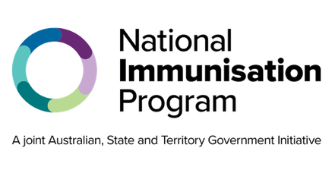National Immunisation Program

RSV immunisation consumer fact sheet

## About Respiratory syncytial virus (RSV)

Respiratory syncytial virus (RSV) is a common virus that can cause a range of severe respiratory illnesses such as bronchiolitis in children and pneumonia.

RSV is spread through droplets from an infected person’s cough or sneeze. The droplets can be inhaled by others or land on surfaces where the virus can live for several hours.

Symptoms of RSV disease include:

* runny nose
* cough
* fever
* wheezing or difficulty breathing.

It may be a mild disease for some, but it can cause serious illness and hospitalisation in otherwise healthy children and adults.

RSV vaccination in pregnancy protects your newborn baby against RSV from birth and in their vulnerable first few months of life.

## Who is recommended an RSV vaccine

Women at 28 to 36 weeks pregnancy are recommended to receive the maternal RSV vaccine (Abrysvo®) to protect their baby against serious illness from RSV. The vaccine is available to eligible women for free through the National Immunisation Program (NIP).

All adults aged 60 and over including Aboriginal and Torres Strait Islander people and people aged 50 to 59 with medical risk conditions are recommended to receive Abrysvo® or Arexvy® RSV vaccines. RSV vaccines for these groups are not funded through the NIP. They can be purchased privately through general practices or pharmacies, but the cost cannot be claimed or reimbursed through the NIP or state or territory programs.

## Who is recommended an RSV monoclonal antibody

Infants up to 8 months and children aged 8 months up to 2 years may be recommended to receive the infant RSV monoclonal antibody Beyfortus™ (nirsevimab). This is available for free through state and territory RSV infant protection programs.

If you have questions about these programs, speak with your health professional or state or territory health department.

| **RSV vaccination is especially important in pregnancy** |
| --- |
| The maternal RSV vaccine, Abrysvo®, helps to protect your newborn baby against RSV.  RSV is a leading cause of hospitalisation in children aged less than 6 months. Even healthy infants and children can get very sick from RSV.  Research shows that maternal vaccination reduces the risk of severe RSV illness in infants under 6 months of age by around 70%.  Vaccination in pregnancy enables you to transfer antibodies to your baby through the placenta. This protects your baby from birth and in their vulnerable early months of life against RSV. |

## Pregnant women

A single dose of the maternal RSV vaccine, Abrysvo®, is recommended at 28 to 36 weeks pregnancy and is free through the NIP for eligible women.

You can safely receive the RSV vaccine at the same visit as the recommended NIP maternal influenza and whooping cough vaccines. You can also receive a COVID-19 vaccine if it is recommended by your trusted health professional.

## Infants and children

Infants up to 8 months may be recommended to receive the RSV monoclonal antibody Beyfortus™ (nirsevimab) if:

* their mother did not receive the RSV vaccine during pregnancy, or
* they were born within 2 weeks after the mother receiving an RSV vaccine, or
* they have a condition or circumstance that increases their risk of severe RSV disease.

Young children aged 8 months up to 2 years who have certain risk conditions for severe RSV disease are recommended to receive the RSV monoclonal antibody before their second RSV season.

It is safe for your child to get the RSV monoclonal antibody either on its own or at the same appointment as their other routine childhood vaccinations.

The infant and child RSV monoclonal antibody is available for free through state and territory RSV infant protection programs.

## All people aged 60 and over including Aboriginal and Tores Strait Islander people and medically at risk aged 50-59 years

All people aged 60 and over, including Aboriginal and Torres Strait Islander people and those 50 to 59 years with medical risk factors can receive an Abrysvo® or Arexvy® RSV vaccine, however, they are not funded through the NIP.

RSV vaccines can be purchased privately through general practices or pharmacies but cannot be claimed or reimbursed through the NIP.

## RSV vaccines and RSV monoclonal antibodies safety

RSV vaccines and RSV monoclonal antibodies are both safe and effective. The Therapeutic Goods Administration tests all vaccines, products and medicines before they are approved for use in Australia.

Side effects from RSV vaccines and RSV monoclonal antibodies include mild pain, redness or swelling where the injection was given, tiredness and headaches. These usually last for a few days and go away without any treatment. Serious side effects, such as severe allergic reaction, are rare.

| **Where to get the maternal RSV vaccine or infant RSV monoclonal antibody** |
| --- |
| Appointments for the NIP maternal RSV vaccine can be booked at a range of health services including:   * maternal health specialists or general practices * local council immunisation clinics * (available in some states and territories) * community health centers * Aboriginal health services * participating pharmacies.   Not all of these health services will have free NIP maternal vaccines. Check with your preferred health service to find out if they are available and when you can book your vaccination appointment.  The infant RSV monoclonal antibody is available through your state or territory RSV infant protection program. Check with your health department to find out where and how to book an appointment. |

## Australian Immunisation Register

**Your health professional should always check the Australian Immunisation Register (AIR) before giving you or your baby a vaccine or the monoclonal antibody. They should also report to the AIR all the immunisations they give to ensure you and your baby’s immunisation history is complete and accurate.**

## More information

**To find out more about RSV and vaccination, go to:**

* **the maternal vaccination website at** [health.gov.au/maternalvaccinations](http://www.health.gov.au/maternalvaccinations)
* **the Department of Health, Disability and Ageing at** [health.gov.au/immunisation](http://www.health.gov.au/immunisation)
* **your state or territory health department website or trusted health professional**
* **Sharing Knowledge About Immunisation at** [skai.org.au](http://www.skai.org.au/)**.**

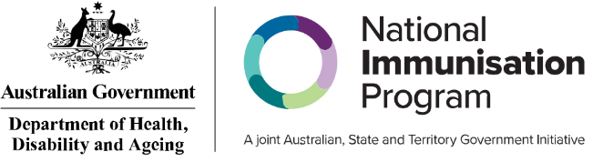

| **State and territory health department contact numbers:** | |
| --- | --- |
| **ACT** 02 5124 9800 | **SA** 1300 232 272 |
| **NSW** 1300 066 055 | **TAS** 1800 671 738 |
| **NT** 08 8922 8044 | **VIC** immunisation@health.vic.gov.au |
| **WA** 08 9321 1312 | **QLD** Contact your local Public Health Unit |

This information is current as of August 2025