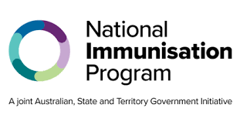National Immunisation Program

# Childhood and adolescence pneumococcal vaccine − Program advice for health professionals

| Key points and updates |
| --- |
| * The Australian Technical Advisory Group on Immunisation (ATAGI) has reviewed pneumococcal vaccines on the current childhood and adolescence immunisation schedules. Based on ATAGI’s advice, the government has made changes to the National Immunisation Program (NIP). * From 1 September 2025, Prevenar 20 will be introduced into the NIP to replace Prevenar 13 and Pneumovax 23 on the childhood and adolescence schedule. * The introduction of Prevenar 20 simplifies the vaccine schedule, reduces the number of doses and covers more strains of the disease. * All Aboriginal and Torres Strait Islander children should receive 4 doses, making the program consistent across all states and territories. * From 1 September 2025, children under 5 years, who have:   + not yet started their pneumococcal schedule should receive 3 doses of Prevenar 20.   + previously received 1 or 2 doses of Prevenar 13 should receive Prevenar 20 for all subsequent doses to complete the recommended vaccination course (where required).   + already completed a Prevenar 13 vaccination course who are due for a Pneumovax 23 booster should receive 1 dose of Prevenar 20 instead. Do not delay vaccination, if required, Pneumovax 23 can still be used (while stock is available). |

## About pneumococcal disease

Pneumococcal disease is caused by the bacterium Streptococcus pneumoniae. It can cause severe [invasive disease](https://immunisationhandbook.health.gov.au/technical-terms#invasive-disease), including meningitis, pneumonia and bacteraemia, and non-invasive disease, including otitis media.

## Who is most at risk of pneumococcal disease

Anyone can develop pneumococcal disease. Those at greatest risk of disease and severe outcomes are:

* Infants and children
* Aboriginal and Torres Strait Islander people
* Children, adolescents and adults with risk conditions for pneumococcal disease.

## Who should receive Prevenar 20

Prevenar 20 vaccines are recommended for:

* All infants and children under 5 years
* Aboriginal and Torres Strait Islander infants and children under 5 years
* Children with specified medical risk conditions aged 2 months and over
* Adolescence with specified medical risk conditions aged 17 years and under.

## ATAGI recommendations

All Children aged 2-12 months should receive 2 doses plus 1 booster (called a 2+1 schedule). This stays the same when using Prevenar 20.

### Aboriginal and Torres Strait Islander children

All Aboriginal and Torres Strait Islander children should receive 4 doses of Prevenar 20:

* 3 primary doses plus 1 booster (called a 3+1 schedule).
* This continues the current approach in NT, QLD, SA, and WA where Aboriginal and Torress Strait Islander children already get 4 doses.
* In ACT, NSW, VIC, and TAS, an extra dose at 6 months will be added, making it 4 doses in total.

This change is based on higher rates of disease in some Aboriginal and Torres Strait Islander communities, especially near state borders where different vaccine schedules were used.

### Medically at-risk

All children aged 2-12 months with specified medical risk conditions should receive 4 doses of Prevenar 20, 3 primary doses plus 1 booster (called a 3+1 schedule).

All children aged 12 months and over with specified medical risk conditions should receive 1 dose of Prevenar 20 at diagnosis.

All adolescents aged 17 years and under with specified medical risk conditions should receive 1 dose of Prevenar 20 at diagnosis.

### Removing Pneumovax 23 from the childhood vaccine and adolescence schedule

Eligible children should receive 1 dose of Prevenar 20 instead of the Pneumovax 23 vaccine when they are due next (i.e. a single dose of Prevenar 20 instead of dose 1 and 2 of Pneumovax 23 **OR** a single dose of Prevenar 20 instead of dose 2 of Pneumovax 23).

### Pneumococcal schedule

| Cohort and age | NIP-funded schedule |
| --- | --- |
| All children aged 2 – 12 months | Prevenar 20 at 2, 4 and 12 months of age |
| All Aboriginal and Torres Strait Islander children* | Prevenar 20 at 2, 4, 6 and 12 months of age |
| Children with specified medical risk conditions aged 2 – 12 months** | Prevenar 20 at 2, 4, 6 and 12 months of age |
| Children with specified medical risk conditions over 12 months** | Prevenar 20 at diagnosis |
| Adolescents with specified medical risk conditions aged 17 and under** | Prevenar 20 at diagnosis |

**Note:** *Aboriginal and Torres Strait Islander children who have received 4 PCV doses as part of their routine schedule do not require an additional dose of PCV. **For medical risk conditions please see the [Australian Immunisation Handbook](https://immunisationhandbook.health.gov.au/contents/vaccine-preventable-diseases/pneumococcal-disease#people-with-medical-risk-factors).

## Pneumococcal vaccine safety

Evidence from clinical trials found that Prevenar 20 is safe in children and has a similar safety profile to Prevenar 13.

The most common side effect at the injection site was pain. The rates of these local side effects were similar between the two vaccines: Prevenar 20 (25%–60%) and Prevenar 13 (27%–57%).

## Contraindications

The only absolute contraindications to pneumococcal vaccines are:

* [anaphylaxis](https://immunisationhandbook.health.gov.au/technical-terms#anaphylaxis) after a previous dose of any pneumococcal vaccine
* anaphylaxis after any component of a pneumococcal vaccine

## Adverse events or administration errors

You must notify all adverse events and vaccine administration errors through the reporting mechanisms in your state or territory.

## Australian Immunisation Register

Vaccination providers can continue to report Prevenar 13 administrations to the **Australian Immunisation Register (**AIR) after 1 September 2025.

Prevenar 20 and Prevanar 13 will be considered equivalent vaccines within the AIR. This means that a child can receive either vaccine brand, in any sequence and they will be considered up-to-date for pneumococcal (in line with the AIR due and overdue rules).

**Check the AIR before administering Prevenar 20.**  It is mandatory for you to report to the AIR all NIP vaccinations administered in Australia. This ensures that individuals have a complete and accurate record of their vaccinations.

**For more information, go to** [servicesaustralia.gov.au/hpair](https://servicesaustralia.gov.au/hpair)**.**

## Keep up to date

Read the advice in this factsheet in conjunction with the Australian Immunisation Handbook at [immunisationhandbook.health.gov.au](https://immunisationhandbook.health.gov.au)

Subscribe to the NIP update email update service. Search ‘NIP updates’ on [health.gov.au](http://www.health.gov.au).

| State and territory health department contact numbers: | |
| --- | --- |
| **ACT** 02 5124 9800 | **SA** 1300 232 272 |
| **NSW** 1300 066 055 | **TAS** 1800 671 738 |
| **NT** 08 8922 8044 | **VIC** immunisation@health.vic.gov.au |
| **WA** 08 9321 1312 | **QLD** Contact your local Public Health Unit |

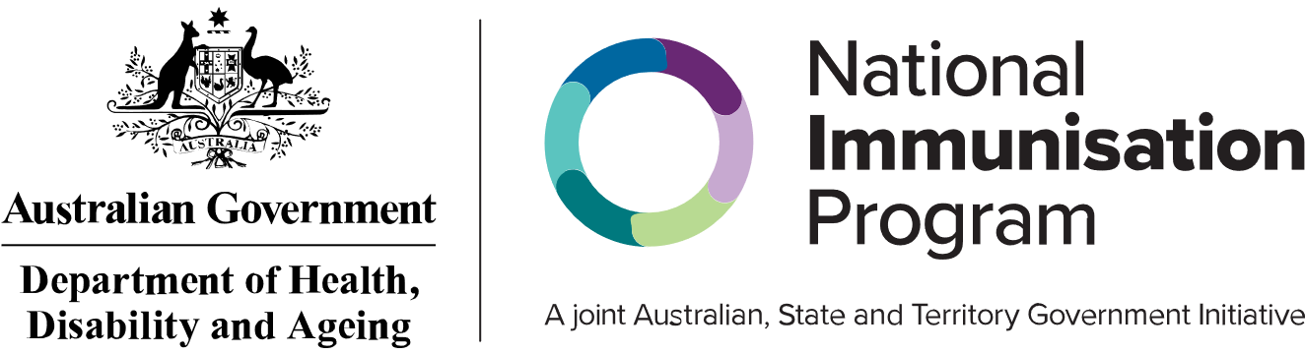This information is current as of August 2025