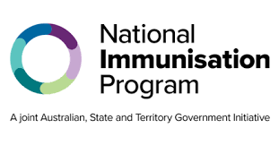National Immunisation Program

# Childhood and adolescence pneumococcal vaccine

# Consumer fact sheet

## About pneumococcal disease

Pneumococcal disease is an infection caused by *Streptococcus pneumoniae* bacteria, sometimes known as pneumococcus. It is especially serious for young children and older people and is most common in winter and spring.

Many people carry the bacteria in their nose and throat, where they do not cause any symptoms. However, sometimes the bacteria grow and spread to other parts of the body and cause illness.

Pneumococcal disease can be:

* Non-invasive, such as middle-ear infection and sinusitis. This type is the most common.
* Invasive, which means the bacteria has entered the bloodstream, brain and spinal cord, and lungs.

## Pneumococcal symptoms

| **Symptoms of the disease depend on where the infection is** |
| --- |
| Middle-ear   * Pain in ear and poor hearing * Fever * Sometimes diarrhoea and vomiting |
| Sinus   * Aching face and headache * Blocked or runny nose |
| Lungs (pneumonia)   * Shortness of breath, cough or chest pain * Fever * Headache * Lack of energy or loss of appetite |
| Bloodstream (bacteraemia or sepsis)   * Fever or chills * Drowsiness * Pain |
| Brain or spinal cord (meningitis)   * Fever * Headache or stiff neck * Nausea and vomiting * Drowsiness |

## How pneumococcal infection is caught

The pneumococcal bacteria are easily spread from person to person.

This can happen through:

* coughing and sneezing
* contact with mucus from the nose and saliva from throat

## How to protect against pneumococcal disease

Vaccination is the best way to protect against pneumococcal disease and serious illness.

The pneumococcal vaccine recommended for children protects against 20 different strains of pneumococcal bacteria that cause disease.

## Vaccine effectiveness

| **Vaccination helps to protect against serious pneumococcal disease** |
| --- |
| Up to 86% of children who have 3 doses of the pneumococcal vaccine develop enough protection to safeguard against severe illness from pneumococcal disease.  Research shows that since pneumococcal vaccines have been included on the National Immunisation Program, there has been a large drop of up to 82% in invasive pneumococcal disease due to vaccination in children aged under 2 years. |

## Which children and adolesence are recommended the pneumococcal vaccine

Pneumococcal vaccines are recommended for:

* All infants and children under 5 years
* Aboriginal and Torres Strait Islander infants and children under 5 years
* Children aged 2 months and over with specified medical risk conditions for pneumococcal disease
* Adolescence aged under 18 years with specified medical risk conditions for pneumococcal disease

## When children and adolesence should get a vaccine

All children are recommended to get a free pneumococcal vaccine at 2, 4 and 12 months of age.

Aboriginal and Torres Strait Islander children are recommended to get a free pneumococcal vaccine at 2, 4, 6 and 12 months of age.

Children and adolescence with specific medical conditions may also be eligible for extra doses. Talk to your health professional to see if your child is recommended extra vaccines.

## Can pneumococcal disease be caught from the vaccine?

It is not possible to catch pneumococcal disease from the vaccine because it does not contain the live bacteria that causes the disease.

## Vaccine safety

Vaccines are like other medicines and can have side effects. However, all vaccines used in Australia provide benefits that greatly outweigh their risks.

The Therapeutic Goods Administration tests all vaccines, products and medicines before they are approved for use in Australia. After vaccines are given to people, their safety is continually monitored.

Clinical trials have proven that the pneumococcal vaccine is both safe and effective for children.

## Vaccine side effects

Side effects from the pneumococcal vaccine are generally mild. These usually last for a few days and go away without any treatment.

They can include:

* Mild pain, redness or swelling where the injection was given
* Occasionally an injection-site lump (may last weeks but no treatment is needed)
* Tiredness or crankiness
* Mild fever

Most common side effects are a sign that your child’s body is starting to build immunity against a disease.

Serious side effects, such as severe allergic reactions, are rare. If you have questions or concerns about a reaction to a vaccine, talk with your health professional.

| **Where to get pneumococcal vaccines** |
| --- |
| Vaccination appointments can be booked at a range of health services including:   * General practices * Local council immunisation clinics * (available in some states and territories) * Community health centers * Aboriginal Medical Services   Not all these health services will have free National Immunisation Program vaccines, and some vaccination providers may charge an administration fee. Check with your preferred health service to find out if National Immunisation Program vaccines are available when you can book your vaccination appointment. |

## Australian Immunisation Register

**Your health professional should always check the Australian Immunisation Register (AIR) before giving your child a vaccine. They should also report all the vaccines they give to the AIR to ensure your child’s immunisation history is complete and accurate.**

## More information

**To find out more about pneumococcal disease and vaccines, go to:**

* **the childhood immunisation website at** [health.gov.au/childhoodimmunisation](https://www.health.gov.au/childhoodimmunisation)
* **the Department of Health, Disability and Ageing at** [health.gov.au/immunisation](http://www.health.gov.au/immunisation)
* **your state or territory health department website or trusted health professional**
* **HealthDirect at** [healthdirect.gov.au/pneumococcal-disease](https://www.healthdirect.gov.au/pneumococcal-disease)
* **Sharing Knowledge About Vaccination website at** [skai.org.au](https://www.skai.org.au/)

| **State and territory health department contact numbers:** | |
| --- | --- |
| **ACT** 02 5124 9800 | **SA** 1300 232 272 |
| **NSW**1300 066 055 | **TAS** 1800 671 738 |
| **NT** 08 8922 8044 | **VIC** immunisation@health.vic.gov.au |
| **WA**  08 9321 1312 | **QLD** Contact your local Public Health Unit |

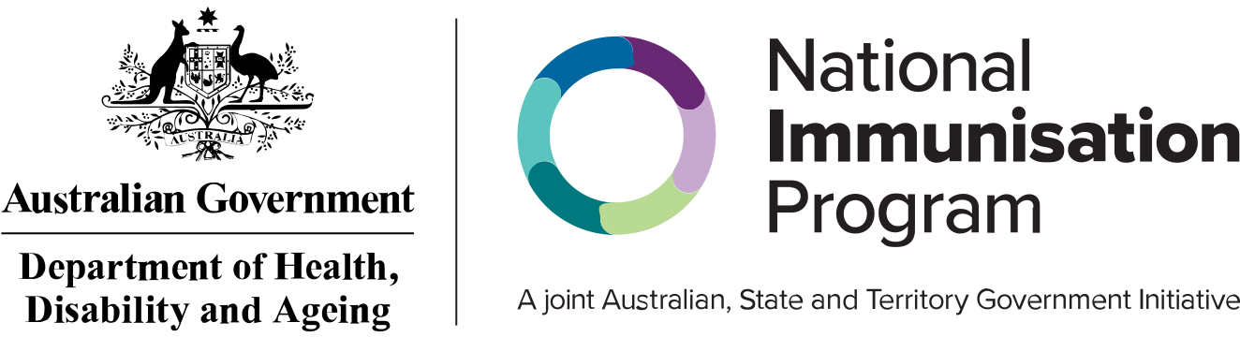

This information is current as of August 2025