Medical Research  
Future Fund

Financial assistance to support the Australian Medical Research and Innovation Priorities 2022-2024

June 2025

Table of Contents

List of Tables iii

Introduction 1

Background 2

Purpose of this report 2

Australian Medical Research Advisory Board 2

Australian Medical Research and Innovation Strategy and Priorities 2

10-year investment plan for the MRFF 5

MRFF policy, performance, governance and assurance 6

New policies 6

Refresh of the MRFF assessment criteria 6

MRFF Principles for consumer involvement 6

Statement on Sex, Gender, Variations of Sex Characteristics and Sexual Orientation in Health and Medical Research 6

Policy on MRFF and NHMRC funding outcomes released under media embargo 6

Performance and evaluation 7

Refresh of the MRFF Monitoring, evaluation and learning strategy 7

Performance indicators towards the impact of the MRFF 7

Completed evaluation activities 8

MRFF Grant Opportunity Gender Data Report 10

MRFF Chief Investigator Report 10

Medical Research Future Fund Early to Mid-Career Researchers grant opportunity outcomes data 11

Medical Research Future Fund Report on the Coronavirus Research Response 11

Medical Research Future Fund Report on funding for rural, regional and remote health research 11

Governance and assurance 12

Improving alignment and coordination between the MRFF and National Health and Medical Research Council (NHMRC)’s Medical Research Endowment Account (MREA) 12

MRFF Program Assurance Group 12

Project progress and final reports 13

Medical Research Future Fund – since inception 13

Financial assistance from the MRFF Special Account 14

Consistency of financial assistance with the 2022–2024 Priorities 17

Medical Research Future Fund 2022–2024 22

Funding 22

Highlights from the MRFF initiatives 23

A snapshot of publications of research funded by MRFF 31

Further analysis on MRFF financial assistance provided during the 2022–2024 Priorities 32

Processes for determining grants of financial assistance 39

Determination of MRFF initiatives 39

Response to emerging priorities 39

Determination of grants of financial assistance 40

MRFF Grant Assessment Committees 43

A snapshot of Grant Assessment Committees 44

Other financial assistance provided by the Australian Government for medical research and innovation 46

Other financial assistance provided by the Australian Government for research and development 47

Appendix A Initiatives under the 2022–2024 Priorities 48

Appendix B MRFF Disbursements since inception by theme and initiative 50

Appendix C MRFF grants since inception by theme and initiative 52

Appendix D MRFF grant opportunities since inception by theme and initiative 54

Appendix E MRFF grants with payments commencing between 6 November 2022 and 5 November 2024 56

Appendix F MRFF funding with payments commencing between 6 November 2022 and 5 November 2024 105

Appendix G Methodology used in this report 106

Grant opportunities and grants awarded 106

Grant Assessment Committees 106

## List of Tables

Table 1 Australian Medical Research and Innovation Priorities 2022–2024 3

Table 2 Funding for MRFF initiatives, since 2016–17, as at 30 November 2024 14

Table 3 MRFF initiatives and open grant opportunities during 2022–2024 Priorities (6 November 2022 and 5 November 2024) 17

Table 4 MRFF themes: grants and funding between 6 November 2022 and 5 November 2024 32

Table 5 Funded rate by MRFF theme 32

Table 6 MRFF Initiatives: grants and funding between 6 November 2022 and 5 November 2024 32

Table 7 Funded rate by MRFF initiative 33

Table 8 Location of lead researcher for grants with payments commencing between 6 November 2022 and 5 November 2024 34

Table 9 Funded Rate by location of administering institution 35

Table 10 Organisation of lead researcher for grants with payments commencing between 6 November 2022 and 5 November 2024 35

Table 11 Broad research area of grants, grant opportunities and funding between 6 November 2022 and 5 November 2024 36

Table 12 Funded Rate by broad research area 36

Table 13 Top 20 Field of research of grants, grant opportunities and funding between 6 November 2022 and 5 November 2024 36

Table 14 Australian Government financial support for medical research and innovation, 2022–23 and 2023–24 46

Table 15 Australian Government financial support for key research and development initiatives, 2022–23 and 2023–24 47

Table A MRFF initiatives under the 2022–2024 Priorities 48

Table B MRFF Disbursements since inception by theme and initiative 50

Table C MRFF grants since inception by theme and initiative 52

Table D MRFF Grant opportunities opened since inception by theme and initiative 54

Table E MRFF grant recipients with payments commencing between 6 November 2022 and 5 November 2024 inclusive 56

Table F Total funding by MRFF initiative, with payments commencing between 6 November 2022 and 5 November 2024 105

# Introduction

The Health and Medical Research Office (HMRO) within the Department of Health, Disability and Ageing (the Department) is responsible for the management of the Medical Research Future Fund (MRFF). The HMRO is committed to transparency of information within the operational framework of the Department’s policy and legislative requirements, including obligations under the *Privacy Act 1988*.

The Australian Government established the MRFF under the *Medical Research Future Fund Act 2015* (MRFF Act) to provide grants of financial assistance to support health and medical research and innovation, and improve health outcomes, quality of life and health system sustainability. MRFF funding is primarily disbursed through expert-reviewed, open, competitive processes to ensure the integrity of the research design, quality and safety for patients, and best return on Australian Government investment.

This report presents information required under section 57A of the MRFF Act. The report also provides updates on the operation of the MRFF, and analysis of the grants provided by the MRFF.

Further information is at the [MRFF website.](https://www.health.gov.au/our-work/medical-research-future-fund)

# Background

## Purpose of this report

The *Medical Research Future Fund Act 2015* (MRFF Act) requires the Health Minister to report to Parliament on the financial assistance provided for medical research and medical innovation from the MRFF Special Account during the time the most recent Australian Medical Research and Innovation Priorities were in force.

Accordingly, this report presents the financial assistance provided from the MRFF Special Account for the period when the *Australian Medical Research and Innovation Priorities 2022–2024* (2022–2024 Priorities) were in force; from 6 November 2022 to 5 November 2024.

As required under section 57A of the MRFF Act, this report:

* describes how the financial assistance provided was consistent with the 2022–2024 Priorities
* describes the processes for determining the grants of financial assistance
* includes information about any other financial assistance provided by the Australian Government for medical research and medical innovation.

The report also provides other information about the MRFF, including details of grant opportunities, grants awarded, and statistics such as funding rates, some of which dates from the inception of the MRFF.

## Australian Medical Research Advisory Board

The second Australian Medical Research Advisory Board (AMRAB) for the MRFF was announced on 17 September 2021 for the period 2021–2026. Professor Ian Frazer AC continued as the Chair, and Professor Caroline Homer AO was announced as the inaugural Deputy Chair.

The following members continued to serve on the second AMRAB: Mr Yasser El-Ansary and Professor Doug Hilton AO. Professor Steve Wesselingh replaced Professor Anne Kelso AO when he commenced in the role of CEO, National Health and Medical Research Council (NHMRC).

The following members were newly appointed to the second AMRAB: Professor Tom Calma AO; Professor Denise Doolan; and Ms Imelda Lynch.

On 16 February 2025, Professor Ian Frazer AC announced his resignation and stepped down as Chair. Professor Caroline Homer AO was appointed Acting Chair of AMRAB for a period of 3 months while a recruitment process commenced.

## Australian Medical Research and Innovation Strategy and Priorities

The MRFF Act establishes the independent, expert AMRAB to determine the:

* Australian Medical Research and Innovation Strategy (the Strategy) every 5 years
* Australian Medical Research and Innovation Priorities (the Priorities) every 2 years.

The MRFF Act requires the Health Minister to consider the Priorities when making decisions about the financial assistance provided from the MRFF Special Account.

AMRAB developed the first *Australian Medical Research and Innovation Strategy 2016-2021* (2016–2021 Strategy) in 2016 after extensive national, public consultation.

AMRAB developed the second *Australian Medical Research and Innovation Strategy 2021-2026* (2021–2026 Strategy) in 2021 after extensive national, public consultation.[1]

The 2021–2026 Strategy intends to:

*Transform health and medical research using priority-driven investments that promote collaborative research, research innovation, research translation and impact to improve lives, whilst contributing to health system sustainability, nurturing the next generation of researchers and building the Australian economy.*

Table 1 lists the 2022–2024 Priorities. As required by the MRFF Act, the Priorities must be consistent with the Strategy that is in force.

Both the MRFF Strategy and Priorities are informed by national consultation, as required under the MRFF Act. The 2022–2024 Priorities were consistent with the 2021–2026 Strategy.

Table 1  
Australian Medical Research and Innovation Priorities 2022–2024

|  |  |
| --- | --- |
| Priority | Description |
| Consumer-Driven Research | Research that is driven by meaningful consumer involvement and partnerships, to incorporate priorities, needs, values and experiences to deliver fit-for-purpose outcomes that can be adopted by consumers, carers, healthcare professionals and other end-users. |
| Research Infrastructure and Capability | Address gaps in the generation of knowledge and in early biomedical and medical technology product development by supporting access to expertise, capability and infrastructure (i.e. research facilities, equipment, systems, services), including in partnership with industry, that seeks to drive new research discoveries and accelerate innovation. |
| Translation and Commercialisation | Provide a focus on research translation, implementation and commercialisation by facilitating collaborations between the research sector, industry and community. This includes accelerating and advancing innovation to bring about progress in health outcomes by leveraging opportunities from novel or emerging tools and technologies (e.g. personalised medicine, synthetic biology, advanced communications and manufacturing technologies) that can transform health and medical research, health interventions and care. |
| Comparative Effectiveness Research | Systematic evaluation and demonstration of the comparative value of therapeutics, devices and health interventions to inform the decisions by policy makers, clinicians and consumers regarding healthcare, and to minimise unnecessary, ineffective and harmful health interventions. |
| Preventive and Public Health Research | Invest in preventive health to maximise the social and economic benefits of better health. The investments in preventive health research made through the MRFF are expected to contribute to policy objectives of the National Preventive Health Strategy 2021-2030 and other national initiatives. |
| Primary Care Research | Support primary care research with an emphasis on multi-disciplinary collaboration, adaptive research methodologies, innovative models of care, and clinician capability. This can include developing the evidence base about the efficacy and value of different primary care models and health systems, including to improve primary care intersection with both secondary care and tertiary care for a more integrated and efficient health care sector. |
| Health and Medical Researcher Capacity and Capability | Support and enhance Australian health and medical research capacity, especially clinician researchers, with a focus on multidisciplinary engagement and improving the translation and integration of evidence-based research into primary through to tertiary care and commercial outcomes. This includes fostering gender equity and opportunities for early to mid-career researchers in the research workforce. |
| Aboriginal and Torres Strait Islander Health | Improve the health of Aboriginal and Torres Strait Islander people to close the gap in health mortality and morbidity through Aboriginal and Torres Strait Islander leadership and Aboriginal and Torres Strait Islander-led priority setting to drive health-related research. |
| Priority Populations | Ensure equitable health outcomes for all people living in Australia by targeting funding towards biomedical discovery and health service innovation to address specific and unique health challenges for priority populations, including:  • older people experiencing diseases of ageing (e.g. cognitive decline and dementia)  • people with rare or currently untreatable diseases/conditions  • people in remote/rural communities  • people with a disability (including people with intellectual disability)  • individuals from culturally and linguistically diverse communities.  This includes supporting research into specific health and healthcare needs to improve diagnosis, treatment and care to meet the needs of individuals and communities, to improve quality of life. |
| Antimicrobial Resistance | Reduce the health impact of antimicrobial resistance (AMR). This includes supporting research into stewardship practices, diagnostic and treatment tools, preventive measures, and new or novel antimicrobials, host-directed therapeutics and vaccines that span the divide between human health and animal health. |
| Global Health and Health Security | Build capacity for preparedness, prevention, response, eradication and/or management of identified and emerging or potential global health threats, including pandemics and zoonotic disease threats. This includes building and strengthening international collaborations and capabilities, particularly within the Indo-Pacific region. |
| Health Impacts from Environmental Factors | Address the emerging and long-term health impacts of environmental factors, such as bushfires and climate change. The indirect impact of the COVID-19 pandemic has also resulted in delayed health screening, treatment and care for other illnesses. |
| Data, Digital Health and Artificial Intelligence | Improve data utilisation for more integrated and effective health and healthcare systems. Support for informatics (e.g. data registries, biobanks, data linkage platforms and secure data storage), artificial intelligence, machine learning and predictive analytics research, advanced clinical decision-making tools, wearables, and other emerging innovative digital technologies is the key to realising the benefits of healthcare digitalisation. |

Source: Australian Medical Research Advisory Board (2021). *Australian Medical Research and Innovation Priorities 2022–2024*, AMRAB, Canberra.

## 10-year investment plan for the MRFF

In May 2024, the Australian Government announced the $6.5-billion 3rd [10-year Investment Plan](https://www.health.gov.au/resources/publications/medical-research-future-fund-2nd-10-year-investment-plan-2022-23-to-2031-32?language=en) for the MRFF that directs MRFF funding through 4 themes:

* **Patients**, which aims to bring benefits to patients, including supporting life-changing clinical trials, funding innovative treatments and advanced health care and medical technologies.
* **Researchers**, which aims to support Australian researchers, including to help build their skills and capacity, support their research in priority areas and assist them to develop and bring new research discoveries to the market.
* **Research missions** are large programs of work that bring together key researchers, health professionals, stakeholders, industry partners and patients to tackle big health challenges.
* **Research translation**, which aims to translate research outcomes into practice by building the evidence base to support the adoption of best practice care into health care delivery.

There are 22 initiatives under these themes, funded across 10 years (starting in 2024–25) to support lifesaving research, create jobs, strengthen the local industry base for commercialising research and innovation, and further grow Australia’s reputation as a world leader in medical research.

Commitments made through prior 10-year Investment Plans will remain available for expenditure as part of the 3rd 10-year Investment Plan. The second and third 10-year investment plans were in place while the 2022–2024 Priorities were in force.

The 10-year Investment Plan is a mechanism for implementing the Strategy and the related Priorities and will continue to evolve to address emerging health challenges and respond to the evolution of these guiding documents. The Strategy, the Priorities and the 10-year Investment Plan provide transparency and predictability to researchers and industry about the strategic objectives and scale of MRFF disbursements.

# MRFF policy, performance, governance and assurance

The Department is committed to continuous improvement of MRFF policies and procedures to ensure they are fit for purpose, generate improvements in health care and outcomes, and support researchers in doing their work.

In September 2021, the Auditor General tabled a report titled [*Department of Health’s Management of Financial Assistance under the Medical Research Future Fund*](https://www.anao.gov.au/work/performance-audit/department-health-management-financial-assistance-under-the-medical-research-future-fund). The audit found that Health’s management of the MRFF is largely effective. The Department has addressed all 3 recommendations in the report and is continuing to implement continuous improvements to MRFF policies and processes in response to other findings in the report.[2]

## New policies

### Refresh of the MRFF assessment criteria

In October 2022 (not captured in the previous *Financial assistance to support the Australian Medical Research and Innovation Priorities 2020-2022* report), the Department refined the criteria descriptors used to assess MRFF grant applications, to reflect a strong focus on research translation, to identify health priorities, and to ensure funds are appropriately targeted to the best research. These changes are outlined in the [Refresh of the Medical Research Future Fund Assessment Criteria](https://www.health.gov.au/resources/publications/refresh-of-the-medical-research-future-fund-assessment-criteria-october-2022?language=en) document.

### MRFF Principles for consumer involvement

The MRFF Consumer Reference Panel, following its establishment in April 2022, developed in March 2023 a set of [Principles for Consumer Involvement in Research Funded by the MRFF](https://www.health.gov.au/resources/publications/principles-for-consumer-involvement-in-research-funded-by-the-medical-research-future-fund?language=en), which provides advice on how to promote and strengthen consumer involvement in MRFF-funded research. This document sets out the Consumer Reference Panel’s advice on best practice principles as well as implementation guidance for consumer involvement in research.

### Statement on Sex, Gender, Variations of Sex Characteristics and Sexual Orientation in Health and Medical Research

The [Statement on Sex, Gender, Variations of Sex Characteristics and Sexual Orientation in Health and Medical Research](https://www.health.gov.au/resources/publications/statement-on-sex-gender-variations-of-sex-characteristics-and-sexual-orientation-in-health-and-medical-research?language=en), published in July 2024, is a joint initiative of the Department and the NHMRC. It aims to encourage and guide the consideration of sex, gender, variations of sex characteristics and sexual orientation in health and medical research.

### Policy on MRFF and NHMRC funding outcomes released under media embargo

The [Policy on MRFF and NHMRC funding outcomes released under media embargo](https://www.health.gov.au/resources/publications/policy-on-mrff-and-nhmrc-funding-outcomes-released-under-media-embargo), published in September 2024, outlines for applicants and administering organisations the requirements for handling information about application outcomes for MRFF and NHMRC grant opportunities.

## Performance and evaluation

### Refresh of the MRFF Monitoring, evaluation and learning strategy

The [MRFF Monitoring, evaluation and learning strategy](https://www.health.gov.au/resources/publications/mrff-monitoring-evaluation-and-learning-strategy-2020-21-to-2023-24) (Evaluation Strategy) provides an overarching framework for assessing the performance of the MRFF. It also aims to establish a learning system to support continued improvements within the MRFF. The Evaluation Strategy, first established in November 2020, was refreshed in August 2024. Key changes were:

* refinement of the wording of 1 impact measure and 3 measures of success, to better capture impacts on public and preventive health
* incorporation of the performance indicators published in 2023 (see below)
* better articulation of performance monitoring data sources.

### Performance indicators towards the impact of the MRFF

To support the implementation of the Evaluation Strategy, the Department developed a number of [MRFF performance indicators towards the impact of the MRFF](https://www.health.gov.au/resources/publications/performance-indicators-towards-the-impact-of-the-medical-research-future-fund?language=en) in March 2023. These are project-level outputs that track progress towards capturing the longer-term impact of MRFF-funded research.

The first survey of MRFF grant recipients was conducted from March to May 2024 to capture data on these performance indicators. The key findings of the report, based on a response rate of 75% of 1328 grantees (n=1002), were published on the Department’s [website](https://www.health.gov.au/resources/publications/results-of-the-medical-research-future-fund-performance-indicator-survey-december-2024?language=en).

* Collectively, MRFF-funded projects were at a relatively early stage in their project life cycle, with 14% of respondents indicating their project has completed. Indicators that could be captured via early-stage research activities were widely reported.
* 84% of MRFF projects focussed on a priority population and 67% on emerging issues, driven by the MRFF’s mission to direct research activity to areas of unmet need.
* Over half of MRFF projects involved clinical trials, with at least 744 clinical trials funded, and 59% of this subset (30% of MRFF projects overall) included trials in rural, regional and remote sites. Notably, 46% of MRFF-funded trials were described as phase 3 or 4.
* The MRFF supported 7,527 research staff, amounting to 9,959 full-time-equivalent years, and attracted $787 million in co-funding and $949 million in new funding.
* 84% of MRFF projects involved consumers in their research, while 83% had engaged with clinicians.
* While longer-term indicators related to health care change and commercialisation showed proportionately less progress, 42% of completed projects had contributed to healthcare policy or guidelines, and 35% had changed health professional education.

### Completed evaluation activities

Consistent with the Evaluation Strategy, 7 MRFF evaluation activities have been completed to date, and final reports available on the Department’s website:

* [*Evaluation of the Rapid Applied Research Translation Initiative*](https://www.health.gov.au/resources/publications/evaluation-of-the-rapid-applied-research-translation-initiative)(2020)
* [*Medical Research Commercialisation Landscape Report*](https://www.health.gov.au/resources/publications/medical-research-commercialisation-landscape-report) (2020)
* [*Million Minds Mental Health Research Mission Review*](https://www.health.gov.au/resources/publications/million-minds-mental-health-research-mission-review) (2021–22)
* [*Evaluation of the Clinical Trials Activity initiative*](https://www.health.gov.au/resources/publications/evaluation-of-the-medical-research-future-fund-clinical-trials-activity?language=en)(2023)
* [*Review of the Australian Brain Cancer Mission*](https://www.health.gov.au/resources/publications/review-of-the-australian-brain-cancer-mission?language=en)(2023)
* [*Review of the Genomics Health Futures Mission*](https://www.health.gov.au/resources/publications/mrff-Review-of-the-Genomics-Health-Futures-Mission?language=en)(2024)
* [*Review of the Cardiovascular Health Mission*](https://www.health.gov.au/resources/publications/review-of-the-medical-research-future-fund-cardiovascular-health-mission?language=en)(2024)

The Department continues the evaluation program set out in the MRFF Monitoring, evaluation and learning strategy, with one further evaluation due to be completed within 2024–25:

* Review of the Dementia, Ageing and Aged Care Mission

The outcomes of these evaluation activities have informed future investment strategies and other improvements for the initiatives:

* Within the 2022–2024 period, the outcomes of the *Million Minds Mental Health Research Mission Review* have informed the Mission’s second Expert Advisory Panel in its refresh of the Roadmap and development of an Implementation Plan. These documents have in turn been refined via national and international consultations, and are now published on the Department’s [website](https://www.health.gov.au/resources/publications/mrff-million-minds-mental-health-research-mission-strategic-documents).
* Refresh of other Missions based on the outcomes of their respective reviews has also occurred since then:
  + the outcomes of the Genomics Health Futures Mission Review have informed the Expert Advisory Panel in its [refresh of the Roadmap and Implementation Plan](https://www.health.gov.au/resources/publications/mrff-genomics-health-futures-mission-strategic-documents?language=en) in February 2025, and
  + the outcomes of the Australian Brain Cancer Mission review have informed the [refresh of the Roadmap and development of an Implementation Plan](https://www.health.gov.au/resources/publications/mrff-australian-brain-cancer-mission-strategic-documents) in March 2025.

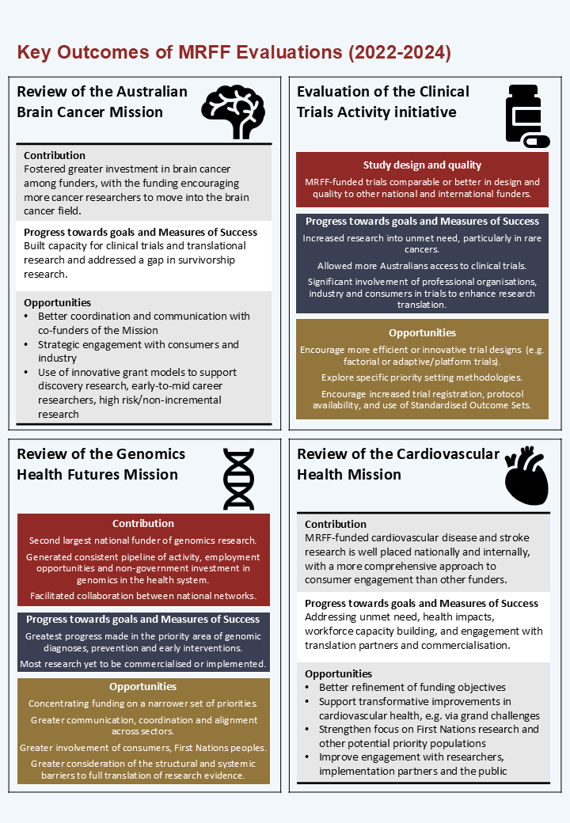

### MRFF Grant Opportunity Gender Data Report

The [Medical Research Future Fund Report on gender data for grant opportunities](https://www.health.gov.au/resources/publications/medical-research-future-fund-report-on-gender-data-for-grant-opportunities-december-2024?language=en) was the third report from the Australian Government to provide an overview of gender data for MRFF grant opportunities.

* The report findings showed a continued trend towards better parity between men and women researchers across the MRFF.
* Across all years, the MRFF received a similar number of applications from women and men, as both Chief Investigators and lead Chief Investigators. Overall funded rates were also similar for men and women.
* In 2022–23, women Chief Investigators submitted more applications and had higher funded rates than men, continuing the trend observed in 2021–22.
* However, men still received a higher proportion of funding than women, and there was still lower representation among women at more senior levels.
* Correspondingly, due to recent special measures introduced by the NHMRC for the Investigator Grant scheme, for the first time in 2023 NHMRC reported more funding awarded to women than men and more women applying at the higher Leadership levels; it will take time for these ongoing efforts to affect longer-term retention of women researchers later in their careers.
* This was also the first report for which sufficient gender data is available to report on funded rates for non-binary researchers. Across all years, Chief Investigators who identified as non-binary had higher overall funded rates (33.8%) than men (24.7%) or women (25.7%), although this is based on small numbers.
* The better representation of diverse genders among health and medical researchers will have a positive impact on health outcomes, as recognised in the joint MRFF/NHMRC Statement on Sex, Gender, Variations of Sex Characteristics and Sexual Orientation in Health and Medical Research.

### MRFF Chief Investigator Report

The [Medical Research Future Fund Report on Chief Investigator data](https://www.health.gov.au/resources/publications/medical-research-future-fund-report-on-chief-investigator-data?language=en) provided an overview and insight into the characteristics of Chief Investigators who applied for and/or received MRFF funding. Where data was available, the report also compared these against lead Chief Investigators of Medical Research Endowment Account (MREA) funding via the NHMRC. The report findings showed:

* About half of researchers funded by the MRFF have more than one MRFF grant, and the funded rate for distinct Chief Investigators (CIs) was 37.0% (28.5% for distinct Lead Chief Investigators (CIAs)).
  + More distinct CIs and CIAs apply to and are funded by the MRFF every year.
* Funded rates tend to be higher for established researchers, First Nations researchers, rural, regional and remote researchers, those from the University sector (followed very closely by Medical Research Institutes), and those from Clinical Medicine and Science, though other sectors and Broad Research Areas were supported as well.
* There was a sizeable proportion of MRFF grantees (54.8%) who had not received MREA funding via the NHMRC as CIA since the establishment of the MRFF, and some suggestion that these represent, compared to those who receive both MRFF and MREA funding:
  + the earliest and most established career researchers
  + a lower proportion of applicants with a PhD
  + a higher proportion of Health Services researchers.
* The proportion of First Nations researchers supported by the MRFF was similar regardless of whether they were also supported by the MREA.
* These findings demonstrated the breadth, diversity and complementarity of researchers supported by the MRFF and MREA, in terms of increasing the pool of funding for the health and medical research sector, as well as additional support for researchers from non-traditional career pathways, health services research and translational research.

### Medical Research Future Fund Early to Mid-Career Researchers grant opportunity outcomes data

The MRFF’s Early to Mid-Career Researchers initiative supports Australia’s emerging leaders in health and medical research to make breakthrough discoveries and tackle significant health challenges.

The Department has committed to providing regular reports on the outcomes of this initiative under the Evaluation Strategy. So far two reports have been published, for the [2021 and 2023 Early to Mid-Career Researchers Grant Opportunities](https://www.health.gov.au/resources/publications/medical-research-future-fund-early-to-mid-career-researchers-grant-opportunity-outcomes-data?language=en). These reports provide information on:

* the assessment of applications for funding under the respective grant opportunities
* funding awarded
* outcomes by broad research area, fields of research, states and territories and eligible organisations
* the characteristics of Chief Investigators.

### Medical Research Future Fund Report on the Coronavirus Research Response

The [Medical Research Future Fund Report on the Coronavirus Research Response](https://www.health.gov.au/resources/publications/medical-research-future-fund-report-on-the-coronavirus-research-response?language=en), published in May 2023 provided insight into the research, researchers and institutions funded under the MRFF Coronavirus Research Response.

The Australian Government announced the MRFF Coronavirus Research Response as part of the COVID-19 National Health Plan on 11 March 2020. This document reports on:

* the research, researchers, and institutions funded under the MRFF Coronavirus Research Response
* the impact of funded grants
* opportunities for learning and future funding.

### Medical Research Future Fund Report on funding for rural, regional and remote health research

The [Medical Research Future Fund Report on funding for rural, regional and remote health research](https://www.health.gov.au/resources/publications/mrff-report-on-funding-for-rural-regional-and-remote-health-research?language=en) was published in August 2023.

This document shares information on:

* MRFF investment in rural, regional and remote health research
* funding insights
* the impact of MRFF investment in rural, regional and remote health research
* opportunities for learning and future funding.

## Governance and assurance

### Improving alignment and coordination between the MRFF and National Health and Medical Research Council (NHMRC)’s Medical Research Endowment Account (MREA)

The co-existence of the MRFF and the MREA, together awarding more than $1.5 billion in research grants each year, presents an opportunity to align the complementary purposes and characteristics of the two funds.

In June and July 2023, the Australian Government undertook a national consultation, ‘Improving alignment andcoordination between the Medical Research Future Fund and the NHMRC’s Medical Research Endowment Account.’ The summary report can be found on the Department’s [website](https://www.health.gov.au/resources/publications/improving-alignment-and-coordination-between-the-medical-research-future-fund-and-nhmrcs-medical-research-endowment-account-consultation).

The government has initiated two major developments in response to the consultation since it was completed:

* New joint NHMRC-MRFF advisory committees.
* Development of a [National Health and Medical Research Strategy.](https://www.health.gov.au/our-work/national-health-and-medical-research-strategy)

The four new joint NHMRC-MRFF advisory committees commenced in the first quarter 2025, to advise on research strategies and funding policies for the two funds:

* + NHMRC-MRFF Consumer Advisory Group – to advise on consumer and community involvement in health and medical research, including on strengthening consumer involvement in MREA and MRFF grant programs.
  + NHMRC-MRFF Industry, Philanthropy and Commercialisation Committee – to advise on industry and philanthropic involvement in health and medical research and strategies to foster greater research commercialisation.
  + NHMRC-MRFF Public Health and Health Systems Committee – to advise on strategies for strengthening preventive health, public health, primary care and health services, and for embedding research translation in the Australian health system.
  + NHMRC-MRFF Indigenous Advisory Group – to advise on health research involving Aboriginal and Torres Strait Islander communities and capacity building for health researchers who identify as Aboriginal or Torres Strait Islander.

Research Committee (which is established as an NHMRC Principal Committee under the NHMRC Act) is also expected to support both NHMRC and the Department, including advising on alignment between the funding policies and processes for the MREA and the MRFF.

The Department and the NHMRC are also working together to identify and develop joint policies and procedures, and potential grant opportunities, consistent with feedback from the 2023 national consultation.

### MRFF Program Assurance Group

The Department established a Program Assurance Group (PAG) in October 2019, which continues to meet regularly to provide internal oversight of the management of the MRFF. The role of the MRFF PAG is to provide assurance to MRFF implementation and to assist with the continuous improvement of assurance mechanisms, risk management practices and program assurance more broadly as a result of lessons learnt and to increase consistency across MRFF initiatives.

### Project progress and final reports

MRFF grantees are required to submit regular project reports describing the progress and outcomes of their projects via the relevant administering grants hub (Business Grants Hub (BGH) or NHMRC).

Routine monitoring provides assurance that projects are meeting their intended objectives during MRFF funding and after it ends, allows oversight of issues and risks as they arise, and provides information to support improvements in grant design (e.g., understanding key features of successful projects).

Further information about project reporting can be found on the Department’s [website](https://www.health.gov.au/our-work/mrff/grants-management-resources), and the website of the relevant grants hub.

# Medical Research Future Fund – since inception

The establishment of the MRFF was announced in the 2014–15 Budget. The MRFF Act received the Royal Assent from the Governor-General on 26 August 2015. The first disbursements from the MRFF Special Account began during the 2016–17 financial year. Since the inception of the MRFF, the financial assistance provided, and the number of grants, has increased year on year.

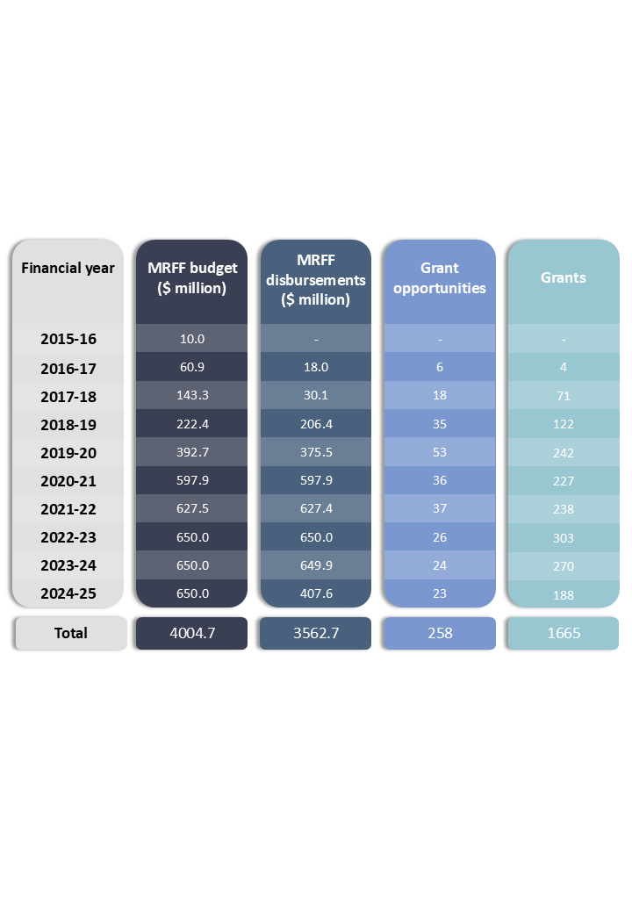

For the above table, **MRFF disbursements** values, **Grant Opportunities** data and **Grants data** for 2024–25 are for a partial Financial Year (FY), noting this report was prepared prior to the end of the 2024–25 FY. MRFF budget values for 2024–25 are for the full 2024–25 FY. The 2021 GBM AGILE Grant Opportunity did not proceed to assessment and is therefore not included in the above analysis.

**MRFF budget** values are taken from Health Portfolio Budget Statements in the relevant financial year (more information at the Department’s [website](https://www.health.gov.au/about-us/corporate-reporting/budgets)). **MRFF disbursements** values represent payments made to all active grants in the relevant FY (i.e., new grants as well as grants commenced in previous FYs – see Table 2, below) as at 30 April 2025. **Grant Opportunities data** represents all grant opportunities that had opened for applications as at 1 June 2025. **Grants data** represents newly awarded and announced grants for the relevant FY, as at 1 June 2025.

## Financial assistance from the MRFF Special Account

Table 2 presents the funding profiles of all MRFF initiatives since 2016–17, as at 30 November 2024.   
See Appendix A Initiatives under the 2022–2024 Priorities for a description of each of these initiatives.

Table 2  
Funding for MRFF initiatives, since 2016–17, as at 30 November 2024

|  |  |  |  |  |  |  |  |  |  |  |  |  |  |  |  |  |
| --- | --- | --- | --- | --- | --- | --- | --- | --- | --- | --- | --- | --- | --- | --- | --- | --- |
|  |  | Actuals ($ million) | | | | | | | | Budget ($ million) | | | | Total ($ million) | | |
| **Theme** | **Initiative** | **16-17** | **17-18** | **18-19** | **19-20** | **20-21** | **21-22** | **22-23** | **23-24** | **24-25** | **25-26** | **26-27** | **27-28** | **12-year total** | **Out years  (28-29 to 33-34)** | **Total** |
| Patients | Emerging Priorities and Consumer-Driven Research | 7.0 |  | 63.4 | 54.0 | 84.5 | 84.4 | 66.0 | 72.5 | 67.2 | 80.5 | 75.5 | 70.5 | **725.3** | **360.0** | **1085.3** |
| Clinical Trials Activity | 1.0 | 4.8 | 47.4 | 68.1 | 63.7 | 59.3 | 96.6 | 63.5 | 75.0 | 75.0 | 75.0 | 75.0 | **704.4** | **450.0** | **1154.4** |
| Global Health |  | 2.5 | 1.8 | 3.4 | 2.7 | 3.0 | 3.0 | 3.0 | 3.0 | 3.0 | 3.0 | 3.0 | **31.3** | **18.0** | **49.3** |
| Researchers | Frontier Health and Medical Research |  |  |  | 20.1 | 53.6 | 61.5 | 48.7 | 57.7 | 70.0 | 70.0 | 70.0 | 70.0 | **521.6** | **420.0** | **941.6** |
| Researcher Exchange and Development within Industry |  |  |  | 8.0 | 10.0 | 10.0 | 4.0 |  |  |  |  |  | **32.0** |  | **32.0** |
| Clinician Researchers |  | 1.8 | 4.9 | 19.8 | 20.4 | 22.2 | 19.9 | 19.9 | 20.0 | 20.0 | 20.0 | 20.0 | **188.8** | **120.0** | **308.8** |
| Early to Mid-Career Researchers |  |  |  |  |  |  | 13.4 | 26.0 | 35.2 | 40.0 | 44.8 | 44.8 | **204.2** | **268.8** | **473.0** |
| Research Missions | Australian Brain Cancer Mission |  | 1.0 | 4.7 | 7.4 | 5.0 | 3.6 | 8.5 | 1.0 | 5.0 | 5.0 | 5.0 |  | **46.3** |  | **46.3** |
| Million Minds Mental Health Research Mission |  |  | 6.2 | 7.0 | 12.0 | 15.0 | 26.9 | 20.1 | 20.0 | 10.0 | 10.0 | 5.0 | **132.2** |  | **132.2** |
| Genomics Health Futures Mission |  |  | 8.8 | 37.5 | 87.4 | 69.9 | 55.0 | 40.9 | 50.0 | 50.0 | 50.0 | 41.2 | **490.8** |  | **490.8** |
| Dementia, Ageing and Aged Care Mission |  |  | 10.0 | 13.1 | 17.0 | 17.2 | 17.5 | 20.8 | 17.5 | 17.5 | 17.5 | 17.5 | **165.5** | **17.5** | **183.0** |
| Indigenous Health Research Fund |  |  | 15.0 | 22.5 | 18.8 | 11.4 | 17.1 | 13.7 | 12.5 | 12.5 | 12.5 | 12.5 | **148.5** | **12.5** | **161.0** |
| Stem Cell Therapies Mission |  |  |  | 6.0 | 17.6 | 18.0 | 12.7 | 29.4 | 18.0 | 18.0 | 18.0 | 18.0 | **155.8** |  | **155.8** |
| Cardiovascular Health Mission |  |  |  | 22.1 | 23.8 | 23.6 | 23.8 | 29.3 | 20.0 | 20.0 | 20.0 | 20.0 | **202.6** | **20.0** | **222.6** |
| Traumatic Brain Injury Mission |  |  |  | 5.0 | 4.0 | 3.9 |  | 5.3 | 5.0 | 5.0 | 5.0 | 5.0 | **38.3** | **5.0** | **43.3** |
| Low Survival Cancers Mission* |  |  |  |  |  |  |  |  |  |  |  | 14.4 | **14.4** | **82.8** | **97.2** |
| Reducing Health Inequities Mission* |  |  |  |  |  |  |  |  |  |  |  | 14.4 | **14.4** | **82.8** | **97.2** |
| *For allocation to Research Missions pending evaluation* | | | | |  |  |  |  |  |  |  | 5.0 | **5.0** | ***697.4*** | ***702.4*** |
| Research Translation | Preventive and Public Health Research | 10.0 |  | 11.2 | 35.2 | 63.9 | 31.5 | 70.3 | 85.4 | 68.6 | 60.5 | 60.8 | 50.8 | **548.0** | **304.5** | **852.5** |
| Primary Health Care Research |  |  |  | 6.7 | 7.1 | 4.1 | 13.5 | 10.0 | 10.0 | 10.0 | 10.0 | 10.0 | **81.4** | **60.0** | **141.4** |
| Rapid Applied Research Translation |  | 10.0 | 17.6 | 16.6 | 20.6 | 22.0 | 22.0 | 22.0 | 23.0 | 23.0 | 23.0 | 23.0 | **222.9** | **138.0** | **360.9** |
| Medical Research Commercialisation |  | 10.0 | 15.4 | 15.3 | 60.3 | 35.3 | 44.3 | 45.0 | 45.0 | 45.0 | 45.0 | 45.0 | **405.6** | **270.0** | **675.6** |
| National Critical Research Infrastructure |  |  |  | 7.7 | 12.6 | 119.2 | 77.0 | 75.0 | 75.0 | 75.0 | 75.0 | 75.0 | **591.5** | **300.0** | **891.5** |
| Research Data Infrastructure |  |  |  |  | 12.9 | 12.3 | 10.0 | 9.2 | 10.0 | 10.0 | 10.0 | 10.0 | **84.4** | **60.0** | **144.4** |
| Total MRFF profile | | 18.0 | 30.1 | 206.4 | 375.5 | 597.9 | 627.4** | 650.0 | 649.9 | 650.0 | 650.0 | 650.0 | 650.0 | **5755.1** | **3687.3** | **9442.4** |
| Budget balance over forward estimates | | | | |  |  |  |  |  |  |  |  |  |  | **212.7** | **212.7** |
| Revised MRFF profile due to low RBA cash rate˄ | | | |  |  |  |  | -52.0 |  |  |  |  |  | **-52.0** |  | **-52.0** |
| MRFF supplementation˄˄ | |  |  |  |  |  |  | 52.0 |  |  |  |  |  | **52.0** |  | **52.0** |
| **MRFF total** |  | **18.0** | **30.1** | **206.4** | **375.5** | **597.9** | **627.4** | **650.0** | **649.9** | **650.0** | **650.0** | **650.0** | **650.0** | **5755.1** | **3900.0** | **9655.1** |

* Funding extends beyond the 10-year plan

**The Actuals for 2021–22 includes expenditure from the MRFF Health Special Account (MHSA) and $172.5 million MRFF supplementation (announced at the Mid-Year Economic and Fiscal Outlook   
2020–21 which was administered separately to the MSHA).

˄The historic low Reserve Bank of Australia cash rate prior to 2022–23 reduced the amount available from the MRFF in 2022–23 from $650.0 million to $598.0 million.

˄˄ To maintain the Australian Government's commitment to the investments under the MRFF 10-year investment plan, an additional $52.0 million was provided to the MRFF in 2022–23, which is administered separately  
to the MHSA.

Notes: The table includes all funding since MRFF’s inception and is not reflective of the current reporting period. Figures may not add up exactly due to rounding. Budgeted amounts are per the 3rd 10-year MRFF investment plan. Amounts spent under each initiative over the budgeted years may be adjusted to reflect actual spending.

# Consistency of financial assistance with the 2022–2024 Priorities

The Australian Government considered the 2022–2024 Priorities when the MRFF initiatives were established under the 10-year investment plan for the MRFF. A list of the 2022–2024 Priorities is provided at Table 1.

Table 3 presents how MRFF initiatives and grant opportunities (as at 5 November 2024) relate to the 2022–2024 Priorities.

Table 3  
MRFF initiatives and open grant opportunities during 2022–2024 Priorities  
(6 November 2022 and 5 November 2024)

|  |  |  |
| --- | --- | --- |
| MRFF initiative | Grant opportunity | 2022–2024 Priorities |
| Australian Brain Cancer Mission | 2024 Brain Cancer Discovery and Translation | * Preventive and Public Health Research * Translation and Commercialisation * Health and Medical Researcher Capacity and Capability * Priority Populations |
| Cardiovascular Health Mission | 2023 Cardiovascular Health* | * Primary Care Research * Consumer-Driven Research * Public Health Interventions * Aboriginal and Torres Strait Islander Health |
| 2024 Cardiovascular Health | * Preventive and Public Health Research * Data, Digital Health and Artificial Intelligence |
| Clinical Trials Activity | 2022 Clinical Trials Activity | * Antimicrobial Resistance * Comparative Effectiveness Research * Priority Populations |
| 2023 Clinical Trials Activity | * Comparative Effectiveness Research * Priority Populations * Health and Medical Researcher Capacity and Capability |
| 2024 Clinical Trials Activity | * Comparative Effectiveness Research * Priority Populations * Health and Medical Researcher Capacity and Capability |
| 2023 International Clinical Trial Collaborations (Round 23.1) | * Health and Medical Researcher Capacity and Capability |
| 2023 International Clinical Trial Collaborations (Round 23.2) | * Health and Medical Researcher Capacity and Capability |
| 2024 International Clinical Trial Collaborations (Round 24.1) | * Health and Medical Researcher Capacity and Capability |
| 2024 International Clinical Trial Collaborations (Round 24.2) | * Health and Medical Researcher Capacity and Capability |
| Clinician Researchers | 2023 Clinician Researchers: Applied Research in Health | * Health and Medical Researcher Capacity and Capability * Comparative Effectiveness Research * Primary Care Research |
| Dementia, Ageing and Aged Care Mission | 2023 Dementia, Ageing and Aged Care | * Priority Populations * Data, Digital Health and Artificial Intelligence * Primary Care Research * Preventive and Public Health Research |
| 2024 Dementia, Ageing and Aged Care | * Priority Populations * Health and Medical Researcher Capacity and Capability |
| Early to Mid-Career Researchers | 2023 Early to Mid-Career Researchers | * Health and Medical Researcher Capacity and Capability * Priority Populations |
| 2024 Early to Mid-Career Researchers | * Health and Medical Researcher Capacity and Capability * Priority Populations |
| Emerging Priorities and Consumer-Driven Research | 2023 Models of Care for Sexuality & Gender Diverse People & People with Innate Variations of Sex Characteristics | * Consumer-Driven Research * Priority Populations |
| 2023 Post-Acute Sequelae of COVID-19 | * Consumer-Driven Research * Preventive and Public Health Research * Primary Care Research * Research Infrastructure and Capability |
| 2024 Post-Acute Sequelae of COVID-19 | * Consumer-Driven Research * Preventive and Public Health Research * Primary Care Research * Aboriginal and Torres Strait Islander Health * Priority Populations |
| 2023 Childhood Mental Health Research | * Consumer-Driven Research * Preventive and Public Health Research * Primary Care Research * Priority Populations * Health and Medical Researcher Capacity and Capability * Aboriginal and Torres Strait Islander Health |
| European Joint Programme on Rare Diseases 2022 MRFF Joint Transnational Call* | * Consumer-Driven Research * Digital Health Intelligence |
| 2023 Multidisciplinary Models of Primary Care (Streams 1 and 4)** | * Primary Care Research * Priority Populations * Preventive and Public Health Research * Consumer-Driven Research * Research Infrastructure and Capability |
| 2024 Integrated Multidisciplinary Models of Primary Care | * Primary Care Research * Priority Populations * Preventive and Public Health Research * Consumer-Driven Research |
| 2024 Paediatric Brain Cancer Research | * Consumer-Driven Research * Research Infrastructure and Capability * Health and Medical Researcher Capacity and Capability * Priority Populations |
| 2024 Infertility, Pregnancy Loss and Menopause | * Consumer-Driven Research * Priority Populations * Preventive and Public Health Research |
| 2024 Novel Treatments and Management Strategies for Chronic Pain | * Preventive and Public Health Research * Priority Populations |
| 2024 Alcohol and Other Drugs | * Preventive Public Health Research * Priority Populations * Aboriginal and Torres Strait Islander Health * Consumer-Driven Research |
| Frontier Health and Medical Research | 2022 Frontier Health and Medical Research* | * Translational Research Infrastructure * Consumer-Driven Research |
| Genomics Health Futures Mission | 2023 Genomics Health Futures | * Consumer-Driven Research * Preventive and Public Health Research * Primary Care Research * Data, Digital Health and Artificial Intelligence |
| 2024 Genomics Health Futures | * Preventive and Public Health Research * Priority Populations * Antimicrobial Resistance |
| Global Health | 2023 Global Health | * Antimicrobial Resistance * Global Health and Health Security |
| Indigenous Health Research Fund | 2023 Indigenous Health Research | * Aboriginal and Torres Strait Islander Health |
| 2024 Indigenous Health Research | * Aboriginal and Torres Strait Islander Health * Preventive and Public Health Research |
| Medical Research Commercialisation | 2023 BioMedTech Incubator - Dementia and Cognitive Decline | * Translation and Commercialisation * Priority Populations |
| 2024 BioMedTech Incubator | * Translation and Commercialisation |
| Million Minds Mental Health Research Mission | 2022 Mental Health Research | * Preventive and Public Health Research * Primary Care Research * Health and Medical Researcher Capacity and Capability |
| 2023 Mental Health Research | * Preventive and Public Health Research * Primary Care Research * Health and Medical Researcher Capacity and Capability * Priority Populations * Aboriginal and Torres Strait Islander Health |
| 2024 Mental Health Research | * Preventive and Public Health Research * Primary Care Research * Health and Medical Researcher Capacity and Capability |
| National Critical Research Infrastructure | 2023 Innovative Trials | * Research Infrastructure and Capability * Health and Medical Researcher Capacity and Capability |
| 2023 National Critical Research Infrastructure | * Data, Digital Health and Artificial Intelligence * Research Infrastructure and Capability |
| 2024 National Critical Research Infrastructure | * Data, Digital Health and Artificial Intelligence * Research Infrastructure and Capability |
| Preventive and Public Health Research | 2023 Targeted Translation Research Accelerator - Cardiovascular Disease and Diabetes Mechanisms | * Health and Medical Researcher Capacity and Capability * Preventive and Public Health Research |
| 2023 Chronic Respiratory Conditions | * Preventive and Public Health Research * Consumer-Driven Research * Comparative Effectiveness Research |
| 2023 Consumer-Led Research | * Consumer-Driven Research * Priority Populations * Aboriginal and Torres Strait Islander Health |
| 2023 Targeted Translation Research Accelerator - Cardiovascular Disease and Diabetes Drugs and Devices | * Preventive and Public Health Research * Translation and Commercialisation |
| 2023 Maternal Health and Healthy Lifestyles | * Preventive and Public Health Research |
| 2024 Maternal Health and Healthy Lifestyles | * Consumer-Driven Research * Aboriginal and Torres Strait Islander Health * Preventive and Public Health Research |
| 2023 Optimising Screening, Diagnosis and Management of Obstructive Sleep Apnoea | * Preventive and Public Health Research * Comparative Effectiveness Research |
| 2024 Survivorship Care and Collaborative Research Prioritisation | * Consumer-Driven Research * Priority Populations * Aboriginal and Torres Strait Islander Health |
| 2024 Enhancing Medical Device Surveillance Through Registries | * Data, Digital Health and Artificial Intelligence |
| Primary Health Care Research | 2023 Multidisciplinary Models of Primary Care (Streams 2 and 3)** | * Primary Care Research * Priority Populations * Preventive and Public Health Research * Consumer-Driven Research * Research Infrastructure and Capability |
| 2023 Primary Health Care Research | * Primary Care Research * Priority Populations * Preventive and Public Health Research |
| Rapid Applied Research Translation | 2022 Rapid Applied Research Translation | * Translation and Commercialisation * Priority Populations |
| Research Data Infrastructure | 2023 Research Data Infrastructure | * Research Infrastructure and Capability * Data, Digital Health and Artificial Intelligence |
| 2024 Research Data Infrastructure | * Research Infrastructure and Capability * Data, Digital Health, and Artificial Intelligence |
| Stem Cell Therapies Mission | 2023 Stem Cell Therapies* | * Consumer-Driven Research * Drug Repurposing * Translation and Commercialisation |
| 2024 Stem Cell Therapies | * Consumer-Driven Research |
| Traumatic Brain Injury Mission | 2023 Traumatic Brain Injury* | * Digital Health Intelligence * Consumer-Driven Research |
| Overall, this table represents grant opportunities that opened when the 2022–2024 Priorities were in force.  * Some grant opportunities in this list were mapped to the previous *Australian Medical Research and Innovation Priorities 2020–2022*in their Grant Opportunity Guidelines but are reported here as they were not included in the previous *Financial assistance to support the Australian Medical Research and Innovation Priorities 2020-2022* report.  ** 2023 Multidisciplinary Models of Primary Care appears twice in Table 3 as it was funded under both Primary Health Care Research and Emerging Priorities and Consumer-Driven *Research*, under different streams. | | |

# Medical Research Future Fund 2022–2024

From 6 November 2022 to 5 November 2024, the Priorities provided a wide-ranging platform that allowed the MRFF to respond to health challenges, while continuing to fund projects aimed at stimulating health and medical research across the entire research pipeline and achieve the MRFF’s strategic objectives. Innovative MRFF-funded projects are featured at the [MRFF website](https://www.health.gov.au/initiatives-and-programs/medical-research-future-fund).

## Funding

MRFF funding has continued to support and promote developments in current and future health and medical research projects. Analysis[3] of the financial assistance provided from the MRFF during 2022–2024 shows:

* funding was provided across MRFF themes and initiatives
* funding was spread across all states and territories
* projects were predominately led through universities and medical research institutes
* support for innovative research approaches using different grant models
* diversity in the expertise of MRFF grant assessment committee membership, including international experts.

Reporting is complemented by other MRFF reports and publications outlined in the ‘Performance and Evaluation’ section of this report.

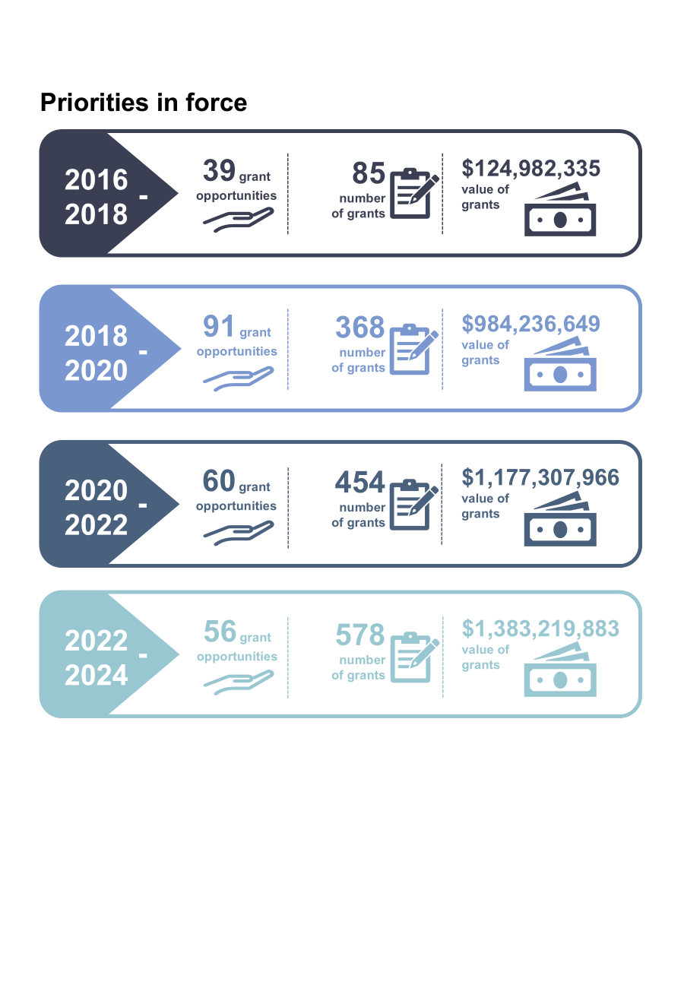

Data represents (i) grant opportunities that were opened, and (ii) numbers and associated funding amounts for grants with payments commencing, during the periods when Australian Medical Research and Innovation Priorities were in force: 9 November 2016 to 8 November 2018, 8 November 2018 to 6 November 2020, 7 November 2020 to 5 November 2022 and 6 November 2022 to 5 November 2024, respectively. Analysis was correct as at 1 June 2025. The 2021 GBM AGILE Grant Opportunity did not proceed to assessment and is therefore not included in the above analysis. Note that the number of grant opportunities differ from previous reports due to a change in methodology (for earlier reports, grant opportunities were either consolidated within the same initiative or kept distinct for ad hoc/targeted grants), and greater availability of data from grant opportunities with known outcomes.

## Highlights from the MRFF initiatives

MRFF funding has:

* addressed under-representation among priority populations
* bolstered the research workforce
* increased support for medical research commercialisation
* enabled clinical trials research.

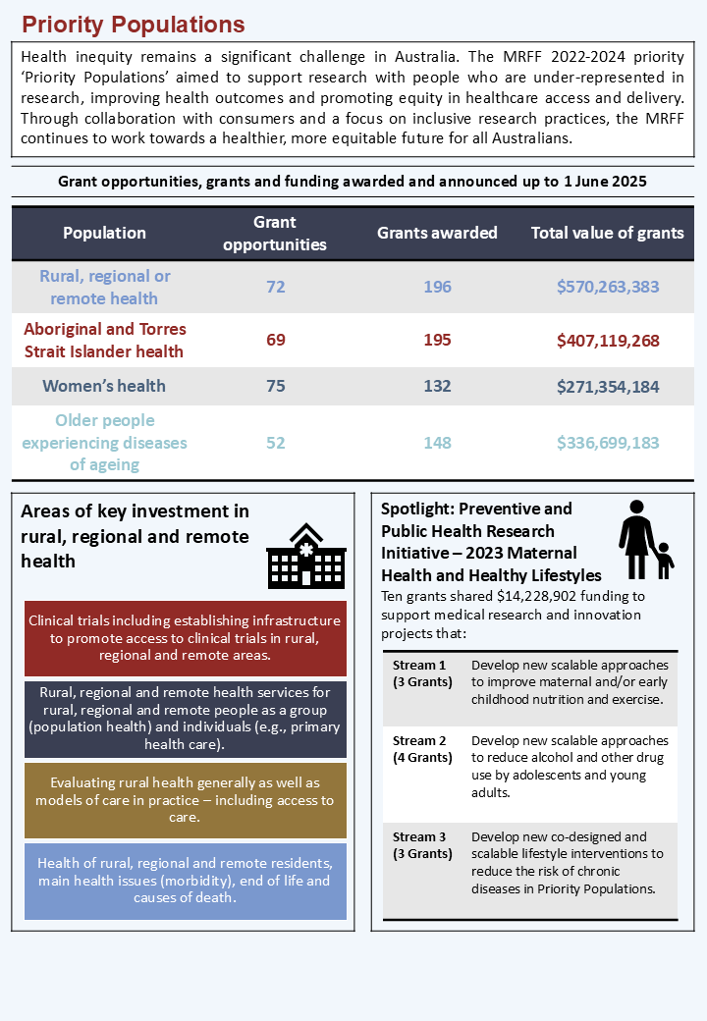

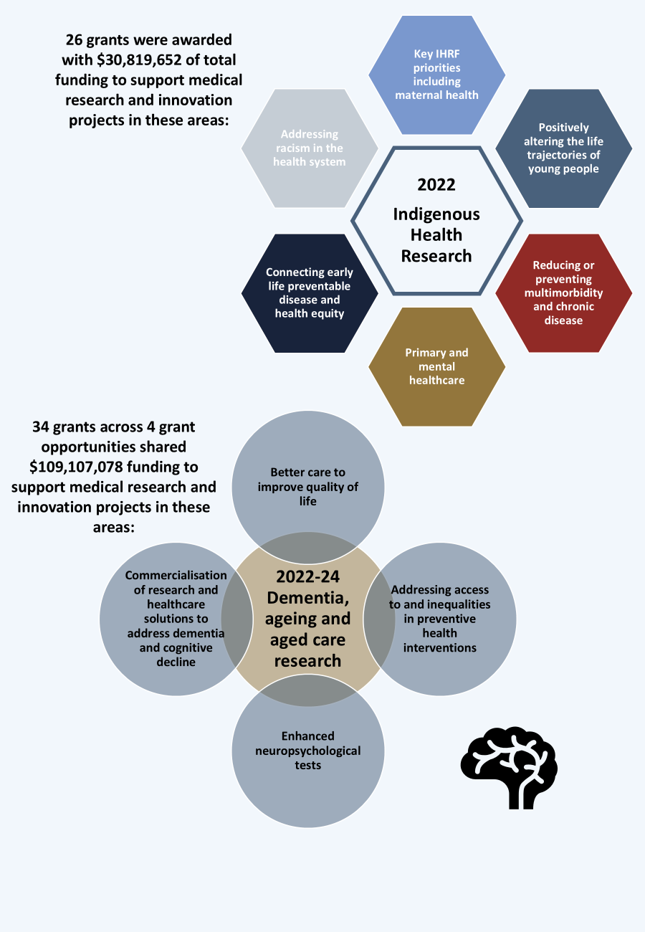

The number of grant opportunities refers to those that funded at least one grant within the priority population, where outcomes were awarded and announced up to 1 June 2025. Key areas of rural, regional and remote health investment as per [MRFF report on funding for rural regional and remote health research](https://www.health.gov.au/resources/publications/mrff-report-on-funding-for-rural-regional-and-remote-health-research?language=en). Indigenous Health research areas per 2022 Indigenous Health Research grant opportunity. Dementia, Ageing and Aged Care research areas per 2022 Dementia, Ageing and Aged Care, 2023 Dementia, Ageing and Aged Care, 2023 BioMedTech Incubator - Dementia and Cognitive Decline and 2024 Dementia, Ageing and Aged Care grant opportunities.

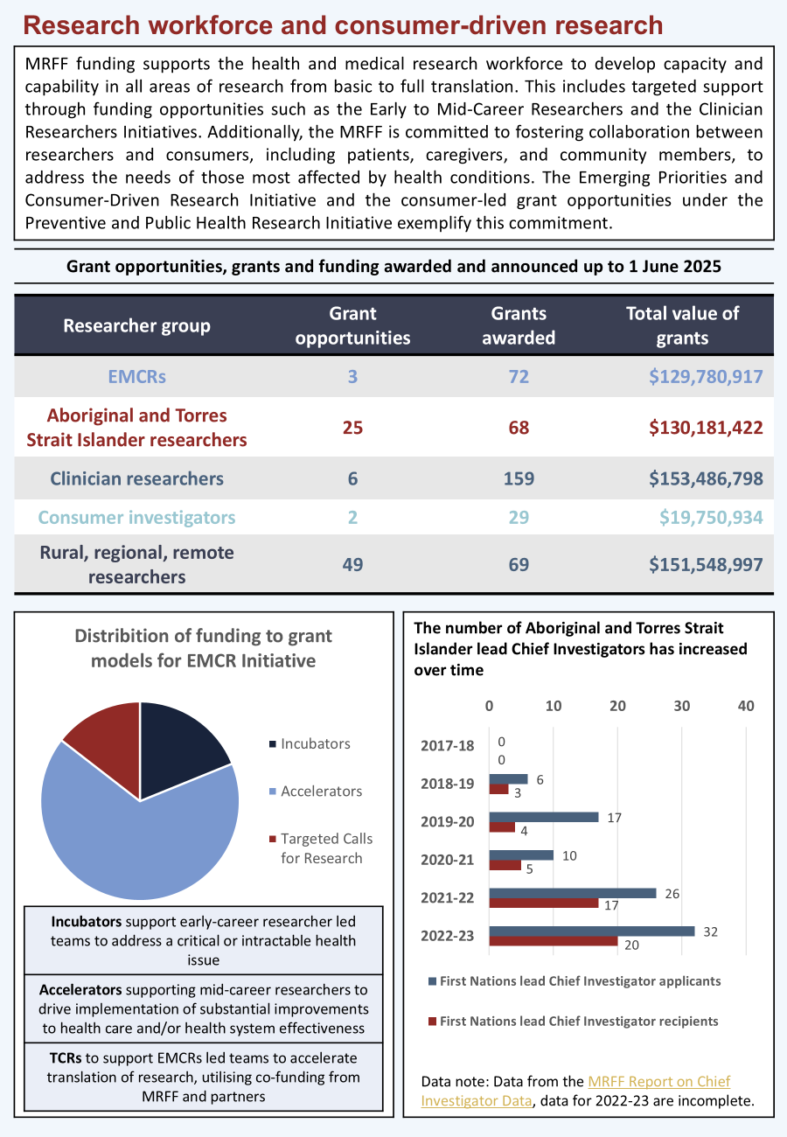

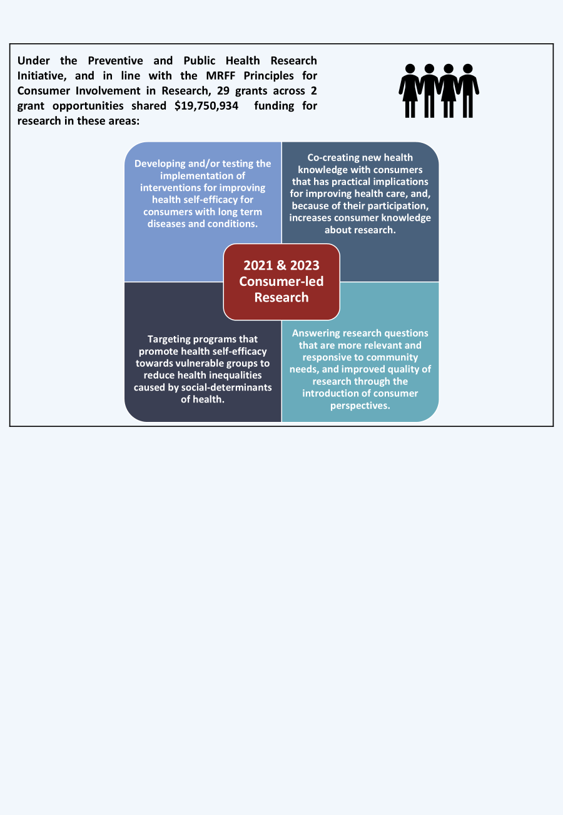

For Aboriginal and Torres Strait Islander researchers and Rural, Regional, and Remote researchers, the number of grant opportunities refers to those that funded at least one grant with a Chief Investigator A (CIA) from the specified cohort, where outcomes were awarded and announced up to 1 June 2025. For all other cohorts, this refers to the number of grant opportunities specifically tailored to these cohorts, where outcomes were awarded and announced up to 1 June 2025. Aboriginal and Torres Strait Islander lead Chief Investigator data from [MRFF Report on Chief Investigator Data](https://www.health.gov.au/resources/publications/medical-research-future-fund-report-on-chief-investigator-data?language=en), data from 2022–23 are incomplete.

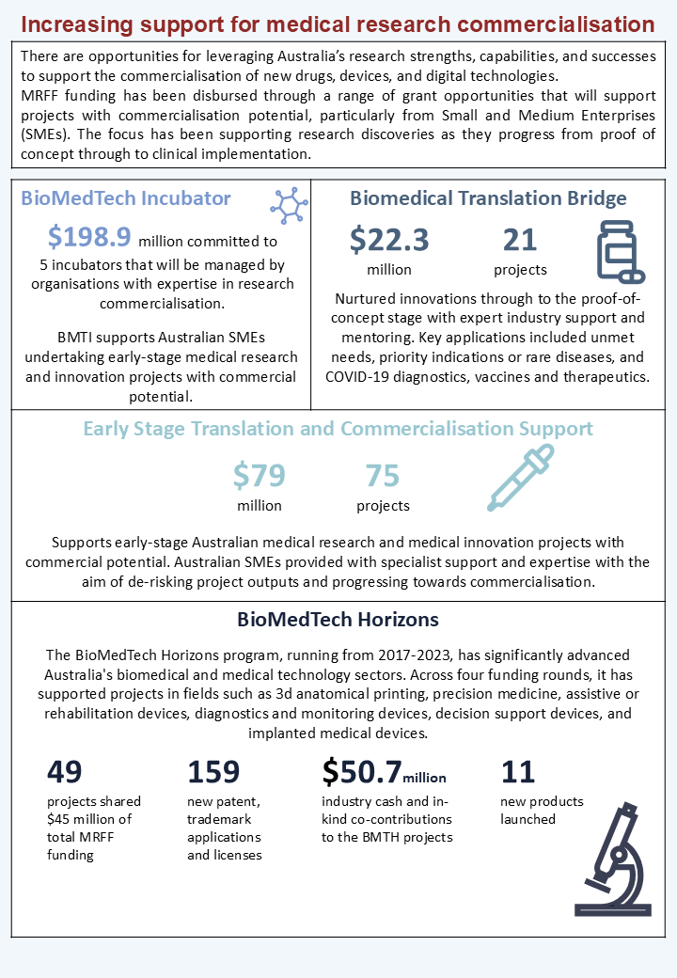

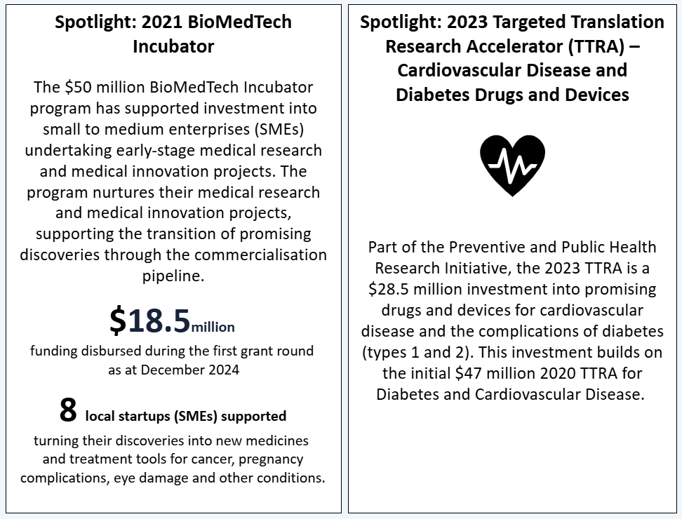

The BioMedTech Incubator, Biomedical Translation Bridge, Early Stage Translation and Commercialisation Support and BioMedTech Horizons (BMTH) programs are funded through the MRFF Medical Research Commercialisation Initiative. The 2023 Targeted Translation Research Accelerator is part of the Preventive and Public Health Research Initiative. Data on BMTH outcomes taken from MTPConnect, BioMedTech Horizons Impact Report – Round 1, MTPConnect, October 2021, and MTPConnect, BioMedTech Horizons Impact Report – Rounds 2, 3 & 4, MTPConnect, August 2023, <https://www.mtpconnect.org.au/reports/BMTH-Impact-Reports>.

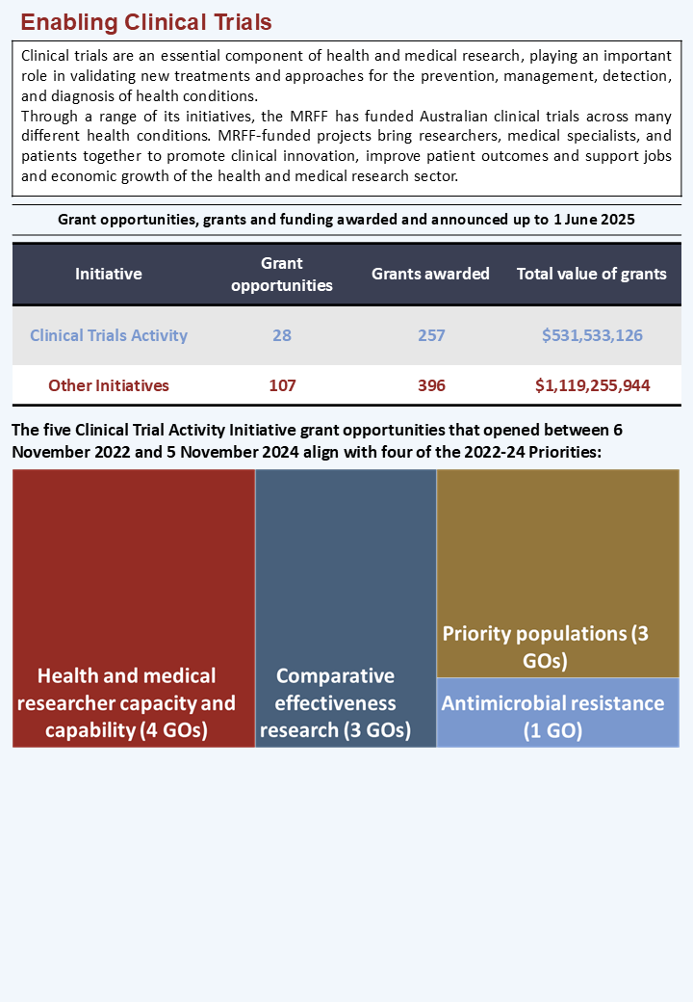

The number of grant opportunities refers to those that funded at least one grant which included a clinical trial, where outcomes were awarded and announced up to 1 June 2025. Some grant opportunities in this list opened during the 2022–2024 Priorities period but outcomes were not available until the *Australian Medical Research and Innovation Priorities 2024–2026* came in force. The above analysis includes priorities as identified in the grant opportunity guidelines however grants may have aligned with other priorities at award. Where multiple application rounds were conducted under a single MRFF grant opportunity and shared the same grant opportunity guidelines, these rounds were treated as a single distinct grant opportunity for the purposes of this analysis.

## A snapshot of publications of research funded by MRFF

Research outputs, such as scientific articles, give healthcare systems, clinicians, researchers, consumers, and other end-users access to the latest information on topics that may be relevant to advancing continued research and health care. Sharing of research outcomes also reduces research waste, minimising unnecessary research duplication and maximising the benefits and value arising from research funding.

Research projects may be funded by more than one funding organisation. The majority of papers that attribute MRFF funding have also been co-funded by other agencies, with only 17% of publications attributed to MRFF alone as the sole funding source. Just under half (48%) of papers that attribute MRFF funding have also been co-funded by the NHMRC and at least one other funder. Over one third (35%) of MRFF-attributed papers were co-funded by other international government funders.

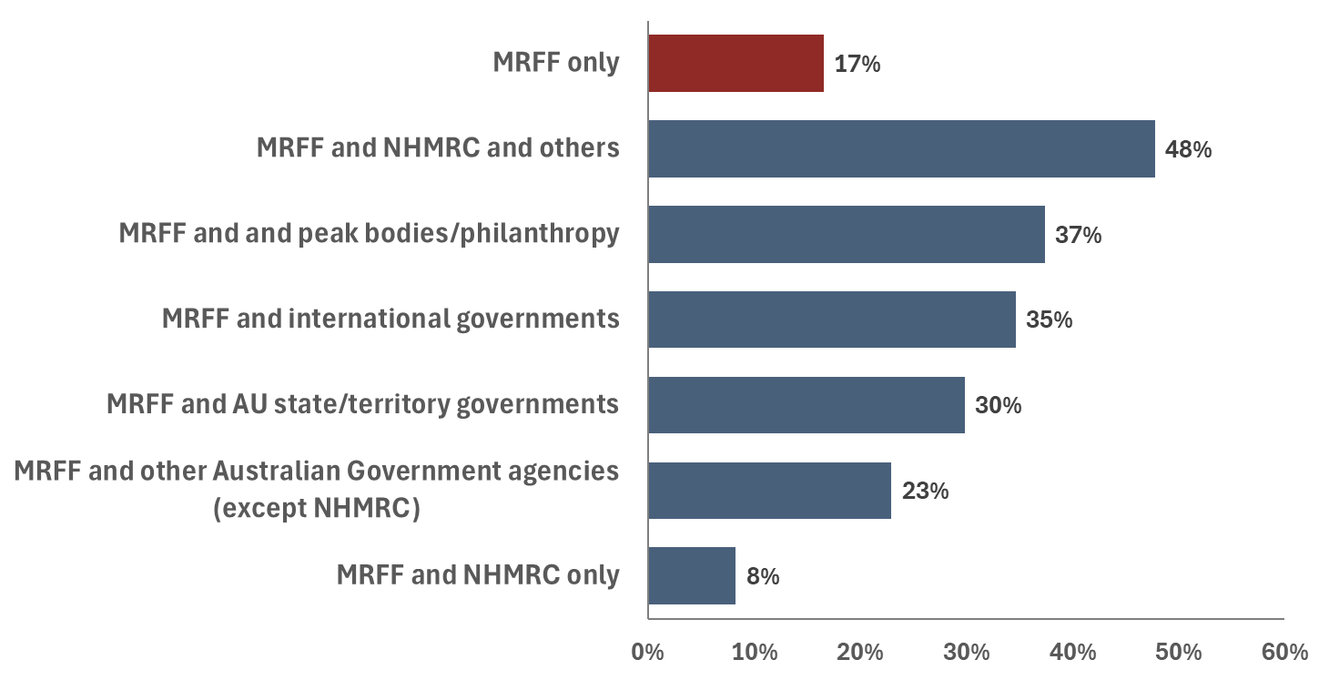

Dimensions AI bibliometric tool (Digital Science & Research Solutions Inc, London, UK) was used to identify all peer-reviewed, original research and review articles, published between 1 January 2018 and 12 December 2024, that attributed at least one Australian funder. Data was filtered for publications listing at least one of the 43 Fields of Research (FoR) funded by the MRFF, and that attributed MRFF as a funder across this period. Additional funders attributed by these publications were further categorised. In addition to MRFF and NHMRC, additional funders included the Australian Government, state and territory governments and other national and international funders. The percentages of publications attributed to each funder do not add up to 100%, as some publications have multiple funders. The proportion of MRFF-funded research outputs may not be complete as it relies on grantees to actively attribute the MRFF as a funder.

# Further analysis on MRFF financial assistance provided during the 2022–2024 Priorities

Table 4 shows how grants and funding were distributed across the 4 MRFF themes, while Table 5 shows the number of applications and funded rate (the percentage of applications funded) of grant opportunities within the 4 MRFF themes.

Table 4  
MRFF themes: grants and funding between 6 November 2022 and 5 November 2024

|  |  |  |
| --- | --- | --- |
| MRFF theme | Number of grants with payments commenced | Funding amount |
| Patients | 114 | $239,595,033.36 |
| Research Missions | 146 | $288,648,155.63 |
| Research Translation | 217 | $574,662,624.60 |
| Researchers | 101 | $280,314,069.31 |
| **Total** | **578** | **$1,383,219,882.90** |

The grant numbers and funding figures are based on each MRFF-funded grant with payment commencing between 6 November 2022 and 5 November 2024.

Table 5  
Funded rate by MRFF theme

|  |  |  |  |
| --- | --- | --- | --- |
| MRFF theme | Number of applications | Funded grants | Funded rate |
| Patients | 508 | 129 | 25.4% |
| Research Missions | 590 | 104 | 17.6% |
| Research Translation | 667 | 151 | 22.6% |
| Researchers | 431 | 89 | 20.6% |
| **Total – all MRFF** | **2196** | **473** | **21.5%** |

Data represents the funded rates of applications to competitive grant opportunities at award. Thus, the grants in scope differ to those defined in Table 4, and withdrawn and relinquished grants are included in this analysis.  
Included grant opportunities are those that (1) were administered by the NHMRC and BGH, (2) opened for applications between 6 November 2022 and 5 November 2024 and (3) had a known outcome as at 1 June 2025.  
A grant opportunity across more than one MRFF theme, applications or funded grants was assigned to a single MRFF theme, with the larger number of applications (for example, the 2023 Multidisciplinary Models of Primary Care grant opportunity was funded across the Patients and Research Translation themes; thus, it was assigned to Research Translation, the MRFF theme with the greater funding amount for this analysis).

Table 6 presents grants and funding for MRFF Initiatives. MRFF grants with payments commencing between 6 November 2022 and 5 November 2024 were distributed across 20 Initiatives.

Table 6  
MRFF Initiatives: grants and funding between 6 November 2022 and 5 November 2024

|  |  |  |
| --- | --- | --- |
| MRFF initiative | Number of grants with payments commenced | Funding amount |
| Australian Brain Cancer Mission | 1 | $5,991,219.44 |
| Cardiovascular Health Mission | 25 | $46,471,697.83 |
| Clinical Trials Activity | 70 | $160,688,095.06 |
| Clinician Researchers | 48 | $65,780,069.24 |
| Dementia, Ageing and Aged Care Mission | 22 | $40,107,077.60 |
| Early to Mid-Career Researchers | 48 | $85,136,565.07 |
| Emerging Priorities and Consumer-Driven Research | 41 | $73,064,585.30 |
| Frontier Health and Medical Research | 5 | $129,397,435.00 |
| Genomics Health Futures Mission | 33 | $93,087,125.42 |
| Global Health | 3 | $5,842,353.00 |
| Indigenous Health Research Fund | 26 | $30,819,652.39 |
| Medical Research Commercialisation | 2 | $100,000,000.00 |
| Million Minds Mental Health Research Mission | 18 | $22,372,533.67 |
| National Critical Research Infrastructure | 51 | $196,277,800.00 |
| Preventive and Public Health Research | 127 | $180,206,821.75 |
| Primary Health Care Research | 21 | $46,556,191.85 |
| Rapid Applied Research Translation | 8 | $32,395,884.00 |
| Research Data Infrastructure | 8 | $19,225,927.00 |
| Stem Cell Therapies Mission | 19 | $44,476,430.33 |
| Traumatic Brain Injury Mission | 2 | $5,322,418.95 |
| **Total** | **578** | **$1,383,219,882.90** |

Data represents all grant opportunities that had opened for applications between 6 November 2022 and 5 November 2024. The grant numbers and funding figures are based on each MRFF-funded grant with payment commencing between 6 November 2022 and 5 November 2024.

Table 7 shows the funded rate by MRFF Initiative. Primary Health Care Research saw the highest funded rate, and Research Data Infrastructure had the lowest funded rate.

Table 7  
Funded rate by MRFF initiative

|  |  |  |  |
| --- | --- | --- | --- |
| MRFF initiative | Number of applications | Funded grants | Funded rate |
| Cardiovascular Health Mission | 74 | 17 | 23.0% |
| Clinical Trials Activity | 294 | 58 | 19.7% |
| Clinician Researchers | 99 | 33 | 33.3% |
| Dementia, Ageing and Aged Care Mission | 128 | 18 | 14.1% |
| Early to Mid-Career Researchers | 314 | 51 | 16.2% |
| Emerging Priorities and Consumer-Driven Research | 199 | 68 | 34.2% |
| Frontier Health and Medical Research | 18 | 5 | 27.8% |
| Genomics Health Futures Mission | 29 | 8 | 27.6% |
| Global Health | 15 | 3 | 20.0% |
| Indigenous Health Research Fund | 63 | 16 | 25.4% |
| Medical Research Commercialisation | 29 | 4 | 13.8% |
| Million Minds Mental Health Research Mission | 206 | 26 | 12.6% |
| National Critical Research Infrastructure | 158 | 40 | 25.3% |
| Preventive and Public Health Research | 357 | 84 | 23.5% |
| Primary Health Care Research | 17 | 10 | 58.8% |
| Rapid Applied Research Translation | 43 | 9 | 20.9% |
| Research Data Infrastructure | 63 | 4 | 6.3% |
| Stem Cell Therapies Mission | 84 | 17 | 20.2% |
| Traumatic Brain Injury Mission | 6 | 2 | 33.3% |
| **Total – all MRFF** | **2196** | **473** | **21.5%** |

Data represents the funded rates of applications to competitive grant opportunities, at award. Thus, the grants in scope differ to those defined in Table 6, and withdrawn and relinquished grants are included in this analysis.  
Included grant opportunities are those that (1) were administered by the NHMRC and BGH, (2) opened for applications between 6 November 2022 and 5 November 2024 and (3) had a known outcome as at 1 June 2025.   
A grant opportunity across more than one MRFF initiative, applications or funded grants was assigned to a single MRFF initiative, with the larger number of applications.

Table 8 shows the number of grants and the total funding by location of the lead researcher. All states and territories received support from the MRFF.

Table 8  
Location of lead researcher for grants with payments commencing between 6 November 2022 and 5 November 2024

|  |  |  |  |  |
| --- | --- | --- | --- | --- |
| Location | Number of grants with payments commenced | Percentage of grants | Funding amount | Percentage of funding |
| ACT | 13 | 2.2% | $29,671,955.00 | 2.1% |
| NSW | 183 | 31.7% | $393,700,336.75 | 28.5% |
| NT | 8 | 1.4% | $15,978,000.78 | 1.2% |
| QLD | 90 | 15.6% | $201,557,944.85 | 14.6% |
| SA | 61 | 10.6% | $93,713,803.43 | 6.8% |
| TAS | 4 | 0.7% | $6,534,435.54 | 0.5% |
| VIC | 187 | 32.4% | $583,597,709.54 | 42.2% |
| WA | 32 | 5.5% | $58,465,697.01 | 4.2% |
| **Total** | **578** | **100.0%** | **$1,383,219,882.90** | **100.0%** |

The grant numbers and funding figures are based on the lead organisation (also known as administering institution, eligible organisation or primary organisation) of each MRFF-funded grant with payment commencing between 6 November 2022 and 5 November 2024.

Table 9 shows the funded rate by the state or territory of the administering institution. The highest funded rates were observed in Northern Territory and South Australia.

Table 9  
Funded Rate by location of administering institution

|  |  |  |  |
| --- | --- | --- | --- |
| Administering Institution State/Territory | Number of applications | Funded grants | Funded rate |
| ACT | 47 | 10 | 21.3% |
| NSW | 702 | 140 | 19.9% |
| NT | 28 | 11 | 39.3% |
| QLD | 333 | 69 | 20.7% |
| SA | 164 | 45 | 27.4% |
| TAS | 12 | 1 | 8.3% |
| VIC | 780 | 170 | 21.8% |
| WA | 129 | 27 | 20.9% |
| **Total – all MRFF** | **2196** | **473** | **21.5%** |

Data represents the funded rates of applications to competitive grant opportunities, at award. Thus, the grants in scope differ to those defined in Table 8, and withdrawn and relinquished grants are included in this analysis. There was an unfunded application with an unspecified location.  
Included grant opportunities are those that (1) were administered by the NHMRC and BGH, (2) opened for applications between 6 November 2022 and 5 November 2024 and (3) had a known outcome as at 1 June 2025.

Table 10 shows the type of organisations receiving MRFF funding. Universities and medical research institutes received 97.9% of grants. In practice, many MRFF-funded grants are collaborative research efforts across multiple Australian locations and organisations.

Table 10  
Organisation of lead researcher for grants with payments commencing between 6 November 2022 and 5 November 2024

|  |  |  |  |  |
| --- | --- | --- | --- | --- |
| Organisation | Number of grants with payments commenced | Percentage of grants | Funding amount | Percentage of funding |
| Corporation | 12 | 2.1% | $159,350,652.67 | 11.5% |
| Medical Research Institute | 47 | 8.1% | $100,131,790.07 | 7.2% |
| University | 519 | 89.8% | $1,123,737,440.16 | 81.2% |
| **Total** | **578** | **100.0%** | **$1,383,219,882.90** | **100.0%** |

The grant numbers and funding figures are based on the lead organisation (also known as administering institution or primary organisation) of each MRFF-funded grant with payment commencing between 6 November 2022 and 5 November 2024.

The following analysis of MRFF funding is based on information available in applications to grant opportunities that were completed during the period of this report and the outcome was known. More information on the methodology is at Appendix G Methodology used in this report.

Table 11 shows the broad research area of grants, grant opportunities and funding.  
Grants in the research area ‘Clinical Medicine and Science’ attracted the highest amount of funding during this reporting period, with Health Services Research having the highest funded rate (Table 12).

Table 11  
Broad research area of grants, grant opportunities and funding between 6 November 2022 and 5 November 2024

|  |  |  |  |  |
| --- | --- | --- | --- | --- |
| Broad research area | Number of grants with payments commenced | Percentage of grants | Funding amount | Percentage of funding |
| Basic Science | 31 | 6.5% | $37,679,046.07 | 4.5% |
| Clinical Medicine and Science | 213 | 44.7% | $425,794,732.78 | 50.4% |
| Health Services Research | 137 | 28.7% | $231,456,213.93 | 27.4% |
| Public Health | 96 | 20.1% | $150,172,473.12 | 17.8% |
| **Total** | **477** | **100.0%** | **$845,102,465.90** | **100.0%** |

The grant numbers and funding figures are based on each MRFF-funded grant with payment commencing between 6 November 2022 and 5 November 2024.  
Broad research area is nominated by applicants in the application form. Applicants can assign more than one broad research area to an application.

Table 12  
Funded Rate by broad research area

|  |  |  |  |
| --- | --- | --- | --- |
| Broad Research Area | Number of applications | Funded grants | Funded rate |
| Basic Science | 173 | 36 | 20.8% |
| Clinical Medicine and Science | 770 | 156 | 20.3% |
| Health Services Research | 503 | 123 | 24.5% |
| Public Health | 389 | 79 | 20.3% |

Data represents the funded rates of applications to competitive grant opportunities, at award. Thus, the grants in scope differ to those defined in Table 11, and withdrawn and relinquished grants are included in this analysis.  
Included grant opportunities are those that (1) were administered by the NHMRC, (2) the applicant nominated a research area in the application, (3) opened for applications between 6 November 2022 and 5 November 2024 and (4) had a known outcome as at 1 June 2025.   
Broad research area is nominated by applicants in the application form. Applicants can assign more than one broad research area to an application.

Table 13 presents fields of research supported by the MRFF during this reporting period.

Table 13  
Top 20 Field of research of grants, grant opportunities and funding between 6 November 2022 and 5 November 2024

|  |  |  |
| --- | --- | --- |
| Field of research | Funded grants | Funding amount |
| Aboriginal and Torres Strait Islander health and wellbeing | 40 | $85,057,775.01 |
| Allied health and rehabilitation science | 26 | $44,424,254.31 |
| Bioinformatics and computational biology | 8 | $26,986,326.94 |
| Biomedical engineering | 9 | $13,952,466.62 |
| Cardiorespiratory medicine and haematology | 14 | $22,638,899.14 |
| Cardiovascular medicine and haematology | 51 | $90,642,053.89 |
| Clinical and health psychology | 16 | $31,573,257.25 |
| Clinical sciences | 103 | $235,939,166.32 |
| Genetics | 19 | $57,859,533.54 |
| Health services and systems | 137 | $352,130,378.39 |
| Immunology | 14 | $34,375,694.07 |
| Medical biotechnology | 16 | $33,833,723.19 |
| Neurosciences | 33 | $83,416,428.92 |
| Nursing | 9 | $16,080,471.75 |
| Nutrition and dietetics | 10 | $11,318,592.14 |
| Oncology and carcinogenesis | 36 | $92,863,579.37 |
| Paediatrics | 14 | $27,548,058.40 |
| Pharmacology and pharmaceutical sciences | 14 | $24,025,271.90 |
| Public health | 68 | $116,483,350.76 |
| Public health and health services | 42 | $81,707,136.69 |

The grant numbers and funding figures are based on each MRFF-funded grant with payment commencing between 6 November 2022 and 5 November 2024 and had a known outcome as at 1 June 2025.  
Field of research is nominated by applicants in the application form. Applicants can assign more than one field of research to an application. The top 20 fields assigned to applications are reported. Self-reported fields may not directly align with description of MRFF initiatives.

**Grant models to fund research projects**

Different grant models have been included in grant opportunities during 2022–2024 to support innovative research approaches and to help find solutions to significant health challenges and to turn knowledge into practice.

**Incubator Grants**

* 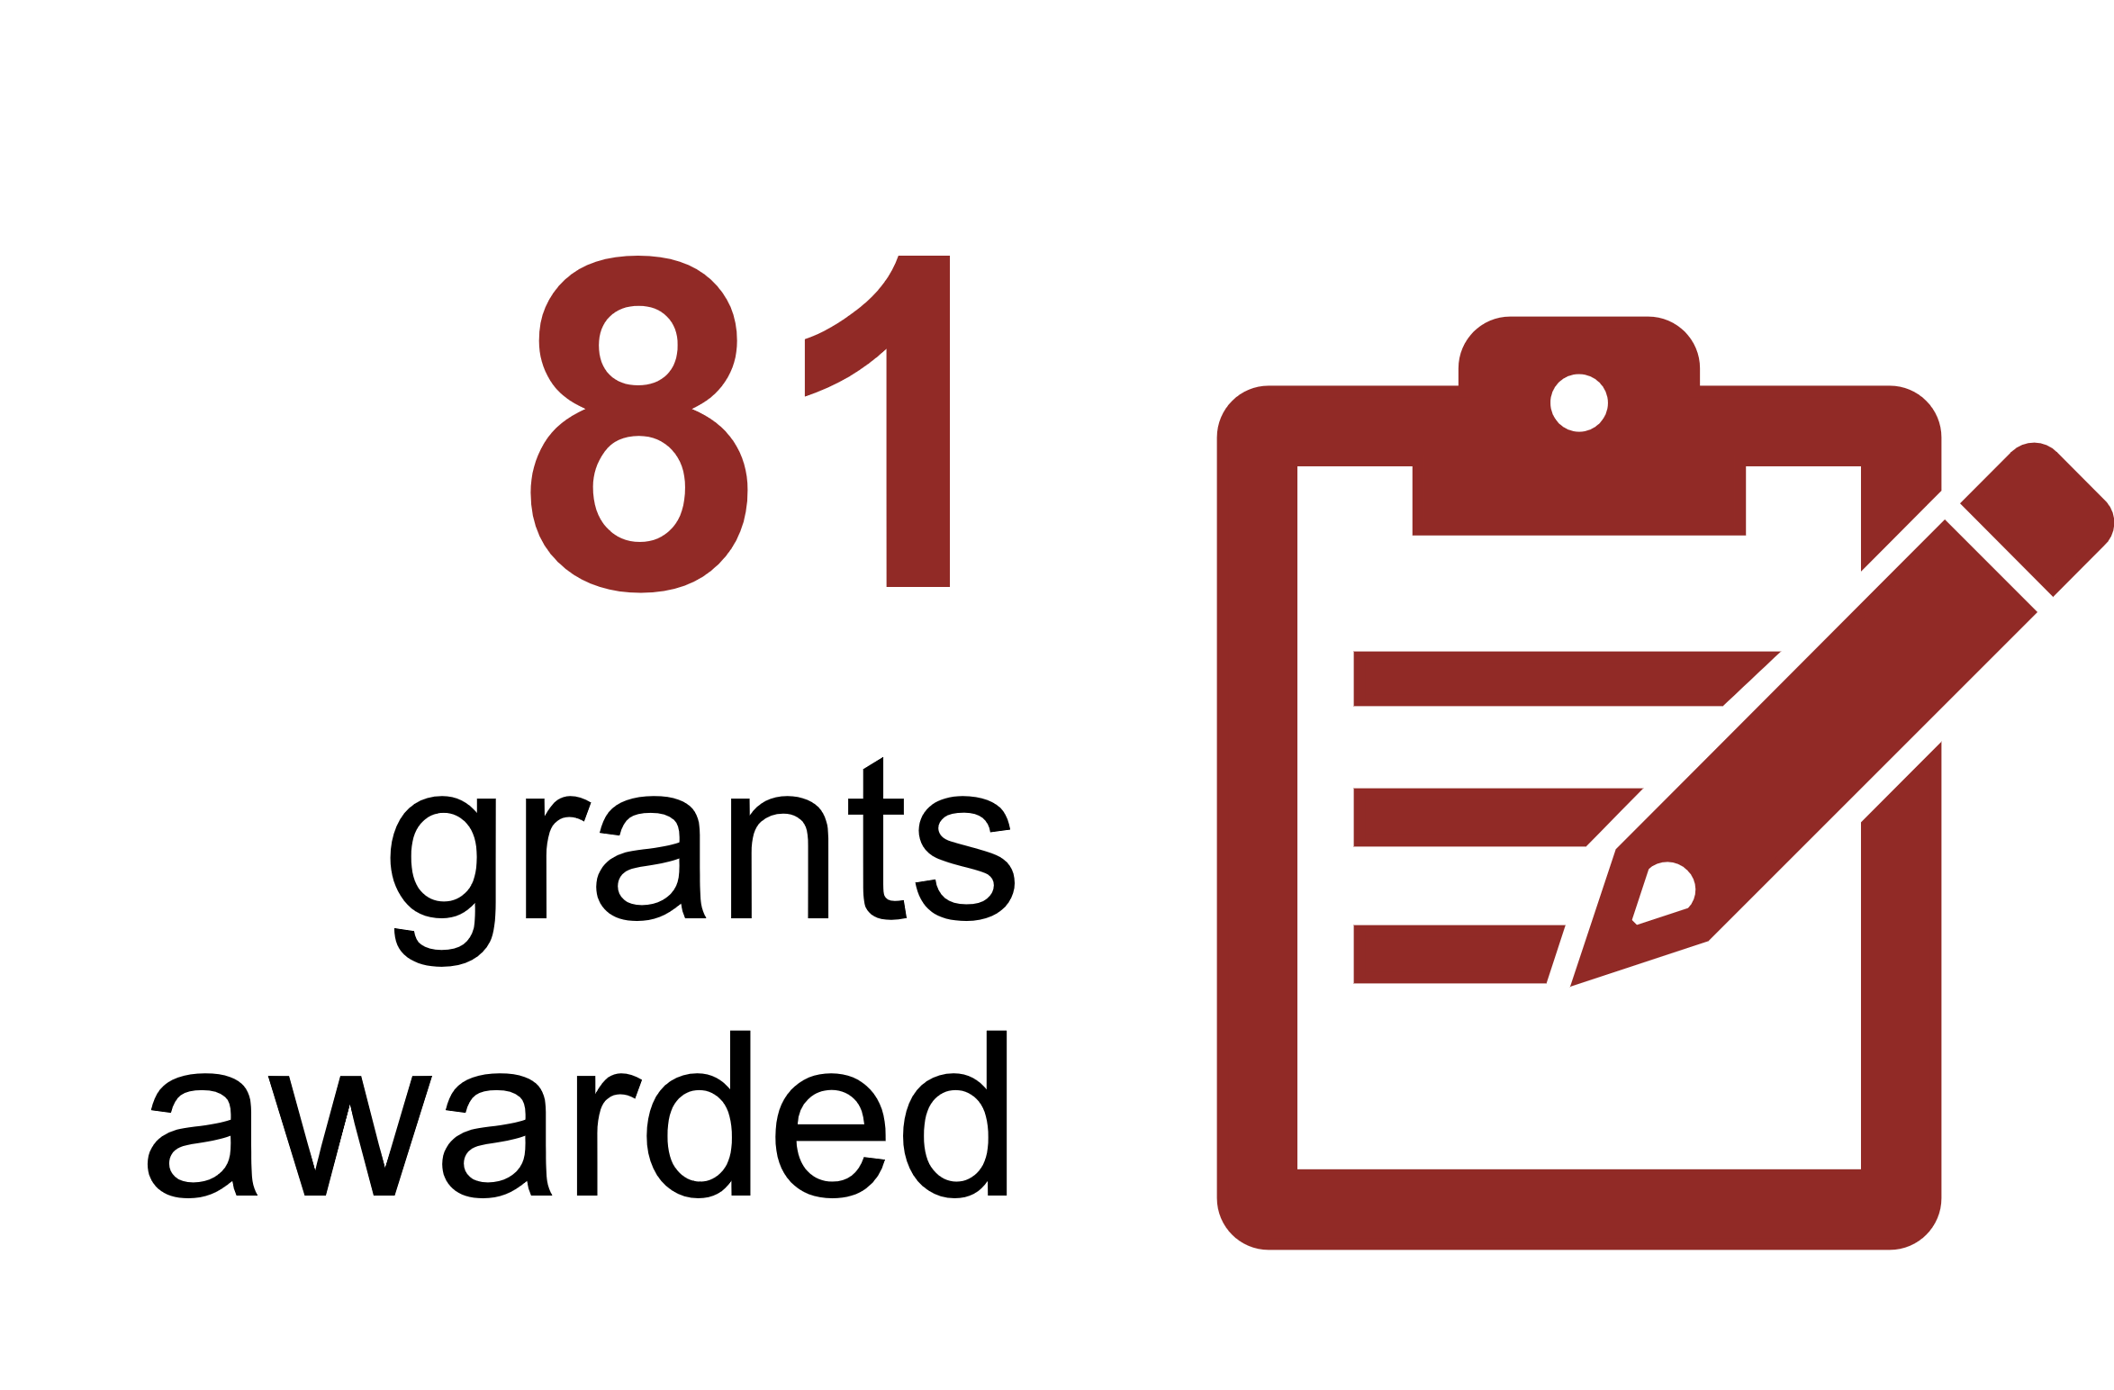Support early stage, small scale research projects
* Assess the potential and feasibility of novel strategies
* Address critical/intractable health issues
* Small scale (up to $1 million) and short-term (6-24 months) funding
* Examples:
  + 2022 Mental Health Research Grant Opportunity
  + 2023 Post-Acute Sequelae of COVID-19 Grant Opportunity

**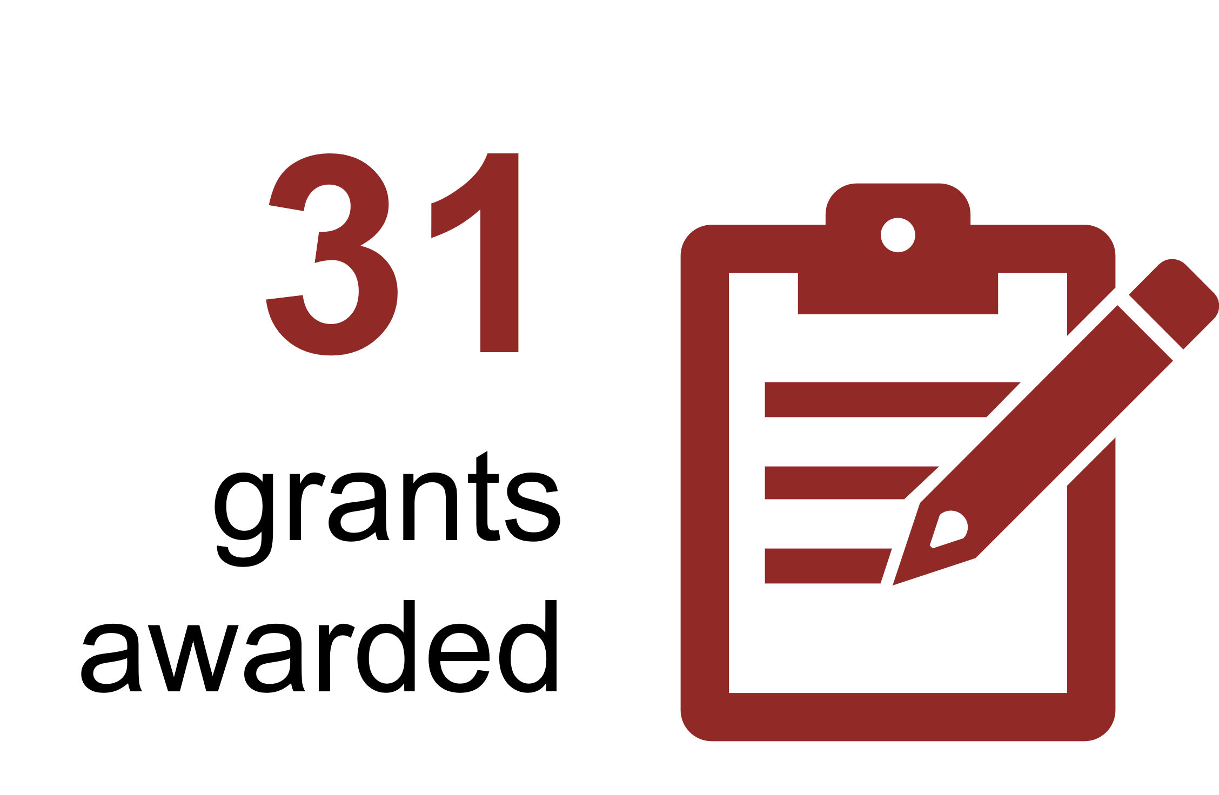****Accelerator Grants**

* Support large-scale interdisciplinary research
* Drive implementation of substantial improvements to  
  health care and/or health system effectiveness
* Large scale (up to $5 million) and long-term (up to 5 years) funding
* Examples:
  + 2022 Rapid Applied Research Translation Grant Opportunity
  + 2023 Stem Cell Therapies Grant Opportunity

**Targeted Calls for Research**

**466**

grants awarded

* Support larger-scale interdisciplinary research
* Larger-scale and longer-term (generally three to 5 years)
* Main model used in MRFF
* Examples:
  + 2022 Consumer-Led Research Grant Opportunity
  + 2023 Traumatic Brain Injury Grant Opportunity

Number of grants are grants with payments commencing between 6 November 2022 and 5 November 2024 inclusive.

# Processes for determining grants of financial assistance

All MRFF grant opportunities are consistent with the *Commonwealth Grant Rules and Guidelines 2017,* the *Commonwealth Grants Rules and Principles 2024* (which replaced the *Commonwealth Grants Rules and Guidelines 2017* on 1 October 2024) and the MRFF Act.

## Determination of MRFF initiatives

The AMRAB is responsible for developing the MRFF Strategy and Priorities. AMRAB determined the 2016–2021 Strategy, 2021–2026 Strategy and the 2022–2024 Priorities through extensive national consultation with consumers, researchers, health care providers and managers.

The Health Minister took into account the 2022–2024 Priorities when the MRFF initiatives were extended under the third 10-year investment plan for the MRFF. This occurred in the context of the 2024–2025 Budget.

## Response to emerging priorities

Within the period covered by the 2022–2024 Priorities, the Australian Government also identified four key emerging health priorities that could be addressed by health and medical research. In response to these emerging priorities, the Minister for Health and Aged Care appointed four independent Expert Advisory Panels to provide advice and developed a Research Plan for each area. These Research Plans articulated aims and priorities areas for investment under the MRFF’s existing initiatives, and are published on the Department’s website:

* [*MRFF Post-Acute Sequelae of COVID-19 (PASC) Research Plan*](https://www.health.gov.au/resources/publications/mrff-post-acute-sequelae-of-covid-19-research-plan?language=en) – Following a referral from the Minister for Health and Aged Care on 1 September 2022, the House of Representatives Standing Committee on Health, Aged Care and Sport launched an enquiry into Long COVID and Repeated COVID Infections. The findings from this investigation were tabled on 19 April 2023 and published on 24 April 2023, in a report titled *Sick and tired: Casting a long shadow*.

The *MRFF PASC Research Plan* takes into account the findings of this report and supports research investments under the Emerging Priorities and Consumer-Driven Research initiative to improve outcomes for people experiencing PASC. PASC is also known as long COVID.

* [*MRFF Primary Health Research Plan*](https://www.health.gov.au/resources/publications/mrff-primary-health-research-plan?language=en) – In response to the recommendations of the Australian Government’s [*Strengthening Medicare Taskforce Report*](https://www.health.gov.au/resources/publications/strengthening-medicare-taskforce-report?language=en) released on 3 February 2023, this plan guides investments under the Emerging Priorities and Consumer-Driven Research and Primary Health Care Research initiatives. These investments follow on from the opening of the $20 million 2023 Primary Health Care Research Grant Opportunity, which focused on supporting best-practice models of multidisciplinary team-based care for patients with complex and chronic conditions.

The *MRFF Primary Health Research Plan* includes aims and priority areas for research investment amounting to $50 million over four years from 2023–24 that support:

* + patient access to multidisciplinary team-based care
  + integrated health services providing patient-centred care
  + the use of data to improve patient care.
* [*MRFF Childhood Mental Health Research Plan*](https://www.health.gov.au/resources/publications/mrff-childhood-mental-health-research-plan?language=en) – This plan supports research investments under the Emerging Priorities and Consumer-Driven Research initiative to improve the mental health of children. It includes aims and priority areas for research investment amounting to $50 million over four years from 2024–25.
* [*MRFF Targeted Translation Research Accelerator Research Plan*](https://www.health.gov.au/resources/publications/mrff-targeted-translation-research-accelerator-research-plan?language=en) – This plan guides investments under the Preventive and Public Health Research initiative, that support new models of care, therapeutics and devices for diabetes and cardiovascular disease. A total of $77.5 million of the original $124.5 million is still available for allocation. The Plan includes aims and priority areas for research investment that will:
  + improve care by building knowledge about cardiovascular disease and diabetes
  + use technology and data to improve the accessibility, quality and cost effectiveness of care
  + accelerate new treatment options.

## Determination of grants of financial assistance

Grant opportunities under MRFF initiatives are supported by grant opportunity guidelines and processes that outline the:

* conduct of the application process
* assessment of applications
* determination of outcomes based on assessment
* awarding of grants to successful applicants.

The Department works in partnership with BGH within the Department of Industry, Science and Resources, and the NHMRC to administer grant opportunities under the MRFF. In this relationship, the Department retains responsibility for policy and program oversight to ensure that grants align with the aims and objectives of specific grant opportunities. The grants hub (BGH or NHMRC) is responsible for conducting the grant opportunity, inclusive of the assessment of applications by expert reviewers (such as scientific experts, consumers, industry experts, and health service providers) and reporting the outcomes of the assessment process to the program delegate as determined by the Health Minister.

Grant opportunities can be ‘open competitive’ and ‘targeted or restricted competitive’, depending on the aims and objectives of the specific grant opportunities. These categorisations allow all organisations, identified in the MRFF Act as eligible to receive MRFF funding, to be able to apply for funding (i.e., these grant opportunities are not restricted to an application from a single organisation). When the 2022–2024 Priorities were in force, 56 of 56 grant opportunities (in Table 3) were ‘open competitive’ or ‘targeted or restricted competitive’. All applications to MRFF grant opportunities were assessed by independent experts against criteria set out in the grant opportunity guidelines.

The list of MRFF grants with payments commencing during the period when the 2022–2024 Priorities were in force (6 November 2022 to 5 November 2024), is provided at Appendices E and F.

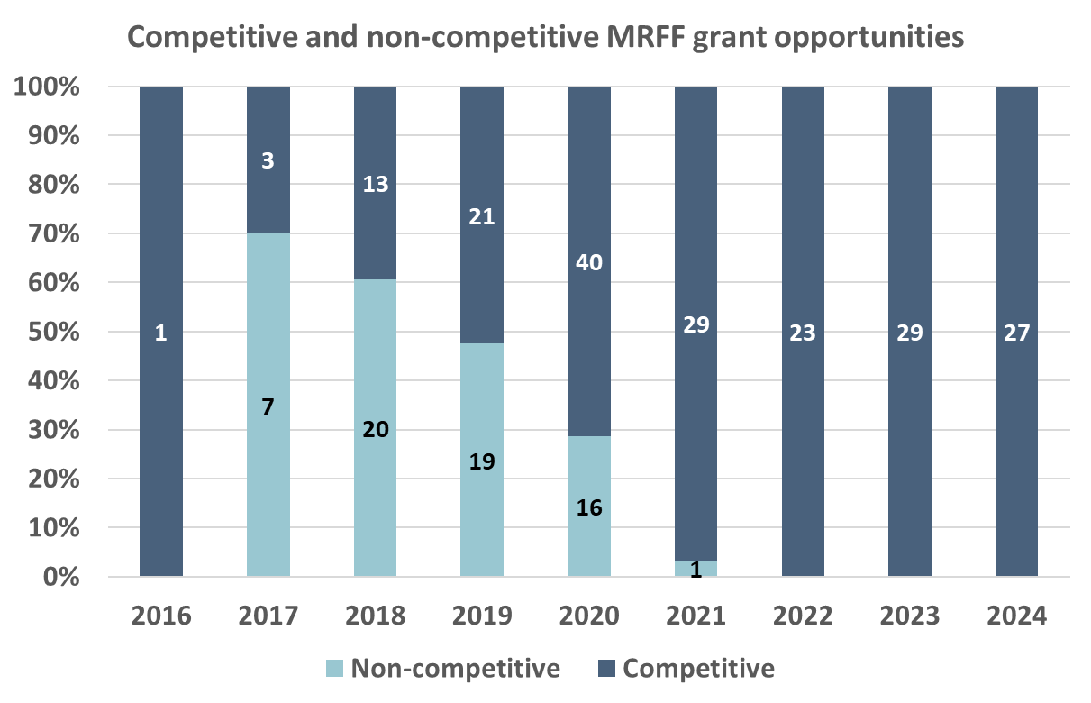

Grant opportunities were categorised as “competitive” if their grant type was ‘open competitive’ or ‘targeted or restricted competitive’, and “non-competitive” otherwise. Grant opportunities were sorted by their Calendar Year Open date. All opened Grant Opportunities up to 2024 were included regardless of whether outcomes were known.

What happens after a grant opportunity closes?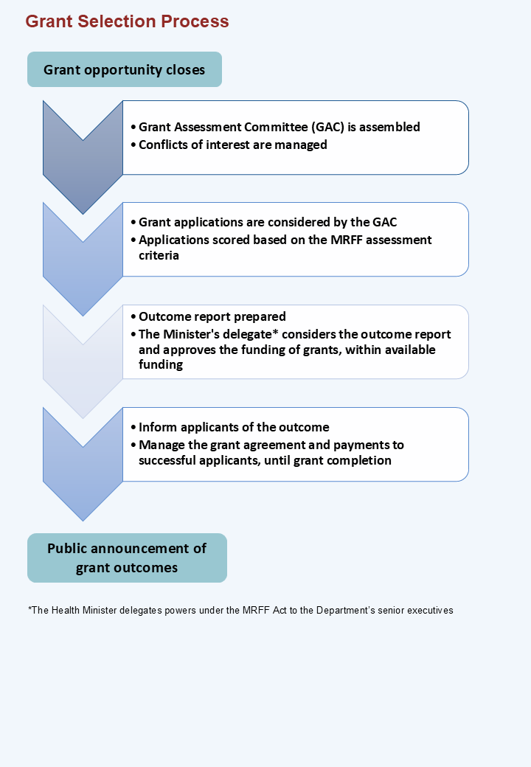

## MRFF Grant Assessment Committees

MRFF funding is primarily disbursed through peer-reviewed contestable processes to ensure the integrity of the research design, quality and safety for patients, and best return on government investment.

Independent Grant Assessment Committees (GACs) are assembled and managed by one of the grants hubs (NHMRC or BGH), comprised of qualified and experienced national and international experts who assess applications and provide recommendations regarding funding.

GAC members come from different backgrounds and bring different perspectives. They include expert reviewers such as scientific experts, consumers, industry experts and health service providers. Members are selected on the basis that they will bring experience and expertise in a range of areas including:

* transdisciplinary
* academia
* clinical
* health services delivery
* translation research
* consumers and patients
* Aboriginal and/or Torres Strait Islander health
* industry and commercialisation expertise.

People who would like to participate in MRFF grant assessments are able to register their interest on this MRFF [website](https://www.nhmrc.gov.au/2022-23-medical-research-future-fund-mrff-grant-opportunities). Potential members of GACs may be contacted directly by the Department or one of the grants hubs.

## A snapshot of Grant Assessment Committees

During 2022–2024, 1025 experts were engaged in Grant Assessment Committees   
across 44 grant opportunities.

Of the 1025 experts appointed, 454 were male, 567 were female, and 4 were non-binary or other gender identities.

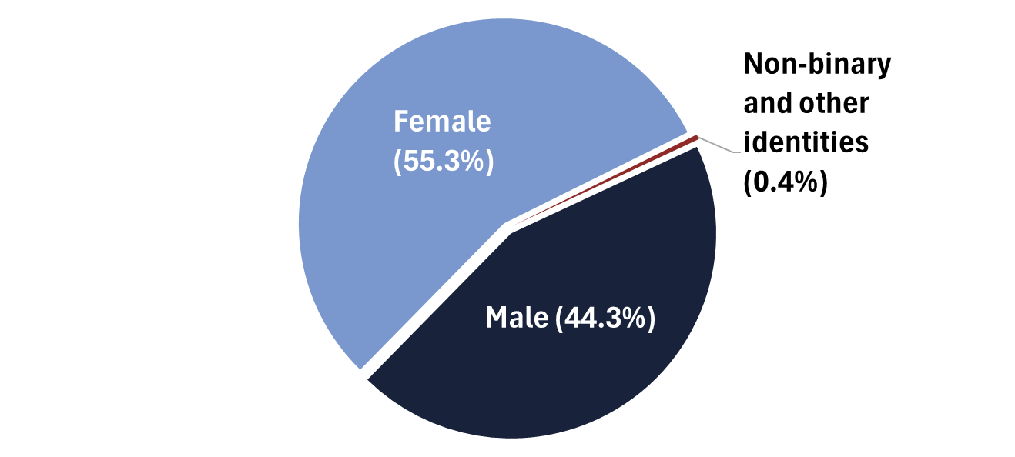

GAC members came from all states and territories. International experts from 10 different countries participated in GACs.

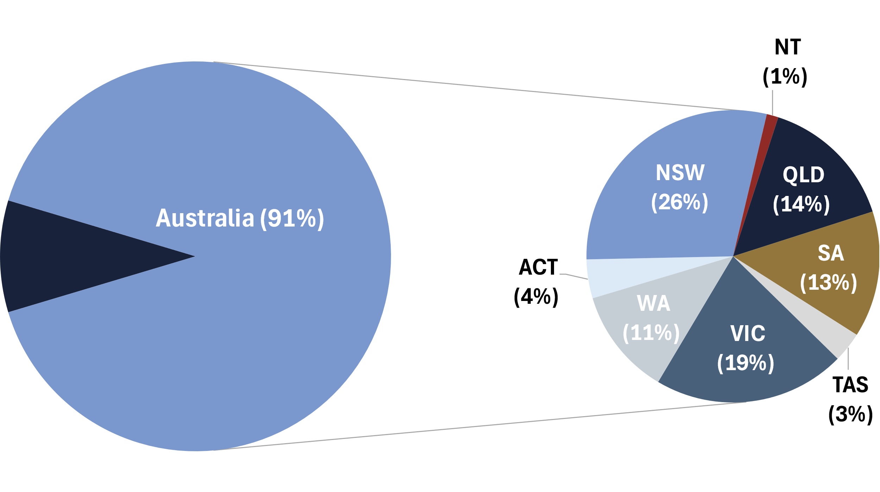

**International (9%)**

GAC members came from 143 Australian and 48 international organisations and had diverse expertise. Biostatistics, cardiovascular disease, health economics and epidemiology among the most common fields of expertise represented at GACs. Summaries of organisation affiliation and expertise are provided below.

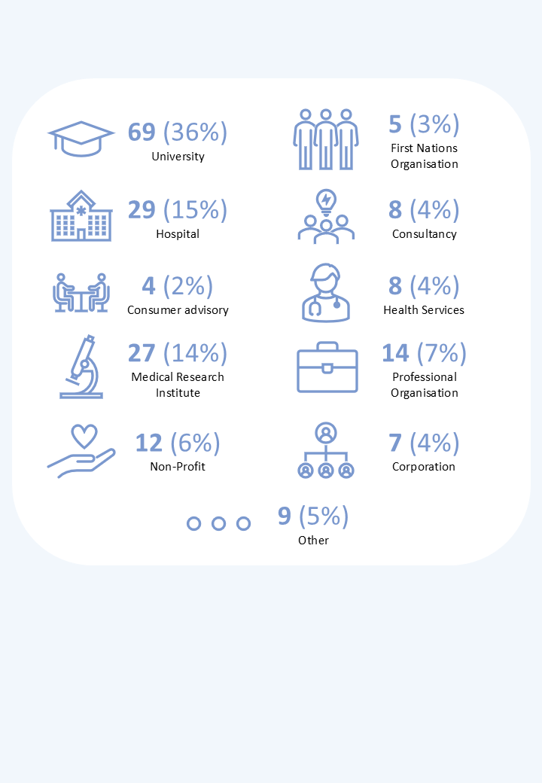

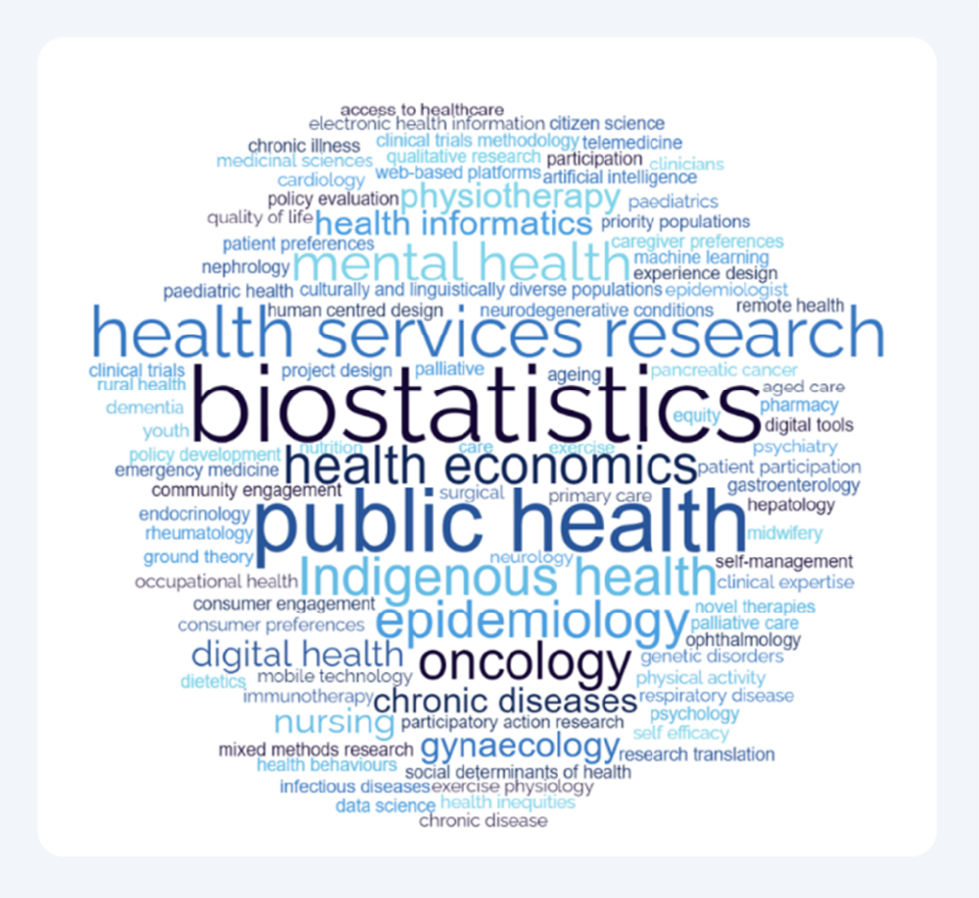

The data represents the composition of 44 GAC panels held to consider the subset of competitive grant opportunities that were assessed while the Priorities were in force between 6 November 2022 and 5 November 2024. Gender and terms describing expertise were self-assigned by the GAC members. Australian organisations identified by GAC members as their employer or organisation they were representing.

# Other financial assistance provided by the Australian Government for medical research and innovation

Other financial assistance provided by the Australian Government for medical research and innovation includes funding from:

* the NHMRC, for research grants
* the Biomedical Translation Fund (BTF) to private sector fund managers to develop and commercialise biomedical discoveries in Australia
* other funding opportunities.

Table 14 outlines the financial assistance provided in 2022–23 and 2023–24; these periods represent financial years and are not identical to the period during which the 2022–2024 Priorities were in force.

Table 14  
Australian Government financial support for medical research and innovation,  
2022–23 and 2023–24

|  |  |  |
| --- | --- | --- |
| Funding opportunity | 2022–23 ($ million) | 2023–24 ($ million) |
| NHMRC research grantsa | 898.3 | 945.9 |
| BTF investmentsb | 29.0 | 14.4 |
| Other initiativesc | 139.4 | 92.6 |

1. Derived from the Australian Government’s Science, Research and Innovation Budget Tables 2024–25. As at 1 June 2025, actual figures are available for 2022–23 and estimated actuals for 2023–24. NHMRC also reports financial assistance via their annual reports; $844.5m in 2022–23 NHMRC Annual Report (p. 136) and $892.4m in 2023–24 NHMRC Annual Report (p. 135).
2. Derived from the Australian Government’s Science, Research and Innovation Budget Tables 2024–25. As at 1 June 2025, actual figures are available for 2022–23 and estimated actuals for 2023–24.
3. The amounts for other initiatives were derived from the Australian Government’s Science, Research and Innovation Budget Tables 2024–25 – research and development investment by program/activity under the Health Portfolio, excluding the MRFF and MRFF supplementation, the NHMRC and the BTF. As at 1 June 2025, actual figures are available for 2022–23 and estimated actuals for 2023–24.

# Other financial assistance provided by the Australian Government for research and development

The Australian Government provides support for research and development across the whole of government. Table 15 outlines the financial assistance for key research and development initiatives in 2022–23 and 2023–24; these are the financial years – that is,   
the period is not identical to the period during which the 2022–2024 Priorities were in force.

Table 15  
Australian Government financial support for key research and development initiatives,   
2022–23 and 2023–24

|  |  |  |
| --- | --- | --- |
| Funding opportunitya | 2022–23 ($ million) | 2023–24 ($ million) |
| Australian Research Council – National Competitive Grants Program | 831.6 | 850.3 |
| Research Block Grantsb | 2044.0 | 2160.2 |
| Cooperative Research Centres (CRC) Program | 199.4 | 200.5 |

1. The amounts were derived for the stated initiative from the Australian Government’s Science, Research and Innovation Budget Tables 2024–25 – research and development investment by program/activity. As at 1 June 2025, actual figures are available for 2022–23 and estimated actuals for 2023–24.
2. Comprises the Research Support Program and the Research Training Program.

Overall, the MRFF accounted for 13.4% of Australian Government financial support in key research and development initiatives during 2022–23 and 2023–24.

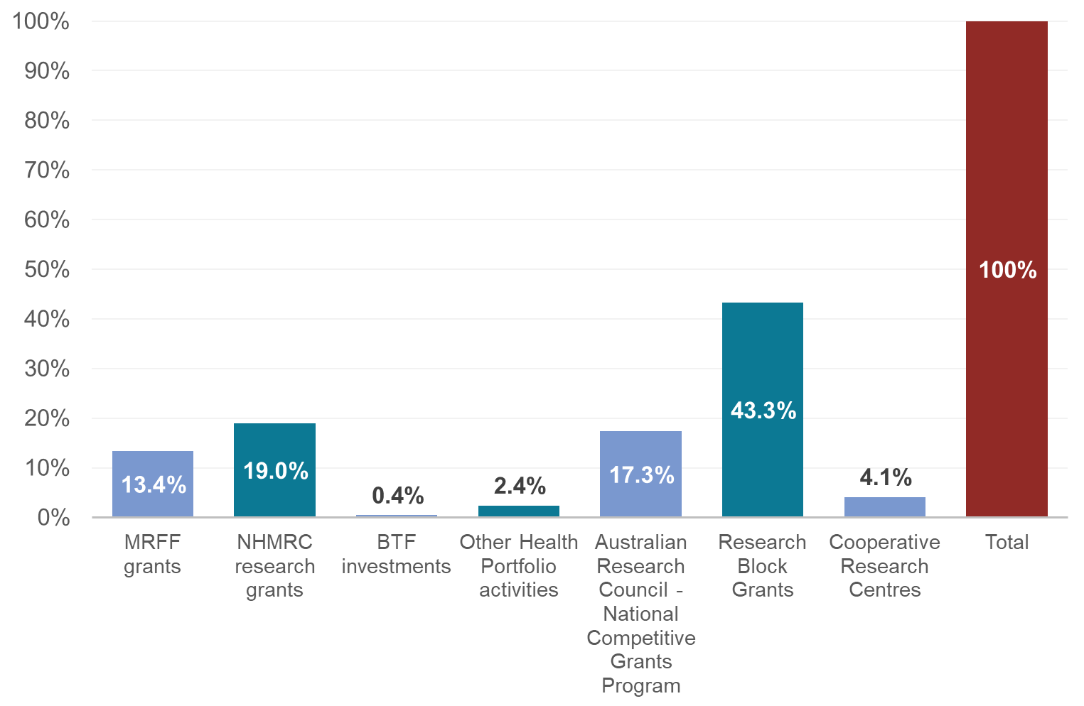

The data represents combinations of the amounts from 2022–23 and 2023–24 financial years in Table 2, Table 14 and Table 15.

# Appendix A Initiatives under the 2022–2024 Priorities

Table A MRFF initiatives under the 2022–2024 Priorities

|  |  |  |
| --- | --- | --- |
| Theme | Initiative | Objective |
| Patients | Clinical Trials Activity | The objectives of this initiative are to increase clinical trial activity in Australia in order to improve the evidence base supporting clinical care and to help patients access trials relevant to their health circumstances, and enable researchers to bring international trials to Australian patients. |
| Emerging Priorities and Consumer-Driven Research | The objectives of this initiative are to support research that improves patient care and translation of new discoveries, and encourage collaboration between consumers and researchers. |
| Global Health | The objective of this initiative is to develop knowledge and tools for addressing threats to Australia’s national health security from regional and global challenges. |
| Researchers | Clinician Researchers | The objective of this initiative is to help the next generation of talented Australian health care professionals drive medical research, make new discoveries and ensure implementation of best practice care for their patients. |
| Early to  Mid-Career Researchers | The objective of this initiative is to build and grow research capacity and capability in Australia by supporting Early to Mid-Career Researchers (EMCRs) to continue their health and medical research careers. |
| Frontier Health and Medical Research | The objective of this initiative is to create opportunities to explore bold and innovative ideas, make discoveries of great potential, and to support the translation and commercialisation of these discoveries to achieve global health impact. |
| Research missions | Australian Brain Cancer Mission | The objectives of this Mission are to:   * double the survival rate of Australians living with brain cancer over 10 years * improve quality of life for people with brain cancer * give every patient (adult and child) with brain cancer a chance to join a clinical trial * boost Australian research and build research capacity. |
| Cardiovascular Health Mission | The objective of this Mission is to make transformative improvements in cardiovascular health and stroke management for all Australians. |
| Dementia, Ageing and Aged Care Mission | The objective of this Mission is to improve quality of life for Australians as they age. |
| Genomics Health Futures Mission | The objective of the Genomics Health Futures Mission is to save or transform the lives of more than 200,000 Australians through genomics research to deliver better testing, diagnosis and treatment. It will:   * help Australia move towards routine use of genomics in healthcare * support new clinical trials and technology applications allowing Australian patients to benefit from the latest medical research * create a new highly skilled workforce and new career pathways * support new industries * talk with the Australian community to share the value of genomics * listen and respond to the perspective of communities on issues like privacy, family impact, and the legal and social aspects of using genomics in health care * support development of secure data storage, access, analysis and sharing to benefit Australians. |
| Indigenous Health Research Fund | The objective of the Indigenous Health Research Fund is to improve the health of Aboriginal and Torres Strait Islander people through:   * Indigenous-led research practice and governance * knowledge translation * evidence-based structural change in Aboriginal and Torres Strait Islander health practice * building on the unique knowledge, strengths and endurance of our communities, with particular reference to Country, culture and spirituality. |
| Low Survival Cancers Mission | The objective of the new Low Survival Cancers Mission is to improve care and health outcomes for individuals with low survival cancer. This Mission would contribute to the Australian Cancer Plan. |
| Million Minds  Mental Health Research Mission | The objective of this Mission is to help an extra one million people be part of new approaches to mental health prevention, diagnosis, treatment and recovery. |
| Reducing Health Inequities Mission | The objective of the new Reducing Health Inequities Mission is to address inequities in health outcomes by improving access to quality health services by priority populations. |
| Stem Cell  Therapies Mission | The objective of this Mission is to support world-leading translational stem cell research that develops and delivers innovative, safe and effective stem cell medicines to improve health outcomes, in partnership with patients and carers. |
| Traumatic Brain Injury Mission | The objectives of this Mission are to:   * better predict recovery outcomes after a traumatic brain injury * identify the most effective care and treatments * reduce barriers to support people to live their best life after a traumatic brain injury. |
| Research translation | Medical Research Commercialisation | The objective of this initiative is to support early-stage health and medical research and innovation in Australia through to proof-of-concept and beyond, providing opportunities for commercialisation. |
| National Critical Research Infrastructure | The objective of this initiative is to establish and extend infrastructure (facilities, equipment, systems and services) of critical importance that will be used to conduct world-class health and medical research. |
| Preventive and Public Health Research | The objective of this initiative is to support research into new ways to address preventive and public health issues in Australia. This will include new ways to address risk factors and to detect, diagnose and treat chronic and complex diseases early. |
| Primary Health  Care Research | The objective of this initiative is to increase Australia’s evidence base in primary health care through research to improve service delivery and patient outcomes, and translate this knowledge into action. |
| Rapid Applied Research Translation | The objective of this initiative is to support transformative translational research, so that patients can benefit from better quality of care. |
| Research Data Infrastructure | The objective of this initiative is to support strategic investments that establish and extend national research data infrastructure to support world-class health and medical research. |

Description of MRFF initiatives from the [Medical Research Future Fund 3rd 10-year Investment Plan](https://www.health.gov.au/sites/default/files/2024-06/mrff-3rd-10-year-investment-plan-2024-25-to-2033-34.pdf) 2024–25 to 2033–34.

# Appendix B MRFF Disbursements since inception by theme and initiative

Table B MRFF Disbursements since inception by theme and initiative

|  |  |  |  |  |  |  |  |  |  |  |  |
| --- | --- | --- | --- | --- | --- | --- | --- | --- | --- | --- | --- |
|  |  | Financial year ($ million) | | | | | | | | | |
| **Theme** | **MRFF initiative** | **16-17** | **17-18** | **18-19** | **19-20** | **20-21** | **21-22** | **22-23** | **23-24** | **24-25** | **Total** | |
| Patients | Emerging Priorities and Consumer-Driven Research | 7.0 |  | 63.4 | 54.0 | 84.5 | 84.4 | 66.0 | 72.5 | 42.0 | **473.7** | |
| Clinical Trials Activity | 1.0 | 4.8 | 47.4 | 68.1 | 63.7 | 59.3 | 96.6 | 63.5 | 67.6 | **472.0** | |
| Global Health |  | 2.5 | 1.8 | 3.4 | 2.7 | 3.0 | 3.0 | 3.0 |  | **19.3** | |
| Researchers | Frontier Health and Medical Research |  |  |  | 20.1 | 53.6 | 61.5 | 48.7 | 57.7 | 56.7 | **298.3** | |
| Researcher Exchange and Development within Industry |  |  |  | 8.0 | 10.0 | 10.0 | 4.0 |  |  | **32.0** | |
| Clinician Researchers |  | 1.8 | 4.9 | 19.8 | 20.4 | 22.2 | 19.9 | 19.9 | 19.7 | **128.5** | |
| Early to Mid-Career Researchers |  |  |  |  |  |  | 13.4 | 26.0 | 34.6 | **74.0** | |
| Research Missions | Australian Brain Cancer Mission |  | 1.0 | 4.7 | 7.4 | 5.0 | 3.6 | 8.5 | 1.0 | 1.0 | **32.3** | |
| Million Minds Mental Health Research Mission |  |  | 6.2 | 7.0 | 12.0 | 15.0 | 26.9 | 20.1 | 12.2 | **99.4** | |
| Genomics Health Futures Mission |  |  | 8.8 | 37.5 | 87.4 | 69.9 | 55.0 | 40.9 |  | **299.6** | |
| Dementia, Ageing and Aged Care Mission |  |  | 10.0 | 13.1 | 17.0 | 17.2 | 17.5 | 20.8 | 21.3 | **116.9** | |
| Indigenous Health Research Fund |  |  | 15.0 | 22.5 | 18.8 | 11.4 | 17.1 | 13.7 | 12.2 | **110.7** | |
| Stem Cell Therapies Mission |  |  |  | 6.0 | 17.6 | 18.0 | 12.7 | 29.4 | 5.5 | **89.3** | |
| Cardiovascular Health Mission |  |  |  | 22.1 | 23.8 | 23.6 | 23.8 | 29.3 | 12.0 | **134.6** | |
| Traumatic Brain Injury Mission |  |  |  | 5.0 | 4.0 | 3.9 |  | 5.3 |  | **18.3** | |
| Low Survival Cancer Mission* |  |  |  |  |  |  |  |  |  |  | |
| Reducing Health Inequities Mission* |  |  |  |  |  |  |  |  |  |  | |
| Research Translation | Preventive and Public Health Research | 10.0 |  | 11.2 | 35.2 | 63.9 | 31.5 | 70.3 | 85.4 | 51.5 | **358.9** | |
| Primary Health Care Research |  |  |  | 6.7 | 7.1 | 4.1 | 13.5 | 10.0 | 14.6 | **56.0** | |
| Rapid Applied Research Translation |  | 10.0 | 17.6 | 16.6 | 20.6 | 22.0 | 22.0 | 22.0 | 8.0 | **138.9** | |
| Medical Research Commercialisation |  | 10.0 | 15.4 | 15.3 | 60.3 | 35.3 | 44.3 | 45.0 | 45.0 | **270.6** | |
| National Critical Research Infrastructure |  |  |  | 7.7 | 12.6 | 119.2 | 77.0 | 75.0 | 3.6 | **295.1** | |
| Research Data Infrastructure |  |  |  |  | 12.9 | 12.3 | 10.0 | 9.2 |  | **44.4** | |
| **Total** |  | **18.0** | **30.1** | **206.4** | **375.5** | **597.9** | **627.4** | **650.0** | **649.9** | **407.6** | **3,562.7** | |

Data represents payments made to all active grants in the relevant financial year (FY) (i.e., new grants as well as grants contracted in previous FYs). Figures for 2024-2025 are partial. Figures may not add up exactly due to rounding. Data as at 30 April 2025. *Budget allocation commencing from 2027–28 FY.

# Appendix C MRFF grants since inception by theme and initiative

Table C MRFF grants since inception by theme and initiative

|  |  |  |  |  |  |  |  |  |  |  |  |
| --- | --- | --- | --- | --- | --- | --- | --- | --- | --- | --- | --- |
|  |  | Number in Financial Year | | | | | | | | | |
| Theme | MRFF initiative | 16-17 | 17-18 | 18-19 | 19-20 | 20-21 | 21-22 | 22-23 | 23-24 | 24-25 | Total |
| Patients | Emerging Priorities and Consumer-Driven Research | 2 |  | 23 | 38 | 28 | 36 | 15 | 25 | 36 | **203** |
| Clinical Trials Activity | 1 | 18 | 32 | 43 | 25 | 43 | 37 | 33 | 26 | **258** |
| Global Health |  | 5 |  | 4 |  |  |  | 3 |  | **12** |
| Researchers | Frontier Health and Medical Research |  |  |  | 16 | 22 | 18 | 3 | 2 | 3 | **64** |
| Researcher Exchange and Development within Industry |  |  |  | 1 |  |  |  |  |  | **1** |
| Clinician Researchers |  | 37 | 28 | 15 | 17 | 14 | 15 | 33 |  | **159** |
| Early to Mid-Career Researchers |  |  |  |  |  |  | 23 | 25 | 24 | **72** |
| Research Missions | Australian Brain Cancer Mission |  | 1 | 4 | 2 | 1 |  | 4 |  |  | **12** |
| Million Minds Mental Health Research Mission |  |  | 7 | 3 | 8 |  | 10 | 8 | 7 | **43** |
| Genomics Health Futures Mission |  |  | 2 | 20 | 21 | 20 | 25 | 8 |  | **96** |
| Dementia, Ageing and Aged Care Mission |  |  | 1 | 15 | 11 | 18 | 15 | 7 | 11 | **78** |
| Indigenous Health Research Fund |  |  | 1 | 9 | 6 | 11 | 26 |  | 16 | **69** |
| Stem Cell Therapies Mission |  |  |  | 10 | 17 | 7 | 13 | 6 | 11 | **64** |
| Cardiovascular Health Mission |  |  |  | 14 | 16 | 41 | 14 | 11 | 6 | **102** |
| Traumatic Brain Injury Mission |  |  |  | 3 | 6 | 3 |  | 2 |  | **14** |
| Research Translation | Preventive and Public Health Research | 1 |  | 13 | 32 | 25 | 6 | 68 | 59 | 25 | **229** |
| Primary Health Care Research |  |  |  | 4 | 7 | 4 | 6 | 9 | 6 | **36** |
| Rapid Applied Research Translation |  | 9 | 9 | 8 | 1 | 9 |  | 7 | 2 | **45** |
| Medical Research Commercialisation |  | 1 | 2 |  | 4 |  | 1 | 1 | 3 | **12** |
| National Critical Research Infrastructure |  |  |  | 5 | 5 | 3 | 24 | 27 | 12 | **76** |
| Research Data Infrastructure |  |  |  |  | 7 | 5 | 4 | 4 |  | **20** |
| **Total** |  | **4** | **71** | **122** | **242** | **227** | **238** | **303** | **270** | **188** | **1665** |

Data represents newly awarded and announced grants in the relevant financial year. Figures for 2024–25 are partial. Data as at 1 June 2025.

# Appendix D MRFF grant opportunities since inception by theme and initiative

Table D MRFF Grant opportunities opened since inception by theme and initiative

|  |  |  |  |  |  |  |  |  |  |  |  |
| --- | --- | --- | --- | --- | --- | --- | --- | --- | --- | --- | --- |
|  |  | Number in financial year | | | | | | | | | |
| **Theme** | **MRFF initiative** | **16-17** | **17-18** | **18-19** | **19-20** | **20-21** | **21-22** | **22-23** | **23-24** | **24-25** | **Total** |
| Patients | Emerging Priorities and Consumer-Driven Research | 2 | 8 | 15 | 16 | 6 | 6 | 2 | 3 | 6 | **64** |
| Clinical Trials Activity | 1 | 3 | 3 | 5 | 7 | 3 | 3 | 3 | 3 | **31** |
| Global Health | - | 2 | - | 1 | - | - | 1 | - | 1 | **5** |
| Researchers | Frontier Health and Medical Research | - | - | 1 | 5 | 5 | - | 1 | - | - | **12** |
| Researcher Exchange and Development within Industry | - | - | - | 1 | - | - | - | - | - | **1** |
| Clinician Researchers | 1 | 1 | - | 1 | 1 | 1 | 1 | - | - | **6** |
| Early to Mid-Career Researchers | - | - | - | - | - | 1 | 1 | 1 | 1 | **4** |
| Research Missions | Australian Brain Cancer Mission | - | 3 | 1 | 1 | 1 | 2 | - | - | 1 | **9** |
| Million Minds Mental Health Research Mission | - | - | 1 | 2 | 1 | - | 1 | 2 | - | **7** |
| Genomics Health Futures Mission | - | - | 4 | 1 | 1 | 1 | 1 | 1 | 1 | **10** |
| Dementia, Ageing and Aged Care Mission | - | - | 1 | 3 | 1 | 2 | 1 | 1 | 1 | **10** |
| Indigenous Health Research Fund | - | - | 1 | 1 | 1 | 1 | 2 | 1 | - | **7** |
| Stem Cell Therapies Mission | - | - | - | 2 | 1 | 2 | 1 | 1 | 1 | **8** |
| Cardiovascular Health Mission | - | - | - | 4 | 1 | 2 | 1 | 1 | 1 | **10** |
| Traumatic Brain Injury Mission | - | - | - | 1 | 1 | - | 1 | - | 1 | **4** |
| Research Translation | Preventive and Public Health Research | 1 | - | 5 | 3 | 4 | 5 | 4 | 6 | 2 | **30** |
| Primary Health Care Research | - | - | - | 1 | 1 | 2 | 1 | - | - | **5** |
| Rapid Applied Research Translation | 1 | - | 1 | 1 | 1 | - | 1 | - | 1- | **6** |
| Medical Research Commercialisation | - | 1 | 2 | - | 1 | 1 | 1 | 1 | - | **7** |
| National Critical Research Infrastructure | - | - | - | 3 | 1 | 2 | 1 | 1 | 2 | **10** |
| Research Data Infrastructure | - | - | - | - | 1 | 1 | 1 | 1 | 1 | **5** |
| Various | Various a | - | - | - | 1 | - | 5 | - | 1 | - | **7** |
| **Total** |  | **6** | **18** | **35** | **53** | **36** | **37** | **26** | **24** | **23** | **258** |

a: Includes grant opportunities that were funded across more than one MRFF initiative.   
Data represents all grant opportunities that had opened for applications as at 1 June 2025. Figures for 2024–25 are partial.

The 2021 GBM AGILE Grant Opportunity did not proceed to assessment and is therefore not included in the above analysis.

# Appendix E MRFF grants with payments commencing between 6 November 2022 and 5 November 2024

Table E MRFF grant recipients with payments commencing between 6 November 2022 and 5 November 2024 inclusive

|  |  |  |  |  |  |
| --- | --- | --- | --- | --- | --- |
| MRFF initiative | Grant opportunity | Institution | Project name or description | Amount  ($ excl GST) |  |
| Australian Brain Cancer Mission | 2022 Australian Brain Cancer Research Infrastructure | University of Sydney | Supporting Australian Brain Cancer Research with an integrated network of platforms | 5,991,219.44 | a |
| Cardiovascular Health Mission | 2022 Cardiovascular Health | Baker Heart and Diabetes Institute | Novel, targeted therapies for heart failure with preserved ejection fraction | 998,334.81 | a |
| Cardiovascular Health Mission | 2022 Cardiovascular Health | Deakin University | Early detection of insulin-resistance with a mixed meal challenge - The REFINE study | 1,498,740.60 | a |
| Cardiovascular Health Mission | 2022 Cardiovascular Health | Edith Cowan University | Investigating genetic and lifestyle determinants of abdominal aortic calcification, and their relationship with cardiovascular disease | 1,202,212.80 | a |
| Cardiovascular Health Mission | 2022 Cardiovascular Health | James Cook University | Activation of AMPK to treat abdominal aortic aneurysm (5As) | 1,044,836.20 | a |
| Cardiovascular Health Mission | 2022 Cardiovascular Health | Monash University | Advancing preclinical development of novel GPCR-targeted therapeutics for heart failure | 1,496,862.61 | a |
| Cardiovascular Health Mission | 2022 Cardiovascular Health | Queensland University of Technology | Clinical and health economics implications of routine CTCA for emergency department assessment of Aboriginal and Torres Strait Islander people at risk of acute coronary syndrome | 1,488,717.70 | a |
| Cardiovascular Health Mission | 2022 Cardiovascular Health | The University of Newcastle | Increasing the capacity of Community Managed Organisations to provide preventive care to people with a mental health condition | 1,135,281.00 | a |
| Cardiovascular Health Mission | 2022 Cardiovascular Health | University of Melbourne | Impact of Total Arterial Revascularisation in Coronary Artery Surgery on cardiovascular, cerebrovascular and multiorgan outcomes - an RCT (TA Trial) | 4,958,416.40 | a |
| Cardiovascular Health Mission | 2022 Cardiovascular Health | University of Melbourne | Post-thrombectomy intra-arterial tenecteplase for Acute manaGement of Non-retrievable thrombus and no-reflow in Emergent Stroke (EXTEND-AGNES TNK) | 3,885,163.16 | a |
| Cardiovascular Health Mission | 2022 Cardiovascular Health | University of New South Wales | The Elusive Hearts Study: Using genomics to diagnose and manage inherited cardiovascular diseases | 1,499,286.00 | a |
| Cardiovascular Health Mission | 2022 Cardiovascular Health | University of Sydney | Clinical imaging inspired point-of-care microtechnology for enhanced diagnosis and monitoring of recurrent stroke | 1,199,996.00 | a |
| Cardiovascular Health Mission | 2022 Cardiovascular Health | University of Sydney | Evaluation of a Standardised ClinicAl Pathway to improve Equity and outcomes in Cardiogenic Shock (ESCAPE-CS) | 971,931.94 | a |
| Cardiovascular Health Mission | 2022 Cardiovascular Health | University of Sydney | Gap Junction Modulation: A Novel Molecular Target in the Management of Ventricular Arrhythmia in Ischaemic Cardiomyopathy | 1,104,168.00 | a |
| Cardiovascular Health Mission | 2022 Cardiovascular Health | University of Sydney | Replenishing enzymatic cofactor NAD+ in Heart Failure: Rescuing an engine out of fuel | 1,499,523.00 | a |
| Cardiovascular Health Mission | 2023 Cardiovascular Health | Deakin University | Digital-enabled solutions to support healthcare delivery: Transforming outcomes for heart failure in Australia (SMART; Self-Management And Remote Technologies) | 945,530.00 |  |
| Cardiovascular Health Mission | 2023 Cardiovascular Health | James Cook University | Fighting inequity in peripheral artery disease-related burden in North Queensland (NQ-PAD) | 999,998.40 |  |
| Cardiovascular Health Mission | 2023 Cardiovascular Health | La Trobe University | Maximising Aphasia Treatment and Recovery across Australia through Innovative Group Telerehabilitation | 565,192.28 |  |
| Cardiovascular Health Mission | 2023 Cardiovascular Health | The Heart Research Institute Ltd | PrEventing Progression of AF in Indigenous People (The Pepp Study) | 2,698,931.00 |  |
| Cardiovascular Health Mission | 2023 Cardiovascular Health | The University of Adelaide | Healthy Heart Actions Right Time | 1,986,146.40 |  |
| Cardiovascular Health Mission | 2023 Cardiovascular Health | The University of Queensland | Bridging the Heart Gap. Building partnerships to improve paediatric cardiac surgery care equity | 1,998,871.70 |  |
| Cardiovascular Health Mission | 2023 Cardiovascular Health | The University of Queensland | The CArdiovascular Risk assessment equations for Aboriginal and Torres Strait Islander (CARAT) Study | 859,143.40 |  |
| Cardiovascular Health Mission | 2023 Cardiovascular Health | University of Melbourne | Premature risk meets system failure: understanding, detecting and managing cardiovascular disease risk among Indigenous Australian children, adolescents and young adults | 1,975,020.90 |  |
| Cardiovascular Health Mission | 2023 Cardiovascular Health | University of New South Wales | Improving outcomes and survivorship following sudden cardiac arrest in the young (IMPROVE-SCA) | 4,999,576.00 |  |
| Cardiovascular Health Mission | 2023 Cardiovascular Health | University of New South Wales | The LOTUS Trial (LOw dose combinations To improve stroke oUtcomeS) | 2,464,230.65 |  |
| Cardiovascular Health Mission | 2023 Cardiovascular Health | University of Sydney | CARDIOvascular support for patients after disCHARGE - CardioCHARGE | 2,995,586.88 |  |
| Clinical Trials Activity | 2021 Clinical Trials Activity | Australia New Zealand Gynaecological Oncology Group | Tailored adjuvant therapy in POLEmut & NSMP early stage endometrial cancer (TAPER) | 1,271,471.61 | a |
| Clinical Trials Activity | 2021 Clinical Trials Activity | Australian National University | Modulating stem cell differentiation in individuals with high risk clonal haematopoiesis: the MOSAIC trial | 2,971,763.69 | a |
| Clinical Trials Activity | 2021 Clinical Trials Activity | Deakin University | CoDeEndo: Co-Designing, Evaluating, and Implementing Supportive Care for Endometriosis | 1,470,988.82 | a |
| Clinical Trials Activity | 2021 Clinical Trials Activity | Deakin University | Randomized E-hypnotherapy for Chronic Pelvic Pain Syndrome Trial (REST) | 1,300,459.86 | a |
| Clinical Trials Activity | 2021 Clinical Trials Activity | Deakin University | iCare - An interactive online portal to improve health and wellbeing for people living with complex cancers, and their informal carers: a Phase II randomised controlled trial | 826,731.86 | a |
| Clinical Trials Activity | 2021 Clinical Trials Activity | Macquarie University | A comparative effectiveness trial of digital mental health care models for adults with epilepsy | 973,195.11 | a |
| Clinical Trials Activity | 2021 Clinical Trials Activity | Monash University | A Phase 2, double-blind, placebo-controlled trial of sodium selenate as a disease modifying treatment for chronic drug resistant temporal lobe epilepsy (SELECT Trial) | 2,961,326.74 | a |
| Clinical Trials Activity | 2021 Clinical Trials Activity | Monash University | Generating new evidence to reduce complications and improve the safety and efficacy of extracorporeal membrane oxygenation (ECMO) in patients with severe cardiac and respiratory failure: THE RECOMMEND Platform Trial | 2,985,992.73 | a |
| Clinical Trials Activity | 2021 Clinical Trials Activity | Monash University | Interfant-21: A new international clinical trial for infants diagnosed with KMT2A-rearranged acute lymphoblastic leukaemia | 718,933.55 | a |
| Clinical Trials Activity | 2021 Clinical Trials Activity | Monash University | Just Say No to the Just in Case Cannula: An Implementation Science Trial with Roadmap for National Roll Out | 2,890,283.87 | a |
| Clinical Trials Activity | 2021 Clinical Trials Activity | Monash University | The CONSEP trial: Implementing screening for a hidden cause of hypertension | 2,299,203.19 | a |
| Clinical Trials Activity | 2021 Clinical Trials Activity | Queensland University of Technology | Preventing bronchiectasis in children: A multicentre randomised controlled trial and cohort study | 2,621,218.26 | a |
| Clinical Trials Activity | 2021 Clinical Trials Activity | St Vincent's Institute of Medical Research | A Randomised Controlled Trial to Assess if the Implementation of an Artificial Intelligence Mammogram Reader Improves Breast Cancer Screening | 2,994,374.19 | a |
| Clinical Trials Activity | 2021 Clinical Trials Activity | The University of Newcastle | A comprehensive digital solution to empower asthma and comorbidity self-management | 2,415,561.62 | a |
| Clinical Trials Activity | 2021 Clinical Trials Activity | The University of Newcastle | Individualised blood pressure targets versus standard care among critically ill patients with shock - a multicentre randomised controlled trial | 2,823,845.94 | a |
| Clinical Trials Activity | 2021 Clinical Trials Activity | The University of Queensland | INCremental dialysis to improve Health in people starting HaemoDialysis (INCH-HD) | 2,679,683.25 | a |
| Clinical Trials Activity | 2021 Clinical Trials Activity | The University of Queensland | PRioRTI: PReventing chronic pain after whiplash Road Traffic Injury | 2,035,691.85 | a |
| Clinical Trials Activity | 2021 Clinical Trials Activity | The Walter and Eliza Hall Institute of Medical Research | ADAPT (Achieving Durable remission via Adaptive Pro-survival Targeting in Acute Myeloid Leukaemia) | 2,980,478.10 | a |
| Clinical Trials Activity | 2021 Clinical Trials Activity | University of Melbourne | Restoration of Respiratory and Upper Limb function after cervical spinal cord Injury (RRULI) | 2,993,843.40 | a |
| Clinical Trials Activity | 2021 Clinical Trials Activity | University of Melbourne | Sugammadex, neostigmine and postoperative pulmonary complications | 2,948,208.65 | a |
| Clinical Trials Activity | 2021 Clinical Trials Activity | University of Melbourne | The Cannabidiol First-Episode Psychosis Study | 2,604,231.90 | a |
| Clinical Trials Activity | 2021 Clinical Trials Activity | University of New South Wales | Comparative Effectiveness of Ketamine and Esketamine in Treatment Resistant Depression | 2,989,718.53 | a |
| Clinical Trials Activity | 2021 Clinical Trials Activity | University of New South Wales | Enhancing point-of-care testing for hepatitis C infection: the OPTIMISE study | 2,066,438.73 | a |
| Clinical Trials Activity | 2021 Clinical Trials Activity | University of New South Wales | Neurostimulation to improve walking after spinal cord injury | 2,994,189.70 | a |
| Clinical Trials Activity | 2021 Clinical Trials Activity | University of New South Wales | Targeted, Adaptive Genomics for Ethical, Evidence-based Expansion of Newborn Screening: a type II hybrid effectiveness-implementation trial | 2,993,818.99 | a |
| Clinical Trials Activity | 2021 Clinical Trials Activity | University of South Australia | ReconNECKt: A randomised placebo-controlled trial to test the safety, clinical and cost effectiveness of a new treatment for chronic neck pain | 1,470,061.06 | a |
| Clinical Trials Activity | 2021 Clinical Trials Activity | University of Sydney | Delayed cord clamping in babies born before 37 weeks gestation to prevent anaemia, death and disability (WAMM - Wait a Minute or More): a pragmatic stepped-wedge implementation trial | 2,975,545.90 | a |
| Clinical Trials Activity | 2021 Clinical Trials Activity | University of Sydney | Optimising the treatment of antibiotic resistant urinary tract infections in children: The FOSUTI Trial | 1,534,478.05 | a |
| Clinical Trials Activity | 2021 Clinical Trials Activity | University of Sydney | The E2CAR Trial:A Phase I clinical trial to evaluate administration of EphA2 targeted CAR T cells to children with sarcoma | 2,286,848.24 | a |
| Clinical Trials Activity | 2021 Clinical Trials Activity | University of Western Australia | A programme to improve medical follow-up and health outcomes for First Nations children hospitalised with lung infections | 1,970,716.29 | a |
| Clinical Trials Activity | 2021 Clinical Trials Activity | University of Western Australia | Identifying Advanced Liver Fibrosis in Primary Care | 2,550,696.32 | a |
| Clinical Trials Activity | 2022 Clinical Trials Activity | Australasian Gastro-Intestinal Trials Group | Cessation of Somatostatin Analogues after Peptide radionuclide Therapy in non-functioning mid-gut Neuroendocrine tumours (STOPNET) | 1,285,404.77 |  |
| Clinical Trials Activity | 2022 Clinical Trials Activity | Bond University Limited | Evidence-based Antimicrobial Stewardship: Sustainable Implementation in Primary Care - The EASSI-PC Trial | 3,994,688.10 |  |
| Clinical Trials Activity | 2022 Clinical Trials Activity | Flinders University | A randomised trial of intensive vs less intensive corticosteroids for children with nephrotic syndrome (OPEN trial) | 1,959,838.95 |  |
| Clinical Trials Activity | 2022 Clinical Trials Activity | La Trobe University | Improving Hip Dysplasia Outcomes for Children and Adolescents | 2,714,343.10 |  |
| Clinical Trials Activity | 2022 Clinical Trials Activity | Menzies School of Health Research | TREAT-SC: A Randomised, Double-Blinded Placebo-Controlled Trial of Early, Short Course Oral Dexamethasone for the Treatment of Sydenham's Chorea in Children | 1,732,653.05 |  |
| Clinical Trials Activity | 2022 Clinical Trials Activity | Monash University | A Centralized Platform for Functional High Risk Multiple Myeloma - THE ZEPFHR MM Trial (AMaRC 22-03) | 3,417,814.60 |  |
| Clinical Trials Activity | 2022 Clinical Trials Activity | Monash University | A randomised controlled trial of interventions to reduce the pain and distress of nasogastric tube insertion in young children | 2,222,022.50 |  |
| Clinical Trials Activity | 2022 Clinical Trials Activity | Monash University | BEACON2: A Multi-Arm, Multi-Stage Platform Trial For Relapsed Neuroblastoma | 1,499,384.50 |  |
| Clinical Trials Activity | 2022 Clinical Trials Activity | Monash University | Co-design and evaluation of a resource to improve patient-clinician communication in rural chronic disease settings | 864,168.65 |  |
| Clinical Trials Activity | 2022 Clinical Trials Activity | Monash University | DRIVE RCT: Driving pressure versus tidal volume-limited ventilation for acute respiratory failure | 1,599,085.85 |  |
| Clinical Trials Activity | 2022 Clinical Trials Activity | Monash University | VICTORY: Vinblastine In Combination with TOvorafenib in Relapsed/progressive paediatric low grade gliomas | 1,023,273.00 |  |
| Clinical Trials Activity | 2022 Clinical Trials Activity | Murdoch Children's Research Institute | Individualised Dose optiMisAtion of Ganciclovir in Immunocompromised Children (ID-MAGIC) trial | 1,780,876.24 |  |
| Clinical Trials Activity | 2022 Clinical Trials Activity | Queensland University of Technology | Improving outcomes of recurrent preschool wheeze: a multicentre RCT with biomarker discovery | 2,588,607.14 |  |
| Clinical Trials Activity | 2022 Clinical Trials Activity | Southern Cross University | After the Floods: Evaluating a Stepped Care Model to Treat Chronic Disaster-related PTSD | 3,824,461.58 |  |
| Clinical Trials Activity | 2022 Clinical Trials Activity | The University of Newcastle | Comparative effectiveness of walk-and-talk vs traditional psychotherapy for men with low mood: A randomised trial | 781,001.00 |  |
| Clinical Trials Activity | 2022 Clinical Trials Activity | The University of Queensland | BrainCAR19 Study - Treatment of relapsed Primary Brain Lymphoma with CD19 directed CAR-T cells | 3,884,521.10 |  |
| Clinical Trials Activity | 2022 Clinical Trials Activity | University of Melbourne | A novel non-surgical intervention to improve outcomes after anterior cruciate ligament injury: A multicentre randomised controlled trial | 1,725,343.30 |  |
| Clinical Trials Activity | 2022 Clinical Trials Activity | University of Melbourne | PLATIPUS: A Platform for Adaptive Trials in Perinatal Units | 3,998,773.00 |  |
| Clinical Trials Activity | 2022 Clinical Trials Activity | University of New South Wales | A randomised controlled trial of plasmalyte versus normal saline as resuscitation and maintenance fluid therapy for patients presenting with diabetic ketoacidosis (BEST-DKA) BalancEd fluids vs Saline Trial in Diabetic KetoAcidosis | 1,655,323.50 |  |
| Clinical Trials Activity | 2022 Clinical Trials Activity | University of New South Wales | Fludrocortisone in ICU patients with aneurysmal subarachnoid haemorrhage | 1,999,834.54 |  |
| Clinical Trials Activity | 2022 Clinical Trials Activity | University of New South Wales | The NeuRoStiM Trial - A randomised placebo-controlled trial to investigate the efficacy of an interactive brain-computer interface neuromodulation treatment combined with transcranial direct current stimulation for spinal cord injury neuropathic pain | 2,225,652.10 |  |
| Clinical Trials Activity | 2022 Clinical Trials Activity | University of Sydney | ADAPT-ED: An adaptive trial of emergency department interventions for back pain | 3,208,395.75 |  |
| Clinical Trials Activity | 2022 Clinical Trials Activity | University of Sydney | CureMOG: A randomised double-blind placebo-controlled multicentre phase III clinical trial for the treatment of MOGAD | 2,806,584.00 |  |
| Clinical Trials Activity | 2022 Clinical Trials Activity | University of Sydney | SAGE: Safer AnalGEsia | 2,888,744.35 |  |
| Clinical Trials Activity | 2022 Clinical Trials Activity | University of Western Australia | Comparative and cost effectiveness of different protocols of pentosan polysulfate in osteoarthritis: repurposing an old drug | 3,597,138.50 |  |
| Clinical Trials Activity | 2022 Clinical Trials Activity | University of Wollongong | The Optimal Implementation of Antimicrobial Stewardship in General Practice study - OPTIMAS-GP study | 2,767,445.50 |  |
| Clinical Trials Activity | 2022 International Clinical Trial Collaborations (Round 22.1) | Menzies School of Health Research | Neonatal probiotics to prevent early-onset acute respiratory infections (ARIs) in high-risk children: A multisite randomised controlled trial (RCT) | 2,428,288.66 | a |
| Clinical Trials Activity | 2022 International Clinical Trial Collaborations (Round 22.1) | University of New South Wales | Strategies and Treatments for Respiratory Infections and Viral Emergencies (STRIVE) | 1,993,166.40 | a |
| Clinical Trials Activity | 2022 International Clinical Trial Collaborations (Round 22.1) | Western Sydney University | Title Closed-loop Insulin delivery by glucose Responsive CompUter algorithms In Type 1 diabetes pregnancies (CIRCUIT) | 763,386.00 | a |
| Clinical Trials Activity | 2022 International Clinical Trial Collaborations (Round 22.2) | Monash University | Personalised Exercise Rehabilitation FOR people with Multimorbidity - The PERFORM trial | 2,999,443.50 | a |
| Clinical Trials Activity | 2022 International Clinical Trial Collaborations (Round 22.2) | University of Melbourne | Early treatment of Atrial fibrillation for Stroke prevention Trial in acute STROKE (EAST-STROKE) | 2,199,704.40 | a |
| Clinical Trials Activity | 2022 International Clinical Trial Collaborations (Round 22.2) | University of Western Australia | Australian participation in the Antiplatelet Secondary Prevention International Randomised trial after INtracerebral haemorrhaGe (ASPIRING) | 813,994.00 | a |
| Clinical Trials Activity | 2022 Multiple Sclerosis Research | Griffith University | A phase III, multicentre, randomised, double-blinded, placebo controlled clinical trial of SpironolacTOne and famciclovir in Progressive Multiple Sclerosis: the STOP-MS trial | 1,999,362.50 | a |
| Clinical Trials Activity | 2022 Multiple Sclerosis Research | University of Sydney | Fatigue In Relapsing Multiple Sclerosis - Epstein Barr Virus (EBV) treatment trial (FIRMSEBV) | 1,998,942.00 | a |
| Clinical Trials Activity | 2023 International Clinical Trial Collaborations (Round 23.1) | The University of Queensland | The Threshold for Platelets study: a prospective randomised trial to define the platelet count at which critically ill patients should receive a platelet transfusion prior to an invasive procedure | 1,762,384.43 |  |
| Clinical Trials Activity | 2023 International Clinical Trial Collaborations (Round 23.1) | University of Melbourne | Salpingectomy with delayed oophorectomy to prevent ovarian cancer (TUBA WISP II) | 2,023,568.40 |  |
| Clinical Trials Activity | 2023 International Clinical Trial Collaborations (Round 23.1) | University of Sydney | A multi-centre randomised controlled trial to treat acute T-cell mediated rejection in kidney and kidney pancreas transplant recipients (TACKLE-IT trial) | 2,731,060.45 |  |
| Clinical Trials Activity | 2023 International Clinical Trial Collaborations (Round 23.2) | Curtin University | COLchicine and non-enteric coated aspirin in the Cardiovascular Outcomes Trial of patients with Type 2 Diabetes | 2,844,476.20 |  |
| Clinical Trials Activity | 2023 International Clinical Trial Collaborations (Round 23.2) | Monash University | Antithrombotic therapy to ameliorate clinical complications in community acquired pneumonia (ATTACC-CAP) | 2,484,939.45 |  |
| Clinician Researchers | 2022 Clinician Researchers: Nurses, Midwives and Allied Health | Avondale University Limited | Hospital Acquired Pneumonia PrEveNtion (HAPPEN study) | 1,493,004.18 | a |
| Clinician Researchers | 2022 Clinician Researchers: Nurses, Midwives and Allied Health | Bond University Limited | Adoption, impact and sustainability of evidence-based practice into health care: Co-design and evaluation of projects, systems and processes | 299,118.94 | a |
| Clinician Researchers | 2022 Clinician Researchers: Nurses, Midwives and Allied Health | Curtin University | Melatonin supplementation to reduce the induction of labour rates in first time mothers: The MyTIME Trial | 1,040,529.02 | a |
| Clinician Researchers | 2022 Clinician Researchers: Nurses, Midwives and Allied Health | Deakin University | SAFE-HF - tranSlating heArt Failure guidElines into practice: a RCT of a Nurse Practitioner primary care service | 1,488,730.44 | a |
| Clinician Researchers | 2022 Clinician Researchers: Nurses, Midwives and Allied Health | Menzies School of Health Research | Remote Aboriginal Communities Ending TB (REACT) | 1,400,225.22 | a |
| Clinician Researchers | 2022 Clinician Researchers: Nurses, Midwives and Allied Health | Monash University | A national platform for improving quality of nutrition care for critically ill adults and children | 1,494,950.90 | a |
| Clinician Researchers | 2022 Clinician Researchers: Nurses, Midwives and Allied Health | The University of Newcastle | ESTEEM After Stroke: Improving access to stroke rehabilitation for regional Australians | 1,485,667.11 | a |
| Clinician Researchers | 2022 Clinician Researchers: Nurses, Midwives and Allied Health | The University of Queensland | Building capacity to prevent healthcare harm for hospitalised infants: A Type 1 Hybrid Randomised Controlled Trial | 1,491,791.12 | a |
| Clinician Researchers | 2022 Clinician Researchers: Nurses, Midwives and Allied Health | The University of Queensland | E-PACT: Randomised Trial of Parenting Acceptance and Commitment therapy for Parents of children with neurodevelopmental disabilities | 1,458,918.95 | a |
| Clinician Researchers | 2022 Clinician Researchers: Nurses, Midwives and Allied Health | The University of Queensland | Implementing integrated psychological and physical care for Australians after road traffic injury | 1,481,206.11 | a |
| Clinician Researchers | 2022 Clinician Researchers: Nurses, Midwives and Allied Health | University of Melbourne | IDC-IMPROVE: The co-design, implementation and evaluation of a care bundle to improve indwelling catheter care (IDC) in residential aged care homes | 1,455,163.33 | a |
| Clinician Researchers | 2022 Clinician Researchers: Nurses, Midwives and Allied Health | University of Melbourne | Implementing univerSal Tele-prehabiliTation into cAnceR caRe pathwayS STTARRS trial | 1,244,761.78 | a |
| Clinician Researchers | 2022 Clinician Researchers: Nurses, Midwives and Allied Health | University of Sydney | Nurse-Led Improvements to the Quality and Safety of Residential Aged Care - Project HIRAID-AgedCare | 1,494,519.50 | a |
| Clinician Researchers | 2022 Clinician Researchers: Nurses, Midwives and Allied Health | University of Sydney | Responsible pre-operative Opioid use for Hip and knee ArthropLasTy (OpioidHALT) Study: Opioid tapering in patients prior to hip and knee arthroplasty | 1,479,940.39 | a |
| Clinician Researchers | 2022 Clinician Researchers: Nurses, Midwives and Allied Health | University of Sydney | Restructuring musculoskeletal health services to ensure equitable access to effective, affordable allied health care | 1,491,473.01 | a |
| Clinician Researchers | 2023 Clinician Researchers: Applied Research in Health | Bond University Limited | Chronic insomnia: comparing the effectiveness of interventions utilising digital health in priority populations | 1,319,463.24 |  |
| Clinician Researchers | 2023 Clinician Researchers: Applied Research in Health | Curtin University | Redefining integrating care to improve health outcomes for people with multimorbid chronic conditions in rural, remote, and very remote WA: Multimorbidity Integrating Care Study | 1,366,353.77 |  |
| Clinician Researchers | 2023 Clinician Researchers: Applied Research in Health | Deakin University | A clinician-led feasibility, acceptability and pilot efficacy intervention to improve bone health and muscle strength in people with multiple sclerosis | 1,467,407.17 |  |
| Clinician Researchers | 2023 Clinician Researchers: Applied Research in Health | Deakin University | Revolutionising sarcopenia care for people living with cancer: Establishing effective screening and referral pathways into evidence-based treatment in rural and specialist cancer services | 1,465,954.82 |  |
| Clinician Researchers | 2023 Clinician Researchers: Applied Research in Health | Institute for Breathing and Sleep | Synchronise non-invasive ventilation at home | 1,268,154.94 |  |
| Clinician Researchers | 2023 Clinician Researchers: Applied Research in Health | Macquarie University | Implementation and effectiveness of cognitive functional therapy: A hybrid implementation effectiveness trial | 1,441,979.63 |  |
| Clinician Researchers | 2023 Clinician Researchers: Applied Research in Health | Monash University | Australian Autoimmune Encephalitis Consortium Study - improving diagnosis, outcomes, and quality of care for patients with this devastating neurological illness | 1,468,455.56 |  |
| Clinician Researchers | 2023 Clinician Researchers: Applied Research in Health | Monash University | Improving Pelvic Organ Prolapse Surgical Outcomes in Women with Nanotechnology | 1,367,696.07 |  |
| Clinician Researchers | 2023 Clinician Researchers: Applied Research in Health | Monash University | Optimising chest pain pathways that ensure earlier access to definitive care for patients in remote and rural communities | 1,464,955.38 |  |
| Clinician Researchers | 2023 Clinician Researchers: Applied Research in Health | Monash University | The role of caregivers in recognition and response to serious childhood illness: a mixed-methods study | 1,468,068.34 |  |
| Clinician Researchers | 2023 Clinician Researchers: Applied Research in Health | Rural Medical Education Australia | Enhancing the involvement of Aboriginal and Torres Strait Islander peoples in goal-setting as part of general practice chronic disease management planning and routine health assessments through the development of a culturally safe goal-setting tool | 938,007.14 |  |
| Clinician Researchers | 2023 Clinician Researchers: Applied Research in Health | The University of Adelaide | Nutrition to improve recovery for critically ill patients | 1,115,443.09 |  |
| Clinician Researchers | 2023 Clinician Researchers: Applied Research in Health | The University of Adelaide | Repurposing mTOR inhibitors to boost vaccine responses in the immunocompromised and elderly | 1,319,883.26 |  |
| Clinician Researchers | 2023 Clinician Researchers: Applied Research in Health | The University of Notre Dame Australia | BREATHE SMART- Breathlessness Rapid Evaluation And THErapy- Screening, Management And IntegRated Technology | 1,178,798.59 |  |
| Clinician Researchers | 2023 Clinician Researchers: Applied Research in Health | The University of Queensland | Effectiveness of a Healthy Lifestyle and Resilience Program in New-Onset Rheumatoid Arthritis | 1,461,792.20 |  |
| Clinician Researchers | 2023 Clinician Researchers: Applied Research in Health | University of Melbourne | Bridging the Urban and regIonal Divide in Stroke care (BUILDS): A national Tele-Stroke Unit and Inpatient Service for remote and rural Australia | 1,468,399.78 |  |
| Clinician Researchers | 2023 Clinician Researchers: Applied Research in Health | University of Melbourne | Developmental and Epileptic Encephalopathies - a novel treatment for behavioural and mental health problems | 1,461,992.85 |  |
| Clinician Researchers | 2023 Clinician Researchers: Applied Research in Health | University of Melbourne | Link-Me Plus: A Study to Optimise and Implement Link-Me Care Navigation into Primary Care General Practice | 1,220,720.93 |  |
| Clinician Researchers | 2023 Clinician Researchers: Applied Research in Health | University of New South Wales | Early Pain Intervention after Knee replacement (EPIK) | 1,467,744.83 |  |
| Clinician Researchers | 2023 Clinician Researchers: Applied Research in Health | University of New South Wales | Enabling Implementation of a Clinical Pathway for Chemotherapy-induced Peripheral Neuropathy Assessment and Management | 978,702.30 |  |
| Clinician Researchers | 2023 Clinician Researchers: Applied Research in Health | University of New South Wales | Improving Paediatric Trauma Care: SWAPT | 1,455,274.53 |  |
| Clinician Researchers | 2023 Clinician Researchers: Applied Research in Health | University of New South Wales | Improving quality of life for young people with cancer across the care trajectory through integrated patient-centred palliative care: A stepped-wedge trial of a new model of care | 1,468,239.19 |  |
| Clinician Researchers | 2023 Clinician Researchers: Applied Research in Health | University of New South Wales | The Emotional Recovery Program: A randomised controlled trial to investigate the efficacy of internet-delivered dialectical-behavioural skills training to improve emotional wellbeing and pain intensity in individuals with chronic pain | 1,468,444.99 |  |
| Clinician Researchers | 2023 Clinician Researchers: Applied Research in Health | University of South Australia | Evaluating a Collaborative Approach for Reducing harm and optimising Medication outcomes through partnered charting: The CARe-MED study | 1,467,733.18 |  |
| Clinician Researchers | 2023 Clinician Researchers: Applied Research in Health | University of Sydney | A hybrid-II implementation-effectiveness trial of a peer-supported self-management tool for young people in preparation for early intervention in psychosis service discharge (MY PREP-ED) | 1,457,031.28 |  |
| Clinician Researchers | 2023 Clinician Researchers: Applied Research in Health | University of Sydney | Creating and maintaining links for people in opioid dependence treatment programs with general practice care through LINK: A co-designed integrated care model | 1,466,168.84 |  |
| Clinician Researchers | 2023 Clinician Researchers: Applied Research in Health | University of Sydney | Does initial incubator humidity of 95% versus 80% reduce hypernatraemia, skin injury, sepsis and brain damage in extremely preterm infants? Establishing a world-first, pragmatic, randomised comparative effectiveness trial | 1,467,697.32 |  |
| Clinician Researchers | 2023 Clinician Researchers: Applied Research in Health | University of Sydney | Equitable Pathways and Integrated Care in Cerebral Palsy | 1,464,888.22 |  |
| Clinician Researchers | 2023 Clinician Researchers: Applied Research in Health | University of Sydney | Increase the liver donor pool through extended organ perfusion | 1,188,244.91 |  |
| Clinician Researchers | 2023 Clinician Researchers: Applied Research in Health | University of Sydney | The General Practice and Residential Aged Care Study of Virtual Care Models (The Grace-VC Study): Implementing safe, person-centred virtual care for residents | 1,468,436.37 |  |
| Clinician Researchers | 2023 Clinician Researchers: Applied Research in Health | University of Technology Sydney | Delivering Better Care for Older Australians with Cancer | 1,468,223.13 |  |
| Clinician Researchers | 2023 Clinician Researchers: Applied Research in Health | University of Western Australia | Safe Recovery - Reducing Falls Injuries by Older People in Australian Hospitals | 1,463,025.83 |  |
| Clinician Researchers | 2023 Clinician Researchers: Applied Research in Health | Western Sydney University | PatiEnt nAvigation to improve outcomes in people affected by cancer from cultuRally and Linguistically diverse backgrounds- the PEARL study | 1,466,687.56 |  |
| Dementia, Ageing and Aged Care Mission | 2022 Dementia, Ageing and Aged Care | Australian National University | To know me is to understand me: Digital life story packages in dementia care transitions | 1,349,944.20 | a |
| Dementia, Ageing and Aged Care Mission | 2022 Dementia, Ageing and Aged Care | Edith Cowan University | BEFRIENDING with GENIE: An intervention to reduce loneliness and increase social support and service access for people living with dementia and their caregivers from CaLD backgrounds | 1,480,064.60 | a |
| Dementia, Ageing and Aged Care Mission | 2022 Dementia, Ageing and Aged Care | Flinders University | Spatial navigation assessment: pathway to clinical translation and early diagnosis of dementia | 1,999,825.50 | a |
| Dementia, Ageing and Aged Care Mission | 2022 Dementia, Ageing and Aged Care | Monash University | An Integrated Method for the Assessment and Monitoring of Dementia and Cognitive Impairment: The Cognition - Optimised, Digitised, And Harmonised (C-ODH) platform | 1,997,763.20 | a |
| Dementia, Ageing and Aged Care Mission | 2022 Dementia, Ageing and Aged Care | The Sax Institute | Evaluating the implementation and uptake of prevention programs to support healthy ageing amongst Aboriginal people | 1,493,993.80 | a |
| Dementia, Ageing and Aged Care Mission | 2022 Dementia, Ageing and Aged Care | The University of Adelaide | Connecting aged care, health care and social services systems to support older Aboriginal and Torres Strait Islander people to live their best lives | 1,497,743.50 | a |
| Dementia, Ageing and Aged Care Mission | 2022 Dementia, Ageing and Aged Care | The University of Newcastle | Increasing days living in the community and improving quality of life among people living with dementia and their carers | 1,691,490.59 | a |
| Dementia, Ageing and Aged Care Mission | 2022 Dementia, Ageing and Aged Care | The University of Queensland | Enhancing utility of neuropsychological evaluation for earlier and effective diagnosis of dementia in Parkinson's disease | 2,000,000.00 | a |
| Dementia, Ageing and Aged Care Mission | 2022 Dementia, Ageing and Aged Care | The University of Queensland | Home hearing and vision care to improve quality of life for people with dementia and carers | 1,361,891.80 | a |
| Dementia, Ageing and Aged Care Mission | 2022 Dementia, Ageing and Aged Care | The University of Queensland | Oral Health in Aged Care: Addressing Oral Health Inequity and Unmet Dental Care Needs in Vulnerable Populations | 1,425,890.90 | a |
| Dementia, Ageing and Aged Care Mission | 2022 Dementia, Ageing and Aged Care | University of Canberra | Enhancing allied health services for people with dementia in residential aged care: an integrated, transdisciplinary model | 647,854.40 | a |
| Dementia, Ageing and Aged Care Mission | 2022 Dementia, Ageing and Aged Care | University of Melbourne | Implementation and evaluation of a co-designed exercise program to reduce falls in older people from culturally and linguistically diverse communities | 1,498,604.40 | a |
| Dementia, Ageing and Aged Care Mission | 2022 Dementia, Ageing and Aged Care | University of Sydney | A new tool to optimise the early and accurate diagnosis of frontotemporal dementia | 1,789,025.10 | a |
| Dementia, Ageing and Aged Care Mission | 2022 Dementia, Ageing and Aged Care | University of Sydney | Active Women over 50 in rural, regional and remote areas: an effectiveness-implementation trial | 1,218,977.20 | a |
| Dementia, Ageing and Aged Care Mission | 2022 Dementia, Ageing and Aged Care | University of Western Australia | Strengthening and enhancing the utility of a neuropsychological tool for dementia in First Nations peoples | 1,972,394.80 | a |
| Dementia, Ageing and Aged Care Mission | 2023 Dementia, Ageing and Aged Care | La Trobe University | Mind Care Digital: Improving access to dementia prevention in CALD communities | 2,999,070.70 |  |
| Dementia, Ageing and Aged Care Mission | 2023 Dementia, Ageing and Aged Care | Monash University | Co-designing a novel digital sleep intervention for community-dwelling people living with cognitive impairment and their care partner | 1,480,585.20 |  |
| Dementia, Ageing and Aged Care Mission | 2023 Dementia, Ageing and Aged Care | The University of Newcastle | Living Well after Hospital: A randomised controlled trial testing the effectiveness of a coordinated transitional care program for older adults being discharged from hospital | 916,761.11 |  |
| Dementia, Ageing and Aged Care Mission | 2023 Dementia, Ageing and Aged Care | University of New South Wales | Digital Home-Based Rehabilitation Program for Enhancing Health and Independence in Older People | 2,949,625.80 |  |
| Dementia, Ageing and Aged Care Mission | 2023 Dementia, Ageing and Aged Care | University of New South Wales | New solutions for the older person | 2,336,442.50 |  |
| Dementia, Ageing and Aged Care Mission | 2023 Dementia, Ageing and Aged Care | University of New South Wales | Secondary prevention of dementia through lifestyle risk reduction in cognitively at-risk older adults | 2,999,298.00 |  |
| Dementia, Ageing and Aged Care Mission | 2023 Dementia, Ageing and Aged Care | University of Sydney | Strategic Development of Real-Time Frailty Monitoring Technology to Improve Care for Older Australians | 2,999,830.30 |  |
| Early to Mid-Career Researchers | 2021 Early to Mid-Career Researchers | Australian National University | Personalised medicine in the treatment of complex autoimmunity and autoinflammatory disease | 1,553,568.84 | a |
| Early to Mid-Career Researchers | 2021 Early to Mid-Career Researchers | Griffith University | A biological nerve bridge device for repairing spinal cord injury in humans | 761,471.40 | a |
| Early to Mid-Career Researchers | 2021 Early to Mid-Career Researchers | Monash University | A national critical care research platform to ensure high-quality sepsis care in Australian ICUs | 4,899,778.81 | a |
| Early to Mid-Career Researchers | 2021 Early to Mid-Career Researchers | Monash University | Better biomarkers for dementia diagnosis: NfL and Voice Acoustic analysis In Dementia Diagnosis (NAVAIDD) | 1,589,171.41 | a |
| Early to Mid-Career Researchers | 2021 Early to Mid-Career Researchers | Monash University | Expanded umbilical cord blood cells for neuroprotection in extremely preterm infants | 590,134.71 | a |
| Early to Mid-Career Researchers | 2021 Early to Mid-Career Researchers | Monash University | Zest - A personalised, digital intervention for sleep and wellbeing in Australian shift workers | 805,255.87 | a |
| Early to Mid-Career Researchers | 2021 Early to Mid-Career Researchers | St Vincent's Institute of Medical Research | Repurposing approved drugs for Friedreich's ataxia heart disease | 570,744.47 | a |
| Early to Mid-Career Researchers | 2021 Early to Mid-Career Researchers | The Council of the Queensland Institute of Medical Research | Treatment of Obsessive-Compulsive Disorder with Transcranial Focused Ultrasound | 289,870.25 | a |
| Early to Mid-Career Researchers | 2021 Early to Mid-Career Researchers | The University of Adelaide | Plasma Flush- translating cold plasma technology as an antimicrobial wound irrigation towards clinical trials | 758,437.60 | a |
| Early to Mid-Career Researchers | 2021 Early to Mid-Career Researchers | The University of Queensland | Broad-spectrum vaccine design for flaviviruses and henipaviruses | 936,701.61 | a |
| Early to Mid-Career Researchers | 2021 Early to Mid-Career Researchers | The University of Queensland | Personalising Innate-immunotherapy for Superior Treatment Outcomes with Large anticancer applicability (PISTOL) | 990,020.97 | a |
| Early to Mid-Career Researchers | 2021 Early to Mid-Career Researchers | The University of Queensland | Running for Health: community-based adaptive exercise for cardiorespiratory health in young people with moderate to severe cerebral palsy | 768,886.64 | a |
| Early to Mid-Career Researchers | 2021 Early to Mid-Career Researchers | The University of Queensland | “Max Up” Trial - Maximising uptake of lung cancer screening and smoking cessation outcomes | 917,239.91 | a |
| Early to Mid-Career Researchers | 2021 Early to Mid-Career Researchers | University of Melbourne | MEGA-dose aSCORbatE for Sepsis (MEGASCORES): An interdisciplinary research program to transform management of sepsis in intensive care units | 4,897,652.65 | a |
| Early to Mid-Career Researchers | 2021 Early to Mid-Career Researchers | University of New South Wales | Harnessing nanopore sequencing technology to improve diagnosis of human disease | 954,947.75 | a |
| Early to Mid-Career Researchers | 2021 Early to Mid-Career Researchers | University of New South Wales | TRACKERx: Biomarkers to predicting relapse in early stage hepatocellular carcinoma | 980,081.41 | a |
| Early to Mid-Career Researchers | 2021 Early to Mid-Career Researchers | University of New South Wales | Transition Compass - Optimising transition from paediatric to adult healthcare services: A randomised controlled trial | 4,704,635.53 | a |
| Early to Mid-Career Researchers | 2021 Early to Mid-Career Researchers | University of Sydney | Developing a promoter-less gene therapy approach for haemophilia A | 513,720.11 | a |
| Early to Mid-Career Researchers | 2021 Early to Mid-Career Researchers | University of Sydney | Learning health systems approach to the diagnosis and management of lower respiratory tract infections in children | 958,403.57 | a |
| Early to Mid-Career Researchers | 2021 Early to Mid-Career Researchers | University of Sydney | Reducing medication-related harm in people living with dementia through community action: Development and testing of novel co-designed medication management resources across care settings | 664,384.24 | a |
| Early to Mid-Career Researchers | 2021 Early to Mid-Career Researchers | University of the Sunshine Coast | Obstructive sleep apnoea diagnosis and management in First Nations communities: community co-design, local capacity building and place-based models for sustainable success | 4,063,176.88 | a |
| Early to Mid-Career Researchers | 2021 Early to Mid-Career Researchers | University of Western Australia | MandEval: Effectiveness and Consequences of Australia's COVID-19 Vaccine Mandates | 4,754,183.37 | a |
| Early to Mid-Career Researchers | 2021 Early to Mid-Career Researchers | University of Western Australia | The missing heritability of human disease: discovery to implementation | 4,877,532.00 | a |
| Early to Mid-Career Researchers | 2023 Early to Mid-Career Researchers | Australian National University | Molecular determinants and clinical outcomes of Australian Indigenous blood cancer: The first comprehensive survey | 883,925.76 |  |
| Early to Mid-Career Researchers | 2023 Early to Mid-Career Researchers | Central Queensland University | Working together: A collective impact approach to achieve the priority reforms underpinning Closing the Gap targets | 4,988,655.25 |  |
| Early to Mid-Career Researchers | 2023 Early to Mid-Career Researchers | Centre for Eye Research Australia Limited | Integrating an Artificial Intelligence Powered Smart Camera for Red Flag Detection of Life-Threatening Headaches in Rural Emergency Departments | 598,392.60 |  |
| Early to Mid-Career Researchers | 2023 Early to Mid-Career Researchers | Deakin University | A spatial, systems and solution focused approach to understanding food environment factors that influence dietary risks of Australians living in rural and remote areas | 757,310.20 |  |
| Early to Mid-Career Researchers | 2023 Early to Mid-Career Researchers | Deakin University | Driving equitable cancer outcomes across Australia: Establishing a nationally scalable model to embed best practice cancer care into rural health services | 4,899,021.10 |  |
| Early to Mid-Career Researchers | 2023 Early to Mid-Career Researchers | Griffith University | Development of Bespoke Chemotherapeutics that Target Advanced, Drug-Resistant Tumours by a Novel Mechanism | 524,762.00 |  |
| Early to Mid-Career Researchers | 2023 Early to Mid-Career Researchers | Monash University | 3D Bioprinted Strategies for Improving Female Pelvic Reconstructive Surgery Outcomes | 759,541.90 |  |
| Early to Mid-Career Researchers | 2023 Early to Mid-Career Researchers | Monash University | NOTE-FY: Nocturnal Oxygen with Telemonitoring in Fibrotic Interstitial Lung Disease Feasibility Evaluation | 642,425.80 |  |
| Early to Mid-Career Researchers | 2023 Early to Mid-Career Researchers | Monash University | Targeting the Dysregulated Epigenome to Enhance Immunotherapy Response | 993,500.10 |  |
| Early to Mid-Career Researchers | 2023 Early to Mid-Career Researchers | Murdoch Children's Research Institute | BRAINtegrate: an alliance for better outcomes in young people with brain cancer and epilepsy | 1,279,641.90 |  |
| Early to Mid-Career Researchers | 2023 Early to Mid-Career Researchers | The University of Adelaide | Effectiveness of Zinc Supplementation in Respiratory Infections in COPD Patients: A Randomised Controlled Trial | 990,064.00 |  |
| Early to Mid-Career Researchers | 2023 Early to Mid-Career Researchers | The University of New England | Mental health of first responders in rural Australia | 344,920.70 |  |
| Early to Mid-Career Researchers | 2023 Early to Mid-Career Researchers | The University of Newcastle | Mesenchymal Signal Targeting in Myelodysplasia as a pathway to transfusion independence and blood count improvement - the MESSAGE study | 827,655.28 |  |
| Early to Mid-Career Researchers | 2023 Early to Mid-Career Researchers | The University of Newcastle | Tools for Change: Informing and Supporting Sustainable Chronic Disease Prevention in Australian Schools | 4,869,263.25 |  |
| Early to Mid-Career Researchers | 2023 Early to Mid-Career Researchers | The University of Newcastle | Understanding the Social Determinants of Young Peoples Mental Health: an Exploratory Mixed Methods Study | 457,765.90 |  |
| Early to Mid-Career Researchers | 2023 Early to Mid-Career Researchers | The University of Queensland | METASPATIAL Study: Metabolic Spatial Analysis of Lung Cancer Study | 999,824.80 |  |
| Early to Mid-Career Researchers | 2023 Early to Mid-Career Researchers | University of Melbourne | COMet AMS: Constructing One Health Metrics for evaluating antimicrobial stewardship | 794,587.60 |  |
| Early to Mid-Career Researchers | 2023 Early to Mid-Career Researchers | University of Melbourne | Reducing alcohol intake and harm through individualised feedback | 488,637.75 |  |
| Early to Mid-Career Researchers | 2023 Early to Mid-Career Researchers | University of Melbourne | Relighting the firesticks: Accelerating diffusion and progressing to sustainability of innovative care to foster a healthy start to life for Aboriginal and Torres Strait Islander families | 4,999,953.60 |  |
| Early to Mid-Career Researchers | 2023 Early to Mid-Career Researchers | University of Melbourne | Tracking retinal biomarkers throughout prodromal and symptomatic prion disease | 702,151.63 |  |
| Early to Mid-Career Researchers | 2023 Early to Mid-Career Researchers | University of New South Wales | Like your life depends on it: Integrating digital interventions into schools to prevent self-harm in children and adolescents | 3,470,823.35 |  |
| Early to Mid-Career Researchers | 2023 Early to Mid-Career Researchers | University of New South Wales | RESOLVE-D, Implementing new and effective treatments for low back pain | 999,330.20 |  |
| Early to Mid-Career Researchers | 2023 Early to Mid-Career Researchers | University of Sydney | Developing Personalised and Portable Point-Of-Care Testing (POCT) Microtechnologies for Rapid Thrombotic Risk and Anticoagulant Dosage Assessment | 600,000.00 |  |
| Early to Mid-Career Researchers | 2023 Early to Mid-Career Researchers | University of Sydney | Translating trustworthy AI to improve decision-making and outcomes for children with pneumonia | 469,078.50 |  |
| Early to Mid-Career Researchers | 2023 Early to Mid-Career Researchers | University of Sydney | Virtual Multimodal Hub for Patients Undergoing Major Colorectal Cancer Surgery - PRIORITY-CONNECT 2 | 4,995,331.90 |  |
| Emerging Priorities and Consumer Driven Research | 2022 Effective Treatments and Therapies | The University of Adelaide | Developing Nanoparticle Mediated Gene Transfer for Childhood Dementia | 302,148.00 | a |
| Emerging Priorities and Consumer Driven Research | 2022 Effective Treatments and Therapies | University of Melbourne | Developing an mRNA-based gene therapy strategy for Niemann-Pick Disease Type C1: a blueprint to treat childhood dementia | 599,650.36 | a |
| Emerging Priorities and Consumer Driven Research | 2022 Effective Treatments and Therapies | University of New South Wales | Improving health outcomes by identifying biomarkers to delineate common mechanistic pathways and to monitor therapeutic effect of clinical trials in childhood dementia | 595,955.60 | a |
| Emerging Priorities and Consumer Driven Research | 2022 Effective Treatments and Therapies | University of Sydney | RTTomics: Towards developing new treatments and therapies for Rett syndrome individuals using cortical brain organoids | 595,972.93 | a |
| Emerging Priorities and Consumer Driven Research | 2022 Effective Treatments and Therapies | University of Tasmania | A new substrate reduction strategy to treat childhood dementias: Glucosylceramide synthase-targeting antisense oligonucleotides | 599,977.30 | a |
| Emerging Priorities and Consumer Driven Research | 2022 Mitochondrial Donation Pilot Program | Monash University | Introducing Mitochondrial Donation into Australia: The mitoHOPE (Healthy Outcomes Pilot and Evaluation) Program | 15,000,000.00 | a |
| Emerging Priorities and Consumer Driven Research | 2022 Multiple Sclerosis Research | The University of Queensland | How does Epstein-Barr virus infection lead to multiple sclerosis? | 1,919,998.80 | a |
| Emerging Priorities and Consumer Driven Research | 2022 Multiple Sclerosis Research | University of Melbourne | Understanding how Epstein-Barr virus and other factors program multiple sclerosis onset and progression through epigenetic pathways to inform prevention and treatment with risk stratification | 1,783,892.34 | a |
| Emerging Priorities and Consumer Driven Research | 2022 Multiple Sclerosis Research | University of New South Wales | Applying OCCAMS molecular razor to study the role of EBV in MS pathogenesis | 2,000,000.00 | a |
| Emerging Priorities and Consumer Driven Research | 2022 Multiple Sclerosis Research | University of Tasmania | Unravelling the interplay between EBV genomics and host T cell immune regulation in multiple sclerosis | 1,999,236.76 | a |
| Emerging Priorities and Consumer Driven Research | 2022 Pancreatic Cancer Research | Monash University | Supplemental Jejunal feeding to Improve Quality of Life (SuperQoL) | 1,668,079.00 | a |
| Emerging Priorities and Consumer Driven Research | 2022 Pancreatic Cancer Research | The University of Adelaide | Faecal Microbiota Transplantation to improve pain, symptom management and treatment efficacy in patients with pancreatic cancer | 1,521,832.00 | a |
| Emerging Priorities and Consumer Driven Research | 2022 Pancreatic Cancer Research | University of Melbourne | Overcoming inequity of opportunity for optimal pain and symptom management for Australians affected by pancreatic cancer | 1,239,777.00 | a |
| Emerging Priorities and Consumer Driven Research | 2022 Pancreatic Cancer Research | University of South Australia | First-in-Human feasibility and safety trial of a theranostic agent for image-guided treatment and radiosensitisation of advanced pancreatic cancer | 1,273,047.00 | a |
| Emerging Priorities and Consumer Driven Research | 2023 Models of Care for Sexuality & Gender Diverse People & People with Innate Variations of Sex Characteristics | Deakin University | A Whole of Community Systems Approach to Co-Designing and Implementing a Safe Spaces Model of Primary Healthcare for Sexuality Diverse Young People in Western Victoria | 1,995,092.40 |  |
| Emerging Priorities and Consumer Driven Research | 2023 Models of Care for Sexuality & Gender Diverse People & People with Innate Variations of Sex Characteristics | Deakin University | SAGE Dem: A model of care to improve health of sexuality and/or gender diverse people living with dementia | 754,121.00 |  |
| Emerging Priorities and Consumer Driven Research | 2023 Models of Care for Sexuality & Gender Diverse People & People with Innate Variations of Sex Characteristics | Flinders University | Developing an Inclusive Mental Healthcare Model of Care for LGBTQ people in South Australia | 705,205.60 |  |
| Emerging Priorities and Consumer Driven Research | 2023 Models of Care for Sexuality & Gender Diverse People & People with Innate Variations of Sex Characteristics | La Trobe University | Optimising the role and impact of mental health and AOD services and programs delivered by LGBTIQ+ community-controlled organisations in Australia | 1,998,842.00 |  |
| Emerging Priorities and Consumer Driven Research | 2023 Models of Care for Sexuality & Gender Diverse People & People with Innate Variations of Sex Characteristics | Murdoch Children's Research Institute | Improving health outcomes via the Australian Research Consortium for Trans Youth and Children (ARCTYC) | 4,999,773.77 |  |
| Emerging Priorities and Consumer Driven Research | 2023 Models of Care for Sexuality & Gender Diverse People & People with Innate Variations of Sex Characteristics | Southern Cross University | Co-creating rainbow-inclusive care for gender & sexually diverse people in residential aged care | 999,533.59 |  |
| Emerging Priorities and Consumer Driven Research | 2023 Models of Care for Sexuality & Gender Diverse People & People with Innate Variations of Sex Characteristics | The University of Queensland | Blak and Proud: Safe and deadly healthcare | 986,490.00 |  |
| Emerging Priorities and Consumer Driven Research | 2023 Models of Care for Sexuality & Gender Diverse People & People with Innate Variations of Sex Characteristics | The University of Queensland | PRIDE: Promoting queer-inclusive professional identities for diversity in primary healthcare | 997,825.80 |  |
| Emerging Priorities and Consumer Driven Research | 2023 Models of Care for Sexuality & Gender Diverse People & People with Innate Variations of Sex Characteristics | University of Melbourne | CO-designed Shared care Model of care for gender Affirming hormone Therapy (COSMAT Study)) | 1,000,000.00 |  |
| Emerging Priorities and Consumer Driven Research | 2023 Models of Care for Sexuality & Gender Diverse People & People with Innate Variations of Sex Characteristics | University of Melbourne | Defining and measuring 'whole-of-self' affirming care to evaluate a multidisciplinary, patient-centred, and sustainable model of care for trans young people experiencing intersectional disadvantage | 999,516.60 |  |
| Emerging Priorities and Consumer Driven Research | 2023 Models of Care for Sexuality & Gender Diverse People & People with Innate Variations of Sex Characteristics | University of New South Wales | A 'whole-of-setting' model of care for trans and gender diverse people in prison | 987,423.20 |  |
| Emerging Priorities and Consumer Driven Research | 2023 Models of Care for Sexuality & Gender Diverse People & People with Innate Variations of Sex Characteristics | University of Sydney | Improving the physical and mental health of people born with innate variations of sex characteristics | 4,991,065.94 |  |
| Emerging Priorities and Consumer Driven Research | 2023 Models of Care for Sexuality & Gender Diverse People & People with Innate Variations of Sex Characteristics | Western Sydney University | Developing models of sexual health care for LGBTQA+ people living with disability | 571,266.30 |  |
| Emerging Priorities and Consumer Driven Research | 2023 Multidisciplinary Models of Primary Care | University of New South Wales | National Multidisciplinary Primary Care Research, Policy and Advocacy Consortium | 5,199,815.00 |  |
| Emerging Priorities and Consumer Driven Research | 2023 Post-Acute Sequelae of COVID-19 | Bond University Limited | Australian Long COVID Adaptive Platform trial - ALCAP trial | 245,688.80 |  |
| Emerging Priorities and Consumer Driven Research | 2023 Post-Acute Sequelae of COVID-19 | Burnet Institute | HEAL : Harnessing Effective Approaches for Long COVID through an adaptive clinical trial | 249,893.20 |  |
| Emerging Priorities and Consumer Driven Research | 2023 Post-Acute Sequelae of COVID-19 | Deakin University | Pathways of Influence through the Gut Microbiome in Post-Acute COVID-19 Sequelae: The RECOVERy Study | 996,923.80 |  |
| Emerging Priorities and Consumer Driven Research | 2023 Post-Acute Sequelae of COVID-19 | Murdoch Children's Research Institute | REvealing MOlecular mechanisms and Validating Effective therapies for Post-COVID19 Pulmonary Fibrosis (REMOVE-PC19PF) | 998,455.20 |  |
| Emerging Priorities and Consumer Driven Research | 2023 Post-Acute Sequelae of COVID-19 | RMIT University | Emerging from the long shadow: Optimising supportive consumer and provider journeys through the post-acute sequelae of COVID-19 (PASC) | 4,999,855.75 |  |
| Emerging Priorities and Consumer Driven Research | 2023 Post-Acute Sequelae of COVID-19 | The University of Adelaide | Validation of a novel PACS Biomarker and development of a diagnostic test | 997,056.20 |  |
| Emerging Priorities and Consumer Driven Research | 2023 Post-Acute Sequelae of COVID-19 | The University of Queensland | ALL IN - AI and Laboratory Led IdentificatioN of PASC | 999,475.96 |  |
| Emerging Priorities and Consumer Driven Research | 2023 Post-Acute Sequelae of COVID-19 | The Walter and Eliza Hall Institute of Medical Research | Clearing the Fog: Defining the molecular mechanism of neurological PASC to identify biomarkers for Long COVID | 989,518.20 |  |
| Emerging Priorities and Consumer Driven Research | 2023 Post-Acute Sequelae of COVID-19 | University of Melbourne | Neural Basis of Disturbed Cardiovascular Control in Post-Acute Sequelae of COVID-19 | 797,606.80 |  |
| Emerging Priorities and Consumer Driven Research | 2023 Post-Acute Sequelae of COVID-19 | University of Melbourne | OUTcomes POST COVID - Australian Platform Trial (OUTPOST-APT) | 249,757.20 |  |
| Emerging Priorities and Consumer Driven Research | 2023 Post-Acute Sequelae of COVID-19 | University of New South Wales | Understanding the impacts of post-acute sequelae of COVID-19 on the Australian healthcare system and workforce, and modelling the impact of prevention strategies to inform policy | 1,955,132.90 |  |
| Emerging Priorities and Consumer Driven Research | 2023 Post-Acute Sequelae of COVID-19 | University of New South Wales | Unraveling PASC: Comparative Immune Profiling and Mechanistic Insights into drivers of Post-Acute Sequelae of SARS-CoV-2 Infection | 999,683.00 |  |
| Emerging Priorities and Consumer Driven Research | European Joint Programme on Rare Diseases 2022 MRFF Joint Transnational Call | Hudson Institute of Medical Research | Optimization of the diagnostic approach for inborn errors of immunity leading to hyper-inflammation | 300,000.00 |  |
| Frontier Health and Medical Research | 2021 Frontier Health and Medical Research | Monash University | The Artificial Heart Frontiers Program | 50,000,000.00 | a |
| Frontier Health and Medical Research | 2021 Frontier Health and Medical Research | Ternarx Pty Ltd | Australian Centre for E3 Therapeutics (ACE3T) | 15,000,000.00 | a |
| Frontier Health and Medical Research | 2021 Frontier Health and Medical Research | University of Sydney | Australian Corneal Bioengineering: Novel Therapies to Fight Blindness | 35,000,000.00 | a |
| Frontier Health and Medical Research | 2022 Frontier Health and Medical Research | The University of Queensland | Reset Rheumatoid Arthritis | 11,538,587.00 |  |
| Frontier Health and Medical Research | 2022 Frontier Health and Medical Research | The University of Queensland | The HEART REHAB Clinical Trials: Therapeutics to Protect the Human Heart | 17,858,848.00 |  |
| Genomics Health Futures Mission | 2022 Genomics Health Futures | Australian National University | Advancing health equity for Indigenous Australians through pharmacogenomics: building an end-to-end discovery pipeline | 2,959,805.94 | a |
| Genomics Health Futures Mission | 2022 Genomics Health Futures | Australian National University | Improving genetic diagnosis of autoimmune and autoinflammatory disease through an integrated multi--omics approach | 2,950,844.17 | a |
| Genomics Health Futures Mission | 2022 Genomics Health Futures | Central Queensland University | Integrated Genetic HealthCare - Improving Access to Quality Genetic Services for Aboriginal and Torres Strait Islander Patients | 1,973,205.84 | a |
| Genomics Health Futures Mission | 2022 Genomics Health Futures | Flinders University | Implementing a novel model of management for glaucoma using polygenic risk profiling | 2,934,013.14 | a |
| Genomics Health Futures Mission | 2022 Genomics Health Futures | Macquarie University | Embedding Genomics in Primary Care: Using Implementation Science to Design a Robust National Approach | 1,974,062.84 | a |
| Genomics Health Futures Mission | 2022 Genomics Health Futures | Monash University | Assessing the clinical impact of pharmacogenomics in IVF using a novel clinical decision support system integrating whole genome sequencing and artificial intelligence | 2,920,166.09 | a |
| Genomics Health Futures Mission | 2022 Genomics Health Futures | Murdoch Children's Research Institute | Gene-STEPS: Rapid diagnosis and tailored management for infantile epilepsies | 2,959,388.58 | a |
| Genomics Health Futures Mission | 2022 Genomics Health Futures | Murdoch Children's Research Institute | Minimising Adverse drug Reactions and Verifying Economic Legitimacy - Pharmacogenomics Implementation in Children (MARVEL-PIC) | 2,956,475.04 | a |
| Genomics Health Futures Mission | 2022 Genomics Health Futures | Murdoch Children's Research Institute | RE Pathways: New technologies for genetic diagnosis of ataxia and the repeat expansion disorders | 2,901,766.94 | a |
| Genomics Health Futures Mission | 2022 Genomics Health Futures | The Council of the Queensland Institute of Medical Research | Enabling pharmacogenomics in the Australian context: improving the accuracy of clinical utility and cost effectiveness analyses | 2,595,260.79 | a |
| Genomics Health Futures Mission | 2022 Genomics Health Futures | The Council of the Queensland Institute of Medical Research | Using risk profiles to overcome challenges in incorporating polygenic risk scores into clinical mental health practice | 1,126,562.69 | a |
| Genomics Health Futures Mission | 2022 Genomics Health Futures | The University of Adelaide | Genomic testing pathways for precision health in cerebral palsy | 2,956,614.23 | a |
| Genomics Health Futures Mission | 2022 Genomics Health Futures | The University of Newcastle | DPYD and UGT1A1 genotyping for fluoropyrimidine and irinotecan dose personalisation to reduce severe toxicity | 2,705,260.74 | a |
| Genomics Health Futures Mission | 2022 Genomics Health Futures | The University of Newcastle | Facematch: Harnessing frontier technologies in facial recognition to transform genetic diagnosis of children with moderate to severe intellectual disability | 2,295,611.34 | a |
| Genomics Health Futures Mission | 2022 Genomics Health Futures | The University of Newcastle | Using polygenic scores to guide the treatment and prophylaxis of hypertension | 2,619,700.94 | a |
| Genomics Health Futures Mission | 2022 Genomics Health Futures | University of Melbourne | The CASSOWARY Trial: an RCT of the clinical utility and cost-effectiveness of a multi-cancer polygenic risk score in general practice | 2,414,562.74 | a |
| Genomics Health Futures Mission | 2022 Genomics Health Futures | University of Melbourne | Trial Integration of Polygenic Scores for Common Cancers into Standard Clinical Care | 2,870,236.94 | a |
| Genomics Health Futures Mission | 2022 Genomics Health Futures | University of New South Wales | A national long-read genome sequencing program to improve rare disease diagnosis | 2,938,941.93 | a |
| Genomics Health Futures Mission | 2022 Genomics Health Futures | University of New South Wales | An integrated multi-omics approach to expedite diagnosis and management of inborn errors of immunity | 2,959,795.93 | a |
| Genomics Health Futures Mission | 2022 Genomics Health Futures | University of New South Wales | Establishment of a comprehensive rhabdomyolysis genetic diagnostic pipeline - a large cross-disciplinary Australian collaboration | 2,910,959.14 | a |
| Genomics Health Futures Mission | 2022 Genomics Health Futures | University of New South Wales | Genetically guided therapy choice for gastrointestinal autoimmune disorders - The Leveraging pharmacogenomics to Optimise Choice of IBD therapy (LOCI) validation trial | 2,762,256.69 | a |
| Genomics Health Futures Mission | 2022 Genomics Health Futures | University of New South Wales | Monogenic Parkinson's Disease Australia Initiative (MonoPDAus Initiative) - towards a precision medicine approach | 2,952,427.28 | a |
| Genomics Health Futures Mission | 2022 Genomics Health Futures | University of Sydney | Donor and recipient polygenic risk scores predictive of late graft loss | 2,474,439.74 | a |
| Genomics Health Futures Mission | 2022 Genomics Health Futures | University of Sydney | PRECISE (Practitioner Readiness, Education and Capabilities, with Implementation Science Evaluation) Genomics Research Project | 1,941,508.62 | a |
| Genomics Health Futures Mission | 2022 Genomics Health Futures | University of Tasmania | Genomic approaches for better outcomes in pulmonary fibrosis: addressing the knowledge gap | 2,946,131.68 | a |
| Genomics Health Futures Mission | 2023 Genomics Health Futures | Macquarie University | ctDNA-guided clinical management of melanoma | 2,692,777.40 |  |
| Genomics Health Futures Mission | 2023 Genomics Health Futures | Monash University | Harnessing the circulating genome to improve diagnosis and outcomes for patients with multiple myeloma: the Genomic Liquid biopsy Analysis for Myeloma (GLAM) study | 1,701,126.70 |  |
| Genomics Health Futures Mission | 2023 Genomics Health Futures | Murdoch Children's Research Institute | A national platform for evaluation and integration of advanced analytics in the diagnosis of genetic disease | 7,999,534.40 |  |
| Genomics Health Futures Mission | 2023 Genomics Health Futures | St Vincent's Institute of Medical Research | Liquid biopsy in multiple myeloma to monitor disease progression and response to treatment | 2,999,977.38 |  |
| Genomics Health Futures Mission | 2023 Genomics Health Futures | The Council of the Queensland Institute of Medical Research | Personalising Treatment Strategies to Improve Outcomes for Colorectal Cancer | 2,999,022.00 |  |
| Genomics Health Futures Mission | 2023 Genomics Health Futures | The University of Queensland | Reducing invasive lobular carcinoma mortality by enhanced liquid biopsy monitoring | 2,696,444.54 |  |
| Genomics Health Futures Mission | 2023 Genomics Health Futures | University of Melbourne | Harnessing the next generation of liquid biopsy assays for clinical translation in breast cancer | 2,998,333.00 |  |
| Genomics Health Futures Mission | 2023 Genomics Health Futures | University of Sydney | Evaluation of Multi-Cancer Early Detection (MCED) Testing Approaches in Australia | 2,999,910.00 |  |
| Global Health | 2023 Global Health | The University of Queensland | Unlocking the gut microbiome to track the spread of AMR genes and pathogens | 1,990,643.00 |  |
| Global Health | 2023 Global Health | University of Sydney | Managing mobile antibiotic resistance: tracking and evicting plasmids | 1,994,553.00 |  |
| Global Health | 2023 Global Health | University of Technology Sydney | Development of an mRNA vaccine for recurrent urinary tract infection (rUTI) | 1,857,157.00 |  |
| Indigenous Health Research Fund | 2022 Indigenous Health Research | Curtin University | Development of the Aboriginal Solid Families Program | 998,089.25 | a |
| Indigenous Health Research Fund | 2022 Indigenous Health Research | Deakin University | Connecting with Country: promoting healthy eating and bush tucker for chronic disease prevention | 999,536.40 | a |
| Indigenous Health Research Fund | 2022 Indigenous Health Research | Edith Cowan University | Pride Yarns: Development and Trial of an Inter-generational Intervention for Supporting Aboriginal and Torres Strait Islander LGBTQA+ Young Peoples' Wellbeing | 624,242.00 | a |
| Indigenous Health Research Fund | 2022 Indigenous Health Research | Flinders University | Assessing the impact of a transferable and adaptive health sciences training model in the Northern Territory: An evaluation of the Ramaciotti Regional and Remote Health Sciences Training Centre | 506,978.40 | a |
| Indigenous Health Research Fund | 2022 Indigenous Health Research | Flinders University | Optimizing screening and surveillance models of care for liver disease in remote Indigenous Australian communities | 2,960,917.80 | a |
| Indigenous Health Research Fund | 2022 Indigenous Health Research | Macquarie University | Systematically and Together Overcoming Racism Model (STORM) - co-designing a robust framework to reduce racism across the hearing health sector | 744,026.50 | a |
| Indigenous Health Research Fund | 2022 Indigenous Health Research | Menzies School of Health Research | A multi-pronged approach to enhance type 2 diabetes management among First Nations youth in remote Northern Australia through improved systems of culturally-safe and clinically-effective care | 2,593,360.65 | a |
| Indigenous Health Research Fund | 2022 Indigenous Health Research | Menzies School of Health Research | Air in East Arnhem: Crowdsourcing Air Quality, Temperature, and Health Data with Yolngu Citizen Scientists | 856,885.20 | a |
| Indigenous Health Research Fund | 2022 Indigenous Health Research | Murdoch University | Koonjula yipi, jiji and bamili- Building strong mothers, babies and families | 257,767.00 | a |
| Indigenous Health Research Fund | 2022 Indigenous Health Research | The Sax Institute | Decolonising lactation care to support the initiation and maintenance of breastfeeding among First Nations women | 973,863.00 | a |
| Indigenous Health Research Fund | 2022 Indigenous Health Research | The University of Adelaide | An Australian Cognitive-Behavioural Therapy informed Racism Reduction Model | 627,255.30 | a |
| Indigenous Health Research Fund | 2022 Indigenous Health Research | The University of Adelaide | The mouth as an expression of racial injustice: Building the evidence to foster an anti-racist dental health system in Australia | 898,629.25 | a |
| Indigenous Health Research Fund | 2022 Indigenous Health Research | The University of Adelaide | Towards a culturally appropriate coordination, rehabilitation and secondary prevention model in primary care for Aboriginal people hospitalised with chronic disease | 2,388,524.70 | a |
| Indigenous Health Research Fund | 2022 Indigenous Health Research | The University of Newcastle | Koori Quit Pack- Mailout smoking cessation support for Aboriginal and Torres Strait Islander people who smoke | 999,186.20 | a |
| Indigenous Health Research Fund | 2022 Indigenous Health Research | The University of Newcastle | The Gomeroi Gaaynggal Breastfeeding Study: A Community-Led Program to Enhance Breastfeeding Support for Aboriginal and Torres Strait Islander Families | 726,149.00 | a |
| Indigenous Health Research Fund | 2022 Indigenous Health Research | The University of Queensland | Implementation of anti-racism strategies to improve health outcomes for First Nations peoples in a large urban hospital | 980,279.00 | a |
| Indigenous Health Research Fund | 2022 Indigenous Health Research | University of Melbourne | Co-design approaches to preventing cardiovascular disease among Aboriginal and Torres Strait Islander women | 987,428.20 | a |
| Indigenous Health Research Fund | 2022 Indigenous Health Research | University of Melbourne | Dhirrabuu Maaruma-li -“Excellent Healing” (Gamilaraay) | 967,563.80 | a |
| Indigenous Health Research Fund | 2022 Indigenous Health Research | University of Melbourne | Walking together to reduce blood sugar in the community: Innovative and culturally appropriate strategies to reduce diabetes and chronic disease in Indigenous Australians living in a remote community in Arnhem Land | 998,263.45 | a |
| Indigenous Health Research Fund | 2022 Indigenous Health Research | University of New South Wales | Gaawaadhi Gadudha: A stepped-wedge cluster randomised implementation trial and evaluation of an Aboriginal cultural health and traditional healing program | 2,902,798.39 | a |
| Indigenous Health Research Fund | 2022 Indigenous Health Research | University of New South Wales | Improving social and emotional wellbeing of Aboriginal and Torres Strait Islander children through contemporary Indigenous/cultural dance | 978,478.70 | a |
| Indigenous Health Research Fund | 2022 Indigenous Health Research | University of South Australia | A bush foods program to facilitate cultural connections and nutrition knowledges for Aboriginal young people | 550,744.60 | a |
| Indigenous Health Research Fund | 2022 Indigenous Health Research | University of Sydney | Connecting our Way: Improving the Well Being of Aboriginal and Torres Strait Islander children aged 5-12 years | 908,760.10 | a |
| Indigenous Health Research Fund | 2022 Indigenous Health Research | University of Sydney | Creating Mental Health Safe Spaces in Pharmacy for Aboriginal and Torres Strait Islander Consumers: Educating the primary care workforce in Mental Health First Aid (The MH-SPACE Trial) | 1,862,639.00 | a |
| Indigenous Health Research Fund | 2022 Indigenous Health Research | University of Sydney | Development of the first Culturally-based Social and Emotional Wellbeing program for Aboriginal and Torres Strait Islander young people in prison | 477,485.90 | a |
| Indigenous Health Research Fund | 2022 Indigenous Health Research | University of Western Australia | Understanding Hearing Loss to address the health needs of Older Aboriginal and Torres Strait Islander People- A life course approach | 2,049,800.60 | a |
| Medical Research Commercialisation | 2021 BioMedTech Incubator | MRCF Pty Ltd | The Brandon BioCatalyst and ANDHealth BioMedTech Incubator | 50,000,000.00 | a |
| Medical Research Commercialisation | 2023 BioMedTech Incubator - Dementia and Cognitive Decline | MRCF Pty Ltd | CUREator+ accelerating innovations for dementia and cognitive decline | 50,000,000.00 |  |
| Million Minds Mental Health Research Mission | 2022 Mental Health Research | Curtin University | Social determinants of mental health among children with language difficulties: Identifying intervention targets to prevent mental disorders | 973,658.71 |  |
| Million Minds Mental Health Research Mission | 2022 Mental Health Research | Deakin University | 1 in 10 men: Informing prevention of and treatment for paternal mental health problems | 894,072.93 |  |
| Million Minds Mental Health Research Mission | 2022 Mental Health Research | Deakin University | The effect of a gut-focused dietary smartphone app for pregnant women on infant mental health-related outcomes: Beyond Bugs and Bumps RCT | 930,501.49 |  |
| Million Minds Mental Health Research Mission | 2022 Mental Health Research | Flinders University | Understanding social determinants of mental health for young people from refugee backgrounds to improve mental health | 831,680.41 |  |
| Million Minds Mental Health Research Mission | 2022 Mental Health Research | Griffith University | Adaptation, feasibility and utility of Systematic Tailored Assessment for Responding to Suicidality protocol (STARS-p) for youth/parent populations | 474,051.59 |  |
| Million Minds Mental Health Research Mission | 2022 Mental Health Research | The University of Adelaide | Work and unemployment: vital to effective suicide prevention | 904,604.13 |  |
| Million Minds Mental Health Research Mission | 2022 Mental Health Research | University of Melbourne | A data-driven assessment tool for mental health in young adults | 394,318.64 |  |
| Million Minds Mental Health Research Mission | 2022 Mental Health Research | University of Melbourne | Policy solutions to improve the mental health of Australians with disability | 706,390.81 |  |
| Million Minds Mental Health Research Mission | 2022 Mental Health Research | University of Melbourne | Right here right now. What are the social determinants and protective factors for mental illness, suicidal ideation and self-harm in young Australians and what are the best bets for prevention? | 920,755.74 |  |
| Million Minds Mental Health Research Mission | 2022 Mental Health Research | University of Melbourne | ScreenED: Developing and validating a universal eating disorder screening tool for children 5-12 years | 969,965.55 |  |
| Million Minds Mental Health Research Mission | 2023 Mental Health Research | Deakin University | Safeguarding the mental health of families in rural communities affected by environmental threats | 995,123.00 |  |
| Million Minds Mental Health Research Mission | 2023 Mental Health Research | Deakin University | “It's not over yet”: Improving the mental health and wellbeing of frontline healthcare workers and their families through co-designed intervention | 885,772.98 |  |
| Million Minds Mental Health Research Mission | 2023 Mental Health Research | Flinders University | Left to their own devices: Addressing the unmet needs of youth and their GPs during the wait time for mental health treatment | 975,579.20 |  |
| Million Minds Mental Health Research Mission | 2023 Mental Health Research | Monash University | Improving Telehealth Delivered Mental Health Care for Rural and Remote Areas | 953,635.60 |  |
| Million Minds Mental Health Research Mission | 2023 Mental Health Research | Murdoch University | Changes to Country: The role of Aboriginal cultural practices in mitigating the impact of, and adapting to, climate change to enhance Social and Emotional Wellbeing | 973,967.29 |  |
| Million Minds Mental Health Research Mission | 2023 Mental Health Research | The University of New England | A community-based mental wellbeing and preparedness program for fire, drought and extreme weather events | 5,000,000.00 |  |
| Million Minds Mental Health Research Mission | 2023 Mental Health Research | The University of Queensland | Developing evidence-based responses for a climate-resilient mental health care system | 588,455.60 |  |
| Million Minds Mental Health Research Mission | 2023 Mental Health Research | University of Melbourne | Whose Care is Left Behind? A Multi-Level collective strategy to address structural inequalities in new models of care with priority populations | 4,000,000.00 |  |
| National Critical Research Infrastructure | 2021 mRNA Clinical Trial Enabling Infrastructure | Biocina Pty Ltd | Developing enabling technologies for manufacture of precision mRNA vaccines | 5,000,000.00 | a |
| National Critical Research Infrastructure | 2021 mRNA Clinical Trial Enabling Infrastructure | Monash University | Development of novel mRNA products for clinical trials | 5,000,000.00 | a |
| National Critical Research Infrastructure | 2021 mRNA Clinical Trial Enabling Infrastructure | Southern RNA Pty Ltd | Translational ecosystem for clinical development of mRNA modalities | 5,000,000.00 | a |
| National Critical Research Infrastructure | 2021 mRNA Clinical Trial Enabling Infrastructure | University of Melbourne | RNA Powered Antiviral Antibodies | 5,000,000.00 | a |
| National Critical Research Infrastructure | 2021 mRNA Clinical Trial Enabling Infrastructure | University of New South Wales | BRIDGE: Bringing RNA Innovations through the Developmental Gap Effectively | 5,000,000.00 | a |
| National Critical Research Infrastructure | 2022 National Critical Research Infrastructure | Advancell Isotopes Pty Limited | Australian Research Network for Translation of Targeted Alpha Therapies | 9,764,996.00 | a |
| National Critical Research Infrastructure | 2022 National Critical Research Infrastructure | Australian National University | Closed Loop Non-Invasive Brain Stimulation Treatment for Depression | 2,929,420.00 | a |
| National Critical Research Infrastructure | 2022 National Critical Research Infrastructure | Baker Heart and Diabetes Institute | Building an Australian Cardiovascular disease Data Commons (ACDC) | 2,929,499.00 | a |
| National Critical Research Infrastructure | 2022 National Critical Research Infrastructure | Flinders University | AutoMedic: A scalable, smart solution to detect and resolve medicine harm | 2,923,818.00 | a |
| National Critical Research Infrastructure | 2022 National Critical Research Infrastructure | Flinders University | In SCOPE: Digital solutions to optimise colonoscopy surveillance | 2,929,493.00 | a |
| National Critical Research Infrastructure | 2022 National Critical Research Infrastructure | La Trobe University | Tissue Repository of Airway Cancers for Knowledge Expansion of Resistance | 2,929,496.00 | a |
| National Critical Research Infrastructure | 2022 National Critical Research Infrastructure | Monash University | Digital health for optimising translation and impact in women's health | 2,918,586.00 | a |
| National Critical Research Infrastructure | 2022 National Critical Research Infrastructure | Monash University | Drug Target Identification Platform | 2,927,359.00 | a |
| National Critical Research Infrastructure | 2022 National Critical Research Infrastructure | Monash University | MedChem Australia - Catalysing value creation in drug discovery | 9,764,996.00 | a |
| National Critical Research Infrastructure | 2022 National Critical Research Infrastructure | Monash University | The One Water Consortium | 2,928,136.00 | a |
| National Critical Research Infrastructure | 2022 National Critical Research Infrastructure | Queensland University of Technology | The Australian Human Microbiome Biobank | 2,923,109.00 | a |
| National Critical Research Infrastructure | 2022 National Critical Research Infrastructure | The University of Adelaide | Augmented Reality to improve telemedicine delivery and wound research | 2,270,382.00 | a |
| National Critical Research Infrastructure | 2022 National Critical Research Infrastructure | The University of Newcastle | Establishing a National Aboriginal Health Research Human Ethics Committee | 2,925,197.00 | a |
| National Critical Research Infrastructure | 2022 National Critical Research Infrastructure | The University of Queensland | Building the next mRNA vaccines and therapies | 4,256,244.00 | a |
| National Critical Research Infrastructure | 2022 National Critical Research Infrastructure | The University of Queensland | NINA: National Infrastructure for federated learNing in DigitAl health | 6,012,148.00 | a |
| National Critical Research Infrastructure | 2022 National Critical Research Infrastructure | University of Melbourne | Applying artificial intelligence for surveillance of infections in cancer | 2,883,741.00 | a |
| National Critical Research Infrastructure | 2022 National Critical Research Infrastructure | University of Melbourne | Optimising real-world data use to drive cancer care delivery and research | 2,927,895.00 | a |
| National Critical Research Infrastructure | 2022 National Critical Research Infrastructure | University of Sydney | AIS-SHIELDS: Securing Health Intelligence Efforts & Linking Data Silos | 2,927,077.00 | a |
| National Critical Research Infrastructure | 2022 National Critical Research Infrastructure | University of Sydney | Using AI to personalise treatment decisions in youth mental health services | 2,928,408.00 | a |
| National Critical Research Infrastructure | 2023 National Critical Research Infrastructure | Australian National University | ISO15189-Accredited Cytokine Testing and Deep Immunophenotyping Facility | 2,781,220.00 |  |
| National Critical Research Infrastructure | 2023 National Critical Research Infrastructure | Australian National University | National Platform for Therapeutic mRNA Development | 3,985,792.00 |  |
| National Critical Research Infrastructure | 2023 National Critical Research Infrastructure | Flinders University | SMART-PH - Digitising Information for Practice in Public Health | 2,999,843.00 |  |
| National Critical Research Infrastructure | 2023 National Critical Research Infrastructure | Griffith University | BioMotionAi - Precision clinical care for people with musculoskeletal pain | 2,919,859.00 |  |
| National Critical Research Infrastructure | 2023 National Critical Research Infrastructure | Hudson Institute of Medical Research | RNAte: developing safe and effective RNA-based vaccines and therapeutics | 2,410,704.00 |  |
| National Critical Research Infrastructure | 2023 National Critical Research Infrastructure | Monash University | AI Precision Medicine for Multiple Sclerosis : Building Medical AI Capacity | 2,952,673.00 |  |
| National Critical Research Infrastructure | 2023 National Critical Research Infrastructure | Monash University | High-Precision Biomarker Discovery Platform | 2,972,904.00 |  |
| National Critical Research Infrastructure | 2023 National Critical Research Infrastructure | Monash University | National Centre for Biopharmaceutical Optimisation of mRNA Therapeutics | 3,999,315.00 |  |
| National Critical Research Infrastructure | 2023 National Critical Research Infrastructure | Monash University | RNA Mass Spectrometry Platform | 4,000,000.00 |  |
| National Critical Research Infrastructure | 2023 National Critical Research Infrastructure | Monash University | The Australian Centre for Advanced Translational Science (ACATS) | 6,999,727.00 |  |
| National Critical Research Infrastructure | 2023 National Critical Research Infrastructure | Murdoch Children's Research Institute | GenV: A powerful open research asset to improve maternal & infant health | 6,999,963.00 |  |
| National Critical Research Infrastructure | 2023 National Critical Research Infrastructure | Queensland University of Technology | AusEnHealth: managing place-based health in the context of our environment | 1,940,080.00 |  |
| National Critical Research Infrastructure | 2023 National Critical Research Infrastructure | South Australian Health and Medical Research Institute Limited | ROSA: National Multisectoral Data Platform to Drive High Quality Aged Care | 2,999,924.00 |  |
| National Critical Research Infrastructure | 2023 National Critical Research Infrastructure | The University of Queensland | 3D total skin imaging for melanoma early detection in regional Australia | 3,000,000.00 |  |
| National Critical Research Infrastructure | 2023 National Critical Research Infrastructure | The University of Queensland | Building mRNA Cancer Vaccines for Australia | 3,335,576.00 |  |
| National Critical Research Infrastructure | 2023 National Critical Research Infrastructure | The University of Queensland | Life and health After Childhood cancEr (LACE): a national linkage project | 3,000,000.00 |  |
| National Critical Research Infrastructure | 2023 National Critical Research Infrastructure | The University of Queensland | NASCENT: National infrastructure for real-time clinical AI trials | 2,994,539.00 |  |
| National Critical Research Infrastructure | 2023 National Critical Research Infrastructure | The University of Queensland | Paediatric Immune Cell Atlas for Immunotherapy Innovation - PICACHIU | 4,658,823.00 |  |
| National Critical Research Infrastructure | 2023 National Critical Research Infrastructure | University of Melbourne | Enabling early psychosis research via a national clinical quality registry | 2,993,285.00 |  |
| National Critical Research Infrastructure | 2023 National Critical Research Infrastructure | University of Melbourne | OMIX3: High-capacity integrated multi-omics | 6,998,210.00 |  |
| National Critical Research Infrastructure | 2023 National Critical Research Infrastructure | University of Melbourne | Predicting & Reducing Complications After Surgery with AI: PRECAST4 | 2,913,279.00 |  |
| National Critical Research Infrastructure | 2023 National Critical Research Infrastructure | University of Melbourne | Youth AI: Infrastructure for the Next Generation of Youth Mental Healthcare | 2,997,208.00 |  |
| National Critical Research Infrastructure | 2023 National Critical Research Infrastructure | University of New South Wales | National Injury Surveillance for Actionable Research - Emergency Department | 2,985,952.00 |  |
| National Critical Research Infrastructure | 2023 National Critical Research Infrastructure | University of New South Wales | Scaling and piloting a genomic platform for population newborn screening | 5,455,776.00 |  |
| National Critical Research Infrastructure | 2023 National Critical Research Infrastructure | University of Sydney | An AI Platform for Targeted Radiotherapy to Improve Cancer Patient Outcomes | 2,984,230.00 |  |
| National Critical Research Infrastructure | 2023 National Critical Research Infrastructure | University of Sydney | PrecisionGO: Advancing Precision Medicine and Enhancing Patient Outcomes | 3,000,000.00 |  |
| National Critical Research Infrastructure | 2023 National Critical Research Infrastructure | University of Western Australia | National Australian Cardiac CT Platform For Automated Cardiac CT Reporting | 2,998,918.00 |  |
| Preventive and Public Health Research | 2021 Chronic Respiratory Conditions | Curtin University | Treating Pulmonary Pseudomonas Infections with Bacteriophage Therapy (TERMINATE- TRIALS) | 1,972,631.60 | a |
| Preventive and Public Health Research | 2021 Chronic Respiratory Conditions | Flinders University | A novel targeted approach to deliver treatable trait-based precision medicine for obstructive sleep apnoea | 1,999,634.00 | a |
| Preventive and Public Health Research | 2021 Chronic Respiratory Conditions | Flinders University | A treatable traits framework for chronic respiratory disease in rural and regional Aboriginal communities | 1,997,629.00 | a |
| Preventive and Public Health Research | 2021 Chronic Respiratory Conditions | Monash University | Primary Breathe AUS: A primary care technology-enabled intervention to improve symptom self-management for people with chronic respiratory illness | 1,977,834.10 | a |
| Preventive and Public Health Research | 2021 Chronic Respiratory Conditions | The University of Newcastle | Minimising Oral Corticosteroid use in Asthma using Treatable Traits | 1,813,800.20 | a |
| Preventive and Public Health Research | 2021 Chronic Respiratory Conditions | The University of Newcastle | Personalising the management of obesity-associated asthma using medical nutrition therapy and physical activity prescription: The IDEAL Study | 1,474,151.15 | a |
| Preventive and Public Health Research | 2021 Chronic Respiratory Conditions | University of New South Wales | The Breathlessness Rapid Evaluation And THErapy (BREATHE) Project | 1,878,738.80 | a |
| Preventive and Public Health Research | 2021 Chronic Respiratory Conditions | University of Sydney | A randomised clinical trial of a digital self-management package for people with Interstitial Lung Disease (the REBUILD-SM trial) | 1,999,997.08 | a |
| Preventive and Public Health Research | 2021 Chronic Respiratory Conditions | University of Sydney | Lungs for life: Using wearable oximetry and a virtual ward to improve outcomes of infants with bronchopulmonary dysplasia (BPD) | 1,918,884.78 | a |
| Preventive and Public Health Research | 2021 Chronic Respiratory Conditions | University of Western Australia | Treatable Traits in Interstitial Lung Disease (TTRILD) Study: The New Frontier | 1,999,323.20 | a |
| Preventive and Public Health Research | 2021 Consumer-Led Research | Flinders University | Development and Evaluation of Lived Experience Peer Support Intervention for Mental Health Service Users in Primary Care | 599,663.76 | a |
| Preventive and Public Health Research | 2021 Consumer-Led Research | Flinders University | Harnessing the power of co-design to develop digital solutions and improve health self-efficacy after stroke | 599,874.14 | a |
| Preventive and Public Health Research | 2021 Consumer-Led Research | La Trobe University | MINDCARE: Co-producing a dementia risk reduction program for CALD communities to improve health self-efficacy | 599,932.06 | a |
| Preventive and Public Health Research | 2021 Consumer-Led Research | Monash University | Consumer and Community Involvement; Implementation Research for Impact (CCIRI) | 999,128.90 | a |
| Preventive and Public Health Research | 2021 Consumer-Led Research | Monash University | HeartPath+: Targeting self-efficacy and health literacy through patient education to prevent recurrent heart events in Australians with heart disease | 598,381.24 | a |
| Preventive and Public Health Research | 2021 Consumer-Led Research | The University of Queensland | Bridging the Digital Divide: Building Health Self-Efficacy through Communication-Accessible Online Environments | 537,750.00 | a |
| Preventive and Public Health Research | 2021 Consumer-Led Research | University of Melbourne | A Citizen Science Project to co-create 'BigaagARri' a Preventive Experiential, Arts, Cultural Evidence (PEACE) model for implementing at-scale in primary care and community | 934,035.60 | a |
| Preventive and Public Health Research | 2021 Consumer-Led Research | University of Sydney | Adolescent-led transformation of preventive and public health research using citizen science | 799,815.10 | a |
| Preventive and Public Health Research | 2021 Consumer-Led Research | University of Sydney | DRIV-R: A co-designed personalised App to navigate and accelerate my mental health recovery | 556,676.50 | a |
| Preventive and Public Health Research | 2021 Consumer-Led Research | University of Sydney | The Natural Helper approach to culturally responsive healthcare | 576,851.10 | a |
| Preventive and Public Health Research | 2021 Consumer-Led Research | University of Tasmania | Privileging the spirit, voices, and culture of Aboriginal people in dementia care: Education for non-Aboriginal healthcare providers | 989,089.80 | a |
| Preventive and Public Health Research | 2021 Consumer-Led Research | University of Technology Sydney | Co-designing with consumers, carers and other stakeholders a self-management plan for breathlessness crises from chronic obstructive pulmonary disease (COPD) | 397,111.74 | a |
| Preventive and Public Health Research | 2021 Consumer-Led Research | University of Technology Sydney | Our Recovery - A consumer-led, evidence-based online program to optimise pain self management in the community | 591,639.40 | a |
| Preventive and Public Health Research | 2021 Consumer-Led Research | University of Western Australia | Good paths for healthy hearts: bringing choice and flexibility to long-acting penicillins for rheumatic heart disease | 999,230.40 | a |
| Preventive and Public Health Research | 2021 Maternal Health and Healthy Lifestyles | Cancer Council Victoria | Improved labelling of ready-made infant & toddler foods to empower healthier parental choices: a scalable policy intervention | 349,041.63 | a |
| Preventive and Public Health Research | 2021 Maternal Health and Healthy Lifestyles | Deakin University | A randomised controlled trial to assess the impact of Baby-EATS, a scalable digital health intervention targeting infant feeding and weight in children aged 0-2 years | 1,377,504.90 | a |
| Preventive and Public Health Research | 2021 Maternal Health and Healthy Lifestyles | Flinders University | "Escape the vape": Designing health communications for prevention of e-cigarette use in young people | 854,636.30 | a |
| Preventive and Public Health Research | 2021 Maternal Health and Healthy Lifestyles | The University of Adelaide | Implementation of an omega-3 precision nutrition strategy to prevent preterm birth | 1,366,712.80 | a |
| Preventive and Public Health Research | 2021 Maternal Health and Healthy Lifestyles | The University of Newcastle | Getting quality evidence to policy makers and practitioners more quickly: Applying novel methods to identify effective, scalable interventions to prevent e-cigarette use in youth | 1,862,283.00 | a |
| Preventive and Public Health Research | 2021 Maternal Health and Healthy Lifestyles | The University of Newcastle | The Gulibaa (Coolamon) Project: A state-wide, co-designed model of care supporting Aboriginal mothers to be smoke-free in pregnancy and beyond | 1,996,981.10 | a |
| Preventive and Public Health Research | 2021 Maternal Health and Healthy Lifestyles | The University of Queensland | Closing the final gaps in maternal and infant health: the Deadly Fit Mums program | 1,806,991.40 | a |
| Preventive and Public Health Research | 2021 Maternal Health and Healthy Lifestyles | University of Sydney | A new scalable eHealth approach to prevent e-cigarette use among adolescents: The OurFutures Vaping program | 1,879,022.00 | a |
| Preventive and Public Health Research | 2021 Maternal Health and Healthy Lifestyles | University of Sydney | Health4Life Parents & Teens: a co-designed and scalable eHealth intervention to reduce modifiable cancer risk factors among socio-economically disadvantaged adolescents | 1,624,922.28 | a |
| Preventive and Public Health Research | 2021 Maternal Health and Healthy Lifestyles | University of Sydney | Scalable approaches to reducing alcohol and other drug use among traumatised young people: A RCT examining the safety, effectiveness, and cost-effectiveness of an integrated cognitive-behavioural therapy delivered via telehealth | 1,886,854.20 | a |
| Preventive and Public Health Research | 2021 Maternal Health and Healthy Lifestyles | University of Western Australia | Scaling-up the 'Play Active' program to improve children's physical activity in early childhood education and care - a multi-state hybrid effectiveness-implementation trial | 1,727,513.22 | a |
| Preventive and Public Health Research | 2022 Assessment of High-Cost Gene Treatments and Digital Health Interventions | Flinders University | Electronic Patient REPorted Outcome MeAsures for REmote Symptom Monitoring (The PREPARES Implementation study) | 744,286.60 | a |
| Preventive and Public Health Research | 2022 Assessment of High-Cost Gene Treatments and Digital Health Interventions | Flinders University | Remote monitoring of cardiac implantable electronic devices using an exception-based model of care | 1,459,974.13 | a |
| Preventive and Public Health Research | 2022 Assessment of High-Cost Gene Treatments and Digital Health Interventions | Griffith University | Implementation, process evaluation and cost-effectiveness of the Australian Tommy's App - a digital clinical decision tool to improve maternal and perinatal outcomes | 739,525.80 | a |
| Preventive and Public Health Research | 2022 Assessment of High-Cost Gene Treatments and Digital Health Interventions | Monash University | A multi-modality med-tech approach to dietary therapy for epilepsy care (MED-TEC): A randomised controlled trial | 748,037.60 | a |
| Preventive and Public Health Research | 2022 Assessment of High-Cost Gene Treatments and Digital Health Interventions | Monash University | Enhanced Pregnancy Care - Realising the benefits of digitalisation in pregnancy care | 746,637.20 | a |
| Preventive and Public Health Research | 2022 Assessment of High-Cost Gene Treatments and Digital Health Interventions | Monash University | Subscalp EEG Augmentation of Routine Care in Epilepsy | 749,970.90 | a |
| Preventive and Public Health Research | 2022 Assessment of High-Cost Gene Treatments and Digital Health Interventions | Queensland University of Technology | Improving the management and outcomes of preschool wheeze and paediatric asthma: a multicentre cohort study | 749,917.10 | a |
| Preventive and Public Health Research | 2022 Assessment of High-Cost Gene Treatments and Digital Health Interventions | The University of Queensland | External validation of a classifier for the detection of aspiration in children | 156,265.80 | a |
| Preventive and Public Health Research | 2022 Assessment of High-Cost Gene Treatments and Digital Health Interventions | University of Melbourne | Evaluation of Flash Glucose Monitoring for Indigenous Australians | 632,846.80 | a |
| Preventive and Public Health Research | 2022 Assessment of High-Cost Gene Treatments and Digital Health Interventions | University of Sydney | Augmented versus face-to-face services for skin cancer diagnosis - Costs, benefits, and stakeholder preferences | 747,162.40 | a |
| Preventive and Public Health Research | 2022 Assessment of High-Cost Gene Treatments and Digital Health Interventions | University of Sydney | Development of a generalisable evaluation framework for high upfront-cost therapies: clinical, economic, ethico-legal, social and cultural considerations | 999,541.20 | a |
| Preventive and Public Health Research | 2022 Assessment of High-Cost Gene Treatments and Digital Health Interventions | University of Sydney | REMOTE-CARE: REmote MOnitoring deTEcting CArdiac issues Rapidly to Enable care | 1,295,376.82 | a |
| Preventive and Public Health Research | 2022 Effective Treatments and Therapies | Curtin University | Talking together, walking together: developing, implementing and validating community-led physical activity programs in diverse Aboriginal populations | 571,856.58 | a |
| Preventive and Public Health Research | 2022 Effective Treatments and Therapies | Griffith University | Improving quality of life in adults with severe mental illness | 591,249.38 | a |
| Preventive and Public Health Research | 2022 Effective Treatments and Therapies | Griffith University | STOP FRACTURE! Strength Training for Optimum Prevention of Fracture. Refocussing A Clinical paradigm That Underutilises Recognised Effective therapy | 1,484,165.09 | a |
| Preventive and Public Health Research | 2022 Effective Treatments and Therapies | The University of Newcastle | Improving activity-sleep patterns to enhance glucose control in higher risk mid aged adults | 909,691.84 | a |
| Preventive and Public Health Research | 2022 Effective Treatments and Therapies | The University of Queensland | Implementation and scale-up of a consumer codesigned physical activity promotion program for people with moderate-to-profound disabilities | 590,868.88 | a |
| Preventive and Public Health Research | 2022 Effective Treatments and Therapies | University of Melbourne | Implementation of a co-designed, community led exercise program to reduce falls in older people from culturally and linguistically diverse communities: a pilot trial | 586,939.18 | a |
| Preventive and Public Health Research | 2022 Effective Treatments and Therapies | University of New South Wales | CAPACITY: A telehealth, effectiveness-implementation hybrid trial to increase physical activity in adults with chronic low back pain | 1,384,135.99 | a |
| Preventive and Public Health Research | 2022 Effective Treatments and Therapies | University of South Australia | Small Steps towards personalised dementia prevention | 588,352.18 | a |
| Preventive and Public Health Research | 2022 Effective Treatments and Therapies | University of Sydney | Active Women over 50: an effectiveness-implementation randomised controlled trial | 1,210,256.79 | a |
| Preventive and Public Health Research | 2022 Effective Treatments and Therapies | University of Sydney | PANDA Trial: Physical Activity in Nature for Cardiometabolic Diseases in People Aged 45y+ | 1,491,204.51 | a |
| Preventive and Public Health Research | 2022 Effective Treatments and Therapies | University of Sydney | Walk with Ease Australia | 591,279.58 | a |
| Preventive and Public Health Research | 2022 Quality, Safety and Effectiveness of Medicine Use and Medicine Intervention by Pharmacists | Macquarie University | Leveraging informatics to optimise medication reviews and outcomes in RAC | 1,479,329.00 | a |
| Preventive and Public Health Research | 2022 Quality, Safety and Effectiveness of Medicine Use and Medicine Intervention by Pharmacists | Monash University | Maximising Embedded pharmacists in aGed cAre Medication Advisory Committees | 1,499,612.00 | a |
| Preventive and Public Health Research | 2022 Quality, Safety and Effectiveness of Medicine Use and Medicine Intervention by Pharmacists | The University of Queensland | Optimising medicine information handover after discharge (REMAIN HOME 2.0) | 1,498,330.00 | a |
| Preventive and Public Health Research | 2022 Quality, Safety and Effectiveness of Medicine Use and Medicine Intervention by Pharmacists | The University of Queensland | Pharmacogenomics for better treatment of fungal infections in cancer | 1,499,982.00 | a |
| Preventive and Public Health Research | 2022 Quality, Safety and Effectiveness of Medicine Use and Medicine Intervention by Pharmacists | The University of Queensland | REducing hospital re-admission for high-risk CARDiology patients | 1,499,818.00 | a |
| Preventive and Public Health Research | 2022 Quality, Safety and Effectiveness of Medicine Use and Medicine Intervention by Pharmacists | University of Canberra | Implementation and scale up of on-site pharmacist in residential aged care | 1,498,638.00 | a |
| Preventive and Public Health Research | 2022 Quality, Safety and Effectiveness of Medicine Use and Medicine Intervention by Pharmacists | University of Melbourne | PRECISION- PhaRmacogEnomiC medIcines optimiSatIon for peOple with caNcer | 1,500,000.00 | a |
| Preventive and Public Health Research | 2022 Quality, Safety and Effectiveness of Medicine Use and Medicine Intervention by Pharmacists | University of South Australia | Establishing the PHARMA-Care quality monitoring program in aged care homes | 1,499,093.00 | a |
| Preventive and Public Health Research | 2022 Quality, Safety and Effectiveness of Medicine Use and Medicine Intervention by Pharmacists | University of Sydney | Timely post discharge medication reviews in rural and regional Australia | 1,499,128.00 | a |
| Preventive and Public Health Research | 2022 Quality, Safety and Effectiveness of Medicine Use and Medicine Intervention by Pharmacists | University of Western Australia | Pharmacist Review to Optimise Medicines in Residential Aged Care: PROMPT-RC | 1,499,766.00 | a |
| Preventive and Public Health Research | 2023 Chronic Respiratory Conditions | Curtin University | FINGERPRINT: FINdinG Early markers of Respiratory disease for survivors of PReterm birth which IdeNtify Treatable traits | 1,991,549.62 |  |
| Preventive and Public Health Research | 2023 Chronic Respiratory Conditions | Flinders University | Improving clinical outcomes and predicting susceptibility in mesothelioma and lung cancer | 1,986,574.60 |  |
| Preventive and Public Health Research | 2023 Chronic Respiratory Conditions | Monash University | Enhancing Adherence and Self-management in the Treatment of Respiratory Conditions (ENGAGEMENT) | 1,999,924.50 |  |
| Preventive and Public Health Research | 2023 Chronic Respiratory Conditions | Monash University | Implementing a treatable traits approach to optimise care of high risk chronic respiratory disease (the TAPPET trial) | 1,542,349.91 |  |
| Preventive and Public Health Research | 2023 Chronic Respiratory Conditions | Murdoch University | The UNFOLD study: Investigating immunotherapy for chronic lung disease | 1,570,798.00 |  |
| Preventive and Public Health Research | 2023 Chronic Respiratory Conditions | South Australian Health and Medical Research Institute Limited | Breathe for bub: Treatable traits asthma care for Aboriginal women during pregnancy | 1,994,722.80 |  |
| Preventive and Public Health Research | 2023 Chronic Respiratory Conditions | The University of Adelaide | Reducing Steroid and Antibiotic Use in Rhinosinusitis and Asthma with Precision Medicine | 1,811,682.60 |  |
| Preventive and Public Health Research | 2023 Chronic Respiratory Conditions | The University of Newcastle | Multicomponent Digital Intervention Targeting Breathlessness and Physical Activity in Severe Asthma | 1,486,922.42 |  |
| Preventive and Public Health Research | 2023 Chronic Respiratory Conditions | The University of Newcastle | Treatable Traits for Asthma Management during Pregnancy | 1,924,408.10 |  |
| Preventive and Public Health Research | 2023 Chronic Respiratory Conditions | The University of Queensland | Nanoparticle gene therapy for cystic fibrosis | 1,420,002.10 |  |
| Preventive and Public Health Research | 2023 Chronic Respiratory Conditions | University of Melbourne | Creating A RIsk assessment biomarker Tool to prevent Seasonal allergic and Thunderstorm Asthma - CARISTA | 1,999,052.20 |  |
| Preventive and Public Health Research | 2023 Chronic Respiratory Conditions | University of New South Wales | A Pragmatic Randomized Controlled Trial to Digitally Support Self-Management for Inhaler Device Technique and Medication Adherence among People with Chronic Obstructive Pulmonary Disease (COPD) and Comorbidities - The PRISIMA-PECO Trial | 1,988,115.40 |  |
| Preventive and Public Health Research | 2023 Chronic Respiratory Conditions | University of Sydney | Dispensing patient empowerment and self-management skills through technology enabled interventions delivered by community pharmacists | 1,998,235.80 |  |
| Preventive and Public Health Research | 2023 Consumer-Led Research | Deakin University | Guided Self-Determination: A co-designed self-management program for Aboriginal and/or Torres Strait Islander peoples living with type 2 diabetes | 484,836.20 |  |
| Preventive and Public Health Research | 2023 Consumer-Led Research | Flinders University | Supporting self-management of lymphoedema after breast cancer. Co-design and implementation of a Lymphoedema Navigation Online (LeaN On) Program | 598,546.20 |  |
| Preventive and Public Health Research | 2023 Consumer-Led Research | Flinders University | Targeting Out-of-Pocket Healthcare Expenditure through Citizen Sciences with Aboriginal Communities | 997,152.90 |  |
| Preventive and Public Health Research | 2023 Consumer-Led Research | Griffith University | Moving without fear when living with stoma: A consumer-led physical activity study | 523,309.57 |  |
| Preventive and Public Health Research | 2023 Consumer-Led Research | Macquarie University | Pioneering co-created patient-reported experience measures for people with intellectual disability to improve health outcomes | 996,820.40 |  |
| Preventive and Public Health Research | 2023 Consumer-Led Research | Murdoch Children's Research Institute | A randomised controlled trial of consumer-led Trans Adolescent Group ThErapy for Alleviating Minority stress (TAG TEAM) | 593,860.27 |  |
| Preventive and Public Health Research | 2023 Consumer-Led Research | The University of Adelaide | The MyWELL study: empowering people with myeloma to not just live, but live well | 464,131.30 |  |
| Preventive and Public Health Research | 2023 Consumer-Led Research | The University of Newcastle | From community priority to delivery of care: Co-designing effective treatment models for Aboriginal women with asthma during pregnancy | 598,156.80 |  |
| Preventive and Public Health Research | 2023 Consumer-Led Research | The University of Queensland | CP-KASP (Cerebral Palsy Knowledge, Advocacy Skills, and Support Program): co-designed with families to optimise evidence-based support through the NDIS | 994,906.80 |  |
| Preventive and Public Health Research | 2023 Consumer-Led Research | The University of Queensland | Co-creating virtual environments with consumers to enhance self-awareness and preparedness for home after brain injury | 598,976.20 |  |
| Preventive and Public Health Research | 2023 Consumer-Led Research | University of Melbourne | ConnectUp: Citizen Science informed online platform to increase social connection, physical health, and mental wellbeing in people with disability and their carers | 999,789.05 |  |
| Preventive and Public Health Research | 2023 Consumer-Led Research | University of Melbourne | Left Write Hook: A survivor-led program to empower adult survivors of child sexual abuse | 599,820.48 |  |
| Preventive and Public Health Research | 2023 Consumer-Led Research | University of Sydney | Using Waldenström's Macroglobulinemia patient-driven research and patient-derived data to increase knowledge of therapy options and quality of life in a rare disease | 324,811.60 |  |
| Preventive and Public Health Research | 2023 Consumer-Led Research | University of Technology Sydney | NurtureNextGen: Co-design of a digital tool to support families of children with genetic neurodevelopmental conditions to receive balanced prognostic information | 598,101.81 |  |
| Preventive and Public Health Research | 2023 Consumer-Led Research | University of Western Australia | Development and evaluation of culturally relevant healthy skin storybooks | 598,534.80 |  |
| Preventive and Public Health Research | 2023 Maternal Health and Healthy Lifestyles | Deakin University | A nutrition and movement behaviour intervention for toddlers: efficacy, cost effectiveness and scale-up pathways | 1,855,634.60 |  |
| Preventive and Public Health Research | 2023 Maternal Health and Healthy Lifestyles | Flinders University | The power of parents: co-designing health communications to reduce adolescent drinking | 946,472.77 |  |
| Preventive and Public Health Research | 2023 Maternal Health and Healthy Lifestyles | Monash University | Co-designing an evidence-informed, scalable school-based program to promote help-seeking for substance use problems | 1,365,880.00 |  |
| Preventive and Public Health Research | 2023 Maternal Health and Healthy Lifestyles | The University of Queensland | QuikFix Good Night Out Program: A new social network targeted approach to reducing alcohol and other drug (AOD) use and related harm in young university students | 1,797,262.50 |  |
| Preventive and Public Health Research | 2023 Maternal Health and Healthy Lifestyles | The University of Queensland | Unclouding the future: Igniting change with an AI-powered social media campaign against youth vaping | 715,060.80 |  |
| Preventive and Public Health Research | 2023 Maternal Health and Healthy Lifestyles | University of Canberra | Scaling up the Baby Friendly Hospital Initiative in support of maternal and newborn health | 767,867.00 |  |
| Preventive and Public Health Research | 2023 Maternal Health and Healthy Lifestyles | University of Melbourne | Active-Prem: Enhancing exercise participation in early childhood for children born very preterm | 1,189,266.85 |  |
| Preventive and Public Health Research | 2023 Maternal Health and Healthy Lifestyles | University of New South Wales | Chronic disease risk reduction in older adults with high dementia risk: CogCoach trial | 1,999,822.20 |  |
| Preventive and Public Health Research | 2023 Maternal Health and Healthy Lifestyles | University of South Australia | Dialling Up Health: a Non-Inferiority Trial of an AI Enhanced Telephone Lifestyle Counselling Service | 1,892,910.17 |  |
| Preventive and Public Health Research | 2023 Maternal Health and Healthy Lifestyles | University of Sydney | The HeLP-R trial: Adaptation and implementation of an effective lifestyle program for with musculoskeletal pain in rural populations | 1,698,725.60 |  |
| Preventive and Public Health Research | 2023 Optimising Screening, Diagnosis and Management of Obstructive Sleep Apnoea | Flinders University | A randomised controlled trial of multi-night screening and diagnosis of obstructive sleep apnoea to improve diagnostic test accessibility, accuracy and reduce costs | 1,996,310.46 |  |
| Preventive and Public Health Research | 2023 Optimising Screening, Diagnosis and Management of Obstructive Sleep Apnoea | Flinders University | Novel home monitoring and integrated support program of obstructive sleep apnoea management | 1,496,447.76 |  |
| Preventive and Public Health Research | 2023 Optimising Screening, Diagnosis and Management of Obstructive Sleep Apnoea | Flinders University | SIMPLIFI-OSA - A Study to Investigate the Management of Patients using LImited-channel testing versus Full polysomnography for Identification of Obstructive Sleep Apnea | 1,995,310.08 |  |
| Preventive and Public Health Research | 2023 Optimising Screening, Diagnosis and Management of Obstructive Sleep Apnoea | Macquarie University | Randomised controlled trial of screening patients with Schizophrenia for obstructive sleep apnoea using in-laboratory polysomnography or 3-nights of home oximetry | 1,026,061.33 |  |
| Preventive and Public Health Research | 2023 Optimising Screening, Diagnosis and Management of Obstructive Sleep Apnoea | University of Sydney | Adherence in the air - CPAP adherence support programs dispensed in pharmacies providing sleep apnea services | 1,497,497.89 |  |
| Preventive and Public Health Research | 2023 Optimising Screening, Diagnosis and Management of Obstructive Sleep Apnoea | University of Sydney | Clinical utility of Level 3 studies in paediatric sleep medicine | 1,993,278.32 |  |
| Preventive and Public Health Research | 2023 Optimising Screening, Diagnosis and Management of Obstructive Sleep Apnoea | University of the Sunshine Coast | Co-designing Obstructive Sleep Apnoea screening and diagnostic approaches for First Nations Australians: Strengthening clinical pathways with lived-experience support from community champions | 1,995,094.16 |  |
| Preventive and Public Health Research | 2023 Targeted Translation Research Accelerator - Cardiovascular Disease and Diabetes Drugs and Devices | MTPConnect | Targeted Translation Research Accelerator 2 (Devices) (#2) | 13,500,000.00 |  |
| Preventive and Public Health Research | 2023 Targeted Translation Research Accelerator - Cardiovascular Disease and Diabetes Drugs and Devices | MTPConnect | Targeted Translation Research Accelerator 2 (Drugs) (#1) | 15,000,000.00 |  |
| Preventive and Public Health Research | 2023 Targeted Translation Research Accelerator - Cardiovascular Disease and Diabetes Mechanisms | Baker Heart and Diabetes Institute | Solving heart failure with preserved ejection fraction | 999,366.00 |  |
| Preventive and Public Health Research | 2023 Targeted Translation Research Accelerator - Cardiovascular Disease and Diabetes Mechanisms | Flinders University | Impact of excess folic acid on the pathogenesis of Gestational Diabetes | 1,000,000.00 |  |
| Preventive and Public Health Research | 2023 Targeted Translation Research Accelerator - Cardiovascular Disease and Diabetes Mechanisms | Menzies School of Health Research | CVD Check NT: Understanding and addressing CVD risk in a diabetes epidemic | 995,311.00 |  |
| Preventive and Public Health Research | 2023 Targeted Translation Research Accelerator - Cardiovascular Disease and Diabetes Mechanisms | Menzies School of Health Research | Understanding early onset diabetes and its sequelae: the PANDORA study | 972,393.00 |  |
| Preventive and Public Health Research | 2023 Targeted Translation Research Accelerator - Cardiovascular Disease and Diabetes Mechanisms | Monash University | Advancing the novel drug target gp130 to treat cardiometabolic disease | 993,506.00 |  |
| Preventive and Public Health Research | 2023 Targeted Translation Research Accelerator - Cardiovascular Disease and Diabetes Mechanisms | The Garvan Institute of Medical Research | Repurposed Semaglutide to Bridge the T1d Cardiovascular Risk Gap | 916,315.00 |  |
| Preventive and Public Health Research | 2023 Targeted Translation Research Accelerator - Cardiovascular Disease and Diabetes Mechanisms | The Heart Research Institute Ltd | Preventing Indigenous CVD and Diabetes through Exercise (PrIDE Study) | 945,546.00 |  |
| Preventive and Public Health Research | 2023 Targeted Translation Research Accelerator - Cardiovascular Disease and Diabetes Mechanisms | The University of Adelaide | Diabetic heart failure: focus on the coronary microvascular glycocalyx | 999,536.00 |  |
| Preventive and Public Health Research | 2023 Targeted Translation Research Accelerator - Cardiovascular Disease and Diabetes Mechanisms | The University of Adelaide | Sweet tasting kidneys - a novel pathway in glucose homeostasis | 999,733.00 |  |
| Preventive and Public Health Research | 2023 Targeted Translation Research Accelerator - Cardiovascular Disease and Diabetes Mechanisms | The University of Queensland | Glycaemic variability: a culprit cause of heart disease in diabetes | 969,084.00 |  |
| Preventive and Public Health Research | 2023 Targeted Translation Research Accelerator - Cardiovascular Disease and Diabetes Mechanisms | University of Melbourne | Unlocking the potential of novel therapies in treating diabetes and obesity | 1,000,000.00 |  |
| Preventive and Public Health Research | 2023 Targeted Translation Research Accelerator - Cardiovascular Disease and Diabetes Mechanisms | University of South Australia | Exercise for diabetes-related foot wounds: A randomised feasibility trial | 713,532.00 |  |
| Primary Health Care Research | 2021 Primary Health Care Digital Innovations | La Trobe University | Making it easier for Aboriginal and Torres Strait Islander primary health care services to screen for risky drinking and provide tailored feedback: adapting the Grog Survey App | 3,466,749.00 | a |
| Primary Health Care Research | 2021 Primary Health Care Digital Innovations | Monash University | Co-designing and evaluating the effectiveness of a digital parenting intervention with peer-coaching for parents of adolescents with emerging mental health problems | 1,599,056.00 | a |
| Primary Health Care Research | 2021 Primary Health Care Digital Innovations | Queensland University of Technology | 3D digital solutions for diabetes related foot ulcer offloading treatment | 810,102.00 | a |
| Primary Health Care Research | 2021 Primary Health Care Digital Innovations | The University of Queensland | Digital Health Transformation of Rural Primary Health Care Through an Innovative Digital Indigenous Primary Health Care Delivery Model: ID-INSPIRED | 926,568.00 | a |
| Primary Health Care Research | 2021 Primary Health Care Digital Innovations | University of New South Wales | Identifying primary care opportunities to enhance HPV vaccination and cervical screening for priority population groups | 1,583,120.00 | a |
| Primary Health Care Research | 2021 Primary Health Care Digital Innovations | University of New South Wales | The NOTUS trial (NOn-pharmacological Treatment for chronic low back pain USing digital health technology) | 1,614,405.00 | a |
| Primary Health Care Research | 2023 Multidisciplinary Models of Primary Care | Bond University Limited | An automatic electronic frailty index in Australian primary care and a toolkit for action | 3,380,039.10 |  |
| Primary Health Care Research | 2023 Multidisciplinary Models of Primary Care | Curtin University | Remote and Regional Health Monitoring Platform | 3,611,430.25 |  |
| Primary Health Care Research | 2023 Multidisciplinary Models of Primary Care | Macquarie University | An equity-focused prospective evaluation of patient registration in Australia | 998,386.20 |  |
| Primary Health Care Research | 2023 Multidisciplinary Models of Primary Care | Monash University | Australian Primary caRe Initiative for mediCine use Optimisation and safeTy (APRICOT) | 3,999,470.60 |  |
| Primary Health Care Research | 2023 Multidisciplinary Models of Primary Care | University of New South Wales | MyMedicare for older adults living in residential aged care homes: mixed-methods evaluation | 1,000,000.00 |  |
| Primary Health Care Research | 2023 Multidisciplinary Models of Primary Care | University of New South Wales | Unlocking the power of linked data to improve patient journeys across the health system | 3,967,959.50 |  |
| Primary Health Care Research | 2023 Primary Health Care Research | Monash University | Scalable internet-delivered primary care for shoulder pain with or without telehealth support | 1,277,299.95 |  |
| Primary Health Care Research | 2023 Primary Health Care Research | The University of New England | Exploring the benefit of multidisciplinary primary care | 1,744,251.10 |  |
| Primary Health Care Research | 2023 Primary Health Care Research | The University of Notre Dame Australia | Optimising the Detection and Multidisciplinary Management of Heart Failure in Primary Care | 1,934,504.40 |  |
| Primary Health Care Research | 2023 Primary Health Care Research | The University of Queensland | Applying needs-based workforce planning in primary care | 2,885,185.90 |  |
| Primary Health Care Research | 2023 Primary Health Care Research | University of Melbourne | Promoting Safer Families: Strengthening primary care to sustainably address domestic and family violence | 2,638,296.90 |  |
| Primary Health Care Research | 2023 Primary Health Care Research | University of South Australia | Equipping Primary care and the general Public to reduce Chronic pain (EPPiC) | 2,998,654.44 |  |
| Primary Health Care Research | 2023 Primary Health Care Research | University of Sydney | A primary care multi-disciplinary team care approach, including pulmonary rehabilitation, to improve uptake and outcomes of comprehensive evidence-based care for COPD | 1,629,440.51 |  |
| Primary Health Care Research | 2023 Primary Health Care Research | University of Sydney | Healthy Back: building capacity and safe access to integrated primary care support options for people living in rural areas with chronic back pain and healthy lifestyle risks | 1,985,395.85 |  |
| Primary Health Care Research | 2023 Primary Health Care Research | University of Sydney | Implementation of a PAthway of CarE for people with chronic musculoskeletal conditions living in RURAL and remote Australia using allied telehealth (PACE-RURAL) | 2,505,877.15 |  |
| Rapid Applied Research Translation | 2022 Rapid Applied Research Translation | Charles Darwin University | Birthing on Country Translational Research Centre | 4,998,884.00 |  |
| Rapid Applied Research Translation | 2022 Rapid Applied Research Translation | Charles Sturt University | Translating Cognitive remediation therapy into mental health practice | 4,391,311.00 |  |
| Rapid Applied Research Translation | 2022 Rapid Applied Research Translation | Griffith University | The Tracking Cube: Diagnosing children faster, supporting them sooner | 4,999,731.00 |  |
| Rapid Applied Research Translation | 2022 Rapid Applied Research Translation | James Cook University | TRIP: OT led environmental assessment and modification for falls prevention | 2,645,198.00 |  |
| Rapid Applied Research Translation | 2022 Rapid Applied Research Translation | Macquarie University | The National Paediatric Applied Research Translation Initiative (N-PARTI) | 4,981,095.00 |  |
| Rapid Applied Research Translation | 2022 Rapid Applied Research Translation | The University of Newcastle | Demonstrating and optimising the impact generated from the RART Initiative | 494,986.00 |  |
| Rapid Applied Research Translation | 2022 Rapid Applied Research Translation | The University of Queensland | Aphasia Treatment TranslAtIon Network (ATTAIN) | 4,884,793.00 |  |
| Rapid Applied Research Translation | 2022 Rapid Applied Research Translation | University of New South Wales | Enhancing scale-up of point-of-care testing for hepatitis C infection | 4,999,886.00 |  |
| Research Data Infrastructure | 2022 Research Data Infrastructure | Griffith University | National data infrastructure to inform treatment in cerebral palsy | 2,498,406.00 | a |
| Research Data Infrastructure | 2022 Research Data Infrastructure | Monash University | A National Intensive Care Research Data Initiative (NICE-Data) | 2,497,605.00 | a |
| Research Data Infrastructure | 2022 Research Data Infrastructure | The University of Adelaide | Are we meeting the health needs of 50,000 children in out-of-home care? | 2,495,942.00 | a |
| Research Data Infrastructure | 2022 Research Data Infrastructure | University of Melbourne | National Integrated Stroke Data: Advancing Learning Health System | 2,496,136.00 | a |
| Research Data Infrastructure | 2023 Research Data Infrastructure | Monash University | A National, Linked, Clinical Quality Registry (CQR) for Cervical Cancer | 2,497,426.00 |  |
| Research Data Infrastructure | 2023 Research Data Infrastructure | Murdoch Children's Research Institute | GenV: A linked national data asset for early and midlife health solutions | 2,499,711.00 |  |
| Research Data Infrastructure | 2023 Research Data Infrastructure | University of New South Wales | Fertility Medicine Data Asset for Australia: FM-DATA | 1,753,512.00 |  |
| Research Data Infrastructure | 2023 Research Data Infrastructure | University of Sydney | Creating a National Congenital Heart Disease (CHD) “Knowledge Bank” | 2,487,189.00 |  |
| Stem Cell Therapies Mission | 2022 Stem Cell Therapies | Centre for Eye Research Australia Limited | Development of a photoreceptor regenerative therapy to treat blindness | 587,569.30 | a |
| Stem Cell Therapies Mission | 2022 Stem Cell Therapies | Flinders University | Pre-clinical iPSC-neuron screen of repurposed drugs for children with a form of dementia | 738,228.02 | a |
| Stem Cell Therapies Mission | 2022 Stem Cell Therapies | Monash University | Intracerebral delivery of Neuropeptide Y through hiPSC-derived progenitors (NPY-hiPSC- NPs) as a disease-modifying treatment for drug-resistant epilepsy | 671,512.00 | a |
| Stem Cell Therapies Mission | 2022 Stem Cell Therapies | Murdoch Children's Research Institute | Novel human stem cell-based models of genetic cardiomyopathy as a platform for disease modelling and therapeutic development | 732,251.00 | a |
| Stem Cell Therapies Mission | 2022 Stem Cell Therapies | St Vincent's Institute of Medical Research | Bio-engineering vascularized skin flaps for complex wound reconstruction | 710,793.20 | a |
| Stem Cell Therapies Mission | 2022 Stem Cell Therapies | St Vincent's Institute of Medical Research | PAGETURNA: Pioneering Application of Gene Editing in Transplant Using RNA | 979,980.00 | a |
| Stem Cell Therapies Mission | 2022 Stem Cell Therapies | St Vincent's Institute of Medical Research | Repurposing Clinical Grade Medications for Treatment of Friedreich Ataxia Heart Disease | 812,364.52 | a |
| Stem Cell Therapies Mission | 2022 Stem Cell Therapies | The University of Adelaide | Bioengineering a Superior Humanized Haematopoietic Niche Derived from Mesenchymal Stem Cells for Pre-Clinical Avatar Cancer Trials | 854,593.92 | a |
| Stem Cell Therapies Mission | 2022 Stem Cell Therapies | The University of Queensland | Moon's Mission: creating a replicable therapeutic framework for hereditary spastic paraplegias | 940,424.52 | a |
| Stem Cell Therapies Mission | 2022 Stem Cell Therapies | The Walter and Eliza Hall Institute of Medical Research | A novel stem cell-derived manufacturing platform for next-generation dendritic cell vaccines | 909,695.60 | a |
| Stem Cell Therapies Mission | 2022 Stem Cell Therapies | University of New South Wales | Bioengineered tissue models to identify new antiarrhythmics for atrial fibrillation | 979,564.92 | a |
| Stem Cell Therapies Mission | 2022 Stem Cell Therapies | University of Sydney | Purification and cryopreservation of an allogeneic stem cell-derived photoreceptor cell product | 515,340.00 | a |
| Stem Cell Therapies Mission | 2022 Stem Cell Therapies | University of Sydney | Transforming corneal stem cell-based therapies with innovative bioengineered technologies | 567,683.00 | a |
| Stem Cell Therapies Mission | 2023 Stem Cell Therapies | Griffith University | Enabling new restorative treatments for spinal cord injury: a clinical trial of autologous olfactory cell nerve bridge transplantation in combination with intensive long-term rehabilitation | 6,801,842.80 |  |
| Stem Cell Therapies Mission | 2023 Stem Cell Therapies | Magellan Stem Cells | A Phase III Randomized Controlled Trial to evaluate the effectiveness of allogeneic adipose-derived mesenchymal stem cells for knee osteoarthritis | 6,997,286.63 |  |
| Stem Cell Therapies Mission | 2023 Stem Cell Therapies | The University of Queensland | Spider venom peptides: precision therapy for genetic epilepsies | 4,169,463.40 |  |
| Stem Cell Therapies Mission | 2023 Stem Cell Therapies | University of Melbourne | Accelerated drug discovery using population wide screening of patient iPSC's for MND | 4,999,238.00 |  |
| Stem Cell Therapies Mission | 2023 Stem Cell Therapies | University of Melbourne | Treating tiny tummies: Next generation cell therapies for paediatric gut disorders | 6,509,100.50 |  |
| Stem Cell Therapies Mission | 2023 Stem Cell Therapies | University of New South Wales | POPSTEM: Patient-specific cardiac stem cell villages for personalised therapeutic design | 4,999,499.00 |  |
| Traumatic Brain Injury Mission | 2023 Traumatic Brain Injury | Monash University | Implementing evidence-based care for cognitive and psychosocial consequences of moderate-to-severe traumatic brain injury | 2,999,957.15 |  |
| Traumatic Brain Injury Mission | 2023 Traumatic Brain Injury | University of Sydney | Implementation of the Australian Physical Activity Clinical Practice Guideline for people with moderate to severe traumatic brain injury | 2,322,461.80 |  |
| **Total** |  |  |  | **1,383,219,882.90** |  |
|  |  |  |  |  |  |
| a Grants included in the 2020–2022 reporting period, but with payments commencing during the 2022–2024 reporting period.  Note: The grant recipients are listed on the MRFF website. Figures may not add up exactly due to rounding. | | | | |  |

# Appendix F MRFF funding with payments commencing between 6 November 2022 and 5 November 2024

Table F Total funding by MRFF initiative, with payments commencing between 6 November 2022 and 5 November 2024

|  |  |  |
| --- | --- | --- |
| Theme | MRFF initiative | Funding amount ($) |
| Patients | Emerging Priorities and Consumer-Driven Research | 73,064,585.30 |
| Clinical Trials Activity | 160,688,095.06 |
| Global Health | 5,842,353.00 |
| Researchers | Frontier Health and Medical Research | 129,397,435.00 |
| Researcher Exchange and Development Within Industry | 0.00 |
| Clinician Researchers | 65,780,069.24 |
| Early to Mid-Career Researchers | 85,136,565.07 |
| Research missions | Australian Brain Cancer Mission | 5,991,219.44 |
| Million Minds Mental Health Research Mission | 22,372,533.67 |
| Genomics Health Futures Mission | 93,087,125.42 |
| Dementia, Ageing and Aged Care Mission | 40,107,077.60 |
| Indigenous Health Research Fund | 30,819,652.39 |
| Stem Cell Therapies Mission | 44,476,430.33 |
| Cardiovascular Health Mission | 46,471,697.83 |
| Traumatic Brain Injury Mission | 5,322,418.95 |
| Research translation | Preventive and Public Health Research | 180,206,821.75 |
| Primary Health Care Research | 46,556,191.85 |
| Rapid Applied Research Translation | 32,395,884.00 |
| Medical Research Commercialisation | 100,000,000.00 |
| National Critical Research Infrastructure | 196,277,800.00 |
| Research Data Infrastructure | 19,225,927.00 |
| **Total** |  | **1,383,219,882.90** |

# Appendix G Methodology used in this report

## Grant opportunities and grants awarded

The *Australian Medical Research and Innovation Priorities 2022–2024* were in force from 6 November 2022 to 5 November 2024. For the purpose of this report at the time it was written, the included grant opportunities are those that opened during the period 6 November 2022 to 5 November 2024. For analyses involving funded rates, included grant opportunities are those for which outcomes were available as at 1 June 2025.

Grants awarded and announced refers to grants with payments commencing between 6 November 2022 and 5 November 2024. Due to the usual process of awarding grants after a grant opportunity closes, grants awarded in this report includes grants from opportunities that were opened before 6 November 2022. This methodology is consistent with the approach used in previous reports on *Financial assistance to support the Australian Medical Research and Innovation Priorities* (2018–2020 and 2020–2022)*.*

The Australian Medical Research and Innovation Priorities 2016-2018 were in force from 9 November 2016 to 8 November 2018; the Australian Medical Research and Innovation Priorities 2018-2020 were in force from 8 November 2018 to 6 November 2020 and the Australian Medical Research and Innovation Priorities 2020-2022 were in force from 7 November 2020 to 5 November 2022.

All amounts in this report are in Australian dollars and GST exclusive. Grants awarded can include projects conducted by partner organisations that were funded from a single MRFF grant, as well as grants relinquished and/or withdrawn. The grant recipients are listed on the [MRFF website](https://www.health.gov.au/resources/publications/medical-research-future-fund-mrff-grant-recipients?language=en).

## Grant Assessment Committees

Information on panels of GACs was provided by the NHMRC and BGH. Gender and terms describing expertise were self-assigned by the GAC members. Australian organisations identified by GAC members as their employer or organisation they were representing. The data includes grant opportunities where the GAC met during the reporting period. Not all grant opportunities listed in Table 3 are included in this analysis.

Health.gov.au

All information in this publication is correct as at June 2025

1. Australian Medical Research Advisory Board (2021). *Australian Medical Research and Innovation Strategy 2021-2026*, AMRAB, Canberra.
2. Medical Research Future Fund – Outcomes of Performance Audit by the Australian National Audit Office (ANAO) at <https://www.health.gov.au/resources/publications/medical-research-future-fund-outcomes-of-performance-audit-by-the-australian-national-audit-office-anao>
3. Notes about data reported in analysis of MRFF 2022–2024 activities:

   This section includes grant opportunities that opened for applications between 6 November 2022 and 5 November 2024. Not all grant opportunities had closed or undergone the assessment phase by 5 November 2024.

   The awarded grant numbers and funding figures are based on MRFF-funded grants with payment commencing between 6 November 2022 and 5 November 2024. These figures include grants from opportunities that were opened before 6 November 2022.

   Information such as Broad Research Area and Field of Research data is only collected for NHMRC-administered grants. These terms are self-nominated by applicants and there may be a difference to descriptions of MRFF initiatives.

   Therefore, the total number of grant opportunities, grants and funding for NHMRC-administered grants will be less than figures in Table 4 for all MRFF grants for the same period. More information on the methodology is at Appendix G Methodology used in this report.