eNRMC User Resource

14 August 2025

Contents

Abbreviations, Acronyms, and Initialisms III

1 Introduction 1

1.1 Purpose of this resource 1

1.2 What is an eNRMC? 1

1.3 The evolution of medication charts in residential aged care homes 2

1.4 Relevant legislation 10

1.5 eNRMC Roles and Responsibilities 11

2 General eNRMC information and principles 19

2.1 About eNRMC systems 19

2.2 Consumer consent, choice, and privacy 21

2.3 Access and audit 22

2.4 Chart validity and duration 26

2.5 Medicines which can be prescribed using eNRMC 28

3 eNRMC workflows 32

3.1 Overarching workflow 32

3.2 Creating a new chart 32

3.3 Creating a medication chart order and generating an electronic prescription 34

3.4 Recording prescriptions generated outside an eNRMC as an administration-only order 35

3.5 Supplying medication before presentation of a prescription (urgent supply) 35

3.6 Supporting transitions of care 36

4 Prescribers 39

4.1 Benefits for prescribers 39

4.2 Prescribing workflow 39

4.3 General Practice in Aged Care Incentive (GPACI) 41

5 Pharmacists 43

5.1 Benefits for pharmacists 43

5.2 Pharmacy workflow 43

5.3 Quantity supplied and number of supplies 47

6 Aged Care Management and Care Staff 49

6.1 Benefits for RACHs 49

6.2 Administration Workflow 50

6.3 When is two-nurse signing (double-checking) required? 51

6.4 What to do with remaining dispensed medicine when the resident’s eNRMC has ceased 52

6.5 Processes for regular review 52

Glossary 53

References and further reading 56

Legislation 56

Other eNRMC resources 56

Clinical guidelines and other information 57

Contacts 61

# Abbreviations, Acronyms, and Initialisms

|  |  |
| --- | --- |
| Term | Meaning |
| ACOP | Aged Care On-site Pharmacist |
| ACQSC | Aged Care Quality and Safety Commission |
| ACSQHC | Australian Commission on Safety and Quality in Health Care |
| Agency | Australian Digital Health Agency |
| Ahpra | Australian Health Practitioner Regulation Agency |
| AIP | Active Ingredient Prescribing |
| APN | Authority Prescription Number |
| BCP | Business Continuity Plan |
| CAR | Complex Authority Required |
| CIS | Clinical Information System |
| CPv | Conformance Profile version |
| Department | Department of Health, Disability and Ageing |
| DSPID | Delivery Service Provider ID |
| DVA | Department of Veterans’ Affairs |
| EMM | Electronic Medication Management |
| eMR | Electronic Medical Record |
| eNRMC | Electronic National Residential Medication Chart |
| eP | Electronic prescription/prescribing |
| GPACI | General Practice Aged Care Incentive |
| HPI-I | Healthcare Provider Identifier- Individual |
| HPI-O | Healthcare Provider Identifier- Organisation |
| MAC | Medicines Advisory Committee |
| MPS | Multi-Purpose Services |
| NATSIFAC | National Aboriginal and Torres Strait Islander Flexible Aged Care Program |
| NEMCF | National Electronic Medication Chart Framework |
| NPDS | National Prescription Delivery Service |
| NRMC | National Residential Medication Chart (paper-based) |
| OPA | Online PBS Authority System |
| PBS | Pharmaceutical Benefits Scheme |
| PRN | Pro re nata (as needed) |
| QUM | Quality Use of Medicines |
| RACF | Residential Aged Care Facility |
| RACH | Residential Aged Care Home |
| RACS | Residential Aged Care Service |
| RMMR | Residential Medication Management Review |
| RPBS | Repatriation Pharmaceutical Benefits Scheme |

1. Introduction

## Purpose of this resource

This resource brings together all the key information on using electronic National Residential Medication Charts which have Electronic Prescribing (eP) capability, referred to throughout as ‘eNRMC’ or ‘eP eNRMC’.

This resource focuses on the use of eNRMC systems for prescribing, supplying and administering Pharmaceutical Benefits Scheme (PBS)/Repatriation Pharmaceutical Benefits Scheme (RPBS) medicines. However, these systems are also used for non-PBS medicines.

While this resource includes information relevant to all eNRMC users, it is primarily intended for the main user groups including:

* Pharmacists
* Prescribers
* Residential aged care management and care staff

The purpose of this resource is to:

help pharmacists, prescribers, and aged care management and care staff understand how to use eNRMC systems effectively and safely

clarify how eNRMC systems support compliance with relevant legislation and policy, including PBS/RPBS requirements

address common questions and challenges raised by stakeholders during implementation

support sector readiness ahead of the cessation of the eNRMC Transitional Arrangement

promote consistent understanding of roles, workflows, and responsibilities across different user groups.

While this is not a substitute for vendor-specific user manuals, it complements them by explaining the policy, legislative, and system-level requirements that underpin eNRMC functionality. It also aims to improve communication and coordination across the sector by providing a shared reference point for all stakeholders.

## What is an eNRMC?

An eNRMC system is a type of electronic medication management (EMM) system that enables legal electronic prescribing, supply and claiming of PBS and RPBS medicines in Residential Aged Care Homes (RACHs). A resident’s eNRMC, created and managed in an eNRMC system, is ideally a single source of truth for their medication information.

eNRMC systems connect to the National Prescription Delivery Service (NPDS) and generate chart-based electronic prescriptions, similar to community electronic prescriptions. They also meet all technical electronic prescribing and legislative requirements.

* Prescribers can prescribe PBS/RPBS medicines directly within the chart—no separate paper or electronic prescription is required.
* Pharmacists can access a resident’s eNRMC to retrieve chart-based electronic prescriptions and supply medicines.
* RACH staff can record medicine administration and track other important details about a resident’s health to better support their care.

eNRMC systems differ from Transitional eNRMC systems approved for use under the eNRMC Transitional Arrangement, which do not include eP functionality or meet all legislative and technical conformance requirements.

The Department of Health, Disability and Ageing (department) has specified that Transitional eNRMC systems must be approved as conformant systems by October 2025, to continue to be used for PBS purposes.

The department anticipates the eNRMC Transitional Arrangement will end on 1 March 2026 at which point RACHs will have safely transitioned to eP conformant versions of eNRMC.

See also End of Transitional Arrangement section.

## The evolution of medication charts in residential aged care homes

Medication management in RACH has evolved over the past decade due to:

* digital technology improvements (e.g. electronic medication management systems)
* changes in prescribing and supply processes across the healthcare system
* implementation of national tools and standards, such as the NRMC, eNRMC and NPDS.

The development of the paper-based National Residential Medication Chart (NRMC) in 2014 provided a standardised approach to medication charting. Since then, demand for electronic solutions led to the trial of eNRMC systems, and enablement of “Transitional eNRMC” to support remote prescribing and telehealth during the COVID-19 pandemic.

### A brief history (2014-2025)

#### Paper National Residential Medication Chart (NRMC)

The NRMC improved medication safety and reduced paperwork for prescribers and pharmacists by removing the need for duplicate PBS prescriptions (in addition to a chart). However, NRMC still relies on using a single paper document, which different medical professionals need in different locations at the same time. As a result, information can quickly become outdated, increasing the risk of medication errors and other issues surrounding the quality use of medicines. 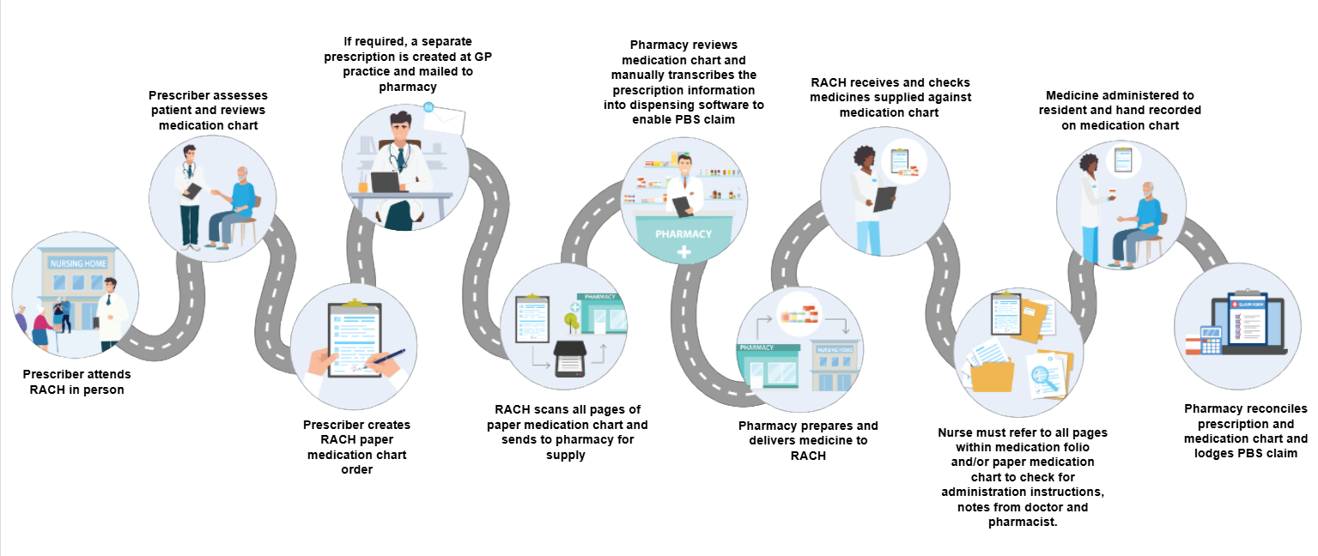

Figure 1 User journey in RACH with paper NRMC.

#### eNRMC Trial

In 2018, the department began a trial of three EMM systems in twelve RACHs in New South Wales and South Australia.

During the trial, prescribers and suppliers working with participating services were able to prescribe, dispense and track administration of PBS medicines on an electronic version of the NRMC. Evaluation of the trial found significant benefits for users and residents. See section 2.1.2 What are the benefits of using an eNRMC for more information.

Recognising the benefits of remote system access during the COVID-19 pandemic, the department expanded the trial to include additional software systems and over 500 RACHs to support safe care delivery.

While these systems addressed many of the limitations of the paper-based NRMC, some issues and restrictions remained. For example, pharmacists needed to manually transcribe prescription information into their dispensing software.

Figure 2 User journey in RACH under the eNRMC Trial and Transitional Arrangement



Figure 1 User journey in RACH with paper NRMC

#### Royal Commission into Aged Care Quality and Safety

The [Royal Commission into Aged Care Quality and Safety](https://www.royalcommission.gov.au/aged-care) was established in 2018 to examine the quality of aged care services in Australia. It investigated whether these services met community needs and explored potential improvements for the future.

During the Royal Commission, significant issues about medication management and misadventure were raised by RACH residents and their advocates. Over half of all concerns raised related to this issue. The Royal Commission recommended that all aged care providers delivering personal or clinical care adopt a digital care management system including an EMM system as soon as possible (Recommendation 68). The Government addressed the recommendation by providing support to RACHs to adopt My Health Record and implement eNRMC systems through a grant opportunity.

#### eNRMC Adoption Grant

In response to the medication management issues identified through the Royal Commission, the Government committed $30 million in grant funding from 2022-24 to support the uptake of eNRMC systems in residential aged care. Nearly 80% of eligible residential aged care services received funding and committed to implement an eNRMC system by December 2025. Eligible residential aged care services also included National Aboriginal and Torres Strait Islander Flexible Aged Care Program (NATSIFAC) Program services and Multi-Purposes Services that provide residential aged care services.

#### Transitional Arrangement

In July 2022, the department introduced the eNRMC Transitional Arrangement. This allowed RACHs to adopt “Transitional” versions of eNRMC systems without requiring each individual RACH to be approved by the department to participate. Systems had to attest conformance with legislative and technical requirements to be considered a Transitional eNRMC system. While these systems could not connect to the NPDS, they provided an interim solution until electronic prescribing functionality became available. This also enabled the eNRMC Adoption Grant Opportunity, as RACHs were able to apply for grant funding to adopt a Transitional eNRMC system.

Meanwhile, the NPDS, eNRMC and dispensing software vendors have continued developing their systems to meet the requirements of the Australian Digital Health Agency’s (Agency) Electronic Prescribing Conformance Profile version 3.0.2 (CPv3.0.2). This enables eNRMC software to use electronic prescribing functionality. Once eNRMC meet the requirements of CPv3.0.2, the Transitional Arrangement will end and only eP eNRMC systems will be permitted for PBS prescribing.

The user journey for Transitional eNRMC systems is the same as the eNRMC Trial, as shown below in Figure 2.

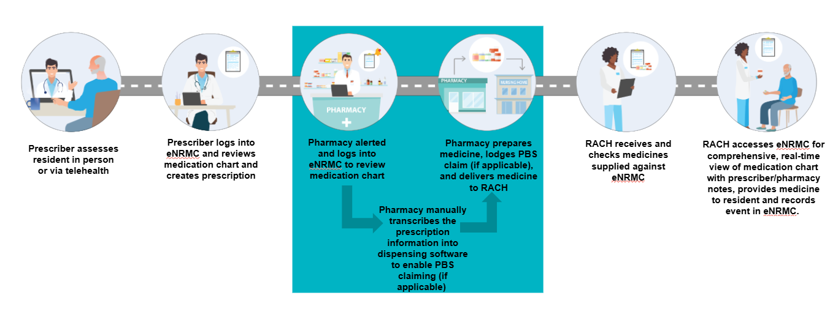

Figure 2 User journey in RACH under the eNRMC Trial and Transitional Arrangement

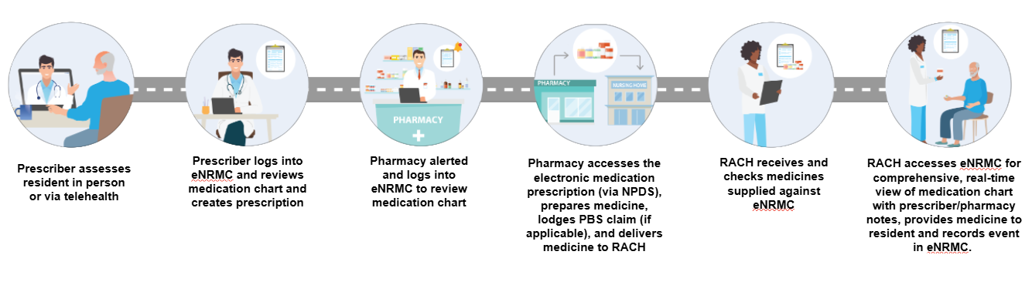

Figure 3 User journey in RACH using eP eNRMC

### Where are we now?

With eNRMC systems achieving electronic prescribing capability, pharmacy and prescriber workflows are enhanced, supporting the timely supply of medicines for residents.

Figure 3 above shows the user journey when using an eNRMC system.

Table 1 below outlines the differences between Transitional eNRMC and eNRMC systems.

Table 1 Differences between Transitional eNRMC and eNRMC

|  |  |  |
| --- | --- | --- |
| Functionality/parameter | Transitional eNRMC | Electronic Prescribing eNRMC |
| User restrictions | Open to any RACH and pharmacy, using software listed on [Transitional eNRMC Conformance Register](https://www.digitalhealth.gov.au/about-us/policies-privacy-and-reporting/registers) | Open to any RACH and pharmacy, using eNRMC vendor listed on eP – [External Conformance Register](https://www.digitalhealth.gov.au/about-us/policies-privacy-and-reporting/registers) |
| Connects to the National Prescription Delivery Service (NPDS) | No | Yes |
| Location in which the legal prescription is stored | eNRMC system | NPDS |
| Safety and Quality Use of Medicines (QUM) features | Provides benefits in comparison to paper NRMC | Enhanced safety and quality features |
| Pharmacist access to prescriptions enhanced | Pharmacists need to manually transcribe the prescription information from the eNRMC into their dispensing software | Pharmacists can retrieve chart-based electronic prescriptions from the NPDS through a token. |
| Chart duration | Up to the end of 4 months | 6 months from date of first PBS prescription |

### Where are we heading?

#### End of eNRMC Transitional Arrangement – Key Dates and requirements

As the national rollout of eNRMCs progresses, aged care providers must prepare for the end of the Transitional Arrangement. This section outlines the key dates and requirements that will shape the transition to fully conformant eNRMC systems. From 30 September 2025, only eNRMC systems that meet electronic prescribing conformance standards will be eligible for continued use under the Transitional Arrangement. Providers must ensure they are ready to upgrade or adjust workflows to maintain compliance and support safe, streamlined medication management.

|  |  |
| --- | --- |
| 30 Sep 2025 | **Electronic prescribing conformance to be achieved by eNRMC systems**  If the eNRMC system does not have an approved conformant version available by this date, RACHs may only use non-conformant version of eNRMC for administration purposes and must revert to using separate paper/electronic PBS prescriptions or revert to NRMC. |
| 01 Oct 2025 - 28 Feb 2026 | **Implementation phase**  Transitional Arrangement remains active only for eNRMC systems that have approved electronic prescribing conformant versions available. The eNRMC can continue to operate under the Transitional Arrangement until RACHs can safely upgrade to the new electronic prescribing conformant version. |
| 01 Mar 2026 | **Transitional Arrangement ends**  All RACHs using an eNRMC system must either:   * Use an electronic prescribing conformant version of their eNRMC systems OR * use non-conformant version of eNRMC for administration purposes only and revert to using separate paper/electronic PBS prescriptions or revert to paper NRMC. |

#### Future interoperability

The department continues to work with the clinical software industry to encourage integration between eNRMC and the following systems:

* GP prescribing software, including PBS Authorities
* Health Provider Online Services
* RACH clinical information systems (CIS)
* Hospital clinical systems such as electronic Medical Record (eMR) My Health Record.

Once achieved, increased interoperability will provide many benefits to prescribers, aged care homes and pharmacists. Interoperability will streamline the prescribing and supply process and ensure seamless clinician access to a resident’s important information at the point of care.

#### National Electronic Medication Chart Framework (NEMCF)

eNRMC is currently the only form of electronic medication chart that is approved to be used for prescribing, supply and administration of PBS medications, and is for the exclusive use for residents at RACHs. However, there is increasing interest in the potential use of electronic medication charts in other care settings.

In response, the department is developing a National Electronic Medication Chart Framework (NEMCF). The NEMCF will authorise the use of PBS approved national electronic medication charts in other facility-based care settings, such as other residential settings and hospitals in mid-2026. The NEMCF will provide a functional baseline for the legislative, technical conformance and clinical safety requirements for medication charts in as many settings as possible.

### Next steps

The Australian Government supports the Royal Commission's recommendations, recognising the critical role of technological innovation in improving residential aged care.

The department will continue working with industry to implement new technologies which improve the safety and quality of care for older Australians, both in community settings and residential aged care homes.

## Relevant legislation

The PBS is governed by the National Health Act 1953. Key Commonwealth legislation relevant to prescribing and supply of PBS medications – including using medication charts – is summarised in Table 2 below for easy reference.

In addition to Commonwealth requirements, eNRMC users must also comply with relevant state and territory legislation. This includes laws governing prescribing, dispensing, administration, and the use of medication charts. Practitioners are expected to be familiar with the legal obligations specific to the jurisdiction in which they practice and to adhere to these requirements alongside national regulations.

Table 2 Key legislation relevant to eNRMC

| Legislation | Relevance to eNRMC |
| --- | --- |
| [National Health (Pharmaceutical Benefits) Regulations 2017](https://www.legislation.gov.au/F2017L00313/latest/text) | Governs:   * eligibility to receive pharmaceutical benefits * requirements for the listing and pricing of drugs and medicinal preparations as pharmaceutical benefits * arrangements for prescribing, supply, payment, subsidy, and safety nets in relation to medication charts and electronic prescriptions. |
| [National Health (Pharmaceutical Benefits) Electronic National Residential Medication Charts Approval Instrument 2025](https://www.legislation.gov.au/F2025N00483/latest/text) | Governs:   * eNRMC system requirements for: * Information * System functionality * Copy of an electronic medication chart for use in urgent situations. |
| [National Health (Supply of Pharmaceutical Benefits—Under Co-payment Data and Claims for Payment) Rules 2022](https://www.legislation.gov.au/F2022L00436/latest/text) | Governs:   * PBS claiming requirements, including claiming using electronic medication charts. |
| [Electronic Prescriptions Information Technology Requirements Instrument 2019](https://www.health.gov.au/resources/publications/electronic-prescriptions-information-technology-requirements-instrument-2019?language=en) | Governs:   * information systems requirements used by healthcare provider organisations that must be adhered to. |
| State and Territory poisons and medicines legislation | eNRMC systems and users must also comply with any relevant state and territory laws. Depending on the jurisdiction the legislation may govern:   * legal requirements for prescribing, dispensing, and administering medicines, including the use of medication charts * specific documentation standards for administration orders (e.g., prescriber details, dosage, route, frequency) * additional rules for Schedule 8 medicines (e.g., quantity in words and numbers, patient DOB) * compliance with jurisdiction-specific health regulations and controlled substances laws * approval of eNRMC systems for use in their jurisdiction. |

## eNRMC Roles and Responsibilities

### Government Agencies

A range of government agencies and regulatory bodies play key roles in the development, implementation, and oversight of eNRMC. The following outlines their responsibilities:

#### Department of Health, Disability and Ageing

The department is responsible for PBS and eNRMC policy, legislation and support for national implementation. In collaboration with other government agencies such as the states and territories, peak bodies and software vendors, the department develops eNRMC policies to promote the safe and effective use of medications in residential aged care.

The department regulates legislative requirements for eNRMC information and system functionality to allow systems to electronically prescribe and supply PBS/RPBS medicines.

The department also provides general support for eNRMC implementation nationally.

The department does not regulate user interface of eNRMC systems (for example, the look, feel and design of individual systems).

#### Australian Digital Health Agency

The Agency plays a pivotal role in the development and implementation of eNRMC systems. The Agency is responsible for developing and maintaining the Electronic Prescribing Medication Chart Prescribing systems Conformance Profile. The Conformance Profile lists the specific conformance requirements for medication chart prescribing systems that must or should be met to support participation in electronic prescribing by connecting to the NPDS. (The Agency maintains a Register of conformant software systems that have been assessed against the relevant Conformance Profile version).

Conformance services provided by the Agency include:

* development of Conformance Profiles and Conformance Test Specifications.
* provision of eNRMC conformance assessment process.

#### Services Australia

The department and Services Australia collaborate closely to facilitate the claiming process for PBS/RPBS medications, including those prescribed using an eNRMC.

Services Australia manages the technical infrastructure and systems that allow prescribers to obtain PBS Authority approvals and pharmacies (PBS approved suppliers) to submit PBS claims electronically. This includes the Online PBS Authorities system and the PBS Online Claiming system.

Pharmacies submit claims for PBS medications through the PBS online system, and the claims are processed to ensure they meet the policies and regulations for the PBS, set by the department. Once claims are processed, Services Australia facilitates the payment to pharmacies for the PBS medications supplied, noting that these claims must be certified within 30 days of the claim period being closed.

#### Australian Commission on Safety and Quality in Healthcare (ACSQHC)

The Commission is established to contribute to improvement in health outcomes and experiences for all patients and consumers, and improved value and sustainability in the health system. This is done through leading and coordinating national initiatives to improve safety and quality of health care.

The eNRMC is an example of a national initiative designed to improve safety and quality outcomes for consumers in residential aged care. The eNRMC was developed based on the success of the Commission’s suite of standardised paper-based medication charts including the paper-based NRMC. The department may also engage the Commission to develop guidance and supporting resources, and/or to provide advice on matters relating to medication safety and quality use of medicines to inform policy decisions related to the eNRMC.

#### Aged Care Quality and Safety Commission (ACQSC)

The purpose of the Aged Care Quality and Safety Commission (the Commission) is to protect and enhance the safety, health, wellbeing and quality of life of older people receiving aged care. The Commission achieves this by regulating aged care providers to ensure that they uphold their obligations to provide safe, quality care, and treat the people using their services with dignity and respect. The Commission is the national regulator of Commonwealth-funded aged care services. It works with stakeholders to foster a world-class sector that safeguards the wellbeing and rights of older Australians. The Commission is responsible for:

* approving providers to deliver (Commonwealth-subsidised) aged care services
* engaging with and educating key stakeholders in the aged care sector about the Commission’s functions
* resolving complaints about aged care services
* accrediting residential aged care services
* monitoring providers’ compliance with the Aged Care Quality Standards and other obligations
* administering the Serious Incident Response Scheme
* regulating aged care workers, volunteers and governing persons under the Code of Conduct
* undertaking compliance and enforcement actions
* revoking the approval of an organisation to deliver (Commonwealth-subsidised) aged care services.

#### States and Territories

The States and Territories are responsible for any powers not listed as a Commonwealth responsibility under the Australian Constitution. The relevant state and territory legislation must be applied, depending on the location of a particular RACH, prescriber and/or pharmacy. Responsibilities include:

* Prescribing, supply and administration: Each state and territory are responsible for the regulation and broader management of prescribing, supply, and administration of all medicines.
* Medicine scheduling: The application of medicine scheduling varies by jurisdiction. For example, while federal legislation restricts Schedule 8 prescribing and supply using medication charts, each state and territory may have additional specific requirements.
* Technical conformance: States and territories may have specific technical conformance requirements for eNRMC systems. These requirements ensure that the systems meet local legislative and regulatory standards.
* Compliance and enforcement: States and territories are responsible for ensuring that RACHs, prescribers, and pharmacists comply with local legislation related to the use of eNRMC systems. They have the authority to enforce compliance and address any breaches of legislation or regulations.
* Regulation of health professions: The National Registration and Accreditation Scheme (the National Scheme) is a framework for regulating 16 health professions in Australia. The National Scheme is governed by a nationally consistent law passed by each state and territory parliament – the [Health Practitioner Regulation National Law](https://www.ahpra.gov.au/About-Ahpra/What-We-Do/National-Law.aspx).

### eNRMC Users

Prescribers, pharmacists and RACH staff have specific obligations when using eNRMC systems.

#### All users

The [ACSQHC’s implementation guide](https://www.safetyandquality.gov.au/publications-and-resources/resource-library/electronic-national-residential-medication-chart-medication-management-systems-your-guide-safe-implementation-residential-care-facilities) details these roles and responsibilities for each eNRMC user group. At a high-level, responsibilities for all users include:

* complying with Commonwealth and state and territory legislative requirements
* complying with Australian Privacy Principles (for example, maintaining security over user access credentials)
* registration as required (for example, Healthcare Provider Identifier-Individual (HPI-I) and Healthcare Provider Identifier-Organisation (HPI-O), Australian Health Practitioner Regulation Agency (Ahpra))
* ensuring resident choice is maintained (see section 2.2.2 Resident choice of pharmacy and GP section for more information)
* practising in line with relevant professional standards and scope of practice
* undertaking training to use the eNRMC system in line with the RACH use policies.

Those already using a Transitional eNRMC should also make themselves aware of the changes for eP eNRMC systems. See section 1.3.2 Where are we now? for more information.

The following sections list further role-specific responsibilities.

#### Residential Aged Care Home Providers and staff

##### Selecting an eNRMC

The RACH providers and executives are responsible for selecting an eNRMC system suitable for their service. RACHs are encouraged to review the [eNRMC Guide to safe implementation in residential care facilities](https://www.safetyandquality.gov.au/publications-and-resources/resource-library/electronic-national-residential-medication-chart-medication-management-systems-your-guide-safe-implementation-residential-care-facilities) and to consult with their pharmacy(s) and prescriber(s) when selecting and implementing an eNRMC system.

RACH providers should also confirm with their chosen software vendor that their system conforms with:

* the latest technical conformance requirements for electronic prescribing
* Commonwealth PBS legislative requirements
* state and territory legislative requirements
* Australian Privacy Principles.

##### Upgrading from a Transitional eNRMC to an eNRMC system

Where a RACH already has a Transitional eNRMC in place:

* Vendor Communication: Speak to vendors about when they expect to become eP conformant, when the RACH can transition, and the impact on the RACH.
* Pharmacy Notification: Inform servicing pharmacies that they have upgraded to an eP eNRMC.
* Awareness of Transitional Arrangement: Once the Transitional Arrangement ends, if your system is not listed on the Agency’s [Electronic Prescribing Conformance Register](https://www.digitalhealth.gov.au/about-us/policies-privacy-and-reporting/registers):
* RACHs may use the EMM systems for administration purposes only
* any medicine orders created will not constitute a valid PBS prescription

RACHs may wish to consider procuring an eNRMC (see [eNRMC Guide to safe implementation in residential care facilities](https://www.safetyandquality.gov.au/publications-and-resources/resource-library/electronic-national-residential-medication-chart-medication-management-systems-your-guide-safe-implementation-residential-care-facilities) for support).

##### Ensuring System Access and Permissions

The RACHs should ensure:

* Authorised Personnel Access: Only authorised personnel have access to the eNRMC system with role-based permissions, allowing them to perform permitted actions (for example, prescribe or administer).
* Access to Residents Charts: Access to a resident’s chart should be limited to a need only basis. This means, access should only be provided to clinicians and care workers who support the resident’s healthcare. Access and permissions must also be aligned with the user’s legal permissions under State and Territory medicines and poisons legislation.
* User Training: eNRMC users are appropriately trained before using the system, with ongoing reviews for the need for refresher training.

##### Governance and Relationships

RACHs should ensure:

* Governance: Appropriate governance is in place to ensure the eNRMC system is managed effectively to support medication safety and quality use of medicines on an ongoing basis. This is often the role of the Medication Advisory Committee (MAC) at the RACH.
* Working Relationships: Processes and procedures are in place to support effective working relationships with prescribers and pharmacists.
* Processes for regular review: Ensure medication reviews are conducted regularly. See section 6.5 Processes for regular review for more information.

#### Prescribers

When using an eNRMC, prescribers are responsible for reviewing a resident, prescribing medicines, and supporting the RACH and pharmacist to ensure that the resident receives their medicines in a timely manner. Prescribers must:

* Be legally authorised to prescribe medicines in accordance with the relevant poisons’ legislation of the state or territory in which they practice (see Contacts section).
* Be authorised to prescribe PBS/RPBS medicines and non-PBS medicines.
* Provide electronic prescriptions as required by the eNRMC system use policy operating in each RACH.
* Review a resident’s medicines and re-prescribe or create a new eNRMC at least every six months.
* Maintain open lines of communication with pharmacists and other healthcare providers to ensure seamless medication management.

These responsibilities help ensure that prescribers can effectively contribute to the safe and efficient use of the eNRMC system in RACHs.

#### Pharmacists

In addition to the general eNRMC user responsibilities above, pharmacists must:

* View the resident’s whole eNRMC prior to dispensing any medication.
* Maintain open lines of communication with prescribers, RACHs and other healthcare providers to ensure seamless medication management.
* Ensure dispense and residential care software remains current.

Pharmacists who are dispensing medicines ("servicing pharmacists") must:

Be legally authorised to dispense medicines according to the poisons legislation of the state or territory in which they practice and have PBS approval to dispense and supply PBS medicines.

Pharmacists may also add administration-only orders to a resident’s eNRMC at their discretion and where this functionality is available. See section 3.4 Recording prescriptions generated outside the eNRMC as an administration-only record for more information.

#### Aged Care On-site Pharmacist (ACOP)

An aged care on-site pharmacist (ACOP) is a credentialed pharmacist who works in a RACH. The ACOP brings their expertise in medication management and pharmacotherapy to provide collaborative and integrated care for all residents as part of the multidisciplinary healthcare team. Some of the responsibilities of an ACOP include:

* medication management and continuity of care
* communication during transitions of care
* quality use of medicine activities.

An ACOP may also add administration-only orders to an eNRMC at their discretion and if this functionality is available. See section 3.4 Recording prescriptions generated outside an eNRMC as an administration-only order for more information.

To be eligible for ACOP funding, RACHs must either have a functioning eNRMC or commit to introducing one in the next 12 months.

More information about the ACOP is available on the department’s website [Aged care on-site pharmacist](https://www.health.gov.au/our-work/aged-care-on-site-pharmacist).

### Vendors

#### Dispensing vendors

Dispensing vendors are responsible for ensuring their software meets the requirements of the Agency’s CPv3.0.2 and is rolled out to users. This enables pharmacists to retrieve chart-based electronic prescriptions from the NPDS into their dispensing software.

#### National Prescription Delivery Service (NPDS) provider

The NPDS is a centralised service that streamlines prescription delivery management. The service facilitates the transfer of electronic prescription information between clinicians and pharmacists who utilise participating systems.

It is the responsibility of the NPDS provider to assess eNRMC software against technical requirements to ensure connectivity between eNRMC software and the NPDS.

#### ENRMC Software Vendors

eNRMC software vendors must ensure their systems comply with a range of technical, legislative and safety requirements. eNRMC software vendors also have responsibilities to support and communicate with the users of their systems and provide sufficient training and ongoing support.

##### Technical responsibilities

To have their system deemed an eNRMC system, software vendors system must:

* connect with the NPDS
* complete and pass the electronic prescribing conformance testing process for CPv3.0.2
* sign an electronic prescribing system deed poll with the Agency which declares their system complies with relevant legislation (including PBS legislation and the Privacy Act 1988).
* be issued with an electronic prescribing conformance ID and be listed on the [Electronic Prescribing – External Conformance Register](https://www.digitalhealth.gov.au/about-us/policies-privacy-and-reporting/registers).

##### Legislative responsibilities

eNRMC software vendors must:

* ensure their systems are maintained and work in line with relevant Commonwealth, state and territory legislation, Australian Register of Therapeutic Goods and PBS releases, including:
* Information and system functionality requirements
* requirements for a copy of an eNRMC and for storage of electronic medicine orders
* Audit, reporting, security and privacy
* Active Ingredient Prescribing (AIP)
* ensure they obtain approval under jurisdictional and territory legislation where required.

##### Safety and quality use of medicines responsibilities

eNRMC software vendors must:

* ensure that their eNRMC systems:
* are safe, fit for purpose, and adequately support best-practice guidance around medication safety and quality use of medicines
* functions in line with Australian requirements – for example:
* the Aged Care Quality Standards
* the national medicines priorities, and the safety and quality agenda of the residential aged care sector
* changes to technical data standards
* optimise the medication safety capabilities of the eNRMC system
* maintain resident choice of prescriber and pharmacy for supply of their medicines
* be involved in system investigations where there is suspicion that the eNRMC system architecture or configuration may have contributed to resident harm.

Vendors should review the [eNRMC Software vendor information resource](https://www.safetyandquality.gov.au/our-work/medication-safety-and-quality/electronic-medication-charts/electronic-national-residential-medication-chart) developed by the department and the ACSQHC. They should ensure their system aligns with these guidelines as they are considered clinical best practice. This resource supports vendors for system enhancement, which facilitates safer medication management and improved quality use of medicines.

##### Responsibilities to system users

eNRMC software vendors should:

* develop an interface design that meets the needs of their users
* let RACHs that are using the Transitional eNRMC system version know:
* that their status has changed to an eP eNRMC system and detail any actions they need to take to upgrade to an electronic prescribing enabled eNRMC system
* that when the Transitional Arrangement ceases, any RACHs that do not upgrade to the electronic prescribing enabled eNRMC version are aware they can no longer use the Transitional version of the eNRMC system for chart-based prescribing.
* give access, information and training to RACH using the system as well as the prescribers and pharmacists servicing the RACH.
* ensure the system meets state and territory requirements and that the relevant jurisdiction has approved its use.
* respond to any requests from the RACH for system improvements.

For more detailed information on eNRMC software vendors responsibilities, please refer to the [eNRMC Software vendor information resource](https://www.safetyandquality.gov.au/our-work/medication-safety/electronic-medication-charts/electronic-national-residential-medication-chart).

1. General eNRMC information and principles

## About eNRMC systems

### Where can an eNRMC system be used?

eNRMC systems can be used in the following settings:

Residential Aged Care Homes (RACHs)

* National Aboriginal and Torres Strait Islander Flexible Aged Care Program (NATSIFAC) services providing residential aged care
* Multi-Purpose Services (MPSs) providing residential aged care (including those run by state and territory governments).

These services must have a current and valid residential aged care service unique system identifier issued by the Commonwealth to be able to use eNRMC for prescribing and dispensing. This could be a Residential Aged Care Service (RACS)/Residential Aged Care Facility (RACF) ID.

A RACS ID is a unique number allocated by Services Australia, used to authenticate a registered RACH. RACHs can find their RACS ID on the [Aged Care Quality and Safety Commission website](https://www.agedcarequality.gov.au/reports).

The department has allocated RACS IDs to NATSIFAC and Multi-Purpose Services (MPSs) that provide residential aged care services. If an MPS or NATSIFAC needs to confirm their RACS ID, they can do so by emailing [eNRMC@health.gov.au](mailto:eNRMC@health.gov.au).

### What are the benefits of using an eNRMC system?

eNRMC systems offer a wide range of benefits for residential aged care providers, aged care staff, prescribers, and pharmacists. Detailed benefits for each user group can be found in the user specific sections below for prescribers, pharmacists and Aged Care Management and Care Staff. The general advantages include:

#### Efficiency and safety

* eliminates need for paper-based prescriptions and paper medication charts
* reduces medication safety risks, such as discrepancies between prescriber records and paper medication charts
* less time spent by pharmacists reconciling differences.

#### Improved visibility and communication

* real-time access to residents’ medication records for all care team members
* enhanced visibility of information about residents’ allergies and adverse drug reactions
* reminders/alerts for new prescriptions, missed doses, or follow-up consultations
* build-in collaboration and communication tools

#### Reduced administrative burden

* reduced administrative burden for aged care providers and staff, prescribers, and pharmacists
* increased legibility of prescription information.

Using an eNRMC system enables aged care staff, prescribers and pharmacists to reduce medication errors and gain greater flexibility and coordination in the way their services are delivered.

#### Additional Benefits of Conformant eNRMC Systems

eNRMC systems that are conformant to legislative and technical requirements for electronic prescribing offer further advantages:

##### Advanced functionality

* safety and functionality enhancements
* pharmacists can retrieve chart-based electronic prescriptions from the NPDS, eliminating manual transcription

##### Flexible chart management

* increased chart duration of six months rather than the four-month duration in place for paper NRMC and Transitional eNRMC, reducing administrative burden
* charts no longer have to cease at month-end, allowing prescribers and RACH staff to better manage chart cease dates, reviews and renewals by staggering them if they wish to
* better alignment with biannual care planning sessions, remunerated through the General Practice Aged Care Incentive (GPACI) (see section 4.3 General Practice in Aged Care Incentive)

##### Real-time alerts

* real-time alerts from the RACH and/or servicing pharmacy regarding a resident’s medicines or any outstanding actions.

#### Benefits for residents

Use of eNRMC systems also supports consumer-centred care and improves communication between all those supporting the resident’s clinical care. As detailed in the ACQSHC’s [eNRMC Guide to safe implementation in residential care facilities](https://www.safetyandquality.gov.au/publications-and-resources/resource-library/electronic-national-residential-medication-chart-medication-management-systems-your-guide-safe-implementation-residential-care-facilities), specific benefits for residents in RACH that use eNRMC systems, including:

##### Medication safety and timeliness

* reduced risk of transcription errors due to electronic prescription transfer
* potential reduction in polypharmacy (number of regular medications)
* faster dispensing and delivery of medicines after prescription changes, reducing the chance of the resident missing any of their scheduled doses.

##### Streamlined records and shared decision making

* consolidated medication history in one system for easier recall and review
* facilitates discussions about medicines and supports shared decision-making (for example, consumer consent for an off-label indication or use of a medicine).

### Are eNRMC systems mandatory in RACHs?

While eNRMC systems are not currently mandatory in RACHs, the department strongly encourages their adoption to support safe and accountable medication management. The Royal Commission into Aged Care Quality and Safety recommended that all aged care providers delivering personal or clinical care adopt a digital care management system including an EMM system as soon as possible ([Recommendation 68](https://www.health.gov.au/sites/default/files/documents/2021/05/australian-government-response-to-the-final-report-of-the-royal-commission-into-aged-care-quality-and-safety.pdf)).

While it is not mandatory to use eNRMC systems now, please be aware that as part of the Strengthening electronic prescribing and targeted digital enhancements budget measure, electronically prescribing of high-risk medicines will become mandatory. For more information on the budget measure please contact [ePrescribing@health.gov.au](mailto:ePrescribing@health.gov.au).

In addition, access to ACOP funding is linked to the planned implementation or use of an eNRMC system, aligning with national goals for digital medication management and safety. The department views eNRMC adoption as critical to enabling pharmacists to contribute effectively to medication management and to support interoperability across care systems.

The use of eNRMC systems also supports wider system interoperability and integration improving continuity and quality of care.

## Consumer consent, choice, and privacy

### Informed Consent

Informed consent is a crucial aspect of implementing and using an eNRMC system, directly relating to both quality and safety in aged care.

As detailed in the ACQSC’s [Consent for medication in aged care](https://www.agedcarequality.gov.au/sites/default/files/media/consent-for-medication-in-aged-care-fact-sheet_0.pdf) resource, informed consent is a person’s decision, given voluntarily, to agree to a healthcare treatment, procedure, or other intervention. It is made following the provision of accurate and relevant information about the healthcare intervention and alternative options available, with adequate knowledge and understanding of the benefits and material risks of the proposed intervention.

In line with the [Electronic Prescriptions Privacy Policy (2021)](https://www.health.gov.au/resources/publications/electronic-prescriptions-privacy-policy?language=en%20%E2%80%93), eNRMC systems must support the recording and secure storage of informed consent to receive medicines. All personal and medical information must be managed in accordance with the Australian Privacy Principles (APPs) under the Privacy Act 1988, which govern how personal information is collected, used, disclosed, and stored.

In addition to national requirements, state and territory legislation also applies. Each jurisdiction may have specific legal and technical requirements for how consent is obtained, documented, and retained—particularly in relation to the prescribing, supply, and administration of medicines. eNRMC systems must therefore be capable of meeting both Commonwealth and local legislative obligations to ensure compliance and uphold residents’ rights. By ensuring that informed consent is properly obtained and managed, aged care facilities can uphold residents' rights and maintain trust in the eNRMC system.

### Resident choice of pharmacy and GP

Resident choice of pharmacy and GP is a foundational principle of the PBS and is consistent with the [Aged Care Quality Standard 1: Consumer dignity and choice](https://www.agedcarequality.gov.au/providers/standards). It is also supported by professional standards and regulatory guidance:

* The [Pharmacy Board of Australia’s Guidelines for Dispensing of Medicines](https://www.pharmacyboard.gov.au/News/2015-10-02-revised-guidelines.aspx)explicitly state in Guideline 13 that patients have the right to choose where they access their medicines.
* A [joint statement from the Pharmacy Board and Ahpra](https://www.pharmacyboard.gov.au/Codes-Guidelines/Joint-statement-on-professional-responsibilities.aspx)outlines professional obligations for prescribers and dispensers, including the requirement to respect patient choice when prescribing, compounding, and dispensing medicines.

It is the responsibility of the RACH to ensure resident choice of pharmacy and GP are preserved while still supporting the resident to receive their medications in a timely way. Pharmacists and GPs need access to the eNRMC system to view and annotate their resident’s eNRMC. The RACH should consult with their eNRMC system vendor to allow eNRMC system access for both contracted and non-contracted pharmacies and prescriber(s) and provide a copy of the chart to pharmacists in urgent situations.

If a resident or their family would like to fill a prescription themselves, the RACH also needs to provide them with a copy of their chart to enable medicine supply. See section 2.3.3 Using a copy of a chart for further information.

### Privacy

The development and use of an eNRMC system must comply with the Australian Privacy Principles (APPs) under the Privacy Act 1988, which govern the handling of personal information in Australia. This includes information found in medication charts (paper or electronic) and on prescription medicine labels.

Privacy is a shared responsibility between eNRMC software vendors and all users:

* Vendor responsibilities: eNRMC vendors must ensure that all resident and clinician data is protected in accordance with the APPs. They are also required to sign a deed poll with the Agency, confirming their system's compliance with the Privacy Act. Additional guidance is available in the [Electronic Prescriptions Privacy Policy](https://www.health.gov.au/resources/publications/electronic-prescriptions-privacy-policy?language=en), which outlines the obligations of non-government participants in electronic prescribing.
* User responsibilities: users should refer to principles 1, 3, and 9 of the [Guiding Principles to Achieve Continuity in Medication Management](https://www.health.gov.au/resources/publications/guiding-principles-to-achieve-continuity-in-medication-management?language=en) for further guidance on data privacy when implementing eNRMC systems.

The Ahpra also provides guidance on [responding to privacy breaches](https://www.ahpra.gov.au/documents/default.aspx?record=WD14%2F13440%5Bv6%5D&dbid=AP&chksum=xR19a2yGyOf%2BX81dsyws3PqoRuvnxjyuoOlEpAIe%2Fgg%3D).

By adhering to these responsibilities and resources, all parties can help ensure the privacy and security of sensitive information in RACHs.

## Access and audit

### Who can access an eNRMC?

As per the department and ACQSHC’s [eNRMC Guide to safe implementation in residential care facilities](https://www.safetyandquality.gov.au/publications-and-resources/resource-library/electronic-national-residential-medication-chart-medication-management-systems-your-guide-safe-implementation-residential-care-facilities), various health care practitioners may be authorised to access an eNRMC for a resident. Access should only be granted where it is necessary to support care. Access and system functionality (for example, ability to prescribe) should also be limited based on the user’s role as defined by legislation in the state or territory in which the system operates.

Practitioners who may be authorised to have access to an eNRMC system include:

* RACH managers
* nurses
* care workers
* medical practitioners
* pharmacists
* other registered clinicians who provide health care
* Other registered clinicians providing quality monitoring, reporting, auditing and medicines optimisation as part of clinical governance including for the National Aged Care Mandatory Quality Indicator Program or accreditation purposes
* students who provide health care under supervision.

All users should be mindful of the Australian Privacy Principles (see section 2.2.3 Privacy).

RACHs and software vendors must ensure that a resident’s chosen GP and pharmacist have access to their eNRMC. See section 2.2.2 Resident choice of pharmacy and GP for more information.

#### User authentication and audit

As per the department and ACQSHC’s [eNRMC Software vendor information resource,](https://www.safetyandquality.gov.au/our-work/medication-safety/electronic-medication-charts/electronic-national-residential-medication-chart) the eNRMC system must support all clinicians (prescribers and non-prescribers) who use it to support safety and quality in medication management. The eNRMC should have a validation check built into the system, to ensure that only clinicians registered with the Ahpra are granted access to prescribe medicines in the eNRMC system.

To cover auditing, access and synchronisation requirements, the eNRMC system must maintain audit log records of all medication management transactions.

#### Healthcare Identifiers

eNRMC software must capture and validate both the Healthcare Provider Identifier-Individual (HPI-I) and Healthcare Provider Identifier-Organisation (HPI-O). This is a mandatory requirement for prescriber authentication and authorisation and is also required for electronic prescriptions.

For details on how to [Register as a health care provider organisation](https://www.servicesaustralia.gov.au/register-health-care-provider-organisation-for-hi-service?context=20) and the [HI Service for individual health care providers](https://www.servicesaustralia.gov.au/healthcare-identifiers-hi-service-for-individual-health-care-providers?context=20#:~:text=There%20are%202%20ways%20to%20get%20a,Service%20using%20Health%20Professional%20Online%20Services%20(HPOS).), visit Services Australia’s website.

### How do I access an eNRMC?

Instructions and functions of user roles and access will vary between eNRMC system configuration and user interface design.

Some eNRMC software vendors manage access to their systems while others allow RACH to grant access to specific users. Prescribers and pharmacists should speak to RACH staff and/or software vendor for information on how to access and use the RACH’s chosen eNRMC system and other tailored support. See also section 2.3.3 Using a copy of a chart and section 5.2.1 Pharmacist access for more information.

### Using a copy of a chart

Wherever possible, the live eNRMC should be used for supply by pharmacists. However, there are some urgent situations where a copy of a chart may be used. There is also specific information which must be included on a copy of the chart for it to be valid, and restrictions around how long a copy is valid to support PBS supply and claiming. The chart token/identifier, and prescription tokens (evidence of prescription) will also be available on the copy of the chart to ensure the supplying pharmacy (contracted or non-contracted) can access the chart-based electronic prescription.

#### Requirements and validity of copies for PBS dispensing

Schedule 3 of the [National Health (Pharmaceutical Benefits) Electronic National Residential Medication Charts Approval Instrument 2025](https://www.legislation.gov.au/F2025N00483/latest/text) outlines the specific requirements for what must be included in a copy of an eNRMC.

Required information includes:

* RACH details
* Resident’s personal details
* Allergies and drug reactions
* Current medicines (including regularly administered, short-term, variable dose, and pro re nata (PRNs))
* Recently ceased medicines within the current chart period
* Requirements for administration
* Nutritional supplements
* Period of validity
* Chart token and prescription tokens (to enable access to the prescriptions for dispensing)
* Date and time the copy was generated.

When a copy of a medication chart is used, pharmacists must only supply a single maximum PBS quantity within 72-hours of generation. After 72 hours, the copy of the chart can no longer be used for supply. If a pharmacist is required to provide a further supply, a new copy of the chart will be required, to ensure they have the latest medication chart available for medication safety purposes.

#### Supply where an eNRMC is not available

Where the pharmacist cannot access the resident’s live eNRMC, they may supply from a copy of the eNRMC. Pharmacists can use the tokens on a copy of the chart to access the prescriptions for dispensing. RACH and pharmacists can use their clinical judgement to decide what classifies an urgent situation for supply. Some examples of an urgent situation may include where the usual pharmacy is out of stock or not able to be contacted or where a compounding pharmacy needs to supply medicines.

#### Temporary leave / resident independently filling a prescription

There may be situations where a resident is on [temporary leave](https://www.health.gov.au/our-work/residential-aged-care/managing-residential-aged-care-services/managing-temporary-leave-for-residential-aged-care) from their RACH, or where they wish to fill a prescription independently. In both cases, the RACH should generate a copy of the resident’s medication chart for the resident or their representative to take with them.

As a copy can only be used for supply purposes up to 72 hours after creation, the RACH may also need to organise pharmacist access to view the eNRMC if required.

See section 2.2.2 Resident choice of pharmacy and GP for more information.

### Recordkeeping

Information stored in eNRMC systems should be treated the same way as other medical records, in line with the laws and regulations of the relevant state or territory. Practitioners must be familiar with the medical record retention requirements in the jurisdiction where they practice.

Chart-based electronic prescriptions have the same recordkeeping requirements as general electronic prescriptions. In addition, a record of the resident’s eNRMC should also be stored.

#### Pharmacist responsibilities

* Pharmacists should maintain an audit trail that shows the basis for each medicine supply.
* Printing and storing copies of all medication charts annotated with supply information is no longer required. Instead, pharmacists should record supply information directly on the electronic prescription, not on the chart (unlike with paper charts). For more information see section 5.2.3 Annotating a resident’s eNRMC or prescriptions.
* Pharmacists must retain a record of the electronic prescription for two years for PBS purposes (like recordkeeping requirements for general electronic prescriptions)
* Practitioners are required to be familiar with the state and territory laws regarding retention of health records in the jurisdiction in which they practice.
* If dispensing was based on a copy of a chart, pharmacists should keep the copy for recordkeeping purposes.

#### System support requirements

* eNRMC systems must maintain audit log records of all medication management transactions, including the following:
* all changes to medicine orders, and the dose and route of the administered medicine;
* all changes to annotations;
* the date and time of each transaction; and
* the name, designation and registration number of the user undertaking each transaction;
* Dispensing software must also support the storage of medicine supply records from medication charts for a minimum of two years.
* To allow clinicians to easily view medication changes over time, at least three months of medication history should be available.
* eNRMC vendors can assist users in accessing older prescription histories if needed.

#### Responsibilities for RACH

* RACHs should confirm with their eNRMC software vendors that all recordkeeping requirements are being met.

### Downtime procedures

As per the department and ACQSHC’s [eNRMC Guide to safe implementation in residential care facilities](https://www.safetyandquality.gov.au/publications-and-resources/resource-library/electronic-national-residential-medication-chart-medication-management-systems-your-guide-safe-implementation-residential-care-facilities), RACHs should create clear, documented procedures for occurrences of system downtime, in consultation with their software vendor. Business continuity plans (BCPs) should be documented, rehearsed, reviewed and updated regularly to support planned and unplanned downtime. BCPs should include when to invoke the BCP and the different roles and responsibilities of the workforce involved in the plan.

Records of current and recently ceased medicines should be available during system downtime. RACHs must:

* be able to print a paper record of the medicines list
* record administration to support downtime mitigation strategies
* provide a copy to the pharmacy where required.

A downtime medication chart is a paper-based medication chart used for prescribing and administering medicines during the period in which the eNRMC system is unavailable for use. Downtime medication charts should be pre-populated with all the medicines that have previously been authorised by the person’s regular prescriber for administration.

See Chapter 9 of the [eNRMC Guide to safe implementation in residential care facilities](https://www.safetyandquality.gov.au/publications-and-resources/resource-library/electronic-national-residential-medication-chart-medication-management-systems-your-guide-safe-implementation-residential-care-facilities) for more information about how to manage system downtime.

## Chart validity and duration

### eNRMC duration and restrictions

Chart duration refers to the total period during which the eNRMC is active and valid for prescribing, dispensing, and administering medicines. An eNRMC begins the date on which the first pharmaceutical benefit is prescribed. It is valid for up to six months from that date. For example, if the chart commences on 10 July 2025, it will cease on 10 January 2026.

A prescriber can start a new chart at any time in the chart cycle (see section 2.4.3 Can a prescriber start a new medication chart at any time? for further information).

The duration of the medicine order and associated prescription is dependent on the prescriber’s directions (for example, duration of the chart or a specified duration) but no order or prescription can extend beyond the chart’s cease date.

The system must provide alerts at least 3 weeks prior to chart expiry to prompt review and renewal.

CHANGE FROM PREVIOUS CHART Types

For the paper based NRMC and Transitional eNRMC systems, charts cease 3 full months after the month the first pharmaceutical benefit is prescribed (i.e. a maximum of 4 months).

For eP eNRMC a resident’s chart can cease on any date, up to a maximum of 6 months after the date of which the first pharmaceutical benefit was prescribed.

For more information on prescribing and medicine orders that are not valid for the duration of a chart, refer to section 2.5 Medicines which can be prescribed using eNRMC.

### Ensure the resident has only one active medication chart

To support resident safety, an aged care resident must only have **one** active medication chart at any time.

If an interim chart is in place to support a transition of care, the interim chart ceases

* on expiry (up to seven days depending on jurisdiction) or
* as soon as a new eNRMC for the resident is in place.

See section 3.6 Supporting transitions of care for more information.

Prescribers cannot create medicine orders/prescriptions for future medication charts as this would trigger an additional chart. Creating a prescription which extends beyond the resident’s active eNRMC expiration date also breaches PBS legislative requirements.

The date of prescribing is the date identified on the prescription which means prescriptions cannot be future dated. However, prescribers may indicate when administration of a medicine needs to start at a later date where clinically appropriate. In this instance, the associated electronic prescription would be valid from the date it is authorised, but the medicine order for administration would begin at a later date. For example, a prescriber may order an antibiotic medicine to begin before a future planned procedure.

### Can a prescriber start a new medication chart at any time?

Prescribers can review a resident and start a new medication chart (and associated medication chart prescriptions for that chart period) at any time.

When prescribing a new medicine, prescribers should consider the duration left on the medication chart and whether it would be helpful to review all prescriptions and start a new medication chart. This is especially important when prescribing PBS Authority items, as the approved duration may extend beyond the chart’s expiry. Starting a new chart can help avoid needing to reapply for the same authority once the chart expires.

Authority approved for PBS items can be obtained from Services Australia or, for eligible veterans, from the Department of Veterans’ Affairs (DVA) under the RPBS.

For more information see section 2.5.4 Authority Required PBS items.

### Expiring medication charts

Once a resident’s eNRMC has expired, no further medicine prescription, supply or administration can legally occur from that chart. Prescribers must ensure that prescriptions are created within the eNRMC duration and must not extend past the resident’s eNRMC expiry date.

At the end of an eNRMC period (up to six months), all medication chart orders/prescriptions cease.

The eNRMC system must alert all users at least three weeks before a resident’s eNRMC expires. The RACH must ensure prescribers review the resident’s chart and create a new one prior to expiry to ensure resident safety, continuity of care, medicine supply and administration.

## Medicines which can be prescribed using eNRMC

eNRMC systems can be used for both PBS/RPBS and non-PBS medicines.

Prescribers can issue medication chart prescriptions based on treatment duration, unlike general prescriptions, which rely on maximum quantities and number of repeats.

An overview of the restrictions for prescribing, supplying, and claiming different medicines is provided below in Table 333.

Table 33 PBS medicines and restrictions when using an eNRMC system

| Categorisation | Restrictions |
| --- | --- |
| Non-Schedule 8 / Authority Required  Unrestricted, Restricted, and Authority Required (Streamlined) PBS items  PBS Section 85 (General Schedule) | For medicines prescribed for treatment and supply for the duration of the chart – can be prescribed and supplied for duration of chart, as long as there is a current valid order at the time of the supply  For medicines prescribed for treatment and supply for a specified period – for example a 5-day course of antibiotics – quantity of medicines to be supplied must in line with the duration of treatment prescribed. |
| Schedule 8  including Unrestricted, Restricted, and Authority Required (Streamlined) PBS item | PBS listing restrictions and maximum quantities must be observed. Cannot be prescribed and supplied for duration of chart.  If ongoing treatment with a medicine in this category is required, Prescribers should seek the relevant authority approval for increased supply.  Where applicable under state or territory legislation, prescribers should also obtain a relevant permit for ongoing prescribing. |
| Authority Required  (does not include streamlined authorities) | Duration of supply based on PBS authority approval.  Prescriber must enter cease date corresponding to authority approval. |
| Other  PBS Section 100 medicines  (for example, CARs) | Cannot be prescribed using eNRMC systems  eNRMC can still be utilised for medicine administration purposes when these items are added as ‘administration-only’ orders |

### 60 Day Dispensing

Items eligible for 60 Day Dispensing may be prescribed or supplied from an eNRMC. See the department’s [Eligibility for 60-day prescriptions webpage](https://www.health.gov.au/cheaper-medicines/about-cheaper-medicines) for more information.

### Psychotropics

Best practice guidelines should be considered when prescribing psychotropics on a medication chart. This includes obtaining informed consent. Additionally, any other relevant jurisdictional and local requirements, policies or processes should be followed to identify, monitor and mitigate risks associated with the use of psychotropic medication, including reducing inappropriate use.

The eNRMC allows for the capture of sedation scores to assist with prescribing psychotropic medicines and for RACH staff to determine if it is appropriate to administer the medicine.

For more information about the use of psychotropics, see the following resources:

* [Restrictive practices in aged care – a last resort](https://www.health.gov.au/topics/aged-care/providing-aged-care-services/training-and-guidance/restrictive-practices-in-aged-care-a-last-resort?language=und)
* [Psychotropic medications used in Australia - information for aged care](https://www.agedcarequality.gov.au/resource-library/psychotropic-medications-used-australia-information-aged-care)
* [Six steps for safe prescribing antipsychotics and benzodiazepines in residential aged care](https://www.agedcarequality.gov.au/resource-library/six-steps-safe-prescribing-antipsychotics-and-benzodiazepines-residential-aged-care)

### Schedule 8 (S8) medicine restrictions

S8 medicines can be prescribed using an eNRMC, but they are not eligible for ongoing supply in the same way as other medicines. Prescribing and supply must comply with both PBS requirements and state and territory legislation governing controlled substances.

#### Key requirements

* prescriptions must include relevant streamline authority numbers (where necessary) and cease dates consistent with a single pack (for example, 20-day supply). States and territories are responsible for regulating the use of non-PBS S8 medicines. If prolonged treatment with a S8 medicine is clinically necessary, prescribers must obtain an authority approval from Services Australia for extended supply.
* Where an authority has been sought and issued, a cease date on the prescription must align with the authority quantity and duration specified in the authority.
* Prescribers must also comply with state or territory-specific legislation for S8 medicines, including any additional approvals, documentation, and treatment duration limits.).

For detailed legal requirements by jurisdiction, refer to the [Schedule 8 Quick Reference Guide for Electronic Prescriptions](https://www.digitalhealth.gov.au/sites/default/files/documents/schedule_8_quick_reference_guide_for_electronic_prescriptions.pdf).

#### Prescriber responsibilities when using eNRMC for S8 medicines

When prescribing S8 medicines using an eNRMC, prescribers should:

* Ensure prescription cease dates for S8 medicines comply with PBS and state and territory regulations, including maximum durations
* Seek authority approval from Services Australia for increased supply where longer-term prescribing or increased quantity of an S8 medicine is clinically justified
* If an authority is not obtained, reassess the resident once the previous supply has been administered. If further treatment is deemed clinically necessary, a new prescription for a single supply may be issued via the eNRMC system.

### Authority Required PBS items

The process for obtaining approval for Authority Required items is available on [Services Australia’s website](https://www.servicesaustralia.gov.au/apply-for-pbs-authority). Authority Required items can only be prescribed and supplied in line with the specific authority that is provided.

Authority Required (Streamlined) items (non-S8) can be prescribed for the duration of the chart and supplied as many times as required to give effect to the treatment duration specified by the prescriber.

When prescribing an Authority Required or Authority Required (Streamlined) items, the prescriber must ensure the Streamlined Authority Code or Authority Approval Number is included. All Authority Prescriptions must also include a PBS Authority Prescription Number (APN) which will be generated by the eNRMC system.

If an authorised prescriber is seeking an authority for a new medicine, they should consider:

1. starting a new chart and
2. seeking a new authority for any other authority required items already on the chart.

This would ensure continued authority to administer the medicine through a medicine order and the availability of further prescriptions for supply. This would also align all the authority cease dates (as much as possible) with the medication chart cease date (as most authority prescriptions are for a 6-month supply).

Authorities’ processes will continue to be reviewed and improved through the NEMCF.

Figure 4 below summarises the limitations on prescription duration and the number of supplies when prescribing on an eNRMC.

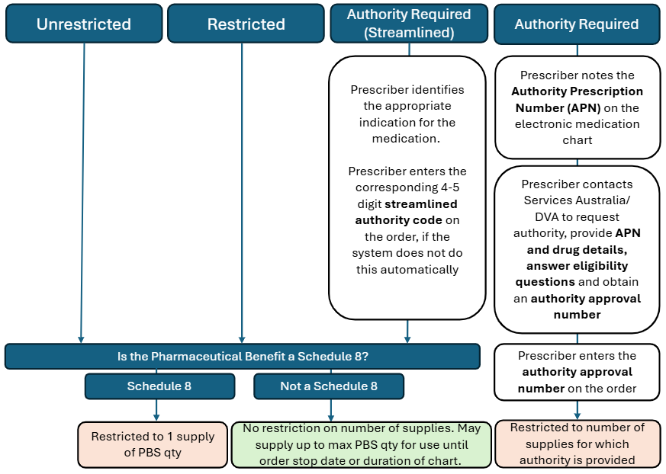

Figure 4 PBS Item restriction types and prescribing limitations when using eNRMC system

Figure 5 below shows the information pharmacists must include when supplying and claiming PBS medicines listed as Authority Required or Authority Required (Streamlined).

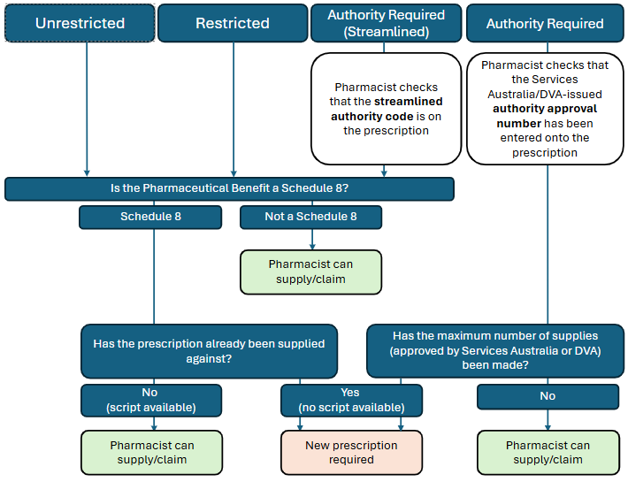

Figure 5 Supply and claiming restrictions when using eNRMC systems

1. eNRMC workflows

## Overarching workflow

eNRMC workflows may vary slightly depending on the system, local policies, and preferences. Table 6 shows the user and system interactions, and the general workflow is outlined on the next page.

## Creating a new chart

A new chart can be created at any time for a resident. At a minimum, a new chart must be created every six months. See section 2.4 Chart validity and duration for more information.

A prescriber should start a new chart if a resident transitions to a RACH from another RACH or following a hospital episode of care. See section 3.6 Supporting transitions of care for more information.

A new chart does not need to be created each time a medicine order is added or ceased. Orders that have ceased during the chart period will remain visible on the chart as inactive orders.

### Who can create a new medication chart in the eNRMC system?

A resident’s eNRMC commences the date the first PBS prescription is authorised by a prescriber using the resident’s eNRMC. This means that any PBS prescriber prescribing within their scope of practice can start a medication chart.

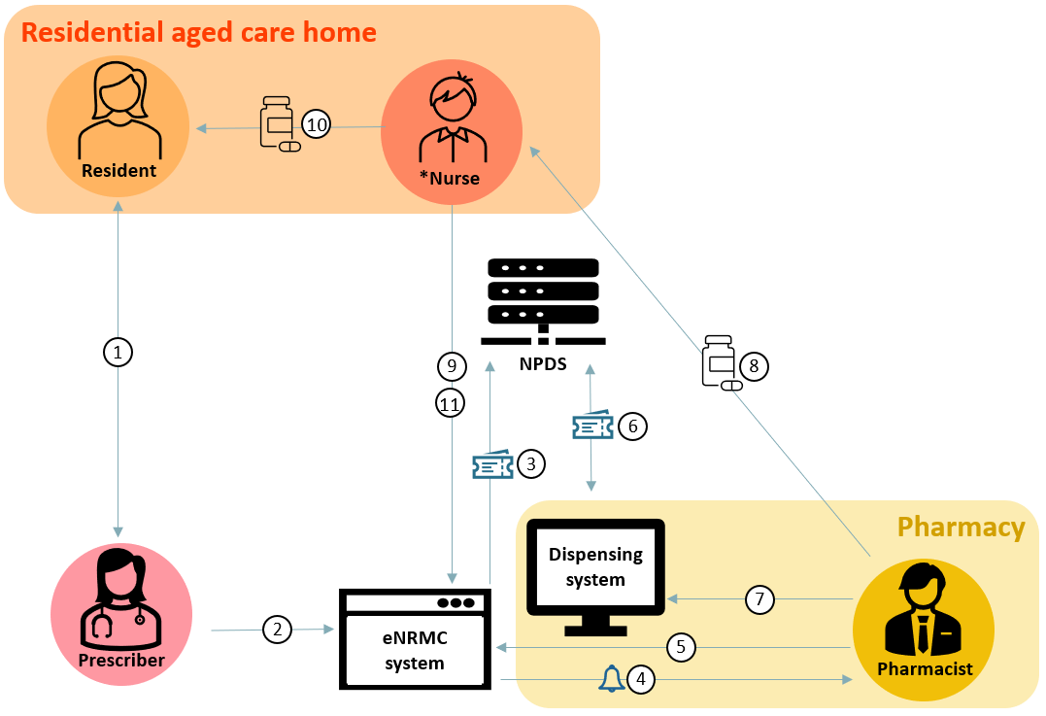

| Order |
| --- |
| * Prescriber assesses resident. * Prescriber enters medicine order into eNRMC system (including any details of authorities obtained) * eNRMC system sends order details to NPDS, creating a chart-based electronic prescription. |
| Dispense |
| * Pharmacist is notified of medication change in eNRMC. * Pharmacist views resident’s eNRMC (live eNRMC or copy). * Pharmacist scans prescription token/s to retrieve associated prescription information from NPDS. * Pharmacist creates dispense record and makes any required annotations. Pharmacist may also annotate eNRMC (within eNRMC system or on copy). * Pharmacist supplies the medicine to the RACH. |
| Administer |
| * Nurse (*or administrator of medicine) views resident’s medication chart and checks this against resident’s dispensed medicine. * Nurse administers medicine to resident. * Nurse enters administration event in eNRMC system. |

Figure 6 eNRMC user and system interactions

## Creating a medication chart order and generating an electronic prescription

In an electronic prescribing enabled eNRMC, the prescription and medicine order are two separate concepts. However, the information in both should be identical.

Paper NRMC and Transitional eNRMC Systems

In these systems, the medicine order and prescription are the same. The chart itself serves as the legal prescription for administration and dispensing.

eNRMC Systems

In these systems, the medicine order and the electronic prescription are separate:

* A prescriber creates a medicine order in the eNRMC which authorises administration and generates an associated electronic prescription.
* The associated electronic prescription is stored in the NPDS and enables dispensing and must match the information on the order.

Figure 7 shows the process of a medicine order generating a chart-based electronic prescription.

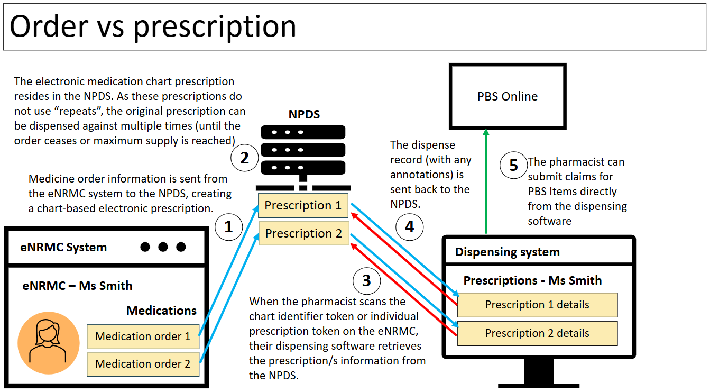

Figure 7 Medication chart order and chart-based electronic prescription workflow

### Ceasing orders and prescriptions

When an eNRMC ceases, all medicine orders and associated electronic prescriptions on that chart also cease. If a medicine order is cancelled before the chart end date, the associated electronic prescription is also cancelled.

For short term medicines, such as antibiotics, the prescription will no longer be available once supply has occurred (in line with prescribed quantity) but the medicine order will remain on the chart to able administration of the medicine for the specified period.

## Recording prescriptions generated outside an eNRMC as an administration-only order

Only health practitioners who are legally authorised to prescribe under the PBS can create PBS prescriptions within an eNRMC system.

However, if a prescription (paper or electronic) has been issued outside the eNRMC system (for example, by hospital or specialist), a pharmacist or a GP can record the existing paper or electronic prescription in an eNRMC for medicine administration purposes only. This record should:

* include the same information included on the prescription information such as prescriber details, date of prescribing, medicine details, instructions, relevant authority details etc.
* be for the sole purpose of enabling administration of the medicine to the resident
* not constitute a new prescription or order
* clearly indicate that the order is for administration only
* not generate an electronic prescription to enable any supply.

! As this administration order is not a prescription, a pharmacist MUST NOT use this order to supply the medicine.

Supply of the medicine would typically have already occurred, for instance for residents returning from hospital. If supply has not yet occurred, the pharmacist must supply the medicine from the existing prescription (paper or electronic) and not from the chart.

This is not a mandatory activity for a pharmacist and is subject to pharmacist agreement and eNRMC system functionality supporting this activity. This process should only be utilised in situations where no alternative is available, such as urgent scenarios following hospital discharge.

RACHs should work with their pharmacists to establish appropriate processes and mechanisms to ensure safe transcription, avoid duplication and availability of information at point of care.

## Supplying medication before presentation of a prescription (urgent supply)

In urgent situations, pharmacists may dispense a medicine before receiving a written prescription, as long as they have received explicit oral instruction from the prescriber in accordance with state or territory medicines legislation. eNRMC systems generally reduce the need for owing scripts because prescribers can log in to the system remotely. However, if a prescriber cannot access the eNRMC system, they may provide the prescription details by phone or email to the pharmacist to enable urgent supply. However, the prescriber must provide an appropriate prescription or chart-based electronic prescription within 7 days to enable PBS claiming by the pharmacist. Note that if an authority is required for the medicine, the authority approval number still needs to be supplied to the pharmacist.

Services Australia explains the process for these prescriptions on their [Submit PBS claims for pharmacy](https://www.servicesaustralia.gov.au/how-to-submit-pharmaceutical-benefits-scheme-pbs-claims-for-pharmacy?context=20#accordion3) webpage.

However, an order for urgent supply as outlined in the situation above, would still be required to be added to the chart for administration. See section 3.4 Recording prescriptions generated outside an eNRMC as an administration-only order for more information.

## Supporting transitions of care

The transfer of medicines information recorded in a resident’s eNRMC is critical during transitions of care. As outlined in the department’s [Guiding Principles to Achieve Continuity in Medication Management,](https://www.health.gov.au/resources/collections/guiding-principles-to-achieve-continuity-in-medication-management-collection) more than 50% of medication errors occur during transitions of care. Ensuring availability of accurate medicine-related information is critical to support safe transitions of care at all transition points. Examples of transition points include medicines information transfer between:

* RACH and visiting healthcare providers; and
* RACH and other care settings – such as community care, hospital, and resident’s various health providers including pharmacists.

Undertaking medicines reconciliation when a resident transitions between providers and settings:

* reduces the opportunity for medication errors
* reduces pressure on hospitals by reducing unnecessary hospital readmissions
* supports handover and care that can be provided through primary care and/or aged care
* supports better continuity of care for older people.

The workflows for managing medication information on transfer are detailed below. More information about medication reconciliation and review in residential aged care is available in the department’s [Guiding Principles for Medication Management in Residential Aged Care Facilities](https://www.health.gov.au/resources/publications/guiding-principles-for-medication-management-in-residential-aged-care-facilities?language=en) resource.

### General workflows for transferring a resident from a RACH to hospital (admission) or another RACH

When a resident is admitted to hospital or another RACH, it is important that their RACH provides their medication information to the hospital or the new RACH, along with any other documentation required. Refer to the department’s [Guiding Principles to Achieve Continuity of Medication Management](https://www.health.gov.au/resources/collections/guiding-principles-to-achieve-continuity-in-medication-management-collection) for further information.

When a resident transfers to another managed care service (such as a hospital or to another RACH that uses an eNRMC system), the receiving service should create a new chart for the resident/patient to manage their medications in their new location.

The resident’s eNRMC should be ceased on transfer to a new managed care service (for example, hospital or a new RACH). Ceasing a resident’s eNRMC on transfer will ensure clinical safety risks are medicated such as previous medications (which may have been changed during their hospitalisation) are not administered when the resident returns without a medication chart review. This process will ensure the supplying pharmacist does not continue to dispense and pack medicines for this resident while they are in hospital.

**Example RACH to hospital workflow**

1. Resident requires transfer to hospital.
2. RACH provides medication information and other medical information to hospital (My Health Record, printed copy of medication chart).
3. RACH ceases resident's eNRMC which should alert residents GP and pharmacist.
4. Hospital reviews the resident’s medication information provided by the RACH and creates a new hospital medication chart for the resident (paper or electronic).

**Example RACH to RACH workflow**

1. Resident requires transfer to another RACH
2. RACH provides medication information to new RACH (My Health Record, printed copy)
3. New RACH creates a new profile in their eNRMC system for the resident
4. Previous RACH ceases resident's eNRMC in their eNRMC system
5. Either:
6. GP reviews the resident and creates a new eNRMC for them using the new RACH’s eNRMC system; or
7. while waiting for the GP to do a formal review, the contracted community pharmacist or ACOP may add any already dispensed medicines to the chart for administration-only purposes (if the system supports this functionality).

When a resident is transferred to another managed care service (for example, a hospital), there is no current mechanism for the seamless transfer of their eNRMC details available to that service. The Government is working with the aged care sector to enable the use of the My Health Record - Residential Care Transfer Overview that can support such transfers not only in aged care, but also in similar residential care settings. Information provided about medications would then be used as part of a medication review and reconciliation process at the receiving service. National systems such as My Health Record can facilitate the transfer of such information.

### General workflow for transferring a resident back to their RACH after hospital (discharge)

When a resident returns to their RACH after a hospital episode of care, a new eNRMC should be created. This eNRMC should reconcile any hospital discharge medications with those listed on the previously ceased chart (see above) to reflect any changes in the resident’s medication regime following their hospital stay.

It is critical that any medication changes are accurately reflected in a resident’s eNRMC. Only medicine orders that are recorded on a resident’s eNRMC can be legally administered by the RACH (or from an interim medication chart during a transition of care). However, medications cannot be dispensed from an interim medication chart as these orders would constitute administration-only orders.

To ensure that residents can be administered their prescribed medicines without delay after hospital discharge, a pharmacist may, where the system allows, record hospital-prescribed medications into the eNRMC while awaiting review by the resident’s usual prescriber. A pharmacist could use either discharge prescriptions or an interim medication chart for this purpose. See section 3.4 Recording prescriptions generated outside the eNRMC as an administration-only order for more information.

Interim Residential Care Medication Administration Charts, used in some jurisdictions, support continuity of medication management when a person transfers from hospital to a RACH. These charts, prepared by the hospital before discharge, provide continuing medicines orders for up to seven days or until the person’s own prescriber (for example, a medical practitioner or nurse practitioner) reviews and prescribes ongoing treatment.

Example transfer from hospital workflow

1. Resident is discharged from hospital
2. Hospital should provide an interim medication administration chart (IMAC) and discharge summary to RACH, and discharge medications dispensed by the hospital pharmacy
3. Resident returns to RACH
4. Either:
5. GP reviews the resident and creates a new eNRMC for them using the RACH’s eNRMC system; or
6. while waiting for the GP to do a formal review, the contracted community pharmacist or ACOP may add any already dispensed medicines to the chart for administration-only purposes (if the system supports this functionality).
7. Interim chart (if in place) is ceased.

RESIDENTIAL MEDICATION MANAGEMENT REVIEW PROGRAM

A Residential Medication Management Review (RMMR) is a service provided by credentialed pharmacists to eligible residents residing in eligible Australian Government-funded RACHs with the intended purpose of identifying, resolving, and preventing medication-related problems. Funding to support the provision of RMMRs for eligible residents is available under the [RMMR Program](https://www.ppaonline.com.au/programs/medication-management-programs/residential-medication-management-review-and-quality-use-of-medicines).

1. Prescribers

## Benefits for prescribers

As detailed in the department and ACQSHC’s [eNRMC Guide to safe implementation in residential care facilities](https://www.safetyandquality.gov.au/publications-and-resources/resource-library/electronic-national-residential-medication-chart-medication-management-systems-your-guide-safe-implementation-residential-care-facilities), there are many benefits for prescribers who use eNRMC systems, including:

Reduced administrative burden

* no paper-based prescriptions or paper-based charts, saving time
* increased chart duration to 6 months - rather than the 4-month duration in place for paper NRMC and Transitional eNRMC
* system support to complete the information requirements to issue a legal prescription.

Remote access

* the ability to prescribe and review medicines remotely, via telehealth consultations also reducing telephone orders
* greater ownership and visibility of the resident’s eNRMC, and the ability to remotely observe how a resident is responding to treatment.

Greater control

* charts no longer cease at the end of a month, meaning prescribers and RACHs can better manage chart cease dates, reviews and renewals by staggering them
* better alignment of chart review and renewal with bi-yearly care planning sessions, remunerated through the GPACI (see section 4.3 General Practice in Aged Care Incentive).

Real-time alerts

* Notifications from the RACH and/or the servicing pharmacy regarding a resident’s medicines and any outstanding actions.

Improved medication safety and quality use of medicines

* Enhanced quality use of medicines through clinical decision support (where available).

## Prescribing workflow

Generally, the prescribing workflow when using an eNRMC follows the steps outlined below. However, there may be differences depending on the prescriber’s own preferences and the specific eNRMC software they are using.

**Prescribing workflow:**

* The prescriber reviews the resident and either creates a new eNRMC for the resident or reviews the resident’s current eNRMC and makes a clinical decision to prescribe.
* The prescriber enters/authorises the new medicine order in the eNRMC system.
* The eNRMC system generates an electronic prescription which is sent to the NPDS.

Figure 8 is a visual representation of this prescribing workflow.



The prescriber enters the medicine order into the **eNRMC** system.

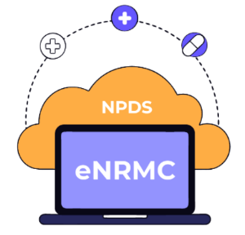

The prescriber reviews the resident and their **eNRMC** and makes clinical decision to prescribe.

The eNRMC system sends a chart based electronic prescription to the **NPDS.**

Figure 8 Prescriber workflow using an eNRMC system

### Is a Prescriber required to physically attend the RACH to renew or amend an eNRMC?

While in-person visits remain essential for delivering comprehensive care, eNRMC systems improve care flexibility by allowing prescribers to access the system remotely. This enables them to prescribe medications during telehealth consultations or make urgent changes to a resident’s medication regimen, even when they are not physically present at the RACH.

Previously, where paper medication charts were used, the medication charts remained at the RACH. Prescribers were required to attend the RACH in person to prescribe PBS medicines or renew a chart. Alternatively, a telephone order was required and the PBS prescription was sent to the pharmacy within seven days to support PBS claiming. See section 3.5 Supplying medication before presentation of a prescription (urgent supply) for more information on how this is managed in relation to eNRMC.

### Who can prescribe medications using an eNRMC?

All authorised [PBS Prescribers](https://www.health.gov.au/topics/medicines/about-prescriptions#who-can-prescribe-medicines) are legally able to prescribe PBS medicines using an eNRMC system, in accordance with their scope of practice and relevant state or territory requirements or restrictions.

Under the National Health Act 1953, approved PBS prescribers include:

1. Medical practitioners
2. Participating dental practitioners
3. Authorised optometrists
4. Authorised midwifes
5. Authorised nurse practitioners.

State based restrictions in different jurisdictions may exist, or RACHs may have other relevant policies.

### Re-authentication

Under state and territory legislation, it is necessary for prescribers to re-authenticate at certain points during the prescribing process, such as when prescribing Schedule 8 medicines. This ensures that where a public computer is being used, or a mobile device such as an iPad within a RACH, fraudulent prescriptions cannot be generated (particularly for high-risk medicines).

### Specialist prescribing

Specialists can be provided access to the eNRMC system to prescribe medicines. All eNRMC systems include processes to support access.

However, some specialists may be unwilling or unable to use an unfamiliar system for a rare prescribing event. In such cases, prescriptions may be generated outside the eNRMC (for example, paper or electronic prescriptions). This presents an issue for medicine administration, as state and territory legislation generally require a valid medication chart order for any medicine to be administered to a resident in a RACH.

If a specialist cannot access the resident’s eNRMC, or it is not practical to do so, they should:

* contact the resident’s regular GP or pharmacist
* provide the prescription (paper or electronic) and any associated token to the pharmacist for dispensing.

There are two options for ensuring the medicine can be administered safely and legally:

1. **Administration-only order**

The GP or pharmacist can enter the medicine into the resident’s eNRMC as an administration-only order.

* This allows the medicine to be administered in the RACH.
* The original specialist prescription must be retained to support PBS supply and claiming.
* This process is especially important for authority-required medicines, where PBS compliance is essential.
* See section 3.4 Recording prescriptions generated outside the eNRMC as an administration-only order for more information.

1. **Prescribing by the GP (in consultation with the specialist)**

In some cases, the GP may choose to prescribe the medicine directly, provided:

* It falls within their usual prescribing scope, or
* It is prescribed in consultation with the specialist, in line with PBS rules and any jurisdictional requirements.
* Additional approvals may be required under state or territory laws, particularly for Schedule 8 (S8) medicines. See section [2.5.3 Schedule 8 (S8) medicine restrictions](#_Schedule_8_(S8)) for more information.

## General Practice in Aged Care Incentive (GPACI)

The General Practice in Aged Care Incentive (GPACI) aims to support GPs and practices to deliver planned, quality and continuous primary care services in RACHs rather than in GP practices, including utilising eNRMC systems. This forms an important part of the Australian Government’s response to the Royal Commission into Aged Care Quality and Safety and the Strengthening Medicare Taskforce.

From 1 July 2024, eligible GPs and practices can receive incentive payments for providing regular visits and care planning for each of their residents living in RACH by following the program [guidelines](https://www.health.gov.au/resources/publications/general-practice-in-aged-care-incentive-program-guidelines-2024). This includes ensuring they are registered in the MyMedicare program and being responsible for their resident’s eligibility as part of the resident registration process.

For helpful resources and to find out more about the incentive, payments, eligibility criteria, and servicing requirements, visit the department’s [General Practice in Aged Care Incentive](https://www.health.gov.au/our-work/gpaci) (GPACI) webpage.

# 

1. Pharmacists

## Benefits for pharmacists

As detailed in the department and ACQSHC’s [eNRMC Guide to safe implementation in residential care facilities](https://www.safetyandquality.gov.au/publications-and-resources/resource-library/electronic-national-residential-medication-chart-medication-management-systems-your-guide-safe-implementation-residential-care-facilities), there are many benefits for pharmacists who use eNRMC systems, including:

Improved efficiency

* elimination of manual transcription into dispensing software due to the introduction of electronic prescribing functionality
* reduced risk of transcription errors during dispensing

Enhanced clarity

* improved the legibility of orders and prescriptions
* greater confidence in prescribing directions and current medication lists for packing dose administration aids, thanks to real time, accurate medicine lists

Reduced errors and follow-up

* fewer transcription errors from paper-based charts or prescriptions
* less need to contact prescribers for amendments or clarifications

Streamlined emergency supply

* reduced need for emergency telephone orders, as prescribers can access the eNRMC system remotely and issue prescriptions directly.

## Pharmacy workflow

The process for dispensing from an eNRMC is generally the same regardless of whether the pharmacist is contracted by the RACH. The process for accessing the eNRMC and making any annotations will vary depending on whether the pharmacist has access to the live eNRMC or is using a copy of the chart.

Figure 9 below shows the workflow of a pharmacist dispensing and supply from an eNRMC.

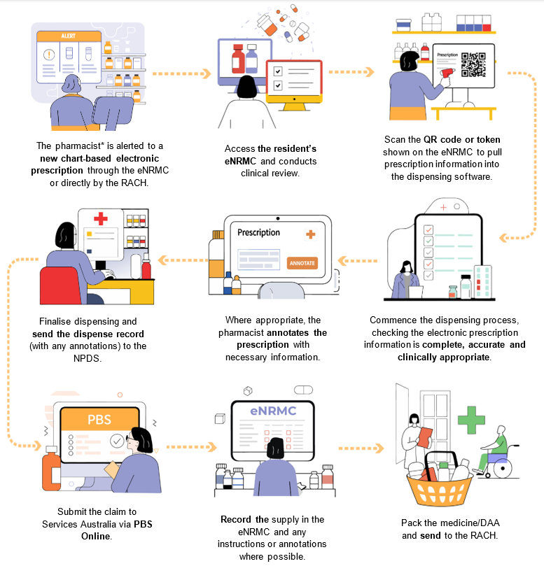

Figure 9 Workflow for dispensing and supplying from an eNRMC

* Please note, pharmacy technicians, assistants, interns or students may also undertake some of these tasks under the supervision of a pharmacist.

Generally, the pharmacy workflow will include the steps outlined below, depending on the pharmacists' own preferences and the specific software used:

1. The pharmacist is alerted to a new prescription. This might be in the eNRMC system, through phone call, or through secure messaging.
2. The pharmacist accesses the resident’s eNRMC (the live eNRMC or a copy in urgent situations) and assesses for clinical risks and quality use of medicines.
3. The pharmacist scans either the individual prescription token or the chart identifier token shown on the resident’s eNRMC. This pulls the prescription information from the NPDS into the dispensing software. The prescription information will look the same as a community prescription, except that it will have a clear indicator that it is a medication chart prescription and will specify a duration of supply rather than repeats. See section 5.2.2 Retrieving prescriptions from the NPDS using Tokens for more information.
4. The pharmacist prepares the dispense record, ensuring all required information is included.
5. Where appropriate, the pharmacist annotates the prescription and if required, the eNRMC (the live eNRMC or a copy in urgent situations). See section 5.2.3 Annotating a resident’s eNRMC or prescriptions for more information.
6. The pharmacist sends the dispense record (with any annotations) to the NPDS. If the prescription is for a single supply of a medicine, the token is extinguished, removing the ability for future dispensing (i.e. Schedule 8).
7. The pharmacist submits a PBS or RPBS claim to Services Australia through PBS Online where appropriate. See section 5.2.4 Claiming through PBS online for more information.
8. The pharmacist records the supply and any instructions in the eNRMC, where possible.
9. The pharmacist packs the resident’s medicines and sends them to the RACH.

### Pharmacist access

See section 2.3 Access and audit for general information.

The RACH or software vendor must give pharmacists (including QUM, RMMR or ACOP) access to view a resident’s eNRMC if they are supplying medicines to that resident. This applies regardless of whether the pharmacist is contracted by the RACH or is the resident’s regular supplier. This ensures that resident choice is maintained.

If a pharmacist is not contracted by the RACH, they may not have existing access to the eNRMC system. In this case, the RACH/eNRMC software vendor must arrange access to view the resident’s live eNRMC, at the pharmacist’s request.

When dispensing a medicine for a resident, they must view either:

* the live electronic medication chart
* in urgent situations (i.e. when access to the live environment is not possible), a copy of an entire chart which is date and time stamped. See section 2.3.3 Using a copy of a chart and [National Health (Pharmaceutical Benefits) Electronic National Residential Medication Charts Approval Instrument 2025](https://www.legislation.gov.au/F2025N00483/latest/text) for further information.

### Retrieving prescriptions from the NPDS using Tokens

An electronic prescription token contains a unique identifier (an alpha-numerical code with associated barcode or QR code) which enables a pharmacist to access the necessary information to dispense a prescribed medication in their EP conformant dispensing software. A resident’s eNRMC has a chart identifier token which groups all chart items together, as well as tokens for each individual prescription.

Tokens generated by the eNRMC system for medicines prescribed using an eNRMC must be clearly identifiable as being part of a medication chart. Each individual prescription has an ID that is a combination of the chart ID and the consecutive number from the list of the resident’s prescribed medications.

To retrieve prescriptions from the NPDS into their dispensing software, pharmacists can scan either the chart ID to view all prescriptions (where the software system allows) or individual prescription ID to dispense against a single prescription. Pharmacists must also view the resident’s entire eNRMC when dispensing (refer or link to section of legislation here). See section 5.2 Pharmacy workflow for more information.

If a prescription is for a single supply of a medicine (for example, Schedule 8), sending the dispense record to the NPDS will extinguish the token so that it cannot be dispensed again.

Copies of a chart must contain the chart ID token and prescription ID tokens to enable pharmacist review and dispense. See section 2.3.3 Using a copy of a chart and section 4.2.2 Who can prescribe medications using an eNRMC?

#### Software requirements to be able to scan tokens to retrieve prescriptions

To retrieve eNRMC-generated chart-based electronic prescriptions from the NPDS, a pharmacy must use dispensing software that is conformant with electronic prescribing. The software must meet the Agency’s electronic prescribing CPv3.0.2 and appear on the Agency’s [Electronic Prescribing - External Conformance Register](https://www.digitalhealth.gov.au/about-us/policies-privacy-and-reporting/registers).

Temporarily, a pharmacy can still supply from an eNRMC if they do not yet have CPv3.0.2 conformant dispensing software. However, claiming rules and processes will be under the eNRMC Transitional Arrangement. In this case, pharmacists will need to manually transcribe the prescription information into their dispensing software. As the Transitional Arrangement is due to cease by 1 March 2026, all pharmacies supplying medicines for residential aged care must be using CPv3.0.2 conformant software by this time.

### Annotating a resident’s eNRMC or prescriptions

All pharmacists can annotate chart-based electronic prescriptions during dispensing, similar to community prescriptions. These annotations are stored in the NPDS, but do not appear within the eNRMC.

eNRMC systems also support pharmacist annotations directly on a resident’s medication chart. However, this functionality will depend on the level of access provided to the pharmacist.

* If full access is available, pharmacists should use the eNRMC to record any relevant clinical instructions or information that may assist the RACH in safely administering medicines.
* If annotation functionality is not available, pharmacists should communicate this information directly to the RACH using alternative methods (for example, phone, secure messaging).

The department and Agency are currently exploring options to improve visibility and sharing of annotation data across systems (eNRMC and NPDS).

### Claiming through PBS online

Claiming for PBS items must be undertaken in line with the [National Health (Supply of Pharmaceutical Benefits—Under Co-payment Data and Claims for Payment) Rules 2022.](https://www.legislation.gov.au/F2022L00436/latest/text)

Table 444 shows some of the key information required as part of a PBS claim for eNRMC.

Table 44 Key information required when claiming through PBS Online for eNRMC

| Information required | Selection/Value |
| --- | --- |
| Patient category | R (Residential aged care service patient (PBS NRMC prescription) |
| Prescription Format | E (Claim from an electronic prescription, including one that is a medication chart prescription) |
| Chart start date | DD/MM/YYYY |
| RACS ID | Unique ID |

## Quantity supplied and number of supplies

Unlike the process for general prescriptions, electronic chart-based prescriptions created on an eNRMC do not use the concept of “repeats”. Each supply from an eNRMC will be treated as an ‘original supply’.

When a prescriber creates an order and generates a prescription on an eNRMC, these will either be valid:

* for ongoing supply for the duration of the chart

**OR**

* until a specified stop date.

The supplier may supply up to one PBS maximum quantity at a time, with subsequent supplies as required to meet the prescriber’s order until the stop date or chart expiry date, whichever is earlier.

There is no set dispensing interval for prescriptions generated using an eNRMC.

If PBS authority has been provided for a prescription for a specific number of supplies, the prescription should not be supplied from more times than this amount. See section 2.5.4 Authority Required PBS items for more information.

Where a prescriber indicates a stop date for a medicine, the pharmacist must only supply the quantity sufficient for administration to the resident up to and including the stop date indicated by the prescriber.

Where a medicine has been prescribed for the duration of the chart and the last quantity supplied from the eNRMC will overrun the chart validity period, the pharmacist may dispense a full PBS maximum quantity. When there is more than one PBS maximum quantity available (for example, Paracetamol 500mg 100 tablets and Paracetamol 500mg 300 tablets), the lesser maximum quantity MUST be dispensed unless the doctor has indicated that 60 Day Dispensing is permitted. See section 2.5.1 60 Day Dispensing for more information.

Information on managing leftover dispensed medicines when a chart expires is outlined in section 6.4 What to do with remaining dispensed medicine when the resident’s eNRMC has ceased.

**NOTE:** As outlined section 2.5.4 Authority Required PBS items, there are restrictions for prescribing and supplying Schedule 8 medicines using an eNRMC. A prescriber can only prescribe **one** supply of a Schedule 8 medicine unless they specifically obtain authority for additional supplies to enable a longer treatment duration. Prescriptions for Schedule 8 medicines can therefore only be supplied from **once** unless PBS authority has been provided for additional supplies.

### Dispensing intervals and Single Supply of Schedule 8s

Where a medication is prescribed for a set duration on a medication chart with no maximum number of supplies, a pharmacist can dispense as required to fulfil the supply for treatment prescribed. There is no minimum interval between supplies, which is different to what is legally allowed for community prescriptions.

The exceptions are Schedule 8 medicines, which can only be supplied once unless specific authority has been sought for more supplies. See section 2.5.4 Authority Required PBS items for more information.

1. Aged Care Management and Care Staff

## Benefits for RACHs

As detailed in the department and ACQSHC’s [eNRMC Guide to safe implementation in residential care facilities](https://www.safetyandquality.gov.au/publications-and-resources/resource-library/electronic-national-residential-medication-chart-medication-management-systems-your-guide-safe-implementation-residential-care-facilities), there are many benefits for providers and nurses that use eNRMC systems.

### Residential aged care providers

Key benefits for providers include:

#### Improved safety and compliance

* enhanced standardisation and adherence to regulations, policies, and best practices for prescribing and administration of medicines
* improved medication safety through streamlined processes.

#### Greater visibility and accountability

* transparent prescribing and administration workflows with no manual steps or workarounds
* elimination of printing and scanning paper charts, saving time and improving efficiency.

#### Better governance and reporting

* automated medicines data to support monitoring, reporting and auditing
* facilitates compliance with programs like the National Aged Care Mandatory Quality Indicator Program and accreditation requirements
* RACHs should collaborate with eNRMC software vendors to ensure reporting functionality meets their obligations.

#### Reduced administrative burden

* extended chart duration from 4 to 6 months
* charts no longer cease at the end of a month (as in place for paper and Transitional eNRMC) allowing for staggered reviews and renewals.

#### Improved communication

* enhanced sharing of information between clinicians caring for the same resident, including current medicines and known allergies
* supports continuity of care during transitions.

#### Enhanced legibility

* medicine orders are computer generated, improving clarity and reducing errors.

### Nurses/administrators of medicine

Benefits for nurses and medication-competent care staff include:

#### Support for safe administration

* integrated support for the six ‘rights’ of medication administration:
* right consumer
* right medicine
* right time
* right dose
* right route
* right documentation.

#### Simplified charting

* no confusion from overlapping paper charts at the end of charting periods
* no need to print medicines lists (signing sheets) for administration or create new paper-based chart every four months to support administration documentation.

#### Increased efficiency

* eliminates need to scan or fax paper charts to a consumer’s pharmacy (for example)
* reduces time spent locating missing charts.

#### Streamlined documentation

* medicine administration is recorded electronically
* missed doses are highlighted in the eNRMC system, with reasons documented to support handover.

#### More time for resident care

* reduced administrative workload allows nurses to focus more on residents’ physical and emotional needs.

## Administration Workflow

Generally, the administration workflow will include the following steps below, depending on the RACH's own preferences and the specific software used:

1. Administrator of medicine views resident’s medication chart and checks this against resident’s medicine, usually packed in a dose administration aid
2. Administrator of medicine ensures the six 'rights' of administering medication are applied: the right medication; the right dose; the right person (by viewing photo and checking name); the right time; the right route; and the right documentation
3. Administrator of medicine administers medicine to the resident
4. Administrator of medicine enters the administration event in the eNRMC system. This could also include information on missed doses and the reason.

Figure 10 shows the workflow of a nurse at a RACH administering medicine and recording this medicine administration using an eNRMC.

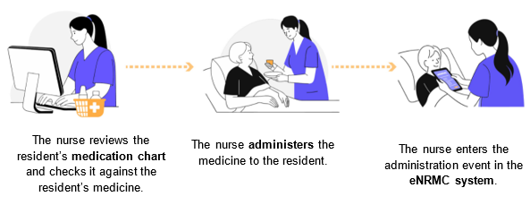

Figure 10 Workflow of a nurse at a RACH administering medicine and recording this medicine administration using an eNRMC

### Who can administer medications?

Medicine administration is governed by states and territories. It is strictly regulated for individual, public safety and quality of care. Approved residential aged care providers and their delegated managers and staff must comply with relevant legislation (i.e. state and territory medicines and poisons acts).

All regulated healthcare professionals (including pharmacists, medical practitioners, nurse practitioners, registered, and enrolled nurses) must comply with national, and local laws that govern their professional responsibilities, including medication management. Care workers may assist with medication management under the supervision of registered nurses, provided they follow local policies, receive appropriate training, and adhere to specific guidelines.

For a best practice checklist for safe medication administration, see section 5.2 of the department and ACQSHC’s [eNRMC Software vendor information resource](https://www.safetyandquality.gov.au/our-work/medication-safety-and-quality/electronic-medication-charts/electronic-national-residential-medication-chart).

#### Self-administration

Medication in a RACH may be administered by a healthcare professional or self-administered by the resident. Self-administration is when a person can take their own medicines. Detailed guidance on self-administration can be found under Guiding Principle 14: Self-administration of medicines within [Guiding Principles for Medication Management in Residential Aged Care Facilities](https://www.health.gov.au/resources/publications/guiding-principles-for-medication-management-in-residential-aged-care-facilities?language=en).

Staff must record self-administration in the resident’s eNRMC as such, eNRMC systems must enable the capture of self-administered medicines.

## When is two-nurse signing (double-checking) required?

eNRMC systems must support two-nurse signing for certain medicines. In residential aged care, “double-checking” is a safety process where two healthcare professionals independently verify medication details as per the six ‘rights’ of medication administration before administration. This acts as a second layer of verification to reduce errors and ensure safe medication administration.

The credentials of the first and second nurse authorising and administering the pharmaceutical benefits are required for:

* Insulin (non-Pro Re Nata) (non-PRN)
* Variable dose (non-insulin)
* Schedule 8 (controlled)

Two-nurse signing is also required for scripts requested for supply before presentation of a prescription. See also section 3.5 Supplying medication before presentation of a prescription (urgent supply).

## What to do with remaining dispensed medicine when the resident’s eNRMC has ceased

Table 55shows what to do with any medicine that is remaining after an eNRMC has ceased.

Table 55 Situations where medicine may remain after an eNRMC ceases

| Situation – Chart has ceased | Action |
| --- | --- |
| **Scenario 1**: The course of medication is complete. | 1. Dispose of any remaining medicine appropriately. |
| **Scenario 2**: The course of medication has not been completely administered, and further treatment is required in the next chart. The full course has been previously dispensed. | 1. Prescriber creates a new chart for the resident.  2. GP or pharmacist can create an administration-only order in the resident’s new chart to administer the remaining medicine. |
| **Scenario 3**: The resident requires additional treatment in the new chart and an additional supply from the pharmacist (i.e. another pack). | 1. Prescriber creates a new chart for the resident.  2. Prescriber creates a new medicine order and prescription using the new chart.  3. Once order and prescription are created on the new chart, nursing staff can administer any remaining doses from the previous supply before pharmacists dispense the new pack. |

## Processes for regular review

RACHs should have processes in place to ensure medication reviews are conducted regularly including:

* at the commencement of care, are transitions of care and annually when care is ongoing
* when there is a change in diagnosis or deterioration in behaviour, cognition, or mental or physical condition or when a person is acutely unwell
* when there is polypharmacy and the potential to deprescribe when a new medicine is commenced
* a change is made to an existing medicine or medication management plan when there is an adverse event potentially related to medicines.

# Glossary

| Term | Meaning |
| --- | --- |
| Chart Identifier | An identifier that is used to group one or more electronic prescriptions from the same medication chart. |
| Chart-based electronic prescriptions | A chart-based electronic prescription (sometimes referred to as an electronic medication chart prescription) is generated from an active electronic medication chart (e.g. a resident’s eNRMC) via an electronic medication chart prescribing system (e.g. eNRMC system). The chart-based electronic prescriptions will have a chart identifier which is used to group one or more chart-based electronic prescriptions from the same medication chart. |
| Consumer | Recipient of care. |
| Dose administration aid (DAA) | A device or packaging system such as blister packs, bubble packs or sachets for organising doses of medicines according to the time of administration. |
| Electronic medication chart order | An order for a medication created in a resident’s electronic medication chart. Includes important information about the medication and instructions for administration. Medication cannot be administered to the resident without a corresponding order on their chart.  If the medication requires a prescription, the eNRMC will generate an electronic prescription which is sent to the NPDS and the pharmacist will use this to dispense the medication.  If the pharmacist is not required to supply the medication (e.g. the medication has been dispensed separately), an order may be created by the pharmacist for “administration purposes only”. |
| Electronic prescribing | The process by which a prescription is electronically generated by a prescriber and securely transmitted to a prescription delivery service for dispensing and supply, downloaded by a supplier, seamlessly integrated into the dispensing software and, in the case of Australian government subsidised prescriptions, available to be electronically sent to Services Australia for claiming purposes.  Note: This definition does not preclude the use of paper processes to support electronic prescribing activity. |
| Electronic prescription | Electronic clinical documents that contain all information relating to an order to supply medicine to an individual. An electronic prescription is generated electronically by a prescriber, authenticated, securely transmitted (either directly or indirectly) for dispensing and supply, integrated into dispensing software and, in the case of Pharmaceutical Benefits Scheme (PBS) prescriptions, available to be sent electronically to Services Australia for claiming purposes. The prescription resides in the NPDS.  Note: This definition does not preclude the use of other processes or artefacts to support e- Prescribing. |
| eNRMC | An electronic medication chart for residents in aged care homes that is generated, managed, and stored in an eNRMC system.  The chart can legally be used to prescribe, supply, claim and track administration of Pharmaceutical Benefits Scheme (PBS) and Repatriation Pharmaceutical Benefits Scheme (RPBS) medicines. The chart also includes a resident’s medication-related information, such as allergies. A resident’s eNRMC is a single source of truth for their medication information. |
| eNRMC system | A type of electronic medication management system used exclusively in residential aged care services, including NATSIFAC and MPS services. It enables electronic medication charting functions, such as:   * Recording intended pharmacological treatment of a resident * Ordering and prescribing medicines for a resident * Allowing pharmacists to review and annotate all medicine orders and view other key information * Recording the administration of medications to a resident according to a schedule * Recording other necessary clinical and resident information, such as allergies.   eNRMC systems connect to the national electronic prescribing infrastructure (including the NPDS) and generate legal PBS prescriptions for supply and claiming purposes. They are approved by the Australian Digital Health Agency as conformant with the latest version of the electronic prescribing conformance profile and are listed on the Agency’s Electronic Prescribing – External Conformance Register. |
| General electronic prescription | A general electronic prescription (or community prescription) is generated from a conformant electronic prescribing system. |
| Interim Residential Care Medication Administration Charts | A temporary medication chart used in some jurisdictions, to support the safe administration of medicines to residents in aged care facilities during transitions of care—typically following discharge from a hospital or other health service.  **Note**: is not used nationally and its legal status and implementation may vary between states and territories. Health professionals should refer to **local policies and guidelines** to determine its applicability. |
| Medication chart | A grouping of individual prescriptions and provides capacity to record medicines administration events and additional information to support a resident’s care. For example, this information includes a resident’s weight, allergies and adverse drug events and information to support the calculation of variable dose medicines (e.g. INR blood test results). |
| National Prescription Delivery Service (NPDS) | The national e-Health service contracted by the Commonwealth or Agency that supports defined interfaces and services to facilitate the transfer of electronic prescriptions for persons and related information between participating systems. |
| Paper prescription | A printed prescription that has been physically signed by a prescriber. |
| Prescription | A legal document that a registered health practitioner writes for a pharmacist to dispense a specific medicine.  PBS prescription: For medicines that are subsided by the Australian Government and available to residents with a Medicare card.  Private prescription: For medicines that are not subsidised under the PBS or RPBS. The cost can vary between pharmacies and the full price of the medicine is charged to the resident. A portion of the cost may be claimable from a resident’s private health insurer. |
| Resident | A person who resides at a Residential Aged Care Home. Also considered a consumer/recipient of care. |
| Residential Aged Care Home (RACH) | An aged care home (sometimes known as a nursing home or residential aged care facility or service) is for older people who can no longer live at home and need ongoing help with everyday tasks or health care.  Also known as Residential Aged Care Facility (RACF) / Residential Aged Care Service (RACS).  For the purposes of eNRMC policy, includes MPS and NATSIFAC Program services that provide residential aged care. |
| Residential Aged Care Provider | An organisation or entity responsible for operating one or more Residential Aged Care Homes (RACHs). Providers are accountable for ensuring safe, compliant, and high-quality care delivery, including the implementation and governance of systems like eNRMC. They oversee staffing, clinical care, medication management, and adherence to aged care regulations and standards. |
| Servicing Pharmacy | A pharmacy that is approved to dispense medications covered by the PBS. They can handle prescriptions and make claims for subsidies associated with those medications. |
| Token  (or “evidence of prescription”) | In the context of electronic medication charting, refers to an electronic key, also known as the DSPID (e.g. barcode, QR code, number/letter sequence) that corresponds to a chart-based electronic prescription OR to an entire electronic medication chart. The token is used to access a chart-based electronic prescription or chart by a pharmacist. A token may or may not be provided with other prescription information.  For a chart-based electronic prescription token, the token is linked to the individual electronic medication chart order. It is displayed on the resident’s eNRMC.  For an electronic medication chart token, the token correlates to the chart identifier and is a grouping token, linked to the entire associated electronic medication chart and all medication chart orders. It is displayed on the resident’s eNRMC.  A pharmacist can scan either of these tokens to retrieve the resident’s prescription details from the NPDS and/or automatically populate the relevant fields in the dispensing record. Scanning the electronic medication chart token will enable the pharmacist to retrieve the details of all active prescriptions at once. |

# References and further reading

Legislation

Legislation that governs eNRMC systems:

* Electronic Prescriptions Information Technology Requirements 2019.

Link: <https://www.health.gov.au/resources/publications/electronic-prescriptions-information-technology-requirements-instrument-2019?language=en>

* National Health (Pharmaceutical Benefits) Electronic National Residential Medication Charts Approval Instrument 2025.
* Link: <https://www.legislation.gov.au/F2025N00483/latest/text>
* National Health (Pharmaceutical Benefits) Regulations 2017.

Link: <https://www.legislation.gov.au/F2017L00313/2023-04-01/text>

* National Health (Supply of Pharmaceutical Benefits- Under Co-payment Data and Claims for Payment) Rules 2022.

Link: <https://www.legislation.gov.au/F2022L00436/latest/text>

Other eNRMC resources

Support resources developed by the department and the ACQSHC

#### eNRMC Guide and Workbook for safe implementation in residential aged care facilities

For organisations looking to adopt an eNRMC system. The guidance can be applied to all types of RACH settings, whether a single site or part of a larger provider network.

The guide’s focus is on RACHs that wish to transition from a paper-based or hybrid (electronic and paper) medication management system to an eNRMC system.

Link: <https://www.safetyandquality.gov.au/publications-and-resources/resource-library/electronic-national-residential-medication-chart-medication-management-systems-your-guide-safe-implementation-residential-care-facilities>

#### eNRMC software vendor information resource

Supports vendors to identify opportunities for eNRMC system enhancement, with the aim of delivering safer medication management and improved quality use of medicines.

Link: <https://www.safetyandquality.gov.au/publications-and-resources/resource-library/electronic-national-residential-medication-chart-medication-management-systems-software-vendor-information-resource>

eNRMC Transitional Arrangement resources

**Australian Digital Health Agency - Transitional eNRMC Conformance Register**

Link: <https://www.digitalhealth.gov.au/about-us/policies-privacy-and-reporting/registers>

**National Health (Electronic National Residential Medication Chart Trial) Special Arrangement 2018**

Link: <https://www.legislation.gov.au/F2018L01004/latest/text>

The department previously published targeted information packs on the eNRMC Transitional Arrangement:

**Aged Care staff**

Link: <https://www.health.gov.au/resources/publications/electronic-national-residential-medication-chart-enrmc-transitional-arrangement-residential-aged-care-services-information-pack?language=en>

**Pharmacists**

Link: <https://www.health.gov.au/resources/publications/electronic-national-residential-medication-chart-enrmc-transitional-arrangement-pharmacy-information-pack?language=en>

**Prescribers**

Link: <https://www.health.gov.au/resources/publications/electronic-national-residential-medication-chart-enrmc-transitional-arrangement-prescriber-information-pack?language=en>

**Software vendors**

Link: <https://www.health.gov.au/resources/publications/electronic-national-residential-medication-chart-enrmc-transitional-arrangement-electronic-medication-management-emm-vendor-information-pack?language=en>

Paper National Residential Medication Chart (NRMC) resources

The ACQSHC has developed separate NRMC User Guides for prescribers, nursing staff and pharmacists.

**User guide for nursing staff**

Link: <https://www.safetyandquality.gov.au/publications-and-resources/resource-library/national-residential-medication-chart-user-guide-nursing-staff>

**User guide for pharmacists**

Link: <https://www.safetyandquality.gov.au/publications-and-resources/resource-library/national-residential-medication-chart-user-guide-pharmacists#:~:text=The%20National%20Residential%20Medication%20Chart,Pharmaceutical%20Benefits%20Scheme%20(RPBS)>.

**User guide for prescribers**

Link: <https://www.safetyandquality.gov.au/publications-and-resources/resource-library/national-residential-medication-chart-user-guide-prescribers>

Clinical guidelines and other information

**Aged Care Quality and Safety Commission – Aged Care Quality Standards (i.e. Standard 3, Personal care and clinical care).**

Link: <https://www.agedcarequality.gov.au/providers/quality-standards>

**Aged Care Quality and Safety Commission – Service and Reports.**

Link: <https://www.agedcarequality.gov.au/service-and-reports>

**Australian Commission on Safety and Quality in Health Care – consent for medication in aged care.**

Link: <https://www.agedcarequality.gov.au/sites/default/files/media/consent-for-medication-in-aged-care-fact-sheet_0.pdf>

**Australian Digital Health Agency – Schedule 8 quick reference guide for electronic prescriptions.**

Link:<https://www.digitalhealth.gov.au/sites/default/files/documents/schedule_8_quick_reference_guide_for_electronic_prescriptions.pdf>

**Australian Health Practitioner Regulation Agency – Procedure to respond to a breach of privacy.**

Link:<https://www.ahpra.gov.au/search.aspx?profile=ahpra&query=procedure%20to%20respond%20to%20a%20breach%20of%20privacy&collection=ahpra-websites-web&f.Content+type%7Ccontent=procedure>

**Department of Health, Disability and Ageing – Medication management in residential aged care facilities – Guiding Principles.**

Link: <https://www.health.gov.au/resources/publications/guiding-principles-for-medication-management-in-residential-aged-care-facilities?language=en>

**Department of Health, Disability and Ageing – Achieving continuity in medication** **management – Guiding principles.**

Link: <https://www.health.gov.au/resources/collections/guiding-principles-to-achieve-continuity-in-medication-management-collection>

**Department of Health, Disability and Ageing – Eligibility for 60-day prescriptions.**

Link: <https://www.health.gov.au/cheaper-medicines/about-cheaper-medicines>

**Department of Health, Disability and Ageing – Electronic Prescriptions Privacy Policy.**

Link: <https://www.health.gov.au/resources/publications/electronic-prescriptions-privacy-policy?language=en%20%E2%80%93>

**Department of Health, Disability and Ageing – Managing temporary leave for residential aged care.**

Link: <https://www.health.gov.au/our-work/residential-aged-care/managing-residential-aged-care-services/managing-temporary-leave-for-residential-aged-care>

**Department of Health, Disability and Ageing – Strengthened Aged Care Quality standards**.

Link: <https://www.health.gov.au/resources/publications/strengthened-aged-care-quality-standards-february-2025>

**Department of Health, Disability and Ageing – Who can prescribe medicines.**

Link: <https://www.health.gov.au/topics/medicines/about-prescriptions#who-can-prescribe-medicines>

**Pharmacy Board of Australia – Joint statement on professional responsibilities for prescribing and dispensing medicines.**

Link: <https://www.pharmacyboard.gov.au/Codes-Guidelines/Joint-statement-on-professional-responsibilities.aspx>

**Pharmacy Board of Australia – Releases revised guidelines for pharmacists.**

Link: <https://www.pharmacyboard.gov.au/News/2015-10-02-revised-guidelines.aspx>

**Royal Australian College of General Practitioners – Medical Records.**

Link: <https://www.racgp.org.au/running-a-practice/security/managing-practice-information/privacy-of-health-information/information-management-for-gp/medical-records>

Technical resources

**Australian Digital Health Agency – Aged Care Transfer Summary – Conformance Profile v1.2.**

Link: <https://developer.digitalhealth.gov.au/resources/aged-care-transfer-summary-conformance-profile-v1-2>

Services Australia has published useful webpages that support claiming and health care provider registration:

**Apply for PBS Authority.**

Link: <https://www.servicesaustralia.gov.au/apply-for-pbs-authority?context=20>

**Submit PBS claims for pharmacy.**

Link: <https://www.servicesaustralia.gov.au/how-to-submit-pharmaceutical-benefits-scheme-pbs-claims-for-pharmacy?context=20#accordion3>

**HI Service for individual health care providers**.

Link: <https://www.servicesaustralia.gov.au/healthcare-identifiers-hi-service-for-individual-health-care-providers?context=20#:~:text=There%20are%202%20ways%20to%20get%20a,Service%20using%20Health%20Professional%20Online%20Services%20(HPOS>)

**Register as a health care provider organisation.**

Link: <https://www.servicesaustralia.gov.au/register-health-care-provider-organisation-for-hi-service?context=20>

Programs

**Department of Health, Disability and Ageing – Aged care on site pharmacist (ACOP).**

Link: <https://www.health.gov.au/our-work/aged-care-on-site-pharmacist>

**Department of Health, Disability and Ageing – General Practice in Aged Care Incentive (GPACI).**

Link: <https://www.health.gov.au/our-work/gpaci>

**Pharmacy Programs Administrator – Residential Medication Management Review (RMMR) and Quality Use of Medicines (QUM).**

Link: <https://www.ppaonline.com.au/programs/medication-management-programs/residential-medication-management-review-and-quality-use-of-medicines>

Contacts

The department encourages users to contact their eNRMC software vendor for questions about their system functionality or user interface.

Contact details for each government organisation, and the relevant topics for eNRMC related enquiries, are provided in Table 6 below.

Table 6 Contact details for relevant enquiries

| Organisation | Topics | Contact | |
| --- | --- | --- | --- |
| Department of Health, Disability and Ageing | Policy and legislation | [enrmc@health.gov.au](mailto:enrmc@health.gov.au) | |
| Australian Digital Health Agency | Conformance and testing | [Help@digitalhealth.gov.au](mailto:Help@digitalhealth.gov.au) | |
| Australian Commission on Safety and Quality in Health Care | Medicine safety and QUM | [medsafety@safetyandquality.gov.au](mailto:medsafety@safetyandquality.gov.au) | |
| Aged Care Safety and Quality Commission | Aged Care Service Regulation, Complaints | [info@agedcarequality.gov.au](mailto:info@agedcarequality.gov.au) | |
| Services Australia | PBS/RPBS Claiming information requirements, Authorities | PBS Online claiming – PBS General Enquiry Line 132 290  PBS Authorities – 1800 888 333  RPBS Authorities – 1800 552 580  or  [PBS.Authorities.Systems@servicesaustralia.gov.au](mailto:PBS.Authorities.Systems@servicesaustralia.gov.au)  Software developers – 1300 550 115 or [pbsonline@servicesaustralia.gov.au](mailto:pbsonline@servicesaustralia.gov.au) | |
| States and Territories | Jurisdiction specific legislation, for example, non-PBS medications, administration | ACT | - Canberra Script - [canberrascript@act.gov.au](mailto:canberrascript@act.gov.au)  - Health Pharmaceutical Services - [PSS@act.gov.au](mailto:PSS@act.gov.au) | |
| NSW | [MOH-PharmaceuticalServices@health.nsw.gov.au](mailto:MOH-PharmaceuticalServices@health.nsw.gov.au) | |
| NT | [poisonscontrol@nt.gov.au](mailto:poisonscontrol@nt.gov.au) | |
| QLD | [medicines.legislation@health.qld.gov.au](mailto:medicines.legislation@health.qld.gov.au) | |
| SA | TBA | |
| TAS | [pharmserv@health.tas.gov.au](mailto:pharmserv@health.tas.gov.au) or (03) 61 66 0400 | |
| VIC | TBA | |
| WA | TBA | |

For more information on the roles and responsibilities of each organisation please refer to section 1.5.1 Government Agencies.

Technical support

eNRMC software vendors provide technical support, training and help to all eNRMC users, including RACH staff, prescribers and pharmacists (contracted and non-contracted as required). A range of technical support information should also be made available through their websites.

Dispensing vendors may provide more support to pharmacists who dispense using their software.

Health.gov.au

All information in this publication is correct as of 14 August 2025