COVID-19 outbreaks in Australian residential aged care homes

National snapshot
As at 8:00 am 7 August 2025, there are 685 active COVID-19 cases reported in 134 active outbreaks in residential aged care homes (RACHs) across Australia. There have been 49 new outbreaks, 5 new resident deaths and 991 combined new resident and staff cases reported since 31 July 2025.
Table 1: Aged Care COVID-19 data as at 8.00am 7 August 2025
Category | Active | Change in active (7 days) | Cumulative  Total | Cumulative increase (7 days)
Outbreaks | 134 | -24 | 26,841 | 49
RACHs affected | 134 | -24 | 2,922 | 1
Resident cases | 474 | -144 | 256,642 | 711
Resident deaths | N/A | N/A | 7,551 | 5
Staff cases | 211 | -23 | 132,259 | 280
Residential aged care homes with active outbreaks are included in Appendix.
Data collected from 31 March 2020 including retrospective data on outbreaks and cases from 18 February 2020.
Table 2: Overview of active outbreaks in Australia
 | ACT | NSW | NT | QLD | SA | TAS | VIC | WA | Total
Total RACHs with outbreaks | 1 | 46 | 0 | 26 | 17 | 2 | 28 | 14 | 134
Total number of active resident cases | 0 | 169 | 0 | 87 | 92 | 3 | 88 | 34 | 474
Total number of active staff cases | 1 | 71 | 0 | 45 | 28 | 2 | 41 | 23 | 211
Total outbreaks opened in previous 7 days | 0 | 12 | 0 | 19 | 20 | 1 | 15 | 5 | 77
Total outbreaks closed in previous 7 days | 1 | 24 | 0 | 15 | 6 | 3 | 21 | 6 | 76
Figure 1: National outbreak trends in aged care – December 2021 to present
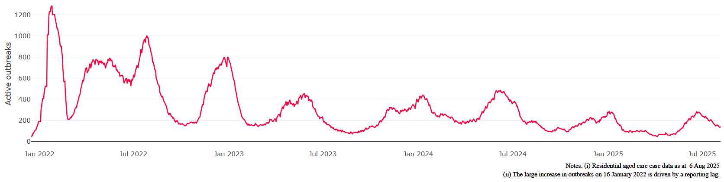
Figure 2: Trends in aged care cases – December 2021 to present
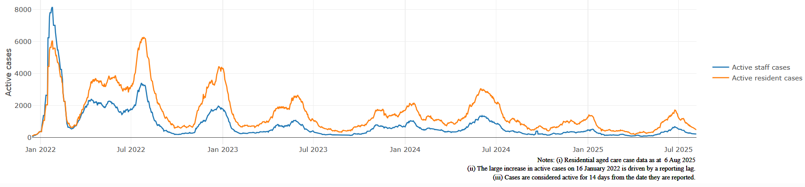

Mortality
For the period of 1 January 2025 to 2 August 2025, COVID-19 is recorded as the cause of death in 0.9% of all deaths in permanent residents in aged care homes.
Since the beginning of the Omicron outbreak in mid-December 2021, there have been 224,776 deaths in residential aged care from all causes (report period from 15 December 2021 to 2 August 2025). COVID-19 deaths account for 3.0% of this figure.
There has been a decrease year on year for the rate of case fatality, from a 33% case fatality rate in resident COVID-19 cases in 2020 to 3.3% in 2022 and 1.5% in 2025.
Over the course of the pandemic, all-cause excess mortality in residential aged care was below expected numbers in 2020, and within expected range in 2021. In the first half of 2022, all-cause excess mortality in residential aged care was above the expected range. Excess mortality for the second half of the 2022 is yet to be finalised.
Figure 3: COVID-19 deaths in RACHs overlaid with community deaths
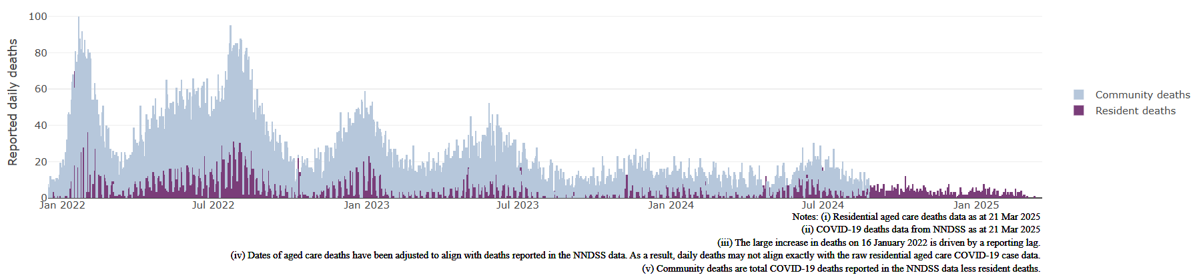

Workforce in active residential aged care outbreaks
As at 6 August 2025, surge workforce providers report a total of 202,643 shifts delivered in aged care services impacted by COVID-19. These shifts include roles for GPs, nurses, care workers, allied health workers, executive and ancillary staff. In the past week surge workforce providers have reported assisting 3 residential aged care home(s) and filled 38 shifts in aged care services.
Table 3: Workforce resources supplied to RACHs
Workforce provider | Total shifts | Previous 7 days
Aspen Medical⁸ | 34,108 | 0
Randstad⁹ | 1,524 | 38
Previous contracted providers¹⁰ | 167,011 | N/A
Total | 202,643 | 38
⁸Aspen Medical shift data as at 6 August 2025, reported fortnightly.
⁹Randstad shift data as at 6 August 2025, reported weekly.
¹⁰Previous contracted providers include RCSA, HealthCare Australia, HealthX, Mable and Torrens.

Oral antiviral treatments
Distribution of the oral anti-viral Lagevrio (Molnupiravir) commenced on 6 February 2022 to all RACHs with outbreak sites prioritised for delivery. The National Medical Stockpile has deployed 48,269 treatment courses of Lagevrio (Molnupiravir) to RACHs.
170,772 prescriptions for Lagevrio (Molnupiravir) have been issued to residents in RACHs, with a further 27,014 prescriptions for Paxlovid (nirmatrelvir + ritonavir) also issued since 28 February 2022 and up to 31 July 2025.
*Note: Oral antiviral data is only being updated monthly.

Vaccination in RACHs
On 27 March 2025, recommendations for 2025 COVID-19 vaccinations were released. Recommended doses for the program are based on an individual's age and level of severe immunocompromise.
Those aged 75 years and over are recommended to get a COVID-19 vaccine dose every 6 months. Those aged over 65 years of age, and adults with severe immunocompromise are recommended to receive a COVID-19 vaccine dose every 12 months and are eligible to receive a COVID-19 vaccine dose every 6 months based on individual risk-benefit assessments. All other adults can receive a single dose this year.
Recommendations can be found on the Department of Health and Aged Care (department) website at: ATAGI statement on the administration of COVID-19 vaccines in 2025
People are encouraged to seek vaccination advice from their healthcare providers, specific to their circumstances.
People living in residential aged care are a high priority for the Government’s COVID-19 vaccination program.
Older age remains the biggest risk factor for severe COVID-19 disease. Vaccination reduces the risk of severe disease and death from COVID-19.
The department is working with both the aged care and primary care sectors to ensure residents have access to the COVID-19 vaccine. The department continues to target support for RACHs to arrange COVID-19 vaccinations with local primary care providers such as GPs, community pharmacists and Aboriginal Community Controlled Health Services.
As at 6 August 2025:
- 72.1% of aged care residents have received a booster dose in the last 12 months.
- For residents over the age of 75:
  - 100,231 (57.4%) aged care residents received a booster dose in the last 6 months.
- 13,100 aged care residents have received a vaccination in the last 28 days (compared to 17,928 in the 28 days prior).

Table 4: Aged care COVID-19 Booster Doses (data as at 6 August 2025)
Jurisdiction | 75+ with booster in last 6 months
 | Residents vaccinated | % of residents vaccinated
National | 100,231 | 57.4%
NSW | 32,715 | 57.9%
VIC | 25,447 | 55.9%
QLD | 19,660 | 56.5%
WA | 9,527 | 58.5%
SA | 8,791 | 58.7%
TAS | 2,300 | 58.0%
ACT | 1,580 | 69.9%
NT | 211 | 52.0%
Data in this report is sourced from Australian Immunisation Register (AIR) data of residents in permanent residential aged care homes.
An updated data methodology was implemented on 14 March 2025. Aged Care AIR data as at 6 August 2025; Matched AIR data uses a snapshot of permanent residents in residential aged care homes as at 30 April 2025. The Residential Aged Care Home {RACH) Recipient ID to Medicare PIN linkage file was loaded into Health Enterprise Data Warehouse on
18 June 2025 which linked Medicare Consumer Directory data as at 30 June 2024 and RACH recipient data as at
15 March 2025.

Note: Booster doses in this report refer to any dose 2 or above administered to an individual.

Infection control and audit
The Aged Care Quality and Safety Commission (Commission) conducts site audits and assessment contacts (site and non-site) to monitor and assess residential aged care services against the Aged Care Quality Standards (see Table 5 below). This may include conducting infection control monitoring (ICM) spot checks.
An ICM spot check involves an on-site visit to residential aged care services, without an outbreak, to observe infection control practices, to ensure that staff, management, and visitors are adhering to safe personal protective equipment protocols and to safe infection control arrangements, as required under the Quality Standards.
As at 7 August 2025, the Commission had conducted 6,105 ICM spot checks to observe infection control practices and PPE protocols in RACHs.
Table 5: Total quality assessment and monitoring activities with residential services (including IPC), by type and month 1 March 2020 to 7 August 2025
Regulatory Activities | 2019-20  (1 Mar - 30 Jun 2020) | 2020-21 | 2021-22 | 2022-23 | 2023-24 | 2024-25 | 2025-26 (to 7 August) | Total
Site visits | 318 | 3,452 | 1,732 | 3,814 | 2,840 | 1,517 | 37 | 13,710
Non-site activities | 3,704 | 8,396 | 6,665 | 1,413 | 488 | 929 | 39 | 21,634
Total activities | 4,022 | 11,848 | 8,397 | 5,227 | 3,328 | 2,446 | 76 | 35,344

Appendix: National residential aged care homes (RACHs) with active outbreaks COVID-19
Please note, information reported in this table has been directly reported to the department by RACHs.
‘Total cases’ refers to all staff and resident cases associated with the active outbreak and may not reflect the count of currently active cases. Where numbers have been incorrectly reported, RACHs are able to correct these in the COVID-19 Support Portal through My Aged Care.
Where a RACH is reporting less than six resident or staff cases or less than six deaths, data has been suppressed to protect the privacy of affected individuals (note that “n/p” indicates data is not provided to protect privacy).
Data below for individual services is as at 7 August 2025.
Service Name | State | Resident Deaths | Resident Cases | Staff  Cases | Total Cases
Adria Village Ltd | Australian Capital Territory | 0 | 28 | 11 | 39
Abernethy Nursing Home | New South Wales | 0 | 8 | 6 | 14
Anglicare Farrer Brown Court | New South Wales | 0 | 10 | <6 | n/p
Australian Vietnamese Aged Care Services | New South Wales | 0 | 11 | <6 | n/p
BaptistCare Morven Gardens Centre | New South Wales | 0 | <6 | <6 | <6
Beresford Hall | New South Wales | 0 | <6 | 0 | <6
Bolton Clarke Bayside (PKA - Bayside Residential Aged Care Facility) | New South Wales | 0 | <6 | 0 | <6
Bolton Clarke Coastal Waters (PKA - Coastal Waters Aged Care) | New South Wales | 0 | <6 | <6 | n/p
Bupa Armidale | New South Wales | 0 | 19 | 8 | 27
Bupa Ballina | New South Wales | 0 | 34 | 16 | 50
Bupa Bankstown | New South Wales | 0 | <6 | <6 | <6
Bupa Baulkham Hills | New South Wales | 0 | <6 | <6 | <6
Catholic Healthcare Charles O'Neill Hostel | New South Wales | 0 | <6 | 0 | <6
Catholic Healthcare Holy Spirit Casula | New South Wales | 0 | 18 | 0 | 18
Chamberlain Gardens Aged Care | New South Wales | 0 | <6 | <6 | 8
Columbia Aged Care Services - Oberon Village | New South Wales | 0 | <6 | <6 | <6
Cooinda Aged Care | New South Wales | 0 | 9 | 11 | 20
Dellacourt | New South Wales | 0 | 21 | 12 | 33
Emily Gardens at the Rock | New South Wales | 0 | <6 | <6 | <6
Garden View Nursing Home | New South Wales | 0 | 7 | 0 | 7
HammondCare - Cardiff | New South Wales | 0 | <6 | 0 | <6
Heritage Kingswood | New South Wales | 0 | <6 | 0 | <6
Huang Ying Jung Nursing Home | New South Wales | 0 | 19 | <6 | n/p
Infinite Care Tweed | New South Wales | 0 | <6 | <6 | 7
IRT Tarrawanna Care Centre | New South Wales | 0 | <6 | 0 | <6
Mercy Place Albury | New South Wales | 0 | 20 | 7 | 27
Mountain View Lodge Hostel | New South Wales | 0 | 9 | <6 | n/p
Mudgee Grove Care Community | New South Wales | 0 | 26 | 14 | 40
Orange Grove Care Community | New South Wales | 0 | 18 | <6 | n/p
Regis Hornsby | New South Wales | 0 | 8 | 0 | 8
Regis Hurstville | New South Wales | 0 | 15 | 0 | 15
RFBI Armidale Masonic Village | New South Wales | 0 | 6 | <6 | n/p
Rutherford Park Care Community | New South Wales | 0 | 7 | <6 | n/p
Southern Cross Care John Woodward Residential Aged Care | New South Wales | 0 | 11 | <6 | n/p
Southern Cross Care Reynolds Court Residential Aged Care | New South Wales | 0 | <6 | <6 | 6
St Elizabeth Home | New South Wales | <6 | <6 | <6 | <6
St Joseph's Aged Care Facility Kensington | New South Wales | 0 | 18 | 9 | 27
St Josephs Nursing Home | New South Wales | 0 | <6 | <6 | <6
St Vincent's Care Services Auburn | New South Wales | 0 | <6 | 0 | <6
St Vincent's Care Services Heathcote | New South Wales | 0 | 10 | <6 | n/p
Tingira Hills Care Community | New South Wales | 0 | 8 | <6 | n/p
Toongabbie Terrace Care Community | New South Wales | 0 | 38 | 7 | 45
Uniting Gerringong | New South Wales | 0 | 28 | <6 | n/p
Uniting Lindsay Gardens Hamilton | New South Wales | 0 | 18 | 8 | 26
Warrigal Multi-Cultural Village | New South Wales | 0 | <6 | <6 | <6
Wenonah Lodge | New South Wales | 0 | <6 | <6 | 9
Winston Hillside Care Community | New South Wales | 0 | <6 | <6 | 7
501 Respite & Care Services | Queensland | 0 | <6 | 0 | <6
Blue Care Bundaberg Riverlea Aged Care Facility | Queensland | 0 | <6 | 8 | n/p
Blue Care Kingaroy Canowindra Aged Care Facility | Queensland | 0 | 6 | <6 | n/p
Bolton Clarke Pioneers | Queensland | 0 | <6 | <6 | <6
Bolton Clarke Sunset Ridge | Queensland | 0 | <6 | 0 | <6
Churches of Christ Toowoomba Aged Care Service | Queensland | 0 | 6 | 0 | 6
Cunnamulla Multi-Purpose Service | Queensland | 0 | <6 | <6 | 8
Harbour Quays Residential Aged Care | Queensland | 0 | <6 | <6 | <6
Infinite Care Ashmore | Queensland | 0 | <6 | 0 | <6
Infinite Care Mount Lofty | Queensland | 0 | <6 | <6 | <6
Kirra Beach Care Community | Queensland | 0 | 13 | <6 | n/p
Lutheran Services - Tabeel | Queensland | 0 | <6 | <6 | <6
Lutheran Services - Trinder Park | Queensland | 0 | <6 | 0 | <6
Lutheran Services - Wahroonga | Queensland | 0 | 17 | 8 | 25
Marebello | Queensland | 0 | 6 | <6 | n/p
New Auckland Place | Queensland | 0 | 7 | <6 | n/p
Ozcare Innisfail | Queensland | 0 | 13 | 10 | 23
Regis Ferny Grove | Queensland | 0 | <6 | 0 | <6
Rockpool RAC Morayfield | Queensland | 0 | 16 | 12 | 28
Southern Cross Care Facility Caloundra | Queensland | <6 | 9 | <6 | n/p
Southern Cross Care Nanango - Karinya | Queensland | 0 | 6 | 7 | 13
Southern Cross Care Raceview - St Mary's | Queensland | <6 | 14 | 8 | 22
Springwood Terrace Care Community | Queensland | 0 | 26 | <6 | n/p
St Paul de Chartres Residential Aged Care | Queensland | 0 | <6 | <6 | <6
St Vincent's Care Services Southport | Queensland | 0 | <6 | <6 | 7
Sunnymeade Park Aged Care Community | Queensland | 0 | <6 | <6 | 6
ACH Group Residential Care - Kapara | South Australia | 0 | 11 | 9 | 20
AnglicareSA Grange | South Australia | 0 | <6 | 0 | <6
Barunga Village Incorporated | South Australia | 0 | <6 | <6 | 6
Bene Aged Care - St Clair | South Australia | 0 | 9 | <6 | n/p
Bolton Clarke Charles Young | South Australia | 0 | 18 | <6 | n/p
Eldercare Allambi | South Australia | 0 | 21 | 7 | 28
Estia Health Encounter Bay | South Australia | <6 | 11 | 22 | 33
Estia Health Toorak Gardens | South Australia | 0 | <6 | <6 | <6
Fullarton Residential Care | South Australia | 0 | 26 | <6 | n/p
Klemzig Residential Care Services | South Australia | 0 | 7 | 0 | 7
Loxton District Nursing Home | South Australia | 0 | <6 | <6 | <6
Onkaparinga Lodge Residential Care | South Australia | 0 | <6 | 0 | <6
Regis Kingswood | South Australia | 0 | <6 | <6 | <6
UnitingSA Wesley House Aged Care | South Australia | <6 | <6 | <6 | 8
UnitingSA Westminster Village Aged Care | South Australia | 0 | <6 | <6 | <6
Walara Gilbert Valley | South Australia | 0 | 10 | <6 | n/p
Yeltana Nursing Home | South Australia | 0 | 14 | <6 | n/p
Mary Ogilvy Home (A) | Tasmania | 0 | 19 | <6 | n/p
Wynyard Care Centre | Tasmania | 0 | 16 | 10 | 26
Arcare Ringwood | Victoria | 0 | <6 | <6 | 6
Bolton Clarke Bayside (VIC) | Victoria | 0 | 6 | <6 | n/p
Bolton Clarke Claremont Terrace | Victoria | 0 | <6 | 0 | <6
Bolton Clarke Montclaire | Victoria | 0 | 17 | 10 | 27
Bolton Clarke Sutton Park | Victoria | 0 | <6 | 0 | <6
Bupa Croydon | Victoria | 0 | 25 | 26 | 51
Bupa Mildura | Victoria | 0 | <6 | 0 | <6
Churches of Christ Arcadia Aged Care Service | Victoria | 0 | 12 | 7 | 19
Doutta Galla Lynch's Bridge Aged Care Facility | Victoria | 0 | <6 | <6 | <6
Golden Oaks Nursing Home | Victoria | <6 | <6 | <6 | <6
Grace Villa Aged Care | Victoria | 0 | <6 | <6 | <6
Heathcote Health High Care Service | Victoria | 0 | <6 | <6 | <6
Homewood Residential Aged Care | Victoria | 0 | 15 | 0 | 15
Kilmore Grove Care Community | Victoria | 0 | <6 | <6 | <6
mecwacare Rositano House | Victoria | 0 | <6 | <6 | <6
mecwacare Trescowthick Centre | Victoria | 0 | 9 | <6 | n/p
Mercy Place Lynbrook | Victoria | 0 | <6 | 0 | <6
Mercy Place Mentone | Victoria | 0 | <6 | <6 | <6
Mercy Place Montrose | Victoria | 0 | <6 | 0 | <6
MiCare Overbeek Lodge | Victoria | 0 | <6 | 0 | <6
Moyne Health Services-Moyneyana House | Victoria | 0 | 20 | 9 | 29
Mt Eliza Gardens Aged Care | Victoria | <6 | 10 | 7 | 17
Myrtleford Multi-Purpose Service | Victoria | 0 | 13 | <6 | n/p
Robinvale Multi-Purpose Service | Victoria | 0 | 0 | <6 | <6
Rose Lodge | Victoria | 0 | 6 | 0 | 6
Vermont Views Care Community | Victoria | 0 | <6 | 0 | <6
WARRAGUL COMMUNITY AGED CARE | Victoria | 0 | 44 | 9 | 53
Yarraman Nursing Home | Victoria | 0 | <6 | <6 | 7
Aegis Parkview | Western Australia | 0 | 11 | <6 | n/p
Amana Living Lady McCusker Home | Western Australia | 0 | 7 | 0 | 7
Amana Living St George's Care Centre | Western Australia | <6 | <6 | 0 | <6
Brightwater The Cove | Western Australia | 0 | <6 | 0 | <6
Bunbury Gardens Care Community | Western Australia | 0 | 21 | 12 | 33
Carnarvon Multi-Purpose Service | Western Australia | 0 | <6 | <6 | <6
Corrigin Multi-Purpose Service | Western Australia | 0 | 8 | <6 | n/p
Craigcare Ascot Waters | Western Australia | 0 | <6 | <6 | 9
Esperance Aged Care Facility | Western Australia | 0 | <6 | <6 | <6
Juniper Hilltop | Western Australia | 0 | <6 | 0 | <6
Regents Garden Residential Aged Care Resort - Lake Joondalup | Western Australia | 0 | 13 | <6 | n/p
Rosewood Care West Perth | Western Australia | 0 | <6 | 0 | <6
Treeby Parklands Care Community | Western Australia | 0 | 17 | 9 | 26
Wattle Hill Lodge | Western Australia | 0 | 7 | <6 | n/p

Outbreak opening and closure includes changes in the status of exposure sites to outbreaks (and vice versa), which are applied retrospectively to facility records. New case information can also change the status of a recovered site back to an active outbreak site. As a result, changes in active outbreak status may not align with day-on-day variations to active totals. These adjustments will also affect the number of cases in staff and residents reported each week.
Active residents and staff cases are the total currently positive cases in active outbreaks.
An outbreak is considered to be active pending advice from the relevant Public Health Unit. An outbreak is defined as at least 1 (one) positive case in a resident or 2+ cases in staff.
The Omicron outbreak start date has been redefined from late November 2021 to mid-December 2021. Changes have been made to align reporting with the start date of Omicron published in the department’s external facing Epidemiology report.
The department is now accessing aged care deaths data from the SIEBEL dataset. Figures are live and subject to change. Source: Department of Health and Aged Care unpublished data / SIEBEL dataset.
Case fatality calculated as total reported resident COVID-19 deaths divided by total resident COVID-19 cases.

