BONDED RETURN OF SERVICE SYSTEM (BROSS)

**Participant User Guide**

**-Return of Service Obligation (RoSO)-**

**August 2025**

1. RoSO

# Entering a planned RoSO event

Under the Program you are required to enter a Planned RoSO event:

**For participants joining as a new student**: you must register a RoSO plan no later than the day you finish your medical course. You are required to log into BRoSS every 6 months from the completion date of your medical course to confirm or update the details of your RoSO plan.

**For opted-in former legacy scheme participants**: you must register a plan within 3 months from the date of opt-in. Thereafter, you are required to log into BRoSS every 6 months to confirm or update

the details of your RoSO plan .

When recording RoSO, you must meet the following legislated requirements:

* + - It must be eligible work in an eligible location.
    - Participants must plan, activate and complete their RoSO in BRoSS.
    - RoSO plans must be activated within 6 months of the plan’s start date.
    - RoSO plans must be completed within 3 months of the plan’s end date.
    - RoSO activation and completion evidence must meet the requirements outlined in the [Rule.](https://www.legislation.gov.au/F2019L01513/latest/text)

To plan a RoSO activity, click on the ‘**Plan a RoSO activity**’ button on the ‘**Manage my RoSO**’ page from your ‘**Dashboard**’, this will take you to the ‘**Plan a RoSO activity**’ page.

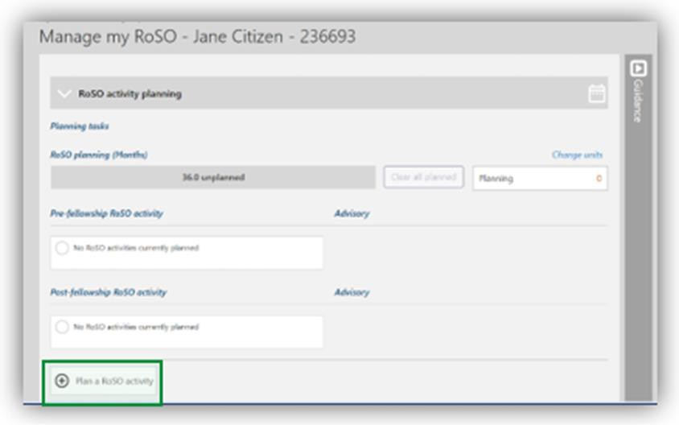

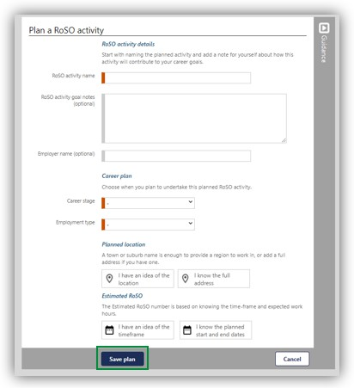

All mandatory fields are marked in orange, which includes:

**RoSO Activity Name**: when naming your RoSO activity provide a descriptive title for this specific RoSO activity. This could include the practice name and location.

**Career Stage**: as RoSO activities can be planned in advance, the career stage selection is to identify the stage in which the RoSO activity may be completed in.

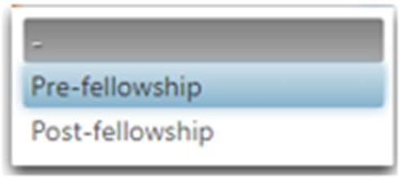

**Employment Type:** you can select one of the following employment types, this will need to match

your ‘**Expected hours per week**’ entered in the estimated RoSO information.

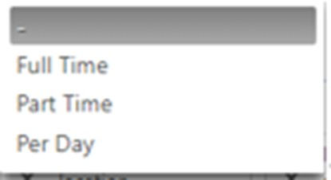

Work can be undertaken in the following basis:

**Full Time**: 35 hours or over per week.

**Part Time**: at least 20 hours, but less than 35 hours per week.

**Per Day**: less than 20 hours in a week.

**Planned location** can either be searched by selecting a generic search ‘**I have an idea of the location**’ button or entering the full address by selecting ‘**I know the full address**’.

BRoSS contains an in-bult eligible location search function. Participants can enter a town, suburb, or the full street address, and BRoSS will return an immediate assessment of the location eligibility depending on your individual circumstances. BRoSS will also let you know if that location is eligible for use towards scaling benefits.

When using the ‘**I have an idea of the location**’ selection, enter the suburb or town to get the planned MMM classification location eligibility.

When using the ‘**I know the full address**’ selection, enter the full address of the location into the

‘**Find an address**’ bar, pre-filled results will show below the bar, select the correct address by clicking on the relevant address from the drop-down menu.

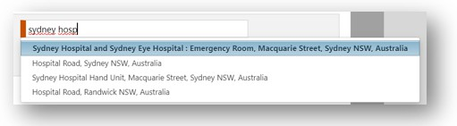

Once you have selected the location, BRoSS will inform you if the location is eligible by displaying a red, orange or green automated banner.

Once you have reached your Vocational phase, you can review your eligible DWS or DPA locations for your specialty in BRoSS. If BRoSS returns an ineligible location assessment you can request a review of location eligibility by selecting ‘**location override**’. This will automatically generate a case ticket in BRoSS for us to review .

Location overrides only exist for dual fellowship holders, or participants who are working in locations recently classified (e.g. before BRoSS is updated with new classifications). These location override requests are all individually assessed and verified before the location override is accepted.

Outside of these limited circumstances, we will decline all location override requests. All MM1 inner metropolitan locations are ineligible under the Program and will be denied.

**Estimated RoSO**: once you know the location is eligible you must enter the dates and hours for the RoSO activity. You can enter this using a proposed period for future RoSO planning that is not

confirmed by selecting the **‘I have an idea of the timeframe**’ button or if you know the exact period

by selecting the ‘**I know the planned start and end dates**’ button.

You will be required to enter the ‘**Commencement date**’, the ‘**Proposed completion date**’ and the

‘**Expected hours per week**’. Once these mandatory orange fields are completed select ‘**Calculate**’ this will display the amount of RoSO that can potentially be reduced from your obligation for this period of work.

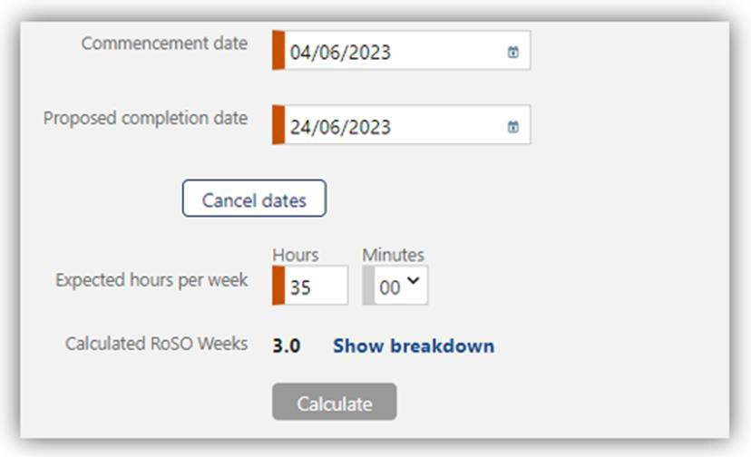

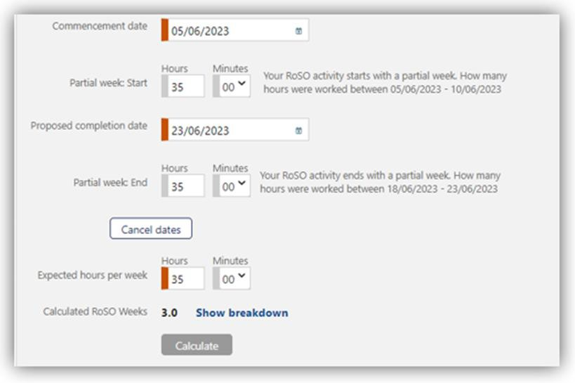

To finalise the plan, select ‘**Save Plan**’ at the bottom of the page.

BRoSS calculates a week from Sunday to Saturday. If your start date or end date falls on a day different to these, you will be asked to enter your ‘**Partial week’** hours for a specific period.

# Multiple location RoSO event

Under the Program, you can complete RoSO in any eligible location. This means that you may choose to work in more than one eligible location over the same period. For example:

* + - you regularly work hours in eligible location A and eligible location B.
    - you undertake ongoing locum and/or on call work across multiple eligible locations.
    - you deliver telehealth services, where both your location and the location of your patient receiving the service are eligible.

In these circumstances, it is recommended that you record your RoSO in BRoSS as a single RoSO plan with multiple locations. Doing so will ensure the RoSO displayed in BRoSS is calculated correctly.

When you register a RoSO plan in BRoSS, it only accepts a single location to be entered. After activating your RoSO plan in BRoSS, you can enter additional locations to your plan. Your activation evidence will need to detail your work at each location entered.

You can edit and update a current plan, which includes entering additional locations. When doing so, please ensure you also upload the required evidence to support the update.

When activating your RoSO plan or editing a current RoSO plan, click on *Add a full address* to enter an additional location.

# Edit a planned RoSO event

You can edit a ‘**Planned RoSO activity**’ at any time by clicking on the RoSO activity name in blue text in the ‘**RoSO Activity planning**’ accordion.

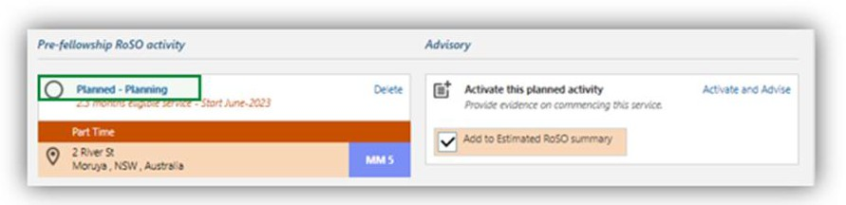

Click the ‘**Edit**’ button on the ‘**Planned RoSO activity**’ page to edit the details, then click ‘Save’ to update the ‘**Planned RoSO activity**’.

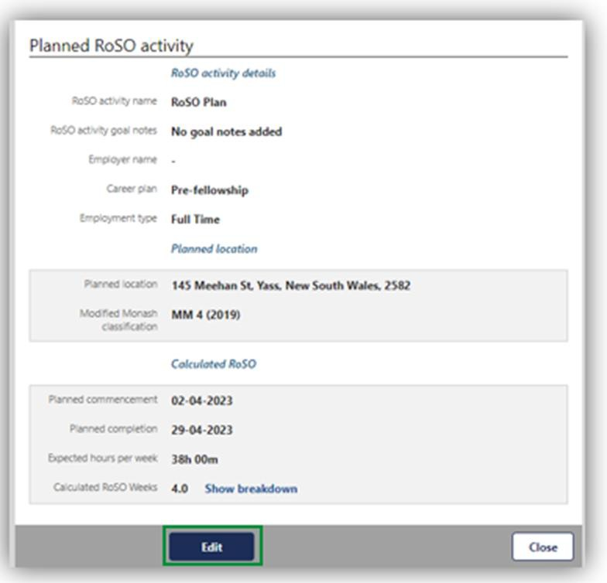

Edit all the required information and click ‘**Save**’.

# Activating your planned RoSO event

To activate a previously planned RoSO event, open your ‘**Manage my RoSO**’ page by clicking on the ‘**Plan my RoSO**’ button. RoSO plans must be activated within 6 months of the plan’s start date.

Evidence to be uploaded must be either a signed contract or a signed letter of agreement from your employer that confirms an eligible location has been selected, and includes the following

information:

* + - name of the bonded participant.
    - commencement date.
    - expected completion date of employment.
    - position name.
    - employer name.
    - employer address.
    - primary locations of work.
    - number of hours employed each week.

If you are unable to provide the evidence outlined, you may provide a statutory declaration that includes all the required information.

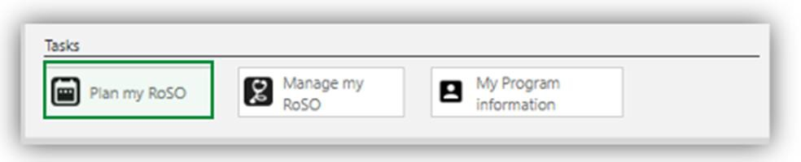

Under the ‘**RoSO activity planning**’ accordion, it will show all your planned RoSO events. When you are ready to activate/commence your plan, click on the ‘**Activate and Advise**’ link.

A pop-up window will show to confirm you wish to activate this RoSO plan. To continue click ‘**OK**’.

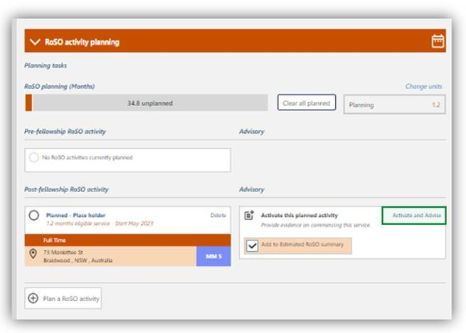

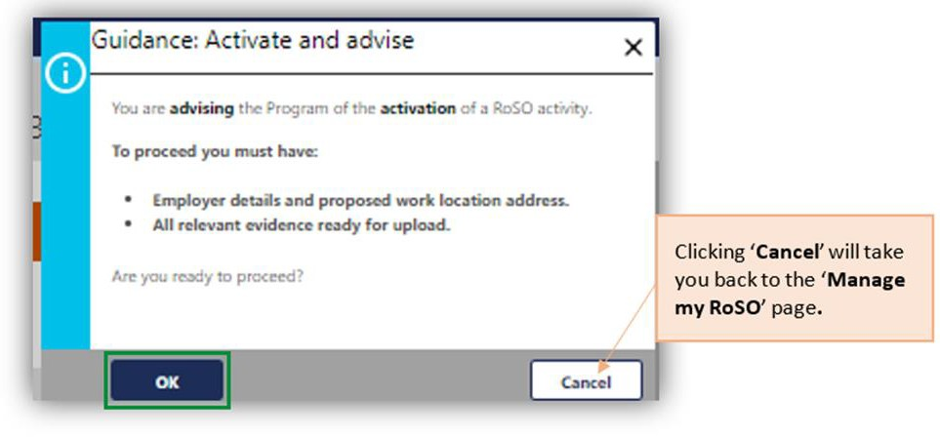

After clicking **‘OK’** the **‘Advisory: Activate a RoSO activity’** page will open for you to update and enter additional mandatory orange field information before saving.

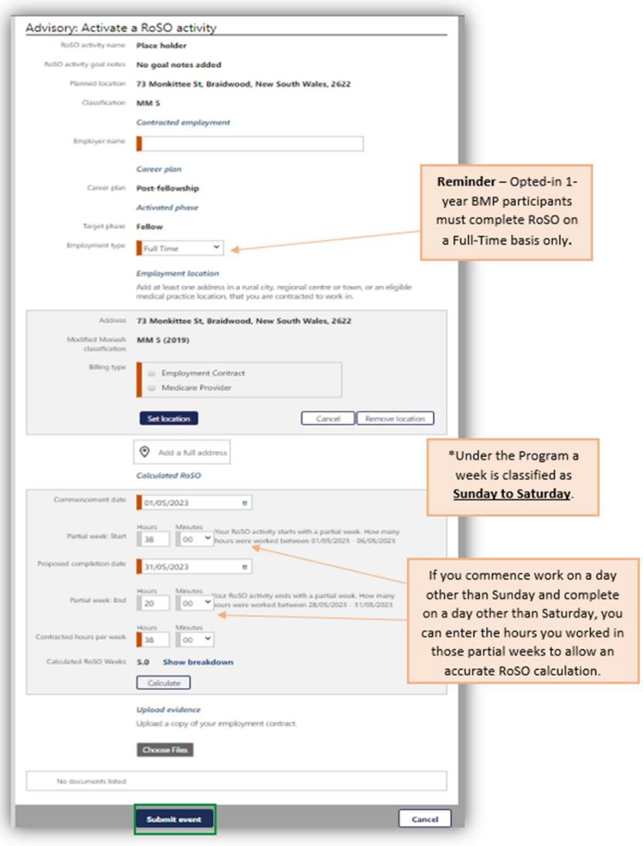

# Edit your current Activated RoSO event

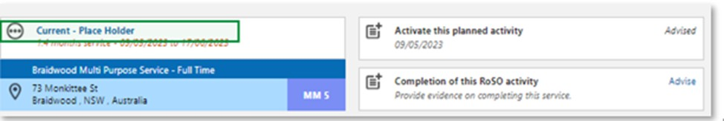You can edit your current activated RoSO activity at any time by clicking on the RoSO activity name in the relevant phase accordion.

Click the ‘**Edit**’ button on the ‘**Activated RoSO activity**’ page to edit the details, then click ‘**Save**’ to update the Planned RoSO activity.

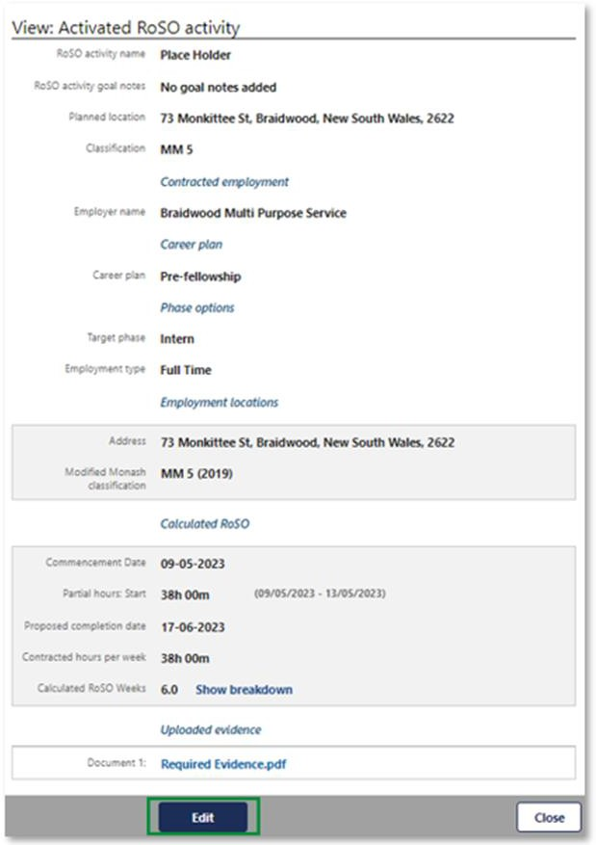

# Entering Per-Day RoSO in a current RoSO event

Under the Program, you can complete your RoSO on a full time, part time, or per day basis. The type of RoSO plan you create and how you record your work hours will depend on how you are employed and how many hours you work each week.

For all three plan types, the maximum RoSO that you can accrue in any given week is one week. BRoSS calculates a week from Sunday to Saturday.

* + - **Full time:** you can accrue one week of RoSO on a full-time basis if you have undertaken eligible work in an eligible location for at least 35 hours or more in that week.
    - **Part time:** you can accrue one week of RoSO on a part time basis if you undertake eligible work at an eligible location for at least 20 hours, but less than 35 hours, in that week.
    - **Per day:** you can accrue one week of RoSO on a per day basis if you undertake 20 hours of eligible work in an eligible location over two or more days. Unlike full time or part time plans, there is no requirement for per day work to be undertaken within a single week. The hours you work and record in BRoSS will be banked in the system. Once you reach 20 hours of eligible work you will be credited one week of RoSO.

Per day RoSO plans can be entered when:

* + - you regularly work less than 20 hours per week in an eligible location.
    - you work fluctuating hours, and do not consistently meet the definition of part time or full time.
    - you work as a contractor or locum, with periods of unpaid leave that is not counted as RoSO.
    - you work in a telehealth role, delivering services to patients in both eligible and ineligible locations, so the amount of work considered eligible for RoSO can fluctuate daily.

To update a per day basis plan, open your ‘**Manage my RoSO’** page and click on the blue RoSO activity title.

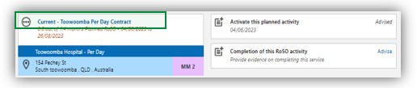

This will allow you to update your daily hours and locations via the ‘**View: Activated RoSO activity**’. Scroll to the bottom to view the ‘**Hours by week**’ section. Click ‘**Edit**’ against your current week to enter your hours and locations.

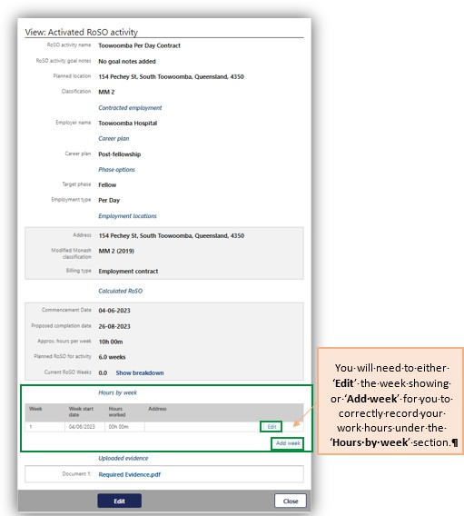

If your work week does not show, you can add additional weeks by clicking ‘**Add week’** link.

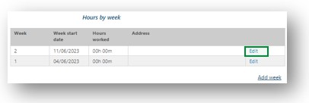

Click on the ’**Edit**’ link of the week you need to update.

The ‘**Edit week entry’** page will open.

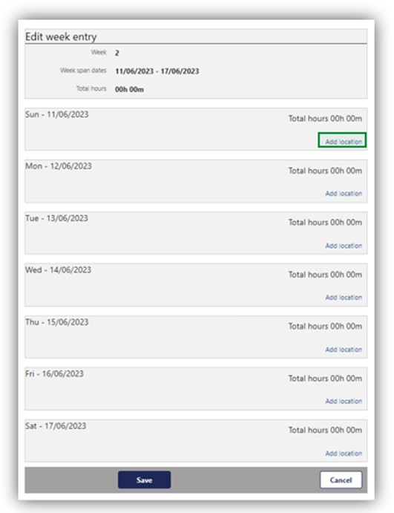

Click on the ‘**Add location’** link and enter the hours and location(s) worked that day from the dropdown menu.

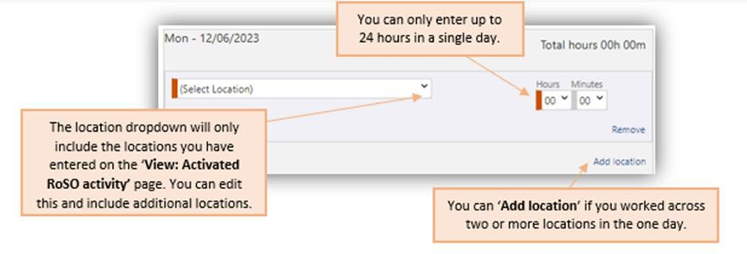

Once you have entered all your data for the day(s)/week, click ‘**Save**’ at the bottom of the page. You will be taken back to your ‘**View: Activated RoSO activity**’ page.

Your ‘**Current RoSO weeks**’ will show once you have accumulated greater than 20 hours of RoSO.

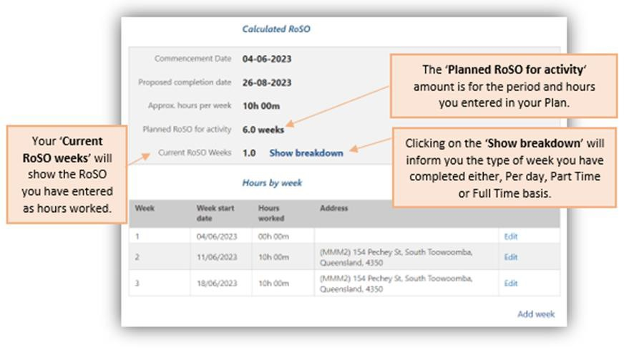

# Completing current RoSO event

To update you current RoSO activity with your completion information, go to your **‘Manage my RoSO’** page and then open the relevant phase accordion for your RoSO activity. RoSO plans must be completed within 3 months of the plan’s end date. Evidence to be uploaded must be from your

employer and show work has been completed in accordance with your signed employment contract or letter of employment.

If you are unable to provide the evidence outlined, you may provide a statutory declaration that includes all the required information.

Once you have your current RoSO event on the page, click the ‘Advise’ link on the ‘Completion of this RoSO activity’ tile.

You are required to update BRoSS within 3 months after your RoSO activity completion date.

A pop-up for the ‘Guidance: Completion of this RoSO activity’ page will show to ensure you have the correct information before you proceed. If you are ready to proceed, click the ‘OK’ button.

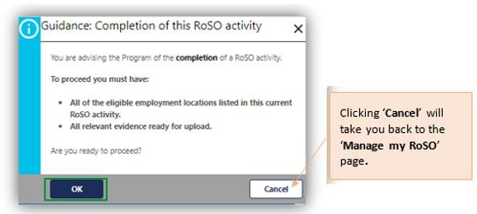

In the ‘**Advisory: Completion of this RoSO activity’** complete the mandatory orange fields and upload the relevant evidence. Once updated click the ‘**Submit**’ button to complete this RoSO activity. The view page will then show, and you can ‘**Edit**’ the information if required or click ‘**Close**’ to exit the page

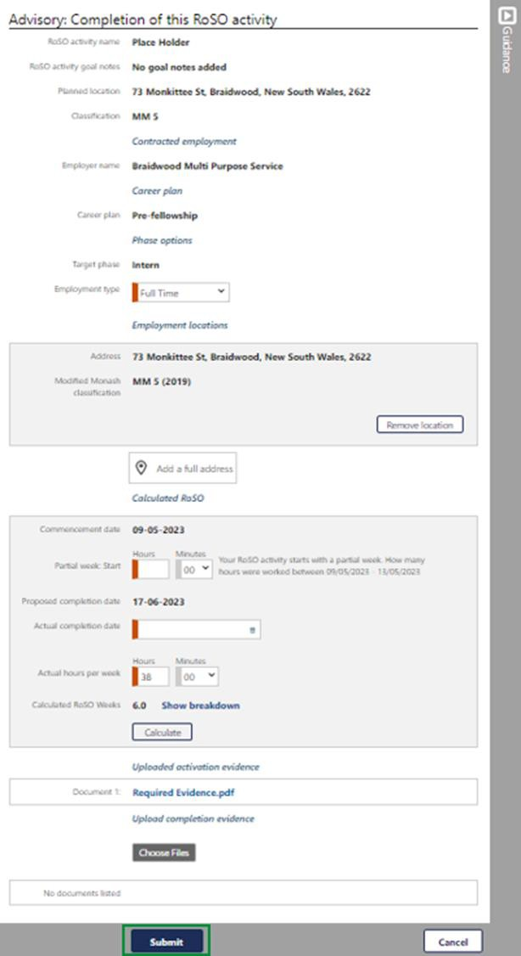

Your RoSO event will now show as green as it has been completed. This activity will reflect in your RoSO summary bar in green.

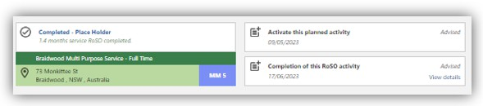

All completed RoSO will be reviewed to confirm eligibility.