BONDED RETURN OF SERVICE SYSTEM (BROSS)

**Participant User Guide**

**-Career Phases-**

**August 2025**

1. Phases

# Entering Medical Course duration changes

To update your ‘**Prevocational**’ phase with your APHRA registration and Medicare provider number, go to your ‘**Manage my RoSO**’ page and then under the ‘**Prevocational**’ accordion.

You can get to your ‘**Manage my RoSO**’ page from your dashboard by clicking on either the ‘**Manage my RoSO**’ button or the ‘**Prevocational**’ button under the Program timeline.

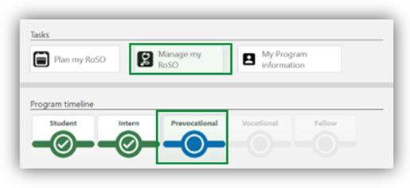

To enter your ‘**APHRA registration**’ click on the ‘**Advise**’ link under the ‘**Prevocational**’ accordion.

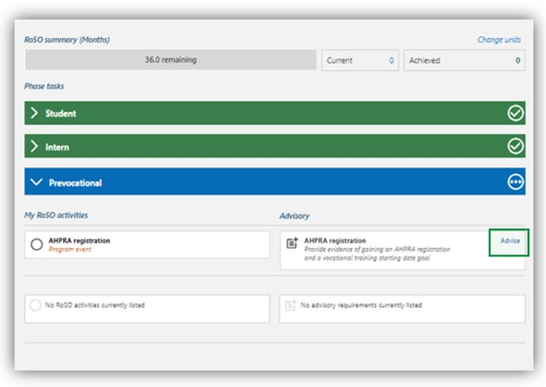

In the ‘**Advisory: General registration with AHPRA**’ page, complete all mandatory orange fields and upload the required evidence from AHPRA that general registration has been attained. If you are unable to provide the evidence outlined, you may provide a statutory declaration that includes all

the required information.

The final field ‘**Vocational training goal’** is the future date that you think you will commence training with your specialty college, which can be changed at any time. If you do not intend to undertake vocational training, enter a date that falls after your Program completion date to avoid receiving automated reminders.

Click ‘**Submit**’ once completed.

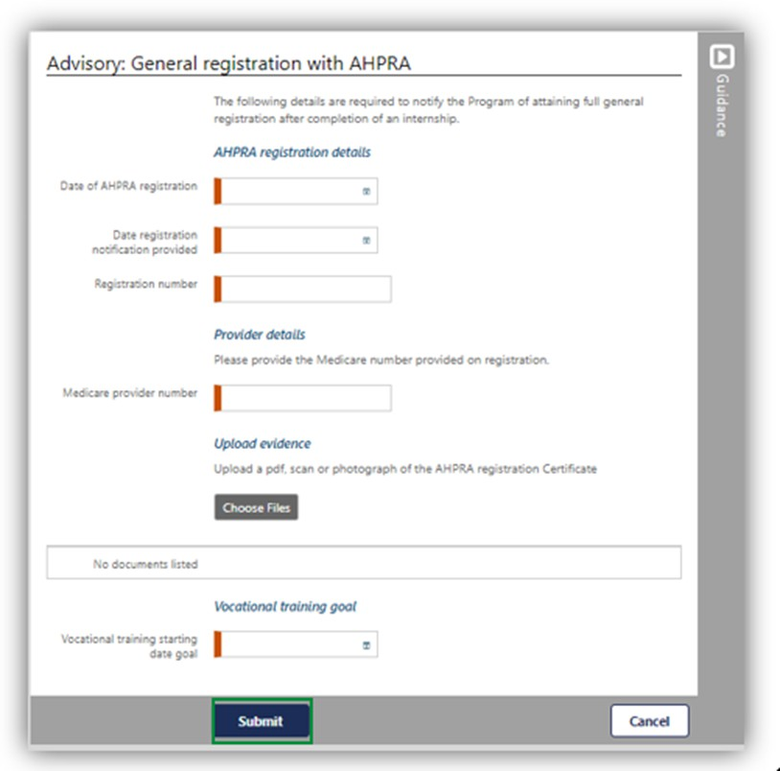

# Completing Student Phase

To update your **‘Student’** phase with your medical course completion, go to your ‘**Manage my RoSO**’ page and select the ‘**Studen**t’ accordion.

You must update in BRoSS any change which impacts on the completion time of your course of study in medicine. Evidence must be from the university confirming the change and including the following information:

* + - name of the bonded participant.
    - date of the evidence.
    - date on which the change takes effect.
    - date on which the approved change of circumstances has been completed.

If you are unable to provide the evidence outlined, you may provide a statutory declaration that includes all the required information.

You can get to your ‘**Manage my RoSO**’ page by clicking on the ‘**Student**’ button under the Program timeline.

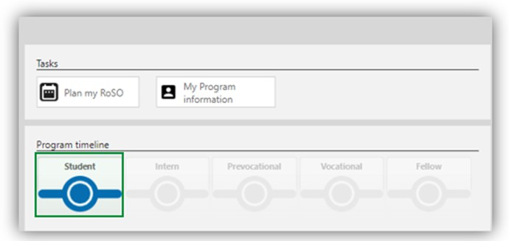

On the ‘**Completion of medical course’** tile click the ‘**Advise**’ link.

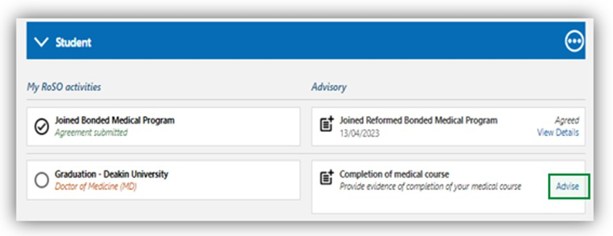

In the ‘**Advisory: Completion of medical course’** fill in the required information, upload your evidence and click ‘**Submit**’.

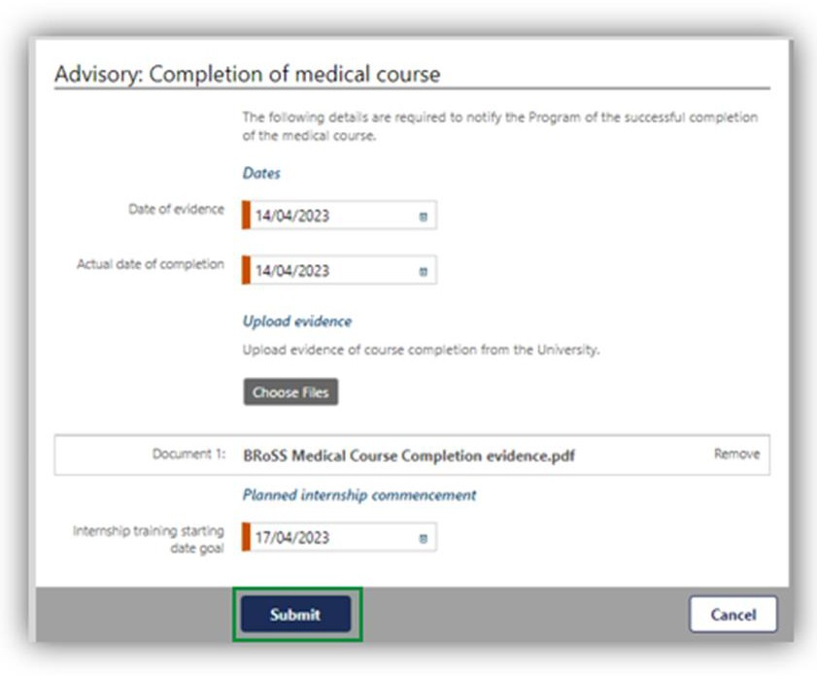

After submitting this advisory, your ‘**Student**’ accordion will change to green with a tick and the ‘**Intern**’ accordion will now be blue.

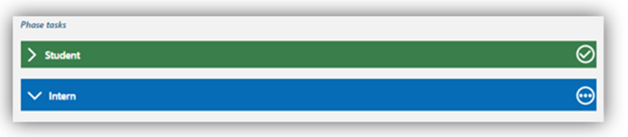

# Entering your Internship Information

To update your ‘**Intern**’ phase with your APHRA registration and internship details, go to your ‘**Manage my RoSO’** page and then select the ‘**Intern**’ accordion. Internship and vocational training sections also have planning dates set within BRoSS. If your plans change, review your record, and amend your planned start or finish date.

You can get to your ‘**Manage my RoSO’** page from your dashboard by clicking on either the ‘**Manage my RoSO**’ button or the ‘**Intern**’ button under the Program timeline.

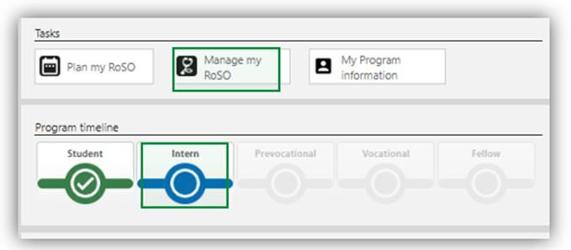

To enter your ‘**Provisional registration with APHRA**’ click on the ‘**Advise**’ link.

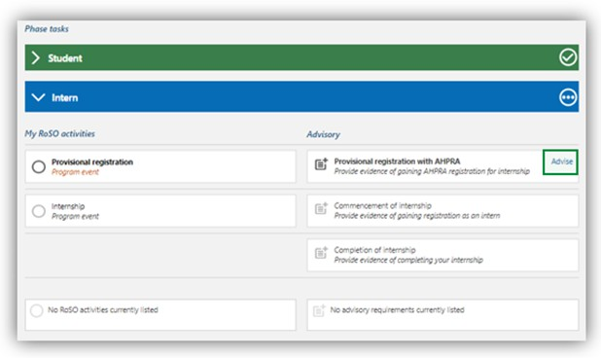

In the ‘**Advisory: Provisional registration with APHRA’** complete the mandatory orange fields and upload the required evidence from APHRA showing that provisional registration has been attained.

Click ‘**Submit**’ once completed.

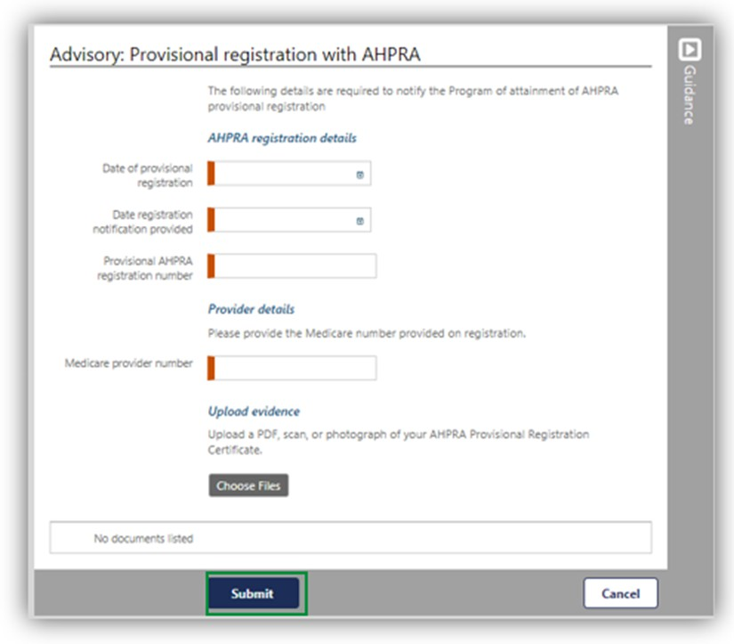

You will be taken back to the ‘**Manage my RoSO**’ page, there will now be green text with a tick next to the event tile.

To enter your ‘**Commencement of internship**’ details click the ‘**Advise**’ link.

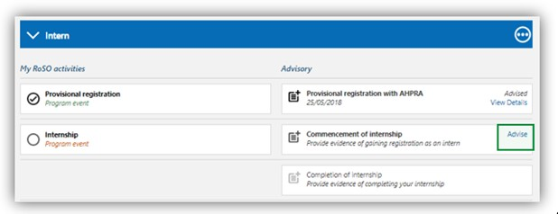

In the ‘**Advisory: Commencement of internship**’ complete the mandatory orange fields, adding your facility address and upload a signed contract of employment or letter of agreement from your

employer, including:

* name of the bonded participant.
* commencement date of the internship.
* expected completion date of the internship.
* position name.
* facility name.
* facility address.
* number of hours employed each week.

If you are unable to provide the evidence outlined, you may provide a statutory declaration that includes all the required information.

Click ‘**Submit**’ once completed.

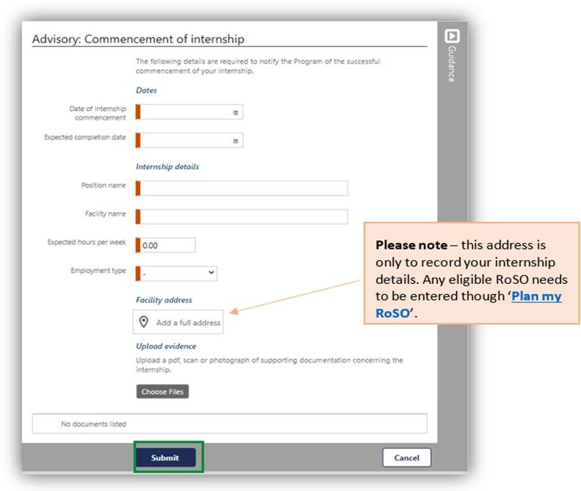

You will be taken back to the ‘**Manage my RoSO**’ page, there will now be three dots next to the event title that indicate your internship is activated.

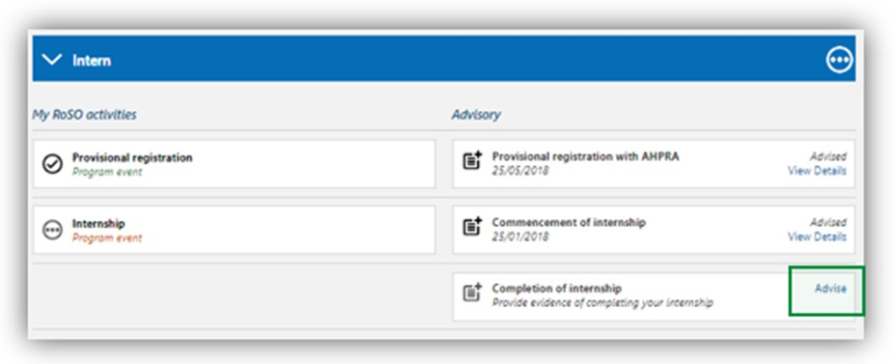

# Completing your Internship Phase

On the completion of your internship training, you will need to update your BRoSS ‘**Intern**’ phase on your ‘**Manage my RoSO’** page.

You can get to your ‘**Manage my RoSO**’ page from your dashboard by clicking on either the ‘**Manage my RoSO**’ button or the ‘**Intern**’ button under the Program timeline.

Click on the ‘**Advise**’ link on the ‘**Completion of internship**’ tile.

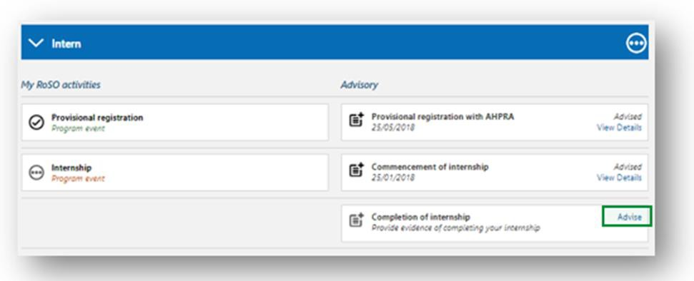

Enter the date you completed your internship and click ‘**Submit**’.

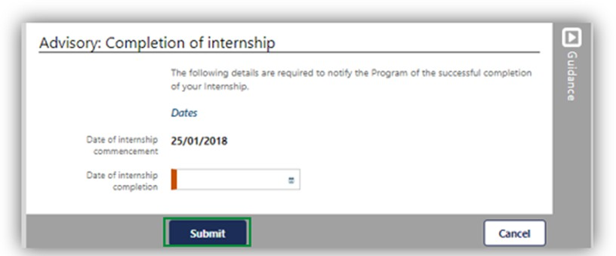

Your ‘**Manage my RoSO**’ page will update so your ‘**Intern**’ phase will now be green, and your ‘**Prevocational**’ phase will be blue.

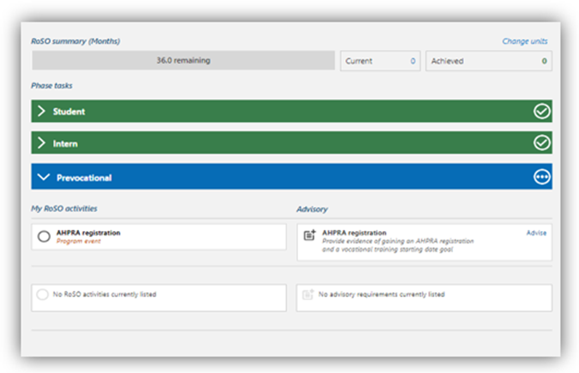

# Commencing your Pre-Vocational training Phase

To update your ‘**Prevocational**’ phase with your APHRA registration and Medicare provider number, go to your ‘**Manage my RoSO**’ page and then under the ‘**Prevocational**’ accordion.

You can get to your ‘**Manage my RoSO**’ page from your dashboard by clicking on either the ‘**Manage my RoSO**’ button or the ‘**Prevocational**’ button under the Program timeline.



To enter your ‘**APHRA registration**’ click on the ‘**Advise**’ link under the ‘**Prevocational**’ accordion.



In the ‘**Advisory: General registration with AHPRA**’ page, complete all mandatory orange fields and upload the required evidence from AHPRA that general registration has been attained. If you are unable to provide the evidence outlined, you may provide a statutory declaration that includes all

the required information.

The final field ‘**Vocational training goal’** is the future date that you think you will commence training with your specialty college, which can be changed at any time. If you do not intend to undertake vocational training, enter a date that falls after your Program completion date to avoid receiving automated reminders.

Click ‘**Submit**’ once completed.

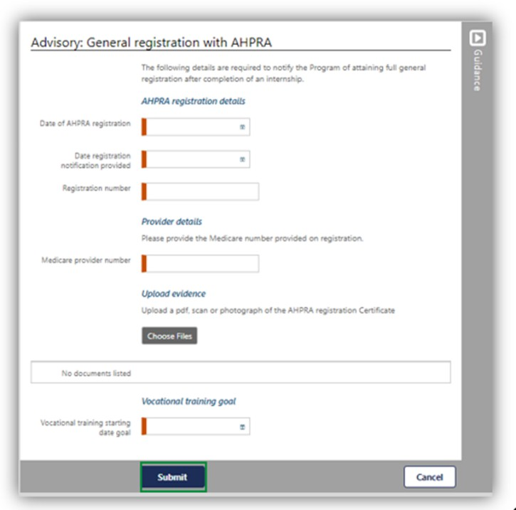

# Commencing your Vocational Phase

To update your ‘**Vocationa**l’ phase with your training college details, go to your ‘**Manage my RoSO**’ page and then under the ‘**Vocational**’ accordion.

You can get to your ‘**Manage my RoSO**’ page from your dashboard by clicking on the ‘**Manage my RoSO’** button or the ‘**Prevocational**’ phase under the Program timeline.

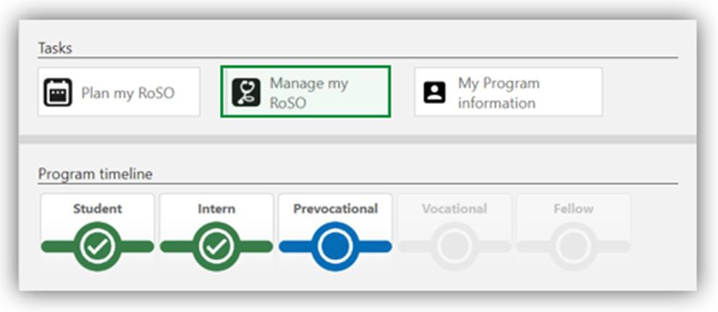

The ‘**Vocational**’ accordion will be greyed out until you ‘**Advise**’ of your ‘**Commencement of vocational training**’ by clicking on the ‘**Advise**’ link.

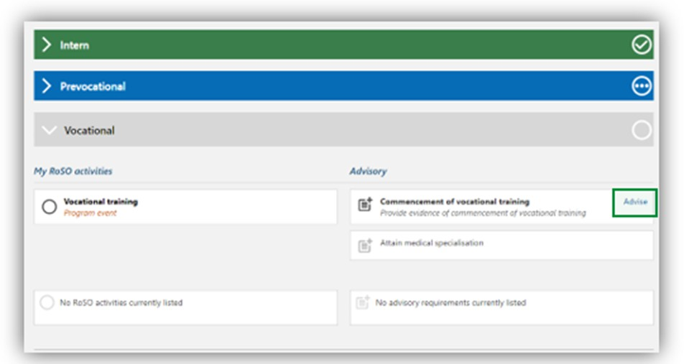

In the ‘**Advisory: Commencement of vocational training**’ page, complete all mandatory orange fields and upload evidence from both the medical college that you have enrolled in vocational training and evidence from your employer. Evidence must include both of the following:

* + - information from the medical college, including:
      * date of commencement of vocational training.
      * anticipated date of completion.
      * name of the medical college.
      * type of specialisation; and
    - a signed employment contract or signed letter of agreement from your employer, including the following information:
      * name of the bonded participant.
      * employment commencement date.
      * expected employment completion date.
      * position name.
      * facility name.
      * facility address.
      * number of hours employed each week.

When entering your specialty work placement details, you are required to provide your work contract or Medicare provider number (including location specific provider number).

If you are unable to provide the evidence outlined, you may provide a statutory declaration that includes all the required information.

Click ‘**Submit**’.

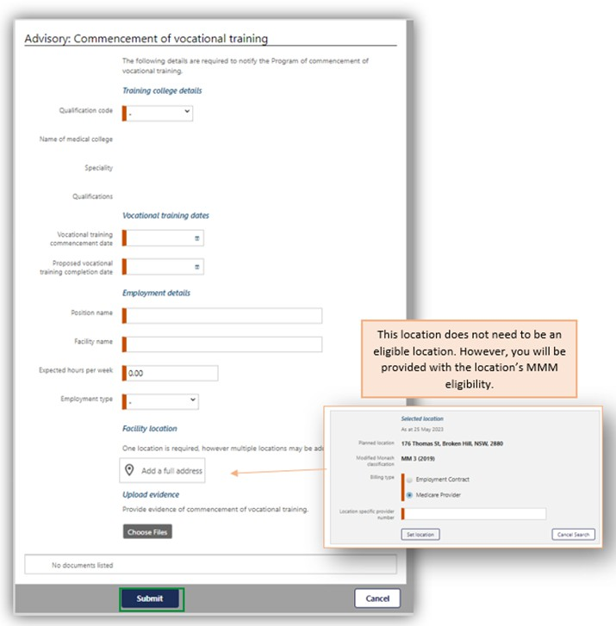

Once completed, the accordion will change to blue as it is now your current phase.

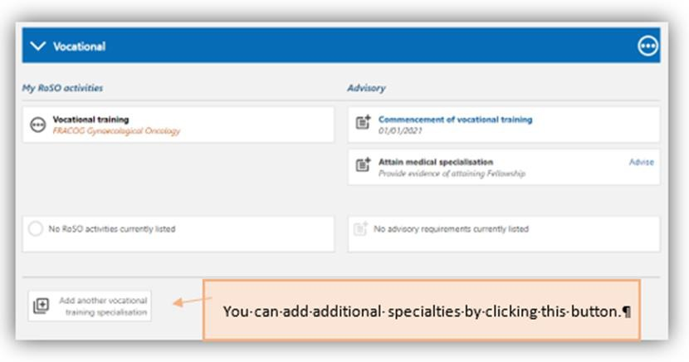

# Attaining Fellowship – Completing your Vocational Phase

To update your ‘**Vocational**’ phase with your fellowship details, go to your ‘**Manage my RoSO**’ page and then under the ‘**Vocational**’ accordion.

You can get to your ‘**Manage my RoSO**’ page from your dashboard by clicking on either the ‘**Manage my RoSO**’ button or the ‘**Vocational**’ button under the Program timeline.

Under the ‘**Vocational**’ accordion, click on the ‘**Advise**’ link on the ‘**Attain medical specialisation**’ tile.

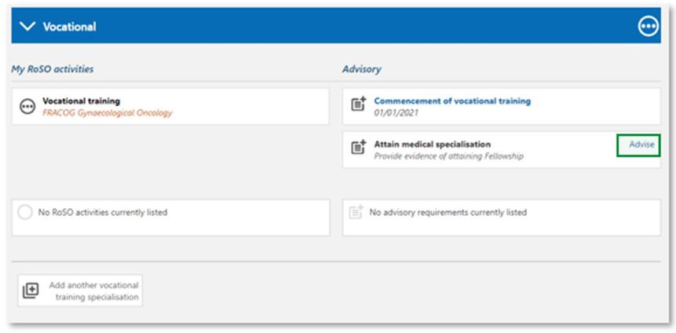

The ‘**Advisory: Attain medical specialisation**’ page will open. Enter the date you attained your Fellowship and upload your evidence. Evidence must be from the relevant medical college and include:

* + - name of the bonded participant.
    - name of the medical college.
    - type of specialisation.
    - date the specialisation was attained.

If you are unable to provide the evidence outlined, you may provide a statutory declaration that includes all the required information.

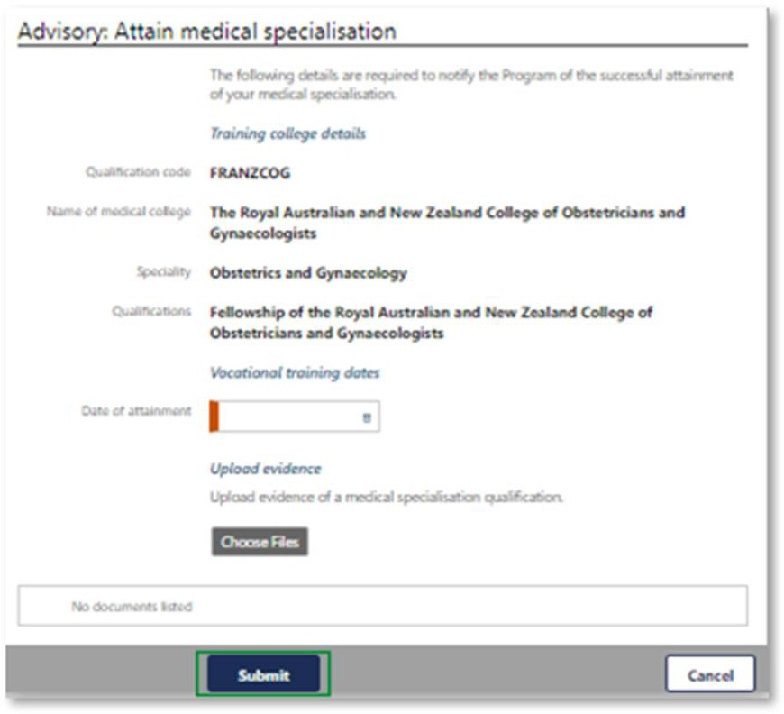

then click ‘**Submit’.**

If you are undertaking a dual speciality, you can add a second vocational training specialisation in

BRoSS. To add this, under your Vocational or Fellow phase accordion, select *Add another vocational training specialisation*.

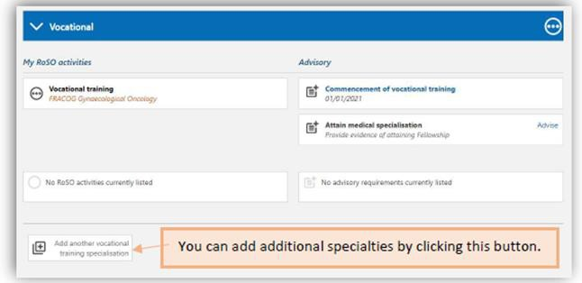

Once you begin your training for your second specialty, you will need to ‘Advise’ your

*Commencement of vocational training*.

Locations that are eligible under your second speciality may require you to lodge a location override request. Refer to the location override section for information on how to do this.

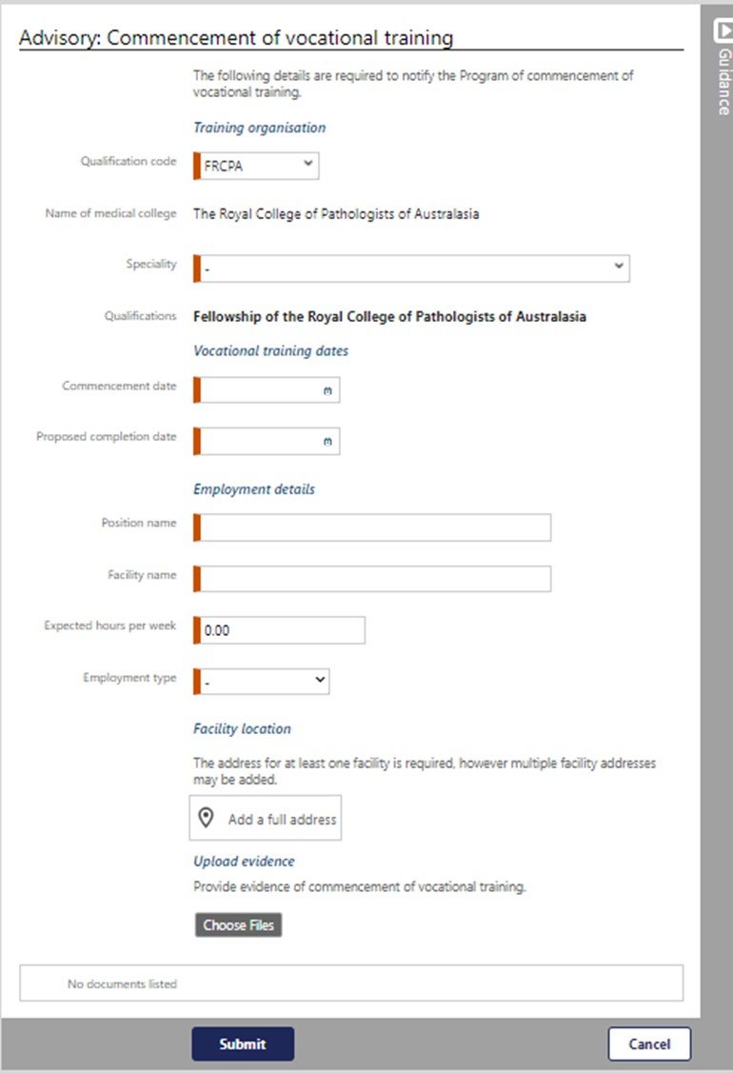

To advise your commencement of vocational training, input your information into the mandatory orange fields. You must also add your facility location/s and upload evidence. Once completed, click *Submit.*

Both specialties will now appear on your BRoSS record.

Your ‘**Manage my RoSO**’ page will update so your ‘**Fellow**’ phase will now be blue, and your ‘**Vocational**’ phase will be green.

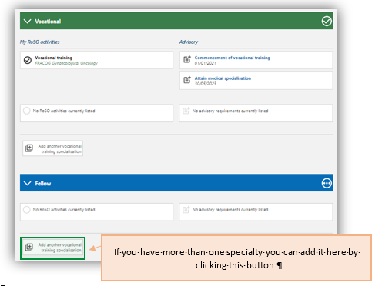

Once you have attained fellowship, BRoSS will allow you to complete the final 78 weeks of your RoSO as per section 9(3) of the [Rule.](https://www.legislation.gov.au/Series/F2019L01513) If you do not attain fellowship, you will able to complete the final 78 weeks on the day 12 years after the day you completed your course of study in medicine.