BONDED RETURN OF SERVICE SYSTEM (BROSS)

**Participant User Guide**

**-Managing your agreement-**

**August 2025**

1. Managing your Agreement

# Requesting an Extension to Program timeline

A participant may apply for an extension to program if the participant, or a member of the bonded participant’s family, has a medical condition that prevents the bonded participant from completing their RoSO within the 18-year period required by paragraph 124ZF(2)(a) of the [Act.](https://www.legislation.gov.au/C2004A00101/latest/versions)

A **member of your family** is defined as a partner, child, grandchild, parent, grandparent or sibling of the bonded participant; or a person who satisfies the following criteria:

* the person is a relation of the bonded participant;
* the bonded participant has significant responsibility for the care of the person;
* there are no family members (other than the bonded participant) who are able to provide care to the person;
* the person is not on a temporary visa; and
* the person has not been provided with an assurance of support in relation to the grant of a visa.

The **medical condition** must not have been reasonably foreseen when you entered the Program, and must either:

* Require treatment or care for which Medicare benefits are payable, or
* Require treatment of care for which pharmaceutical benefits are payable, or
* Require treatment of care in a hospital.

You must also upload evidence of the medical condition from a treating practitioner dated within 3 months from the date of your application. The treating practitioner must:

* have sufficient expertise, qualifications and specialist registration to provide the medical evidence; and
* state for how long they have known you or your family member, as the case may be; and
* state that they do not have a personal or professional relationship with you or any potential conflicts of interest; and
* state why the bonded participant cannot complete their return of service obligation within the 18 year period.

These extension of time requirements are outlined in section 11 - 13 of [the Rule](https://www.legislation.gov.au/F2019L01513/latest/text).

To submit your request, click on the ‘**Manage my agreement**’ accordion on the bottom left side of the ‘**My dashboard**’ page.

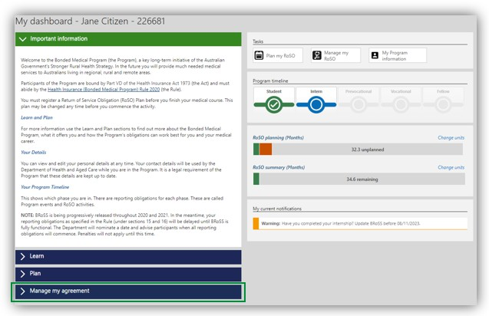

The ‘**Manage my agreement**’ accordion will open. Click on the ‘**Program extension**’ button.

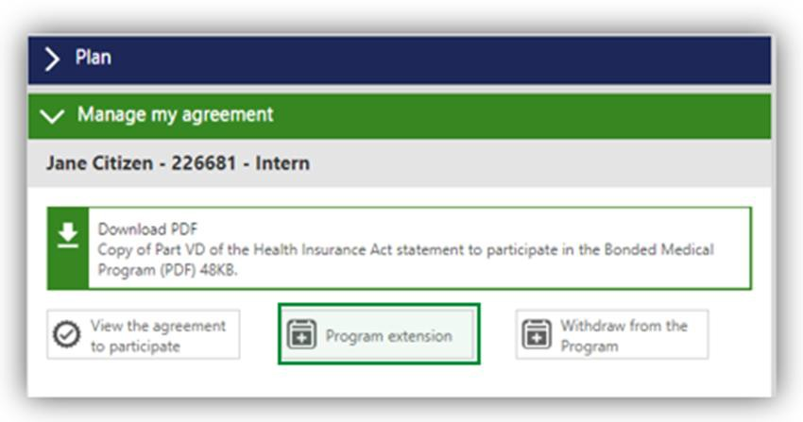

The ‘**My Program information’** page will open, click on the ‘**Program extension**’ accordion at the bottom of the page. This page will show your current Program completion date.

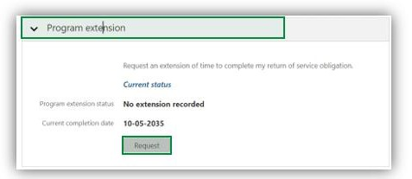

Click the ‘**Request**’ button, enter your ‘**Proposed completion date’**. The new completion date should not extend the period to complete your RoSO by more than 2 years. Ensure the evidence you upload meets the requirements outlined in section 13 of the Rule.

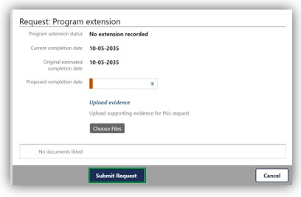

Once you click on the ‘**Submit Request**’ button, the below ‘**Warning**’ page will show, click ‘**OK**’ to continue with your extension request.

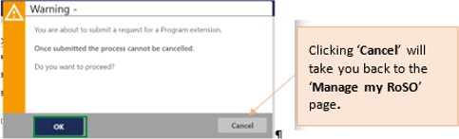

Your ‘**Program extension**’ accordion will update to ‘**Pending**’ status and show your extension request and ‘**Status**’. The ‘**View/Edit**’ button will enable you to amend your request.

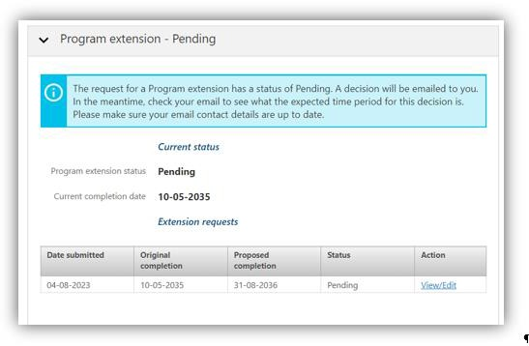

Your request will be reviewed and you will be contacted if additional evidence is required, or when a decision has been made.

If you would like to cancel your request, please email the [BondedMedicalProgram@health.gov.au](mailto:BondedMedicalProgram@health.gov.au) providing your details and the reason for cancellation.

# Withdrawing from the Program

Once you have agreed or opted in to the Program you can withdraw at any time. You can request a ‘**Withdrawal Repayment estimate’** report by clicking the ‘**My dashboard**’ page, open the ‘**Manage my agreement**’ accordion on the bottom left side of the dashboard.

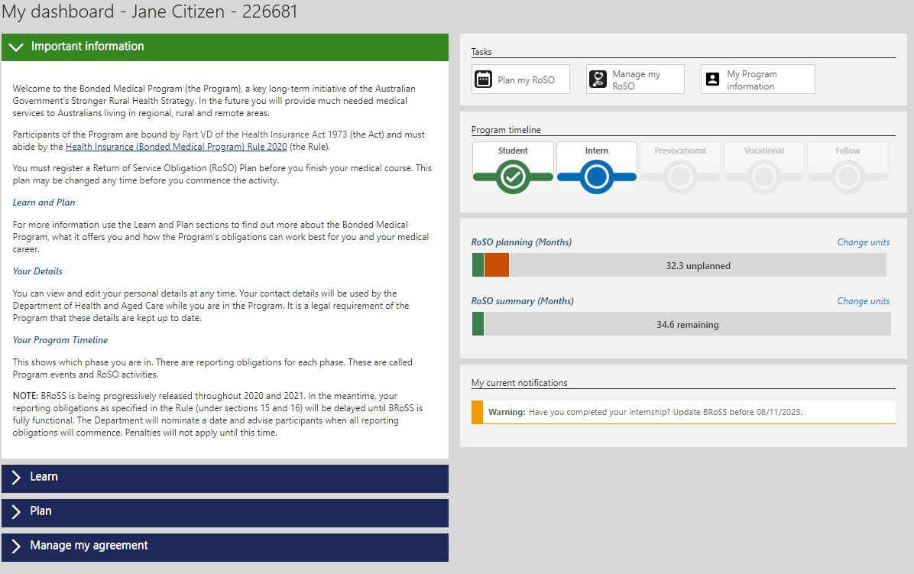

The ‘**Manage my agreement**’ accordion will open. Click on the ‘**Withdraw from the Program**’ button.

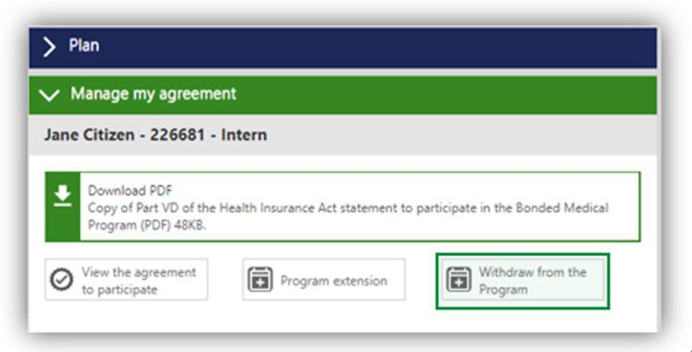

The opening pages will be different depending on whether you have opted-in to the Program via the BMP Scheme the MRBS Scheme or began with the Program. These processes are detailed in the

following sections.

# Withdrawing as a former Bonded Medical Rural Bonded Scholarship (MRBS) scheme participant

If you withdraw prior to your second-year census date you are not required to repay the CSP amount.

Once you have clicked on the ‘**Withdraw from the Program**’ button the ‘**Estimate: Withdraw from the Program**’ page will open. Enter the ‘**Proposed withdrawal date**’ and click ‘Next’.

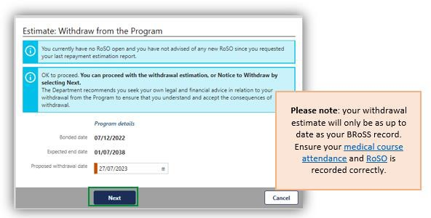

In the ‘**Estimated: Withdraw from the Program**’ page, you can download a repayment estimation report that contains information about your withdrawal. Click ‘**Close**’ once reviewed.

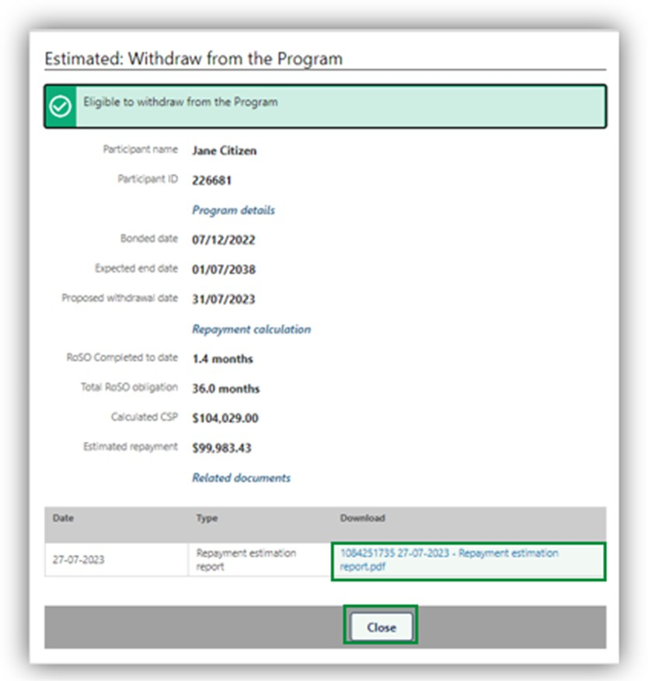

You will return to the ‘**My dashboard**’ page. If you would like to continue with your withdrawal request or get an updated withdrawal repayment estimate, open your ‘**Manage my agreement**’ accordion and then click on the ‘**Withdraw from the Program**’ button.

The ‘**View: withdraw from the Program**’ page will open. There are two options available on this page:

1. you can get a new withdrawal repayment estimate by clicking on the ‘**Re-estimate**’ button. This will update your ‘**Estimate: Withdraw from the Program**’ page and provide a new repayment figure and report as detailed above.
2. continue with your withdrawal by clicking on the ‘**Withdraw**’ button, which will take you to the ‘**View: Withdraw from the Program’** page.

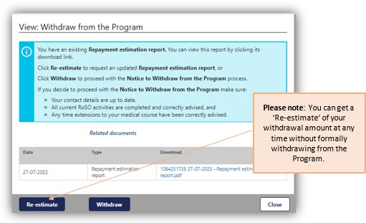

After clicking on the ‘**Withdraw**’ button, the pop-up ‘**Warning**’ page will show. Click ‘**OK**’ to continue with your withdrawal from the Program.

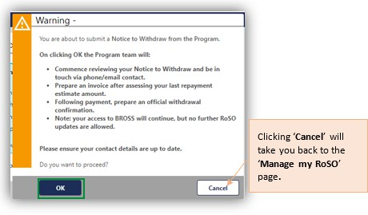

The ‘**Advise: Withdraw from the Program**’ page will allow you to update and complete your withdrawal request. Once completed click ‘**Next**’ to submit the request.

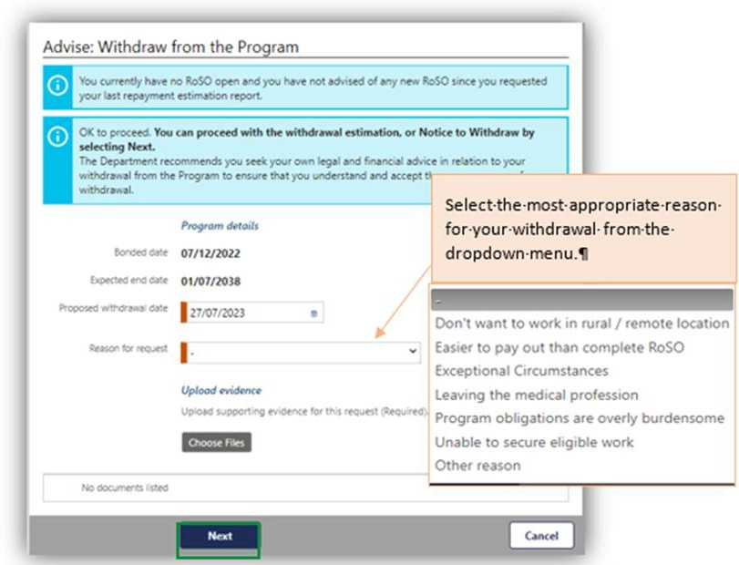

If you select the ‘**Exceptional Circumstances**’ – you will be required to provide sufficient evidence and documentation to enable the Secretary (or Delegate) to make an informed decision.

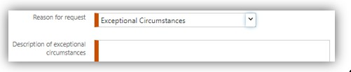

If you select ‘**Other**’ you will also be required to provide additional information in the new field.

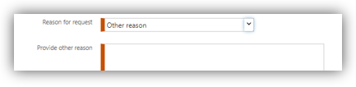

After clicking ‘**Next**’ the ‘**Advised: Withdrawal from the Program**’ page will show your withdrawal information that has been submitted for assessment.

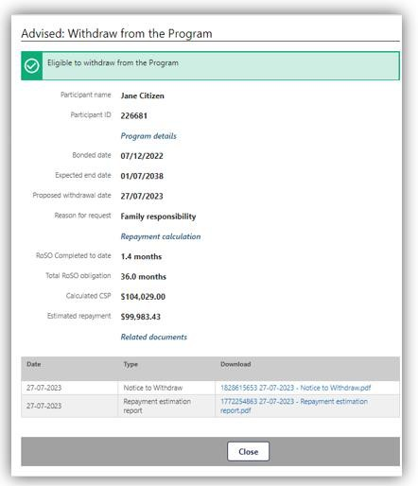

Your withdrawal request will be reviewed and you will be contacted if additional evidence is required. You will be provided with an invoice when your withdrawal request is processed.

For ‘**Exceptional Circumstances**’, we will send you an email with the decision outcome. If you would like to cancel your withdrawal request, please email the

[BondedMedicalProgram@health.gov.au](mailto:BondedMedicalProgram@health.gov.au) providing your details and the reason of cancellation.

# Withdrawing as a former Bonded Medical Places (BMP) Scheme Participant who has opted-in

Withdrawing from the Program as an opted-in MRBS participant will mean Medicare benefits are not payable for a period of six (6) years from the date you withdraw, in accordance with section 124ZQ(4) of [the Act](https://www.legislation.gov.au/C2004A00101/latest/text/2).

Once you have clicked on the **‘Withdraw from the Program’** button the **‘Estimate: Withdraw from the Program’** page will open. Enter the **‘Proposed withdrawal date’** and click **‘Next’**.

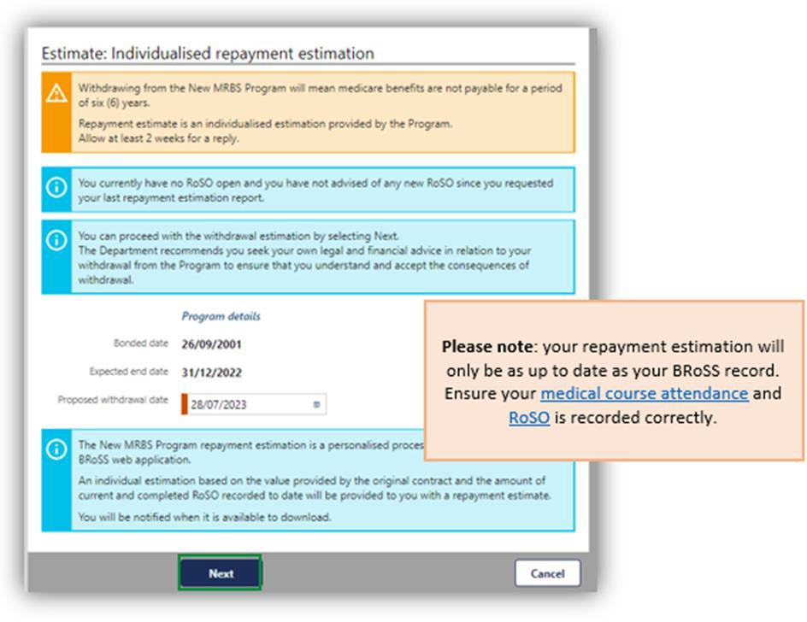

After clicking on the ‘**Next**’ button the pop-up ‘**Warning**’ page will show, click ‘**OK**’ to continue with your withdrawal request from the Program.

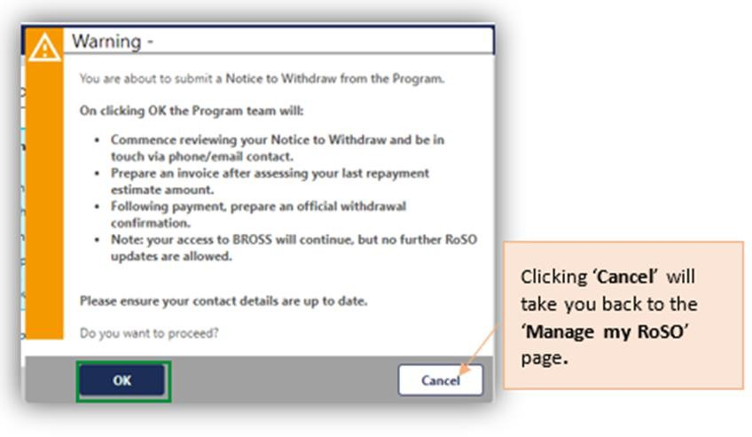

The ‘**Estimated: Withdraw from the Program**’ page will open with your ‘**Repayment estimation request**’ document used to provide an estimate of your repayment amount.

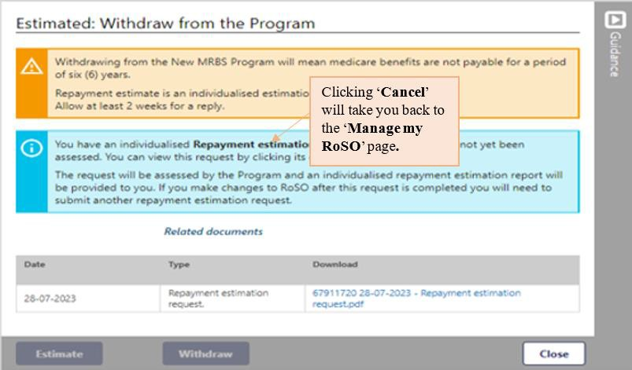

Once your request is submitted, an estimate of your repayment amount will be emailed to you within 4 weeks, based on your BRoSS record. The estimate will account for all currently active and completed RoSO activities up to the proposed withdrawal date.

Once you receive your estimate, go to the ‘**My dashboard**’ page.

Open your ‘**Manage my agreement**’ accordion and then click on the ‘**Withdraw from the Program**’ button to open the ‘**View: Withdrawal from the Program**’ page. Your ‘**New MRBS repayment estimation.pdf**’ can be downloaded from here.

There are two options on this page:

* + 1. You can get a new withdrawal repayment estimate by clicking on the ‘**Re-estimate’** button, this will take you back to the ‘**Estimate: Withdraw from the Program**’ page as detailed above.
    2. Continue with your withdrawal by clicking on the ‘**Withdraw**’ button which will take you to the ‘**View: Withdraw from the Program’** page.

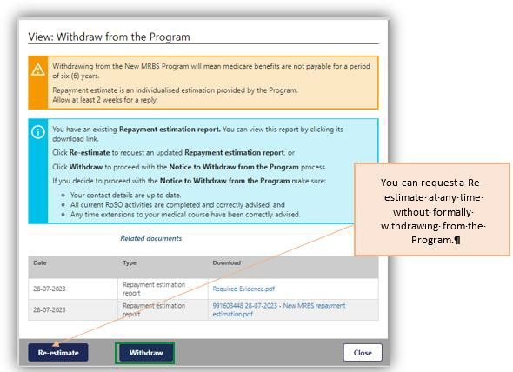

After clicking on the ‘**Withdraw**’ button the pop-up ‘**Warning**’ page will show. Click ‘**OK**’ to confirm and continue with your withdrawal from the Program.



The ‘**Advise: Individualised repayment estimation’** page, will show for you to update and complete for your withdrawal request, once completed click ‘**Next**’ to submit your withdrawal.

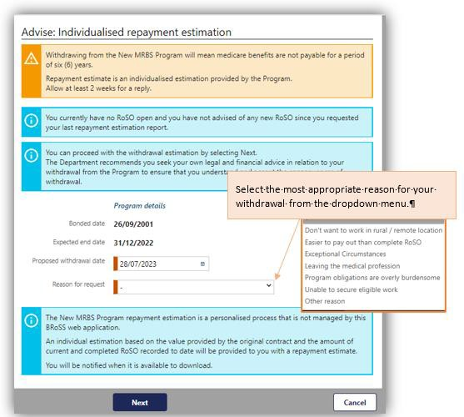

If you select the ‘**Exceptional Circumstances**’ – you will be required to provide additional information in a new field and upload any evidence to support your request.

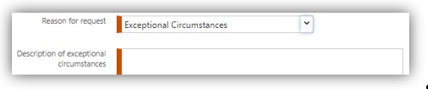

If you select ‘**Other**’ you will also be required to provide additional information in the new field.

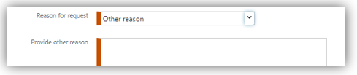

After clicking ‘**Next**’ the ‘**Advised: Withdrawal from the Program**’ page will show your withdrawal information that will be used for your withdrawal request.

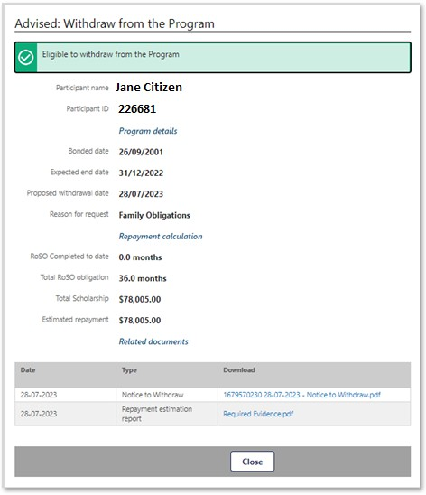

Your withdrawal request will be reviewed and you will be contacted if additional evidence is required. You will be provided with an invoice once your withdrawal request is processed.

For ‘**Exceptional Circumstances**’ we will send you an email with the decision outcome. If you would like to cancel your withdrawal request, please email the

[BondedMedicalProgram@health.gov.au](mailto:BondedMedicalProgram@health.gov.au) providing your details and the reason of cancelation.

* (Monday-Friday, 8:30am to 5:00pm AEST/AEDT).