BONDED RETURN OF SERVICE SYSTEM (BROSS)

Participant User Guide

-Login Guide-

August 2025

- Login

How to log into BRoSS
You will need to have a myGov account to log in to BRoSS. Go to myGov Home.
    - If you do not have a myGov account, please go to 'Create account' and follow the prompts to
create an account. Log into your myGov account.
    - If you do have a myGov account, go to ‘Sign in.’
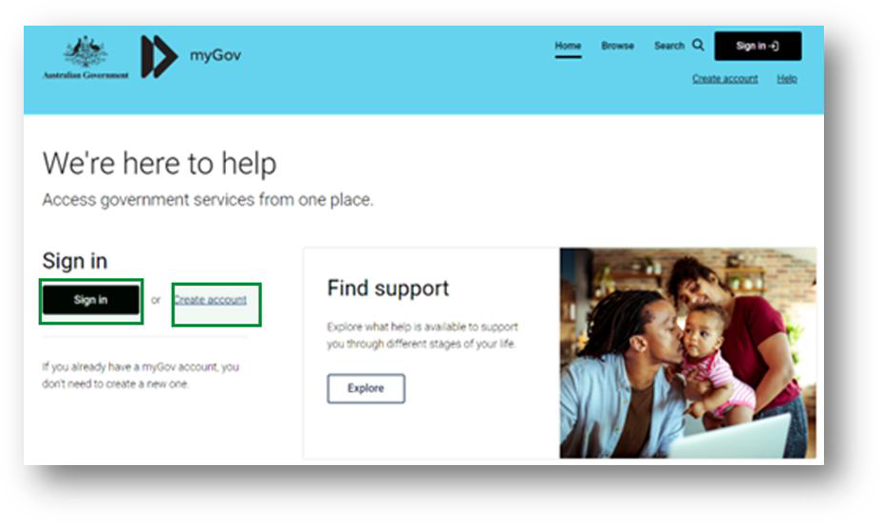
Sign in with your myGov details.
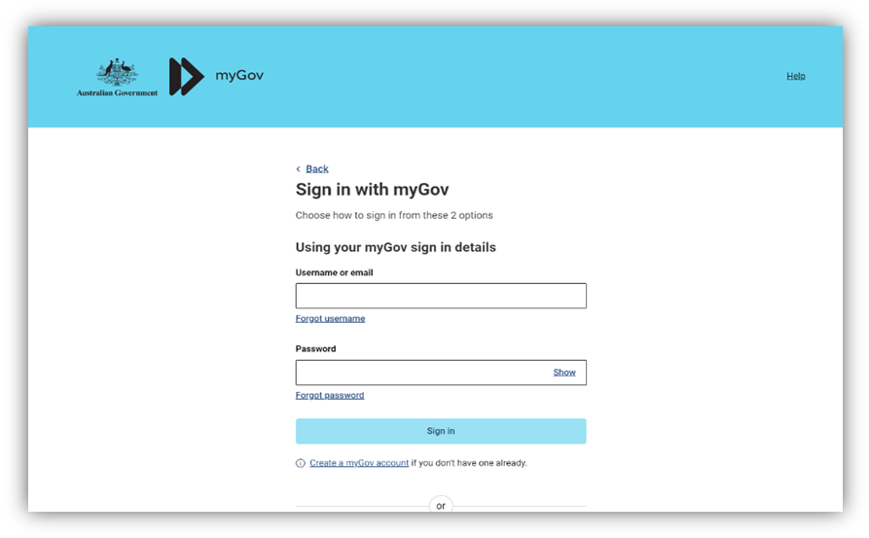

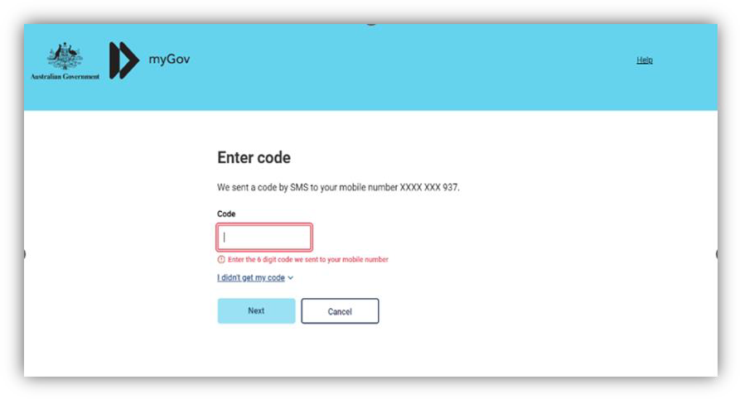
Authenticate your login.
You will need to link the ‘Department of Health Applications Portal’ to your services by clicking the ‘View and link services’.
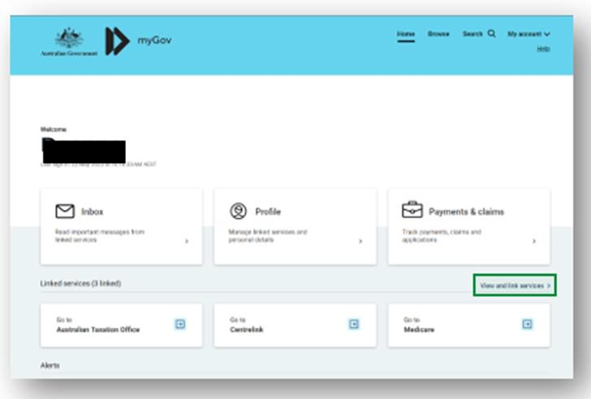

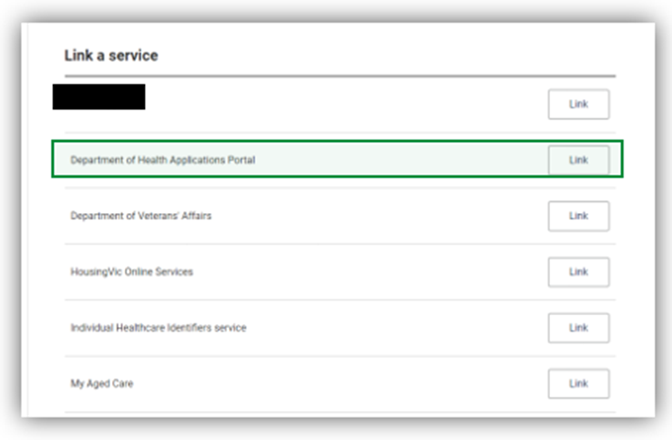
Scroll to the service and click ‘Link’.
You will be taken to the Health Data Portal page, click ‘Log in’.
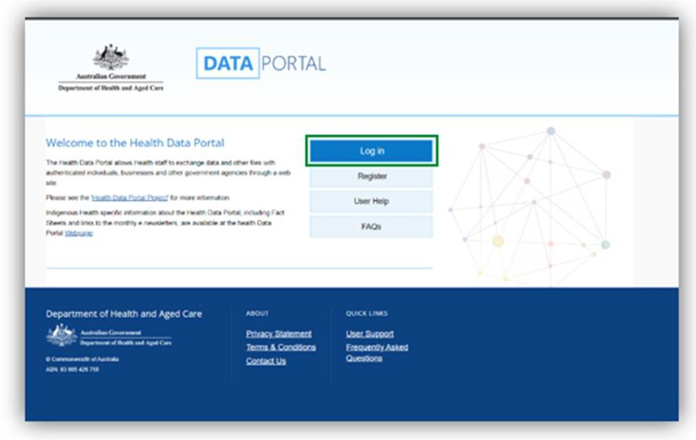

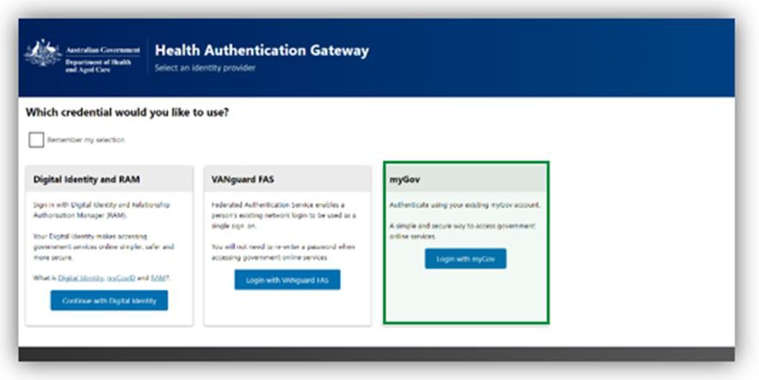
Select ‘Login with myGov’ as your log-in credential choice.
Enter your BRoSS user ID (username) and your linking code (password) on the 'Health Authentication Gateway' page. Your BRoSS user ID and linking code can be found within your ‘Firm offer’ email or the ‘Welcome to the Bonded Medical Program’ email sent to your primary email address.
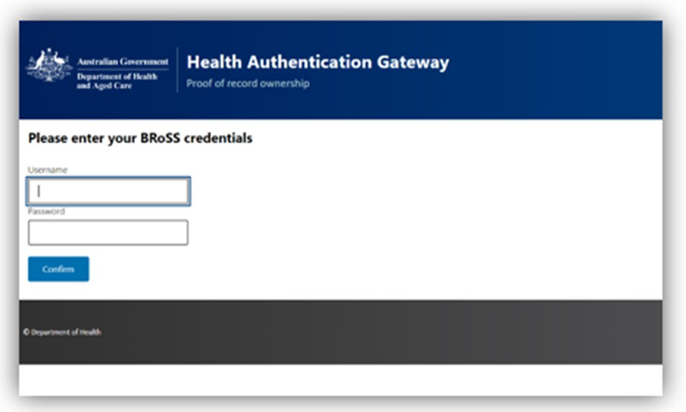

This will be a once-off action. Once you have linked 'Department of Health Applications Portal'
as a service, the next time you try to sign in to BRoSS you will not be required to enter your BRoSS User ID (Username) and linking code or Temporary Password (Password).

You will be taken to the Health Data Portal, on the menu bar, select 'BRoSS'. Your dashboard will open.
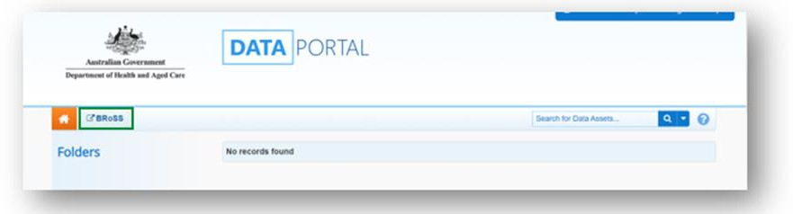
Occasionally, you may experience log in issues such as seeing an account inactive message, an error message, or BRoSS may not display correctly. These are usually due to a cache or browser issue.

If you experience log in issues, please:
- Do not unlink the Department of Health Applications Portal service from your myGov account. Doing so will require you to be issued with a new temporary password, delaying access to your BRoSS record.
- Clear your cache, as this should clear any previously saved data which may be causing your BRoSS log in issues (if you need assistance on how to do this, you can google ‘[Your browser name] clear browser cache’).
- Try a different browser if you continue to experience log in issues.

If the issue persists, please reach out to our Contact Centre for assistance on 1800 987 104
(Monday-Friday, 8:30am to 5:00pm AEST/AEDT).

Accepting your Firm Offer Place
Once your university position has been confirmed, you will receive an email titled - ‘FIRM OFFER APPLICANT – BONDED MEDICAL PROGRAM’ which will contain information on the Program including your BRoSS User ID and Temporary Password to log in to the system.
After logging in to your BRoSS record following the steps in the ‘How to Log in to the Bonded Return of Service System (BRoSS)’. Your ‘My dashboard’ page will open.
Review all the information on the left-hand side of the page by opening the accordions. Under ‘Update your details’ accordion, review and update your ‘Personal contact details’
‘Contact email’ and ‘Mailing address’ information by clicking on the ‘Edit’ button on the bottom of the page. Ensure all mandatory fields (marked orange in the Edit pages) are correct and click ‘Save’.

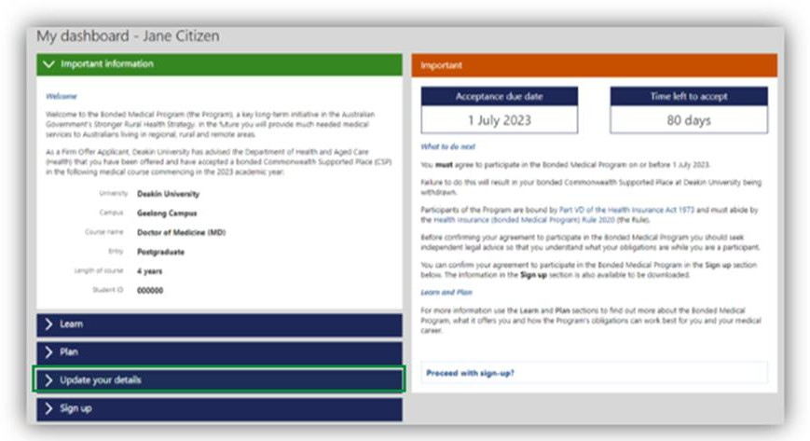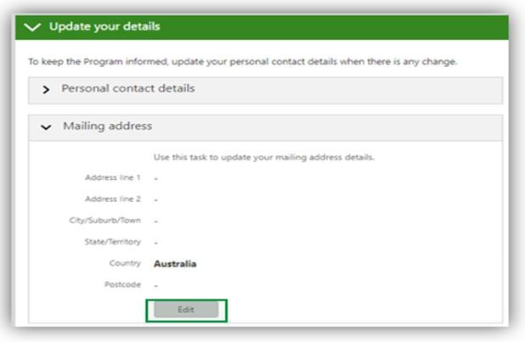

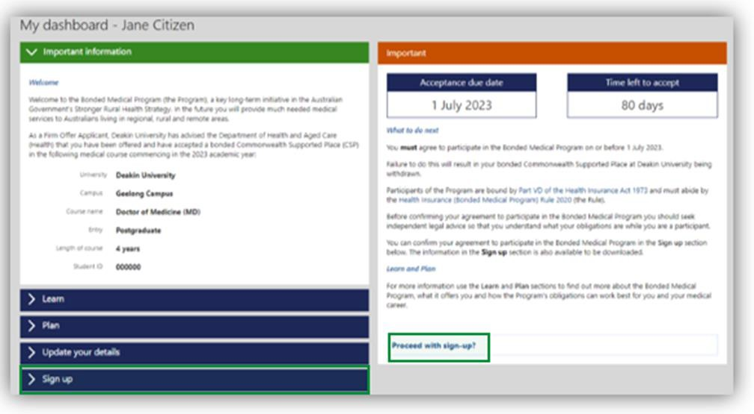
Once your details are updated either click on the ‘Proceed with Sign-up’ link or open the ‘Sign- up’ accordion to see your ‘Agreement to Participate’.

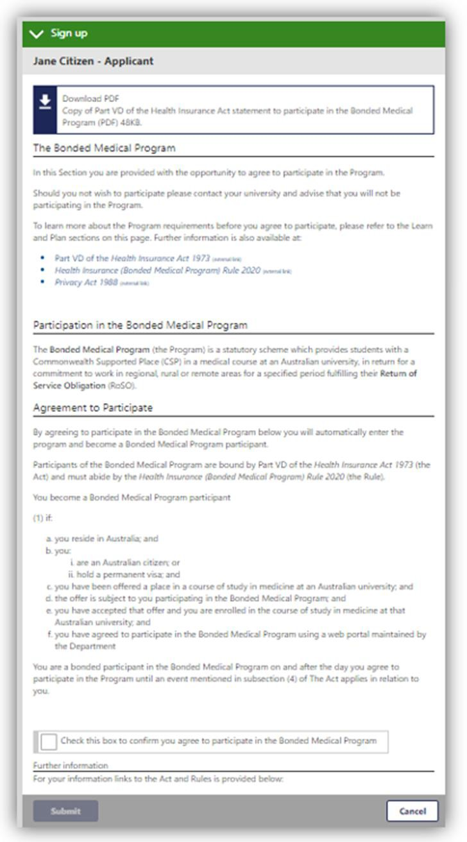

Read the information and if you agree, check the ‘tick box’ and click ‘submit’.
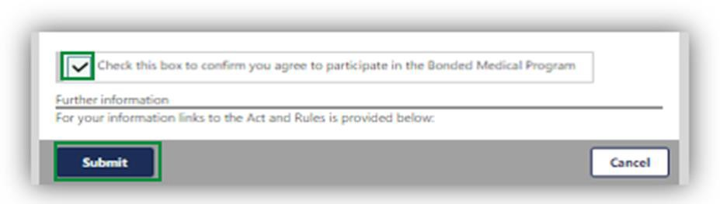
A pop-up page will confirm your acceptance into the Program. Click ‘Go’.
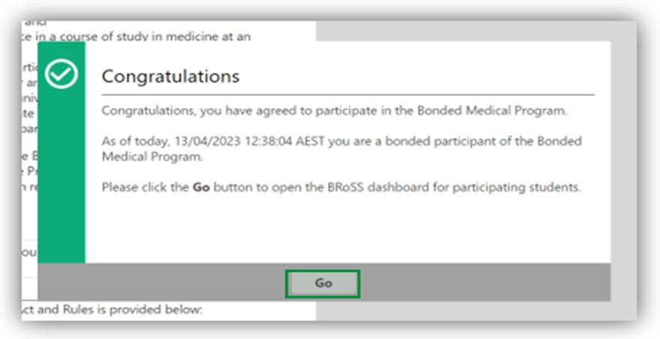
Once you click ‘Go’, you will be redirected to the BRoSS dashboard.
