BONDED RETURN OF SERVICE SYSTEM (BROSS)

**Participant User Guide**

**-BRoSS Dashboard-**

**August 2025**

1. BRoSS Dashboard
   1. Navigating your Participant Dashboard

When logging in after accepting your place in the Program or where you have opted in from a Medical Rural Bonded Scholarship Contract or Bonded Medical Places Agreement, your personal dashboard will contain information to guide you through your obligations under the Program.

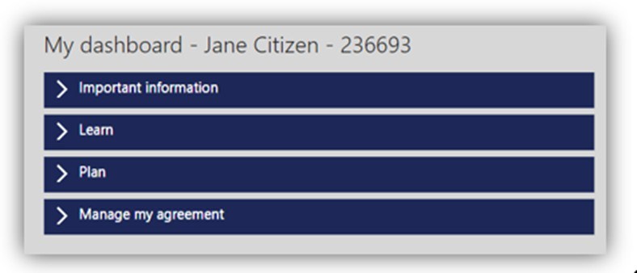

**Important information:** is used to communicate key messages about the Program.

**Learn:** contains helpful information about the Program and your obligations, including your reporting requirements from the time you join the Program to the time you exit. BRoSS will assist you in

managing your reporting requirements and advise what support is available to you to answer any Program questions.

BRoSS allows you to self-manage your reporting obligations, and uses in-built messaging, guidance and emails to alert you.

As a Program participant you are required to log in every 6 months and ensure all your information is up to date and adheres to the Program’s reporting requirements.

**Plan:** contains helpful information about the Program and your RoSO obligations, including eligible work types, how and when you can complete your RoSO, and what tools are available in BRoSS to help you plan, activate, and complete your RoSO.

**Manage my agreement:** contains a couple of key functions. Here you can download a copy of your agreement to participate, which includes the date you joined the Program. You can also request a Program extension or a Program withdrawal quote calculation.

**Tasks:** will change depending on the phase you are currently in your medical career. The task banner will allow you to quickly jump straight to planning your RoSO, managing your RoSO activities, notifiable events and updating your personal details.

**Student phase tasks**: As a new student, you must enter at least one RoSO plan in BRoSS prior to completing your medical course.

**Internship to fellow phase tasks:** have planning dates set within BRoSS. If your plans change, review your record and amend your planned start or finish dates.

**Program timeline:** shows your last updated phase. You can click directly on your current phase or previous phase, to take you to the related notifiable events and any RoSO activities.

A green icon with a tick indicates that this phase of the timeline has been completed, a blue icon indicates that the phase is still underway, and the greyed-out icons represent the phase(s) yet to be commenced.

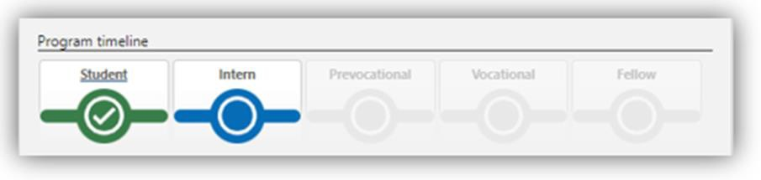

**RoSO planning and summary bar:** show the amount of RoSO you have planned (orange), current/commenced (blue), completed (green) and remaining RoSO balance (grey).

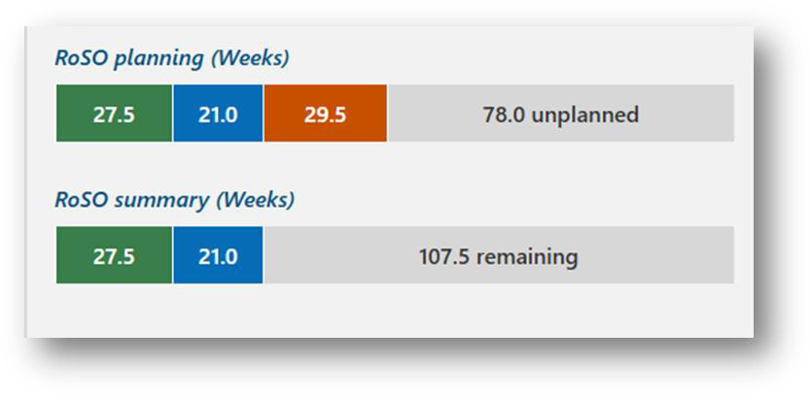

**My current notifications:** provides guidance on actions that are required to be undertaken in BRoSS. It will also let you know if you are approaching a reporting deadline.

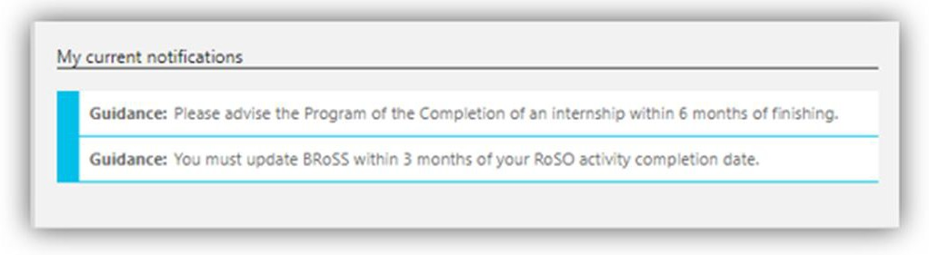

**BRoSS guidance bar:** is an in-system guidance feature built into every page on the right-hand side listed as ‘Guidance’. Click on the arrow to read about the current page. To close the ‘Guidance’ bar click on the arrow and it will close.

