**Assistive Technology Loans Scheme Trial Evaluation**

Department of Health, Disability and Ageing

14 April 2025

****Nous Group** acknowledges Aboriginal and Torres Strait Islander peoples as the First Australians and the Traditional Custodians of country throughout Australia. We pay our respect to Elders past, present and emerging, who maintain their culture, country and spiritual connection to the land, sea and community.

This artwork was developed by Marcus Lee Design to reflect Nous Group’s Reconciliation Action Plan and our aspirations for respectful and productive engagement with Aboriginal and Torres Strait Islander peoples and communities.

*Disclaimer:*

*Nous Group (****Nous****) has prepared this report for the benefit of the Department of Health and Aged Care (the* ***Client****).*

*The report should not be used or relied upon for any purpose other than as an expression of the conclusions and recommendations of Nous to the Client as to the matters within the scope of the report. Nous and its officers and employees expressly disclaim any liability to any person other than the Client who relies or purports to rely on the report for any other purpose.*

*Nous has prepared the report with care and diligence. The conclusions and recommendations given by Nous in the report are given in good faith and in the reasonable belief that they are correct and not misleading. The report has been prepared by Nous based on information provided by the Client and by other persons. Nous has relied on that information and has not independently verified or audited that information*

© Nous Group

Contents

Executive summary 1

1 Introduction and methodology 3

1.1 Overview 3

1.2 Evaluation methodology 3

1.3 Parameters and limitations 5

2 Environment 7

2.1 Assistive technology in aged care 7

2.2 Jurisdictional AT programs 10

2.3 Non-government and condition-specific programs 12

2.4 AT suppliers 13

2.5 International examples 14

3 Implementation 17

3.1 Need for and role of the trial 17

3.2 Establishment 19

4 Effectiveness 25

4.1 Summary of trial activity to date 25

4.2 Experiences of the trial 28

5 Trial outcomes 42

5.1 Outcomes for older Australians 42

5.2 Outcomes for prescribers and the system 44

6 Efficiency 46

6.1 The case for loans schemes 46

6.2 Cost and efficiency considerations 47

7 Learnings 50

7.1 Key learnings from the trial 50

7.2 Applying trial learnings to the National Scheme 53

7.3 Further investigation 56

Appendix A Jurisdictional program arrangements 58

Appendix B International AT loans programs 62

# Executive summary

The Assistive Technology Loans Scheme Trial tested a new model to improve access to assistive technology for older Australians receiving in-home aged care

The Department of Health and Aged Care (the Department) is establishing the Assistive Technology and Home Modifications (AT-HM) Scheme, launching on 1 July 2025, to provide upfront funding for assistive technology (AT) and home modifications. As part of this initiative, the Department commissioned EnableNSW to conduct an AT Loans Scheme Trial (the trial) in metro and regional NSW to test a loan-based model for AT provision. The trial aims to inform the design and implementation of the proposed National Assistive Technology Loans Scheme (National Scheme).

The trial successfully provided assistive technology to older Australians who may not have accessed it otherwise, improving independence and system efficiencies

Between July 2024 and January 2025, the trial received 583 applications, with the majority (79%) from South West Sydney (metro site) and 20% from Riverina/Murray (regional site). The trial filled a critical gap by supporting older people who had exhausted aged care funding, were awaiting package approvals, and/or required urgent AT for hospital discharge. It also facilitated faster access to essential equipment compared to existing programs, and played a key role in enabling safe and timely hospital discharge. Patient-reported outcomes and prescriber feedback indicate that the trial improved quality of life, enabled safer independent living, and reduced strain on carers.

Prescribers and providers viewed the trial model favourably, but some process inefficiencies and equity concerns were noted

Prescribers reported high satisfaction with the application process, AT availability, and EnableNSW’s responsiveness. They valued the ability to consult with clinical advisers and the overall streamlined approval process. However, some challenges were noted, including difficulties obtaining aged care identification numbers, bundling requirements that resulted in some unnecessary prescriptions, and a pre-approval process that some prescribers felt required more justification than expected. Communication gaps between EnableNSW, delivery partners, and prescribers, especially in regional areas, created inefficiencies in delivery coordination and follow-up, while stock shortages occasionally delayed access to equipment.

The trial demonstrated potential costs efficiencies but requires further assessment of long-term sustainability

By leveraging centralised procurement, the trial achieved an estimated 20% saving on equipment compared to retail prices. The loans model also positions the cost-effective reuse of AT, with greater savings expected as more equipment is returned and reissued. However, some design elements may have inflated costs, such as requiring lower-cost items to be bundled with high-cost equipment and retrieving all returned items regardless of cost-effectiveness. As the trial is still in relatively early stages, further assessment of its long-term cost efficiency – including equipment reissue rates and financial sustainability – would be valuable.

Similarities and differences between the metro and regional sites highlight the importance of flexibility in the National Scheme design

The trial found similar core needs in both South West Sydney and Riverina/Murray, particularly among older Australians facing financial barriers to assistive technology. Prescribers at both sites valued EnableNSW’s responsiveness, clinical advisory support, and wrap around supports. However, notable differences included higher trial participation, more balanced hospital and private prescriptions, and faster delivery at the metro site. The trial’s regional implementation faced logistical constraints, raising concerns about scalability and sustainability. This underscores the need for the national scheme to be flexible and adaptable to local contexts and infrastructure.

The trial highlighted key considerations for the National Scheme

Insights from the trial provide valuable guidance for the design and implementation of the National Scheme. Key considerations include:

* Ensuring equitable access – Addressing prescriber shortages and improving referral pathways, particularly in regional and underserved areas, is critical to ensuring timely and equitable access to AT.
* Balancing national consistency with local flexibility – The National Scheme must be adaptable to different jurisdictions, allowing for varying roles of government and private sector partners based on local market structures and service capabilities.
* Developing a sustainable financial model – Consideration of co-contributions and loan fees is needed to balance sustainability, equity, and administrative feasibility, while maintaining accessibility for those most in need.
* Strengthening data and reporting – Clear contract arrangements should define data-sharing requirements to enable ongoing monitoring, evaluation, and continuous improvement of the National Scheme.

The trial underscores the importance of a well-integrated AT provision model to ensure that older Australians receive the right support at the right time. It offers valuable insights into the feasibility of an AT loans model while highlighting the need for further investigation to contextualise its findings across key environmental and operational differences nationwide.

# Introduction and methodology

|  |
| --- |
| This section provides an overview of the context for AT Loans Scheme Trial and this evaluation, the evaluation methodology and progress to date. |

## Overview

### The ways in which older Australians access assistive technology and home modifications are changing as a result of the new Support at Home program

The Department of Health and Aged Care (the Department) is currently investigating options for a National AT Loans Scheme (National Scheme), designed to enhance the accessibility of assistive devices and services for older Australians requiring support in their homes. It is proposed that the National Scheme will be delivered through State and Territory Government programs to older people receiving aged care under the Support at Home Program. The National Scheme is anticipated to commence from 1 July 2025.

### The Department has commissioned EnableNSW to deliver an Assistive Technology Loans Scheme Trial to inform the design and rollout of the National Scheme

The Assistive Technology Loans Scheme Trial (the trial) is operating from July 2024 to June 2025 in the South Western Sydney (SWS) and Riverina/Murray (RM) Aged Care Planning Regions in NSW (encompassing a metropolitan and regional site). It involves older people who currently receive in-home aged care support through a Home Care Package or Short-Term Restorative Care. EnableNSW was chosen to deliver the Trial as an addition to their existing programs, which include the provision of AT and related services to people who require them to live safely at home. See Section 3.1 for an overview of the role and need of the trial.

### This report provides the findings from an independent evaluation of the trial, undertaken between September 2024 and February 2025

Nous Group (Nous) was engaged by the Department to conduct an independent evaluation of the trial. The evaluation explored the effectiveness and efficiency of the trial to help inform the design and implementation of the proposed National Scheme. The evaluation was conducted from September 2024 to February 2025, using the methodology outlined in Section 1.2. This report presents Nous’ final findings and learnings from the trial evaluation.

## Evaluation methodology

### Key questions provided structure for the evaluation

The evaluation was underpinned by a set of key evaluation questions (KEQs) that were developed by Nous in collaboration with the Department. The KEQs and research questions were organised under four headings: environment, implementation, effectiveness & efficiency, and learnings and together they help to guide data collection and analysis (see Table 1 below).

Table 1 | Questions guiding the evaluation

|  |  |  |
| --- | --- | --- |
|  | Key evaluation questions | Research questions |
| ENVIRONMENT | 1. What is the current state of AT schemes across jurisdictions and internationally? | * What is currently in place across States and Territories? * What good-practice examples exist from countries other than Australia? |
| IMPLEMENTATION | 1. What has been undertaken to implement the trial across sites? | * What needs is the trial seeking to address? * What was intended to be implemented? * What are the inputs of the trial? * What activities have been implemented at each site to establish the trial? * What factors have impacted implementation at each trial site, and how? |
| EFFECTIVENESS & EFFICIENCY | 1. How well has the trial been delivered across contexts? | * What has been delivered to date, by whom and for whom? * To what extent are older Australians, providers, services and other stakeholders satisfied with their experiences of trial elements? * What challenges, if any, have impacted delivery? |
| 1. To what extent has the trial achieved its intended outcomes? | * To what extent has the trial achieved its intended outcomes for older Australians? * To what extent has the trial achieved its intended outcomes for providers and the system? |
| 1. How efficient is the trial? | * What are the general cost considerations of the trial? * To what extent were resources used efficiently? |
| LEARNINGS | 1. To what extent is the trial fit for purpose? | * To what extent is the model, resourcing and governance of the trial sufficient to achieve intended outcomes? * What are the opportunities to improve the trial? |
| 1. What learnings from the trial could be applied to the design of a National Scheme? | * How will the elements of the trial fit with the roll out of the National Loans Scheme in each current jurisdictional AT Loan programs? * What specific considerations and recommendations can be made from the trial when implementing the National Loans Scheme across each of the existing jurisdictional Loans programs? |

### The evaluation triangulated data from a range of sources

To inform the findings and learnings outlined in this report, the evaluation triangulated data across a range of quantitative and qualitative data sources. This included interviews and focus groups with the State and Territory health departments, trial staff, trial delivery partners, prescribers, aged care service providers, AT suppliers and peak bodies representing older people, families and carers. Consultation has been supplemented by desktop research, a survey of prescribers, and analysis of trial operational data (as available). Figure 1 summarises these data collection activities.

Figure 1 | Data collection activities

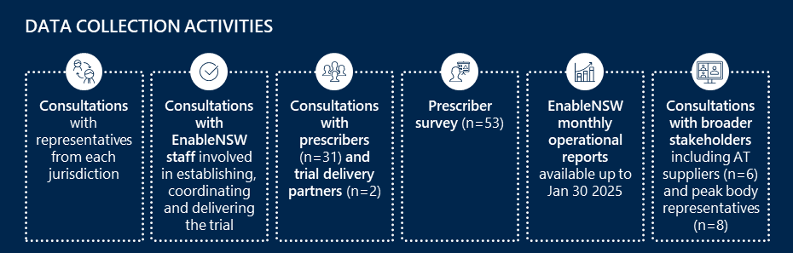

### The evaluation was conducted across three stages

Evaluation activities occurred in three stages between September 2024 and February 2025:

* Stage 1 (September to October 2024) involved the planning and designing of the evaluation. An evaluation plan, including the methodology and framework, research questions, and stakeholder engagement approach was developed and agreed with the Department. This was informed by early consultation with EnableNSW and each jurisdiction to understand the AT context across Australia and identify areas of focus for the evaluation.
* Stage 2 (October to December 2024) focused on data collection and analysis. This stage involved comprehensive engagement with stakeholders directly and indirectly involved in the trial via consultations and a survey. These activities gathered insights on AT needs and experiences, early experiences and outcomes of the trial, and potential considerations for the future National Scheme.
* Stage 3 (January to February 2025) involved iterative development of evaluation findings and recommendations. This included a second round of consultations with prescribers, and other key stakeholders to test and iterate emerging findings, address remaining gaps and explore their continued experiences of the trial. Analysis of updated activity data and available financial information was also undertaken to inform the final evaluation report.

## Parameters and limitations

### It is important to highlight that this evaluation was conducted in the early stages of the trial implementation, as activity increased, and processes matured

Findings in this report reflect activity and experiences with the trial in its first 6 - 7 months, from August 2024 to the end of January 2025. Additionally, contractual arrangements between EnableNSW and delivery partners limited the availability of certain data. Given the timing of the evaluation and data availability issues, there are several key limitations to the evaluation findings:

* Prescriber views (collected via survey and consultations) reflect a point in time during the trial and may not be fully reflective of more recent experiences, which may be different given ongoing fine tuning of processes.
* The short duration of the evaluation limits the findings on changes in experiences over time (for example, how well the trial works with increasing demand and any changes to trial processes to improve experiences for older people, prescribers and delivery partners).
* Due to the trial's early stage and limited access to datasets for assessing clinical or system outcomes, the evaluation cannot draw substantive conclusions about the outcomes for older Australians, prescribers, and the system. In addition, the scope of this evaluation did not include direct engagement with older Australians to explore their experiences with and perspectives on the trial. Findings about the outcomes of the trial are thus largely based on anecdotal evidence from prescribers and surveys of trial users conducted by EnableNSW (patient reported experience measures (PREMS) and patient reported outcomes measures (PROMS)).
* Sharing of data related to the efficiency of the trial was limited to aggregate costing information, which was insufficient to evaluate the financial efficiency of the loans scheme model. Findings related to financial efficiency are thus high-level, and are supplemented by comparable evidence from other research where available.
* The level of activity at the regional trial site was relatively low, and so did not support deep exploration of the appropriateness of the trial model for delivery in different contexts. Where possible, comparisons of the activity, processes, experiences and outcomes of trial sites is provided based on anecdotal evidence from key stakeholders and the limited activity data available.

Further analysis will be required to understand the extent to which the trial model is appropriate to deliver on its intended outcomes in different contexts. This includes understanding the effectiveness and efficiency of the trial, and identifying outcomes generated for older Australians, providers and the system with greater certainty.

### The trial tests one possible model for an AT loans scheme and is intended to inform the various options and elements that could be incorporated into a National Scheme

It is important to note that the trial intended to highlight key considerations for designing the National scheme, rather than to test the appropriateness of that specific model for national roll out. The evaluation explored the appropriateness the agreed trial model to achieve the intended outcomes and considered findings in the context of how they might inform decisions about the National Scheme. It is expected that there will be other models and components that become part of the National Scheme, and these may need to be trialled or tested in different contexts.

# Environment

|  |
| --- |
| This section outlines the findings of an environmental scan, collected through engagement with jurisdictions and desktop research. It explores the current state of AT programs across Australia and internationally, including: arrangements in place across jurisdictions, programs delivered by non-government organisations across Australia and examples of international programs and strategies utilised to address challenges with program implementation and delivery. |

## Assistive technology in aged care

### AT comes in many forms, and supports older people’s functioning in all aspects of life

AT describes products used to help or maintain an individual’s functioning, including cognition, communication, hearing, mobility, self-care and vision, to enable their health, wellbeing, inclusion and social participation.[1]

Australia’s ageing population is driving increased demand for aged care services, with a growing need for support with age-related health conditions in people’s homes, the community, and residential aged care.[2] AT is utilised across all aged care settings to increase, maintain or improve the functional capabilities of older Australians, and support delivery of high-quality patient-centred care.[3] It ranges from basic, low-cost and low risk equipment such as jar openers to more expensive and complex technology and often customised equipment, such as hoists and power wheelchairs (see Figure 2).

Figure 2 | Types of assistive technology used in aged care[4],[5]

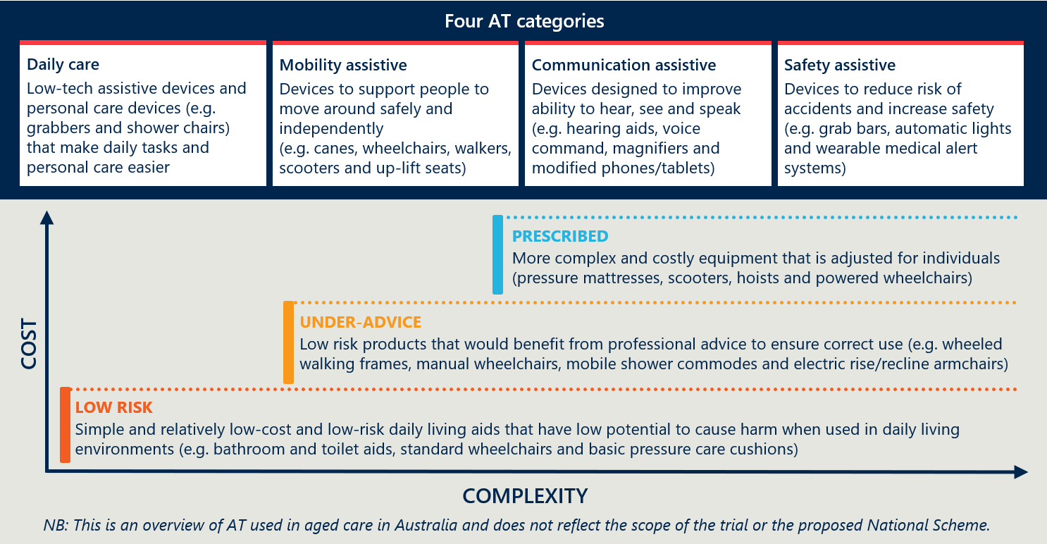

### Use of AT has significant benefits for both individuals and the aged care system

AT is important for supporting older Australians receiving aged care services in all settings. For those receiving care at home, it has a central role in maintaining independence and autonomy and supporting them to remain at home, safely, for longer.[6],[7] There is significant evidence to suggest the cost benefits of investment in AT, with early intervention significantly reducing the costs of functional decline and associated complications to the aged care and health systems (see Figure 3).[8]

Figure 3 | Benefits of AT in aged care[9],[10]

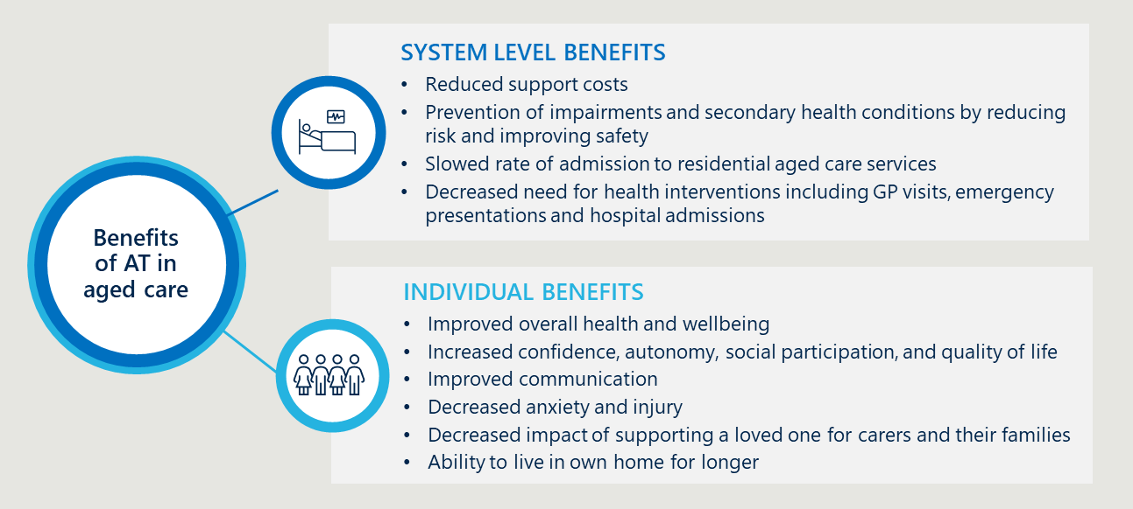

### A range of government departments and non-government organisations subsidise AT for eligible older Australians

There are over 70 different national and jurisdictional level programs in place to deliver AT across the health, aged care and disability sectors in Australia.[11] Older Australians can access AT through a range programs funded by commonwealth and jurisdictional governments, as well as through non-government organisations and self-funded options (see Figure 4). These programs offer a mix of purchases and loans, with varying levels of subsidy for eligible individuals.[12]

Figure 4 | AT funding streams in Australia[13]

Figure 4 is a diagram outlining assistive technology funding streams in Australia, showing various Commonwealth, jurisdictional, and non-government sources and access pathways.


Currently, the Department of Health and Aged Care funds AT for older Australians receiving in-home aged care support through the Commonwealth Home Support Programme (CHSP), Home Care Packages (HCP) and Short-Term Restorative Care Programme (STRC). Arrangements for the provision of AT vary between these aged care programs, including the types if AT available and level of subsidy. For example:

* CHSP offers up to $500 per year to access AT, or up to $1,000 with supporting evidence from an occupational therapist.[14]
* HCP funding does not currently assign an amount specifically for AT. Depending on assessment, HCP funding is provided at pre-determined levels (between $8,928-$51,808 per year) based on complexity of needs. This funding is intended to cover the cost all support needs (e.g. support services, AT and home modifications), and recipients make their own decisions on what to prioritise.[15] An additional $2,500 can be accessed for urgent AT if a person has insufficient HCP funds for AT to meet short term needs.[16]
* STRC includes provision of AT, at a means-tested cost. Equipment purchased through STRC remains with the older person after the 8-week program has finished.[17]

The way that older people access AT varies depending on the program through which they receive funding. For STRC recipients, AT is supplied by approved providers, who submit claims directly to Services Australia.[18] Eligible CHSP and HCP recipients can access low-risk, low-cost AT through GEAT2GO or approved MAC service providers.[19] Older Australians who hold a Veteran Gold Card or Veteran White Card and have an assessed clinical health care need are also able to access AT through the Department of Veterans’ Affairs’ Rehabilitation Appliances Program (RAP).[20] Figure 5 provides an overview of GEAT2GO and DVA RAP.

Several other state and federal government-funded schemes provide funding for AT beyond aged care, including the Job Access Employment Assistance Fund (JAEAF), Essential Medical Equipment Payment Scheme (EMEPS), Continence Aids Payment Scheme (CAPS) and Hearing Services Program (HSP).[21] These programs are mostly condition or circumstance specific.’

Figure 5 | Overview of GEAT2GO and DVA RAP[22],[23],[24]

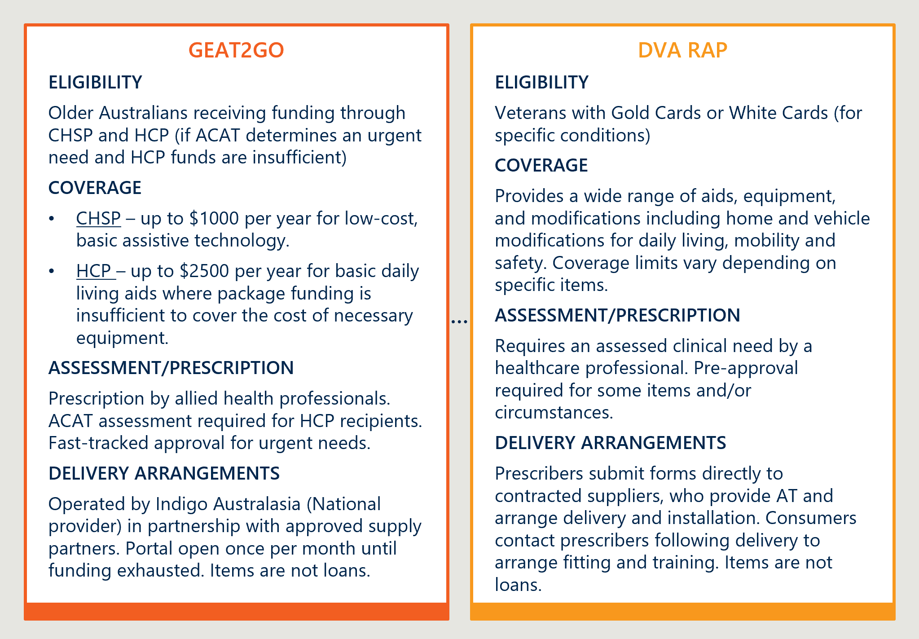

Older Australians who are not eligible to access AT through these programs may be eligible for jurisdictional programs, condition-specific programs or may access AT via non-government organisations or private purchase/hiring arrangements. Jurisdictional program arrangements are explored in Section 2.2, non-government and condition-specific options are explored in Section 2.3 and AT suppliers are explored in Section 2.4.

## Jurisdictional AT programs

### Jurisdictional AT programs vary in design and delivery arrangements

Each jurisdiction funds an AT program that provides access to subsidised AT for eligible consumers (see Figure 6). These programs vary in budget, scope, eligibility, level of subsidy and use of loans and/or purchase arrangements. However, they are similar in terms of access, assessment and prescription processes, and provision across health, disability and aged care. Consultations with jurisdictions highlighted some program similarities, including:

* Most programs are delivered through collaboration across health, aged care and/or disability to increase efficiencies. Some jurisdictions also work with local hospitals to cover rural/remote areas, particularly where there is a lack of private providers.
* The pathways through which individuals can access AT are similar across jurisdictions and include assessment, application and prescription by eligible prescribers.
* Clinical governance arrangements typically involve oversight by a clinical advisor who reviews and advises on applications that include more complex and higher cost equipment
* All programs with a loans component include delivery, maintenance, repair and replacement of AT.
* Most jurisdictional programs play a ‘gap filling’ role for the aged care system. Whilst jurisdictional programs are focused on delivering AT within the state-funded health system, most report that they are providing AT to older people who require AT but have no aged care funds remaining or where items are not available via aged care funding.

Figure 6 | Jurisdictional AT Programs

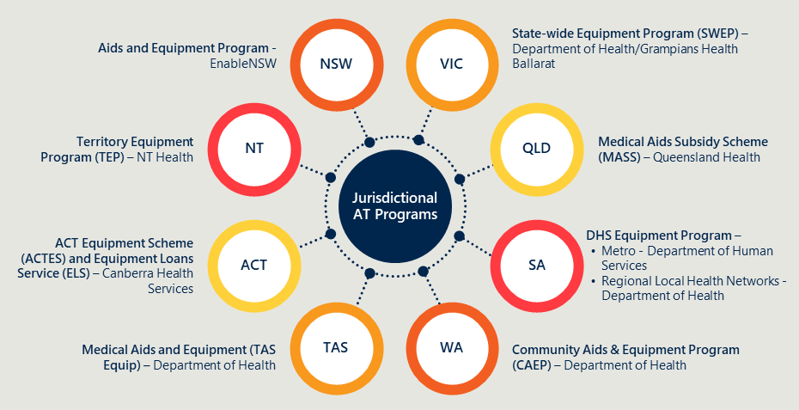

As these programs are designed to work in unique contexts, there is significant variation in design and delivery arrangements across jurisdictions. For example:

* Not all programs are loans schemes – some operate a purchase-only model. Purchase models are used in jurisdictions where the cost of delivering, maintaining and retrieving equipment outweighs the benefit of retrieving and reissuing it. They are also favoured in harsher environments that reduce the life of equipment. There are differences in items reissued or categorised as single use across programs.
* Each program has a unique eligibility criteria, some of which are more extensive than others. For example, eligibility for some programs require individuals to be in receipt of government support, whilst others only require that individuals are not eligible for funded AT through other programs.
* Not all programs cover the cost of assessments/prescriptions. Some programs cover these costs only if they are not covered by another program, whilst others do not cover them at all.
* Item lists vary across programs, with some programs offering more flexibility around specific items and brands, particularly in jurisdictions where there are procurement challenges.
* Warehousing and storage arrangements range from a single location to smaller stores in multiple locations. Some have arrangements with local hospitals for storing small amounts of equipment, or do not store equipment at all, and instead draw from the stores of local suppliers to source equipment. Most jurisdictions are at capacity with storage.
* Responsibility for delivery is mixed across jurisdictional programs. Some are run in-house by jurisdictions, while others are delivered by block-funded contractors or service providers. Some programs are completely outsourced to one contractor, whilst others use multiple service providers to cover a range of locations and/or needs.
* Data collection is highly variable across programs. Most jurisdictions rely on old Information and Communications and Technology systems (ICT systems) that have limited capacity to collect data and interact with other systems. Data mostly tracks types of equipment; however, this is not consistent across programs. In some cases, data collection varies within programs as several providers deliver them.

A more detailed description of jurisdictional program arrangements can be found in Appendix A.

## Non-government and condition-specific programs

### Several non-government organisations (NGOs) and private organisations deliver AT programs that accept funding from government-funded schemes

Some of these programs include a loans/hire component, however many operate a purchase model. Figure 7 compares the key components of a sample of these programs, including funding options, availability of loans or hires, ability to trial AT in the home, inclusion of repairs and reissue of equipment.

These organisations provide advice, assessments and prescriptions to older Australians to ensure they are accessing appropriate AT. Whilst most are not loans schemes, many offer in-home trials of equipment. Most of these programs do not hold stock of their own, instead working with AT suppliers to source and deliver AT following prescription.

Whilst most programs do not include a loans component, FlexEquip is an example that maintains a pool of AT, which is provided as a long-term loan at no cost for people over 65 with motor neurone disease (MND), or NDIS participants. Equipment is returned, cleaned and reissued when no longer required. This model intends to ensure that people with MND can access appropriate AT as their needs change – this is similar to EnableNSW’s Aids and Equipment Program.[25]

Figure 7 | Examples of non-government AT programs[26],[27],[28],[29],[30]

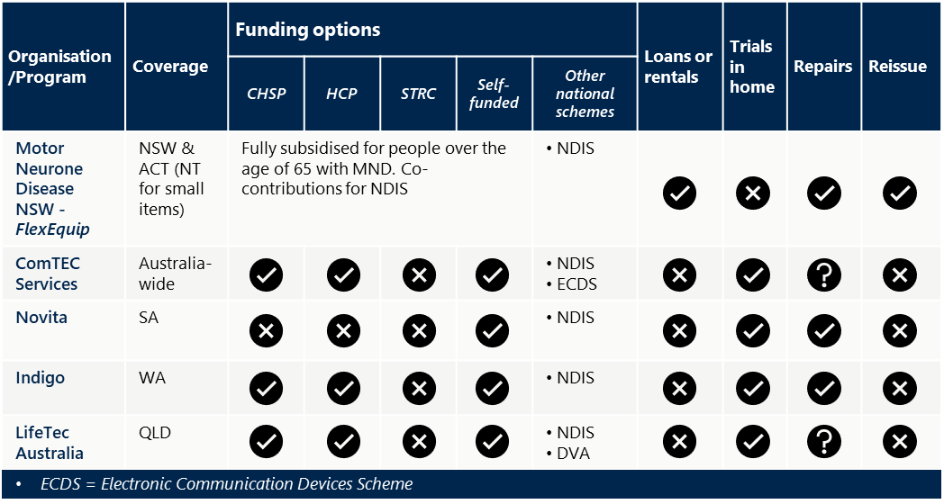

## AT suppliers

### AT suppliers across Australia supply assistive technology through government programs, and private purchases and hire

Australia’s AT market is vibrant, with over 350 specialist and thousands of generalist providers ranging from local shopfronts to organisations with branches across the country.[31] Some suppliers provide the AT that is subsidised through government programs, whilst others deliver AT directly to consumers via local shopfronts and/or online catalogues. Larger suppliers often deliver both of these functions, whilst also procuring AT from overseas manufacturers, supplying to smaller businesses, offering repair and maintenance services and manufacturing their own products.

Some businesses have national coverage, including contracting arrangements with suppliers in rural and regional areas, warehouses and workshops across the country and large prescriber networks. Larger organisations often supply, deliver, maintain and reissue AT within multiple state-funded programs, whilst also delivering AT to NDIS participants, older Australians receiving aged care services and direct to consumers via private purchases (see Figure 8).[32] Many AT suppliers also offer clinical support, assessments, equipment trials and training for AT users and their families/carers.

Figure 8 | Examples of AT suppliers, funding options and service offerings[33],[34]

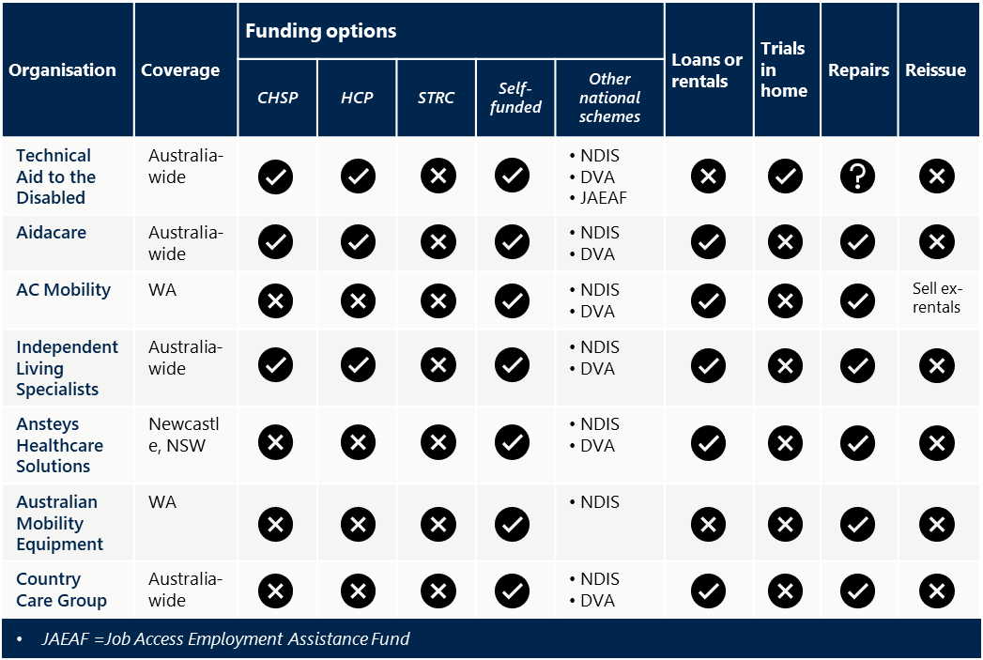

## International examples

### AT loans schemes are being delivered in several countries, each with a different model

This includes schemes in the United Kingdom, Denmark, New Zealand and Norway which are designed to provide AT for a range of needs, not all age related. Key features of these programs are outlined in Table 2 overleaf, with further detail provided in Appendix B.

Table 2 | Key features of international AT loans schemes[35], [36], [37], [38]

|  |  |
| --- | --- |
| Key feature | Examples |
| National level funding agreements delivered by several contracted organisations or local councils | * The United Kingdom’s AT loans scheme is NHS funded but delivered by local councils, who conduct social care needs and financial assessments and provide equipment based on identified needs. * Schemes in Denmark and Norway are funded at a national level, and delivered by local authorities, who adapt the model to suit their local context. For example, in some cases neighbouring councils share warehousing facilities and/or workshops, whilst other councils lease equipment from private suppliers who have their own warehousing functions. * New Zealand’s loans scheme is funded at a national level, with two organisations delivering the program for different areas/needs. Accessable covers Auckland and Northland for disability needs, whilst EnableNZ covers the rest of the country and accident rehabilitation needs. |
| Assessments are sometimes conducted outside of the health system and some schemes do not require assessments for low-cost items | * Social care needs assessments are conducted by local councils in the United Kingdom. Healthcare professional input is required for specialist equipment not available through the loan pool. * Consumers complete applications through a self-service portal in Denmark and Norway – with local councils providing guidance on the most appropriate AT as required. |
| Loan pools stock commonly required low-cost items, with more specialised equipment subsidised though a voucher program | * In the United Kingdom, Denmark and Norway, loan pools stock basic AT and vouchers are provided for specialist equipment on the recommendation of a healthcare professional. |
| Variable requirements for co-contributions | * AT is provided free of charge and there is upfront cost for assessments in Denmark and Norway. * In the United Kingdom, co-contributions are required if the cost of AT is over a certain amount or depending on the economic circumstances of an individual. * In New Zealand, items recommended by an EMS assessor are fully subsidised for eligible people, as long as they are required for more than 6 months. |

### Programs delivered in other countries highlight several strategies to overcome challenges with designing and delivering loans schemes

The WHO and UNICEF’s [*Global report on assistive technology*](https://www.who.int/publications/i/item/9789240049451) highlights key challenges in the provision of AT and what is required to improve access for people around the world. The report outlines strategies for improving access to AT, including to mitigate system level barriers related to workforce, governance and procurement (see Figure 9).

Figure 9 | Strategies to address common challenges with the provision of AT[39], [40]

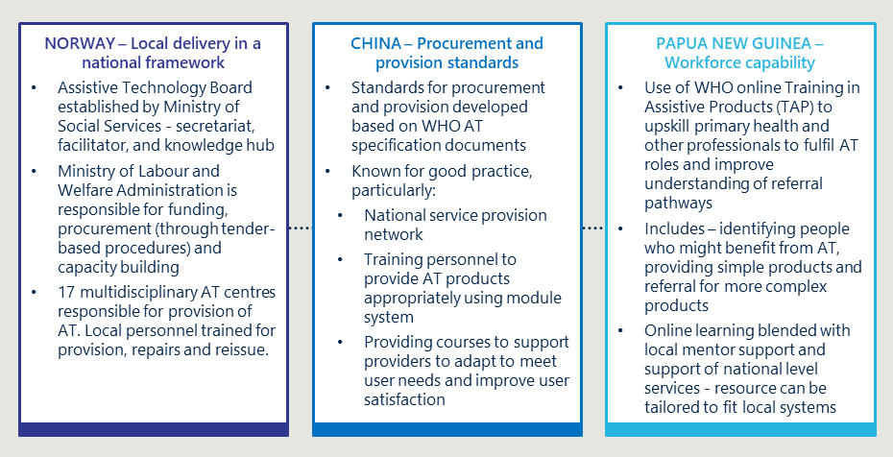

The report includes recommendations to guide countries to improve access to AT, with a view to supporting universal coverage, including:[41]

* Taking an intersectoral approach to AT provision by involving all key sectors and developing standalone AT policies and plans that are adequately resourced to support provision across all sectors.
* Strengthening regulatory systems and standards and building feedback mechanisms into supply chains to ensure products are safe, effective and affordable. The report suggests governments should leverage international tendering to support value for money. It also highlights the need to engage users and their carers in product selection and provide adequate training for use and maintenance to support the longevity of equipment.
* Investing in capacity building to expand, diversify and improve workforce capacity to support the provision and maintenance of AT. This includes exploring opportunities to broaden the prescriber pool beyond healthcare professionals to mitigate bottlenecks.
* Invest in data collection to better understand population-level trends about need and demand for AT and develop evidence-based policies and programs. The report recommends using the [WHO Rapid Assistive Technology Assessment (rATA) tool](https://www.who.int/publications/i/item/WHO-MHP-HPS-ATM-2021.1) to collect population-based data, and integrating this with other national data collection activities and/or the health information system.

Whilst each country must consider its specific context to identify the best way to ensure access to AT, the report includes considerations that are relevant to the Australian context. Australia can learn from the experiences of other countries and leverage the strategies and recommendations outlined in this report in to ensure the design of an effective model and supporting policies for the National AT Loans Scheme.

# Implementation

|  |
| --- |
| This section includes findings about the implementation of the trial including the need for the trial and how it was established. |

## Need for and role of the trial

### Assistive technology has a significant impact on the ability for older Australians to age in their own home

AT promotes independence, safety and improved quality of life, which are key factors in enabling older Australians to remain in their home. As people age, they often become more frail and experience functional decline or disability. Modifications to the environment can support the independence and autonomy of older Australians. This can be done by home modification and/or AT. AT can help older Australians maintain their independence and autonomy by maintaining or improving a person’s functional capabilities, preventing impairments and secondary health conditions and reducing the burden on family carers and formal caring arrangements.

### In the current system older Australians’ access to AT can be limited due to fragmentation, lack of information and funding constraints

Despite being available through existing programs and schemes, many older Australians struggle to access AT within the current system. Challenges with access are the result of interrelated barriers, including:[42], [43]

* A lack of information about available options, poor communication and contradictory advice from service providers about available programs and appropriate AT. High rates of abandonment of AT also suggest that more information is required to support decision-making.
* Significant wait times for assessments, and requirements for multiple assessments when more than one item is required, which is true of most people who use AT.[44] This results in unnecessary spending of HCP funds, distress and confusion, delays and poor coordination of care.
* Insufficient funding within aged care packages to support both access to AT and provision of care. Older people sometimes report that the funding in their package level is insufficient to afford both the care services and AT they require to meet their needs, so they must limit care services to accumulate funds for AT. Accumulated funds are sometimes viewed as an underspend within their current package level, preventing them from being approved for a higher-level package even if it is required. Additionally, there is a lack of transparency about what is available within different funding levels and programs. As a result, jurisdictional programs play a gap filling role to meet the needs of older Australians, as well as serving their intended purpose within the state-funded health system.
* Insufficient coverage to meet demand in current programs, for example prescribers have reported that the allocation of funding within GEAT2GO typically runs out very quickly and before they are able to submit applications for all who need it.

The Royal Commission into Aged Care Quality and Safety (the Royal Commission) echoed these concerns, and recommended increased investment in AT, including the creation of an AT and HM funding category to enable access to AT (and HM) that will support people to remain at home for longer as they age.[45]

### Support at Home will change the way in which older Australians access AT, with the introduction of a National Loans Scheme (the National Scheme)

The National Scheme is a key part of the reform to in-home aged care as part of the Support at Home program, and intends to enhance the accessibility of assistive devices and services for individuals requiring support in their homes (see Figure 10). It is currently expected that the National Scheme will be delivered through existing State and Territory Government loans programs to older people receiving aged care support under Support at Home. The detailed design of the National Scheme is currently in progress.

Figure 10 | Context underpinning the trial

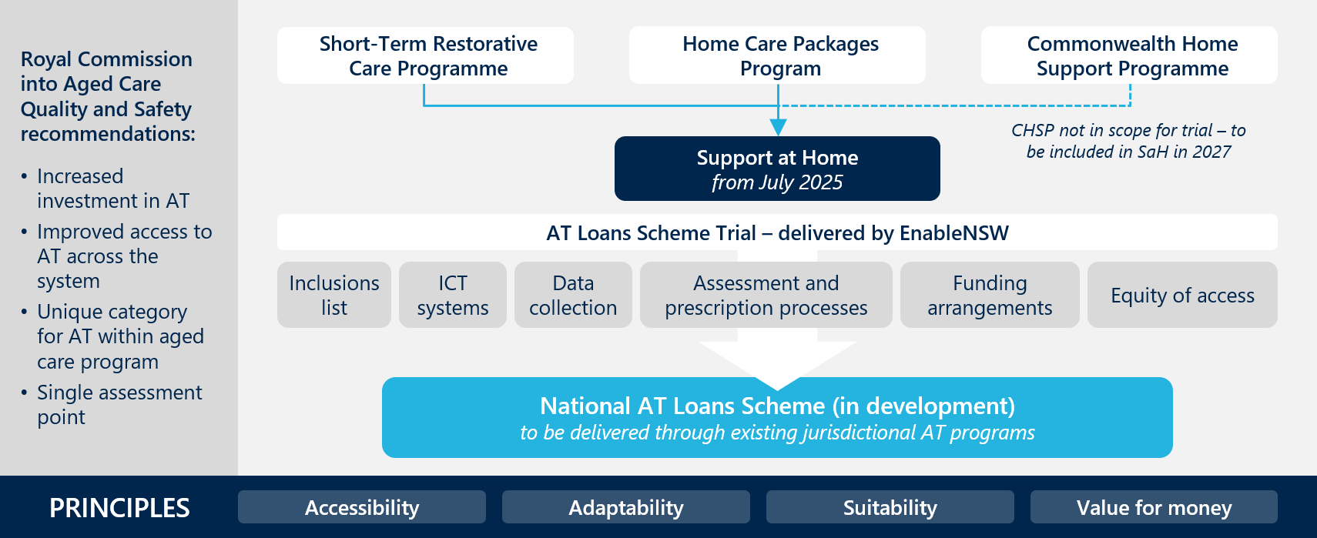

### Because of contextual differences across jurisdictions, a trial is valuable to test elements of the National Scheme

As outlined in 2.2, existing State and Territory AT programs vary in design – including budget, scope, eligibility and levels of subsidy. The National Scheme will need to account for variations in current State and Territory programs, the policy environment, priorities, needs and context specific barriers and enablers for implementation and delivery across jurisdictions when considering the appropriateness of the proposed model for national implementation.

As introduced earlier in this report, the Department has commissioned an AT Loans Scheme Trial to help to inform the design of the National Scheme. The trial involves older people who currently receive in-home aged care support through a Home Care Package or Short-Term Restorative Care and is currently running across two sites in NSW. The purpose of the trial is to test key aspects of the Loans Scheme model, including: [46]

* + the proposed inclusion and exclusions list of AT items
  + prescription process and documentation
  + equity of access to socially and culturally appropriate AT
  + ICT systems – including both the front-end (prescriber facing) and back-end (application and equipment management) systems
  + data collection
  + proposed funding arrangements.[47]

The trial will provide important insights about key elements of the model, including what works well and not so well in different contexts. This will likely inform thinking on elements that could be flexible to local contexts within the National Scheme model, to ensure viability across jurisdictions.

## Establishment

### The Department engaged with stakeholders to identify the desired goals and service elements of the National Scheme

In 2022, prior to initiating planning for the trial, the Department undertook several activities to explore how best to deliver AT to older Australians through Support at Home:

* A co-design project was undertaken with older Australians and their families/carers, industry professionals and government stakeholders to explore options for delivering AT and home modifications within the Support at Home program. This included identifying desired outcomes, objectives and principles, specific elements and services that should be included within the National Scheme.[48]
* Work was conducted with Monash University (Monash) to develop an inclusions and exclusions list of AT for older Australians under the Support at Home program.[49]

### The trial model was designed to align with the proposed National Scheme elements, with input from various stakeholders

The Department engaged with the NSW Ministry of Health (MoH) and EnableNSW in late 2023 to begin planning for the trial, building on the learnings generated through prior stakeholder engagement. The planning phase of the project formally commenced in April 2024 following site scoping and informal stakeholder engagement in early 2024. Initial funding was provided to EnableNSW with funds earmarked for designing, planning and establishing the trial across two sites in metropolitan and regional NSW, and other funds for procuring additional AT for the trial’s eventual loan pool.

The trial was designed by the NSW Health project team, including a project working group of subject matter experts from EnableNSW and the NSW MoH Aged Care Unit, in collaboration with the Department’s Support at Home Reform Branch. The proposed National Scheme elements were used as the foundation of the trial model, with adjustments made to align with EnableNSW’s context to ensure a high standard of service and implementation feasibility. This included modifying the scope of items recommended for inclusion by Monash.

EnableNSW engaged with contracted suppliers to ensure they had capacity for increased volumes, and sought advice from Aged Care Assessment Teams, prescribers and Local Health District partners who work with older people. A proposal was agreed on by the MoH and the Department before EnableNSW commenced implementing the trial. The Department provided subsequent funding for the trial’s delivery.

Figure 11 overleaf presents a visual overview of the trial program under evaluation, including intended outcomes for older Australians, providers and the system, an overview of service delivery and key stakeholders involved.

Figure 11 | AT loans scheme trial overview

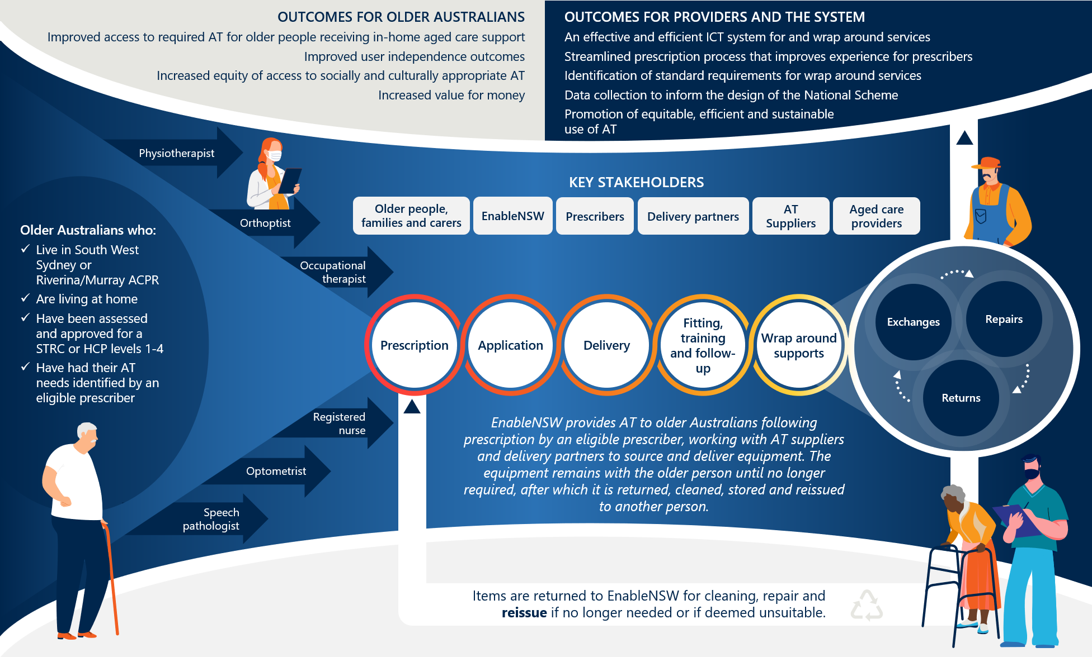

### Establishment activities included process development, staff recruitment and training, and assistive technology procurement

With funds allocated for project planning in April 2024, EnableNSW conducted a series of activities to prepare for the trial’s implementation, including:

* development of processes related to data collection, reporting, applications, referral pathways and charging and billing mechanisms
* implementation of any ICT enhancements and other system configuration requirements
* design of training material for EnableNSW officers, subcontractors and suppliers
* identification and procurement of agreed AT products
* creation of an itemised catalogue of AT available for loan.

### EnableNSW worked with the Department to establish data collection processes and agree on reporting requirements prior to commencing the trial

Agreed metrics included data related volume and type of activity, timeliness, patient experiences and outcomes and cost (see Table 3). This data was intended to enable insights across metro and regional areas, and to deliver insights to support planning and decision making on the structure and processes for delivering the National Scheme.

Table 3 | Agreed data metrics for inclusion in operational reporting

|  |  |
| --- | --- |
| Trial element | Metrics |
| Activity | * Number of requests by equipment type and stock flag * Number of prescribers and number of applications * Application received date and completion date * Number of people assisted (application count, LHD and item count) * Application status (outcome) and reason |
| Equipment usage | * Date item delivered and date returned * Abandonment rates by equipment type |
| Repairs | * Repairs count and equipment category * Reason for repair |
| Returns | * Number of returns and reason for return |
| Delivery | * Date picked up from EnableNSW Equipment Centre * Date delivered to customer * Number of late or delayed deliveries (made outside delivery targets) |
| Average cost | * Average cost of repairs * Average cost by equipment category (where there are multiple brands in a category) |
| Feedback | * Survey responses * Complaints |

### Contracted partners were responsible for delivering items and providing wrap around services through the trial

A delivery partner was selected in each of the trial locations to assist with delivery, installation, repair and collection services. The two delivery partners were selected for the trial because they were the incumbent delivery partners for the existing Enable program; the South West Sydney (SWS) delivery partner was the successful tenderer for delivery and collection services within the greater metropolitan area in a 2022 NSW Government tender, and the regional delivery partner has been delivering to Riverina/Murray since 2015.[50]

### EnableNSW leveraged existing delivery arrangements to deliver the trial at the metro site, and worked with the delivery partner to establish new processes for regional delivery

Arrangements between EnableNSW and delivery partners vary between trial sites. EnableNSW purposefully tailored the trial model and arrangements to leverage existing processes, resources and relationships at each site, including:

* using the existing fleet of vehicles and team of staff dedicated to the SWS delivery partner’s contracts with EnableNSW
* incorporating trial items within the regular shipping schedule and vehicles used by the RM delivery partner to transport from Sydney to Albury, and use of warehousing facilities at both locations.

EnableNSW tailored delivery arrangements for each trial site to align with existing activities and resources in an effort to support efficiencies and enable seamless integration of the trial with existing activities. Figure 12 provides an overview of the processes established with delivery partners at each site.

Processes for requesting repairs, exchanges and returns were same for both sites. To arrange a repair or return, the older person or their nominee contacted EnableNSW to request repair, return or exchange. EnableNSW passed on relevant information to the delivery partner who actioned repairs or returned equipment to EnableNSW for cleaning and reissue.[51], [52]

If an item was provided and was not suitable, prescribers contacted EnableNSW in writing to request an exchange. EnableNSW then prepared the new item for shipment and added instructions for the delivery partner to collect the old item at delivery.[53] If there was not enough space to collect the item at the same time as delivery, or there was risk of contamination, the delivery partner would return to collect the item at a later date.

Figure 12 | Arrangements with delivery partners for each trial site

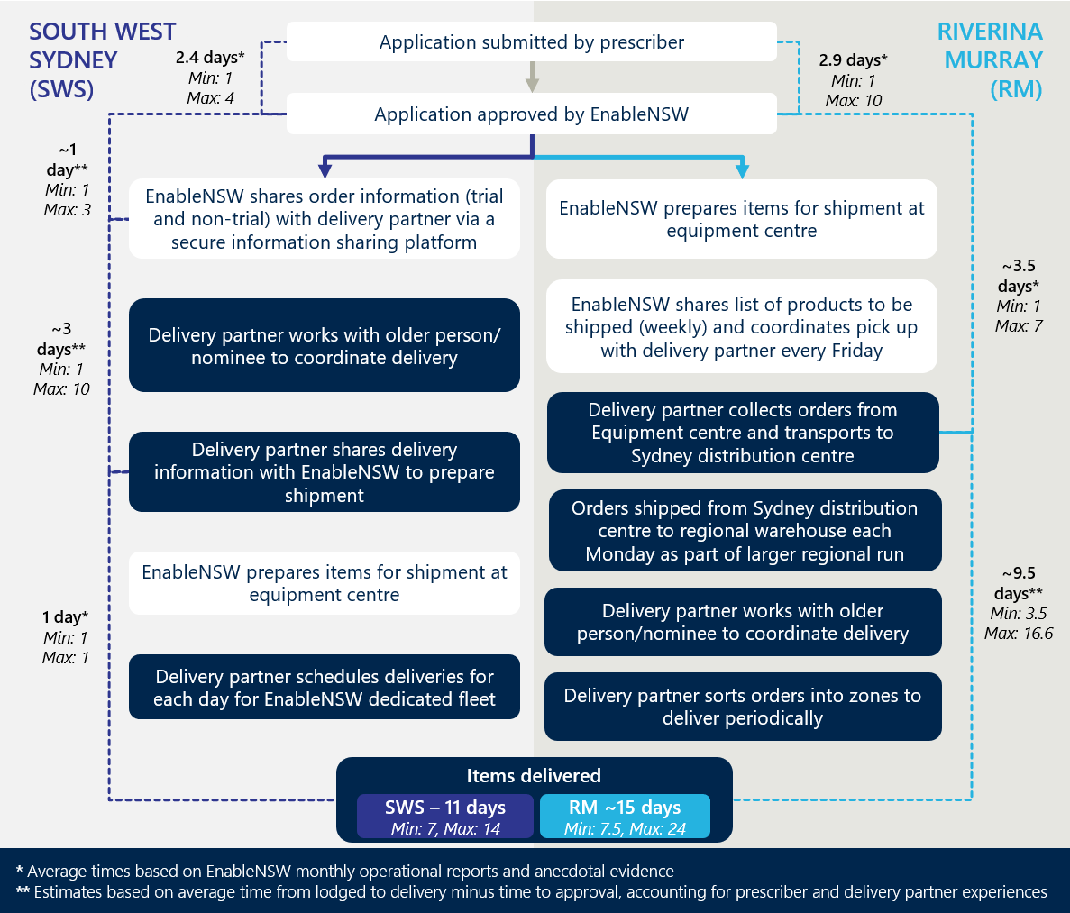

### EnableNSW hosted a series of webinars to build prescriber awareness of the trial

EnableNSW initially informed prescribers of the trial through pre-existing communication channels and hosted a series of webinars to build prescriber awareness of and confidence in the trial. These channels were effective for reaching NSW Health prescribers in the hospital setting, as many of these were familiar with EnableNSW and their processes which made it easy for them to learn about and interact with the trial.

Figure 13 outlines how prescribers first heard about the trial, based on a sample of 45 health professionals who prescribed through the trial. It indicates that a little over half of prescribers who participated in the trial attended an EnableNSW-hosted webinar with information about the trial. Of the 25 respondents who reported attending a webinar, 23 were occupational therapists (OTs) (see Figure 14). Some NSW Health prescriber’s hospital-based prescribers also reported hearing about the trial through their OT advisory, internal team communications and meetings, professional networks, communications from the NSW Ministry of Health and/or in-services run by EnableNSW.[54]

Figure 13 | How prescribers heard about the trial[55]

Figure 13 is a Bar chart showing how prescribers first heard about the AT Loans Scheme Trial, including sources such as webinars, team meetings, and professional networks.


Figure 14 | Prescribers who attended a webinar about the trial[56]

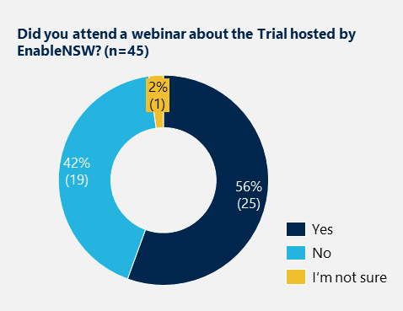

# Effectiveness

|  |
| --- |
| This section outlines insights about the effectiveness of the trial, including trial activity, how stakeholders have experienced the trial and what factors have enabled or limited success. Insights in this section draw on data from EnableNSW monthly activity reports for August 2024 through to January 2025, stakeholder engagements and a prescriber survey. |

## Summary of trial activity to date

### The trial received 583 applications between July 2024 and the end of January 2025

Monthly reporting from EnableNSW indicated that 79% of applications received were from South West Sydney (SWS), and 20% were from Riverina/Murray (RM). A small number of applications came from outside of the trial regions (n=7). Applications from both sites remained relatively steady, though began to increase in January 2025. Of all applications, 93% were approved, and 7% were declined or withdrawn.[57] The number of applications that were declined does not include applications where individual items were declined. EnableNSW suggested anecdotally that this rate was approximately 10%. Figure 15 summarises application activity to date across sites.

Figure 15 | Applications by reporting month and site [58]

Figure 15 is aBar chart showing the number of applications to the AT Loans Scheme Trial by month and site from July 2024 to January 2025.


The majority of prescriptions were for readily available items purchased by EnableNSW during establishment

The most frequently prescribed product categories included beds, pressure mattresses, pressure cushions and manual wheelchairs (see Figure 16). EnableNSW reported in consultations in December 2024 that they had received 80 applications for items requiring pre-approval, mostly for power lift chairs (n=54). There were minimal applications for AT from the purchased on-request category. The majority (97%) of items were shipped from existing stock at the EnableNSW Equipment Centre. This was mostly new equipment purchased by EnableNSW during the establishment phase of the trial. The remainder were purchased from suppliers on prescription.

Figure 16 | Average prescriptions per month by product category[59]

Figure 16 is a Bar chart of average monthly prescriptions by product category, highlighting most frequently prescribed items like shower, bath and toilet equipment, and pressure mattresses.


### Prescriptions from private prescribers increased over time at both trial sites

Whilst low initially, the proportion of applications submitted by private prescribers each month (with ‘private’ referring to those not employed by NSW health) increased from August 2024-January 2025 (see Figure 17). Further information about challenges associated with low prescriber awareness and changes over time is included in Section 4.2.1. Responses to the prescriber survey (n=46) highlighted that prescribers were primarily occupational therapists working in community-based services, hospitals and for aged care providers (see Figure 18). Other prescriber qualifications included registered nurses, physiotherapists and speech pathologists.

Figure 17 | Proportion of prescriptions by prescriber type, from EnableNSW reports[60]

Figure 17 is a Line graph showing the proportion of prescriptions submitted by private versus public prescribers over the course of the trial.


Figure 18 | Respondent qualifications and service types, from Prescriber Survey[61]

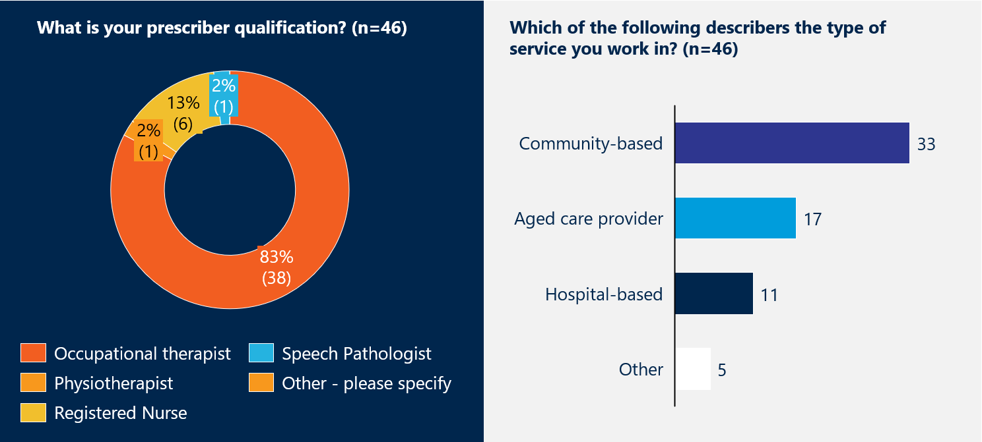

### Information about the older Australians who used the trial is limited

Insights on the demographics of older Australians who used the trial were limited to anecdotal evidence gathered through the prescriber survey and consultations. Stakeholders noted that the trial users were often people:

* from lower socioeconomic backgrounds
* who lived alone or had little support from family or friends
* with continually evolving needs or needs that had changed significantly in a short period of time and were unable to access equipment in a timely manner through the aged care system
* who required AT for a safe and timely discharge from hospital
* who had exhausted their HCP funds, were awaiting funds or awaiting assessments.

Many prescribers reported that the older Australians who had received AT through the trial were those who were unable to access it though other avenues, or who required it urgently.

### Repairs were minimal, but requests for returns increased over time

Insights about repairs were limited due to a small number of requests (n=12) in the reporting period. Of these, nine were from SWS and three were from RM, and related to beds and mattresses (n=4), transfer equipment (n=4), shower, bath and toilet equipment (n=3) and wheelchairs (n=1).[62]

Whilst low initially, requests for returns and number of items returned began to increase in September. Returns usually included multiple items. The most common reasons for returning equipment were that the older person had passed away (50%) or the items were no longer needed (39%) (see Figure 19).[63] A small number of returns were due to a transition into residential aged care (7%) or if items were unsuitable (4%). Requests for returns were largely from SWS (31 of 40). While limited by available data, Section 4.2.3 provides insights about stakeholder experiences of wrap around supports, based on qualitative evidence.

The rate of reissue was low at the time of the evaluation, which was expected given the relative immaturity of the trial and small number of returns. EnableNSW added that demand for the trial exceeded available equipment, which also contributed to a low reissue rate. It was anticipated that returns and reissues would increase over time as the trial progressed.

Figure 19 | Returns activity, August 2024 - January 2025[64]

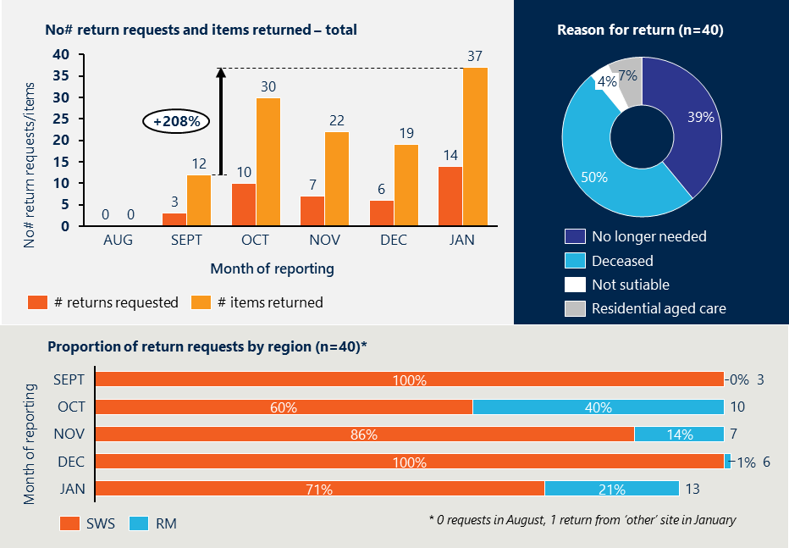

## Experiences of the trial

This section explores stakeholder perspectives on what worked well and what could be improved across each stage of the trial. The findings in this section draw on interviews with prescribers, delivery partners, trial staff and other key stakeholders, and insights from the prescriber survey.

Figure 20 summarises what worked well and what could be improved across the trial as a whole. The remainder of this section explores these themes in greater detail as they relate to key activities involved in delivering the trial.

Figure 20 | Summary of what is working well and what could be improved

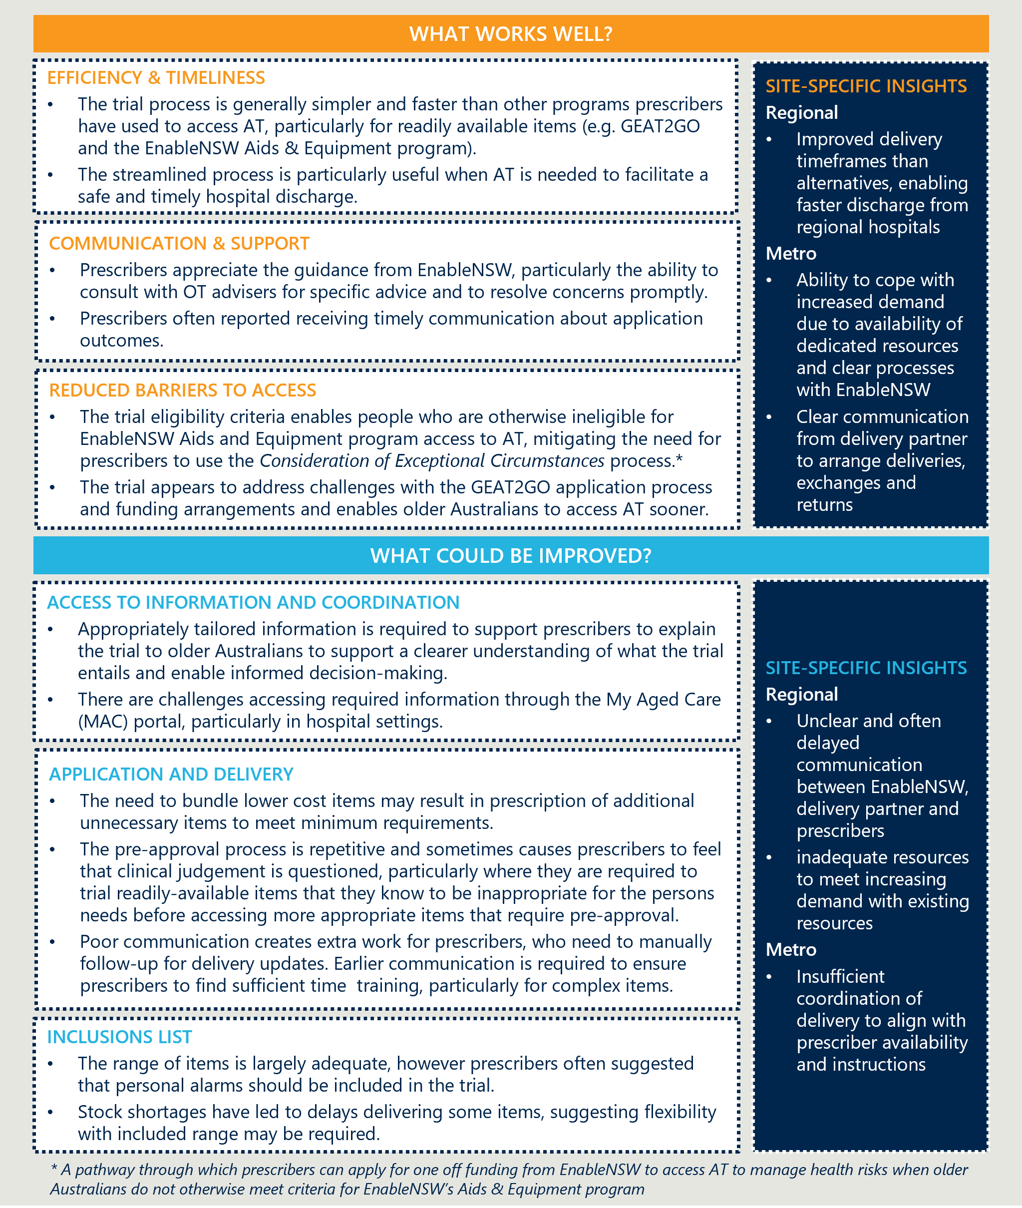

### Prescription and application

#### Most prescribers reported that the prescription process and documentation was easy to complete

All prescribers who participated in the survey reported that they were extremely or somewhat satisfied with their experiences of the trial overall (n=43). They were particularly satisfied with the categories of AT offered, equipment catalogue and prescription processes and application (see Figure 21). However, some prescribers suggested in consultations and the survey that the inclusions list should be expanded to include personal alarms. The majority (78%) reported that they found it easy to access additional information about the trial when they needed it.

Prescribers particularly valued the quick and simple prescription process, comprehensive equipment list and timely support from EnableNSW when required. The trial’s clinical support services were well utilised, with EnableNSW receiving 104 inbound calls to its clinical advisors between July 2024 and January 2025.[65] Several prescribers reported that the processes used by the trial were an improvement on the processes used by other AT programs, including EnableNSW’s Aids and Equipment program and consideration of exceptional circumstances process (used to access AT for older Australian’s who otherwise do not meet the criteria for EnableNSW programs).

Figure 21 | Prescriber satisfaction with trial elements[66]

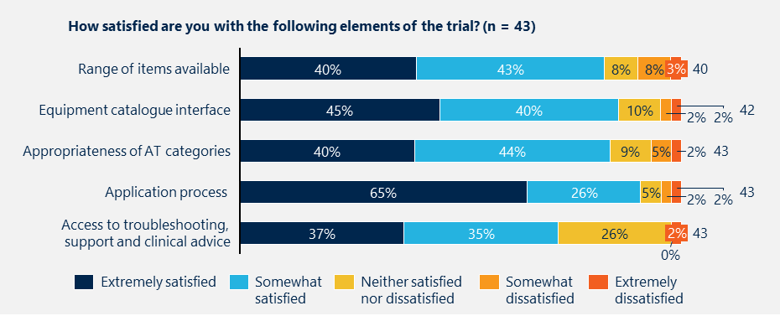

#### Some prescribers experienced challenges with the prescription process and interface

Issues shared included insufficient resources to help explain the trial to older people, difficulty navigating the online catalogue and challenges accessing Aged Care ID numbers. Specifically, they reported that:

1. There were no resources available to help share information about the trial with older people and package managers. The majority of prescribers reported in consultations that a lack of accessible resources meant that they were often left to explain the process and eligibility based on their own knowledge. This was sometimes confusing for older people, particularly when they had used other funding options to access AT which were not always through a loans model (e.g. GEAT2GO). A small number of prescribers noted that some older Australians had decided against using the trial because of personal or cultural preferences for new items and suggested that a culturally sensitive resource would be useful for supporting communication. Some prescribers were also concerned about ensuring that older people had sufficient information to make a decision about using the trial and questioned whether there was a need to gain consent.

“We didn’t need to provide the Aged Care ID number early in the trial… we were told that EnableNSW would check this off behind the scenes. Since then, they have changed the system and we need to include an ID number and now we have challenges… it has put a dampener on how smooth the process was before that.” - Hospital-based prescriber

“It feels weird to be prescribing something without a consent form or something to sign - it’s your word and the thing will just appear.” – Community-based prescriber

1. It was difficult to obtain a person’s Aged Care ID number, particularly for hospital-based prescribers. Hospital-based prescribers reported that they sometimes faced challenges as they did not have access to the person’s Aged Care ID number or the MAC portal. While they were able to complete the prescription process and documentation without the number, their application was not able to be approved without it. Some prescribers noted that initially they were told that EnableNSW would be able to add this information into their applications, but it seemed this was not the case. Obtaining the number was particularly difficult when a person did not have a package manager or carer who could share this information. Prescribers sometimes reported having to call the Aged Care Assessment Team (ACAT) with the older person present to provide consent so that they could obtain the number. This delayed approval, and subsequently hospital discharge when the AT was required for the person to return home safely.
2. The prescriber-facing interface was not as intuitive or user friendly as it could be. Prescribers reported that the online catalogue was not well integrated with the prescription interface and lacked information about the availability of items. Prescribers found it frustrating that the online catalogue lacked a function to add items to cart, which meant they had to manually copy the item numbers from the catalogue to the prescription interface. They also noted that they were unable to see which items in the catalogue were in stock, and found that this created extra work for them and delayed delivery when they had to work with EnableNSW to identify alternatives.
3. Bundling requirements may have created additional barriers for older Australians and resulted in some unnecessary prescriptions. Some prescribers reported that they were initially unaware that some lower-cost items could not be ordered on their own, and others found the rules unclear or inconsistent. A small number of prescribers highlighted that, while these items were too low-value to be provided through the trial, they were still too expensive for many older Australians to purchase privately (in situations where package funding was exhausted). Some prescribers reported adding a higher-cost item to the prescription – even when it was not clinically required – to meet the trial’s bundling requirements, enabling their client to access the lower-cost item they needed.

“$400 is not cheap, but those items still need to be bundled… people might get things that are a nice to have rather than a need to have [to meet the requirements].” – Community-based prescriber

Prescribers mostly reported that EnableNSW provided timely and useful guidance to discuss and resolve the challenges they encountered when completing prescription processes and documentation. EnableNSW added that they were able to reduce the number of applications which were declined by working directly with prescribers to resolve issues and concerns during the application process.

#### Some prescribers felt that the preapproval process was overly burdensome and required unnecessary equipment trials

The pre-approval process requires prescribers to repeat the same information multiple times and can be time consuming. Prescribers reported that the process required them to submit an initial application online and then complete a separate form with the same information following EnableNSW’s response to the initial application.

“It feels like it [the level of justification required] has ramped up for certain items - power lift chairs particularly. Basic equipment is easy, but the pre-approval items are much trickier.” – Community-based prescriber

Some prescribers felt that the requirement for pre-approval for some common items was unnecessary and overly burdensome. Prescribers felt that the level of justification required for these items increased over time within the trial and was sometimes greater than the justification required to purchase items through HCP or access them through EnableNSW’s Aids & Equipment program.

Some prescribers reported in consultations and the survey that they felt their clinical judgement was undermined by the preapproval process and advice provided by EnableNSW. This was particularly true when preapproval was required for items that they prescribed regularly (e.g. beds). Clinical advice provided by EnableNSW undermined their clinical judgement and had resulted in needing to exchange items and additional costs for the older person.

Prescribers provided several suggestions for improving the prescription and application process, outlined in Table 4.

Table 4 | Prescriber suggestions to improve the prescription and application process

|  |  |
| --- | --- |
| Element | Opportunity to improve |
| Access to information and guidance | * Developing a one-page guide about the trial to support prescribers to discuss it with older Australians, families/carers and package managers. * Providing clearer guidance about pre-approval requirements and information required to complete prescription processes and documentation (e.g. Aged Care ID numbers). * Publishing a frequently asked questions page on the EnableNSW website.   “Some providers and prescribers are not aware of the trial... it would be good to get a resource to help.” – HCP case manager |
| Online catalogue and prescription interface | * Improving integration of online catalogue with the front-end system used by prescribers to complete the prescription process and documentation, including by enabling items to be added directly to from the catalogue to the prescription. * Providing an up-to-date or live indication of availability for each item within the catalogue.   “If the portal could be more intuitive it would be good - like click to add to cart…. Like the old system instead of [needing to add the] number and code… that would enhance the usability.” - Hospital-based prescriber |
| Prioritisation/ fast-tracking of applications | * Implementing a priority system that enables prescribers to rank the urgency of a request when completing applications. * Including a form field that allows hospital-based prescribers to indicate if items are required for hospital discharge, to ensure all prescribers are aware of the ability to fast track applications and avoid the need to follow-up separately with EnableNSW.   “If we could indicate [the urgency] at the time of prescription it would save us having to call back and escalate. Particularly if it is the only thing that is delaying hospital discharge.” – Hospital-based prescriber |
| Information requirements | * Adjusting the requirement for prescribers to provide a person’s Aged Care ID in particular circumstances, including for hospital-based prescribers who are often unable to access it. * Streamlining the pre-approval process – including reducing the need to repeat information after submitting the initial application.   “[we] don’t have access to the MAC portal, so we have to rely on family or clients to have access to those details or contact ACAT to give us access.” – Hospital-based prescriber |

#### Prescriber availability and awareness were sometimes barriers to accessing the trial

“We intentionally restricted communications to the providers who we thought provided prescriptions in the specific areas [early on]… we got this a little bit wrong in the beginning.” – EnableNSW

As outlined in Section 4.1, the proportion of prescriptions from private (i.e. non-NSW Health) prescribers was low early in the trial, however increased over time due to expanded communication about the trial from EnableNSW and as prescribers shared information with their networks. Prescribers working in private practice and for aged care providers were more difficult to reach as a result of the limited geographies of the trial and narrow scope of the initial contact list provided to EnableNSW, which did not include pre-existing contacts with private and home care prescribers.

EnableNSW reported in consultations that they gradually broadened the scope of their communications over time, after keeping tight at the start in an effort to manage demand. They began by engaging with a list of prescribers provided by the Department, who were primarily within NSW Health. EnableNSW also noted that these prescribers were already familiar with EnableNSW programs and processes and thus easier to engage as the trial ramped up. However, they expanded communications over time to include prescribers beyond the initial list, including through new and targeted communication efforts as the trial has progressed, including leveraging the Aged & Community Care Providers Association (ACCPA) to inform its members and arranging additional webinars for private cohorts.

Whilst prescriptions by private prescribers increased over time, several prescribers and other stakeholders highlighted that prescriber awareness was a key barrier to ensuring equitable access to the trial. They suggested that a lack of prescriber awareness could continue to impact access for some older Australians who require AT and are eligible for the trial, depending on how their AT needs are assessed, and by whom.

“[initially] not anyone in private practice in the Riverina Region had any idea about the program. Also, no HCP/ CHSP providers - who lose sleep worrying about clients with insufficient funds/ waiting for upgrades/ waiting for a HCP - knew about it. So I would say the original broadcast was too limited.” – Prescriber survey

When interpreting trial uptake and activity, it should be considered that low awareness may have constrained demand for the trial. Actual demand for AT among older Australians receiving aged care support may be much greater.

#### Prescriptions and outcomes were assessed and communicated in a timely manner

EnableNSW reported that the average time between application and approval was 2.6 days and remained steady over time, only increasing in December due to closures and reduced capacity during the holiday period (see Figure 22). Average approval times are similar across sites (2.4 days for SWS and 2.9 days for RM), however delays in December disproportionately impacted RM. Potential reasons for this may include closures or reduced capacity on the part of the RM delivery partner, or the lesser frequency of fulfilment for RM orders by EnableNSW.

Figure 22 | Average time between application and approval[67]

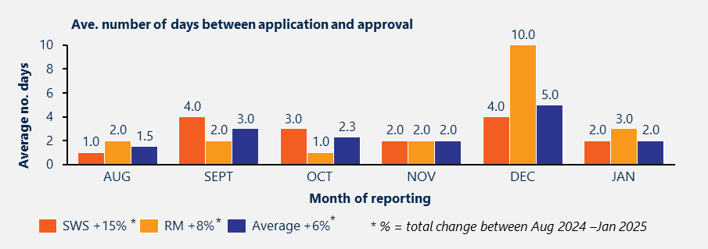

Hospital-based prescribers found that the fast approval times delivered by the trial were particularly valuable for ensuring a safe and timely discharge from hospital, and valued EnableNSW’s responsiveness to urgent needs. They reported this was an improvement on other arrangements and programs that they had used to access AT to support a safe and timely hospital discharge.

Survey responses indicate that prescribers are mostly satisfied with the communication of application outcomes from EnableNSW (see Figure 23), however some reported that the time from application to approval increased over time. EnableNSW shared several reasons for delays, including:

* stock issues and items on backorder
* capacity constraints during holiday closure period
* time taken to reconcile missing information in applications (e.g. Aged Care ID numbers – see Section 4.2.1 above)
* where the application required additional review by a clinical advisor.

Figure 23 | Prescriber satisfaction with communication of application outcomes from EnableNSW[68]

Figure 23 is a Bar chart illustrating prescriber satisfaction with EnableNSW's communication of application outcomes.


“[There is] not a clear process when aids are declined. I didn't get a declined email, call and only found out when I rang up to chase the item.” – Prescriber survey

Some prescribers reported in consultations that they did not always receive communication about application outcomes and that communication was unclear when they had prescribed multiple items. EnableNSW noted that this was due to a template issue in the communications process and rectified this problem during the trial.

#### Fulfilment processes were tailored to align with the existing activities of delivery partners

EnableNSW fulfilled orders daily for SWS and weekly for RM, which aligned with the existing shipment and delivery schedules of both delivery partners (see Figure 24).

Figure 24 | Fulfilment process and frequency by trial site

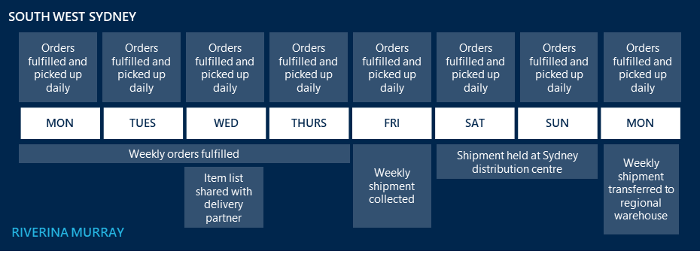

These tailored processes supported seamless integration of trial orders into business as usual for both delivery partners, including by:

* Leveraging dedicated resources and arrangements in place under existing contracts with the metro delivery partner. This included a staff member responsible for scheduling all EnableNSW deliveries, staff to deliver and install equipment and a fleet of vehicles used only for EnableNSW orders. EnableNSW reported that they fulfilled orders for SWS daily, after the delivery partner had coordinated delivery with the older person or nominee (~3 days after applications were approved on average, range 1-10 days).[69]
* Fulfilling regional deliveries for inclusion in the RM delivery partner’s weekly shipping route from Sydney to Albury. EnableNSW prepared trial orders weekly for shipment to the regional warehouse. The list of items to be shipped each week was shared with the delivery partner on Wednesday, and orders were prepared for pick up on Friday (~3.5 days after applications were approved on average, range 1-7 days).[70] Trial orders were held at the delivery partner’s Sydney distribution centre over the weekend for shipment to the regional warehouse on Monday along with other items being moved by the delivery partner.

Delivery partners mostly felt that these arrangements were sufficient to manage demand for the trial, particularly as this was concentrated in SWS, where fulfilment and delivery were more frequent and designated resources were available.

### Delivery

#### Delivery times were an improvement on other programs, however equipment shortages and capacity challenges caused periodic delays

Average time from approval to delivery across sites was 9 days between August 2024 and January 2025.[71] This fluctuated over time, ultimately increasing by 19% over the period (see Figure 25). Delivery times were longest in October, December and January. EnableNSW reported that delays in October were due to a shortage of beds, and those in December and January were due to staffing and capacity challenges over the end of year break. RM was disproportionately impacted by delays, particularly in December when time to approval was the slowest (see Figure 22 in Section 4.2.1 above). Prescribers suggested that increasing awareness and demand amongst prescribers at trial sites may also have contributed to delays.

The average time between approval and delivery was longer for RM than SWS (12 days compared to 9 days). This is expected given differences in the fulfillment and shipping arrangements for RM, outlined in Section 4.2.1 above, and the additional steps required to deliver the trial in a regional area (explained below).

Figure 25 | Average time between approval and delivery[72]

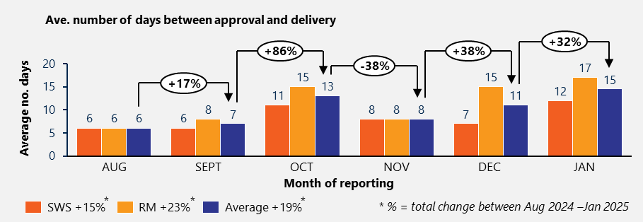

#### Demand, distance and resource availability drove differences in average delivery time across sites

The average time between approval and delivery was longer and more variable for RM (ave. 12 days, range 5-22 days) than SWS (ave. 9 days, range 6-12 days). Figure 26 outlines differences in the sequencing, frequency and timing of activities related to delivery across sites.

Figure 26 | Delivery arrangements and approximate timing by site

Figure is a infographic showing the Side-by-side comparison of delivery arrangements and timing between metro and regional trial sites.


The delivery partner arrangements for SWS, which leveraged existing activity and resources, resulted in shorter and more consistent delivery times. The combination of daily deliveries and shorter distances in SWS meant that the delivery partner was able to cope with the additional (and gradually increasing) volume of trial-related deliveries, and to manage fluctuations in demand over time.

Longer average delivery times and greater variability at RM were expected due to the additional steps required to deliver the trial in a regional context. This included:

1. The need to ship equipment from the EnableNSW equipment centre to the delivery partner’s regional warehouse, and to align this with non-trial shipments.

* Trial orders were collected from EnableNSW on Friday, regardless of the day that they were approved, contributing to variability in delivery times for RM.
* Orders were held over the weekend at the delivery partner’s distribution centre and shipped to the regional warehouse the following Monday. This added 3 days to the delivery time for all orders, contributing to a longer average time to delivery.

1. Significant coordination required to ensure efficient delivery across a broad geographic area.

“Delivery times are determined by client, staff and vehicle availability… this involves a lot of coordination, exacerbated by long distances.” – RM delivery partner

* Orders were sorted into zones based on distance from the regional warehouse to support more efficient delivery. The variability of delivery times was likely influenced by the volume and timing of non-trial deliveries scheduled in a zone, as coordination was required to seek efficient use of time and resources.
* The RM delivery partner reported that the average number of deliveries completed per month had risen from four to 23 since the trial began, without a proportionate increase in resources. Limited staff and vehicle availability may have contributed to a longer average delivery time, further compounded by travel time and distances.

The RM delivery partner highlighted that their capacity to include trial orders within existing routes was limited by space, and that this arrangement may be unfeasible without additional resources or locally held stock if volumes continue to increase.

“it wouldn’t work to ship from Sydney [if volume increased]… [RM delivery partner] wouldn't be able to manage demand without stock being held more locally.” – RM delivery partner

#### Faster delivery is required when assistive technology is required for a safe hospital discharge

While community-based prescribers mostly felt that the current timeframes were better than other programs, hospital-based prescribers reported that faster timeframes were desired where safe discharge was dependent on AT being ready for the older person. Hospital-based prescribers suggested that in urgent circumstances, deliveries would ideally occur within 1-2 days.

Several prescribers noted that while EnableNSW was quick to approve their prescription documentation, delays often occurred in the process of coordinating delivery with delivery partners, which resulted in longer stays in hospital whilst awaiting deliveries.

#### Older Australians reported positive experiences of delivery, however prescribers noted that it was often challenging to coordinate with delivery partners

PROMs indicated that older Australians were satisfied with their experiences of delivery and interactions with delivery partners, rating their experience 8.8 out of 10 on average. (n=73) (see Figure 27). Almost all trial users (99%, n=78) reported that the equipment arrived in good condition.[73] A small number of prescribers reported that they received items that were well worn or not clean, however noted these were exchanged quickly once they notified EnableNSW.

Figure 27 | Feedback from older Australians about experiences with delivery partners [74]

Figure 27 is a bar chart of older Australians' satisfaction with delivery partners, including ratings of equipment condition and delivery experience.


Prescribers were more often dissatisfied with the process of coordinating delivery and installation than other elements of the trial, but were still largely satisfied with this process (see Figure 28).

Figure 28 | Prescriber satisfaction with experiences of coordinating delivery[75]

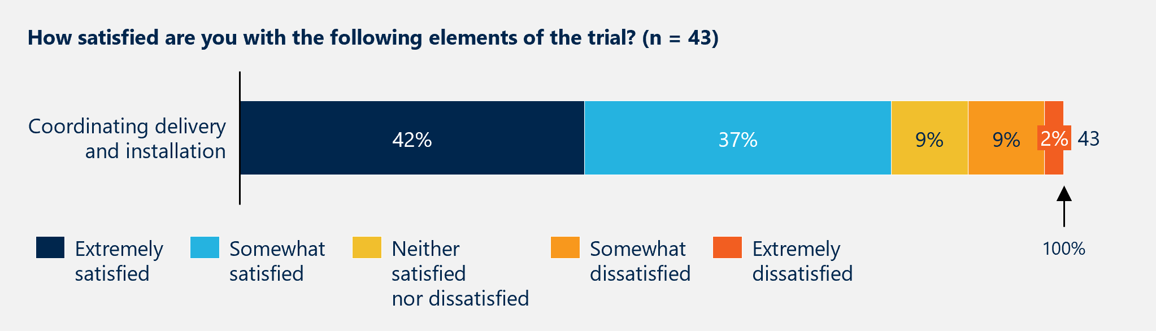

In relation to coordination of deliveries, prescribers shared some common challenges:

* Indirect communication of delivery dates through the older person, sometimes only once delivery had occurred, which some prescribers reported was confusing for the older person.
* Sparse updates about anticipated delivery dates and times, which meant that prescribers had to be available for fitting and training at short notice. This was particularly challenging for complex items that require trial on delivery and significant time for fitting and training. Prescribers in the RM region added that the delivery partner sometimes changed depending on the item, which made it more difficult to follow up on delivery information.

“I don’t get a notification when it is delivered or when it is out for delivery – instead I rely on family members to let me know when it is there… only when I follow up do I find out.” – Hospital-based prescriber

* Difficulty ensuring the room was adequately prepared for deliveries, particularly where the older person was living alone and/or lacks support from family or friends. One prescriber recalled a situation where an older person did not have support to prepare a room for delivery, which resulted in the items not being delivered at all. There was a 2-week delay before delivery could be attempted again, and the older person passed away in the meantime.

Delivery partners also reported challenges coordinating delivery, noting that clear and timely communication of recipient and/or prescriber details was critical. The RM delivery partner reported that these details were initially missing from information shared by EnableNSW, which may have contributed to the challenges experienced by prescribers. EnableNSW reported that this issue was caused by a process gap which resulted in prescribers in RM only being notified about delivery by exception. EnableNSW subsequently worked with the RM delivery partner and prescribers to adjust their processes and ensure that prescribers were copied into all delivery notifications.

Some prescribers suggested that communication could be improved by using an online platform or other message board to enable collaborative and transparent communication between EnableNSW, prescribers, delivery partners, care teams and the older person.

### Wrap around supports

As outlined in Section 4.1 above, small volumes of repairs, returns and reissues (collectively ‘wrap around supports’) occurred during the trial period, limiting findings about the effectiveness of these processes. Exchange activity was not included in reporting, however stakeholder consultations provided some insights into this process.

##### EnableNSW worked with delivery partners and suppliers to action repairs and returns

Delivery partners were responsible for repairing stock items when this was able to be completed at the older persons home, and for non-stock equipment when they were also the equipment supplier. In cases where the expertise of the equipment supplier was required, EnableNSW contacted the supplier to arrange repairs.

“I don’t have access to a trial pool to test things so I have had to exchange things a lot. They [EnableNSW] were really good about it.” – Community-based prescriber

Delivery partners or suppliers assessed items and provided EnableNSW with an estimated cost. In some cases an exchange process was initiated, where it was more cost effective to replace the item and complete repairs at the EnableNSW equipment centre.

The repairs process was the same for both sites, however involved extra steps at RM in cases when a repair replacement was required. While timeliness data for repairs was not available, differences in delivery times (outlined in Section 4.1 above) would suggest that it would take longer to implement a replacement when an item needed to be returned to EnableNSW for repair in RM than in SWS. The delivery partner suggested that this could be improved if EnableNSW held stock locally in RM, or if they used equipment supplied by the delivery partner more often as this would streamline the repairs process by ensuring availability of spare parts and technical expertise.

The returns process involved the older person or nominee lodging a request with EnableNSW, who worked with the delivery partner to arrange collection. Items being returned from RM were sometimes held locally until there were enough items to make the shipment back to EnableNSW cost effective.[76] The delivery partner noted that their capacity to cope with increasing demand would be limited by available staff, vehicles, warehouse and shipping space.

##### Prescribers valued the ability to exchange unsuitable items, and the simplicity of this process

Exchanges were not included in trial activity data, however anecdotal evidence suggested that prescribers were requesting exchanges fairly frequently and found that the process was quick and easy.

The exchange process was the same for both trial sites, however varied depending on the type of equipment. Exchanges of readily available items were arranged via a written request from the prescriber which included the details of the unsuitable item and new item required. Once approved, new items were prepared for delivery, and delivery partners were instructed to collect the unsuitable item at the time of delivery or soon after where there was a risk of contamination or inadequate space.

Several prescribers shared positive experiences with the exchange process. They particularly valued EnableNSW’s timely responses to requests, their advice about alternative items, and clear communication about delivery partner pick-up arrangements. They highlighted that the ability to exchange items was invaluable for older Australians, particularly given their continually changing needs.

### Data collection and reporting

##### The trial’s ICT system supported collection and reporting on useful metrics

EnableNSW uses an ICT system, known as the Get My Assistive Technology (GMAT) platform, to manage and track equipment and generate data for operational reporting. EnableNSW delivered comprehensive monthly and quarterly reports using data collected through this system, supplemented by data collected manually by delivery partners and through feedback surveys. Monthly operational reports included unanalysed data on:

* application activity by trial site (number of applications, number of people requesting equipment, prescriber type, product category and procurement category) and application outcomes overall
* breakdown of time taken for approvals and deliveries by trial site
* volume of repair requests by equipment type, volume of returns (requests and total items) by trial site and reason for return
* call volumes and feedback collected in post call surveys
* client surveys, including PREMs (delivery experiences – equipment condition and experience with the delivery person), PROMs (equipment outcomes – usage, safety and daily living needs).

Quarterly reports presented data and analysis related to the costs of the trial, including:

* total application cost for approved applications and comparison by site (includes aggregate costs of acquiring and delivering equipment for the first time, including administration)
* percentage of applications falling within proposed Support at Home funding tiers
* number of approved products by site
* proportion of total product cost by product category
* average product cost (at category level) (including supply, delivery, pickup and application processing) and prescribing frequency.

Monthly and quarterly reports supported a broad understanding of the effectiveness of the trial to-date and differences across trial sites. The ICT system seemed fit for purpose overall, in contrast to those described by each jurisdiction in consultations, which were mostly outdated, unable to collect data on returns, life of equipment and reissue or inconsistent across different program streams delivered in individual jurisdictions.[77]

##### EnableNSW addressed early issues with data collection to rectify discrepancies in reporting as they were identified

EnableNSW noted several challenges with data collection and reporting early in the trial. Whilst expected in the early stages of a new program, these resulted in discrepancies in monthly operational reports. EnableNSW conducted periodic data cleaning and worked to address key challenges as they arose, including:

* systems issues with the assessment dates used to calculate application volumes and timeliness
* missing data – including delivery dates for some RM applications
* inconsistent collection of feedback by delivery partners
* low engagement with client surveys.

Further exploration of the suitability of this system to enable accurate reporting of trial activity is required to understand if systems are appropriate to meet the data collection and reporting objectives of the trial.

# Trial outcomes

|  |
| --- |
| This section provides insights about the outcomes of the trial for older Australians, providers and the system to date. Findings in this section are limited as the trial was still relatively new at the time of this evaluation. |

## Outcomes for older Australians

### PROM feedback suggested that the trial was delivering positive outcomes

EnableNSW collected outcome information from trial participants, including through phone calls to the older people receiving the AT to seek their responses to targeted questions. Of the 46 participants who provided input, average satisfaction was 9/10, with 98% continuing to use equipment. Figure 29 below shows that the trial users largely agreed that the equipment was helpful.

Figure 29 | Patient reported outcomes (PROMs)[78]

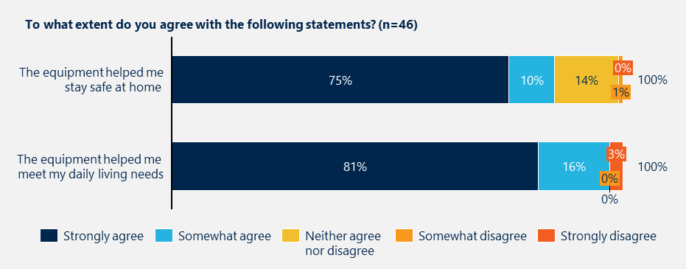

### Prescribers also believed that the trial delivered positive outcomes for users

The prescriber survey asked prescribers’ views on the extent to which they felt the trial was benefiting older people in different ways, including considerations of access, equity and outcomes. This feedback (n=40) was very positive, with strongly agree or agree responses of between 80-94% across the statements as shown below in

“The client literally called me in happy tears as transfers at the lounge were stressing her out that much and she was spending so much time in bed because she couldn't do it safely.”

– Prescriber survey

Figure 30. Benefits were seen to extend beyond trial users, with prescribers also reporting that it reduced the burden on families and carers.

Figure 30 | Prescriber reflections on the impact of the trial[79]

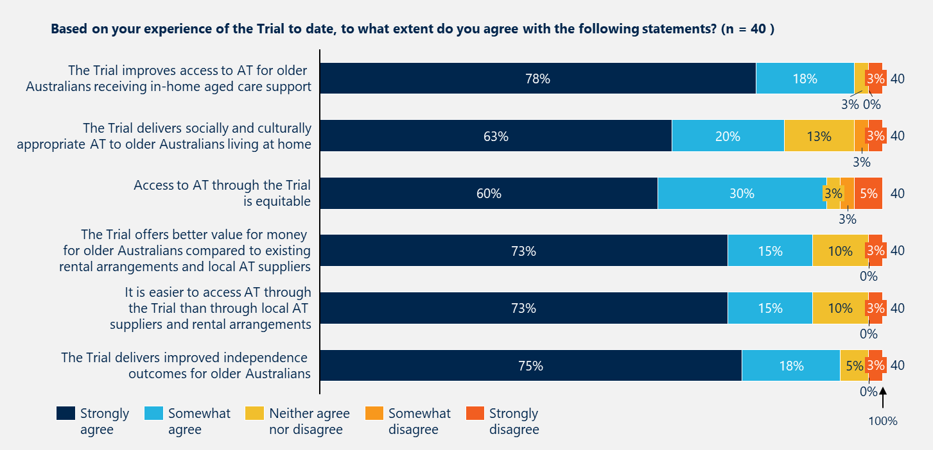

### The trial appeared to provide assistive technology to older Australians who would otherwise have struggled to access it, though some prescribers were concerned about equity of access

Prescribers reported in consultations that the trial enabled access to AT for older Australians who were unable to access it through alternative pathways, for example, people who:

* did not have sufficient HCP/CHSP funds for the AT they required, or who would have had to reduce their care services to free up funds for that AT
* had been assessed but were awaiting HCP funding
* had continually changing needs which would otherwise deter them from spending funds on AT
* were unable to afford the co-payments required through other programs
* required AT to support a safe and timely discharge from hospital, particularly where they did not have support from family or friends.

“There are so many people who are disadvantaged or fall through the gaps… This has been one of the best initiatives I've seen as a community OT with over 14 years experience, including in disadvantaged areas.” – Prescriber survey

Prescriber comments also suggested some barriers to equity of access, including:

* older people not having the available funds (either in an aged care package or privately) to fund the prescriber involvement required for prescription processes and documentation, fitting and training, and possible returns or exchanges
* a lack of prescriber/allied health provider availability in some areas, particularly more regional and rural
* the fact that there was a minimum package value, so while someone may need only a readily available, lower cost item, they could not order only this item
* a lack of awareness of the trial – which could be exacerbated by isolation, digital exclusion and cultural and linguistic diversity
* cultural protocols which meant that using reissued AT was inappropriate for some people, who may go without if they were unable to purchase it new.

|  |
| --- |
| Ensuring equipment is in good condition is essential for a successful loans scheme  Older Australians and prescribers expect loaned AT to be clean, safe and fit for purpose. This evaluation found no significant concerns about equipment condition, partly because most items provided were new. However, some prescribers expressed mild concern about receiving older equipment in the future. Clearly communicating standards for reusing, cleaning and presenting loaned items will be important to maintain trust and encourage reuse. |

## Outcomes for prescribers and the system

### Prescribers reported that the trial streamlined prescription and delivery of assistive technology, and was an improvement on other programs they had used

Insights suggested that the front-end system interface used by the trial (Qualtrics) was effective and efficient for prescribers, and better than the systems used by other programs (e.g. the user interfaces for GEAT and EnableNSW’s core program). However, there were some suggestions for streamlining the process and supporting clear and timely communication, as outlined earlier in Sections 4.2.1 and 4.2.2.

Prescribers reported that the trial reduced administrative burden associated with back and forth with suppliers and delivery partners that they have experienced with other programs.

### The trial appeared to fill a gap in the current system and had the potential to deliver longer term benefits at a system level

As outlined in Section 3.1, several interrelated issues in the current system make it challenging for older Australians receiving in-home aged care to access the AT that they need to stay at home. This is particularly true of people who are awaiting assessments, approved for a package but awaiting funding and those who do not have sufficient funding for AT within their current package.

Prescribers overwhelmingly reported that the trial effectively filled these gaps and had the potential to deliver significant benefits to the individual and to aged care and health systems in the longer term (see Figure 31). Key benefits included preventing avoidable admissions to hospital, reducing delays in hospital discharge and delaying entry to residential aged care.

“This is fantastic, because if we had people receiving funds through HCP around prescribing equipment - there was comms back and forth to find a supplier and someone to deliver it… it was lengthy… we used to have delays with providers, and would have to look at temporary option before a longer term option.” – Hospital-based prescriber

Aged care providers also highlighted that the trial delivered additional benefits, including by supporting delivery of high quality in-home aged care and reducing the risks to staff arising from a lack of, or inappropriate AT.

Figure 31 | Prescriber reflections on outcomes for providers and the system

Figure 31 is a Quote panel highlighting prescriber views that the trial improves timely access to AT, fills service gaps, and reduces hospital admissions.


# Efficiency

|  |
| --- |
| This section introduces the case for loans schemes and a model for assessing the efficiency of a loans model. It then presents trial data related to establishment and delivery costs and outlines general cost and efficiency considerations. |

## The case for loans schemes

### Loans schemes provide an efficient and sustainable approach to delivering AT

Loans schemes enable greater access to AT by spreading the cost of expensive equipment over time, providing affordable access and promoting sustainability through reissue. For lower-cost AT, loans schemes must be carefully designed to balance administrative costs with direct benefits. However, for higher-cost items, the long-term efficiencies from reuse loans models are particularly cost-effective.[80] Centrally-coordinated programs further enhance impact by achieving economies of scale, streamlining inventory management and reducing administrative burden.

In addition to generating cost savings, loans models have been shown to effectively address gaps in AT provision to improve user wellbeing and support more responsible service delivery.[81] Loans schemes are particularly useful for adapting to continually changing needs, enabling ready access to different equipment. Loans schemes that facilitate repairs and ongoing wrap around support reduce the risks associated with ongoing use of damaged items.

### The trial data currently available limits the evaluation’s ability to assess efficiency in financial terms but still offers useful cost considerations

At this stage, there are some limitations that constrain a full assessment of the trial’s efficiency:

* The trial has not been running long enough to evaluate key efficiency aspects, such as the number of times equipment is returned and reissued over its usable life.
* Only a limited set of cost data has been shared with the evaluation to protect commercially sensitive supplier information.

While these data constraints prevent a definitive assessment of whether scheme represents value for money for older Australians and the system, the available information still provides useful insights into the trial’s costs. The sections below describe how resources were used in the trial and outline cost and efficiency considerations. Future studies, with access to a more complete dataset, could explore the full extent of the trial’s efficiency.

### In principle, the trial model is more cost efficient than other modes of providing AT, however this needs to be validated further be researched further

There are two main factors contributing to the efficiency of the trial model:

* Central procurement savings – The savings attained through centralised procurement of AT equipment (in this case through a competitive tender process at the state-level) delivers up-front savings.
* Reissue savings – The savings resulting from returning and reissuing equipment (as compared to purchasing a new product) are realised over time.

EnableNSW analysis indicates a significant saving on the cost of equipment procured for the trial loan pool compared to retail prices.[82]

As the loans scheme matures, and more equipment is returned and reissued, there is an opportunity to explore the savings and sustainability benefits of a circular model in more detail.

## Cost and efficiency considerations

### The trial model represents value for money for older people and providers, but some settings may not be realistic for a long-term model

The trial arrangements allowed eligible older people to access prescribed AT without caps or co-contributions. This provided significant value to participants, with prescribers highlighting cases where the trial enabled access to AT that otherwise would not have been feasible – particularly when home care package funds were depleted.

However, these arrangements differ from those proposed for the National Scheme. The design decision to not require financial contributions or caps incentivised participation in the trial, but it also limited an assessment of the model’s true value for money. (See Section 7.3 for a discussion on the trial not fully representing the proposed National Scheme model).

Additionally, the trial’s approach led to unintended consequences. To ensure financial sustainability, some lower-cost items were only available when bundled with higher-cost equipment. In cases where an older person needed a lower-cost item that couldn’t be loaned individually, prescribers reported selecting a higher-cost alternative that may not have been strictly necessary. If unchecked, this practice may have inflated costs and limited the scheme’s ability to optimise the distribution of AT based on actual need.

### The trial effectively leveraged EnableNSW’s existing capabilities, with supplementary resources addressing specific gaps

The trial’s establishment costs were contained by leveraging EnableNSW’s existing infrastructure and systems where possible. EnableNSW’s equipment centre had sufficient capacity to store the additional trial equipment, and no major facility modifications were required. Similarly, funding allocated for AT procurement supplemented EnableNSW’s existing stock to make up the trial loan pool.

While this approach enabled a cost-effective trial, it relied heavily on an established loan pool supported by significant infrastructure and operational capability. As a result, it did not assess the feasibility or costs of setting up a scheme in other contexts, such as building one from scratch, expanding a private sector AT scheme, or adapting a different jurisdictional program.

### The trial could improve efficiency by introducing clear business rules for AT returns, reducing unnecessary retrieval costs while maintaining equitable access

Currently, the trial picks up all AT that is no longer required without assessing the cost-effectiveness of retrieval. One prescriber was surprised when EnableNSW arranged to collect a toilet seat when it was no longer required after a week, commenting, “I wouldn’t have expected the cost would be worth it.” Another prescriber described an older person returning a cushion three times before finding a suitable one. These experiences suggest that not all returns justify the associated administration and logistics costs.

A peak body representing older Australians emphasised the need to separate recycling economics from distribution – while items should be collected for reuse where viable, retrieval should not occur automatically if it is not cost-effective.

“If distribution costs drive up expenses, we need to ensure this doesn’t affect the person’s access or increase their costs.” – Peak body representing older Australians

EnableNSW does not have formal business rules to guide decisions on whether an item should be retrieved. The default approach is to collect all returned items through the trial, even in the Riverina/Murray area. While the EnableNSW team is developing an on-the-spot evaluation process using historical loans scheme data, immediate efficiency improvements could be made by introducing business rules using reasonable cost estimates as a starting point (e.g. items under $100 in metro areas and under $200 in regional areas are not retrieved by default).

### Trial stakeholders held mixed views on whether the model should include financial contributions being paid by older Australians

Reflecting on how the trial model could be sustained into the future, stakeholders expressed mixed views on the role and value of client co-contributions and loans fees. Some saw financial contributions as a way to encourage responsible use of equipment and program sustainability, while others were concerned that even a small fee could create barriers to access. Stakeholders also questioned whether contributions should come from the older person’s funding package rather than being paid out-of-pocket, and whether a fee structure should distinguish between different types of equipment.

Table 5 below summarises the mix of stakeholder perspectives on co-contributions and loan fees. See Section 7.2 for considerations for the National Scheme, including a set of guiding questions to support decision-making related to establishing an approach for financial contributions.

Table 5 | Summary of stakeholder perspectives on client co-contributions and fees

|  |  |
| --- | --- |
| For client co-contributions or fees | Against client contributions or fees |
| * A financial contribution could ensure that people only request equipment they genuinely need. “$100 max is enough to make people think about it… If it is free, it is up for abuse.” – Community-based prescriber, SWS * A small, once-off or annual fee could help sustain the scheme and support equipment maintenance and repairs. * A contribution model has been generally accepted by clients in some contexts, e.g., the $100 fee used by EnableNSW outside of the trial. * A fee structure that scales based on income or equipment type (e.g., distinguishing between high- and low-cost items) could balance sustainability with affordability. “If we are charging the same amount for low- and high-cost equipment, it feels off.” – Hospital-based prescriber, SWS * A loan fee that is paid regularly (e.g., annually) would reinforce that the AT is part of a loan pool that could be used by others. It would incentivise the return of equipment when it no longer needed. * Contributions could be integrated into funding packages rather than requiring out-of-pocket payments. | * Even a nominal fee could limit access, particularly for those on pensions or with low financial flexibility​. * Clients already contribute to aged care funding through their pensions, and some questioned why they should pay more for equipment when NDIS participants do not face similar costs. * Financial discussions can be uncomfortable and time-consuming for prescribers, detracting from clinical care. * An annual fee could create administrative burdens and be difficult to enforce​. * Many older Australians accessing the trial actively checked that the trial did not impact their package funds or require out-of-pocket payments. There is uncertainty about how older Australians would react if contributions were introduced. “I am not sure how they would react if there were co-contributions in the future. The question would be if it would come out of their package or out of their pocket.” – Case manager, SWS |

# Learnings

|  |
| --- |
| This section provides key learnings from the trial and considerations for the National Scheme. These findings are presented while the National Scheme is still in development, with many details yet to emerge and largely outside the scope of this evaluation. As such, the learnings in this section are generalised to the service delivery model evaluated in the NSW trial and its potential application at the national level. |

## Key learnings from the trial

The evaluation of the AT Loans Scheme Trial, though constrained by timing and data availability, offers valuable insights to support ongoing improvements. These insights can inform both the refinement of the trial and the broader development of future models. This section highlights key learnings related to scheme design and governance, coordinated and efficient program delivery, and stakeholder experience.

### Scheme design and governance

#### EnableNSW leads the trial model, partnering with private AT suppliers for delivery

As a business unit of NSW Health, EnableNSW leveraged its well-established loans scheme and supplier relationships to plan and implement the trial efficiently. Its physical infrastructure supports equipment storage, cleaning, repairs, and reissue, while private suppliers, contracted through competitive tenders, manage equipment delivery and, in some cases, repairs. This partnership approach has enabled economies of scale, allowing the trial equipment to be delivered alongside other equipment. By integrating with existing logistics, the model has facilitated more timely deliveries than would have been feasible if operating as a standalone trial.

#### The trial was delivered in two different contexts, demonstrating the need for a flexible model that can be tailored to local needs

Table 6 overleaf outlines key similarities and differences observed between the metro site (South West Sydney) and the regional site (Riverina/Murray). Exploring and understanding these factors provides valuable insights into how the scheme operates under differing local conditions. Recognising both commonalities and contextual distinctions can inform decisions about which scheme components could be continued as standardised and those where greater flexibility is important.

Table 6 | Observations on how the trial model performed across sites

|  |  |
| --- | --- |
| Metro and regional model similarities | Needs and target populations. Both sites identified a critical need for AT among older Australians with limited package funding, those awaiting approvals, and those needing urgent AT for hospital discharge. Stakeholders across both locations emphasised the role of the scheme in addressing financial barriers to accessing AT. While specific enablers and barriers to AT access differ across Australia, the core needs of older Australians were broadly consistent at both metro and regional trial sites.  Both sites showed similar demand patterns for certain AT categories, with uniformly high prescriptions for items such as beds and pressure mattresses. (However, there was greater diversity in the product categories prescribed at the metro site compared to the regional site. For example, in January 2025, prescribers in SWS applied across 26 product categories, while prescribers in RM prescribed across only 15 categories.)  Prescriber satisfaction and EnableNSW responsiveness. Prescribers across both sites largely expressed high satisfaction with the application process, including experience of EnableNSW’s customer support and clinical advice functions. Prescribers highlighted that having timely access to clinical support and advice when completing prescriptions significantly improved the application experience compared to other AT schemes. Subject to a more detailed efficiency review, this consistency indicates the effectiveness and scalability of centralised clinical advisory support for loans schemes generally.  Importance and value of wrap around supports. Stakeholders across the trial regions reported that access to effective wrap around supports – including repairs, exchanges and returns – was highly valued. Prescribers noted the ease of the exchange process that facilitated timely solutions when AT was unsuitable, which was particularly valuable for older people with rapidly changing needs. While the logistical execution differed between sites due to the regional context, the fundamental processes and their perceived value were similar.  Initial challenges with prescriber awareness. At both sites, the trial initially faced challenges related to prescriber awareness and understanding of the scheme, particularly among private practice and community-based prescribers. EnableNSW progressively addressed these challenges through targeted communication, webinars, and proactive outreach efforts. The common experience across metro and regional areas highlights that while effective communication channels exist at the state and local health service level for hospital-based prescribers, engaging private prescriber networks is inherently more difficult and requires additional time and targeted strategies. |
| Metro and regional model differences | Demand and split of hospital and private prescriptions. The regional site had lower trial participation and a higher proportion of hospital-based prescriptions compared to the metro site in the five months to January 2025:[83]   * Demand levels – The trial received 347 applications from SWS and 85 applications from RM. Accounting for the population of people using home care in each region, the participation rate in the trial was approximately 2.6 times higher in the metro location.[84] * Hospital-based prescriptions – 48% of applications in SWS came from hospital-based prescribers, while 75% of applications in RM came from hospital-based prescribers.   While giving an early indication of demand patterns across the regions, these figures should be reviewed once the trial is more established.  Delivery timelines and frequency. In SWS, delivery took 11 days on average (7-14 days), while in RM, it took 15 days on average (8-24 days). This difference is partially due to metro orders being sent daily from EnableNSW’s equipment centre, while regional orders were first sent to the Albury warehouse (weekly), before being dispatched periodically. While trial efficiency should be reassessed once more data is available, it is likely that an efficient loans scheme would involve longer timeframes and less frequent deliveries in regional areas, balancing cost-effectiveness with service quality.  Resource availability and capability. The metro site leveraged a dedicated vehicle fleet and existing infrastructure, capable of scaling deliveries quickly in response to demand changes. Deliveries in the regional site had to align with broader regional delivery schedules and were constrained by limited staff, space and vehicle resources. While this difference reflects EnableNSW’s arrangements prior to the trial, it raises questions about the scalability of the trial model in regional areas if partner resources and capabilities cannot easily adjust in the short-term.  Degree of cost-effectiveness and sustainability. Evaluation insights suggest that SWS experienced efficiency gains from existing economies of scale, indicating the potential for replication in other metropolitan sites. In RM, it was unclear whether the trial arrangements would be sustainable with significantly higher delivery volumes, without additional investment in the logistics network and a review of the wrap around supports provided. As data becomes available, an efficiency assessment across the sites is required, particularly in relation to cost-effectiveness of delivery, exchanges, repairs, collection, and reissue. |

### Coordinated and efficient program delivery

#### Timely and consistent communication is essential for realising the full benefits of a loans scheme

Effective program delivery relies on the coordinated efforts of multiple stakeholders, including the older person, their family, the delivery and installation partner, the prescriber or aged care provider, and the loans scheme program provider. While a supplier-led approach may streamline coordination in some respects – by removing the need for a separate loans program provider – all AT delivery models face challenges in achieving effective collaboration between stakeholders involved in service delivery. This underscores the importance of timely and efficient communication between all parties involved in the provision of AT and delivery of wraparound supports. Consistent communication processes between key stakeholders and clearly defined escalation pathways for any delivery issues would enhance coordination and user satisfaction.

#### There is a need for streamlined and transparent eligibility checks to reduce administrative hurdles

The trial has identified that complexity (or perceived complexity) in understanding and confirming eligibility can place a burden on prescribers and confuse consumers. For example, the requirement to provide My Aged Care ID numbers as part of the trial process raised concerns among hospital-based prescribers, who did not readily have access to this information. There may be an opportunity to adapt the processes to improve the experience for prescribers (and older people). This could be through establishing centralised eligibility checks, through updated eligibility criteria which accounts for what information is available to prescribers, or other changed settings.

### Stakeholder experience

#### Clear and tailored information and interfaces will enable easier access for prescribers and potential users

The aged care service and funding environment is complex, with many different providers and processes including multiple pathways through which to source AT. Given this complexity it is important to proactively communicate new programs to all key stakeholders, especially prescribers. Trial stakeholders flagged an opportunity to better support prescribers in understanding the program, and to improve their engagement with older people, by providing access to tailored, user-friendly, accessible information (e.g., simple eligibility information, explanation of the process, frequently asked questions, etc.). Ensuring user-friendly processes for prescribers as they access the scheme will deliver greater efficiency and experience. This could include for example: intuitive, integrated user interfaces that provide prescribers with real-time access to availability information, enable easy comparison of different products, and enable flagging of urgency.

#### Demonstrating rigorous refurbishment standards is key to building confidence in reissued AT

The trial highlighted that some stakeholders have preconceived concerns about the quality and safety of reissued AT. They can view it as potentially inferior to new equipment due to a lack of awareness about refurbishment and cleaning standards. For EnableNSW, demonstrating these rigorous standards through education sessions and site tours has proven effective in the past in addressing prescriber misconceptions. Such initiatives not only build trust but also help stakeholders appreciate the effort and quality behind reissued AT. These learnings highlight the importance of proactive engagement in building stakeholder confidence and increasing acceptance of reissued AT.

## Applying trial learnings to the National Scheme

The evaluation findings provide key insights to guide the design and implementation of the National Scheme. This section outlines key considerations related to (1) access within the broader aged care system and (2) scheme design and operations.

### Access considerations

#### Adequate availability of prescribers is critical for the timely success of the National AT Loans Scheme

Timely access to AT through the National Scheme hinges on a sufficient supply of qualified prescribers to conduct assessments. Current shortages in occupational therapy (OT) services already contribute to delays, impacting older people's access to needed AT and potentially compromising their safety and independence. Stakeholders anticipate the National Scheme will increase the demand for prescriber services, exacerbating existing workforce pressures and further lengthening wait times – particularly in regional and remote areas. Strategically expanding and supporting prescriber capacity is essential to ensure the National Scheme meets increasing demand effectively and promptly. Stakeholders also highlighted the importance of investing in training to ensure prescribers not only have the capacity but the capability to prescribe appropriately and navigate relevant systems and processes.

Additionally, timely access to AT through the National Scheme will depend on streamlined access to Support at Home funding. Historically, delays in Aged Care Assessment Team (ACAT) processes have posed barriers, although the new Support at Home system aims to reduce assessment wait times to a maximum of three months, potentially improving overall access.

#### Equitable access to the National Scheme relies on improving pathways to prescriber assessments, particularly in regional and underserved areas

Equitable access to the National Scheme primarily hinges on effective entry pathways for older Australians to connect with prescribers, particularly in regional and remote areas. Insights from the trial suggest that once older Australians are connected with a prescriber, challenges related to digital literacy and language barriers are mitigated, as prescribers assume responsibility for navigating the system on behalf of clients. However, disparities persist at the critical point of initial connection with prescribers, creating uneven access risks. Addressing this requires targeted mechanisms to improve connectivity between older Australians and prescribers, particularly in areas with limited local provider infrastructure.

### Scheme design considerations

#### Given the diverse operating contexts across Australia, it is expected that models should be flexible and open to involvement from a range of implementation partners

The governance and operational structure of the National Scheme must adapt to jurisdictional differences in AT service delivery, existing market structures, and geographic realities. There is no single ‘right’ mix of public and private sector roles – rather, the balance will need to be shaped by each state and territory’s capabilities, existing infrastructure and geographic and demographic realities.

EnableNSW provides a useful case study, demonstrating how a mature, mostly state-run scheme can effectively leverage private sector partnerships for wraparound services and logistics. However, other jurisdictions may require different models, particularly where private sector suppliers play a larger role in direct AT provision. The scale and structure of private sector involvement will flex to ensure nationwide coverage while integrating local expertise and resources.

Some stakeholders suggested that a hybrid model, where government contracts multiple suppliers to offer both rental and purchase options, could maintain service quality while fostering competition. The National Scheme must carefully consider these factors to avoid unintended consequences such as supplier market exits, delays in AT access, and a decline in service quality (see call-out box below). A well-calibrated approach will be essential to balancing national consistency with local responsiveness.

|  |
| --- |
| AT suppliers are concerned about the market impacts of the National Scheme  As the National Scheme is rolled out, the private sector is expected to play a key role in ensuring nationwide coverage. However, the specific role of AT suppliers is likely to vary based on jurisdictional and regional factors.  Stakeholders raised concerns that a centralised loans scheme could disrupt the market, leading to unintended consequences for the National Scheme. AT suppliers identified the following risks:[85]   * Restricted loan pool categories may limit prescriber discretion, reducing access to tailored AT solutions and slowing down quick access to the most appropriate equipment in some cases. This could lead to delays similar to those seen in the NDIS two-stage approval process. * Bulk procurement strategies may compromise equipment quality, as cost-saving measures might take priority over user needs. * Centralised distribution could unnecessarily prolong wait times for access and service, particularly in regions where local AT suppliers and retailers are already operating. |

#### The National Scheme should consider how access to AT is impacted when older people move into residential aged care

The National Scheme should monitor for cases of older Australians losing access to AT when moving into residential aged care as a result of the home not providing the same equipment as was available through the loans scheme. Currently, older people who purchase AT through a HCP can keep their equipment when they enter residential aged care. In contrast, those accessing loaned AT through the trial are required to return it, as responsibility for the funding shifts to the aged care home. However, prescribers have reported that items such as riser chairs and manual tilting wheelchairs are typically not funded by aged care homes. This leaves some older people worse off for having accessed the loans scheme rather than purchasing equipment – an unintended consequence of the trial model. Should this be validated to be a significant issue, the National Scheme might consider mechanisms to allow loaned AT to transition with the older person. This would help to prevent gaps in care and loss of independence, while also maintaining the attractiveness of a loans model for older people and prescribers.

#### The National Scheme will need an appropriate financial model, including consideration of co-contributions or loan fees

The trial has been run with no cost to the AT user (either directly out of pocket, or via their aged care funding packages) which has enabled the testing of the trial model, but has not tested different financial options or feasibility. The National Scheme will need to balance policy objectives, financial sustainability, equity, and administrative feasibility, and consider options for co-contributions and/or loan fees. As highlighted in Section 6.2, stakeholder views on financial contributions were mixed – some supported a modest fee to promote responsible use and ensure the scheme’s sustainability, while others raised concerns about access barriers and equity implications.

Table 7 below presents a set of guiding questions to support decision-making on financial contributions for the National Scheme. These questions are informed by insights from the trial evaluation and can be used either as a broad set of considerations or as a structured framework for assessing the appropriateness and feasibility of different financial contribution models.

Table 7 | Guiding questions for considering financial contribution models

|  |  |
| --- | --- |
| Consideration | Guiding questions |
| Equity and access implications | * How would co-contributions or fees affect different groups of older Australians, particularly those on lower incomes or with limited access to other funding sources? * Should a financial contribution model align with existing funding approaches (e.g., Home Care Packages) to ensure consistency and fairness? * If a fee is introduced, what safeguards (e.g., means testing, exemptions) would prevent it from creating barriers to access? |
| Sustainability and cost recovery | * Should co-contributions primarily aim to recover costs, or is their main purpose to influence behaviour, such as encouraging responsible equipment use? * Would alternative funding sources (e.g., integrating contributions into HCPs) be more effective for cost recovery than direct client payments? * Would behavioural insights interventions (e.g., targeted communication, reminders, or default options) be sufficient to encourage responsible equipment use without requiring a financial contribution? * How would differentiating fees based on equipment cost, length of use, or financial circumstances impact both cost recovery and user behaviour? |
| Administrative feasibility | * What mechanisms would be required to collect, track, and administer contributions? Would these create excessive administrative burdens for providers? * Would enforcement be necessary, and if so, should fees be enforced strictly, flexibly, or waived in some cases? * If means testing or exemptions are applied, how would these be assessed fairly and efficiently without increasing complexity? |
| Alternative options and counterfactuals | * If fees are introduced, what are the alternatives for those unable to pay? Would they go without AT, rely on lower-quality alternatives, or seek assistance from other programs? * Where should the National Scheme sit within the broader health, aged care, and AT ecosystem? Should it be a ‘catch-all’ for those unable to access AT through other means, or should it target specific cohorts? |
| Consumer and provider acceptability | * How would older Australians and prescribers perceive and respond to co-contributions? Would this create friction in AT prescription and access, such as placing an undue burden on clinical interactions? * Would some older Australians be discouraged from seeking AT, even if they could afford a contribution, due to uncertainty or concerns about affordability? |

#### National Scheme contract arrangements could clearly define data and reporting requirements to enable ongoing monitoring of progress and continuous improvement

While it seemed that EnableNSW had strong information systems and data capability, the process of evaluating the efficiency of the trial has been limited by the lack of granular activity and cost data due to contractual constraints. Therefore, the extent to which the data currently collected enables ongoing analysis and process improvement it is not known. In preparing for a National Scheme, the Department should define detailed reporting requirements in advance to enable these to be incorporated into jurisdictional agreements with operators and suppliers. Alongside an appropriate enforcement approach to support data sharing, the Department could consider using an independent intermediary to enable robust data monitoring while managing data sensitivities.

## Further investigation

### The trial is not fully representative of the proposed National Scheme model so its learnings must be contextualised and validated with further investigation

While the trial demonstrates the effectiveness and operational feasibility of an AT loans scheme for older Australians, its ability to inform a future National Scheme is limited by key differences in design, scope and operational context. As with any trial of this nature, the selected trial sites cannot fully reflect the diversity of circumstances across the country, though including both metro and regional locations in NSW provided some variation in service delivery. However, these constraints highlight several areas requiring further investigation to better inform a national rollout.

Key areas for additional investigation include:

* Established infrastructure and pre-existing relationships: The trial was conducted by a well-established loan pool operator with strong systems, structures and awareness among prescribers. While some operational elements had to be developed for the trial – particularly in Riverina/Murray – these still relied on pre-existing contractual arrangements with a delivery partner. Further exploration is required to understand the feasibility and costs associated with establishing a loans scheme in jurisdictions without existing infrastructure or established service relationships.
* Trial processes suited to high-density areas: The trial’s exchange, return, and logistics processes operated under conditions that may not be scalable or cost-effective in lower-density or remote areas. For example, frequent exchanges and rapid turnarounds may be feasible in regions with centralised storage and high service coverage but could pose challenges in areas with dispersed populations. This necessitates additional investigation into adapting processes for varied contexts.
* Simplified financial model: Unlike a potential National Scheme, the trial did not test co-contributions, caps or structured cost-sharing mechanisms. Further investigation is needed to assess how home care providers might administrate or support the scheme under these conditions. Additionally, demand trends observed during the trial should be explored further as they may not be reliable indicators for future uptake, particularly if financial contributions influence the decisions of older Australians.
* Varied scope of AT: The trial used a list of AT that was influenced by EnableNSW’s existing loans scheme and the service relationships it already had in place to facilitate wrap around supports. While this was appropriate for the NSW context, further examination is needed to determine how a broader, more flexible catalogue of AT could accommodate diverse needs and operational environments nationwide..

These differences have important implications for the design of the National Scheme. While the trial provides valuable insights into the logistical and operational aspects of delivering AT through a loans model, its findings must be carefully contextualised. Further investigation is essential for designing a more comprehensive model that accounts for jurisdictional variations, financial sustainability, and the full range of AT needs.

### The efficiency of the trial model should be further reviewed as the trial period continues and as data is made available

As noted in Section 6, the efficiency of the trial model cannot be fully assessed, as the trial has not been running long enough to measure key efficiency metrics, such as equipment returns and reissues over its usable life. Additionally, limited cost data has been provided due to the need to protect commercially sensitive supplier information.

As the trial progresses, more operational data is likely to become available, including information on wrap around supports and reissue. Additionally, a larger volume of cost data over time may allow EnableNSW to provide more detailed cost breakdowns while maintaining supplier confidentiality.

To further test the trial efficiency, the Department may pursue further analysis in the following areas, where feasible:

* Breaking down aggregate costs related to equipment purchase, administration, delivery, repairs, collection, and cleaning and refurbishment (or disposal) for the trial. These costs can be benchmarked against alternative models and external research[86] to assess the efficiency of specific trial elements. At a minimum, establishing these benchmarks will help inform future policy decisions.
* Expanding on the trial’s Total Application Cost metric to capture all costs associated with loaning and reissuing AT, even if granular cost components are unavailable. This would provide more comprehensive view of the financial sustainability of the loans model.
* Investigating the completeness and accuracy of data on equipment returns, including exchanges where AT is swapped rather than fully returned (currently excluded from reported metrics).
* Exploring item-level cost and utilisation data could provide valuable insights for evaluating the loan pool’s scope and informing future funding frameworks. This data would support a more nuanced understanding of AT demand, lifecycle, and cost efficiency (noting that EnableNSW has not been able to provide this information).

1. Jurisdictional program arrangements

Table 8 provides further detail on AT programs in jurisdictions outside NSW collected through desktop research and consultations.

Table 8 | AT program arrangements by jurisdiction

|  | Program arrangements | Delivery elements | Key partnerships |
| --- | --- | --- | --- |
| ACT | * Programs managed and delivered by Canberra Health Services – independent programs with separate stock * ACTES – long term loans, more specialised/complex equipment, ELS - short-term loans * Not typically for people with funding through HCP/NDIS – but can provide if they have used all their funding or are waiting for NDIS | * Access via referral from prescriber * Reissue in both – mostly beds and pressure care * Single workshop onsite does all wrap around * One delivery van to deliver across ACT * Old IT system – needs to be reinstated | * Prescribers * Committee – assess and approve applications |
| WA | * Long-term/permanent loans – rarely reissue items * Decentralised - Budget managed by Dept Health and allocated to service providers (approx. 30) * Inclusions list indicates item types and budgets, with flexibility about specific items * Eligible if 3 months post hospital discharge. Ineligible if able to access AT through GEAT/MAC/CHSP (unless funding exhausted and critical) | * Service providers enter into agreement to provide all aspects of program including assessment * All delivered locally – stored and recycled at local services to reduce costs of delivery and return * Old IT system – no data on reissue, returns, life of equipment * Service providers each collect different data and report to department 2 x per year | * Service providers include OT depts and others within hospitals and health, some external contracts for disability service organisations |
| VIC | * Outsourced – department manages contract with Grampians health. Contractor block funded to deliver programs for health, disability and aged care. * Consumer makes gap payment and covers cost of assessment * Priority of access framework * Some refurbished equipment | * Independent assessments and referrals go to provider, check availability/purchase, figure out gap for consumer to pay and deliver * Central storage of refurbished equipment in Melbourne – cover whole state for urgent maintenance and delivery * IT system not sophisticated – collect data on what kinds of AT people get | * Contractor responsible for delivering program and reporting to Dept |
| TAS | * Loans scheme with emphasis on reducing footprint through a strong refurbishment model – almost all items are reissued, some many times * reissue broader range of equipment than other states * Short and long-term loans, * Program for people living at home, or being discharged from hospital, who are unable access to AT through other programs or sources * Flexibility with inclusions and exclusions to ensure maintenance is regionally manageable | * Regional warehouses in three locations with own staffing to ensure coverage of state year-round * Families/carers often collect/drop off equipment to warehouses if possible * Old IT system - track equipment history and information about consumers | * Prescribers – mostly allied health, nurses (palliative care, community) * Regional hospitals – small sub stores and urgent requests * Carers and families of older Australians |
| NT | * Two cost centres (top end and central) – five regional services with storage at each site, either with hospital or community based allied health * Permanent loans scheme, usually don’t reissue but get some returns * Fully funded for basics, contributions for extra features * AT list based on what is available in NT – equipment must be durable, cheap and lightweight * Eligibility - assessment by health therapist and means testing (receiving financial support) | * 3 technicians – repair and maintain all equipment across jurisdiction * Equipment prescribed by re-approved prescribers – level 1 or 2. OT program lead assesses all level 2 prescriptions to ensure they are appropriate * Current system - ageing clinical information system that will be replaced. Replacement doesn’t have the capability to manage equipment | * Local suppliers – buy equipment in bulk (NT Procurement Legislation) * Prescribers - Private OT, Physios, nurses and NT Health staff |
| SA | * Six program streams – metro, regional, disability, chronic conditions, custom equipment and aged care * Interdependent programs for health and aged care. Metro delivered by Dept Human services and regional delivered by Dept health * Aged care – 6LHNs have own equipment services supplying into funded programs for HCP, mostly in a purchase model, but hire for fee | * Warehousing across regions, lots of little holdings supplying into urgent Cwth program areas and health * Assessment, prescription and application by approved prescribers (assessment, prescription, review and follow up if not funded by other programs) * Delivery and wrap around by contracted suppliers * Obsolete system for tracking clients and equipment in regional program. Metro good functions, but difficult with external suppliers | * Contracted suppliers * Use alternative suppliers where required to fill gaps (custom AT etc.) * Approved prescribers |
| QLD | * Permanent loans until no longer needed or used * MASS retains ownership of equipment and takes responsibility for reasonable repairs and maintenance (unless consumer pays more than 50% of cost and is deemed ownership) * Designated prescribers for each category of AT includes; speech pathologists, nurses/specialist nurses, physiotherapists, OT, designated specialists, rehabilitation engineers and private providers (surgeons, neurologists and other medical specialists) * Order equipment directly from supplier who delivers to consumer - demand-driven service in a direct-to-consumer model * Hub is Brisbane service centre – most supplier warehouses in SE QLD. Small service centre in Townsville – limited warehousing but no warehouse IT system | * Prescriber completes assessment and application – submitted through MASS eApply. Organise post-delivery follow-up to check appropriateness of equipment, adjust, train user and explain MASS processes * Ordered directly from suppliers – mostly delivered to consumer by supplier. Couriers used to deliver equipment to locations outside scope of suppliers * Program covers servicing, maintenance and repairs * AT purchase new and returned/reissued if feasible and economical ($1500+ may be reissued). Returned to MASS offices in Townsville or Brisbane for processing * Ownership deemed to client for single use items and if consumer moves out of QLD. Do not provide servicing, maintenance and repairs in these cases. If moving to NSW, consumer contacts EnableNSW who then takes on ownership and manages wrap around * Work closely with First Nations community services to deliver program in culturally appropriate ways (e.g. delaying retrieval for sorry business) * IT system beyond life | * Prescribers – conduct assessment and submit application. Organise/complete post-delivery follow up * AT Suppliers – fulfil orders and deliver AT across QLD * Couriers – delivery to areas outside scope of suppliers (isolated, remote or deemed unsafe) |

1. International AT loans programs

Table 9 | Examples of AT loans schemes across countries

| Country | Model description |
| --- | --- |
| United Kingdom[87] | * AT loans program funded by NHS and delivered by local councils * Local councils provide free social care needs assessment and fully funded equipment based on needs (up to £1000). Consumers may also be referred by OT’s or GP’s depending on AT needs * Most basic AT option provided initially, and recommendation adjusted if items do not meet needs. Co-contributions may be required depending on financial circumstances * Vouchers for specialist equipment provided on recommendation from relevant healthcare professional. If purchased by consumer using voucher arrangements, may not be considered a loans item * Councils use preferred suppliers. If consumers wish to use alternative suppliers they may request a direct payment to purchase equipment * Equipment is a loan for as long as required. Once no longer needed, it is cleaned, refurbished and reissued |
| Denmark[88] | * Responsibility for delivery split between county and municipal councils. Interdepartmental approach to funding – the sector where an AT need arises is responsible for financing it * Municipal councils responsible for advice and support, including managing applications, purchasing, warehousing and storage and recycling/reissue. Delivery arrangements vary between municipalities * Consumers complete applications through online self-service portal, with guidance from local councils if required * Some councils lease equipment from private suppliers with own warehousing functions, whilst others collaborate with neighbouring councils to procure and store equipment with neighbouring councils. All councils have AT centres that provide advice and repairs * AT loaned to consumer free of charge for as long as required |
| New Zealand[89]**,**[90] | * Funded by Ministry of Health and delivered by two providers - Accessable (Auckland and Northland) and EnableNZ (rest of country) * Support for AT provided for people who have had an injury or who have a disability. Equipment and Modifications Services assessors (who are qualified healthcare professionals) determine eligibility for equipment if for a disability-related need. Funding level proportionate to assessed need * Uses a priority system to ensure that AT is provided to those with the most urgent need * Requests for equipment sent to relevant provider by relevant healthcare professional. Providers source equipment from available stock or arranges for suppliers to deliver equipment directly to consumer. Trials for up to 20 days on request. * Equipment is owned by the Ministry and loaned to consumer for as long as required, Accessable and EnableNZ repair, service, replace and collect equipment when no longer needed * Does not include loans for items for less than 6 months, or that costs less than $50 |
| Norway[91] | * Administered by the Norwegian Labor and Welfare Administration through 13 AT Centres across the country * Offers long-term loans entirely funded by the state for people with a permanent disability (lasting more than 2 years) and/or functional impairments. * Consumers complete applications through online self-service portal, with guidance from local councils if required. Items are borrowed from AT centres or purchased from suppliers using vouchers if unavailable |



1. WHO (2024). *Assistive Technology.* [Available here](https://www.who.int/news-room/fact-sheets/detail/assistive-technology).
2. Royal Commission into Aged Care Quality and Safety (2021). *Final Report: Care, Dignity and Respect.* [Available here.](https://www.royalcommission.gov.au/system/files/2024-03/aged-care-rc-final-report-volume-1.pdf)
3. National Aged Care Alliance (2018). *Assistive Technology for Older Australians: rapid evidence review and economic pathway analysis.* [Available here](https://naca.asn.au/wp-content/uploads/2019/02/4.2-Assistive-Technology-for-Older-Australians-Research-Paper.pdf).
4. Australian Healthcare Associates. (2020). *Review of Assistive Technology Programs in Australia.* [Available here.](https://www.health.gov.au/resources/publications/review-of-assistive-technology-programs-in-australia-final-report?language=en)
5. IRT Group (2022). *A guide to assistive technology for ageing in place.* [Available here.](https://www.irt.org.au/the-good-life/assistive-technology-for-ageing-in-place/)
6. National Aged Care Alliance (2018). *Assistive Technology for Older Australians: rapid evidence review and economic pathway analysis.* [Available here](https://naca.asn.au/wp-content/uploads/2019/02/4.2-Assistive-Technology-for-Older-Australians-Research-Paper.pdf).
7. Australian Healthcare Associates (2020). *Review of Assistive Technology Programs in Australia.* [Available here](https://www.health.gov.au/resources/publications/review-of-assistive-technology-programs-in-australia-final-report?language=en).
8. National Aged Care Alliance (2018). *Assistive Technology for Older Australians: rapid evidence review and economic pathway analysis.* [Available here](https://naca.asn.au/wp-content/uploads/2019/02/4.2-Assistive-Technology-for-Older-Australians-Research-Paper.pdf).
9. Australian Healthcare Associates (2020). *Review of Assistive Technology Programs in Australia.* [Available here](https://www.health.gov.au/resources/publications/review-of-assistive-technology-programs-in-australia-final-report?language=en)
10. National Aged Care Alliance (2018). *Position Paper: Assistive Technology for Older Australians.* [Available here.](https://naca.asn.au/wp-content/uploads/2018/11/NACA_Assistive_Technology_for_Older_Australians_Position_Paper-1-June-2018.pdf)
11. Australian Healthcare Associates. (2020). *Review of Assistive Technology Programs in Australia.* [Available here.](https://www.health.gov.au/resources/publications/review-of-assistive-technology-programs-in-australia-final-report?language=en)
12. Ibid.
13. Australian Rehabilitation & Assistive Technology Association (2024). *AT funding map.* [Available here](https://www.arata.org.au/access-&-funding/funding-your-at/).
14. Assistive Technology for All (n.d.) *The aged care system.* [Available here.](https://assistivetechforall.org.au/at-funding-outside-the-ndis/the-aged-care-system/#:~:text=The%20Commonwealth%20Home%20Support%20Program%20(CHSP)%20provides%20a%20range%20of,year%20for%20aids%20and%20equipment.)
15. Ibid.
16. Department of Health and Aged Care (2024). *Home Care Packages: access to $2,500 for urgent goods, equipment, and assistive technology.* [Available here.](https://www.health.gov.au/sites/default/files/2024-11/home-care-packages-access-to-2-500-for-urgent-goods-equipment-and-assistive-technology.pdf)
17. Department of Health and Aged Care (2024). *About the Short Term Restorative Care (STRC) program.* [Available here.](https://www.health.gov.au/our-work/short-term-restorative-care-strc-programme/about-the-short-term-restorative-care-strc-programme)
18. Department of Health and Aged Care (2024). *Funding for the Short-Term Restorative Care (STRC) Programme.* [Available here.](https://www.health.gov.au/our-work/short-term-restorative-care-strc-programme/funding-for-the-short-term-restorative-care-strc-programme)
19. Department of Health and Aged Care (2024). *About the Commonwealth Home Support Programme (CHSP).* [Available here.](https://www.health.gov.au/our-work/chsp/about#what-services-the-chsp-can-provide)
20. Department of Veterans’ Affairs (2024). *RAP overview.* [Available here](https://www.dva.gov.au/get-support/providers/programs-services/rehabilitation-program-providers/rehabilitation-appliances-program-rap/rap-overview).
21. National Equipment Database (n.d.) *How to Fund Assistive Technology.* [Available here.](https://askned.com.au/how-to-fund-assistive-technology/)
22. Indigo Australasia (n.d.). *geat2GO.* [Available here.](https://www.indigosolutions.org.au/funding/commonwealth-home-support-programme/geat2go)
23. Department of Veterans’ Affairs (2024). *RAP overview.* [Available here](https://www.dva.gov.au/get-support/providers/programs-services/rehabilitation-program-providers/rehabilitation-appliances-program-rap/rap-overview).
24. Interviews with Trial prescribers, 2024.
25. MND NSW (2021). *About FlexEquip.* [Available here](https://www.mndnsw.asn.au/what-we-do/equipment-flexequip/853-about-flexequip.html#:~:text=FlexEquip%20is%20the%20equipment%20and,items%20as%20your%20needs%20change.).
26. MND NSW (2024). *Getting Assistive Technology.* [Available here](https://flexequip.com.au/getting-assistive-technology).
27. ComTEC Services (2024). *About.* [Available here.](https://comtec.services/about/)
28. NovitaTech (n.d.). *About NovitaTech.* [Available here](https://www.novitatech.com.au/about-us/).
29. Indigo Australiasia (2024). *Assistive Technology.* [Available here](https://www.indigosolutions.org.au/our-services/assistive-technology).
30. LifeTec (n.d). *Assistive technology consumer pathway.* [Available here.](https://lifetec.org.au/about-us/assistive-technology-consumer-pathway/)
31. Assistive Technology Suppliers Australia (2014). *Assistive Technology Suppliers in Australia – Briefing Paper.* [Available here.](https://atsa.org.au/wp-content/uploads/2018/03/AT_IN_Australia.pdf)
32. Focus groups with AT suppliers 2024
33. TAD Australia (n.d.). *How we can help.* [Available here](https://tadaustralia.org.au/).
34. Assistive Technology Suppliers Australia (2024). *Member Directory.* [Available here](https://atsa.org.au/find-an-atsa-organisation/).
35. Danish Authority of Social Services and Housing (n.d.). *Provision & advising.* [Available here.](https://hmi-basen.dk/en/news.asp?newsid=10685&x_newstype=30)
36. Nordic Co-operation (n.d.). *Loan of assistive devices in Norway.* [Available here](https://www.norden.org/en/info-norden/loan-assistive-devices-norway).
37. Scope (2024). *How to get disability equipment and assistive technology.* [Available here](https://www.scope.org.uk/advice-and-support/talking-to-healthcare-professionals-about-equipment-and-assistive-technology)
38. Enable New Zealand (2024). *Financial support for disability equipment.* [Available here](https://firstport.co.nz/financial-support/financial-support-disability-equipment)
39. WHO (202*2). Global report on assistive technology.* [Available here](https://www.who.int/publications/i/item/9789240049451).
40. Ibid.
41. Ibid.
42. OPAN (2024). The National Aged Care Advocacy Program Presenting Issues – Report 4. [Available here](https://s3.ap-southeast-2.amazonaws.com/cdn-production.opan.org.au/uploads/2024/11/OPAN_Presenting_Issues_Report_112024_web.pdf).
43. Australian Healthcare Associates (2020). *Review of Assistive Technology Programs in Australia.* [Available here](https://www.health.gov.au/resources/publications/review-of-assistive-technology-programs-in-australia-final-report?language=en)
44. WHO (2024). *Assistive Technology.* [Available here](https://www.who.int/news-room/fact-sheets/detail/assistive-technology).
45. Department of Health and Aged Care (2023). *Progress report: Implementation of the Recommendations of the Royal Commission into Aged Care Quality and Safety.* [Available here](https://www.health.gov.au/sites/default/files/2023-10/progress-report-implementation-of-the-recommendations-of-the-royal-commission-into-aged-care-quality-and-safety.pdf).
46. Department of Health and Aged Care (2024). *AT Loans Trial Overview – Working Group.* 
47. The trial used a simplified financial model that did not test funding arrangements. The evaluation explores this and suggests areas for further investigation in Section 7.3.
48. Department of Health (2022). *Assistive technology and home modification scheme for in-home aged care.* [Available here](https://www.health.gov.au/sites/default/files/2022-12/assistive-technologies-and-home-modifications-scheme-for-in-home-aged-care.pdf).
49. Layton, N et al. (2024). *Assistive Technology and Home Modifications in the Australian Government Support at Home Scheme: Final report.* Unpublished.
50. Information provided by EnableNSW, 2024
51. EnableNSW (2025). AT Loans Scheme Trial Repairs – Blueworks process.
52. EnableNSW (2025). AT Loans Scheme Trial Returns (pickups) – Blueworks process.
53. EnableNSW (2025). AT Loans Scheme Trial Exchanges – Blueworks process.
54. Prescriber focus groups, 2024/2025
55. Prescriber survey, 2024
56. Ibid.
57. EnableNSW monthly operational reports, August 2024-January 2025
58. Ibid.
59. EnableNSW, Assistive Technology Loans scheme Trial: Quarterly Report – December 2024.
60. EnableNSW monthly operational reports, August 2024-January 2025
61. Prescriber survey, 2024
62. EnableNSW monthly operational reports, August 2024-January 2025
63. Ibid.
64. EnableNSW monthly operational reports, August 2024-January 2025
65. Provided by EnableNSW, 2025.
66. Prescriber survey, 2024.
67. EnableNSW monthly operational reports, August 2024-January 2025
68. Prescriber survey 2024
69. Estimates based on EnableNSW monthly reporting of average time from lodged to delivery minus time to approval, accounting for anecdotal evidence shared by prescribers and delivery partners in consultations.
70. Ibid.
71. Based on the average time from lodged to delivery minus average time from lodged to approval in EnableNSW monthly operational reports, August 2024-January 2025
72. Based on the average time from lodged to delivery minus average time from lodged to approval in EnableNSW monthly operational reports, August 2024-January 2025
73. EnableNSW monthly operational reports, August 2024-January 2025
74. Ibid.
75. Prescriber survey 2024
76. Information provided by EnableNSW, 2024
77. Consultations with jurisdictions, 2024
78. EnableNSW monthly operational reports, August 2024-January 2025
79. Prescriber survey 2024
80. Layton, N. & Brusco, N. (2022). *The Australian assistive technology equity studies: Improving access to assistive technology for people with disability who are not eligible for the NDIS.* [Available here](https://assistivetechforall.org.au/wp-content/uploads/2022/10/Australian_AT_Equity_Studies_Report-final.pdf).
81. Pousada, T. et al. (2021). *How Loan Bank of Assistive Technology Impacts on Life of Persons with Amyotrophic Lateral Sclerosis and Neuromuscular Diseases: A Collaborative Initiative.* [Available here](https://pmc.ncbi.nlm.nih.gov/articles/PMC7830315/).
82. The analysis performed by EnableNSW compared the cost to supply AT through the trial to the supply and delivery of equivalent retail products.
83. Trial data from September 2024 to January 2025. Only the five most recent months were used as the initial two months were less indicative of established demand patterns. Moreover, the split of the NSW Health and non-NSW Health prescribers by site was not provided in the July 2024 and August 2024 monthly reports.
84. Australian Institute of Health and Welfare. People using home care by service location. 30 June 2023.[*Accessed here.*](https://www.gen-agedcaredata.gov.au/resources/access-data/2024/july/gen-data-people-using-aged-care-by-region)The participation rate approximation was calculated by dividing the number of applications received from September 2024 to January 2025 (RM: 85, SWS: 347) by the number of people using home care (HCP) based on the physical address of the service (RM: 3,588, SWS: 5,684). This is an approximation only and does not account for unique applicants.
85. Stakeholder consultations, 2024.
86. Layton, N. & Brusco, N. (2022). *The Australian assistive technology equity studies: Improving*

    *access to assistive technology for people with disability who are not eligible for the NDIS.* [Available here](https://assistivetechforall.org.au/wp-content/uploads/2022/10/Australian_AT_Equity_Studies_Report-final.pdf).
87. Scope (2024). *How to get disability equipment and assistive technology.* [Available here](https://www.scope.org.uk/advice-and-support/talking-to-healthcare-professionals-about-equipment-and-assistive-technology).
88. Danish Authority of Social Services and Housing (n.d.). *Provision & advising.* [Available here.](https://hmi-basen.dk/en/news.asp?newsid=10685&x_newstype=30)
89. Enable New Zealand (2024). *Financial support for disability equipment.* [Available here](https://firstport.co.nz/financial-support/financial-support-disability-equipment).
90. Disability Support Services (2024). *Equipment available to loan or buy.* [Available here.](https://www.disabilitysupport.govt.nz/disabled-people/support-and-services/equipment-and-aids/equipment-available-to-loan-or-buy)
91. Nordic Co-operation (n.d.). *Loan of assistive devices in Norway.* [Available here](https://www.norden.org/en/info-norden/loan-assistive-devices-norway).