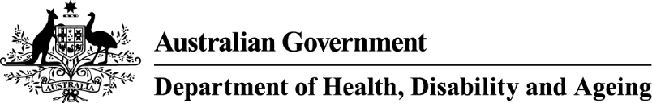

Approved Medical Deputising Services (AMDS) program

Changes to program guidelines – 7 August 2025

The AMDS program and documentation has been amended to ensure the outcomes from the

*Working Better for Medicare Review* and *After-Hours Review 2023-2024* are supported.

The requirement for AMDS Service Providers to submit a statutory declaration by 30 June each year has been removed from the program guidelines.

**Change to program guidelines**