Annual Report on MAIF Agreement complaints for 2024-25
  - Department of Health and Aged Care Report on complaints received by the Marketing in Australia of Infant Formulas – Manufacturers and Importers (MAIF) Agreement Complaints Committee

Contents
1 Introduction 3
The Marketing in Australia of Infant Formulas: Manufacturers and Importers Agreement 3
Authorisation of the MAIF Agreement 3
Signatories to the MAIF Agreement (as of 28 February 2025) 4
Review of the MAIF Agreement 4
2 MAIF Complaints Committee 5
MAIF Complaints Committee Membership 5
Cessation of the MAIF Complaints Committee 6
3 How complaints were processed 6
4 Complaint outcomes 2024 – 2025 8
Outcomes of complaints considered and resolved 8
In-scope of the MAIF Agreement 8
Out-of-scope of the MAIF Agreement 8

Nutrition Policy Section
Australian Government Department of Health, Disability and Ageing
MDP 570, GPO Box 9848, Canberra ACT 2601
Email: infantformula@health.gov.au

Introduction

The Marketing in Australia of Infant Formulas: Manufacturers and Importers Agreement
The Marketing in Australia of Infant Formulas: Manufacturers and Importers Agreement (MAIF Agreement) operated from 1992-2025, as a voluntary, self-regulatory, code of conduct between the manufacturers and importers of infant formula products in Australia. It was part of Australia’s response to the World Health Organization’s International Code of Marketing of Breast-milk Substitutes 1981 (WHO Code).
The MAIF Agreement aimed to contribute to the provision of safe and adequate nutrition for infants, by protecting and promoting breastfeeding; and by ensuring the proper use of breast-milk substitutes, when they are necessary, through appropriate marketing and distribution. The MAIF Agreement applied to infant formula products for infants up to 12 months.
The MAIF Agreement applied to Australian manufacturers and importers of infant formula who were signatories to the MAIF Agreement. Signatories to the MAIF Agreement were required to adhere to provisions with respect to marketing and promotion of formulas for infants up to 12 months. The marketing activities of retailers including pharmacies and supermarkets were outside the scope of the MAIF Agreement. Products aimed at toddlers over 12 months of age (commonly referred to as toddler milk), and baby food, feeding bottles, teats and dummies were also outside the scope of the MAIF Agreement.

Authorisation of the MAIF Agreement
The MAIF Agreement was authorised under the Competition and Consumer Act 2010 (the Act) and can be viewed at the Australian Competition and Consumer Commission (ACCC) website1. As the MAIF Agreement and guidelines restricted promotion and advertising of infant formula to the public, ACCC authorisation was required to ensure it did not breach the competition provisions of the Act.
The ACCC last reauthorised the MAIF Agreement in 2021 for a period of 3 years to 31 August 2024. On 14 August 2024, the ACCC granted interim authorisation to enable the MAIF Agreement to continue while it completed its assessment of the Infant Nutrition Council’s application for reauthorisation. On 6 February 2025, the ACCC announced their final decision to not reauthorise the MAIF Agreement. The MAIF Agreement ceased on 28 February 2025.

Signatories to the MAIF Agreement (as of 28 February 2025)
Abbott Australasia Pty Ltd | Aspen Pharmacare Pty Ltd
Australian Dairy Nutritionals Ltd | Australian Dairy Park Pty Ltd
Bellamy’s Organic | H & H Group
Max Biocare | Nature One Dairy Pty Ltd
Nestlé Australia Ltd | Nuchev Pty Ltd
Nutricia Australia Pty Ltd | Sanulac Nutritionals Australia Pty Ltd
Spring Sheep Milk Co | Sprout Organic
The a2 Milk Company Ltd | The Infant Food Co. Pty Limited
The LittleOak Company | Fonterra Oceania

Review of the MAIF Agreement
The Department of Health and Aged Care (the Department) engaged Allen + Clarke Consulting Pty Ltd (Allen and Clarke) to conduct an independent review of the effectiveness and scope of the MAIF Agreement. The Review Report was published in April 2024 and is available on the Department's website.
The review found the voluntary, self-regulation approach, was no longer fit for purpose. The report recommended the implementation of a stronger regulatory framework, by introduction of a mandatory code to effectively restrict the marketing of infant formula in Australia, promote and protect public health, and create a level playing field for industry.
In addition, the review included recommendations to improve infant nutrition via improved data collection, and better education and resources for healthcare professionals and the general public on infant feeding.
In October 2024, in response to the review of the MAIF Agreement, the Government announced its intention to replace the MAIF Agreement with stronger mandatory controls to contribute to the provision of safe and adequate nutrition for infants, by the protection and promotion of breastfeeding, and by ensuring the proper use of breastmilk substitutes, when these are necessary, on the basis of adequate information and through appropriate marketing and distribution.

MAIF Complaints Committee
The MAIF Agreement Complaints Committee (the Committee) was established in September 2018 and was administered by the Department. The Committee consisted of 4 members: an independent representative (Chair); a public health representative; an industry representative; and a second independent representative. The Department was responsible for associated secretariat functions.
In July 2024, the long-standing independent representative, Adjunct Professor Debra Scott resigned from her role as Chair of the MAIF Complaints Committee. In August 2024, the Department appointed a new independent member and Chair, a new industry representative and re-appointed the enduring public health representative. A fourth member was appointed to the committee in January 2025, as a second independent member.

MAIF Complaints Committee Membership
Independent representative and Chair: Adjunct Associate Professor Kellie Wilton BMid Wif, Grad Cert Intl Health, Grad Cert Clin Ed, M Primary Maternity Care, MHML MPH, MACM
Adjunct Associate Professor Kellie Wilton has extensive experience in midwifery and leadership. Using her experience to provide specialist and strategic policy advice in her current role as Chief Nursing and Midwifery Officer of the Northern Territory a position she took up in February 2025. Associate Professor Wilton also holds a role at the Curtin University as Adjunct Associate Professor of Midwifery. Previously she spent almost three years, from 2022, as Commonwealth Senior Midwifery Advisor at the Department of Health and Aged Care and prior to that as the Principal Midwifery Advisor at the Australian College of Midwives. At the beginning of her career, Associate Professor Wilton worked as a clinical and community midwife. Associate Professor Wilton is also continuing to complete her PhD in Identifying and dismantling racism in maternity care settings: frameworks for culturally safe care.
Public health representative: Emeritus Professor Jane Scott PhD, MPH, Grad Dip Dietetics (with Distinction), BApp Sci (Nutrition and Food Science), Fellow Dietitians Australia
Emeritus Professor Jane Scott is a public health dietitian whose early childhood nutrition research has underpinned and influenced national and international policy and practice. She has contributed to the surveillance of infant feeding practices in Australia and advised on the 2010 National Infant Feeding Survey and National Breastfeeding Indicators. Professor Scott was a member of the Breastfeeding Expert Reference Group, which contributed to the development of the Australian National Breastfeeding Strategy: 2019 and Beyond. She is a Fellow of Dietitians Australia and, prior to her retirement at the end of 2020, was Deputy Head of the School of Public Health at Curtin University.
Industry representative: Mr Jonathan Chew, Chief Executive Officer, Infant Nutrition Council
Mr Jonathan Chew has been the CEO of the Infant Nutrition Council (INC) since November 2023. He is also the industry representative on the Compliance Panel, the New Zealand equivalent to the MAIF Complaints Committee. Prior to his appointment at INC, Mr Chew was a policy consultant to Spirits and Cocktails Australia and Alcohol Beverages Australia. In a previous role, he worked for French multinational Pernod Ricard for seven years, first as Head of Public Affairs in Australia and New Zealand, and secondly as Associate Director of Corporate Affairs for Pernod Ricard Asia in Hong Kong. Mr Chew started his career at the Department of Foreign Affairs and Trade, which included roles overseas and a secondment to the Department of Prime Minister and Cabinet. Mr. Chew holds a B.Com/L.L.B. (Hons) from the University of Melbourne and an M.B.A. from Macquarie Graduate School of Management.
Independent Representative: Ms Jacky Mandelbaum,
Ms Jacky Mandelbaum is an experienced legal counsel, specialising in intellectual property and commercialisation in the scientific research and health industries. Ms Mandelbaum has expertise in food labelling and the marketing of food, particularly to children, and is knowledgeable in compliance, policy development, and regulatory enforcement in the food industry. Ms Mandelbaum is currently senior legal counsel at Alfred Health and is appointed as a member (previously Director and Deputy Chair) of the Audit and Risk Committee for Alola Australia Limited. In most recent years Ms Mandelbaum held roles at Orygen as general counsel and at the Commonwealth Scientific and Industrial Research Organisation (CSIRO) as legal counsel. In her early career, Ms Mandelbaum held numerous roles including legal counsel and consultancy roles and as a senior associate lawyer. Ms Mandelbaum holds a Bachelor of Law (Hons) and Bachelor of Science from University of Melbourne.

Cessation of the MAIF Complaints Committee
As a result of ACCC’s final determination not to re-authorise the MAIF Agreement, the MAIF Complaints Committee has ceased. The Committee’s final meeting was held on 27 February 2025.

How complaints were processed
Formal complaints could be lodged with the MAIF Complaints Committee Secretariat from any interested party, such as members of the public, breastfeeding advocacy groups, and health professionals. The flowchart below demonstrates the complaints handling process.
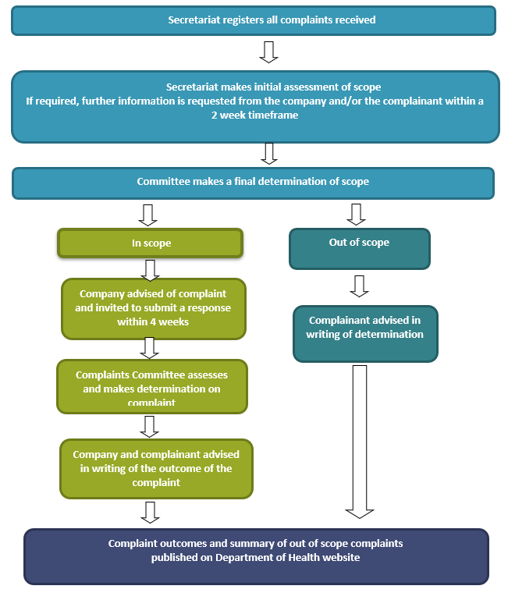

Complaint outcomes 2024 – 2025
In the 2024-25 the MAIF Complaints Committee:
- Considered a total of 25 complaints. 13 were new complaints received in 2024-25 and 12 were carried over from 2023-24.
- Resolved a total of 25 complaints.

Outcomes of complaints considered and resolved

In-scope of the MAIF Agreement
Of the 25 complaints resolved in 2024-25, 12 complaints were determined to be in scope of the MAIF Agreement:
- 11 complaints were determined to be in breach.
- 1 complaint was determined not a breach.

Out-of-scope of the MAIF Agreement
- 13 complaints were determined to be out of scope of the MAIF Agreement:
- 5 related to non-signatory activity.
- 4 related to retailer activity.
- 2 related to toddler milk.
- 2 related to ‘other’ activity.
- Other: International retailer.
Detailed information about each complaint is available on the Department’s Marketing in Australia of Infant Formulas (MAIF) Complaints Committee webpage.

https://www.accc.gov.au/system/files/public-registers/documents/D15%2B143530.pdf
World Health Organization 1981, International Code of Marketing of Breast-Milk Substitutes, Geneva.
https://www.accc.gov.au/public-registers/authorisations-and-notifications-registers/authorisations-register/infant-nutrition-council-ltd
https://www.health.gov.au/topics/pregnancy-birth-and-baby/breastfeeding-infant-nutrition/marketing-infant-formula

