The Disability Support for Older Australians (DSOA) Program



# Information about how some people will need to move into in-home aged care by 1 January 2025

**Easy Read version**

# How to use this document

The Australian Government Department of Health, Disability and Ageing (the department) wrote this document. When you see the word ‘we’, it means the department.

We wrote this document in an easy to read way. We use pictures to explain some ideas.

We wrote some words in **bold**. This means the letters are thicker and darker.

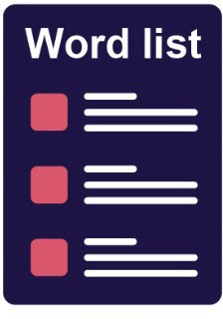We explain what these words mean. There is a list of these words on page **26**.

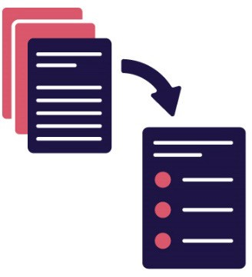This is an Easy Read summary of another document. It only includes the most important ideas.

You can find the other document on our website. https://www.health.gov.au/our-work/disability-support-for-older-australians-dsoa-program/resources

You can ask for help to read this document. A friend, family member or support person may be able to help you.

What’s in this document?

About this document 5

The in-home aged care system 10

How to move into the in-home aged care system 16

Having your assessment 26

Your funding and making payments 33

How to contact My Aged Care 43

Word list 28

# About this document

This document explains what you need to do if you have to move out of the Disability Support for Older Australians (DSOA) Program.

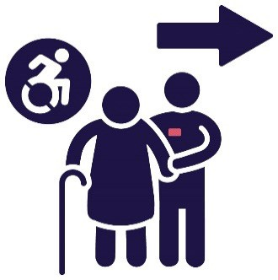The DSOA Program provides **funding** for services to support older people with disability. Funding is the money from the government that pays for the supports you need.

Before 1 January 2025, you will need to move out of the DSOA Program if you:

* receive **less than $50,000** of funding each year for supports
* live in a private home
* can get the same support from the **in-home aged care system**.

The in-home aged care system is made up of programs that the Australian Government runs. These programs support older people who live at home.

Through the in-home aged care system, you will still get the same support that you do now. But the way you get the support will be different.

On 1 November 2023, we sent a letter to some of our **DSOA service coordinators**.

DSOA service coordinators provide supports and services to older people with disability.

In the letter, we explained who needs to move out of the DSOA Program.

Your DSOA service coordinator should have told you if you need to move:

* out of the DSOA Program
* to a different aged care program.

You can talk to your DSOA service coordinator to learn:

* if this will affect you
* how to move into a different aged care program.

They can also tell you if the support workers you have now can continue to give you support after you move.

You can also choose to move into **residential aged care** instead.

Residential aged care is where older people live when they can’t live in their home anymore.

# The in-home aged care system

There are 2 programs that can support you if you need to move out of the DSOA Program. They are both part of the in-home aged care system.

The 2 programs are:

* the Commonwealth Home Support Programme
* the Support at Home program.

We explain these programs on the following pages.

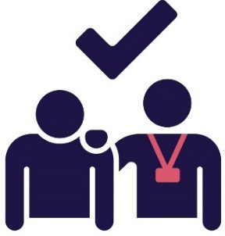These programs will support you in the same way that the DSOA Program supports you now.

If you need to move into the in-home aged care system, you must do it before 1 January 2025.

## The Commonwealth Home Support Programme

The **Commonwealth Home Support Programme** provides different types of care at home services.

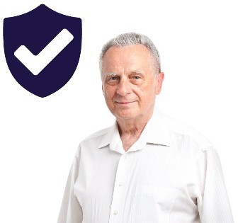Care at home services can help you keep doing things for yourself in a safe way.

This might include:

* personal care, like showering and getting dressed
* cooking your own meals.

If you need more information about the Commonwealth Home Support Programme, you can visit the My Aged Care website.

[www.myagedcare.gov.au/help-at-home/commonwealth-home-support-programme](https://www.myagedcare.gov.au/help-at-home/commonwealth-home-support-programme)

**The Support at Home program**

The **Support at Home program is** a group of aged care supports and services the Australian Government helps to fund.

These supports and services can help you:

* do things for yourself
* live in your own home for as long as you can.

This might include:

* personal services, like showering and getting dressed
* gardening and cleaning
* 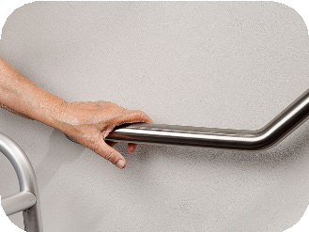changing small things in your home, like ramps or grab rails.

If you need more information about the Support at Home program, you can visit the My Aged Care website. [www.myagedcare.gov.au/support-home-program](http://www.myagedcare.gov.au/support-home-program)

# How to move into the in-home aged care system

To move into the in-home aged care system, you need to have an **assessment**. An assessment helps someone work out what support you might need.

You need to contact My Aged Care to get an assessment.

My Aged Care supports older people to find and use the aged care services they need. This includes their families and carers.

You will need to register with My Aged Care if this is your first time contacting them. You can find their contact details on page **24**.

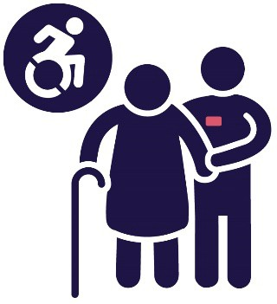When you contact My Aged Care, you need to explain that you:

* take part in the DSOA Program
* need to move into the in-home aged care system before 1 January 2025.

They will ask you some questions to find out which **assessor** should do your assessment.

An assessor is someone who has the skills and knowledge to do an assessment.

They will check if you need:

* the Commonwealth Home Support Programme

or

* other in-home aged care programs, such as Support at Home.

They will also check if you:

* can’t get support in the in-home aged care system
* need to stay in the DSOA Program.

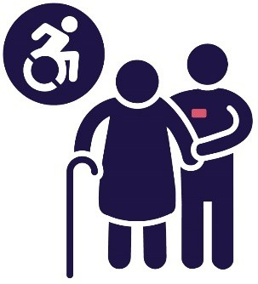They can also check if you can move into residential aged care.

## If you are already registered with My Aged Care

If you have already registered with My Aged Care, you will still need to contact them.

They will make sure the information they have about you is up to date.

And even if you had an assessment in the past, you might need to do another one.

My Aged Care might connect you with an assessor who can:

* **review** your support plan
* 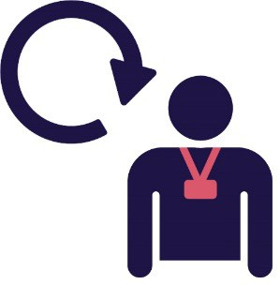update your aged care services.

When an assessor reviews your support plan, they check to see what:

* works well
* needs to be better.

My Aged Care will also tell you about the next steps to move into the in-home aged care system if you had an assessment recently.

This includes how to take part in:

* the Commonwealth Home Support Programme
* other in-home aged care programs, such as Support at Home.

# Having your assessment

Where you live will affect how long you need to wait before you can have an assessment.

Your assessment will be:

* in person
* in your home.

The assessor will ask you some questions about your daily life to find out what support you need.

And if you are happy with the amount of support you get now.

You can ask someone you know to be with you during this visit. For example, a friend or family member. Or a support person, like your carer.

You should tell your assessor if you need a **translator** during your assessment. A translator is someone who can help you understand information in a different language.

You can visit the My Aged Care website for more information about how to get ready for your assessment.

[www.myagedcare.gov.au](http://www.myagedcare.gov.au)

**After your assessment**

After your assessment, you will find out which program you will move into.

You will stay in the DSOA Program if the assessment shows that the in-home aged care system can’t support you.

If you can get in-home support services, you will get a **priority**.

Your priority is about how soon you will get your in-home services.

Your priority depends on:

* when you had your assessment
* how quickly you need care services.

People usually wait to get their in-home support services.

## If you can’t move into the in-home aged care system before 1 January 2025

So that you can move into the in-home aged care system before 1 January 2025, you should call My Aged Care **as soon as possible**.

## 1800 200 422

There might be a reason why you can’t move into the in-home aged care system before 1 January 2025.

For example, there might be a long list of people waiting at the same time as you for in-home support services.

If this happens, you will continue to get funding from the DSOA Program while you wait to get into the in-home aged care system.

Ask your DSOA service coordinator to send us an email to explain why you are waiting to move into the in-home aged care system. [CommonwealthDSOA@health.gov.au](mailto:CommonwealthDSOA@health.gov.au)

# Your funding and making payments

You will **not** get less services when you move into the in-home aged care system.

But you might need to make payments for the cost of your care. These payments are different for each program.

## The Commonwealth Home Support Programme

For the Commonwealth Home Support Programme, we will ask you to make payments for the cost of your care if you can afford to.

Your Commonwealth Home Support Programme **provider** will talk with you about how much you can afford to pay. Providers support people by delivering a service.

You can visit our website for more information.

[www.health.gov.au/resources/publications/chsp-manual](http://www.health.gov.au/resources/publications/chsp-manual)

The in-home aged care system

For other in-home aged care programs, you need to make payments towards the cost of your care if you can afford to. We call this the ‘**income** tested care fee’. It is based on your income.

Your income is all the money you earn. It includes the money you get from:

* working
* government payments, like your **pension**.

A pension is a payment from the government to help with your day-to-day living costs.

The income tested care fee is also based on other money you have.

This includes things like:

* the money you have in your bank accounts
* other things, like people paying you rent.

You don’t have to make an income tested care fee if you:

* receive your full income from your pension
* 43arn **less than $33,849.40** each year.

This amount usually changes in March and September every year.

It became **$33,849.40** on 20 March 2025.

Your provider might ask you to pay a daily fee. We call this the ‘basic daily fee’.

The amount depends on your level of In-home aged care services.

Not all providers will ask you to pay a basic daily fee.

The My Aged Care website has a tool you can use to check which providers in your area will ask you to pay this fee.

It is called the ‘Find a provider’ tool.

[www.myagedcare.gov.au/find-a-provider](http://www.myagedcare.gov.au/find-a-provider)

You can visit the Department of Health, Disability and Ageing for more information. [www.health.gov.au/resources/publications/consumer-protections-for-support-at-home-prices-fact-sheet-for-participants](http://www.health.gov.au/resources/publications/consumer-protections-for-support-at-home-prices-fact-sheet-for-participants)

You can also visit the Services Australia website to learn more about these payments. [www.servicesaustralia.gov.au/understanding aged care costs to get aged care services](http://www.servicesaustralia.gov.au/understanding%20aged%20care%20costs%20to%20get%20aged%20care%20services)

# How to contact My Aged Care

You can call My Aged Care.

## 1800 200 422

You can also visit their website to:

* learn about different aged care programs
* get ready for your assessment
* use the ‘Find a provider’ tool to compare different providers.
* [www.myagedcare.gov.au](http://www.myagedcare.gov.au)

[](http://www.myagedcare.gov.au)You can contact your DSOA service coordinator for more information about changes to your care.

## How to book an in-person appointment

You can also call Services Australia for free to make an appointment with a staff member.

We call them Aged Care Specialist Officers.

You can have an in-person appointment with them to talk about moving from the DSOA Program.

You can call Services Australia to find out if there’s an Aged Care Specialist Officer close to where you live.  
**1800 227 475**

You can visit the Services Australia website to:

* find an Aged Care Specialist near you
* book an in-person appointment with them. [www.servicesaustralia.gov.au/my-aged-care-face-to-face-services](http://www.servicesaustralia.gov.au/my-aged-care-face-to-face-services)

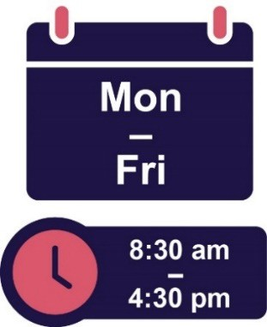You can call Services Australia from:

* 8:30 am to 4:30 pm
* Monday to Friday.

# Word list

This list explains what the **bold** words in this document mean.

## Assessment

An assessment helps someone work out what support you might need.

## Assessor

An assessor is someone who has the skills and knowledge to do an assessment.

## Commonwealth Home Support Programme

The Commonwealth Home Support Programme provides different types of care at home services.

## DSOA service coordinators

DSOA service coordinators provide supports and services to older people with disability.

## Funding

Funding is the money from the government that pays for the supports you need.

## Support at Home

The Support at Home program is a group of aged care supports and services the Australian Government helps to fund.

## Income

Your income is all the money you earn. It includes the money you get from:

* working
* government payments, like your pension.

## In-home aged care system

The in-home aged care system is made up of programs that the Australian Government runs. These programs support older Australians who live at home.

## Pension

A pension is a payment from the government to help with your day-to-day living costs.

## Priority

Your priority is about how soon you will get your Home Care Package.

## Providers

Providers support people by delivering a service.

## Residential aged care

Residential aged care is where older people live when they can’t live in their home anymore.

## Review

When an assessor reviews your support plan, they check to see what:

* works well
* needs to be better.

## Translator

A translator is someone who can help you understand information in a different language.

The Information Access Group created this Easy Read document using stock photography and custom images. The images may not be reused without permission. For any enquiries about the images, please visit [**www.informationaccessgroup.com**](http://www.informationaccessgroup.com/). Quote job number 5501.