# Supporting evaluation and implementation research through the Medical Research Future Fund (MRFF) – consultation report

## Context

* Translation of research findings into health policy and practice is a key measure of success for the MRFF, and it is important to understand factors, methods and models that promote the uptake of new evidence to optimise performance in this measure.
* The Department of Health, Disability and Ageing (department) piloted a grant opportunity model for prospective evaluation that aimed to uncover barriers and facilitators to research translation and encourage MRFF grantees to think about the full path to translation from early on in their projects.
* While work on these pilot projects is underway and outcomes are pending, the department is exploring additional models to achieve these aims, that could either complement the pilot model or address any gaps identified, e.g. the timing and heterogeneity in the projects being evaluated.
* The department held meetings with external experts to consider alternative funding models and received advice to foster evaluation and implementation research through in-built components to funded MRFF projects, or standalone small or larger-scale evaluation or implementation research projects.

These consultations centred discussion on three possible models for supporting evaluation and implementation research (Figure 1):

* **Model 1** – A grantee in a separate stream is funded to prospectively evaluate all other projects within the same grant opportunity (used in the 2022 Clinician Researchers and 2022 Rapid Applied Research Translation initiatives)
* **Model 2** – All projects funded by a grant opportunity must integrate an evaluation or implementation research component into their research design
* **Model 3** – A dedicated stream within a grant opportunity that funds evaluation or implementation research. It does not need to be connected to the other projects funded under the same grant opportunity.

These models encompass evaluation of research at all stages from design to outcomes and impacts[1], as well as research focussed on the latter stage of implementation of research findings into health impacts[2], to the fostering of implementation science as a discipline. All are aimed towards promoting the successful translation of MRFF-funded projects, in pursuit of [MRFF priorities](https://www.health.gov.au/our-work/mrff/about/strategy-and-priorities) regarding effective and high value care, and measures of success as outlined in the [MRFF Monitoring, evaluation and learning strategy](https://www.health.gov.au/resources/publications/mrff-monitoring-evaluation-and-learning-strategy?language=en).

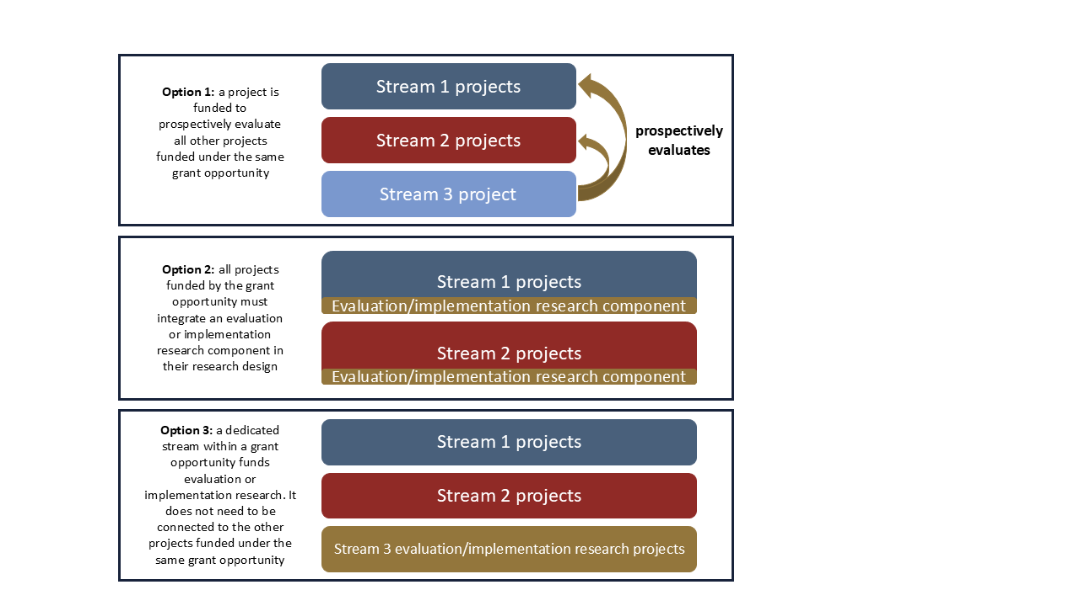

**Figure 1**: Basic conceptual diagram for the 3 potential options (models) by which evaluation and implementation research could be better supported by MRFF funding programs. These options were not prescriptive and were presented to stimulate discussion; elements of each option may be incorporated in different ways across different MRFF initiatives.

## Key findings from consultations

The consultations took the form of a series of small roundtables in September 2024, conducted by the Health and Medical Research Office to seek expert views on how the MRFF can better encourage prospective evaluation among researchers and better support implementation of research into health policy, practice and systems. The roundtables included 12 experts in health evaluation and economics, health technology assessment, implementation science, with experience across research as well as state and federal public sectors.

Stakeholders gave the broadest support to Model 3 as the best option for supporting implementation science. This is because Model 3 supports: (a) large-scale collaborative partnerships that can achieve systems change; and (b) smaller-scale projects for translating evidence into practice at the hospital/single local health district level. There was some support for Model 2 as it enables thinking about implementation earlier in the research pipeline compared to Model 3. Model 1 (the current model) was the most divisive, yet stakeholders acknowledged that it had positive advantages and could work in the right context.

| **Model** | **Advantages** | **Caveats** |
| --- | --- | --- |
| **Model 1:** prospective evaluation stream (used in Stream 3 of the Rapid Applied Research Translation and Clinician Researchers initiatives) | * Model 1 deploys an independent evaluator to facilitate funded projects to think about translation as early as possible. * The main advantage of Model 1 is in having one evaluator synthesising similarities and differences across diverse projects to pinpoint common success factors. * Model 1 tries to yield information about why projects hit barriers or fail, which tends to be buried because research culture is critical by nature and often lacks transparency. * Model 1 could work well for some topics (similar to external evaluations for health technology assessment). | * Evaluator must establish partnerships with funded projects early on. Otherwise, it is more like ‘an auditing role’ with an evaluator ‘scrutinising someone else’s work.’ * Model 1 may be challenging if the evaluator does not have content or methodological expertise. * Stakeholders were divided on whether Model 1 meets the stated intent of gathering evidence of the factors that promote the integration of new evidence in healthcare practice. * As Model 1 is being piloted, it is too early to tell whether funded projects will engage with the evaluator and produce the intended evidence. |
| **Model 2:** No separate prospective evaluation stream; all projects funded must incorporate prospective evaluation or implementation research | * Model 2 provides points of difference with Model 3 as it enables researchers to do early implementation work, even at the lab stage (e.g. process evaluation to get critical information that informs implementation strategies down the track). * Model 2 has the advantage of nested studies and alongside evaluation within the actual content of the project. | * Some stakeholders think Model 2 imposes too much on researchers to both test an intervention and work on its implementation and evaluation * Relevant evaluation expertise must be properly factored into grant applications. Some have experience difficulty recruiting people with the right expertise. |
| **Model 3:** Dedicated stream for evaluation and implementation research (does not involve projects funded in other streams) | * Model 3 is the most conducive to the formation of broad partnerships between researchers, clinicians, local health districts and policymakers for systems change. * Model 3 supports small-scale projects that translate evidence into practice. * Model 3 is ideal for supporting implementation science as a broad umbrella covering many activities. * Model 3 is the most flexible because it is not tied to other projects. * Implementation science introduces nuances into study designs that is believed to place them at a disadvantage compared to other research projects (e.g. Randomised Control Trials). A separate implementation science stream ensures these projects are competing on a level playing field. | * Assumes that evidence already exists ready for implementation, unlike Model 1 or 2. * Absence of direct engagement with funded research (potentially, though not necessarily), removes the opportunity to prospectively optimise the investment pipeline. Necessitates that this evidence is aligned to, and/or already integrated within the funding and evaluation processes of the wider research system. |

Outside of the discussion on funding models, the experts consulted also provided the following implementation advice:

* Australia has a small research community with limited capacity. The model that will be most conducive to success is one that is more collaborative. It should bring people together to share capacity and knowledge.
* All groups saw a need for better translation planning and suggested we could build prospective evaluation principles into grant assessment criteria, to be applied widely across the MRFF.
* For MRFF Initiatives that fund later-stage research translation, policy areas should consider piloting a dedicated stream for large-scale implementation studies conducted by collaborative partnerships (e.g. multiple local health districts, state-wide, national).
* Care should be taken not to be overly prescriptive by specifying methods (e.g. randomised control/other trials), as a wide range of methods exist that suit different fields of research or stages of implementation and to allow for innovative approaches.
* Projects funded under the proposed models must have team members with implementation science expertise, as well as the appropriate mix of skills (e.g. scientific, project management, research translation). There is a need for capacity and capability uplift in Australia and it would be beneficial to consider funding a training component.
* It would be beneficial to provide additional material to Grant Assessment Committees on implementation science methodology, as they may lack the necessary expertise to review such grants.
* There was support for department-led work to facilitate the research translation and impact of MRFF grants that are relevant to the Health Technology Assessment Committee.

## Conclusions

Ultimately, there is no one-size-fits-all for supporting evaluation and implementation research. Any support must be tailored to the specific context and characteristics of each MRFF Initiative (e.g. stage of research pipeline, target cohort of researchers) (Figure 2).

The department will consider these findings in future, not just for the initiatives currently piloting Model 1, but for the MRFF more broadly. The department will also continue to examine and improve current efforts to facilitate more effective translation and impact of MRFF-funded research, e.g. dedicated funding driven by Health Technology Assessment needs under the Preventive and Public Health Research initiative, ongoing engagement with the National Health Technology Assessment Chairs Committee and fostering of early engagement between grantees and relevant policymakers, consumers, end-users and other stakeholders of research.

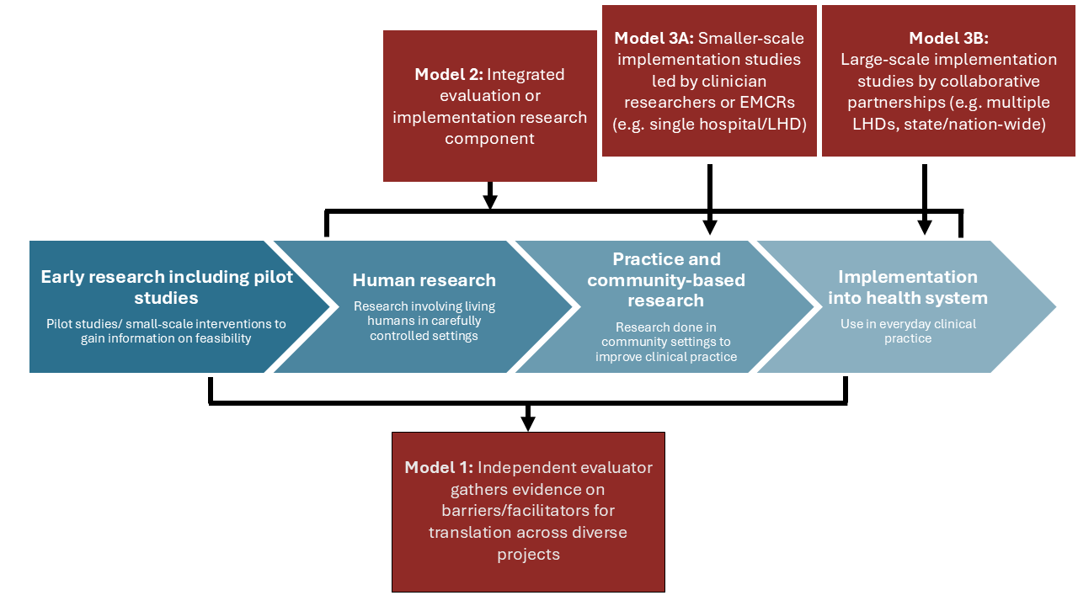

**Figure 2:** An example of how the proposed grant models could support evaluation and implementation research along the research pipeline. LHD refers to local health district. EMCR refers to early-to-mid-career researchers. It is acknowledged that research translation pathways are often non-linear and complex.

1. **Evaluation** is defined as “the systematic collection of information about the activities, characteristics, and outcomes of a program, service, policy, or process, in order to make judgments about the program/process, improve effectiveness, and/or inform decisions about future development.” (Bowen, S. A Guide to Evaluation in Health Research. Canadian Institutes of Health Research. Available at: <https://cihr-irsc.gc.ca/e/45336.html>).
2. **Implementation research** is defined as “the scientific study of methods to promote the integration of research findings and evidence-based interventions into healthcare policy and practice.” (Dissemination and Implementation Research in Health (R01). Program announcement number PAR-10-038. US Department of Health and Human Services. Available at: <http://grants.nih.gov/grants/guide/pa-files/PAR-10-038.html>).