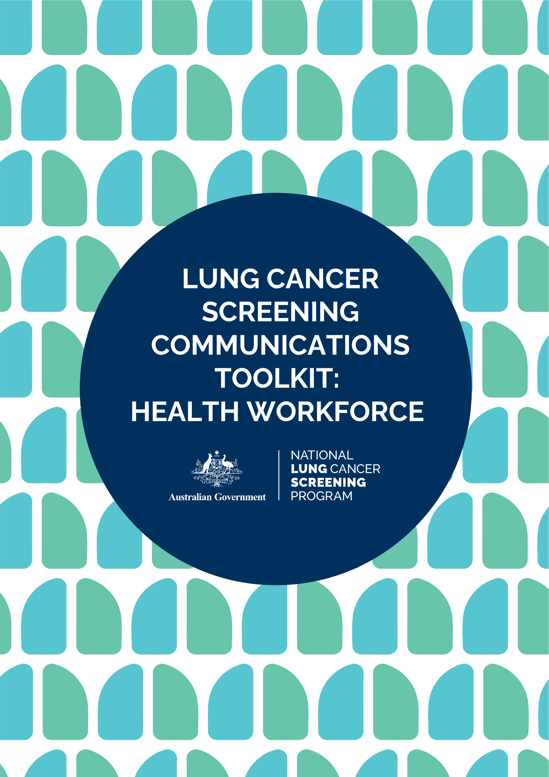

CONTENTS

The Communication Toolkit 3

Terms of Use 3

About the NLCSP 4

Key Messages 4

Newsletter Content 5

Content 1: Healthcare provider channels 5

Content 2: Consumer-facing channels 6

Website Content 7

Email to Stakeholders 8

Social Media Content 9

Healthcare provider facing channels 9

Consumer-facing channels 10

Images and Social Media Assets 12

Hashtags 12

NLCSP Frequently Asked Questions 12

Program Resources 13

More Information 13

# **THE COMMUNICATION TOOLKIT**

This communication toolkit has been developed by the Australian Government Department of Health, Disability and Ageing.

The toolkit is designed to support healthcare providers and the health support workforce to promote the National Lung Cancer Screening Program (NLCSP) with their networks.

The toolkit contains key messages, images and content for your social media, newsletters, emails and websites that can be used directly or adapted for your channels.

Share this content with your staff and networks to help them prepare for and deliver the National Lung Cancer Screening Program.

Please contact the Cancer Screening Communication and Partnerships team at [CancerScreeningCommunications@health.gov.au](mailto:CancerScreeningCommunications@health.gov.au) if you have any questions about this toolkit.

The toolkit was last updated: July 2025

# **TERMS OF USE**

The messages, images and assets within this toolkit can be used to promote the National Lung Cancer Screening Program and available resources and materials for healthcare providers.

# **ABOUT THE NLCSP**

The NLCSP aims to reduce deaths from lung cancer and achieve better health outcomes for Australians through early detection of lung cancer.

The program targets asymptomatic (no signs or symptoms suggestive of lung cancer) high-risk individuals (based on tobacco cigarette smoking history) to detect lung cancer in its early stages to increase the likelihood of successful treatment and improved patient outcomes. By detecting lung cancer early, the program is expected to save hundreds of lives each year from lung cancer.

People are eligible for the program if they are:

* aged between 50-70 years, and
* show no signs or symptoms suggesting they may have lung cancer (that is, they are asymptomatic), and
* currently smoke or have quit smoking in the past 10 years, and
* have a history of tobacco cigarette smoking of at least 30 pack-years.

The screening will involve completing a low-dose computed tomography (CT) scan every two years.

# **KEY MESSAGES**

* The National Lung Cancer Screening Program has now launched.
* Developed by the Australian Government, in partnership with the National Aboriginal Community Controlled Health Organisation, this program is designed to be equity-focused, culturally safe, and person-centered.
* Australians are eligible for the program if they are:
  + aged between 50-70 years, and
  + show no signs or symptoms suggesting they may have lung cancer (that is, they are asymptomatic), and
  + currently smoke or have quit smoking in the past 10 years, and
  + have a history of tobacco cigarette smoking of at least 30 pack-years.
* The program will help to improve health outcomes for Australians by increasing early detection of lung cancer and saving lives.
* Lung cancer screening can detect up to 70% of lung cancers in the early stages. If found early, over 65% of lung cancers can be successfully treated.
* Healthcare providers, such as GPs, nurse practitioners and medical specialists, play a critical role in the delivery and success of the program by assessing participant eligibility, referring eligible participants to the program, and supporting participants through the screening and assessment pathway.
* Program resources and education are available to support you to deliver the program.
* Access education and resources for healthcare providers: health.gov.au/nlcsp-hcp-toolkit
* Your participation and support for this program will help save hundreds of lives each year from lung cancer.
* Lung cancer screening saves lives. Find out more about the program: health.gov.au/nlcsp

# **NEWSLETTER CONTENT**

## Content 1: Healthcare provider channels

**Heading:**

Now available: The new National Lung Cancer Screening Program

**Body:**

The National Lung Cancer Screening Program is now available, allowing eligible Australians aged 50-70 with no signs or symptoms of lung cancer to screen in the program every two years.

Healthcare providers and the health support workforce are critical for the delivery and success of the program.

With the program now launched, you can expect to start receiving enquiries from the community. Make sure you are ready to deliver the program by accessing the program resources and education.

Lung cancer is the leading cause of cancer-death in Australia. Yet, if found early, over 65% of lung cancers can be treated.

Developed by the Australian Government, in partnership with the National Aboriginal Community Controlled Health Organisation, this program is designed to be equity-focused, culturally safe, and person-centered.

Find out more: **health.gov.au/nlcsp-hcp-toolkit**

## Content 2: Consumer-facing channels

**Heading:**

Lung cancer screening is now available

**Body:**

The National Lung Cancer Screening Program has now launched.

This program aims to improve early detection of lung cancer in those at higher risk and is expected to save hundreds of lives every year.

Lung cancer screening involves a low-dose CT scan of your chest to look for signs of lung cancer.

You may be eligible for the program if you are:

* aged between 50-70 years, and
* show no signs or symptoms suggesting you may have lung cancer (e.g. persistent cough, coughing up blood, shortness of breath), and
* currently smoke or have quit smoking in the past 10 years, and
* have a history of tobacco cigarette smoking of at least 30 pack-years.

If you think you might be eligible, book in to speak to your healthcare provider.

Lung cancer screening saves lives.

[Find out more](https://www.health.gov.au/nlcsp?utm_source=qr_code&utm_medium=digitaladvertising&utm_campaign=nlcsp2025)

# **WEBSITE CONTENT**

**Delivering the National Lung Cancer Screening Program**

The National Lung Cancer Screening Program (NLCSP) is now available, allowing eligible Australians aged 50-70 with no signs or symptoms of lung cancer to screen in the program every two years.

Lung cancer is Australia’s leading cause of cancer death. This program aims to improve health outcomes for Australians by increasing early detection of lung cancer and saving lives.

**Make sure you are ready to deliver the program**

Healthcare providers and the health support workforce play a central role in the NLCSP by assessing participant eligibility, referring eligible participants, and supporting participants through the screening and assessment pathway.

To support you in delivering the program, education and resources are available for healthcare providers. You can access the resources on the [Australian Department of Health Disability and Ageing website](https://www.health.gov.au/nlcsp-hcp-toolkit).

To make sure you feel ready, you should:

* Familiarise yourself with the [Program Guidelines](https://www.health.gov.au/resources/publications/nlcsp-guidelines?language=en)
* Complete the relevant [online education](https://www.health.gov.au/our-work/nlcsp/resources)
* Download or order [program resources](https://www.health.gov.au/our-work/nlcsp/resources)
* Register and integrate your practice with the [National Cancer Screening Register](https://ncsr.gov.au/information-for-healthcare-providers/accessing-the-ncsr/clinical-software-integration.html).

Lung cancer screening can detect up to 70% of lung cancers in the early stages and could help save hundreds of lives each year.

Developed by the Australian Government, in partnership with the National Aboriginal Community Controlled Health Organisation, this program is designed to be equity-focused, culturally safe, and person-centered

Find out more about the program and access information and resources for the health workforce at **health.gov.au/nlcsp-hcp-toolkit**.

# **EMAIL TO STAKEHOLDERS**

Dear [staff/colleagues/members]

The National Lung Cancer Screening Program (NLCSP) is now available, allowing eligible Australians aged 50-70 with no signs or symptoms of lung cancer to screen in the program every two years.

Lung cancer is Australia’s leading cause of cancer death. This program aims to improve health outcomes for Australians by increasing early detection of lung cancer and saving lives.

With the program now launched, you can expect to start receiving enquiries from the community. Program education and resources are available to ensure you are ready to deliver the program.

 A digital [Healthcare Provider Toolkit](https://www.health.gov.au/resources/collections/national-lung-cancer-screening-program-healthcare-provider-toolkit?utm_source=qr_code&utm_medium=digitaladvertising&utm_campaign=nlcsp2025) is available, with

* Information to support you to prepare for the program
* [Resources](https://www.health.gov.au/our-work/nlcsp/resources) for healthcare providers and the public
* A link to the program-specific [low-dose CT request form](https://www.health.gov.au/resources/publications/nlcsp-ldct-request-form?language=en)
* Links to [online training and education](https://www.health.gov.au/our-work/nlcsp/resources), including new program eLearning modules developed by Lung Foundation Australia and the Royal Australian and New Zealand College of Radiologists.
* A communications toolkit containing promotional content.

The NLCSP website is the central source of information on the program for healthcare providers and health support workers. New information and resources will be added to this website as they become available.

Complete the relevant education and download or order resources to make sure you are ready for the program.

Developed by the Australian Government, in partnership with the National Aboriginal Community Controlled Health Organisation, this program is designed to be equity-focused, culturally safe, and person-centered.

Find out more: **health.gov.au/nlcsp-hcp-toolkit**

# **SOCIAL MEDIA CONTENT**

## Healthcare provider facing channels

| **Facebook / Instagram / LinkedIn** |
| --- |
| Now available: The National Lung Cancer Screening Program!  Australians aged 50-70 with no signs or symptoms of lung cancer and a history of smoking may now be eligible to screen for lung cancer.  Healthcare providers and the health support workforce will play a critical role in the delivery and success of the program.  Your participation in supporting the program will help save hundreds of lives each year from lung cancer.  You can start now by accessing the new education and resources for healthcare providers.  Find out more: health.gov.au/nlcsp-hcp-toolkit |
| National Lung Cancer Screening Program education and resources are available for healthcare providers!  The National Lung Cancer Screening Program has now launched, allowing eligible people aged 50-70 to have a low-dose CT scan to check for signs of lung cancer.  This program will increase early detection of lung cancer (Australia’s leading cause of cancer death) and improve treatment outcomes, helping to save hundreds of lives every year.  Your participation will support the delivery of this program and save lives.  Find education, information and resources: health.gov.au/nlcsp-hcp-toolkit |
| Are you ready to deliver the National Lung Cancer Screening Program?  The National Lung Cancer Screening Program has now launched, allowing eligible people aged 50-70 to screen for lung cancer.  Lung cancer screening can detect up to 70% of lung cancers early and is expected to save hundreds of lives each year.  Your participation will support the delivery the program and save lives.  Access program education and resources: health.gov.au/nlcsp-hcp-toolkit |
| Is your practice ready for the National Lung Cancer Screening Program?  The National Lung Cancer Screening Program has now launched, allowing eligible people aged 50-70 to screen for lung cancer.  Primary care plays a critical role in the delivery of the program by assessing eligibility and referring eligible participants into the program.  This program will help to improve outcomes for Australians by detecting lung cancers early and saving lives. Make sure your practice is ready for July.  Access information, training and resources: health.gov.au/nlcsp-hcp-toolkit |

| **X (previously Twitter)** |
| --- |
| Eligible Australians aged 50-70 with no signs or symptoms of #LungCancer are now able to screen through the #NationalLungCancerScreeningProgram. Education and resources for healthcare providers are available. |
| New #NationalLungCancerScreeningProgram education and resources for healthcare providers are available! Make sure you’re ready to support the delivery of this new program and save lives. |
| Are you ready for #lungcancerscreening? The new #NationalLungCancerScreeningProgram will help to improve outcomes for Australians and save hundreds of lives each year. Get prepared by accessing program education and resources. |
| Is your practice ready for the #NationalLungCancerScreeningProgram? Primary care will play a critical role in the delivery and success of the program. Access information, training and resources. |

# Consumer-facing channels

| **Facebook / Instagram / LinkedIn** |
| --- |
| Did you know there is a new National Lung Cancer Screening Program?  Lung cancer screening is now available in Australia for eligible people aged 50-70 who are at higher risk of lung cancer.  This test involves a free low-dose CT scan of your chest to look for signs of lung cancer and can detect up to 70% of lung cancers in the early stages when they are easier to treat.  Find out about the program and see if you're eligible: health.gov.au/nlcsp |
| The National Lung Cancer Screening Program is now available!  If found early, over 65% of lung cancer can be successfully treated. Lung cancer screening uses a CT scan of the chest to look for early signs of lung cancer and is expected to save hundreds of lives every year.  If you're aged 50-70, with a smoking history and have no signs or symptoms of lung cancer, you may be eligible for the program.  Speak to your healthcare provider to find out if you are eligible for the free scan.  Find out more: health.gov.au/nlcsp |
| Are you eligible for the new National Lung Cancer Screening Program?  Lung cancer is the fifth most common cancer in Australia with around 15,000 Australians diagnosed last year alone.  When found early, over 65% of lung cancers can be successfully treated. The National Lung Cancer Screening Program launched in July can find lung cancers earlier and is expected to save hundreds of lives every year.  If you're aged 50-70, with no signs or symptoms of lung cancer and are currently smoking or have recently quit, you may be eligible for the free scan.  Lung cancer screening saves lives. Speak with your healthcare provider to see if you are eligible for the program.  Find out more: health.gov.au/nlcsp |
| Early detection of lung cancer saves lives!  The National Lung Cancer Screening Program is now available for eligible people aged 50-70.  When found early, over 65% of lung cancers can be successfully treated.  If you're aged 50-70, with no signs or symptoms of lung cancer and are currently smoking or have recently quit, you may be eligible for a free scan.  Speak to your healthcare provider to see if you are eligible. Find out more: health.gov.au/nlcsp-hcp-toolkit |

| **X (previously Twitter)** |
| --- |
| Eligible Australians aged 50-70 with no signs or symptoms of #LungCancer are now able to screen every two years through the #NationalLungCancerScreeningProgram. Find out more. |
| The #NationalLungCancerScreeningProgram is now available. If you are aged 50-70 with a history of smoking, you may be eligible. Speak to your healthcare provider to find out more. |
| Early detection of #lungcancer saves lives! Did you know that over 65% of lung cancers can be successfully treated if found early. Speak to your healthcare provider to see if you're eligible for the new #NationalLungCancerScreeningProgram. |
| If you're aged 50-70, with no signs or symptoms of lung cancer and are currently smoking or have recently quit, you may be eligible for the new #NationalLungCancerScreeningProgram. Speak to your doctor to find out more. |

# **IMAGES AND SOCIAL MEDIA ASSETS**

We have created several high-resolution images saved with this toolkit that you can use for your social media and other digital channels to promote the NLCSP.

# **HASHTAGS**

#LungCancer #LungCancerScreening #LungCancerScreeningSavesLives #PreventLungCancer #NationalLungCancerScreeningProgram #NLCSP

# **NLCSP FREQUENTLY ASKED QUESTIONS**

[Frequently asked questions from the health workforce](https://www.health.gov.au/resources/publications/nlcsp-workforce-faqs?language=en)

[Frequently asked questions from community members](https://www.health.gov.au/resources/publications/nlcsp-community-faqs?language=en)

# **PROGRAM RESOURCES**

A suite of National Lung Cancer Screening Program Resources has been developed for the health sector and the public. Access these resources on the NLCSP website via the links below.

[NLCSP resources for the health sector](https://www.health.gov.au/our-work/nlcsp/resources/health-sector)

[NLCSP resources for the public](https://www.health.gov.au/our-work/nlcsp/resources/general-public)

[NLCSP translated resources](https://www.health.gov.au/resources/translated?f%5b0%5d=h_translations_our_work:46566)

# **MORE INFORMATION**

Access information, resources and education for healthcare providers and the health support workforce on the program website: [www.health.gov.au/nlcsp](http://www.health.gov.au/nlcsp)

**health.gov.au/nlcsp**

