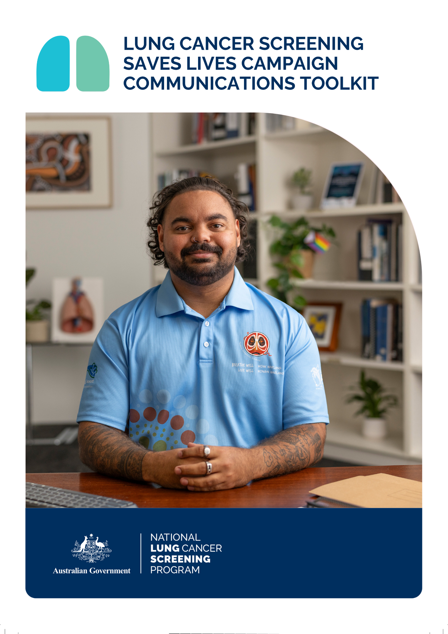

CONTENTS

The Communication Toolkit 3

Terms of use 3

About the NLCSP 4

About the campaign 4

Key messages 5

Newsletter content 6

Option 1: 6

Option 2: 6

Email to stakeholders 7

Social media content 8

Images and social media assets 9

Hashtags 9

NLCSP Frequently Asked Questions 9

Program resources 10

More information 10

# **THE COMMUNICATION TOOLKIT**

This communication toolkit has been developed by the Australian Government Department of Health, Disability and Ageing.

The toolkit is designed to support stakeholders to promote lung cancer screening, and the new *Lung Cancer Screening Saves Lives* campaign to their networks.

The toolkit contains key messages, images and content for your social media, newsletters, emails and websites that can be used directly or adapted for your channels.

Share this content on your communications channels to promote the program and help save lives.

Please contact the Cancer Screening Communication and Partnerships team at [CancerScreeningCommunications@health.gov.au](mailto:CancerScreeningCommunications@health.gov.au) if you have any questions about this toolkit.

The toolkit was last updated: July 2025

# **TERMS OF USE**

The messages, images and assets within this toolkit can be used to promote the National Lung Cancer Screening Program (NLCSP).

# **ABOUT THE NLCSP**

Lung cancer is the leading cause of cancer-related death in Australia, with almost 15,000 Australians diagnosed every year.

To help save lives from lung cancer and achieve better health outcomes for Australians, the Department of Health, Disability and Ageing launched the new NLCSP on 1 July 2025.

Lung cancer screening provides free low-dose computed-tomography (CT) scans to look for early signs of lung cancer in people at higher risk, due to their age and smoking history. By detecting lung cancer early, the program is expected to save hundreds of lives each year.

People are eligible for the program if they are:

* aged between 50-70 years, and
* show no signs or symptoms suggesting they may have lung cancer (that is, they are asymptomatic), and
* currently smoke or have quit smoking in the past 10 years, and
* have a history of tobacco cigarette smoking of at least 30 pack-years.

In partnership with the National Aboriginal Community Controlled Health Organisation, this program is designed to be equity-focused, culturally safe, and person-centered.

# **ABOUT THE CAMPAIGN**

The *Lung Cancer Screening Saves Lives* campaign aims to raise awareness of the new NLCSP and the importance of early detection amongst eligible Australians. The campaign will run on digital channels and radio from mid-July 2025 until late September 2025 in preparation for a second wave of campaign activity being delivered from late September 2025, with tailored communications for priority populations.

Evidence shows low understanding among those eligible about the benefits of early detection of lung cancer. This campaign aims to address these knowledge gaps and prime the audience ahead of the equity-first campaign.

The national campaign launching in September 2025 is being developed by a consortium of organisations, including Cancer Council Victoria, The Daffodil Centre, ACON, Australian Multicultural Health Collaborative, NACCHO and the Royal Flying Doctors Service South-Eastern section.

# **KEY MESSAGES**

* A new National Lung Cancer Screening Program is now available.
* If you’re aged 50-70 with a smoking history, you may be eligible for the program.
* You may eligible for a free scan if you are:
  + aged between 50-70 years, and
  + currently smoke or have quit smoking in the past 10 years, and
  + show no signs or symptoms of lung cancer (e.g. persistent cough, coughing up blood, shortness of breath), and
  + have a history of tobacco cigarette smoking of at least 30 pack-years.
* You don’t need to quit smoking to be part of the program.
* Eligible Australians are encouraged to have a free scan every two years under the program.
* If detected early, over 65% of lung cancers can be successfully treated.
* Lung cancer screening can detect up to 70% of lung cancers in the early stages.
* Lung cancer screening uses a low-dose CT scan of your chest to look for signs of lung cancer.
* The earlier cancer is found, the better our chances of treating it.
* Lung cancer screening saves lives.
* Talk to a doctor or healthcare provider to see if you are eligible.
* Find out more: [www.health.gov.au/lung](http://www.health.gov.au/lung)

# **NEWSLETTER CONTENT**

## Option 1:

**Now available: A new lung cancer screening program**

The new National Lung Cancer Screening Program has now launched for eligible Australians aged 50-70.

The program provides free low-dose CT scans of your chest to look for early signs of lung cancer. If detected early, over 65% of lung cancers can be successfully treated.

If you’re aged 50 to 70, have no signs or symptoms of lung cancer and currently smoke or have quit in the last 10 years, you may be eligible.

The earlier cancer is found, the better our chances of treating it. Lung cancer screening could save your life.

Speak to a doctor or healthcare provider to find out if you are eligible.

Find out more: [www.health.gov.au/lung](http://www.health.gov.au/lung)

## Option 2:

**Lung cancer screening saves lives**

A new National Lung Cancer Screening Program is now available to help find lung cancer earlier.

You may be eligible for a free scan if you are:

* aged 50-70, and
* currently smoke or have quit in the past 10 years, and
* have no signs or symptoms or lung cancer,
* have a history of tobacco cigarette smoking of at least 30 pack-years.

The test involves a free low-dose CT scan of your chest to look for signs of lung cancer called nodules.

The scan is quick and doesn’t involve any needles. Your appointment will usually take around 10 to 15 minutes.

The earlier lung cancer is found, the better our chances of treating it. When found early, over 65% of lung cancers can be successfully treated.

Lung cancer screening could save your life. If you think you might be eligible, speak to a doctor or healthcare provider.

Find out more: [www.health.gov.au/lung](http://www.health.gov.au/lung)

# **EMAIL TO STAKEHOLDERS**

**Subject:** Help promote the new National Lung Cancer Screening Program

Dear [staff/colleagues/members]

The new National Lung Cancer Screening Program is now available for eligible Australians aged 50-70 with a smoking history and no signs or symptoms of lung cancer.

Lung cancer is the leading cause of cancer-related death in Australia and is often detected in the later stages when symptoms are present. The program aims to improve health outcomes for Australians by increasing early detection of lung cancer amongst those at highest risk.

When found early, over 65% of lung cancers can be successfully treated. By finding more lung cancers in the early stages, this program is expected to save hundreds of lives each year.

To raise broad awareness of the program amongst eligible Australians and their friends and family, the Department of Health, Disability and Ageing has launched a new campaign – *Lung Cancer Screening Saves Lives*.

The campaign aims to raise broad awareness of the new program and the importance of early detection amongst eligible Australians and will be running on digital channels and radio from mid-July until the end of September 2025. A second wave of campaign activity will then be launched in late September 2025, with tailored communications for priority populations.

Find out more about lung cancer screening and the new campaign**:** [**www.health.gov.au/lung**](http://www.health.gov.au/lung)

**Share with your networks**

Help to increase awareness about this new program by sharing campaign messaging and images with your networks. To support you, a communications toolkit has been developed with content for your social media, newsletters and other digital channels.

The earlier cancer is found, the better our chances of treating it. Your support in raising awareness about the National Lung Cancer Screening Program could help save lives from lung cancer.

Find out more and access the communications toolkit: [**www.health.gov.au/lung**](http://www.health.gov.au/lung)

# **SOCIAL MEDIA CONTENT**

| **Facebook / Instagram / LinkedIn** |
| --- |
| Did you know there is a new National Lung Cancer Screening Program?  Lung cancer screening is now available in Australia for eligible people aged 50-70, with a smoking history.  This test involves a free low-dose CT scan of your chest to look for signs of lung cancer and can detect up to 70% of lung cancers in the early stages when they are easier to treat.  Lung cancer screening could save your life. Find out more: health.gov.au/lung |
| A new lung cancer screening program is now available!  If you're aged 50-70, with a smoking history, you may be eligible for the new National Lung Cancer Screening Program.  If found early, over 65% of lung cancers can be successfully treated. Lung cancer screening could save your life.  Speak to a doctor or healthcare provider to find out if you are eligible for the free scan. Lung cancer screening could save your life.  Find out more: health.gov.au/lung |
| Are you eligible for the new National Lung Cancer Screening Program?  The program is now available for eligible Australian’s aged 50-70, with a smoking history.  The test involves a free scan of your chest to look for early signs of lung cancer. Because the earlier lung cancer is found, the easier it is to treat.  Lung cancer screening saves lives. Speak with a doctor or healthcare provider to see if you are eligible.  Find out more: health.gov.au/lung |
| Lung cancer screening saves lives!  A new National Lung Cancer Screening Program is now available for eligible people aged 50-70.  When found early, over 65% of lung cancers can be successfully treated.  If you're aged 50-70, with no signs or symptoms of lung cancer and are currently smoking or have recently quit, you may be eligible for a free scan.  Lung cancer screening saves lives. Speak with a doctor or healthcare provider to see if you are eligible.  Find out more: health.gov.au/lung |

| **X (previously Twitter)** |
| --- |
| Eligible Australians aged 50-70 with a history of smoking and no signs or symptoms of #LungCancer are now able to screen for lung cancer through the #NationalLungCancerScreeningProgram. Find out more. |
| A New #NationalLungCancerScreeningProgram is now available. If you are aged 50-70 with a history of smoking, you may be eligible. Speak to a healthcare provider to find out more. |
| Early detection of #lungcancer saves lives! Did you know that over 65% of lung cancers can be successfully treated if found early. Speak to a healthcare provider to see if you're eligible for the new #NationalLungCancerScreeningProgram. |
| #LungCancerScreening saves lives! If you’re aged 50-70 with a history of smoking, see a healthcare provider to see if you’re eligible for the new #NationalLungCancerScreeningProgram. |

# **IMAGES/SOCIAL MEDIA ASSETS**

We have created several high-resolution images saved with this toolkit that you can use for your social media and other digital channels to promote the National Lung Cancer Screening Program.

# **HASHTAGS**

#LungCancer #LungCancerScreening #LungCancerScreeningSavesLives #PreventLungCancer #NationalLungCancerScreeningProgram #NLCSP

# **NLCSP FREQUENTLY ASKED QUESTIONS**

[Frequently asked questions from community members](https://www.health.gov.au/resources/publications/nlcsp-community-faqs?language=en)

# **PROGRAM RESOURCES**

A suite of NLCSP Resources has been developed for the public. Access these resources on the [NLCSP website](https://www.health.gov.au/our-work/nlcsp/resources/general-public).

# **MORE INFORMATION**

Find out more about the NLCSP at: [www.health.gov.au/nlcsp](http://www.health.gov.au/nlcsp)

More information about the campaign can be found at: [www.health.gov.au/lung](http://www.health.gov.au/lung)