# **Modified Monash Model**

## The Modified Monash Model (MMM) 2023 has been updated to align with the latest available census data (2021).

The MMM was developed to better target health workforce programs, with the goal of attracting health professionals to regional, rural and remote communities. The MMM classifies metropolitan, regional, rural and remote areas according to geographical remoteness, as defined by the Australian Bureau of Statistics (ABS), road distance between towns and town size.

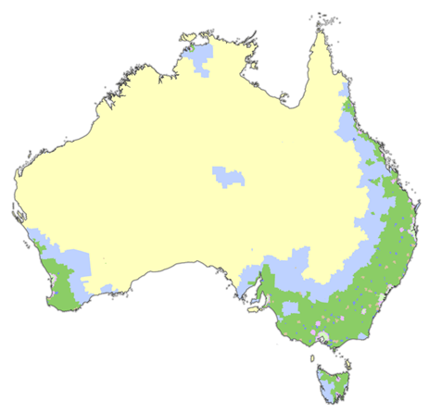MMM 2023 was implemented by Services Australia on 13 April 2025 for health workforce programs. Implementation for the purposes of aged care programs will begin from 1 October 2025.

|  | MM1 | Metropolitan |
| --- | --- | --- |
| MM2 | Regional centres |
| MM3 | Large rural towns |
| MM4 | Medium rural towns |
| MM5 | Small rural towns |
| MM6 | Remote communities |
| MM7 | Very remote communities |
|  |  |

| Modified Monash  Category (MMM 2023) | Description (including the Australian Statistical Geography Standard –  Remoteness Area (2021) |
| --- | --- |
| MM 1 | **Metropolitan areas:** Major cities accounting for 70% of Australia’s population  All areas categorised ASGS-RA1. |
| MM 2 | **Regional centres:** Inner (ASGS-RA 2) and Outer Regional (ASGS-RA 3) areas that are in, or within a 20km drive of a town with over 50,000 residents.  For example: Ballarat, Mackay, Toowoomba, Kiama, Albury, Bunbury. |
| MM 3 | **Large rural towns:** Inner (ASGS-RA 2) and Outer Regional (ASGS-RA 3) areas that are not MM 2 and are in, or within a 15km drive of a town between 15,000 to 50,000 residents. For example: Dubbo, Lismore, Yeppoon, Busselton. |
| MM 4 | **Medium rural towns:** Inner (ASGS-RA 2) and Outer Regional (ASGS-RA 3) areas that are not MM 2 or MM 3, and are in, or within a 10km drive of a town with between 5,000 to 15,000 residents. For example: Port Augusta, Charters Towers, Moree. |
| MM 5 | **Small rural towns:** All remaining Inner (ASGS-RA 2) and Outer Regional  (ASGS-RA 3) areas. For example: Mount Buller, Moruya, Renmark, Condamine. |
| MM 6 | **Remote communities:** Remote mainland areas (ASGS-RA 4) AND remote islands less than 5kms offshore. For example: Cape Tribulation, Lightning Ridge, Alice Springs, Mallacoota, Port Hedland. Additionally, islands that have an MM 5 classification with a population of less than 1,000 without bridges to the mainland will now be classified as MM 6 for example: Bruny Island. |
| MM 7 | **Very remote communities:** Very remote areas (ASGS-RA 5). For example: Longreach, Coober Pedy, Thursday Island and all other remote island areas more than 5kms offshore. |

MMM 2023 classifications throughout Australia can be viewed on the [Health Workforce Locator](http://www.health.gov.au/resources/apps-and-tools/health-workforce-locator/app).