

July 2025

Integrated Care and Commissioning initiative

The Australian Government is undertaking the Integrated Care and Commissioning initiative to respond to community identified needs and help build a sustainable care and support sector.

The initiative brings together resources in health, aged care, disability, and veterans’ care to better support and coordinate services in rural, remote and First Nations communities.

Many Australians in rural and remote locations do not have access to adequate care and Support. This includes First Nations communities, where access to culturally safe care and services is limited.

Mainstream approaches are not working for these markets. Instead, more collaborative, community-driven solutions across the care and support sector are needed.

# About the Integrated Care and Commissioning initiative

The Integrated Care and Commissioning initiative will support communities to:

* identify what better access to care looks like for them
* design sustainable solutions
* tailor care and support activities to local community needs.

Trials will run in up to 10 locations in communities that face a shortage of care and support services.

The goal of the initiative is to enable communities to identify what better access to care looks like for them and what activities they need to get there.

The project is flexible in nature. Activities will differ across sites and be tailored to local needs, in consultation with community stakeholders.

The initiative is being jointly delivered by:

* Department of Health, Disability and Ageing (DHDA)
* National Disability Insurance Agency (NDIA)
* Department of Veterans’ Affairs (DVA). The initiative is supported by:
* National Indigenous Australians Agency (NIAA)
* Australian state, territory and local governments.

# Trial site locations

The Integrated Care and Commissioning trial sites have started in:

* Kimberley, Western Australia
* Central West Queensland
* South-Eastern New South Wales
* Gippsland, Victoria
* Port Augusta/Whyalla, South Australia

**Kimberley, WA**

Broome

Derby-West Kimberley Halls Creek

Wyndham-East Kimberley

**South Australia** Port Augusta Whyalla

**Gippsland, VIC**

Bass Coast Baw Baw

East Gippsland Latrobe

**Central West Queensland** Barcaldine Barcoo Blackall Tambo Boulia Diamantina Longreach Winton

**South- Eastern NSW** Bega Valley Eurobodalla

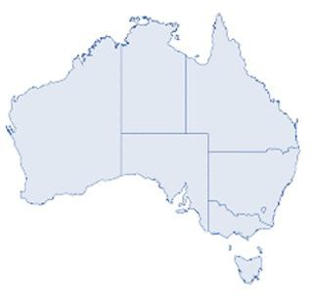

* Northern Tasmania

South Gippsland

Wellington

**Northern Tasmania**

Snowy Monaro

# The Integrated Care and Commissioning approach will help to:

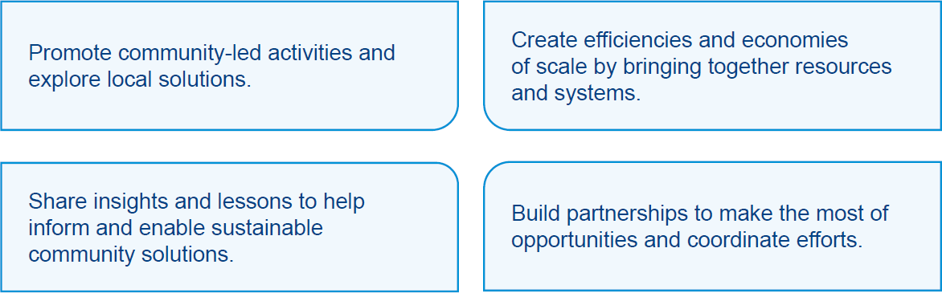

**Areas of focus**

Based on earlier consultation with communities, areas of focus for activities could include:

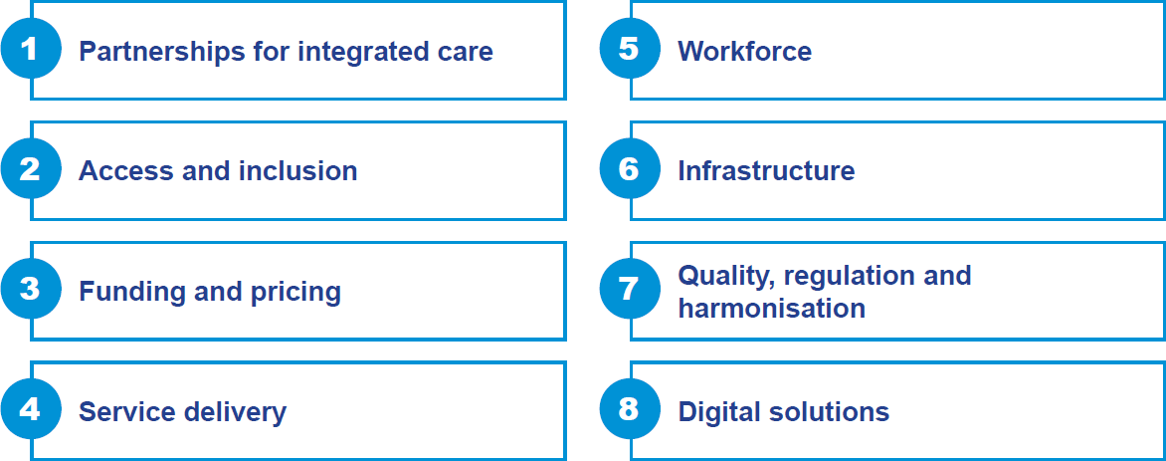

For more information:

Visit [**health.gov.au/our-work/integrated-care-and-commissioning-initiative**](https://health.gov.au/our-work/integrated-care-and-commissioning-initiative)

Email [**IntegratedCareCommi@health.gov.au**](mailto:IntegratedCareCommi@health.gov.au)