

GUIDE TO TOBACCO PACKAGING REQUIREMENTS
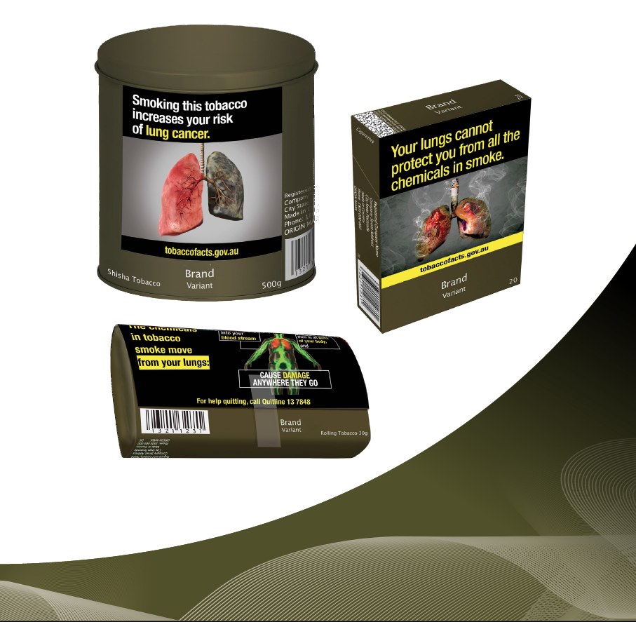

ISBN: 978-1-76007-449-4
Online ISBN: 978-1-76007-450-0
Copyright
© 2025 Commonwealth of Australia as represented by the Department of Health, Disability and Ageing
This work is copyright. You may copy, print, download, display and reproduce the whole or part of this work in unaltered form for your own personal use or, if you are part of an organisation, for internal use within your organisation, but only if you or your organisation:
(a) do not use the copy or reproduction for any commercial purpose; and
(b) retain this copyright notice and all disclaimer notices as part of that copy or reproduction.
Apart from rights as permitted by the Copyright Act 1968 (Cth) or allowed by this copyright notice, all other rights are reserved, including (but not limited to) all commercial rights.
Requests and inquiries concerning reproduction and other rights to use are to be sent to the Communication Branch, Department of Health, Disability and Ageing, GPO Box 9848, Canberra ACT 2601, or via e-mail to copyright@health.gov.au.
DISCLAIMER
All manufacturers, packagers, suppliers and retailers (including importers and wholesalers) of tobacco and e-cigarette products should ensure they understand all of the requirements in the Public Health (Tobacco and Other Products) Act 2023 and Public Health (Tobacco and Other Products) Regulations 2024.
This guide does not itemise all of the requirements under the Public Health (Tobacco and Other Products) legislation. The requirements that are not itemised in this guide are not any less important or significant than those that are displayed.
The guide does not provide legal advice and is not to be relied upon as a source of legal advice. It is provided for general information and as such any person reading this guide should rely upon their own judgement and make their own inquiries seeking relevant professional advice.
There are additional requirements under the Commonwealth Public Health (Tobacco and Other Products) legislation for tobacco products and packaging. Anyone who possesses, manufactures, packages, purchases, sells or supplies (including import, wholesale and retail), tobacco products or tobacco product accessories in Australia, must ensure they comply with these requirements. There are some limited exceptions for personal use or export out of Australia of tobacco products and tobacco accessories.
Nothing in this guide should be taken in any way to replace the provisions of the Public Health (Tobacco and Other Products) Act 2023 and Public Health (Tobacco and Other Products) Regulations 2024.
The Department of Health, Disability and Ageing (the department) does not certify compliance with any tobacco legislation. The department does not undertake a review or approval scheme for tobacco packaging and the associated health warnings, tobacco product safety, tobacco advertising, or any other tobacco legislation issues.
For complete requirements refer to the legislation available at http://www.legislation.gov.au.
Contents
Introduction 5
Purpose of the guide 5
Definitions 5
Requirements for tobacco products 6
Standardised mass, volume or number of units in retail packaging 6
Physical requirements – all retail packaging 7
Physical requirements 7
Colour requirements 7
Linings 8
Wrappers 8
Marking requirements 9
Mandatory markings 9
Brand names and variant names 9
Fire risk statement 10
Other 10
Permitted marks 13
Origin mark 13
AQS mark 14
Calibration mark 14
Track and trace identifiers 14
Cigarette packs 15
Additional physical requirements 15
Mandatory markings – Brand names and variant names 16
Cigarette cartons 18
Additional physical requirements 18
Mandatory markings – Brand names and variant names 18
Cigar tubes 21
Additional physical requirements 21
Mandatory markings – Brand names and variant names 21
Retail packaging for cigars, other than a cigar tube 23
Cigar bag – Vertical retail packaging 24
Cigar box – horizontal packaging 26
Little cigar tin – square packaging 28
Large cigar cylinder – vertical packaging 30
Loose processed tobacco 32
Physical Requirements 32
Loose tobacco pouch – horizontal packaging 33
Small tobacco cylinder 36
Other retail packaging 38
Mandatory markings – Brand names or variant names 38
Shisha tobacco cylinder – vertical packaging 38
Shisha tobacco box – horizontal packaging 41
Shisha tobacco foil – horizontal packaging 43
Bidi box – vertical packaging 45
Enforcing the Public Health (Tobacco and Other Products) legislation 46

Introduction

Purpose of the guide
The Australian Government Department of Health, Disability and Ageing (the department) has produced this guide to help the public understand the Commonwealth's Public Health (Tobacco and Other Products) Act 2023 (the Act) and the Public Health (Tobacco and Other Products) Regulations 2024 (the Regulations), specifically the requirements for tobacco packaging. This guide is not intended to comprehensively cover tobacco packaging requirements. The images in this guide are an example of how the tobacco packaging may look.
This guide does not contain all of the tobacco product requirements, or the requirements relating to health warnings, health promotion inserts (HPIs) or advertising and sponsorship. Other guides available include:
Guide to Tobacco Product Requirements
Guide to Health Warnings
Guide to Health Promotion inserts
Guide to Advertising , and Sponsorship Prohibitions
Guide to Online Point-of-Sale Advertising Requirements
All of these resources are available from www.health.gov.au.
You are encouraged to download an up-to-date version of the Act and Regulations from the Federal Register of legislation website (www.legislation.gov.au).

Definitions
‘Public Health (Tobacco and Other Products) legislation' means the Public Health (Tobacco and Other Products) Act 2023 and the Public Health (Tobacco and Other Products) Regulations 2024.
'Tobacco product' means the following designed or intended for human consumption or use:
(a) processed tobacco in any form;
(b) a product that contains tobacco as an ingredient.
'Container' includes (without limitation) any pack, carton, box, tin, packet, bag, pouch, tube or other container.
'Cigar tube' means a tube for packaging a single cigar.
'Cigarette pack' means any container for retail sale in which cigarettes are directly placed.
'Cigarette carton' means any container for retail sale that contains smaller containers in which cigarettes are directly placed.
'Pouch' means primary packaging of a tobacco product that:
(a) is made from flexible material; and
(b) takes the form of a rectangular pocket with a flap that covers the opening.
The definitions used in the Public Health (Tobacco and Other Products) legislation can be viewed in section 8 of the Act, and section 5 of the Regulations. The above definitions are provided to assist in understanding this guide.

Requirements for tobacco products
The Public Health (Tobacco and Other Products) legislation contains requirements for tobacco product packaging, including, but not limited to:
- a requirement that the outer surfaces of retail packaging are coloured drab dark brown (Pantone 448C) in a matt finish
- standardised retail packaging for certain kinds of tobacco products, being cigarettes, cigarette cartons, filtered and little cigars and loose processed tobacco
- a requirement to display health warnings on the outer surfaces of retail packaging
- a requirement for inclusion of on-product health messages on cigarettes that contain a filter
- a requirement to include health promotion inserts in the retail packaging
- restrictions on the marks permitted to appear on retail packaging, including brand and variant names, which must appear in a standard colour, position, font size and style
- restrictions on the size, packaging format and materials used in retail packaging
- restrictions on the use of inserts and onserts, other than those required to be included.
From 1 July 2025, all tobacco products and retail packaging must comply with the requirements in the Public Health (Tobacco and Other Products) legislation.

Standardised mass, volume or number of units in retail packaging
The Public Health (Tobacco and Other Products) legislation requires the mass, volume or number of units in retail packaging to be standardised so that each retail package of tobacco products contains the same nominal quantity as outlined in the table below. This requirement does not apply to shisha tobacco products.
The retail packaging of tobacco products:
Cigarette packs | Cigarette cartons | Filtered and little cigars* | Loose processed tobacco**
Must contain 20 cigarettes.  Must not include any tobacco product accessories. | Must contain 10 cigarette packs.  Must not include any tobacco product accessories. | Must contain 20 cigars.  Must not include any tobacco product accessories. | Must contain 30 grams of loose processed tobacco.  Must not include any tobacco product accessories.
* Little cigar means a cigar no more than 10mm in diameter and 1.4 grams in mass (excluding any mouthpiece).
** Loose processed tobacco includes pipe tobacco.

Physical requirements – all retail packaging
To ensure that tobacco products are not packaged in a way that makes one tobacco product more appealing than another, there are requirements to ensure packaging is of a standard appearance. These requirements place restrictions on the physical packaging's construction, its colours, and the appearance of mandated health warnings.
The requirements also specify the format in which information about the product is printed on the pack, such as the brand and variant, or the details of the Australian business responsible for the manufacture, and other mandatory and permitted markings.

Physical requirements
All retail packaging must:
- be free from embellishments of any sort, including (but not limited to) decorative ridges, etching, embossing, debossing or bulges
- only use glues or other adhesives that are transparent and not coloured
- not have a cut-out area or window that enables the contents of the packaging to be visible from outside
- not contain any voids, spacers, fillers or inserts (other than those permitted or required by the Regulations)
- not include any features designed or intended to change the packaging after retail sale
- not make a noise or contain or produce a smell
- not display any terms that are prohibited under the Public Health (Tobacco and Other Products) legislation.
The primary packaging of non-cigarette tobacco products may include a means for resealing the packaging (such as a tab or press seal) that complies with the requirements in the Regulations.

Colour requirements
The inner and outer surfaces of all primary and secondary packaging must:
All outer surfaces* | All inner surfaces
Be coloured Pantone 448C – a drab dark brown. Have a matt finish. | Be coloured Pantone 448C or white.  For packaging that is made of metal or wood:  Be the natural colour of the metal or wood.** Have a matt finish.
* Except for the health warnings, mandatory markings, and other markings on the packaging permitted by the Regulations. This includes any adhesive labels attached to the packaging in accordance with the Regulations.
** Except for a cigarette pack or cigarette carton which must be made of rigid cardboard.

Linings
The linings (if any) used in the primary packaging of a tobacco product must not:
- be textured, unless: this is necessary for the automated manufacture of the packaging or placing tobacco products in the packaging
- form a pattern, symbol or design or represent, or be suggestive of, the brand name or variant name of the tobacco product
- be capable of being removed from the retail packaging without being damaged.

Wrappers
The plastic or other wrappers that form part of the retail packaging for tobacco products:
- must be transparent and free from colours, marks, textures or embellishments
- if a plastic or other wrapper covers more than one item of primary packaging – may be marked with a solid black rectangle to conceal the bar code on each item covered by the wrapper
- may include one tear strip that complies with the requirements in the Regulations.
Note: Single sale cigars, with or without wrappers, must be packaged into compliant retail packaging (such as a cigar bag or cigar tube) prior to selling, offering for sale or otherwise supplying the product.
The supply of branded cigars and/or branded cigar tubes placed into compliant cigar bags, cigar tube or other compliant packaging is not permitted.
Figure 1: Image of cigar with cigar band in wrapper
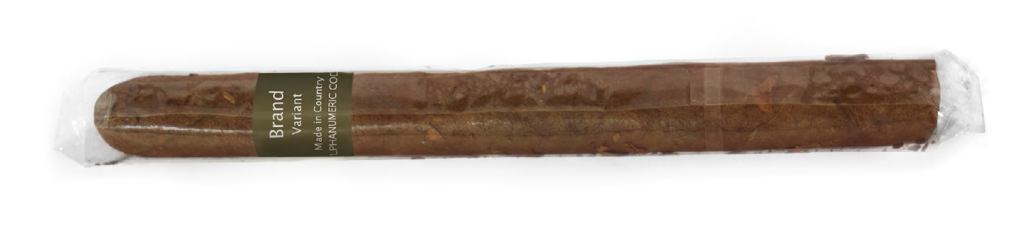
Note:
Any tear strip:
- must be either entirely black or entirely transparent and not coloured.
- must form a single continuous straight line of constant width not wider than 3mm around circumference.
- if a transparent tear strip, may include a single solid black line not more than 15mm long indicating where the tear strip begins.

Marking requirements
There are specific requirements under the Public Health (Tobacco and Other Products) legislation for mandatory and permitted markings on the retail packaging of tobacco products.

Mandatory markings

Brand names and variant names
The Public Health (Tobacco and Other Products) legislation prescribes requirements for the appearance of brand names or variant names on the retail packaging of tobacco products.
Any brand name or variant name that appears on retail packaging:
- must not be or include a prohibited term
- must appear across one line only
- must comply with the orientation and location requirements prescribed by the Regulations
- must be printed:
- in the typeface Lucida Sans, with only the first letter in each word capitalised
- in a normal weighted regular font and in the colour known as Pantone Cool Gray 2C
- using the following dimensions:
Brand name | Variant name
4mm in height | 3mm in height
up to 50mm in width | up to 35mm in width

Fire risk statement
All cigarettes manufactured or imported into Australia are subject to the mandatory standard for reduced fire risk cigarettes. A reduced fire risk cigarette is a cigarette that slows down the rate at which a cigarette burns. The fire risk statement is a statement that declares compliance with that mandatory standard.
All cigarette packs and cigarette cartons must display the following fire risk statement in accordance with the Public Health (Tobacco and Other Products) legislation:
AUSTRALIAN FIRE RISK STANDARD COMPLIANT. USE CARE IN DISPOSAL.
The wrappers used to cover cigarette packs and cigarette cartons may also display a fire risk statement.
The fire risk statement must comply with the text and colour requirements prescribed in the Regulations and:
Cigarette packs | Cigarette cartons | Wrappers
must be placed beneath the health warning displayed on the back outer surface of the pack.  may be printed on an adhesive label that is attached firmly to the pack and the adhesive label is the colour known as Pantone 448C. | must be placed on the back outer surface of the carton.  may be printed on an adhesive label that is attached firmly to the carton and the adhesive label is the colour known as Pantone 448C. | may appear on a wrapper that covers one or more cigarette packs.  if printed on the wrapper, it must be printed in white on a black rectangular background.  may be printed on an adhesive label that is attached firmly to the wrapping and has a background that is black, white or grey.

Other
The primary packaging of all tobacco products (other than single cigars):
- must state the product's country of origin using the format 'Made in [Country]'
- must display an alphanumeric code representing the date on which the product was packaged
- must be marked with a statement of the measurement of the product
- must be marked with a trade description
- must display a rectangular bar code
- must display the name and address of the entity in Australia who packaged the product (or on whose behalf it was packaged)
- must display an Australian telephone number for the entity in Australia who packaged the product (or on whose behalf it was packaged).
- The secondary packaging of all tobacco products (other than single cigars):
- may be marked with a country of origin statement
- must be marked with a measurement mark
- must be marked with a trade description
- may display a rectangular bar code
- must display the name and address of the entity in Australia who packaged the product (or on whose behalf it was packaged)
- may display an Australian telephone number for the entity in Australia who packaged the product (or on whose behalf it was packaged).

Country of origin statement / Manufacturer's date mark
The primary packaging of a tobacco product must state the product's country of origin, specifically using the 'Made in [Country]' format. 'Product of [Country]' or other descriptors of the product are not permitted to be used. For example, 'Made in Cuba' is permitted, 'Product of Cuba', or 'Made in Cuba from premium tobacco' are not permitted.
The secondary packaging of a tobacco product may include a country of origin statement.
The country of origin statement and manufacturer's date mark displayed on retail packaging must comply with the size, printing and orientation requirements prescribed in the Regulations and:
Cigarette packs and cartons | Other retail packaging
must appear only once on the retail packaging.  must not appear on the same side outer surface as the health warning. | must appear only once on the retail packaging.
The primary packaging of a tobacco product must indicate the date on which the product was packaged by using an alphanumeric code in the specified format. The format requires a 2-character code where the letter represents the month of packaging ('A' represents January, 'B' represents February, etc.) and the number represents a year of packaging ('0' represents a year ending in 0, '1' represents a year ending in 1, etc.). For example, April 2025 is represented by the manufacturer's date mark 'D5'. Additional digits, such as 'D25' to represent April 2025 are not permitted.

Measurement marks / Trade descriptions
A 'measurement mark' is the marking that states the measurement of the goods in package, such as the weight, volume, or number of products, i.e. 30 grams, or 20 units.
Before measurement marks are applied to packaging, consideration of the requirements of the National Measurement Act 1960 and the National Trade Measurement Regulations 2009 should be completed. For more information on the use of measurement marks, contact the National Measurement Institute's Trade Measurement Services helpline on 1300 686 664, or infotm@measurement.gov.au.
A trade description is a description or statement that provides a true description of the goods within the package, such as 'cigarettes' or 'rolling tobacco'.
The primary and secondary packaging of a tobacco product must include the measurement mark and trade description.
The measurement marks and trade descriptions required to be displayed on retail packaging must comply with the size, printing and orientation requirements prescribed in the Regulations and:
Cigarette packs and cartons | Other tobacco products | Wrappers that cover more than one item of primary packaging
for measurement marks – must appear once on the front outer surface of the pack or carton and may appear once on either the top or the bottom outer surfaces of the pack or carton.  for trade descriptions – must appear once on the side outer surface of the pack or carton on which a health warning is not displayed. | for measurement marks – must appear once on an outer surface of the packaging and may appear on no more than 2 outer surfaces.  for trade descriptions – must appear once on an outer surface of the packaging. | may be included on the wrapper and if so, must be printed in white on a black rectangular background.

Bar code
A bar code is a mark containing information about a product in the form of a series of numbers and bars of varying thickness designed to be read by an optical scanner. A QR code is not a bar code and is not a permitted mark. The bar code must not form a symbol or design or represent or be suggestive of the brand name or variant name (if any) of the tobacco product.
The primary packaging of a tobacco product must display a bar code. The secondary packaging of a tobacco product may display a bar code.
The bar code displayed on retail packaging must comply with the shape, colour and design requirements prescribed in the Regulations and:
Cigarette packs and cartons | Other tobacco products | Wrappers covering more than one item of primary packaging
must appear only once on the packaging.  must not appear on the same side outer surface as the health warning. | must appear only once on the packaging. | may be included on the wrapper and if so, must appear only once on the packaging.  may be included on an adhesive label attached firmly to the wrapper or be printed on the wrapper.

Name and address
The primary and secondary packaging of a tobacco product must display the name and address of the entity in Australia who packaged the product or on whose behalf it was packaged.
The name of the entity in Australia who packaged the product, or on whose behalf it was packaged must be the business name in which the entity is registered under the Business Name Registration Act 2011, or the company name registered under the Corporations Act 2001.
The address of the entity in Australia who packaged the product, or on whose behalf it was packaged must be the entity's principal place of business, as registered to the entity under the Business Name Registration Act 2011, or under the Corporations Act 2001. The name and address required to be displayed on retail packaging must comply with the printing requirements prescribed in the Regulations and:
Cigarette packs and cartons | Other tobacco products
must appear on only one side outer surface of the pack or carton, and only once on that surface.  must not appear on the same side outer surface as the health warning. | must appear on only one outer surface of the retail packaging, and only once on that surface.
The requirements in the Public Health (Tobacco and Other Products) legislation apply in addition to any requirements of Regulation 4.7 of the National Trade Measurement Regulations 2009.

Consumer contact telephone number
The primary packaging of a tobacco product must display the consumer contact telephone number for the entity in Australia who packaged the product or on whose behalf it was packaged. The secondary packaging of the tobacco product may display such a consumer contact telephone number.
The consumer contact number displayed on retail packaging must comply with the printing and design requirements prescribed in the Regulations and:
Cigarette packs | Retail packaging of other tobacco products
must be an Australian telephone number that is in service. | must be an Australian telephone number that is in service.
must appear only once on the packaging. | must appear only once on the packaging.
must consist of numerals or any combination of numerals, hyphens and brackets. | must consist of numerals or any combination of numerals, hyphens and brackets.
must be prefaced with the abbreviation 'Phone:' or 'Ph:'. | must be prefaced with the abbreviation 'Phone:' or 'Ph:'.
must appear on the side outer surface of the pack that does not display a health warning. | must appear on the same surface as the name and address.
must not form a symbol or design or represent or be suggestive of the brand name or variant name (if any) of the tobacco product. | must not form a symbol or design or represent or be suggestive of the brand name or variant name (if any) of the tobacco product.

Permitted marks
The following marks are permitted to appear on the primary packaging, and the secondary packaging, of a tobacco product:
Primary packaging | Secondary packaging | Wrappers
An origin mark.  An AQS mark.  One or more calibration marks.  A primary packaging track and trace identifier. | An origin mark.  An AQS mark.  One or more calibration marks.  A secondary packaging track and trace identifier. | An origin mark.  One or more calibration marks.  A bar code.  One or more marks to conceal bar codes.

Origin mark
The retail packaging of a tobacco product is permitted to include an origin mark. An origin mark is used to determine the origin of the tobacco product, in the same manner as a batch number may be used.
The origin mark must be either an alphanumeric code or a covert mark that is not visible to the naked eye.
The origin mark may be printed (either in white, or black with a white background) or applied by etching or debossing (in the colour Pantone 448C if it is an alphanumeric code), on the retail packaging.
If the origin mark is an alphanumeric code, it:
Cigarette packs and cartons | Retail packaging of other tobacco products
must comply with the text and printing requirements in the Regulations.  must appear only once on the retail packaging.  must appear on either:  - the side outer surface that does not contain a health warning; or  - the bottom outer surface of the pack or carton.  must not form a symbol or design, or represent or be suggestive of the brand name or variant name (if any) of the tobacco product. | must comply with the text and printing requirements in the Regulations.  must appear only once on the retail packaging.  must not form a symbol or design, or represent or be suggestive of the brand name or variant name (if any) of the tobacco product.

AQS mark
The Average Quantity System (AQS) is an internationally agreed method of determining the size or quantity of pre-packed articles with a 'constant nominal content'. This means it provides confirmation of the measurement or quantity of goods in the package, being sold by measure.
The AQS mark must appear only as is necessary to indicate that the product is packaged in accordance with the AQS requirements under the National Measurement Act 1960 (Cth).
The AQS mark must be no larger than 3mm in size and coloured Pantone Cool Grey 2C. It must be printed directly adjacent to the measurement mark that is required to be displayed on the tobacco product.
Before AQS marks on packaging are used consideration of the requirements of the National Measurement Act 1960 should be completed. For more information on using the AQS method when packaging products, contact the National Measurement Institute's Trade Measurement Services helpline on 1300 686 664, or infotm@measurement.gov.au.

Calibration mark
A calibration mark is a mark used only for the purpose of the automated manufacture of the retail packaging of tobacco products, such as a mark used for the calibration of printer colours in the manufacture of retail packaging.
The calibration mark must appear only as is necessary for the automated manufacture of the packaging and (if visible or detectable on the packaging) must be as inconspicuous as possible.

Track and trace identifiers
Track and trace identifiers are used by relevant authorities to determine where a tobacco product was produced and to follow it through to its point of sale. Track and trace identifiers are required by European Union law to appear on tobacco products that are grown, manufactured, distributed, or otherwise transhipped throughout the European Union.
The track and trace requirements are not required by Australian law, however the Public Health (Tobacco and Other Products) legislation permit such marks to appear on tobacco product packaging to allow companies to comply with European Union laws. Any other type of track and trace mark is not permitted.
The primary packaging track and trace identifier that may be displayed on retail packaging:
Cigarette packs | Primary packaging (other than cigarette packs)
must appear only once on the cigarette pack.  must, where it is an alphanumeric code or a machine-readable code, be printed in black, white or grey.  must appear on one of the following surfaces only:  - the side outer surface that does not display a health warning.  - the bottom outer surface.  - the top outer surface.  - must be printed on a Pantone 448C background. | must appear only once on the packaging.  must, where it is an alphanumeric code or a machine-readable code, be printed in black, white or grey.  may appear on the outer surface on which a health warning is displayed.  must be printed on the packaging or included on an adhesive label attached firmly to the packaging.  if printed on the packaging—must be printed on a Pantone 448C background.
The secondary packaging track and trace identifier that may be displayed on retail packaging:
Cigarette packs and cartons | Other tobacco products
must appear only once on the carton, on a side outer surface without a health warning.  must be printed on the carton or included on an adhesive label attached firmly to the carton.  must be coloured black, white or grey.  must be printed on a Pantone 448C background. | must appear only once on the packaging.  may appear on the outer surface on which a health warning is displayed.  must be printed on the packaging or included on an adhesive label attached firmly to the packaging.  must be coloured black, white or grey if printed on the packaging—must be printed on a Pantone 448C background.
If either the primary or secondary packaging track and trace identifier is an alphanumeric code, it must be printed in an English sans serif typeface in a normal weighted regular font.

Cigarette packs

Additional physical requirements
All cigarette packs:
- must contain 20 cigarettes that are of equal dimensions
- must be made of rigid cardboard, with the only opening being a flip-top lid hinged at the back
- must have rectangular outer surfaces which meet at 90-degree angles when the pack is closed
- must have rigid, straight edges that are not rounded, bevelled, shaped or embellished in any way
- must be of the following dimensions (when the flip top lid is closed):
Height | Width | Depth
At least 85mm but not more than 90mm | At least 55mm but not more than 60mm | At least 20mm but not more than 24mm
- may have an inside lip with rounded corners
- may include a lining. The lining, if included, must be made of silver coloured foil with a white paper backing and must have a matt finish.

Mandatory markings – Brand names and variant names
Any brand name or variant name that appears on a cigarette pack:
- must not obscure any health warning or mandatory marking
- may only appear on the front, top and bottom outer surfaces of the pack (and must not appear more than once on each surface).
Figure 2: Image of front, side and top of cigarette pack
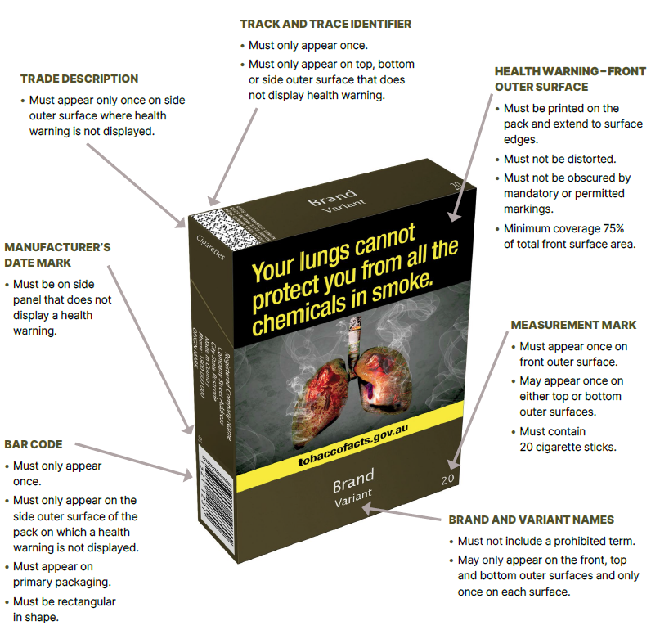
Note: Mandatory markings are required to be no larger than 3mm; in Lucinda Sans font and in Pantone Cool Gray 2C (except for bar codes). Some examples include:
- registered company name and address
- a country of origin statement
- consumer contact phone number within Australia, and
- manufacturer's date mark (to be specified 2-character format i.e. D5).
Figure 3: Image of back, side and bottom of cigarette pack

Note: There are font type, text colour and size requirements for specific permitted markings. Some examples of permitted markings include:
- origin mark
- AQS marks, and
- calibration marks.

Cigarette cartons

Additional physical requirements
All cigarette cartons:
- must be made of rigid cardboard and contain 10 cigarette packs
- must have rectangular outer surfaces which meet at 90-degree angles when the carton is closed
- must have rigid, straight edges that are not rounded, bevelled, shaped or embellished in any way
- may include a perforated strip (used for opening the carton) that leaves serrations on the edge of a surface of the carton when it is opened
- may include a lining that complies with the requirements in the Public Health (Tobacco and Other Products) legislation.

Mandatory markings – Brand names and variant names
Any brand name or variant name that appears on a cigarette carton:
- must not obscure any health warning or mandatory marking
- may only appear on the front outer surface of the carton and the two smallest outer surfaces of the carton (and must not appear more than once on each surface).
Figure 4: Image of front, side and top of cigarette carton
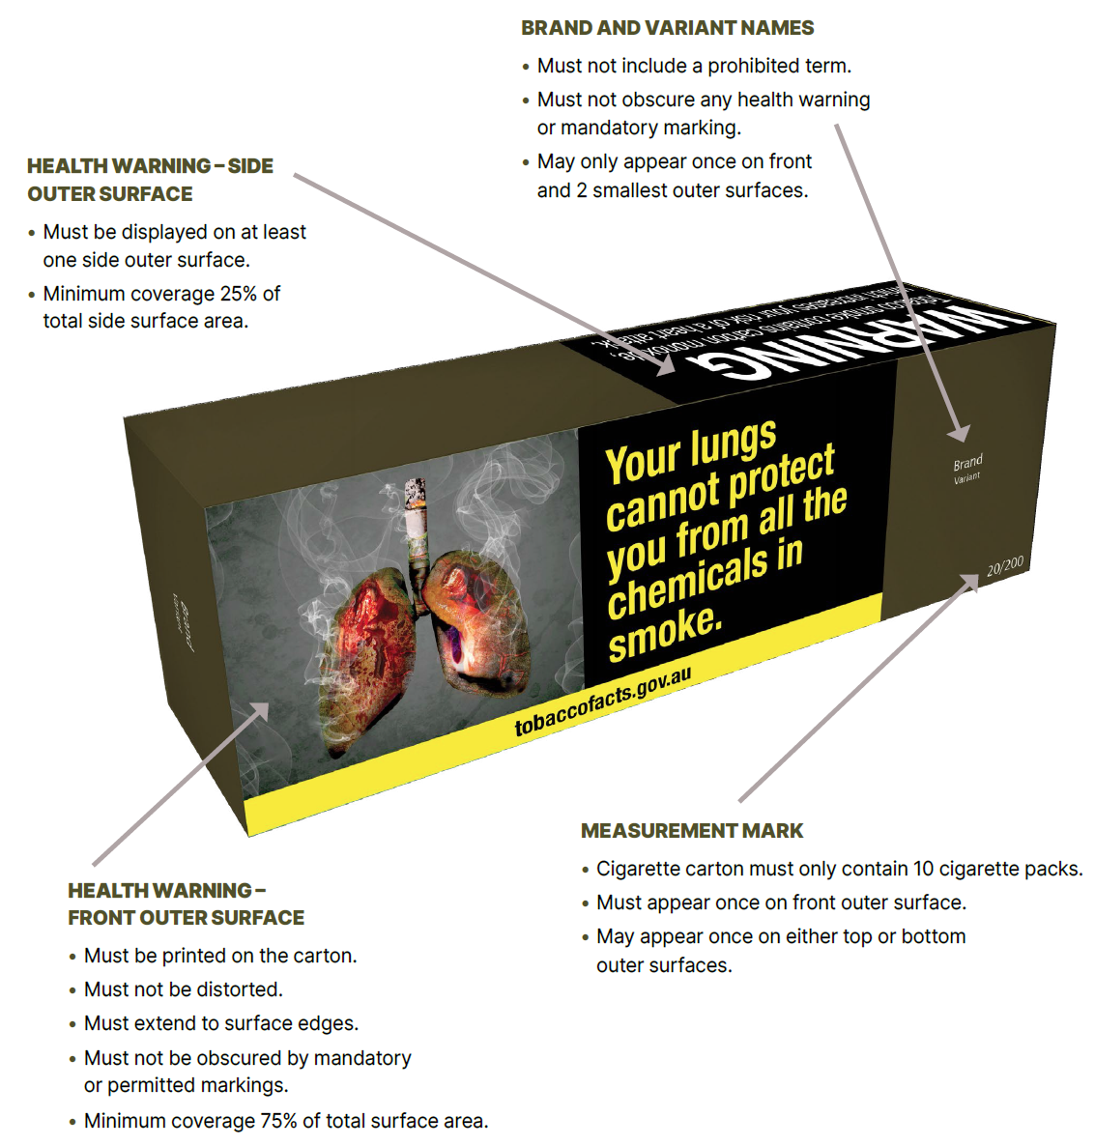
Note:
There are font type, text colour and size requirements for specific permitted markings. Some examples of permitted markings include:
- origin mark
- AQS marks
- calibration marks.
Figure 5: Image of back, side and bottom of cigarette carton
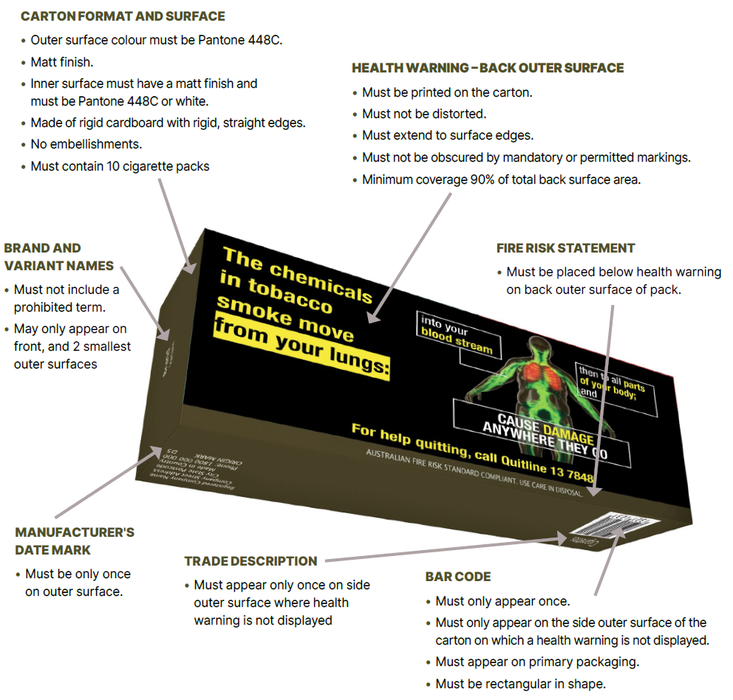
Note:
Mandatory markings are required to be no larger than 3mm; in Lucinda Sans font and in Pantone Cool Gray 2C (except for bar codes). Some examples include:
- registered company name and address
- a country of origin statement
- consumer contact phone number within Australia
- manufacturer's date mark (to be specified 2-character format i.e. D5).

Cigar tubes

Additional physical requirements
All cigar tubes:
- must be cylindrical, rigid and have an opening that is at least 15mm in diameter
- may have tapered or rounded ends.

Mandatory markings – Brand names and variant names
Any brand name or variant name that appears on a cigar tube:
- must appear only once on the cigar tube
- may be printed on an adhesive label attached to the cigar tube, provided the adhesive label is:
coloured Pantone 448C
no larger than is reasonably necessary to print the brand name and/or variant name
attached firmly to the cigar tube so that it cannot be easily removed.
If multiple cigars are purchased by a retailer for individual resale and they are in non compliant packaging (such as an original-coloured tube), the cigar tube and any non compliant cigar bands must be removed prior to being placed in retail packaging that complies with the tobacco product requirements.
Figure 6: Image of front of cigar tube
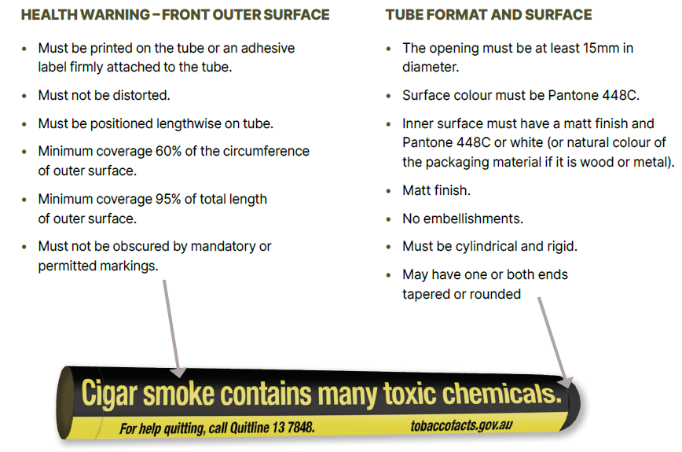
Note:
There are font type, text colour and size requirements for specific permitted markings. Some examples of permitted markings include:
- origin mark
- AQS marks
- calibration marks.
These markings are not required for a single cigar, if packaged by a tobacco product retailer.
Figure 7: Image of back of cigar tube
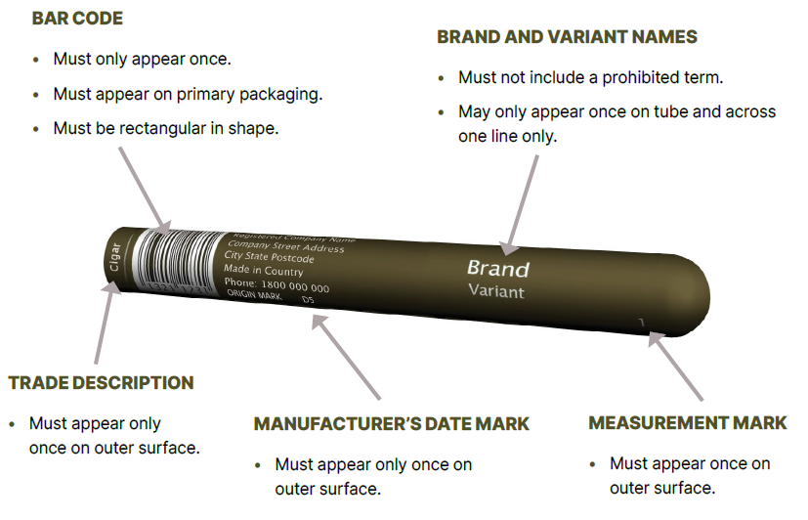
Note:
Mandatory markings are required to be no larger than 3mm; in Lucinda Sans font and in Pantone Cool Gray 2C (except for bar codes). Some examples include:
- registered company name and address
- a country of origin statement
- consumer contact phone number within Australia
- manufacturer's date mark (to be specified 2-character format i.e. D5)

Retail packaging for cigars, other than a cigar tube
Note:
There are font type, text colour and size requirements for specific permitted markings. Some examples of permitted markings include:
- origin mark
- AQS marks
- calibration marks.

Cigar bag – Vertical retail packaging
Figure 8: Image of front of cigar bag
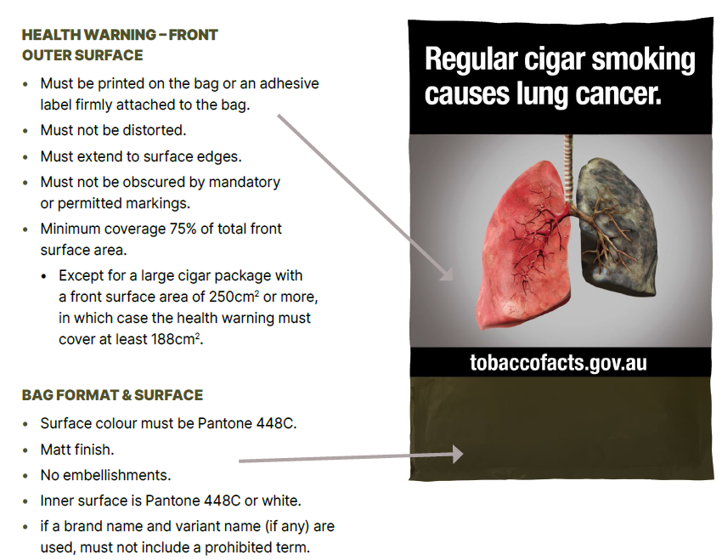
Figure 9: Image of back of cigar bag
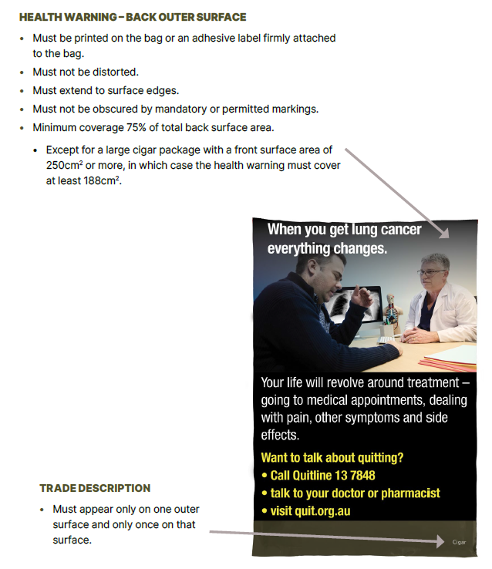

Cigar box – horizontal packaging
Figure 10: Image of front, side and top of cigar box
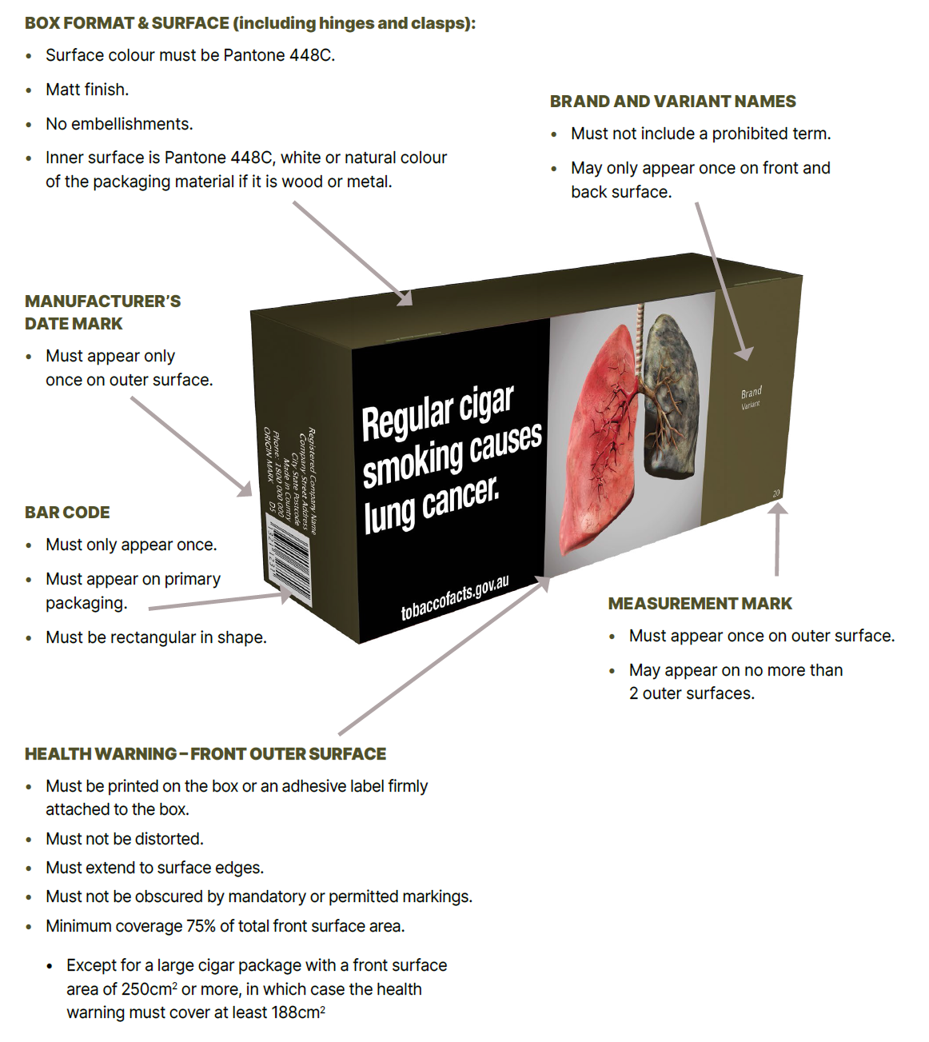
Note:
Mandatory markings are required to be no larger than 3mm; in Lucinda Sans font and in Pantone Cool Gray 2C (except for bar codes). Some examples include:
- registered company name and address
- a country of origin statement
- consumer contact phone number within Australia
- manufacturer’s date mark (to be specified 2-character format i.e. D5).
Figure 11: Image of back, side and bottom of cigar box
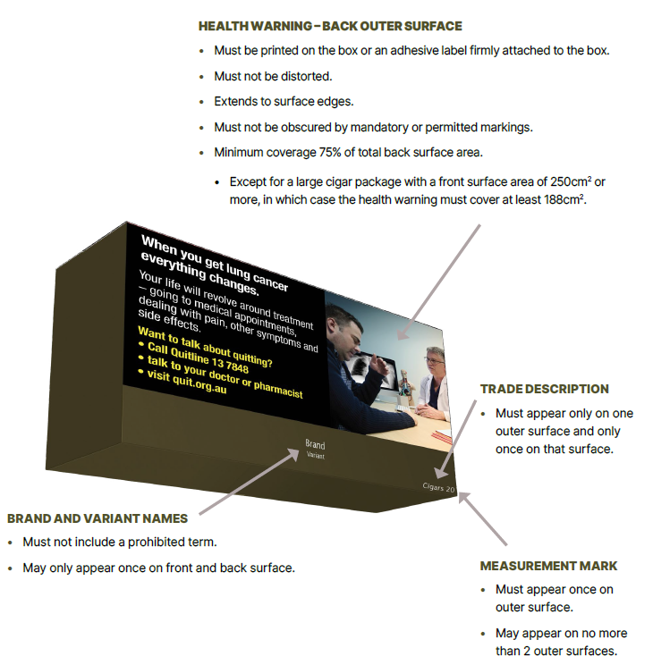
Note:
There are font type, text colour and size requirements for specific permitted markings. Some examples of permitted markings include:
- origin mark
- AQS marks
- calibration marks.

Little cigar tin – square packaging
Figure 12: Image of front, side and top of little cigar tin
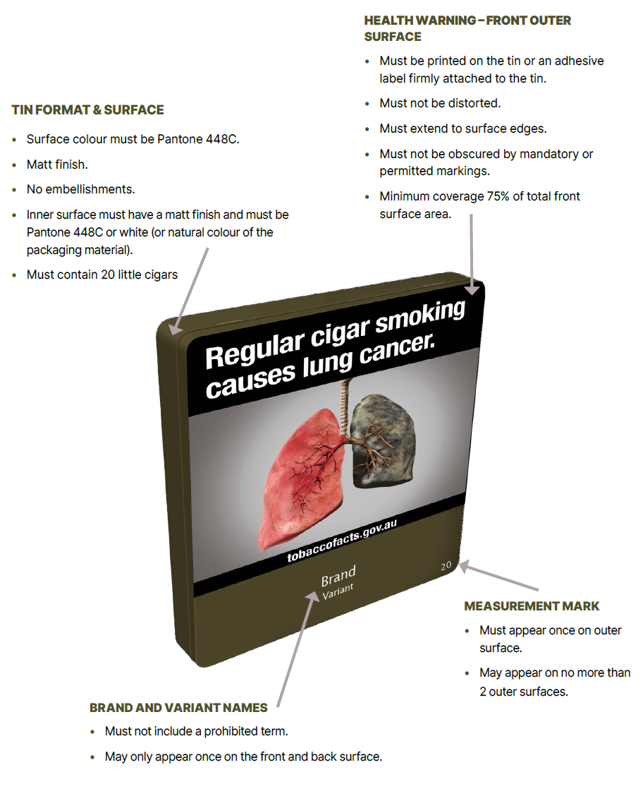
Note:
There are font type, text colour and size requirements for specific permitted markings. Some examples of permitted markings include:
- origin mark
- AQS marks
- calibration marks.
Figure 13: Image of back, side and bottom of little cigar tin
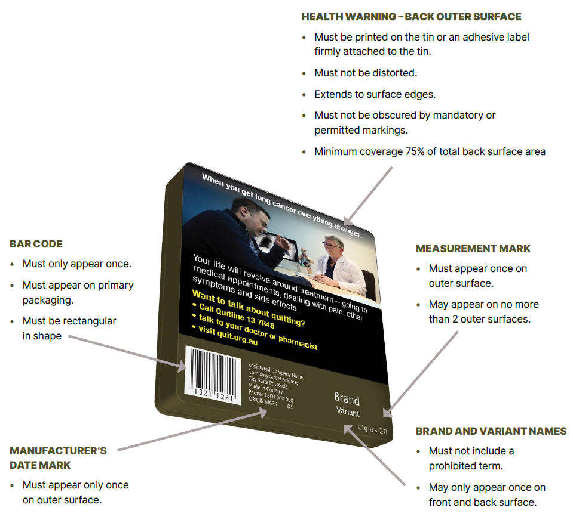
Note:
Mandatory markings are required to be no larger than 3mm; in Lucinda Sans font and in Pantone Cool Gray 2C (except for bar codes). Some examples include:
- registered company name and address
- a country of origin statement
- consumer contact phone number within Australia
- manufacturer's date mark (to be specified 2-character format i.e. D5).

Large cigar cylinder – vertical packaging
Figure 14: Image of front and top of large cigar cylinder
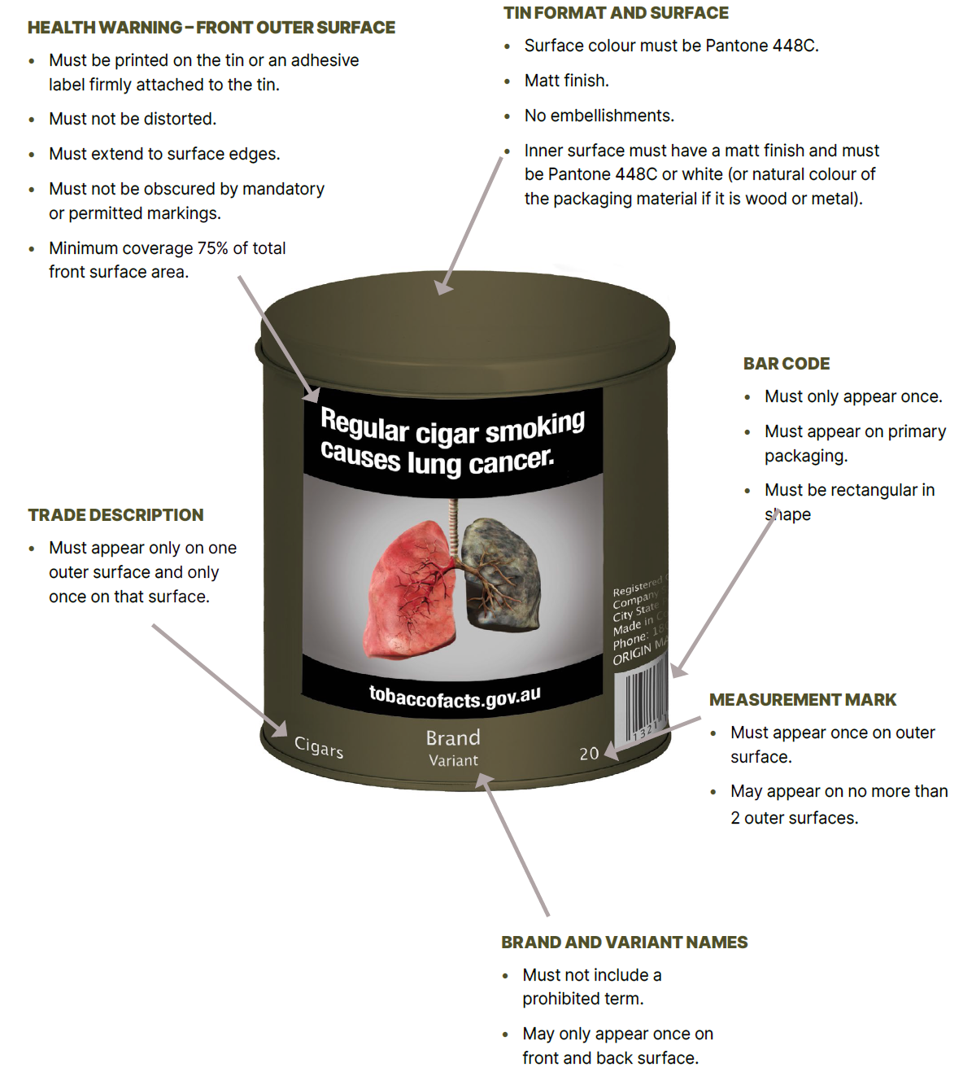
Note:
There are font type, text colour and size requirements for specific permitted markings. Some examples of permitted markings include:
- origin mark
- AQS marks
- calibration marks.
Figure 15: Image of back and top of large cigar cylinder
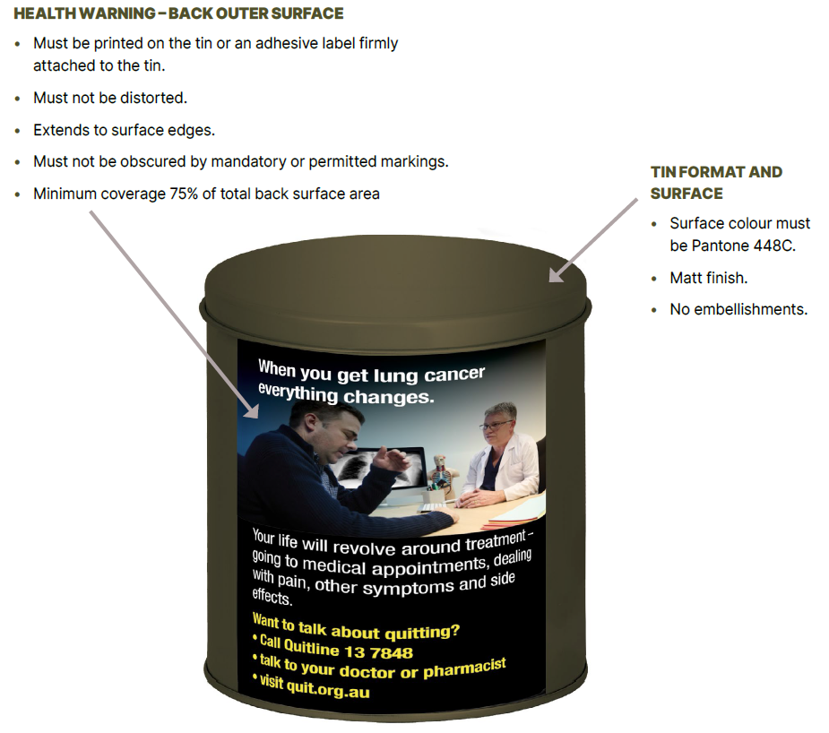
Note:
Mandatory markings are required to be no larger than 3mm; in Lucinda Sans font and in Pantone Cool Gray 2C (except for bar codes). Some examples include:
- registered company name and address
- a country of origin statement
- consumer contact phone number within Australia
- manufacturer's date mark (to be specified 2-character format i.e. D5).

Loose processed tobacco

Physical Requirements
The primary packaging of loose processed tobacco (including pipe tobacco) must be one of:
- a pouch
- a small cylinder
- a large cylinder.
The dimensions for the primary packaging of loose processed tobacco must comply with the following requirements:
- The largest dimension of the primary packaging must be at least 85mm
- The second largest dimension of the packaging must be at least 55mm.

Loose tobacco pouch – horizontal packaging
Figure 16: Image of front of loose tobacco pouch
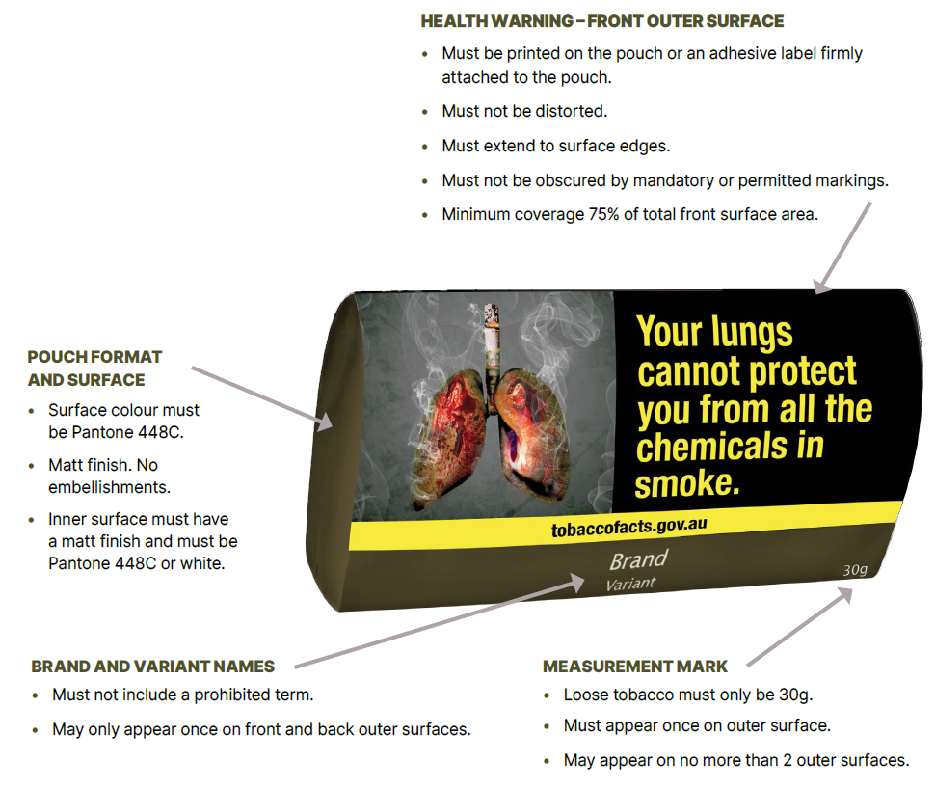
Note:
There are font type, text colour and size requirements for specific permitted markings. Some examples of permitted markings include:
- origin mark
- AQS marks
- calibration marks.

Figure 17: Image of back of loose tobacco pouch
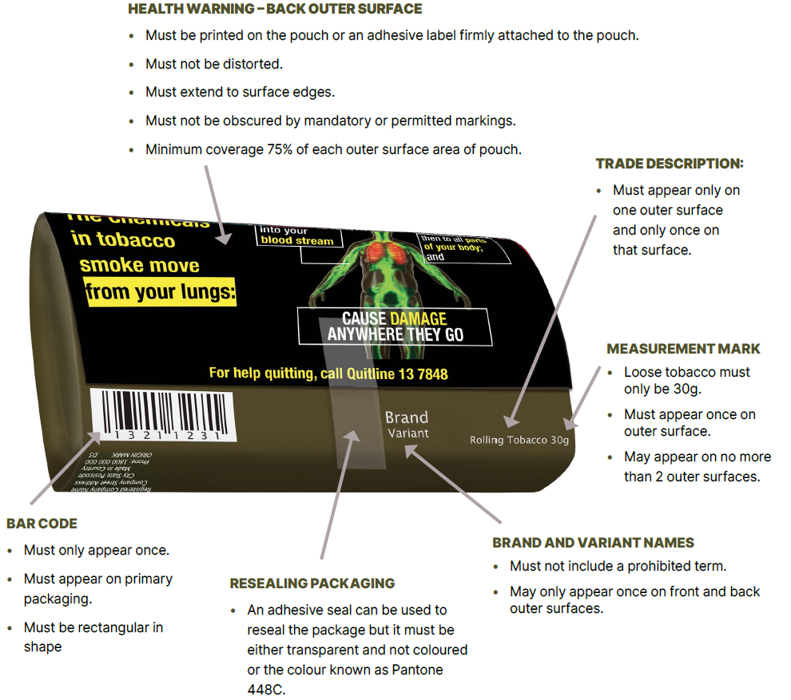
Note:
Mandatory markings are required to be no larger than 3mm; in Lucinda Sans font and in Pantone Cool Gray 2C (except for bar codes). Some examples include:
- registered company name and address
- a country of origin statement
- consumer contact phone number within Australia
- manufacturer's date mark (to be specified 2-character format i.e. D5).

Figure 18: Image of open pouch of loose tobacco showing health promotion insert being placed inside pouch
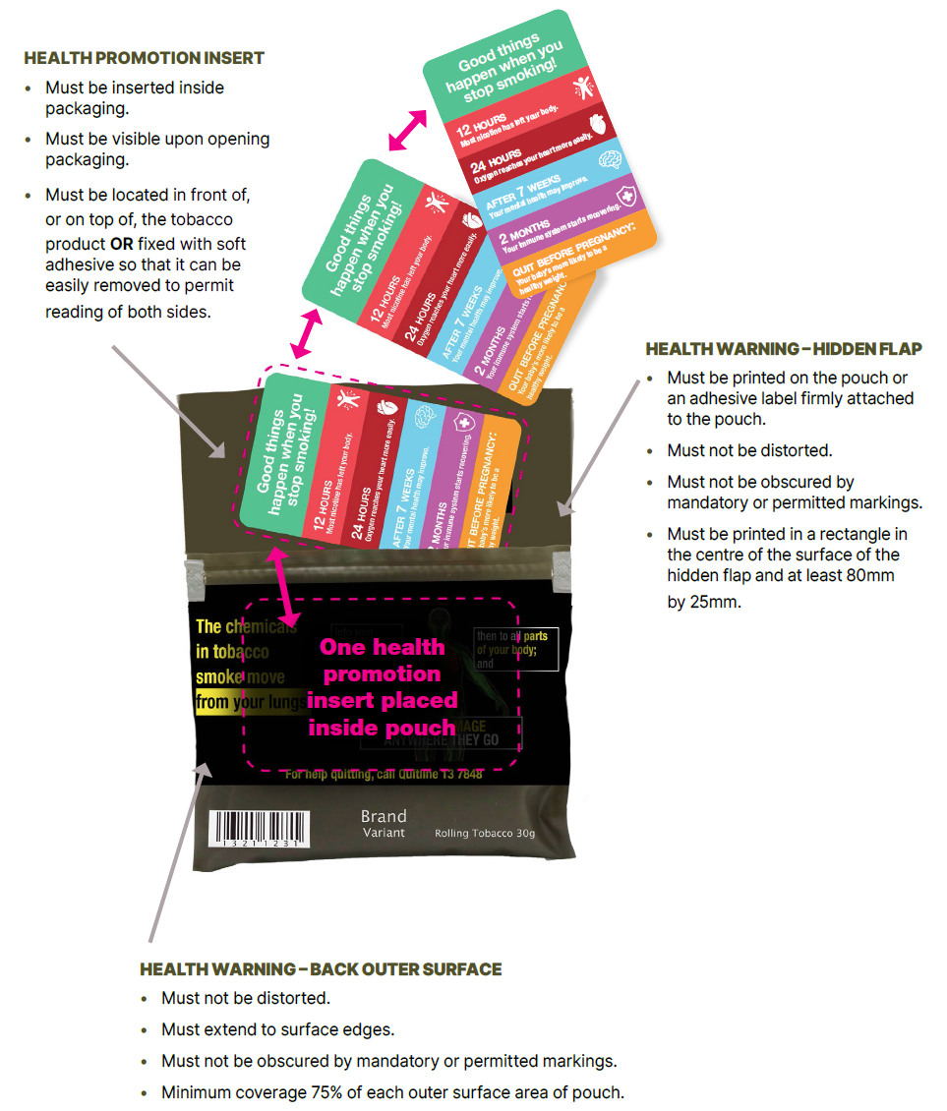

Small tobacco cylinder
Figure 19: Image of front and top of small tobacco cylinder
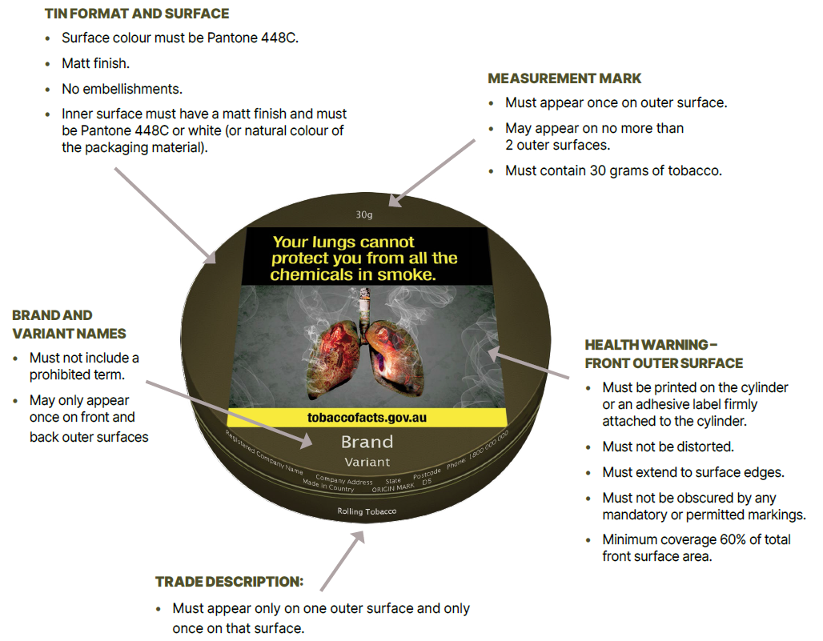
Note:
Mandatory markings are required to be no larger than 3mm; in Lucinda Sans font and in Pantone Cool Gray 2C (except for bar codes). Some examples include:
- registered company name and address
- a country of origin statement
- consumer contact phone number within Australia
- manufacturer's date mark (to be specified 2-character format i.e. D5).

Figure 20: Image of back and bottom of small tobacco cylinder
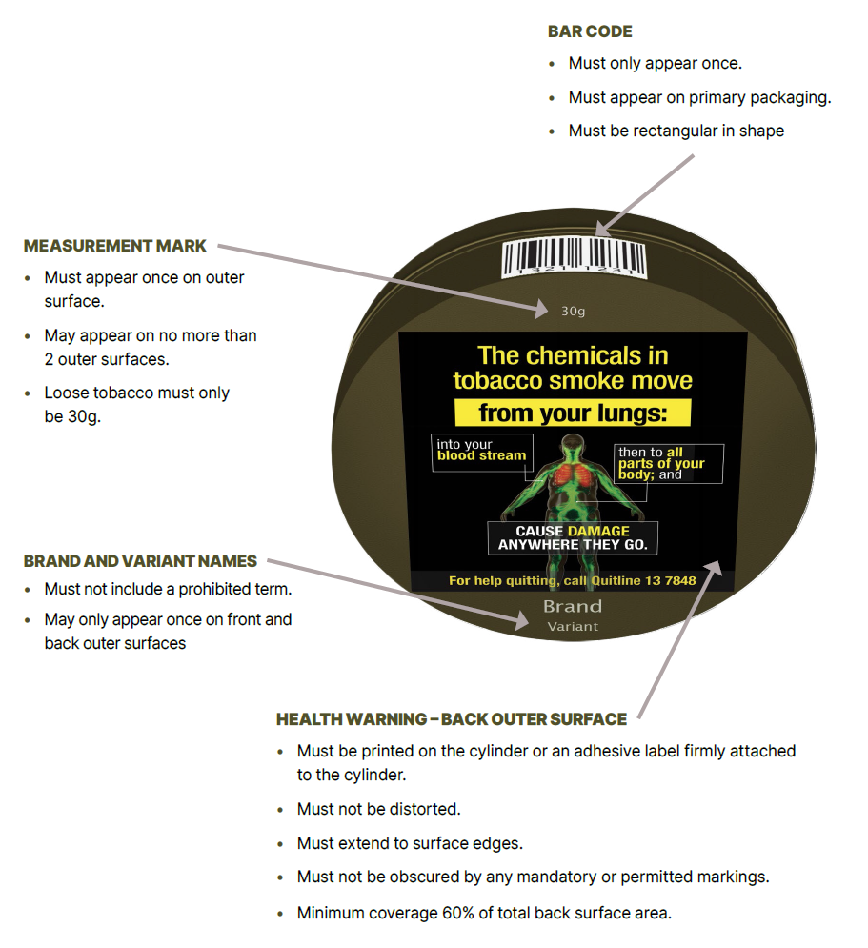
Note:
There are font type, text colour and size requirements for specific permitted markings. Some examples of permitted markings include:
- origin mark
- AQS marks
- calibration marks.

Other retail packaging
The dimensions for the primary packaging of all other tobacco products (including but not limited to shisha tobacco) must comply with the following requirements:
- the largest dimension of the primary packaging must be at least 85mm
- the second largest dimension of the packaging must be at least 55mm.

Mandatory markings – Brand names or variant names
Any brand name or variant name that appears on retail packaging that is not a cigarette pack, cigarette carton or cigar tube may only appear on the front outer surface and back outer surface of the packaging (and must not appear more than once on each surface).
For retail packaging of tobacco products other than a cigarette pack, cigarette carton or certain plastic wrappers, any brand or variant name may be printed on an adhesive label attached to the retail packaging rather than the packaging itself, provided the adhesive label is:
- coloured Pantone 448C
- no larger than is reasonably necessary to print the brand name and/or variant name
- attached firmly to the packaging so that it cannot be easily removed.

Shisha tobacco cylinder – vertical packaging
Note:
Shisha tobacco means a tobacco product that contains molasses as a significant proportion of the product's ingredients. These types of tobacco are commonly referred to as shisha, they may also be described by other names including hookah, narghile, maasal, mu'assel, tumak, tunbak and ajami.
The following display of images, display possible options for the packaging requirements of shisha/ waterpipe tobacco products. However, there may be other formats for shisha packaging such as alternative vertical, horizontal or square packaging formats.
Note:
There are font type, text colour and size requirements for specific permitted markings. Some examples of permitted markings include:
- origin mark
- AQS marks
- calibration marks.
Figure 21: Image of front and top of large shisha tobacco cylinder
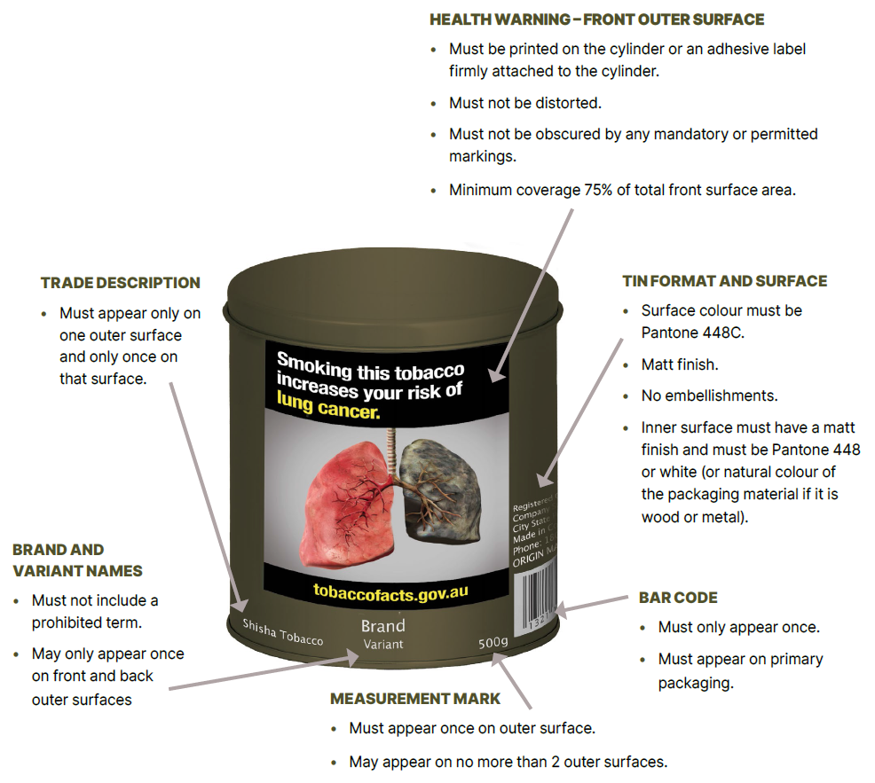

Figure 22: Image of back and top of large shisha tobacco cylinder
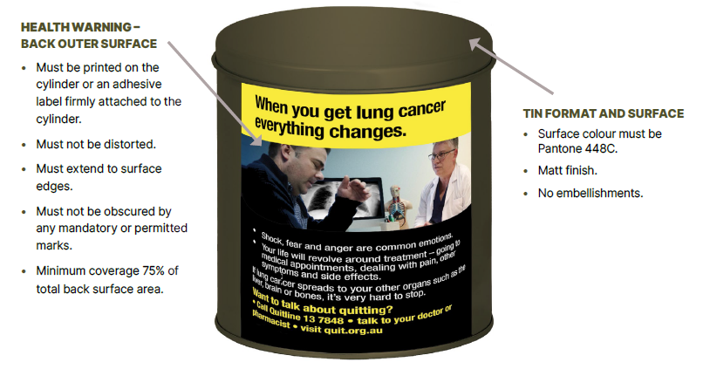
Note:
The back surface of this packaging must display the health warning. The health warning must:
- not be distorted
- extend to surface edges
- not be obscured by any markings permitted or required under the legislation
- have a minimum coverage 50% of total base surface area.
Note:
Mandatory markings are required to be no larger than 3mm; in Lucinda Sans font and in Pantone Cool Gray 2C (except for bar codes). Some examples include:
- registered company name and address
- a country of origin statement
- consumer contact phone number within Australia
- manufacturer's date mark (to be specified 2-character format i.e. D5).

Shisha tobacco box – horizontal packaging
Figure 23: Image of front, side and top of shisha tobacco box
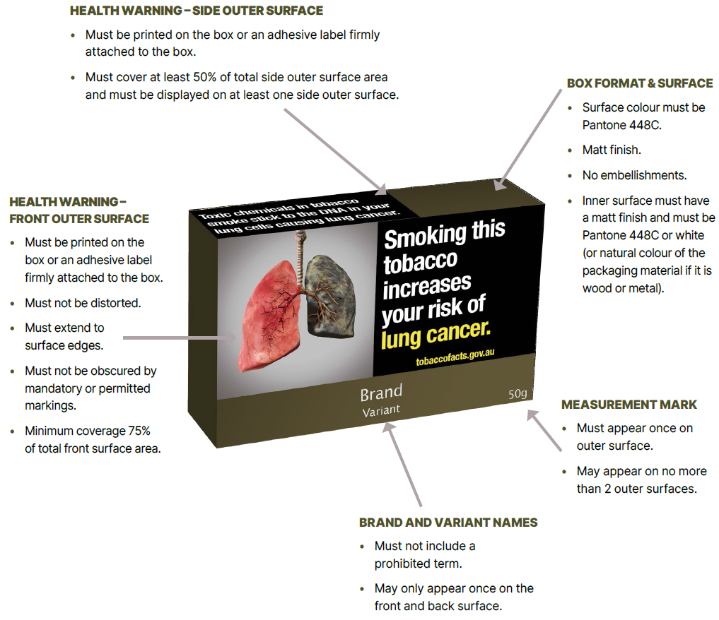
Note:
There are font type, text colour and size requirements for specific permitted markings. Some examples of permitted markings include:
- origin mark
- AQS marks
- calibration marks.
Figure 24: Image of back, side and bottom of shisha tobacco box
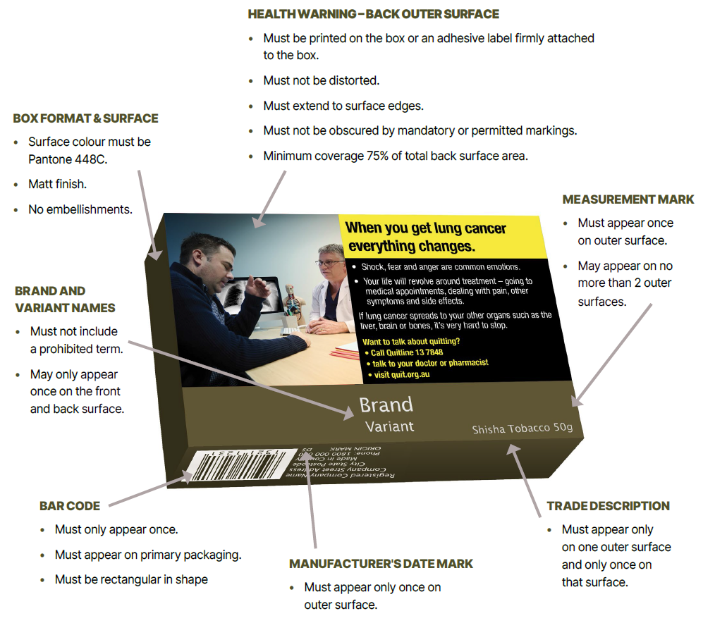
Note:
Mandatory markings are required to be no larger than 3mm; in Lucinda Sans font and in Pantone Cool Gray 2C (except for bar codes). Some examples include:
- registered company name and address
- a country of origin statement
- consumer contact phone number within Australia
- manufacturer's date mark (to be specified 2-character format i.e. D5).

Shisha tobacco foil – horizontal packaging
Figure 25: Image of front of shisha tobacco foil
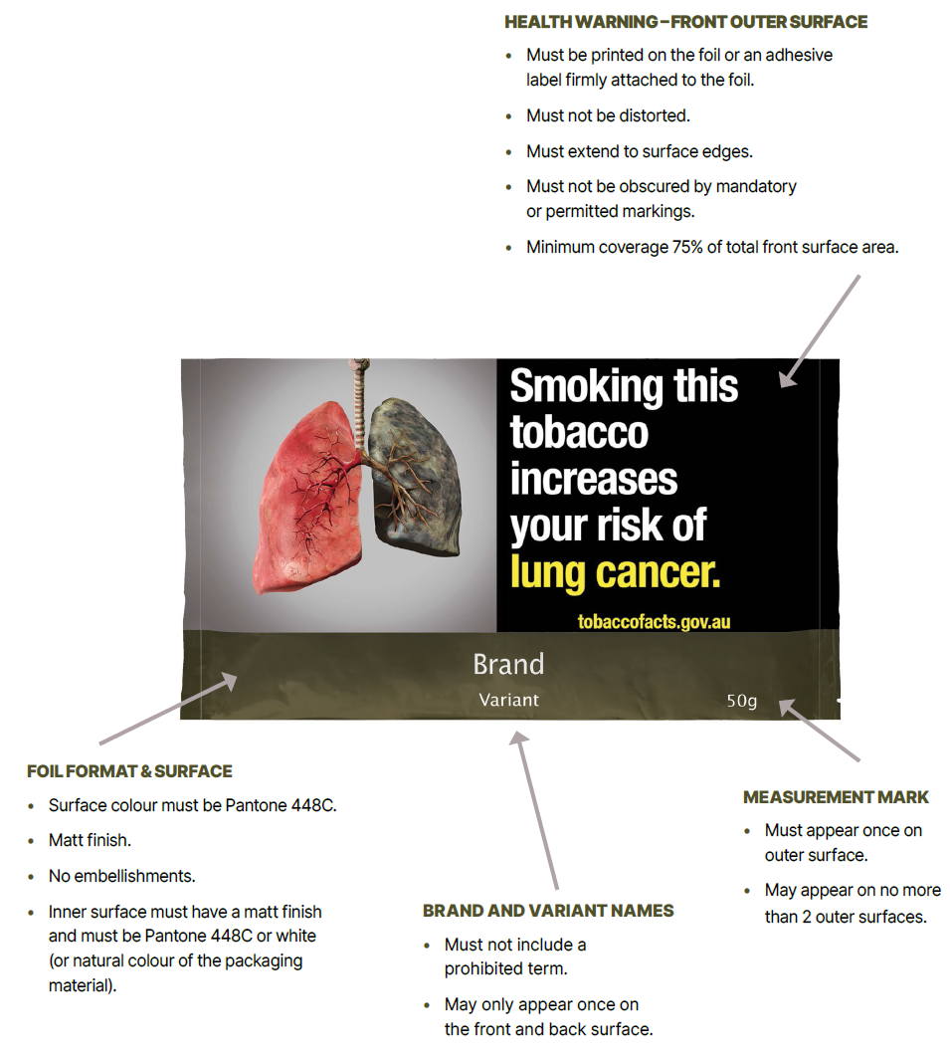
Note:
There are font type, text colour and size requirements for specific permitted markings. Some examples of permitted markings include:
- origin mark
- AQS marks
- calibration marks.

Figure 26: Image of back of shisha tobacco foil
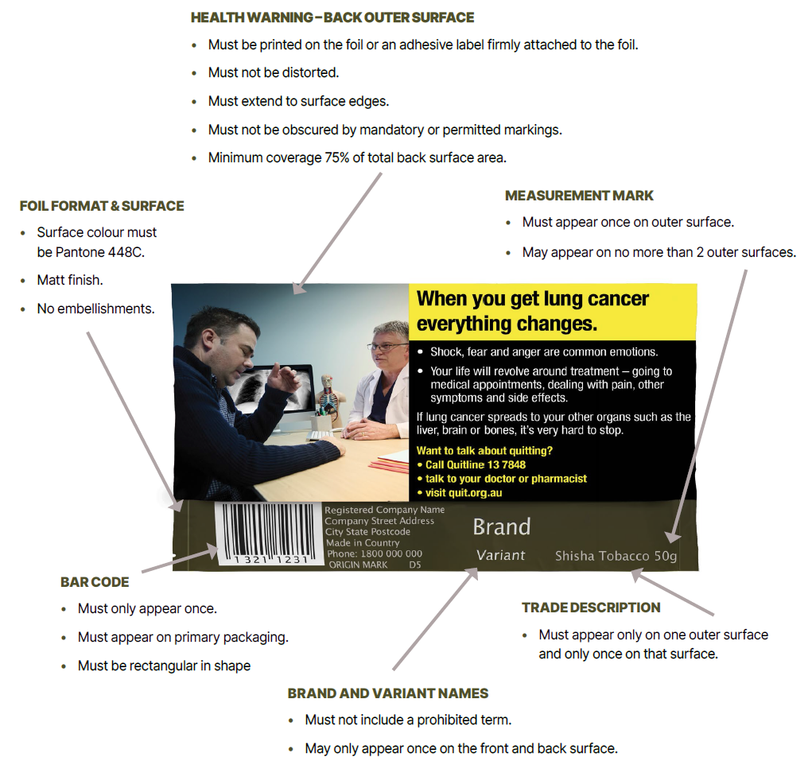
Note:
Mandatory markings are required to be no larger than 3mm; in Lucinda Sans font and in Pantone Cool Gray 2C (except for bar codes). Some examples include:
- registered company name and address
- a country of origin statement
- consumer contact phone number within Australia
- manufacturer's date mark (to be specified 2-character format i.e. D5).

Bidi box – vertical packaging
Note:
Bidi means a tobacco product for smoking and is not enclosed in paper. It may include a single black thread around the circumference of the bidi.
Note:
There are font type, text colour and size requirements for specific permitted markings. Some examples of permitted markings include:
- origin mark
- AQS marks
- calibration marks.
Figure 27: Image of front, side and top of bidi box
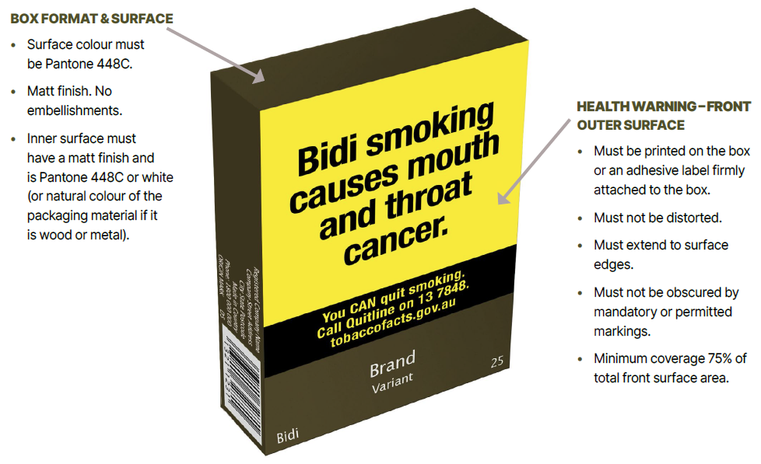
Note:
Mandatory markings are required to be no larger than 3mm; in Lucinda Sans font and in Pantone Cool Gray 2C (except for bar codes). Some examples include:
- registered company name and address
- a country of origin statement
- consumer contact phone number within Australia
- manufacturer's date mark (to be specified 2-character format i.e. D5).

Enforcing the Public Health (Tobacco and Other Products) legislation
The Government takes breaches of the Act seriously. The department is responsible for investigating reported breaches of the Public Health (Tobacco and Other Products) legislation. The department's Tobacco Control Enforcement Policy outlines the principles used to guide the department's decisions and actions in enforcing these laws.
Any person who possesses, manufactures, packages, purchases, sells or supplies (including import, wholesale and retail) tobacco products in Australia which do not comply with the Public Health (Tobacco and Other Products) legislation may face significant criminal or civil penalties. A range of options are available to enforce the Public Health (Tobacco and Other Products) legislation, including issuing infringement notices, seeking enforceable undertakings or injunctions, or referring the matter to the Australian Federal Police who may, in turn, refer the matter to the Commonwealth Director of Public Prosecutions.
As at publication, the maximum penalty for contravening the tobacco product requirements is 2,000 penalty units ($660,000) for individuals and 20,000 penalty units ($6.6 million) for bodies corporate.
If you wish to report a potential breach of the Public Health (Tobacco and Other Products) legislation, please contact the department. Reports of breaches can be submitted in writing through the make a complaint on the department's website or by emailing TobaccoCompliance@health.gov.au. Please include sufficient information to enable the department to investigate the alleged breach, including images or document copies demonstrating the allegation where possible.

For further information on the health warning requirements, see Guide to Health Warnings.
For further information on requirements for tobacco products, see Guide to tobacco product requirements.
For further information on the requirement to display health promotion inserts, see Guide to Health Promotion Inserts.
For more information on transition periods, see Transition Periods Fact Sheet.
For example, heat activated inks, inks or embellishments designed or intended to appear gradually over time, inks that appear fluorescent in certain light, panels designed or intended to be scratched or rubbed to reveal an image or text, removable tabs and fold-out panels.
Primary packaging means the container for retail sale in which the tobacco product is directly placed. Examples of primary packaging include cigarette packs and roll-your-own tobacco pouches.
For further guidance on what constitutes a prohibited term, refer to the Public Health (Tobacco and Other Products) Act 2023, Chapter 3.
'Name' refers to either the registered business name or registered company name of the entity.
'Address' refers to the address of the entity's principal place of business in Australia.
For further information, refer to the section above on Mandatory markings – Other.
For further information, refer to the section above on Mandatory markings – Other.
The adhesive label must be either transparent or coloured Pantone 448C.
The adhesive label must be either transparent or coloured Pantone 448C.
The adhesive label must be either transparent or coloured Pantone 448C.
Since 7 November 2024, the value of one penalty unit is $330.00. This amount may be subject to increase in the future.

