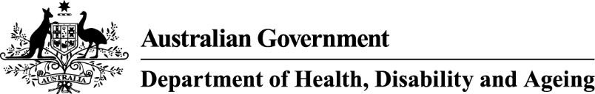

# GUIDE TO ONLINE POINT-OF-SALE ADVERTISING REQUIREMENTS

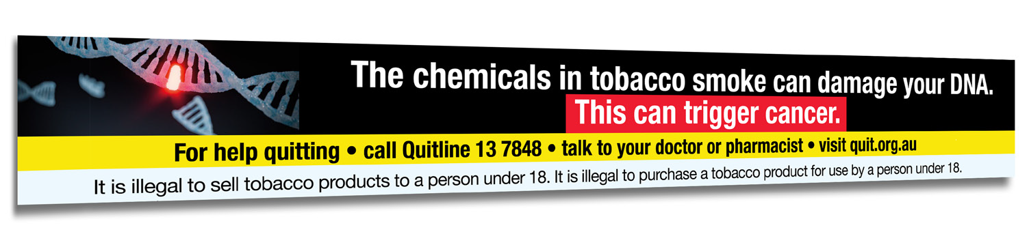

**ISBN:** 978-1-76007-445-6

**Online ISBN:** 978-1-76007-446-3

Copyright

© 2024 Commonwealth of Australia as represented by the Department of Health, Disability and Ageing

This work is copyright. You may copy, print, download, display and reproduce the whole or part of this work in unaltered form for your own personal use or, if you are part of an organisation, for internal use within your organisation, but only if you or your organisation:

do not use the copy or reproduction for any commercial purpose; and

retain this copyright notice and all disclaimer notices as part of that copy or reproduction.

Apart from rights as permitted by the *Copyright Act 1968* (Cth) or allowed by this copyright notice*,* all other rights are reserved, including (but not limited to) all commercial rights.

Requests and inquiries concerning reproduction and other rights to use are to be sent to the Communication Branch, Department of Health, Disability and Ageing, GPO Box 9848, Canberra ACT 2601, or via e-mail to [copyright@health.gov.au](mailto:copyright@health.gov.au).

DISCLAIMER

All manufacturers, packagers, suppliers and retailers (including importers and wholesalers) of tobacco products should ensure they understand all of the requirements in the *Public Health (Tobacco and Other Products) Act 2023*, the Public Health (Tobacco and Other Products) Regulations 2024 and other applicable Commonwealth, state and territory law.

This guide does not itemise all of the requirements under the Commonwealth Public Health (Tobacco and Other Products) legislation or other applicable law. The requirements that are not itemised in this guide are not any less important or significant than those that are displayed.

The guide does not provide legal advice and is not to be relied upon as a source of legal advice. It is provided for general information and as such any person reading this guide should rely upon their own judgement and make their own inquiries seeking relevant professional advice. Reliance on this guide is no excuse to ignorance of any applicable law.

There are additional requirements under the Commonwealth Public Health (Tobacco and Other Products) legislation for tobacco products and packaging. Anyone who possesses, manufactures, packages, purchases, sells or supplies (including import, wholesale and retail), tobacco products or tobacco product accessories in Australia, must ensure they comply with these requirements. There are some limited exceptions for personal use or export out of Australia of tobacco products and tobacco accessories.

Nothing in this guide should be taken in any way to replace the provisions of the *Public Health (Tobacco and Other Products)* Act 2023, the Public Health (Tobacco and Other Products) Regulations 2024 or other applicable Commonwealth, state or territory law.

The Department of Health, Disability and Ageing (the department) does not certify compliance with any tobacco legislation. The department does not undertake a review or approval scheme for tobacco packaging and the associated health warnings, tobacco product safety, tobacco advertising, or any other tobacco legislation issues.

For complete requirements refer to the legislation available at <http://www.legislation.gov.au>.

Contents

GUIDE TO ONLINE POINT-OF-SALE ADVERTISING REQUIREMENTS 1

Introduction 5

Purpose of the guide 5

Definitions 6

An outline of online point‑of‑sale tobacco advertising requirements 7

Application of state and territory laws 8

Overview of format requirements 9

Layout 9

Colours 9

Taxes 9

Language 9

Examples 9

Permitted information 11

Required content 11

Online tobacco advertisement warnings 12

How to access images 13

Access to tobacco retail websites 13

Geoblocking of certain purchasers 13

Prohibited content 14

Enforcing the Public Health (Tobacco and Other Products) legislation 15

## Introduction

### Purpose of the guide

The Australian Government Department of Health, Disability and Ageing (the **department**) has produced this guide to help the public understand the Commonwealth’s *Public Health (Tobacco and Other Products)* *Act 2023* (the **Act**) and the Public Health (Tobacco and Other Products) Regulations 2024 (the **Regulations**), specifically the requirements for online and point-of-sale advertising of tobacco products.

This guide does not contain tobacco product requirements, or the requirements relating to health warnings, health promotion inserts (**HPIs**) or comprehensive explanations of the regulation of advertising and sponsorship.

While the Act and Regulations apply to advertising of e-cigarettes, the specific requirements applicable to these products are not contained within this guide. The *Therapeutic Goods and Other Legislation (Vaping Reforms) Act 2024* (**Vaping Reforms Act**) commenced on 1 July 2024. The Vaping Reforms Act amended the *Therapeutic Goods Act 1989* (**Therapeutic Goods Act**) to establish a national approach to the importation, domestic manufacture, supply, commercial possession and advertisement of vaping goods (which includes e-cigarettes) in Australia. Among other things, it prohibits retailers such as tobacconists, vape shops and convenience stores from selling or advertising vaping goods.

The Therapeutic Goods Act prohibits advertising of vaping goods except where specifically authorised. The prohibition applies to all forms of advertising, including to consumers and persons within the wholesale supply chain, and includes online advertising, in-person advertising as well as other forms of advertising, such as the labelling of vaping goods. There are very significant penalties under the Therapeutic Goods Act for advertising vaping goods without authorisation in Australia.

Any advertisement for e-cigarettes must comply with both the Therapeutic Goods Act and the Public Health (Tobacco and Other Products) legislation (and any other applicable Commonwealth, state or territory law).

Guidance on the prohibitions for advertising and promotion of vaping goods in Australia under the Therapeutic Goods Act can be found on the [Therapeutic Goods Administration Vaping Hub](https://www.tga.gov.au/products/unapproved-therapeutic-goods/vaping-hub) (TGA Vaping Hub).

Guides for the implementation of the Act include:

[Guide to Tobacco Product Requirements](https://www.health.gov.au/resources/publications/guide-to-tobacco-product-requirements?language=en)

[Guide to Tobacco Packaging Requirements](https://www.health.gov.au/resources/publications/guide-to-tobacco-packaging-requirements)

[Guide to Health Warnings](https://www.health.gov.au/resources/publications/guide-to-health-warnings?language=en)

[Guide to Health Promotion Inserts](https://www.health.gov.au/resources/publications/guide-to-health-promotion-inserts?language=en)

[Guide to Advertising and Sponsorship Prohibitions](https://www.health.gov.au/resources/publications/guide-to-advertising-and-sponsorship-prohibitions)

All of these resources are available from <https://www.health.gov.au/>.

For any inquiries regarding the application of the Act and/or Regulations relating to e-cigarettes, please contact the department at [TobaccoCompliance@health.gov.au](mailto:TobaccoCompliance@health.gov.au) and otherwise refer to the [TGA Vaping Hub](https://www.tga.gov.au/products/unapproved-therapeutic-goods/vaping-hub).

You are encouraged to download an up-to-date version of the Act and Regulations from the Federal Register of legislation website ([www.legislation.gov.au](http://www.legislation.gov.au)).

### Definitions

**‘Public Health (Tobacco and Other Products) legislation’** means the *Public Health (Tobacco and Other Products)* Act 2023 and the Public Health (Tobacco and Other Products) Regulations 2024.

**‘Regulated tobacco item’** means a tobacco product or a tobacco product accessory.

**‘Tobacco product’** means the following designed or intended for human consumption or use:

1. processed tobacco in any form;

a product that contains tobacco as an ingredient.

‘**Tobacco product accessory**’ means any of the following:

1. a cigarette paper (including a pre-rolled cigarette paper) that is not part of a tobacco product;

a cigarette roller;

a filter tip for a cigar or cigarette that is not part of a tobacco product;

a wrapper for tobacco that is in the form of a sheet or tube made from or with tobacco;

a card, capsule, bead or other device that is designed or intended to alter the flavour, smell or intensity of a tobacco product (except such a device that is part of a tobacco product);

a pipe designed or intended for smoking pipe tobacco.

The definitions used in the Public Health (Tobacco and Other Products) legislation can be viewed in section 8 of the Act, and section 5 of the Regulations. The above definitions are provided to assist in understanding this guide.

## An outline of online point‑of‑sale tobacco advertising requirements

Tobacco retail websites can come in many forms. Some may be part of websites retailing a wide range of products, while others may be stand-alone tobacco retail websites. However, a website that sells regulated tobacco items would generally include:

a ‘virtual shopfloor’ webpage providing information about the tobacco products available for sale on the website; and

a ‘purchase facility’ comprising:

a ‘virtual shopping cart’ – a webpage (linked to the virtual shopfloor) that puts the products the customer wants to buy in a cart. The product prices and the total cost of the products are shown in the shopping cart; and

a ‘virtual check-out’ – a facility for a customer to buy a product that includes the final list of products the customer wishes to buy, the product prices and the total cost of the products. The check-out also provides a way for the customer to pay for the products (for example, using credit card details or a secure third-party payment facility), the entry of customer details (for example, delivery address) and any other elements that are needed to complete the sale.

The Act prohibits the publication of most tobacco advertisements online or in other electronic media in Australia, including at online point-of-sale unless the advertising complies with requirements set out under the legislation.

The Act permits online point-of-sale tobacco advertising that complies with:

state or territory legislation expressly dealing with online point-of-sale tobacco advertising; or

if there is no applicable state or territory legislation, the requirements in the Regulations.

Where there is no state or territory legislation which applies, the requirements under the Act operate to permit tobacco advertising in specified circumstances. Additional requirements for online tobacco advertisements that connect to an online purchase facility are contained in the Regulations.

The Regulations contain rules governing:

the format of online point-of-sale tobacco advertising

the content permitted to be included in online point-of-sale tobacco advertising

the content required to be included in online point-of-sale tobacco advertising

the content prohibited from being included in online point-of-sale tobacco advertising.

### Application of state and territory laws

Commonwealth, state and territory laws apply to tobacco advertising.

As a general rule, if there are state or territory laws which regulate the online point-of-sale of tobacco, these laws will prevail over Commonwealth laws, subject to certain exceptions.

For further information about state and territory laws please contact the relevant [state or territory health department](https://www.health.gov.au/about-us/contact-us/local-state-and-territory-health-departments).

## Overview of format requirements

### Layout

Permitted online tobacco retail advertisements, on both a virtual shopfloor or purchase facility, **must** follow these requirements:

The webpage **must** contain a text list or a ‘price board’ of the regulated tobacco items being advertised, using black text on a white background.

The price board can only include the ‘permitted information’ outlined below.

The product information **must** be shown in a standardised layout and format using the same sans serif font and font size.

Images of regulated tobacco items, and their associated imagery (such as branding or logos), cannot be shown.

Advertising **must** use a ‘standardised layout and format’ – that is, each individual tobacco item advertised on an online retail website **must** be shown in the price board using the same layout and format. Retailers are encouraged to use a ‘table-like’ format for displaying tobacco items or a list of products in a standard format. Some examples of this are shown below.

The purpose of these requirements is to ensure, among other things, that no individual product is shown more prominently or is more conspicuous than any other product.

### Colours

Online point-of-sale tobacco advertisements **must** use black text on a white background.

### Taxes

All online point-of-sale webpages showing tobacco products **must** include the statement ‘Product prices include all taxes’.

### Language

The information required or permitted to be included on a website that contains a tobacco advertisement **must** be legible, in English and in an undistorted form. This information **may** be provided in additional languages if desired.

### Examples

Examples of online tobacco retail advertisements that comply with the format requirements in the Regulations are shown below. The examples also reflect the **Permitted Information** requirements.

**Example One**

|  |  |
| --- | --- |
| [Product name]  20 pack of cigarettes | $28  [icon: ‘add to shopping cart’] |
| [Product name]  20 pack of cigarettes | $30  [icon: ‘add to shopping cart’] |
| [Product name]  20 pack of cigarettes | $33  [icon: ‘add to shopping cart’] |

* Product prices include all taxes.

**Example Two**

|  |  |  |
| --- | --- | --- |
| [Product name]  Pack of 20 cigarettes  $28  [icon: ‘add to shopping cart’] | [Product name]  Pack of 20 cigarettes  $30  [icon: ‘add to shopping cart’] | [Product name]  Pack of 20 cigarettes  $33  [icon: ‘add to shopping cart’] |

* Product prices include all taxes.

**Example Three**

|  |  |  |
| --- | --- | --- |
| [Product name] | Price $28 | [icon: ‘add to shopping cart’] |
| [Product name] | Price $30 | [icon: ‘add to shopping cart’] |
| [Product name] | Price $33 | [icon: ‘add to shopping cart’] |

* Product prices include all taxes.

**Example Four**

|  |  |  |
| --- | --- | --- |
| [Product name]  Pack of 20 cigarettes  Made in Australia  Item code: XXYAI2  $28  [icon: ‘add to shopping cart’] | [Product name]  Pack of 20 cigarettes  Made in New Zealand  Item code: XXYAI3  $30  [icon: ‘add to shopping cart’] | [Product name]  Pack of 20 cigarettes  Made in Cuba  Item code: XXYAI4  $33  [icon: ‘add to shopping cart’] |

* Product prices include all taxes.

## Permitted information

Webpages containing point-of-sale tobacco advertisements **may** include the following information:

the brand name and variant name (if any) of the tobacco product

the product price (inclusive of all taxes)

the package size or weight of the product

information about any other charges payable (for example, delivery charges)

an item number or product code

the country of origin of the product.

If a country of origin statement is included on an online ‘price board’ for tobacco products, it **must** use the format of ‘Made in [Country]’. Country of origin statements in any other format, including those that describe the product or the components of a product, are prohibited. Examples of statements that do not comply with this requirement include ‘Product of Cuba’ or ‘Made in Cuba from premium tobacco’.

Webpages containing point-of-sale advertisements for tobacco products are not required to include all of this information. Online retailers may choose which information they include in their advertising. However, no additional information may be included in advertisements. Online point-of-sale advertising that includes information other than that listed above is not permitted under the Act.

## Required content

Any webpage that contains a tobacco advertisement on a virtual shopfloor or purchase facility **must** include an online tobacco advertisement warning.

The specific advertisement warnings that **must** be displayed on such webpages are contained in the Regulations. These online advertisement warnings can be requested from the department by completing the webform available on the [department’s website](https://www.health.gov.au/topics/smoking-vaping-and-tobacco/tobacco-control/health-warnings/request-form).

The online tobacco advertisement warnings **must**:

be displayed prominently at the top of the webpage:

the warnings **must** stand out to be easily seen by consumers

be fixed in place and not collapsible:

so that they are always clearly visible to a person accessing and scrolling through the webpage

be legible:

consumers **must** be able to easily read the warnings

be undistorted:

the warnings **must not** be twisted out of their original shape, degraded or otherwise changed

be scaled to an appropriate size to suit any device on which they are viewed

not include any link that would give the consumer access to any other webpage.

### Online tobacco advertisement warnings

Webpages that contain online point-of-sale tobacco advertisements or purchase facilities **must** display either:

a static display that clearly shows the online tobacco advertisement warning required for that quarter. The warning **must** be updated on a quarterly basis to reflect the correct warning for each period of the year

a dynamic display that clearly shows each of the online tobacco advertisement warnings in Schedule 1 of the Regulations on a rotating carousel banner. The images displayed on the warning banner **must** rotate every 15 to 30 seconds.

#### *Schedule 1 of the Regulations prescribes the required online tobacco advertisement warnings which are shown below.*

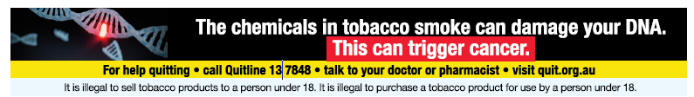

**Figure 1:** Health warning 1.1—Quarter from 1 January to 31 March

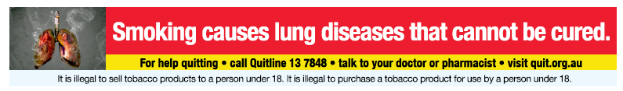

**Figure 2:** Health warning 1.2—Quarter from 1 April to 30 June

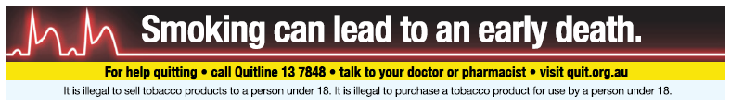

**Figure 3:** Health warning 1.3—Quarter from 1 July to 30 September

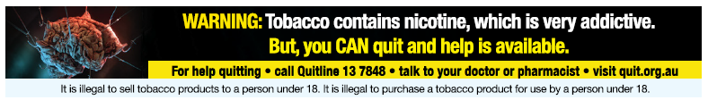

**Figure 4:** Health warning 1.4—Quarter from 1 October to 31 December

### How to access images

Electronic files containing online tobacco advertisement warning images are available on request, free of charge, for people involved in the online retail sale of regulated tobacco items. A copy of the files containing online tobacco advertisement warning images can be requested from the department by completing the webform available on the [department’s website](https://www.health.gov.au/topics/smoking-vaping-and-tobacco/tobacco-control/health-warnings/request-form).

### Access to tobacco retail websites

#### Age verification system

Websites that contain online tobacco advertisements **must** include a system that limits access to the website to people aged 18 years or older. A website displaying a tobacco advertisement that does not contain a system limiting the access of people under 18 years of age may contravene the Act.

In practice, such a system would usually be on the first webpage that customers see when entering a website, or on a webpage customers **must** traverse before viewing any tobacco advertisements or accessing the purchase facility.

However, retailers **may** design their own system as long as it complies with the Regulations.

#### *Examples*

Systems that would comply with the Regulations include:

a system that stops a person accessing the retail advertisement unless, prior to viewing the advertisement, the person declares that they are at least 18 years of age

a system that stops a person accessing the retail advertisement unless, prior to viewing the advertisement, the person specifies their date of birth and the date specified indicates that the person is at least 18 years of age.

### Geoblocking of certain purchasers

Websites that display tobacco advertisements **must** include a system that prevents a person who resides in a state or territory that prohibits the online purchase of tobacco products from purchasing a tobacco product.

For example, if state or territory legislation prohibits the online sale of tobacco products, online tobacco retailers will be prohibited from allowing the sale of tobacco products to persons residing in that jurisdiction.

## Prohibited content

Online point-of-sale tobacco advertisements, including purchase facilities, **must not**:

include any information about regulated tobacco items that is not required or permitted under the Act and Regulations

invite or allow bids or offers to buy regulated tobacco items, for example through auctions

include images of regulated tobacco items

include more than one price for each regulated tobacco item:

that is, advertisements **must not** display a ‘regular’, ‘sale’ or ‘bulk sale’ price

include words or images that entice, or are intended to entice, a person to buy a regulated tobacco item:

this includes examples such as the terms ‘cheap’, ‘discount’, ‘bulk savings’, ‘buy one, get one free’ or ‘tax free’; or

include content that promotes another website that contains a tobacco advertisement, or solicits online traffic to a tobacco advertisement:

for example, a link to a social media website that contains tobacco advertisements.

In addition, online point-of-sale tobacco retail advertisements, including purchase facilities, **must not** include any prohibited terms. For example, this includes:

a term implying reduced harm

a term implying a positive quality or health effect

a colour

a term that refers to a filter

a term that refers to a prohibited ingredient

words that contradict, qualify or modify a health warning or a health promotion insert.

## Enforcing the Public Health (Tobacco and Other Products) legislation

The Government takes breaches of the Act seriously. The department is responsible for investigating reported breaches of the Public Health (Tobacco and Other Products) legislation. The department’s [Tobacco Control Enforcement Policy](https://www.health.gov.au/resources/publications/tobacco-control-enforcement-policy) outlines the principles used to guide the department’s decisions and actions in enforcing these laws.

Any person who advertises, promotes, buys, offers for sale, sells or otherwise supplies tobacco products in Australia which do not comply with the Public Health (Tobacco and Other Products) legislation may face significant criminal or civil penalties. A range of options are available to enforce the Public Health (Tobacco and Other Products) legislation, including issuing infringement notices, seeking enforceable undertakings or injunctions, or referring the matter to the Australian Federal Police who may, in turn, refer the matter to the Commonwealth Director of Public Prosecutions.

As at publication, the maximum penalty for contravening the advertising and sponsorship prohibitions is 2,000 penalty units ($660,000) for individuals and 20,000 penalty units ($6.6 million) for bodies corporate.[1]

If you wish to report a potential breach of the Public Health (Tobacco and Other Products) legislation, please contact the department. Reports of breaches can be submitted in writing through the [make a complaint](https://www.health.gov.au/topics/smoking-vaping-and-tobacco/tobacco-control/plain-packaging/complaints-form) on the department’s website or by emailing [TobaccoCompliance@health.gov.au](mailto:TobaccoCompliance@health.gov.au). Please include sufficient information to enable the department to investigate the alleged breach, including images or document copies demonstrating the allegation where possible.

[www.health.gov.au](http://www.health.gov.au/)

11890 NOV 2024

1. Since 7 November 2024, the value of one penalty unit is $330.00. This amount may be subject to increase in the future.