Government Provider Management System – Quick Reference Guide: Provider Operations Reporting

# Introduction

Since 2023, residential care, home care and transition care providers have been required to report additional information about their operations to the Department of Health, Disability and Ageing on an annual basis.

Reporting opens 01 July and is **due by 31 October annually**, for the previous financial year.

**Residential care and home care providers** need to submit operations information about their organisation via the Government Provider Management System (GPMS). These providers can then preview their reported information about their organisation on GPMS before it is published on the My Aged Care website.

For **Transition Care**, the additional information is submitted through the Transition Care Annual Accountability Report submitted by state and territory governments that are the providers of the Transition Care Program.For assistance in completing this report contact[**tcp@health.gov.au**](mailto:tcp@health.gov.au)**.**

For residential care and home care providers, information collected through the Provider Operations Collection Form, as well as additional information reported by providers, is published on the My Aged Care website.

The published information is to provide greater transparency about providers’ finances and operations and to help older people, their families and carers to make informed decisions about their care and in selecting the right provider.

Please note

Submission deadline: The Collection Form must be submitted by 31 October each year.

Reporting period: The reporting period you are submitting information for is 1 July - 30 June for the previous financial year. (In 2024, this will be for the period 1 July 2023 – 30 June 2024.

# Accessing GPMS, Provider Operations Reporting tile and Provider Operations Collection Form

The Provider Operations Collection Form is accessed in the GPMS Portal, through the Provider Operations Reporting tile.

To access the Provider Operations Reporting tile:

1. Log into the [GPMS Portal](https://www.health.gov.au/resources/apps-and-tools/government-provider-management-system).
2. For assistance logging in to GPMS refer to [Government Provider Management System – Troubleshooting Guide: Login support](https://www.health.gov.au/resources/publications/government-provider-management-system-user-guide-login-troubleshooting?language=en).
3. On the GPMS home page select the **Provider Operations Reporting** tile to access the Provider Operations Collection Form.

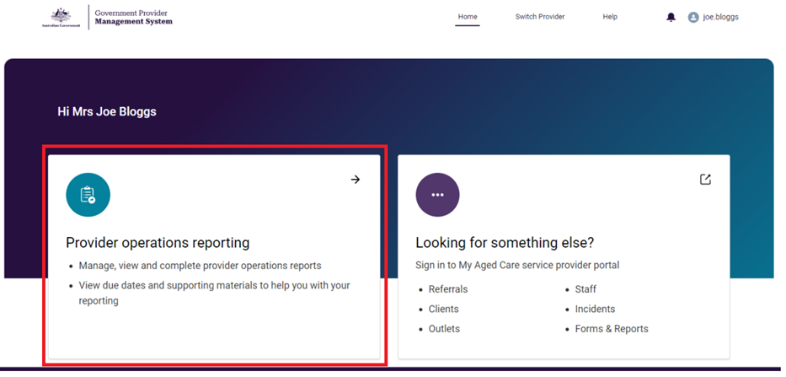

1. On the Provider Operations Reporting home (submission) page, under **Active Submissions**, select the **Case number** for the current reporting period.
2. Select the **Start button – to start completing your Collection Form for the current period.**

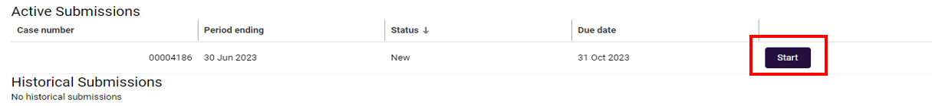

1. **A Privacy Statement will appear each time you enter the Active Submission section - you will need to select Agree to progress with the Collection Form.**
2. The navigation bar on the left of the page in GPMS indicates your progress through the sections of the Collection Form, all the way through to the Declaration and submission.

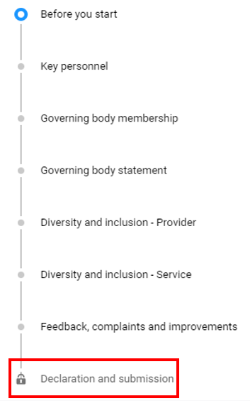

1. **Follow the sections in the navigation bar (which can be completed in any order) to complete the Collection Form.**
2. **You will not be able to submit your Collection Form (last step in Declaration and submission) until all sections of the Collection Form are completed (each completed item in the navigation bar indicated by a green tick).**
3. You can **download** (and save or print) a PDF copy of the Collection Form at any time while completing it, or afer you have submitted it.
4. When all sections have been successfully completed, navigate to the **Declaration and submission** section of the Collection Form. Make the declaration and **submit** the Collection Form.
5. After submission, you will have access to a read-only view of your Collection Form (status will now say **Submitted**).

**Please note:**

You can go back to the Form at any time to resume completion. Where the Status was ‘Start’ in the beginning, it will now say ‘Resume’.

Regularly ‘Save’ your information as you progress through the Collection Form.

## Completing sections of the Collection Form

Key personnel

* Provide the name and role of **at least one (and up to three)** key personnel at a senior executive level, who is responsible for executive decisions.
* You can select roles from the dropdown menu provided in the Collection Form or select **Other** if none of the categories are suitable. You do not need to select all three names and roles.

Governing body membership

* Indicate whether your governing body has a majority of independent non-executive members and at least one member with experience in providing clinical care.
* The Collection Form includes reasons why the requirements may not apply to a provider.

Governing body statement

* Complete a signed Governing Body Statement which allows providers’ governing bodies to demonstrate their understanding of, and accountability for, issues affecting the quality of care of aged care recipients.
* In their signed statement, the members of the provider’s governing body will need to indicate **Has complied** or **Has failed to comply** with the following statement:
  + *Does the governing body believe the approved provider has complied/ has failed to comply with all of its responsibilities under the Aged Care Act 1997 and the requirements under the Aged Care Quality and Safety Commission Act 2018?*
* This information is collected at the provider level.
* Failure to comply with a requirement or responsibility go beyond non-compliances identified by the Aged Care Quality and Safety Commission. Information is to be provided about any non-compliances during the reporting period.
* After including the above information, providers will select **one of two options** to sign and submit the Governing Body Statement: DocuSign digital signature option OR signing a manual hard copy option (print/ sign/ scan/ upload).
* **Digital signature**: When you enter the email address of the person who is provide the e-Signature, please ensure they are available to sign the document and that you enter the correct email address.
* **Hard copy signature**: If manually uploading the Governing Body Statement, your document will be scanned for viruses, which may take up to 48 hours (two days) to upload.
* If any information is changed on the Collection Form after signing, this document will need to be resigned/ resubmitted by the Governing Body Member making the statutory declaration.

Diversity and inclusion – Provider

* Provide information about the diversity of your organisation’s **governing body** by selecting from the dropdown menu of options provided.
* Consent of each governing body member is needed before including information about their diversity in the Collection Form. Their consent is voluntary.

Diversity and inclusion – Service

* Provide information about initiatives implemented at **each residential service and home care service** to support a diverse and inclusive environment between 01 July and 30 June annually for each financial year reporting period.
* All questions in this section are required **for each service operated** by the providers during the reporting period 01 July - 30 June.
* Select either Developing, Implemented or Noto each of the statements for each service operated (during the reporting period).
* Remember to Save your responses for each service.

Feedback, complaints and improvements

* Provide information about the most common kinds of **positive feedback** and **complaints received** about each residential care and home care service, and information about the **key improvements made** at each residential care and home care service between 01 July and 30 June annually for each financial year reporting period.
* Select from the dropdown menu of options of categories for positive feedback, complaints and improvements.

Please note:

The Collection Form will be open 01 July each year and is to be submitted by 31 October each year, for the previous financial year.

Reminders will be sent by email and key dates will be highlighted in the ‘What's new’ tab on GPMS.

If selecting ‘Other’ in any question – providers are asked not to include personal information about any individual due to privacy reasons.

If you need to access the ‘Guides and FAQs’, at any stage while completing the Collection Form, be sure to first save your data (as these resources will take you outside the Collection Form).

# Further information and support

Please report any IT or technical errors to the **My Aged Care service provider and assessor helpline** on **1800 836 799 (Option 5).** The helpline is open Monday to Friday between 8am-8pm and Saturday between 10am-2pm (local time across Australia).

For any residential care and home care provider operations reporting/submission enquiries, please email the **Provider Governance mailbox**: [ProviderGovernance@Health.gov.au](mailto:ProviderGovernance@Health.gov.au).

Webpages and resources available on:

* [**Aged care provider reporting** webpage](https://www.health.gov.au/topics/aged-care/providing-aged-care-services/reporting#:%7E:text=Changes%20to%20provider%20governance%20from%201%20December%202022,-Following%20recommendations%20made&text=Changes%20are%20to%20improve%20the,body%20membership%20and%20advisory%20bodies)
* [Provider Operations Collection Form webpage and training resources](https://www.health.gov.au/topics/aged-care/providing-aged-care-services/reporting/provider-operations) *(including a more detailed Provider Operations Collection Form User Guide):*
* [Government Provider Management System webpage and training resources](https://www.health.gov.au/our-work/government-provider-management-system-gpms):