Government Provider Management System
User Guide: Quarterly Financial Report
July 2024
Version 2.0
This Government Provider Management System (GPMS) User Guide provides instructions to submit data and access reports using the Quarterly Financial Report application.

Contents
1. Introduction 5
1.1 Purpose 5
1.2 Before proceeding 5
1.3 Login to the GPMS portal 6
2. Further information and support 6
3. Accessing the QFR application 6
4. Financial reporting 8
4.1 What’s New tab 9
4.2 Reporting Due Dates tab 9
4.3 Guides & FAQs tab 9
4.4 Table of reports 10
4.5 Completing a report 10
4.5.1 Start function 11
4.5.2 Resume function 12
4.5.3 Download function 13
4.5.4 Submission status 14
4.5.5 Lock function 14
5. Navigation and functions 15
5.1 Sidebar navigation 15
5.2 Banner 17
5.3 Save and Close function 17
5.4 Download Copy function 17
5.5 About This Section 19
5.6 Information icon 20
5.7 Previous and Next functions 20
5.8 Text Input field 20
5.9 Table View function 21
5.9.1 View All 22
5.9.2 View Errors Only 23
5.9.3 View Comments Only 24
5.10 Expand and collapse subsection display 25
5.11 Expand Table and Shrink Table functions 26
Expand Table 27
Shrink Table 28
5.12 Jump to Section function 29
5.13 Jump to Column function 30
5.14 Food preparation model dropdown 31
5.15 Validation function 33
5.15.1 Addressing soft validations 34
5.16 File Management function 36
5.16.1 Preview Declaration 37
5.16.2 Download Declaration 39
5.16.3 Preview submitted QFR 39
5.16.4 Download submitted QFR 39
5.16.5 Update file properties 40
5.16.6 Archive File 42
5.17 Virus scan function 43
5.17.1 Virus scan status 44
5.17.2 Virus scan status notification 44
6. Entering data into the QFR form 45
6.1 Manual entry of QFR data 45
6.2 Bulk update of QFR sections 46
6.2.1 Download the QFR section template 47
6.2.2 The QFR section template 50
6.2.3 Data field comments in the QFR section template 52
6.2.4 Update the QFR section template 52
6.2.5 Save the QFR section template 53
6.2.6 Print the QFR section template 53
6.2.7 Upload the QFR section data 54
6.2.8 Upload Files function 55
6.2.9 Drop files function 55
6.2.10 View QFR section with bulk update data 58
7. QFR form 59
7.1 Before You Start section 60
7.2 Provider Contact section 61
7.2.1 Add a new contact 63
7.2.2 Edit an existing contact 65
7.2.3 Delete an existing contact 67
7.3 Residential Viability and Prudential Reporting section 69
7.4 Home Care Viability and Prudential Reporting section 71
7.5 Year to Date Financial Statements section 79
7.5.1 YTDFS data table 80
7.5.2 YTDFS column display 80
7.6 Residential Labour Costs and Hours section 82
7.6.1 RLC&H data table 82
7.7 Residential Aged Care Home Expenditure Per Resident Per Day section 84
7.8 Home Care Labour Costs and Hours section 84
7.8.1 HCLC&H data table 85
7.8.2 Information icon 86
7.8.3 Centrally Held column display 86
7.9 Residential Food and Nutrition Reporting section 88
7.9.1 RF&NR data table 89
7.10 NATSIFACP Food and Nutrition section 90
7.10.1 NATSIFACP-F&NR data table 92
7.11 MPS Food and Nutrition section 93
7.11.1 MPS-F&NR data table 95
7.12 Declaration and Submission section 96
7.12.1 Declaration 97
7.12.2 Submission 102
7.12.3 Download a copy of your submitted QFR 104
8. Resubmission 106
8.1 Reissue reason/s 108
8.1.1 RV&PR and HCV&PR sections 108
8.1.2 YTDFS, RLC&H, HCLC&H, RF&NR, NATSIFACP-F&NR, and MPS-F&NR sections 109
8.1.3 Download reissued copy of your submitted report 111
9. Validation rules and error alerts 113

Introduction
The Quarterly Financial Report (QFR) application within the GPMS portal supports the submission of quarterly financial and prudential data which is a part of broader initiatives to improve financial reporting and strengthen prudential compliance for approved aged care providers.

Purpose
This User Guide is designed to support aged care providers in submitting and managing their QFR (‘report’) by:
- accessing financial reporting in the GPMS portal
- completing sections of the QFR for the current quarter report submissions
- accessing historical report submissions.

Before proceeding
The Department of Health, Ageing and Disability
(‘department’) will retain records of your access to GPMS and when prompted, you must accept the GPMS Terms of Use to be able to access the system.
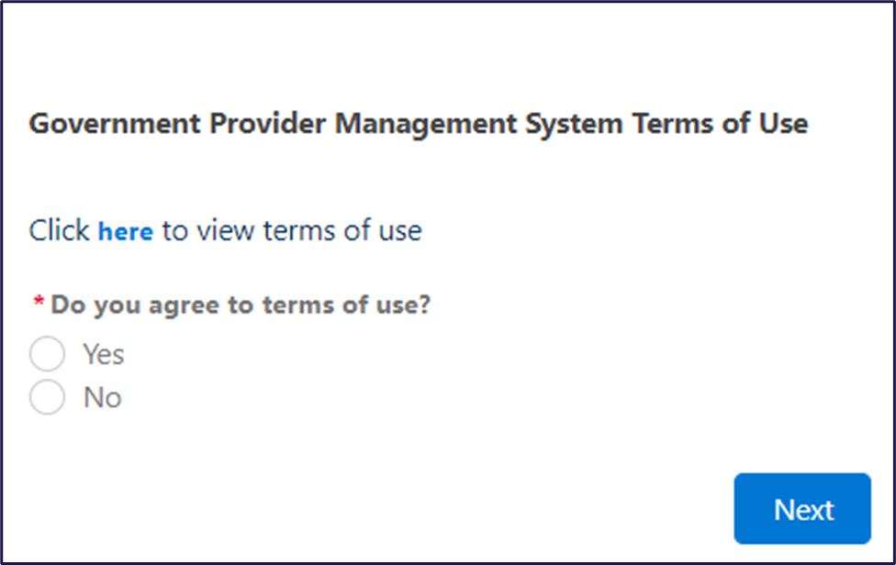

Login to the GPMS portal
To login to the GPMS portal, please visit Log In Using | Service Provider Portal.
If you require assistance logging into the GPMS portal, please refer to the GPMS Logging in to the Aged Care Systems.
To access the QFR application, your Organisation Administrator must have set you up as a Financial Reporting user in GPMS. Refer to Government Provider Management System – User guide for user access options that are available to you as an approved provider.

Further information and support
If you require further assistance to login to GPMS, please contact the My Aged Care service provider and assessor helpline on 1800 836 799, Monday to Friday (8am to 8pm) and Saturday (10am to 2pm) local time across Australia.
For more information on GPMS, please refer to the Government Provider Management System webpage.
For reporting enquiries, please contact the relevant support groups listed below.
- For general enquiries about completing your QFR, email health@formsadministration.com.au or phone (02) 4403 0640, Monday to Friday (8:30am to 5pm AEST)
- For questions about direct care reporting email QFRACFRHelp@health.gov.au.
For translating and interpreting services, call 131 450 and ask for My Aged Care on 1800 200 422.
To use the National Relay Service, visit About the National Relay Service (NRS) | Access Hub or call
1800 555 660.
To access sign language interpreting and captioning services through Deaf Connect, call 1300 773 803 or email interpreting@deafconnect.org.au.

Accessing the QFR application
The GPMS home page is displayed upon successful login to the GPMS portal.
You will see the GPMS application tiles that you have been given access to.

Please note:
If you cannot see the Financial reporting tile, please contact and request access from your Organisation Administrator.

Select the Financial reporting tile from the GPMS portal home page.
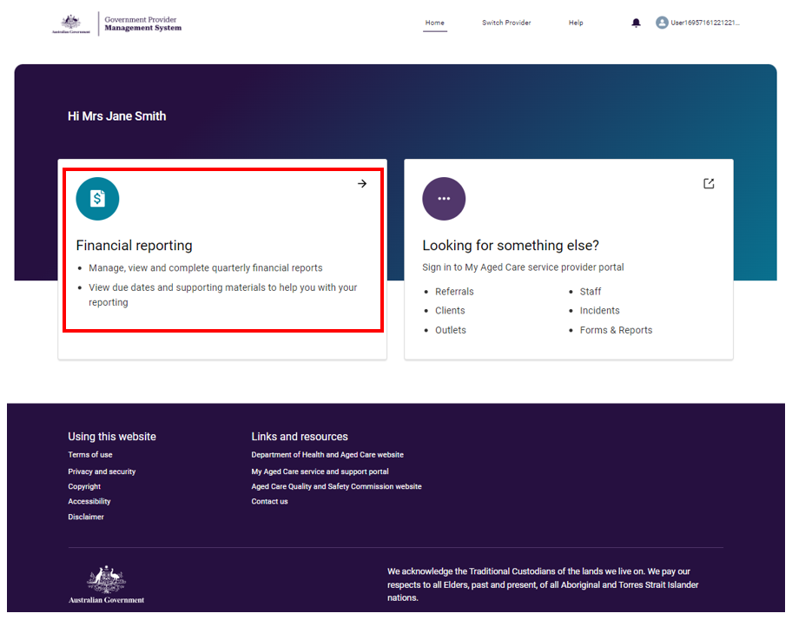
You are now in the Financial reporting home page within GPMS portal.
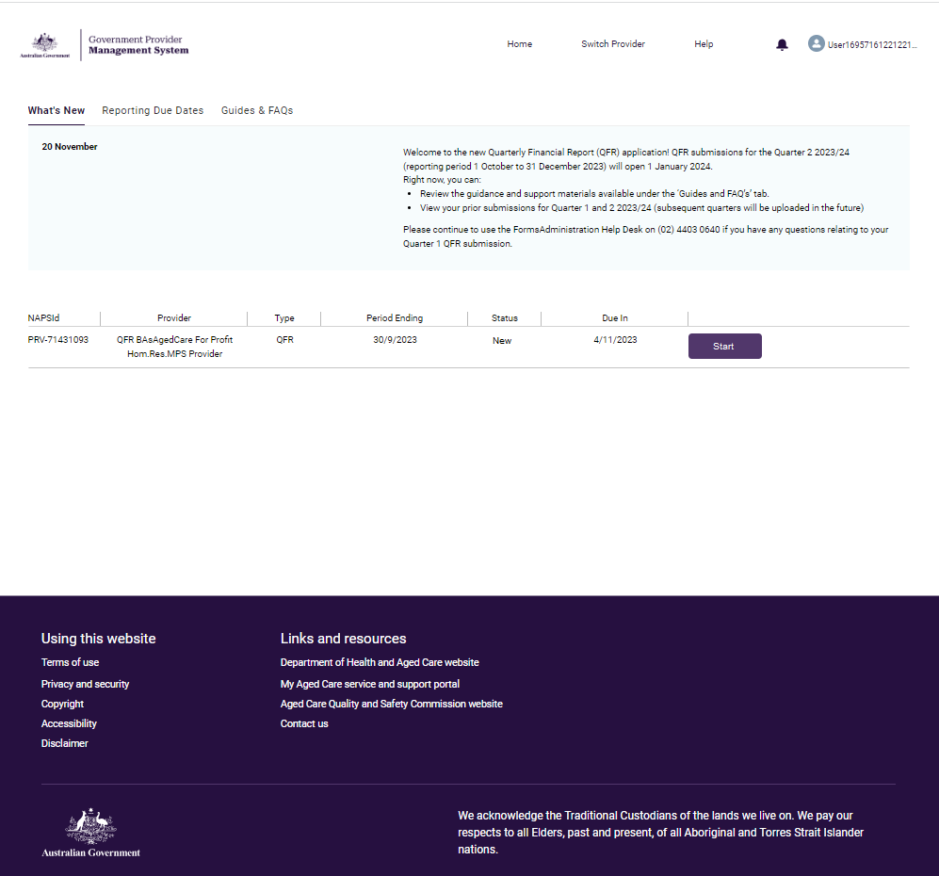
The Financial reporting home page is made up of the three main parts:
- GPMS portal header across the top of QFR application pages
- Financial reporting, which contains QFR information, tabs, links, and buttons that are described in this user guide
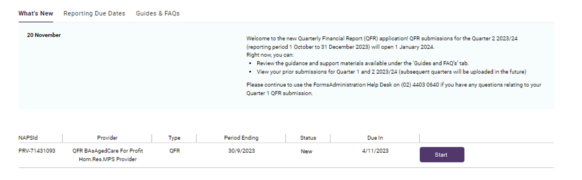
- GPMS portal footer across the bottom of QFR application pages.


Financial reporting
From the Financial reporting home page, you can explore more information about QFR resources by navigating the tabs:
- What’s New
- Reporting Due Dates
- Guides & FAQs.
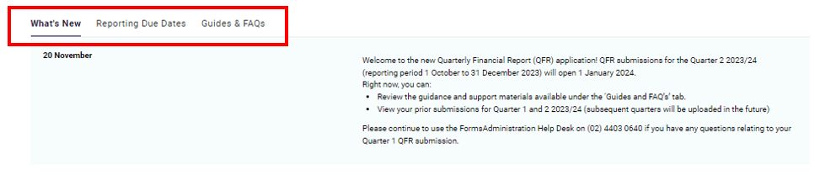
Below the resources section, you will find a table of reports where you can access your QFR.

What’s New tab
What’s New is the default tab displayed when you first navigate to the Financial reporting home page. You will find a summary of updates since the last reporting quarter. The information on this tab may be related to a change in policy, data collection, process, and system functionality.
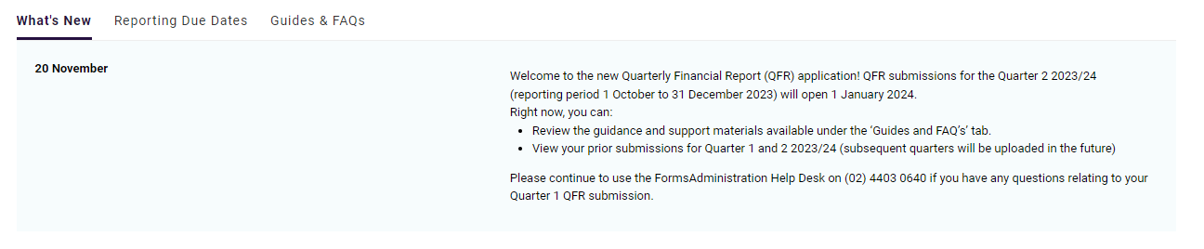
Please note:
Refer to the department’s website for the latest information on QFR.

Reporting Due Dates tab
Select the Reporting Due Dates tab to see the QFR submission dates.
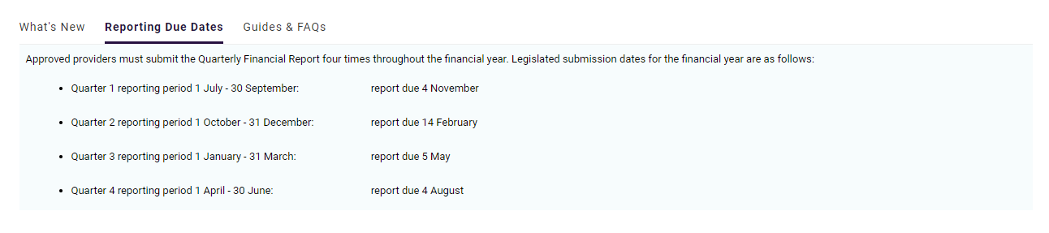
Please note:
The QFR submission opens the day after the previous reporting period end date and closes on the legislated due date.

Guides & FAQs tab
Select the Guides & FAQs tab to access various guidance resources for reporting your quarterly financial and prudential data and using the new QFR application.

When you select a listed resource, you will be redirected the department’s website.
Please note:
The department’s website is the source of truth for all published QFR information and guidance materials.

Table of reports
The table of reports is list of quarterly financial reports that your organisation:
- is required to submit for the current quarter submission
- has submitted for previous quarters.
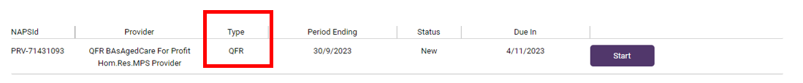
The following information about the report is also displayed:
- NAPS ID is a unique identifier assigned to your organisation as a provider of aged care services
- Provider displays your organisation type, service, and name
- Type indicates the classification of financial reporting by frequency
- Period Ending is the quarter end date of the QFR reporting period
- Status tracks the progress of the QFR submission
- Due In is the date the QFR must be submitted by.
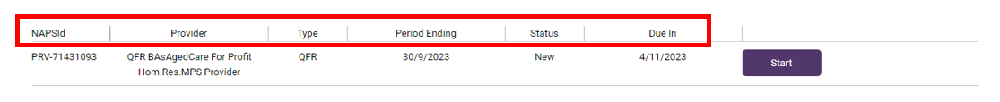
Please note:
Contact Forms Administration if a QFR that you expect to submit is missing from the list.

Completing a report
A QFR can be actioned by selecting the:
- Start button to commence a new submission
- Resume button to continue a submission in progress
- Download button to save a copy of your report in your computer.
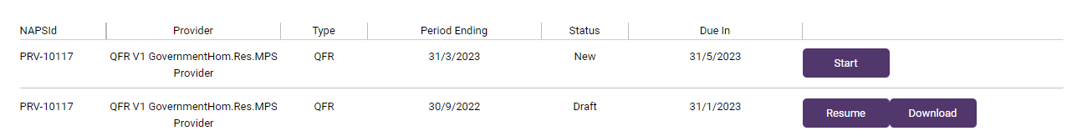Start function
Select the Start button that corresponds to a report in New status that you would like to complete.
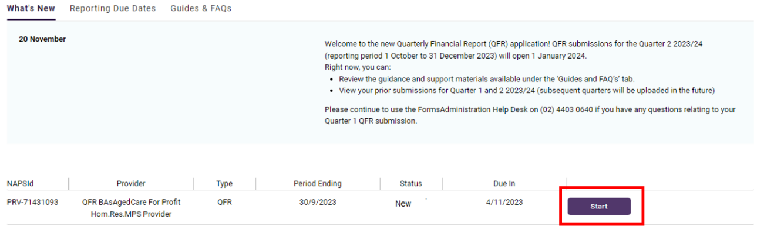
The Before You Start section of the QFR will be displayed.
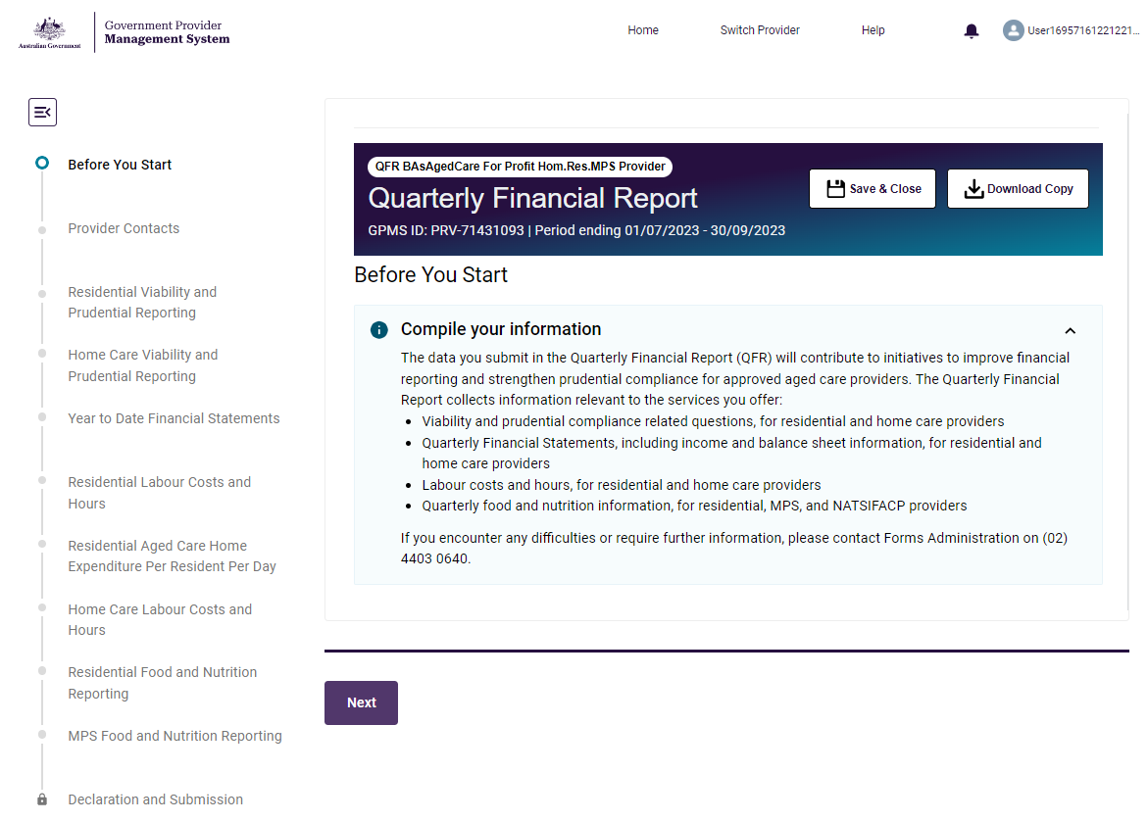

Resume function
Select the Resume button that corresponds to the report that you would like to continue completing. You will be able to resume a report that you have saved in Draft or in Reissued status.
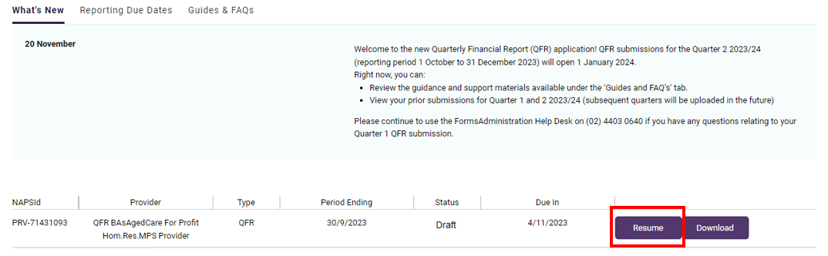
The Before You Start section of the QFR will be displayed.

Download function
Follow the steps to download your submitted report below.
- From the Financial reporting home page, navigate to the table of reports at the bottom half of the screen.
You may download a copy of your report while completion is in progress. In this case, the Resume and Download buttons are both available as options.
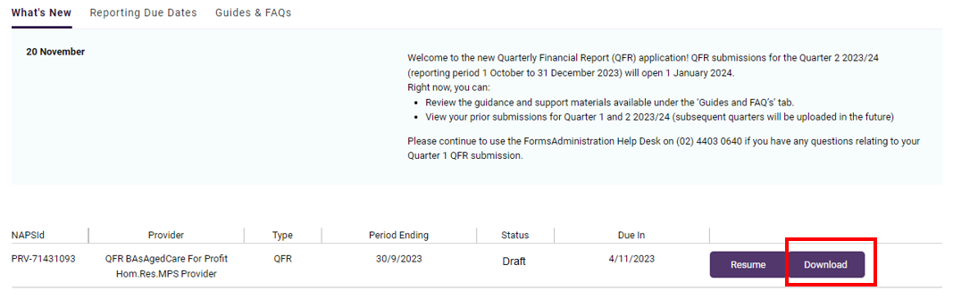
When a report has been submitted, only the Download button is displayed.
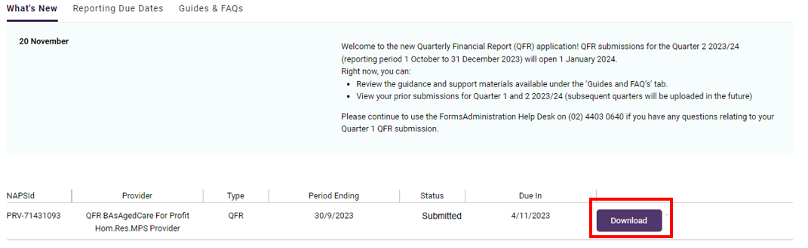
- Select the Download button that corresponds to the report that you wish to save to your storage drive.
You will be prompted to wait while a copy of your QFR downloads.
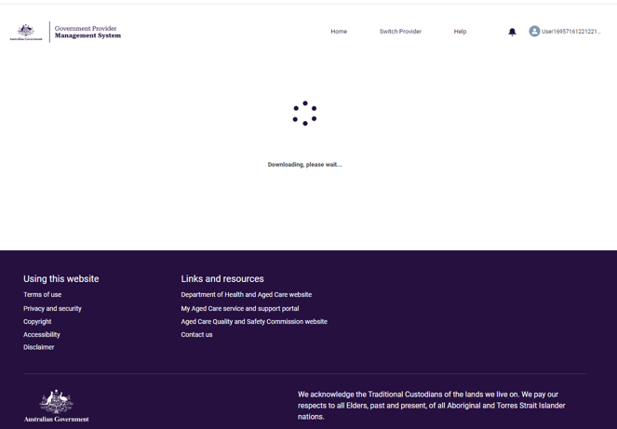
A copy of your report in Excel format will download and automatically save in your computer’s default or nominated Downloads folder.
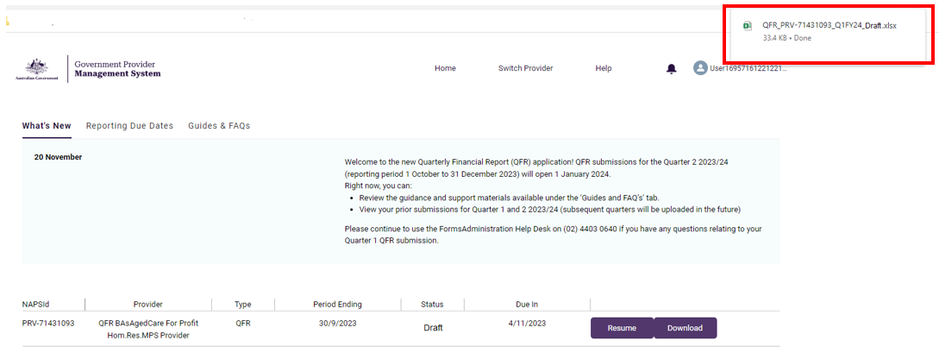

Submission status
The statuses of a QFR submission are explained in the table below.
Status | Definition
New | The report has not been started.
Draft | The report has been started and saved with or without entering data.
Submitted | The report has been submitted for the first time.
Reissued | The report has been submitted and some, or all, sections of the QFR are reopened for revision and resubmission.
Resubmitted | A previously submitted report has been reissued, updated and resubmitted.

Lock function
Your report in New, Draft, or Reissued status is locked the day after the QFR submission closing date. This is indicated by the padlock icon on the locked report line-item in the table of reports.
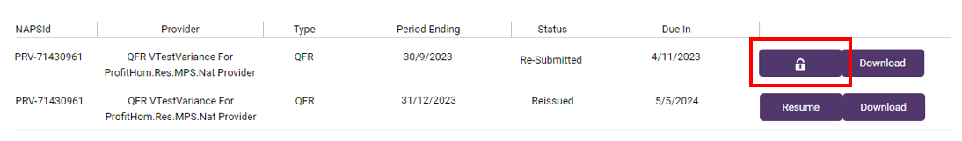

Please note:
If you need to submit or resubmit a QFR after the submission closing date, please contact the Forms Administration and request to unlock your previous quarter’s report.

Navigation and functions
The QFR form navigation and functions include:
- a sidebar navigation for moving through the report sections
- a banner that has provider and report identifiers
- call to action buttons to save and close or download a copy of the report
- the main form containing section guidance and data fields for completion
- Previous and Next buttons for moving backward and forward the form one section at a time.
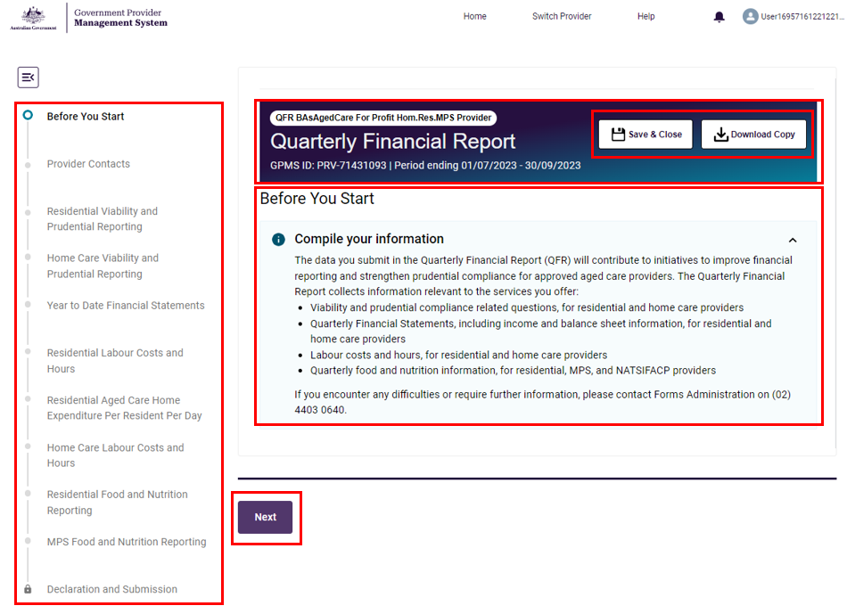

Sidebar navigation
On the left column of the screen is a sidebar navigation that allows you to move between QFR sections in any order.

The sidebar navigation lists the sections that are specific to the services you deliver. For example, the QFR sections applicable to a government provider of residential, home care, and MPS services are shown below.
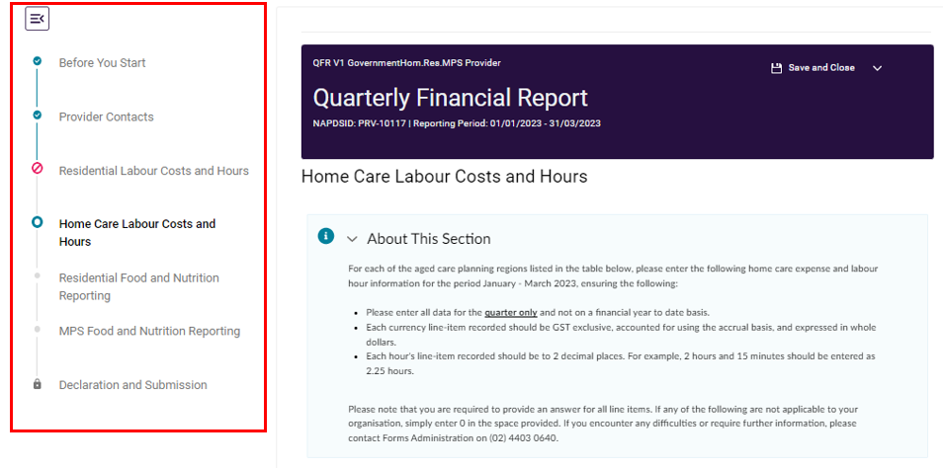
The sidebar navigation is complemented with visual cues. The meaning of each visual cue is explained in the table below.
Icon | Meaning
 | Collapses or hides the sidebar navigation
 | Expands or displays the sidebar navigation
 | Completed and passed validation
 | Visited without making an update or updated with errors
 | Currently updating
 | Not visited yet
 | Call to action buttons are disabled until the applicable sections are validated with no errors

Banner
A banner is displayed with identifying information about the report that you are completing, including:
- Your organisation type
- Your provider name
- The name of the report (Quarterly Financial Report)
- Your provider ID
- The reporting period
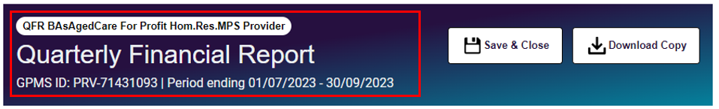

Save and Close function
On the top right-hand corner is the Save and Close button that allows you to save the QFR up to the last data you have entered.

Once saved, the Financial reporting home page is displayed.
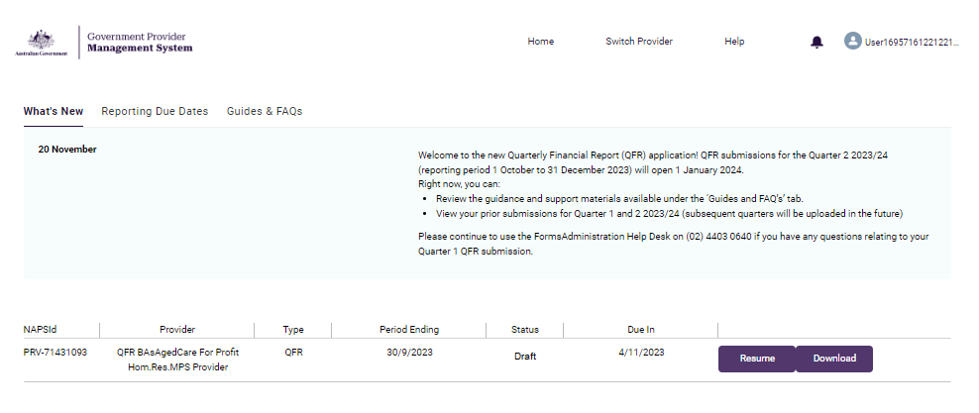

Download Copy function
Another way to download your QFR is to select the Download Copy button, which allows you to download and save a copy of your report while completing it.

You will be prompted to wait while a copy of your QFR downloads.
A copy of your report in Microsoft Excel format will download and automatically saved in your computer’s default or nominated Downloads folder.
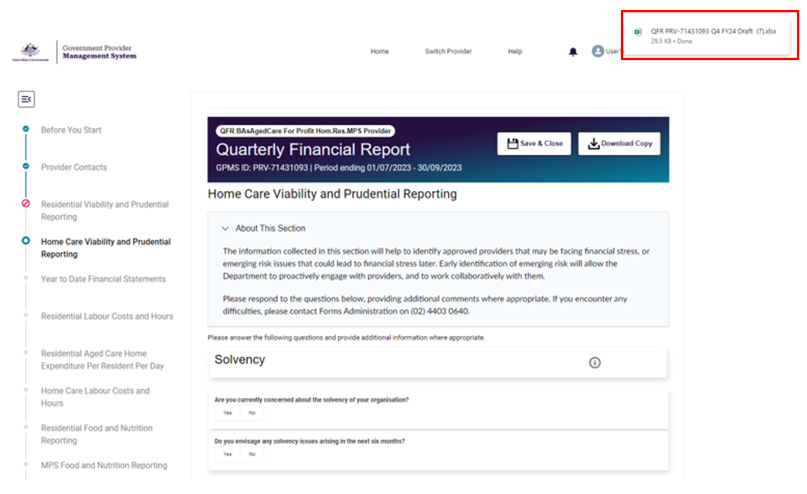

About This Section
The About This Section accordion provides instructions or guidance on the expected data to be entered in the selected section of the QFR form.
For example, the Residential Labour Costs and Hours section displays the About This Section guidance relevant to the expected data for residential labour costs and hours reporting.
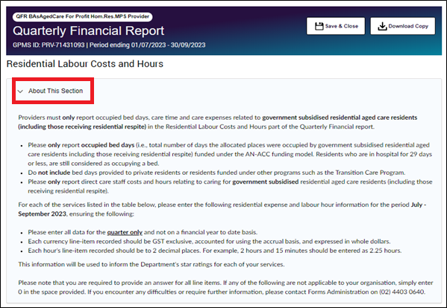
To collapse and hide the About This Section body, select the next to the ‘About This Section’ subheading once.
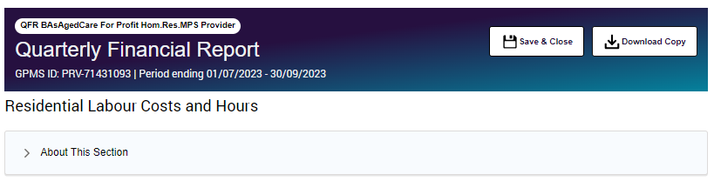

Information icon
An information icon  next to subheading names in a data table provides a link to the QFR guidance material should you require further information on the data fields while completing your report.
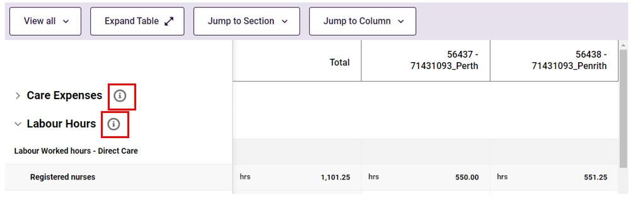

Previous and Next functions
In addition to the sidebar navigation, you can navigate the QFR form by selecting the Previous or Next button found at the bottom of each QFR section. This allows you to move through sections one step back or forward in the set order of your report.
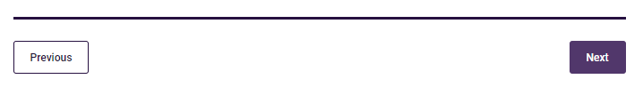
The first section, Before You Start, does not have a Previous button and the last section, the Declaration section, does not have a Next button.

Text Input field
Within the QFR form are input fields that allow data entry of text to capture:
- additional information in response to ‘Yes’ answers in the Residential Labour Costs and Hours and Home Care Labour Costs and Hours sections
- explanations to address soft validations.

For example, where you have selected a Yes answer, a text input field prompts for additional information to support your response.
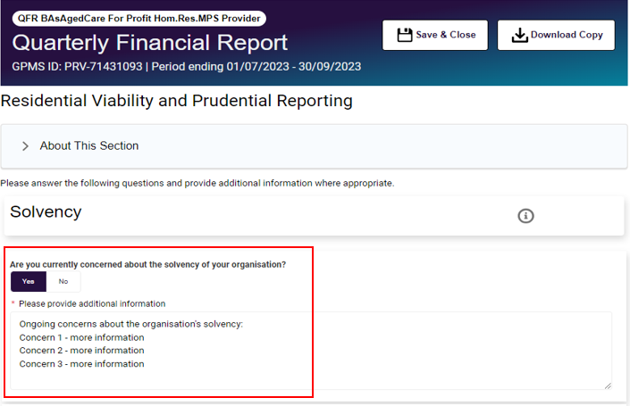
Please note:
You are able to resize the text input window by selecting and dragging down the resize handle icon on the bottom-right corner of the input field.

Table View function
Various data views are available in QFR sections that are presented in data table format:
- View All: the default table data view that displays all the columns of the table
- View Errors Only: displays the columns that have errors in the data fields
- View Comments Only: displays the columns that have comments against the data fields
Follow the steps to switch data views in a table below.

View All
Select View All from the dropdown button to activate the available table view options.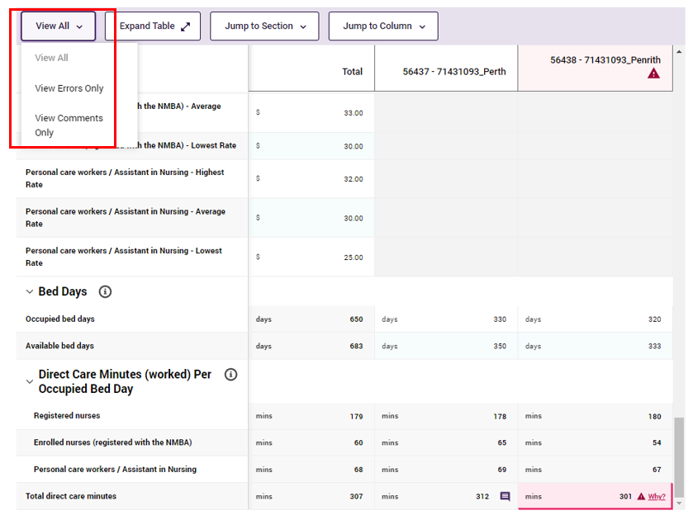
The View all data is displayed in the example Residential Labour Costs and Hours table.
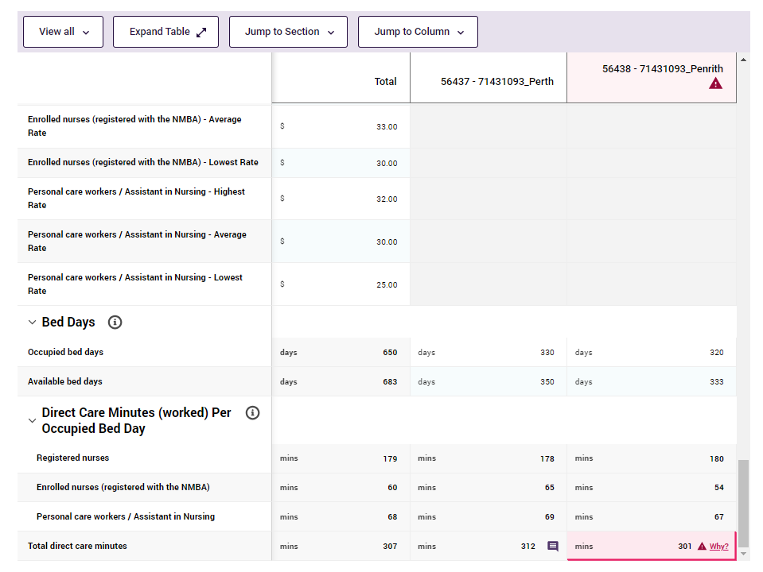

View Errors Only
Select View Errors Only from the dropdown table view options. The table will only display columns that contain an error.
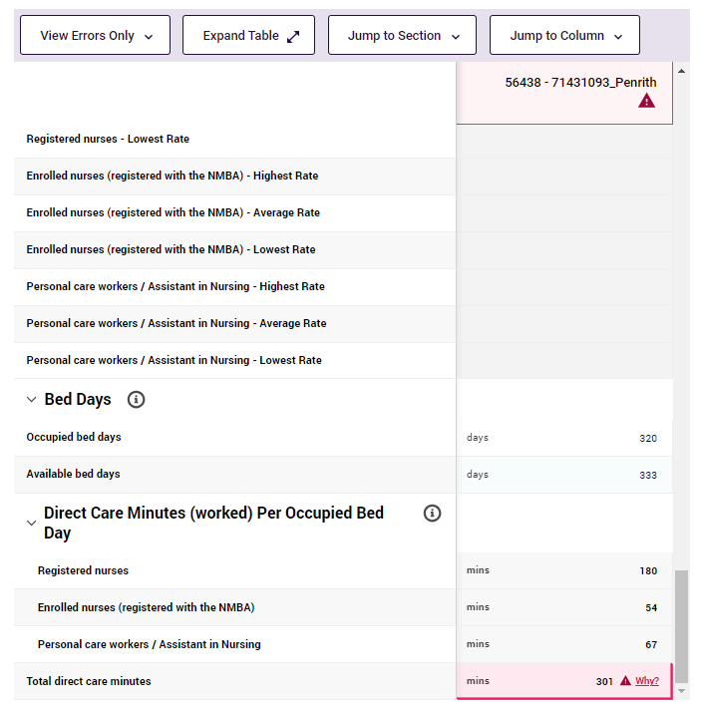

View Comments Only
Select View Comments Only from the dropdown table view options. The table will only display columns where an explanation has been added in response to a soft validation. For more information about soft validations, visit the Validation Function section.
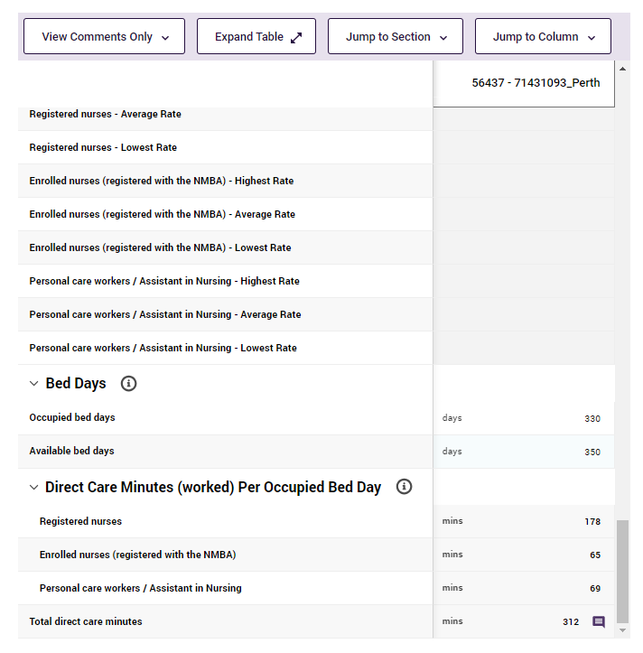

Expand and collapse subsection display
The ability to collapse and expand subsection display is available in QFR sections that are presented in data table format.
Follow the steps to switch subsection display below.
Expand subsection display
- Navigate to a data table in a QFR section.
Subsections are displayed in expanded state by default. For example, the Care Expenses subsection is presented as a heading and the care expense items as rows below the heading.
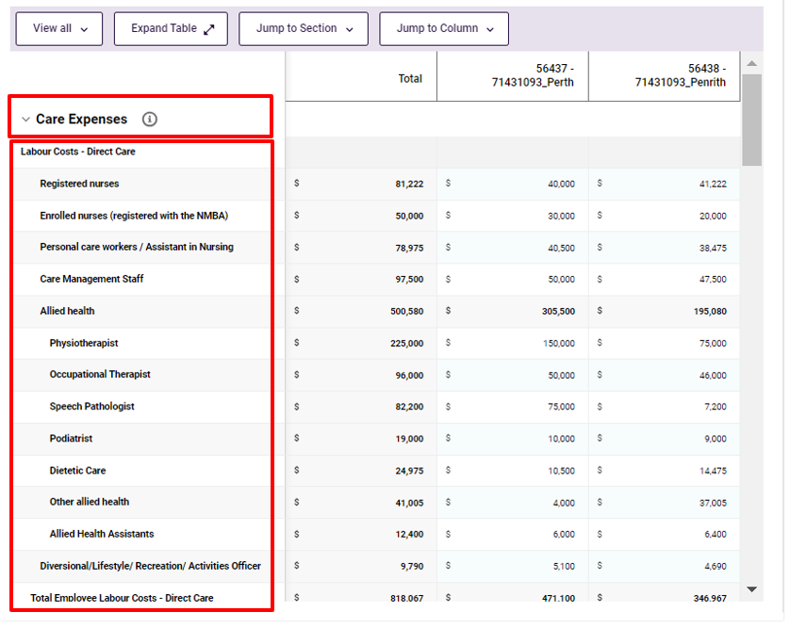

Collapse subsection display
- Select Care Expenses once to collapse the Care Expenses subsection.
The care expense rows are hidden when the Care Expenses subsection is collapsed.
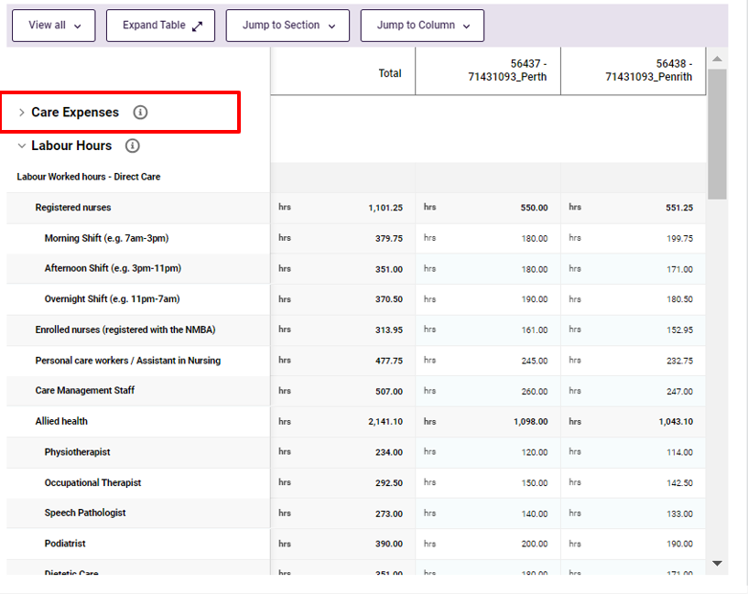

Expand Table and Shrink Table functions
The Expand Table and Shrink Table functions are available in QFR sections that are presented in data table format.
Follow the steps to switch table presentation display below.

Expand Table
Select the Expand Table button for a full on-screen view of the table.
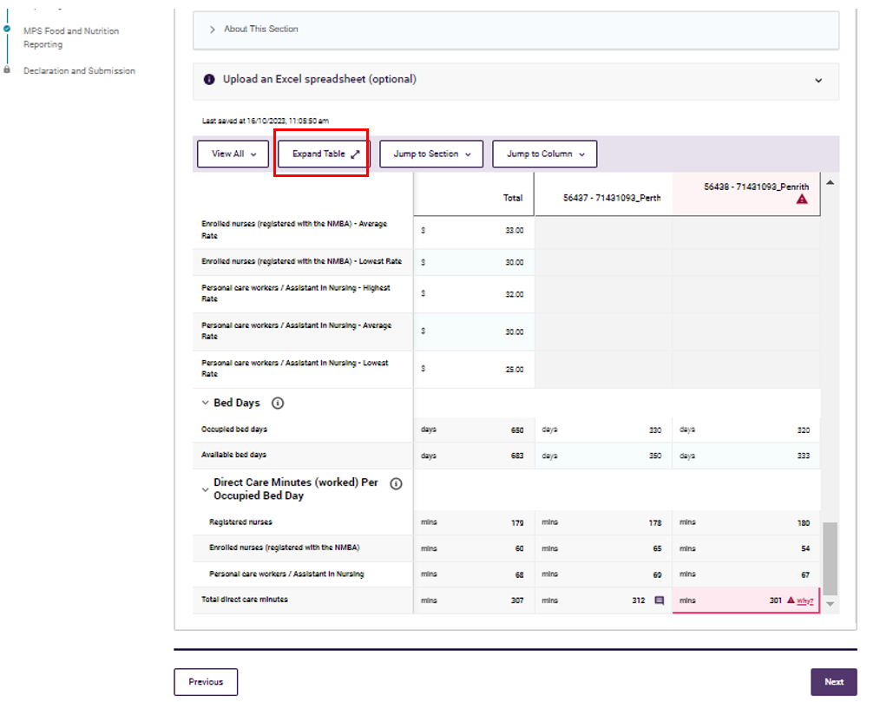
An expanded table displays the columns across the full width of your screen.
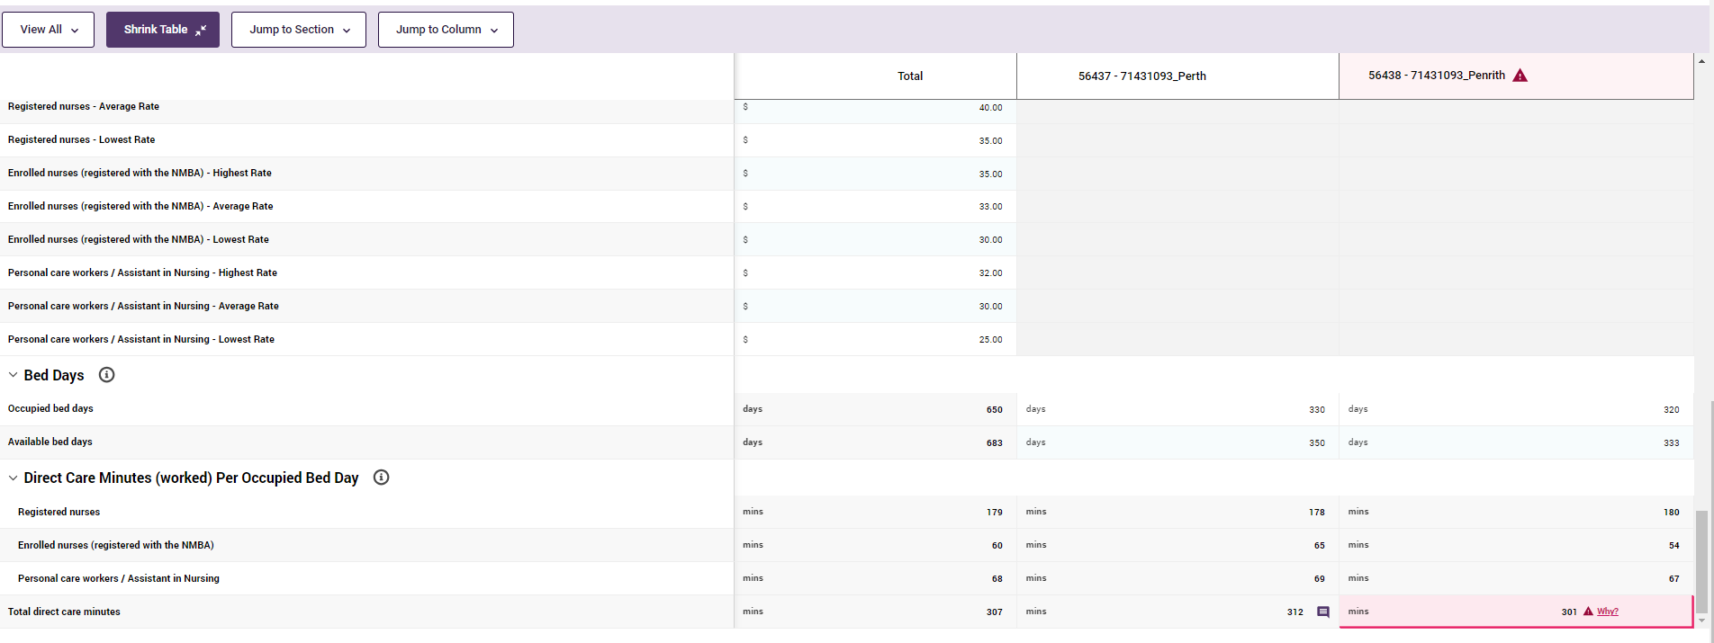
Please note:
There is no call to action displayed in the expanded table view. You must shrink the table to access:
Save and Close and Download Copy options
Sidebar navigation
Previous and Next buttons.

Shrink Table
- Select the Shrink Table button for a compressed view of the table.
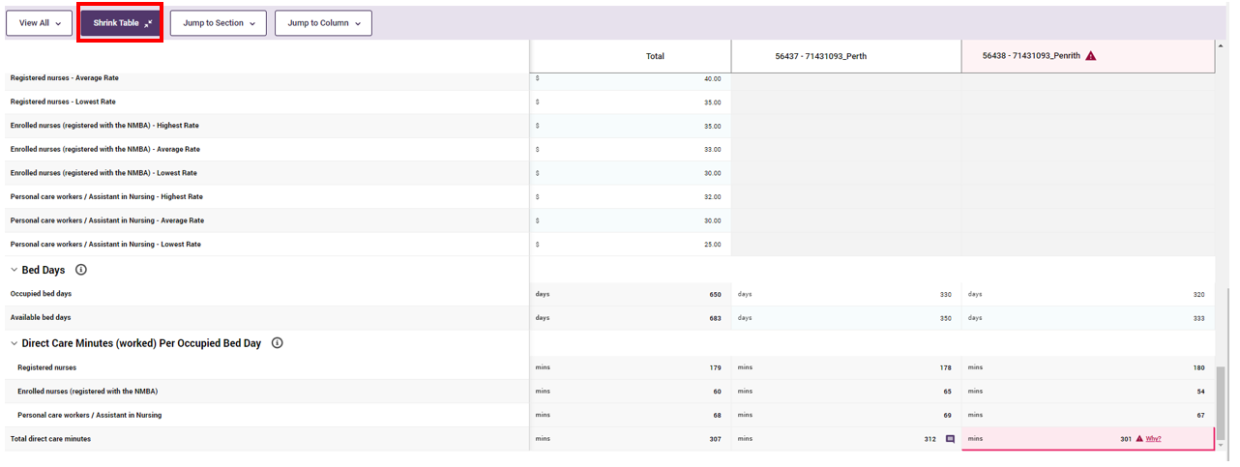
The default compressed table is displayed on your screen.
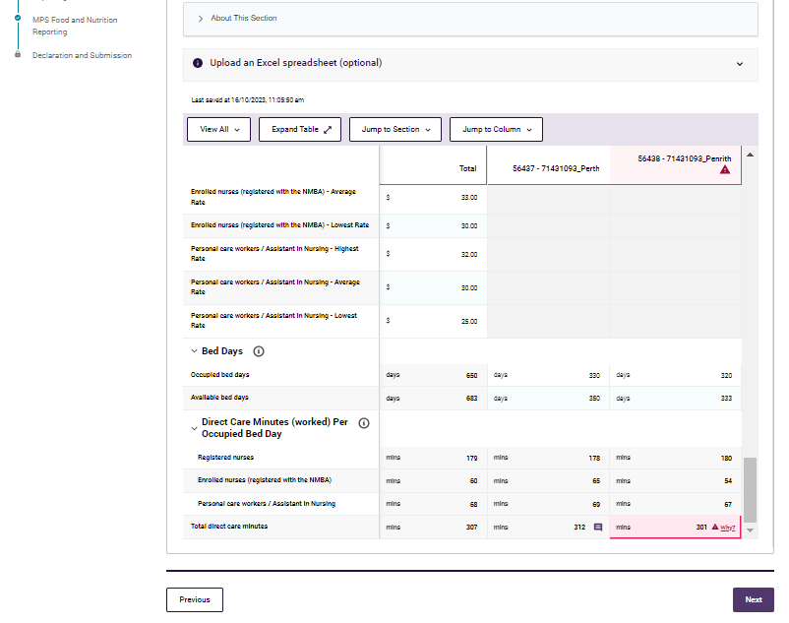

Jump to Section function
The Jump to Section is a navigation shortcut in place of vertical scrolling down the screen. It is available in QFR sections that are presented in data table format.
Follow the steps to jump section display below.
- Select the Jump to Section from the dropdown button. A list of heading names contained within the QFR section is displayed.
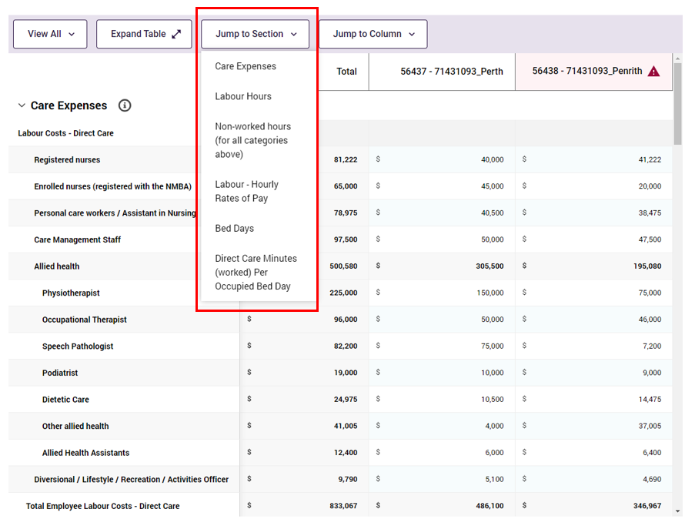
- Select a heading name from the list to reposition your cursor to the beginning of the selected heading within the QFR section.
For example, selecting the Non-worked hours (for all the categories above) section repositions the display of the Non-worked hours (for all the categories above) heading at the top row of the table.
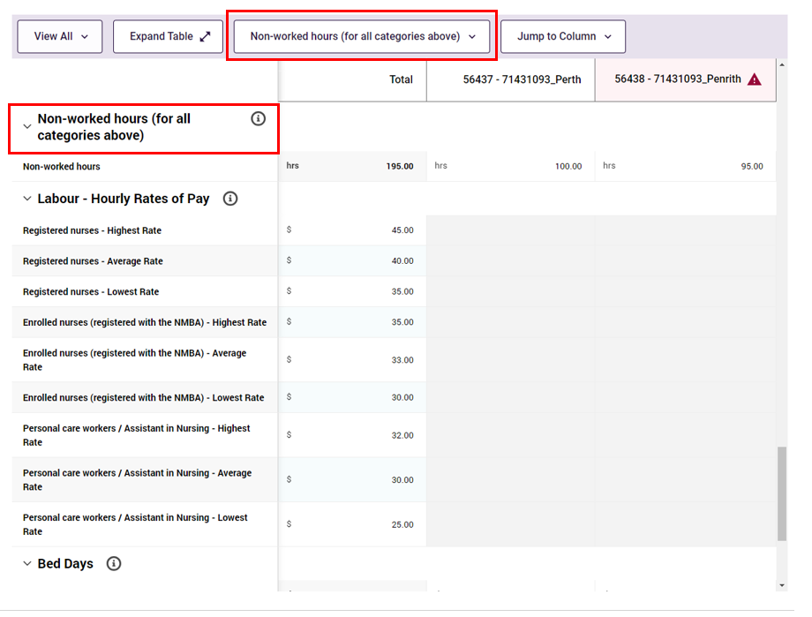

Jump to Column function
The Jump to Column is a navigation shortcut in place of horizonal scrolling across the screen. It is available in QFR sections where a table is presented for completion.
Follow the steps to jump column display below.
- Select Jump to Column from the dropdown button. A list of column names contained within the QFR section is displayed.
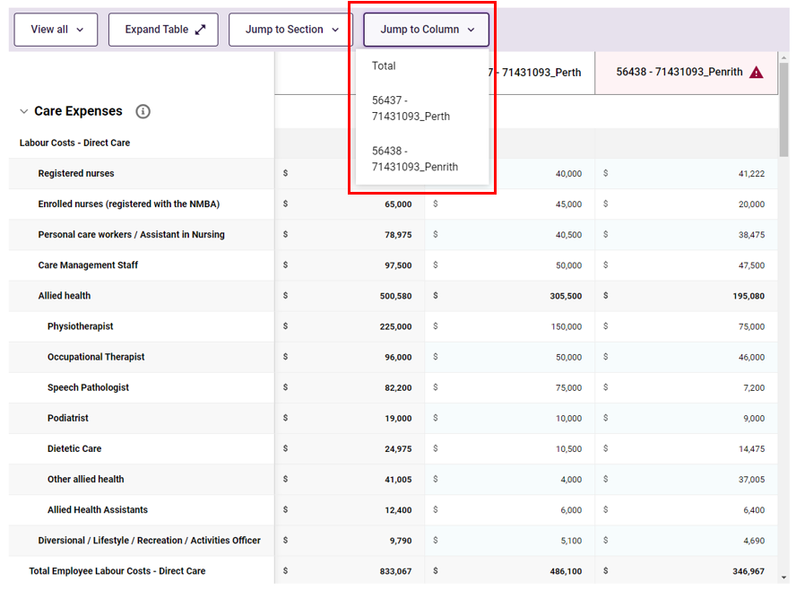
- Select a column heading name from the list, which repositions display to:
- the first column to the right of the column labels, or
- within visible view where a table has limited number of columns.
For example, selecting to jump to the 56438 - 71431093_Penrith column keeps the same display as it is visible without needing to reposition the data to the right of the column labels.
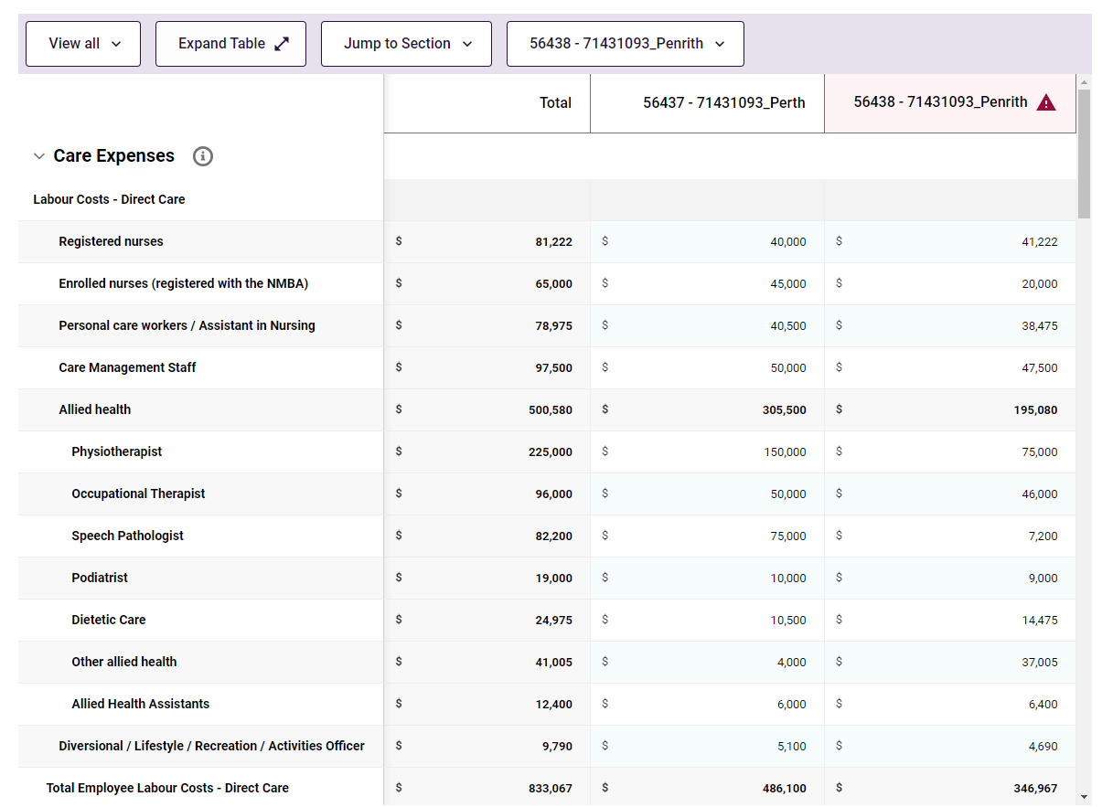

Food preparation model dropdown
You will find the Food preparation model dropdown in the following food and nutrition sections of the QFR:
- Residential Food and Nutrition Reporting
- NATSIFACP Food and Nutrition Reporting
- MPS Food and Nutrition Reporting.

The Food preparation model dropdown limits the valid responses for the main meals food preparation to:
- Cook fresh
- Cook chill
- Cook freeze.

Follow the steps to select the food preparation model below.
- Taking breakfast food preparation for the Perth facility as an example, navigate to the intersecting cell for Select how your breakfast is prepared (excluding snacks) row and for 54206 - 71431042_Perth column.
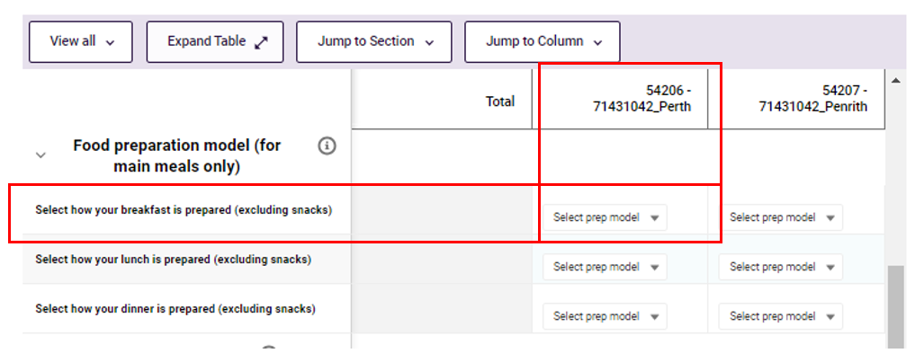
- Select the Select prep model from the dropdown to activate the food preparation model options.
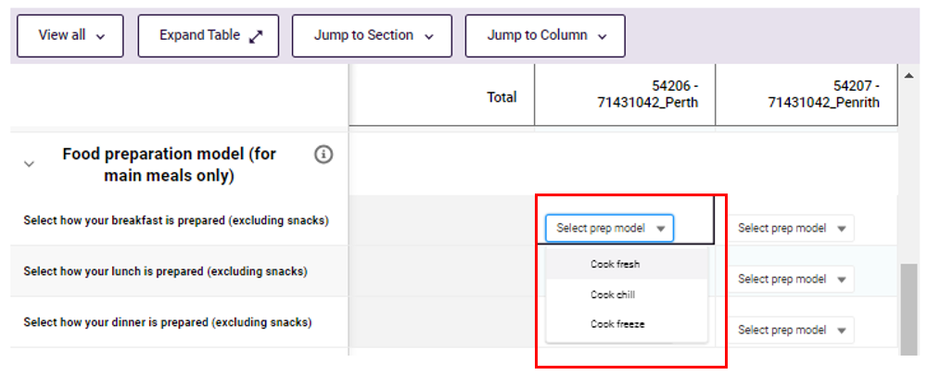
- Select the applicable breakfast food prerpation. For example, Cook chill, for the Perth faciity.
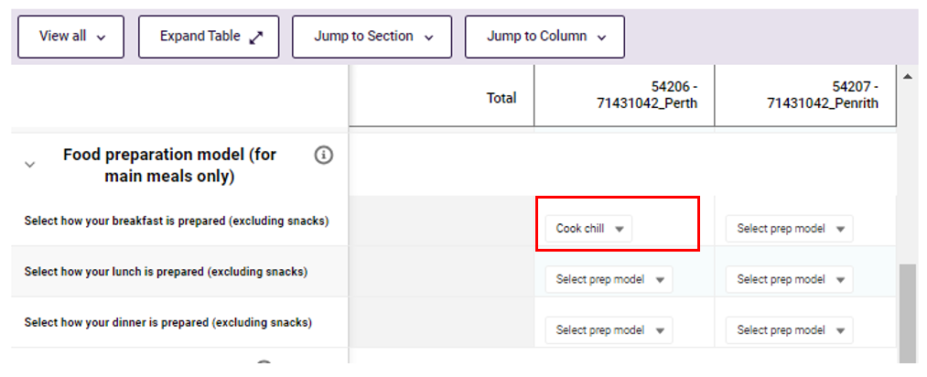

- Complete the selection of the applicable main meals food preparation model for all your facilities.
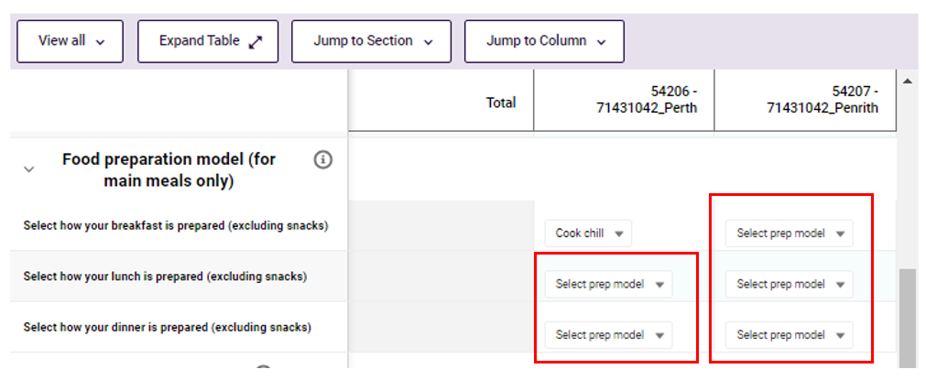

Validation function
The QFR form has built-in data field validations that check for common completeness and accuracy errors when completing your report. The data field validation details are outlined in the Validation rules and error alerts section of this user guide.
There are two types of validations that trigger an error when completing your report:
- Hard validation, where the entered value must be corrected before you can proceed
- Soft validation, where the entered value must be revised or an explanation provided before you can proceed.

Please note:
Data field validations and error alerts are available when you manually enter or bulk update your data into the QFR application.
There are no validations and error alerts while you are completing your report in the downloaded Excel templates.

Addressing soft validations
A soft validation error can be addressed by following the steps below.
- Where a data field is displayed with red highlight error indicator – for example, the Total direct care minutes field is outside the 100 to 300 minutes range in the Residential Labour Costs and Hours section.
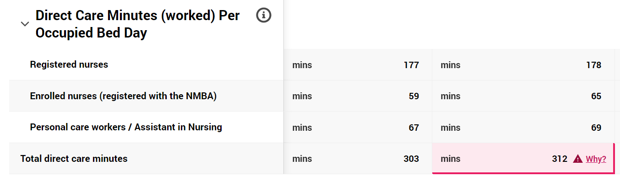
- Select the Why? link for more information about the error and suggested fixes.
If the Total direct care minutes is still outside the expected range after confirming that your data is correct, select the Please click here to provide your explanation link.
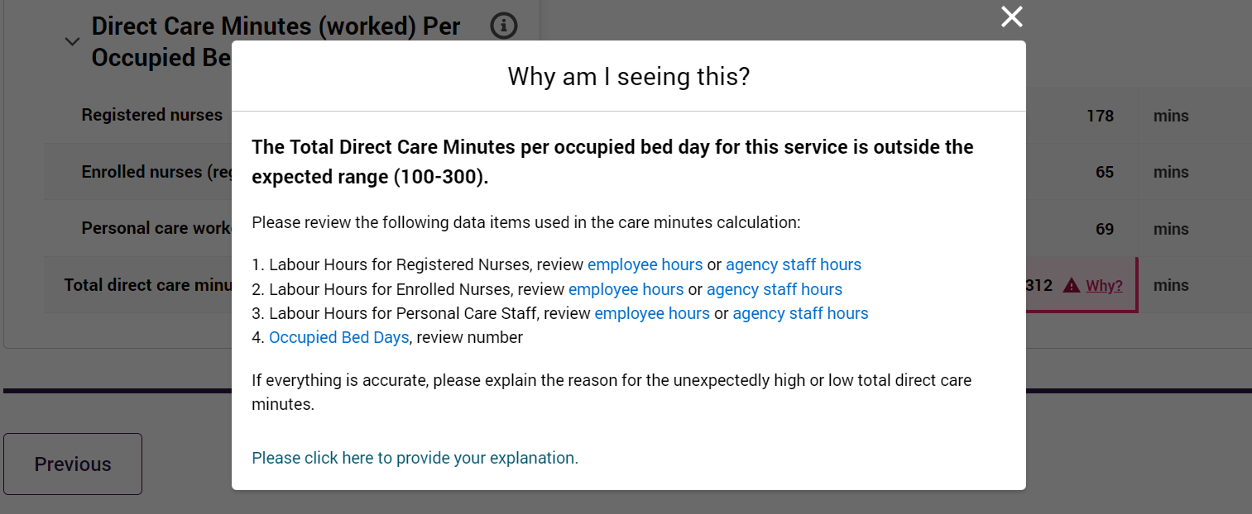
- Scroll down to the bottom half of the pop-up window.
- Enter your explanation in the text input box.
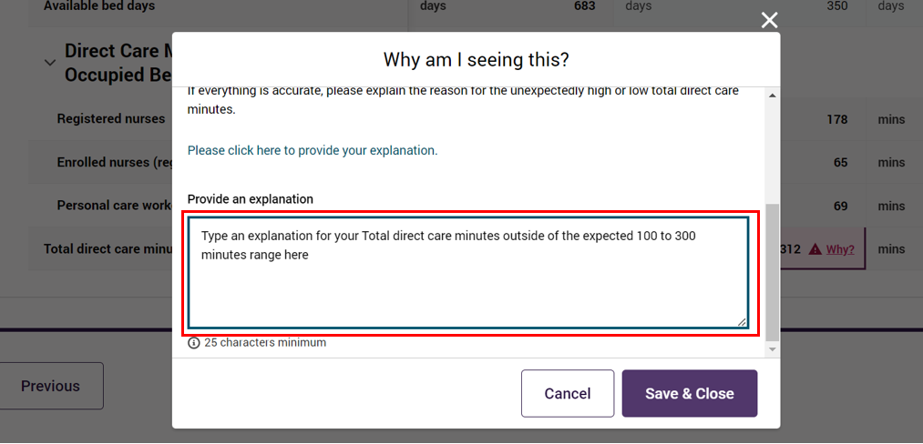
- Select the Save & Close button.
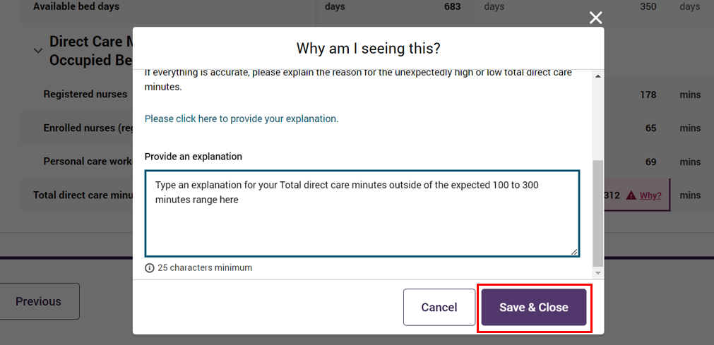
Once an explanation is saved, the error is no longer displayed and replaced by a  comment icon. A comment icon against a data field indicates that a soft validation explanation has been entered.
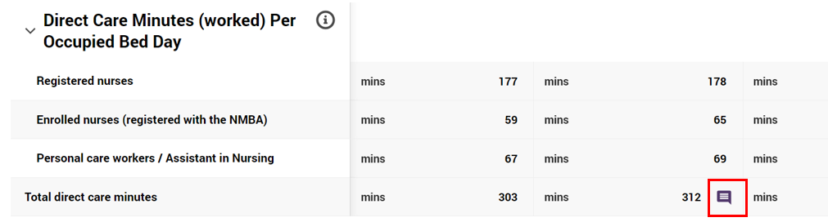
Select the comment icon to view:
- more information about the error and suggested fixes
- your saved explanation.

Please note:
Your explanation and the comment icon are automatically removed when you update the value/s in one or more data fields that contribute to the data field calculation without triggering a soft validation error.

Alternatively, select the Cancel button if you do not wish to save the entered explanation for the Total direct care minutes outside the expected range.
The error remains when you cancel saving your explanation.

File Management function
A File Management table in the Declaration and Submission section of the QFR provides information about uploaded files (‘file properties’), including:
- Title: the name of the uploaded file
- Owner: the logged-in user who uploaded the file
- Category: a grouping identifier of uploaded files by category
- Type: a grouping identifier of uploaded files by type
- Created Date: the date when the file was uploaded
- Size: the size of the uploaded file up to a maximum of 30MB
- Status: the virus scan status of the uploaded file.

Please note:
The File Management table is a shared component across GPMS applications. You may therefore find file property options which are not relevant to QFR.
Uploaded files include files that:
- you have manually uploaded to the QFR application, e.g., Declaration form
- have been automatically created by the system as part of QFR submission, e.g., submitted QFR.
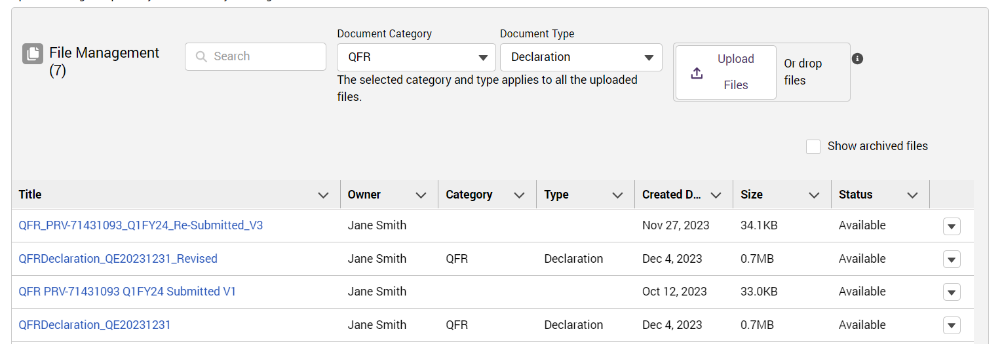
For each uploaded file, you can:
- Preview: view your file on-screen and download the file
- Update: edit file properties
- Archive: archive your file.

Preview Declaration
Follow the steps to preview an uploaded declaration file from the File Management table below.
- Select the down arrow to activate the options corresponding to the declaration file you wish to preview.
- Select the Preview option.
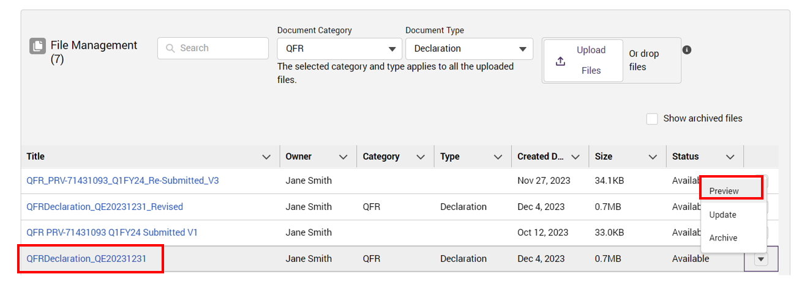

The declaration file you selected to preview is displayed on screen in a new browser window.
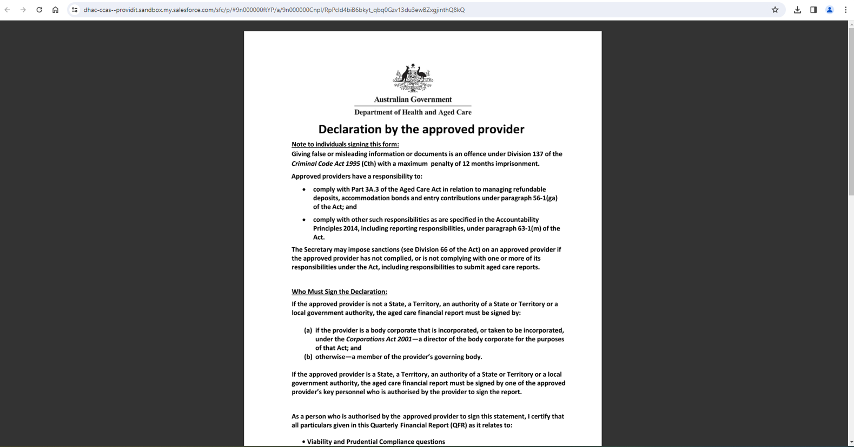
Please note:
In some cases, you may get a message to wait while the file preview generates.
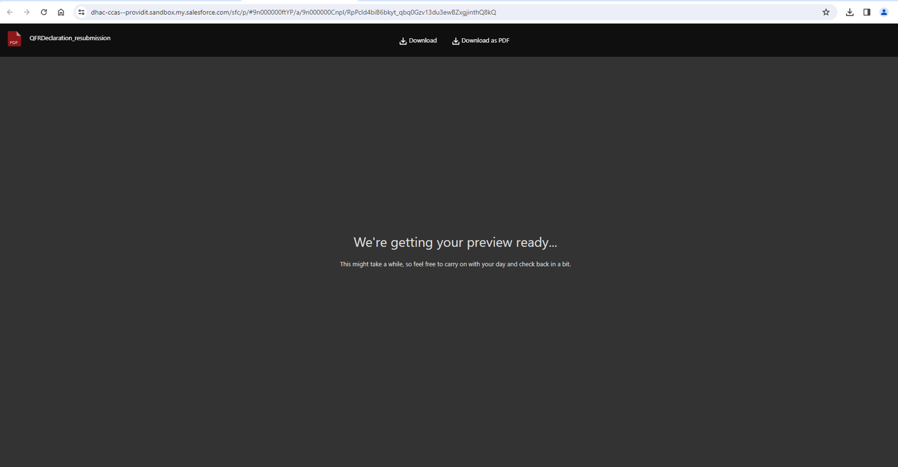

Download Declaration
(Optional download) If the Download buttons are not visible in preview mode, hover your cursor over the file name title bar at the top.
Select the Download as PDF button to save a copy of the QFR Declaration file in your computer.
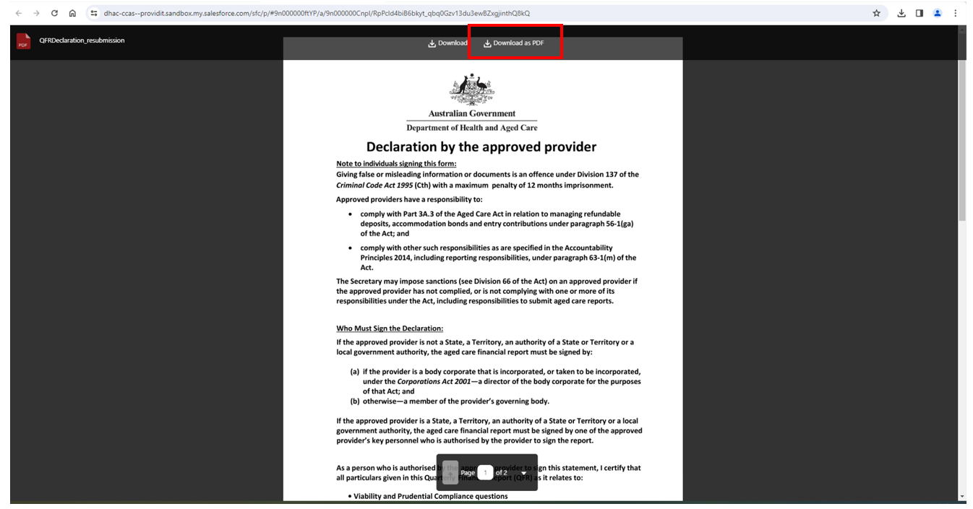

Preview submitted QFR
There is no on-screen preview for your submitted report.

Download submitted QFR
Follow the steps to download a submitted report from the File Management table below.
- Select the down arrow to activate the options corresponding to the file you wish to preview.
- Select the Preview option.
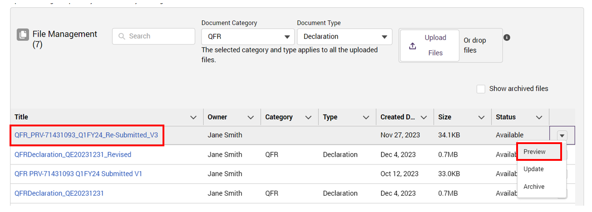
- Select the Download button to save a copy of the submitted report in your computer.
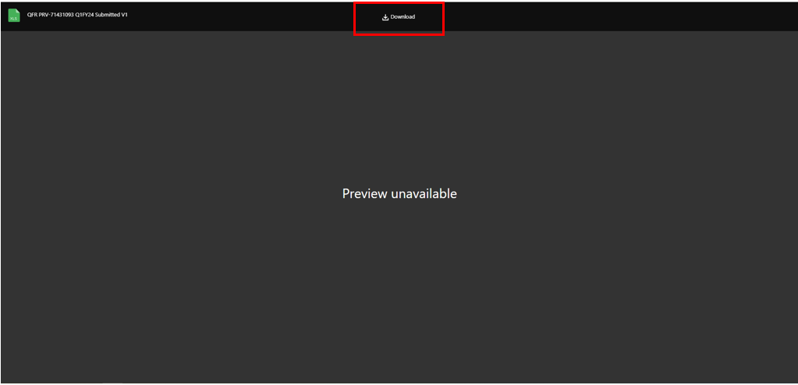

Update file properties
Follow the steps to update properties of a file from the File Management table below.
- Select the down arrow to activate the options corresponding to the file you wish to update.
- Select the Update option.
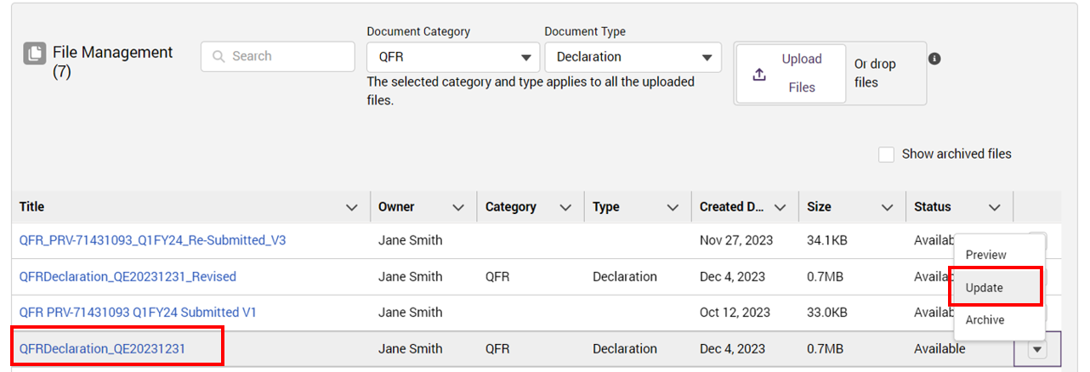
A pop-up window will be displayed with an option to edit the:
- File name
- Description
- Document category
- Document type
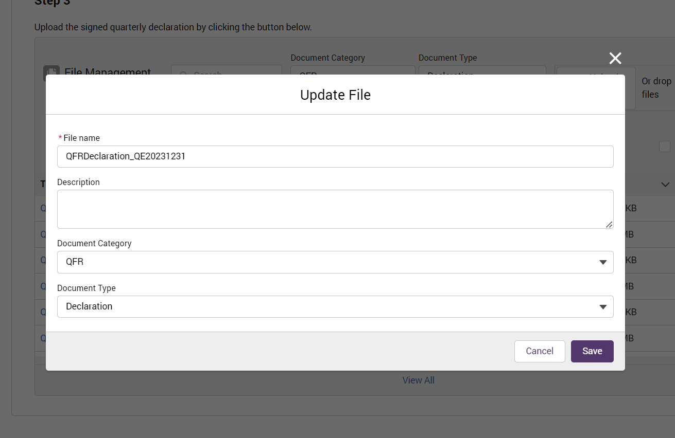
- Edit the relevant data field you wish to update. For example, update the File name to QFRDeclaration_QE20231231_Old and enter a description.
Select the Save button to save the entered file name.
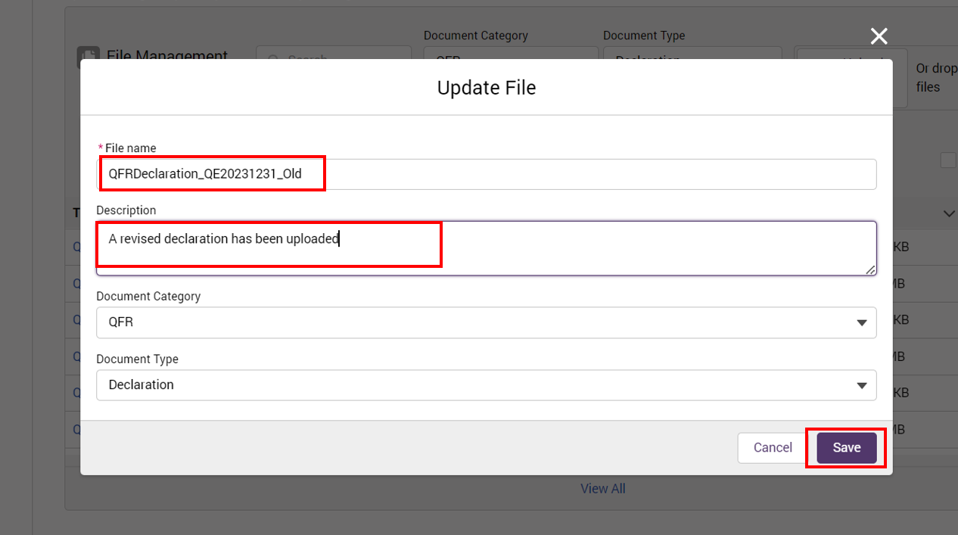
Alternatively, select the Cancel button if you do not wish to save the entered file name.
A notification for a successfully removed file will be displayed.
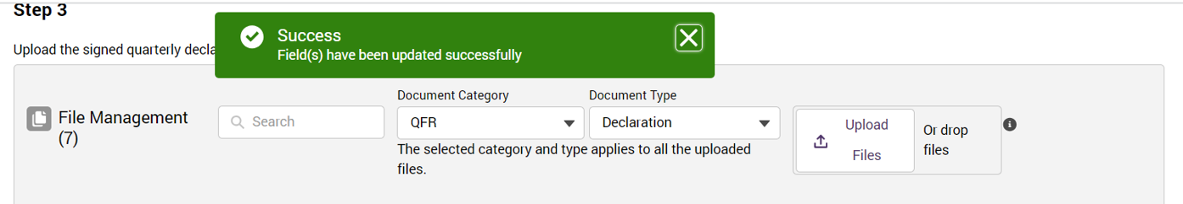

The file with the updated name is displayed.
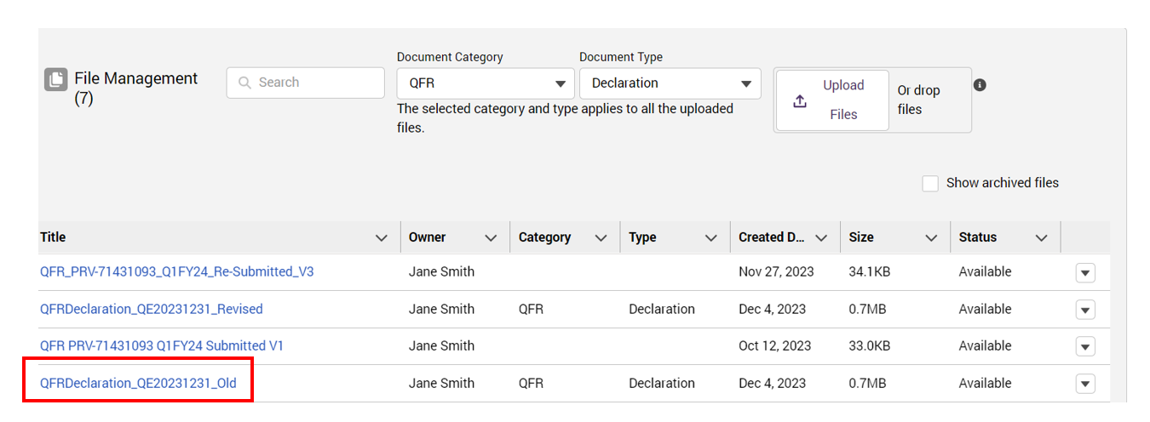

Archive File
Follow the steps to archive a file from the File Management table below.
- Select the down arrow to activate the options corresponding to the file you wish to archive.
- Select the Archive option.
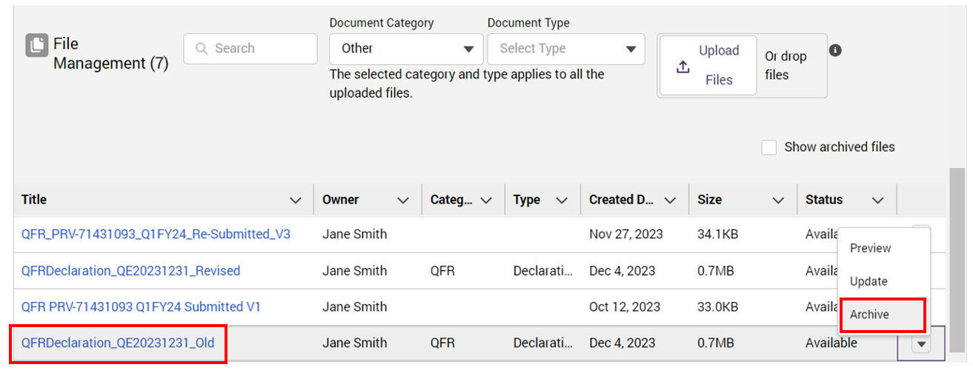
A prompt to confirm archive of the file is displayed.
- Select OK to continue with the archive of the file.
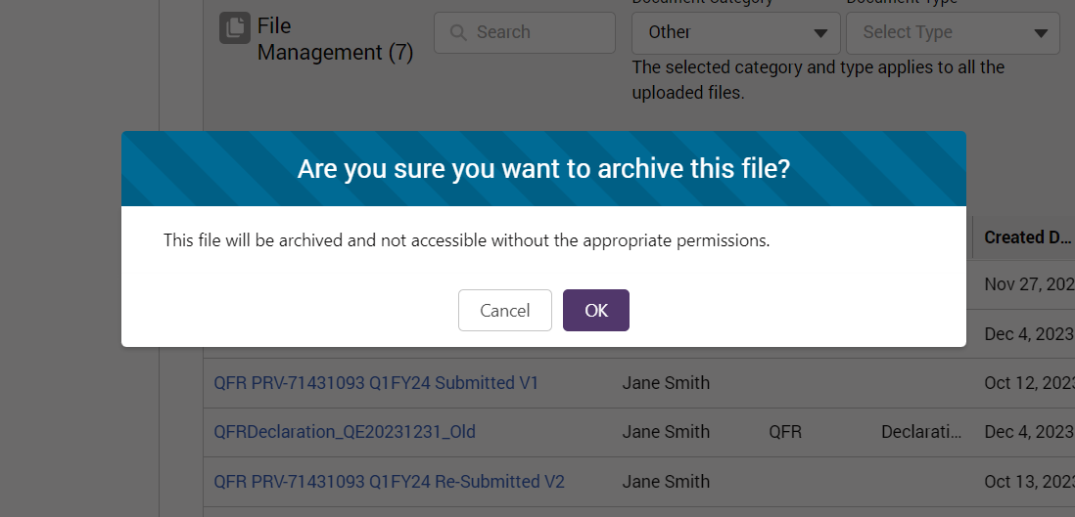
Alternatively, select the Cancel button if you do not wish to archive the file.
A notification for a successfully archived file will be displayed.
The deleted file QFRDeclaration_QE20231231_Old is no longer displayed in the File Management table.
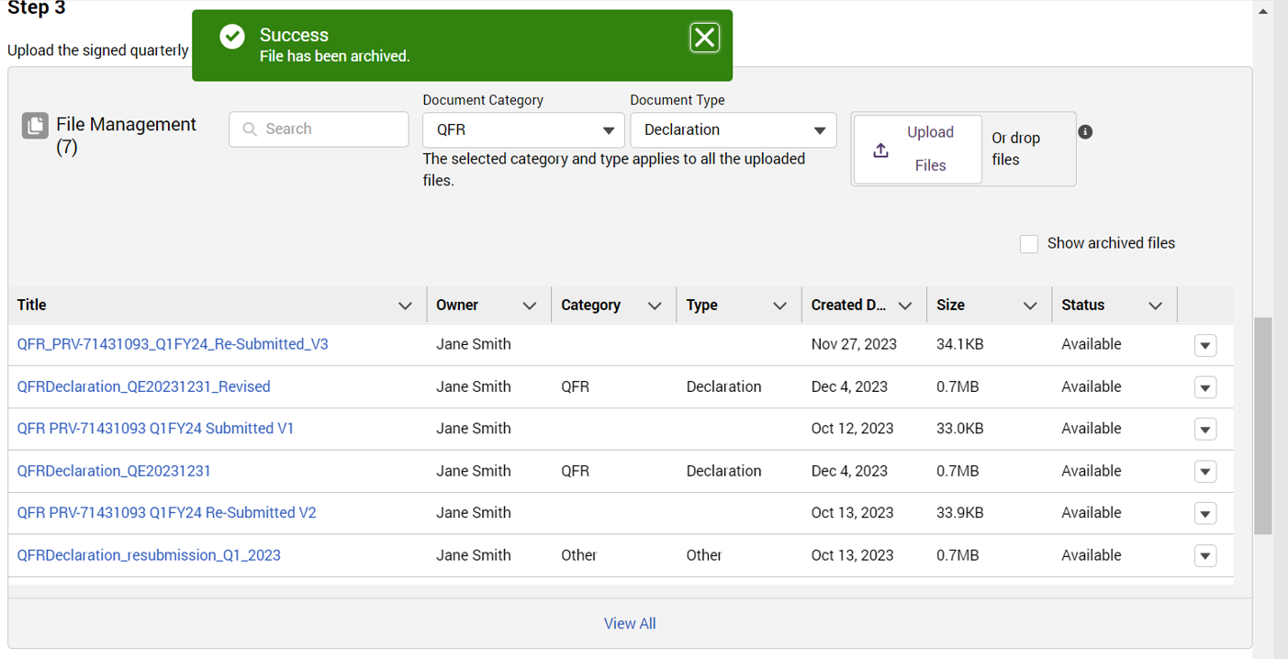
- To view your archived files, select the checkbox next to the Show archived files. The archived file QFRDeclaration_QE20231231_Old will be displayed in the File Management table with an Archived status.
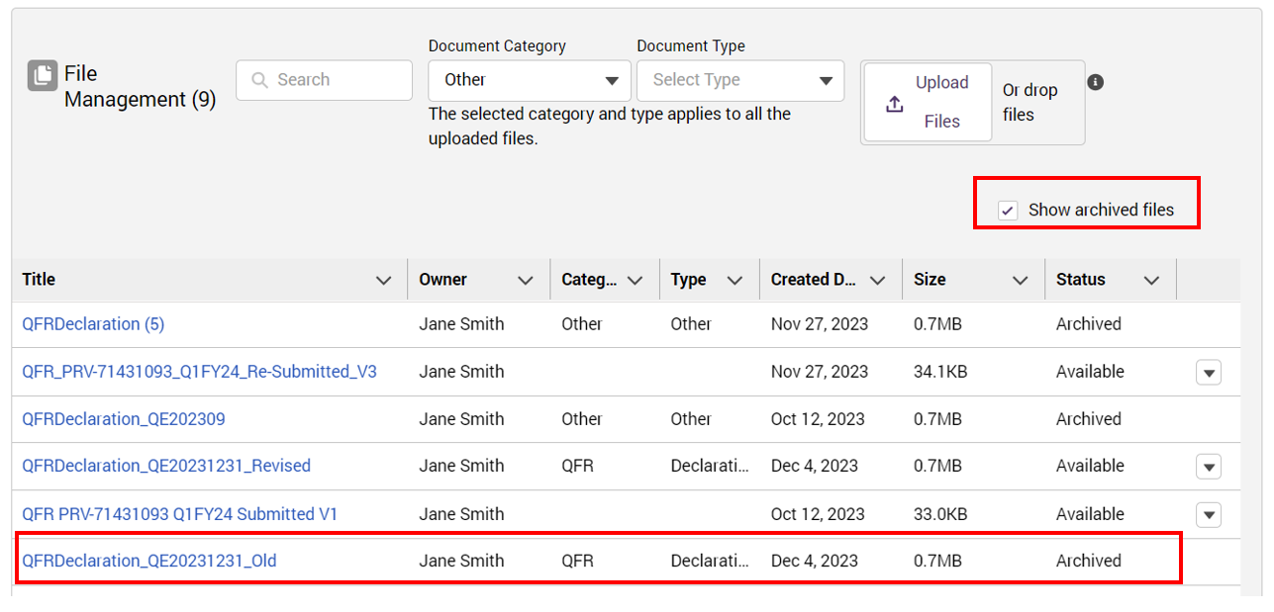

Virus scan function
Files are scanned for viruses when uploaded into the QFR application. This occurs during:
- Bulk update of data in QFR sections
- Upload of signed declaration form.

Virus scan status
After the file upload is completed, a message is displayed to:
- confirm a successful upload of your declaration
- inform that your declaration file is scanned for viruses
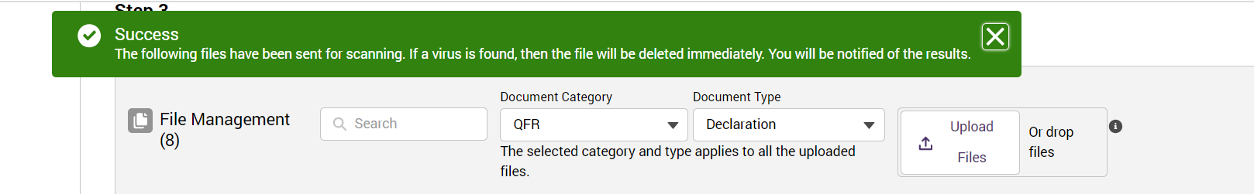
Please note:
There may be a short wait time while the uploaded files are scanned.
When the virus scan is complete, the uploaded file is displayed with Available status.
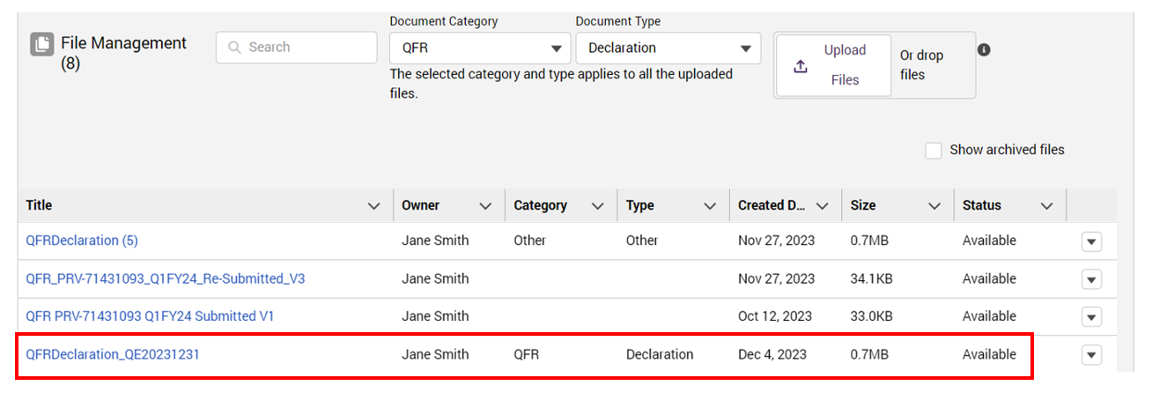

Virus scan status notification
You will also be notified through the internal mailing system of the virus scan status, as indicated by a red count over the incoming message notification icon.
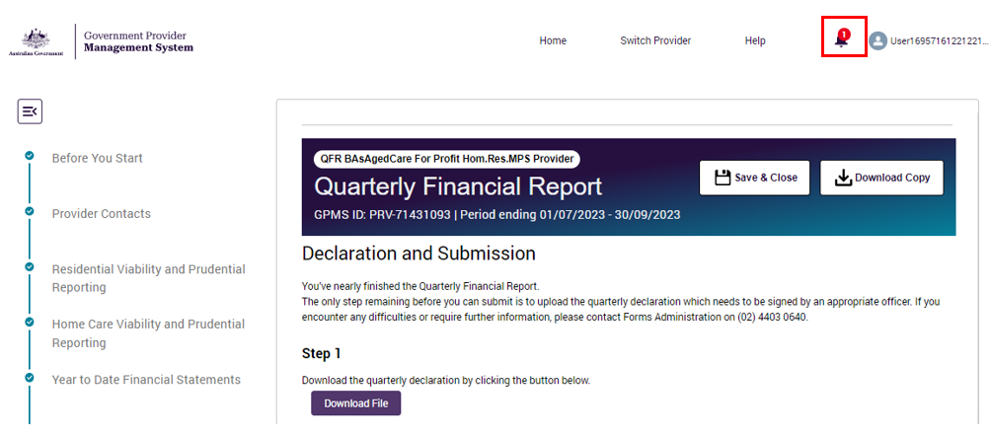
Select the notification icon to view the virus scan result.
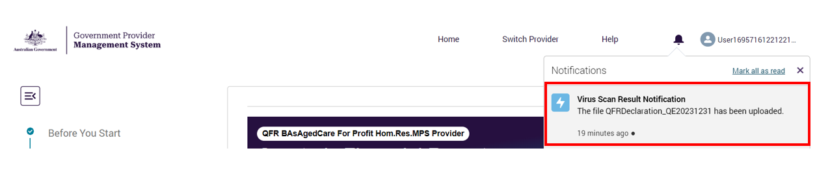

Entering data into the QFR form
The QFR form may be completed by manual and bulk entry (where applicable) of data.

Manual entry of QFR data
Where a section of the QFR is presented in data table format, you have the option to manually enter your data, such as cost amounts, hour values, or count of number of days, into a data field.
Follow the steps to manually enter data into the relevant section of the QFR below.
- Enter your data into the table. The entered data is automatically saved as soon as it is committed into a data field.
- The entered data is validated against a rule that is built into to the applicable data field.
Where the data has passed the field validation, the data field is displayed without an error alert.
Where the data has failed the field validation, the data field is displayed with an error alert. Refer to Validation rules and error alerts for an explanation of common errors. Update your data based on the suggested correction for the error.
- Continue entering data into the table until all the data fields are populated and where applicable, successfully validated. You also have the option to navigate away from a section with errors to complete later.

Please note:
You will not be able to update:
Calculated data fields
Row and column labels.

Refer to QFR form for further guidance on the specific sections of the QFR.

Bulk update of QFR sections
Where the data can be entered by bulk update in a QFR section, instructions are displayed under the Upload an Excel spreadsheet (optional) heading in expanded state.
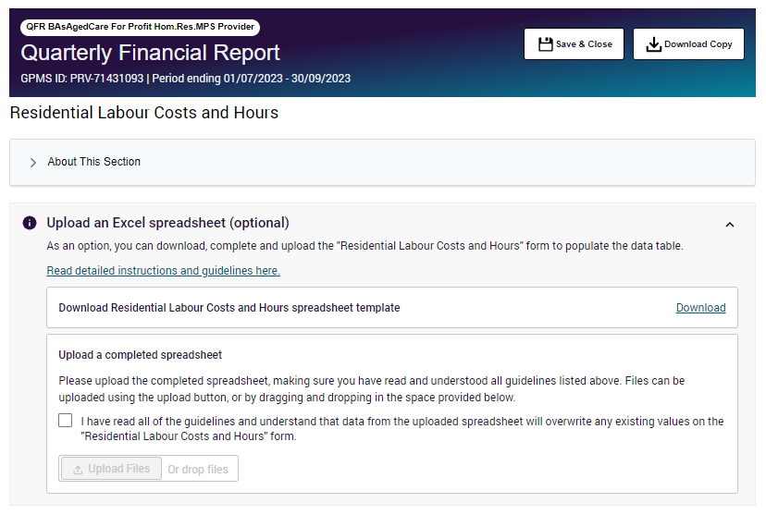
As an alternative to manually entering data in the QFR form, you may download the excel template corresponding to a QFR section, enter or copy your data into the spreadsheet, then upload the updated spreadsheet to fill out data in the following sections:
- Year to Date Financial Statements
- Residential Labour Costs and Hours
- Home Care Labour Costs and Hours
- Residential Food and Nutrition Reporting
- NATSIFACP Food and Nutrition Reporting
- MPS Food and Nutrition Reporting.

Follow the steps to fill out QFR sections by bulk update.

Download the QFR section template
- Select the QFR section that you wish to update. For example, select the Home Care Labour Costs and Hours section of the QFR to download the template.
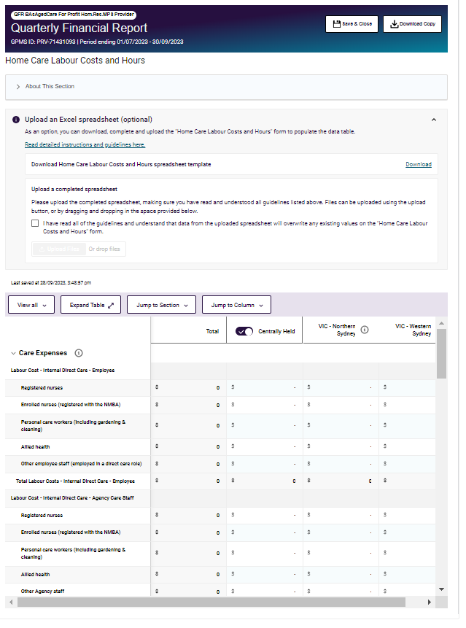

- Select the Read detailed instructions and guidelines here link.
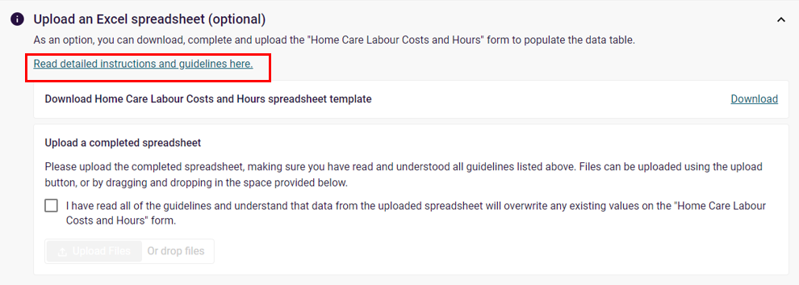
A pop-up window with further information is displayed.
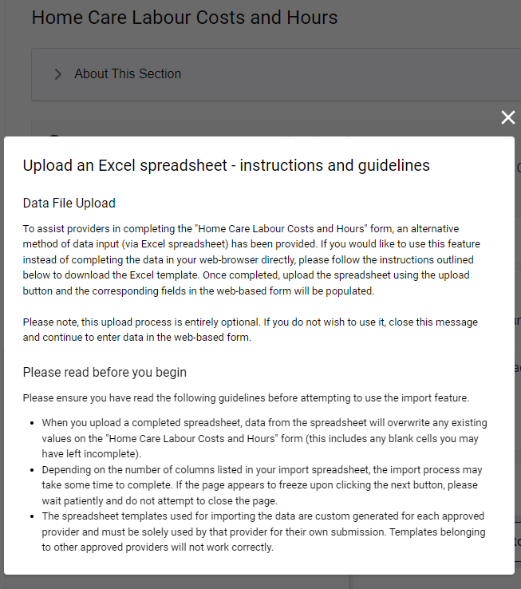

- Select the Download button to save a copy of the template.
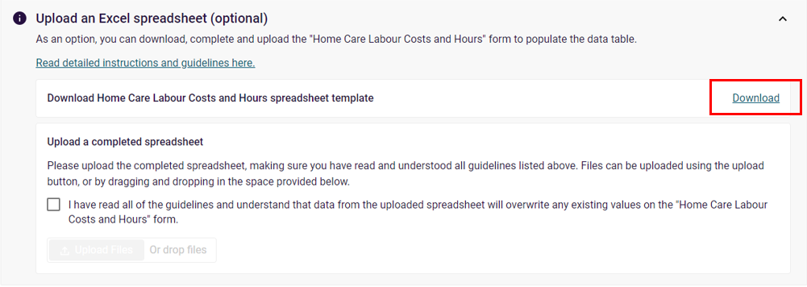
Your template in Excel format will download and automatically save in your computer’s default or nominated Downloads folder.
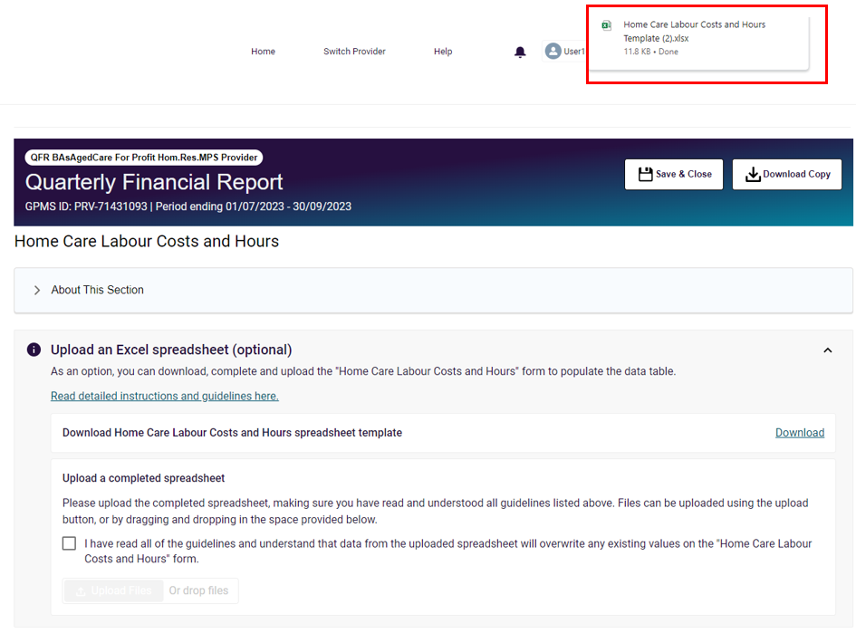
Please note:
The template for importing the data is specific to a provider’s quarterly financial reporting per NAPS ID. You must:
use the template generated for a specific report submission (templates belonging to the same organisation under a different NAPS ID will not upload)
use the template generated for the current submission (templates from previous quarters will not upload).

The QFR section template
- Open the downloaded Home Care Labour Costs and Hours template in Excel.
A spreadsheet version of the Home Care Labour Costs and Hours section is displayed in Protected View mode.
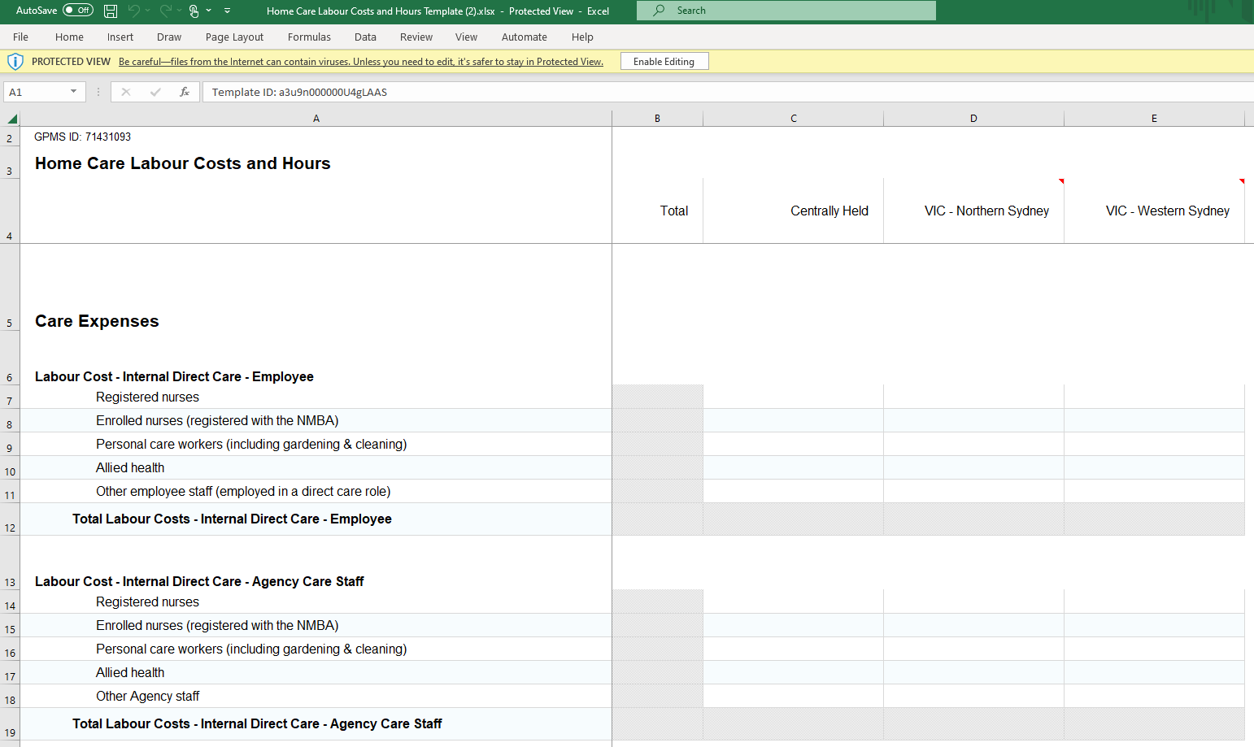
Please note:
If you have manually entered data before downloading the template, there will be no values displayed in calculated cells until you enable editing of the spreadsheet. For example, the template below displays the manually entered values but the calculated Total column and row values are blank.
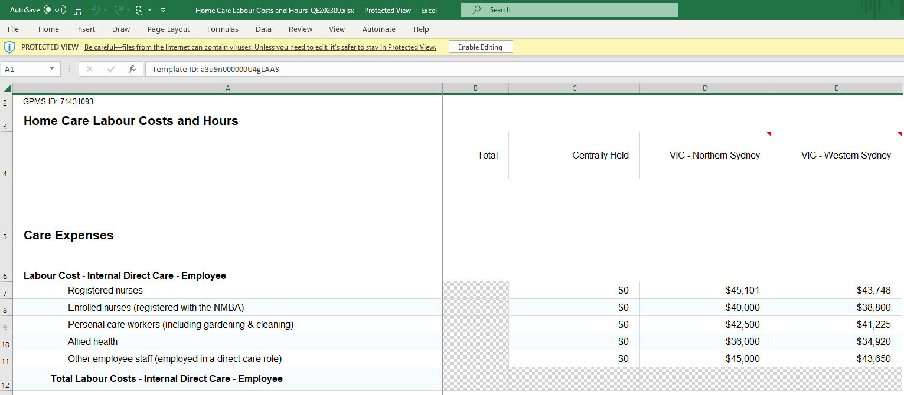

- Select the Enable Editing button to switch off the protected view of the spreadsheet.
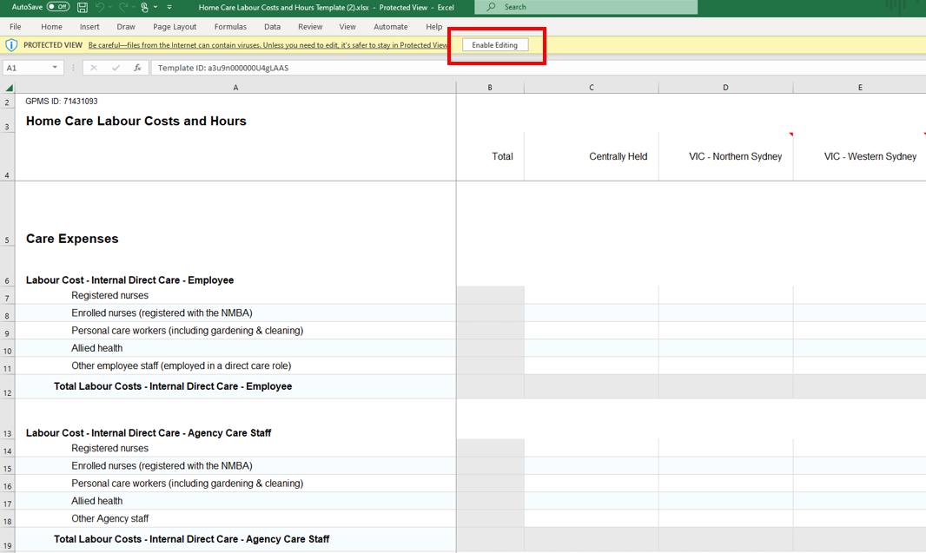
You are now able to populate the template with your data.
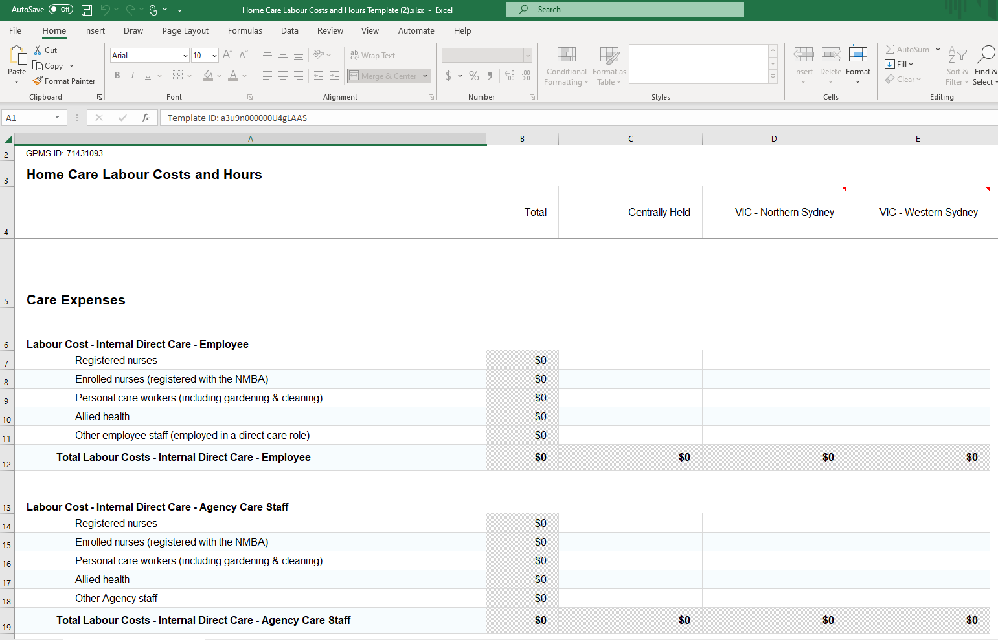
Please note:
The template will contain blank cells if you have not previously entered any data on the Home Care Labour Costs and Hours section of the QFR.
Any manually entered data in the Home Care Labour Costs and Hours section before downloading are included in the template.

Data field comments in the QFR section template
Further information, such as home care planning region details, may be viewed by hovering over the comment indicator on the top right corner of the cell.
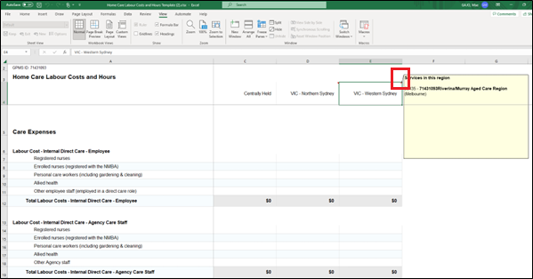

Update the QFR section template
- Enter cost values in whole dollar amounts on the non-protected cells that correspond to the relevant facility.
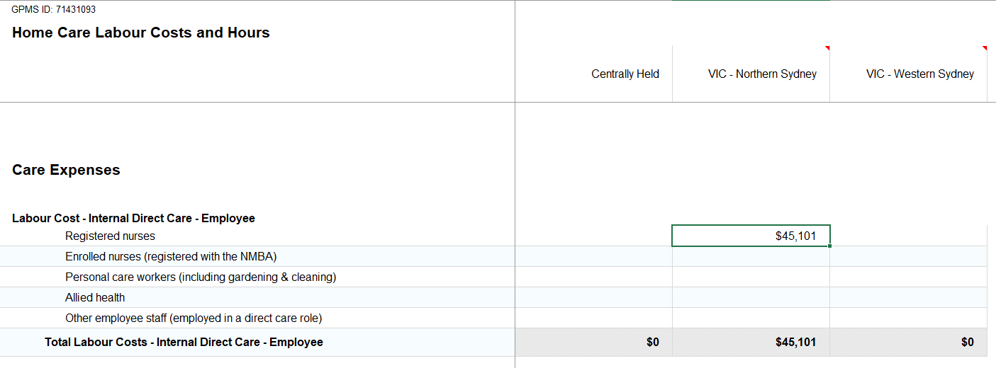
Enter hour values in two decimal places on the non-protected cells that correspond to the relevant facility.
Please note:
Enter the number of minutes as proportion of an hour. For example, your labour worked hours for Direct care is 189 hours and 45 minutes. Convert 45 minutes to hours (45 divided by 60 equals 0.75), then enter 189.75.

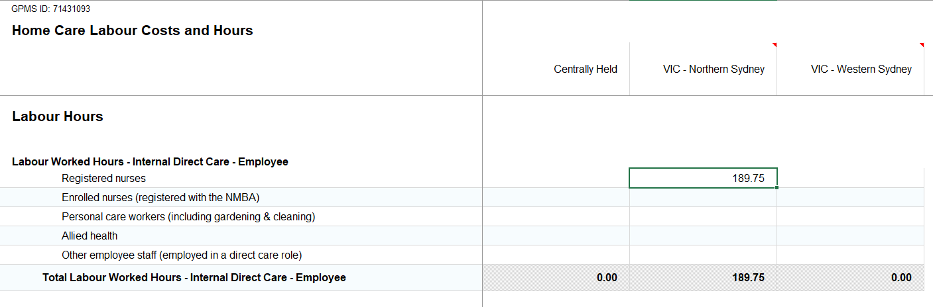
You will not be able to update locked cells, including:
- Calculated cells, such as totals and averages
- Cells that contain row and column labels
- Blank cells for formatting and presentation purposes.
An error message is displayed if you enter data into a locked cell.
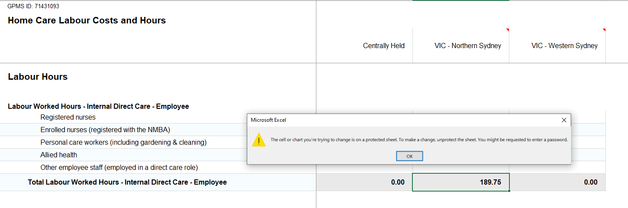

Save the QFR section template
Save a copy of the updated Home Care Labour Costs and Hours template in Excel format when you have completed populating the required cells.
If you wish to give the upload file another name, you can ‘save as’ based on your preferred file naming convention. For example, save as Home Care Labour Costs and Hours_QE202309.xlsx.

Print the QFR section template
(Optional) Print a copy of the Home Care Labour Costs and Hours spreadsheet for your record. You may need to update the spreadsheet print settings for better readability.

Upload the QFR section data
- Navigate to the Home Care Labour Costs and Hours section of the QFR and scroll down to Upload an Excel spreadsheet (optional) sub heading.
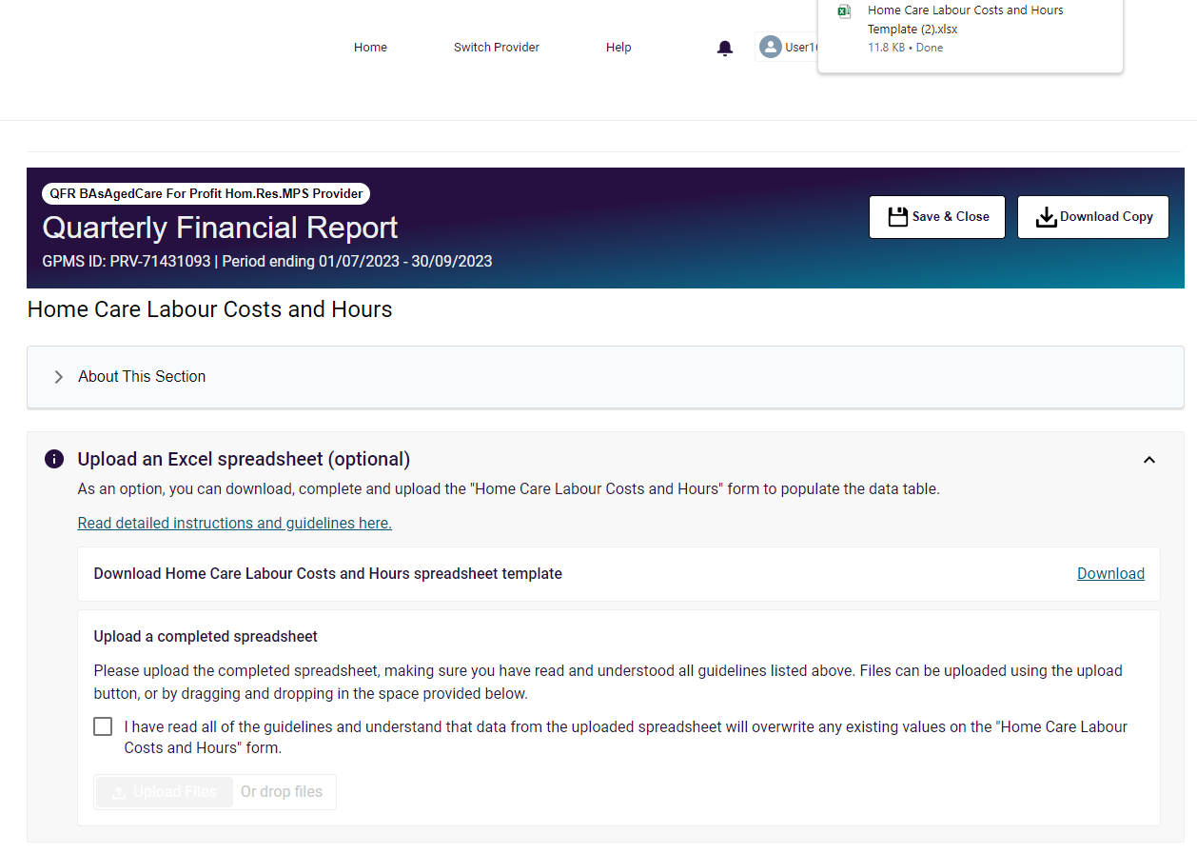
- Read the important note on screen about file upload.
Select the once to acknowledge that you have read the note.
Once the check mark is added, the Upload Files and Or drop files buttons are activated. You will then be able to continue with the bulk update of the QFR section.
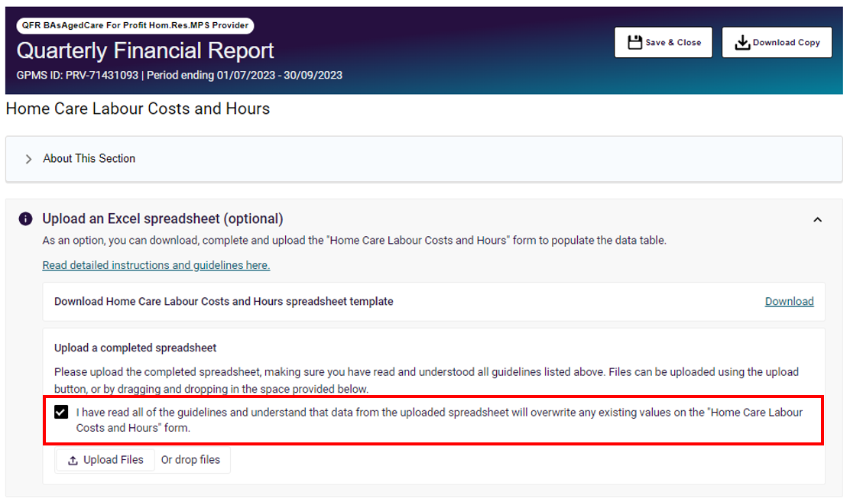
Please note:
Uploading a bulk update file overwrites the existing data in the relevant section of the QFR.

Upload Files function
Select the Upload Files button. Locate and select to upload your spreadsheet.
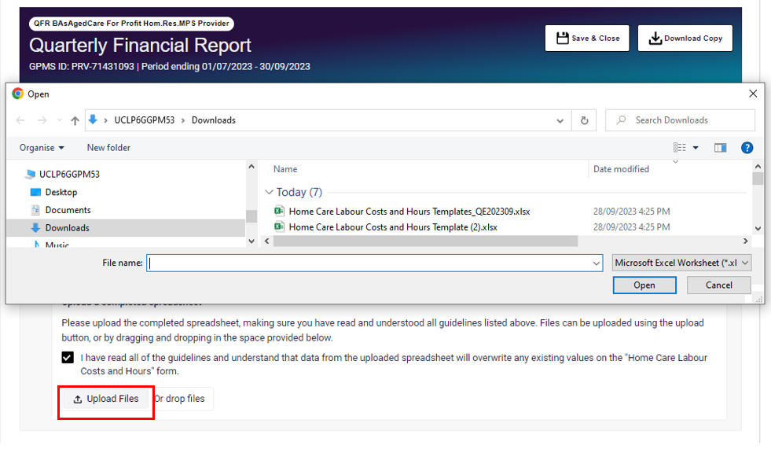

Drop files function
Another way to upload your file is through the drop files function. Locate your spreadsheet, then drag and drop the file over the Or drop files text.
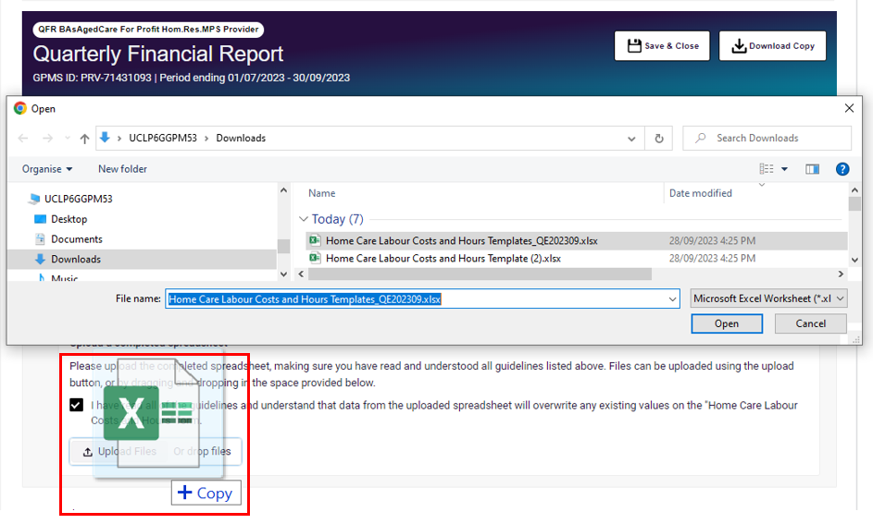
Successful file upload
A successful file upload notification is displayed.
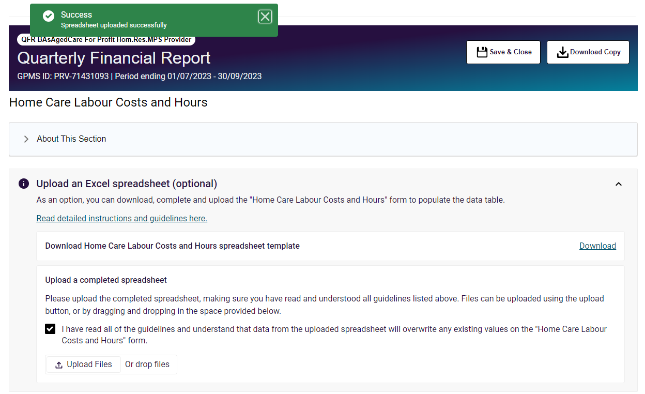
Unsuccessful file upload
An error message is displayed when a file belonging to another QFR section is uploaded. For example, uploading your Home Care Labour Costs and Hours spreadsheet in the Residential Labour Costs and Hours section will result to the following error:
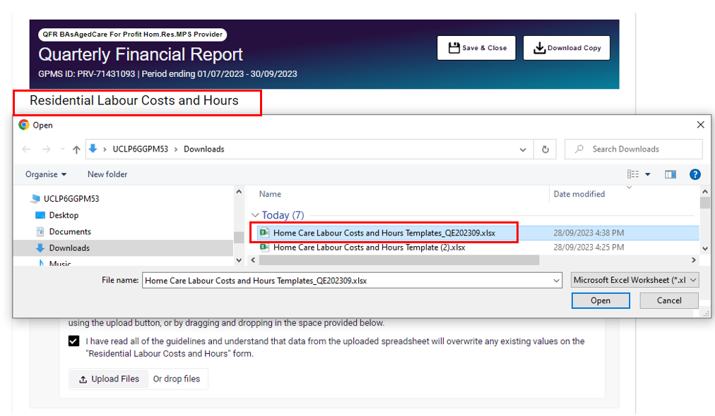
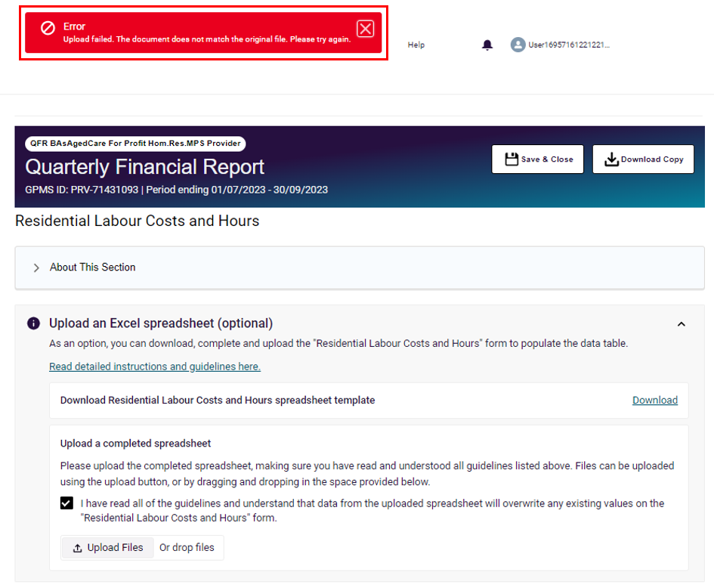
A file upload error is typically caused by uploading a bulk update file that:
- belongs to another QFR section
- is saved in an unsupported file format, such as csv
- has your own password protection enabled
- is not related to the specific QFR submission.

Please note:
You may upload a bulk update file as many times as necessary.

View QFR section with bulk update data
- Upon successful upload of your data, the costs in whole dollar amounts are displayed in the Home Care Labour Costs and Hours section of the QFR.
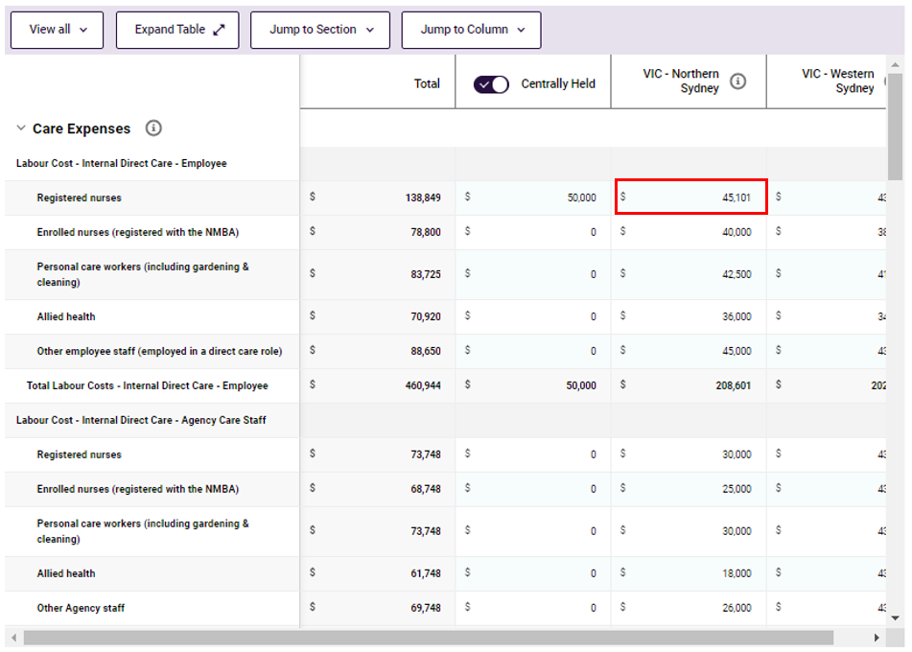
The hour values with two decimal points are also displayed in Home Care Viability and Prudential Reporting section of the QFR form.
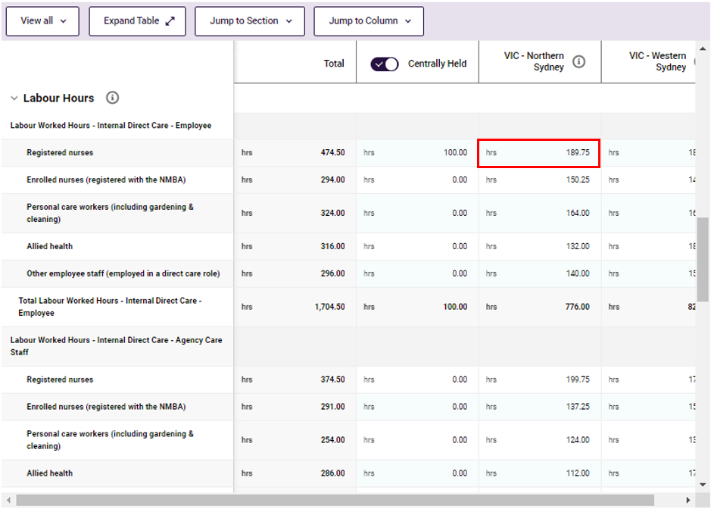
The same steps as the Home Care Labour Costs and Hours section example apply when bulk updating data into the following sections of the QFR:
- Year to Date Financial Statements
- Residential Labour Costs and Hours
- Residential Food and Nutrition Reporting
- NATSIFACP Food and Nutrition Reporting
- MPS Food and Nutrition Reporting

QFR form
After starting or resuming a QFR, you will be presented with a QFR form in a set order of data entry screens (‘QFR sections’).
- Before You Start
- Provider Contact
- Residential Viability and Prudential Reporting (RV&PR)
- Home Care Viability and Prudential Reporting (HCV&PR)
- Year to Date Financial Statements (YTDFS)
- Residential Labour Costs and Hours (RLC&H)
- Residential Aged Care Home Expenditure Per Resident Per Day (RACHE-PRPD)
- Home Care Labour Costs and Hours (HCLC&H)
- Residential Food and Nutrition Reporting (RF&NR)
- NATSIFACP Food and Nutrition Reporting (NATSIFACP-F&NR)
- MPS Food and Nutrition Reporting (MPS-F&NR)
- Declaration and Submission
Only the sections that are specific to the services you deliver will be displayed for your completion. For example, a non-government provider that offers residential, home care, and MPS will be presented with the following QFR sections:
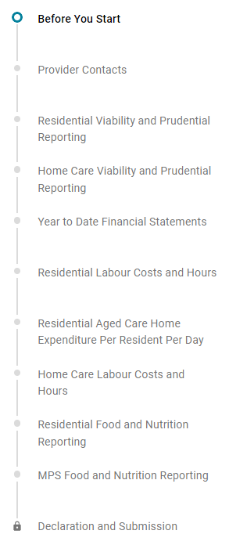
A government provider that offers residential and MPS will be presented with the following QFR sections:
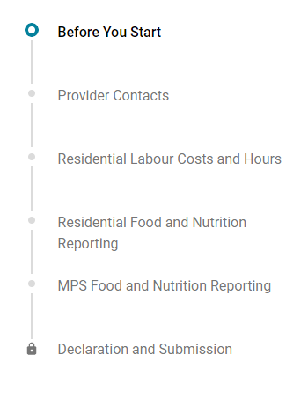
Please note:
Refer to the department’s website for more details and the latest information about the QFR reporting requirements based on the services you deliver.

Before You Start section
The Before You Start section is the first screen displayed after starting or resuming a QFR form that you have selected. It outlines guidance on compiling information for your quarterly financial and prudential reporting.

Provider Contact section
The Provider Contact section allows you to nominate contacts for the current QFR submission, where:
- the primary contact is the first point of contact for your submitted report
- the additional contacts are the optional contacts for questions specific to home care, residential care, and food and nutrition.
Please note:
Adding, updating or deleting a contact in the Provider Contact section of the QFR does not update your organisation’s contact details on GPMS.
You must enter the details of your primary contact to whom the department can direct general questions about your submitted report.
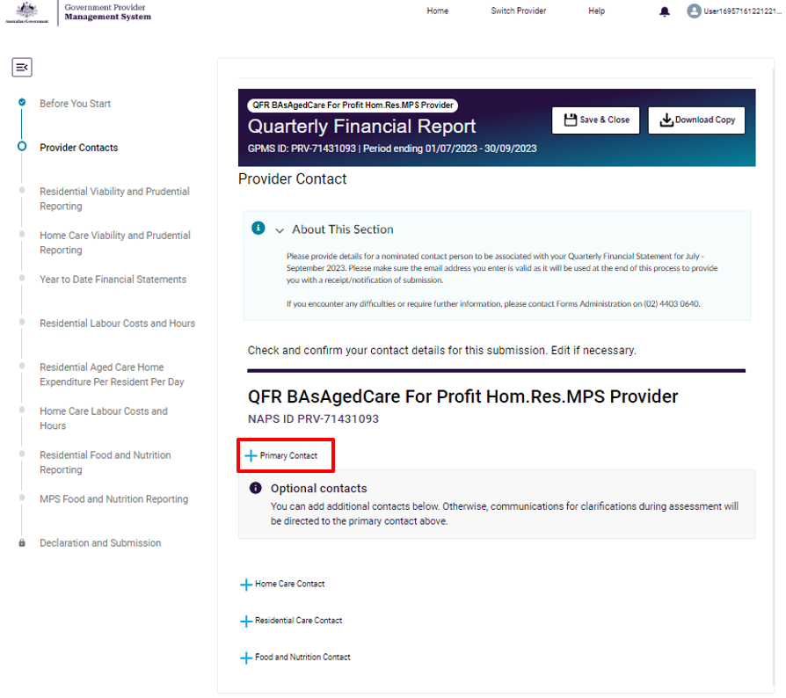

You may nominate optional contacts specific to the home care, residential care, and food and nutrition sections of the report.
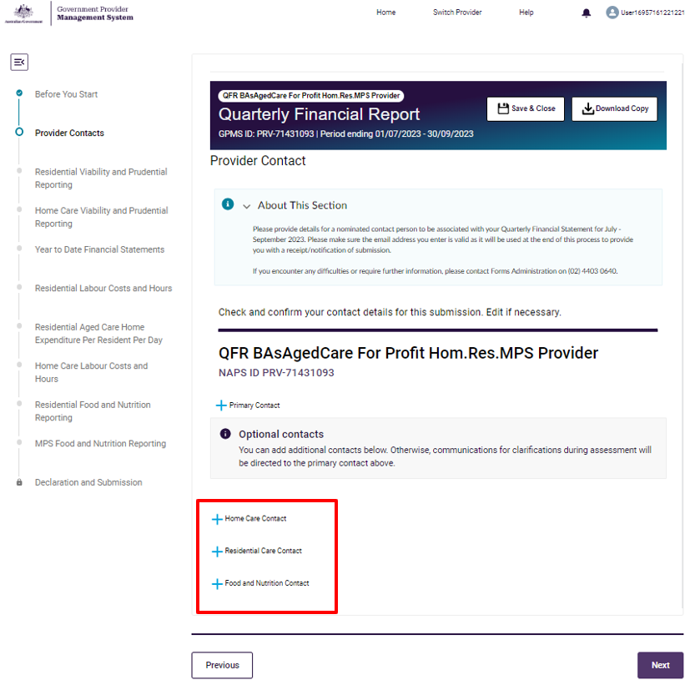

Add a new contact
Follow the steps to add a primary contact for the QFR submission below.
- Select  Primary Contact on the Provider Contact section. A pop-up window over the Provider Contact section is displayed.
- Enter your nominated primary contact details for the current QFR submission:
- First name
- Surname
- Role / Position
- Contact number
- Email

- Select the Save button to save the entered primary contact details.
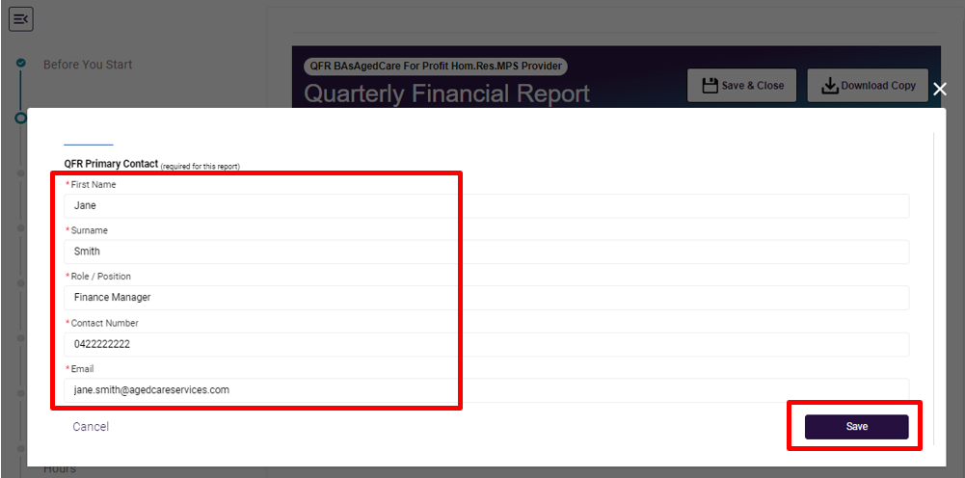
Please note:
The Role / Position data field has a 255-character limit.
Contact Number must be ten digits, and cannot have any spaces or special characters.
The entered contact details are displayed as the QFR primary contact.
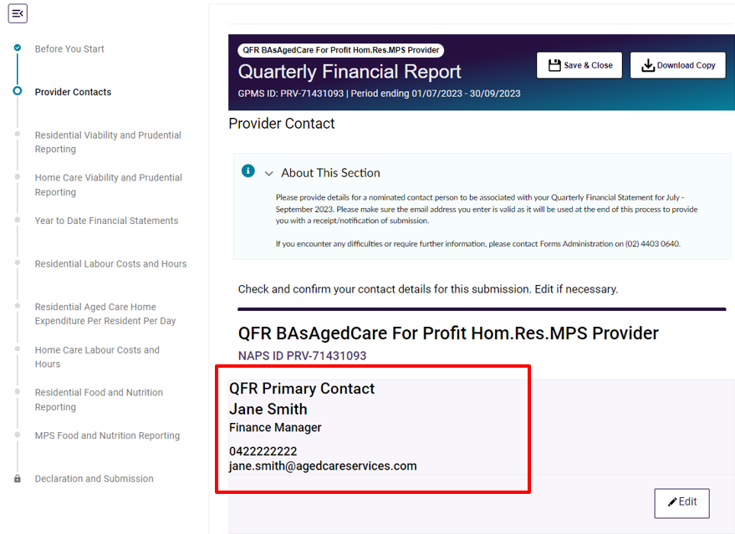
Alternatively, select the Cancel button if you do not wish to add a primary contact.
Please note:
While you can defer entering the primary contact details, providing a primary contact is mandatory for your report submission.
Follow the same steps as adding a new primary contact when adding details for your home care, residential, and food and nutrition contacts. Select the relevant buttons:


Edit an existing contact
Follow the steps to edit a contact for the QFR submission below.
- Select the Edit button below the details of your primary on the Provider Contact section.
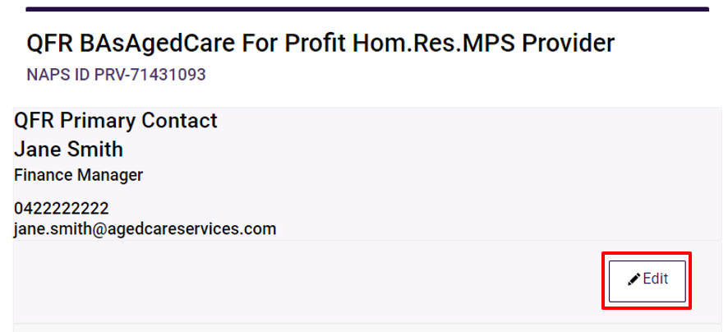
A pop-up window over the Provider Contact section is displayed.
- Edit your primary contact details by updating one or more of the contact details:
- First name
- Surname
- Role / Position
- Contact number
- Email

- Select the Save button to save the update to you primary contact details.
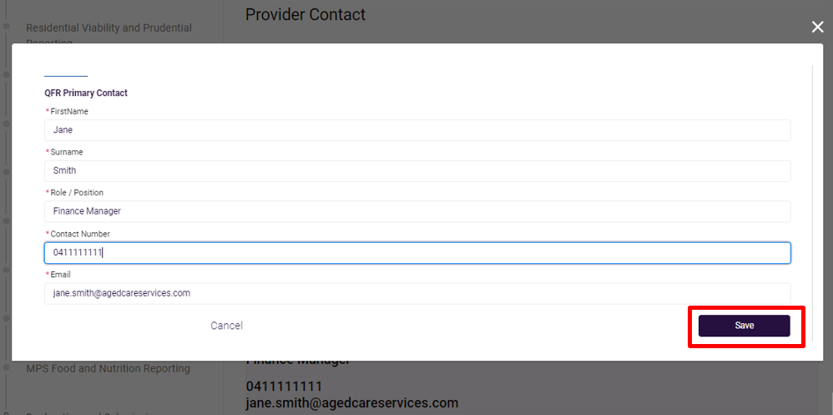
The updated contact details are displayed as the QFR primary contact.
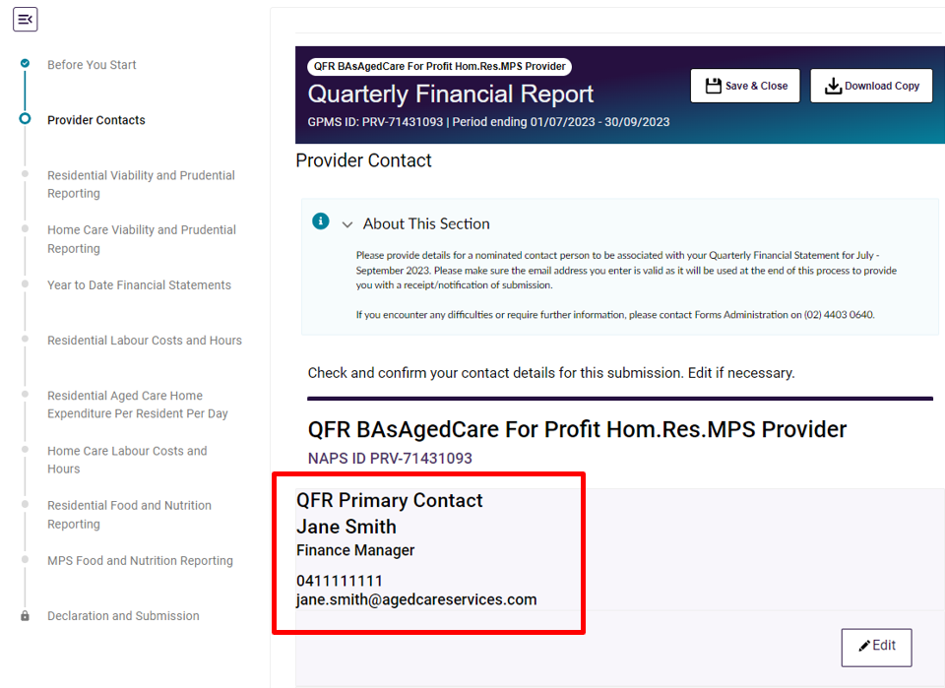
Alternatively, select the Cancel button if you do not wish to continue with the update of your primary contact details.
Follow the same steps as editing a primary contact when updating your home care, residential, and food and nutrition contact details.

Delete an existing contact

Primary contact
Once you have added the primary contact details on the Provider Contact section, there is no Delete button to remove the primary contact.
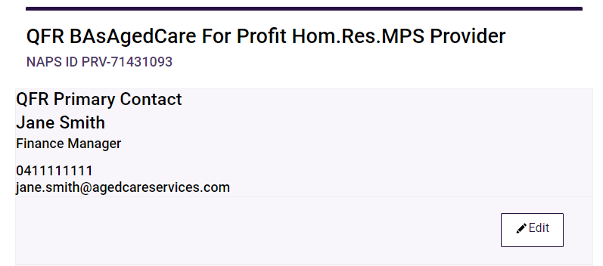
Please note:
You can change your nominated primary contact for the QFR submission by following the steps outlined in Edit an existing contact.

Optional contacts
Follow the steps to remove an existing optional contact for the QFR submission below.
- Select the Delete button below the details of your optional contact on the Provider Contact section. For example, to remove your existing home care contact, select the Delete button below the home care contact details.
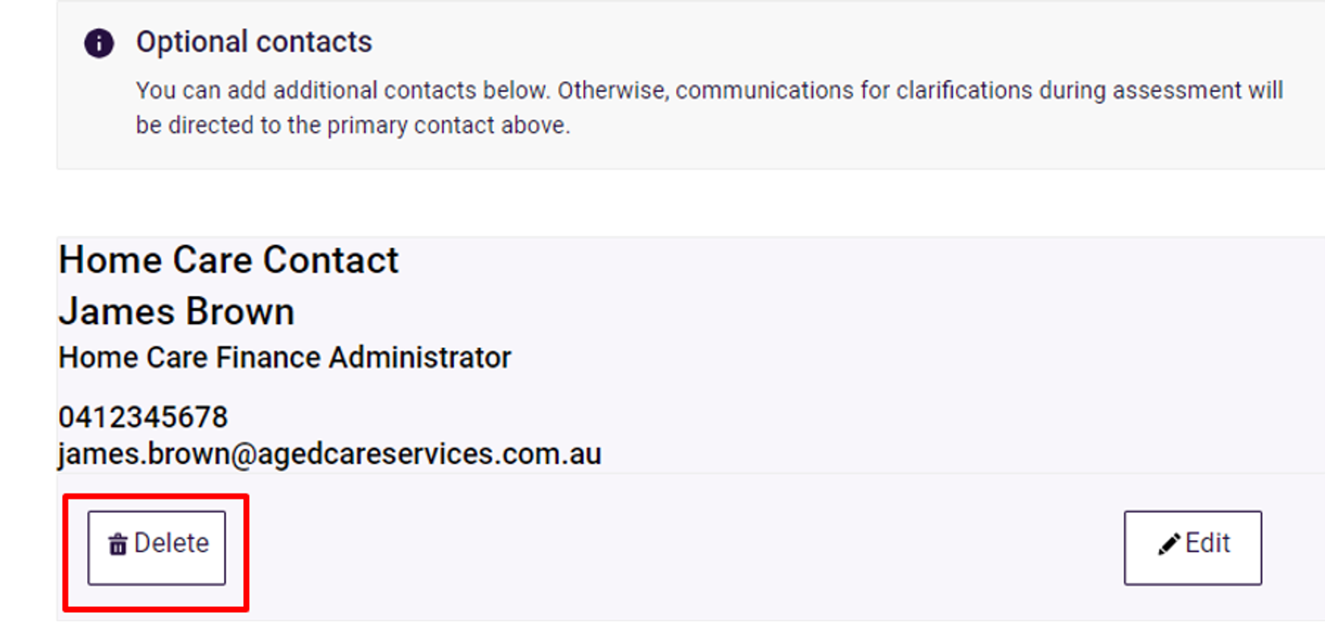
A confirmation message is displayed over the Provider Contact section. Select the Delete button to confirm deletion of your home care contact.
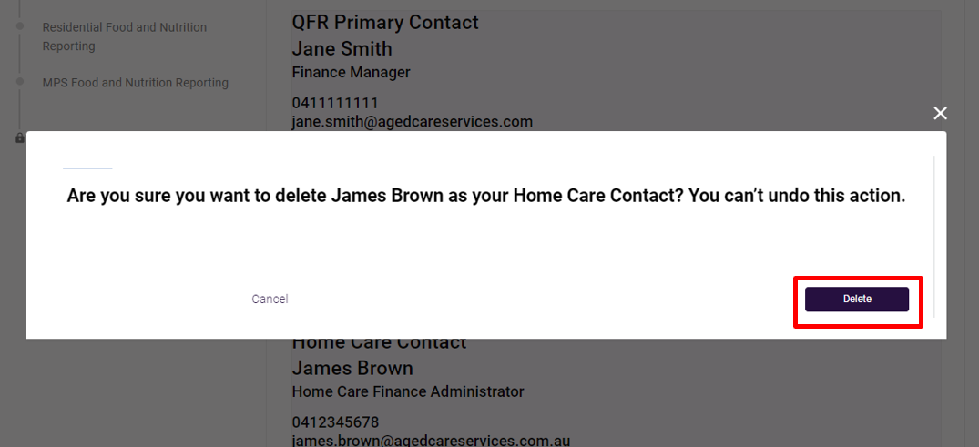
Please note:
If you remove an optional contact by mistake, you can re-enter the optional contact details by following the steps outlined in Add a new contact.
Select the Cancel button if you do not wish to continue deleting your home care contact details.
Follow the same steps as deleting a home care contact when removing your residential, and food and nutrition contacts.
Once you have entered your contacts, you can complete the next section of your report:
- in any order you wish by selecting a section name from the sidebar navigation, or
- by selecting the Next button, which displays the relevant section of the QFR depending on the service that you deliver.

Residential Viability and Prudential Reporting section
The RV&PR section is completed by non-government providers that deliver residential care services. Your responses to these questions are used as forward-looking indicators for viability and prudential risks.
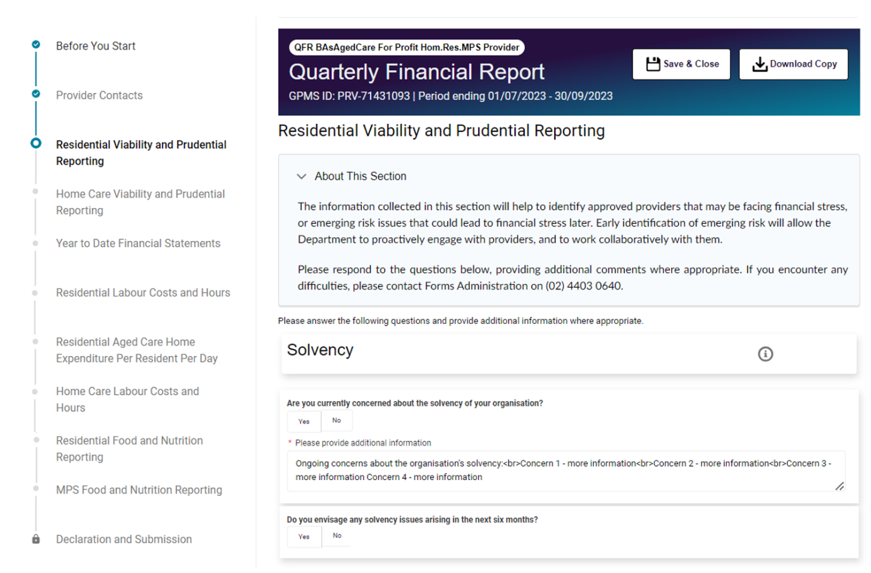
Follow the steps to complete the RV&PR section of the QFR below.
- Select a response to each question in the RV&PR section, which is made up of questions with mandatory Yes or No answers.
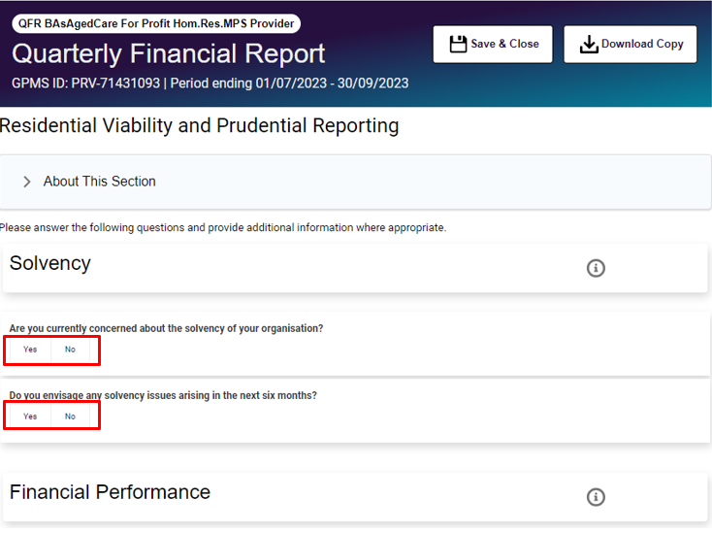
- Where you have answered Yes to a question, it is also mandatory that you provide additional information by completing the text input field that is displayed after you have selected a Yes response.
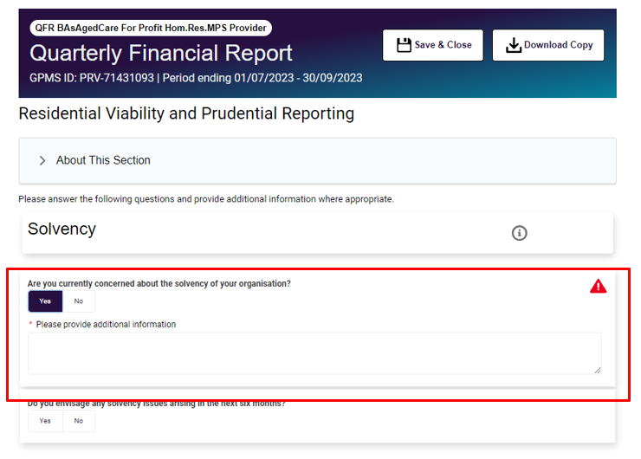

Please note:
You are requested to answer the outbreak management question and what type of outbreaks occurred, if applicable in this section. This can be actioned by completing the last question in the Residential Viability and Prudential Reporting section which relates to outbreak management.
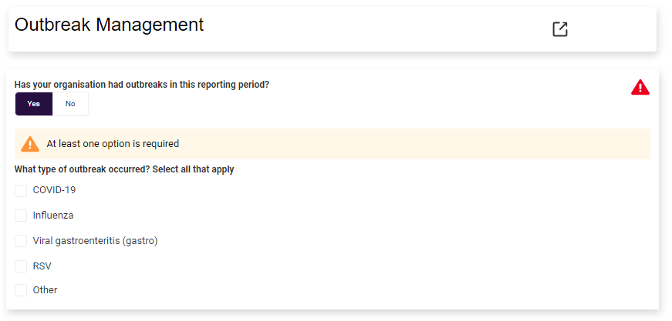
- After answering all the questions, you will need to save your RV&PR responses by:
- selecting the Next button
- selecting the Previous button
- navigating to another section of the QFR using the sidebar navigation, or
- selecting the Save and Close button.

Home Care Viability and Prudential Reporting section
The HCV&PR section of the QFR is completed by non-government providers that deliver home care services. Your responses to these questions are used as forward-looking indicators for viability and prudential risks.
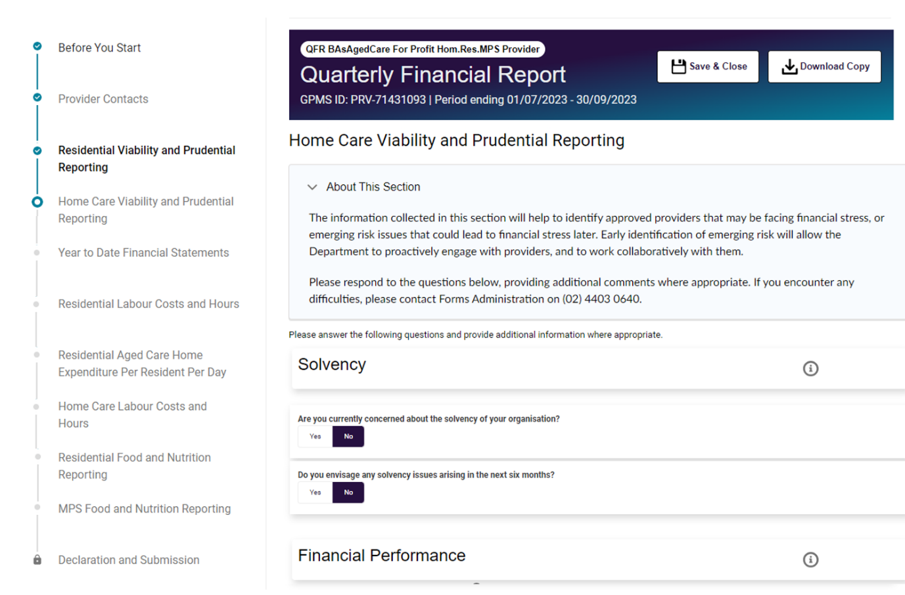
Follow the steps to complete the HCV&PR section of the QFR below.
- Select a response to each question in the HCV&PR section, which is made up of questions with a mandatory Yes or No answer.
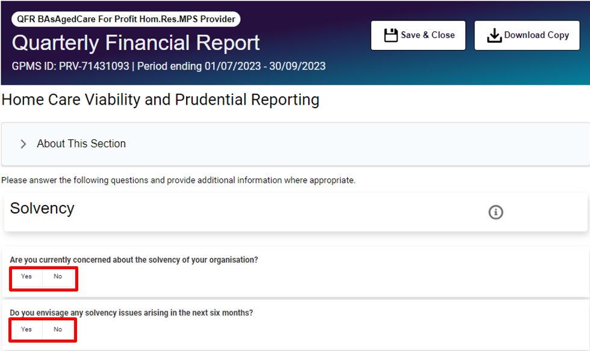
- Where you have answered Yes to a question, it is also mandatory that you provide additional information by completing the text input field displayed.
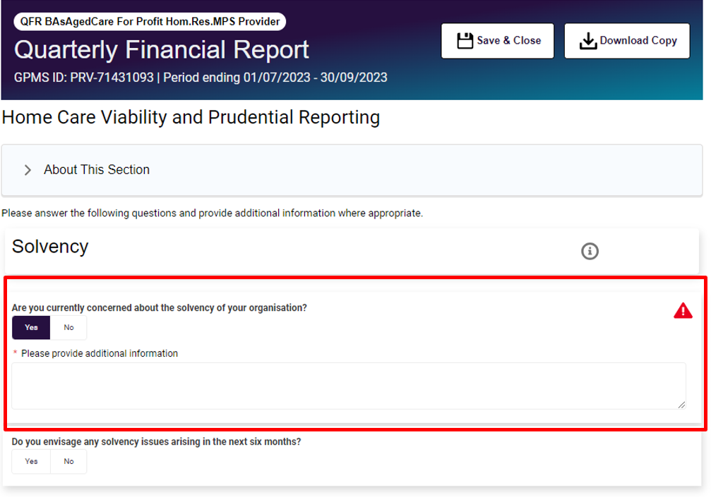
- Under the Business Structure question, you must identify the business structure/s applicable to your organisation for providing home care services:
- In House Delivery
- Franchisee
- Franchisor
- Brokerage
- Subcontractor
- Self-employ Individuals
- Other Business Structure.
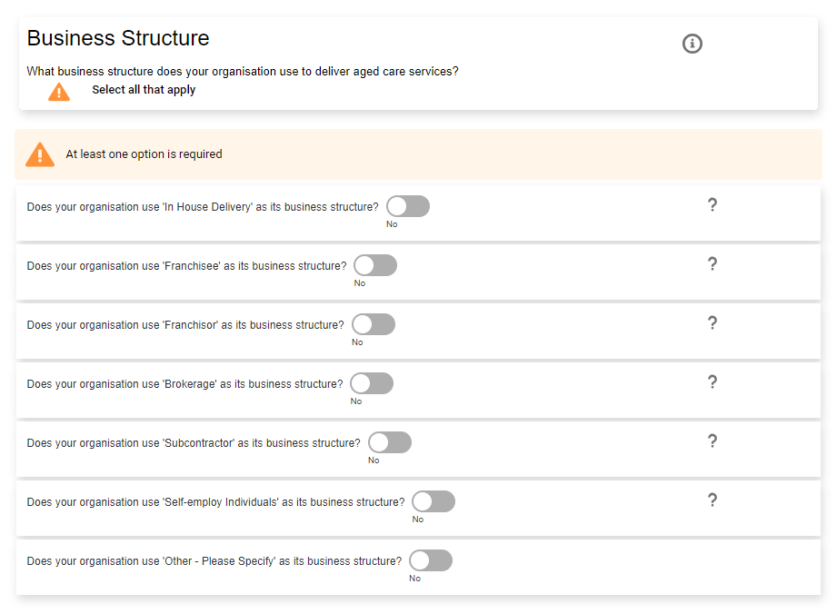
Switch the  toggle to the Yes position for all the business structures that apply for the reporting period.
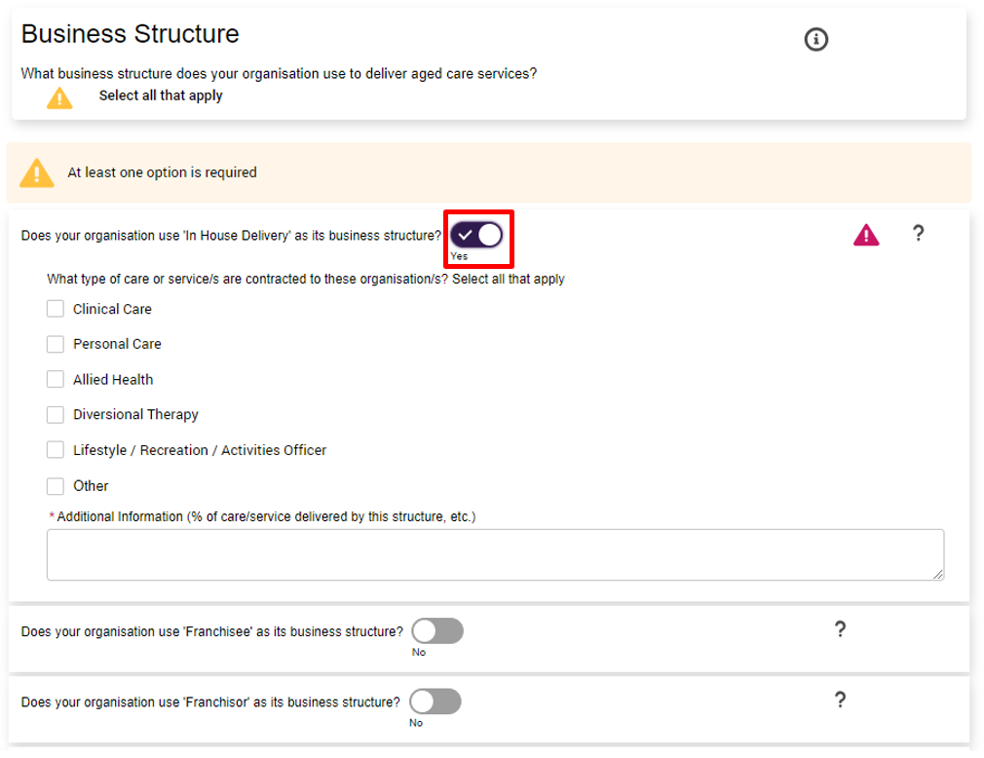
Selecting the  toggle in the Yes position once again removes the business structure from your selection.
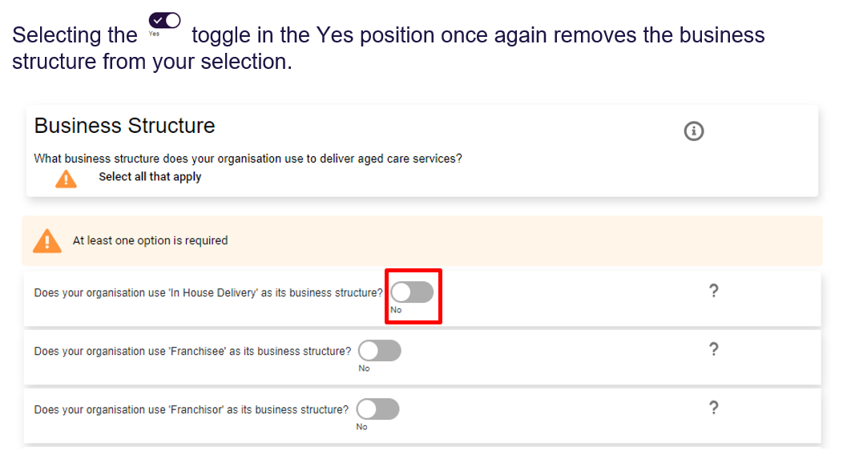

- If you have selected Other Business Structure as a relevant business structure, enter an explanation or elaboration of your ogranisation’s other business structure in the text input field.
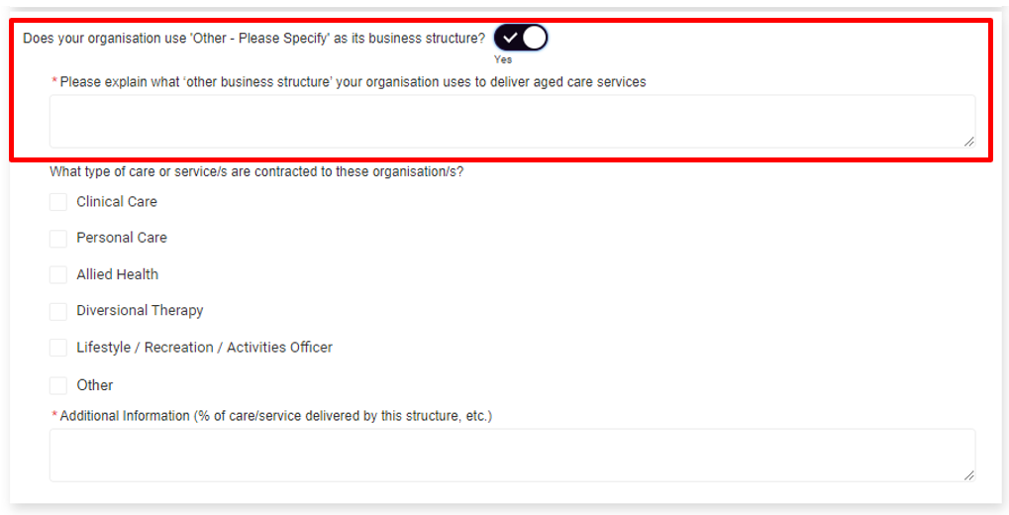
- After selecting a business structure, select the applicable type of care or services delivered during the reporting period. An example of selecting In House Delivery is outlined below.
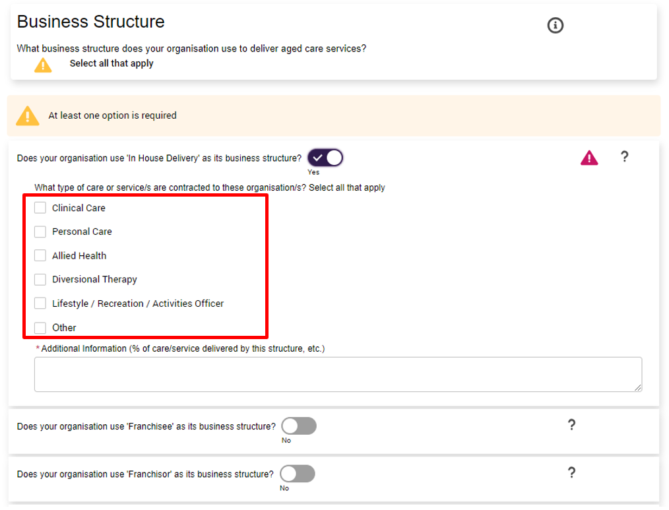

Select all the types of care or service under the business structure that apply to your organisation by selecting the  checkbox next to the type of care or service name.
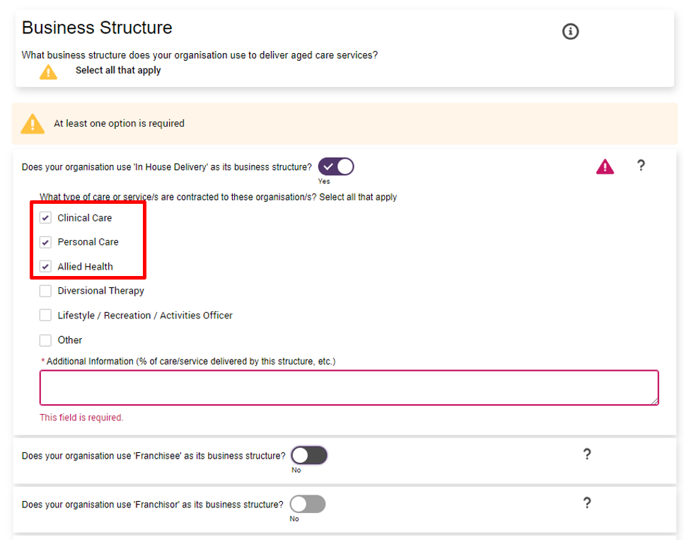
Selecting the o checkbox next to a type of care or service name once again deselects the type of care or service name from your relevant selection.
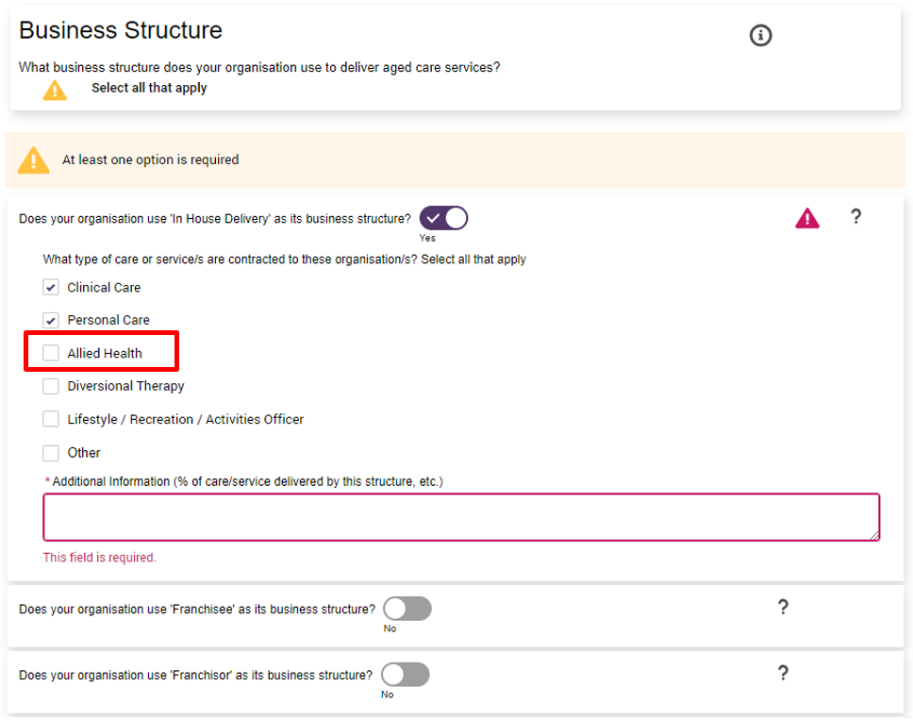
- If you have selected Other as a relevant type of care or service, enter an explanation or elaboration of your ogranisation’s other business structure in the text input field.
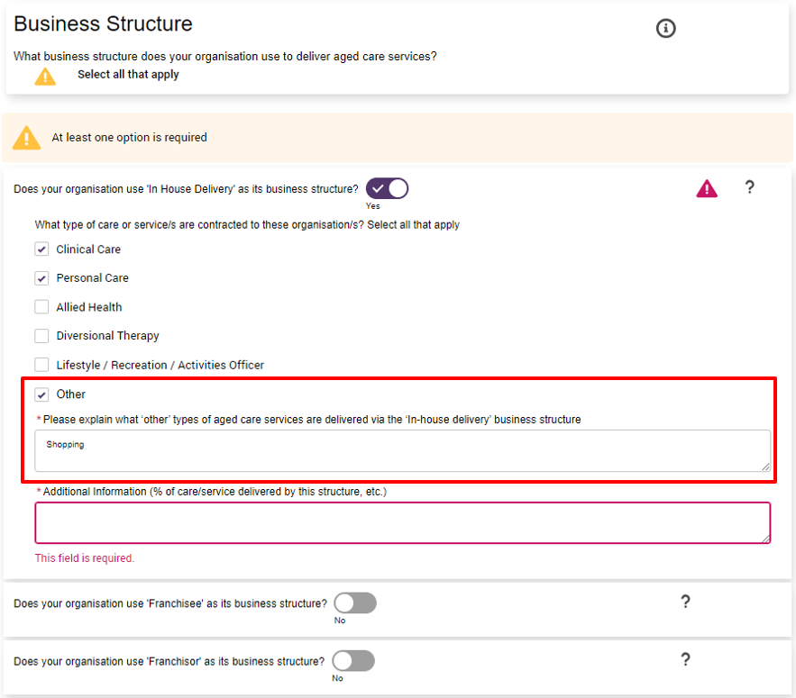
- For each relevant business structure, enter the percentages of care or service delivered under the structure. In the In House Delivery business structure example, the care or service percentages attributed to Clinical Care, Personal Care and Other Officer must be provided in the text input field.
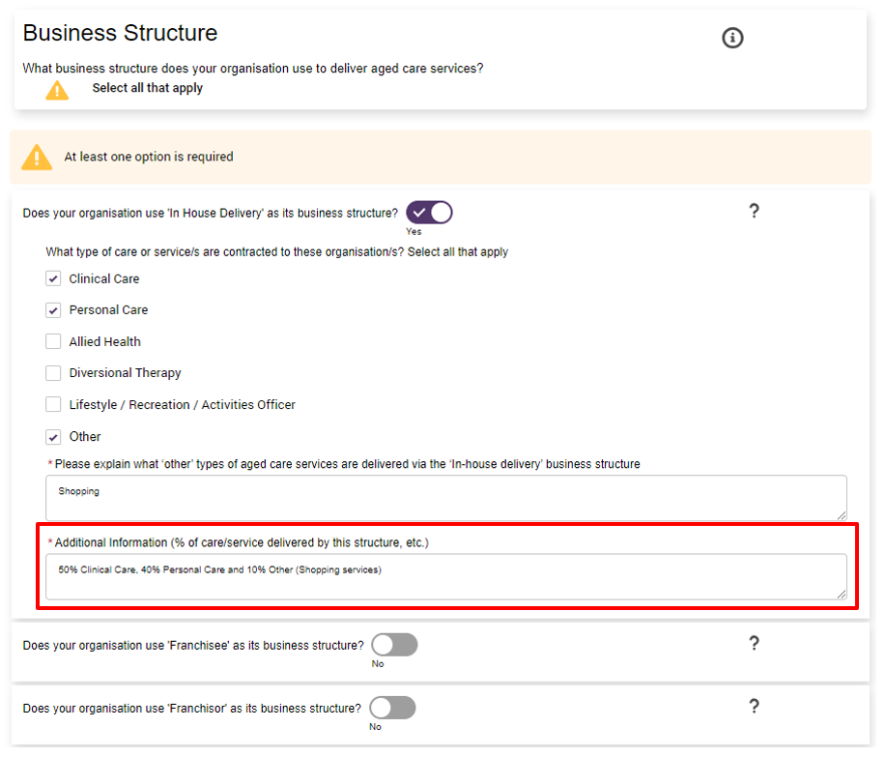
Next, save your HCV&PR responses by:
- selecting the Next button, or
- selecting the Previous button, or
- navigating to another section of the QFR using the sidebar navigation, or
- selecting the Save and Close button.

While the In House Delivery business structure was used as an example, the same steps apply for completing the checkboxes and additional information for:
- Franchisee
- Franchisor
- Brokerage
- Subcontractor
- Self-employ Individuals
- Other Business Structure.

Year to Date Financial Statements section
The YTDFS section is completed by non-government providers that deliver residential and home care services.
Your YTDFS data becomes part of the collective financial information used by the department to understand sector performance, which is communicated back to the sector.
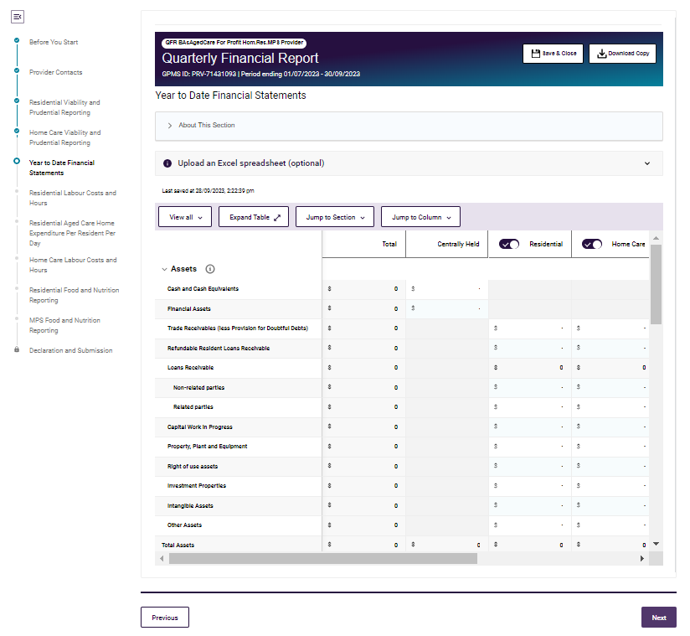

YTDFS data table
The YTDFS data table is made up of rows and columns, and may be completed by manual data entry or using the bulk update method.

YTDFS rows
- Assets
- Liabilities
- Equity
- Income
- Expenses
- External Lines of Credit
- Key ratios.

YTDFS columns
- Total, a column of calculated data fields that add-up the amounts across the segment types
- Centrally Held, a column that captures the total amounts across the segment types where the individual segment type amounts cannot be separately determined.
- Residential
- Home Care
- Community
- Retirement
- Other.

YTDFS column display
The columns on the YTDFS section are all enabled by default. A column heading with the toggle on allows you to enter amounts into the data fields for the segment type.
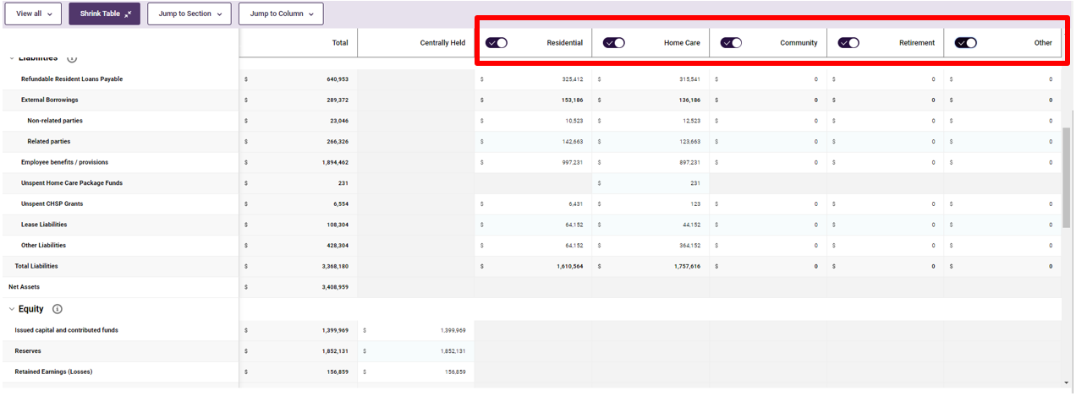
Disable YTDFS column display
Select the toggle once to switch the Other column off and as a result:
- the data fields in those columns are automatically populated fields with values of $0, overwriting any previously entered data
- you will not be able to enter data under the Other service type.

A warning message is displayed to confirm the toggle off request.
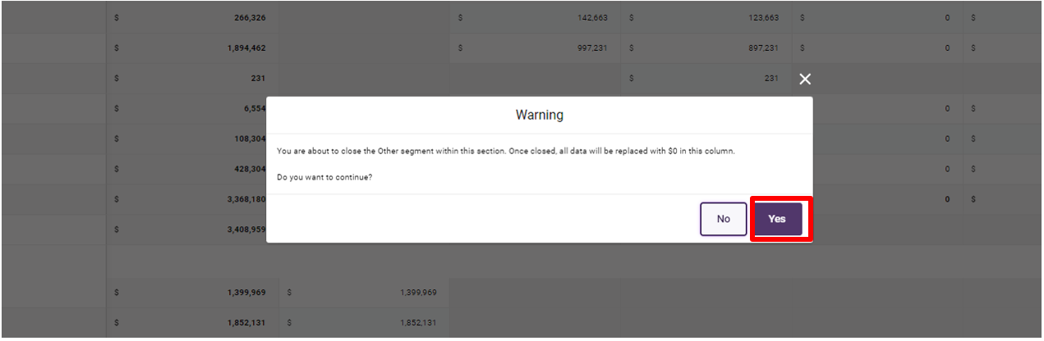
Select Yes to toggle off the Other service type column.
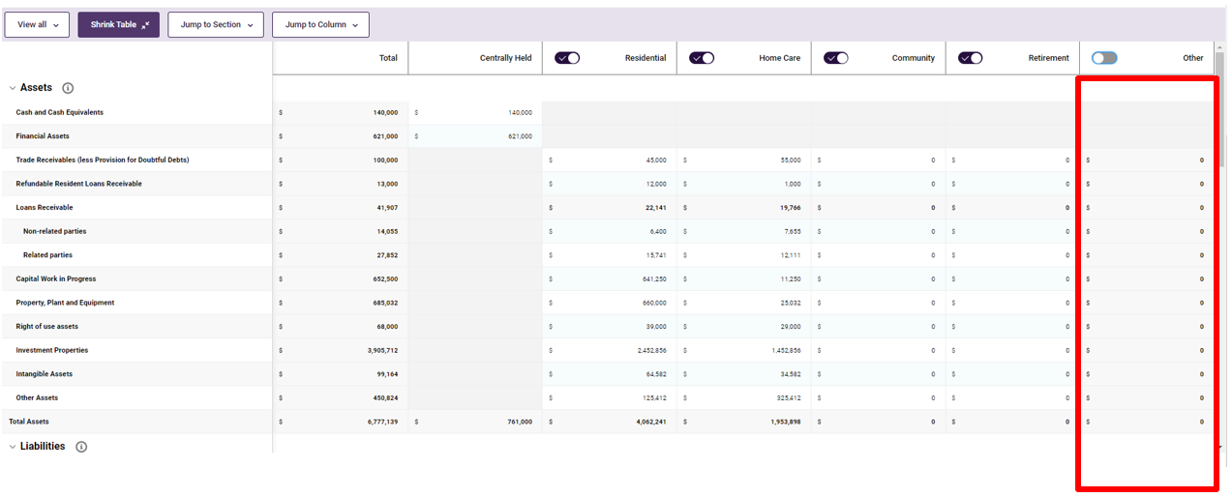
If you do not wish to continue, select No to cancel the toggle off of the Other service type column.
The same guidance applies for toggling off the segment type columns:
- Home Care
- Community
- CentrallyHeld
- Residential
- Retirement.

Residential Labour Costs and Hours section
The RLC&H section is completed by providers that deliver residential services. The department uses your RLC&H data to contribute to the calculation of your Star Ratings and inform costing studies for the new Australian National Aged Care Classification (AN-ACC) funding model.
As part of this section, residential aged care services will also be asked to outline any outbreak management expenses.
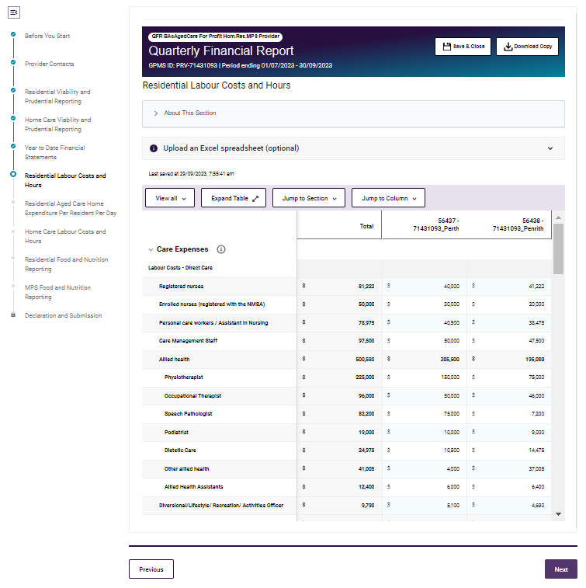

RLC&H data table
The RLC&H data table is made up of rows and columns, and may be completed by manual data entry or using the bulk update method.

RLC&H rows
- Care Expenses
- Labour Hours
- Non-worked hours (for all categories above)
- Labour – Average Hourly Rates of Pay
- Bed Days
- Direct Care Minutes (worked) Per Occupied Bed Day.
- Outbreak Management Expenses

RLC&H columns
The columns on the RLC&H section represent each of the aged care homes or facilities where a provider delivers services.
The Total column contains calculated data fields that add-up the amounts across facilities.
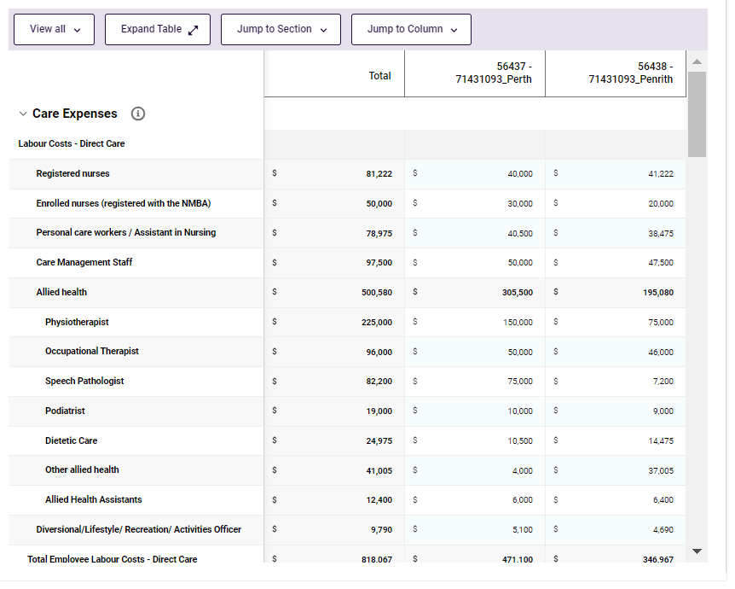
The Residential Labour Costs and Hours columns are customised for each provider with the service ID and service name displayed as column headings.
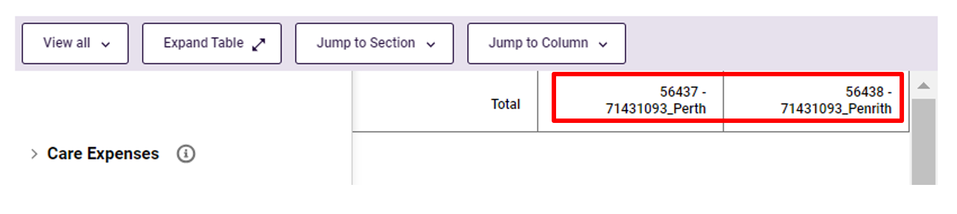
Please note:
Entered responses in the RV&PR section of the QFR are not automatically saved until you do one of the save options:
• select the Next button
• select the Previous button
• navigate to another section of the QFR using the sidebar navigation, or
• select the Save and Close button.
All the save options will result to being navigated away from the RV&PR section.

Residential Aged Care Home Expenditure Per Resident Per Day section
The RACHE-PRPD section contains RLC&H data calculated on a per resident per day basis.
You do not have to enter any data on this section of the QFR, however, you need to select this section and review the information before you can submit your report.

Home Care Labour Costs and Hours section
The HCLC&H section is completed by providers that deliver home care services. The department uses your HCLC&H data for greater transparency and accountability to the home care sector.
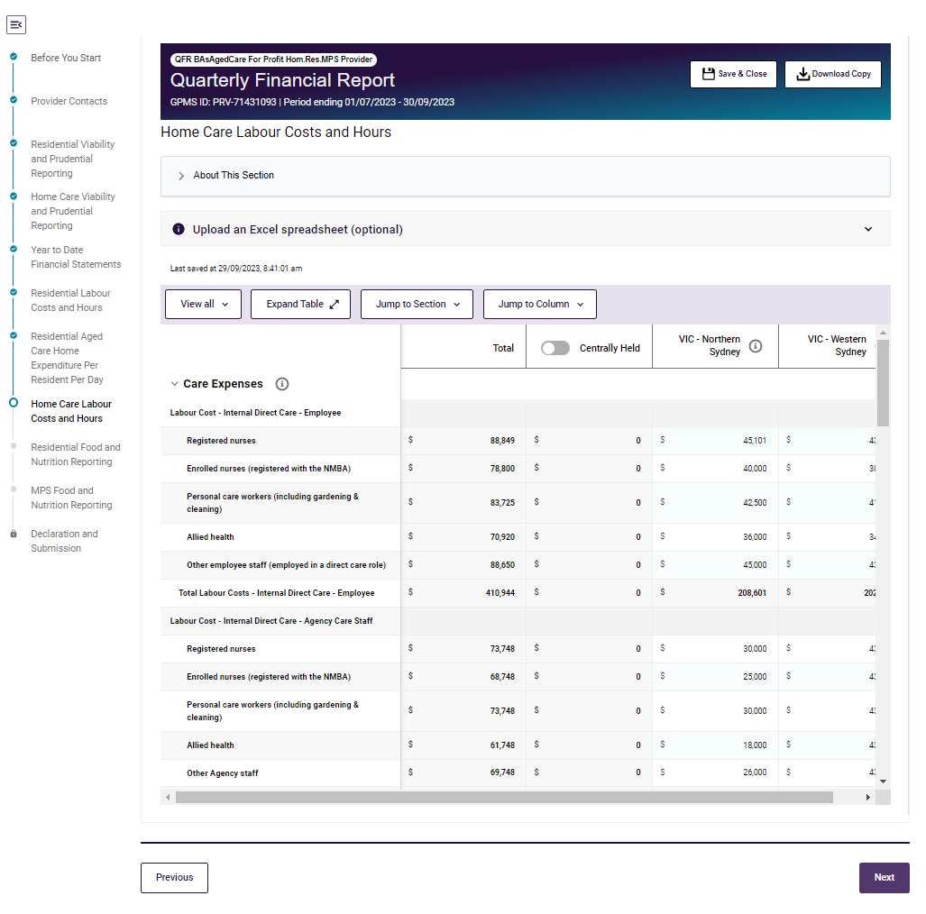

HCLC&H data table
The HCLC&H data table is made up of rows and columns, and may be completed by manual data entry or using the bulk update method.

HCLC&H rows
- Care Expenses
- Labour Hours
- Non-worked hours (for all categories above)
- Labour – Average Hourly Rates of Pay.

HCLC&H columns
The columns on the HCLC&H section represent each of the aged care planning regions where a provider delivers services.
There are also columns for:
- Centrally Held: a column that captures the total amounts across the service types where they cannot be separately determined by service type
- Total: a column of calculated data fields that add-up the amounts across planning regions.
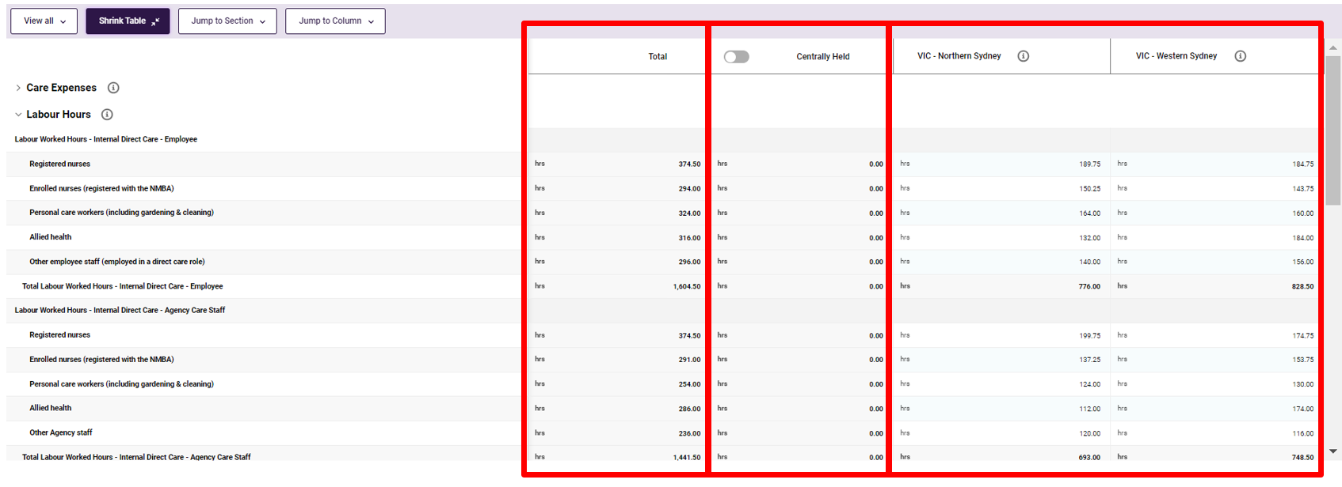
The HCLC&H columns customised for each provider with the planning region code and planning region name displayed as column headings.

Please note:
Entered responses in the HCV&PR section of the QFR are not automatically saved until you do one of the save options:
• select the Next button
• select the Previous button
• navigate to another section of the QFR using the sidebar navigation, or
• select the Save and Close button.
All the save options will result to being navigated away from the HCV&PR section.

Information icon
An information icon next to the planning region name in the HCLC&H section of the QFR displays the services under the selected planning region in a pop-up window.
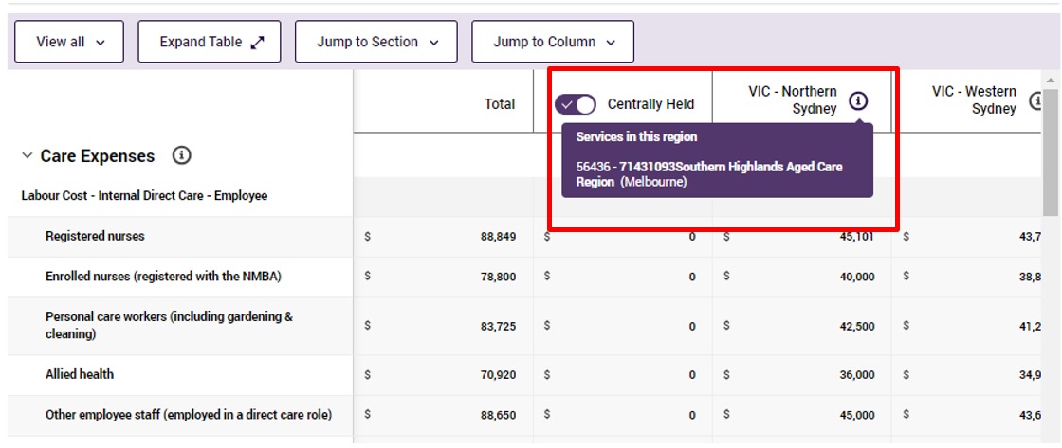

Centrally Held column display
The Centrally Held column is enabled by default, which allows you to enter amounts.
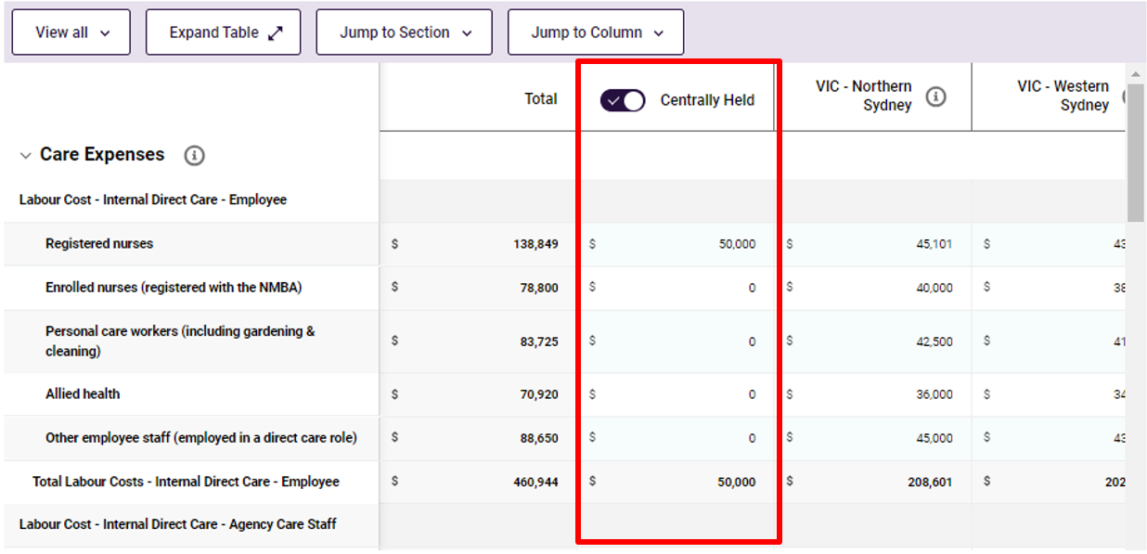

To disable the Centrally Held column, Select the  toggle once to switch the Centrally Held column off and as a result:
- the data fields in those columns are automatically populated fields with $0 values, overwriting any previously entered data
- you will not be able to enter data under the Centrally Held column.
A warning message is displayed to confirm the toggle off request.
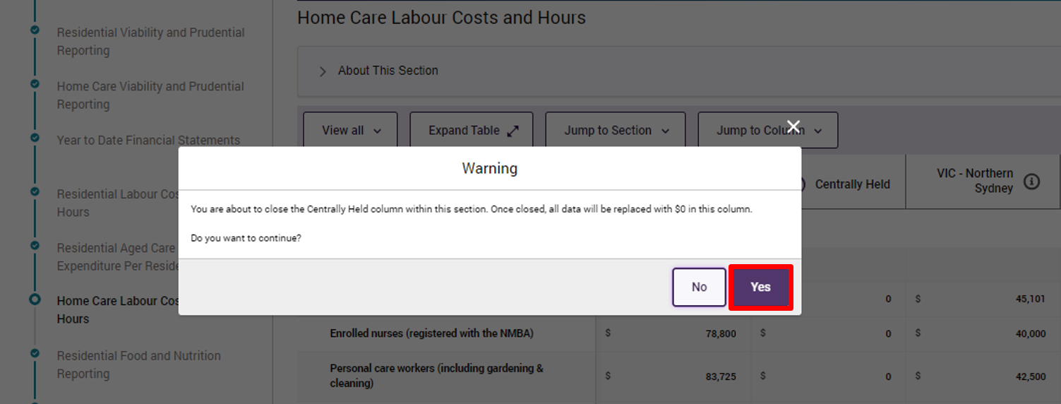
Select Yes to toggle off the Centrally Held column.
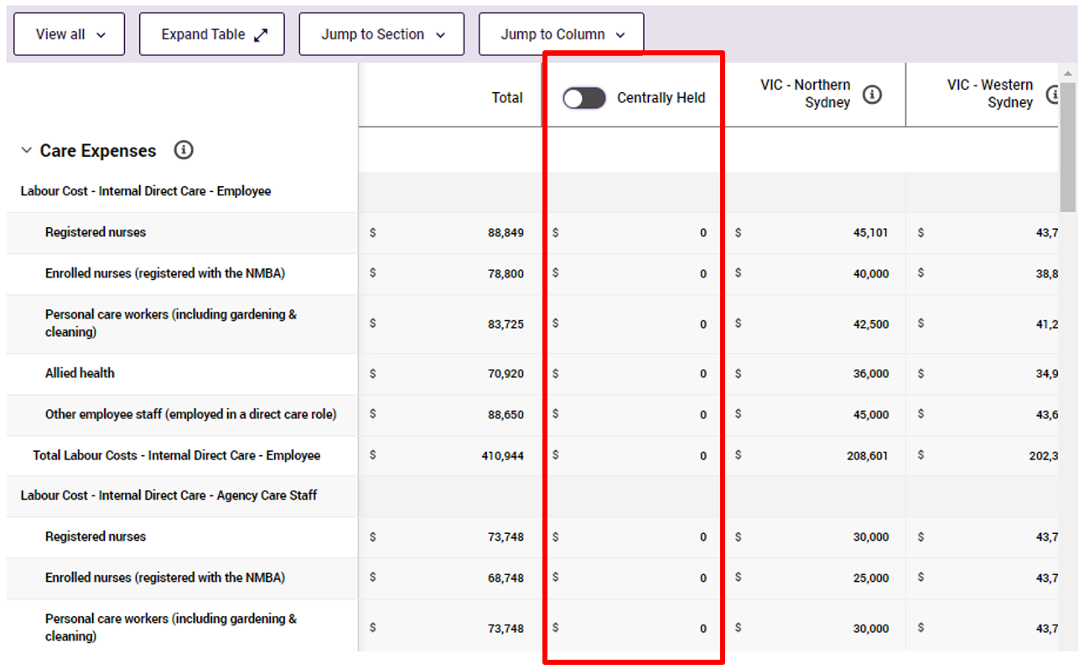
Alernatively, select No if you do not wish to toggle off of the Centrally held column.

Residential Food and Nutrition Reporting section
The RF&NR section is completed by providers that deliver residential care services, except:
- Flexible care services that are Multi-Purpose Services (MPS)
- Services providing residential care under the National Aboriginal and Torres Strait Islander Flexible Aged Care Program (NATSIFACP).
Your residential food and nutrition data becomes part of the collective information used by the department to understand and report on food and nutrition in residential aged care.
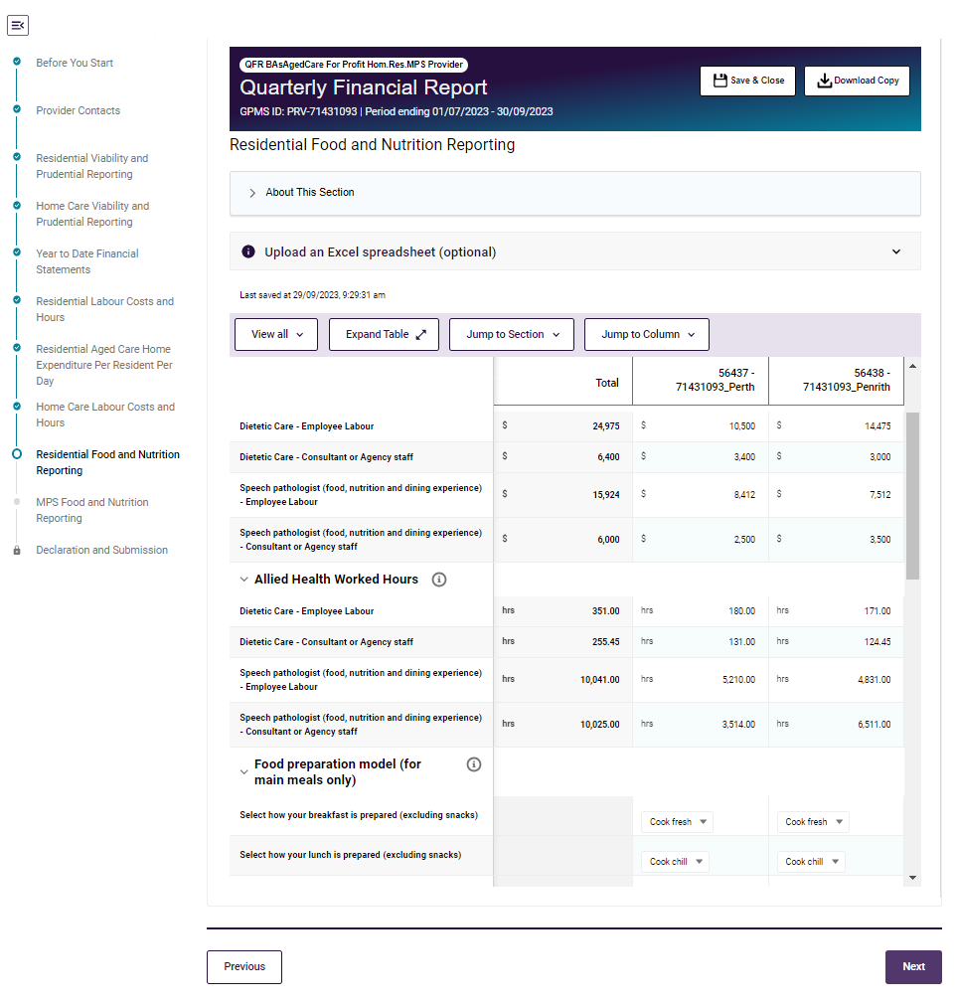

RF&NR data table
The RF&NR data table is made up of rows and columns, and may be completed by manual data entry or using the bulk update method.

RF&NR rows
- Resident expenses
- Allied Health expenses
- Allied Health worked hours
- Food preparation model (for main meals only)
- Internal catering – on site
- Internal catering – off site
- Internal catering – transport/delivery costs
- Contract catering – on site
- Contract catering – off site
- Average daily spend.

RF&NR columns
The columns on the RF&NR section represent each of the aged care homes or facilities where a provider delivers services.
The Total column contains data fields that add-up the amounts across facilities.
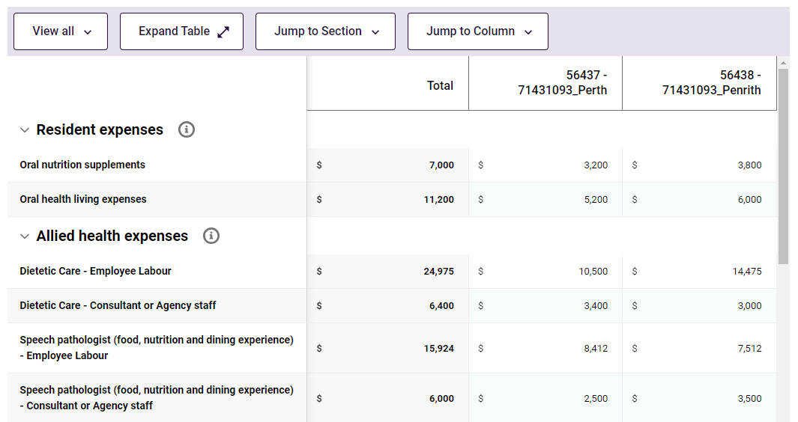
The RF&NR columns are custom generated for a provider with the service ID and service name displayed as column headings.
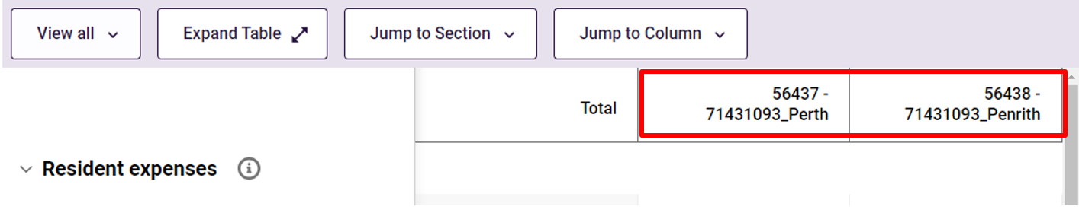

NATSIFACP Food and Nutrition section
The NATSIFACP-F&NR section is completed by providers that deliver residential care under the National Aboriginal and Torres Strait Islander Flexible Aged Care Program.
Your NATSIFACP food and nutrition data becomes part of the collective information used by the department to understand and report on food and nutrition in NATSIFACP residential aged care.
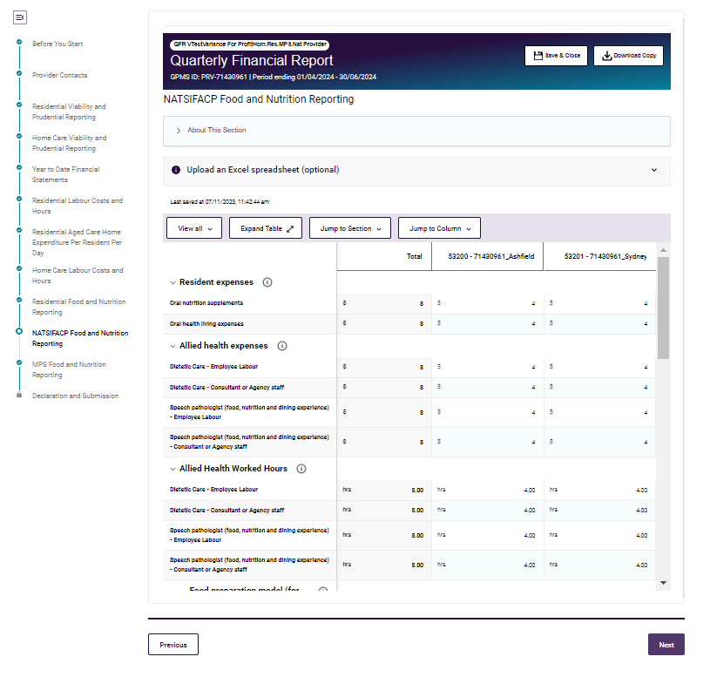

NATSIFACP-F&NR data table
The NATSIFACP-F&NR data table is made up of rows and columns, and may be completed by manual data entry or using the bulk update method.

NATSIFACP-F&NR rows
- Resident expenses
- Allied Health expenses
- Allied Health worked hours
- Food preparation model (for main meals only)
- Internal catering – on site
- Internal catering – off site
- Internal catering – transport/delivery costs
- Contract catering – on site
- Contract catering – off site
- Average daily spend.

NATSIFACP-F&NR columns
The columns on the NATSIFACP-F&NR section represent each of the aged care homes or facilities where a provider delivers services.
The Total column contains data fields that add-up the amounts across facilities.
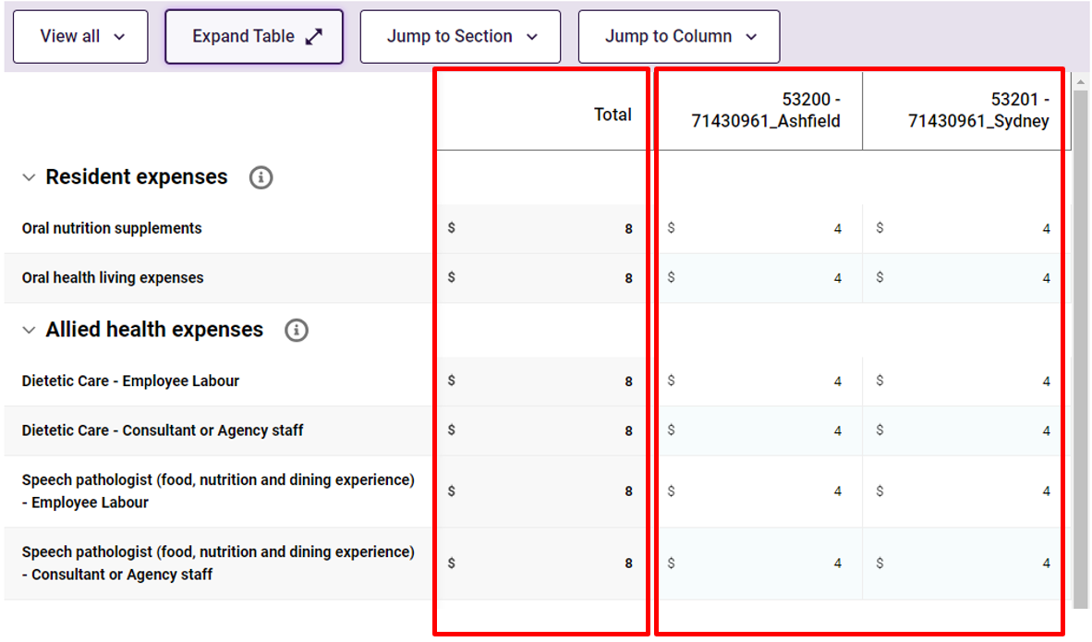
The NATSIFACP-F&NR columns are custom generated for a provider with the service ID and service name displayed as column headings.
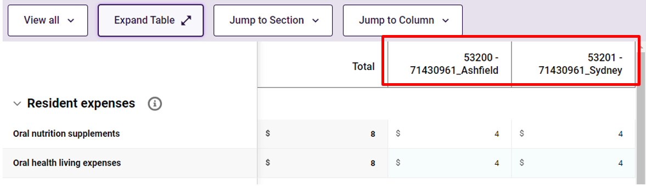

MPS Food and Nutrition section
The MPS-F&NR section is completed by providers that deliver residential care under Multi-Purpose Service (MPS) Program.
Your MPS food and nutrition data becomes part of the collective information used by the department to understand and report on food and nutrition in the MPS residential aged care.
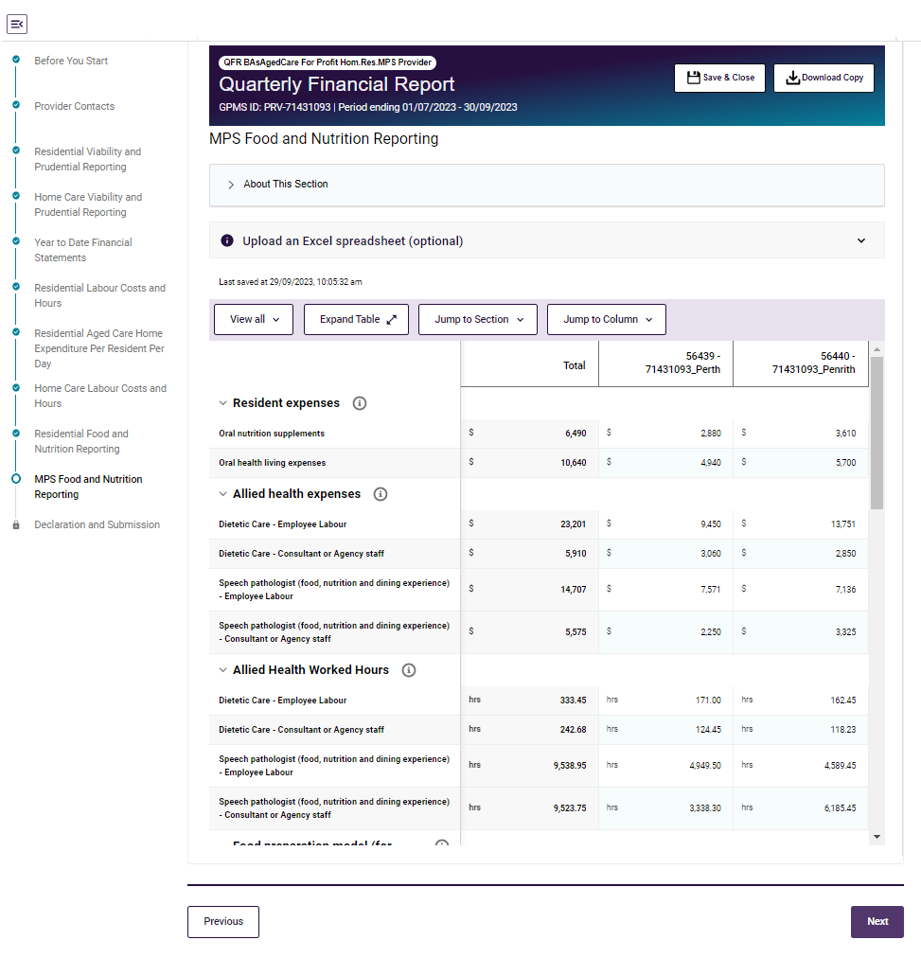

MPS-F&NR data table
The MPS-F&NR data table is made up of rows and columns, and may be completed by manual data entry or using the bulk update method.

MPS-F&NR rows
The row groupings on the MPS-F&NR section are:
- Resident expenses
- Allied health expenses
- Allied Health Worked Hours
- Food preparation model (for main meals only)
- Internal catering – on site
- Internal catering – off site
- Internal catering – transport/delivery costs
- Contract catering – on site
- Contract catering – off site
- Number of Available Bed Days
- Average daily spend.

MPS-F&NR columns
The columns on the MPS-F&NR section represent each of the aged care homes or facilities where a provider delivers services.
The Total column contains data fields that add-up the amounts across facilities.
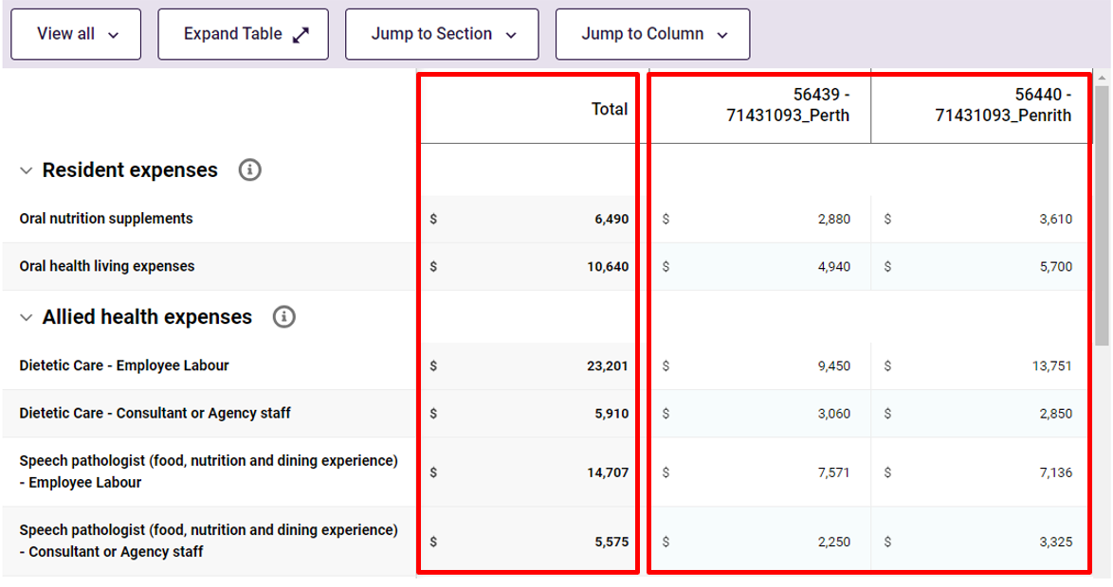
The MPS-F&NR columns are custom generated for a provider with the service ID and NAPS service name displayed as column headings.
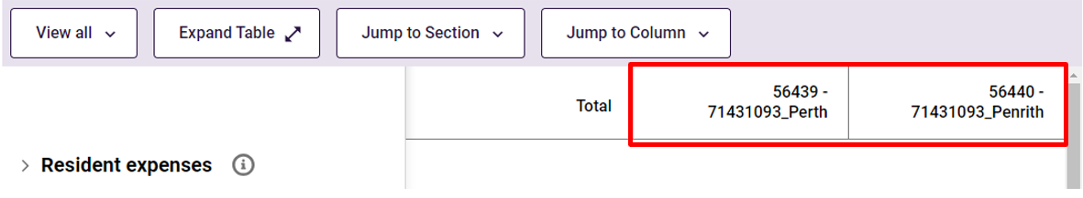

Declaration and Submission section
The Declaration and Submission is the last section of the QFR to be completed by all providers who must submit a QFR.
While you can navigate to the Declaration and Submission at any time when completing your report, the Download File button is disabled until all sections of the QFR form are visited and completed without errors.
QFR form with error
Error in the QFR form is indicated by a  red circle with a diagonal line visual cue in the sidebar navigation. Below is an example of a QFR with one or more errors in the YTDFS section.
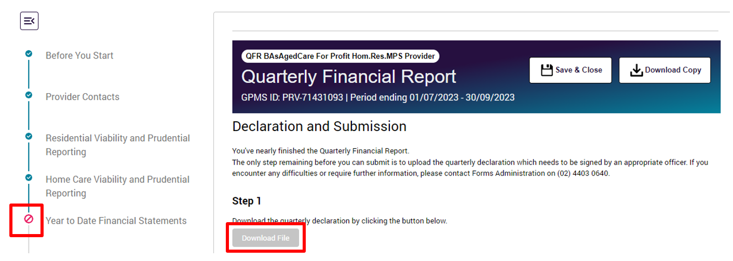
You must go back to the YTDFS section and fix the error/s to enable the Download File button.
QFR form with no error
A QFR form with no error is indicated by the green circle with a tick visual cue in the sidebar navigation. Below is an example of a QFR with no errors.
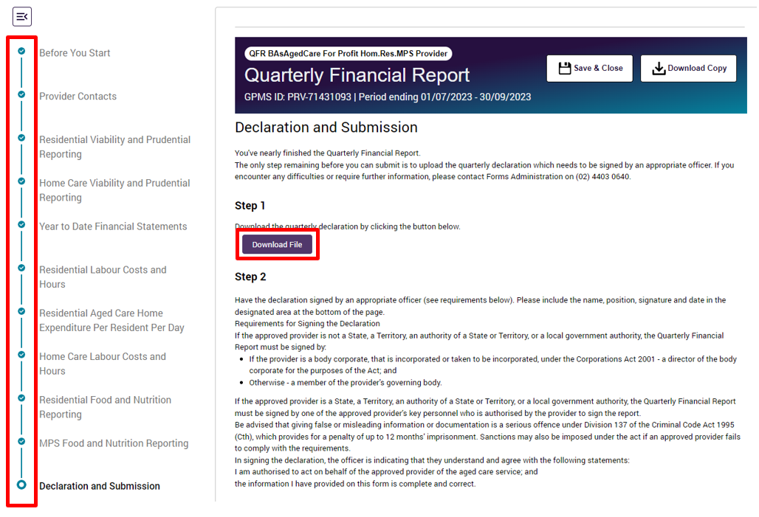

Declaration
Follow the steps to complete your declaration below.
- Navigate to the Declaration and Submission section to download the declaration form.
- Download the declaration form by selecting the Download File button.

A declaration file will download and automatically save in your computer’s default or nominated Downloads folder.
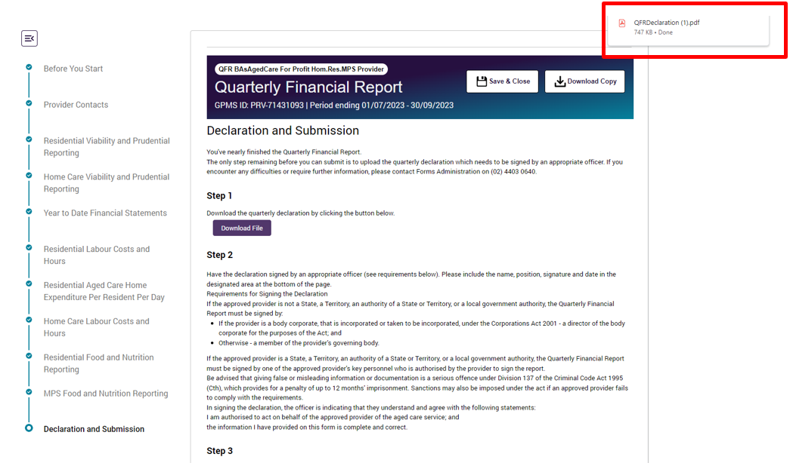

- Open the QFRDeclaration.pdf file.
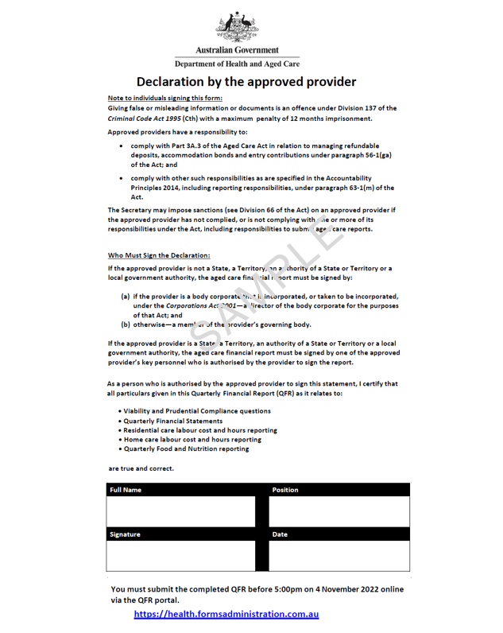
- Complete the declaration by adding the authorised person details for your report submission, including full name, position, signature, and date signed.
Read the declaration requirements carefully to ensure your QFR submission is signed by an authorised signatory.
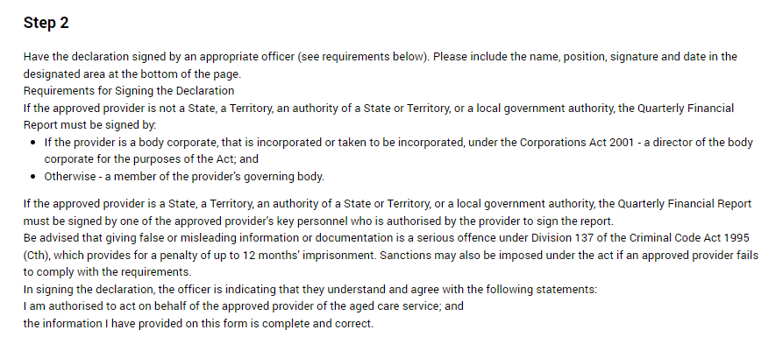
- Save the signed declaration as QFRDeclaration in PDF format. If you wish to give the upload file another name, you can ‘save as’ a filename based on your preferred file naming convention.
- Navigate to step 3 in the Declaration and Submission section to upload the signed declaration form.
- Set the Document Category to QFR. The Document Type will be automatically set to Declaration when you select the QFR document category.
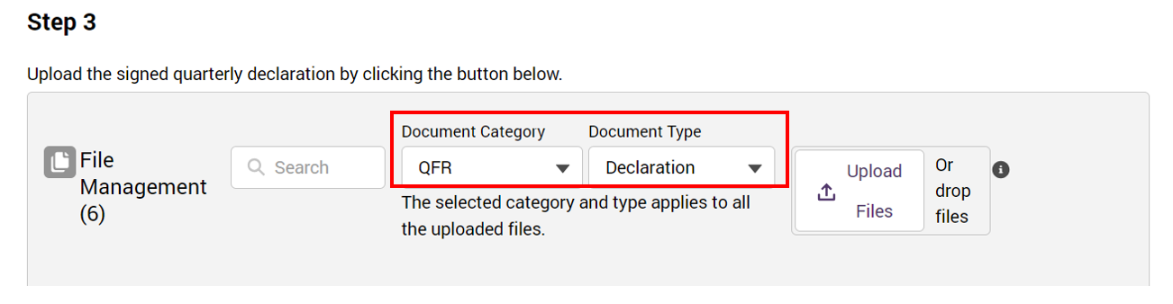
- Select the Upload Files button. Locate and select your signed QFR Declaration form for upload.
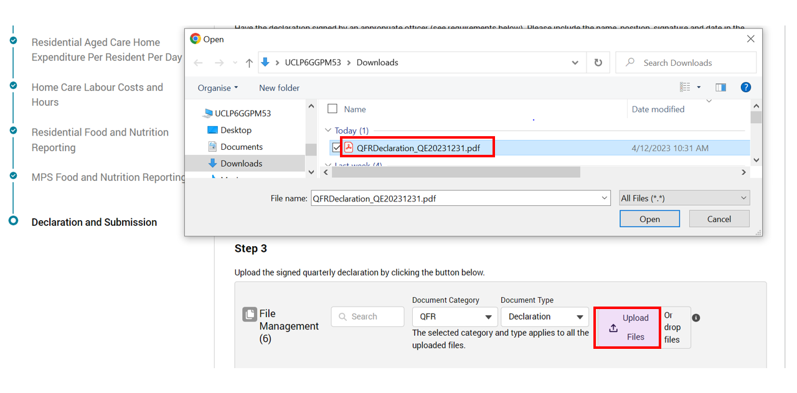
Another way to upload your file is through the drop files function.
Locate your signed QFR Declaration form, then drag and drop the file over the Or drop files text.
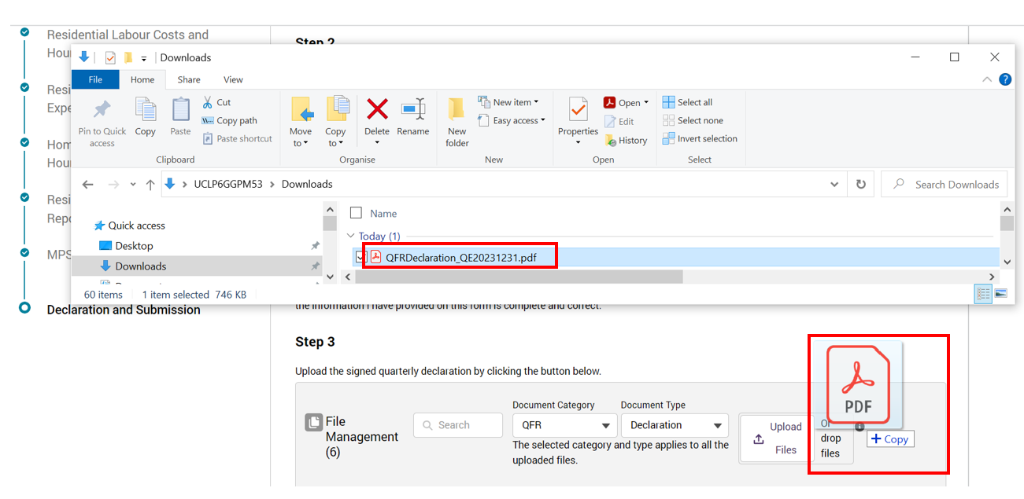
- A confirmation message is displayed when the file upload completes successfully. Select the Done button to continue to the next step.
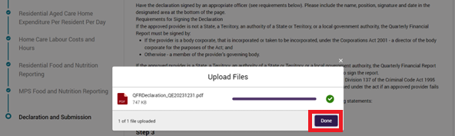
Please note:
You may upload a declaration form as many times as necessary.
You will have to upload a declaration file each time you submit a report, which covers:
initial submission
subsequent resubmissions of your report for the same quarterly reporting period.
Your previous declarations are invalidated upon successful upload of the new declaration form.
Unsuccessful file upload
An error message is displayed when the uploaded declaration file is in an unsupported format.
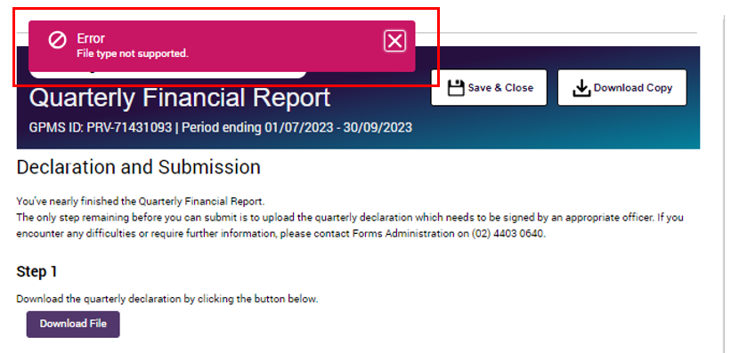

Please note:
The declaration form is expected to be uploaded in pdf format.
There are other file types supported by the upload function, a shared component across GPMS applications, which are not relevant to the QFR declaration process.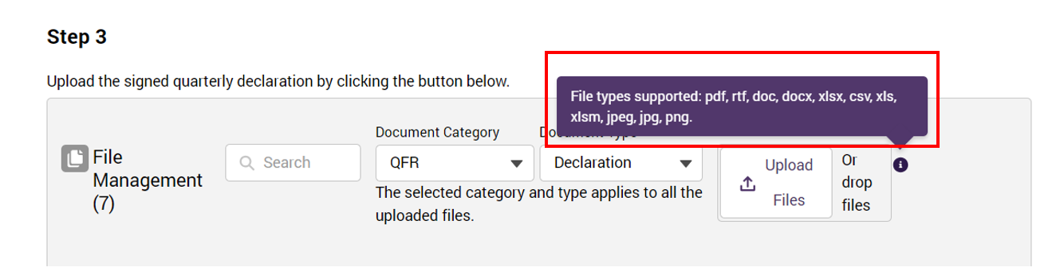
- The declaration form is scanned for viruses after the file is uploaded successfully.

Submission
Follow the steps to submit your QFR below.
- Before you can submit your report, check that:
- there are no errors (indicated by the green circle with a tick visual cue next to the QFR section names in the sidebar navigation)
- you have uploaded a declaration form signed by an authorised officer.
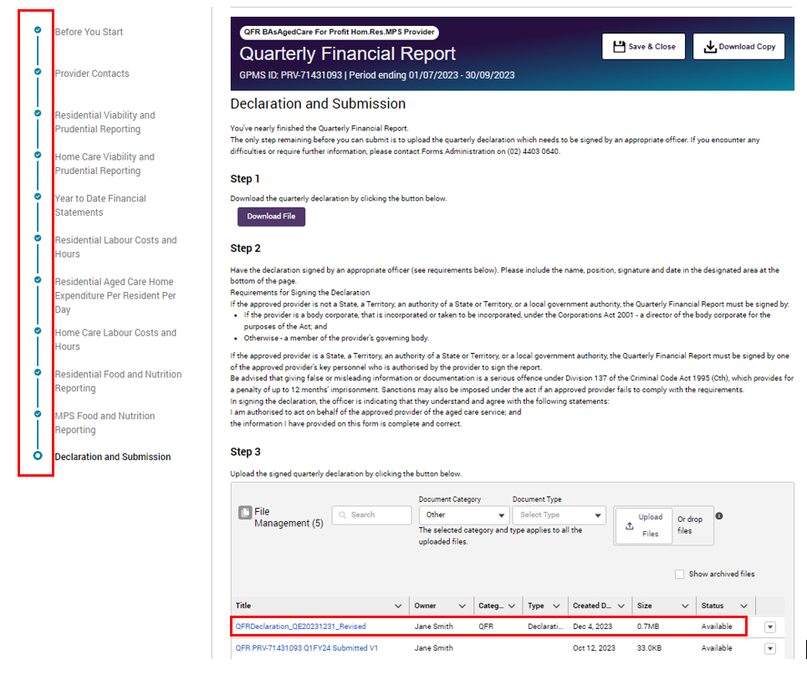

Please note:
The Submit button is disabled when:
there is an error in any of the QFR sections, or
you have not uploaded a declaration for your QFR submission, or
the virus scanning of the uploaded declaration file is in progress.

- Select the Submit button when the virus scan is complete, indicated by an Available status.
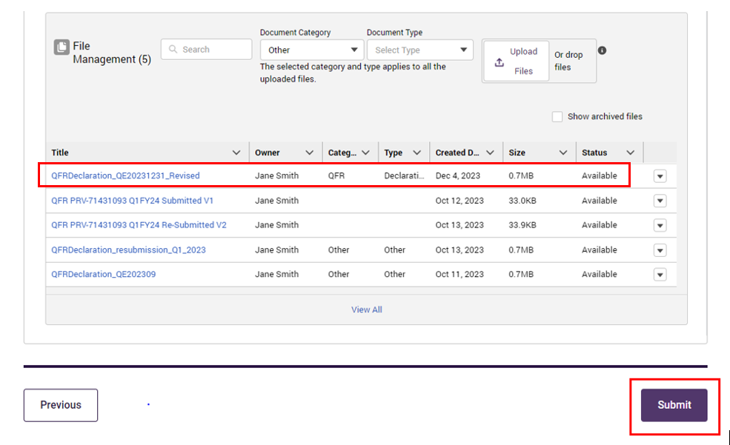
Your QFR is submitted.
A confirmation page will be displayed with a message that your report has been successfully submitted.
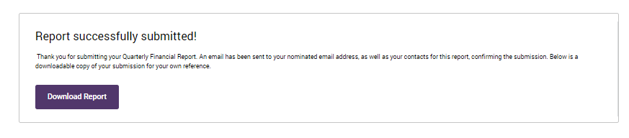

Download a copy of your submitted QFR
There are a number of ways to download a copy of your submitted report:
- from the confirmation page displayed on your screen right after submission
- from the Financial reporting home page
- from the File Management table on the Declaration and Submission section of the QFR.

Follow the steps to download your submitted report from the confirmation page below.
Confirmation page
- Select the Download Report button to preview your submitted report.
- Select the Download button from the preview screen to save a copy of your submitted report.
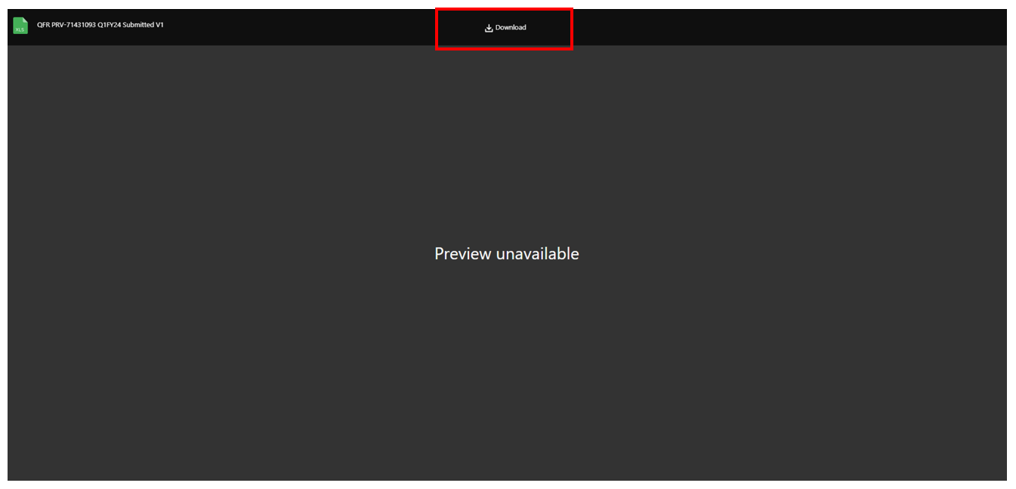
Please note:
There is no on-screen preview for your submitted report.
Your submitted QFR will download and automatically save in your computer’s default or nominated Downloads folder.

Financial reporting home page
Follow the steps to download your submitted report from the Financial reporting home page below.
- Navigate to the Financial reporting home page.
- Refer to the Download function for next steps.
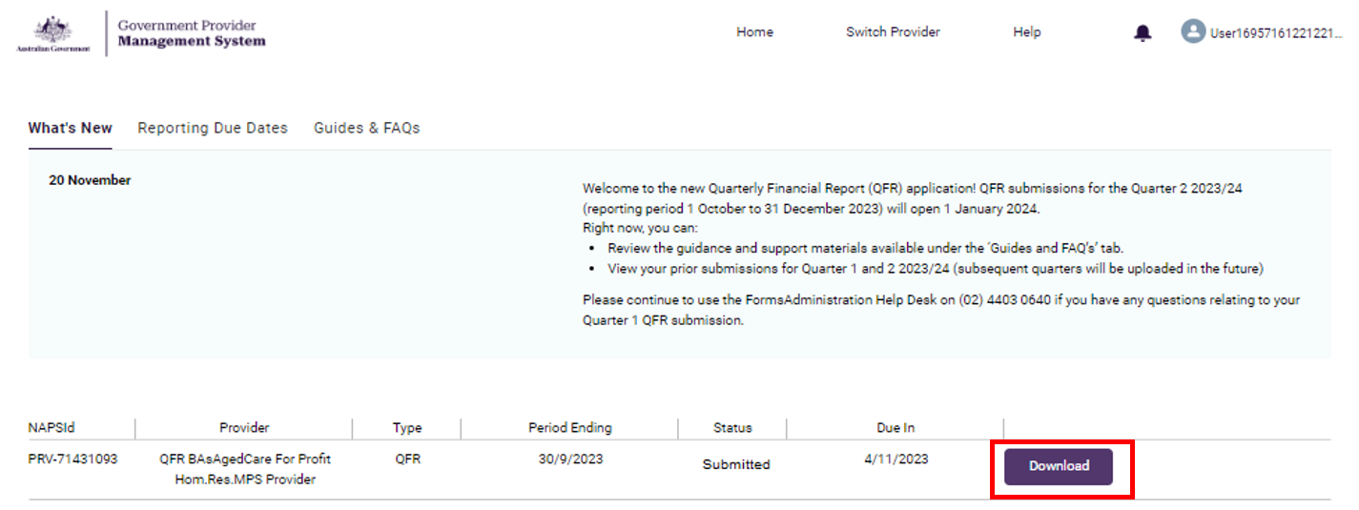

File Management table
Follow the steps to download your submitted QFR from the File Management table below.
- Navigate to the Declaration and Submission section of the QFR.

Please note:
You can only access the Declaration and Submission section when the status of your QFR is Draft or Reissued.
- Locate the submitted report under the Title column that you wish to download.
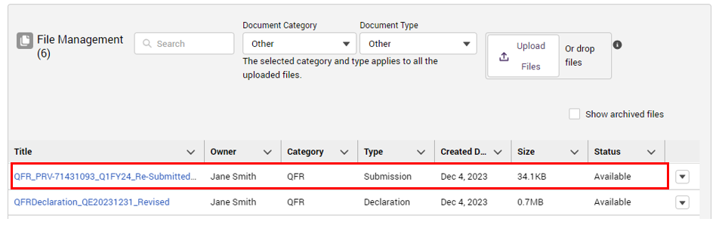
- Refer to the Download submitted QFR function for next steps.

Resubmission
One or more sections of your QFR may be reopened for revision and resubmission for the following reasons:
- You wish to revise the submitted values in your report
- Your reported values or explanation require clarification following the quality assurance checks undertaken by Forms Administration on behalf of the department.

Please note:
If you wish to revise your submitted report, contact Forms Administration and request to reopen the section/s of your submitted report that you would like to update.
You will receive an email if your QFR is reissued to you following the quality assurance checks.
Follow the steps to navigate to your submitted QFR with one or more sections re-opened below.
- Navigate to the Financial reporting home page.
Your report status is updated to Reissued status.
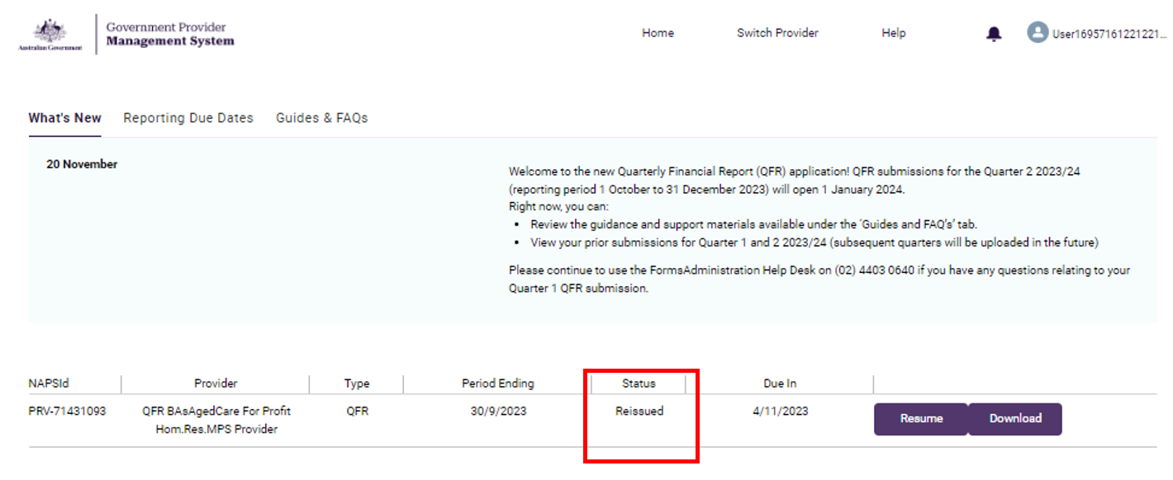
- Select the Resume button to start updating your report.
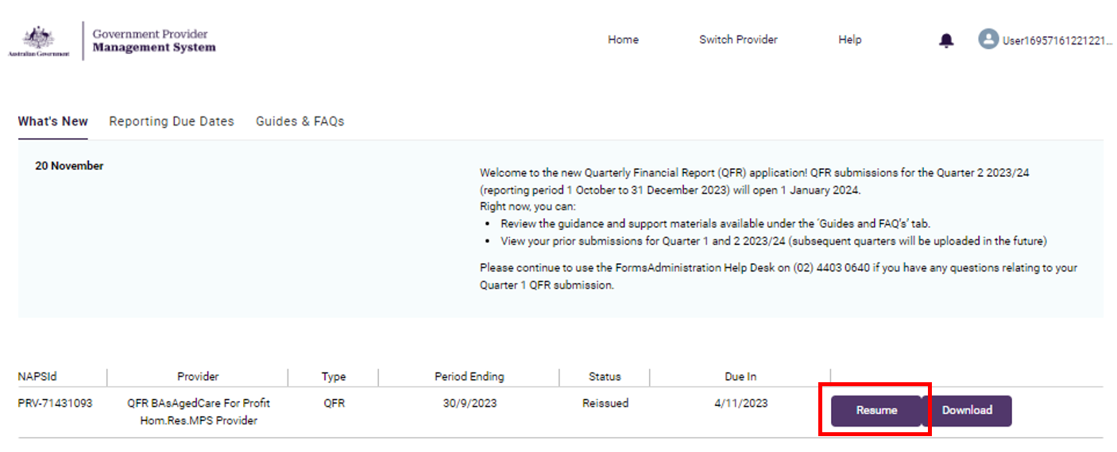
- Navigate to the reissued section/s of the report. A reissued section is indicated by a grey circle () visual cue next to the name of the QFR section in the sidebar navigation.
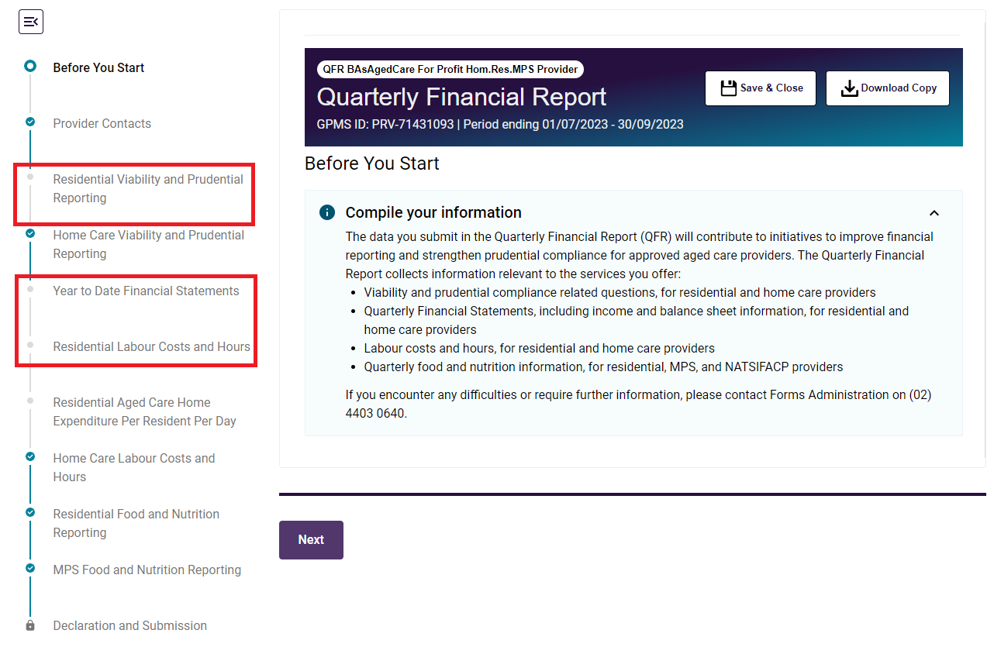
Please note:
While the Residential Aged Care home Expenditure Per Resident Per Day section of the report displays the reissued indicator, this section contains read-only values.
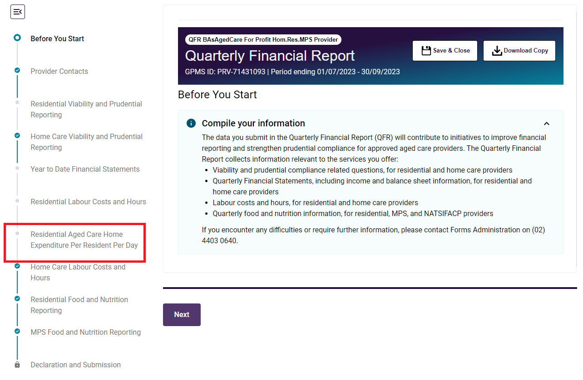
The visual cue for this section is automatically updated in line with the Residential Labour Costs and Hours status.

Reissue reason/s
The reason/s your submission has been reissued and comments from the QA assessor are displayed in the:
- QFR application (varies depending on the section)
- reissued copy of your submitted report.
If your QFR was reissued in relation to the declaration, you will receive an email outlining the reason/s.

RV&PR and HCV&PR sections
Taking the RV&PR section as an example, the  attention icon is displayed on the Financial Performance sub heading bar. A submitted response was rejected by the QA Assessor with a comment displaying below the question to indicate how you might revise your response to be accepted.
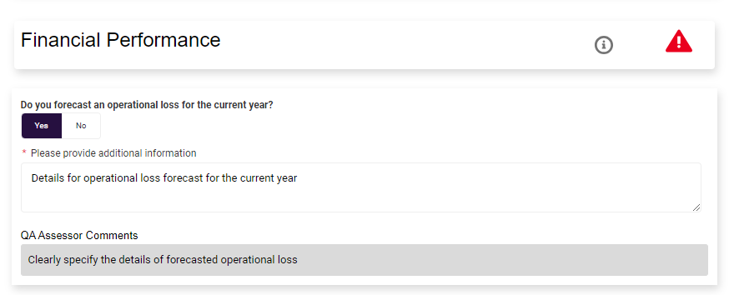
- Type over the text on the additional information input field with your revised response.
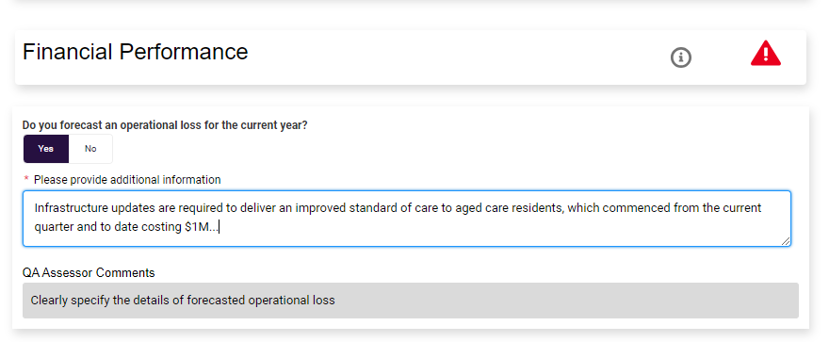
- If applicable, update your response to the next question until the RV&PR section revision is complete.
- Save your revised responses in the RV&PR section by:
- selecting the Next button
- selecting the Previous button
- navigating to another section of the QFR using the sidebar navigation, or
- selecting the Save and Close button.
Please note:
Entered responses in the RV&PR and HCV&PR sections of the QFR are not automatically saved until you do one of the save options described in step 4 above. All the save options will result to being navigated away from the RV&PR section.
Navigating back to the saved RV&PR section before resubmitting the report, you will see:
the attention icon, cleared when your revised response is reviewed and accepted by the QA Assessor
your updated additional information
the QA Assessor’s comment relating to your previous response.

YTDFS, RLC&H, HCLC&H, RF&NR, NATSIFACP-F&NR, and MPS-F&NR sections
- Taking the RLC&H section as an example, you will find an explanation for the section reissue below the banner.
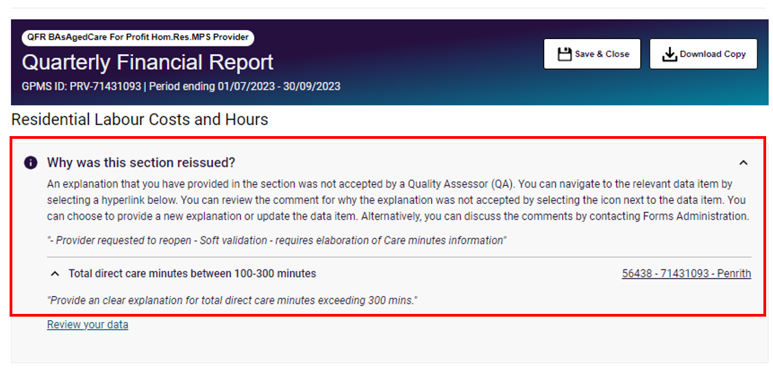
- Select the Review your data link.
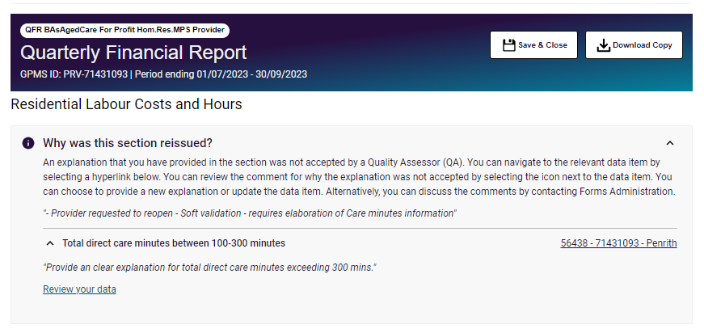
The data table display will reposition your cursor within view of the applicable data field for revision.
- Review your submitted data and revise by:
- updating existing values in the input data fields
- updating your explanation based on the assessor’s comment, or
- entering an explanation when a revised value has triggered a soft validation error.
For example, a QA comment to ‘Provide a more descriptive and quantifiable explanation” against your original explanation of “Low occupied bed days during the reporting quarter”.
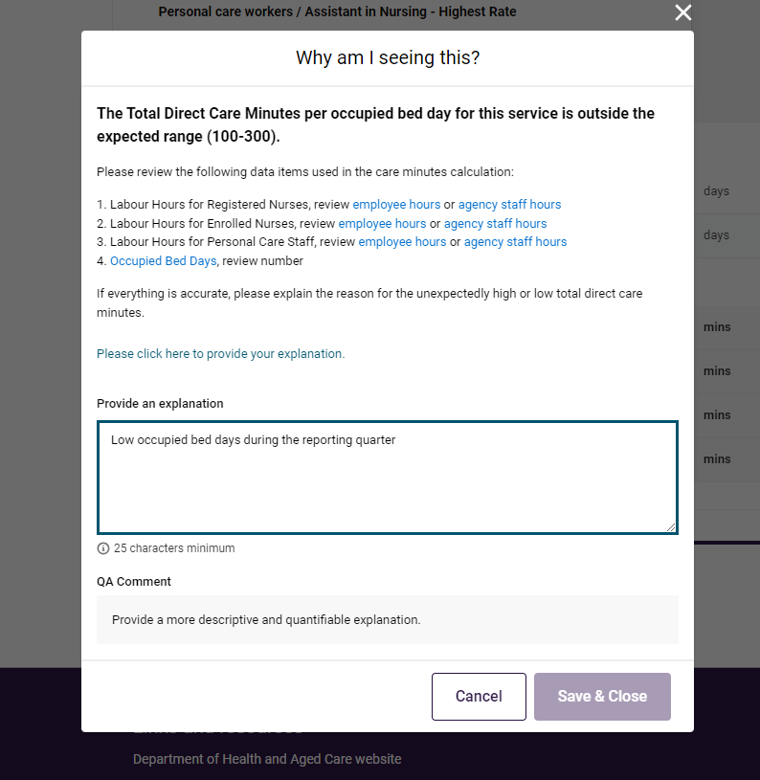
- Type over the text on the Provide an explanation input field with your revised response.
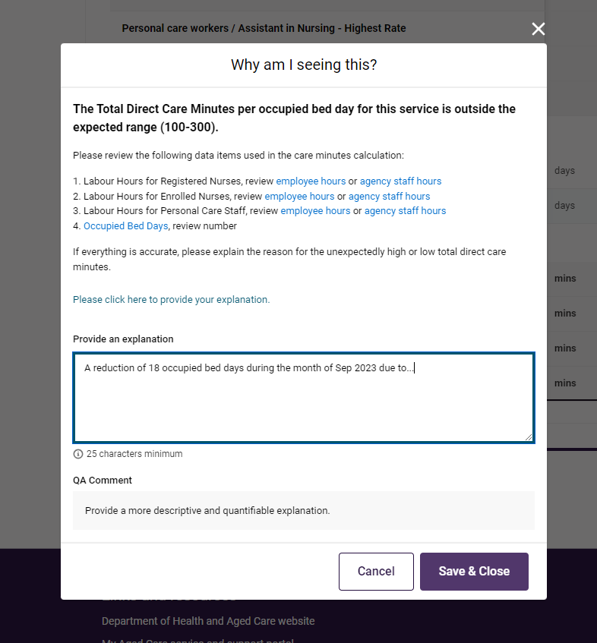
- Select the:
- Save & Close button to save your changes and close the QFR form, or
- Cancel button if you do not wish to save the revised explanation that you have entered into the text input field.

Please note:
Navigating back to the saved RLC&H section before resubmitting the report, you will see:
your updated explanation
the assessor’s comment relating to your previous response.

- Once you have completed the required revisions across the reissued sections of your QFR, follow the steps in the Declaration and Submission section to resubmit your report.

Download reissued copy of your submitted report
- Download your submitted report in Reissued status from the Financial reporting home page by selecting the Download button.
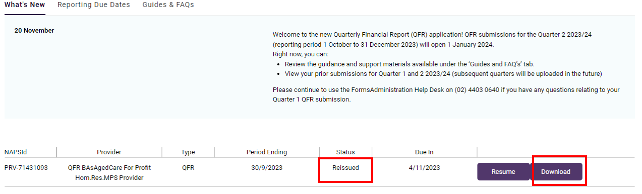
Alternatively, you can download the reissued copy of your submitted report by selecting the Download Copy button after resuming completion of your QFR.
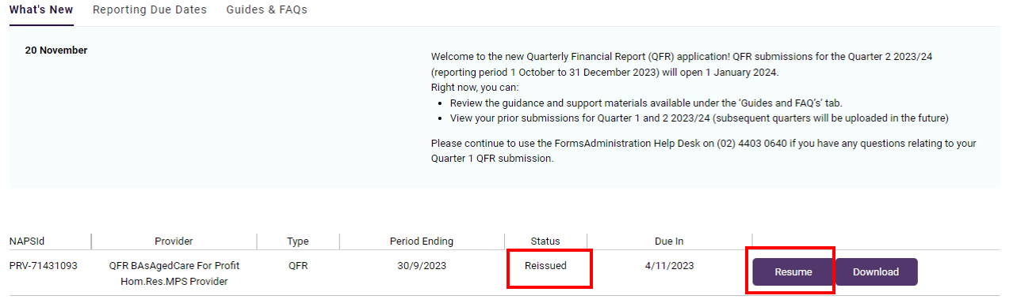
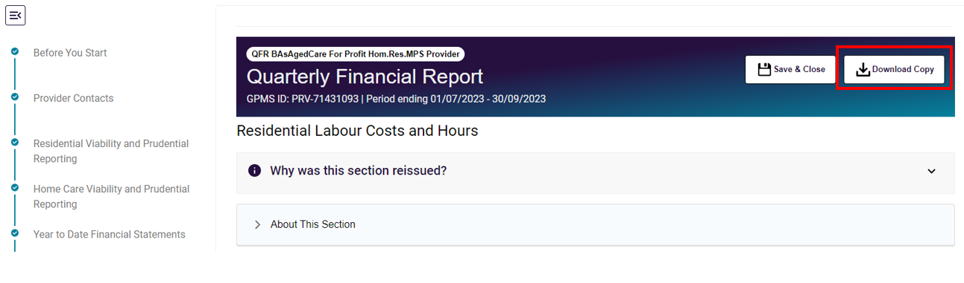
The downloaded copy of your submitted report in Reissued status includes a More information tab that contains the reissue reason/s, grouped by sections of the QFR. In this example, there is only one data field that triggered the reissue of the RLC&H section.
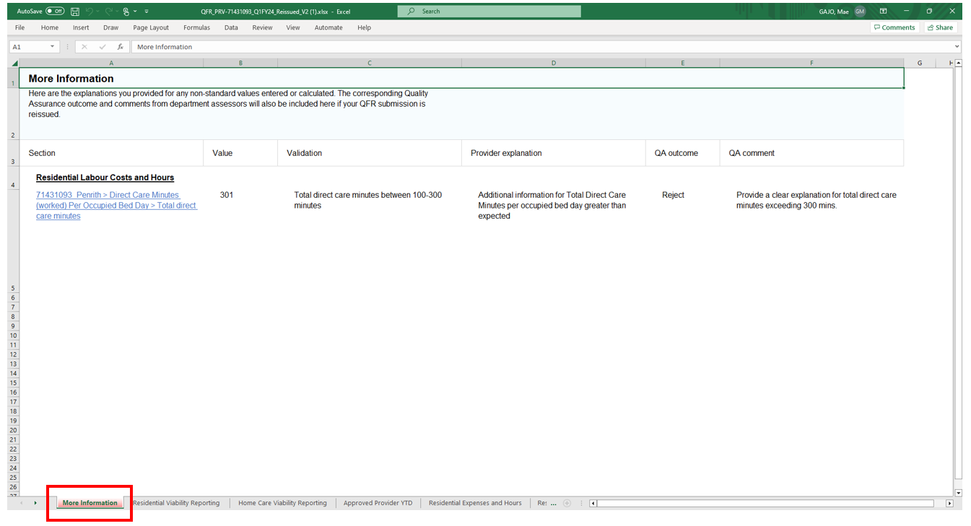
- Review and revise your data as required.

Please note:
Changes to one or more data field values may be done by manual data entry or bulk update.
Changes to your explanation can only be done by manual data entry in the QFR application.

Validation rules and error alerts
When entering data into the QFR form, error alerts are displayed to prompt a review of data per the built-in validation rules. Below are the validations, the error that is displayed and how it can be corrected.

Validation | An explanation must be provided when a Yes or No question is answered with a Yes.
QFR section | RV&PR, HCV&PR
Error | 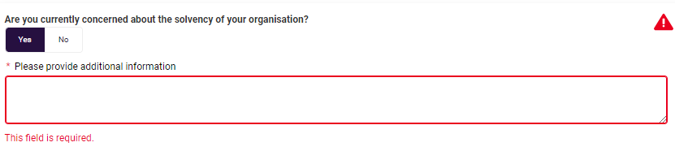
Correction | Supply a reason or justification for your Yes response.

Validation | When business structure is selected, the percentage of care or service delivered is required.
QFR section | HCV&PR
Error | 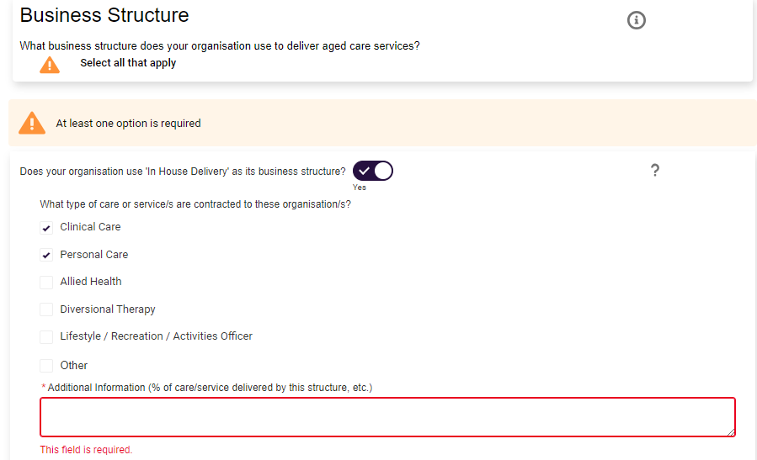
Correction | Enter the percentage for each care or service that you have selected under the business structure.

Validation | A value must be entered in the data field.
QFR section | YTDFS, RLC&H, HCLC&H, RF&NR, NATSIFACP-F&N, MPS-F&NR
Error | 
Correction | Enter the relevant value that you are reporting for the data field.

Validation | Enter the relevant zero or greater value that you are reporting for the data field.
QFR section | RLC&H, HCLC&H, RF&NR, NATSIFACP-F&N, MPS-F&NR
Error | 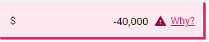
Correction | Enter the relevant value that you are reporting for the data field.

Validation | One or more data field errors in a column.
QFR section | YTDFS, RLC&H, HCLC&H, RF&NR, NATSIFACP-F&N, MPS-F&NR
Error | 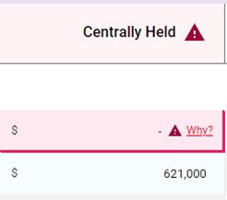
Correction | Enter the relevant values that you are reporting for the data fields with error indicators.  When all the data fields with errors are fixed, column error indicator will no longer be displayed.

Validation | Labour cost and labour hours must be:  - both zero, or  - both non-zero.
QFR section | RLC&H
Error | Non-zero cost, zero hours  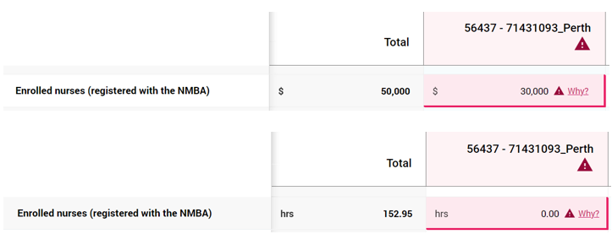  Zero cost, non-zero hours  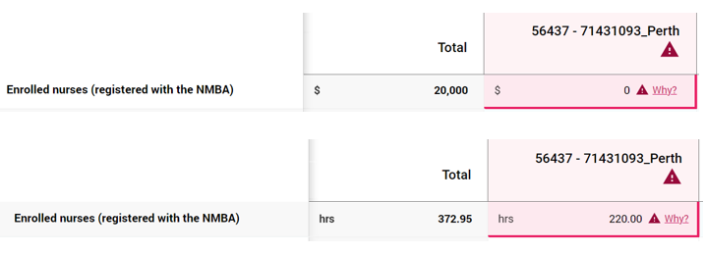
Correction | Enter a value that are both zero when the labour cost category is not applicable to your service, or both non-zero when the cost category applies to your service.

Validation | Occupied Bed Days cannot be greater than Available Bed Days.
QFR section | RLC&H
Error | 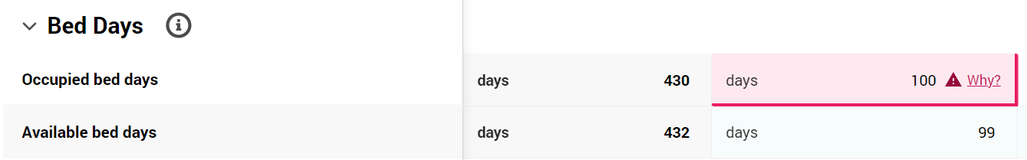
Correction | Enter the number of days beds were occupied, which does not exceed the total number of days beds were available for use during the quarter.

Validation | Available Bed Days cannot be less than100.
QFR section | NATSIFACP-F&N, MPS-F&NR
Error | 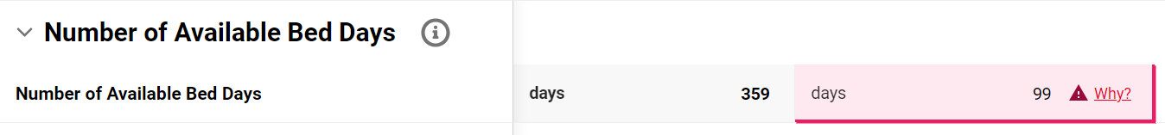
Correction | Review the entered Available Bed Days.  To fix the error, either:  - enter a value of 100 or more, or  - supply a reason or justification for the lower than expected total number of days beds were available for use during the quarter.

Validation | Total direct care minutes is outside the expected range (100-300).
QFR section | RLC&H
Error

Correction | Review the values used in the Total direct care minutes calculation:  - Labour Worked hours - Registered nurses  - Agency Staff Worked hours - Registered nurses  - Labour Worked hours - Enrolled nurses  - Agency Staff Worked hours - Enrolled nurses  - Labour Worked hours - Personal care workers  - Agency Staff Worked hours - Personal care workers  - Occupied Bed Days  To fix the error, either:  - enter the relevant values that you are reporting for the data fields, or  - supply a reason or justification for the unexpectedly high or low total direct care minutes.

Validation | Non-worked hours must be greater than zero.
QFR section | RLC&H, HCLC&H
Error | 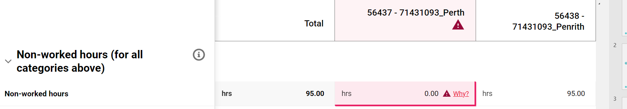
Correction | Enter a value greater than zero for the Non-worked hours data field.

Validation | At least 85% of total wages must be attributed to direct care.
QFR section | RLC&H and YTDFS, HCLC&H and YTDFS
Error | 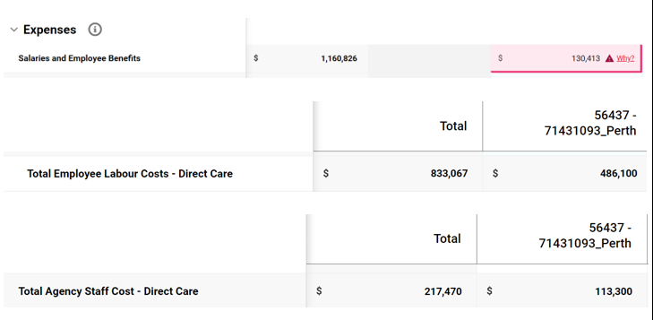
Correction | Review the values in the following data fields are for the quarter only:  - Total Employee Labour Costs - Direct Care in the relevant LC&H form  - Total Agency Staff Costs - Direct Care in the relevant LC&H form.  Also review that data entered in the YTDFS section is on a year-to-date basis:  - Residential Salaries and Employee Benefits.  To fix the error, either:  - update values that you are reporting for the relevant data fields, which will result to at least 85% of total wages attributed to direct care, or  - supply a reason or justification for the lower than expected total wages attributed to direct care.

Validation | Total Income variance between the current and previous year is greater than 50%
QFR section | YTDFS
Error | Q3 – Previous year  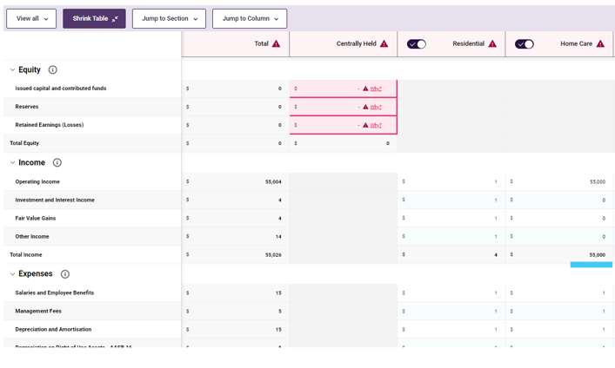  Q3 – Current year  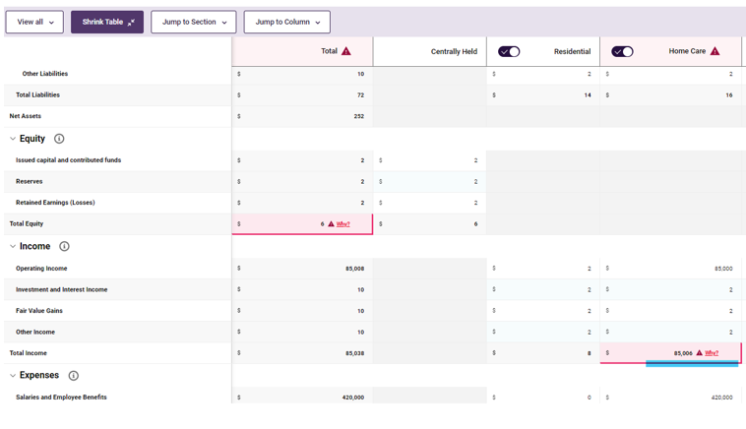  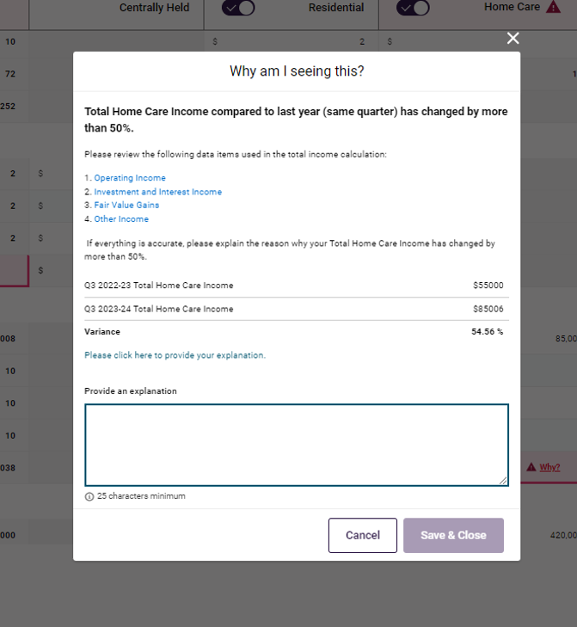
Correction | Review the values in the following data fields used in the total income calculation:  - Operating Income  - Investment and Interest Income  - Fair Value Gains  - Other Income  To fix the error, either:  - update values that you are reporting for the relevant data fields, which will result to a change to your total Home Care Income of no more than 50%, or  - supply a reason or justification for the change to your Home Care Income of more than 50%.

Validation | A non-zero Occupied Bed Days in the RLC&H section must have a non-zero total food cost in the F&NR forms.
QFR section | RLC&H and RF&NR, NATSIFACP-F&N, MPS-F&NR
Error | 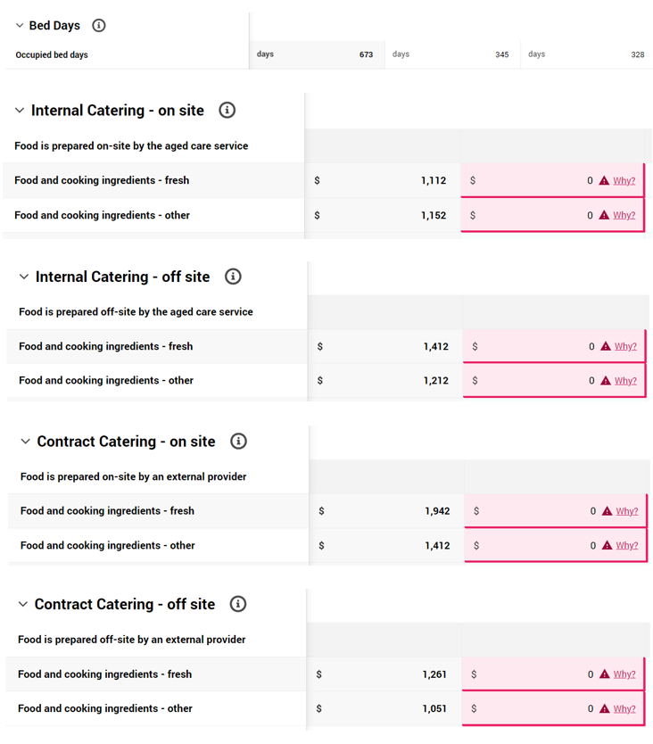
Correction | Enter a food cost with a non-zero total across the following data fields in the F&NR forms:  - Internal Catering – on site  - Internal Catering – off site  - Contract Catering – on site  - Contract Catering – off site

