Government Provider Management System

Troubleshooting Guide: Quarterly Financial Report

February 2024

Version 1.0

This Government Provider Management System (GPMS) troubleshooting guide aims to assist providers in resolving basic issues that may be encountered while submitting a Quarterly Financial Report (QFR) within the QFR application.

**Contents**

1. Introduction 3

1.1 Purpose 3

1.2 Definitions 3

2. Further information 4

3. Known issues 4

3.1 Home, All sections – Incorrect salutation 4

3.2 All sections – Unexpected behaviour of the browser’s Back button 5

3.3 All sections – Carriage return entered in an input field is converted to HTML 6

3.4 All sections – Keyboard shortcuts 6

3.5 PC – Recording of primary contact details is mandatory 6

3.6 PC – Contact number error message 7

3.7 Viability – Entered non-numeric data is not automatically saved 7

3.8 Viability – Missing questions in the downloaded copy of QFR 8

3.9 YTDFS – Alternative financial year 8

3.10 YTDFS, LC&H, F&N – QFR definition tooltips 9

3.11 YTDFS, LC&H, F&N – Why? error displayed when the first value is entered 10

3.12 YTDFS, LC&H, F&N – Expanded table does not have call-to-action buttons 10

3.13 YTDFS, LC&H, F&N – Tab key behaviour when pressed from the last unprotected cell of a table 11

3.14 YTDFS, LC&H, F&N – Enter key behaviour when pressed from the last unprotected cell of a table 12

3.15 YTDFS, LC&H, F&N – Inconsistent validation names 12

3.16 YTDFS, LC&H, F&N – Totals not calculated in downloaded Excel template until editing is enabled 13

3.17 LC&H, RACHE-PRPD, F&N – Residential facilities and home care planning regions are displayed in columns with no logical order 14

3.18 D&S – Irrelevant document upload file types 14

3.19 D&S – Preview of submitted QFR not available 14

# Introduction

## Purpose

This troubleshooting guide outlines the known issues associated with the QFR (‘report’) completion and submission in the QFR application.

This document is current as of 30 January 2024, and will be updated in a timely manner to reflect the fixes and enhancements as implemented in future GPMS releases.

To find issues relevant to a QFR section, the impacted QFR section/s are included as part of the document section titles that may be viewed from the table of contents. For example, the **Entered non-numeric data is not automatically saved** issue is titled **Viability – Entered non-numeric data is not automatically saved** as it occurs in the HCV&PR and RV&PR sections of the QFR.

## Definitions

| Term | Description |
| --- | --- |
| QFR sections | The QFR is made up of the following sections:   * Provider Contact (PC) * Home Care Viability and Prudential Reporting (HCV&PR) * Residential Viability and Prudential Reporting (RV&PR) * Year to Date Financial Statement (YTDFS) * Home Care Labour Costs and Hours (HCLC&H) * Residential Labour Costs and Hours (RLC&H) * Residential Aged Care Home Expenditure Per Resident Per Day (RACHE-PRPD) * Residential Food and Nutrition Reporting (RF&NR) * NATSIFACP Food and Nutrition Reporting (NATSIFACP-F&NR) * MPS Food and Nutrition Reporting (MPS-F&NR) * Declaration and Submission (D&S). |
| Viability sections | Viability sections include:   * Home Care Viability and Prudential Reporting * Residential Viability and Prudential Reporting. |
| Labour Costs and Hours sections | Labour Costs and Hours (LC&H) sections include:   * Home Care Labour Costs and Hours * Residential Labour Costs and Hours. |
| Food &Nutrition sections | Food &Nutrition (F&N) sections include:   * Residential Food and Nutrition Reporting * NATSIFACP Food and Nutrition Reporting * MPS Food and Nutrition Reporting. |

# Further information

If you require further assistance to login to GPMS, please contact the My Aged Care service provider and assessor helpline on **1800 836 799**, Monday to Friday (8am to 8pm) and Saturday (10am to 2pm) local time across Australia.

For more information on GPMS, please refer to the [Government Provider Management System](https://www.health.gov.au/our-work/government-provider-management-system) webpage.

For translating and interpreting services, call **131 450** and ask for My Aged Care on **1800 836 799**.

To use the National Relay Service, visit [About the National Relay Service (NRS) | Access Hub](https://www.accesshub.gov.au/about-the-nrs) or call **1800 555 660**.

To access sign language interpreting and captioning services through Deaf Connect, call [**1300 773 803**](tel:1300%20773%20803) or email [interpreting@deafconnect.org.au](mailto:interpreting@deafconnect.org.au).

For reporting enquiries, please contact the relevant support groups listed below.

* For general enquiries about completing your QFR, email [health@formsadministration.com.au](mailto:health@formsadministration.com.au) or phone (02) 4403 0640, Monday to Friday (8:30am to 5pm AEST)
* For questions about direct care reporting email [QFRACFRHelp@health.gov.au](mailto:QFRACFRHelp@health.gov.au).

# Known issues

## Home, All sections – Incorrect salutation

**Impacted QFR section:** All sections.

**Description:** Some contacts did not have salutations recorded in the National Approved Providers System (NAPS). By default all contacts in GPMS were assigned an ‘Mx’ salutation. There is also currently no functionality in the QFR application to update the salutation field.

**Impact:** On screen display of incorrect ‘Mx’ salutation.

## All sections – Unexpected behaviour of the browser’s Back button

**Impacted QFR section:** All sections.

**Description:** When you select the browser’s Back button, you will be redirected to the GPMS portal home page instead of the last visited page (as per the expected behaviour of the Back button).

**Impact:** When you select your browser’s Back button in the middle of completing your report:

* you will be redirected to the GPMS portal home page, and
* you must navigate back to the relevant section of the QFR to continue completing your report submission.

Unsaved changes will be lost if you select your browser’s Back button from the following sections:

* Provider Contact
* Home Care Viability and Prudential Reporting
* Residential Viability and Prudential Reporting.

No data will be lost if the Back button is selected from the other sections of the QFR.

**Workaround:** Refrain from using your browser’s Back button (highlighted in screenshot below) while navigating the QFR sections.

**Screenshots:**

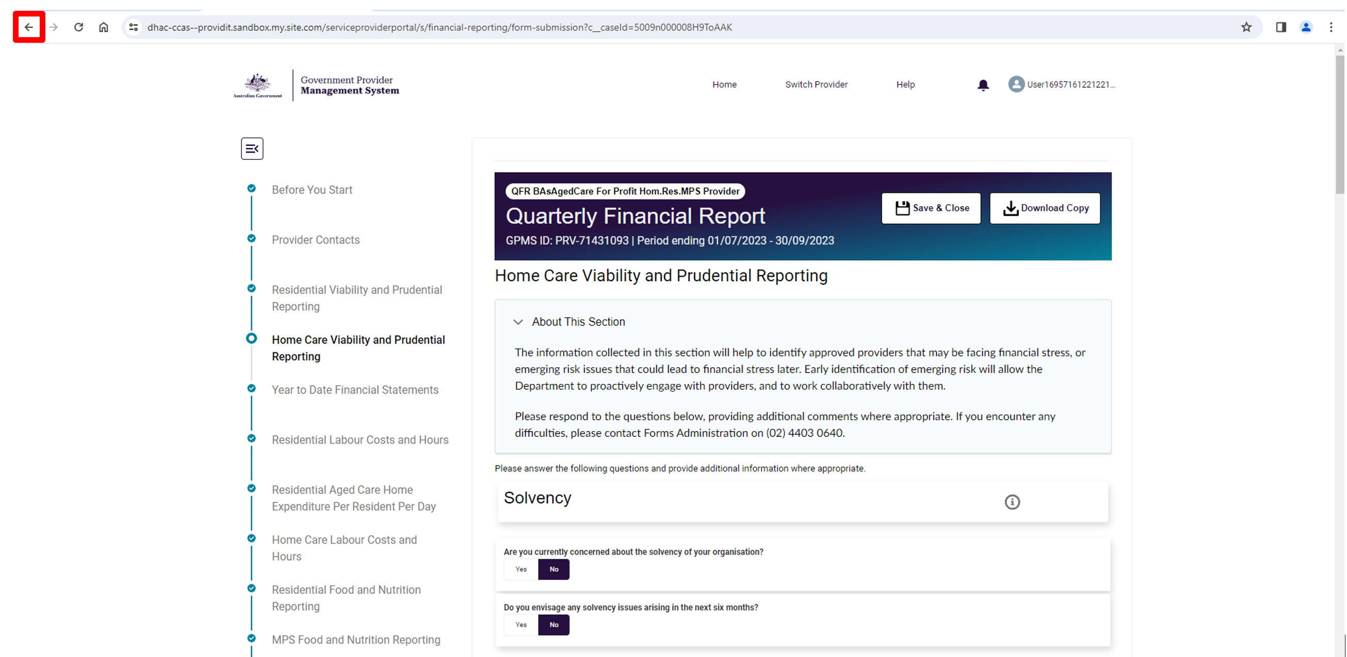

**Note:** Back button behaviour may differ depending on your browser.

## All sections – Carriage return entered in an input field is converted to HTML

**Impacted QFR section:** All sections.

**Description:** When you navigate back to a QFR section where you entered text and line break into an input field, you will find that the line break is converted to <br> HTML element.

**Impact:** Entered text may be difficult to read with <br> tag/s inserted in place of a line break.

## All sections – Keyboard shortcuts

**Impacted QFR section:** All sections.

**Description:** Keyboard shortcuts do not work when moving information by copying or cutting data from a source (e.g., working spreadsheet, value from another data field in the QFR application), then pasting data into an input field on the QFR application. This issue is limited to the data tables in the QFR sections where you enter numeric values.

You will be able to use keyboard shortcuts for copying, cutting and pasting texts in the additional information fields.

**Impact:** You will not be able to use the keyboard shortcuts CTRL + C (copy), CTRL + X (cut), and Ctrl + V (paste) for entering numeric values into data tables of the QFR form.

**Workaround:** Use your mouse right-click function to copy, cut or paste numeric values into data tables of the QFR form.

## PC – Recording of primary contact details is mandatory

**Impacted QFR section:** Provider contact.

**Description:** There are no indicators that a primary contact must be entered on the QFR form, which could be part of:

* guidance or instructions in the About This Section
* error message displayed when primary contact data fields are left blank, or
* banner alerts.

**Impact:** Without guidance or error message displayed, providers will not know the issue is or what needs to be updated in order to submit the report.

**Workaround:** Complete and save the details of the primary contact for the QFR submission.

## PC – Contact number error message

**Impacted QFR section:** Provider contact.

**Description:** Contact numbers are typically entered with a free-form combination of parenthesis, spaces, and numbers. When a contact number is not in the expected format, the error message “Please enter a valid mobile or phone number with area code” is displayed. There is no guidance on the valid format that must be used so that the contact number is accepted.

**Impact:** Unable to save contact details unless a contact number in a valid format is entered.

**Workaround:** Enter a 10-digit contact number that:

* starts with a 0
* contains an Australian area code and phone number
* has no spaces
* has no special characters.

For example, if the contact number (02) 6289 1555 is entered, an error message is displayed – however, it does not provide adequate guidance that the acceptable format is 0262891555.

## Viability – Entered non-numeric data is not automatically saved

**Impacted QFR section:** Home Care Viability and Prudential Reporting, Residential Viability and Prudential Reporting

**Description:** Data entered in the following sections of the QFR are not automatically saved:

* Home Care Viability and Prudential Reporting
* Residential Viability and Prudential Reporting.

**Impact:** Entered data is lost when you download a copy of your report from the impacted sections of the QFR without saving first.

**Workaround:** Save entered data in the impacted sections of the QFR by doing one of the following:

* select the Next button
* select the Previous button
* navigate to another section of the QFR using the sidebar navigation, or
* select the Save and Close button.

## Viability – Missing questions in the downloaded copy of QFR

**Impacted QFR section:** Home Care Viability and Prudential Reporting, Residential Viability and Prudential Reporting.

**Description:** The viability questions corresponding to unanswered questions in the following sections of the QFR are missing from the draft copy of the report:

* Home Care Viability and Prudential Reporting
* Residential Viability and Prudential Reporting.

**Impact:** You will not be able to view all the questions in the impacted sections from a downloaded copy of your report until you have answered all the viability questions.

**Workaround:** Enter correct answers (or dummy answers if you only wish to see the questions) to all viability questions before downloading a draft copy of your report.

## YTDFS – Alternative financial year

**Impacted QFR section:** Year to Date Financial Statement.

**Description:** Unable to record an alternative financial year for providers that operate on financial years other than 1 July to 30 June.

**Impact:** May unnecessarily trigger the following validations in the Year to Date Financial Statement section of the QFR:

* Total direct care labour costs exceeds 85% of total residential salaries
* Total internal direct care labour costs exceeds 85% of total home care salaries

These validations check direct/indirect values are proportionate between the Year to Date Financial Statement and the Residential Labour Costs and Hours / Home Care Labour Costs and Hours sections.

**Workaround:** Where the calculation using standard financial year information (instead of the alternate financial year) triggered the validation, select the Why? link and enter an explanation to resolve the error.

## YTDFS, LC&H, F&N – QFR definition tooltips

**Impacted QFR section:** Year to Date Financial Statement, Home Care Labour Costs and Hours, Residential Labour Costs and Hours, Residential Food and Nutrition Reporting, NATSIFACP Food and Nutrition Reporting, MPS Food and Nutrition Reporting.

**Description:** A tooltip typically displays informative message, such as definition or elaboration of data expected on a sub section or data field, when hovering over the corresponding Image of the information icon.  information icon. Currently, the tooltips in the QFR application are links to an Excel file, Quarterly Financial Report Data Definitions, that contain the tooltip texts.

**Impact:** Extra steps to find help on a sub section or data field.

**Workaround:**

* Select the link in the tooltip bubble to download the Quarterly Financial Report Data Definitions.
* Open the file in Excel.
* Select the relevant tab, which represents a section of the QFR
* Search for the sub section or data field that you need help on.

**Screenshot:**

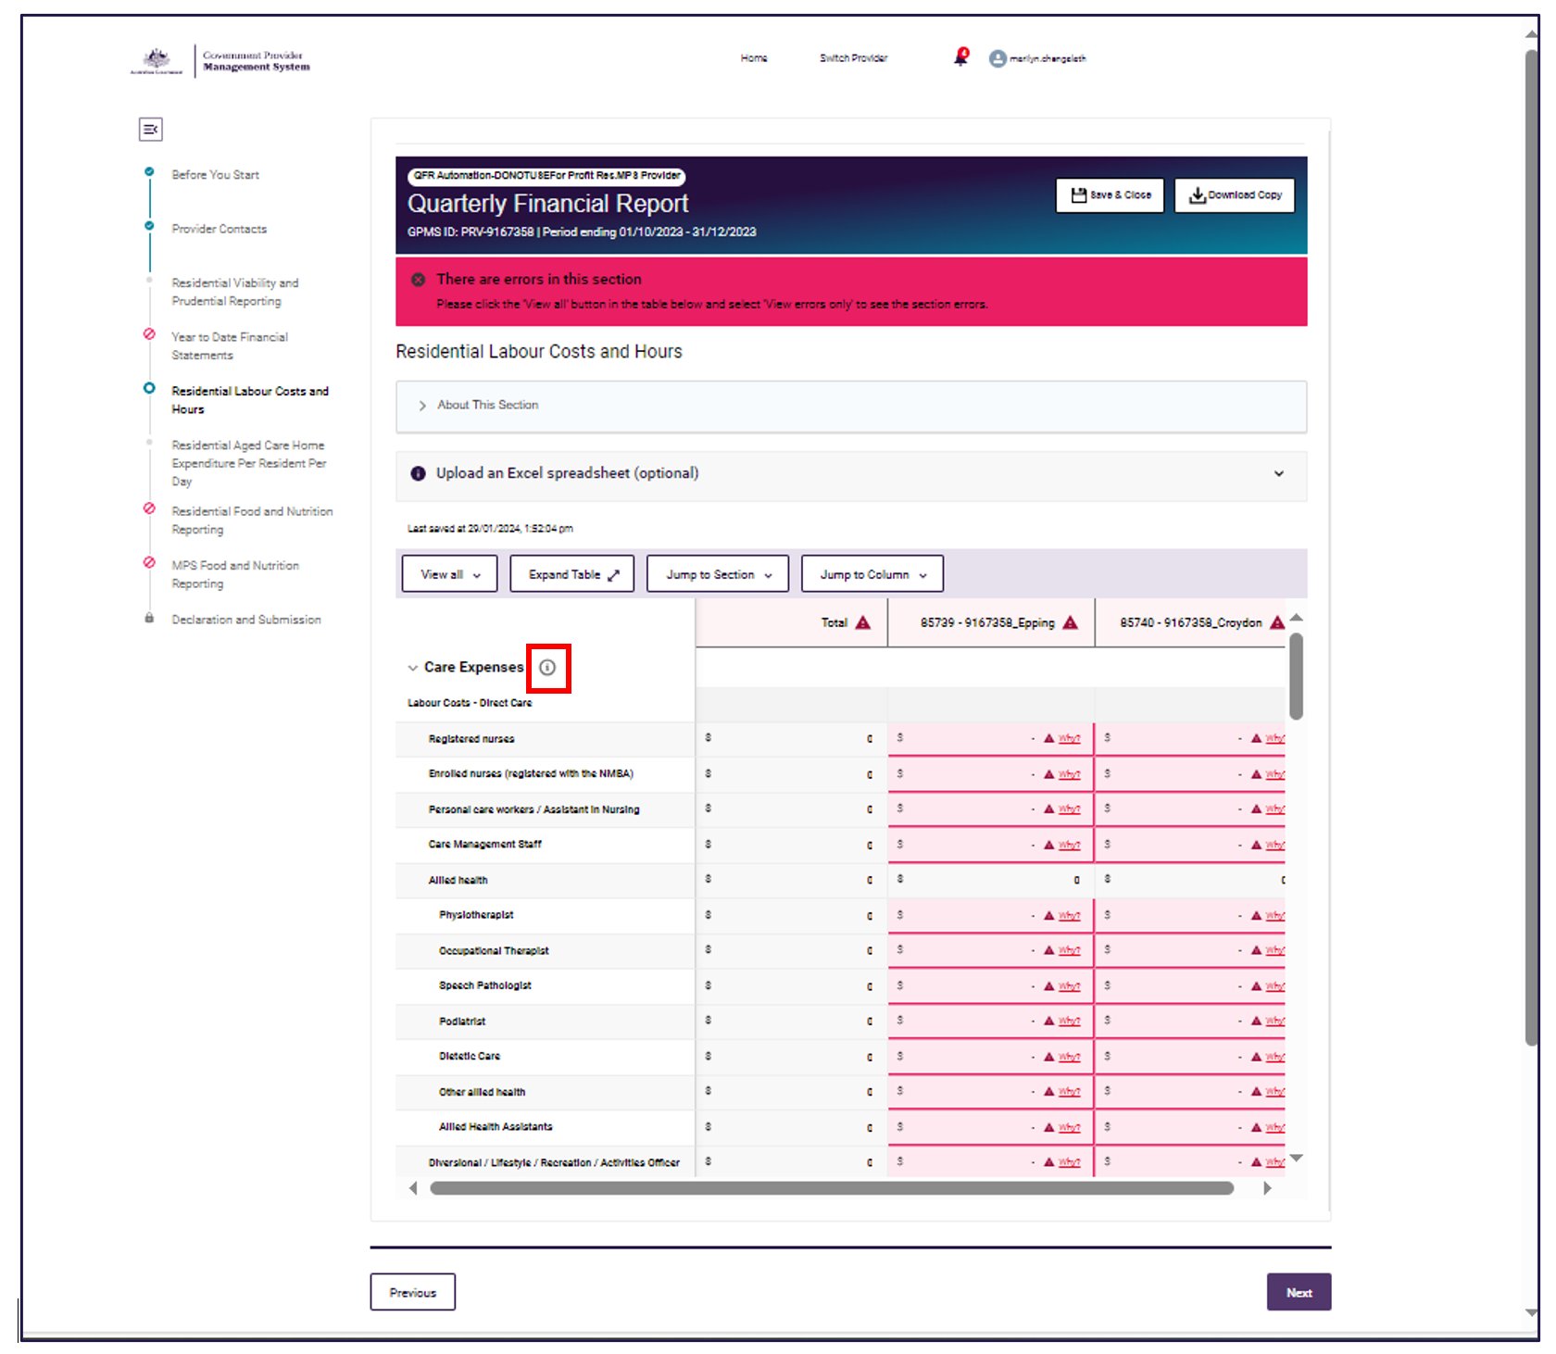

## YTDFS, LC&H, F&N – Why? error displayed when the first value is entered

**Impacted QFR section:** Year to Date Financial Statement, Home Care Labour Costs and Hours, Residential Labour Costs and Hours, Residential Food and Nutrition Reporting, NATSIFACP Food and Nutrition Reporting, MPS Food and Nutrition Reporting.

**Description:** The Why? error is displayed against all data fields (except for one) when the first value is entered on a data table of a QFR section.

**Impact:** It gives the impression that there are multitude of errors after the first value has been entered.

**Screenshot:**

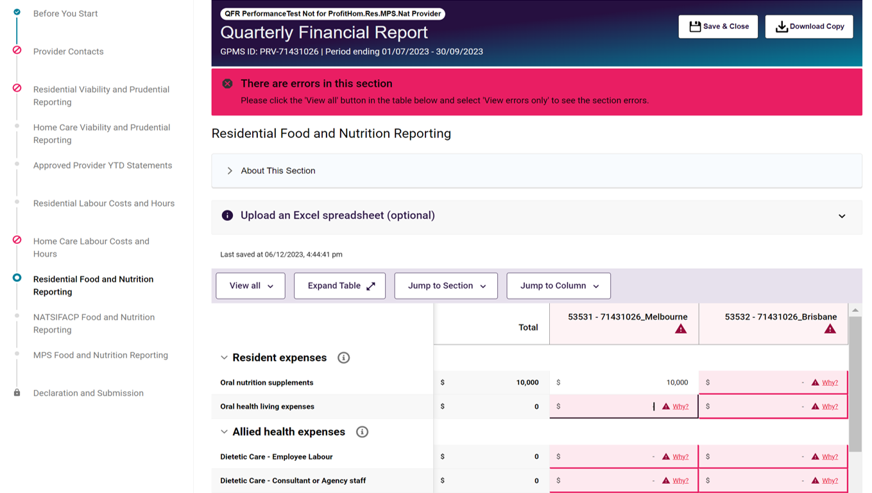

## YTDFS, LC&H, F&N – Expanded table does not have call-to-action buttons

**Impacted QFR section:** Year to Date Financial Statement, Home Care Labour Costs and Hours, Residential Labour Costs and Hours, Residential Food and Nutrition Reporting, NATSIFACP Food and Nutrition Reporting, MPS Food and Nutrition Reporting.

**Description:** The call-to-action buttons normally displayed in a QFR section are not visible in the expanded table view:

* Save and Close and Download Copy options
* Sidebar navigation
* Previous and Next buttons.

**Impact:** Unable to save and close, download a copy of the QFR, and navigate to another QFR section when a table is expanded.

**Workaround:** Call-to-action buttonsare visible in the Shrink table view.

## YTDFS, LC&H, F&N – Tab key behaviour when pressed from the last unprotected cell of a table

**Impacted QFR section:** Year to Date Financial Statement,Home Care Labour Costs and Hours, Residential Labour Costs and Hours, Residential Food and Nutrition Reporting, NATSIFACP Food and Nutrition Reporting, MPS Food and Nutrition Reporting.

**Description:** When the cursor is positioned in a field within a data table, the Tab key will move the cursor through the unprotected cells from left to right then down to the next row.

When the cursor gets to the last unprotected cell in the last row and last column, pressing tab moves to the information icon, Previous button, Next button, then footer links.

**Impact:** Unable to loop through fields in a data table using the Tab key.

**Workaround:** Use the mouse click function to move from the last unprotected cell in the last row and last column.

**Screenshot:**

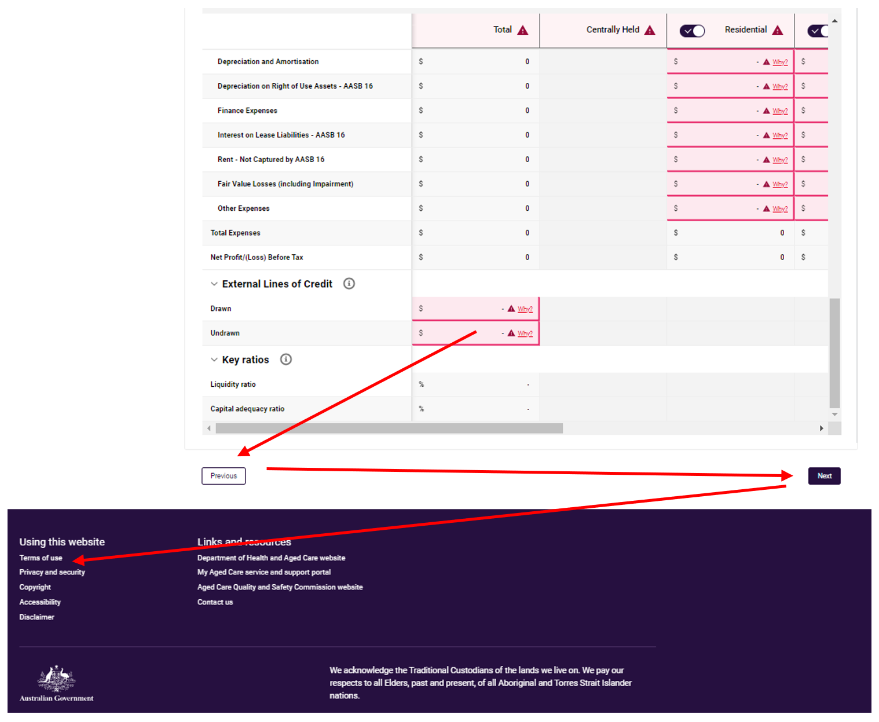

## YTDFS, LC&H, F&N – Enter key behaviour when pressed from the last unprotected cell of a table

**Impacted QFR section:** Year to Date Financial Statement, Home Care Labour Costs and Hours, Residential Labour Costs and Hours, Residential Food and Nutrition Reporting, NATSIFACP Food and Nutrition Reporting, MPS Food and Nutrition Reporting.

**Description:** When the cursor is positioned in a field within a data table, the Enter key moves the cursor through the unprotected cells from top to bottom in a column, then moves to the first row in the next column to the right.

When the prompt gets to the last unprotected cell in the last row and last column, pressing the Enter key after a value is entered on the data field:

* does not accept/save the entered data
* the prompt does not move anywhere.

**Impact:** Unable to commit (accept/save) entered value to a field in a data table using the Enter key.

**Workaround:** Use the mouse click function (click on a cell) to commit the entered data to the last unprotected cell in the last row and last column.

## YTDFS, LC&H, F&N – Inconsistent validation names

**Impacted QFR section:** Year to Date Financial Statement, Home Care Labour Costs and Hours, Residential Labour Costs and Hours, Residential Food and Nutrition Reporting, NATSIFACP Food and Nutrition Reporting, MPS Food and Nutrition Reporting.

**Description:**

Built-in validations in the QFR application are given labels or names to identify which data fields have failed system checks. These validation names can be found in three places:

* Why? pop-up where the validation error is displayed
* Reissue explanation section of the relevant QFR section
* More Information tab on the Excel template when downloaded after your report is reissued.

There is inconsistency in the validation names between the:

* Why? pop-up heading — (1)
* reissue explanation section and More Information tab — (2).

Currently, the validation names in (2) are worded in the form of ‘what is required to prevent a validation from being triggered’. In a future release, these will be restated to ‘what triggers a validation’ for clarity and consistency with the wording in (1).

**Impact:** Inconsistent wording of validation error alerts.

| Validation trigger | ‘What is required to prevent a validation from being triggered’  (Validation names in Reissue explanation section and More Information tab) | ‘What triggers a validation’  (Future release) |
| --- | --- | --- |
| Available bed days is less than 100 | Available bed days over 100 | Available bed days is less than 100. |
| No food costs entered | Bed days must have food costs | If there are occupied bed days, total food costs cannot be zero. |
| Higher occupied bed days than available | Occupied bed days must be less than or equal To available bed days | Occupied bed days cannot exceed available bed days. |
| Direct care values are greater than 85% of total wages | Under 85% of total wages as direct care (residential care) | Total direct care labour costs exceeds 85% of total residential salaries. |
| Indirect care values are greater than 85% of total wages | Under 85% of total wages as direct care (home care) | Total internal direct care labour costs exceeds 85% of total home care salaries. |
| Service's care minutes are less than 100 or greater than 300 | Total direct care minutes between 100-300 minutes | Total direct care minutes per occupied bed day is outside the expected range. |
| Labour costs do not correlate with labour hours | Labour costs correlate with labour hours | Labour costs should correspond to labour hours. |
| Less than 1 (zero) non-worked hours | Greater than zero non-worked hours | Zero non-worked hours. |
| Net assets do not equal equity | Net assets equals Equity | Net assets should balance with Total equity. |
| Total home care income variance greater than 50% | Total Income – variance greater than 50% home care | Total home care income compared to last year has changed by more than 50%. |

## YTDFS, LC&H, F&N – Totals not calculated in downloaded Excel template until editing is enabled

**Impacted QFR section:** Year to Date Financial Statement,Home Care Labour Costs and Hours, Residential Labour Costs and Hours, Residential Food and Nutrition Reporting, NATSIFACP Food and Nutrition Reporting, MPS Food and Nutrition Reporting.

**Description:** Where data has been entered into the QFR application before downloading the template from a QFR section, there will be no values displayed in calculated cells until you enable editing of the spreadsheet. For example, cells with manually entered data display non-zero values but the calculated Total columns are blank.

**Impact:** First appears that the Total column is not calculating correctly.

**Workaround:** Enable editing of the spreadsheet.

## LC&H, RACHE-PRPD, F&N – Residential facilities and home care planning regions are displayed in columns with no logical order

**Impacted QFR section:** Residential Labour Costs and Hours, Residential Aged Care Home Expenditure Per Resident Per Day, Residential Food and Nutrition Reporting, NATSIFACP Food and Nutrition Reporting, MPS Food and Nutrition Reporting, Home Care Labour Costs and Hours,

**Description:** Facilities within the impacted residential sections and planning regions in Home Care Labour Costs and Hours section are displayed as columns with no logical order.

**Impact:** Poor usability, specifically for large providers with many facility and planning region columns, to populate randomly-ordered facilities/planning regions across the width of the screen.

## D&S – Irrelevant document upload file types

**Impacted QFR section:** Declaration and Submission

**Description:** There are several file types supported by the upload function in the Declaration and Submission section, a shared component across GPMS applications, which are not relevant to QFR – such as rtf, doc, docx, xls, xlsx, xlsm, csv, jpeg, jpg, and png file formats. The declaration form is expected to be uploaded in pdf format, and potentially in other conceivable formats, e.g., jpeg, jpg and png.

**Impact:** Accepts any file in a supported format.

**Workaround:** Upload a signed declaration in pdf, jpeg, jpg or png formats.

## D&S – Preview of submitted QFR not available

**Impacted QFR section:** Declaration and Submission

**Description:** Previewing a submitted QFR displays a blank screen.

**Impact:** No on-screen preview of your submitted report is available.

**Workaround:** There is no workaround, however, a submitted report may be downloaded and viewed in Excel.