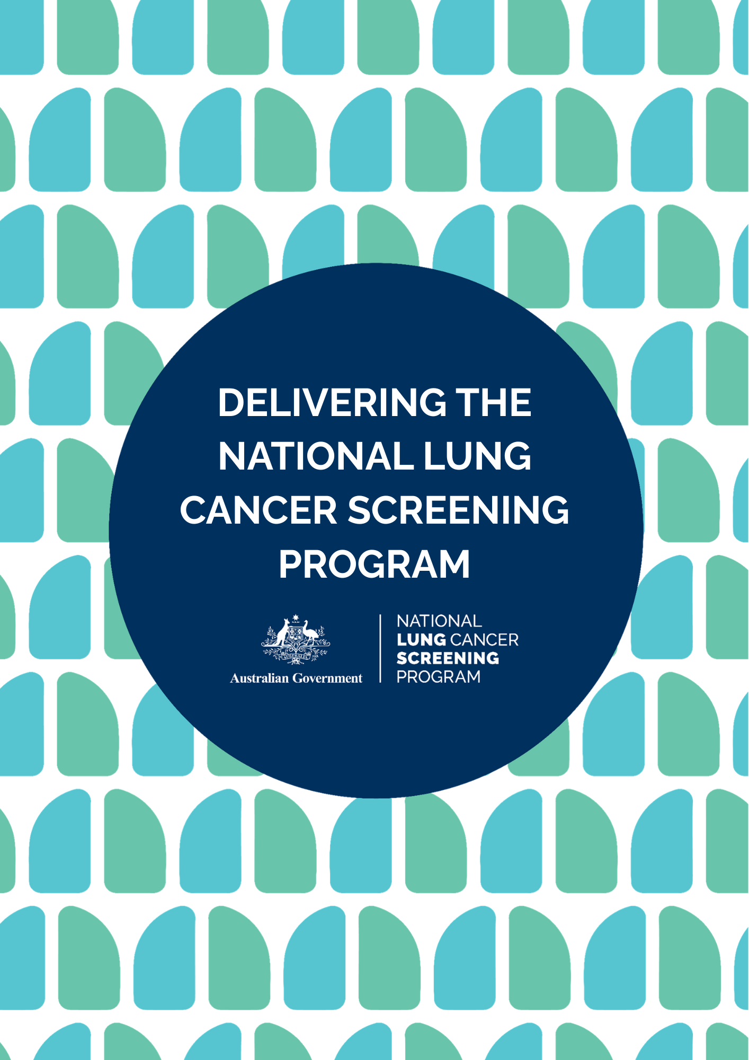

CONTENTS

Purpose of this document 3

Start delivering the NLCSP 4

Health workforce roles and responsibilities 4

Requesting Practitioner (e.g. GP, nurse practitioner) 4

Radiology provider responsibilities 4

Healthcare providers without authorisation to request a low-dose CT scan (e.g. nurses, Aboriginal and Torres Strait Islander health workers and practitioners, allied health professionals) 5

Practice staff in primary care 5

Health support workers (e.g. Aboriginal liaison officers, health support workers and smoking cessation specialists_ 5

Assessing eligibility and supporting informed choice 5

Informed consent 5

Enrolment in the NCSR 6

Requesting a low-dose CT scan 6

Booking a low-dose CT scan 6

Assessment and reporting 7

Results communication 7

Smoking cessation 7

Minimising stigma in the National Lung Cancer Screening Program 7

Promoting equity 8

Supporting Aboriginal and Torres Strait Islander communities 8

Supporting regional and remote communities 8

Access program resources 9

Delivering the National Lung Cancer Screening Program

The National Lung Cancer Screening Program (NLCSP) launched on 1 July 2025. People may now be eligible for lung cancer screening in the NLCSP if they are:

* aged between 50-70 years, and
* show no signs or symptoms suggesting they may have lung cancer (that is, they are asymptomatic), and
* currently smoke or have quit smoking in the past 10 years, and
* have a history of tobacco cigarette smoking of at least 30 pack-years.

Large international randomised trials have shown that a low-dose computed tomography (CT) scan can detect up to 70% of lung cancers at early stages and reduce lung cancer mortality by 20%.

In 2024, it is estimated that about 15,122 Australians were diagnosed with lung cancer and almost 9,000 people died from the disease.

It is the responsibility of all healthcare providers in Australia to work towards providing a culturally safe NLCSP for all people who may benefit. [New program resources and education](https://www.health.gov.au/our-work/nlcsp/resources) are now available to support you to deliver the program.

## Purpose of this document

This document provides healthcare providers with the key information and materials available to support them to prepare for and deliver the NLCSP.

## Start delivering the NLCSP

With the program now launched, healthcare providers should expect to receive enquiries from the community. Ensure you are ready to deliver the program by completing the steps below:

* Complete the [eLearning modules](https://lungfoundation.com.au/health-professionals/training-and-events/national-lung-cancer-screening-program-health-workforce-education/) developed by Lung Foundation Australia, which offers Continuing Professional Development (CPD) points.
* The radiology workforce should access the resources and education developed by the [Royal Australian and New Zealand](https://www.ranzcr.com/our-work/national-lung-cancer-screening-program-nlcsp)  [College of Radiologists (RANZCR)](https://www.ranzcr.com/our-work/national-lung-cancer-screening-program-nlcsp)
* Register and integrate your practice with the [National Cancer Screening Register](https://ncsr.gov.au/information-for-healthcare-providers/accessing-the-ncsr/clinical-software-integration.html), (NCSR) which will be essential for enrolling the participant, viewing their screening status and updating their record. The program specific CT request form lives in your native software for you to complete. Find more details on the [NCSR website](https://www.ncsr.gov.au/information-for-healthcare-providers/accessing-the-ncsr/healthcare-provider-portal/).
* Review and update your smoking history practice data to identify patients who could now be eligible to participate.
* Establish electronic medical record (EMR)- based prompts to help identify potential participants as they become eligible
* Ensure your practice has undertaken formal [cultural safety training](https://aida.org.au/cultural-safety-program/what-is-cultural-safety/), which may assist healthcare providers in fostering and providing culturally safe care to Aboriginal and Torres Strait Islander peoples
* Access resources designed to support Aboriginal and Torres Strait Islander participants and their healthcare providers on the National Aboriginal Community Controlled Health Organisation ([NACCHO) website](https://www.naccho.org.au/cancer/lung-cancer/). Register to be notified when new resources are available on the NACCHO website.
* Familiarise yourself with the program, including eligibility and screening process on the [program website](https://www.health.gov.au/our-work/nlcsp).

For more information, download the [Get your](https://www.health.gov.au/resources/publications/nlcsp-get-practice-ready?language=en) [practice ready for the NLCSP](https://www.health.gov.au/resources/publications/nlcsp-get-practice-ready?language=en) resource.

## Health workforce roles and responsibilities

The health workforce plays a critical role in promoting and supporting the NLCSP.

### Requesting Practitioner (e.g. GP, nurse practitioner)

* Promotion and recruitment
* Conducting eligibility and suitability check and requesting a low-dose CT scan
* Enrolling the participant in the NCSR
* Providing smoking cessation support
* Communicating low-dose CT scan results
* Managing low-risk, low to moderate risk and moderate-risk nodules and actionable additional findings
* Managing referrals and requests for repeat scans and investigations.

### Radiology provider responsibilities

* Conducting the low-dose CT scan
* Reading and reporting the low-dose CT scan
* Uploading the scan results to the NCSR and informing the requesting practitioner as appropriate.

### Healthcare providers without authorisation to request a low-dose CT scan (e.g. nurses, Aboriginal and Torres Strait Islander health workers and practitioners, allied health professionals)

* Promoting the program and recruiting participants
* Assessing eligibility and facilitate shared decision-making
* Enrolling participant in the NCSR
* Offering smoking cessation support
* Supporting results communication.

### Practice staff in primary care

* Promoting the program and recruiting participants
* Assisting participant in making low-dose CT scan appointment
* Ensuring the NCSR is integrated with practice software.
* Assisting with enrolling participants into the NCSR.

### Health support workers (e.g. Aboriginal liaison officers, health support workers and smoking cessation specialists)

* Promoting the program
* Recommend an eligibility assessment
* Providing smoking cessation support.

Read more on the [National Lung Cancer Screening Program health workforce roles and responsibilities](https://www.health.gov.au/resources/publications/nlcsp-workforce).

## Assessing eligibility and supporting informed choice

Potential participants may self-identify or be identified by a healthcare provider or via the health setting. Potential participants will need to have an eligibility assessment by a healthcare provider and be provided with a request for a low-dose CT scan by an authorised practitioner.

Australians who are eligible for the program must:

* Be aged between 50-70 years, and
* show no signs or symptoms suggesting they may have lung cancer (that is, they are asymptomatic), and
* currently smoke or have quit smoking in the past 10 years, and
* have a history of tobacco cigarette smoking of at least 30 pack-years.

Calculating pack-years is an ‘imperfect science’, clinical judgement is required which may err on the side of inclusion. When calculating a patient’s smoking history, primary care providers will need to work with them to estimate the average number of cigarettes smoked per day and over how many years.

To support health professionals working with Aboriginal and Torres Strait Islander people to assess eligibility for the program, NACCHO has developed a ['proxy for pack-years calculation](https://www.naccho.org.au/wp-content/uploads/2025/06/NACCHO_NLCSP_ProxyApproachEligibility_Final.pdf)', based on duration of years smoked.

People with symptoms suggestive of lung cancer should not be referred to the NLCSP. Instead, their symptoms should be investigated according to the [Cancer Australia guide](https://www.canceraustralia.gov.au/ISLCguide) on investigating symptoms of lung cancer.

### Informed consent

It is important to discuss the benefits and harms of lung cancer screening with your patients so they can make an informed decision to participate in lung cancer screening.

Primary care providers can use this [Shared decision-making and informed choice for lung cancer screening guide for healthcare providers](https://www.health.gov.au/resources/publications/nlcsp-informed-choice-guide) to support these conversations.

Resources to support eligible Aboriginal and Torres Strait Islander people and their families to participate in shared decision-making about lung cancer screening with their health professionals are available on the [NACCHO website](https://www.naccho.org.au/cancer/lung-cancer/).

## Enrolment in the NCSR

You will be responsible for enrolling the patient in the NCSR even if they are already enrolled for bowel or cervical screening. The NCSR can be used to view your patients’ screening status for bowel, cervical and lung cancer screening, including if they are overdue, and update their record.

Individuals can choose to opt-out of the NCSR and still have a free low-dose CT scan; however, they will not be considered a participant in the program or receive communication from the NCSR. These individuals will continue to be followed up by the requesting practitioner.

Patients should be provided with the [NLCSP](https://www.health.gov.au/our-work/nlcsp/resources/health-sector) [privacy information notice](https://www.health.gov.au/our-work/nlcsp/resources/health-sector). They will also receive the notice in the welcome letter from the NCSR once they have been enrolled.

### Requesting a low-dose CT scan

Providers will need to complete a [low-dose CT](https://www.health.gov.au/resources/publications/nlcsp-ldct-request-form?language=en) [scan request form](https://www.health.gov.au/resources/publications/nlcsp-ldct-request-form?language=en) to refer eligible patients to undertake a low-dose CT scan. Low-dose CT scan request forms are also available through clinical information software including Communicare, Best Practice, MedicalDirector Professional and MMex.

It is preferred that requesting practitioners use the program-specific form. However, if using a usual practice form, then the low-dose CT scan request will need to identify that it is for lung cancer screening, and include:

* family history of lung cancer in any first-degree relative (i.e. parent, sibling or child), and
* details of any previous chest CT (if known); and
* history of any cancer.

The form can be completed and patients enrolled either through the NCSR interface integrated with clinical software or through the [NCSR Healthcare Provider Portal](https://ncsr.gov.au/information-for-healthcare-providers/accessing-the-ncsr/healthcare-provider-portal.html). All participants need a request for screening.

The low-dose CT scan is free for eligible people under Medicare. The cost of the low-dose CT scan is reimbursed to the radiology imaging provider by Medicare, provided there is a request from a requesting practitioner, which indicates that it is for a low-dose CT scan under the NLCSP.

See the [GP resource guide](https://www.health.gov.au/resources/publications/nlcsp-gp-resource-guide?language=en) for detailed information for primary care providers on eligibility, low-dose CT scan, informed consent and screening results.

## Booking a low-dose CT scan

Patients should be advised to contact radiology services participating in the program to book a low-dose CT scan appointment as soon as possible after receiving the low-dose CT scan request. Clinics are encouraged to compile a list of participating local radiology clinics to help patients with this step.

## Assessment and reporting

Reports for a participant’s scan are read and reported using the National Lung Cancer Screening Program (NLCSP) [Nodule Management](https://www.health.gov.au/resources/publications/nlcsp-nodule-management-protocol?language=en) [Protocol](https://www.health.gov.au/resources/publications/nlcsp-nodule-management-protocol?language=en). The protocol has been developed by the Royal Australian and New Zealand College of Radiologists (RANZCR) and the Thoracic Society of Australia and New Zealand (TSANZ).

Radiologists are responsible for reading and assessing the low-dose CT scan and completing the structure radiology report. Radiologists must report the scans using the NLCSP [structured radiology report template](https://www.ranzcr.com/college/document-library/nlcsp-structured-clinical-radiology-report).

Low-dose CT scan reports are sent to the NCSR and by usual means. The requesting practitioner will also be notified by the NCSR that the results report is available.

Access [RANZCR](https://www.ranzcr.com/our-work/national-lung-cancer-screening-program-nlcsp) resources and education for the radiology sector.

## Results communication

The requesting practitioner is responsible for communicating screening results to the patient. Both the requesting practitioner and the participant will be notified by the NCSR when the results are available.

Requesting practitioners are advised to manage results communication according to usual care, including for actionable additional findings.

All communication with patients should be sensitive to the likelihood of ’scan anxiety‘. Healthcare providers should ensure psychosocial support is available and should be aware of services tailored to specific priority populations.

Read more information about scan results and management in the [Conversation Guide: Discussing](https://www.health.gov.au/resources/publications/nlcsp-conversation-guide-results?language=en) [Results](https://www.health.gov.au/resources/publications/nlcsp-conversation-guide-results?language=en) and the [General Practitioner Resource](https://www.health.gov.au/sites/default/files/2025-05/national-lung-cancer-screening-program-general-practitioner-resource-guide.pdf) [Guide](https://www.health.gov.au/sites/default/files/2025-05/national-lung-cancer-screening-program-general-practitioner-resource-guide.pdf).

## Smoking cessation

It is important to ensure that patients know they do not need to quit smoking to participate in the program. There may be opportunities across the screening and assessment pathway to speak with a participant in a sensitive way about smoking cessation and outline the support available to them.

[Quit Centre](https://www.quitcentre.org.au/) provides healthcare providers with information, education and resources on smoking cessation. Referral to behavioural interventions through [Quitline](http://quit.org.au/) are available and can be encouraged to all people who want to quit smoking.

Additional cessation support, including tools and tips, is available through the [National Cessation](https://www.quit.org.au/) [Platform](https://www.quit.org.au/) and via the [MyQuitBuddy mobile app](https://www.health.gov.au/resources/apps-and-tools/my-quitbuddy-app).

## Reducing stigma in the NLCSP

Reducing the stigma and shame associated with cigarette smoking and cancer risk is critical to supporting participation in the NLCSP.

Patients eligible for the NLCSP will have a history of tobacco cigarette smoking.

They have likely experienced stigma and discrimination because of this, and as a result may be hesitant about lung cancer screening. It is critical to minimise stigma associated with smoking and cancer risk. This can help address barriers to a person participating in the program or seeking medical help more broadly.

Find out more and learn strategies on [reducing](https://www.health.gov.au/sites/default/files/2025-04/national-lung-cancer-screening-program-reducing-stigma-in-the-nlcsp.pdf) [stigma in the National Lung Cancer Screening](https://www.health.gov.au/sites/default/files/2025-04/national-lung-cancer-screening-program-reducing-stigma-in-the-nlcsp.pdf) [Program](https://www.health.gov.au/sites/default/files/2025-04/national-lung-cancer-screening-program-reducing-stigma-in-the-nlcsp.pdf).

## Promoting equity

Lung cancer is the leading cause of cancer death in Australia. The program will help save hundreds of lives each year from lung cancer by detecting signs early before symptoms occur.

Lung cancer in Australia is a disease of health inequity. Lung cancer disproportionately affects:

* Aboriginal and Torres Strait Islander people
* people living in rural and remote areas
* people with disability
* people with mental illness
* people from culturally and linguistically diverse communities
* people in the LGBTIQA+ community.

To help the program achieve equity, healthcare providers need to apply the [Ahpra definition of](https://www.ahpra.gov.au/About-Ahpra/Aboriginal-and-Torres-Strait-Islander-Health-Strategy.aspx) [cultural safety](https://www.ahpra.gov.au/About-Ahpra/Aboriginal-and-Torres-Strait-Islander-Health-Strategy.aspx), which emphasises that culturally safe practice is the ongoing critical reflection of health practitioner knowledge, skills, attitudes, practicing behaviours and power differentials in delivering safe, accessible and responsive healthcare free of racism.

Education resources developed by [Lung](https://www.lunglearninghub.com.au/) [Foundation Australia](https://www.lunglearninghub.com.au/) have used a Cultural Safety Lung Learning Framework, developed in consultation with key First Nations stakeholders.

The RANZCR has developed [cultural safety resources](https://www.ranzcr.com/trainees/resources-and-support/trainees/cultural-safety) to support the radiology workforce to provide culturally safe care to Aboriginal and Torres Islander participants and communities.

### Supporting Aboriginal and Torres Strait Islander communities

In partnership with the National Aboriginal Community Controlled Health Organisation (NACCHO), this program is designed to be equity-focused, culturally safe, and person-centered.

NACCHO is leading the co-design of the program with and for Aboriginal and Torres Strait Islander people and communities and is partnering with the Aboriginal Community Controlled Health Organisation (ACCHO) sector to make sure that the program is equitable, accessible and culturally safe for Aboriginal and Torres Strait Islander people.

Their work includes:

* developing tailored information materials and education resources suitable for Aboriginal and Torres Strait Islander communities and the broader sector’s workforce,
* partnering with the ACCHO sector to determine the most appropriate

implementation strategies and supports to ensure equitable access,

* co-designing clinical materials including guidelines, protocols and data governance,
* developing program information, including customised communication and training materials, to ensure they are culturally safe and meet community needs.

Additional resources, including for Aboriginal and Torres Strait Islander people and people from culturally and linguistically diverse backgrounds are being developed and are being added to this website.

Visit the [NACCHO website](https://www.naccho.org.au/cancer/lung-cancer/) to access resources for Aboriginal and Torres Strait Islander people.

### Supporting regional and remote communities

To support access to lung cancer screening services for people living in rural and remote areas, [Heart of Australia](https://heartofaustralia.com.au/) will deliver culturally safe mobile lung cancer screening services in some rural and remote areas.

Learn more about Heart of Australia’s mobile lung cancer screening services on their [website](https://heartofaustralia.com.au/lung-cancer-screening/).

## Access program resources

Access the full list of NLCSP resources for the health sector and the public via the links below.

[Resources for the health sector](https://www.health.gov.au/our-work/nlcsp/resources/health-sector)

[Resources for the public](https://www.health.gov.au/our-work/nlcsp/resources/general-public)

[Resources for Aboriginal and / or Torres Strait Islander Peoples](https://www.naccho.org.au/cancer/lung-cancer/)

[Translated resources](https://www.health.gov.au/resources/translated?f%5b0%5d=h_translations_our_work:46566)



**health.gov.au/nlcsp**