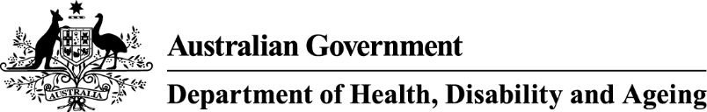Communique 23 & 24 October 2024

**Council of Elders**

**The Hon Anika Wells MP, Minister for Aged Care and Minister for Sport** – Members were pleased to meet with The Hon Anika Wells MP and reiterated their support in working towards passing the Aged Care Bill 2024 this year and remain committed to assist in any way needed.

It was helpful to share feedback on the current state of the Bill and hear that some of the concerns raised may be addressed through amendments during the parliamentary process. Members acknowledge that passing the Bill as soon as possible is essential to give timely information to participants and providers and support them being ready for implementation.

**Reform Progress and Priorities and Aged Care Bill 2024** – Council discussed emerging issues being heard at Senate Inquiry hearings. Members believe some concerns should be addressed, such as moving “showering” to the category “Clinical supports” and removing caps on gardening and cleaning.

Council has a keen interest in the draft Rules, particularly those relating to Rules on fees, charges, caps, and means testing, and looks forward to their release. Members appreciate the tight timeline for passing the Bill and understand the need for any Senate Inquiry amendments to go through both houses of parliament. They remain fully supportive of passing the Aged Care Bill this year and urge that it be prioritised.

**Support at Home and** **Aged Care Taskforce/ Fees and Contributions** – Council noted several positive elements such as the new top funding level of home care packages of around $78,000 annually, a separate scheme for assistive technology and home modifications, and a commitment to waiting times of no more than 3 months by 2027. In addition, Council welcomed the new end of life funding noting implementation practices should be kept under review and adjusted if necessary.

Council discussed the fairness and transparency of using the Age Pension means test in Support at Home, residential care and the thresholds for contributions to the hotelling supplement and non-clinical care in residential care. Council noted the feedback members are hearing is that it’s vital for older people to know the prices they will pay, as percentages alone are hard to understand. Council suggested developing a calculator tool and would be willing to test such a tool.

Council also advised there is some confusion in the community about the protections conferred by the grandfathering or “no worse off” provisions for home care. Council suggested there be greater attention to the provision of simple information in the form of fact sheets and advised communication materials and a central source of information will be crucial.

# Communications and Engagement

Council is supportive of the EngAged monthly newsletter for older people, which now has 7,200 subscribers. In response to previous suggestions from Council, the Aged Care Communications and Change Branch has made contact with the Men’s Sheds Association to increase subscription. Council was encouraged to hear that action is being taken to audit the availability of aged care materials translated for CALD and First Nations communities.

**Indigenous Safe Spaces, Facilities and Providers - Purple House** – Council were delighted to hear from the CEO of Purple House, an innovative health service in Alice Springs. It’s Indigenous-owned and run, providing aged care, primary health, and social support while prioritising high quality services which are person-centred and prioritise cultural safety. Purple House aims to get patients back home to families with a focus on culture. Purple House currently provides dialysis in 19 remote communities and runs two mobile dialysis units called the “Purple Truck.”

In addition, they provide aged care, NDIS, primary health and social support services. Purple House has support staff in Perth, Kalgoorlie and Adelaide to help people get home to their communities.

The Council acknowledges Purple House serves as an inspiring model of excellence in aged care.

The next meeting of the Council of Elders will be held on the 27th and 28th November 2024