Council of Elders

Meeting Communique – 21 & 22 May 2025
The Hon. Sam Rae MP – Minister for Aged Care and Seniors - Council welcomed the opportunity to meet with the Hon. Sam Rae MP and congratulated him on his appointment as Minister for Aged Care and Seniors. Council appreciated his interest in the links between ageing well, aged care, acute care and health services, and looks forward to a productive and ongoing working relationship.
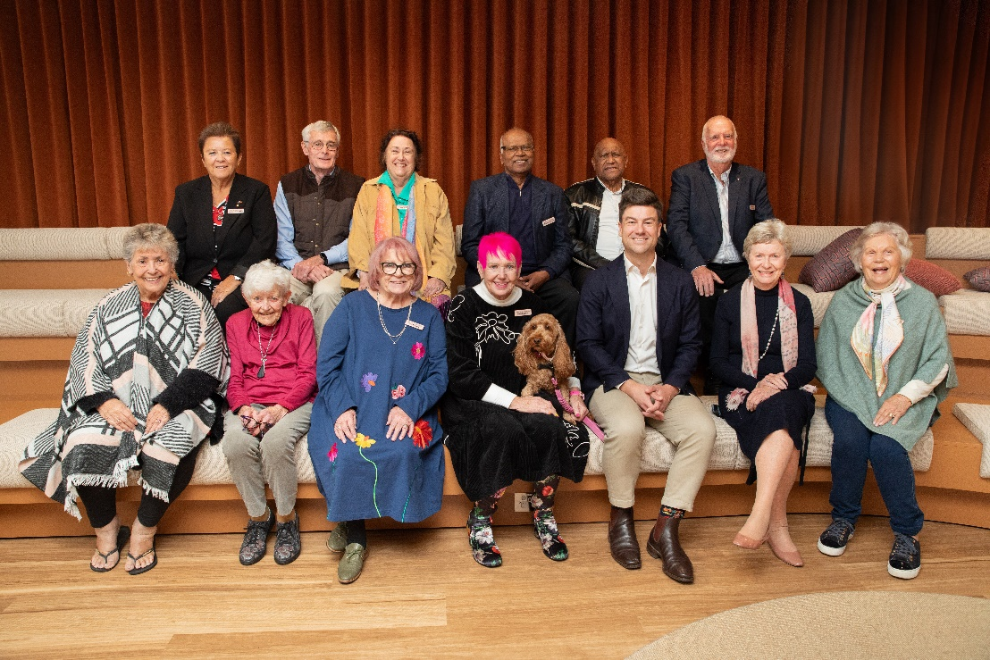
Fees and Contributions – Council discussed the need for clear and consistent information about fees and contributions under the new aged care arrangements commencing on 1 November 2025. Council strongly supports the imminent release of the online fee estimator tool to assist older people and their families in understanding costs and what it means for them.
Reform Implementation – Members heard how the Department is preparing for the new Aged Care Act and shared some concerns they are hearing in the community, including long wait times for services, confusion about costs, and worries that providers and workers may not be ready. Many people still don’t know about the new legislation or what it means, and Council recognised the need to do more to raise awareness and get people involved.
Aged Care Quality and Safety Commission – Council welcomed the Aged Care Quality and Safety Commissioner, Liz Hefren-Webb, and were pleased to hear about what the Commission is doing in preparation for the upcoming changes. This includes new quality standards, more support for First Nations and multicultural providers, and communicating with providers about how funding and safety rules will work. Council are concerned about the time pressure on providers to train their staff, and how the new rights-based Act will operate in practice. Council welcomed the Commission’s commitment to supporting providers who are acting in good faith and reinforced that older people should never feel pressured or rushed into signing new service agreements.
Support at Home – Council is hearing of concerns about waiting times and fees in the Support at Home program.
Commonwealth Home Support Program (CHSP) – Council is hearing of concerns about the proposed changes to the CHSP. Some CHSP providers say they are running out of money to deliver important services like social support and transport, which are a lifeline for many older people and help prevent feelings of loneliness. The transition of CHSP into the new Aged Care Act has led to confusion and uncertainty for people about what services will be available. Council is keen to take part in planning for CHSP over the next two years and to work closely with the Department to help ensure positive results for older people.
Rights and Reform – Council members shared what the idea of “rights” means to them. Council supports the Department’s efforts to make aged care more focused on people’s rights and believes everyone in the Department should know and respect the rights of older people. Council reviewed materials that are being developed and provided feedback, including offering to assist with future work.
Residential Aged Care Reforms – Council was very interested to hear about changes to care minute targets and was pleased to see that more providers are meeting the targets, but acknowledged there is still work to do, especially in for-profit services. Council wants to make sure care minutes are used for hands-on care, not just administrative work, and supports linking funding to care minute targets; providers should still have to meet 100% of their target to receive full funding, although special consideration may be needed for influenza or COVID outbreaks. Council also raised concerns about providers only accepting residents with lower care needs.
General Practice in Aged Care Incentive – Council is very interested in helping aged care residents see a GP more regularly. Members discussed the “My Medicare General Practice in Aged Care Incentive” and Council supports the idea of giving residents better access to the same GP for ongoing care. Members shared ideas for how to improve communication with residents. Council looks forward to hearing the first evaluation results of this incentive.
The next meeting of the Council of Elders will be held on 18 June 2025.

