2025-27 CHSP

Extension Survey

Service provider insights



# Contents

Overview of the survey 3

Unit prices 5

Changes to DEX reporting  7

Specialised Support Services  10

Sector Support and Development 12

Next steps 13

# Overview of the survey

Commonwealth Home Support Program (CHSP) providers play a vital role in helping older people to live independently and with dignity in their own homes and communities for as long as possible.

From 1 November 2025, there will be changes to the way that CHSP services are described, regulated and delivered. These changes are driven by the new Aged Care Act (the Act) and align with the new Support at Home program.

On 22 October 2024, the Department of Health, Disability and Ageing (the department) provided an overview of these changes in the [2025-27 CHSP extension webinar](https://www.health.gov.au/resources/webinars/commonwealth-home-support-programme-chsp-2025-27-extension-webinar).

## Following this webinar, the department published a range of [resources](https://www.health.gov.au/resources/collections/chsp-2025-27-extension-resources?language=en) and sought feedback from providers in the 2025-27 CHSP Extension Surveyin early November 2024.

## Survey objectives

The department conducted the 2025-27 CHSP Extension Surveyto:

* Better understand the diverse perspectives, experiences and knowledge of all CHSP providers.
* Understand how to best utilise the next few years to prepare CHSP providers to transition to Support at Home no earlier than 1 July 2027.
* Seek feedback on proposed changes and identify the most common provider concerns.

**Data collection**

All CHSP providers were invited to complete the survey as part of the department’s consultation with service providers on the proposed changes. The survey was completed by 902 respondents.

The survey sought stakeholder feedback on 4 topics, including the proposed changes to:

* DEX reporting
* Unit prices
* Specialised Support Services
* Sector Support and Development.

The data findings in this report are not weighted to the total number of CHSP providers. Findings from this survey do not represent the views of the whole sector, only of those who participated in the survey.

Respondents did not have to answer every question – they could skip questions if they wanted to. If a respondent submitted a response with at least 50 per cent of questions answered, their response was included for analysis.

Not all respondents answered every question. Therefore, the breakdowns for each question in this report show the percentages of respondents who responded to that question alone, not the total number of respondents who took part in the survey.

**Unit prices**

We asked for your feedback on CHSP unit prices for the 2025-27 period. In the survey, the department presented 3 pricing options for services funded by the hour. As the CHSP extension process is not an opportunity to increase funding levels, any price changes would need to be balanced by changes to output levels.

#### Table 1 – CHSP pricing options considered by providers in the survey

|  |  |  |
| --- | --- | --- |
| **Option 1: Maintain** | **Option 2: Normalise** | **Option 3: Move** |
| Maintain unit price ranges for all CHSP providers, with ordinary annual indexation applied. | Move all providers to the top or near the top of the current price range for all service types where the output measure is by the ‘hour’.  This will result in adjustments to outputs for providers to ensure contract values do not change. | Move to a consistent unit price derived from Support at Home program prices.  For contracting purposes, the Support at Home price would be reduced based on the assumed pension status of CHSP clients. |

Providers were asked to indicate their preferred pricing arrangement for the 2025-27 CHSP extension process from these 3 options.

71 per cent of respondents to this question understood that CHSP prices may align with the Support at Home pricing framework no earlier than 1 July 2027.

The majority of respondents preferred to either normalise (50per cent) or maintain current prices (35 per cent) rather than move to Support at Home pricing.

25per cent indicated more information is required about unit prices and consumer contributions.

**Social capital – meals and transport providers**

Some CHSP services include regular social engagement with clients as part of service provision. The department recognises the importance of these regular engagements for clients and the associated benefits on the physical, mental and emotional health of older people.

The CHSP 2025-27 Extension Survey found the majority of meals and transport providers establish and maintain connections with clients and undertake informal welfare checks.

The majority of respondents who provide meals and transport services (91 per cent) deliver some form of social engagement above base service delivery requirements.

59 per centof respondents reported undertaking regular assessments or surveys capturing data on social benefits provided to clients.

**Graph 1 – Social engagement provided by meals and transport providers**

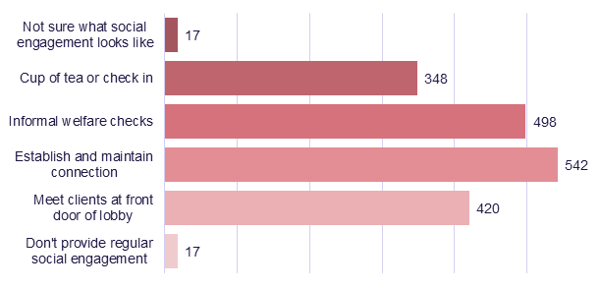

**Changes to DEX reporting**

The Data Exchange (DEX) will be updated to ensure CHSP providers can accurately report against the new service list and comply with new reporting requirements.

Through a staged approach. the department will introduce additional DEX reporting fields and may require providers to report on My Aged Care IDs. The specific requirements will be shared with providers as soon as possible.

The contractual and DEX changes will require providers to update their systems and data collection processes. The department notes that smaller organisations may require additional support to achieve this.

35 per cent of respondents indicated that increased administrative burden was the biggest obstacle to implementing DEX changes.

26 per cent of respondents indicated the next biggest obstacle to implementing DEX changes was cost.

When asked to estimate how long implementing ICT changes would take, 41per cent reported needing more information on the specific changes to make an accurate assessment.

### Additional DEX fields for meals and transport providers

To help the department’s policy development of consistent definitions and pricing structures, additional DEX reporting for meals and transport will collect information and data on the time spent with clients and use of volunteers.

Examples of the new outputs include:

* **Transport**: number of one-way trips per person (trip distance in kilometres and time travelled, including service complexity, no-shows, duration, and social engagement).
* **Meals**: number and types of meals delivered (with each course/drink in a meal recorded as a separate output), and whether social engagement was included.

Meals and transport providers were consulted on the new proposed reporting requirements in the survey.

73 per cent agreed with the proposed increase in reporting requirements for meals and transport services.

**Graph 2 – Meals and transport providers who agree with changes to reporting requirements**

### Graph 2 – Percentage of meals and transport providers who support changes to reporting requirements, Chart element

### Mandatory collection of My Aged Care IDs in DEX

The new Act will strengthen existing requirements to have clients registered and assessed to receive government funded CHSP services. From 1 November 2025, CHSP providers are required to ensure that services are only delivered to clients who have been registered with My Aged Care and have received an assessment for CHSP services.

Providers were asked whether they currently collect My Aged Care IDs, and whether they currently provide government funded service to unregistered clients.

83 per cent of respondents indicated that they already collect My Aged Care ID data.

28 per cent reported servicing unregistered CHSP clients, including clients who do not have an active referral for the service being delivered and/or do not have a My Aged Care ID.

**Graph 3 – Providers who already collect My Aged Care IDs for CHSP clients**

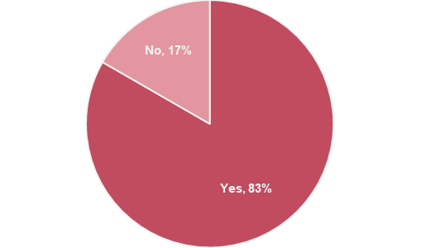

**Graph 4 – Providers who report servicing unregistered CHSP clients**

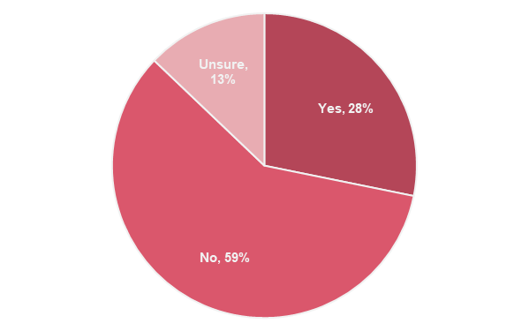

**Specialised Support Services**

There are changes being made to Specialised Support Services (SSS) to reduce duplication of services across the aged care system and align with the Support at Home program service list.

A mapping exercise of existing SSS providers and the services they deliver was undertaken to identify how they could transition across to the new CHSP service list to allow services to continue. As part of the CHSP extension process, SSS providers will be asked to realign their services, where possible, to other service types under the new CHSP service list. For example, allied health and therapy services, social support and community engagement, nursing or personal care. Unit pricing will correspond to the newly mapped CHSP service list.

We acknowledge that some services may not easily realign, such as vision advisory and dementia advisory services. In these circumstances, SSS providers will continue to be funded through a separate schedule in their CHSP agreement for SSS for one year, with a possibility of a further one-year extension if specific criteria are met. During the 2025-26 financial year, the department will work with these providers on future funding arrangements beyond 30 June 2026.

Providers are encouraged to contact their Funding Arrangement Managers if they require further advice regarding their 2025-26 contracts.

In the survey, SSS providers were asked about their understanding of these proposed service list changes.

85 per cent of SSS respondents had read the *Proposed changes to Commonwealth Home Support Programme (CHSP) service list from 1 July 2025* factsheet and understood that their indicative offer will include realigned services.

46 respondents identified that they provide dementia advisory services or vision advisory services.

89 per cent of these 46 dementia and vision providers understood that the department will undertake further consultation with them on future funding settings.

**Graph 5 – SSS provider awareness of proposed CHSP service list changes**

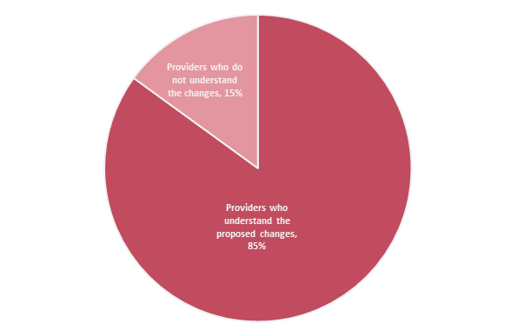

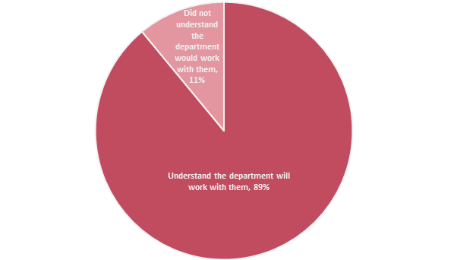**Graph 6 - Awareness amongst dementia and vision advisory service providers about further consultations on proposed changes**

In the survey, SSS providers were consulted on the anticipated impacts of the proposed changes.

65 per cent of respondents indicated that more information is required to identify whether the proposed changes will have a significant impact on their business.

**Graph 7 – SSS provider responses to whether the proposed realignment will have a significant impact on their business**

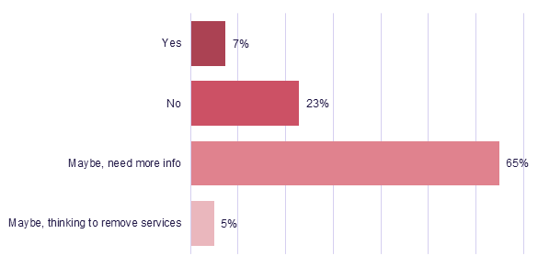

**Sector Support and Development**

Sector Support and Development (SSD) will be extended for another 12 months from 1 July 2025 to 30 June 2026.

During 2025, the department will work with SSD providers to design a proposed new in-home aged care sector support system, not just for the CHSP.

In the survey, SSD providers were consulted about the proposed sector redesign.

44 per cent of respondents requested more information about the department’s new in-home aged care sector support system.

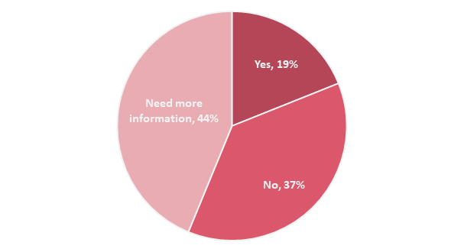**Graph 8 – Providers with concerns about the sector support redesign**

**Next steps**

The department thanks all CHSP providers who participated in the survey. We will continue to work closely with aged care service providers, older people and their representatives to ensure that the transition to the new CHSP arrangements happens as smoothly as possible.

The department hosted a CHSP Sector readiness webinar on Thursday 12 June 2025. A recording of the webinar can be found [here](https://www.health.gov.au/resources/webinars/commonwealth-home-support-programme-chsp-sector-readiness-webinar?language=en).

This webinar included information about:

* changes to the CHSP from 1 July 2025
* changes to the CHSP from 1 November 2025
* CHSP provider obligations under the Act, including deeming and registration categories
* the role of the Aged Care Quality and Safety Commission

resources to support CHSP providers now from 1 November 2025.

For more information about the changes to CHSP from 1 November 2025, please visit the department’s website: [health.gov.au/our-work/chsp-reforms](https://www.health.gov.au/our-work/chsp/reforms)

The CHSP 2025-27 Extension and Reforms Update Webinar was held on 13 March 2025. Please refer to the following webinar recording, fact sheet and guidance materials for further information:

[Commonwealth Home Support Programme 2025–27 extension and reforms update – Webinar | Australian Government Department of Health and Aged Care](https://www.health.gov.au/resources/webinars/commonwealth-home-support-programme-2025-27-extension-and-reforms-update-webinar)

[Commonwealth Home Support Programme (CHSP) resources | Australian Government Department of Health and Aged Care](https://www.health.gov.au/our-work/chsp/resources)

[CHSP provider fact sheet](https://www.health.gov.au/sites/default/files/2025-03/commonwealth-home-support-programme-chsp-provider-fact-sheet-supporting-unregistered-and-unassessed-chsp-clients.pdf)

[CHSP provider letter](https://www.health.gov.au/sites/default/files/2025-03/commonwealth-home-support-programme-chsp-provider-letter-supporting-unregistered-and-unassessed-chsp-clients.pdf)   
[CHSP Reforms](https://www.health.gov.au/our-work/chsp/reforms)

[CHSP extension resources.](https://www.health.gov.au/resources/collections/chsp-2025-27-extension-resources)

|  |  |
| --- | --- |
| Phone icon | Phone **1800 200 422** (My Aged Care’s free call phone line) |
| Website icon | Visit **health.gov.au/aged-care-reforms** |

For translating and interpreting services, call **131 450** and   
ask for My Aged Care on **1800 200 422**.

To use the National Relay Service, visit **nrschat.nrscall.gov.au/nrs**   
or call **1800 555 660**.