# Child Dental Benefits Schedule (CDBS)

‘All children should have a dental check-up by the time their first tooth appears or by their first birthday and be regularly seen by a dentist from that age onwards.’ (Australian Dental Association)

## Who is eligible?

You don’t need to apply or register for the CDBS. If your child is eligible, you will automatically receive a letter in the post or through myGov to let you know. Eligibility is assessed annually and is valid for that calendar year.

**To access the CDBS, your child must be all of the following:**

* 0-17 years old for at least one day that calendar year
* Eligible for Medicare at the time of service
* Receive an eligible payment from Services Australia at least once a year, or have a parent, carer, guardian who receives an eligible payment from Services Australia at least once a year

## Check if your child is eligible

* You can check to see if your child is eligible for the CDBS this year by:
* checking your **Medicare online account** through MyGov at [**my.gov.au**](https://my.gov.au/), select ‘History and statements,’ then ‘Child Dental Benefits

Schedule’

* calling **Medicare on 132 011**

Find out more about the eligibility criteria at [**servicesaustralia.gov.au/childdental**](https://www.servicesaustralia.gov.au/child-dental-benefits-schedule)

## What is covered?

Eligible children can access a capped amount of services over 2 calendar years.

The services covered include:

* dental check-ups
* cleaning
* x-rays
* fissure sealing
* fillings
* root canals
* extractions

At your appointment check what each service will cost and if the CDBS covers the full cost of those services.

The CDBS does not cover:

* orthodontics
* cosmetic dental work
* any dental services in a hospital

## Finding a provider

You can use the CDBS for services at most dental clinics, including public dental clinics and private dental practices.

When you book an appointment:

* let your dental provider know that you want to use the CDBS; and
* ask how much funding you have available under your CDBS cap.

## Finding a provider that bulk bills

You can ask your dental provider if they bulk bill under the CDBS. To search for a dental provider, use the ‘find a health service’ tool on the healthdirect website at: [**healthdirect.gov. au/australian-health-services**](https://www.healthdirect.gov.au/australian-health-services)

Public or private?

A public provider using the CDBS will bulk bill you and there will be no out‑of‑pocket expenses.

Some private dentists bulk bill CDBS services. Where private providers do not bulk bill, you may need to pay a gap fee for services.

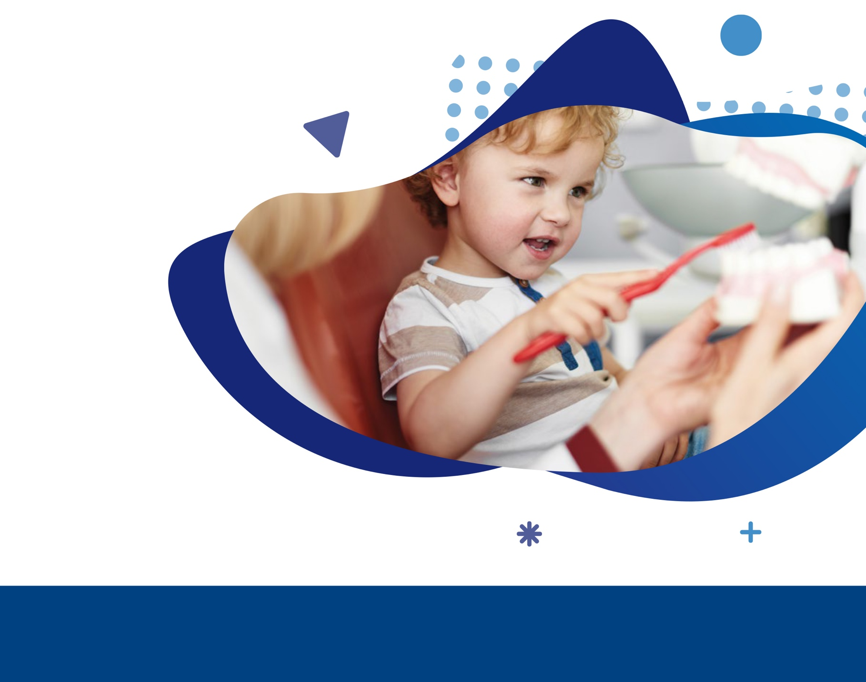**For more information on the CDBS**

1. Visit servicesaustralia.gov.au/childdental
2. Call **Services Australia** on **132 011**
3. **Ask your dental provider** about the CDBS