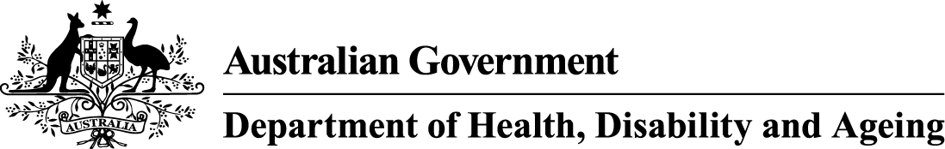

“What’s happened to my smokes?”

This year, cigarettes will change due to new tobacco laws. These changes aim to protect people from the health harms of smoking and help make it easier for people to quit.

# Tobacco products will:

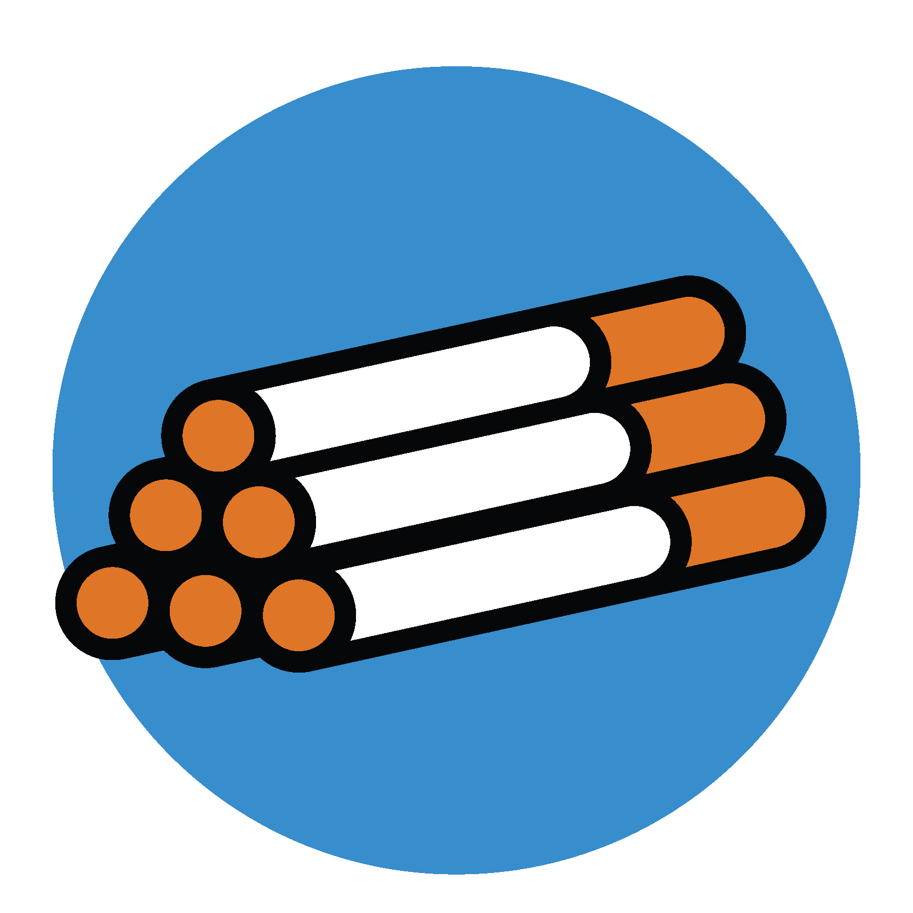

## Taste and feel different

Some things that mask the harshness of tobacco will be banned, including some ingredients, flavours (including menthol, rum and clove) and accessories.

## Be the same shape

Each cigarette stick will be the same length and width, and special filters will be banned.

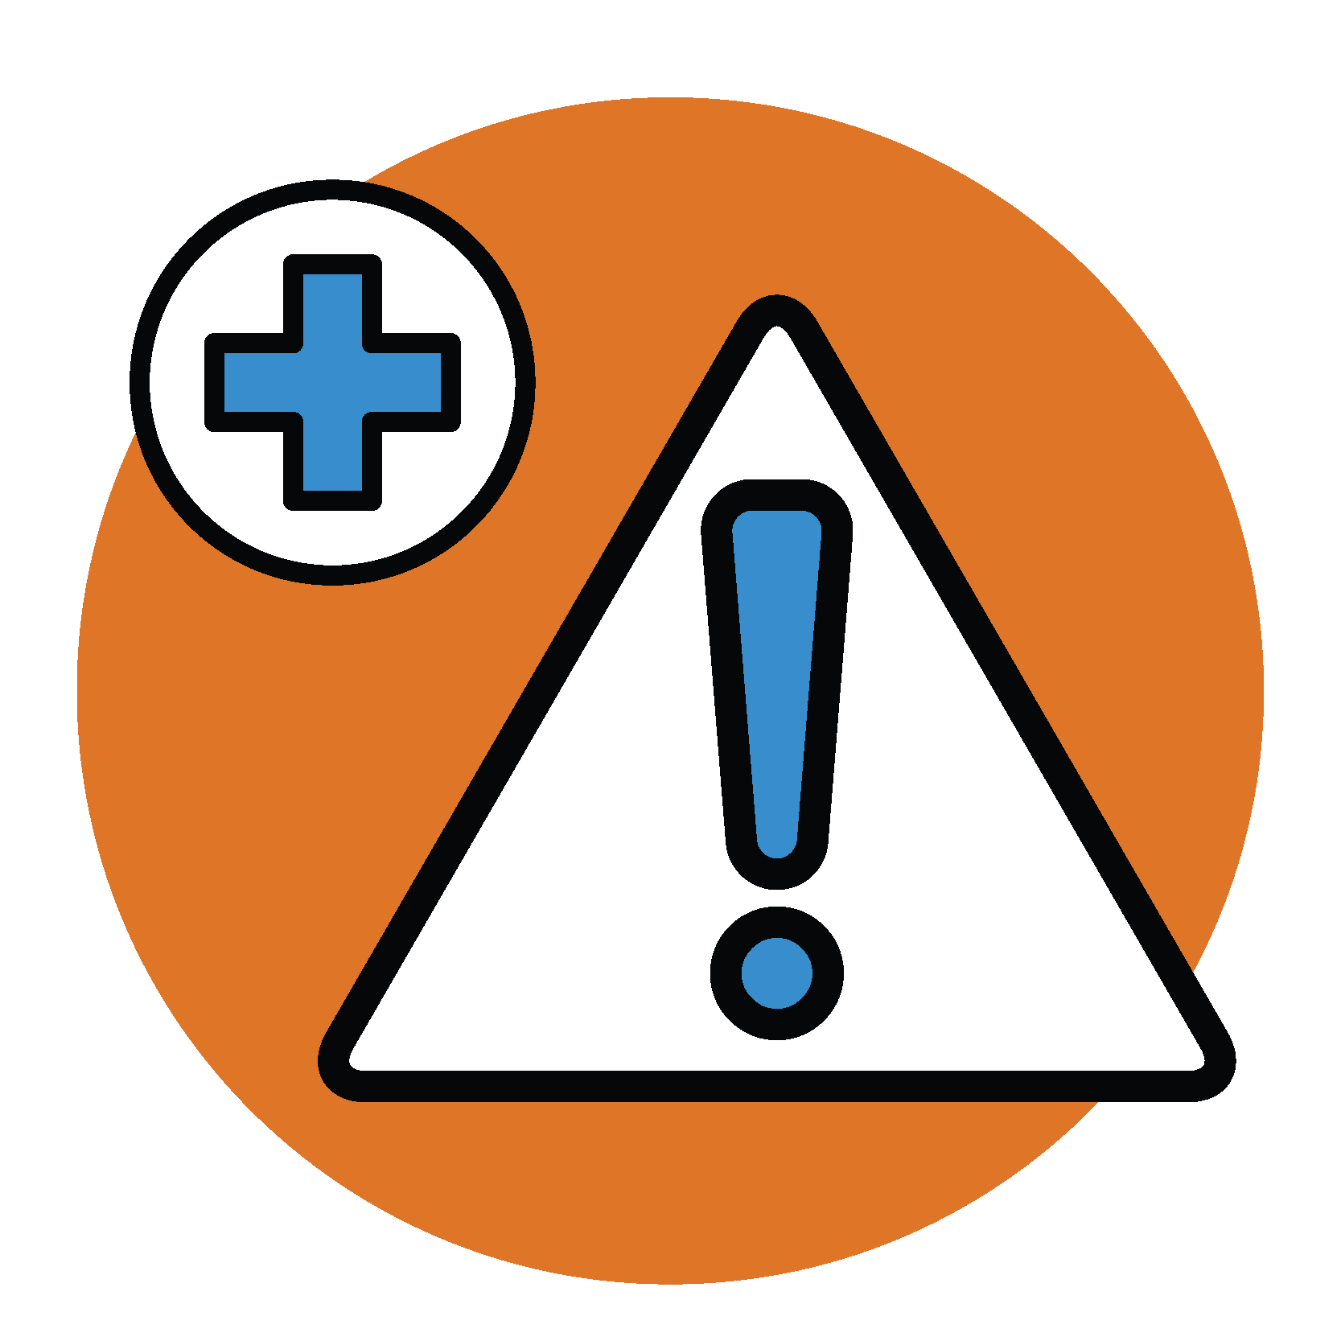

## Have different names

Words like ‘smooth’ and names like ‘gold’ that can falsely suggest some products are less harmful will be removed.

## Have new health information

There will be new health warnings and information cards to help people quit.

## Be consistent in size

Each cigarette pack will have 20 sticks. Roll-your-own pouches will have 30 grams of tobacco.

These changes:

* might mean some tobacco products won’t be sold anymore
* kick in from 1 July 2025, but you might see changes earlier
* don’t make smoking any safer – all tobacco is harmful and addictive

For more information on the changes visit [health.gov.au/tobacco-changes](https://www.health.gov.au/tobacco-changes)

[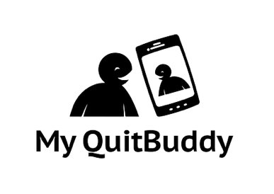](https://www.health.gov.au/resources/apps-and-tools/my-quitbuddy-app) **[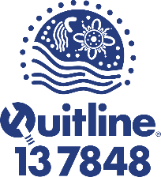](https://www.aql.org.au/)**