Private Health Insurance – Second-tier default benefits guidelines
  - July 2025
Contents
1. Introduction 3
2. About second-tier default benefits eligibility 3
3. Assessment criteria 4
3.1 Be a private hospital 4
3.2 Be accredited 4
3.3 Not bill patients directly for second-tier default benefits 5
3.4 Make provision for informed financial consent 5
3.5 Submit Hospital Casemix Protocol (HCP) data with claims for second-tier default benefits 6
4. How to apply for second-tier default benefits eligibility 7
4.1 Application fee 8
4.2 Timeframes 8
4.3 Outcome of application assessment 9
5. Length of eligibility 9
6. Changes in circumstances 10
7. Comparable hospitals 10
8. Calculating second-tier default benefits 11
9. Audit of second-tier rates 12
10. Hospital category review 12
11. Revocation of second-tier default benefits eligibility 12
12. Changes in circumstances affecting eligibility 13
13. Enquiries and complaints 13
14. Application process flowchart 14

Introduction
These guidelines outline how the Department of Health, Disability and Ageing (the department) administers eligibility for second-tier default benefits. This document explains how the department implements the requirements of sections 121-8 to 121-8D of the Private Health Insurance Act 2007 (the Act), Part 2A of the Private Health Insurance (Health Insurance Business) Rules 2018 and Schedule 5 of the Private Health Insurance (Benefit Requirements) Rules 2011. Where there is any inconsistency between these guidelines and the aforementioned legislation, the relevant legislation takes precedence.

About second-tier default benefits eligibility
Second-tier default benefits eligibility generally provides access to higher benefits than would otherwise be payable where a private hospital does not have a negotiated agreement with a patient’s insurer for that service. Applying for second-tier default benefits eligibility is optional for private hospitals and requires hospitals to meet the assessment criteria specified in Rule 7C of the Private Health Insurance (Health Insurance Business) Rules 2018.
Schedules 1, 2 and 3 of the Private Health Insurance (Benefit Requirements) Rules 2011 provide that private health insurers must pay minimum accommodation benefits for most episodes of hospital treatment. These minimum benefits are sometimes referred to as the basic default benefit.
Schedule 5 of the Private Health Insurance (Benefit Requirements) Rules 2011 requires private health insurers to pay second-tier default benefits for most episodes of hospital treatment where the insurer does not have a negotiated agreement for that service with a private hospital that is eligible for second-tier default benefits.
Second-tier default benefits are calculated as an amount not less than 85 per cent of the average charge for the equivalent episode of hospital treatment under that insurer’s negotiated agreements with comparable private hospitals in the state in which the second-tier eligible hospital is located.
The powers of the Minister for Health and Ageing under sections 121-8 to 121-8D of the Act have been delegated to the department. Any reference in these guidelines to the department exercising those powers is consistent with the Act. Hospitals should apply to the department for inclusion in the second-tier eligible hospitals class.
A reference in these guidelines to an application to become a second-tier eligible hospital means an application for inclusion in the second-tier eligible hospitals class, as defined under rule 7A of the Private Health Insurance (Health Insurance Business) Rules 2018.

Assessment criteria
To be recognised as a second-tier eligible hospital, Rule 7C of the Private Health Insurance (Health Insurance Business) Rules 2018 requires that a hospital:
- be a private hospital;
- be accredited;
- not bill patients directly for the minimum benefit payable by the patient’s insurer;
- make provision for informed financial consent; and
- submit Hospital Casemix Protocol (HCP) data to health insurers electronically with every claim for second-tier default benefits.
The department will assess applications to become a second-tier eligible hospital against these criteria. If eligible, a hospital should be able to claim second-tier default benefits on behalf of their patients.

Be a private hospital
A hospital must be declared as a private hospital for the purposes of private health insurance under section 121-5(6) of the Private Health Insurance Act 2007.
Acceptable evidence that a hospital meets this assessment criterion is:
- the hospital appears on the department’s list of declared private hospitals that is in effect at the time of application.

Be accredited
A hospital must be accredited against the National Safety and Quality Health Service Standards (NSQHS) by an approved accreditation agency at the time of application.
Acceptable evidence that a hospital meets this assessment criterion is:
- a current certificate of accreditation or interim accreditation against the NSQHS, from an independent accrediting agency approved by the Australian Commission on Safety and Quality in Health Care (ACSQHC).
As specified in Advisory AS18/02: Interim accreditation for newly established health service organisations issued by ACSQHC, interim accreditation satisfies the second-tier default benefits eligibility requirement for a hospital to be accredited.

Not bill patients directly for second-tier default benefits
A second-tier eligible hospital must not bill patients directly for the minimum benefit (i.e. the second-tier default benefit) payable by the patient’s insurer where the hospital does not have a hospital purchaser-provider agreement in force with that insurer. Instead, the hospital must claim the second-tier default benefit directly from the patient’s insurer and may only charge the patient for any excess or co-payment and any additional out-of-pocket costs.
The hospital is required to acknowledge in the application form that it will not bill patients directly for the minimum benefit payable by the patient’s insurer.

Make provision for informed financial consent
A hospital must have procedures in place to inform a patient or nominee, in writing, of what hospital charges, insurer benefits and out-of-pocket costs (where applicable) are expected in respect of hospital treatment. A patient or nominee must be informed:
- for scheduled admissions – at the earliest opportunity before admission for the hospital treatment; or
- for unplanned admissions – as soon after the admission as the circumstances reasonably permit.
From 1 January 2019, informed financial consent processes will be assessed as part of the accreditation process for private hospitals. Therefore, hospitals accredited against the second edition of the National Safety and Quality Health Service Standards (NSQHS), are not required to provide other information for this criterion.
For hospitals that have not yet been accredited against the second edition of the NSQHS, acceptable evidence that a hospital meets this assessment criterion is:
- the hospital has made the acknowledgement in the application form that the hospital will inform patients or their nominees, in writing, of what hospital charges, insurer benefits and out-of-pocket costs (where applicable) are expected in respect of hospital treatment;
- a copy of the hospital’s informed financial consent procedures; and
- a de-identified sample informed financial consent form, for treatment at the hospital, as per advisory AS18/10 which includes:
- Name of the proposed procedure
- Item number for the proposed procedure or a statement that no item number is expected to be claimed
- The hospital fee for this admission, as a dollar amount if it exceeds the patient’s insured rebate
- The health insurer benefit, as a dollar amount
- Where applicable, estimates of co-payments including any excess as a dollar amount
- A statement noting where costs are estimates and may vary. Reasons for the variation such as length of stay, type of procedure actually performed rather than scheduled, or other relevant reasons for variation in costs should be included
- Where applicable a statement listing other relevant service providers that may bill a patient separately from the health service organisation. This may include, but is not limited to:
- Pharmacy
- Pathology
- Surgeon
- Anaesthetist
- Perioperative / surgical assistant
- Neonatologist
- Radiology
- Physiotherapy
- Other allied health providers.
- A statement advising patients to confirm with their health insurer prior to admission or as soon as practical after admission, the following:
- Rates of reimbursement for each of the expected charges for the specific insurance policy they hold
- If the planned admission or treatment is within a waiting or exclusion period for the policy
- If the admission or treatment is covered by the health fund’s no gap or gap cover scheme.
- A space for the patient (or nominated substitute decision maker) to sign the form confirming that they have been informed of, and understand the charges.

Submit Hospital Casemix Protocol (HCP) data with claims for second-tier default benefits
It is a requirement for second-tier approved hospitals to submit HCP data electronically to a patient’s health insurer with every claim for second-tier default benefits. It is important for both hospitals and insurers to enter the data correctly, as this can affect hospital categorisation.
Hospitals are required to acknowledge in the application form that the hospital will provide HCP data electronically to patients’ insurers with every claim for second-tier default benefits.
The department may also take into consideration:
- whether the department has received HCP data from insurers for the hospital for any part of the previous 12 months that the hospital was treating patients.
- any unresolved complaints the department has received about the hospital not providing HCP data with claims for second-tier default benefits.
- any steps the hospital has taken to ensure that HCP data will be provided to insurers with every future claim for second-tier default benefits.
The department expects all hospitals to provide a complete set of HCP data (including clinical information) to private health insurers, as per the data specifications.
More information, including data specifications and reporting requirements for hospitals and insurers, can be found at the department’s website.

How to apply for second-tier default benefits eligibility
Hospitals seeking second-tier default benefits eligibility must complete the application form which can be found on the department’s website. Email the application form and all supporting documents to phi.hospitals@health.gov.au.
For new hospitals, the application form can be submitted at the same time as the hospital declaration form. However, the department will not consider the application until the hospital is declared.
The applicant is required to apply separately for each hospital seeking eligibility.
To apply you must:
- complete the online application form on the department’s website.
- address all assessment criteria.
- include the following attachments:
- current state/territory licence noting the individual hospital name. If the licence does not issue bed numbers, you will need to provide alternative evidence of the number of beds and bed equivalents the hospital operates.
- current accreditation certificate
- a de-identified sample informed financial consent form and internal procedures (not applicable if accredited against second edition).
To be considered for second-tier default benefits eligibility, a hospital must complete all required fields in the application form and attach all required evidence in support of its application.

Application fee
An application to become a second-tier eligible hospital is not valid until an application fee has been paid.
- The current application fee is $1,010. GST is not applicable to the fee.
- Upon receiving an application, the department will issue an invoice for the application fee.
- The application fee must be paid within seven days of receiving the invoice and may be paid by electronic funds transfer, credit card, cheque or BPAY.
- The department may not commence any part of application assessment until the application fee has been paid in full. Hospitals should keep this in mind when deciding when to apply to renew eligibility.
The fee covers the cost of assessing an application for one hospital. Hospital groups seeking eligibility for multiple hospitals must pay one application fee per hospital.
There is no provision to waive the application fee. An application fee may be refunded if an application is withdrawn prior to the department commencing any part of assessment. Partial refunds will not be made once the department has begun the assessment process.
Upon receipt of payment, the application becomes valid and the application assessment can then commence.

Timeframes
Applications for second-tier default benefits eligibility will be accepted at any time.
Hospitals will be notified of the outcomes of applications within 60 calendar days of the department receiving the application fee.
Therefore, to ensure second-tier default benefits eligibility does not lapse during assessment, applications should be submitted at least 60 calendar days prior to expiry of a hospital’s second-tier default benefits eligibility.
If a hospital’s eligibility expires before a decision is made about an application, the hospital will not be eligible to claim second-tier default benefits until a decision is made by the Minister for Health and Ageing or the Minister’s delegate that the hospital meets all of the assessment criteria. The department is not responsible for late applications or late payment of application fees.
For new hospitals, the 60 calendar days for assessment of applications to become a second-tier eligible hospital will not commence until the hospital is declared and the application fee paid.
If the department requests additional information from an applicant, the requested information should be provided within five business days. If the requested information is not provided within the specified timeframe, and the department’s 60-calendar day assessment timeframe is close to expiring, the department may assess the application as unsuccessful.

Outcome of application assessment
The department will notify a hospital of the outcome of its application to become a second-tier eligible hospital within 60 calendar days of receiving a valid application. This notification will include the new second tier eligibility dates.
If the department expects that an application is likely to be unsuccessful, the department will provide the hospital with an opportunity to respond prior to the Minister for Health and Ageing or the Minister’s delegate making a formal decision about the outcome of the hospital’s application.
Where a decision is made to not include a hospital in the second-tier eligible hospitals class because it does not meet the assessment criteria, the department will provide written reasons for the decision. The hospital may apply to the Administrative Appeals Tribunal for a review of the decision, if the hospital disagrees with the basis of the decision.
Where the decision is to include a hospital in the second-tier eligible hospitals class, the department will notify the hospital in writing of that decision and the dates on which the hospital’s second-tier default benefits eligibility commences and ends.
The department will maintain and publish a list of second-tier eligible hospitals on its website, including expiry dates.

Length of eligibility
A hospital will be included in the second-tier eligible hospitals class for a period ending 60 calendar days after the date on which its accreditation against the NSQHS is due to expire. This is to ensure that if a hospital is not reaccredited until shortly before an earlier period of accreditation ended, it will have time to reapply to be included in the second-tier eligible hospitals class and for the Minister for Health and Ageing or the Minister’s delegate to consider the application within the 60 calendar days specified in the Act.
However, if a hospital is not reaccredited it is required under the Private Health Insurance (Health Insurance Business) Rules 2018 to notify the department as soon as possible.

Changes in circumstances
A second-tier eligible hospital must advise the department in writing, of any change in circumstances that may prevent it from continuing to meet the assessment criteria as soon as practicable. Second-tier default benefits eligibility may be revoked if at any time the hospital ceases to satisfy the assessment criteria in rule 7C of the Private Health Insurance (Health Insurance Business) Rules 2018. In such circumstances, the department may revoke the hospital’s second-tier default benefits eligibility immediately.

Comparable hospitals
Hospitals are comparable for the purposes of second-tier default benefits if they are placed in the same second-tier hospital category by an authorised officer of the department. The department categorises all hospitals that are declared as private hospitals for the purposes of private health insurance and publishes a list on its website. The following categories are used, as required under clause 1A (7) of Schedule 5 to the Private Health Insurance (Benefit Requirements) Rules 2011:
- private hospitals that provide psychiatric care, including treatment of addictions, for at least 50% of the episodes of hospital treatment, and do not fall into category (g)
- private hospitals that provide rehabilitation care for at least 50% of the episodes of hospital treatment, and do not fall into categories (a) or (g)
- private hospitals that do not fall into categories (a), (b) or (g), with up to and including 50 licensed beds
- private hospitals that do not fall into categories (a), (b) or (g), with more than 50 licensed beds and up to and including 100 licensed beds
- private hospitals that do not fall into categories (a), (b) or (g), with more than 100 licensed beds, without an accident and emergency unit or a specialised cardiac care unit or an intensive care unit
- private hospitals that do not fall into categories (a), (b) or (g), with more than 100 licensed beds, with either (or any combination of) an accident and emergency unit or a specialised cardiac care unit or an intensive care unit
- private hospitals that provide episodes of hospital treatment only for periods of not more than 24 hours.
Insurers use these categories to determine which hospitals are comparable when calculating second-tier default benefits.
The department consults annually on this list in June with the new list published by 1 August.
A hospital may lodge a written request for an internal review of its categorisation within 28 calendar days from the day of notification by the department of the categorisation determination. The department will either confirm the categorisation or re-categorise the hospital within 28 days of receiving the request. In reviewing a determination, the department may also take into consideration evidence provided by other entities.
The department will request a copy of a hospital’s licence as part of both the declaration process and the second-tier default benefits eligibility application process to inform categorisation of hospitals. Where a hospital is based in a state or territory, which does not issue a licence or does not regulate the number of beds or bed equivalents a hospital operates, the hospital should provide alternative evidence of the number of beds or bed equivalents the private hospital operates.
A hospital that is newly declared after the 1 August list is published each year will be added to the appropriate category and the Commonwealth declared hospital list on the department’s website will be updated. Insurers will not be expected to recalculate second-tier default benefits for each category until the next 1 August, but must use the new hospital’s category to determine what benefits it is eligible to claim under second-tier default benefits.

Calculating second-tier default benefits
Insurers must calculate second-tier default benefits in accordance with Schedule 5 of the Private Health Insurance (Benefit Requirements) Rules 2011.
Insurers must use the list of private hospitals published by the department as at 1 August of each year to determine which hospitals are comparable when calculating the second-tier default benefits that will apply from 1 September of that year.
Insurers must use the date of patient admission to determine what second-tier default benefit is payable.

Audit of second-tier rates
Each health insurer is asked to provide to the department a list of its second-tier default benefit rates by 31 August of each year. The list should include the second-tier default benefits payable by the insurer to each second-tier hospital category in each state, between 1 September of that year and 31 August of the next year.
Each health insurer is asked to provide to the department an audit report for an independent audit of the above mentioned list of its second-tier default benefit rates by 30 September of each year. The department expects that the audit will be conducted by an independent auditor acting in compliance with Australian Auditing Standards. Audit reports are expected to include:
- a statement of the auditor’s opinion about whether or not the second-tier default benefit rates for the current payment year have been calculated in accordance with Schedule 5 of the Private Health Insurance (Benefit Requirements) Rules 2011.
- a copy of the list of second-tier default benefit rates to which the audit relates.
When providing the audit report, the insurer is asked to advise the department whether its second-tier default benefit rates changed as a result of the audit, or for any other reason, since the rates it provided to the department by 31 August of that year. The insurer should also advise all hospitals affected by any such change in second-tier default benefit rates by 30 September of each year, and adjust any benefits that were paid that do not comply with the second-tier default benefits formula in Schedule 5 of the Private Health Insurance (Benefit Requirements) Rules 2011.

Hospital category review
Where a hospital disagrees with the second-tier hospital category it has been placed in by the department, the hospital may lodge a written request for an internal review of its categorisation within 28 calendar days from the day of notification by the department. A review may only be requested by the hospital that is the subject of the review. The department will either confirm the categorisation or re-categorise the hospital within 28 days of receiving the request.

Revocation of second-tier default benefits eligibility
If the Minister for Health and Ageing or the Minister’s delegate revokes a hospital’s second-tier default benefits eligibility prior to the specified expiry date, due to the hospital no longer meeting the relevant assessment criteria, the department will provide reason/s for the decision. The hospital may apply to the Administrative Appeals Tribunal for a merits review of the decision if the hospital disagrees with the basis of the decision.

Changes in circumstances affecting eligibility
Where an entity (for example, a government, consumer group, insurer, other hospital) other than a specific second-tier eligible hospital has reason to believe that the hospital no longer meets the assessment criteria for second-tier default benefits eligibility, the entity may advise the department by emailing phi.hospitals@health.gov.au. Any claim should be accompanied by evidence in support of the claim. If any further action is considered, the hospital in question will have an opportunity to address any issues raised.

Enquiries and complaints
Queries about payment of second-tier default benefits may be directed to the Department of Health, Disability and Ageing, by emailing phi.hospitals@health.gov.au. Issues may also be referred to the Private Health Insurance Ombudsman.
The Commonwealth Ombudsman can be contacted on:
Phone: 1300 737 299
Email: phio.info@ombudsman.gov.au
Website: www.ombudsman.gov.au
If either party believes that an issue involves anti-competitive behaviour, the matter should be referred to the Australian Competition and Consumer Commission.

Application process flowchart
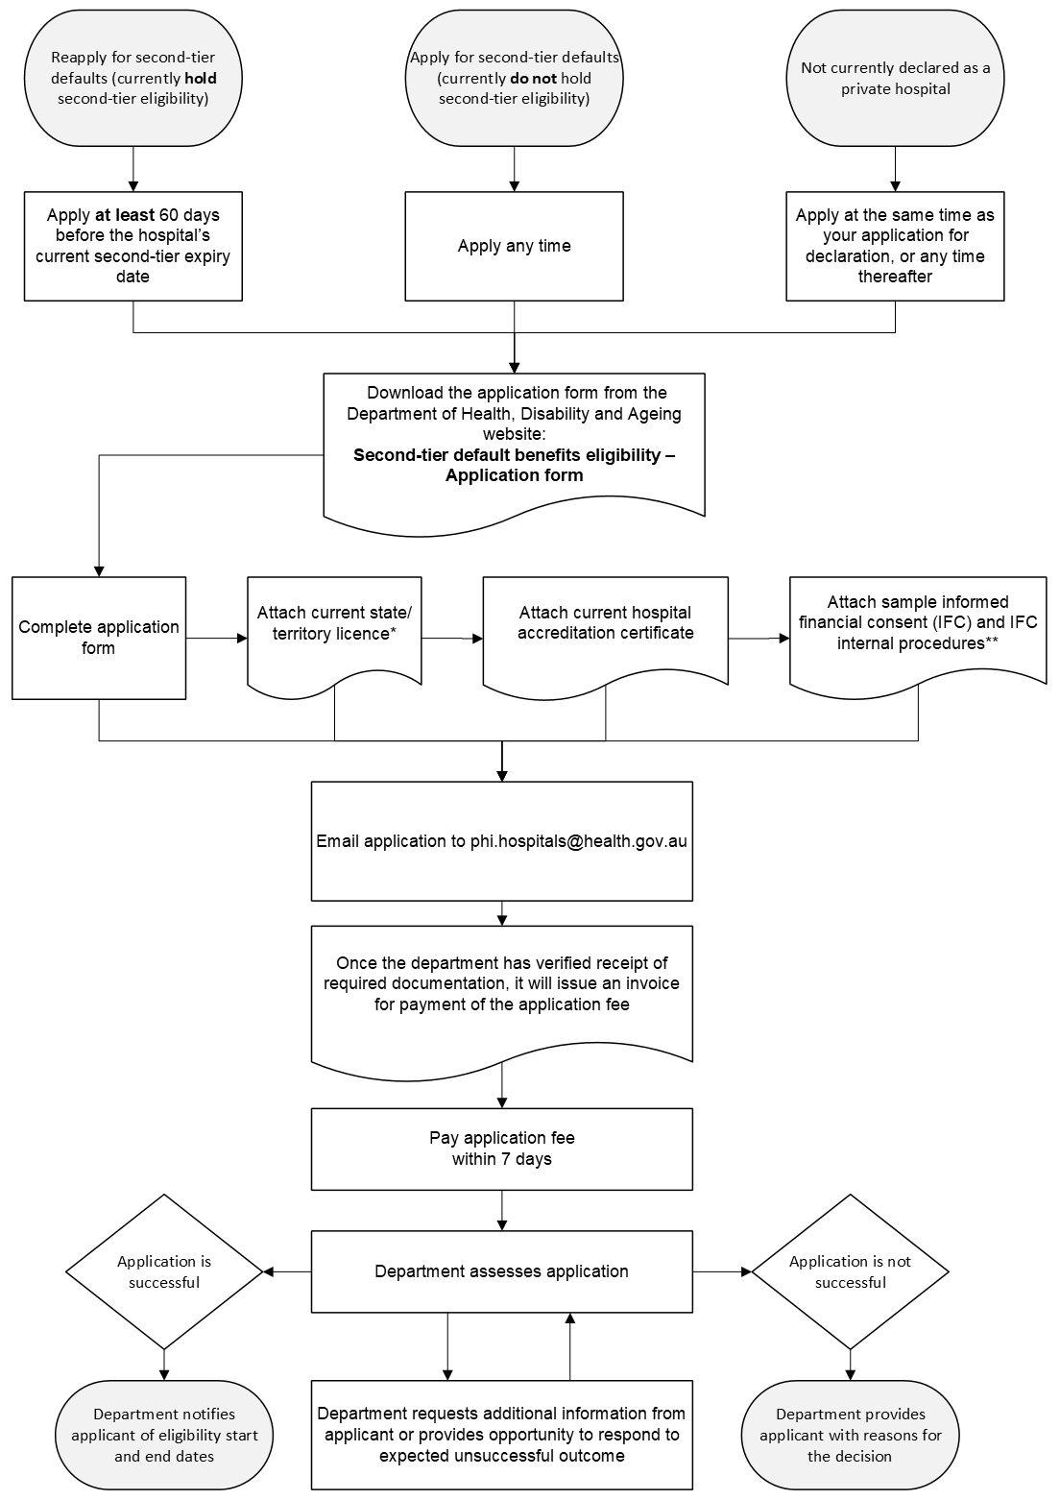
* Where the state/territory in which the hospital is located does not license the number of beds or bed equivalents the hospital can operate, the hospital should provide alternative evidence of the number of beds or bed equivalents that the hospital operates.
** Hospitals which are accredited against the second edition of the National Safety and Quality Health Service Standards are not required to provide this documentation.

The department uses the most recent year of Hospital Casemix Protocol data available to the department to determine the proportion of episodes of hospital treatment that were psychiatric care or rehabilitation care.
A reference to licensed beds is a reference to the beds or patients that a private hospital is permitted, under state or territory legislation in the state or territory where the private hospital is located. If the relevant state or territory legislation does not regulate the number of beds or patients that a private hospital is permitted, a reference to licensed beds is a reference to the beds and bed equivalents the private hospital operates.

