Respiratory syncytial virus (RSV) maternal vaccination campaign

Community campaign kit

  - June 2025

Contents
Introduction 2
Frequently asked questions 4
Communication resources 6
Translated resources 8
First Nations resources 11
Newsletter article 15

Introduction

About respiratory syncytial virus (RSV)
RSV is a common respiratory virus that infects the nose, throat and lungs, and is a leading cause of childhood hospitalisation.
RSV spreads between people when an infected person produces small water droplets while talking, coughing and sneezing. Almost all infants will be infected with RSV before the age of 2, with 12,000 babies admitted to hospital with severe RSV in 2024.
Since February 2025, the RSV vaccine is free under the National Immunisation Program for pregnant women.
The RSV vaccine is recommended at 28 to 36 weeks of pregnancy and is the third maternal vaccine added to this program. Whooping cough and flu vaccines are also available for free during pregnancy, which reduce the risk of severe complications and disease for the mother and newborn child.

About this information kit
This kit includes information and communication resources you can share with your community to raise awareness about the risks of RSV in young children and the benefits of vaccination during pregnancy.
It includes:
- Frequently asked questions
- Communication resources, including printable posters and factsheets
- Translated materials
- A newsletter article
- Social media content.

How to use this kit
You can share information about RSV and vaccination with your community by:
- Including an article in your newsletters and/or on your websites
- Publishing social media posts
- Displaying resources such as the poster or brochure
- Encouraging people to access the resources online.

Further information
For more information visit health.gov.au/maternalvaccinations
If you have questions or require further information, please email the Department of Health, Disability and Ageing at enquiries@health.gov.au

Frequently asked questions
The following frequently asked questions and answers are provided as background and can be used in your communications.

How do vaccinations in pregnancy protect your baby?
Getting vaccinated against influenza, whooping cough and RSV during pregnancy allows protective antibodies to pass through the mother’s placenta to the baby. This protects the baby from birth and in their first few months of life when they are most vulnerable to serious illness.

What is respiratory syncytial virus (RSV)?
RSV is a common, highly contagious virus that affects the airways and lungs and can cause serious illness such as bronchiolitis and pneumonia.
It is spread when an infected person coughs or sneezes.
The droplets can be inhaled by others or land on surfaces, where the virus can live for several hours.
- Almost all children will be infected with RSV in their first 2 years of life.
- RSV is a leading cause of hospitalisation for babies under 6 months in Australia.
- Even otherwise healthy children can develop severe RSV disease and require hospitalisation.
- Maternal vaccination reduces the risk of severe RSV disease.
Getting vaccinated against RSV during pregnancy protects your newborn baby against severe RSV disease from birth and in their first few months of life.

What is the National Immunisation Program?
The National Immunisation Program provides free vaccinations against certain diseases, to increase national immunisation rates and reduce vaccine preventable disease. Vaccinations take place from birth through to adulthood, including during pregnancy.

What vaccinations are recommended in pregnancy?
Pregnant women are recommended to receive influenza, whooping cough and RSV vaccines during their pregnancy. It’s safe to receive all the maternal vaccines at the same time. These can also be given with COVID-19 vaccines, if these are also recommended by a health professional.

Who can receive vaccinations under the National Immunisation Program?
You can receive free vaccines under this program if you have, or are eligible for, a Medicare Card.

Are vaccines safe?
There is extensive evidence demonstrating the safety of recommended vaccines in pregnancy. Studies of women vaccinated in pregnancy have found no evidence that the vaccines harm their developing babies.
All vaccines supplied for use in Australia are approved by the Therapeutic Goods Administration (TGA), which conducts rigorous testing for safety, quality and efficacy. For a vaccine to be approved by the TGA the benefits must outweigh the risks, meaning it is safer to be vaccinated than get the disease.

What side effects can I expect?
You may experience mild side effects following vaccination. Most side effects last no more than 2 days and are part of the immune system’s natural response to the vaccine.
Common reactions include:
- pain, swelling or redness at the injection site
- tiredness
- muscle aches
- mild fever.
Pregnant women are no more likely to experience these side effects than those who aren’t pregnant.
Serious reactions to vaccines are rare. Seek medical advice straight away if you have a reaction that you think is severe or unexpected.

Where can I get vaccinated?
You can receive your vaccinations from the following providers:
- your obstetrician or midwife
- your general practitioner (GP)
- local council immunisation clinics (in some states and territories)
- community health centres
- Aboriginal health services
- participating pharmacies.
While vaccines are free, your vaccination provider may charge a consultation or administration fee for the visit. Check when you make your appointment.

Where can I find more information on maternal vaccinations?
Find information about free vaccines in pregnancy to protect you and your baby at health.gov.au/maternalvaccinations

Communication resources
The table below outlines the resources available to support your community engagement activities.
Resource library
Resource | Preview | Suggested use
Maternal vaccinations consumer brochure  This brochure provides information about recommended maternal vaccinations under the National Immunisation Program.  The brochure is available in DL (print) and A4 formats | 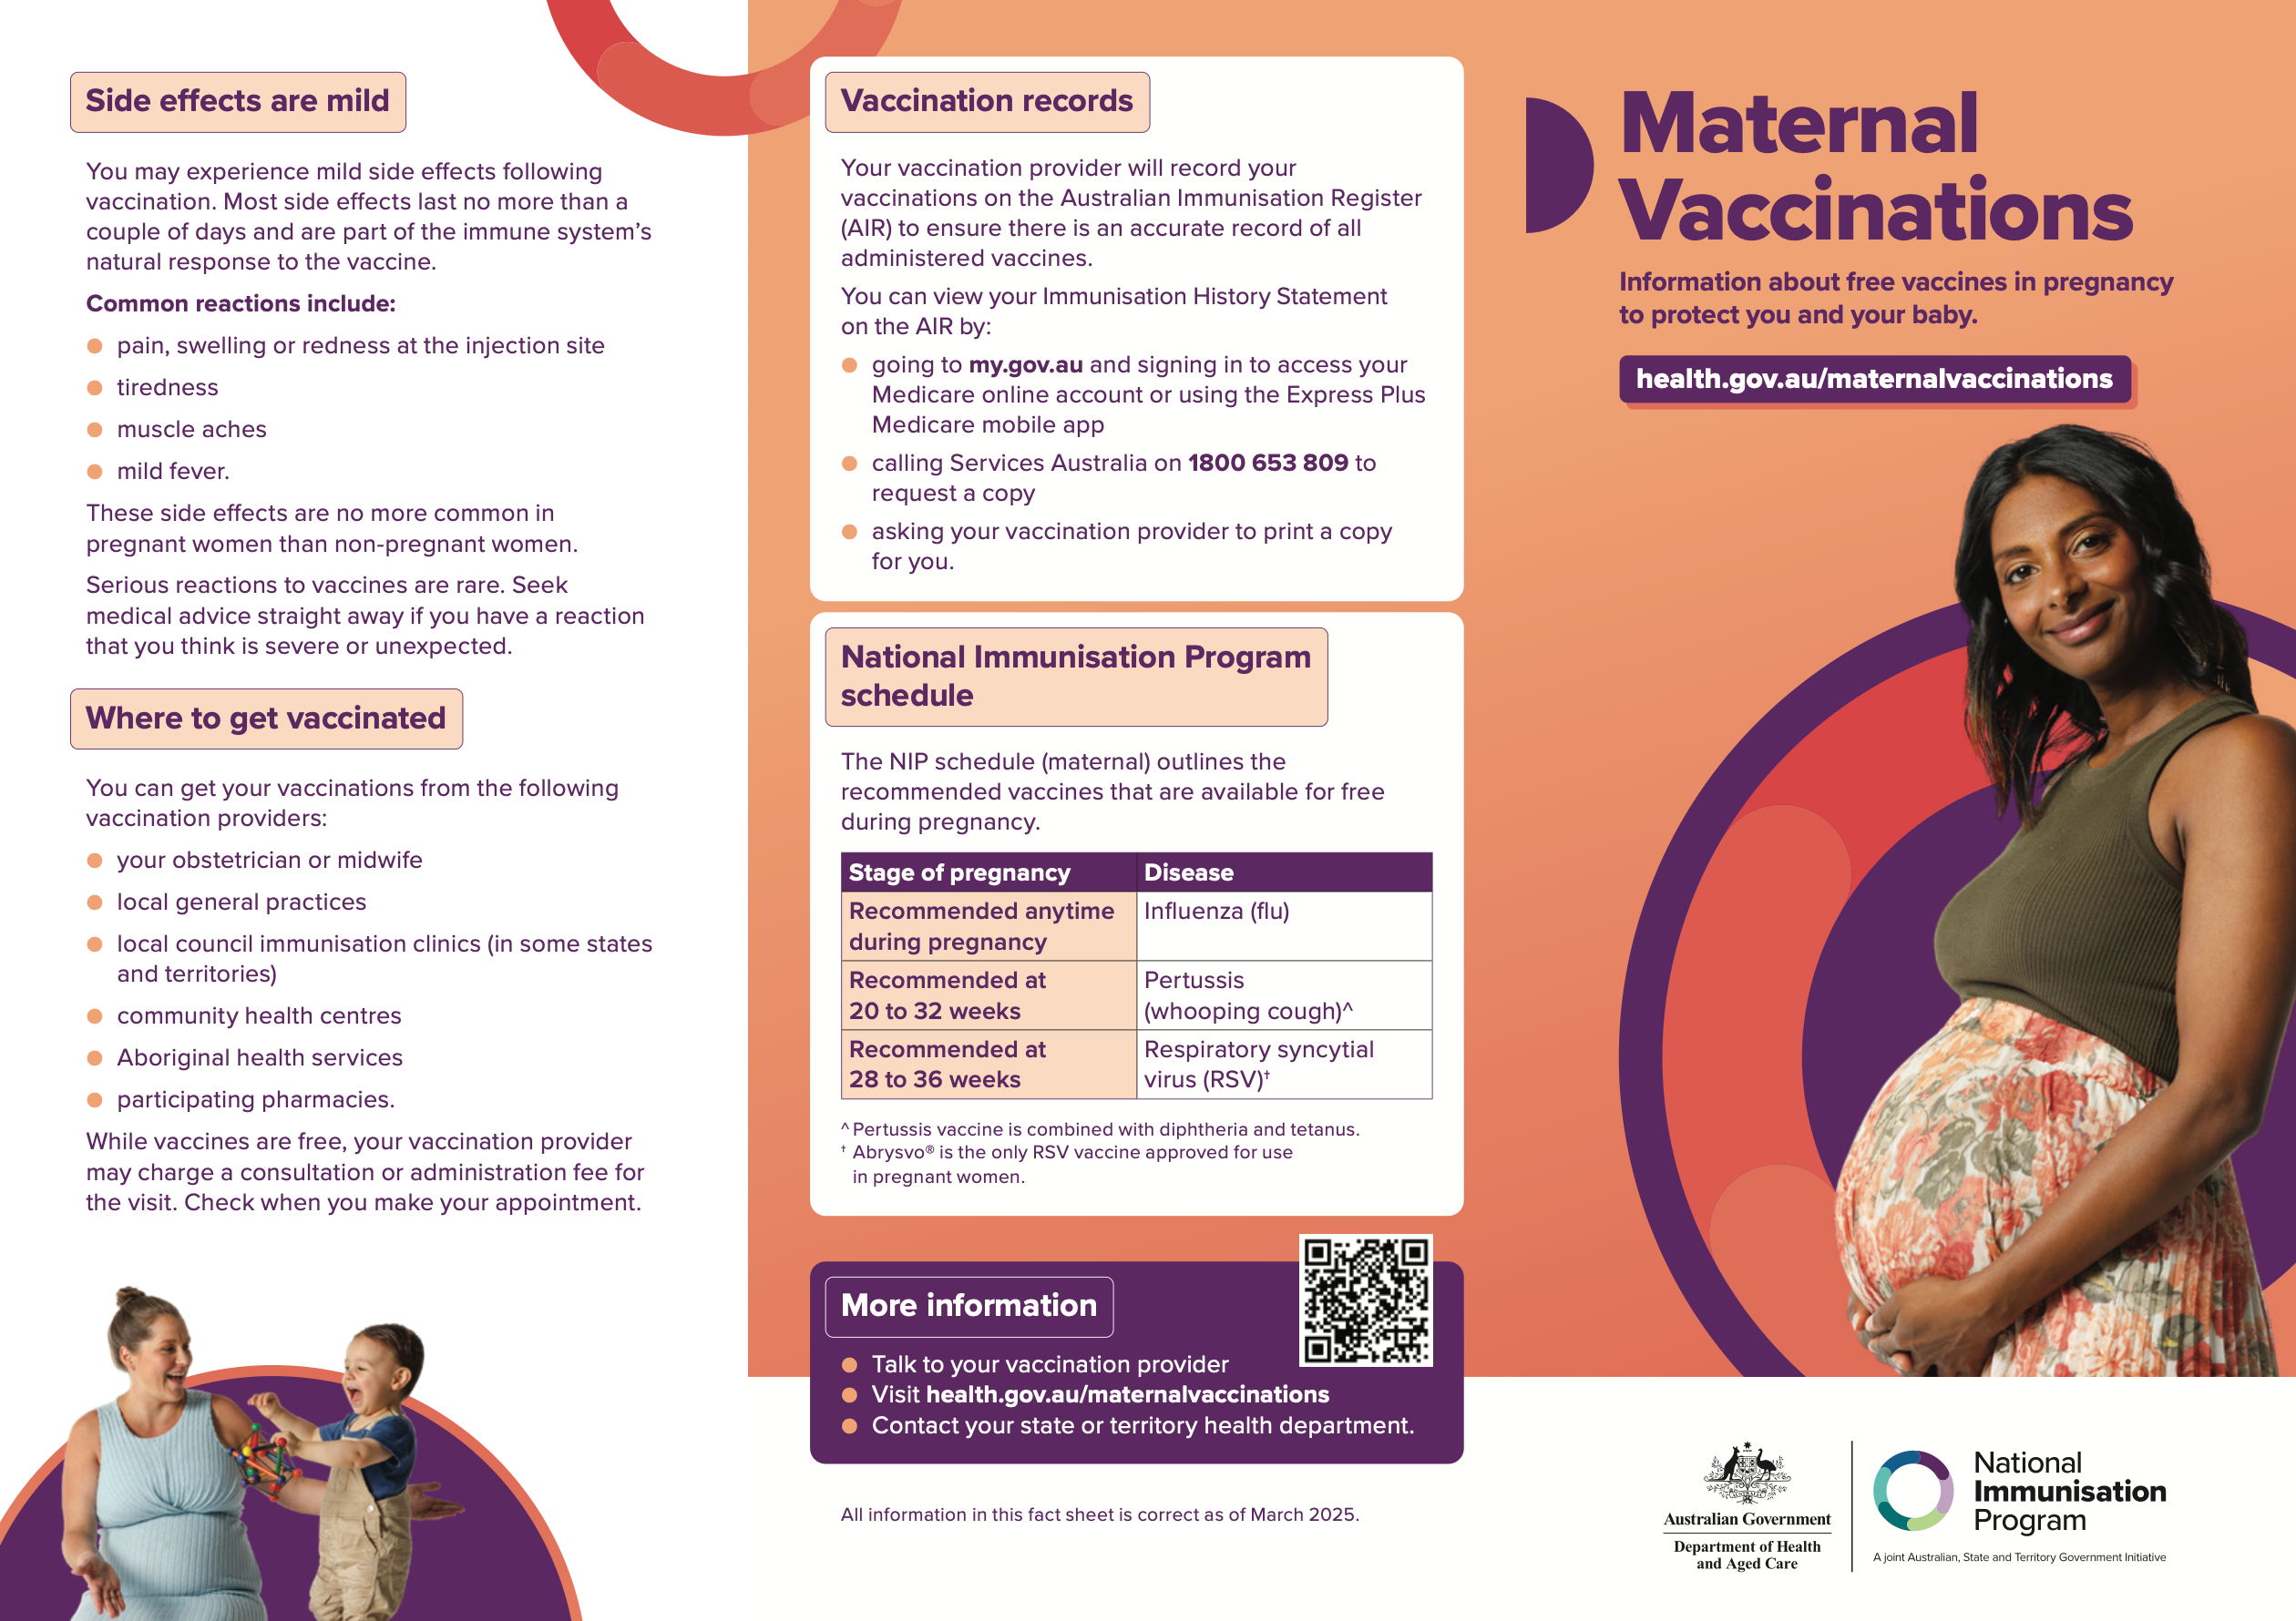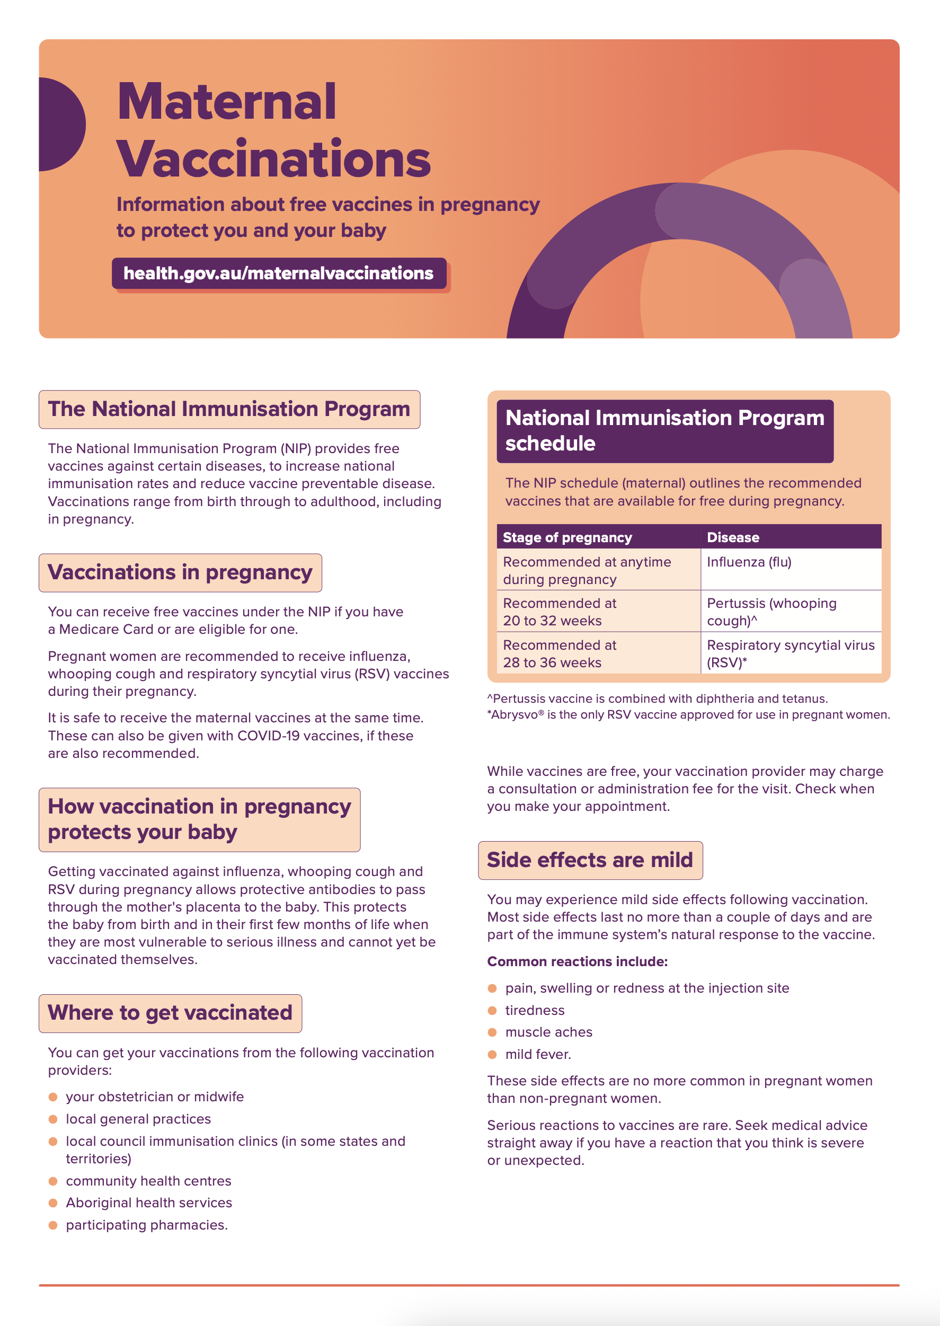 | Print and distribute this brochure in community waiting areas or public spaces.
Maternal vaccinations poster  This poster provides information about maternal vaccinations under the National Immunisation Program. | 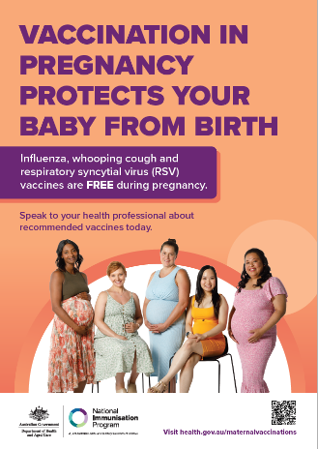 | Print and display this poster in community waiting areas or public spaces.
RSV protection - social tile  Social media tile about protecting babies from RSV with the maternal vaccination.  Available in 3 sizes | 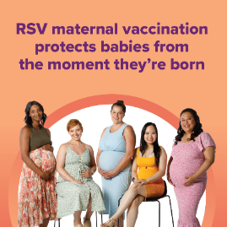 | Publish on your preferred social media channels.  Social tiles available from Fenton. Email health@fenton.com.au.
Free RSV vaccine - social tile  Social media tile about the free RSV vaccine in pregnancy.  Available in 3 sizes | 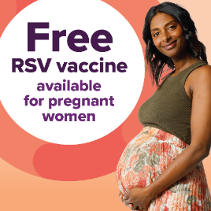
RSV vaccination during pregnancy - social tile  Social media tile about the RSV maternal vaccine.  Available in 3 sizes | 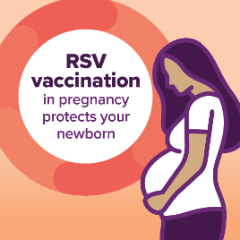
Social media
Resource | Suggested post
Social post #1 | Respiratory syncytial virus (RSV) is a common, highly contagious virus that affects your baby’s airways and lungs.  You can protect your baby against severe RSV disease from birth by getting vaccinated for free during pregnancy.  For more information on vaccines recommended in pregnancy, visit health.gov.au/maternalvaccinations
Social post #2 | Do you have questions about the respiratory syncytial virus (RSV) maternal vaccine?  You may want to know more about how the vaccine works, what other maternal vaccines are recommended and their safety or efficacy.  Talk to your doctor, nurse or other health professional about your upcoming maternal vaccinations.  For more information, visit health.gov.au/maternalvaccinations

Translated resources

Help protect multicultural communities from RSV
There are translated resources available for multicultural communities. These are available in the following languages:
- Arabic
- Chinese Simplified
- Chinese Traditional
- Vietnamese.
Translated resources include:
- Respiratory syncytial virus (RSV) vaccine consumer fact sheet
- Maternal vaccination poster
- Maternal vaccinations consumer brochure
- Health expert video
- Social media content
Find direct links to translated information and resources on the following page.

How you can help
- Share: Forward the stakeholder pack email and download link to your network. Additionally, consider displaying posters and distributing fact sheets and brochures where relevant, to help extend the reach of the campaign.
- Post: Share the resources in this kit with your community by posting on social media platforms
or messaging apps such as WhatsApp, Viber, WeChat, KakaoTalk or Facebook Messenger.
- Discuss: Start conversations about RSV vaccinations with community members at your place of work, or community and migrant centres.

Further information
- For translated resources, visit health.gov.au/maternal-vaccinations/translated-resources

Translated resource links

Resource library
Resource | Preview | In-language links
RSV vaccine consumer fact sheet  This fact sheet provides information to consumers on the maternal RSV vaccine and infant RSV immunisation products. | 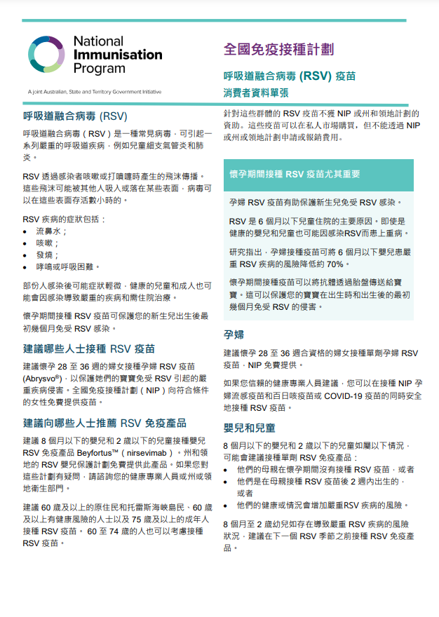 | - Arabic  - Chinese Simplified  - Chinese Traditional  - Vietnamese
Maternal vaccinations consumer brochure  This brochure provides information about recommended maternal vaccinations under the National Immunisation Program.  The brochure is available in A4 format. | 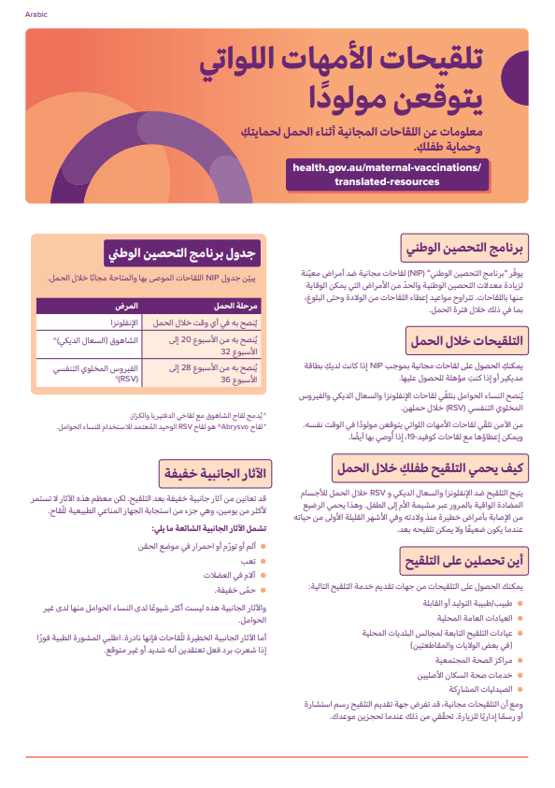 | - Arabic  - Chinese Simplified  - Chinese Traditional  - Vietnamese
Maternal vaccinations poster  This poster provides information about maternal vaccinations under the National Immunisation Program. | 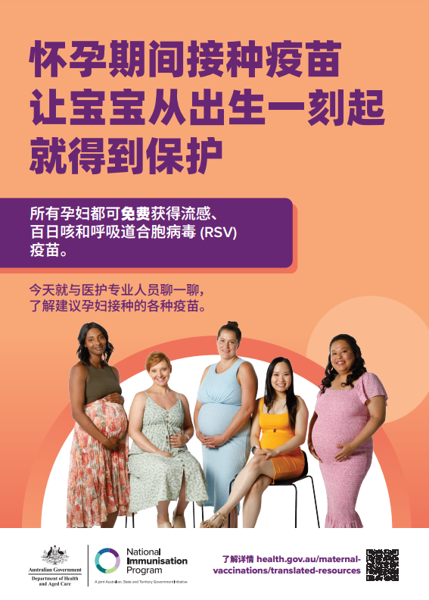 | - Arabic  - Chinese Simplified  - Chinese Traditional  - Vietnamese
Social media
Resource | Preview | Suggested use
RSV protection - social tile  Social media tile about protecting babies from RSV with the maternal vaccination.  Available in 3 sizes | 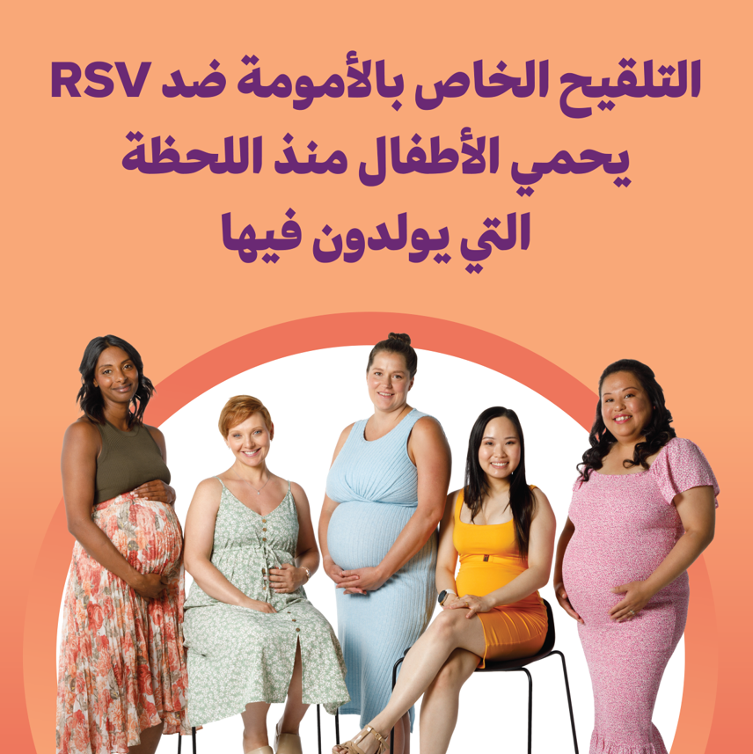 | Publish on your preferred social media channels.  Available in:  - Arabic  - Chinese Simplified  - Chinese Traditional  - Vietnamese  Social tiles available from Fenton. Email health@fenton.com.au.
Free RSV vaccine - social tile  Social media tile about the free RSV vaccine in pregnancy.  Available in 3 sizes | 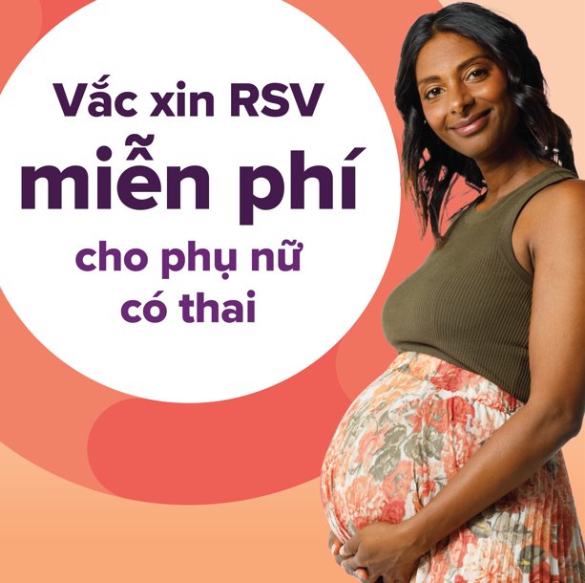
RSV vaccination during pregnancy - social tile  Social media tile about the RSV maternal vaccine.  Available in 3 sizes | 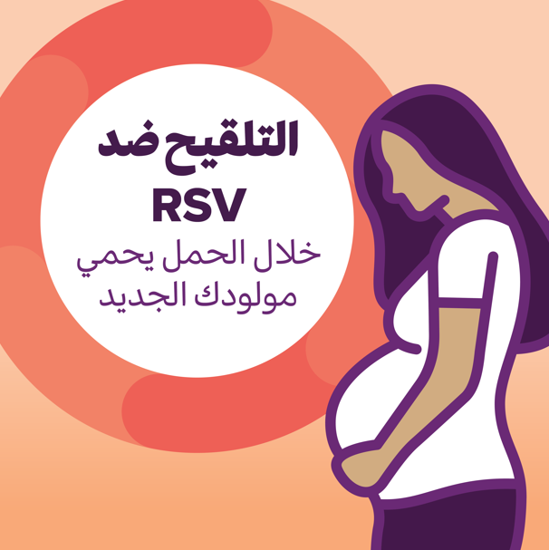
Resource | Suggested post
Social post #1 | 🦠 Respiratory syncytial virus (RSV) is a common and highly contagious virus that can make babies very sick.  👶 It’s a leading cause of hospitalisation for children.  🤰 If you’re 28–36 weeks pregnant, you can get a free RSV vaccine to help protect your baby from birth.  📘 Find trusted info in your language, visit:  https://www.health.gov.au/maternal-vaccinations/translated-resources
Social post #2 | 💬 Did you know most children will get respiratory syncytial virus (RSV) before age 2? Babies under 6 months, especially those under 3 months are most at risk of serious illness.  💛 Protect your baby in the first months of life with the free RSV vaccine during pregnancy. It’s free and safe.  📢 Share this info with your community: https://www.health.gov.au/maternal-vaccinations/translated-resources

First Nations resources

It’s as easy as 1, 2, 3 to protect bub in pregnancy.

There are resources available for Aboriginal and Torres Strait Islander communities. Resources include:

- Maternal vaccination poster
- Maternal vaccinations fact sheet
- Health worker video content
- Social media content

Find direct links to resources on the following page.

Resource library
Resource | Preview | Link
Maternal vaccinations poster  This poster provides information about maternal vaccinations under the National Immunisation Program.  The poster is available in an A4 and A3 format. | 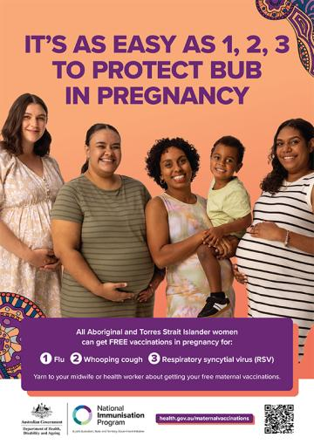 | - Download
Maternal vaccinations fact sheet  This fact sheet provides information about maternal vaccinations under the National Immunisation Program.  The fact sheet is available in an A4 PDF and A4 Word Document format. | 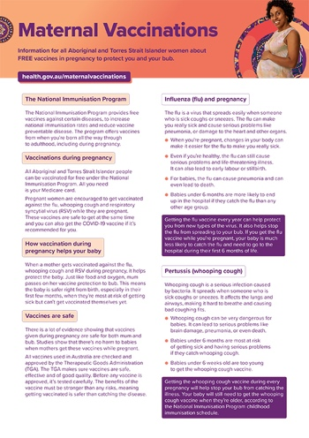 | - Download
Health worker video – maternal vaccinations  This video explains how free maternal vaccinations help protect bub against influenza, whooping cough, and RSV. | 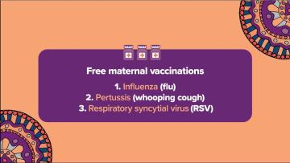 | - View
Health worker video – influenza vaccine  This video explains what influenza is, and why vaccination is important. | 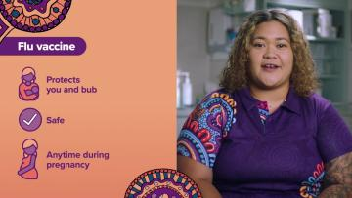 | - View
Health worker video – whooping cough vaccine  This video explains what whooping cough is, and why vaccination is important. | 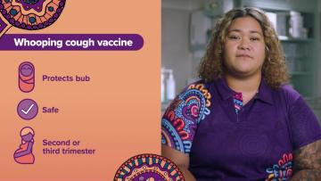 | - View
Health worker video – RSV vaccine  This video explains what RSV is, and why vaccination is important. | 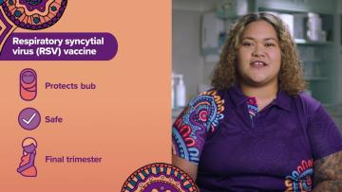 | - View
Social media
Resource | Preview | Suggested use
Social video – maternal vaccinations  Social media animation outlining each of the 3 maternal vaccinations.  Suggested post copy:  It’s as easy as 1, 2, 3 to protect bub in pregnancy, with free maternal vaccinations for flu, whooping cough, and RSV. | 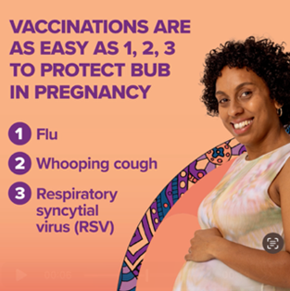 | - Download
Social video – influenza vaccine  Social media animation talking about how the influenza vaccine is safe at any time during pregnancy.  Suggested post copy:  The flu vaccine is safe at any time during pregnancy, and protects you and your bub for their first 6 months of life. | 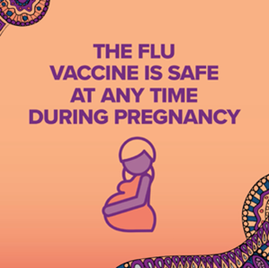 | - Download
Social video – whooping cough vaccine  Social media animation talking about why and when to get the whooping cough vaccine.  Suggested post copy:  Getting a safe and free whooping cough vaccine during pregnancy helps protect bubbas while they’re still too young to get vaccinated themselves. | 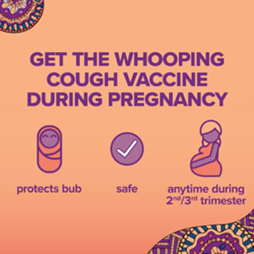 | - Download
Social video – RSV  Social media animation talking about why and when to get the RSV vaccine.  Suggested copy:  RSV spreads really easily, and affects bub’s airways and lungs. It can be very dangerous for littlies, so getting vaccinated really matters! | 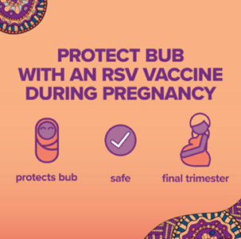 | - Download

Newsletter article
An article has been provided below that can be used on your website, in a newsletter or via email communication.

Free RSV vaccine available during pregnancy
A free vaccine to help protect babies against respiratory syncytial virus (RSV) is available for pregnant women in Australia.
RSV is a common virus that affects the airways and lungs and can lead to serious respiratory illnesses in newborns and infants, such as bronchiolitis and pneumonia.
The RSV vaccine is free under the National Immunisation Program for women who are 28 to 36 weeks pregnant.
This program provides free vaccines against certain diseases, to increase national immunisation rates and reduce vaccine preventable disease. Vaccinations take place from birth through to adulthood, including during pregnancy.
Getting vaccinated during pregnancy helps protect babies from birth, with studies showing it can reduce the risk of severe RSV illness in babies aged under 6 months by around 70%.
It’s also recommended you receive flu and whooping cough vaccinations during pregnancy.
It is safe to receive all the maternal vaccines at the same time.
To learn more, speak with your healthcare provider or visit health.gov.au/maternalvaccinations.

