Webinar Q&As – Reform Readiness for NATSIFAC Providers

Thank you to everyone who attended our webinar on 20 March 2025 and submitted questions. This document provides answers to those questions.

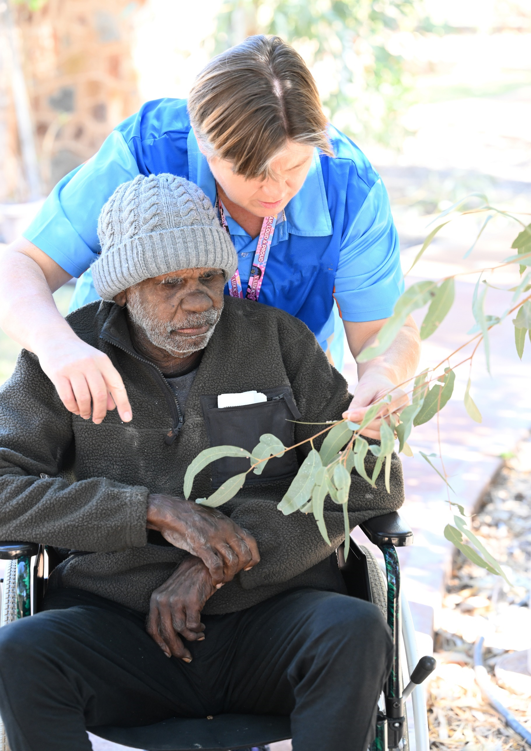

Contents

Introduction 4

Document History 4

Acronyms 5

NATSIFAC and the new regulatory model 6

Aged care worker screening 7

Single Assessment System Update 11

NATSIFAC provider assessments 14

NATSIFAC Costing Study 16

General 17

# Introduction

On 20 March 2025, the Department of Health, Disability and Ageing (the department, we, us) hosted a webinar for NATSIFAC providers (you), to explain how aged care reforms will impact the NATSIFAC program and its providers. We thank everyone who joined the webinar.

The webinar was a way for us to share information with you, to answer questions, and hear your comments on the reforms that will directly impact you.

The webinar included the following topics:

* NATSIFAC and the new regulatory model
* Aged care worker screening
* Single Assessment System update
* The NATSIFAC Costing Study

This document is a summary of key questions and answers from the webinar.

We have based answers below on spoken responses from the department’s presenters during the webinar and have added information where needed.

We have also answered questions that we didn’t have time to answer during the webinar.

Answers are correct at the time of publication.

# Document History

| Version | Date | Q&As added | Changes |
| --- | --- | --- | --- |
| 1.1 | April 2025 | All | None |
| 1.2 | June 2025 | None | Responses for questions relating to Single Assessment System |

# Acronyms

| Acronym |  |
| --- | --- |
| ACAT | Aged Care Assessment Team |
| ACQSC | Aged Care Quality and Safety Commission |
| Ahpra | Australian Health Practitioner Regulation Agency |
| AN-ACC | Australian National Aged Care Classification |
| CHSP | Commonwealth Home Support Programme |
| ECS | Elder Care Support Program (formerly Trusted Indigenous Facilitators/TIF) |
| HCP | Home Care Package |
| IAT | Integrated Assessment Tool |
| IHACPA | Independent Health and Aged Care Pricing Authority |
| NATSIFAC | National Aboriginal and Torres Strait Islander Flexible Aged Care Program |
| NDIS | National Disability Insurance Scheme |
| NPC | National Police Certificate |
| RAS | Regional Assessment Service |

# NATSIFAC and the new regulatory model

**Presented by**: Robert Day, Assistant Secretary, Harmonisation and Regulatory Strategy Branch, Department of Health, Disability and Ageing

## QUESTION

1. **Will there be a 'hotline' or 1300 number where providers can call and talk to a policy person given sometimes these changes are difficult to understand and just need to be talked through?**

There will not be a hotline. If you have any questions on the new aged care regulatory model, you can contact us at [AgedCareRegModel@Health.gov.au](mailto:AgedCareRegModel@Health.gov.au)

## MORE INFORMATION

* Department’s website: [www.health.gov.au/regulatory-model](http://www.health.gov.au/regulatory-model)
* A Provider guidance booklet – *Regulatory changes for NATSIFAC providers* – is coming soon.
* Aged Care Quality and Safety Commission’s website: [www.agedcarequality.gov.au](http://www.agedcarequality.gov.au/)

# Aged care worker screening

**Presented by**: Imran Church, Director, Worker Regulation Section, Department of Health**,** Disability and Ageing

## QUESTIONS

### Topic: Obtaining a worker screening check

1. **Given the very remote Indigenous context NPC and NDIS Worker Screening checks can be sometimes difficult to obtain as Indigenous people often have different versions of their name on their IDs. Sometimes they don't have sufficient number of IDs. Considering NATSIFAC Program flexibility are there any exceptional circumstances for those situations?**

**and**

1. **How do Indigenous staff meet the requirements for a worker screening check if they are affected by not having the required identity documents?**

We understand there can be challenges in obtaining identity documents.

State and territory units that administer police checks may have information or support available to assist people who don’t have the required identity documentation.

We are considering what other steps or supports we can put in place to help Aboriginal and Torres Strait Islander aged care workers to meet the requirements of the NDIS and Aged Care Worker Screening check and will engage with NATSIFAC providers on this work.

Worker screening of all workers and responsible persons is a condition of registration for all registered providers under the new Aged Care Act 2024. The Aged Care Quality and Safety Commission will be responsible for making sure that providers meet the conditions of registration.

1. **What funding will be provided to support Aboriginal and Torres Strait Islander staff to obtain the required ID documentation for the worker screening checks? The current NDIS screening has proven to be a major barrier to employment.**

There is currently no funding to support Aboriginal and Torres Strait Islander staff to obtain the required ID documentation. This remains the responsibility of the individual.

### Topic: Checks required for working in Aged Care

1. **When will the new aged care worker screening arrangements commence?**

The new screening arrangements will not commence before 2026.

1. **Will the NDIS check be mandatory for all aged care workers?**

When the new screening arrangements commence, any responsible person or aged care worker in a risk assessed role will need one of the following:

* an NDIS or Aged Care worker screening clearance
* Ahpra (Australian Health Practitioner Regulation Agency) registration
* police certificate (issued before the transitional period commences).

Aged care workers in non-risk assessed roles will still require a police certificate that does not record certain offences.

Under the new arrangements, it will be your responsibility as a registered provider to ensure that all responsible people and aged care workers in risk assessed roles are one of the required clearances.

1. **The NDIS Worker Screening Check is the only check an aged care worker will need? There won't be separate NDIS and Aged Care checks?**

When the new worker screening arrangements commence, there will be one process for all aged care or NDIS worker screening checks.

This will make it easier for workers to move between employers in the NDIS and aged care sectors, or to work in both sectors.

1. **Do all nurses in Aged Care require two checks, their Ahpra registration and NDIS check?**

From 1 November 2025, a person who has a valid Ahpra registration (such as a nurse) will still require a police certificate or a NDIS worker screening clearance.

When the new worker screening arrangements commence, an Ahpra registered practitioner working in aged care will not need an NDIS or aged care worker screening clearance or a police certificate.

1. **Can you please explain more about Ahpra registration? Who is required to have Ahpra registration?**

The Australian Health Practitioner Regulation Agency (Ahpra) works in partnership with 15 National Boards to regulate certain health professions.

These health professions include, but are not limited to:

* nurses
* dental practitioners
* occupational therapists
* pharmacists
* physiotherapists and
* psychologists.

Ahpra keeps a public, national register of all registered health practitioners. You can use the register to check if a person’s Ahpra registration is current, or has been cancelled, disqualified or otherwise prohibited.

When the new national worker screening arrangements start, a person who has a valid Ahpra registration and is working in a risk-assessed role in aged care won’t need to also obtain a worker screening check.

If the health practitioner also works with NDIS participants they must comply with the NDIS worker screening requirements.

### Topic: Precluding offences

1. **Why is there a different treatment of some criminal offences between CHSP/NATSIFACP (National Aboriginal and Torres Strait Islander Flexible Aged Care Program) workers and residential care or Support at Home Workers?**

All Government funded aged care providers currently have worker screening requirements.

These requirements differ depending on whether the provider is:

* approved and obligated to comply with the Aged Care Act 1997 and Accountability Principles 2014, or
* funded under a grant agreement, which is the case for NATSIFACP and CHSP providers.

The current arrangements led to inconsistencies in worker screening requirements between the different types of providers.

To minimise the risk of workforce disruption from 1 November 2025, the same current offences for approved providers and NATSIFAC providers will continue to apply and CHSP providers will align with NATSIFAC provider requirements.

These arrangements will remain in place until the new national worker screening arrangements commence in 2026.

## MORE INFORMATION

For further information on the Worker Screening requirements you can visit:

<https://www.health.gov.au/topics/aged-care-workforce/screening-requirements>

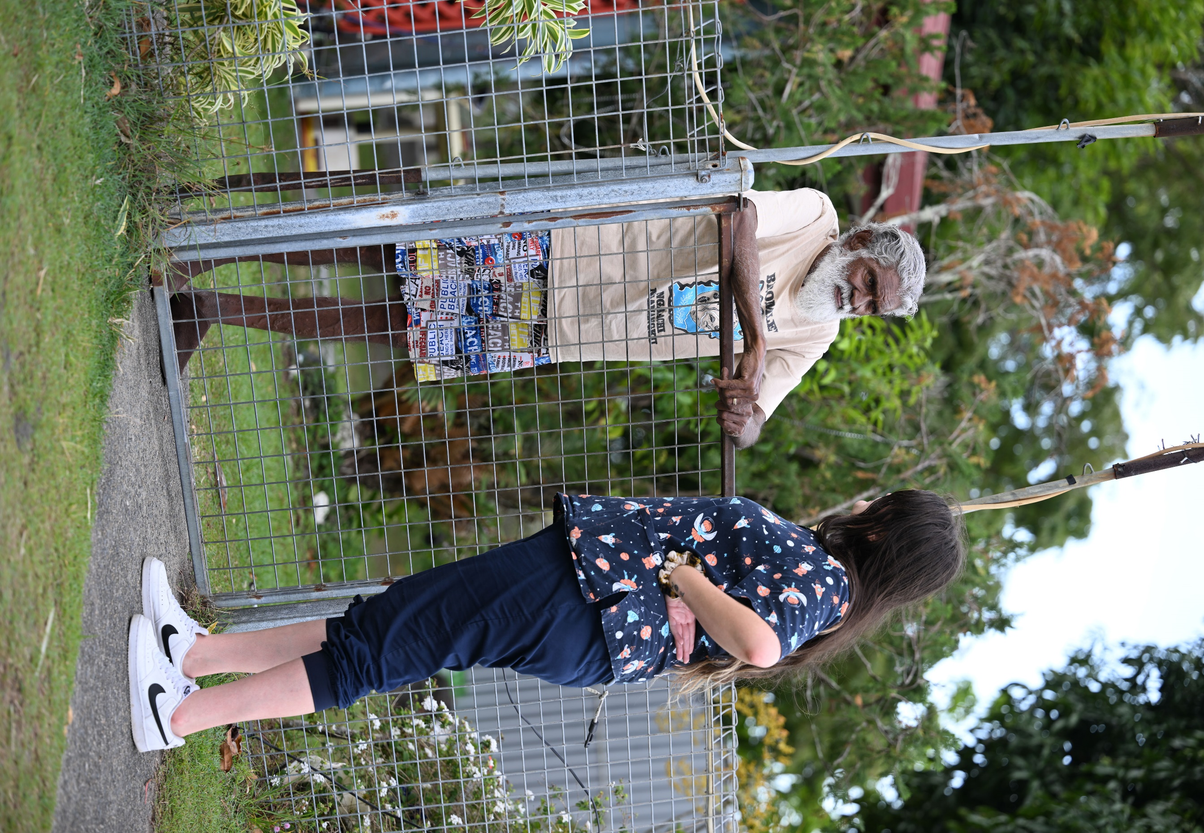

# Single Assessment System Update

Presented by: James Cole, A/g Director, Single Assessment System Branch, Department of Health**,** Disability and Ageing

## QUESTIONS

### Topic: Community controlled organisations

1. How much work is being put into supporting community-controlled organisations to undertake their own assessments under the Indigenous age care assessment framework?

The department has been working closely with key Aboriginal and Torres Strait Islander partners. From July 2025, we will be progressively introducing Aboriginal and Torres Strait Islander assessment organisations. The new assessment organisations will provide a more culturally safe assessment pathway for Aboriginal and Torres Strait Islander older people.

We also regularly engage with Aboriginal and Torres Strait Islander voices through:

* the appointed Interim First Nations Aged Care Commissioner
* existing governance groups
* peak bodies and organisations.

We will genuinely consider these stakeholders’ perspectives as we work to implement this initiative and will plan another program of outcome-focused communication and engagement with Aboriginal and Torres Strait Islander organisations and key stakeholders.

### Topic: Method of assessments

1. On the principle of pro-choice for the client, how can tele-health be the alternative because they are remote, wasn't this the purpose of the recommendation from the Royal Commission that their needs where better assessed?

While face to face assessments are best practice, we know there may be logistical difficulties or other sensitivities that act as a barrier to an in-person assessment. In these cases, a telehealth assessment might be appropriate for an older person, with a NATSIFAC staff member present if needed.

If you have an older person’s consent, you can share information that they have already provided to you with the assessment organisation. This will save the older person from having to retell their story. You will also need to ensure that the assessment is comprehensive and accurate.

The Elder Care Support workforce can also assist older Aboriginal and Torres Strait Islander people in navigating and accessing aged care services which includes the assessment process, either face to face or via telehealth.

1. How can telehealth be deemed the alternate for remote and very remote regions, considering the lack of phone and internet availability in most of these locations?

One of the key performance indicators that assessment organisations need to meet, is that a minimum of 50% of all Aged Care Needs Assessments for an older person in a remote location (MMM6-7) are conducted face to face.

Assessments may also be conducted by telehealth in remote areas, to help address the logistical and travel barriers.

As the question notes, however, Telehealth isn’t always possible.

1. Some assessors in our area are not completing F2F assessments, only offer phone assessment, and are completely unaware of NATSIFAC funding. I am aware of older people currently trying to be assessed and they are met with resistance and lack of understanding of their locations and social situations/barriers. I am concerned when single assessment is the only option, we will see a rise in these issues and even less engagement. How can the department ensure people are not disadvantaged by the change to single assessment?

The Single Assessment System creates a single assessment pathway for older people, supporting them to not have to repeat their story multiple times. It ensures access to assessments in regional, remote and rural areas. Assessors will be trained in all service offerings under the new Act, including NATSIFAC.

While the Single Assessment System aims to streamline and simplify the assessment pathway, we recognise the need for flexibility to address barriers in aged care assessments. We are implementing a culturally safe pathway for older Aboriginal and Torres Strait Islander people to access the aged care services in phases from July 2025.

We expect the organisations undertaking assessments to have a deep understanding of older Aboriginal and Torres Strait Islander people and the capacity to deliver a more culturally safe, trauma aware and healing informed assessment process.

1. Is there a threshold period (eg 12 months) where telehealth assessment will suffice but after 12 months an F2F assessment is done for people in very remote areas so distance is not a prohibitor?

There is no transition period for this as such. However, the Department's KPI for assessment organisations states that at a minimum, 50% of assessments in regional and remote areas need to be conducted face to face.

Alternative entry processes can be applied to meet a person’s needs before an aged care needs assessment can occur.

### Topic: Culturally safe assessments

1. As a remote, closed Aboriginal Community Aged Care and Community Service provider, our observational, experiential assessment system performed once they are admitted is far more appropriate and trauma aware. We often cannot even complete a KIKA as too many questions are triggering for them. Also their needs are drastically different to those in municipal environments and they are suspicious of any stranger regardless of race asking a lot of questions.

We are committed to delivering aged care assessments for older Aboriginal and Torres Strait Islander people in a way that respects their experiences and cultural context.

The Integrated Assessment Tool (IAT) uses the Kimberley Indigenous Cognitive Assessment (KICA) and the Good Spirit, Good Life. Both frameworks have been validated as the most appropriate and reliable instruments for assessing the needs of Aboriginal and Torres Strait Islander people.

Assessments should be a respectful conversation that takes place somewhere where the older person feels at ease. Assessors are trained and guided to be respectful of an older person's culture and experiences and will try to make the assessment as comfortable as possible for them.

Integrating [Elder Care Support](https://www.health.gov.au/our-work/elder-care-support) (ECS), or a trusted support person plays a vital role in ensuring culturally safe aged care assessment as older people navigate the aged care system. The phased implementation of Aboriginal and Torres Strait Islander assessment organisations from July 2025 will improve the support and services available to older Aboriginal and Torres Strait Islander people who need aged care assessments.

1. What's happened with the proposal of the TIFs/Elder Support Coordinator proposals with the Single Assessment Service. I know of two Elder Care Support services in Kempsey NSW but nothing else in the MNC at this time.

A list of organisations delivering Elder Care Support services is available at [Elder Care Support.](https://www.health.gov.au/our-work/elder-care-support)

More support will be available as Aboriginal and Torres Strait Islander Assessment Organisations come online.

### Topic: Single Assessment System workforce

1. Currently aged care refers to ACAT/ACAS. with the Single Assessment System, will this become SAS?

Prior to 9 December 2024, Regional Assessment Service (RAS) workforces completed home support assessments for CHSP, while Aged Care Assessment Teams (ACATs) completed comprehensive assessments for HCP, flexible aged care programs, residential respite and entry into residential care.

The Single Assessment System workforce brings these workforces together. We now have a mix of for profit, not for profit and state and territory governments delivering home support (RAS) and comprehensive (ACAT) aged care assessments, with some also undertaking AN-ACC assessments.

### Topic: Assessments for existing aged care recipients

1. Advice on assessment is incorrect and contradictory to what assessment and service providers have been provided - CHSP clients accessing services without an assessment need to be assessed by 31 October 2025 to continue accessing services as directed by the Act

To align with the new Act, all older people currently receiving CHSP services who have not had an assessment need to start an assessment before 31 October 2025 to still be eligible to receive CHSP services.

The process for older people who have received NATSIFAC services are below.

1. Will current NATSIFAC clients need to a have a needs assessment after 1 November from the new assessors?

People who have received any NATSIFAC services in the 12 months before the start of the new Act on 1 November 2025 will be deemed across to the new Act. This means these care recipients won’t have to undertake an aged care means assessment if they wish to continue receiving NATSIFAC services.

To deem care recipients without a needs assessment, we need certain identifying information. Providers are currently seeking consent from their care recipients to share their information with us.

When we receive this consent, we will enter client information into the system to show that these people can continue to receive aged care services.

If these older people move to a different provider or a different location where NATSIFAC services are not available, they may require an aged care needs assessment. It will depend on the service types they require and the range of programs available at their new location.

# NATSIFAC provider assessments

From 1 November 2025, all aged care services become Act-based services. This means anyone in receipt of NATISFAC or CHSP aged care services will require an aged care needs assessment under the Aged Care Act 2024.

Currently, NATSIFAC providers undertake an assessment to learn someone’s needs when they present to your service (it is referred to as a ‘comprehensive assessment’ in the NATSIFAC manual).

NATSIFAC providers will still be the first port of call for many older people in remote communities. Under the alternate entry process, you will be able to make an initial assessment and start providing services before an aged care needs assessment has occurred.

## New NATSIFAC clients after 1 November 2025

If the alternative entry process is used, the person NATSIFAC providers have assessed to receive services immediately will have up to 30 days to apply for an aged care needs assessment. You can apply for this assessment on their behalf, either by phone or online.

Once an assessment referral has been created, an assessment organisation operating in the service area will make an aged care needs assessment. This may include Aboriginal and Torres Strait Islander Assessment Organisations in future.

With consent from the care recipient, the information the NATSIFAC provider has gathered will help inform the assessment and can be used to avoid older Aboriginal and Torres Strait Islander people having to tell their story multiple times.

1. Commencing services prior to approval by assessment team. If a service is started while waiting for assessment: What will happen if the client turns out to be approved for CHSP service? Will the provider still be able to claim for the services already provided? Is there a possibility that this could occur? Will the same rule apply for CHSP providers - on providing emergency support if the person is registered to receive an assessment?

Delivery of care to individuals who are later approved for CHSP services is an eligible expense for NATISFAC Providers and funding can be used to support these services up to the date of transition to the alternate program. Details of the individual and care provided (including the timeframe of care) must be reported, as with other care recipients, in the Service Activity Report.

## MORE INFORMATION

For further information on the Single Assessment System and the assessment process you can visit:

* The [Single Assessment System for aged care](https://www.health.gov.au/our-work/single-assessment-system-for-aged-care/workforce) page on the Department of Health, Disability and Ageing website.
* The [My Aged Care website](https://www.myagedcare.gov.au/assessment) to learn more about the assessment process.
* The [First Nations Aged Care Assessments](https://www.health.gov.au/our-work/single-assessment-system/needs/first-nations-aged-care-assessments) page on the Department of Health, Disability and Ageing website.

# NATSIFAC Costing Study

**Presented by**: James Chen, Director, Independent Health and Aged Care Pricing Authority (IHACPA)

## QUESTIONS

No questions were submitted in relation to the NATSIFAC Costing Study.

# General

## QUESTIONS

### Topic: Provider support

1. What additional compliance support will be provided to NATSIFAC providers?

The Department has engaged Ninti One to provide tailored support to NATSIFAC service providers to meet the new aged care regulations. Ninti One has extensive experience in developing and delivering culturally safe training to Aboriginal and Torres Strait Islander communities in rural and remote areas. Ninti One will be engaged to provide these supports through till June 2027.

As part of the support and training services, Ninti One will:

* Develop a range of training resources tailored specifically to NATSIFAC service providers. These will summarise and clarify the upcoming changes to the NATSIFAC Program as it moves under the Aged Care Act 2024.
* Bring together key staff from NATSIFAC service providers to deliver face-to-face training workshops in 5 locations around Australia.
* Work with each NATSIFAC service provider to complete individual service support plans to prepare them to meet the new regulations.
* Visit each NATSIFAC Service to provide individualised support and training.
* Provide ongoing telephone, video conferencing and email support to NATSIFAC Service Providers from 1 July 2025 to 30 June 2027.

This support will ensure that providers have the capability and capacity to meet the requirements of the new regulations, allow service providers to revise existing governance structures and make arrangements to respond the Government’s reform agenda as it relates to NATSIFAC providers.

1. Will there be considerations given to costs specifically required for remote and very remote locations such as staff housing and transport, travel costs for allied health providers, freight costs, etc? There is a lot of out-of-pocket costs to organisations and costs that need to be funded by other programs to ensure the client receives what they are fully entitled to.
2. Will there be an increase in financial reporting for NATSIFAC?

Moving under the Aged Care Act is a major transition for many of our providers. It means that the majority of your obligations, conditions and reporting requirements are outlined in the Act rather than in your funding agreement.

Under the Act, NATSIFAC providers will have to report information on their organisation and delivery of care according to their registration categories.

NATSIFAC providers will continue to report through existing channels until system upgrades are completed and access to the Government Provider Management System [GPMS](https://www.health.gov.au/resources/apps-and-tools/government-provider-management-system) is available (expected in late 2025.

Until further notice, providers will continue to submit:

* Biannual Service Activity Reports (SARs, also known as Performance Reports) to the department
* Grant related reporting (including annual financial acquittals) to the Department of Social Services Community Grants Hub, and
* Other mandatory aged care provider reporting through alternative channels.

Read more about the digital changes under the Act.

### Topic: General

1. **Does NATSIFAC require brokerage agreements when brokering services to other providers. Eg, when older people go to another community or for a service we do not provide such as meals.**

Engaging another entity to deliver a service is defined in the grant agreement as sub-contracting.

NATSIFAC Providers must:

* request written consent from the department before an agreement is entered into with a subcontractor or secondary subcontractor, and
* be able to demonstrate that they have agreements in place with any associated provider delivering funded aged care services on their behalf.

Regardless of how subcontracted services are delivered, the registered provider remains responsible for service quality and meeting all regulatory responsibilities.

Further information about subcontracting will be in the registered providers grant agreement.

## CONTACT

Email: [NATSIFACP@health.gov.au](mailto:NATSIFACP@health.gov.au)

