New Aged Care Act and Volunteering in Aged Care

What volunteers need to know

June 2025

Contents

About this information 3

Purpose of this booklet 3

Summary 4

What are key elements I need to know? 4

1. New rights-based approach to aged care 5

1.1. Registered supporters 6

2. Regulation 6

2.1. Code of Conduct for aged care 8

2.2. Protection for whistleblowers 8

2.3. Complaints and feedback 9

2.4. Serious Incident Response Scheme (SIRS) 9

2.5. Worker Screening 10

Future arrangements for worker screening 10

Current arrangements 10

2.6. Training 11

3. What won’t be changing for volunteers 12

3.1. Definition of an ‘aged care worker’ 12

3.2. Volunteer activities 12

3.3. National Registration Scheme 12

3.4. Aged Care Volunteer Visitors Scheme (ACVVS) volunteers 12

3.5. Continuous improvement 12

# About this information

## Purpose of this booklet

Volunteers are an essential part of the aged care system. [Volunteering in aged care](https://www.health.gov.au/topics/aged-care/volunteers) contributes to positive outcomes such as increased mental health and wellbeing, social connectedness, reduced isolation and ageing in place.

This booklet has been developed by the Department of Health, Disability and Ageing (the department) to outline the upcoming changes under the new [*Aged Care Act 2024*](https://www.legislation.gov.au/C2024A00104/latest/text), (the new Act) which commences on 1 November 2025.

It is designed to help you understand what will change, and what will remain the same, so you can continue to provide high-quality, respectful, and rights-based volunteering support to older people.

You can:

* Learn more about the [aged care reforms](https://www.health.gov.au/our-work/aged-care-reforms) and the [new regulatory model](https://www.health.gov.au/our-work/new-model-for-regulating-aged-care).
* Access [learning modules](https://www.health.gov.au/our-work/aged-care-act/prepare/elearning#modules) to support your understanding.
* Visit our [Volunteering in Aged Care](https://www.health.gov.au/topics/aged-care-workforce/new-ways-of-working-in-aged-care) webpage for resources.
* Contact us at [agedcarevolunteer@health.gov.au](mailto:agedcarevolunteer@health.gov.au) for feedback.

**Note**: The information in this booklet is current at time of publication and may be subject to change prior to 1 November 2025

## Summary

### What are key elements I need to know?

#### **Rights-based approach**

The new Act emphasises a rights-based approach to aged care. It puts the rights, dignity, preferences, and needs of older people at the centre of care and support.

This means aged care volunteers will need to be aware of and follow the [Statement of Rights](https://www.health.gov.au/our-work/aged-care-act/about) for older people.

#### **Definition of an aged care worker**

Under the new Act an Aged Care Worker will **continue to mean** an individual employed or otherwise engaged (including as a volunteer) by the registered provider to deliver funded aged care services.

#### **Volunteer activities**

There are **no** legislative changes to activities, support or services provided by volunteers.

#### **Aged care worker screening**

All volunteers **must continue** to have either a police certificate or a NDIS worker screening check. There will be broader changes to worker screening in the future, but these changes will not commence before 2026.

#### **The Aged Care Code of Conduct**

The Aged Care Code of Conduct (the Code) outlines expected behaviour for aged care providers, workers, and volunteers to ensure the safety, dignity, and respect of older people receiving aged care and support.

#### **Whistleblower protections**

Expanded whistleblower protections are included in the new Act to ensure volunteers can report any concerns or issues without fear of reprisal.

#### **Complaints process**

As an aged care volunteer, it is important to understand the complaints process. This means you can help guide older people to where they can raise a concern or make a complaint.

#### **Training**

The new Act highlights the necessity for volunteers to receive appropriate training and support from providers. This includes accessible training and resources to enable you to undertake your role safely and confidently.

1. New rights-based approach to aged care

The new Act commences on 1 November 20025 and places the rights, dignity, and needs of older people at the centre of care. The new Act is very different from the existing legislation. It focuses on empowering older people and upholding their rights, needs and personal choices. As a volunteer, you play a key role in upholding these values, so it is important you are aware of and follow the Statement of Rights.

The [Statement of Rights](https://www.health.gov.au/resources/publications/a-new-aged-care-act-for-the-rights-of-older-people) means older people have the right to:

* **Independence and autonomy**: Older people have the right to make their own choices and live as independently as possible.
* **Empowerment and freedom of choice**: They can make decisions about their care and daily life.
* **Equitable access**: Everyone has the right to access quality aged care services regardless of background or circumstances.
* **Quality and safe care**: Services must be safe, respectful, and meet high standards.
* **Respect for privacy and information**: Personal information must be protected and treated with confidentiality.
* **Person-centred communication**: Communication should be clear, respectful, and tailored to the needs and preference of the individual.
* **Right to raise concerns**: Older people can speak up about issues without fear of reprisal.
* **Support from advocates and social connections**: They can have advocates or support people involved in their care and maintain social relationships (including with volunteers).

The [Statement of Principles](https://parlinfo.aph.gov.au/parlInfo/search/display/display.w3p;db=LEGISLATION;id=legislation%2Fbills%2Fr7238_first-reps%2F0003;query=Id%3A%22legislation%2Fbills%2Fr7238_first-reps%2F0000%22;rec=0) guides how aged care should be delivered and includes:

* person-centred care
* valuing the workforce, including volunteers
* a commitment to continuous improvement.

The new Act also recognises some older people may have unique needs and preferences due to their backgrounds or life experiences, and may require special consideration to ensure safe, respectful care that is inclusive, equitable, culturally appropriate, accessible and sensitive.

Learn more about what the Statement of Rights means for older people, view this [webinar](https://opan.org.au/video/statement-of-rights/) by the Older Persons Advocacy Network (OPAN).

Read the fact sheet on the rights-based approach to aged care under the new Act, available in [plain language](https://www.health.gov.au/resources/publications/a-new-aged-care-act-for-the-rights-of-older-people) and [Easy Read.](https://www.health.gov.au/resources/publications/a-new-aged-care-act-for-the-rights-of-older-people-easy-read-fact-sheet)

* 1. Registered supporters

From 1 November 2025, older people can have registered supporters, if they need or want support in their decision-making. Registered supporters help older people to make and communicate their own aged care decisions.

Registering as a supporter does not mean someone can make decisions on behalf of an older person. Aged care providers and workers (including volunteers) must still go to the older person for decisions related about their own care. Having a registered supporter does not stop older people from doing something they can do themselves.

Aged care providers and workers (including volunteers) must still go to the older person for decisions about their own care. As a volunteer or Volunteer Manager, you can ask the aged care provider or older person themselves if they have registered supporters and who they are.

For more information, including how a person can become a registered supporter, visit the [department’s website](https://www.health.gov.au/our-work/aged-care-act/about/supported-decision-making-under-the-new-aged-care-act).

1. Regulation

Under the new Act, all aged care providers must register under a universal registration system. There are six registration categories, which are based on the type, complexity, and risk of the services provided, not on whether services are delivered by paid staff or volunteers.

For more information about the service categories and the new regulatory model visit the [department’s website](https://www.health.gov.au/our-work/new-model-for-regulating-aged-care/how-it-works).



**2.1 Aged Care Quality Standards**

The [Aged Care Quality Standards](https://www.agedcarequality.gov.au/providers/quality-standards/strengthened-quality-standards) (Quality Standards) are a set of requirements registered providers must comply with under law if they are registered in Categories 4, 5 and 6. They will commence at the same time as the new Act. They are designed to improve outcomes for older people receiving funded aged care services and set clear expectations for providers in delivering quality aged care.

The diagram below outlines the **7 Quality Standards**

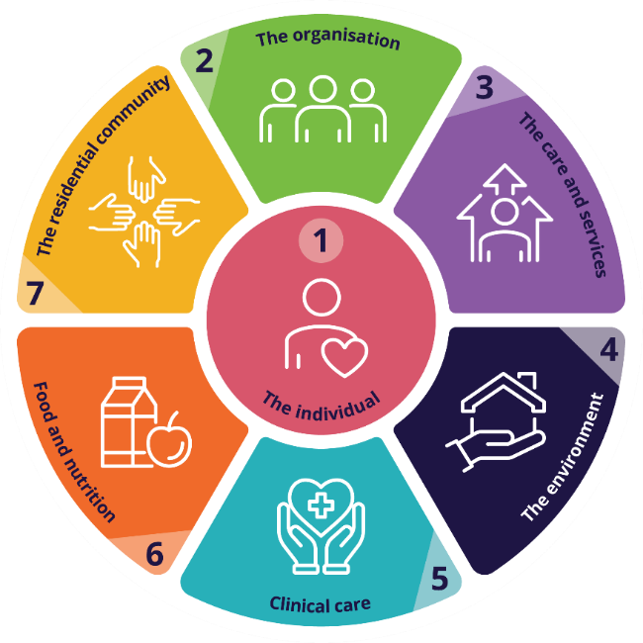The Quality Standards:

* place older people at the centre of aged care
* support people living with dementia
* are more inclusive of people from diverse backgrounds
* have stronger requirements for clinical care, food and nutrition and governance
* have more protections for older people.

The [guidance materials](https://www.agedcarequality.gov.au/resource-library/draft-guidance-aged-care-workers) developed by the Commission aim to support providers and workers (including volunteers) understand their obligations and requirements to deliver safe, effective and quality care and support.

Although providers registered in categories 1, 2 and 3 are not subject to audits against the strengthened Quality Standards, it is still expected that they will deliver the same standard for quality of care and support.

It is important you know that providers registered in all categories must comply with other obligations under law including:

* Statement of Rights and Statement of Principles
* Code of Conduct
* Worker screening
* Complaints, feedback and whistleblower protections
* Serious Incident Response Scheme (SIRS).

More information about the Aged Care Quality Standards is on the [department’s website](https://www.health.gov.au/resources/publications/strengthened-aged-care-quality-standards-february-2025) and the [Commission’s website](https://www.agedcarequality.gov.au/providers/quality-standards/strengthened-quality-standards).

* 1. Code of Conduct for aged care

Under the new Act, there are no substantive changes to the Aged Care Code of Conduct (the Code) which took effect on 1 December 2022. Only the language has been updated to clarify who the Code applies to.

The [Code of Conduct](https://www.agedcarequality.gov.au/for-providers/code-conduct) is part of aged care reforms to ensure older people are safe and describes how aged care providers, responsible persons and workers (including volunteers) must behave and treat people receiving aged care. Volunteers must always act in a respectful, kind and consistent manner aligned with the Code.

More information and resources on the Code are available on the [Commission’s website](https://www.agedcarequality.gov.au/for-providers/code-conduct).

You can also find a training video and fact sheet for volunteers and Volunteer Managers about the Code on the [Commission’s website](https://www.agedcarequality.gov.au/resource-library/volunteers-aged-care).

* 1. Protection for whistleblowers

A whistleblower is someone who raises concerns about wrongdoing they have seen or experienced in a workplace or organisation.

Volunteers will have increased protections through the expanded [whistleblower protections under the new Act.](https://www.health.gov.au/our-work/aged-care-act/rights#protection-for-whistleblowers) This means a volunteer can report a person or organisation who has not followed aged care law, without fear they will be punished or treated unfairly.

You can make a report in-person, over the phone or in writing, and it can be anonymous. The report can be made to:

* the Aged Care Complaints Commissioner or staff member of the Aged Care Quality and Safety Commission
* the Department of Health, Disability and Ageing
* an aged care provider or worker
* a responsible person of an aged care provider, such as a CEO or Board Member
* a police officer.

If you receive a protected disclosure as a volunteer, you must take steps to ensure protections are afforded to the discloser. See [Section 547 of the Act](https://parlinfo.aph.gov.au/parlInfo/download/legislation/bills/r7238_aspassed/toc_pdf/24104b01.pdf;fileType=application%2Fpdf#search=%22legislation/bills/r7238_aspassed/0000%22) for the definition of a disclosure which qualifies for protection.

For more information, visit the [department’s website](https://www.health.gov.au/our-work/aged-care-act/about#protection-for-whistleblowers).

* 1. Complaints and feedback

Everyone in aged care has the right to be safe and to raise a concern about their care or services. When issues arise an older person, their family or representative have the right to make a complaint.

The new Statement of Rights means older people will be encouraged to share their feedback. This includes being able to make a complaint if they feel their provider has not upheld their rights.

As a volunteer in aged care, older people may ask you for information or advice about who to contact or where to find guidance on raising a concern or making a complaint. This means it is important for you to know how to support them by understanding and following the aged care complaints process.

To learn more about how to support an older person understand their rights within the complaints handling process, and to access free training for volunteers and Volunteer Managers, go to the [Commission’s website](https://www.agedcarequality.gov.au/resource-library/volunteers-aged-care).

* 1. Serious Incident Response Scheme (SIRS)

The Serious Incident Response Scheme (SIRS) aims to reduce abuse and neglect of older people receiving government funded aged care services.

As a volunteer **you do not** have to report within SIRS. However, it is important you are aware of what a serious incident is, and if one occurs you need to let your Volunteer Manager, or another staff member, know as soon as possible. If you have any concerns, talk to your Volunteer Manager.

To find out more about SIRS, and to access free training for volunteers, visit the [Commission’s website](https://www.agedcarequality.gov.au/resource-library/volunteers-aged-care)

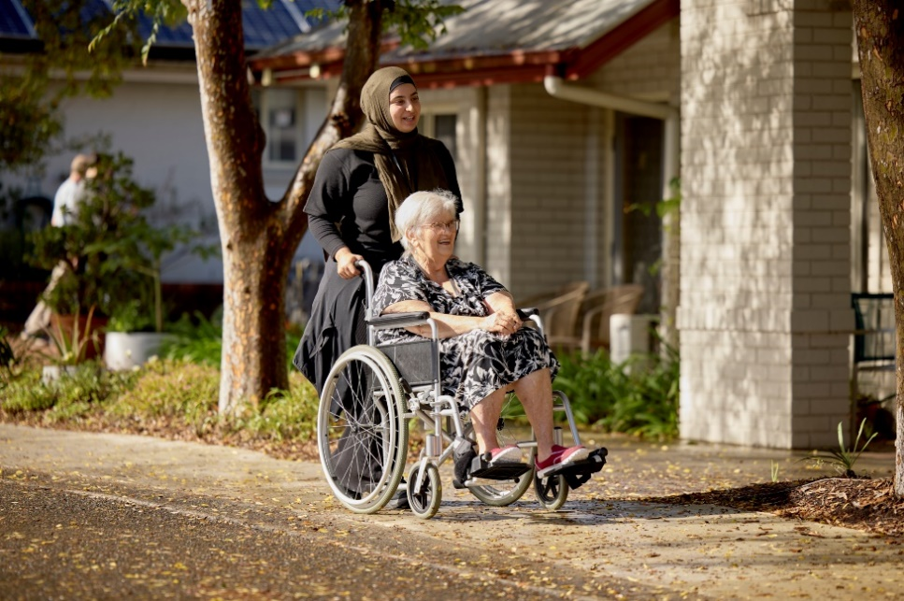

* 1. Worker Screening

Worker screening is an important way to protect older people by making sure people are fit to work and volunteer in aged care.

Changes to worker screening will begin from 1 November 2025 in line with the new Act. These changes will mostly impact people working (or volunteering) for the Commonwealth Home Support Program ([CHSP](https://www.health.gov.au/our-work/chsp)).

The offences that will stop aged care workers (including volunteers) from working for a CHSP provider will align with the same set of offences that stop you from working for a National Aboriginal and Torres Strait Islander Flexible Aged Care Program ([NATSIFACP](https://www.health.gov.au/our-work/national-aboriginal-and-torres-strait-islander-flexible-aged-care-program)) provider. This will apply:

* if you start working for a CHSP provider from 1 November 2025
* if you already work for a CHSP provider and need to renew your police certificate after 1 November 2025.

For other providers, the offences that currently apply will remain the same.

### Future arrangements for worker screening

Together with the states and territories, the Australian Government is working towards the introduction of requirements for aged care worker screening to align with the National Disability Insurance Scheme (NDIS). This will mean more robust screening checks for the aged care sector. Final arrangements are subject to agreement with the states and territories and will not commence before 2026.

### Current arrangements

Until the new worker screening process commences, volunteers **must** comply with current [worker screening arrangements](https://www.health.gov.au/topics/aged-care-workforce/screening-requirements).

You **must have** either a:

* police certificate (not older than 3 years) that does not record certain offences
* NDIS Worker Screening Check

To learn more about worker screening requirements from 1 November 2025, including the offences that will stop you from working as an aged care worker (or volunteer), download our fact sheets for [aged care providers](https://www.health.gov.au/resources/publications/fact-sheet-for-providers-aged-care-worker-screening-from-1-july-2025?language=en) and [aged care workers](https://www.health.gov.au/resources/publications/fact-sheet-for-workers-aged-care-worker-screening-from-1-july-2025?language=en), or visit the department’s website for [updates on screening requirements](https://www.health.gov.au/topics/aged-care-workforce/screening-requirements).

* 1. Training

The new legal and regulatory requirements under the new Act emphasises the importance of providing workers and volunteers with suitable training and support. This includes more accessible training programs and resources to help you undertake your volunteer role.

Registered providers (in Categories 4, 5 and 6) have an obligation under the Quality Standards (*Outcome 2.9: Human resource management*) to ensure as a volunteer, you have suitable training to effectively, safely and confidently perform your role.

Training ensures volunteers:

* provide person centred and rights-based support
* are aware of safety protocols and compliance requirements to keep older people in a safe environment, free from mistreatment and harm
* have the confidence to undertake the volunteer role
* respect and support older people from diverse backgrounds and life experiences.

For training information, guidance and links to training, visit the [department’s website](https://www.health.gov.au/topics/aged-care/volunteers/support-and-training).

1. What won’t be changing for volunteers
   1. Definition of an ‘aged care worker’

Under the new Act the definition of an ‘aged care worker’ **will continue** to mean an individual employed or otherwise engaged (including as a volunteer) by the registered provider to deliver funded aged care services.

See [Subsections 11 (4) and (5)](https://www.legislation.gov.au/C2024A00104/asmade/text) of the new Act

* 1. Volunteer activities

There are **no** legislative changes to activities or services provided by volunteers. It is up to the registered aged care provider to determine what roles and activities the volunteers will undertake in their organisation.

* 1. National Registration Scheme

The new training and skills requirements, through a national registration scheme to support personal care workers employed in aged care will **not** apply to volunteers.

* 1. Aged Care Volunteer Visitors Scheme (ACVVS) volunteers

ACVVS volunteers provide friendship and companionship to older people who are lonely or isolated. In recognition of the important role ACVVS volunteers play in supporting vulnerable older people, registered providers are required under the new Act to allow and facilitate access for ACVVS volunteers to the older person they are matched with.

ACVVS volunteers are managed, screened and trained by an ACVVS community organisation. ACVVS volunteer visitors **should not be** considered as part of the aged care provider volunteer workforce. Aged Care providers **should not require** ACVVS volunteers to undertake additional internal training or enter their personal details into a database.

For further information go to the [ACVVS Guidelines](https://www.health.gov.au/sites/default/files/2024-11/aged-care-volunteer-visitors-scheme-national-guidelines_0.pdf).

* 1. Continuous improvement

We understand you want to provide the best support possible to older people you volunteer for. We are always happy to hear your feedback and suggestions on how we can better support you to undertake your volunteer role.

Let us know your thoughts at [agedcarevolunteer@health.gov.au](mailto:agedcarevolunteer@health.gov.au).