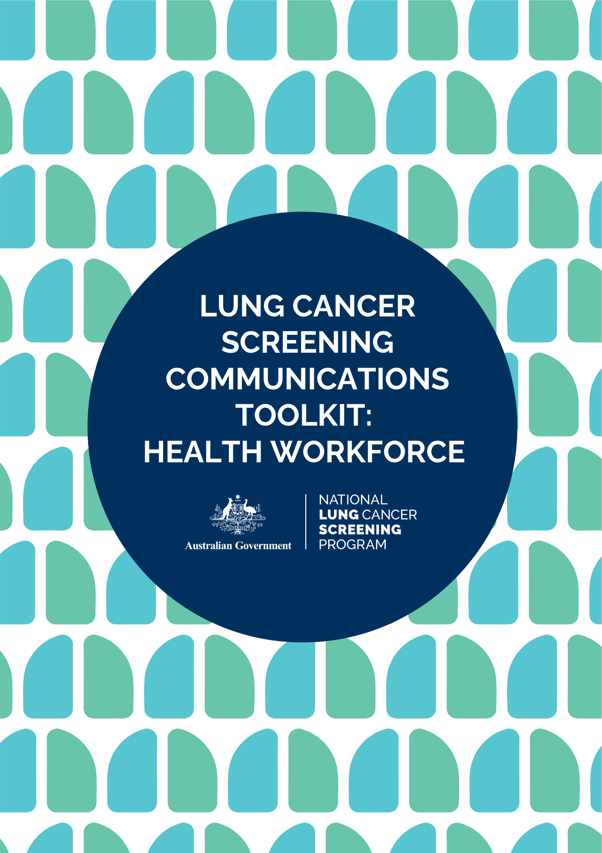

# CONTENTS

The Communication Toolkit 3

Terms of Use 3

About the NLCSP 4

Key Messages 4

Newsletter Content 5

Website Content 6

Email to Stakeholders 7

Social Media Content 8

Images/Social Media Assets 9

Hashtags 9

NLCSP Frequently Asked Questions 10

Program Resources 10

More Information 10

# 

# THE COMMUNICATION TOOLKIT

This communication toolkit has been developed by the Australian Government Department of Health, Disability and Ageing.

The toolkit is designed to support healthcare providers and the health support workforce to promote the National Lung Cancer Screening Program (NLCSP) with their networks.

The toolkit contains key messages, images and content for your social media, newsletters, emails and websites that can be used directly or adapted for your channels.

Share this content with your staff and networks to help them prepare for the program launch in July.

Please contact the Cancer Screening Communication and Partnerships team at [CancerScreeningCommunications@health.gov.au](mailto:CancerScreeningCommunications@health.gov.au) if you have any questions about this toolkit.

The toolkit was last updated: 26 May 2025

# TERMS OF USE

The messages, images and assets within this toolkit can be used to encourage participation in and awareness of lung cancer screening and the National Lung Cancer Screening Program

# ABOUT THE NLCSP

The National Lung Cancer Screening Program (NLCSP) aims to reduce deaths from lung cancer and achieve better health outcomes for Australians through early detection of lung cancer.

The program targets asymptomatic (no signs or symptoms suggestive of lung cancer) high-risk individuals (based on tobacco cigarette smoking history) to detect lung cancer in its early stages to increase the likelihood of successful treatment and improved patient outcomes. By detecting lung cancer early, the program is expected to save hundreds of lives each year from lung cancer.

People are eligible for the program if they are:

* aged between 50-70 years, and
* show no signs or symptoms suggesting they may have lung cancer (that is, they are asymptomatic), and
* currently smoke or have quit smoking in the past 10 years, and
* have a history of tobacco cigarette smoking of at least 30 pack-years.

The screening will involve completing a low-dose computed tomography (CT) scan every two years.

# KEY MESSAGES

* The National Lung Cancer Screening Program is launching in July 2025.
* Led by the Australian Government, in partnership with the National Aboriginal Community Controlled Health Organisation, this program is designed to be equity-focused, culturally safe, and person-centered.
* From 1 July 2025, eligible Australians aged 50-70 will be able to participate in the National Lung Cancer Screening Program and have a low-dose CT scan every two years to look for signs of lung cancer.
* The program will help to improve health outcomes for Australians by increasing early detection of lung cancer and saving lives.
* Lung cancer screening can detect up to 70% of lung cancers in the early stages.
* Healthcare providers will play a critical role in the delivery and success of the program by assessing participant eligibility, referring eligible participants to the program, and supporting participants through the screening and assessment pathway.
* New program resources and education are now available to support you to prepare for the program.
* Your participation in supporting this program could help save hundreds of lives each year from lung cancer.
* Lung cancer screening saves lives.
* Education and resources for healthcare providers: [www.health.gov.au/nlcsp-hcp-toolkit](https://www.health.gov.au/nlcsp-hcp-toolkit?utm_source=qr_code&utm_medium=digitaladvertising&utm_campaign=nlcsp2025)

# NeWSLETTER CONTENT

**Heading:**

Prepare for the National Lung Cancer Screening Program

**Body:**

From 1 July 2025, eligible Australians aged 50-70 will be able to participate in the new National Lung Cancer Screening Program and have a low-dose CT scan every two years to look for signs of lung cancer.

Lung cancer screening can detect up to 70% of lung cancers in the early stages and could help save hundreds of lives each year from lung cancer.

Led by the Australian Government, in partnership with the National Aboriginal Community Controlled Health Organisation, this program is designed to be equity-focused, culturally safe, and person-centered.

Healthcare providers and the health support workforce will play a critical role in the delivery of the program, assessing participant eligibility, referring eligible participants to the program, and guiding participants through the screening and assessment pathway.

To support you to prepare for the program, new education and resources are now available.

Complete the relevant training and download or order the resources to make sure you are ready for the National Lung Cancer Screening Program.

Access program information and resources for the health workforce at: [www.health.gov.au/nlcsp-hcp-toolkit](https://www.health.gov.au/nlcsp-hcp-toolkit?utm_source=qr_code&utm_medium=digitaladvertising&utm_campaign=nlcsp2025)

# WEBSITE CONTENT

**Preparing for the National Lung Cancer Screening Program**

From 1 July, eligible Australians aged 50-70 will be able to participate in the new National Lung Cancer Screening Program and have a low-dose CT scan every two years to look for signs of lung cancer.

Lung cancer is Australia’s leading cause of cancer death. This program aims to improve health outcomes for Australians by increasing early detection of lung cancer and saving lives.

Led by the Australian Government, in partnership with the National Aboriginal Community Controlled Health Organisation, this program is designed to be equity-focused, culturally safe, and person-centered.

Lung cancer screening can detect up to 70% of lung cancers in the early stages and could help save hundreds of lives each year.

Healthcare providers and the health support workforce will play a critical role in the delivery and success of the program by increasing understanding of and participation in the program.

**What you can do now to get ready**

Healthcare providers and the health support workforce will play a central role in the National Lung Cancer Screening Program by assessing participant eligibility, referring eligible participants, and supporting participants through the screening and assessment pathway.

To support you to prepare for the program, new education and resources are now available for healthcare providers. You can access the resources on the [Australian Department of Health Disability and Ageing website](https://www.health.gov.au/our-work/nlcsp/resources).

To make sure you feel ready to deliver the program, you should:

* Familiarise yourself with the [Program Guidelines](https://www.health.gov.au/resources/publications/nlcsp-guidelines?language=en)
* Complete the relevant [online education](https://www.health.gov.au/our-work/nlcsp/resources)
* Download or order [program resources](https://www.health.gov.au/our-work/nlcsp/resources)
* Prepare your practice now by registering and integrating with the [National Cancer Screening Register](https://ncsr.gov.au/information-for-healthcare-providers/accessing-the-ncsr/clinical-software-integration.html).

Find out more about the program and access information and resources for the health workforce at [www.health.gov.au/nlcsp-hcp-toolkit](https://www.health.gov.au/nlcsp-hcp-toolkit?utm_source=qr_code&utm_medium=digitaladvertising&utm_campaign=nlcsp2025).

# EMAIL TO STAKEHOLDERS

Dear [staff/colleagues/members]

The new National Lung Cancer Screening Program (NLCSP) will be available for eligible Australians aged 50-70 from 1 July 2025.

Led by the Australian Government, in partnership with the National Aboriginal Community Controlled Health Organisation, this program is designed to be equity-focused, culturally safe, and person-centered.

Lung cancer is Australia’s leading cause of cancer death. This program aims to improve health outcomes for Australians by increasing early detection of lung cancer and saving lives.

New program education and resources are now available to help you prepare for the program.

 This includes:

* Link to online training and education.
* Information and resources for healthcare providers and the public about the program
* Promotional content.

The NLCSP website is the central source of information on the National Lung Cancer Screening Program for healthcare providers and health support workers. New information and resources will be added to this page as they become available.

Complete the relevant education and download or order resources to make sure you are ready for the program.

Find out more: [www.health.gov.au/nlcsp-hcp-toolkit](https://www.health.gov.au/nlcsp-hcp-toolkit?utm_source=qr_code&utm_medium=digitaladvertising&utm_campaign=nlcsp2025).

# SOCIAL MEDIA CONTENT

|  |
| --- |
| **Facebook / Instagram / LinkedIn** |
| Coming soon: The National Lung Cancer Screening Program!  On 1 July 2025, Australians aged 50-70 with no signs or symptoms of lung cancer may be eligible to screen every two years through the National Lung Cancer Screening Program.  Healthcare providers and the health support workforce will play a critical role in the delivery and success of the program.  Your participation in supporting the program could help save hundreds of lives each year from lung cancer.  Get ready by accessing the new education and resources for healthcare providers.  Find out more: [www.health.gov.au/nlcsp-hcp-toolkit](https://www.health.gov.au/nlcsp-hcp-toolkit?utm_source=qr_code&utm_medium=digitaladvertising&utm_campaign=nlcsp2025) |
| National Lung Cancer Screening Program education and resources are now available!  The National Lung Cancer Screening Program is launching on 1July 2025, allowing eligible people aged 50-70 to have a low-dose CT scan every two years.  This program will increase early detection of lung cancer (Australia’s leading cause of cancer death) and improve treatment outcomes, helping to save hundreds of lives every year.  Make sure you’re ready to support the delivery of this program and save lives.  Find education, information and resources: [www.health.gov.au/nlcsp-hcp-toolkit](https://www.health.gov.au/nlcsp-hcp-toolkit?utm_source=qr_code&utm_medium=digitaladvertising&utm_campaign=nlcsp2025) |
| Are you ready to support lung cancer screening?  The new National Lung Cancer Screening Program is launching on 1 July 2025, allowing eligible people aged 50-70 to screen for lung cancer every two years.  Lung cancer screening can detect up to 70% of lung cancers early and is expected to save hundreds of lives each year.  Get ready to deliver the program and save lives.  Access program education and resources: [www.health.gov.au/nlcsp-hcp-toolkit](https://www.health.gov.au/nlcsp-hcp-toolkit?utm_source=qr_code&utm_medium=digitaladvertising&utm_campaign=nlcsp2025) |
| Is your practice ready for the National Lung Cancer Screening Program?  The National Lung Cancer Screening Program is launching on 1 July 2025.  Primary care plays a critical role in the delivery of the program by assessing eligibility and referring eligible participants into the program.  This program will help to improve outcomes for Australians by detecting lung cancers early and saving lives. Make sure your practice is ready for July.  Access information, training and resources: [www.health.gov.au/nlcsp-hcp-toolkit](https://www.health.gov.au/nlcsp-hcp-toolkit?utm_source=qr_code&utm_medium=digitaladvertising&utm_campaign=nlcsp2025) |

|  |
| --- |
| **X (previously Twitter)** |
| On 1 July 2025, eligible Australians aged 50-70 with no signs or symptoms of #LungCancer will be eligible to screen every two years through the #NationalLungCancerScreeningProgram. Education and resources for healthcare providers are available. |
| New #NationalLungCancerScreeningProgram education and resources for healthcare providers are now available! Make sure you’re ready to support the delivery of this program and save lives. |
| Are you ready for #lungcancerscreening? The new #NationalLungCancerScreeningProgram will help to improve outcomes for Australians and save hundreds of lives each year. Get prepared by accessing program education and resources. |
| Is your practice ready for the #NationalLungCancerScreeningProgram? Primary care will play a critical role in the delivery and success of the program. Access information, training and resources: [www.health.gov.au/nlcsp-hcp-toolkit](https://www.health.gov.au/nlcsp-hcp-toolkit?utm_source=qr_code&utm_medium=digitaladvertising&utm_campaign=nlcsp2025) |

# IMAGES/SOCIAL MEDIA ASSETS

We have created several high-resolution images saved with this toolkit that you can use for your social media and other digital channels to promote the National Lung Cancer Screening Program.

# HASHTAGS

#LungCancer #LungCancerScreening #LungCancerScreeningSavesLives #PreventLung Cancer #NationalLungCancerScreeningProgram #NLCP

# NLCSP FREQUENTLY ASKED QUESTIONS

[Frequently asked questions from the health workforce](https://www.health.gov.au/resources/publications/nlcsp-workforce-faqs?language=en)

[Frequently asked questions from community members](https://www.health.gov.au/resources/publications/nlcsp-community-faqs?language=en)

# PROGRAM RESOURCES

A suite of National Lung Cancer Screening Program Resources has been developed for the health sector and the public. Access these resources on the NLCSP website via the links below.

[NLCSP resources for the health sector](https://www.health.gov.au/our-work/nlcsp/resources/health-sector)

[NLCSP resources for the public](https://www.health.gov.au/our-work/nlcsp/resources/general-public)

# MORE INFORMATION

Access information, resources and education for healthcare providers and the health support workforce on the program website: [www.health.gov.au/nlcsp](http://www.health.gov.au/nlcsp)

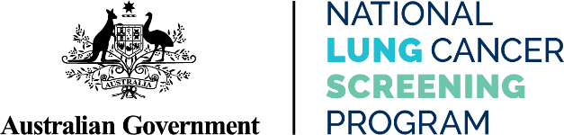

**health.gov.au/nlcsp**