Case Studies

Intellectual Disability Health Capability Framework Resources

## Acknowledgements

The artwork throughout the case studies has been created by people with lived experience of disability. Artwork has been provided by [Studio ARTES](https://www.studioartes.org.au/), a community organisation that provides creative and life skills programs for adults with disability.



#### Acknowledgement of people with intellectual disability and carers, family members and supporters of people with intellectual disability

The Department of Health and Aged Care and the National Centre of Excellence in Intellectual Disability Health acknowledge people with intellectual disability and carers, family, and supporters of people with intellectual disability who have fought and advocated for improved health care for people with intellectual disability. We acknowledge the contribution of these individuals who have shared their knowledge and experiences that have shaped these case studies.

#### Acknowledgement of Country

The Department of Health and Aged Care and the National Centre of Excellence in Intellectual Disability Health acknowledges the traditional owners of Country throughout Australia, and their continuing connection to land, sea and community. We pay our respects to them and their cultures, and to elders both past and present.

We pay our respects to all First Nations people with intellectual disability and acknowledge the higher prevalence of intellectual disability among First Nations peoples and the distinct challenges they face, along with the contributions they make to society.

## Description

These case studies provide examples of interactions between health professionals and people with intellectual disability and their supporters. They are part of a suite of resources intended for use in an educational context and designed to support the [Intellectual Disability Health Capability Framework](https://www.health.gov.au/resources/publications/intellectual-disability-health-capability-framework?language=en). The Framework aims to equip pre-registration students studying health, allied health, dentistry and other health-related disciplines with the required core capabilities to provide quality health care to people with intellectual disability.

Educators can use these case studies as an exemplar for the creation of their own discipline-specific resources. Changes can be made to these case studies to adapt them for specific discipline needs.

Additional resources are also available for educators to support integration of the Framework into existing curricula. Please see the [Intellectual Disability Health Capability Framework and education resources](https://www.health.gov.au/resources/collections/intellectual-disability-health-capability-framework-and-education-resources?language=en) to view all available resources.

## Authors and contributors

#### National Centre of Excellence in Intellectual Disability Health, UNSW Medicine & Health, UNSW Sydney

Dr Seeta Durvasula

Ms Claire Eagleson

Ms Marianne Gibney-Quinteros

Ms Tahli Hind

Ms Michaela Kobor

Professor Julian Trollor

Dr Janelle Weise

Dr Jenna Zhao

#### UNSW Medicine & Health, UNSW Sydney

Associate Professor Margo Lane

Professor Gary Velan

#### Medical School, The University of Queensland

Professor Nalini Pather

## Suggested citation

Durvasula, S., Eagleson, C., Gibney-Quinteros, M., Hind, T., Kobor, M., Lane M., Pather, N., Trollor, J., Velan, G.,Weise, J., Zhao, J. *Intellectual Disability Health Capability Framework Resources* – *Lecture Reference Book.* 2025.<https://www.health.gov.au/resources/collections/intellectual-disability-health-capability-framework-and-education-resources>

This work has been funded by the Department of Health and Aged Care.

This version current as at May 2025.

Contents

Acknowledgements ii

Description ii

Authors and contributors iii

Suggested citation iii

Case Study 1 – Intellectual Disability Awareness: Lauren 1

Learning outcomes 2

Case study – Lauren 3

Questions for discussion 4

Resources 5

Case Study 2 – Communication: Luca 8

Learning Outcomes 9

Case study – Luca 10

Questions for discussion 10

Resources 11

Case Study 3 – Quality evidence-informed health care: Charlie 14

Learning outcomes 15

Case study – Charlie 16

Questions for discussion 16

Resources 17

Case Study 4 – Coordination and collaboration: Arthur 19

Learning Outcomes 20

Case study – Arthur 21

Questions for discussion 22

Resources 23

Case Study 5 – Decision-making and consent: Aisha 25

Learning outcomes 26

Case study – Aisha 27

Questions for discussion 27

Resources 28

Case Study 6 – Responsible, safe and ethical practice: Mirko 32

Learning outcomes 33

Case study 6 – Mirko 34

Questions for discussion 35

Resources 36

# Case Study 1 – Intellectual Disability Awareness: Lauren

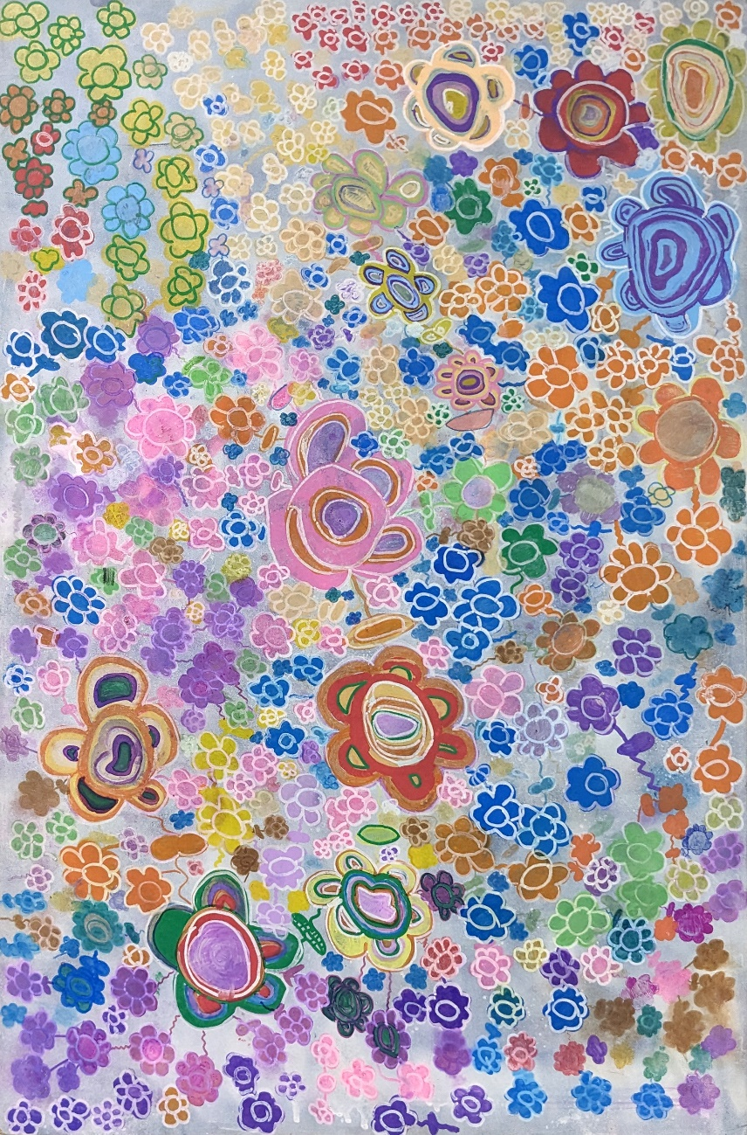

‘Em’s Flowers’, 2023, Emily Tomasetti

## Learning outcomes

#### The following learning outcomes for this case study are from the [Intellectual Disability Health Capability Framework](https://www.health.gov.au/resources/publications/intellectual-disability-health-capability-framework?language=en) (see Section 2)

1.2.3 Compare and contrast strength and deficit-based approaches when working with people with intellectual disability and the value of lived experience.

1.3.1 Describe the concept of power differentials and how they can influence health interactions and provision of health care for people with intellectual disability.

1.6.2 Identify gaps in the health care system, community services and individual care provision that influence health outcomes for people with intellectual disability and identify ways to mitigate them.

1.8.2 Describe how barriers and enablers influence health outcomes for people with intellectual disability.

1.10.1 Describe the key role of support networks in the lives of people with intellectual disability and how to identify support networks.

## Case study – Lauren

Lauren is a 54-year-old woman with Down syndrome and a mild intellectual disability. Lauren lives in a small rural town, about 60km from the nearest regional centre. Until six months ago, she lived with her widowed mother Margaret, aged 85 years. Lauren works with some support at a local small business, doing routine photocopying and filing. She is independent with most activities of daily living, including self-care, cooking, and cleaning. She can use the ATM to withdraw money, but other banking and paying of bills was done by her mother. Lauren’s younger sister, Karen, has her own family, but sees Lauren and her mother regularly. Lauren has never engaged with disability support services, as she and her mother had not felt the need for such support. She receives the Disability Support Pension but has no National Disability Insurance Scheme (NDIS) funding.

Six months ago, Margaret moved into residential aged care in the regional centre, after having had multiple falls and breaking her hip. Around that time Lauren’s work supervisor and sister Karen became concerned about Lauren’s memory and function. She became noticeably slower in performing all activities, could not remember how to complete work tasks and was experiencing difficulty in cooking, doing the laundry and attending to her personal hygiene.

Her employer felt that Lauren could no longer do the required work. However, after advocacy from her sister, the employer agreed to modify the tasks, so Lauren can do them. Karen assists Lauren by providing meals, doing her laundry and some of her house cleaning, but Lauren sometimes forgets to eat the meals or take her blood pressure medication. Karen suspects that Lauren is developing dementia, but her general practitioner, who has limited experience in seeing people with intellectual disability, dismisses her concerns, saying the changes are just part of Down syndrome and ageing. Karen insists on having a specialist assessment and after several months, Lauren is seen by a visiting specialist in the regional centre and is diagnosed with dementia.

Karen applies for NDIS funding for Lauren with appropriate documentation from Lauren’s health professionals. She receives funding that is used to provide drop-in support by disability support staff for a few hours a week. Karen continues to provide additional support, taking Lauren out for shopping trips and to see her mother once a week. As her dementia progresses, Lauren cannot manage with just intermittent support and moves into supported accommodation in the regional centre with full time disability staff.

## Questions for discussion

1. Who or what are the key supports for Lauren?
2. How do these supports change over time?
3. What key roles has Karen played in supporting Lauren?
4. What other types of support would be beneficial for Lauren?
5. How does this case study illustrate strengths-based versus deficits-based approaches when working with people with intellectual disability?
6. Analyse how power differentials and diagnostic overshadowing have influenced Lauren’s diagnosis.
7. How has living in a rural area affected Lauren’s access to health and support systems?

## Resources

#### General Resources

Intellectual disability health resources

Centre for Developmental Disability Health (CDDH)

Click here:

<https://cddh.monashhealth.org/index.php/resources/>

Description:

A collection of resources for health professionals, people with intellectual disability and their families and carers across a range of topics including guidelines on health care for adults with intellectual disability (with specific guidelines on topics such as dementia, women’s health and depression).

#### Dementia

Dementia in Australia web report

Australian Institute of Health and Welfare

Click here:

<https://www.aihw.gov.au/reports/dementia/dementia-in-aus/contents/dementia-in-priority-groups/dementia-people-intellectual-disabilities>

Description:

Outlines dementia in people with intellectual disability, as a subsection of an Australian Government report on dementia in Australia. Includes statistical information on levels of dementia in people with Down syndrome and risk factors for dementia.

Dementia in people with Intellectual Disability: Guidelines for Australian GPs

3DN, UNSW Sydney

Click here:

<https://www.3dn.unsw.edu.au/resources/professionals/health-mental-health-professionals/dementia-people-intellectual-disability-guidelines-australian-gps>

Description:

Guidelines for GPs for dementia health care in people with intellectual disability including guidelines on health checks, assessment and screening for mental disorders.

Dementia care for people with intellectual disability e-Learning course

ID Health Education – 3DN, UNSW Sydney

Click here:

<https://idhealtheducation.edu.au/health-professionals/>

Description:

E-learning course developed by 3DN, UNSW on dementia in people with intellectual disability; includes information on risk factors, presentation, assessment and management of dementia in people with intellectual disability. Available upon registration for a fee, subscription available for groups.

#### NDIS and disability supports for people with intellectual disability

GP and Health Professional’s Guide to the NDIS

National Disability Insurance Scheme (NDIS)

Click here:

<https://www.ndis.gov.au/media/332/download>

Description:

An information leaflet on the NDIS for health professionals, including how to access the NDIS, requirements of evidence, what the NDIS covers and more. Also includes patient summary examples.

Supports funded by the NDIS and disability-related health supports

National Disability Insurance Scheme (NDIS)

Click here:

<https://www.ndis.gov.au/understanding/supports-funded-ndis>

<https://www.ndis.gov.au/understanding/supports-funded-ndis/disability-related-health-supports>

Description:

Information regarding the types of supports available to participants.

#### Attitudes

Journal Article

Pelleboer-Gunnink, H. A., Van Oorsouw, W. M. W. J., Van Weeghel, J., & Embregts, P. J. C. M. *Mainstream health professionals' stigmatising attitudes towards people with intellectual disabilities: a systematic review*. Journal of Intellectual Disability Research, 2017. 61(5) p. 411–434.

Click here:

[10.1111/jir.12353](https://doi.org/10.1111/jir.12353)

Description:

A systematic review of health professionals’ attitudes towards people with intellectual disability. Focusses on challenges of stigmatising attitudes of mainstream health professionals towards people with intellectual disability.

# Case Study 2 – Communication: Luca



‘Spring’, 2022, William Walters

## Learning Outcomes

#### The following learning outcomes for this case study are from the [Intellectual Disability Health Capability Framework](https://www.health.gov.au/resources/publications/intellectual-disability-health-capability-framework?language=en) (see Section 2)

2.1.1 Discuss effective and ineffective communication when interacting with people with

intellectual disability.

2.2.1 Identify how communication might be adapted to a person with intellectual

disability’s preferred ways of communicating and how Augmentative and Alternative

Communication (AAC) resources may support this.

2.3.1 Discuss why it is important to recognise behaviour as a form of communication.

2.4.1 Describe what you may need to communicate to a person with intellectual disability

regarding what will happen during a health care interaction.

## Case study – Luca

Luca is a 34-year-old man with a moderate level of intellectual disability and autism. He has very limited speech. Together with his support worker, Cameron, Luca attends a locum general practitioner (GP), Dr Benson. The doctor asks Luca why he has come, but receiving no answer, he quickly turns and talks to Cameron. Cameron says that Luca has been unwell with a cough and fever. Dr Benson proceeds to examine Luca, lifting his T-shirt to listen to his chest. Luca becomes agitated, shouts and pushes the GP away. Cameron re-assures Luca and explains to the GP that Luca becomes anxious if he does not understand what is happening. Dr Benson notes how Cameron has communicated with Luca and asks him about Luca’s communication preferences. He then explains to Luca, using accessible language, short sentences and gestures, that he would like to listen to his chest with the stethoscope. Dr Benson asks Luca’s permission to do so, and Luca nods his head. The examination proceeds with the GP explaining to Luca what he is doing at each step.

Dr Benson asks Luca to return in two weeks to check that the cough has improved and also for a comprehensive health assessment. He makes an appointment for a long consultation and prior to this appointment, Cameron sends Dr Benson copies of picture boards that Luca uses for communication. At the next consultation, Dr Benson greets Luca and asks him to point to pictures to show how he is feeling. Then, using pictures and gestures, he explains to Luca what he will be doing in the health assessment. Luca’s cough has improved. The second consultation is more successful with Dr Benson finding out more information about Luca’s health and social situation. After the health assessment, Dr Benson makes recommendations, explains these to Luca and provides a written health care plan with instructions to Cameron. Dr Benson updates Luca’s medical record, noting his communication preferences.

## Questions for discussion

1. If a person does not speak, how else can they communicate?
2. If a person cannot express themselves in a way that a health professional understands (either by speech or other means), can it be assumed that they also cannot understand others?
3. How does Luca communicate?
4. What is each person’s role in facilitating communication?
5. How could Dr Benson have continued the consultation if Luca’s support worker had been someone who did not know him well?

## Resources

#### Principles of communication in people with intellectual disability

Fact sheet: Working with people with intellectual disabilities in health care

Centre for Developmental Disability Health Victoria (CDDH)

Click here:

[https://cddh.monashhealth.org/wp-content/uploads/2021/01/2017-working-withpeople-](https://cddh.monashhealth.org/wp-content/uploads/2021/01/2017-working-with-people-with-intellectual-disabilities.pdf)

[with-intellectual-disabilities.pdf](https://cddh.monashhealth.org/wp-content/uploads/2021/01/2017-working-with-people-with-intellectual-disabilities.pdf)

Description:

Fact sheet outlining what intellectual disability is, including an overview of levels of severity and the potential implications on communication. Also includes an overview of barriers to health care, communication strategies, guidelines for working with carers and information on health promotion and disease prevention.

Communication hub resources

Speech Pathology Australia and AGOSCI

Click here:

<https://www.speechpathologyaustralia.org.au/Communication_Hub/Resources/Fact_Sheets/Intellectual_disability.aspx>

<https://www.agosci.org.au/>

Description:

Information about intellectual disability and communication, focussing on how communication difficulties can impact a person’s life and strategies to help.

Click here:

<https://www.communicationhub.com.au/CommunicationHub/Communication_Hub/Resources/Fact_Sheets/Autism_and_Communication.aspx>

Description:

Information about communication with autistic people, including information on communication supports and involuntary body movements.

Click here:

<https://www.communicationhub.com.au/CommunicationHub/Communication_Hub/Resources/Fact_Sheets/Cerebral_Palsy.aspx>

Description:

Information about cerebral palsy and communication, including how cerebral palsy affects communication, and types of Augmentative and Alternative Communication (AAC) used.

#### Reasonable Adjustments

Reasonable Adjustments

Australian Commission on Safety and Quality in Health Care

Click here:

<https://www.safetyandquality.gov.au/our-work/intellectual-disability-and-inclusive-health-care/reasonable-adjustments>

Description:

Information on reasonable adjustments in Australia, including the legal frameworks for reasonable adjustments, examples of reasonable adjustments and links to further resources.

Reasonable adjustments checklists for healthcare staff

Council for Intellectual Disability

Click here:

<https://cid.org.au/resource/reasonable-adjustments-checklist/>

Description:

Checklists for health professionals and administration staff for reasonable adjustments that can be offered before, during, and after health appointments.

Tailorable Easy Read health letters

Council for Intellectual Disability

Click here:

<https://cid.org.au/resource/easy-read-health-letters/>

Description:

Customisable Easy Read templates for health and administration staff. Templates include an Easy Read appointment letter, ‘how to get here’ letter, medicines letter, referral letter and ‘ideas form’.

Journal Article

Moloney, M., Hennessy, T., and Doody, O. *Reasonable adjustments for people with intellectual disability in acute care: a scoping review of the evidence*. BMJ Open, 2021. p. 11:e039647

Click here:

[10.1136/bmjopen-2020-039647](https://doi.org/10.1136/bmjopen-2020-039647)

Description:

Review of how reasonable adjustments are implemented in acute care settings. Highlights the lack of research in this area and need for increased support and education in this area.

# Case Study 3 – Quality evidence-informed health care: Charlie



‘Pond with Flowers’, 2022, Katherine Procter

## Learning outcomes

#### The following learning outcomes for this case study are from the [Intellectual Disability Health Capability Framework](https://www.health.gov.au/resources/publications/intellectual-disability-health-capability-framework?language=en) (see Section 2)

3.3.1 Summarise the principles of person-centred care and their importance to the provision of health care for people with intellectual disability.

3.4.2 Identify which reasonable adjustments are appropriate for an individual with intellectual disability and explain when they are needed.

3.7.2 Give examples of atypical clinical presentations in people with intellectual disability and how they can lead to misdiagnosis.

3.10.1 Discuss the elements of best practice approaches to manage health conditions for people with intellectual disability.

3.12.2 Describe non-restrictive techniques to work safely with people who display behaviours of concern.

3.16.1 Discuss strategies to contribute to health literacy for people with intellectual disability and their support networks.

## Case study – Charlie

Charlie is a 32-year-old man who has a severe level of intellectual disability and lives in a group home. He has long-standing mild behaviours of concern that include shouting or pushing when he does not get what he wants, or if he is frustrated. Charlie has very limited expressive communication. Strategies such as using picture communication boards and diversion to other activities have previously been successful in reducing these behaviours of concern. However, in the last two months Charlie has become more agitated, especially at night, has started showing self-injurious behaviour, is refusing meals, and refusing to go on outings. The disability support staff ask the behaviour support clinician to see Charlie and review his behaviour support plan. A new plan is developed, with additional strategies including calming techniques such as listening to music and teaching Charlie deep breathing. The behaviour support clinician also gives staff tools to record and monitor Charlie’s behaviours of concern. However, the new strategies are unsuccessful.

As Charlie has not seen his dentist for 12 months, a dental appointment is scheduled. On examination, the dentist finds that Charlie has several erosions of his teeth and confirms that there are no dental abscesses or caries. As erosions are often caused by acid reflux, the dentist suggests that Charlie be seen by his general practitioner (GP). Charlie’s GP takes a detailed history from Charlie’s disability support staff about when, how often, and the circumstances in which Charlie has the behaviours of concern. She uses pictures and diagrams of the body with Charlie to check where he may be having pain. After the assessment, the GP agrees that Charlie very likely has gastro-oesophageal reflux with oesophagitis (inflammation of the oesophagus causing pain) and notes that there is no indication for endoscopy at present.

She prescribes a trial of medication for reflux oesophagitis and provides appropriate patient education materials about dietary and lifestyle modifications that may also be useful in reducing Charlie’s symptoms. She communicates to Charlie with pictures and gestures that he will be taking new medication to help with the pain. The GP provides written information about reflux oesophagitis and its management to the disability support staff and asks them to monitor Charlie’s behaviours of concern. On review three weeks later, it is reported that there is marked improvement. Charlie is less agitated, and his appetite has improved. A further review in another two months is organised to check progress.

## Questions for discussion

1. People who have gastro-oesophageal reflux with oesophagitis typically complain of heartburn (especially after meals) and the taste of sour fluid coming up in their throat and mouth. Charlie has presented atypically. What could be the reasons for this?
2. How can you assess pain in someone who has limited communication?
3. Should Charlie have had a medical assessment earlier? If so when, and why?
4. Are Charlie’s support staff using restrictive or non-restrictive practices in response to his behaviours of concern?
5. Why is health literacy important for Charlie’s disability support staff and how can it be facilitated?
6. What are the examples of person-centred care in Charlie’s scenario?

## Resources

#### Gastro-oesophageal reflux

Gastro-oesophageal reflux in adults

Therapeutic guidelines

Click here:

<https://app.tg.org.au/viewTopic?etgAccess=true&guidelinePage=Gastrointestinal&topicfile=c_GIG_Gastro-oesophageal-reflux-in-adultstopic_1&guidelinename=auto&sectionId=c_GIG_Gastro-oesophageal-reflux-in-adultstopic_1#c_GIG_Gastro-oesophageal-reflux-in-adultstopic_1>

Description:

Therapeutic guidelines for gastro-oesophageal reflux in adults, including symptoms, diagnosis, and approaches to management.

Common health problems in people with developmental disability: Gastrointestinal disorders in people with developmental disability

Therapeutic guidelines

Click here:

<https://app.tg.org.au/viewTopic?etgAccess=true&guidelinePage=Developmental%20Disability&topicfile=common-health-problems-developmental-disability&guidelinename=Developmental%20Disability&sectionId=toc_d1e484#toc_d1e484>

Description:

This section contains information on gastro-oesophageal reflux disease (GORD) and includes a list of situations in which it should be considered.

#### Atypical presentations and behaviours of concern

Assessment and Management Framework – Behaviour change in people with intellectual disability

Monash Health

Click here:

<https://cddh.monashhealth.org/wp-content/uploads/2021/01/amf-2018.pdf>

Description:

This decision-making tool provides guidance for the assessment and management of behavioural changes in people with intellectual disability.

Behaviour support and restrictive practices

National Disability Insurance Scheme (NDIS)

Click here:

[https://www.ndiscommission.gov.au/rules-and-standards/behaviour-support-and-restrictive-practices#paragraph-id-9122](https://www.ndiscommission.gov.au/rules-and-standards/behaviour-support-and-restrictive-practices" \l "paragraph-id-9122)

Description:

This Behaviour Support and Restrictive Practice fact sheet includes information on what restrictive practices are, how they are authorised, and when the use of regulated restrictive practice becomes a reportable incident.

Journal Article

Ali, A., Blickwedel, J., and Hassiotis, A. *Interventions for challenging behaviour in intellectual disability.* Advances in Psychiatric Treatment, 2014. 20(3): p. 184-192.

Click here:

<https://doi.org/10.1192/apt.bp.113.011577>

Description:

This article discusses behaviours of concern and associated diagnostic challenges. It includes discussion on the psychosocial and pharmacological management of behaviours of concern.

# Case Study 4 – Coordination and collaboration: Arthur

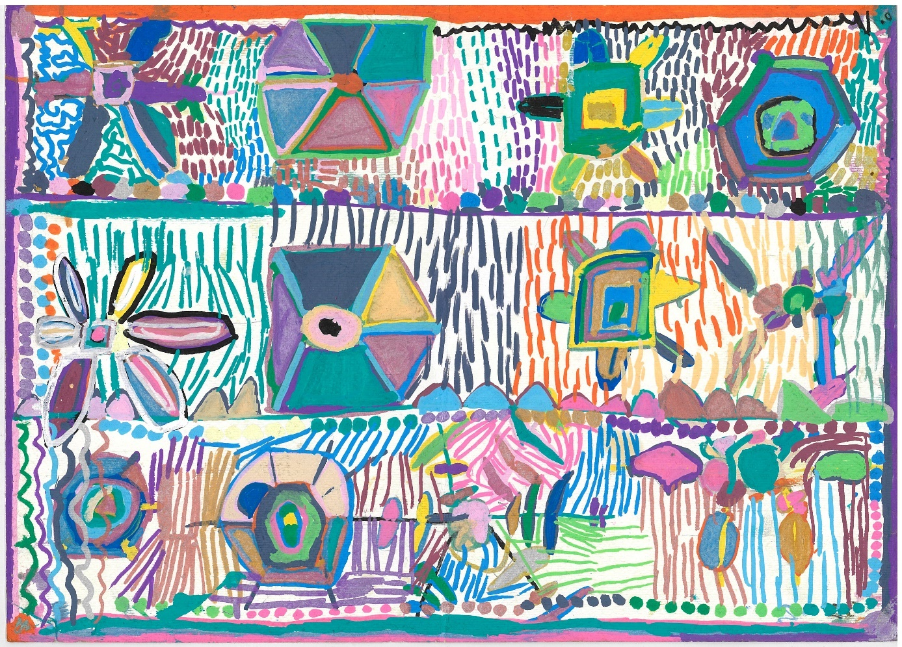

‘Flower Garden’, 2016, Rachelle Rodriguez

## Learning Outcomes

#### The following learning outcomes for this case study are from the [Intellectual Disability Health Capability Framework](https://www.health.gov.au/resources/publications/intellectual-disability-health-capability-framework?language=en) (see Section 2)

4.1.1 Discuss common challenges and gaps in the navigation between health, mental health, and community services for people with intellectual disability.

4.2.1 Describe the importance of trust and positive health care interactions for people with intellectual disability.

4.3.1 Describe the concept of collaborative partnerships and who and what they entail when providing care for people with intellectual disability.

4.4.1 Identify ways that professionals can effectively collaborate and share information at each stage of a care pathway including assessment, care planning and management.

4.5.1 Identify enablers and barriers to continuity of care and the effective transfer of care for people with intellectual disability.

## Case study – Arthur

Arthur is a 65-year-old man with a moderate level of intellectual disability and schizophrenia. His schizophrenia has been stable for many years and is managed by his general practitioner (GP). Arthur was placed into care as a young child and there has been no family contact since then. Arthur has been living in supported accommodation for most of his life and receives NDIS (National Disability Insurance Scheme) funding for disability supports. Arthur has a government appointed guardian for major medical and lifestyle decisions.

Arthur has high blood pressure, type 2 diabetes, and obesity. He has had several falls and recently fractured his hip. Arthur is admitted to hospital for hip surgery and his recovery is prolonged, as he is reluctant to mobilise, and his diabetes is unstable. In hospital, he had delirium with hallucinations and became anxious and aggressive. The episode was managed by the consultation-liaison psychiatry team.

Arthur regains some mobility but needs to use a walker, as his gait is unstable. He now needs insulin to manage his diabetes. A dietitian reviewed Arthur’s diet and developed a nutrition plan. Arthur is medically ready to be discharged, and a coordinated discharge plan is required. A multi-disciplinary case conference is held with the involvement of Arthur, orthopaedic, medical, psychiatry, and allied health clinicians, diabetes educator, a community mental health clinician, discharge planner, Arthur’s GP, guardian, and disability support staff. A coordinated plan for monitoring and follow-up is discussed. This includes Arthur’s review at orthopaedic outpatients, diabetes clinic, and community mental health services. It is also recommended that Arthur see a physiotherapist under NDIS funding for his mobility and balance. This is explained to Arthur in easier-to-understand language and pictures, and he agrees with the plan.

However, the manager of the disability accommodation service expresses reservations about the facility’s ability to support Arthur in the group home. She notes there are steps at the front and back of the house, Arthur’s room is upstairs, and staff are not trained to give insulin injections. She feels that Arthur would be better supported in a residential aged care facility or another group home more suited to Arthur’s needs. Arthur becomes upset at these suggestions, as he has lived in his group home for more than 20 years, has friends there, likes the staff and can access local facilities such as the bowling club and the pub. Arthur’s guardian supports his views and requests that other options be examined.

After further consideration, Arthur is given the option of transferring to a rehabilitation facility for assessments and therapy while additional supports are put in place in his group home. This is explained to Arthur in plain English and pictures and he makes the decision to accept the transfer. Arthur’s NDIS Support Coordinator facilitates an application to the NDIS for a plan review and increase in Arthur’s funding due to his “Change in Circumstances”. She also links Arthur to other supports and services that he will need after returning to his group home. A proposed ongoing management plan once Arthur goes home is discussed with Arthur and after asking some questions, he is satisfied with the plan. The hospital social worker arranges for community nurses to give Arthur insulin injections in the short term, while an NDIS-funded disability nurse implements the diabetes management plan and trains key support staff to administer insulin injections and monitor blood glucose levels. An occupational therapist assesses Arthur’s home environment and makes recommendations about home modifications such as ramps and grab rails. The disability accommodation manager arranges for him to move to a downstairs bedroom.

The discharge plan is finalised, and relevant referrals are made to ensure continuity of care. The agreed discharge and follow-up plans are entered into Arthur’s electronic medical record and a hard copy is provided to his disability support staff, who confirm that they can transport Arthur to his review appointments.

After Arthur’s discharge he is followed up by the community mental health team, diabetes clinic, and the orthopaedic clinic. Both the health and NDIS clinicians agree to send regular updates about Arthur's progress to each other, his GP, guardian and the disability support staff. Arthur’s GP coordinates continuing care and the disability supports that are in place.

## Questions for discussion

1. Why is it important for health professionals from different disciplines to develop a coordinated discharge plan?
2. What are some of the common barriers to integrated care?
3. Would transfer from hospital to a residential aged care facility have been a desirable option? If so, why? If not, why not?
4. What are the potential barriers to successful ongoing management of Arthur’s health and functional needs? How can these be overcome?

## Resources

#### Discharge planning

Discharges from hospital – intellectual disability case studies

Agency for Clinical Innovation

Click here:

<https://aci.health.nsw.gov.au/networks/intellectual-disability/resources/discharges-from-hospital>

Description:

Ten case studies involving people with intellectual disability being discharged from hospital. Includes discussion questions and a summary of priorities and factors which assist the discharge process in these cases.

#### Coordination and collaboration

Working with people with intellectual disability and their team

Intellectual Disability Mental Health Connect

Click here:

<https://idmhconnect.health/i-am-professional/working-people-intellectual-disability-and-their-team>

Description:

Information and resources on how services can work together, and in collaboration with the person with intellectual disability and their support networks. Includes specific considerations, tools and resources.

#### NDIS Services

GP and Health Professional’s Guide to the NDIS

National Disability Insurance Scheme (NDIS)

Click here:

<https://www.ndis.gov.au/media/332/download>

Description:

An information leaflet on the NDIS for health professionals, including how to access the NDIS, requirements of evidence, what the NDIS covers and more. Also includes patient summary examples.

What does the NDIS fund?

National Disability Insurance Scheme (NDIS)

Click here:

<https://www.ndis.gov.au/understanding/supports-funded-ndis>

<https://www.ndis.gov.au/understanding/supports-funded-ndis/disability-related-health-supports>

Description:

Information regarding the types of supports available to participants.

Change in circumstances

National Disability Insurance Scheme (NDIS)

Click here:

<https://www.ndis.gov.au/participants/using-your-plan/changing-your-plan/change-circumstances>

Description:

Information regarding changes in circumstances and the NDIS – including what changes are relevant and guidance for how to update circumstances.

# Case Study 5 – Decision-making and consent: Aisha

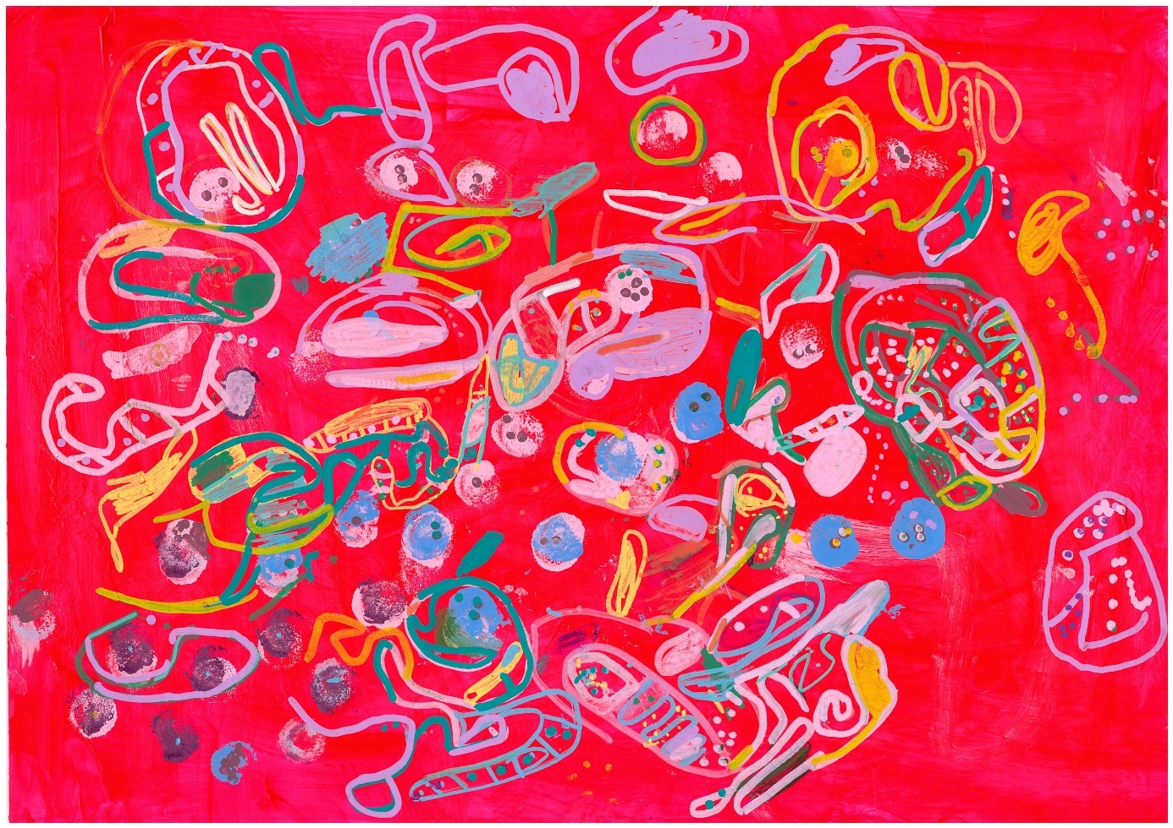

‘Pink!’, 2023, Laura Smit

## Learning outcomes

#### The following learning outcomes for this case study are from the [Intellectual Disability Health Capability Framework](https://www.health.gov.au/resources/publications/intellectual-disability-health-capability-framework?language=en) (see Section 2)

5.1.1 Summarise the key principles of supported decision-making for people with intellectual disability.

5.2.1 Discuss the relevant legislation and potential benefits, risks, and ethical implications of supported decision-making.

5.3.2 Summarise how reasonable adjustments could be made when assessing a person with intellectual disability’s capacity to consent.

5.4.1 Summarise the elements of consent, and how reasonable adjustments can be made to support a person with intellectual disability to provide consent.

5.5.1 Discuss the concept and importance of dignity of risk and how it relates to capacity to consent and supported decision-making.

## Case study – Aisha

Aisha is a 26-year-old woman with cerebral palsy and a mild level of intellectual disability. Aisha lives in supported accommodation and has supported employment. She enjoys going out for meals with her family and friends. Aisha has mobility difficulties and uses a wheelchair. Aisha has very limited speech and prefers to communicate by using an app on her tablet device. Aisha has dysphagia (swallowing difficulty) that has been getting worse over the past two months. She coughs and sometimes chokes when eating or drinking.

A swallowing assessment by a speech pathologist showed that Aisha is at risk of aspiration (inhaling food or liquids into her lungs) and the speech pathologist strongly recommends to Aisha’s residential support staff and family that she have a texture-modified diet of only pureed foods and thickened fluids. The speech pathologist does not give Aisha information such as the pros and cons of texture modification or alternative strategies, as she feels that Aisha would not be able to understand or give informed consent. Aisha does not understand why she cannot eat her favourite foods and becomes extremely distressed. She refuses the texture modified food and drink, loses weight, and becomes dehydrated.

The speech pathologist checks with Aisha’s support staff if she has a formal substitute decision maker. They explain that Aisha can make most of her own health decisions if the situation is explained in a way that she can understand. However, Aisha discusses complex health decisions with her family. The speech pathologist sees Aisha again at a time when she is well-rested. This time, using accessible language and pictures, she explains what dysphagia and aspiration are, and the pros and cons of texture modification. Other strategies, although maybe not as effective, are also discussed. These include sitting upright when eating; using modified cutlery and cups; and not eating and drinking at the same time. The speech pathologist gives time for Aisha to ask questions using her communication app. By asking Aisha to respond using her communication app, the speech pathologist checks that Aisha has understood the information given, including the risk associated with having her usual food and drink. After discussing with her family, Aisha decides not to have a texture-modified diet at present, but to use the other strategies first. She communicates this decision through her communication app. The speech pathologist offers to monitor Aisha’s swallowing and to check periodically that she is happy to continue with her current diet.

## Questions for discussion

1. Why did the speech pathologist initially assume that Aisha did not have the capacity to understand the situation and decide to accept or reject her recommendations?
2. How can health professionals support people with intellectual disability to make health decisions?
3. What should health professionals do when people with intellectual disability do not follow their health recommendations?

## Resources

#### Cerebral palsy

Cerebral palsy

National Institute of Neurological Disorders and Stroke – Cerebral palsy

Click here:

<https://www.ninds.nih.gov/health-information/disorders/cerebral-palsy>

Description:

Information about cerebral palsy, including symptoms, related conditions and early signs, as well as information on how cerebral palsy is diagnosed and treated.

#### Dysphasia

Dysphagia (difficulty swallowing)

Health Direct

Click here:

<https://www.healthdirect.gov.au/dysphagia>

Description:

An Australian government website with information about dysphagia, including what it is, the symptoms and causes of dysphagia, as well as how it is diagnosed and treated.

#### Informed consent

Informed consent

Australian Commission on Safety and Quality in Health Care

Click here:

<https://www.safetyandquality.gov.au/publications-and-resources/resource-library/informed-consent-fact-sheet-clinicians>

Description:

A fact sheet for health professionals on obtaining informed consent. Includes the key principles of informed consent and the legal obligations of a health professional, as well as guidelines on how to obtain valid informed consent, including the principles for assessing legal capacity.

#### Shared and supported decision-making

The role of the speech pathologist in supporting informed choice and shared decision making in dysphagia: Working with ‘risk feeding’

Speech Pathology Australia

Click here:

<https://www.speechpathologyaustralia.org.au/common/Uploaded%20files/About%20Us/Advocacy%20and%20research/Position%20statements/20200221%20Position%20Statement%20Risk%20Feeding%20(1).pdf>

Description:

A detailed exploration of dysphagia and the informed choice of an individual to eat and drink against recommendations (i.e. ‘risk feed’). Includes information on shared decision-making frameworks.

Shared decision making

Australian Commission on Safety and Quality in Health Care

Click here:

<https://www.safetyandquality.gov.au/our-work/partnering-consumers/shared-decision-making>

Description:

A collection of resources on shared decision-making. Includes information on communication to support shared decision-making and setting goals of care. Also includes decision support tools for specific conditions, e.g., antibiotics.

#### Assessing capacity for consent

Capacity Toolkit Factsheet (for the person being assessed)

NSW Government

Click here:

<https://dcj.nsw.gov.au/documents/resource-centre/capacity-toolkit/capacity-toolkit-factsheet.pdf>

Description:

Aimed at people whose capacity is being assessed. Information around capacity and capacity assessment, including information on what a person should do if they have been assessed as lacking capacity.

Toolkit (for professionals, family and carers)

NSW Government

Click here:

<https://dcj.nsw.gov.au/documents/resource-centre/capacity-toolkit/capacity-toolkit.pdf>

Description:

Information around capacity and capacity assessment. This toolkit outlines the process of capacity assessment in each area of life, including health. Also includes a section on supported decision-making.

Assessment of capacity in people with intellectual disability

Australian Psychological Society

Click here:

<https://psychology.org.au/inpsych/2015/august/hagiliassis>

Description:

Article including example referral scenarios, practice and ethical considerations and considerations for test selection, and interpretation within a psychological context.

#### Guardianship

Guardianship orders

NSW Government

Click here:

<https://www.nsw.gov.au/legal-and-justice/financial-management-and-guardianship-orders/guardianship-orders>

Description:

NSW government website with information on guardianship orders, including when a person would need a guardian, what a guardian does, and information on supported decision-making in relation to guardianship.

Individual State and Territory jurisdiction websites

Australian Capital Territory

<https://www.ptg.act.gov.au/guardianship>

New South Wales

<https://www.tag.nsw.gov.au/guardianship>

Northern Territory

<https://nt.gov.au/law/processes/adult-guardianship-and-orders>

Queensland

<https://www.publicguardian.qld.gov.au/guardianship-and-decision-making>

South Australia

<https://www.opa.sa.gov.au/information-service/about-the-information-service/about-guardianship>

Tasmania

<https://www.publicguardian.tas.gov.au/guardianship/about-guardianship>

Victoria

<https://www.publicadvocate.vic.gov.au/guardianship-and-administration>

Western Australia

<https://www.sat.justice.wa.gov.au/G/guardianship_and_administration.aspx>

#### Dignity of risk

Journal Article

Chicoine, B. and Kirschner, K.L. *Considering Dignity of Risk in the Care of People with Intellectual Disabilities: A Clinical Perspective.* Perspectives in Biology and Medicine, 2022. 65(2): p. 189-198.

Click here:

<https://doi.org/10.1353/pbm.2022.0014>

Description:

This case study of a man with Down syndrome includes discussion on a variety of topics including capacity, guardianship and dignity of risk, including consideration on deciding the best course of action in this case.

# Case Study 6 – Responsible, safe and ethical practice: Mirko



‘Untitled”, 2023, Sam Maharaj

## Learning outcomes

#### The following learning outcomes for this case study are from the [Intellectual Disability Health Capability Framework](https://www.health.gov.au/resources/publications/intellectual-disability-health-capability-framework?language=en) (see Section 2)

6.1.2 Identify key resources to support people with intellectual disability to self-advocate or choose a suitable advocate.

6.2.1 Discuss the principles of quality and safety regarding the care of people with intellectual disability.

6.3.3 Recognise signs of exploitation, violence, abuse, and neglect against people with intellectual disability.

6.4.1 Explain the implications of applicable legislation, policy, frameworks, and practice guidelines for the care of people with intellectual disability.

6.5.1 Analyse personal practice and professional development needs with regards to working with people with intellectual disability.

## Case study 6 – Mirko

Mirko is a 41-year-old man with intellectual disability within the severe range, autism and significant behaviours of concern that include verbal and physical aggression towards others, and property destruction. He was born in Australia and both his parents spoke English with him. However, Mirko has no speech and limited understanding of speech. He has very limited capacity to make decisions. After the death of Mirko’s father, his mother Adriana found it increasingly difficult to manage his behaviours of concern on her own and Mirko moved into supported accommodation six months ago. As Adriana has no other family or supports in Australia, she subsequently returned permanently to her home country. Mirko remained in Australia. Mirko has a financial guardian, and disability support staff contact Adriana for any major medical or other decisions. Adriana calls about once a month to see how Mirko is doing but is not involved in day-to-day decisions.

Mirko has a behaviour support plan with strategies to prevent, decrease or manage his behaviours of concern. Mirko also sees a speech pathologist, Brittany, who is helping him to develop more effective communication strategies; and a psychiatrist who prescribes medication for Mirko’s anxiety, which is often a trigger for his behaviours of concern.

The accommodation disability staff have limited training and experience in supporting a person with significant and complex behaviours of concern. On a visit to review Mirko’s communication plan, Brittany noted that his behaviours of concern had escalated in the last three months and the staff were not using the communication or behaviour support strategies outlined in his behaviour support plan. He had not been reviewed by his psychiatrist for over a year. Because the staff found Mirko’s behaviours of concern particularly difficult to manage when he was out in the community, his day program and community access were suspended. Brittany found Mirko in his room restrained in a wheelchair. She noted that he had lost weight and had bruising and finger marks on his arms. The staff stated that Mirko was easier to manage when he was in the wheelchair as he tries to abscond, but he strongly resists being placed in the wheelchair. The use of restraint, a restrictive practice, was not specified in the behaviour support plan and no formal authorisation for its use had been sought.

Brittany was concerned about signs of neglect and for Mirko’s safety. She contacted the accommodation service coordinator, who said they would follow up, but did not seem to take Brittany’s concerns seriously. As a National Disability Insurance Scheme (NDIS) provider, Brittany has a mandatory duty to report any abuse or neglect of a person with disability and she lodged a notification to the NDIS Safety and Quality Commission (the Commission). She also liaised with staff to have Mirko seen by his general practitioner (GP) for the weight loss, bruising and assessment to exclude medical causes for his escalation in behaviours of concern.

After investigating the complaint, the Commission instructed the disability provider to take certain actions, including:

* Cease unauthorised restrictive practices and have Mirko’s behaviour plan reviewed to develop alternatives to restrictive practices.
* Provide education to support staff about non-restrictive behaviour support practices.

A formal review was arranged in three months to check on Mirko’s progress. During this time, Mirko had a health assessment by his GP, and communication and psychiatry reviews. A behaviour clinician worked with staff to develop a new behaviour support plan and also provided staff with education about non-restrictive behaviour support strategies. An NDIS-funded psychologist is providing therapy for Mirko in view of the trauma that he experienced from the restrictive practices, as well as separation from his mother and the family home. After discussion with Adriana, it was decided to apply for appointment of a formal guardian as well as an advocate to monitor Mirko’s health and living situation and to keep Adriana updated about these.

## Questions for discussion

1. What are restrictive practices?
2. What types of unauthorised restrictive practices are being used with Mirko?
3. What are the risk factors for abuse and neglect in Mirko’s case, and how are they best mitigated?
4. What agency authorises restrictive practices in your State or Territory?
5. How would you advise a student or new graduate who witnessed and reported to you (as their supervisor) instances of abuse or neglect?
6. What is the NDIS Quality and Safeguards Commission and what is its role?
7. What are the roles of a guardian and advocate and how do you access them in your State?

## Resources

#### Behaviours of concern

Assessment and Management Framework – Behaviour change in people with intellectual disability

Monash Health

Click here:

<https://cddh.monashhealth.org/wp-content/uploads/2021/01/amf-2018.pdf>

Description:

This decision-making tool provides guidance for the assessment and management of behavioural changes in people with intellectual disability.

Journal article

Ali, A., Blickwedel, J., and Hassiotis, A. *Interventions for challenging behaviour in intellectual disability.* Advances in Psychiatric Treatment, 2014. 20(3): p. 184-192.

Click here:

<https://doi.org/10.1192/apt.bp.113.011577>

Description:

This article discusses behaviours of concern and associated diagnostic challenges. It includes discussion on the psychosocial and pharmacological treatment of behaviours of concern.

Journal article

Hassiotis, A. and Rudra, S. Behaviours that challenge in adults with intellectual disability: overview of assessment and management. BJPsych Advances, 2022. 28(6): p. 393-400.

Click here:

<https://doi.org/10.1192/bja.2022.28>

Description:

This article provides an overview of the assessment and management of behaviours of concern in adults with intellectual disability, including the description of a structured approach to the management of these behaviours.

#### Restrictive practices

Behaviour support and restrictive practices

National Disability Insurance Scheme (NDIS)

Click here:

<https://www.ndiscommission.gov.au/rules-and-standards/behaviour-support-and-restrictive-practices#paragraph-id-9122>

Description:

This Behaviour Support and Restrictive Practice fact sheet includes information on what restrictive practices are, how they are authorised and when the use of regulated restrictive practice becomes a reportable incident.

#### Reportable incidents

Resources to support incident reporting, management and prevention

National Disability Insurance Scheme (NDIS)

Click here:

<https://www.ndiscommission.gov.au/resources/provider-and-worker-resources/resources-support-incident-reporting-management-and#paragraph-id-2944>

Description:

Includes resources such as fact sheets and videos. Includes information such as requirements for reportable incident notifications and guidance for incident reporting, management and prevention.

#### Guardianship

Guardianship orders

NSW Government

Click here:

<https://www.nsw.gov.au/legal-and-justice/financial-management-and-guardianship-orders/guardianship-orders>

Description:

NSW government website with information on guardianship orders, including when a person would need a guardian, what a guardian does, and information on supported decision-making in relation to guardianship.

Individual State and Territory jurisdiction websites

Australian Capital Territory

<https://www.ptg.act.gov.au/guardianship>

New South Wales

<https://www.tag.nsw.gov.au/guardianship>

Northern Territory

<https://nt.gov.au/law/processes/adult-guardianship-and-orders>

Queensland

<https://www.publicguardian.qld.gov.au/guardianship-and-decision-making>

South Australia

<https://www.opa.sa.gov.au/information-service/about-the-information-service/about-guardianship>

Tasmania

<https://www.publicguardian.tas.gov.au/guardianship/about-guardianship>

Victoria

<https://www.publicadvocate.vic.gov.au/guardianship-and-administration>

Western Australia

<https://www.sat.justice.wa.gov.au/G/guardianship_and_administration.aspx>

#### National Standards

Standards Use Guide for the Health Care of People with Intellectual Disability

Australian Commission on Safety and Quality in Health Care

Click here:

<https://www.safetyandquality.gov.au/publications-and-resources/resource-library/nsqhs-standards-user-guide-health-care-people-intellectual-disability>

Description:

The National Safety and Quality Health Service (NSQHS) Standards – User Guide for the Health Care of People with Intellectual Disability were developed to be consistent with the recommendations of the Royal Commission into Violence, Abuse, Neglect and Exploitation of People with Disability [Final Report](https://disability.royalcommission.gov.au/publications/final-report). It includes strategies and resources for health service organisations and clinicians.

Health.gov.au

All information in this publication is correct as at May 2025