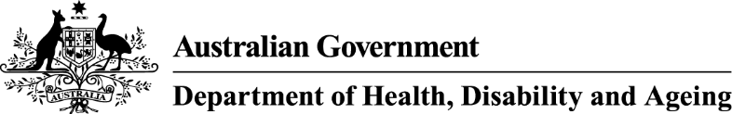

**How and why your smokes are changing**

This year, cigarettes will change due to new tobacco laws. These changes aim to protect people from the health harms of smoking and help make it easier for people to quit.

The main things you need to know:

- The changes kick in from 1 July 2025, but you might see changes earlier.

- Your cigarettes may look different, taste and feel different, have a different name, and only be available in a certain size pack.

- The changes will make cigarettes less attractive, make sure the harms of smoking are clear, and help make it easier for people to quit.

The changes might mean some tobacco products won't be sold anymore.

The changes don’t make smoking any safer – all tobacco is harmful and addictive.

# Tobacco products will:

## **Taste and feel different**

Some things that mask the harshness of tobacco will be banned, including some ingredients, flavours (including menthol, rum and clove), and accessories.

## **Have different names**

Words like ‘smooth’ and names like ‘gold’ that can falsely suggest some products are less harmful will be removed.

## **Be consistent in size**

Each cigarette pack will have 20 sticks. Roll-your own pouches will have 30 grams of tobacco.

## **Be the same shape**

Each cigarette stick will be the same length and width, and special filters will be banned.

## **Have new health information**

There will be new health warnings and information cards to help people quit.

# Why are these changes happening?

The changes are being made to make cigarettes and other tobacco products less attractive. They also help people see how harmful smoking is. This can make it easier for people to stop smoking, stay smoke-free, or never start at all.

Smoking is the main cause of death that can be prevented in Australia. It kills more than 24,000 Australians each year – that’s about one person every 22 minutes.

There’s no getting around it, smokes are bad for you and the people around you. Smoking shortens your life and impacts how healthy you feel. It can also make you very sick and cause serious diseases like cancer, heart disease, stroke, and diabetes.

The best way to reduce harm is to not smoke at all.

There’s now more support than ever to **help you quit**:

**Ask your health worker, doctor or chemist for advice**. They can talk to you about different choices, like medicines that can help with cravings and feeling restless.

**Call Quitline on 13 7848** and ask to yarn with an Aboriginal or Torres Strait Islander counsellor or get a call back.

**Check quit.org.au** for ways to quit and tips for dealing with how you feel while you’re quitting.

**Download the free My QuitBuddy app on your phone**. It helps you set your own goals and motivations to quit, track your progress and see how much money you’re saving by quitting.

For more information on the changes visit [health.gov.au/tobacco-changes](https://www.health.gov.au/tobacco-changes)

[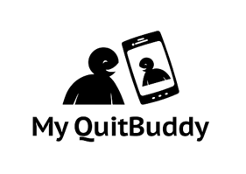](https://www.health.gov.au/resources/apps-and-tools/my-quitbuddy-app) **[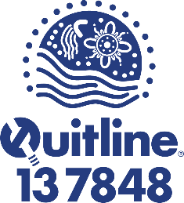](https://www.aql.org.au/)**